FOI Backgrounder: ADDs and Salmon Farms (May 2017)

Please read in conjunction with 'Media Backgrounder: ADDs and Salmon Farms (May 2017)'

From: FOI [mailto:FOI@snh.gov.uk]
Sent: 25 April 2017 19:27
To: Don Staniford
Subject: RE: FOI on ADDs, predator control and salmon farms since 1 Jan 2016

Dear Mr Staniford,

Thank you for your information request. I’ve attached our response.

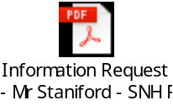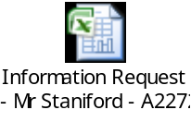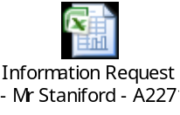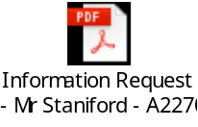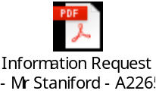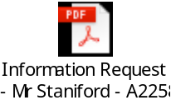

Please don’t hesitate to contact us if you have any questions about our response or any problems with the attached documents.

Yours sincerely,

Rhoda Davidson
Information Officer

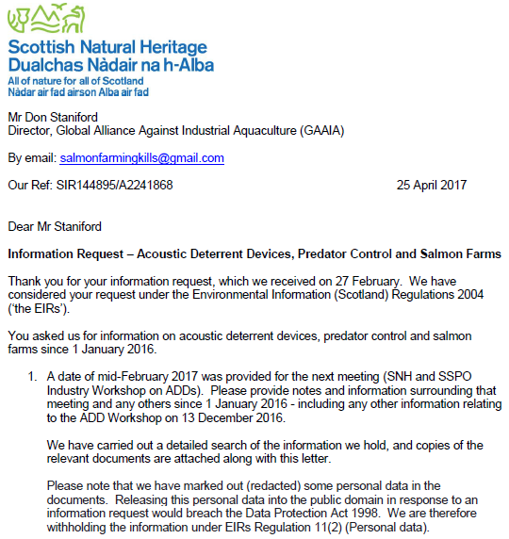
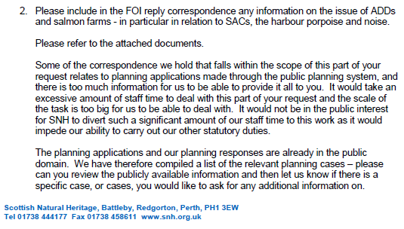

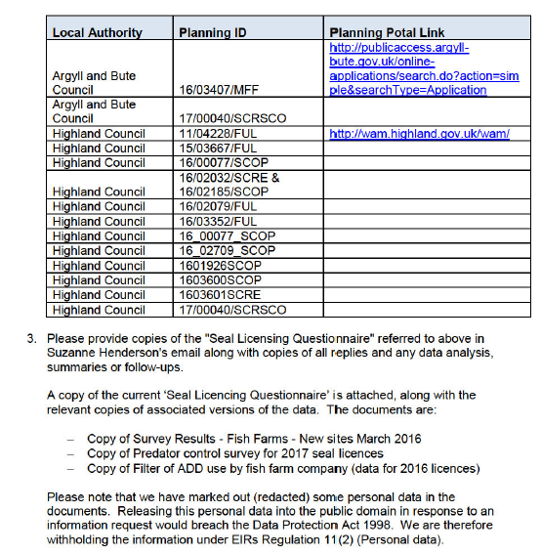

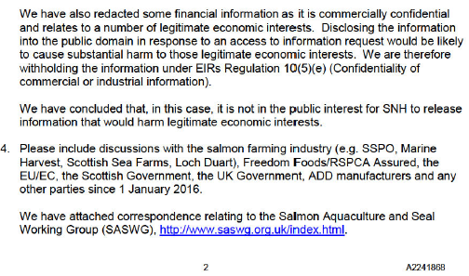

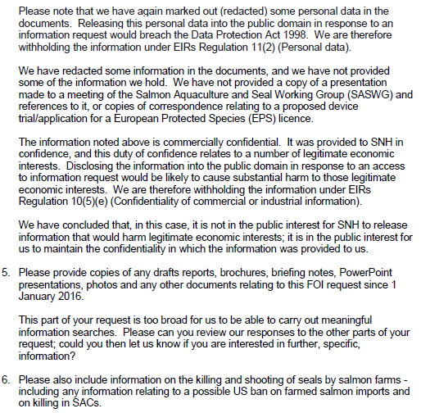
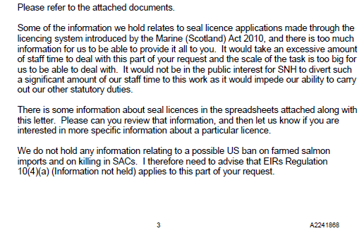

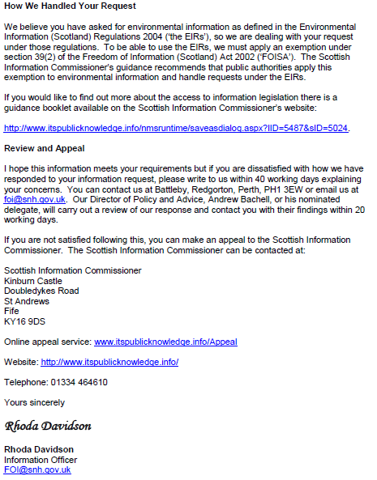

From: Don Staniford [mailto:salmonfarmingkills@gmail.com]
Sent: 26 February 2017 07:55
To: FOI
Subject: FOI on ADDs, predator control and salmon farms since 1 Jan 2016

Please provide information ADDs, predator control and salmon farms since 1 January 2016.

Please note that the information released by SNH on 24 February (attached) included these notes from a meeting with SSPO, the Scottish Salmon Company, Marine Harvest Scotland and Scottish Sea Farms in December 2016:

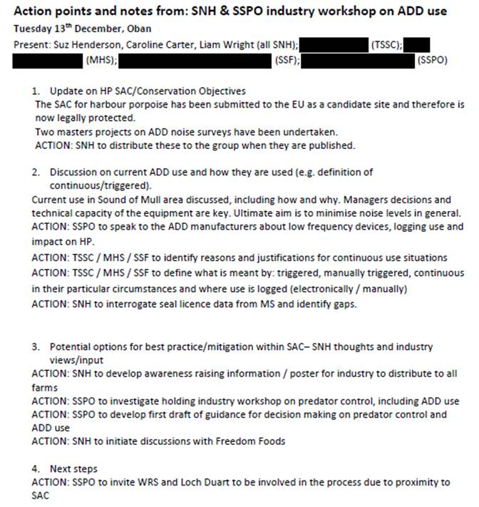

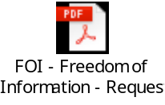

A date of mid-February 2017 was provided for the next meeting. Please provide notes and information surrounding that meeting and any others since 1 January 2016 - including any other information relating to the ADD Workshop on 13 December 2016.

The attached FOI reply from SNH also included:

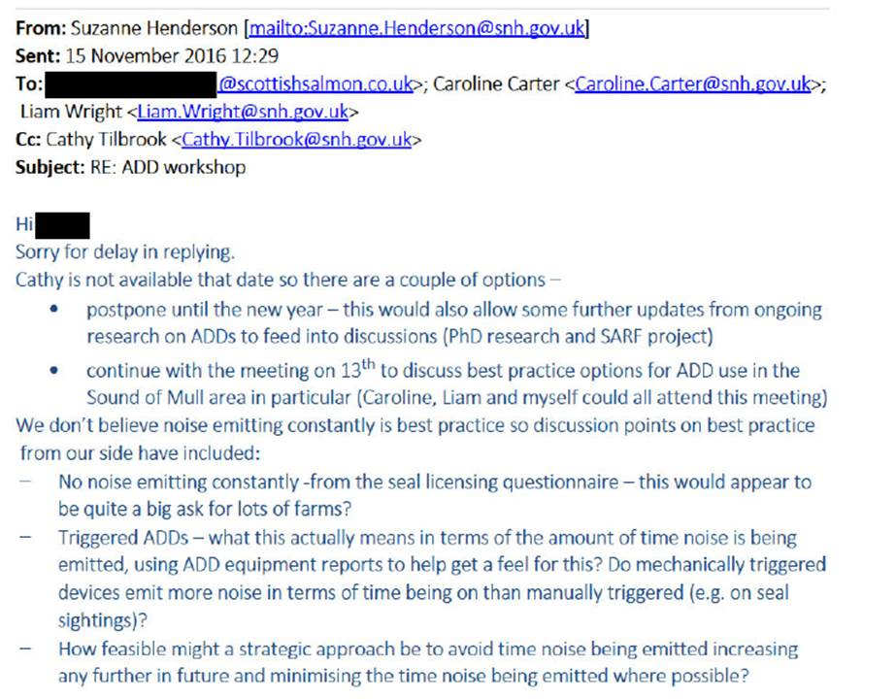

Please include in the FOI reply correspondence and information on the issue of ADDs and salmon farms - in particular in relation to SACs, the harbour porpoise and noise.

Please provide copies of the "Seal Licensing Questionnaire" referred to above in Suzanne Henderson's email along with copies of all replies and any data analysis, summaries or follow-ups.

Please include discussions with the salmon farming industry (e.g. SSPO, Marine Harvest, Scottish Sea Farms, Loch Duart), Freedom Foods/RSPCA Assured, the EU/EC, the Scottish Government, the UK Government, ADD manufacturers and any other parties since 1 January 2016.

Please provide copies of any drafts reports, brochures, briefing notes, Powerpoint presentations, photos and any other documents relating to this FOI request since 1 January 2016.

Please also include information on the killing and shooting of seals by salmon farms - including any information relating to a possible US ban on farmed salmon imports and on killing in SACs.

Please consider this a request for information under the relevant Freedom of Information and Environmental Information Regulations including both the Freedom of Information (Scotland) Act 2002 and the Environmental Information (Scotland) Regulations 2004 (as well as any other new or other regulations which may be appropriate).

Please provide this information electronically via email.

Please acknowledge receipt of this FOI request.

Many thanks and I look forward to a response shortly.

Thanks,

Don

Don Staniford

Director, Global Alliance Against Industrial Aquaculture (GAAIA): http://www.salmonfarmingkills.com

<((((º>`·.¸¸.·´¯`·.¸.·´¯`·...¸><((((º>¸.
·´¯`·.¸. , . .·´¯`·.. ><((((º>`·.¸¸.·´¯`·.¸.·´¯`·...¸><((((º>

