Scottish Salmon Watch, 8 May 2018

Big McSalmon, Large Lice & Toxic Chemicals - Supersized Salmon Goes Global!

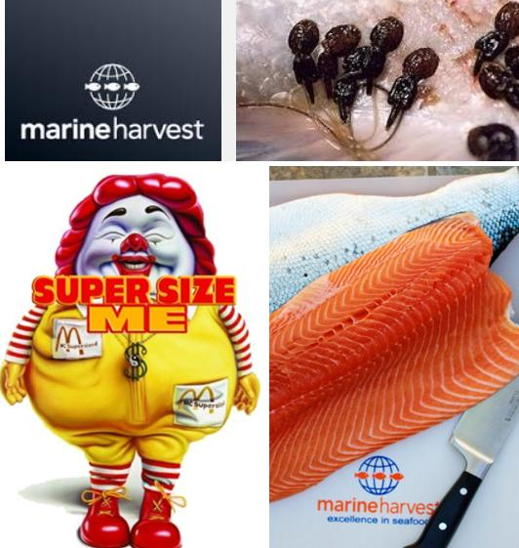

Supersized salmon farming is taking the 'King of Fish' (Atlantic salmon) downmarket with farmed salmon now mass marketed by fast food chains like McDonald's and industry giants like Marine Harvest. Lice-infested 'Big McSalmon' is not only leaving a bad taste in the mouth it is leaving a lasting legacy of environmental pollution (not to mention impacts on wild fish).

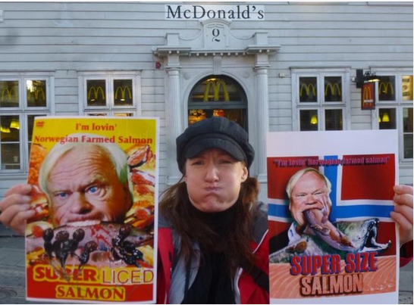
The writing is on the wall as supersized salmon blows a big hole in the international reputation of salmon.

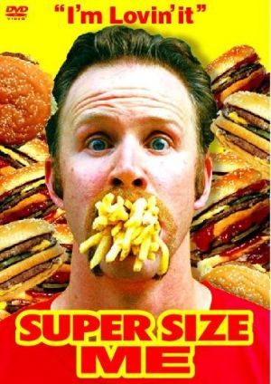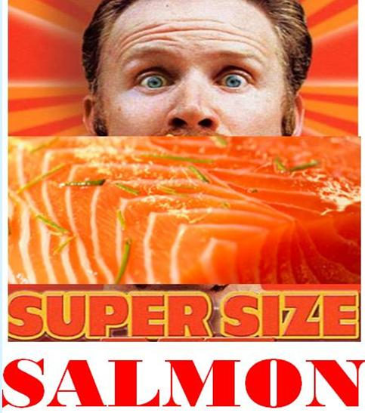

The South China Morning Post reported (5 May 2018):

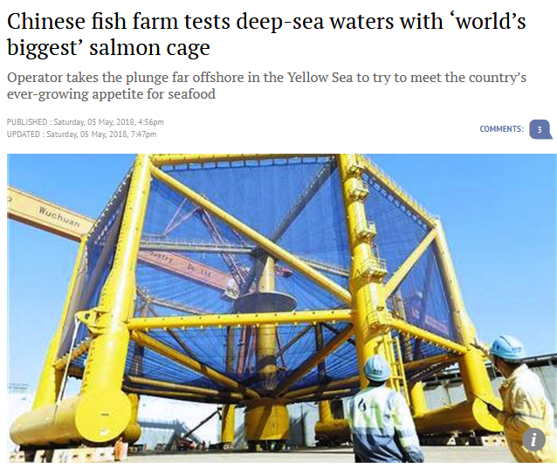
Salmon Business reported (2 May 2018):

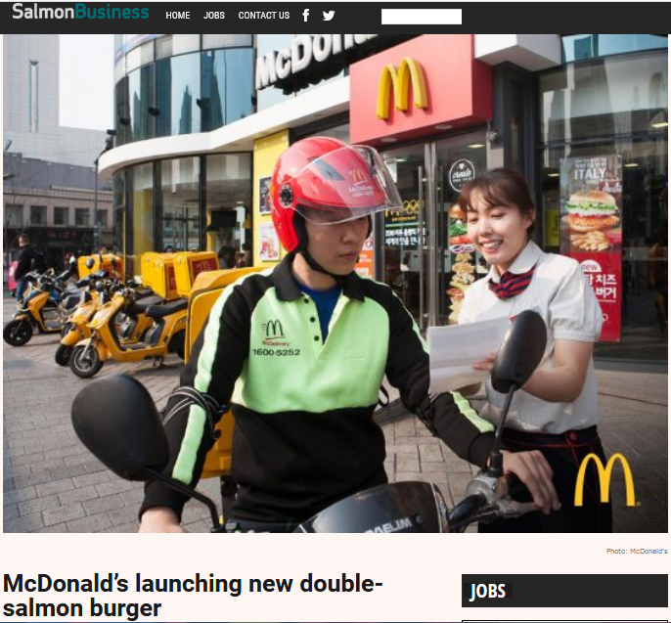

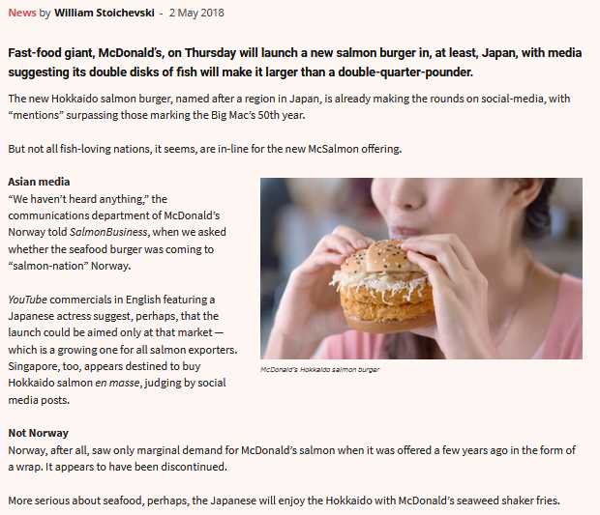

Intrafish reported (2 May 2018):

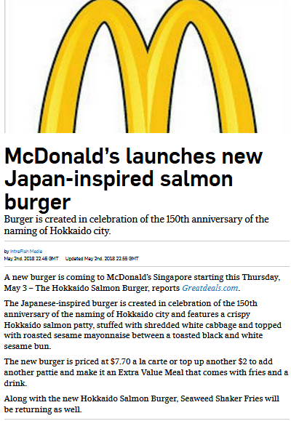

Read more via "McDonald’s new Hokkaido Salmon Burger, Seaweed Shaker Fries and Matcha McFlurry are coming this week"
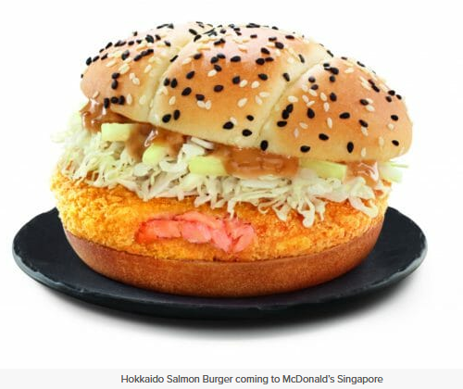
The Financial Times reported in March 2018:

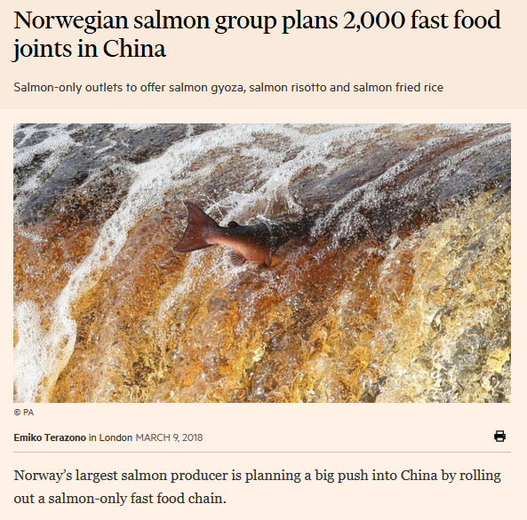
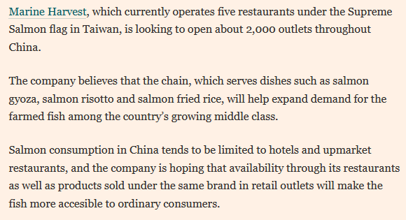

Salmon Business reported in March 2018:

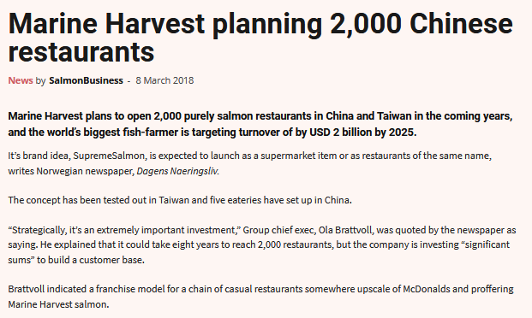

Seafood Source reported in March 2018:

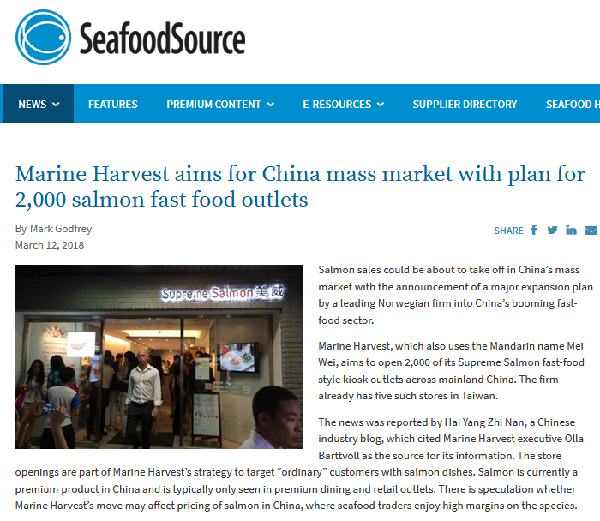
Marine Harvest is not the only company moving into fast food farmed fish. News In English reported in March 2018:

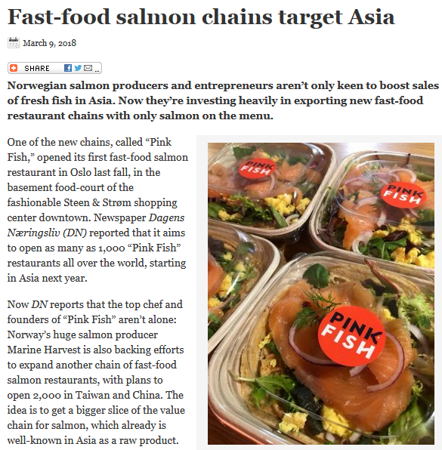

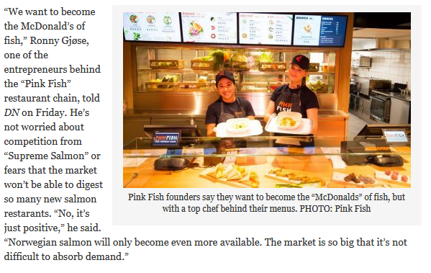
Marine Harvest hooked up with McDonald's a decade ago in Norway with the 'Lakswrap'. The Fish Site reported in 2007:

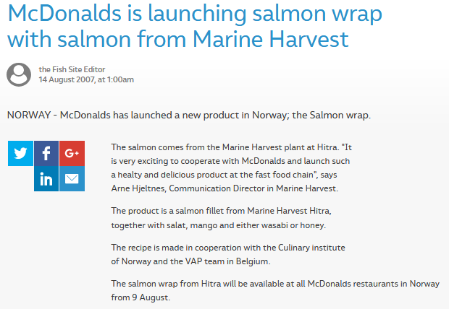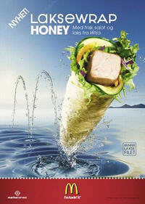

Reuters reported in 2007:

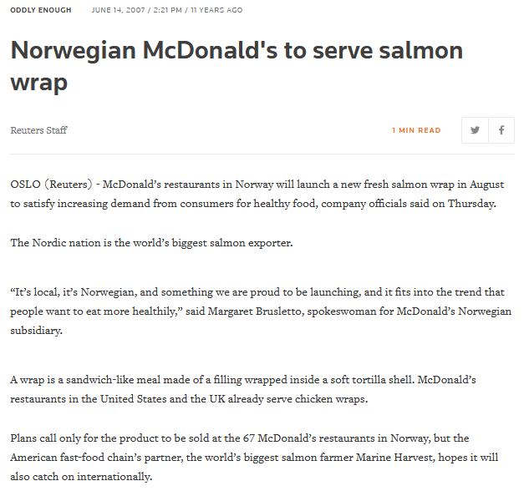

The Norway-only trial of the 'Laksewrap' (Salmon Wrap) was meant to "catch on internationally". Marine Harvest owner John Fredriksen (worth over $7.3 billion and 228th in the Forbes Billionaire's List), was nicknamed 'McFreddy' by the Norwegian media in 2007 following Marine Harvest's link up with McDonald's (he certainly looks as if he's eaten more than his fair share of farmed salmon and Big Macs).
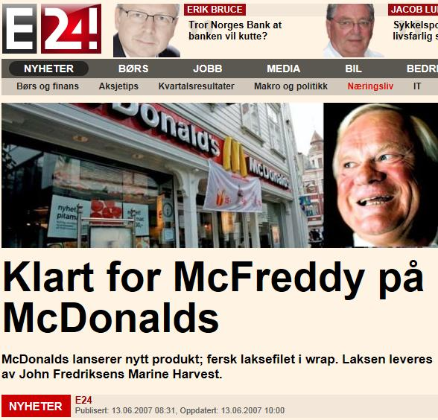

Mmmmm superliced farmed salmon anyone?
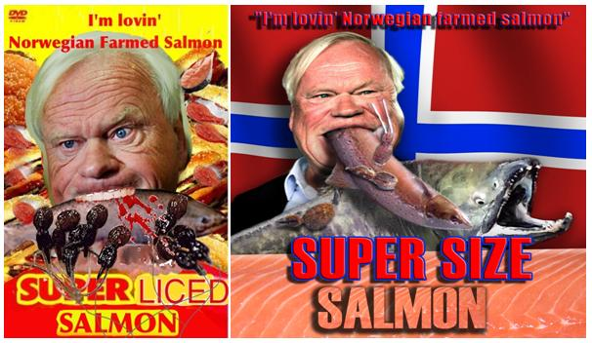
McDonald's' first foray into farmed salmon burgers went downhill fast when diners in Norway were hospitalized with food poisoning in 1997. Top Tenz reported in 2011:

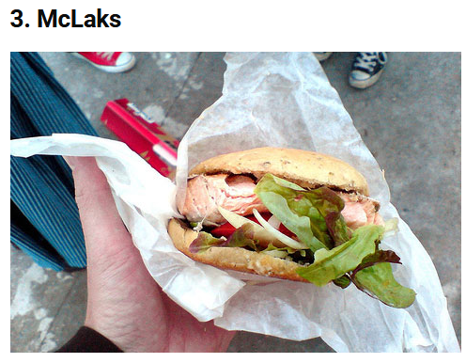
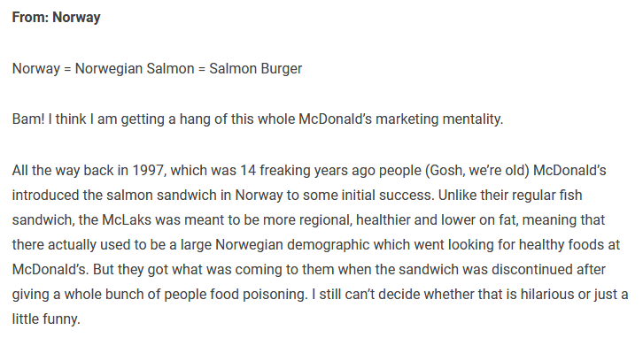

Ad Age reported in 1997:

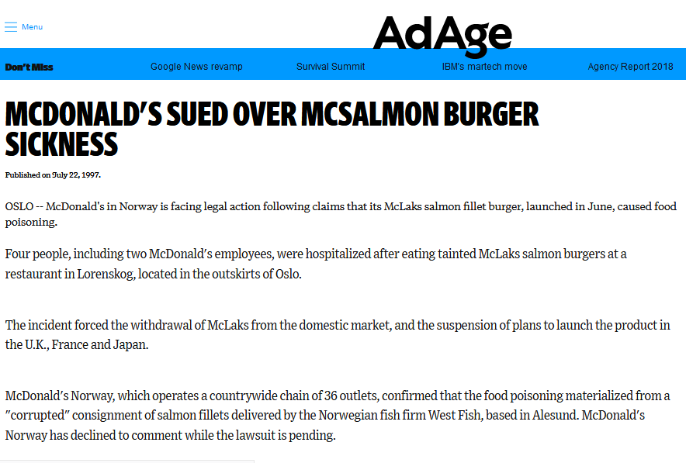
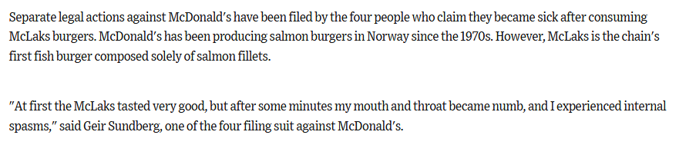

Read more via "McDonald's sued over McSalmon burger sickness" and "Eco-Washing McFarmed Fish"

After his victory against 'pink slime' in McDonald's beef burgers in 2015, maybe celebrity chef Jamie Oliver will now take up his food fight against the pink slime in the shape of farmed salmon?

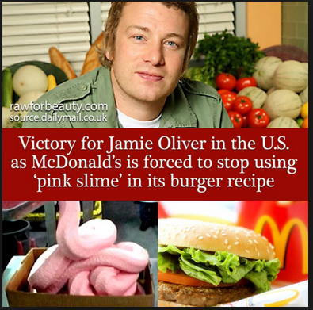

Protestors against a supersized salmon farm in Galway Bay in Ireland look supportive.

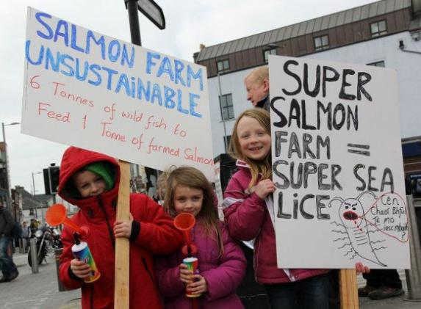
A report on 'Super Salmon' published by the University of Otago in 2006 tackled "the commoditisation and industrial of salmon" arguing that modern salmon farming was 'Fordist' in nature:
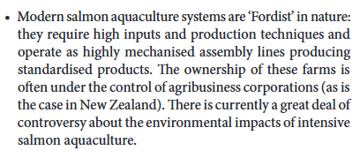

Read more via "Super Salmon: The Industrialisation of Fish Farming and the Drive Towards GM Technologies in Salmon Production"

Writing in New Republic in 2009 via 'Aquacalypse Now', Dr. Daniel Pauly of the University of British Columbia argued:

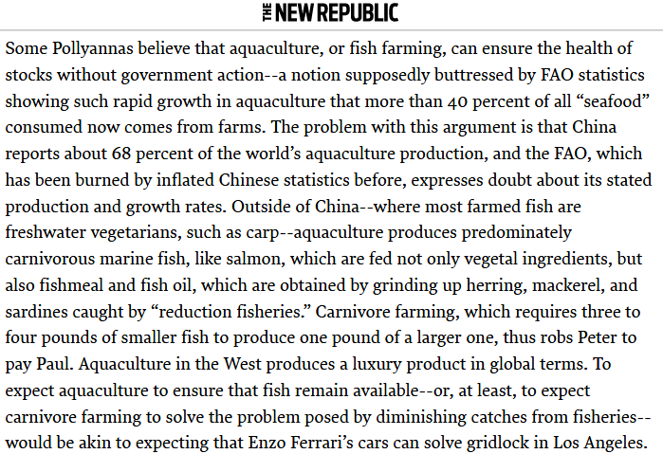

Farmed salmon may still be marketed as a 'luxury' and Scottish farmed salmon may still demand a price premium over Norwegian farmed salmon but not for much longer if supersized Scottish salmon farming drags the industry downmarket into the depths of fast food.
As Ben Hadfield, Managing Director of Marine Harvest Scotland, testified to the Scottish Parliament's Rural Economy & Connectivity Committee on 2 May 2018:

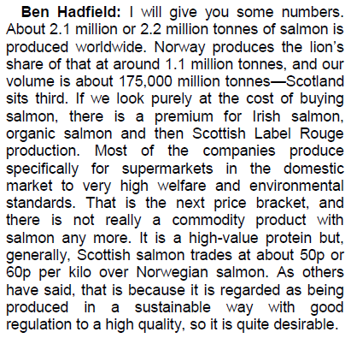

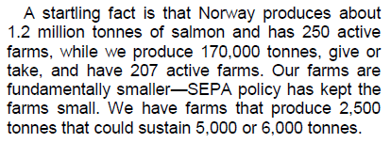

Read more on Marine Harvest via "Media Backgrounder: Marine Harmfest Scotland"

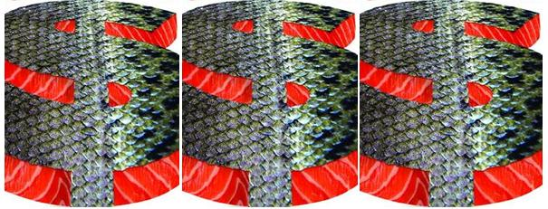

Despite Marine Harvest's aims to grow even bigger, the fact is that salmon farming in Scotland has grown significantly. The latest 'Scottish Fish Farm Production Survey 2016' published in September 2017 details bigger companies producing more salmon from a smaller number of sites:

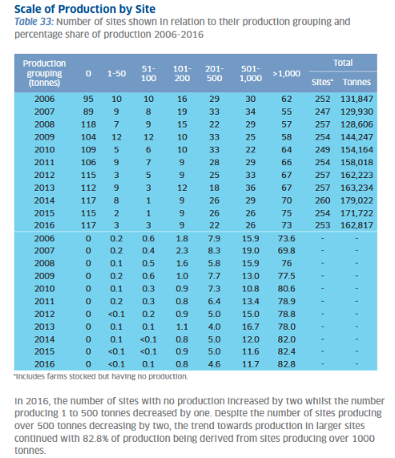

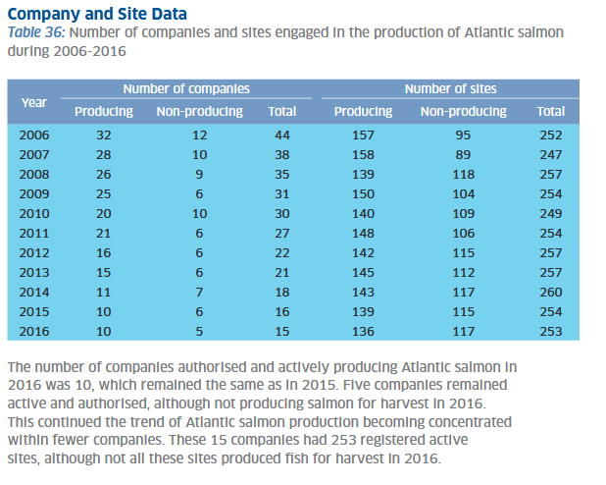

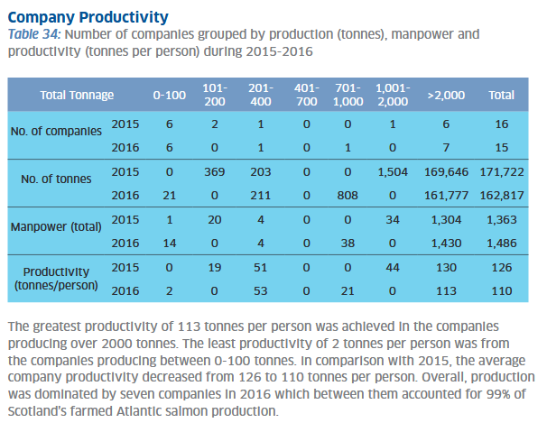

Data obtained from the Scottish Environment Protection Agency via FOI reveals that salmon farms in Scotland are breaching biomass limits.

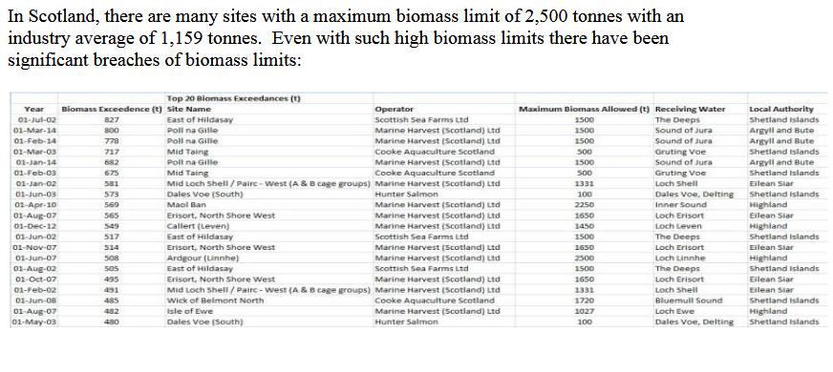

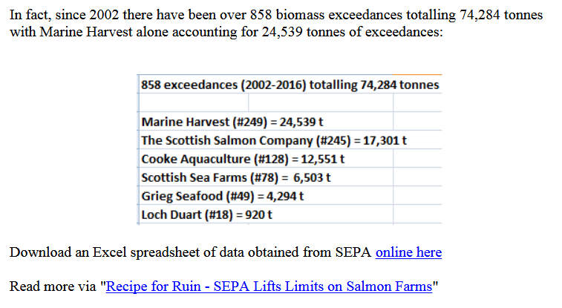

Read more via "The Scottish Environment Pollution Agency"

Despite flagrant biomass breaches, Scottish salmon farms are generally smaller than their Norwegian counterparts. Here's data obtained via FOI from the Norwegian Government's Directorate of Fisheries detailing 11 salmon farms over 7,000 tonnes including one site over 10,000 tonnes.

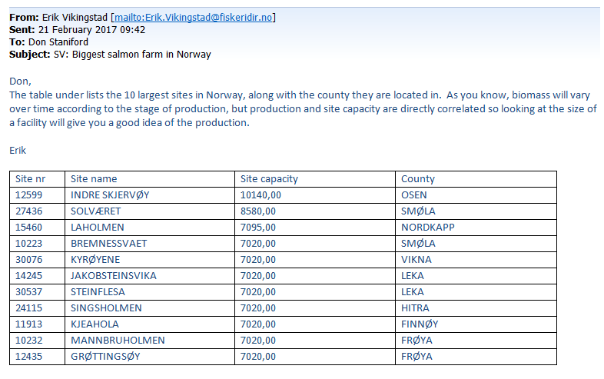

Little wonder then that Norway's supersized salmon farming sector - dubbed 'giant' by The New York Times in 2017 and described by the Green Warriors of Norway as "the most toxic food in the world" - was the subject of a hard-hitting documentary in 2014 titled 'Fillet Oh Fish':

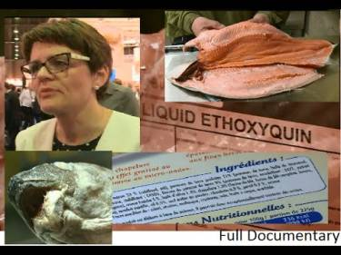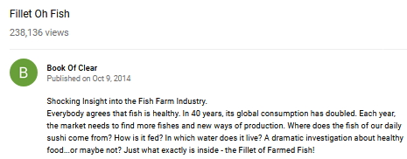
Damning data on cancer-causing chemicals shows that farmed salmon is more fillet de poison than 'Filet de Poisson'.

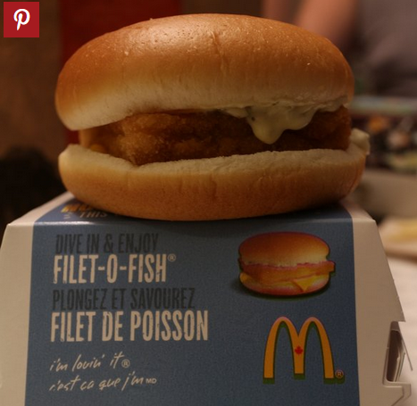

Doubling salmon farming production in Scotland, as promoted by the Scottish Government, can only mean double trouble.

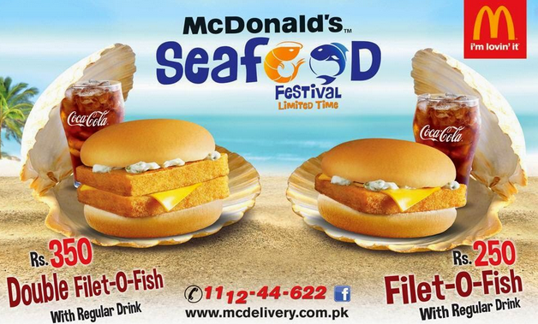

"The gloss is off the Scottish salmon brand," wrote award-winning food writer Joanna Blythman in The Grocer in February 2017 via 'Scotland's farmed salmon industry stinks'.

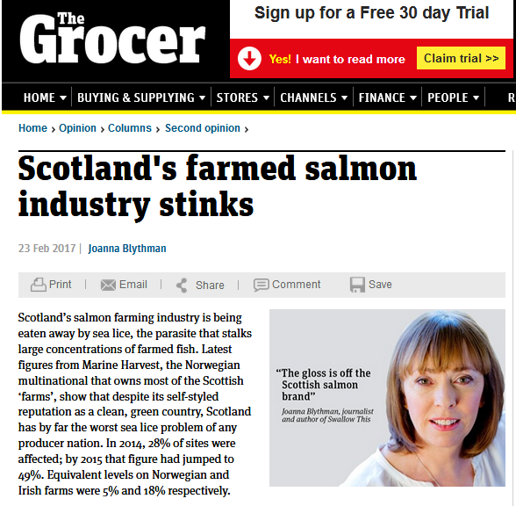

How much further down into the gutter can Scottish salmon go? If the Scottish Government and big multinationals like Marine Harvest have their way then it's clearly going to be all the way into the gutter.
As Fish Update reported (25 April 2018) on Fergus Ewing's marketing trip to last month's Seafood Expo Global:

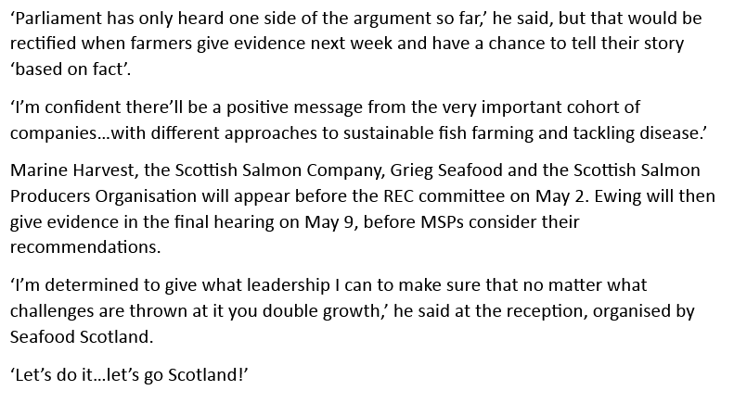

Expanding production and increasing farm size even further will mean that the stench of Scottish salmon farming will go global and destroy Scotland's image as a premium brand. Fast food farmed salmon belongs in the dustbin not your shopping basket.

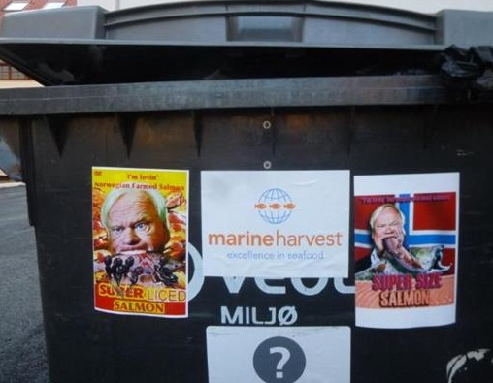

Read more on supersized salmon farming via:

Sunday Times: "Supersizing salmon farms in Scotland 'will be a disaster’"
SEPA proposes lifting biomass cap for Scottish salmon farms
Industry: no imminent plans for super-sized salmon farm
Outrage over secret plans to base world's biggest salmon farm in Scotland
Super-sized Scottish Salmon - 8,000 tonnes of trouble on the horizon!
Opposition mounts to super-sized fish farm in Galway Bay
Concerns over size of proposed new salmon farm in Galway Bay
Ireland Says ‘Feck Off’ to Super-Size Salmon Feedlot in Galway Bay
The Fightin' Irish Take On Super-Size Salmon!

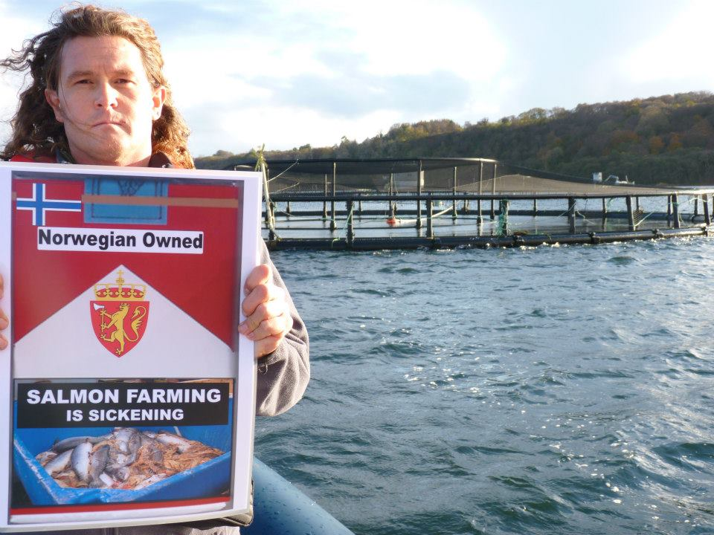

Don Staniford, Director of Scottish Salmon Watch

