Loch Duart - The (Really Not Very) Sustainable Salmon Company

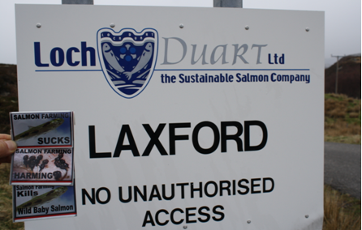

Loch Duart's marketing tag-line is 'The Sustainable Salmon Company' but how true is this claim? In advance of the salmon farming industry's testimony to the Scottish Parliament's inquiry into the environmental impacts of salmon farming (6 February 2018), GAAIA's 'Freedom for Fish' campaign takes a closer look.

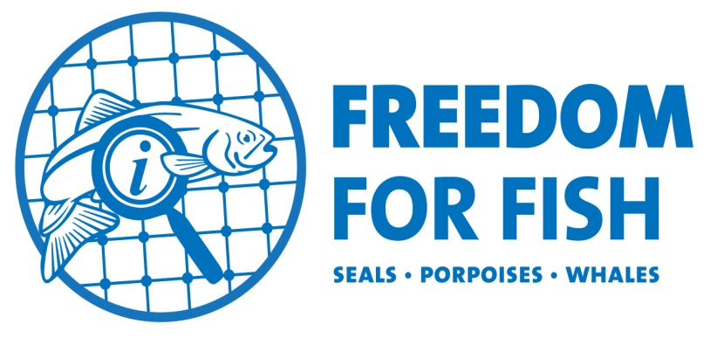

It seems that Loch Duart's "innovative approach to environmental stewardship", "ethos" and "conservation" encompasses the killing of seals - including lactating mothers and pregnant seals - as well as lice infestation, toxic chemical use, mass escapes, infectious diseases and waste pollution.
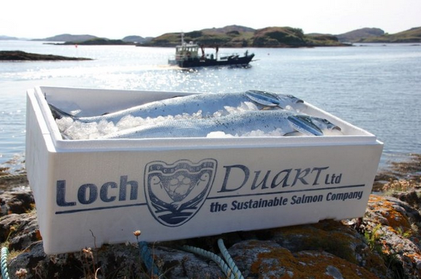
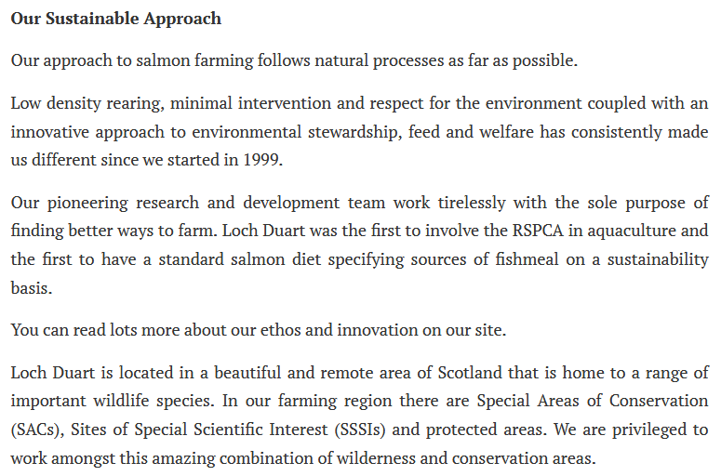

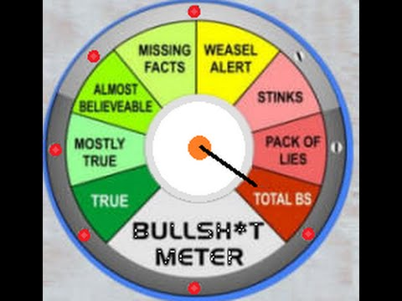

Shamefully, Loch Duart's web-page on Ecology & Wildlife features a photo of seals:

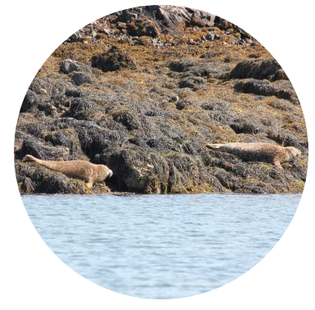

Yet Loch Duart has killed ca. 50 seals since 2011 (from when official statistics were made available).

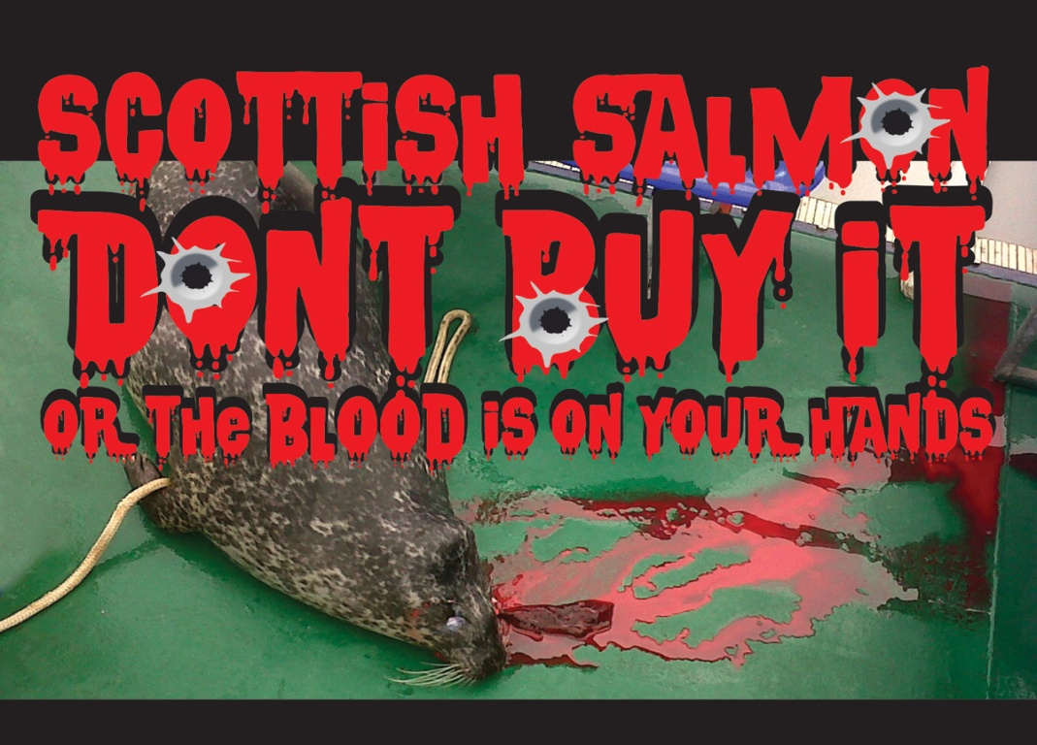

According to Scottish Government statistics Loch Duart killed 10 seals in 2017 (data up to Q2 2017) with 3 seals killed in Loch Carnan, 3 seals killed in Loch Laxford, 2 in Loch A Chainn Bhain and 1 each in Badcall Bay and Outer Bay (some Loch Duart seal kills are recorded via the North & North West Salmon Management Group):

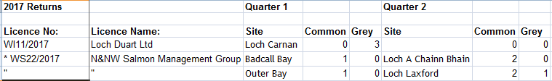

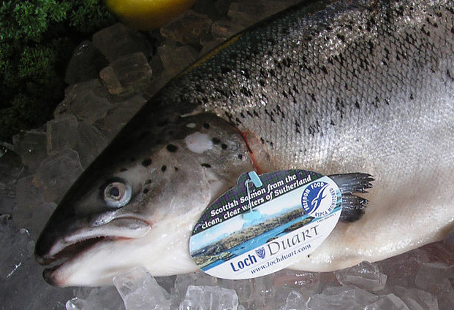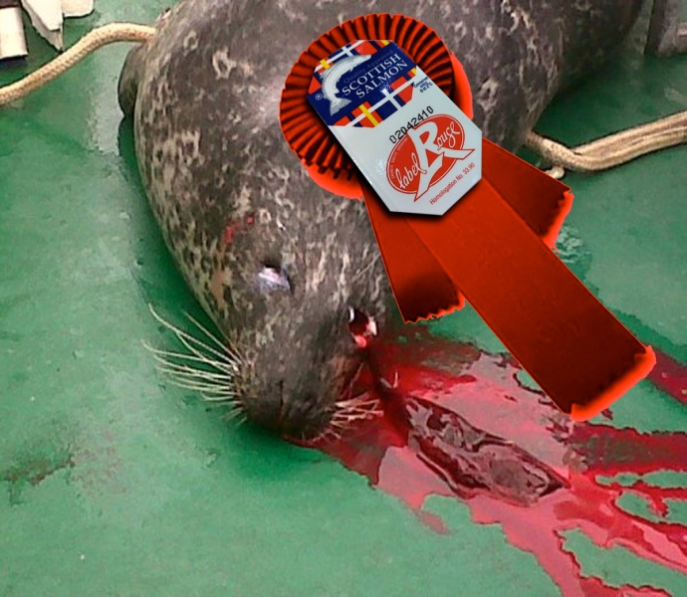

Scottish Government data for 2016 reveals 12 seals killed by Loch Duart:

Scottish Government data for 2015 reveals at least 4 (probably more than 10) killed by Loch Duart (to obtain exact figures you need to cross-reference the sites codes):

Data for 2011 to 2014 is available on the Scottish Government's web-site (just click on the year and download an Excel spreadsheet). According to an analysis of the data by GAAIA, Loch Duart killed 8 seals in 2014 - the third biggest salmon farming killer in Scotland.

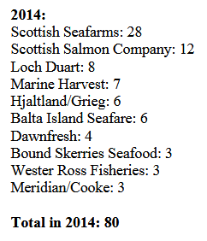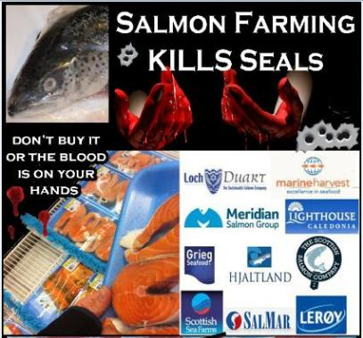
Read more via "Cecil the Seal Killers Named & Shamed in Scotland - Call for Boycott of "Seal Unfriendly" Scottish Salmon"

No matter that Loch Duart is accredited via the RSPCA Assured scheme since the RSPCA sanctions the killing of seals.

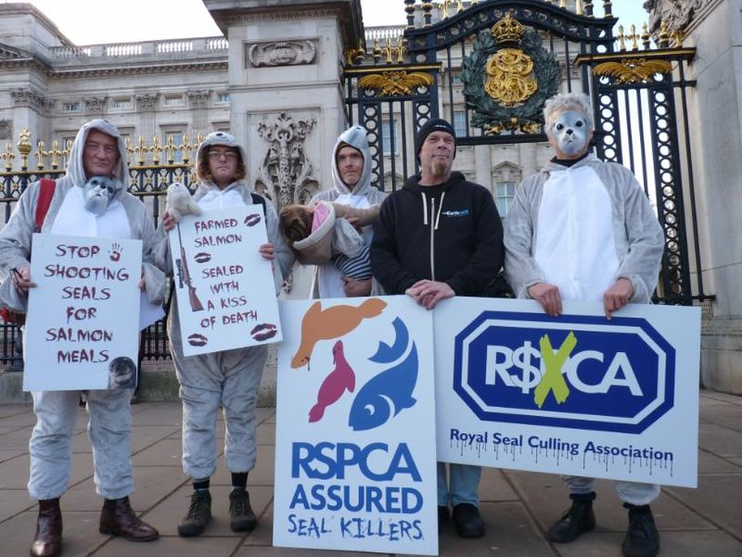
Read more via:
Herald: "RSPCA attacked for fresh support for Scots seal shooting to protect salmon"
Press Release: "RSPCA in firing line over Marine Harvest's seal-killing spree in Scotland - 118 seals killed by Marine Harvest's RSPCA Assured farms since 2011"
RSPCA Assured Seal Killers!

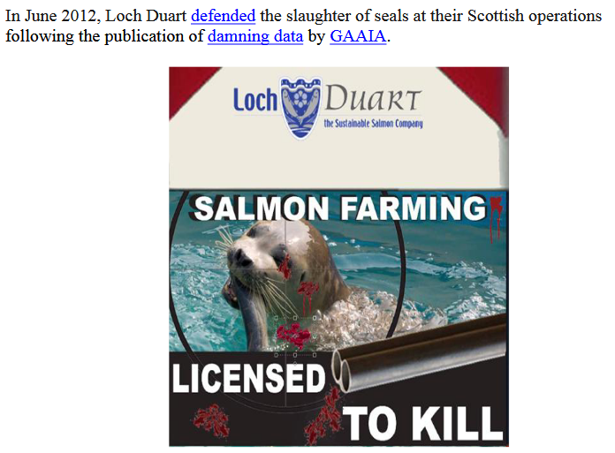

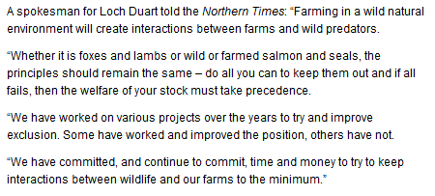

Given Loch Duart's lethal approach to seals it is surprising to see "beautiful" seals featured so prominently on their web-site and promoted in a video.

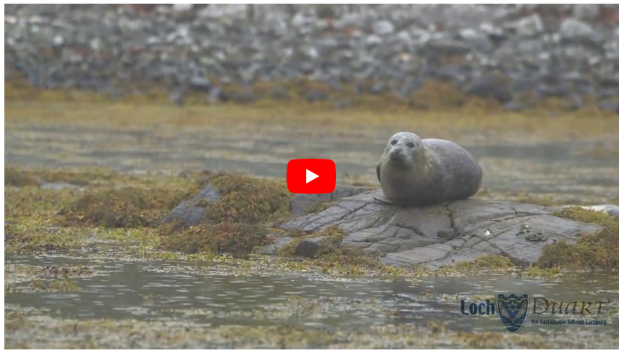

--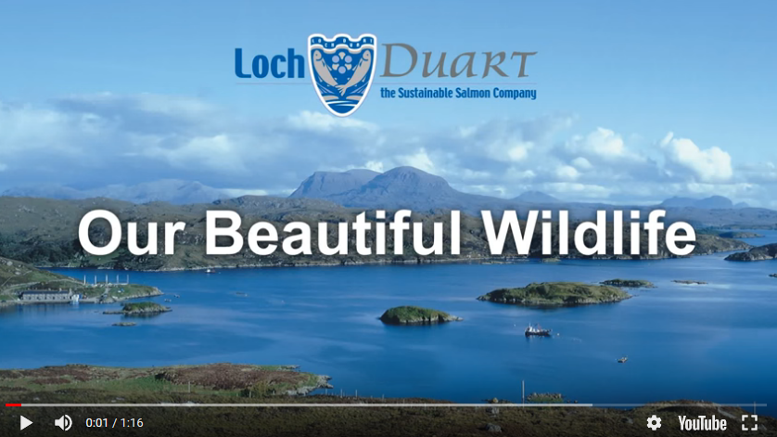

They say 'beauty is in the eye of the beholder' but a seal with a bullet in the head is not GAAIA's idea of beautiful.


Loch Duart - a member of the Scottish Salmon Producers Organisation along with Marine Harvest, Scottish Sea Farms, the Scottish Salmon Company, Wester Ross Salmon and Cooke Aquaculture - promotes itself as "sustainable", "natural" and having a "respect for the environment" yet a close examination of Loch Duart's environmental credentials makes for uncomfortable reading.

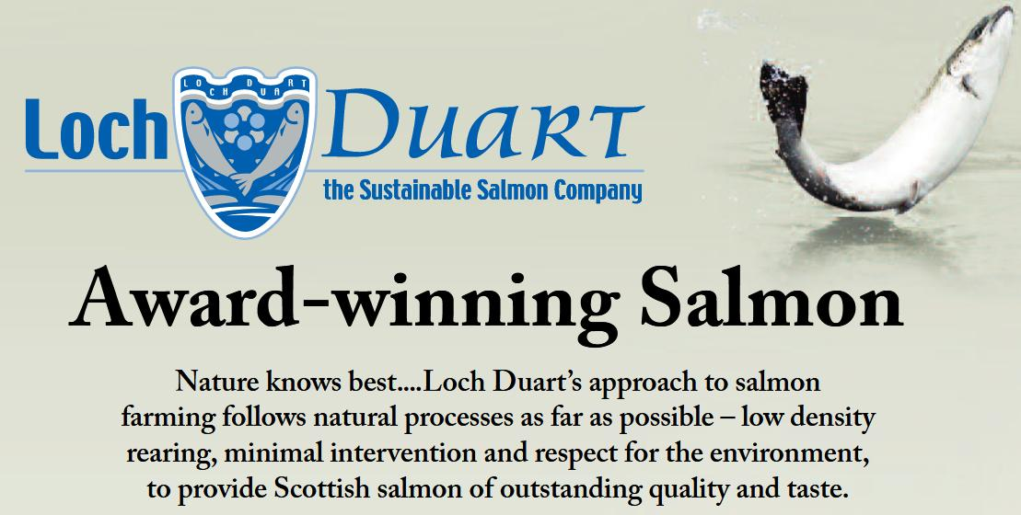

According to the Scottish Government's 'Scotland's Aquaculture' database, Loch Duart has used the toxic organophosphate Azamethiphos (shown by peer-reviewed scientific research to be lethal to lobsters) 187 times since 2003:

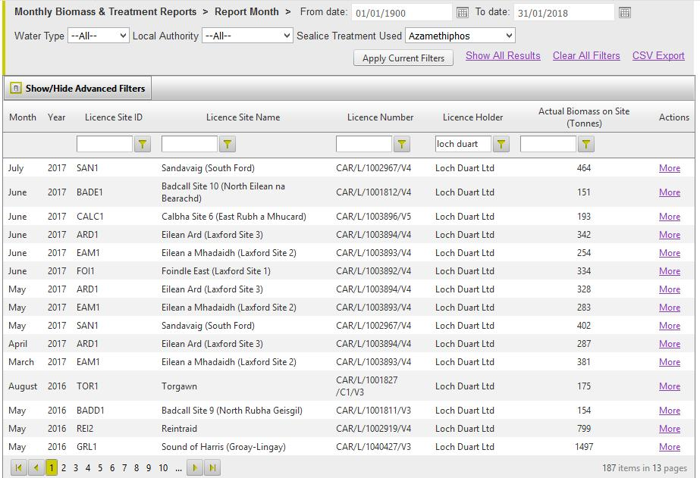

Loch Duart has used the toxic chemical Emamectin benzoate (shown by peer-reviewed scientific research to be lethal to lobsters) 252 times since 2002:

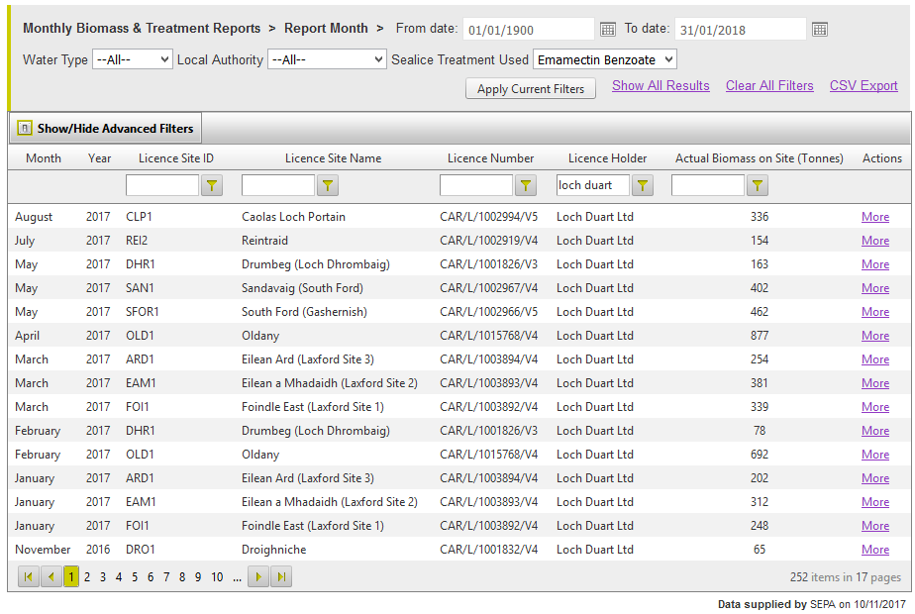

Loch Duart has used the toxic bath treatment Deltamethrin (shown by peer-reviewed scientific research to be toxic to shellfish) 223 times since 2008:

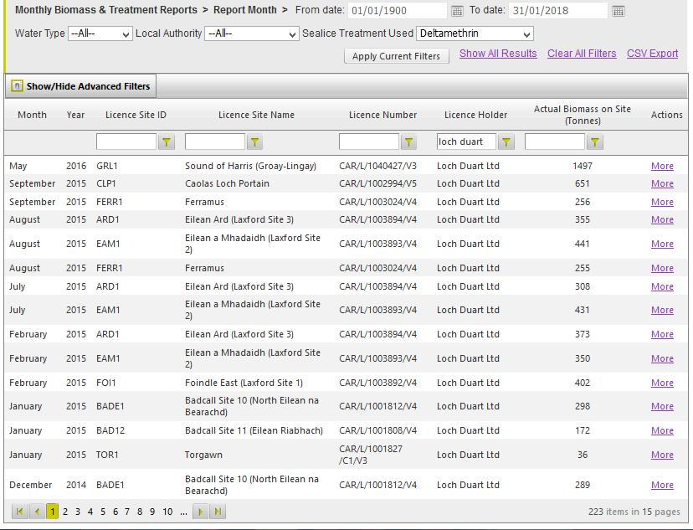

Loch Duart used the now banned toxic chemical Teflubenzuron (due to scientific studies showing it killed shellfish) 13 times since 2011:

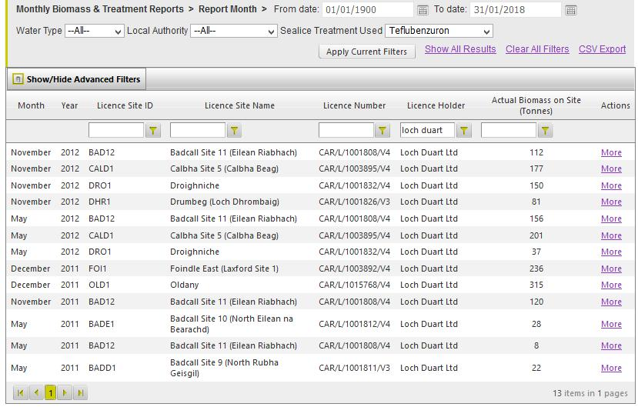

Loch Duart used the toxic bath treatment Cypermethrin (not used since 2010 due to chemical resistance problems) 235 times since 2002:

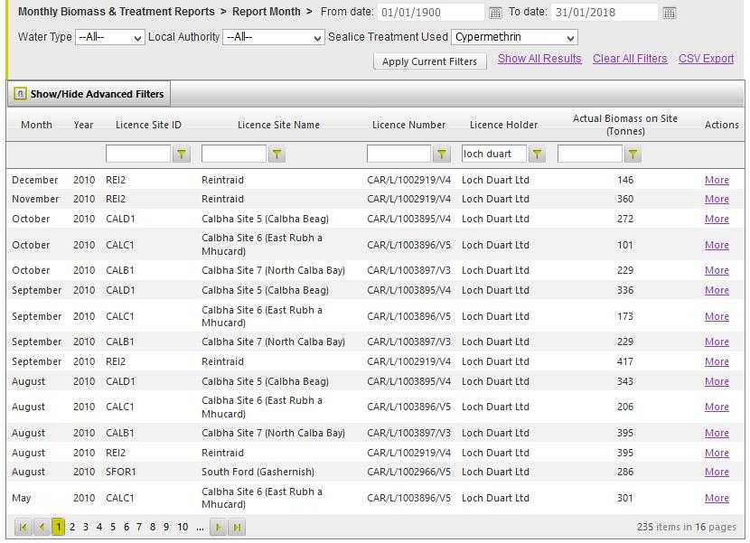

According to data disclosed by the Scottish Environment Protection Agency, Loch Duart was Scottish salmon farming's 4th biggest user of Deltamethrin, Cypermethrin & Teflubenzuron and 5th biggest user of Emamectin benzoate and Azamethiphos between 2002 and 2016 (behind other SSPO member producers):

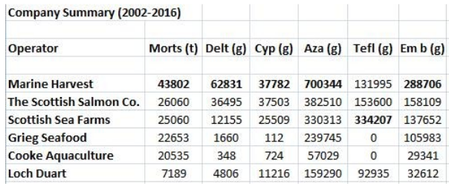

Despite their use of toxic chemicals (shown by peer-reviewed scientific research to be toxic to shellfish including damning research published last year by the Scottish Aquaculture Research Forum detailing lethal effects of Emamectin benzoate on lobsters), Loch Duart's web-site claims:

"Although Loch Duart has faced issues with sea lice in the past, we use no antibiotics nor harmful chemicals on our salmon"

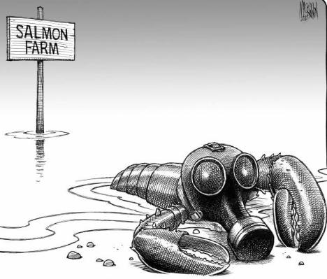

GAAIA visited Loch Duart's head office in Badcall Bay and was shocked to see so many chemical containers.

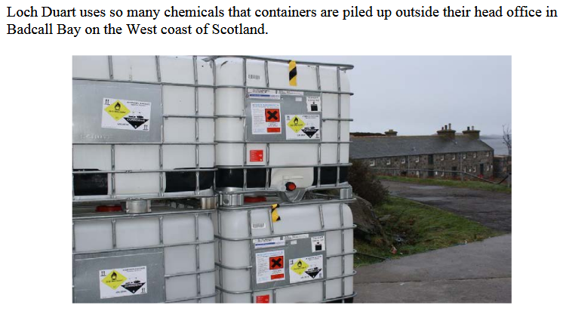

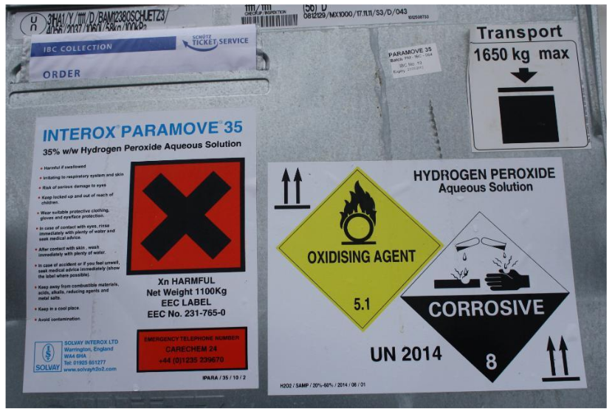
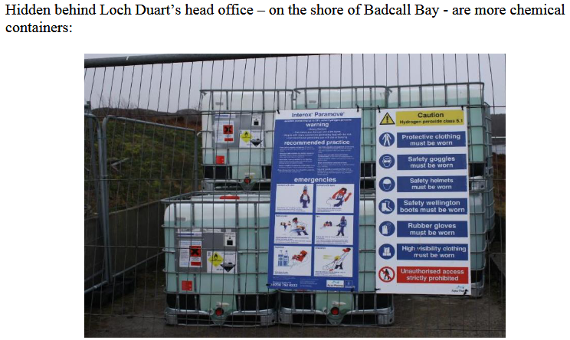

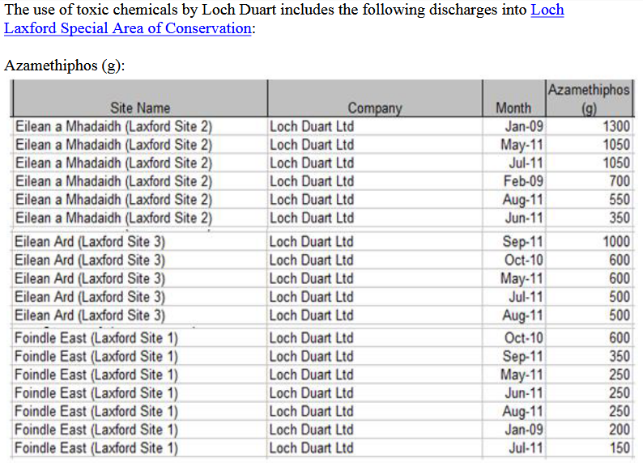

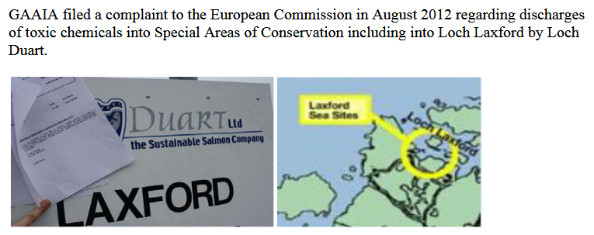

Loch Duart is bad news.

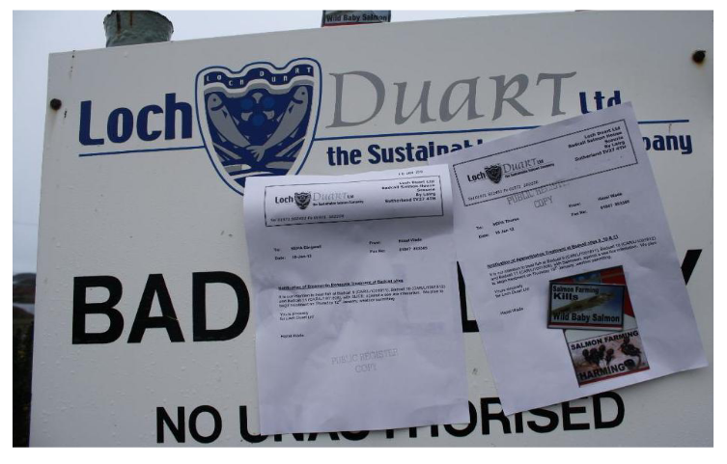
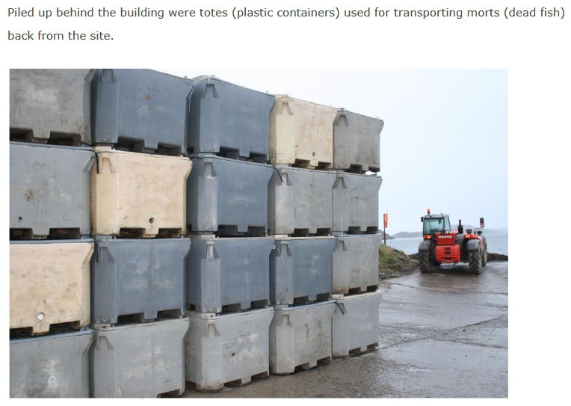
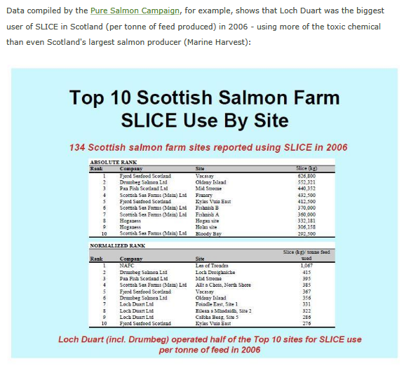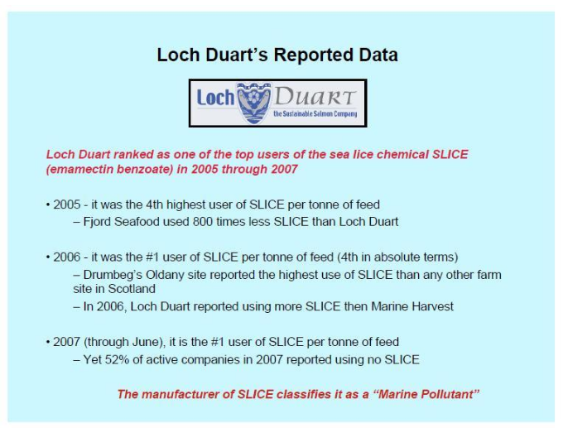
Read more via "Loch Duart's Sustainable Scam Exposed" and "Loch Duart - The Toxic Salmon Company"
Data on antibiotic use obtained via FOI from SEPA reveals that Loch Duart was the third biggest drug user out of all salmon farming companies operating in Scotland between 2002 and 2015:

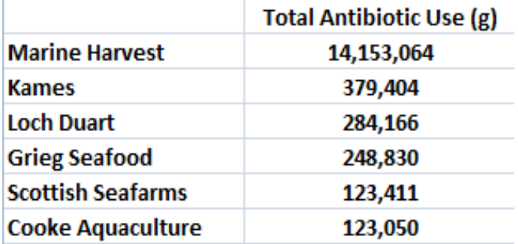

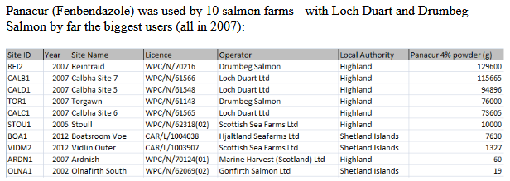

Read more via "Antibiotic-ridden Scottish Salmon: FOI reveals of Oxytetracycline, Florfenicol, Amoxycillin and Fenbendazole" and "Fish 'hooked on chemicals"

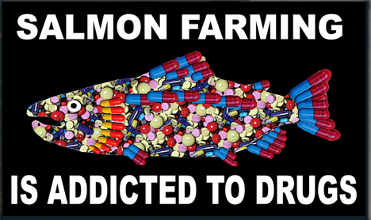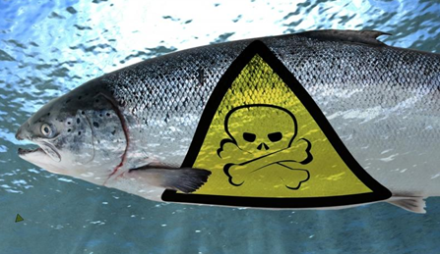

Loch Duart's rhetoric simply does not match the reality on the ground.

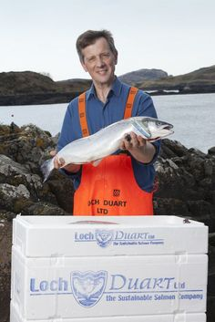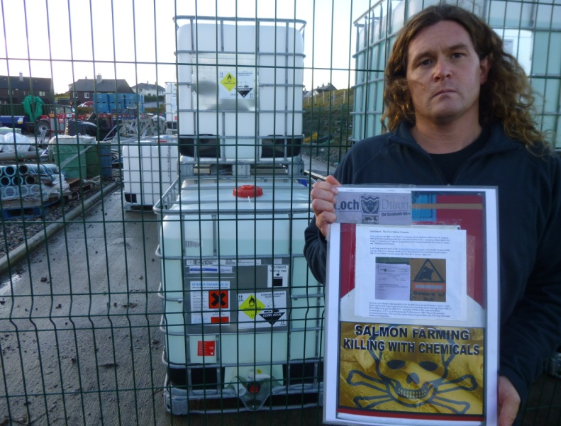

Loch Duart's shocking use of toxic chemicals is symptomatic of their problems due to infectious diseases including sea lice infestations. Lice infestation is a common denominator at all SSPO member producers - in fact 51 of the 62 salmon farms breaching sea lice limits between November 2016 and August 2017 were SSPO member producers (19 sites operated by The Scottish Salmon Company, 11 by Marine Harvest, 10 by Scottish Sea Farms, 7 by Cooke Aquaculture and 4 by Loch Duart).

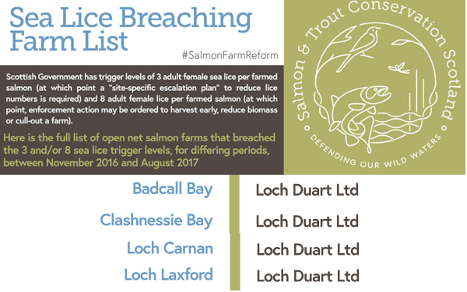

Read more via "Scottish salmon farming's 'liciest' farms named and shamed" and "Scotland's worst sea lice offenders - Full farm list"

Salmon & Trout Conservation reported in October 2017:

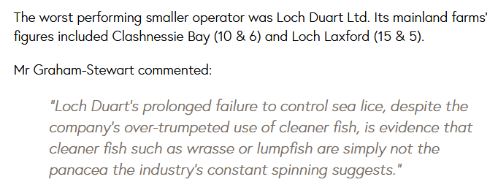

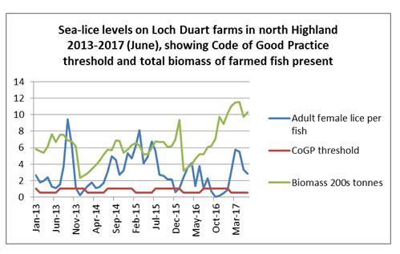

Loch Duart claims that "nature rules" but it seems that sea lice rule.

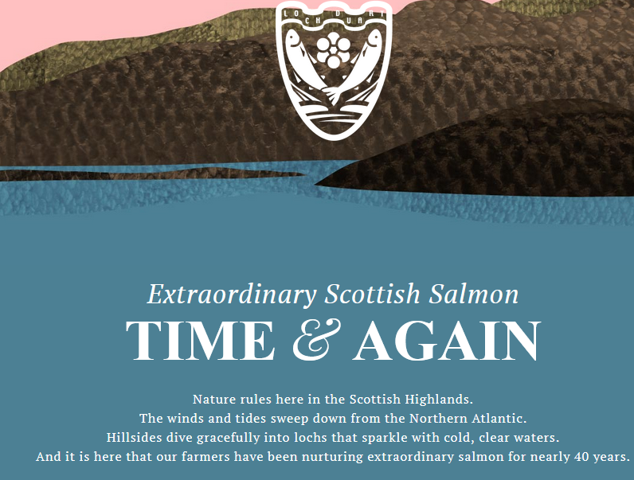

"At Loch Duart, we’re committed to rearing healthy salmon in a sustainable and environmentally friendly way," claimed Loch Duart in October 2017.

However, 'healthy' is no way to describe the conditions reported at various Loch Duart salmon farms.

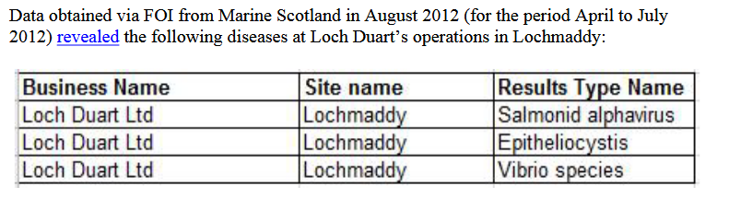
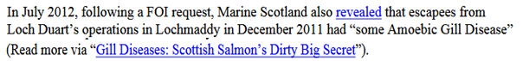

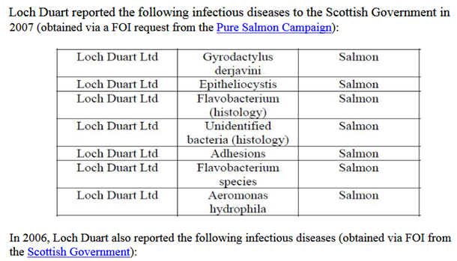

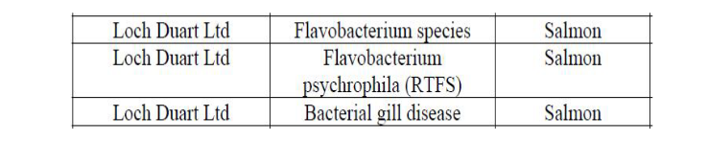

Read more via "Fit for the Queen - Loch Duart’s Chlamydia-Contaminated Salmon?"

Watch a video report online here

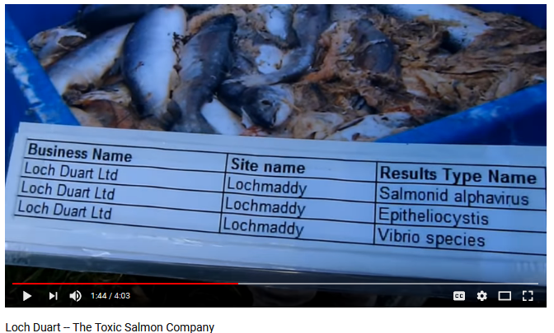
Faced with a mountain of evidence, there's no escaping the proposition that Loch Duart's claims of 'sustainability' and 'environmental friendly' farming are a load of bull (if you visit Loch Duart you will even see road signs near their farms warning you to 'Beware of Bull').

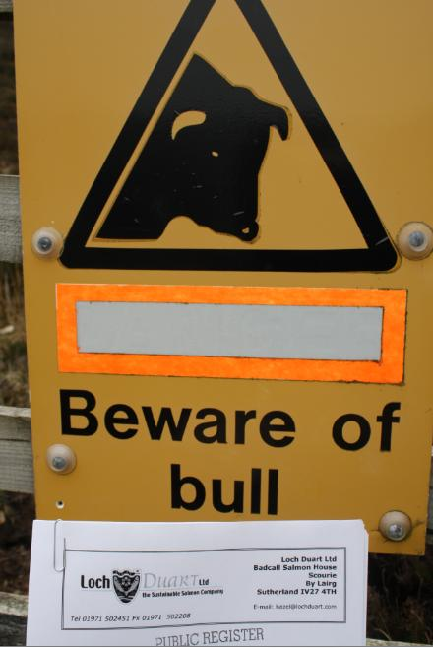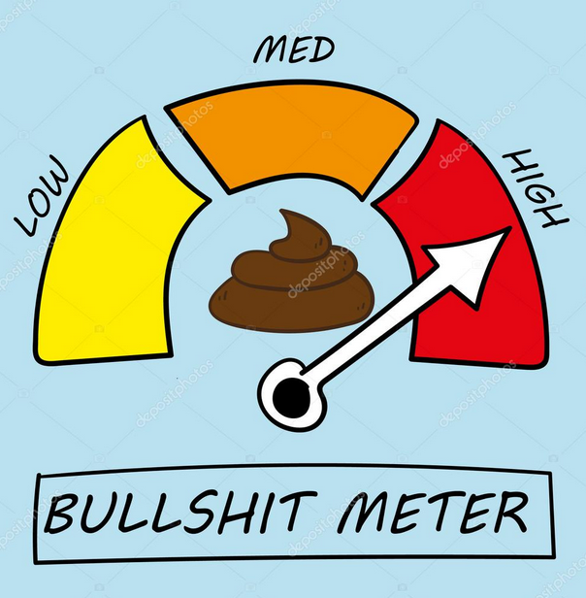

On the escapes front too, Loch Duart's track record is appalling with 14 escape incidents since 2000 totalling over 80,000 fish (according to the Scottish Government's 'Scotland's Aquaculture' database):

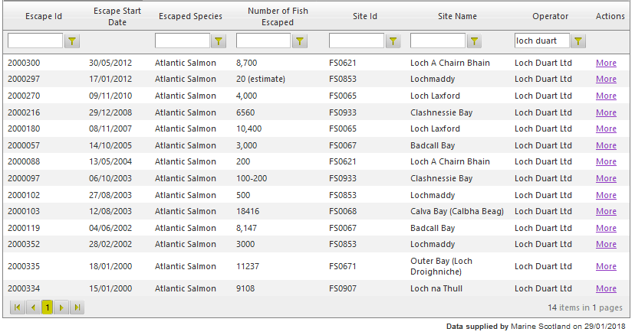

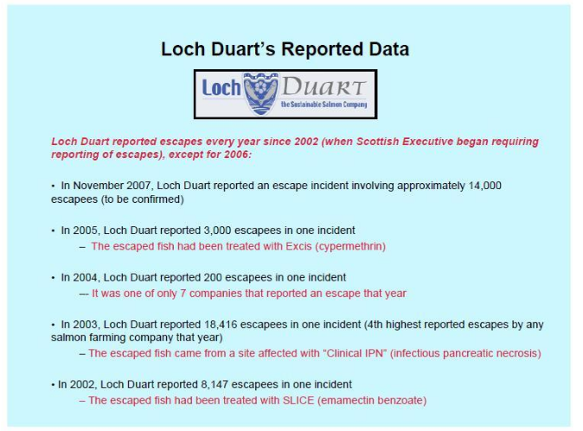

Is Loch Duart farmed salmon really fit for a King or Queen (Loch Duart farmed salmon was served at the Royal wedding of Prince William & Kate Middleton in 2011 and also at the Queen's Diamond Jubilee in 2012)?

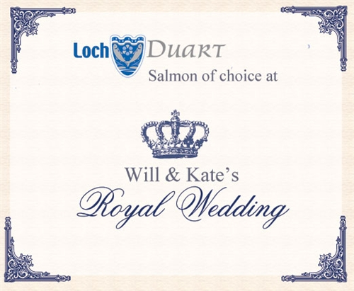

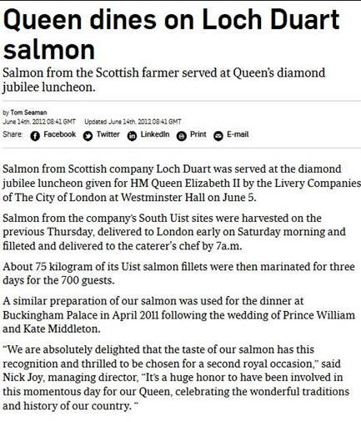

Should Prince Harry & Megan Markle dine on Loch Duart's disease-ridden farmed salmon at their wedding in May? GAAIA thinks not, especially since Prince Harry is known to share his brother's and Dad's "passion for environmental issues".

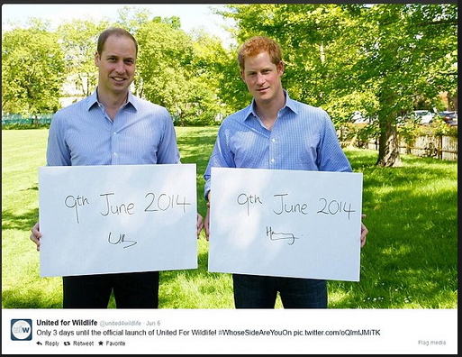

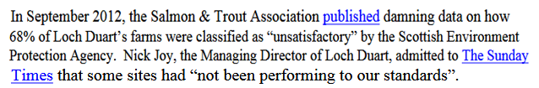

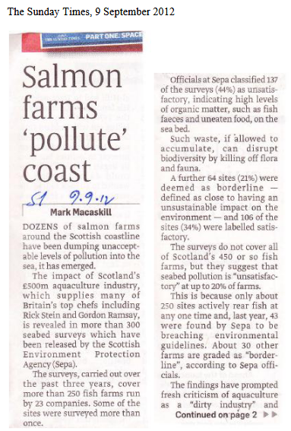
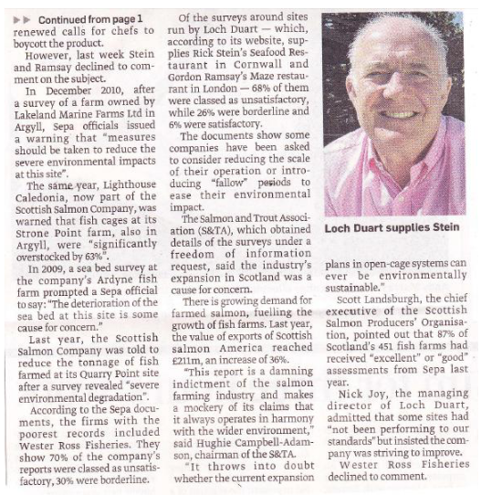

In 2010, Loch Duart refused the Scottish Government's request to publish audits claiming that "inaccurate critical reports could destroy a company or business".

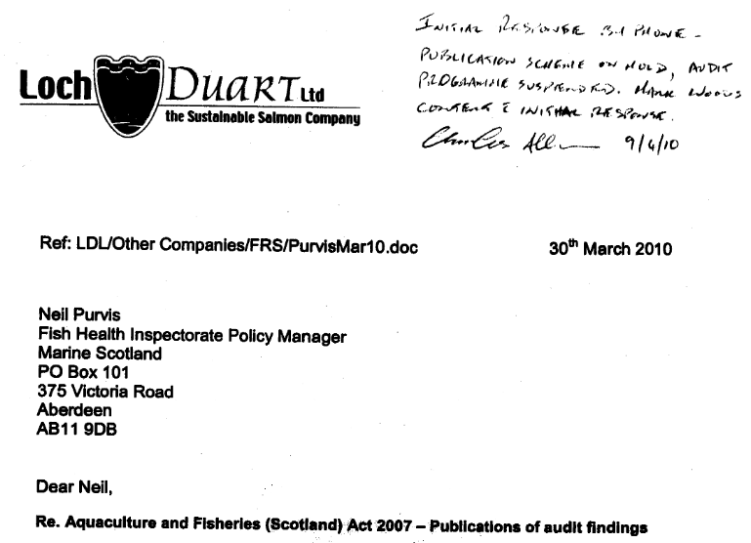
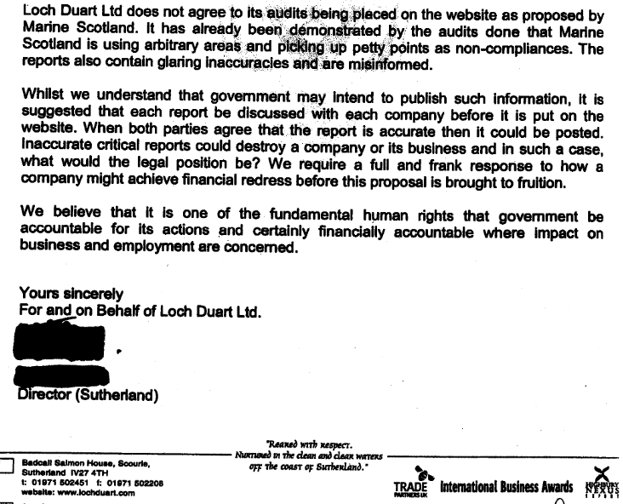
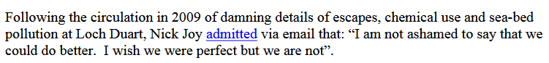

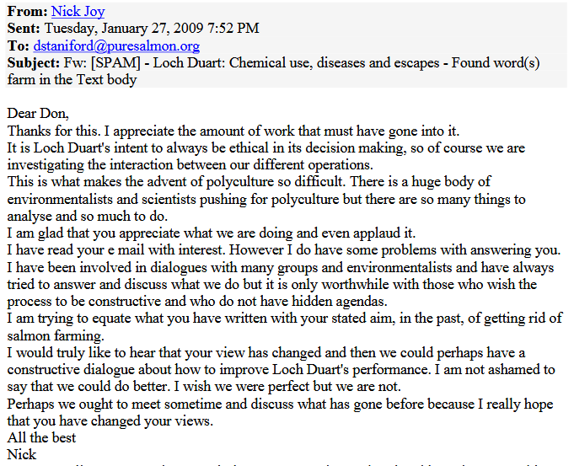

GAAIA's views remain the same - Loch Duart is a sham, scam and a consumer con.

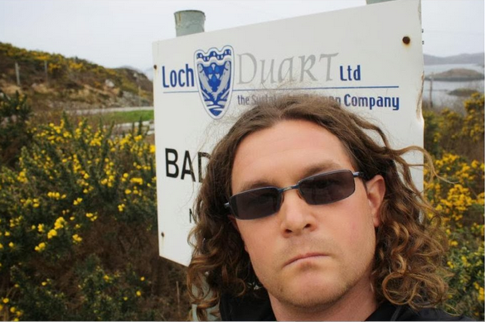
Here's a press statement from GAAIA in 2012.

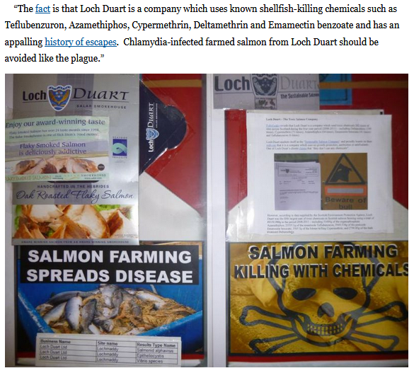

Megan Markle is well known to be a foodie and loves seafood (according to her Instagram posts) so hopefully she will know to avoid Loch Duart salmon.

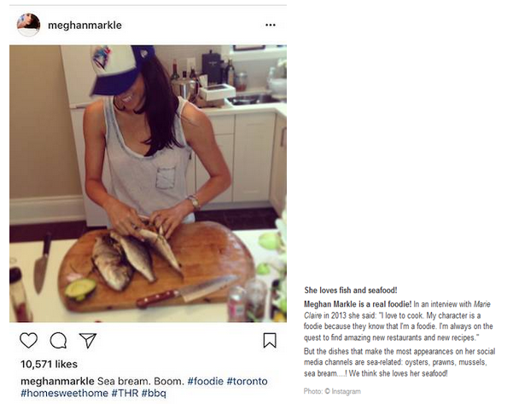

If Megan & Harry are tempted to serve Scottish salmon to their wedding guests (read "25 Reasons to Boycott Scottish Salmon" as an antidote) they would do well to avoid Loch Duart's salmon served with lashings of listeria (especially if anyone is pregnant) and a mouthful of chlamydia (especially if anyone wants to get pregnant)?

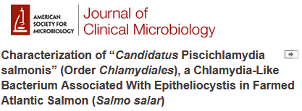

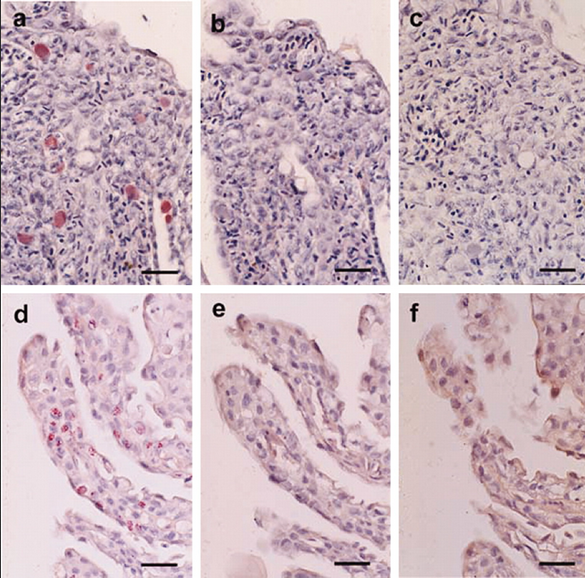

The Sunday Times reported in 2013:
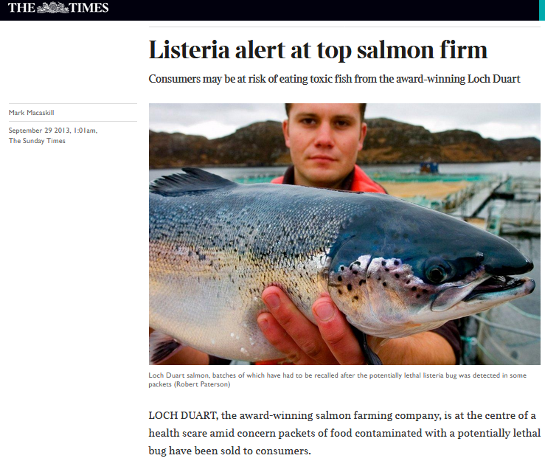
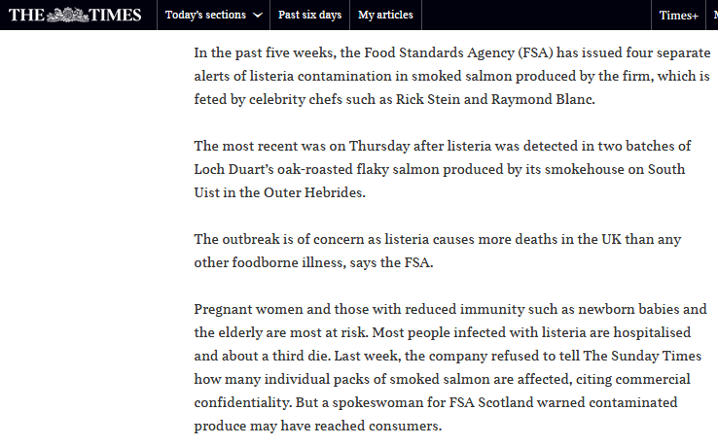

The Food Standards Agency reported:
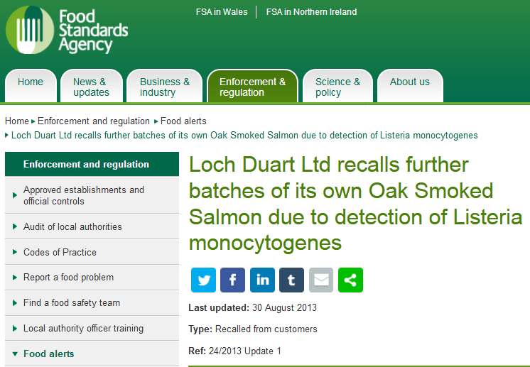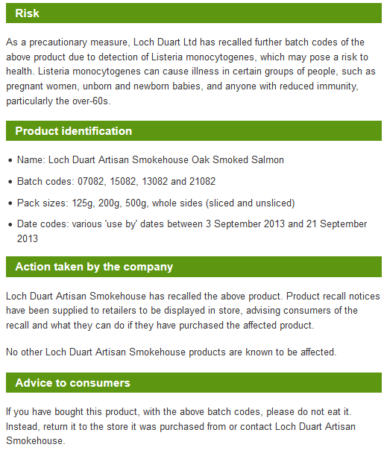
Read more via "Listeria Contamination in Farmed Salmon"
If I were Raymond Blanc I wouldn't be laughing at being used to promote Loch Duart farmed salmon (at least Gordon Ramsay looks grumpy).

Read more via "Salmon Slap for Kate in Canada" and "Fit for the Queen - Loch Duart’s Chlamydia-Contaminated Salmon?"

Loch Duart's salmon is enough to make your flesh creep.

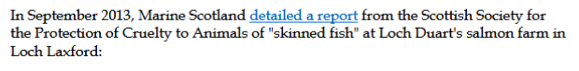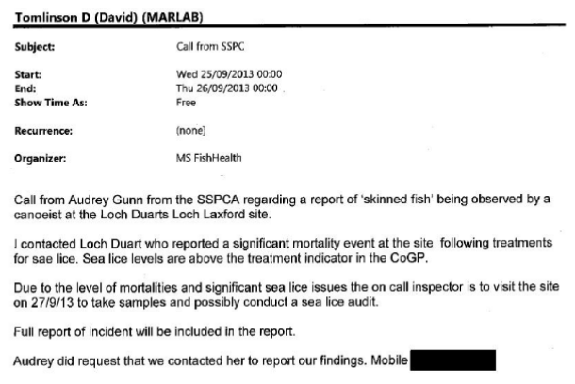

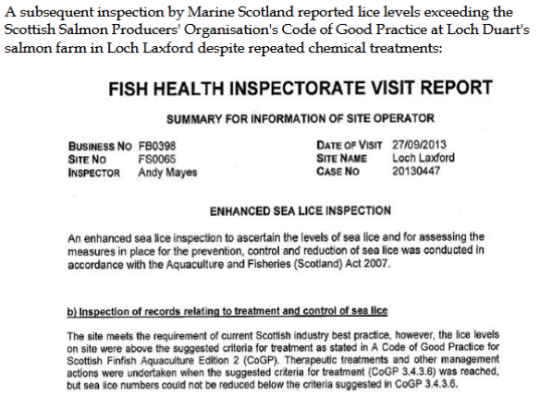

Better stick to Welsh cakes not Scottish salmon hey Megan?

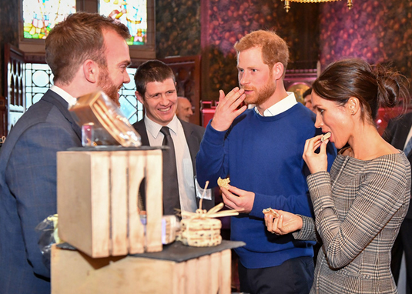

Harry may be better off picking his nose than eating Scottish salmon.

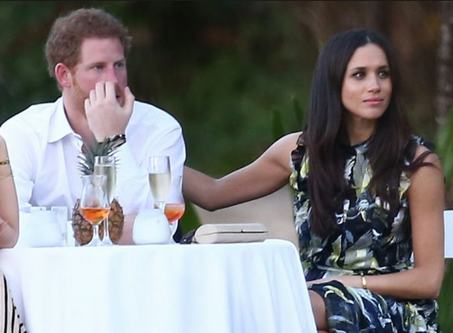

Loch Duart - a member of the Scottish Salmon Producers Organisation - is certainly in bad company.
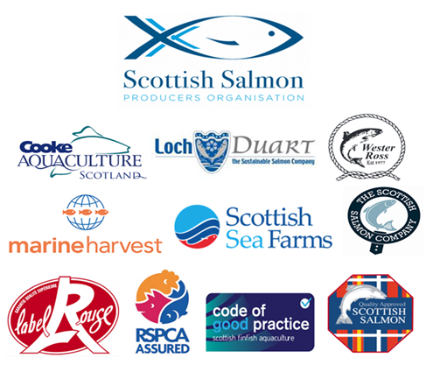

Read more via "The Scottish Salmon Polluters Organisation".

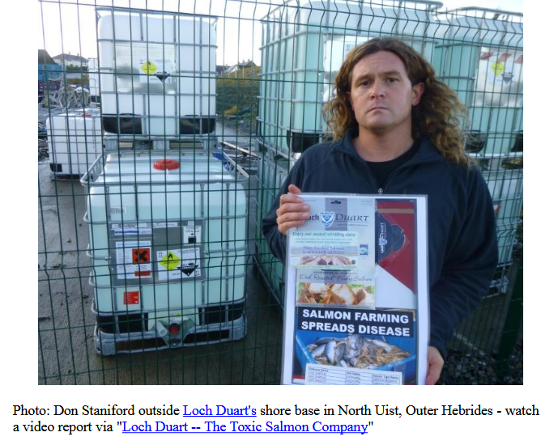

Don Staniford, February 2018

