Complaint to the European Commission

- Breaches of the Animal By-Products Regulations by the United Kingdom

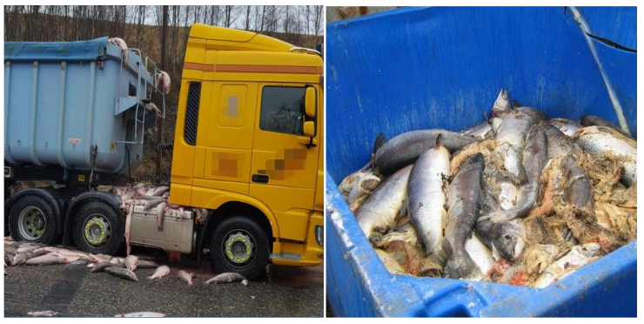
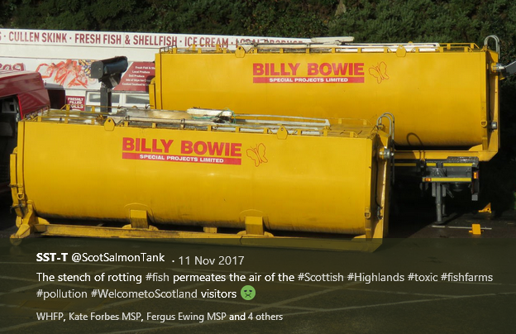
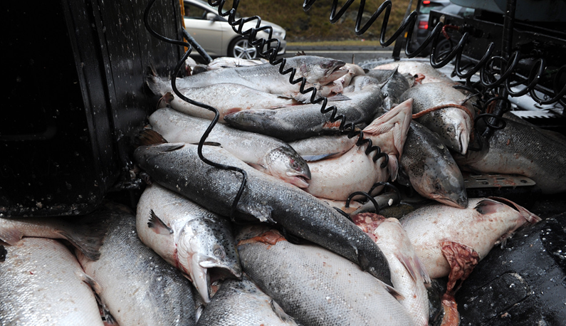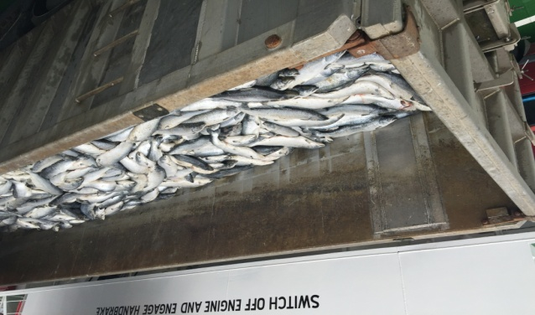

Complaint filed by Don Staniford,
Director of the Global Alliance Against Industrial Aquaculture (GAAIA)

+44 7771 541826
dstaniford@gaaia.org
http://www.gaaia.org
http://donstaniford.typepad.com/my-blog

28 January 2018
Executive Summary:

The United Kingdom has failed to properly implement and enforce Regulation (EC) No 1069/2009 concerning the transport of infectious wastes from Scotland's salmon farming industry; namely via The Animal By-Products (Enforcement) (Scotland) Regulations 2013 and The Animal By-Products (Enforcement) (England) Regulations 2013.

"Guidance for the animal by-products industry" published by the Department for Environment, Food & Rural Affairs and Animal and Plant Health Agency in September 2014 included "Transporting animal by-products" which specified under 'Vehicle Hygiene & Storage': "When you’re transporting animal by-products (ABPs) or any ABP derived products, you must make sure you: use vehicles and containers that are covered and leak-proof".

However, evidence on the ground points to the guidance and the regulations being ignored. GAAIA argues that haulage trucks transporting diseased farmed salmon via 'The Dead Salmon Run' to sites across Scotland and in Northern England are routinely leaking wastes including fluids (and even whole salmon spilled onto the road).

Poor enforcement by the competent authority (local authorities in Scotland and England) has abjectly failed to stem the rising tide of leaking wastes from the disease-ridden salmon farming. The mortality rate at Scottish salmon farms is a staggering 26.7% with an estimated 20 million farmed salmon (over 20,000 tonnes) dying each year.

Information collated by GAAIA details systemic breaches of Regulation (EC) No 1069/20 including footage of leaking farmed salmon wastes from a haulage truck operated by Billy Bowie broadcast by the BBC's 'The One Show' on 11 December 2017. Photographic evidence was assembled via other sources including The Salmon Think Tank, The Courier, ITV News; The Evening Telegraph, BBC News, The Courier & Advertiser and The Daily Telegraph.

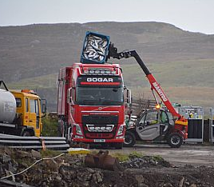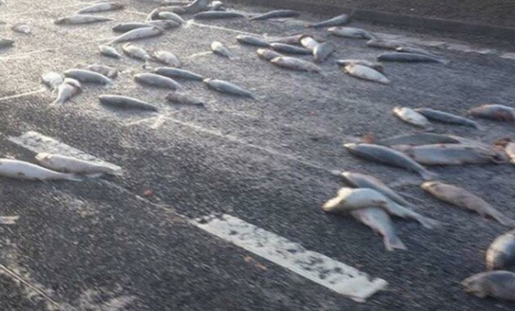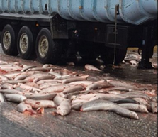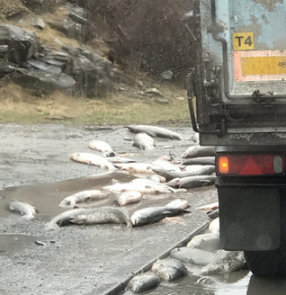
Previous Complaint by Save Seil Sound:

This complaint builds on the "COMPLAINT BY THE SAVE SEIL SOUND CAMPAIGN GROUP TO THE COMMISSION OF THE EUROPEAN COMMUNITIES CONCERNING FAILURE OF THE UNITED KINGDOM TO COMPLY WITH COMMUNITY LAW IN RELATION TO THE SAFE DISPOSAL OF CATEGORY TWO WASTE IN ARGYLL" filed in 2013.

The EC Complaint threatened to cost the Scottish salmon farming industry an infraction fine of €9,666,000 and "possible daily substantial fines of thousands of pounds for continued non-compliance" and forced the Scottish Government to introduce new rules on mort disposal in 2016.

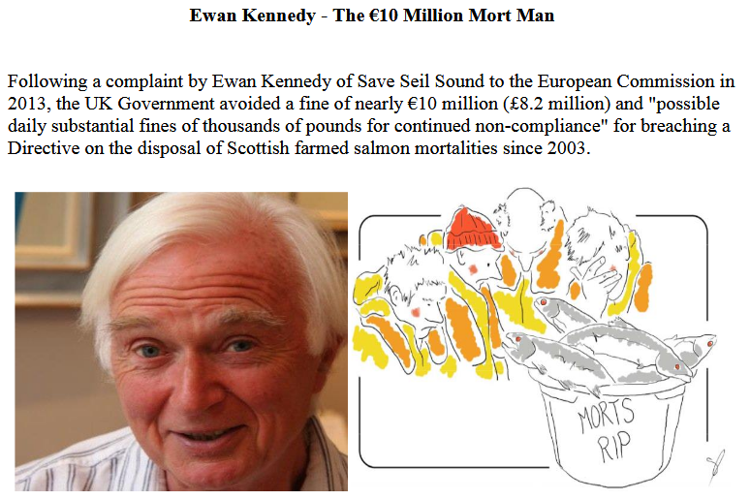

In 2015, the EC complaint prompted the Scottish Government to consult on a change of policy to avoid "large fines". The Scottish Salmon Producers Organisation issued 'General Guidance on the Disposal of Fish' in August 2015.

In January 2016, the Scottish introduced new 'Guidance on the Disposal of Aquaculture Animal By-Products' and published the new report: "Zero Waste Report - Finfish Mortalities in Scotland".

Save Seil Sound's complaint, according to The Sunday Herald in 2016, "forced the Scottish Government to rewrite the rules" and "close the loophile and oblige fish farm companies to dispose of dead fish in safer ways".

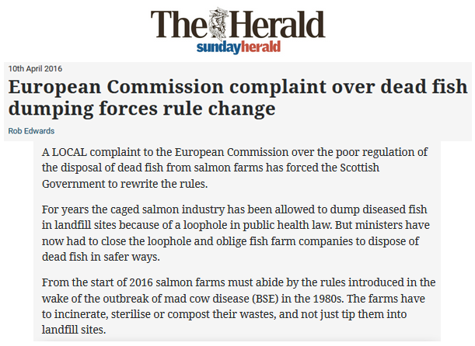

Read more via:
"Media Backgrounder: Mort Disposal of Scottish Farmed Salmon" (May 2017)
"FOI Backgrounder: FOI Replies & FOI Requests Re. Mort Disposal (Scottish Government, European Commission, Scottish Environment Protection Agency & Local Authorities)" (April 2017)

Legislative Background:

Please consider this a formal complaint against the United Kingdom for failure to implement and enforce REGULATION (EC) No 1069/2009 OF THE EUROPEAN PARLIAMENT AND OF THE COUNCIL of 21 October 2009 laying down health rules as regards animal by-products and derived products not intended for human consumption and repealing Regulation (EC) No 1774/2002 (Animal by-products Regulation).

According to the Scottish Government, the EU Regulations were implemented by The Animal By-Products (Enforcement) (Scotland) Regulations 2013 and the Animal By-Products (Miscellaneous Amendments) (Scotland) Regulations 2015. In England, the EU Regulations were implemented via The Animal By-Products (Enforcement) (England) Regulations 2013.

"Guidance for the animal by-products industry" published by the Department for Environment, Food & Rural Affairs and Animal and Plant Health Agency in September 2014 (updated in October 2016) includes guidance on "Transporting animal by-products" which specified under 'Vehicle Hygiene & Storage': "When you’re transporting animal by-products (ABPs) or any ABP derived products, you must make sure you: use vehicles and containers that are covered and leak-proof":

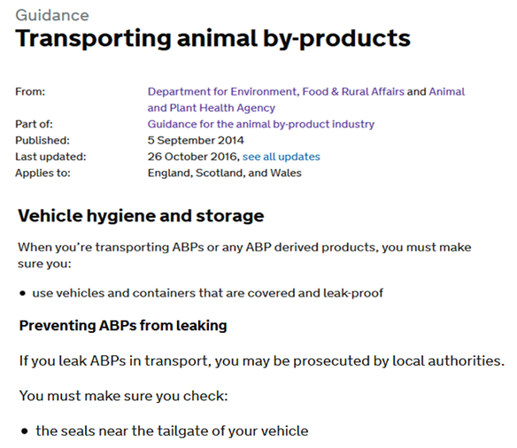

In December 2017, the First Minister of Scotland was questioned in the Scottish Parliament on leaking wastes from dead farmed salmon.
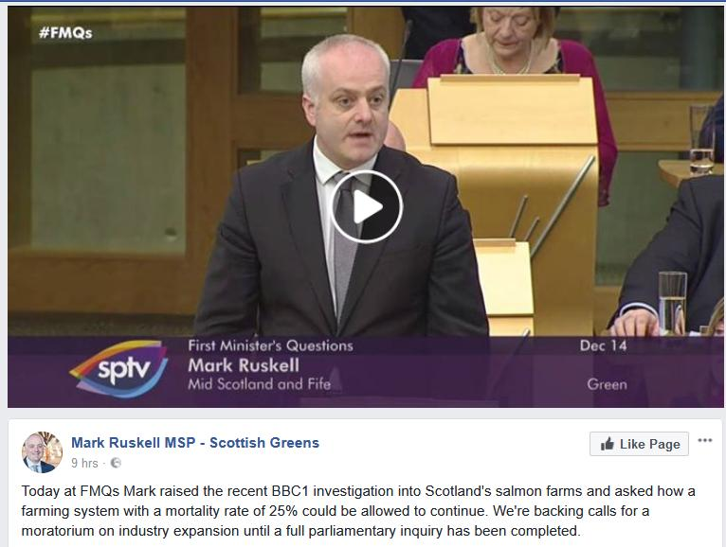
Here's a letter from Mark Ruskell MSP to the Cabinet Secretary dated 13 December 2017:
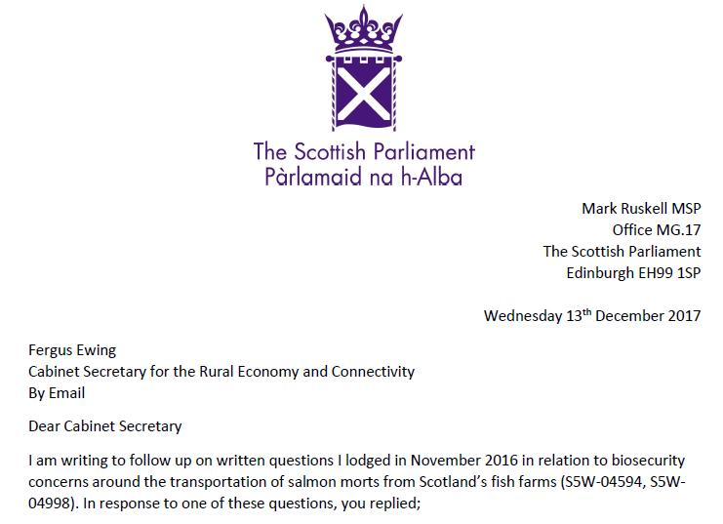
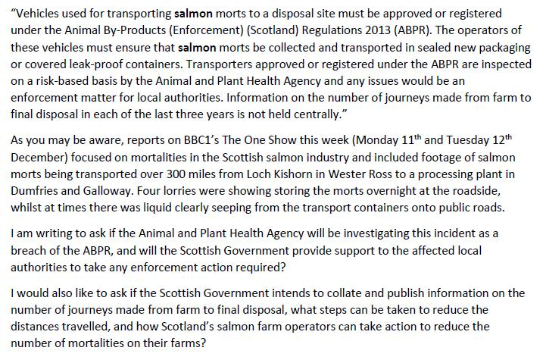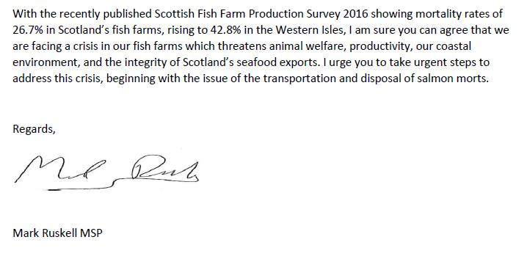
Download letter as a PDF online here
Here's the reply dated 10 January 2018 from Fergus Ewing:

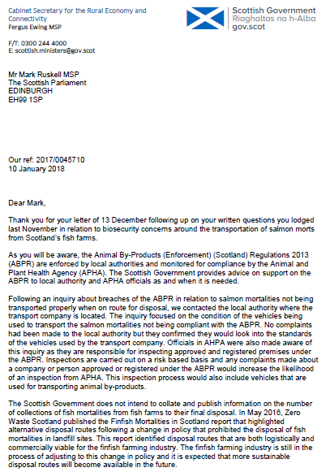

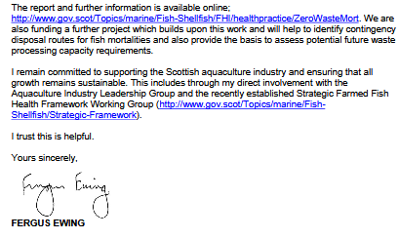

Here's a letter to GAAIA from the Scottish Government dated 17 January 2018:

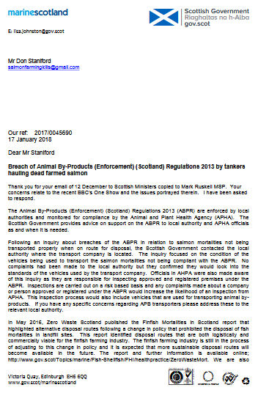

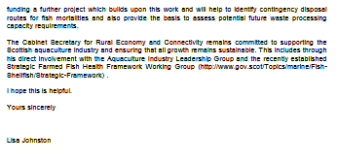
Download as a PDF online here

Here's a letter to GAAIA from the Scottish Government dated 15 January 2018:
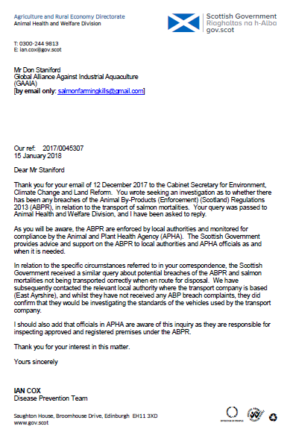

Download as a PDF online here
In November 2016, a Parliamentary Question filed by Mark Ruskell MSP asked "where and by whom containers of diseased salmon morts are checked for biosecurity compliance during their journey from farm to final disposal, and how many such journeys have taken place in each of the last three years".

"Vehicles used for transporting salmon morts to a disposal site must be approved or registered under the Animal By-Products (Enforcement) (Scotland) Regulations 2013 (ABPR)," replied Fergus Ewing, Cabinet Secretary for the Rural Economy and Connectivity, in December 2016. "The operators of these vehicles must ensure that salmon morts be collected and transported in sealed new packaging or covered leak-proof containers."

Another Parliamentary Question and reply in November 2016 also stressed when transporting Animal By-Products transporters must ensure that they "use vehicles and containers that are covered and leak-proof".
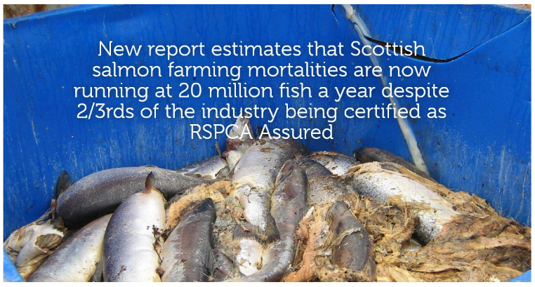

Evidence of Breaches of the Animal By-Products Regulations:

GAAIA's complaint stems from footage of leaking farmed salmon wastes from a haulage truck operated by Billy Bowie broadcast by the BBC's 'The One Show' on 11 December 2017.

"OK, the tanker and the first skipper-lorry have just left the salmon farm and they're both full of salmon," said BBC reporter Joe Crowley as he is driving behind the Billy Bowie tankers/trucks. In fact, I can see some horrible fluid coming out of the back of one of them and it smells vile"



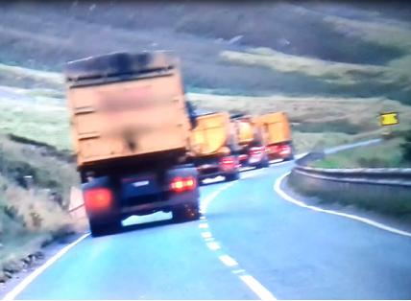

Further photographic evidence is available via other sources including The Salmon Think Tank, The Courier, ITV News; The Evening Telegraph, BBC News, The Courier & Advertiser and The Daily Telegraph:

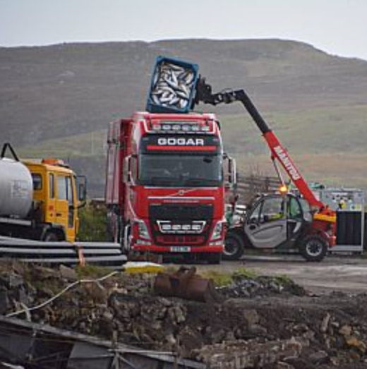
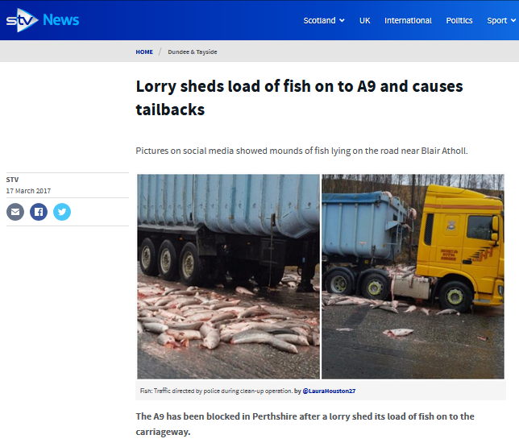
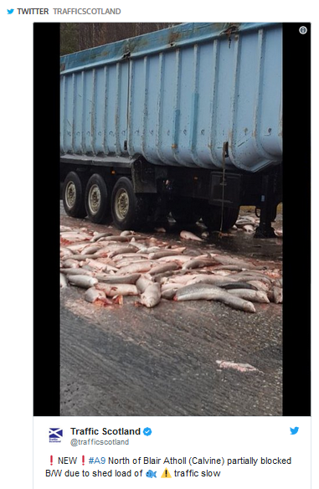

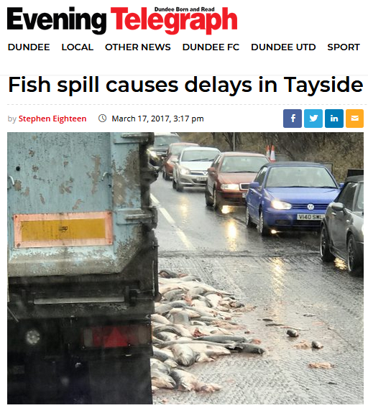

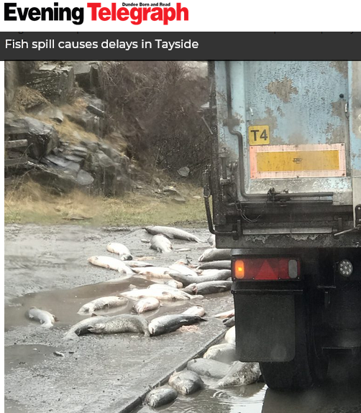

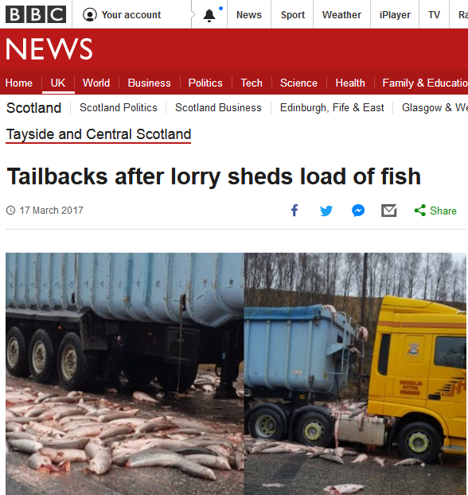

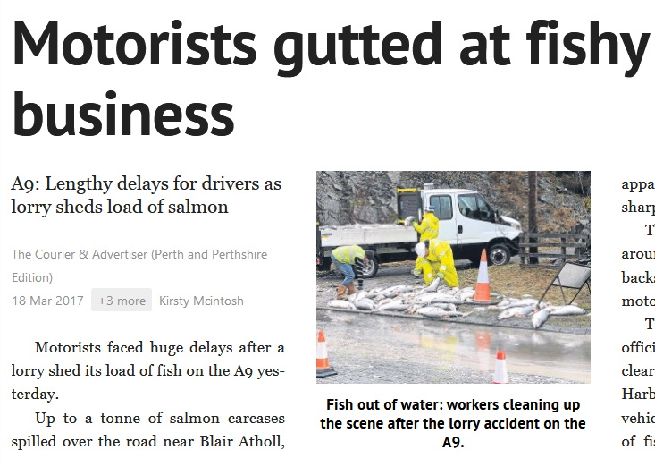
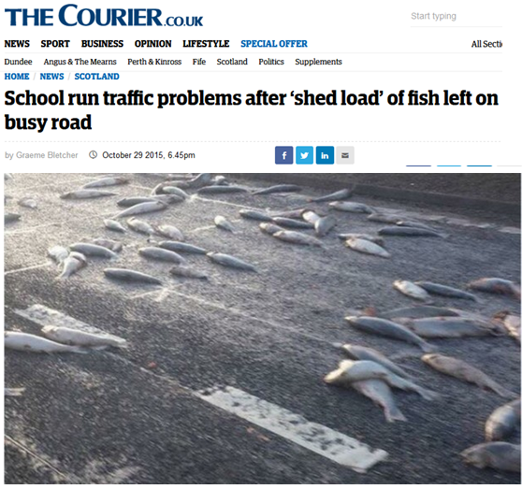
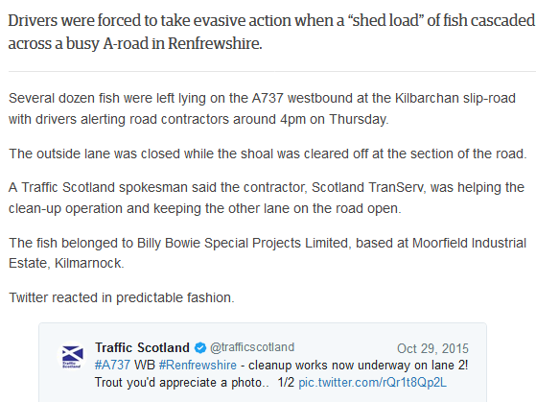

Read more via "Press Release: Diseased Salmon Slip Net & Spill on Road - Local Authorities failing to police transport of morts" (28 January 2018)
Non-Enforcement by Local Authorities:

Freedom of Information requested were filed by GAAIA with local authorities in Scotland December 2017 (Shetland Isles Council, Orkney Islands Council, Comhairle nan Eilean Siar, Highland Council, Argyll & Bute Council and Dumfries & Galloway Council ) and other local authorities in Scotland and England in January 2018 (East Ayrshire, Inverclyde, Scottish Borders, West Dunbartonshire, West Lothian, North Lanarkshire, South Lanarkshire, Falkirk, East Dunbartonshire, Clackmannanshire, South Ayrshire, Fife, Midlothian, Stirling, Perth & Kinross, East Renfrewshire and Renfrewshire in Scotland as well as Cumbria and Lancashire).

Replies thus far reveal that local authorities are not enforcing Regulation (EC) No 1069/2009 and not even monitoring let alone investigating leakage from haulage trucks transporting farmed salmon morts (other than East Ayrshire which according to the Scottish Government is now "investigating the standards of the vehicles used by the transport company" - i.e. Billy Bowie, whose head office is located in Kilmarnock, East Ayrshire).

"We don’t have the resources to carry out any monitoring or surveillance of these activities, we didn’t carry out any investigations into these activities in 2017," replied Argyll & Bute Council on 11 January 2018 to GAAIA's FOI request of 12 December 2017.

"Shetland Islands Council has not had to issue any warning letters, complete any investigations, surveillance or monitoring in regard to the transport and disposal of salmon farm mortalities," replied Shetland Isles Council on 20 December 2017.

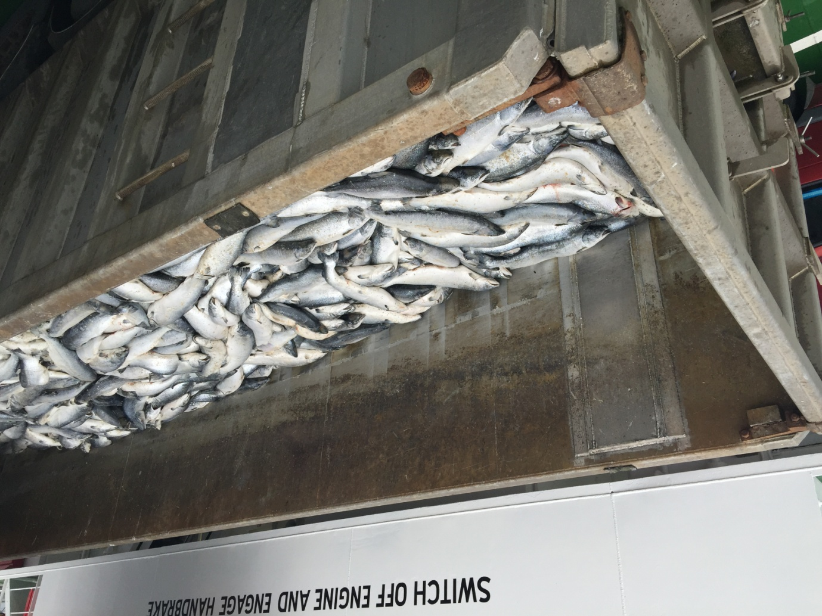
Photo: A truckload of dead salmon on the ferry 'Leirna' from Lerwick to the fishmeal factory in Bressay on 18th August 2015 (download high res image online here)

"Orkney Islands Council holds no information on the transport and disposal of salmon farm mortalities, nor have we received any allegations or complaints alleging any breaches of The Animal By-Products (Enforcement) (Scotland) Regulations 2013 and The Animal By-Products (Enforcement) (England) Regulations 2013 with respect to our premises," replied Orkney Islands Council on 11 January 2018.

Other local authorities have either not replied or did not possess any information even though local authorities are charged by law with enforcing the legislation.

"APHA do not inspect or monitor the transport of salmon farm mortalities," said a FOI reply from the Animal & Plant Health Agency dated 9 January 2018. "The enforcement of the regulations is the responsibility of Local Authorities under the Animal By-Products (Enforcement) (England) Regulations 2013 and of the Scottish Government under The Animal By-Products (Enforcement) (Scotland) Regulations 2013".

"Police Scotland has no protocols with any local authority or operating company regarding the disposal of wastes from fish farms," said a FOI reply from Police Scotland dated 10 January 2018.

Further FOI replies are expected next month.

Read FOI replies from local authorities in full via Appendix 1.

Data on Mortalities on Scottish Salmon Farms:

The mortality rate at Scottish salmon farms is a staggering 26.7% with an estimated 20 million farmed salmon dying each year (although official data on numbers of dead farmed salmon has not been officially collected since 2013 when the Scottish Environment Protection Agency bowed to pressure from the Scottish Salmon Producers Organisation to keep the number of dead salmon secret claiming it "could be used to the commercial detriment or competitive market disadvantage of the companies submitting the data).

The latest statistics published by the Scottish Government in September 2017 reveal a mortality rate of 26.7% for 2014 (2015 figures will not be published until September 2018). Mortality rates in some regions is even higher - with salmon farms in the Western Isles reporting 42.8% and Shetland reporting 31.9% mortality for 2016 (read more via Scottish Fish Farm Production Survey 2016 - see Tables 28 & 30).

Monthly data on mortalities (by weight only) are published online via the Scotland's Aquaculture web-site. Data on the number of mortalities was available from SEPA until 2013 when it bowed to pressure from the Scottish Salmon Producers Organisation to keep the number of dead salmon secret due to its commercially damaging nature.

Official figures published by The Sunday Herald in 2013 revealed that 8.5 farmed salmon died in 2012 compared to 5.5 million in 2010. The Sunday Herald reported in October 2017 that there have been successive, significant increases in 2014, 2015 and 2016. "Critics estimate the total number of dead, discarded salmon last year to have been between 10m and 20m," reported Rob Edwards. "But the industry says it sustained losses of “between 6 and 10 million fish, depending on their size”.

Here's a table of mortality rates (and estimated number of morts) since 2002 using the data published via Scottish Fish Farm Production Survey 2016:

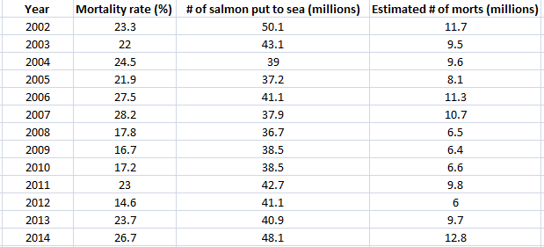

Download Excel spreadsheet online here

Here's Scottish Parliament Written Answer in January 2018:

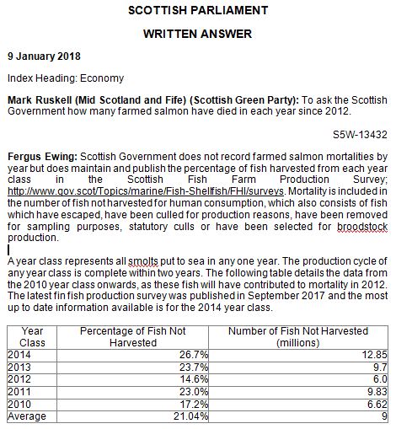
Data on mortalities was made available by SEPA via FOI for the period 2002 to 2016 (up to September):

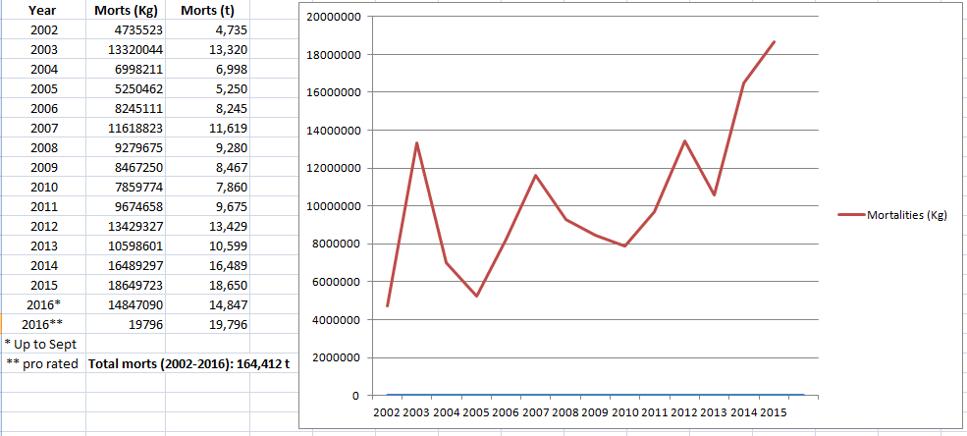

The twenty worst salmon farms in terms of mortalities for the period 2002 to September 2016 were:

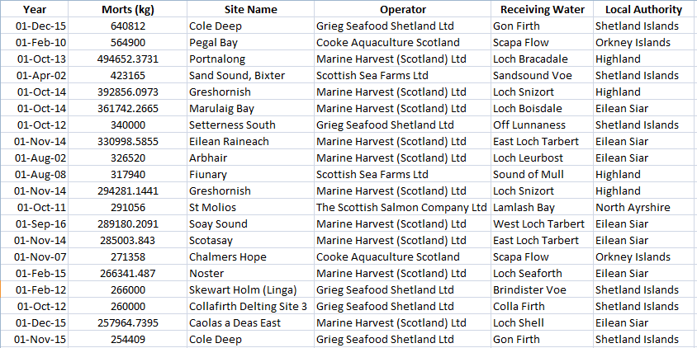

In November 2017, the Scottish Salmon Think Tank Tweeted:
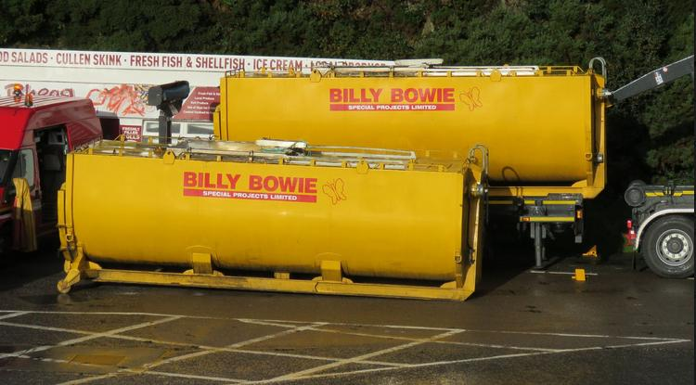
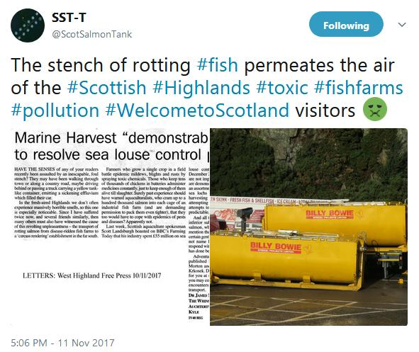

The Scottish Think Tank reported:
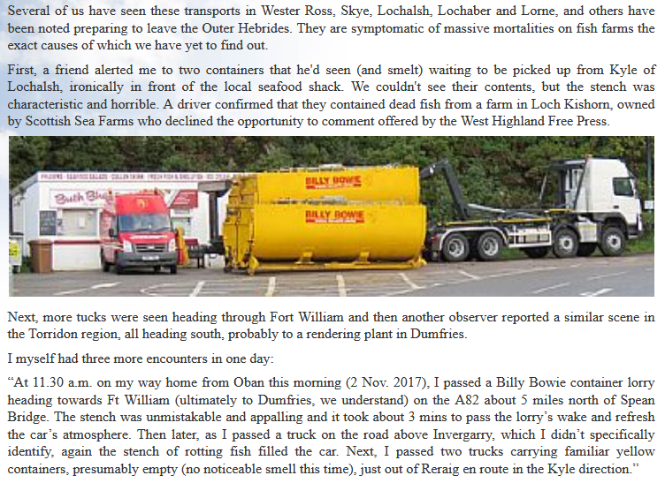
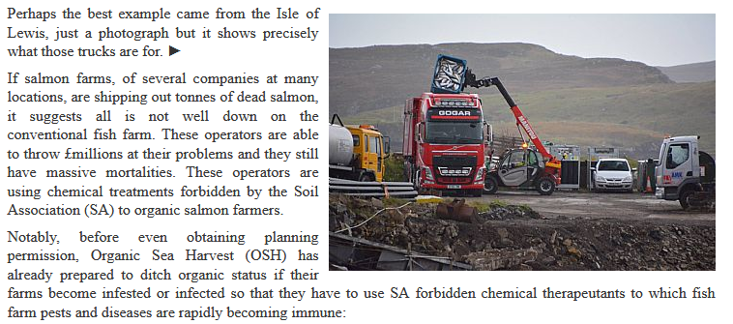
Another Tweet from the Scottish Salmon Think Tank detailed an article in the West Highland Free Press:

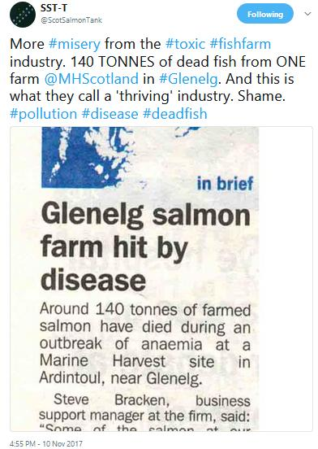
Read more via Letter: "Marine Harvest 'demonstrably failing' to resolve sea louse control problem"

BBC News reported in October 2017: "About 125,000 salmon have died due to a disease outbreak at two fish farms on the Isle of Lewis, BBC Scotland has learned. Marine Harvest confirmed that the sites in Loch Erisort have been hit by the bacterium Pasturella Skyensis" (read more via "125,000 salmon die in disease outbreak at Lewis fish farms").

BBC News reported earlier in October 2017: "Lorry loads of dead fish are being collected from a sea loch on the Isle of Lewis after suffering a bacterial infection, the BBC understands.....Locals have raised concerns about the smell of rotting fish at the shore" (read more via "Thousands of salmon on Lewis killed by infection").

The Sunday Herald reported in October 2017: "Official figures reveal the tonnages of dead fish that had to be disposed of has more than doubled from 10,599 in 2013 to a record high of 22,479 in 2016. Most are transported south to be burnt at an incinerator in Widnes near Warrington in northwest England..... The company that suffered the biggest losses was Marine Harvest, headquartered in Norway, whose mortalities leapt threefold to 7,609 tonnes between 2013 and 2016. Over the same period, the Scottish Salmon Company, which is registered in the Channel Islands, saw its dead fish more than double to 5,873 tonnes" (read more via "A disgrace: Ten million salmon thrown away by fish farm industry in last year alone").

The Times reported in July 2017: "The number of salmon dying on Scottish fish farms has doubled to 20 million a year because of parasites, diseases, and overcrowding in their cages, a campaign group claimed yesterday. For every seven fish that reach supermarket shelves one will have died on the farm, according to research by the Salmon & Trout Conservation Trust, which questioned how farms could be endorsed by the RSPCA given the levels of mortality" (read more via "Death rate at salmon farms doubles to 20m fish a year").

In July 2017, Salmon & Trout Conservation published a report - RSPCA Assured certification of Scottish farmed salmon estimating mortalities at 20 million per year:

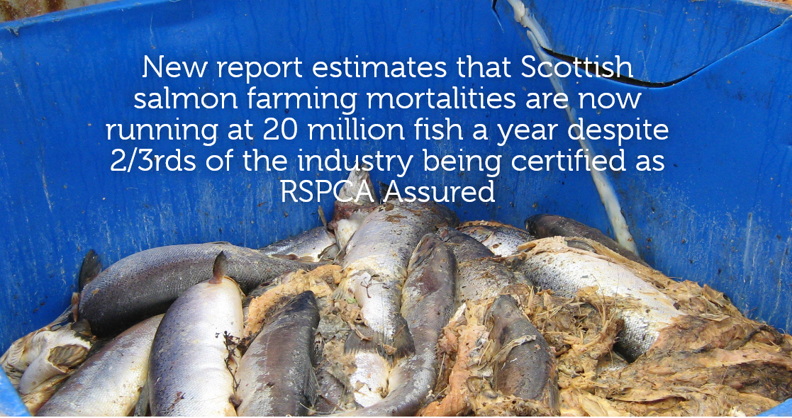

"A new report for S&TC Scotland on RSPCA Assured certification of Scottish farmed salmon reveals that Scottish salmon farming mortalities as a percentage of total production have almost doubled in the last four years," stated the press release. On the basis of official data, the report estimates that over 41 million fish died during 2015 and 2016, an average of over 20 million fish per annum."

The Times reported in June 2017: "More than a million salmon died in a Scottish sea loch last year because of a plague of sea lice at commercial farms" (read more via "A million salmon die in lice plague").

Marine Harvest Scotland has published mortality reports during 2017 - including 4.81% treatment mortality at Loch Hourn and 9.77% mortality at MacLean's Nose due to Cardiomyopathy Syndrome (viral infection causing weak hearts) in June 2017 and 13.96% mortality at MacLean's Nose due to Cardiomyopathy Syndrome (viral infection causing weak hearts) in May 2017.

The Daily Telegraph reported in November 2016: "Thousands of salmon were poached alive when a lice treatment process at Scottish fish farms went disastrously wrong, it has emerged. More than 175,000 salmon died when the water they were swimming in was overheated, prompting calls for those responsible to be prosecuted for cruelty" (read more via "Thousands of fish poached alive in lice treatment bungle that could hit Christmas salmon prices" and "Oops: fish farm firm kills 175,000 of its salmon by accident").

The Herald reported in October 2016: "Conservationists have called for government action after raising concerns that hundreds of thousands of fish have died from an infectious disease in salmon farms in Hebrides and Wester Ross. The Salmon and Trout Conservation Scotland has called on Scottish ministers to intervene to protect wild fish after an outbreak of Amoebic Gill Disease (AGD). It is understood that four farm sites have been affected including West Loch Tarbert and East Loch Tarbert on Harris, Loch Greshornish on Skye and the Isle of Ewe in Wester Ross. Marine Harvest salmon farms have been particularly affected, it is said" (read more via "Alert over salmon deaths crisis on Scots fish farms caused by infectious disease").

The Sunday Herald reported in 2013:

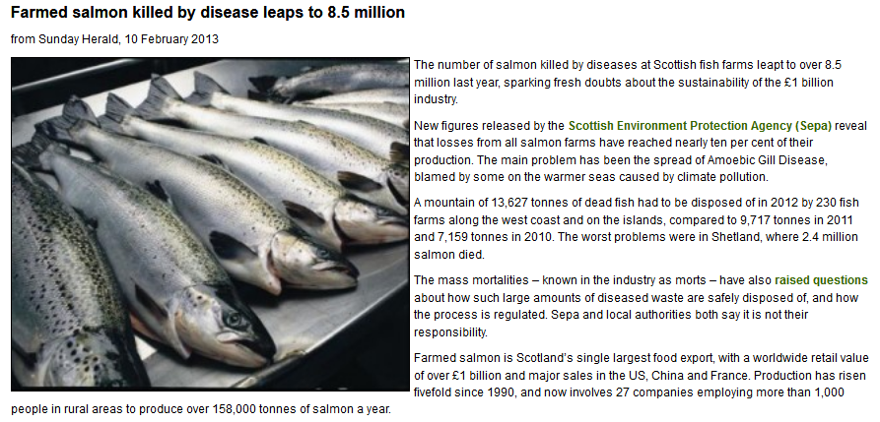

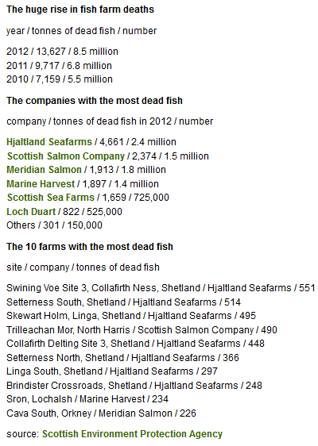

However, later in 2013 the Scottish Environment Protection Agency bowed to pressure from the Scottish Salmon Producers Organisation to keep the number of dead salmon secret:

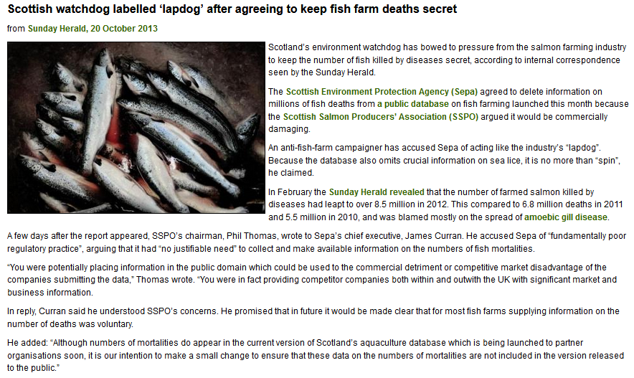

Read more via "Public denied info on full scale of salmon deaths" and "Scottish watchdog labelled ‘lapdog’ after agreeing to keep fish farm deaths secret"
In 2012, GAAIA published a report - "Gill Diseases: Scottish Salmon's Dirty Big Secret" - detailing mass mortalities due to gill diseases (read news story via "Chlamydia and gill disease ravage Scottish salmon: GAAIA"):

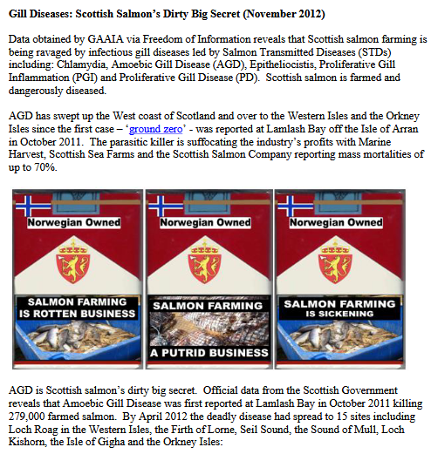

Download report in full online here

Read more via:
Scottish Salmon Farming 101
First Minister questioned on leaking wastes from morts - call for a moratorium from Greens
Press Release: "BBC's 'Dead Salmon Run' Opens Can of Worms"
Press Release: "Millions of Scottish Salmon Going Up in Smoke"
Press Release: Scottish Salmon's Lethal Legacy
European Commission complaint over dead fish dumping forces rule change
Where have all the dead fish gone?
Farmed salmon killed by disease leaps to 8.5 million
Scottish watchdog labelled ‘lapdog’ after agreeing to keep fish farm deaths secret

Despite no official data on the number of morts since 2012, GAAIA has accessed via FOI some data on mort numbers at three salmon farming companies (Scottish Sea Farms, the Scottish Salmon Company and Marine Harvest Scotland) during 2017:
Diseased Mortalities at Scottish Sea Farms:

From: Neil.Purvis@gov.scot [mailto:Neil.Purvis@gov.scot]
Sent: 18 January 2018 15:28
To: salmonfarmingkills@gmail.com
Cc: Helen.McGregor@gov.scot
Subject: FW: FOI - E - FOI re. morts & disease at Scottish Sea Farms during 2017 - Don Staniford

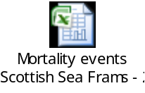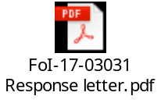

Dear Don,

FoI-17-03031

In response to your request of 14 December 2017 (FoI-1703031) please find the attached response and information provided.

Regards,
Neil

Neil Purvis
Marine Scotland – Science
Scottish Government | Marine Laboratory, PO Box 101| 375, Victoria Road | Aberdeen AB11 9DB
Tel: +44 (0)131 244 3287
S/B: +44 (0)131 244 2500
Mob:+44 (0)777 5818 281
Fax: +44 (0)1224 295620
e: neil.purvis@gov.scot
w: http://www.scotland.gov.uk/marinescotland

The Excel spreadsheet details 356,082 morts in 46 separate reports/incidents during 2017 including the following worst cases:

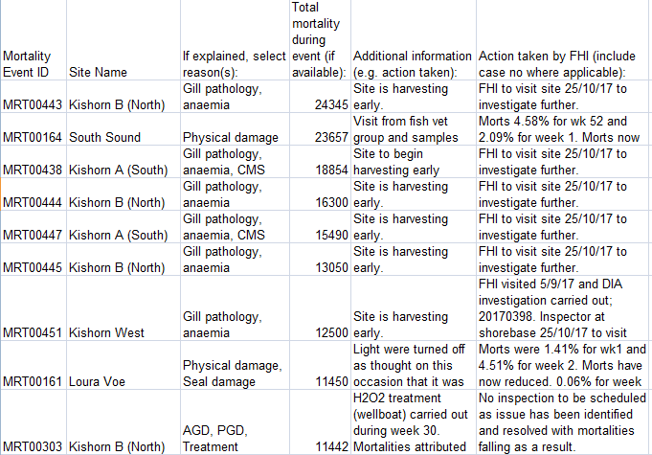
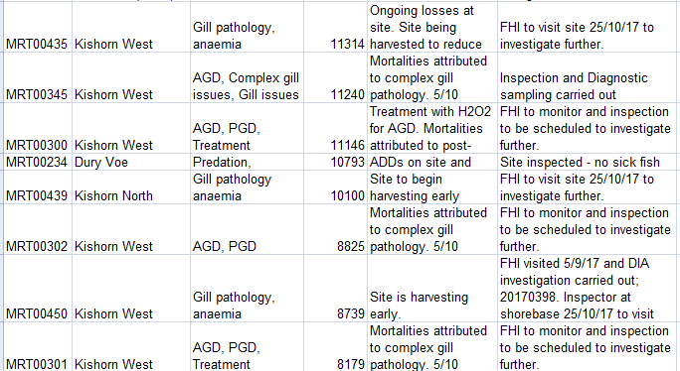

From: Don Staniford [mailto:salmonfarmingkills@gmail.com]
Sent: 14 December 2017 23:24
To: Central Enquiry Unit <CEU@gov.scot>
Subject: FOI re. morts & disease at Scottish Sea Farms during 2017

Please provide information on mortalities and diseases at salmon farms operated by Scottish Sea Farms during 2017.

Please include emails and correspondence with Scottish Sea Farms on the issue of mortalities and diseases - including Mortality Event Reports, Marine Laboratory inspection reports, warning letters, Excel spreadsheets collating data and other information since 1 January 2017.

Please consider this a request for information under the relevant Freedom of Information and Environmental Information Regulations including both the Freedom of Information (Scotland) Act 2002 and the Environmental Information (Scotland) Regulations 2004 (as well as any other new or other regulations which may be appropriate).

Please provide this information electronically via email.

Please acknowledge receipt of this FOI request.

Many thanks and I look forward to a response shortly.

Best fishes,

Don

Don Staniford

Director, Global Alliance Against Industrial Aquaculture (GAAIA): http://www.salmonfarmingkills.com

Read my blog via http://donstaniford.typepad.com/my-blog

<((((º>`·.¸¸.·´¯`·.¸.·´¯`·...¸><((((º>¸.
·´¯`·.¸. , . .·´¯`·.. ><((((º>`·.¸¸.·´¯`·.¸.·´¯`·...¸><((((º>

Since 2014, Scottish Sea Farms has operated three salmon farms in Loch Kishorn.
According to monthly data published via Scotland's Aquaculture web-site, mortality is significant:

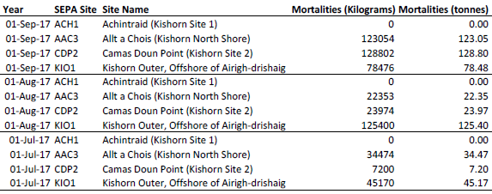

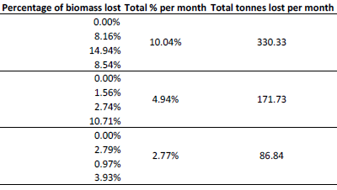

Download as a PDF online here

Please note:

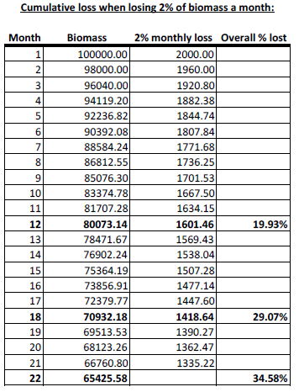

Download as a PDF online here

When questioned by the Scottish Salmon Think Tank, the Scottish Government's Fish Health Inspectorate (Tel: 01312 444 010) gave the following information:

1 Mortalities.

1.1 Are you (FHI) able to disclose the approximate total quantity of mortalities trans-shipped or proposed to be trans-shipped from Kyle pier for disposal during this present case? If you are unable to do so, when would you anticipate such disclosure might be made?

The FHI do not hold details of total numbers of mortalities removed from site for disposal. Animal by-product disposal is regulated by the Animal and Plant Health Agency (APHA), further details can be found here
https://www.gov.uk/guidance/transporting-animal-by-products

The FHI may record details of increased or unexplained mortalities occurring at aquaculture sites as part of routine inspections. Details of increased or unexplained mortalities are held within case information which is published on a quarterly basis. As well as case information and inspection reports, a list of all sites inspected during the quarter is published. Further details can be found here
http://www.gov.scot/Topics/marine/Fish-Shellfish/FHI/CaseInformation

If or when information is held by the FHI as part of our surveillance in relation to this issue it would be released as part of our quarterly publication process.

1.2 Are you able to disclose the site from which the aforementioned morts originate, and if you are unable to do so, when would you anticipate such disclosure might be made?

To our knowledge the waste in the sealed containers originated from fish farm sites in Loch Kishorn.

1.3 Are you able to disclose the possible cause(s) of the mortalities and if unable to do so, when would you anticipate such disclosure might be made?

Mortality information provided to the FHI from farms in Loch Kishorn assign mortalities due to gill pathology, cardiomyopathy syndrome (CMS) and anaemia. In addition, any case information recorded during routine surveillance at the fish farm sites in Loch Kishorn will be published as described.

[Please note that the Fish Health Inspectorate's Case Information does not currently provide data beyond June 2017]

Diseased Mortalities at the Scottish Salmon Company:

From: Neil.Purvis@gov.scot [mailto:Neil.Purvis@gov.scot]
Sent: 18 January 2018 15:27
To: salmonfarmingkills@gmail.com
Cc: Helen.McGregor@gov.scot
Subject: FW: FOI - E - FOI re. morts & disease at Scottish Salmon Company during 2017 - Don Staniford

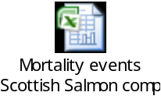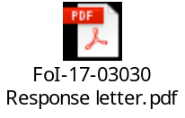

Dear Don,

FoI-17-03030

In response to your request of 14 December 2017 (FoI-1703030) please find the attached response and information provided.

Regards,
Neil

Neil Purvis
Marine Scotland – Science
Scottish Government | Marine Laboratory, PO Box 101| 375, Victoria Road | Aberdeen AB11 9DB
Tel: +44 (0)131 244 3287
S/B: +44 (0)131 244 2500
Mob:+44 (0)777 5818 281
Fax: +44 (0)1224 295620
e: neil.purvis@gov.scot
w: http://www.scotland.gov.uk/marinescotland

The Excel spreadsheet details 1,512,077 morts in 131 separate reports/incidents during 2017 including the following worst cases:

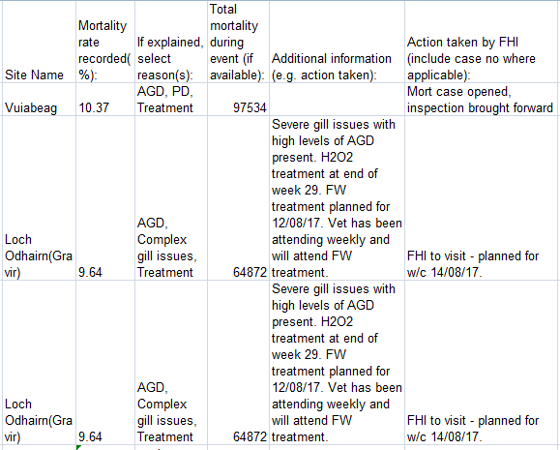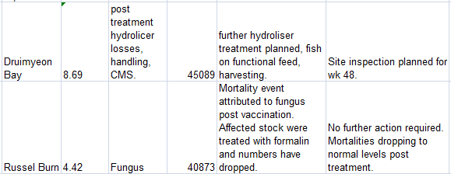
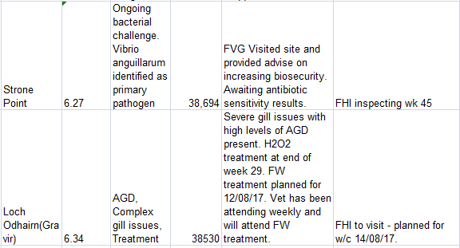

From: Don Staniford [mailto:salmonfarmingkills@gmail.com]
Sent: 14 December 2017 23:25
To: Central Enquiry Unit <CEU@gov.scot>
Subject: FOI re. morts & disease at Scottish Salmon Company during 2017

Please provide information on mortalities and diseases at salmon farms operated by the Scottish Salmon Company during 2017.

Please include emails and correspondence with the Scottish Salmon Company on the issue of mortalities and diseases - including Mortality Event Reports, Marine Laboratory inspection reports, warning letters, Excel spreadsheets collating data and other information since 1 January 2017.

Please consider this a request for information under the relevant Freedom of Information and Environmental Information Regulations including both the Freedom of Information (Scotland) Act 2002 and the Environmental Information (Scotland) Regulations 2004 (as well as any other new or other regulations which may be appropriate).

Please provide this information electronically via email.

Please acknowledge receipt of this FOI request.

Many thanks and I look forward to a response shortly.

Best fishes,

Don

Don Staniford

Director, Global Alliance Against Industrial Aquaculture (GAAIA): http://www.salmonfarmingkills.com

Read my blog via http://donstaniford.typepad.com/my-blog

<((((º>`·.¸¸.·´¯`·.¸.·´¯`·...¸><((((º>¸.
·´¯`·.¸. , . .·´¯`·.. ><((((º>`·.¸¸.·´¯`·.¸.·´¯`·...¸><((((º>

Diseased Mortalities at Marine Harvest Scotland:

From: Neil.Purvis@gov.scot [mailto:Neil.Purvis@gov.scot]
Sent: 13 December 2017 16:46
To: salmonfarmingkills@gmail.com
Cc: Helen.McGregor@gov.scot
Subject: FOI - E - morts & disease at Marine Harvest during 2017 - Don Staniford (FoI/17/0772)

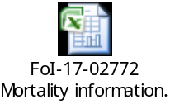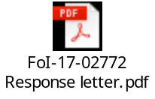

Dear Don,

Please see attached in response to your request of 14 November 2017.

Regards,

Neil

Neil Purvis
Marine Scotland – Science
Scottish Government | Marine Laboratory, PO Box 101| 375, Victoria Road | Aberdeen AB11 9DB
Tel: +44 (0)131 244 3287
S/B: +44 (0)131 244 2500
Mob:+44 (0)777 5818 281
Fax: +44 (0)1224 295620
e: neil.purvis@gov.scot
w: http://www.scotland.gov.uk/marinescotland

The Excel spreadsheet details 572,488 morts in 56 separate reports/incidents during 2017 including the following worst cases:

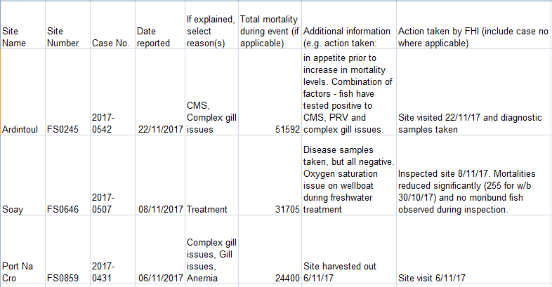
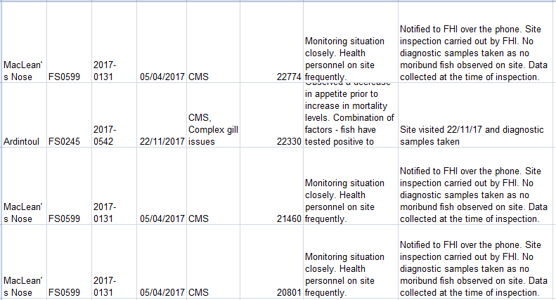
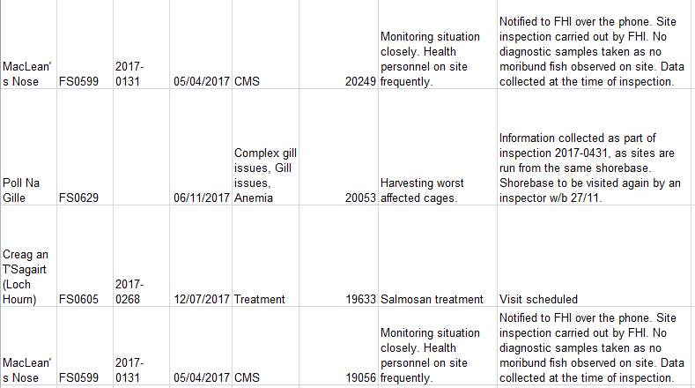

Another document details how Marine Harvest is experiencing increasing problems with mortalities linked to anaemia (not suspected to be linked to ISA), complex gill issues and cardiomyopathy syndrome (CMS):

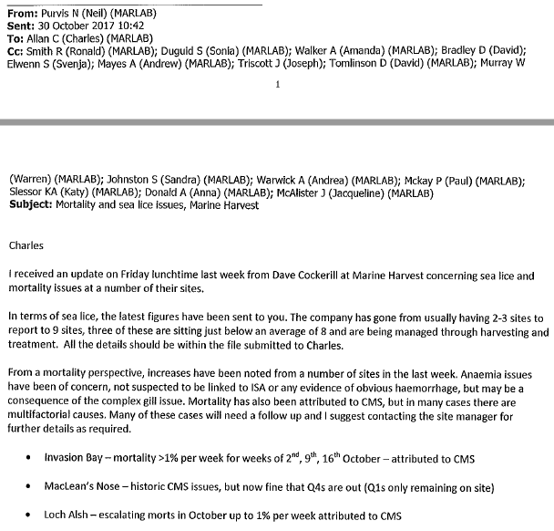
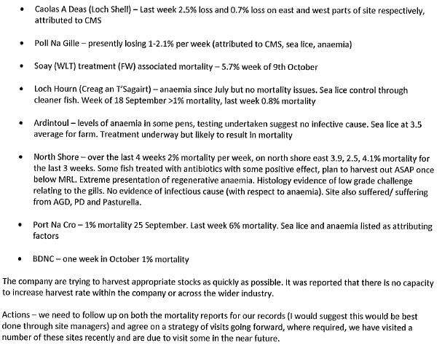

Marine Harvest's mort mountain is plugging into the National Grid (read more via "Energy from dead salmon horrifies vegan activists" and "Vegans in shock at fish electricity: Energy firm SSE admitted generating power from dead salmon earlier this year"):

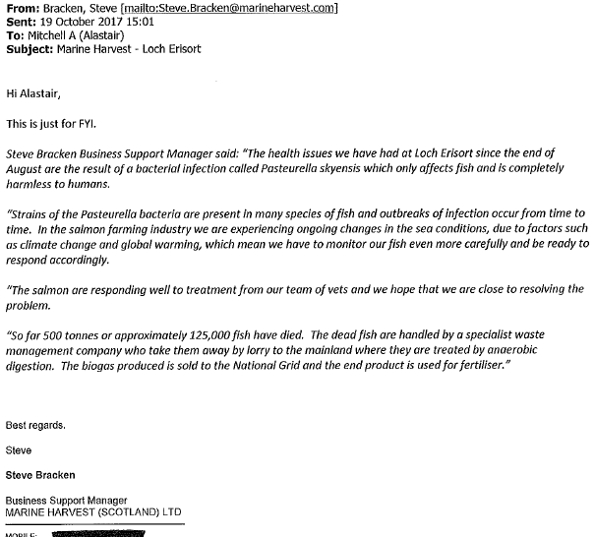

From: Don Staniford [mailto:salmonfarmingkills@gmail.com]
Sent: 14 November 2017 14:35
To: Central Enquiry Unit <CEU@gov.scot>
Subject: FOI re. morts & disease at Marine Harvest during 2017

Please provide information on mortalities and diseases at Marine Harvest fish farms during 2017.

Please include emails and correspondence with Marine Harvest on the issue of mortalities and diseases - including Mortality Event Reports, Marine Laboratory inspection reports, warning letters and other information since 1 January 2017.

As background, a Tweet dated 10 November 2017 included:
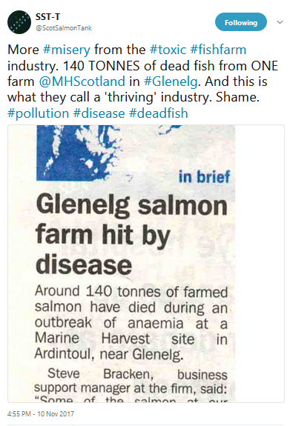

Here's the West Highland Free Press article from 10 November 2017:

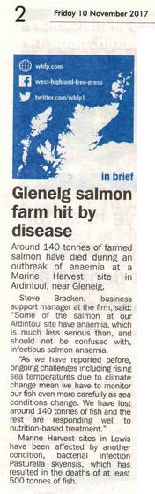

Other media reports refer to mortalities and diseases at other Marine Harvest salmon farms - including:

BBC News (20 October 2017):

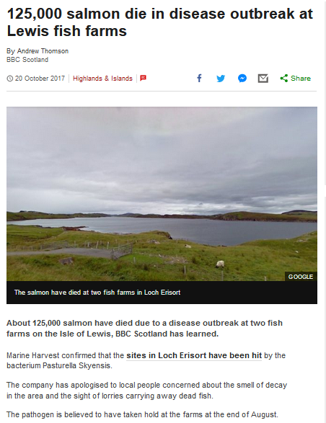

The Sunday Herald (8 October 2017):

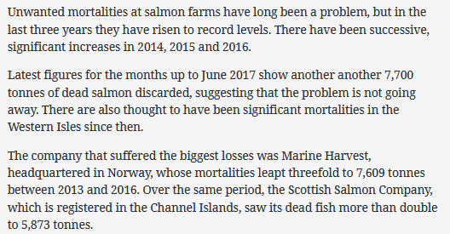

Marine Harvest also reported high mortality at Loch Hourn and MacLean's Nose in June 2017:

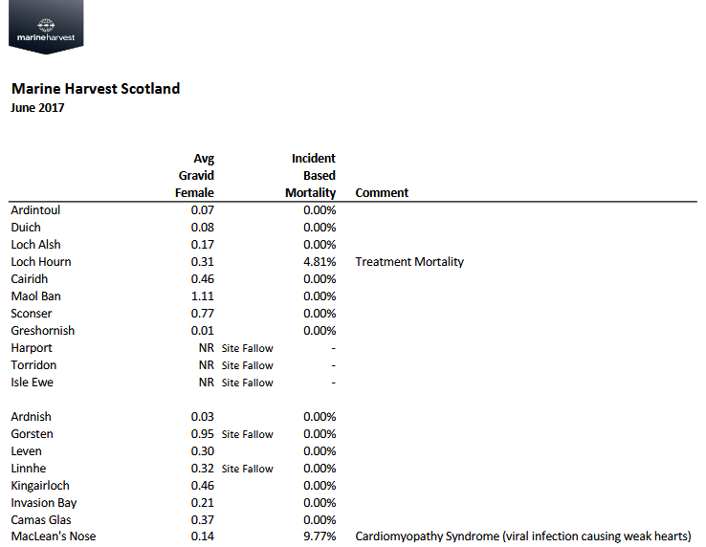

And Marine Harvest reported high mortality in April 2017 at Loch Alsh:

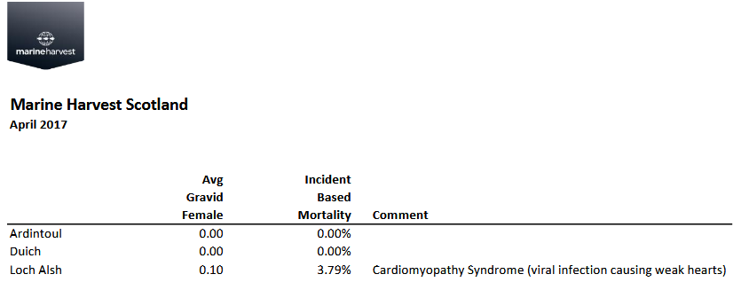

In February 2017, the Scottish Government also disclosed "Information on mortalities and disease problems at Marine Harvest during 2016".

Please consider this a request for information under the relevant Freedom of Information and Environmental Information Regulations including both the Freedom of Information (Scotland) Act 2002 and the Environmental Information (Scotland) Regulations 2004 (as well as any other new or other regulations which may be appropriate).

Please provide this information electronically via email.

Please acknowledge receipt of this FOI request.

Many thanks and I look forward to a response shortly.

Best fishes,

Don

Don Staniford

Director, Global Alliance Against Industrial Aquaculture (GAAIA): http://www.salmonfarmingkills.com

Read my blog via http://donstaniford.typepad.com/my-blog

<((((º>`·.¸¸.·´¯`·.¸.·´¯`·...¸><((((º>¸.
·´¯`·.¸. , . .·´¯`·.. ><((((º>`·.¸¸.·´¯`·.¸.·´¯`·...¸><((((º>

Appendix 1: FOI replies from Local Authorities

Argyll & Bute Council:

From: DIS Performance HQ [mailto:DISPerformanceHQ@argyll-bute.gov.uk]
Sent: 11 January 2018 16:12
To: salmonfarmingkills@gmail.com
Cc: 'argyll@messagestore.co.uk'
Subject: FOI Request argyllbuteir:7930 [OFFICIAL]

Classification: OFFICIAL
Dear Mr Staniford,

Request for information: Transport and Disposal of Salmon Mortalities
Reference: argyllbuteir:7930

I refer to your request for information which was dealt with in terms of the Environmental Information (Scotland) Regulations 2004.

Please see information below in fulfillment of your request.

Please provide information on the transport and disposal of salmon farm mortalities (understood to be defined as Animal By-Products) during 2017.
Response: No such information is held by the Council and as such I must refuse your request in terms of Regulation 10(4)(a) of the EIRs.

Please include any breaches of The Animal By-Products (Enforcement) (Scotland) Regulations 2013 and The Animal By-Products (Enforcement) (England) Regulations 2013 (salmon farm mortalities are understood to be transported to disposal sites in Widnes, Lancashire, as well as in Dumfries and other places in Scotland).
Response: We did not receive any reports of breaches of this legislation during 2017; we don’t have the resources to carry out any monitoring or surveillance of these activities, we didn’t carry out any investigations into these activities in 2017. Therefore I have to advise that the information you requested is information not held by the Council and as such I must refuse your request in terms of Regulation 10(4)(a) of the EIRs.

Please include any warning letters, photos, correspondence and any other information in relation to any investigations, surveillance and monitoring of the transport and disposal of salmon farm mortalities.
Response: Not applicable as we did not carry out any investigations into these activities in 2017. Therefore I have to advise that the information you requested is information not held by the Council and as such I must refuse your request in terms of Regulation 10(4)(a) of the EIRs.

If you are dissatisfied with the way in which your request for information has been dealt with you are entitled to request a review by writing to the Executive Director Customer Services, Argyll and Bute Council, Kilmory, Lochgilphead, Argyll PA31 8RT, or by email to foi@argyll-bute.gov.uk.

Your request for review must state your name and address for correspondence, specify the request for information to which your request for review relates and why you are dissatisfied with the response.

You must make your request for review not later than 40 working days after the expiry of the 20 working day period for response to your initial request by the Council, or not later than 40 working days after the receipt by you of the information provided, any fees notice issued or any notification of refusal or partial refusal.

If you make an application for review and remain dissatisfied with the way in which the review has been dealt with you are entitled to make an application to the Scottish Information Commissioner, Kinburn Castle, Doubledykes Road, St Andrews, Fife KY16 9DS (Tel: 01334 464610) for a further review. You can now do this online here - www.itspublicknowledge.info/Appeal.

You must make representation to the Scottish Information Commissioner no later than 6 months after the date of receipt by you of the notice or decision you are dissatisfied with or within 6 months of the expiry of the period of 20 working days from receipt by the Council of your request for review.

Yours sincerely

Ailsa Barr
DIS Performance HQ Team
Performance and Business Support
Development & Infrastructure Services
Argyll and Bute Council
Tel: 01546 604674 Fax: 01546 604678
DISPerformanceHQ@argyll-bute.gov.uk

Comhairle nan Eilean Siar:

From: CNES FOI Team [mailto:foi@cne-siar.gov.uk]
Sent: 22 December 2017 15:00
To: salmonfarmingkills@gmail.com
Subject: Re: [Ticket#2017121327000194] FW: FOI re. transport & disposal of morts from the salmon farming industry during 2017

Good afternoon,
Re: help desk request (ticket ref 2017121327000194)
Thank you for your recent request submitted under the Freedom of Information (Scotland) Act 2002. Please see the information requested below
Please provide information on the transport and disposal of salmon farm mortalities (understood to be defined as Animal By-Products) during 2017.
Morts transported by carriers registered with APHA and landfilled on islands or transported to approved premises on the mainland.
Please include any breaches of The Animal By-Products (Enforcement) (Scotland) Regulations 2013 and The Animal By-Products (Enforcement) (England) Regulations 2013 (salmon farm mortalities are understood to be transported to disposal sites in Widnes, Lancashire, as well as in Dumfries and other places in Scotland).
No confirmed breaches
Please include any warning letters, photos, correspondence and any other information in relation to any investigations, surveillance and monitoring of the transport and disposal of salmon farm mortalities.
Swabs from a road surface in the area were sampled to determine whether the cause off multiple traffic incidences at that location was related to an alleged spillage of fish waste from tanker transport. Results showed no signs of fish oil present.
Guidance issued by the Department for Environment, Food & Rural Affairs and Animal and Plant Health Agency in 2014 stated under 'Vehicle Hygiene & Storage': "When you’re transporting animal by-products (ABPs) or any ABP derived products, you must make sure you: use vehicles and containers that are covered and leak-proof..... If you leak ABPs in transport, you may be prosecuted by local authorities."

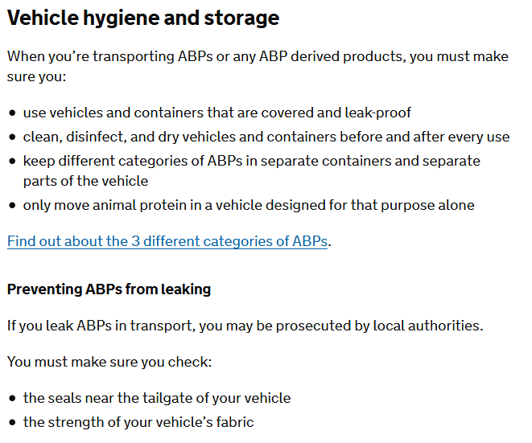
Online via https://www.gov.uk/guidance/transporting-animal-by-products
The Global Alliance Against Industrial Aquaculture (GAAIA) believes that there are a number of potential breaches of the Animal By-Products (Enforcement) (Scotland) Regulations 2013 - including a case featured last night by the BBC's The One Show (see enclosed query/complaint enclosed below for more details).
If you are dissatisfied with this response you can request the Comhairle to review this response to your request for information. You have 40 working days from the date of receipt of this response in which to lodge this request for review. A request for review must be processed in accordance with Part 1 of the Freedom of Information (Scotland) Act 2002, must be in writing, describe your original request and explain why you are dissatisfied. An application for review should be sent to the Chief Executive, Comhairle nan Eilean Siar, Council Offices, Sandwick Road, Stornoway, Isle of Lewis HS1 2BW (m.burr@cne-siar.gov.uk). A request for review lodged with the Chief Executive must be processed promptly and in any event within 20 working days of receipt.
Should you remain dissatisfied after completion of the review process you may, within 6 months, apply to the Scottish Information Commissioner, Kinburn Castle, Doubledykes Road, St Andrews, Fife, KY16 9DS, to establish whether your request for information has been processed in accordance with Part 1 of the Freedom of Information (Scotland) Act 2002. You may also request an appeal through the Commissioner's online appeal service which is available 24/7 and offers requesters real time help and advice about their appeal - www.itspublicknowledge.info/Appeal Should you remain dissatisfied after the conclusion of an application to the Scottish Information Commissioner you have the right to appeal to the Court of Session on a point of law.
--
Kind regards
Rebecca Macleod - CE
FOI Team
Comhairle nan Eilean Siar | Sandwick Road | Stornoway | Isle of Lewis | HS1 2BW
Email: foi@cne-siar.gov.uk
Web: http://www..cne-siar.gov.uk
Tel: 0845 600 70 90 (Extension 211222)

Dumfries and Galloway Council:

From: FOI@dumgal.gov.uk [mailto:FOI@dumgal.gov.uk]
Sent: 12 January 2018 15:05
To: salmonfarmingkills@gmail.com; FOIResponses@dumgal.gov.uk
Subject: Case Reference 295167 Transport and Disposal of morts from the salmon farming industry during 2017

Please find below the Council's response to your request 295167 which was received on 12/12/2017.

Details of request: Please provide information on the transport and disposal of salmon farm mortalities (understood to be defined as Animal By-Products) during 2017.

Please include any breaches of The Animal By-Products (Enforcement) (Scotland) Regulations 2013 and The Animal By-Products (Enforcement) (England) Regulations 2013 (salmon farm mortalities are understood to be transported to disposal sites in Widnes, Lancashire, as well as in Dumfries and other places in Scotland).

Please include any warning letters, photos, correspondence and any other information in relation to any investigations, surveillance and monitoring of the transport and disposal of salmon farm mortalities.

Guidance issued by the Department for Environment, Food &amp; Rural Affairs and Animal and Plant Health Agency in 2014 stated under 'Vehicle Hygiene &amp; Storage': &quot;When you?re transporting animal by-products (ABPs) or any ABP derived products, you must make sure you: use vehicles and containers that are covered and leak-proof..... If you leak ABPs in transport, you may be prosecuted by local authorities.&quot;

Response:

Dumfries and Galloway Council's Environmental Standards can advise that, in accordance with Regulation 10(4)(a) of the Environmental Information (Scotland) Regulations 2004, they do not hold any information in relation to your request.

Please be aware that the Council holds the copyright, where applicable, for the information provided and it may be reproduced free of charge in any format or media without requiring specific permission. This is subject to the material not being used in a misleading context. The source of the material must be acknowledged as Dumfries and Galloway Council and the title of the document must be included when being reproduced as part of another publication or service.

If you require any further clarification, please contact us. However, if you are not satisfied with the way in which your request has been dealt with, you can request us to carry out an internal review of the decision by emailing FOI@dumgal.gov.uk or writing to us within 40 working days of receiving this response.

If you are dissatisfied with the outcome of the review, you have the right to apply to the Scottish Information Commissioner for a decision. Appeals to the Commissioner can be made online at www.itspublicknowledge.info/Appeal or in writing to: The Office of the Scottish Information Commissioner, Kinburn Castle, Doubledykes Road, St Andrews, Fife, KY16 9DS.

Kind Regards

FOI Unit
Dumfries and Galloway Council

Highland Council:

From: Freedom of Information [mailto:foi@highland.gov.uk]
Sent: 19 January 2018 14:08
To: Don Staniford
Subject: RE: FOI Case Ref: HC0226-2760

Dear Mr Stanford,

Thank you for your email.

I can see the case expired on the 15th January, so apologies for the time it’s taking to respond to your request.

Unfortunately the EHO officer who’s dealing wih your request is on annual leave this week. I understand they will be back on Monday, so I’ll contact them for an update, and I will revert back to you as soon as I have more details.

Kind Regards

Eliane Higa
Customer Services Officer
Chief Executive’s Office
The Highland Council
HQ
Glenurquhart Rd
Inverness
IV3 5NX

Tel. no. 01463 702748

From: Don Staniford [mailto:salmonfarmingkills@gmail.com]
Sent: 19 January 2018 11:56
To: Freedom of Information
Subject: FOI Case Ref: HC0226-2760

Where is the FOI reply?

It has been over 20 days now.

Best fishes,

Don

Don Staniford

Director, Global Alliance Against Industrial Aquaculture (GAAIA): http://www.salmonfarmingkills.com

Read my blog via http://donstaniford.typepad.com/my-blog

<((((º>`·.¸¸.·´¯`·.¸.·´¯`·...¸><((((º>¸.
·´¯`·.¸. , . .·´¯`·.. ><((((º>`·.¸¸.·´¯`·.¸.·´¯`·...¸><((((º>

From: noreply@highland.gov.uk [mailto:noreply@highland.gov.uk]
Sent: 12 December 2017 10:36
To: salmonfarmingkills@gmail.com
Subject: FOI Request

Case Ref: HC0226-2760
Dear Don Stanford,
We acknowledge receipt of your request for information under the FOI legislation received on 12/12/2017.
Subject:
Salmon Farming Industry Information
Request Detail:
The Highland Council will endeavour to respond within the legislative time scale of 20 working days from date of receipt unless further clarification of your request is required.
Further information on response times can be found at: http://www.itspublicknowledge.info/YourRights/HowlongwillIwait.asp
Yours Sincerely,
The Highland Council
This is an automatically generated email - PLEASE DO NOT REPLY

Orkney Islands Council:

From: Kate Russell-Duff [mailto:Kate.Russell-Duff@orkney.gov.uk] On Behalf Of foi
Sent: 11 January 2018 14:37
To: 'Don Staniford'
Cc: foi
Subject: RE: Review of FOI 2017-1181 re. transport & disposal of morts from the salmon farming industry during 2017

Dear Mr Staniford

I refer to your Freedom of Information request dated 12 December 2017, Orkney Islands Council's response dated 21 December 2017 and your request that the response be reviewed of 21 December 2017.

Orkney Islands Council holds no information on the transport and disposal of salmon farm mortalities, nor have we received any allegations or complaints alleging any breaches of The Animal By-Products (Enforcement) (Scotland) Regulations 2013 and The Animal By-Products (Enforcement) (England) Regulations 2013 with respect to our premises. The original response to your request was correct and provided additional information to hopefully assure you that we undertook regulatory activities at the plant. However, with respect to your specific request we have no related documentation.

If you are still dissatisfied with the Council’s response to your requirement for a review, you are entitled, under section 47 of the Freedom of Information (Scotland) Act 2002 to apply to the Scottish Information Commissioner for a decision as to whether your request has been dealt with by the Council in accordance with Part 1 of the Act. Your application must be submitted in writing or in another form capable of being used for subsequent reference, and should be submitted before the expiry of six months after the date of your receipt of this letter. Your application can be sent to the Commissioner at www.itspublicknowledge.info/Appeal or at the following address:

Scottish Information Commissioner
Kinburn Castle
Doubledykes Road
St Andrews
KY16 9DS

Telephone: 01334 464611
Email: enquiries@itspublicknowledge.info

Yours sincerely

Gillian Morrison
Executive Director,
Corporate Services,
Orkney Islands Council, Council Offices, Kirkwall, Orkney, KW15 1NY

From: Don Staniford [mailto:salmonfarmingkills@gmail.com]
Sent: 21 December 2017 15:27
To: foi
Subject: Review of FOI 2017-1181 re. transport & disposal of morts from the salmon farming industry during 2017

Please consider this a formal request for a review of FOI 2017-1181 (see below for original FOI and reply).

Suffice to say that the FOI reply from OIC is woefully inadequate - zero source documents are disclosed for example.

OIC refers to "routine food hygiene visits" and "physical inspections" yet supplies no documentation or information as requested.

As the FOI filed by GAAIA specified:

"Please provide information on the transport and disposal of salmon farm mortalities (understood to be defined as Animal By-Products) during 2017......Please include any warning letters, photos, correspondence and any other information in relation to any investigations, surveillance and monitoring of the transport and disposal of salmon farm mortalities."

Please therefore review this case and provide the information requested.

Please provide a receipt for this review request.

Thanks.

Don

Don Staniford

Director, Global Alliance Against Industrial Aquaculture (GAAIA): http://www.salmonfarmingkills.com

Read my blog via http://donstaniford.typepad.com/my-blog

<((((º>`·.¸¸.·´¯`·.¸.·´¯`·...¸><((((º>¸.
·´¯`·.¸. , . .·´¯`·.. ><((((º>`·.¸¸.·´¯`·.¸.·´¯`·...¸><((((º>

From: Irene Cowdry [mailto:Irene.Cowdry@orkney.gov.uk] On Behalf Of foi
Sent: 21 December 2017 13:58
To: 'Don Staniford'
Cc: foi
Subject: RE: FOI 2017-1181 re. transport & disposal of morts from the salmon farming industry during 2017

Dear Sir

Freedom of Information (Scotland) Act 2002 – Request for Information

I refer to your email dated 12 December 2017 and received on 12 December 2017; our reference is FOI 2017-1181.

I am pleased to give the information you requested and hope that it meets your requirements.

The Environmental Health Department is not aware of any breaches of the Animal By-Products (Enforcement) (Scotland) Regulations 2013 in relation to the salmon industry in Orkney. From routine food hygiene visits to the one approved processing plant in Orkney all fish by-products (mainly intestines and other internal organs from the gutting process) are collected in sealed tanks and then transported for suitable disposal. Very few fish die from damage before they are stunned and gutted. From physical inspections of the fish officers of Orkney Islands Council have not seen any sea lice problem here.

You have the right to request a review of the decision if you are not satisfied with the way we have handled your request. Please write to: Head of Legal Services, Council Offices, School Place, Kirkwall, Orkney, KW15 1NY or email to foi@orkney.gov.uk to make this request. The law gives you up to 60 working days from when we received your enquiry or 40 working days from when you receive this correspondence, whichever is the later date.

Where the outcome of the review fails to resolve the matter to your complete satisfaction you have the right to apply to the Scottish Information Commissioner for a decision, within six months of the date of the decision to a request for a review, or within six months from when we should have responded to your request for a review, whichever is the later date.

Regards

Gavin Mitchell
Head of Legal Services
Corporate Services
Orkney Islands Council, Council Offices, Kirkwall, Orkney, KW15 1NY
Telephone: 01856 873535 Extension: 2210
www.orkney.gov.uk

Shetland Isles Council:

From: Paula.Nicolson@shetland.gov.uk [mailto:Paula.Nicolson@shetland.gov.uk]
Sent: 20 December 2017 14:12
To: salmonfarmingkills@gmail.com
Subject: Appeal re: FOI re. transport & disposal of morts from the salmon farming industry during 2017

Dear Mr Staniford

Please find attached an amended spreadsheet showing the details of salmon disposed of at the Energy Recovery Plant between Jan – Nov 2017. The tonnage is less than reported in my previous e-mail because some of the fish disposed of was not salmon so has not been included. The tonnage is 119.420 and came from two companies. The two annual waste transfer notes are attached.

Shetland Islands Council have had no breaches of the regulations as requested.

Shetland Islands Council has not had to issue any warning letters, complete any investigations, surveillance or monitoring in regard to the transport and disposal of salmon farm mortalities

I trust that this response meets your request. However, if you are dissatisfied with the way in which the Council has dealt with your request for information then you may ask the authority to review its actions and decisions in relation to your request, by submitting a formal appeal

Many thanks

Paula

Paula Nicolson
Clerical Officer
Infrastructure Services
Gremista
Lerwick
Tel: 744809

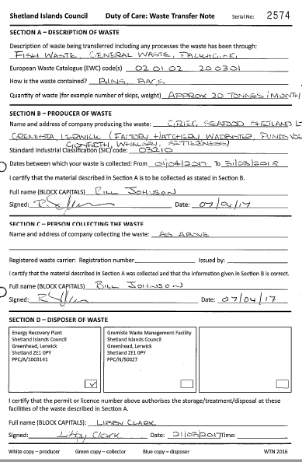

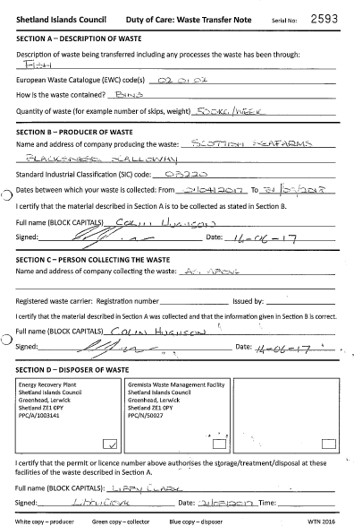

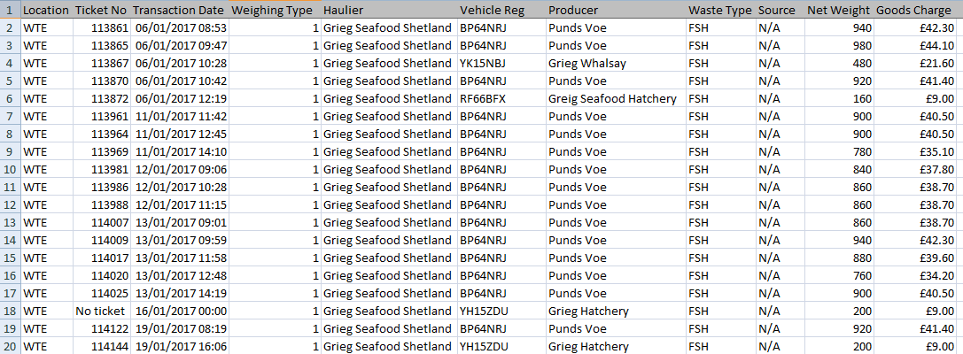

[Excel spreadsheet contains 141 lines of data]

From: Don Staniford [mailto:salmonfarmingkills@gmail.com]
Sent: 18 December 2017 11:02
To: Nicolson Paula@Infrastructure Svs <Paula.Nicolson@shetland.gov.uk>
Subject: Appeal re: FOI re. transport & disposal of morts from the salmon farming industry during 2017

Paula,

Thanks - with respect, I do not think SIC has begun to provide all the information requested on 12 December 2017.

The Excel spreadsheet provided this morning provides zero information in terms of names of companies, for example:

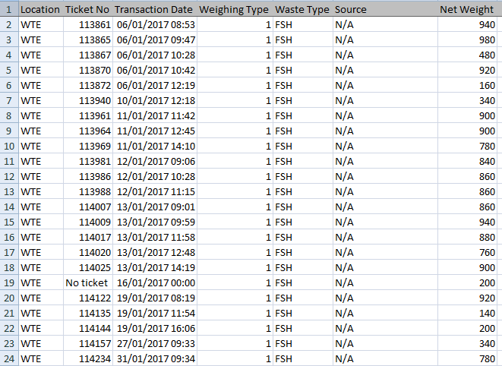

I therefore refer you to GAAIA's FOI dated 12 December 2017; namely:

Please provide information on the transport and disposal of salmon farm mortalities (understood to be defined as Animal By-Products) during 2017.

Please include any breaches of The Animal By-Products (Enforcement) (Scotland) Regulations 2013 and The Animal By-Products (Enforcement) (England) Regulations 2013 (salmon farm mortalities are understood to be transported to disposal sites in Widnes, Lancashire, as well as in Dumfries and other places in Scotland).

Please include any warning letters, photos, correspondence and any other information in relation to any investigations, surveillance and monitoring of the transport and disposal of salmon farm mortalities.

Please therefore consider this a formal appeal.

Best fishes,

Don

Don Staniford

Director, Global Alliance Against Industrial Aquaculture (GAAIA): http://www.salmonfarmingkills.com

Read my blog via http://donstaniford.typepad.com/my-blog

<((((º>`·.¸¸.·´¯`·.¸.·´¯`·...¸><((((º>¸.
·´¯`·.¸. , . .·´¯`·.. ><((((º>`·.¸¸.·´¯`·.¸.·´¯`·...¸><((((º>

From: Paula.Nicolson@shetland.gov.uk [mailto:Paula.Nicolson@shetland.gov.uk]
Sent: 18 December 2017 10:36
To: salmonfarmingkills@gmail.com
Subject: FOI re. transport & disposal of morts from the salmon farming industry during 2017

Dear Mr Staniford

Attached is the information that you requested from the Energy Recovery Plant

Attached is a spreadsheet for the fish disposed of at the Energy Recovery Plant between Jan and Nov 2017. The spreadsheet gives the individual ticket number, the transaction date and time, the description of the waste (Fish) and the weight of each load (kg). The total is 128.360 tonnes.

I trust that this response meets your request. However, if you are dissatisfied with the way in which the Council has dealt with your request for information then you may ask the authority to review its actions and decisions in relation to your request, by submitting a formal appeal

Paula Nicolson
Clerical Officer
Infrastructure Services
Gremista
Lerwick
Tel: 744809

From: Don Staniford [mailto:salmonfarmingkills@gmail.com]
Sent: 15 December 2017 11:48
To: Nicolson Paula@Infrastructure Svs <Paula.Nicolson@shetland.gov.uk>
Subject: RE: FOI re. transport & disposal of morts from the salmon farming industry during 2017

Paula,

Thanks.

As requested, please provide the documents and source information.

Please consider this a friendly second chance to respond to my FOI request rather than a formal review request.

Best fishes,

Don

Don Staniford

Director, Global Alliance Against Industrial Aquaculture (GAAIA): http://www.salmonfarmingkills.com

Read my blog via http://donstaniford.typepad.com/my-blog

<((((º>`·.¸¸.·´¯`·.¸.·´¯`·...¸><((((º>¸.
·´¯`·.¸. , . .·´¯`·.. ><((((º>`·.¸¸.·´¯`·.¸.·´¯`·...¸><((((º>

From: Paula.Nicolson@shetland.gov.uk [mailto:Paula.Nicolson@shetland.gov.uk]
Sent: 15 December 2017 09:42
To: salmonfarmingkills@gmail.com
Subject: FOI re. transport & disposal of morts from the salmon farming industry during 2017

Thank you for your freedom of information enquiry, between Jan and Nov 2017 there was 128.360 tonnes of fish (predominantly salmon) disposed of at the Energy Recovery Plant, Lerwick, Shetland.

I trust that this response meets your request. However, if you are dissatisfied with the way in which the Council has dealt with your request for information then you may ask the authority to review its actions and decisions in relation to your request, by submitting a formal appeal

Paula Nicolson
Clerical Officer
Infrastructure Services
Gremista
Lerwick
Tel: 744809

Here's GAAIA's FOI request to Shetland Isles Council, Orkney Islands Council, Comhairle nan Eilean Siar, Highland Council, Argyll & Bute Council and Dumfries & Galloway Council on 12 December 2017:

From: Don Staniford [mailto:salmonfarmingkills@gmail.com]
Sent: 12 December 2017 08:27
To: 'foi@argyll-bute.gov.uk'
Subject: FOI re. transport & disposal of morts from the salmon farming industry during 2017

Please provide information on the transport and disposal of salmon farm mortalities (understood to be defined as Animal By-Products) during 2017.

Please include any breaches of The Animal By-Products (Enforcement) (Scotland) Regulations 2013 and The Animal By-Products (Enforcement) (England) Regulations 2013 (salmon farm mortalities are understood to be transported to disposal sites in Widnes, Lancashire, as well as in Dumfries and other places in Scotland).

Please include any warning letters, photos, correspondence and any other information in relation to any investigations, surveillance and monitoring of the transport and disposal of salmon farm mortalities.

Guidance issued by the Department for Environment, Food & Rural Affairs and Animal and Plant Health Agency in 2014 stated under 'Vehicle Hygiene & Storage': "When you’re transporting animal by-products (ABPs) or any ABP derived products, you must make sure you: use vehicles and containers that are covered and leak-proof..... If you leak ABPs in transport, you may be prosecuted by local authorities."

Online via https://www.gov.uk/guidance/transporting-animal-by-products

The Global Alliance Against Industrial Aquaculture (GAAIA) believes that there are a number of potential breaches of the Animal By-Products (Enforcement) (Scotland) Regulations 2013 - including a case featured last night by the BBC's The One Show (see enclosed query/complaint enclosed below for more details).

Please consider this a request for information under the relevant Freedom of Information and Environmental Information Regulations including both the Freedom of Information (Scotland) Act 2002 and the Environmental Information (Scotland) Regulations 2004 (as well as any other new or other regulations which may be appropriate).

Please provide this information electronically via email.

Please acknowledge receipt of this FOI request.

Many thanks and I look forward to a response shortly.

Best fishes,

Don

Don Staniford

Director, Global Alliance Against Industrial Aquaculture (GAAIA): http://www.salmonfarmingkills.com

Read my blog via http://donstaniford.typepad.com/my-blog

<((((º>`·.¸¸.·´¯`·.¸.·´¯`·...¸><((((º>¸.
·´¯`·.¸. , . .·´¯`·.. ><((((º>`·.¸¸.·´¯`·.¸.·´¯`·...¸><((((º>

From: Don Staniford [mailto:salmonfarmingkills@gmail.com]
Sent: 12 December 2017 07:35
To: 'scottish.ministers@gov.scot'
Cc: 'Ruskell M (Mark), MSP'
Subject: Breach of Animal By-Products (Enforcement) (Scotland) Regulations 2013 by tankers hauling dead farmed salmon?

Following the BBC's broadcast of images of wastes leaking from a haulage truck transporting dead and diseased farmed salmon from Loch Kishorn via Fort William to Dumfries (believed to be the Dundas Chemical Co at Mosspark), the Global Alliance Against Industrial Aquaculture (GAAIA) is concerned that the Animal By-Products (Enforcement) (Scotland) Regulations 2013 have been breached.

Guidance issued by the Department for Environment, Food & Rural Affairs and Animal and Plant Health Agency in 2014 stated under 'Vehicle Hygiene & Storage': "When you’re transporting animal by-products (ABPs) or any ABP derived products, you must make sure you: use vehicles and containers that are covered and leak-proof..... If you leak ABPs in transport, you may be prosecuted by local authorities."

Online via https://www.gov.uk/guidance/transporting-animal-by-products

It is abundantly clear from the BBC footage broadcast last night (starts at 3 minutes 22 seconds) that there is leakage from at least one of the haulage tankers (operated by Billy Bowie: http://billybowietankers.co.uk/):

"What I'm seeing here is shocking but it isn't illegal nor uncommon," says BBC reporter Joe Crowley as he is driving behind the Billy Bowie tankers/trucks. "OK, the tanker and the first skipper-lorry have just left the salmon farm and they're both full of salmon. In fact, I can see some horrible fluid coming out of the back of one of them and it smells vile"

Surely this is not "leak proof" and therefore constitutes a breach of the Animal By-Products (Enforcement) (Scotland) Regulations 2013?

When questioned by the BBC's One Show, the Scottish Government's Fish Health Inspectorate gave the following information:

1 Mortalities.

1.1 Are you (FHI) able to disclose the approximate total quantity of mortalities transshipped or proposed to be transshipped from Kyle pier for disposal during this present case? If you are unable to do so, when would you anticipate such disclosure might be made?

The FHI do not hold details of total numbers of mortalities removed from site for disposal. Animal by-product disposal is regulated by the Animal and Plant Health Agency (APHA), further details can be found here https://www.gov.uk/guidance/transporting-animal-by-products
The FHI may record details of increased or unexplained mortalities occurring at aquaculture sites as part of routine inspections. Details of increased or unexplained mortalities are held within case information which is published on a quarterly basis. As well as case information and inspection reports, a list of all sites inspected during the quarter is published. Further details can be found here http://www.gov.scot/Topics/marine/Fish-Shellfish/FHI/CaseInformation
If or when information is held by the FHI as part of our surveillance in relation to this issue it would be released as part of our quarterly publication process.

1.2 Are you able to disclose the site from which the aforementioned morts originate, and if you are unable to do so, when would you anticipate such disclosure might be made?

To our knowledge the waste in the sealed containers originated from fish farm sites in Loch Kishorn.

1.3 Are you able to disclose the possible cause(s) of the mortalities and if unable to do so, when would you anticipate such disclosure might be made?

Mortality information provided to the FHI from farms in Loch Kishorn assign mortalities due to gill pathology, cardiomyopathy syndrome (CMS) and anaemia. In addition, any case information recorded during routine surveillance at the fish farm sites in Loch Kishorn will be published as described.

2 Transportation Matters. Under the Aquatic Animal Health Regulations, I understand that authorisation is required from FHI for “the movement of any aquaculture animal or any aquaculture animal product into or out of the area in respect of which the business operates”.

As stated previously, the Aquaculture Production Businesses are authorised to operate under the Aquatic Animal Health (Scotland) Regulations 2009. As part of this authorisation it is a condition that a record is maintained of the movement of any aquaculture animal or any aquaculture animal product into or out of the area in respect of which the business operates. Only when an initial or confirmed designation notice is in place to control a listed or emerging disease would authorisation be required for the movement of any aquaculture animal or product thereof into or out of the area covered by the notice.

2.1 Are you aware of the level of bio-security maintained by the vehicles used in the transportation of morts generally?
2.2 Is the bio-security of vehicles governed by regulation, or is it self regulatory?
2.3 Is there a minimum specification for the container units of vehicles carrying morts for Category 1 Disposal?
2.4 Are the vehicles used certified as compliant in terms of bio-security and if so what checks are made to ensure continued compliance?

Aquaculture Production Businesses work to the requirements of the Industry’s Code of Good Practice which includes developing and implementing a veterinary health and welfare plan and biosecurity plan. All businesses authorised to operate under the Aquatic Animal Health (Scotland) Regulations 2009 must have in place a biosecurity measures plan to ensure that the operation of the business does not lead to an unacceptable risk of spreading disease.

As stated previously the regulation of animal by-product disposal is undertaken by APHA. As far as the FHI are aware there is no category 1 waste being disposed of by Scottish fish farms. Please contact APHA for details of category 1 animal by-product disposal.

2.5 Are authorisations for movement always granted in advance of the movement of morts? If that is not the case please explain why.

As stated previously aquaculture production businesses maintain records of the disposal of aquaculture animal products, which are made available for inspection during routine surveillance. Only when an initial or confirmed designation notice is in place to control a listed or emerging disease would authorisation be required for the movement of any aquaculture animal or product thereof into or out of the area covered by the notice.

We hope this has clarified your questions on animal by-product waste disposal from aquaculture sites.

Regards,
Andrew Mayes
Fish Health Inspector | Aquaculture & Fish Health
Marine Scotland - Science
Scottish Government | Marine Laboratory | 375 Victoria Road | Aberdeen | AB11 9DB
Tel: +44 (0)1312 444 010
S/B: +44 (0)1312 442 500
E-mail: andrew.mayes@gov.scot
w: http://www.gov.scot/Topics/marine

[Please note that the Fish Health Inspectorate's Case Information does not currently provide data beyond June 2017]

In November 2016, a Parliamentary Question filed by Mark Ruskell MSP asked "where and by whom containers of diseased salmon morts are checked for biosecurity compliance during their journey from farm to final disposal, and how many such journeys have taken place in each of the last three years".

"Vehicles used for transporting salmon morts to a disposal site must be approved or registered under the Animal By-Products (Enforcement) (Scotland) Regulations 2013 (ABPR)," replied Fergus Ewing, Cabinet Secretary for the Rural Economy and Connectivity, in December 2016. "The operators of these vehicles must ensure that salmon morts be collected and transported in sealed new packaging or covered leak-proof containers."

Another Parliamentary Question and reply in November 2016 also stressed when transporting Animal By-Products transporters must ensure that they "use vehicles and containers that are covered and leak-proof".

The Loch Kishorn case captured on camera by the BBC is surely not an isolated incident and may represent industry-wide malpractice.

In November 2017, the Scottish Salmon Think Tank Tweeted:
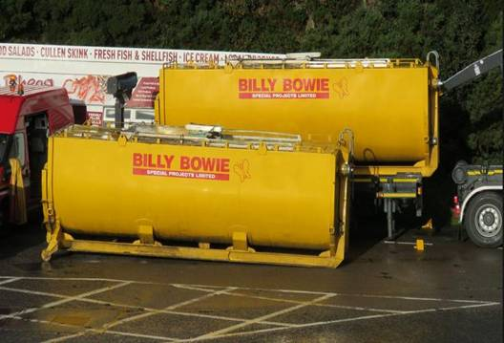
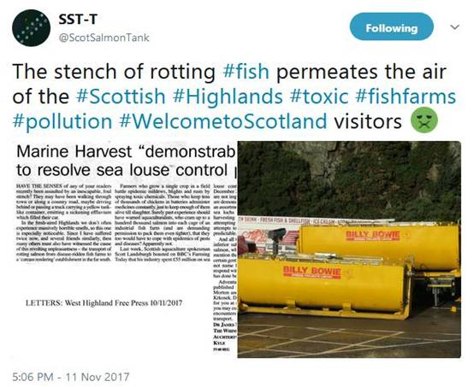
The Scottish Think Tank reported:
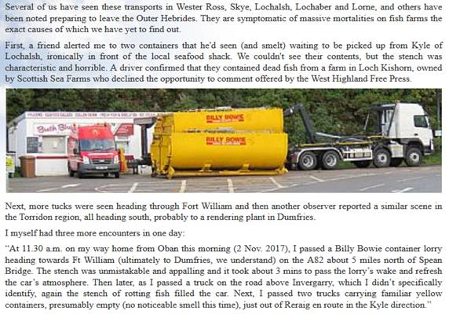
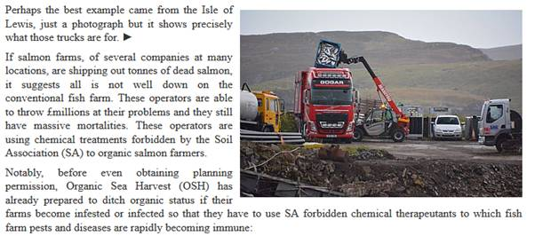

Other incidents where leakage from haulage trucks/tankers has taken place are understood to have taken place in the Western Isles where mass mortalities in recent months have led to the leakage of "slime" onto the road (the company involved is understood to have been Gogar Logistics).

Apparently there is photographic evidence and Comhairle nan Eilean Siar may have come out to clean up after the leakage. The only information GAAIA has at the moment (although we will be filing FOIs) is this snippet from a concerned citizen:

The trucking company (at least from the pic I have seen) taking fish from L Erisort is Gogar. A local informed me that recently there were cases (within a v short time period) of cars (at least half a dozen) going off the road on the main Stornoway road just north of the junction with the minor road from L Erisort. I understand this was due to fish waste and slime on the road surface. Apparently the council came out to disperse it.

If GAAIA receives further details I will forward.

BBC News reported in October 2017: "About 125,000 salmon have died due to a disease outbreak at two fish farms on the Isle of Lewis, BBC Scotland has learned. Marine Harvest confirmed that the sites in Loch Erisort have been hit by the bacterium Pasturella Skyensis" (read more via "125,000 salmon die in disease outbreak at Lewis fish farms").

BBC News reported earlier in October 2017: "Lorry loads of dead fish are being collected from a sea loch on the Isle of Lewis after suffering a bacterial infection, the BBC understands.....Locals have raised concerns about the smell of rotting fish at the shore" (read more via "Thousands of salmon on Lewis killed by infection").

More background is available via:
Press Release: "Millions of Scottish Salmon Going Up in Smoke"
BBC's The One Show: "The Dead Salmon Run"

In conclusion, could you please investigate whether there has been a breach or breaches of the Animal By-Products (Enforcement) (Scotland) Regulations 2013 in relation to the transport of salmon morts?

Please feel free to pass this query/complaint onto the appropriate person or agency.

Any follow up information would be much appreciated.

Yours sincerely,

Don Staniford

Director, Global Alliance Against Industrial Aquaculture (GAAIA): http://www.salmonfarmingkills.com

Read my blog via http://donstaniford.typepad.com/my-blog

<((((º>`·.¸¸.·´¯`·.¸.·´¯`·...¸><((((º>¸.
·´¯`·.¸. , . .·´¯`·.. ><((((º>`·.¸¸.·´¯`·.¸.·´¯`·...¸><((((º>

A similar FOI request was filed on 20 January 2018 with other local authorities in Scotland including East Aryshire, Midlothian, Stirling, Perth & Kinross and Renfrewshire as well as Cumbria and Lancashire in England:

From: Don Staniford [mailto:salmonfarmingkills@gmail.com]
Sent: 20 January 2018 11:23
To: 'foi@renfrewshire.gov.uk'
Subject: FOI re. transport & disposal of morts from the salmon farming industry since 1 Jan 2017

Please provide information on the transport and disposal of salmon farm mortalities (understood to be defined as Animal By-Products) since 1 January 2017.

Please include any breaches of The Animal By-Products (Enforcement) (Scotland) Regulations 2013 and The Animal By-Products (Enforcement) (England) Regulations 2013 (salmon farm mortalities are understood to be transported to disposal sites in Widnes, Lancashire, as well as in Dumfries and other places in Scotland with Kilmarnock-based Billy Bowie understood to be one of the biggest operators).

Please include any warning letters, photos, correspondence (e.g. with the Scottish Government) and any other information in relation to any investigations, surveillance and monitoring of the transport and disposal of salmon farm mortalities. In particular, please check you records of Billy Bowie who GAAIA understands is currently under investigation by East Ayrshire Council.

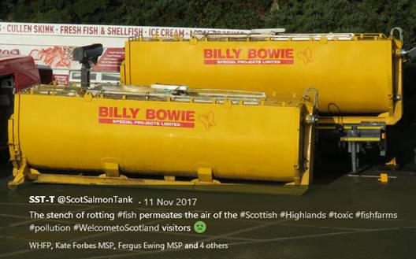

Guidance issued by the Department for Environment, Food & Rural Affairs and Animal and Plant Health Agency in 2014 stated under 'Vehicle Hygiene & Storage': "When you’re transporting animal by-products (ABPs) or any ABP derived products, you must make sure you: use vehicles and containers that are covered and leak-proof..... If you leak ABPs in transport, you may be prosecuted by local authorities."

Online via https://www.gov.uk/guidance/transporting-animal-by-products

In November 2016, a Parliamentary Question filed by Mark Ruskell MSP asked "where and by whom containers of diseased salmon morts are checked for biosecurity compliance during their journey from farm to final disposal, and how many such journeys have taken place in each of the last three years".

"Vehicles used for transporting salmon morts to a disposal site must be approved or registered under the Animal By-Products (Enforcement) (Scotland) Regulations 2013 (ABPR)," replied Fergus Ewing, Cabinet Secretary for the Rural Economy and Connectivity, in December 2016. "The operators of these vehicles must ensure that salmon morts be collected and transported in sealed new packaging or covered leak-proof containers."

Another Parliamentary Question and reply in November 2016 also stressed when transporting Animal By-Products transporters must ensure that they "use vehicles and containers that are covered and leak-proof".

The Global Alliance Against Industrial Aquaculture (GAAIA) believes that there are a number of potential breaches of the Animal By-Products (Enforcement) (Scotland) Regulations 2013 - including a case featured on 11 December 2017 by the BBC's The One Show involving Billy Bowie (see enclosed query/complaint to the Scottish Government enclosed below for more details).

"OK, the tanker and the first skipper-lorry have just left the salmon farm and they're both full of salmon," says BBC reporter Joe Crowley as he is driving behind the Billy Bowie tankers/trucks. "In fact, I can see some horrible fluid coming out of the back of one of them and it smells vile"



Watch the BBC One Show online here: https://www.youtube.com/watch?v=rhrzJEHaWFE&feature=youtu.be

Another case involving Billy Bowie was reported by The Courier in 2015:

Following a complaint by GAAIA in December 2017, the Scottish Government contacted East Ayrshire Council inquiring about the condition of the vehicles being used to transport the salmon mortalities not being complaint with the ABPR and reported "that they would be investigating the standards of the vehicles used by the transport company". A letter to GAAIA dated 17 January 2018 from the Scottish Government included:

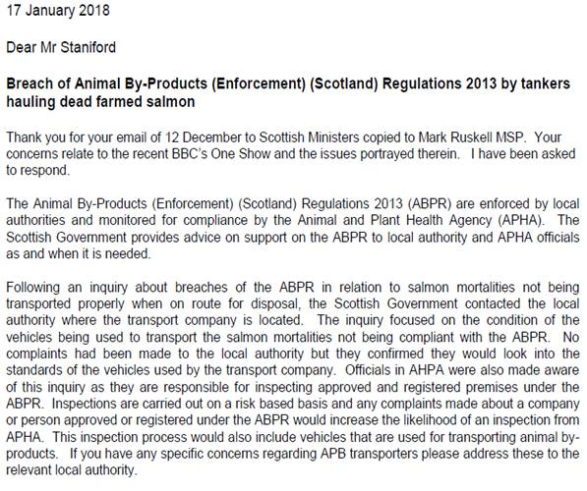

Here's a letter to GAAIA from the Scottish Government dated 15 January 2018 which names East Ayrshire:

"APHA do not inspect or monitor the transport of salmon farm mortalities," said a FOI reply from the Animal & Plant Health Agency dated 9 January 2018. "The enforcement of the regulations is the responsibility of Local Authorities under the Animal By-Products (Enforcement) (England) Regulations 2013 and of the Scottish Government under The Animal By-Products (Enforcement) (Scotland) Regulations 2013".

"Police Scotland has no protocols with any local authority or operating company regarding the disposal of wastes from fish farms," said a FOI reply from Police Scotland dated 10 January 2018.

Please consider this a request for information under the relevant Freedom of Information and Environmental Information Regulations including both the Freedom of Information (Scotland) Act 2002 and the Environmental Information (Scotland) Regulations 2004 (as well as any other new or other regulations which may be appropriate).

Please provide this information electronically via email.

Please acknowledge receipt of this FOI request.

Many thanks and I look forward to a response shortly.

Best fishes,

Don

Don Staniford

Director, Global Alliance Against Industrial Aquaculture (GAAIA): http://www.salmonfarmingkills.com

Read my blog via http://donstaniford.typepad.com/my-blog

<((((º>`·.¸¸.·´¯`·.¸.·´¯`·...¸><((((º>¸.
·´¯`·.¸. , . .·´¯`·.. ><((((º>`·.¸¸.·´¯`·.¸.·´¯`·...¸><((((º>

