Scottish Salmon Watch, 28 May 2018

Hard Evidence: Fast-Tracking Disease-Ridden Scottish Salmon

- Data reveals a shortening of production cycle from 20 to 16 months in last decade
- Deaths due to disease 'masked' via early harvest claim Scottish Parliament
- 'Masked' is an inappropriate word argues Marine Harvest
- "The increased ability to grow larger smolts provides the opportunity to reduce the marine grow out phase of farmed salmon, thus reducing the time spent in sea and the length of exposure to marine challenges such as sea lice," claims 'Scotland’s 10 Year Farmed Fish Health Framework'

A data analysis by Scottish Salmon Watch (see Appendix 1) backs up a claim by the Scottish Parliament's Environment, Climate Change and Land Reform Committee in March that salmon farmers in Scotland are harvesting early due to lice, disease and mortality problems.

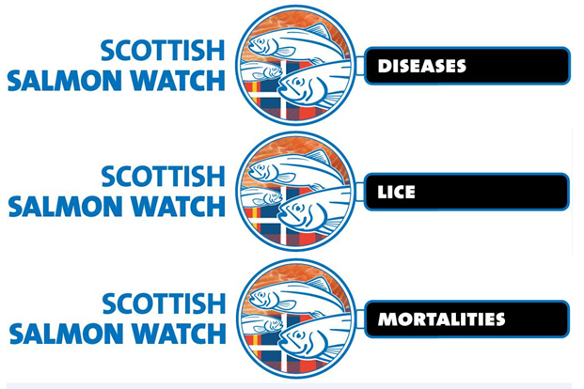

Data accessed via Scotland's Aquaculture web-site reveals that the average production cycle for Scottish salmon farms is currently 16.5 months (sourced from 2013-2017 data - sadly monthly biomass data is only available up to December 2017). This compares to 20.1 months a decade ago (sourced from 2002-2007 data - monthly biomass data is only available from 2002).

Whilst operators in the period 2002 to 2007 all reported production cycles around 20 months (the shortest was Grieg Seafood at 19.4 months and the longest was Marine Harvest at 20.5 months) there was significant fluctuations for the current period (2013-2017). Loch Duart and Cooke Aquaculture reported the shortest production cycle at 13.2 months and 13.5 months respectively with Marine Harvest reporting 16.2 months; both Scottish Sea Farms and The Scottish Salmon Company reporting 18 months and Grieg Seafood the longest at 19.1 months.

Sites operated by Cooke Aquaculture shortened their production cycle by 6.8 months; Loch Duart sites by 6.7 months; Marine Harvest sites by 4.3 months; Scottish Sea Farms sites by 2.3 months and Grieg Seafood by 0.1 month (Kames Fish Farming and Wester Ross Fisheries were not included due to the small sample size and the Scottish Salmon Company only analysed in relation to the current period as it did not exist in 2002-2007).
Background:

The Rural Economy & Connectivity Committee's oral evidence on 2 May 2018, as part of the Scottish Parliament's salmon farming inquiry, included a discussion on 'early harvesting':

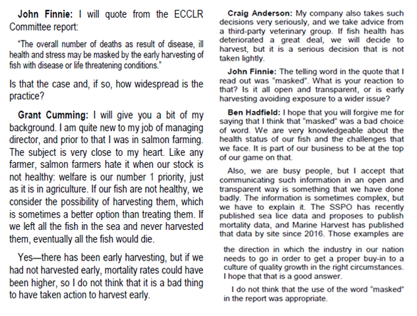

In March, as part of the Environment, Climate Change & Land Reform (ECCLR) Committee's inquiry into the environmental impacts of salmon farming, the ECCLR Committee published a report on the environmental impacts of salmon farming which included:

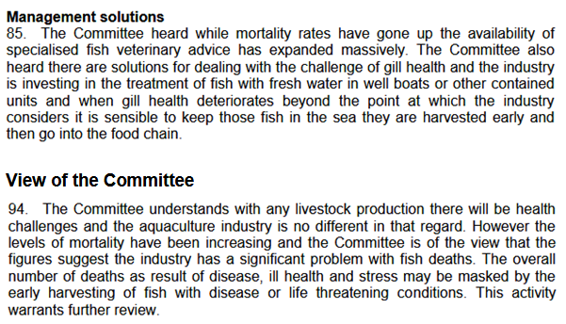
'Scotland’s 10 Year Farmed Fish Health Framework' published on 23 May 2018 claimed: "The increased ability to grow larger smolts provides the opportunity to reduce the marine grow out phase of farmed salmon, thus reducing the time spent in sea and the length of exposure to marine challenges such as sea lice."
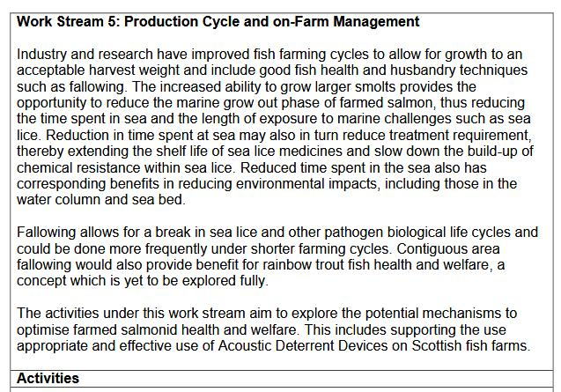
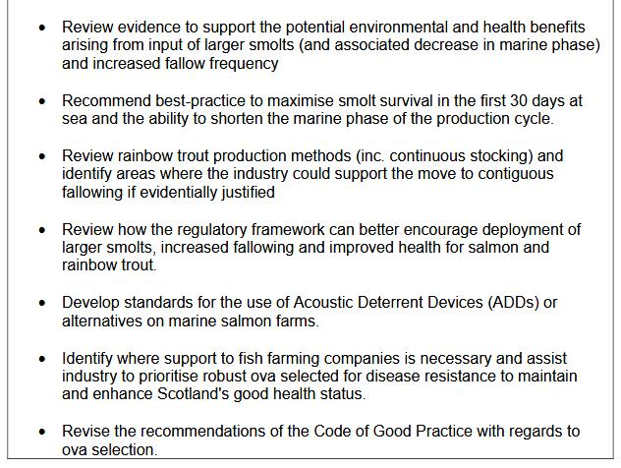

Fish Farming Expert reported in March 2018:

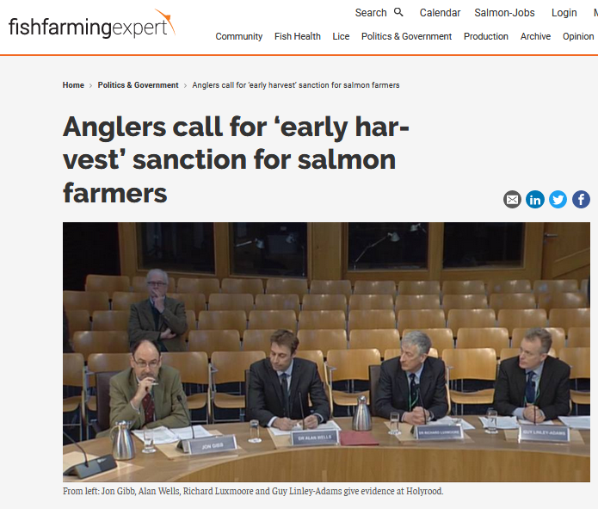

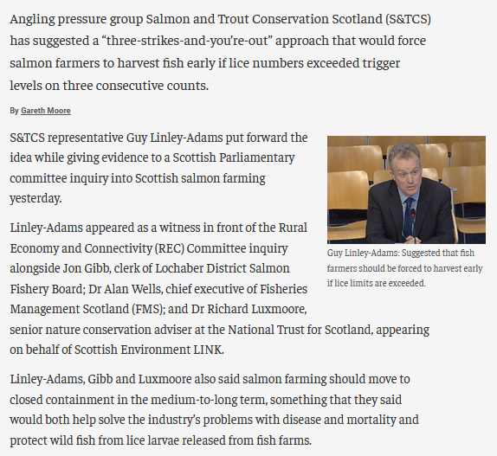

Here's the transcript from the Scottish Parliament's meeting on 14 March 2018:

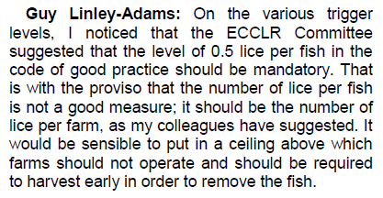

Fish Farming Expert reported in May 2018:

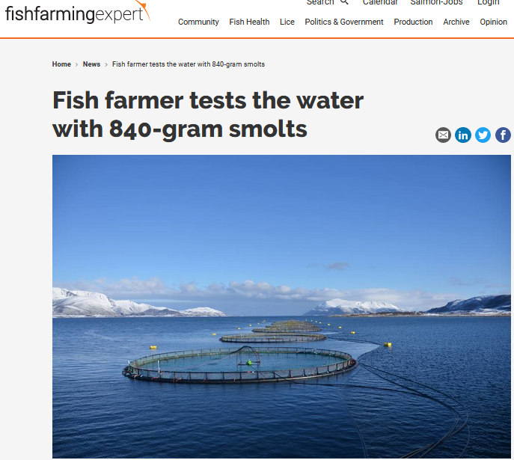
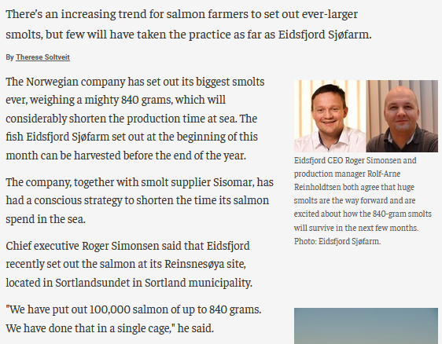
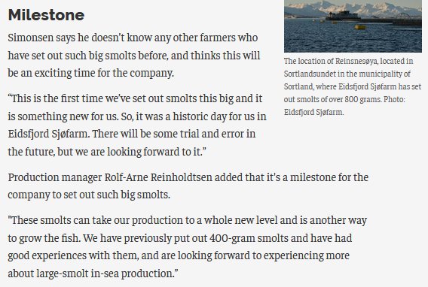

The article also included:

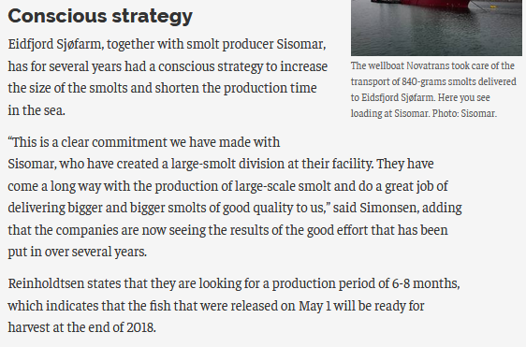

Data published by the Scottish Government's annual fish farm surveys shows weights of farmed salmon inputted as smolts into the sea and final weights at harvest - revealing a trend of increasing mean weight at harvest in year 0 (1.8 kg in 2006 compared to 2.9 kg in 2016) but comparable weights for harvest in year 1 and year 2:

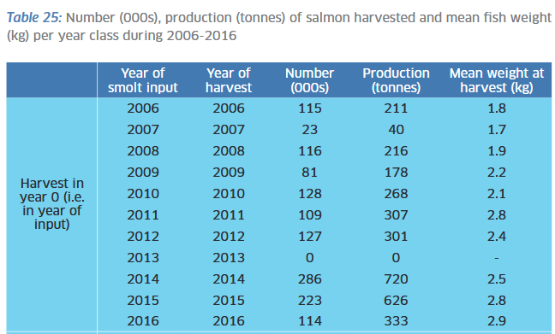
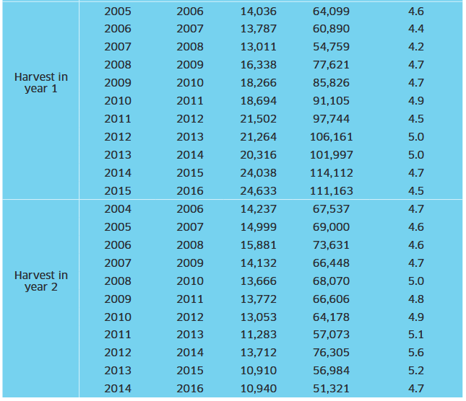

The weight of grisle and pre-salmon harvest during 2006-2016 increased up to 2013 but 2016 weights are on a par with 2006 weights.

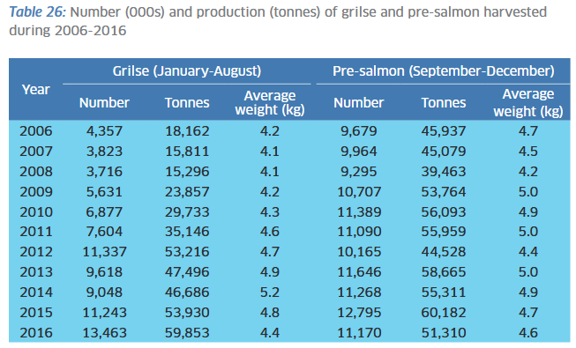
The latest fish farm survey (published in September 2017) shows that the mean weight of smolts in 1999 is on a par with the latest weights. In fact, the weight of smolts in 2000 (3.5 kg) for harvest year 0 is higher than any year since.


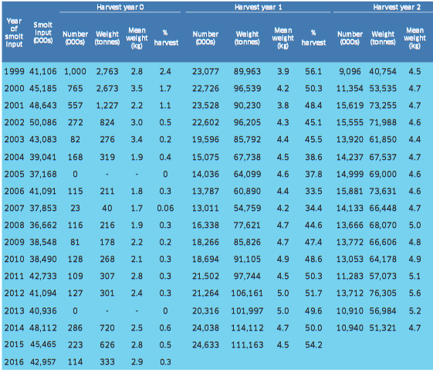

The current lack of up-to-date site-specific information on infectious diseases, lice infestation and mortalities does not make it easy to categorically link early harvesting at certain salmon farms with particular problems. However, disclosures via Freedom of Information and Case Information published by the Scottish Government has made some useful information available which can be cross-referenced with production time-lines.

For example, a FOI disclosure by the Scottish Government revealed that Marine Harvest, Scottish Sea Farms and the Scottish Salmon Company experienced serious problems are various sites in 2017. The top twenty mortality events reported by Marine Harvest in 2017 (up to November) were:

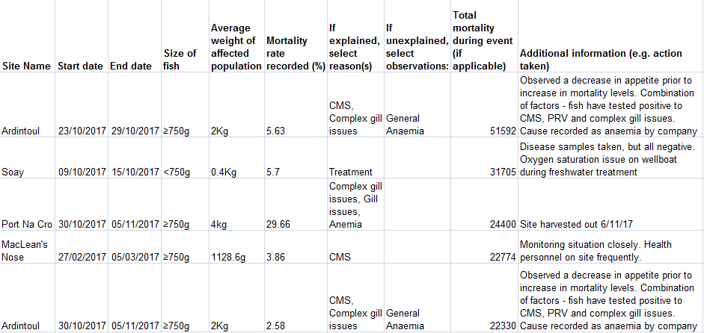
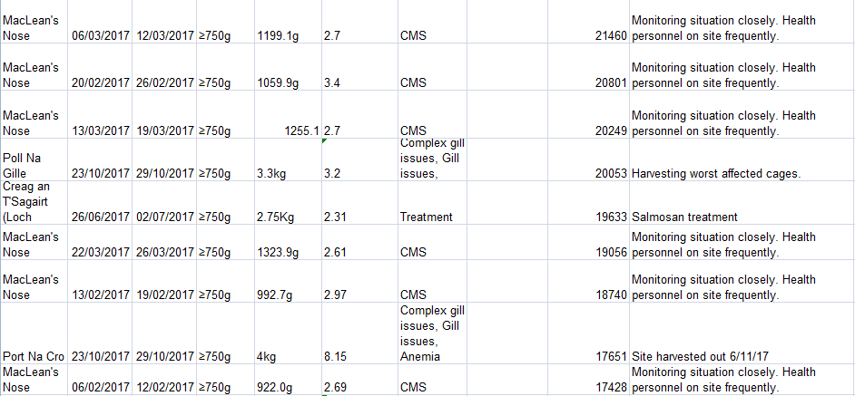
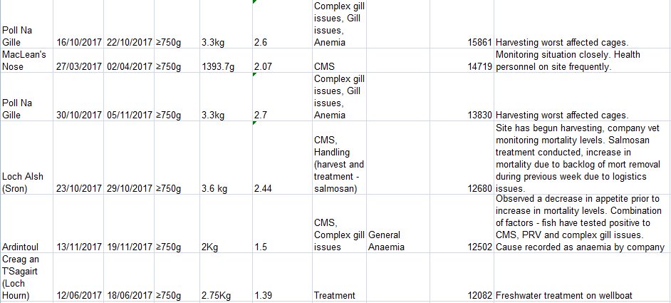

"Harvesting worst affected cages" reported Marine Harvest for Poll Na Gille in November 2017 and "Harvested worst affected cages first" reported Marine Harvest for Linnhe in June 2017. Download the Excel spreadsheet online here.
The top ten mortality events reported by Scottish Sea Farms in 2017 (up to November) included several farms which were described as "site is harvesting early":

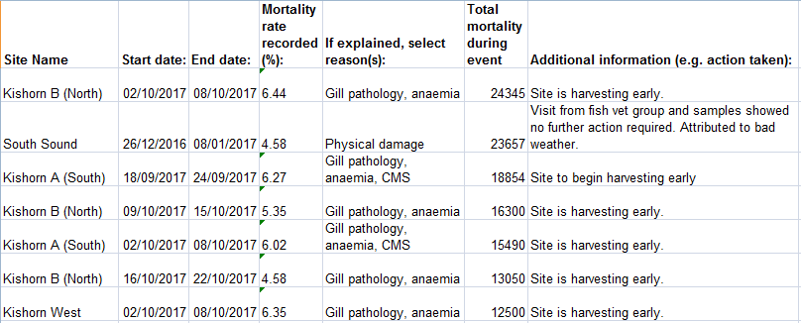
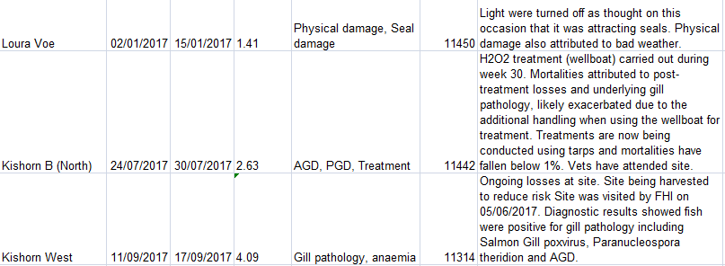

"Harvesting is underway at affected cages to reduce risk"; "Five affected cages to be harvested out, harvesting underway" and "Site being harvested to reduce risk" reported Scottish Sea Farms in relation to Kishorn West. "Site to begin harvesting early" reported Scottish Sea Farms in relation to Kishorn A (South) and Kishorn B (North). "Site is harvesting early" reported Scottish Sea Farms in relation to Kishorn B (North), Kishorn West and Kishorn B (South). Download the Excel spreadsheet online here.

The top ten mortality events reported by the Scottish Salmon Company in 2017 (up to November) included Loch Tuath which was described as "worst effected cages (sic) harvested and reducing biomass":

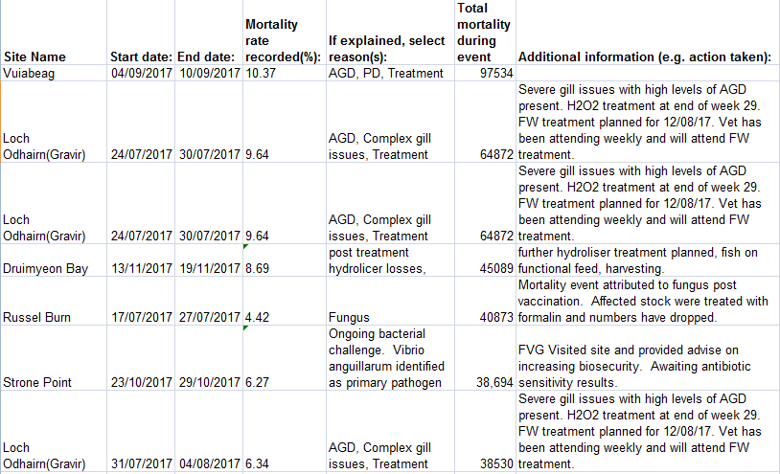
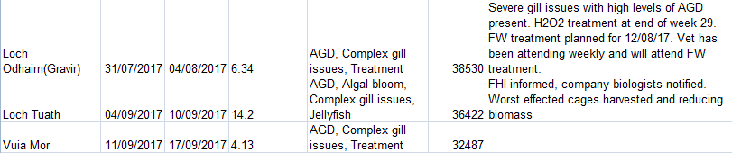

"Site partially harvested to remove worst affected fish - remainder of site due to fallow by end of January 2018" and "Harvesting to reduce biomass" reported the Scottish Salmon Company in relation to Druimyeon Bay. "Planning to harvest out soon" reported the Scottish Salmon Company in relation to Loch Tuath. "Accelerated harvests"; "Biomass has been lowered but gill issues continuing" and "Site has harvested largest grade cages to lower biomass, gill health issues ongoing" reported the Scottish Salmon Company in relation to Loch Odhairn/Gravir. "Hoping to grade out poor doers to reduce biomass" reported the Scottish Salmon Company in relation to Inch Kenneth. Download an Excel spreadsheet online here.

The FOI data also reveals over 135,000 dead salmon due to mechanical treatments with the Thermolicer killing 45,000 and the Hydrolicer killing 90,000 fish:

- Mortality events reported by Marine Harvest in 2017 include three cases (in Creag an T'Sagairt, Cairidh & Caolas A Deas) involving over 20,000 dead salmon due to using a Thermolicer.

- Mortality events reported by Scottish Sea Farms in 2017 include six cases (in Nevis C, Nevis B, Nevis A & South Sound) involving over 25,000 dead salmon due to using a Thermolicer.

- Mortality events reported by the Scottish Salmon Company in 2017 include eight cases (Driumyeon Bay, Sgian Dubh, Sgeir Dughall, North Uiskevagh, Kenmore & Inch Kenneth) involving 90,000 dead salmon due to using a Hydrolicer.

An email obtained via FOI from the Scottish Government revealed that Marine Harvest was experiencing increases in mortality from nine sites in late October 2017 citing "Anaemia issues", "CMS" and "complex gill issue" which "are being managed through harvesting and treatment". "Some fish treated with antibiotics with some positive effect, plan to harvest out ASAP once below MRL," reported Marine Harvest in relation to North Shore (Loch Erisort).


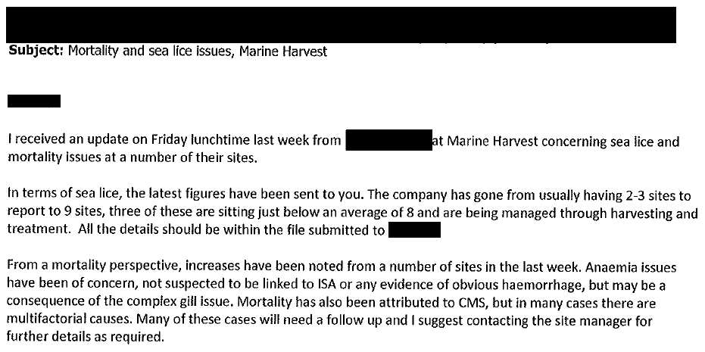
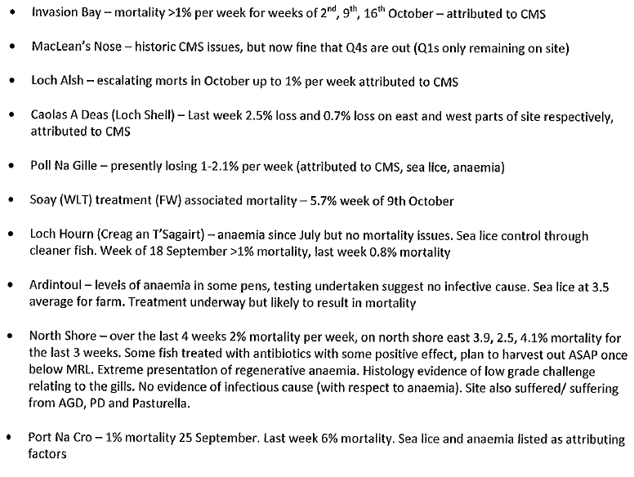
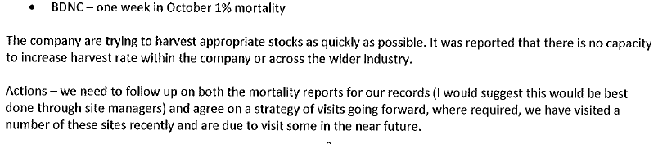

Other data published monthly by Marine Harvest indicates that Cardiomyopathy Syndrome (CMS) started causing mortality problems at MacLean's Nose in February 2017 (10.79% mortality) with problems continuing in March 2017 (11.17% mortality - with 4.02% mortality also reported at Loch Alsh); April 2017 (12.6% and 3.79% at Loch Alsh); May 2017 (13.96%); June 2017 (9.77%) and July 2017 (4.07%).

FOI data obtained from SEPA reveals that the ten biggest monthly losses at Marine Harvest salmon farms during 2017 (up to September) were as follows:

149,949 at Colonsay in August (reported via Scotland's Aquaculture as 12,439kg)
97,235 at MacLeans Nose in March (reported via Scotland's Aquaculture as 107,760 kg)
87,914 at MacLeans Nose in April (reported via Scotland's Aquaculture as 135,641kg)
85,147 at MacLeans Nose in May (reported via Scotland's Aquaculture as 156,754kg)
76,913 at Tabhaigh in August (reported via Scotland's Aquaculture as 265,069kg)
70,627 at MacLeans Nose in February (reported via Scotland's Aquaculture as 67,757kg)
62,747 at Erisort (North Shore East) in September (reported via Scotland's Aquaculture as 214,813kg)
48,620 at Soay Sound in August (reported via Scotland's Aquaculture as 3,645kg)
41,946 at Creag an Sagairt West in June (reported via Scotland's Aquaculture as 116,536kg)
41,615 at Ardintoul in February (reported via Scotland's Aquaculture as 4599kg)

Read more via:
"Data on Mortalities & Diseases at Scottish Salmon Farms"
"Scottish Salmon's Mort Mountain Leaps Over 10 Million - FOI reveals 2.3 million dead salmon at Marine Harvest farms in 2017".
"Hard Evidence: Dossier of Data on Lice, Diseases & Mortalities at Scottish Salmon Farms"

A FOI reply by the Scottish Parliament in April 2018 (search for # 603922) - cites health problems at Marine Harvest's sites during 2018 in Loch Greshornish and Loch Duich:

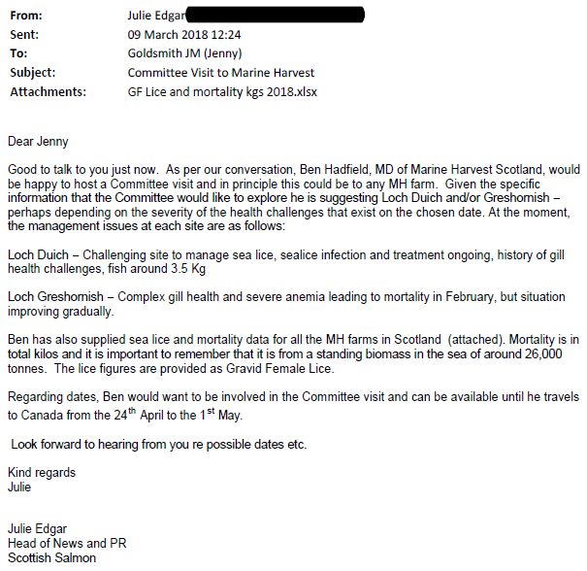

Monthly data on lice levels and mortalities was also disclosed by Marine Harvest to the Scottish Parliament:
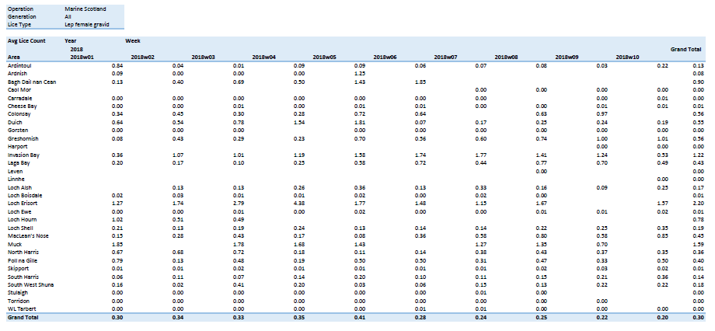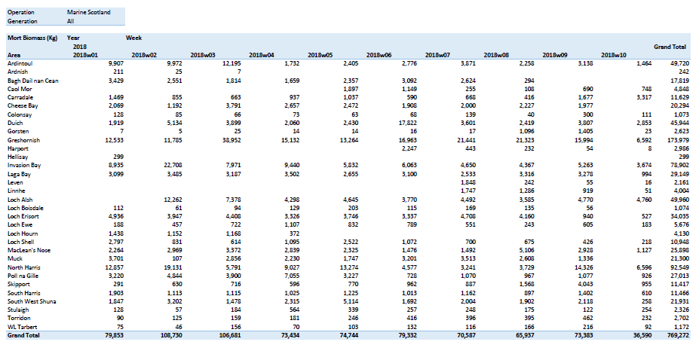
Download as a PDF online here
Read more via "Media Backgrounder: Marine Harmfest Scotland"

Other 'Case Information' is published via the Scottish Government's Fish Health Inspectorate which currently holds data for 2013; 2014; 2015; 2016 and 2017.

The latest Case Information (October to December 2017) detail Cases 20170340-20170460 which includes reference to a "decision taken quickly to empty site" following a rapid rise in mortality reported as due to "gill issues, anaemia" at Marine Harvest's Port Na Cro salmon farm in November 2017. "Issues with gills and anaemia have lead to decision to harvest," concluded the Fish Health Inspectorate report.
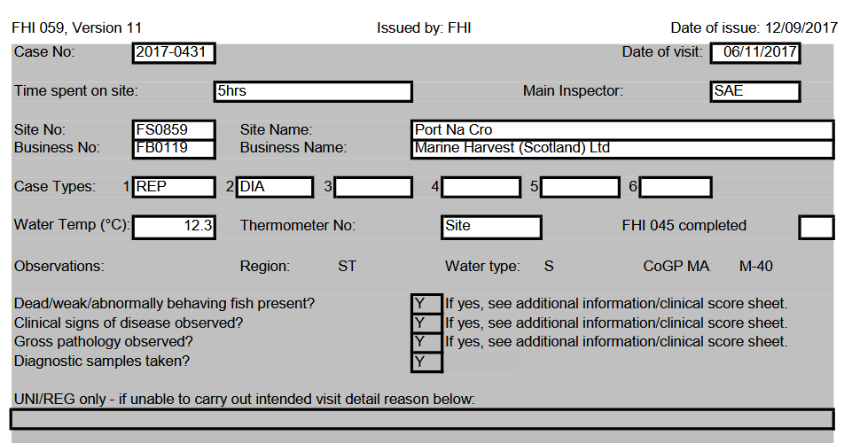
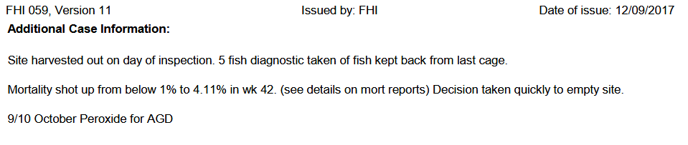
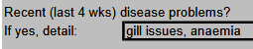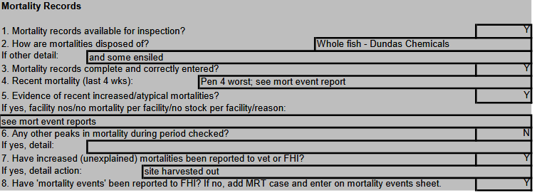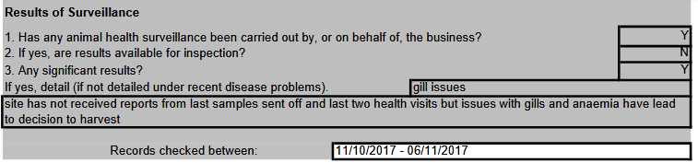
Mortality due to "complex gill issues" at Marine Harvest's Port Na Cro salmon farm was recorded as high as 29.66% in October 2017:

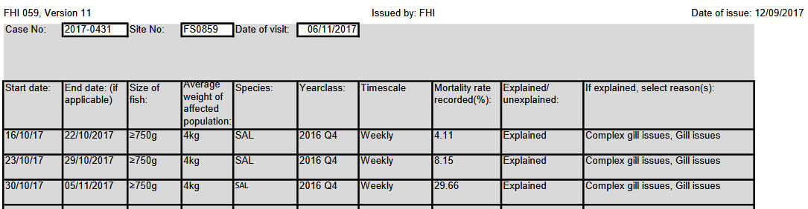

Over 50,000 morts were reported citing "General Anaemia":

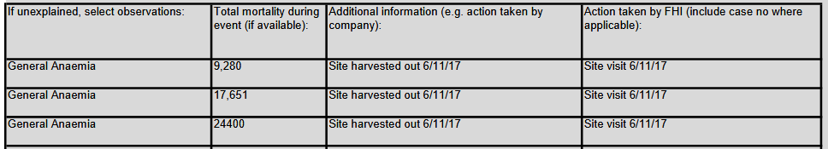

The Scottish Government reported in a letter to Marine Harvest positive tests for proliferative gill pathology with lesions consistent with amoebic gill disease (AGD), epitheliocysts, Piscine myocarditis virus (PMCV) consistent with mild cardiomyopathy syndrome (CMS), Paranucleospora theridon and salmon gill poxvirus (SGPV).

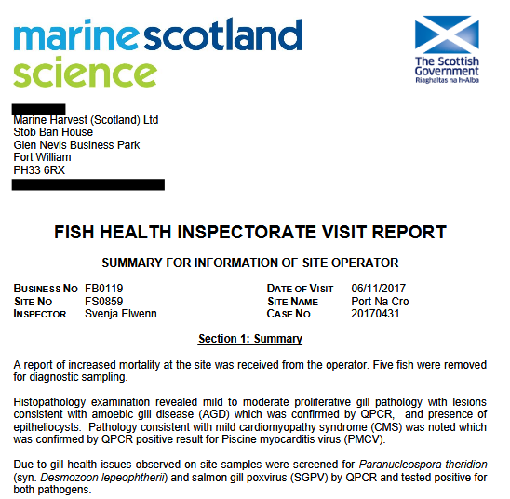
Another FHI visit report dated October 2017 for The Scottish Salmon Company's Loch Tuath salmon farm "revealed complex gill pathology including the presence of amoebic cells suggestive of amoebic gill disease and evidence of gill poxvirus"; "Epitheliocystis were noted and tested positive to Canditus Branchiomonas cysticola" and "Vascular damage and mid hepatic necrosis was also noted". Farmed salmon also tested positive for Parvicapsula pseudobranchicola and Paranucleospora theridon.
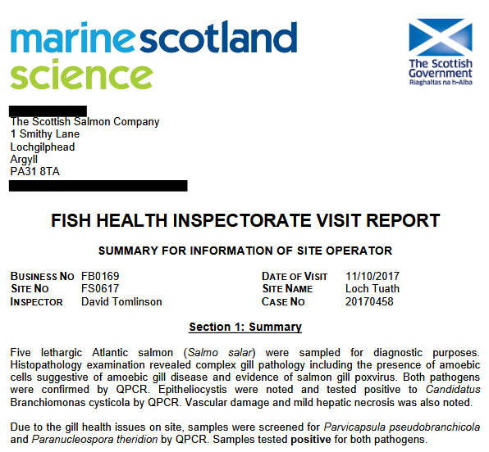

A FHI visit report from October 2017 reported disease problems:

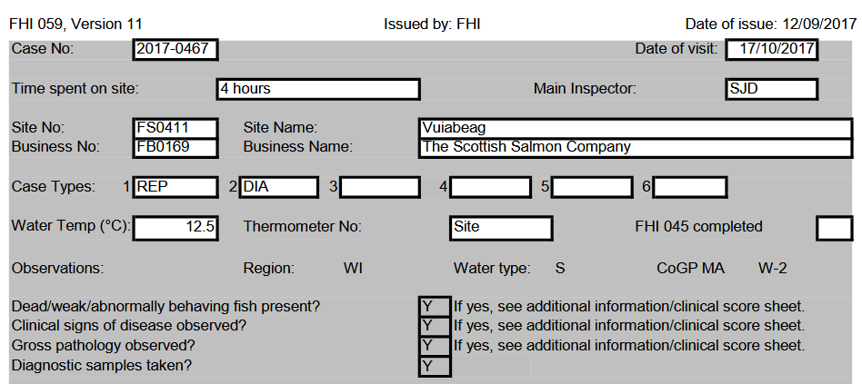

The report for The Scottish Salmon Company's salmon farm at Vuia Beag in Loch Roag detailed "complex disease issues" including "AGD, Para Ther, Salmon gill pox, Microsporidia, SAV and epitheliocystis" with "plans to move all fish to Eughlam in December":

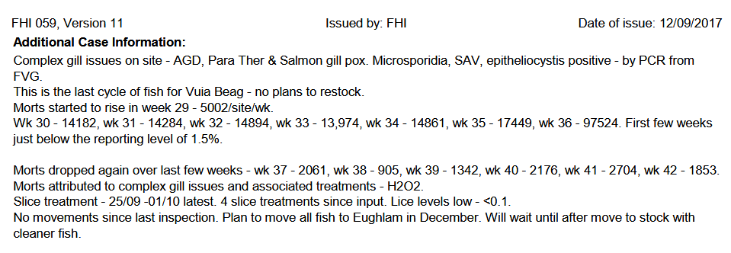

The report also detailed "deformed spine":

As well as a "strong presence" of moribund, anorexic and lethargic farmed salmon in addition to lesions on the flank and a "medium presence" of necrotic gills.

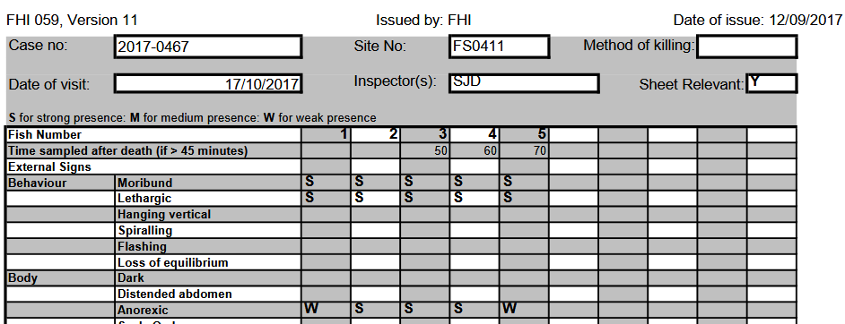

Marine Scotland Science's FHI visit report dated October 2017 included:

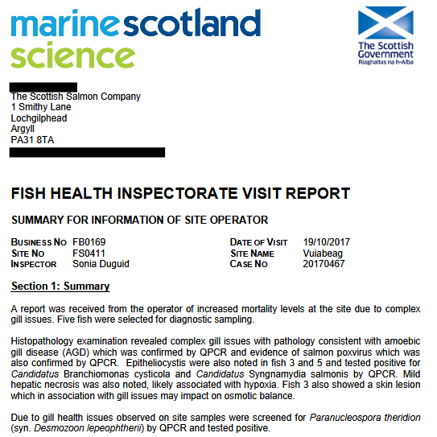

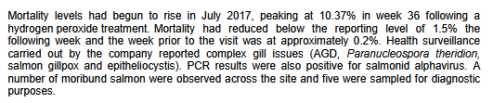

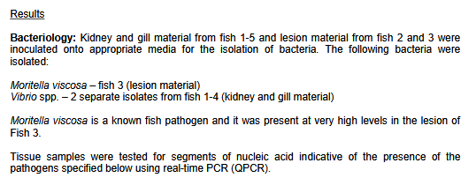

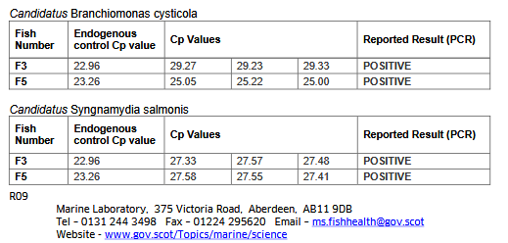

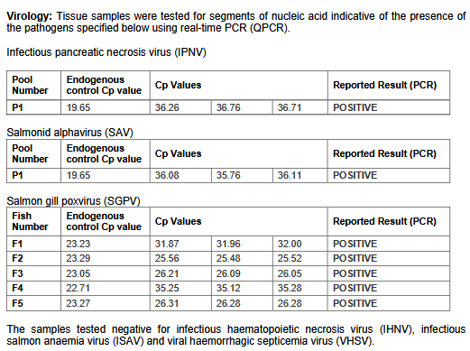

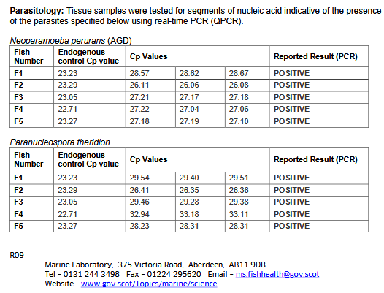

A FHI visit report from October 2017 for The Scottish Salmon Company's salmon farm at Vuia Mor in Loch Roag detailed a total mortality since input of 30.23% with 32,487 morts. Recent disease issues cited were PGD, AGD, Para Ther, Sal Gill pox, PD, HSMI, microsporidia and epitheliocystis.

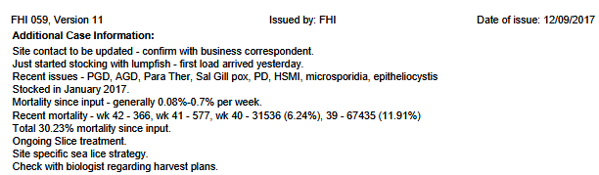

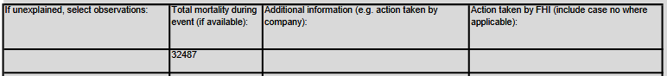

A FHI visit report from October 2017 for Marine Harvest's salmon farm at North Shore in Loch Erisort detailed a "presumptive Pasteurella skyensis diagnosis" and "pathology consistent with previous Pasteurella infections" as well as "some cadiomyopathy", Pancreas Disease, AGD (Amoebic Gill Disease), Salmon gill pox and ParaTher (Paranucleospora theridon):

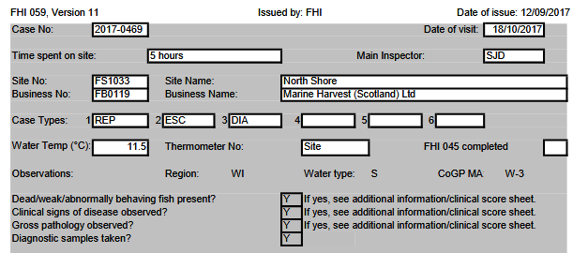

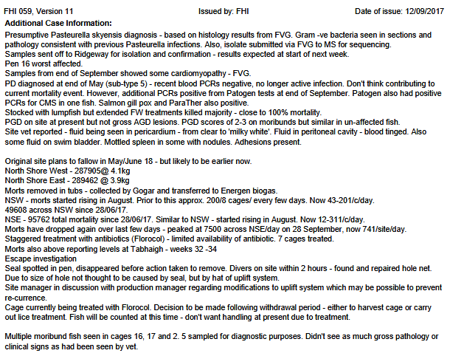

Deformities such as a "shortened upper jaw" and "eyes damaged" were also reported:
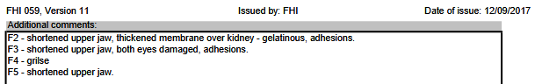

The FHI visit report for Marine Harvest's salmon farm at North Shore in Loch Erisort detailed:

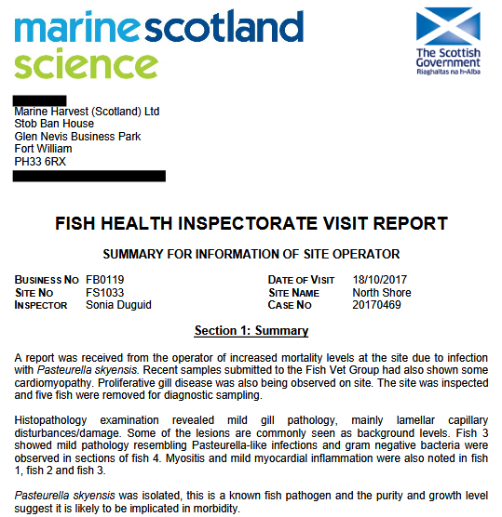
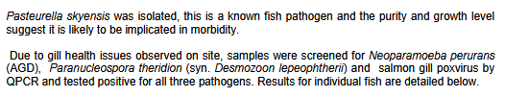
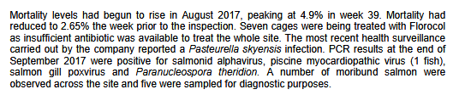
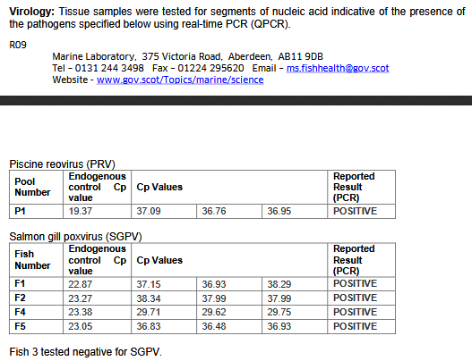

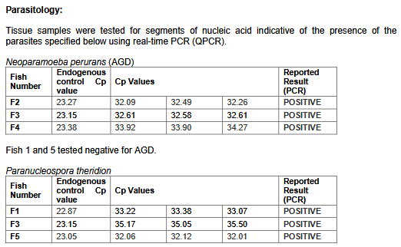

"About 125,000 salmon have died due to a disease outbreak at two fish farms on the Isle of Lewis," reported BBC Scotland in October 2017. "Marine Harvest confirmed that the sites in Loch Erisort have been hit by the bacterium Pasturella Skyensis". "Macleans Nose in Loch Sunart, where salmon have also been exposed to AGD, is believed to be infected by Pasteurella skyensis, too," reported Fish Update in October 2017.

"A staggering 177,000 were hauled out of one loch [Erisort] last autumn," reported The Daily Mail in January 2018.
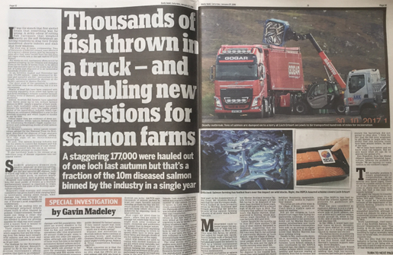

Download high res images via Photo Gallery: Dead Salmon from Scotland's Disease-Ridden Salmon Farms

A FHI visit report from October 2017 for a salmon farm in Loch Kishorn (Kishorn A) operated by Scottish Sea Farms detailed disease problems including AGD, sea lice damage to the heads of farmed salmon, Paranucleospora theridon, salmon gillpox, Branchiomonas, lamellar bleeding of the gills, CMS and HSMI like pathology:

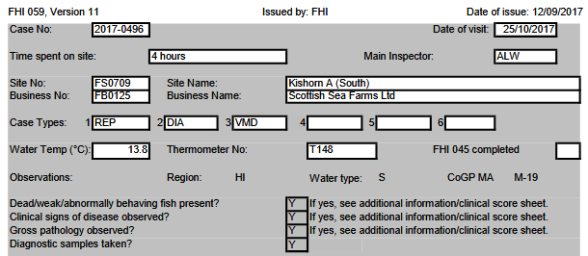

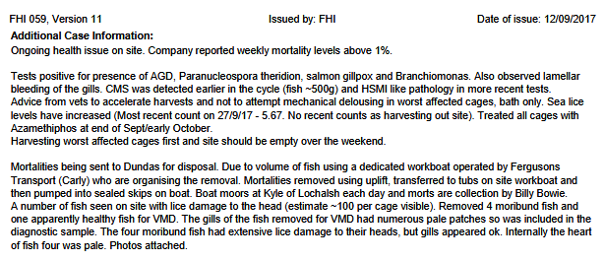

The FHI visit report clearly states "harvesting out site, advised to avoid crowding" as an action response to increased mortalities:

Marine Scotland Science detailed in their FHI Visit Report for October 2017 "complex gill issues" - including pathology consistent with epitheliocystis, amoebic gill disease (AGD), evidence of salmon gill poxvirus, mild hepatic necrosis, mild cardiomyopathy, Paranucleospora theridon, Vibrio sp. and Pseudomonas fluorsecens:

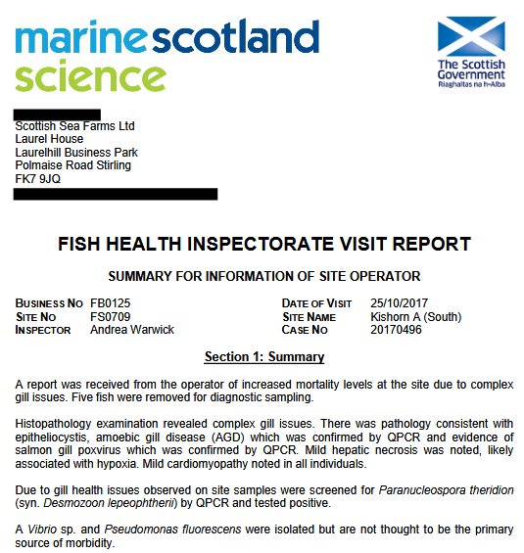

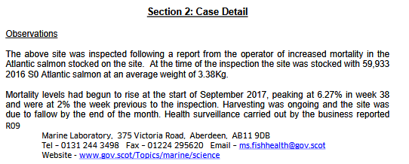

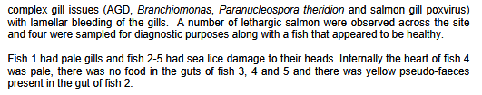
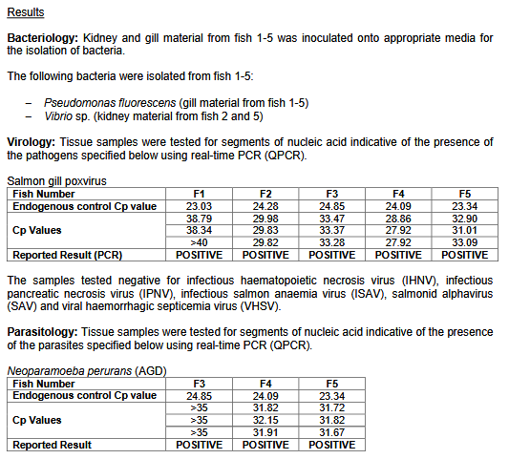

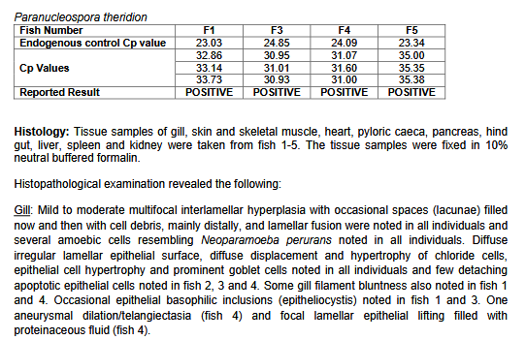

The FHI visit report from October 2017 for another salmon farm in Loch Kishorn (Kishorn B) operated by Scottish Sea Farms detailed similar disease problems including AGD, Paranucleospora theridon, salmon gillpox and Branchiomonas, lamellar bleeding of the gills and sea lice damage to the heads of farmed salmon.

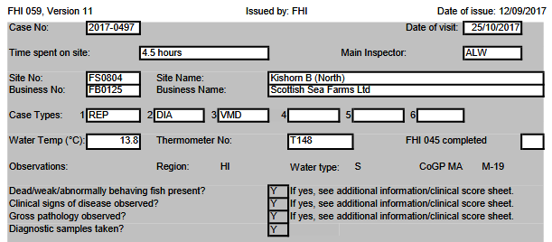

The FHI visit report (October 2017) for the Kishorn B (North) salmon farm operated by Scottish Sea Farms in Loch Kishorn stated: "Harvesting worst affected cages first and site should be empty in next six weeks".

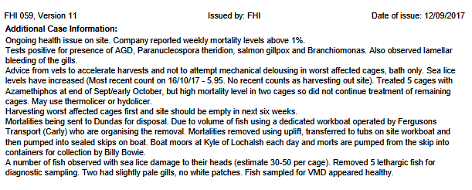

"Advised to accelerate harvest" stated the FHI visit report for October 2017:

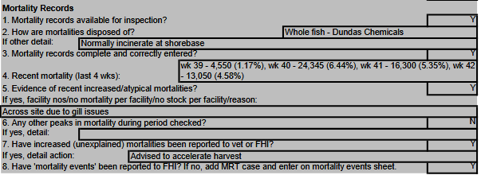
Marine Scotland Science detailed in their FHI Visit Report for October 2017 "complex gill issues" - including pathology consistent with amoebic gill disease (AGD), evidence of salmon gill poxvirus, epitheliocystis, hepatic necrosis, Paranucleospora theridon, Vibrio sp, Branchiomonas cysticola and Candidatus Syngamydia salmonis:

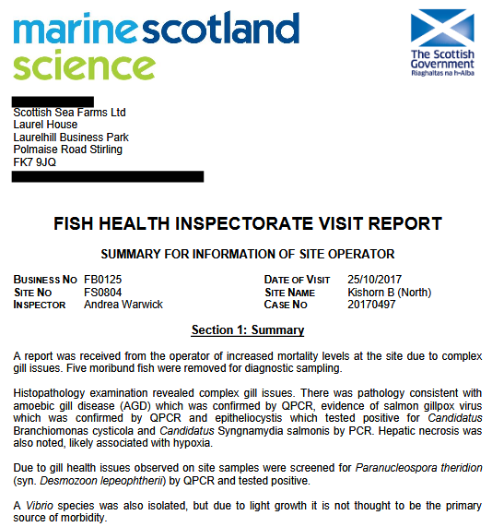

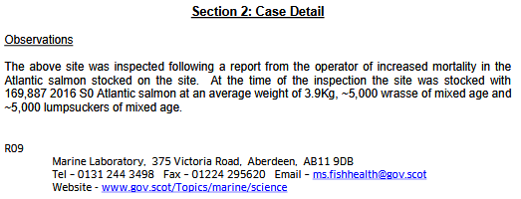

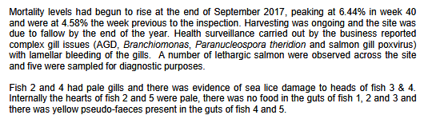

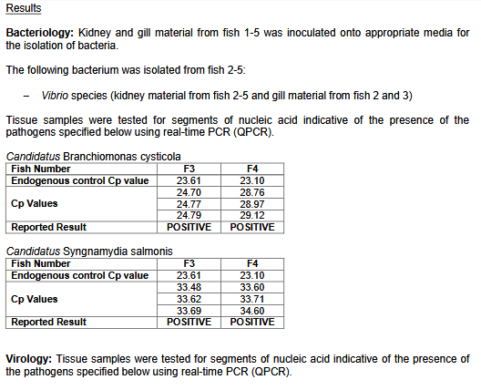

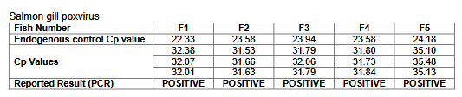

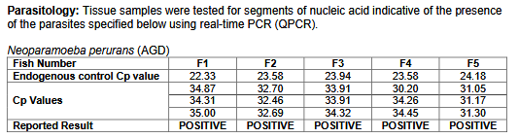
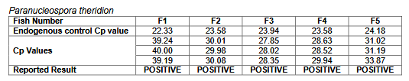

Read more about Candidatus Syngnamydia salmonis via:

Characterization of ‘Candidatus Syngnamydia salmonis’ (Chlamydiales, Simkaniaceae), a bacterium associated with epitheliocystis in Atlantic salmon (Salmo salar L.)
Genotyping of Candidatus Syngnamydia salmonis (chlamydiales; Simkaniaceae) co-cultured in Paramoeba perurans (amoebozoa; Paramoebidae)

Information on other diseases reported on Scottish salmon farms was reported via "Scottish Salmon's Mort Mountain Leaps Over 10 Million - FOI reveals 2.3 million dead salmon at Marine Harvest farms in 2017" in February 2018 - including:

Amoebic Gill Disease (AGD), Proliferative Gill Disease (PGD), Chlamydia and other conditions listed as "complex gill issues" and "gill pathology" have decimated Scottish salmon farming over the last decade (read more via "Gill Diseases: Scottish Salmon's Dirty Big Secret"; "Chlamydia and gill disease ravage Scottish salmon: GAAIA"; "Fit for the Queen - Loch Duart’s Chlamydia-Contaminated Salmon?"; "Characterization of “Candidatus Piscichlamydia salmonis” (Order Chlamydiales), a Chlamydia-Like Bacterium Associated With Epitheliocystis in Farmed Atlantic Salmon (Salmo salar)"; "Characteristics of chlamydia-like organisms pathogenic to fish" and "Characterization of ‘Candidatus Syngnamydia salmonis’ (Chlamydiales, Simkaniaceae), a bacterium associated with epitheliocystis in Atlantic salmon (Salmo salar L.)").

Pasturella skyensis was first reported on Scottish salmon farms in 2002 with another scientific paper co-authored by scientists at the University of Glasgow published in 2015. Read more on Pasteurella skyensis via: "125,000 salmon die in disease outbreak at Lewis fish farms"; "Disease kills 125,000 salmon on Lewis fish farm"; "Campaigners say 'no more salmon farms' after disease on Lewis kills 125,000 fish"; "Pasteurella skyensis sp. nov., isolated from Atlantic salmon (Salmo salar L.)" and "Characterization of two groups of Pasteurella skyensis isolates from Atlantic salmon, Salmo salar L., based on serotype and 16S rRNA and rpoB gene partial sequences".

Cardomyopathy Syndrome (CMS) was first reported on Scottish salmon farms in 2000 with Scottish Quality Salmon (the forerunner to the Scottish Salmon Producers Organisation) claiming "there is no cause for concern" in an interview with The Independent newspaper

Further data on diseases is presented via Scottish Salmon Watch's written submission to the Scottish Parliament's salmon farming inquiry: "Hard Evidence: Dossier of Data on Lice, Diseases & Mortalities at Scottish Salmon Farms" (March 2018).

Another FHI Fish Visit report dated October 2017 for the Kishorn West salmon farm operated by Scottish Sea Farms in Loch Kishorn included: "Advice from vets to accelerate harvests and not to attempted mechanical delousing in worst affected cages"; "Harvested out worst affected cages and should be empty within six weeks" and "Company may look at using Thermolicer/Hydrolicer to reduce lice levels while harvesting ongoing":

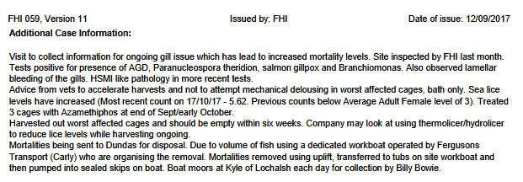
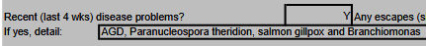

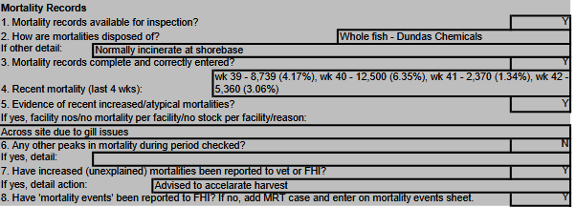

A FHI Fish Visit report dated November 2017 for Marine Harvest's salmon farm at Caolas A Deas in Loch Shell detailed disease problems including PGD (Proliferatitve Gill Disease), CMS (Cardiomyopathy Syndrome), PRV (Piscine Reovirus) and PD (Pancreas Disease).

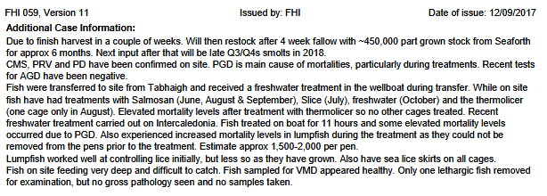
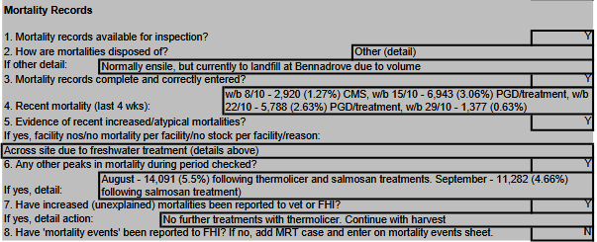
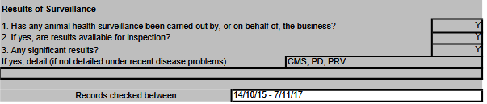

PRV (Piscine Reovirus) - which is linked to Heart & Skeletal Muscle Inflammation (HSMI) - has attracted significant media attention in Canada following the discovery in both wild and farmed salmon. "The disease Heart and Skeletal Muscle Inflammation (HSMI) is causing substantial economic losses to the Norwegian salmon farming industry where the causative agent, piscine orthoreovirus (PRV), is reportedly spreading from farmed to wild Atlantic salmon (Salmo salar) with as yet undetermined impacts," reported a scientific paper published by PLOS in December 2017. "These results suggest that PRV transfer is occurring from farmed Atlantic salmon to wild Pacific salmon, that infection in farmed salmon may be influencing infection rates in wild salmon, and that this may pose a risk of reduced fitness in wild salmon impacting their survival and reproduction."

PRV has affected salmon farms in Norway, Chile, Ireland, Canada, United States and Scotland.

Read more via:
"Piscine Reovirus (PRV): An Underestimated Pathogen in the Scottish Salmon Industry?"
"The effect of exposure to farmed salmon on piscine orthoreovirus infection and fitness in wild Pacific salmon in British Columbia, Canada"
"Piscine Orthoreovirus (PRV) and Heart and Skeletal Muscle Inflammation (HSMI)"
"A novel Totivirus and Piscine Reovirus (PRV) in Atlantic Salmon (Salmo salar) with Cardiomyopathy Syndrome (CMS)"
"First description of clinical presentation of piscine orthoreovirus (PRV) infections in salmonid aquaculture in Chile and identification of a second genotype (Genotype II) of PRV"
"An outbreak of disease resembling Heart and Skeletal Muscle Inflammation in Scottish farmed salmon, Salmo salar L., with observations on myocardial regeneration"
"Piscine orthoreovirus (PRV) infects Atlantic salmon erythrocytes"
"Piscine reovirus (PRV) in wild Atlantic salmon, Salmo salar L., and sea‐trout, Salmo trutta L., in Norway"
The Fish Site reported in 2015:

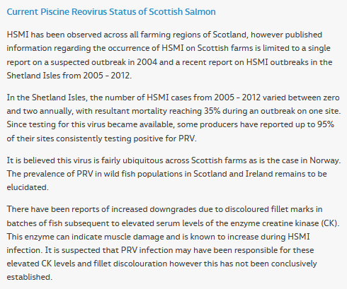

A FHI Fish Visit report dated November 2017 detailed disease problems at Cooke Aquaculture's salmon farm in the Stead of Aithness (Aith Voe) in Shetland.

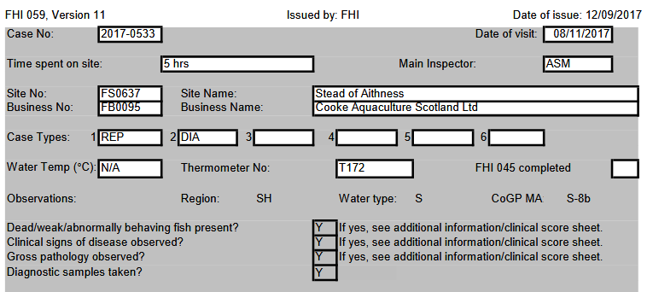

"Harvest has been accelerated by 1 months (sic) due to increased morts," detailed FHI Fish Visit report dated November 2017. "Top sweep is being harvest first (sic) from the worst affected cages."

"During the inspection of the stock on site there were many fish high in the water column," continued the FHI Fish Visit report dated November 2017. "Many fish were moribund and about 20-30 fish over the site were observed dead on the surface of the water."

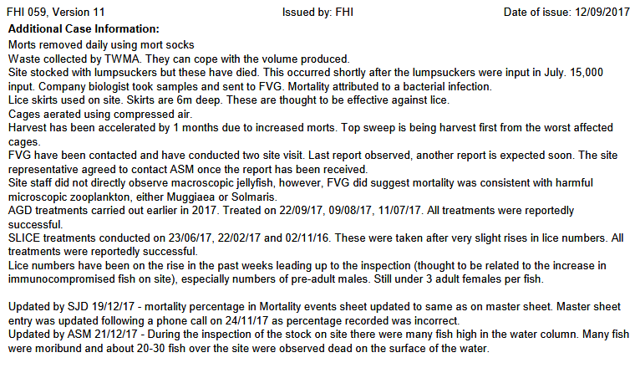

The mortality rate was reported as 11.52%.

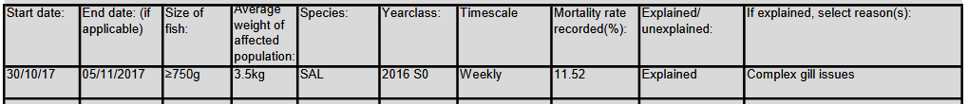

With total mortality of 58,590 farmed salmon.

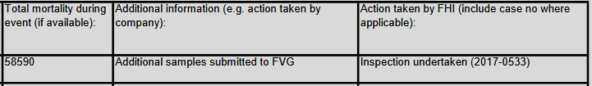

Marine Scotland Science detailed in their FHI Visit Report for November 2017 "pathology consistent with amoebic gill disease, presence of epitheliocystis and some features resembling salmon poxvirus" as well as mild hepatic necrosis and minor cardiomyopathy.

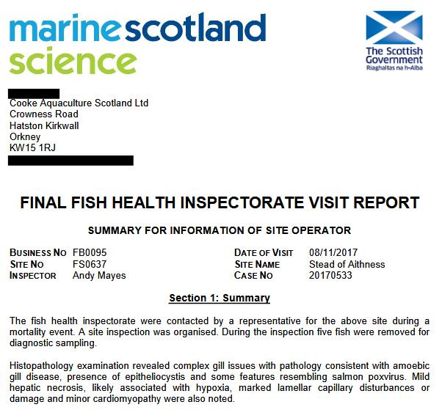

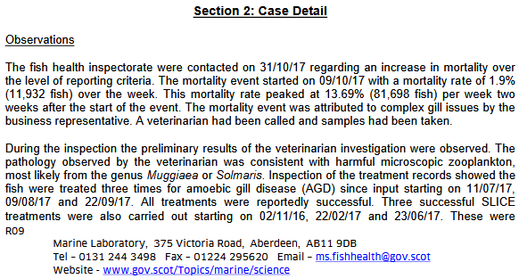

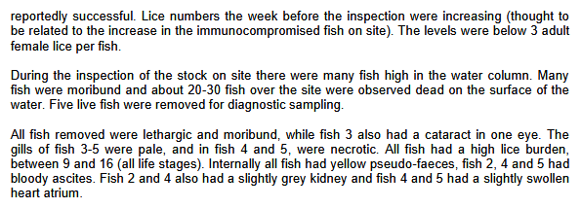

A FHI Fish Visit report dated November 2017 detailed disease problems at Marine Harvest's salmon farm at Ardintoul in Loch Alsh (a Special Area of Conservation protected via the EC Habitats Directive) - including CMS, PRV, AGD, Branchiomonas, Paranucleospora theridon and salmon gill poxvirus.

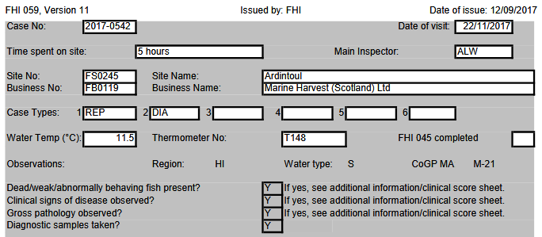

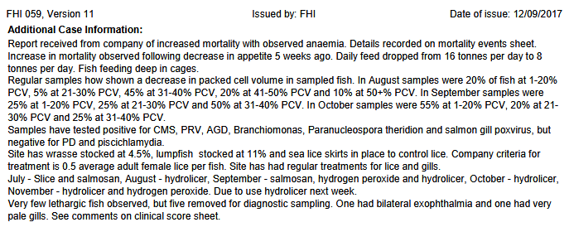

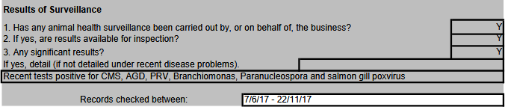

The FHI Fish Visit report dated November 2017 detailed a mortality rate of 5.63% and over 90,000 mortalities between late October 2017 and mid November 2017:

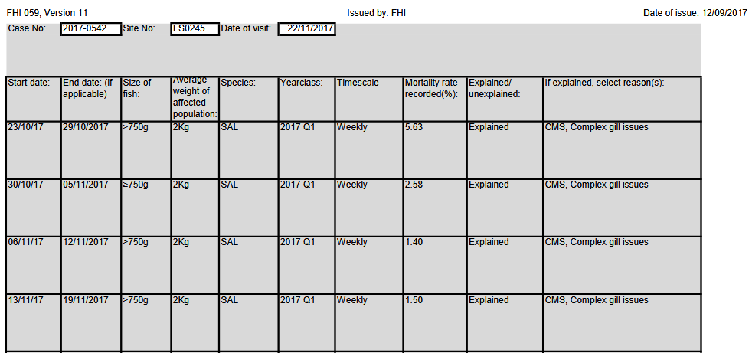

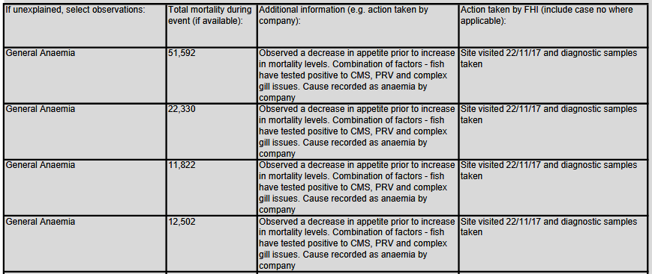

Marine Scotland Science detailed in their FHI Visit Report for November 2017 "complex gill issues with mild proliferative gill pathology" and stated: "Lesions were consistent with amoebic gill disease (AGD) and mid salmon poxvirus pathology". Epitheliocystis, Candidatus Branchiomonas cysticola and Candidatus Syngnamydia salmonis were noted along with "pathology consistent with mild cardiomyopathy syndrome (DMS)", piscine myocarditis virus, piscine reovirus (PRV), hepatic necrosis, granulomatous inflammation and Paranucleospora theridon.

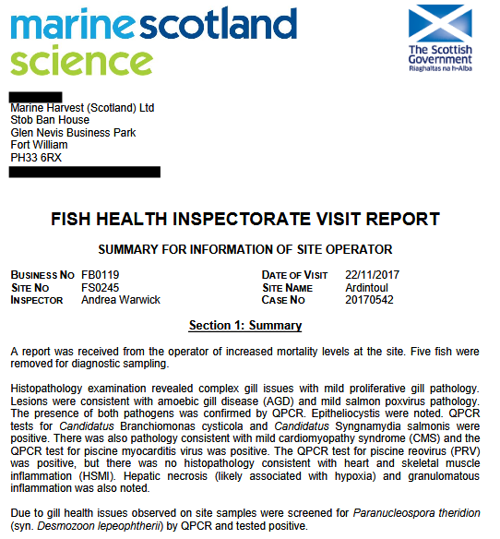
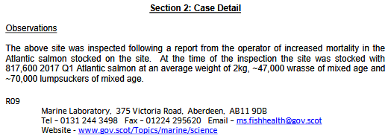
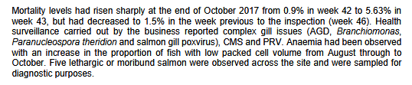
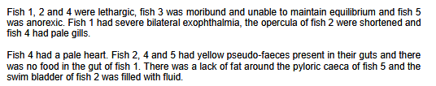

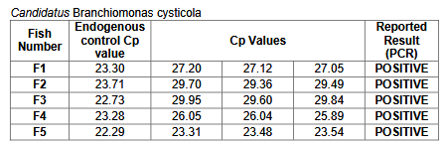

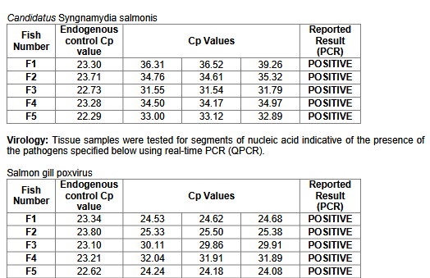

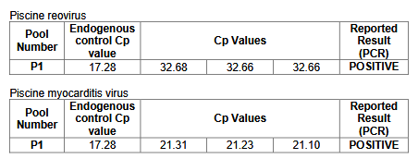

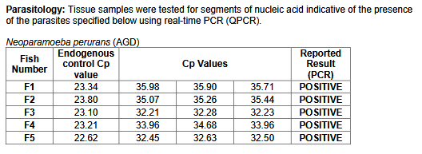

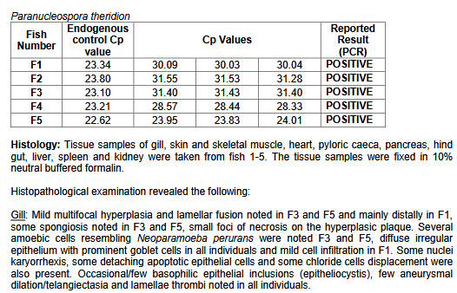

A FHI Fish Visit report dated November 2017 detailed disease problems at Cooke Aquaculture's Bow Hascosay salmon farm in Shetland - including AGD, PD, CMS and lice infestation.

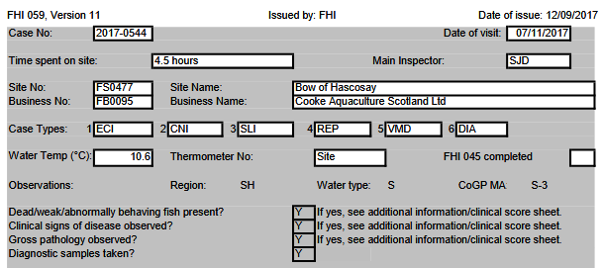

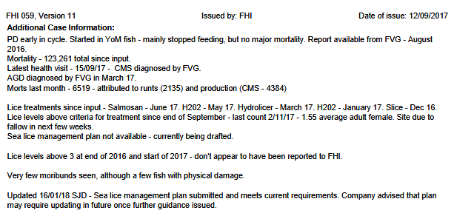

Marine Scotland Science's FHI Visit Report for November 2017 detailed "complex gill issues", cardiomyopathy syndrome, mild enteropathy and Tenacibaculum sp.

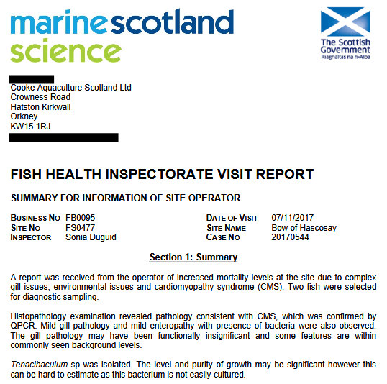

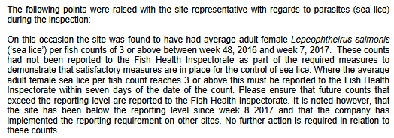

A FHI Fish Visit report dated November 2017 detailed disease problems at another Cooke Aquaculture salmon farm at East of Holm Heogland in Shetland - including "variable complex gill disease including PGD and lowlevel AGD"; "Low level HSMI type pathology" as well as Costia and branchiomonas.

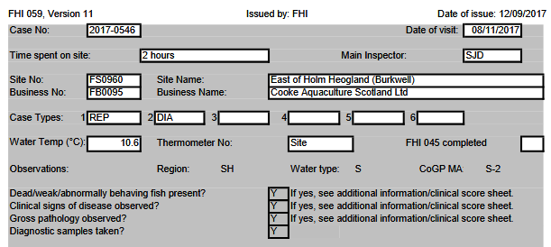

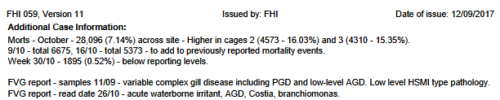

The FHI Fish Visit report dated November 2017 noted a pale/anaemic spleen and stated that the "heart lost shape when removed".

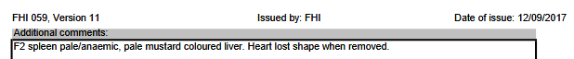

The FHI Fish Visit report dated November 2017 noted positive tests for Salmon gill poxvirus (SGPV), Piscine myocarditis virus (PMCV), Neoparamoeba perurans (AGD) and Paranucleospora theridon:

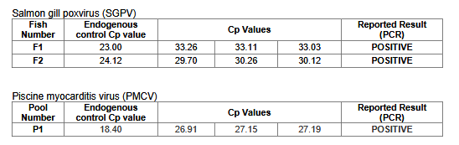
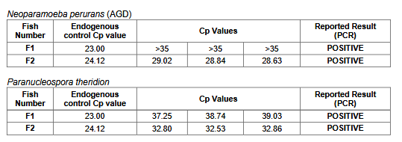

A FHI Fish Visit report for November 2017 detailed disease problems at another Cooke Aquaculture salmon farm at Winna Ness in Shetland - with over 30% mortality and "acute gill pathology".

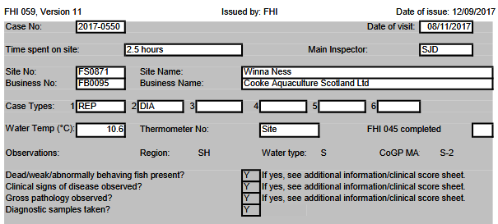

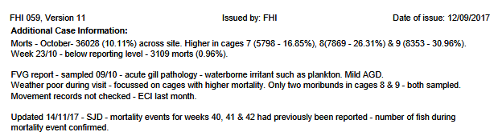

The FHI Fish Visit report for November 2017 detailed "complex gill issues", "pathology consistent with cardiomyopathy syndrome (CMS) and mild amoebic gill disease", "multifocal hepatic necrosis (likely associated with hypoxia)" and positive tests for Paranucleospora theridon (syn. Desmozoon lepeophtheri) and salmon gill poxvirus (SGPV).

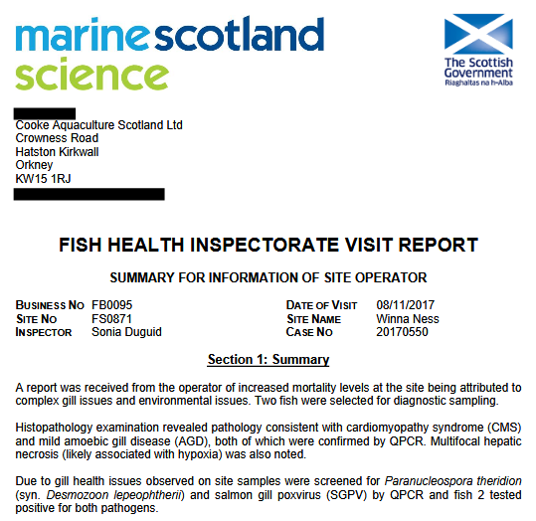

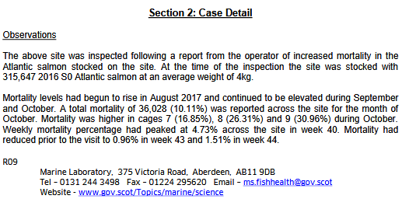

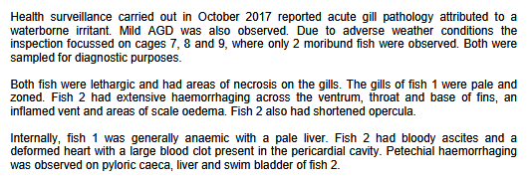

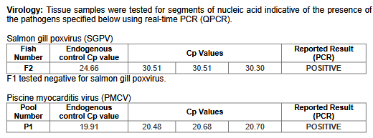

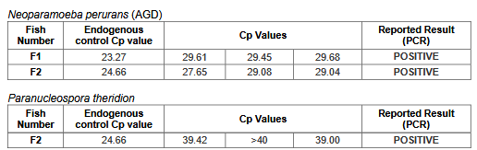

A FHI Fish Visit report dated November 2017 detailed disease problems at the Scottish Salmon Company's salmon farm at Portree on the Isle of Skye - including "complex gill issues", "anorexic and moribund fish", AGD, poxvirus and Desmozooan.

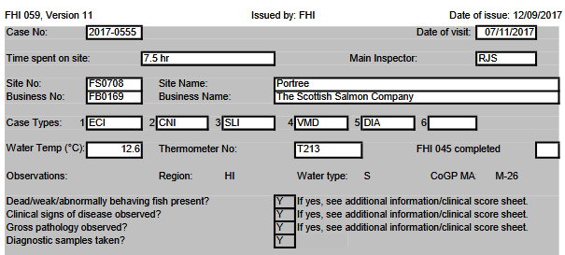

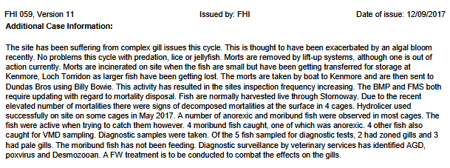

The FHI Fish Visit report for November 2017 detailed "complex gill issues with pathology consistent with amoebic gill disease, epitheliocystis, capillary disturbances and some evidences of salmon gill poxvirus" as well as positive tests for Neoparamoeba perurans, Paranucleospora theridon and salmon gill poxvirus.

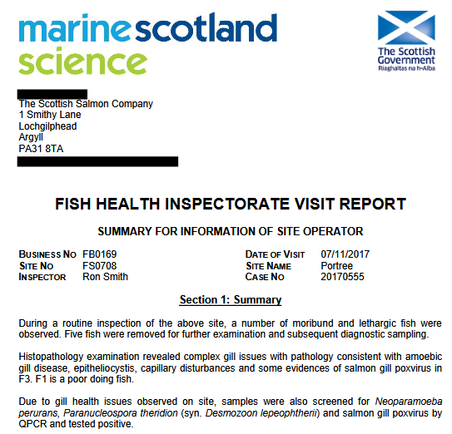

A FHI Fish Visit report dated November 2017 detailed disease problems at Marine Harvest's salmon farm in Loch Greshornish on the Isle of Skye - including 20-30 Caligus (sea lice) with farmed salmon reported as "belly up as if concussed from banging":

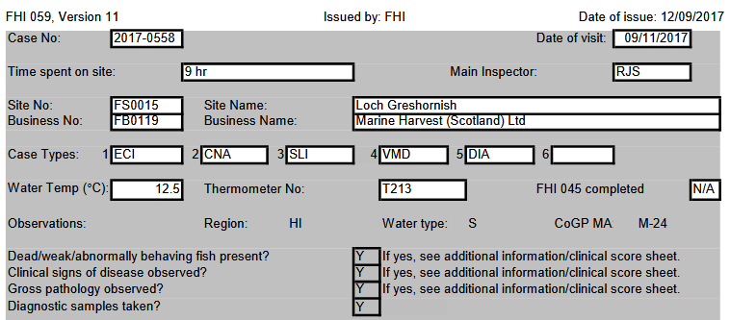

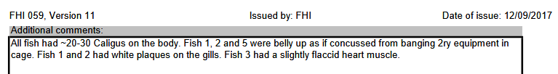

Marine Scotland Science's FHI Visit Report for November 2017 detailed "moribund and lethargic fish", "mild proliferative gill pathology with features consistent with amoebic gill disease (AGD), epitheliocystis, "anorexic poor-doing indivuduals" and positive tests for Neoparamoeba perurans, Paranucleospora theriodon (syn. Desmozoon lepeophtheri) and salmon gill poxvirus.

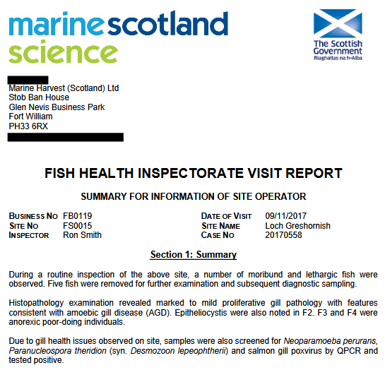

For more background on Desmozoon lepeophtheri read:
"A case study of Desmozoon lepeophtherii infection in farmed Atlantic salmon associated with gill disease, peritonitis, intestinal infection, stunted growth, and increased mortality"
"Gill pathology in Scottish farmed Atlantic salmon, Salmo salar L., associated with the microsporidian Desmozoon lepeophtherii"
The report identified farmed salmon with cataracts and anorexia.

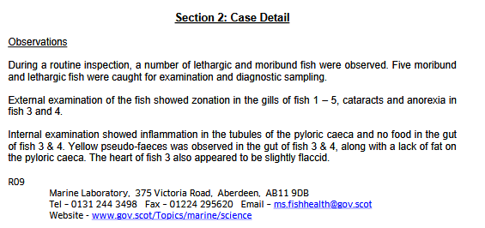

As well as positive tests for SGPV, AGD and Paranucleospora Theridon:

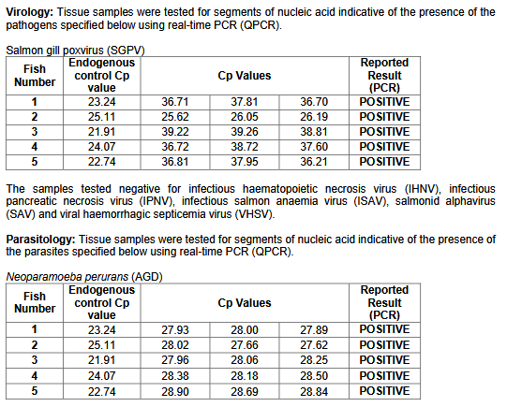
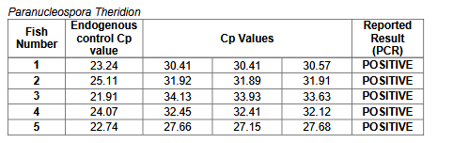

A FHI Fish Visit report dated November 2017 detailed disease problems at The Scottish Salmon Company's salmon farm at Strome Point in Loch Fyne - including AGD, gill issues and "large mortality" and "bacterial infection with V. anguillarum":

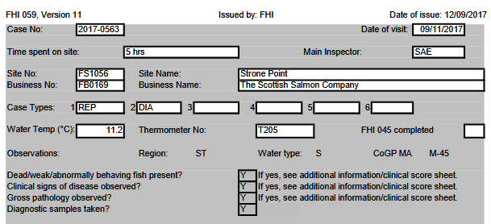

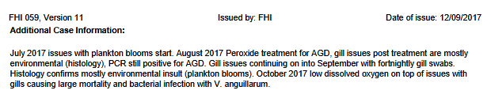

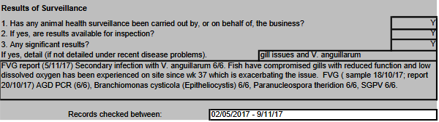

Read more about Vibrio anguillarum via:
"Clinical Vibrio anguillarum infection in lumpsucker Cyclopterus lumpus in Scotland"
"Vibrio anguillarum as a fish pathogen: virulence factors, diagnosis and prevention"
"Vibriophages and Their Interactions with the Fish Pathogen Vibrio anguillarum"

In terms of mortalities, The Scottish Salmon Company reported for Strome Point in Loch Fyne that "mortalities start to increase in the beginning of October" with 20-70 morts per day per cage and 3,000 - 6,000 per day per site:

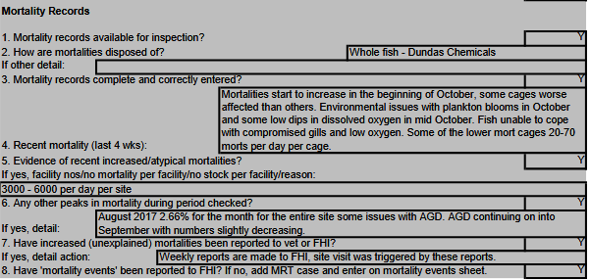

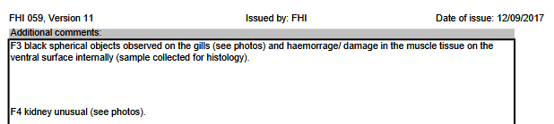

The FHI Fish Visit report dated November 2017 revealed "complex gill issues and some circulatory disturbance". "Pathology was consistent with mid amoebic gill disease and showed evidences of salmon poxvirus," continued the report. Epitheliocystis and confirmed via a positive test for Candidatus Branchiomonas cysticola as well as positives for Paranucleaspora theridon and Vibrio anguillarum. Read more about Candidatus Branchiomonas cysticola via:

'Candidatus Branchiomonas cysticola' is a common agent of epitheliocysts in seawater-farmed Atlantic salmon Salmo salar in Norway and Ireland
Temporal changes in infections with some pathogens associated with gill disease in farmed Atlantic salmon (Salmo salar L)
Ca. Branchiomonas cysticola, Ca. Piscichlamydia salmonis and Salmon Gill Pox Virus transmit horizontally in Atlantic salmon held in fresh water
AGD: a practical guide, part 1

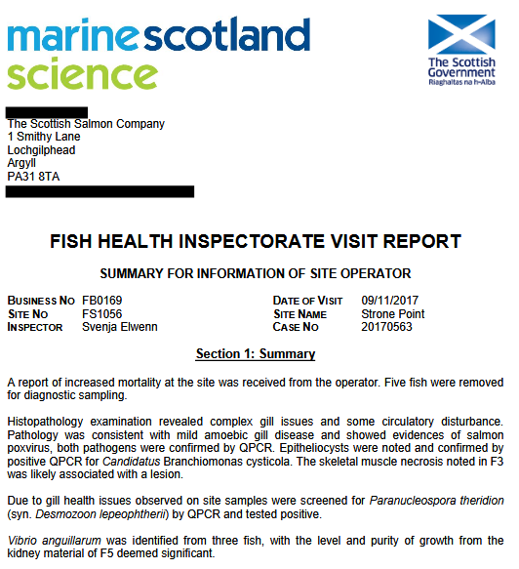

The FHI Fish Visit report dated November 2017 reported positive for the following:

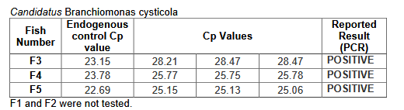

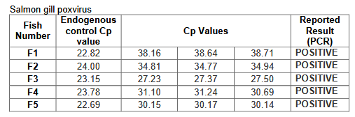

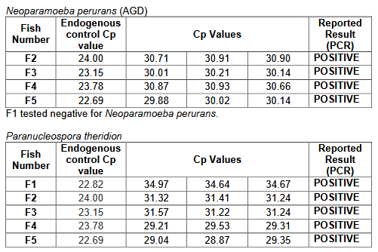

A FHI Fish Visit report dated November 2017 detailed disease problems at Marine Harvest's salmon farm at Poll Na Gille in the Sound of Jura - including "complex gill issues", anaemia, "severe PGD pathology and extensive haemorrhaging":

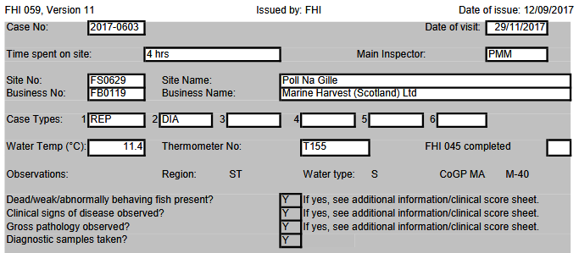

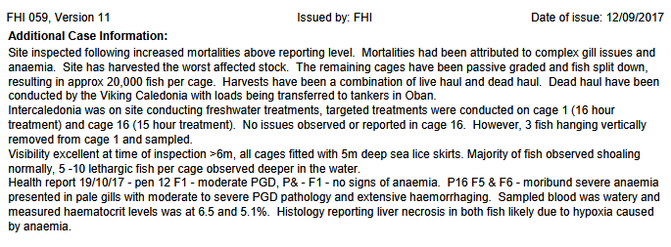

The mortality records stated that Marine Harvest had "harvested worse cages, reducing biomass":

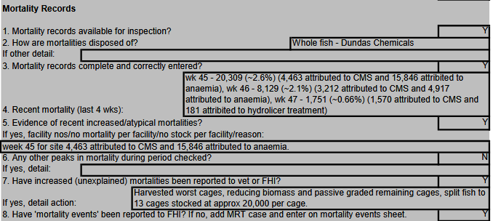

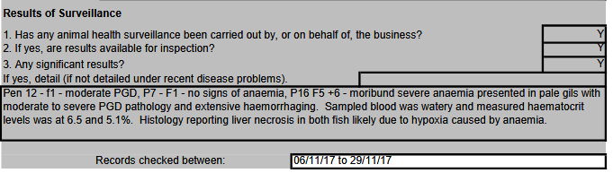

The FHI Fish Visit report for November 2017 detailed "complex gill issues and anaemia", "mild cardiomyopathy with features resembling cardiomyopathy syndrome (CMS) and the presence of the causative agent, piscine myocarditis virus (PMCV)" and reported a positive test for Paranucleospora theridon (syn. Desmozoon lepeophtheri). Over 60,000 mortalities were reported in a four-week period (Week 33 to 36).

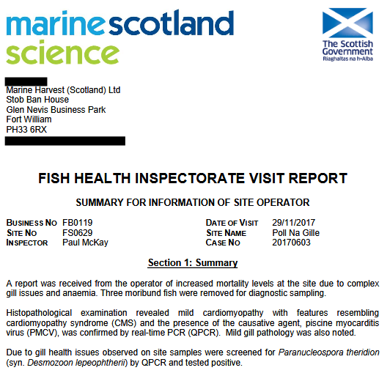

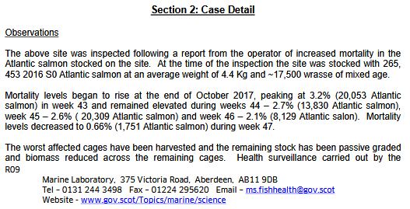

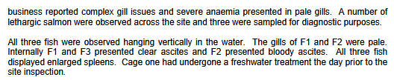
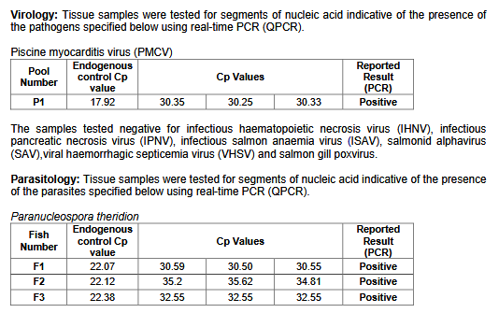

The FHI Fish Visit report signed off by stating that histopathological examination had found "some evidence of erthrophagocytosis" in the spleen, "mild diffuse hepatocyte vacuolation" in the liver, "mild pericarditis" in the heart and "lamellar congestion" in the gills.
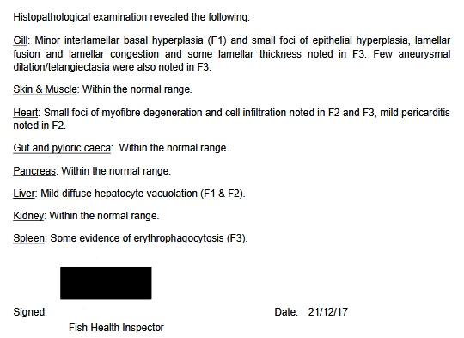

A FHI Fish Visit report for November 2017 detailed disease problems at Kames Fish Farming's salmon farm at Shuna SW (Rubh'an Trilleachain) in Shuna Sound stating that: "Biomass has been reduced with worst affected stock having been harvested. Harvest have been both live haul to Mallaig and dead haul."

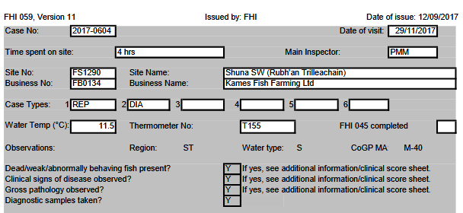

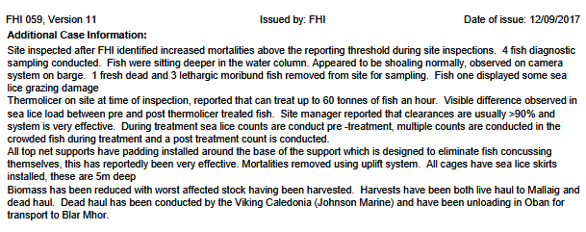

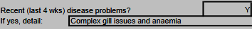

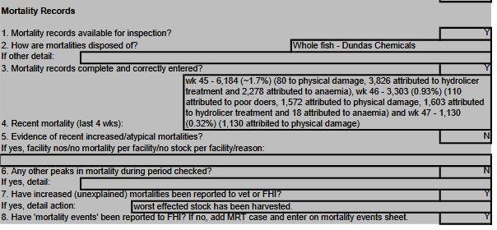
The FHI Fish Visit report for November 2017 detailed "complex gill issues and anaemia", "features resembling salmon gill poxvirus", "epitheliocystis and mild peritonitis", "mild cardiomyopathy with features resembling cardiomyopathy syndrome", piscine myocarditis virus (PMVC), Paranucleospora theridon and Neoparamoeba perurans (AGD).

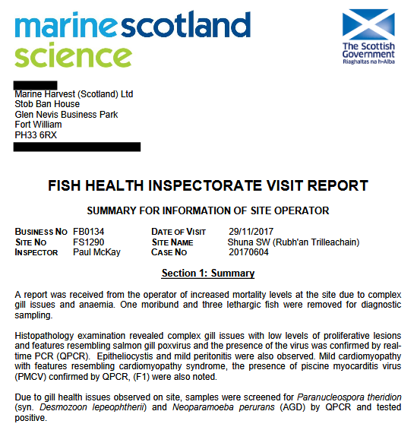

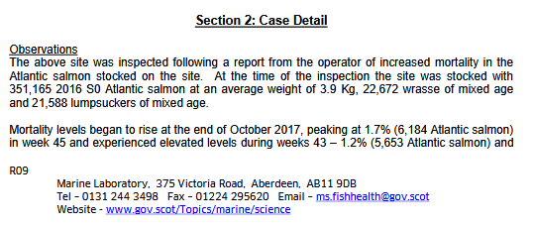

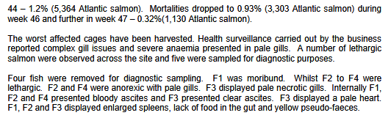

Bacteriology isolated Vibrio species and Moritella viscosa (the causative agent of Winter ulcer):

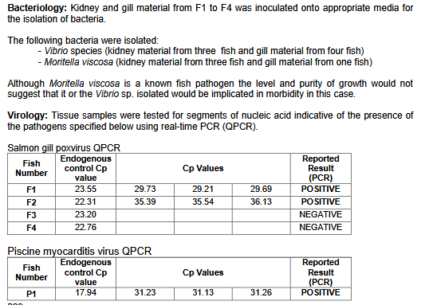

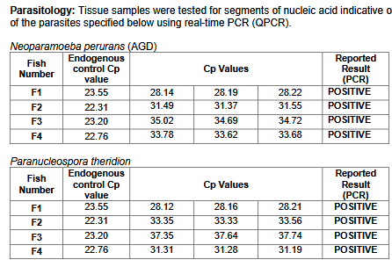

A FHI Fish Visit report for December 2017 detailed disease problems at The Scottish Salmon Company's salmon farm at Druimyeon Bay in the Sound of Gigha - including PGD, CMS and "sea lice grazing damage to heads".

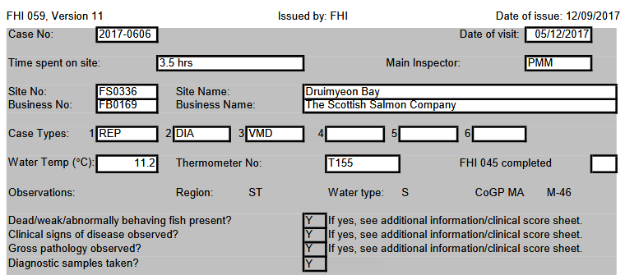

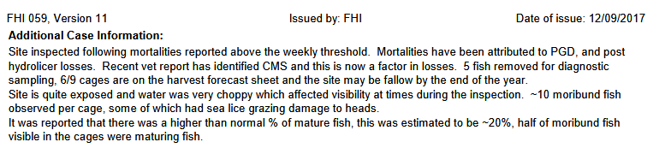

"Harvesting worst affected cages and accelerated harvest of site," stated the FHI report.

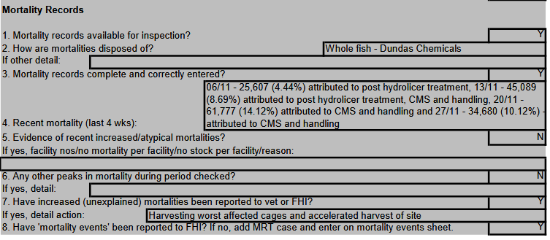

All five farmed salmon tested had a "strong presence" for moribund and lethargic behaviour.
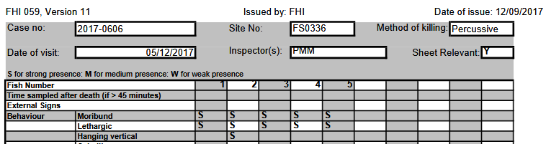

The FHI Fish Visit report for December 2017 reports all the usual suspects with over 30,000 mortalities in Week 43 citing problems such as PGD, CMS, AGD and PMCV.

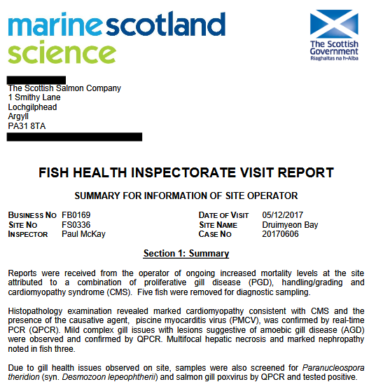

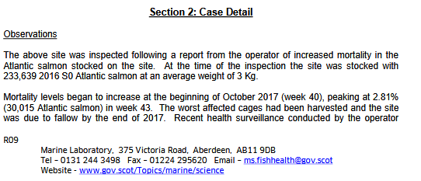

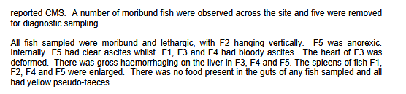

Positive tests included for Salmon gill poxvirus, Piscine myocarditis virus and Salmonid alphavirus.

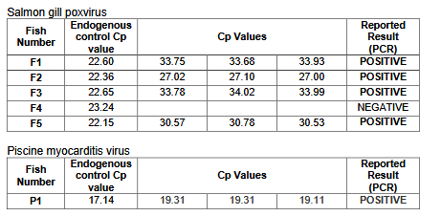

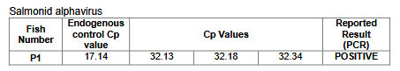

Read more about Salmonid alphavirus (SAV) via:
Salmonid alphavirus (SAV)
Geographical distribution of salmonid alphavirus subtypes in marine farmed Atlantic salmon, Salmo salar L., in Scotland and Ireland
Prevalence of salmonid alphavirus in Scottish fish farms from 2006 to 2007

Case Information published by the Scottish Government's Fish Health Inspectorate for July to September 2017 includes a FHI visit report for Loch Duart's salmon farm in Badcall Bay.

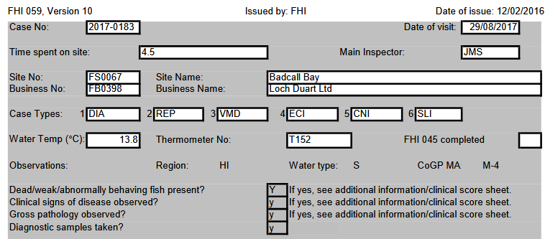

The report details AGD lesions as well as "significant gill pathology (AGD, Branchiomonas, Desmazoon, SGPV), widespread inflammation and vascular damage". "Piscirickettsia suspected but not identified though staining (sic)" stated the report. Mortality rates for some of the worst cages were over 30%.

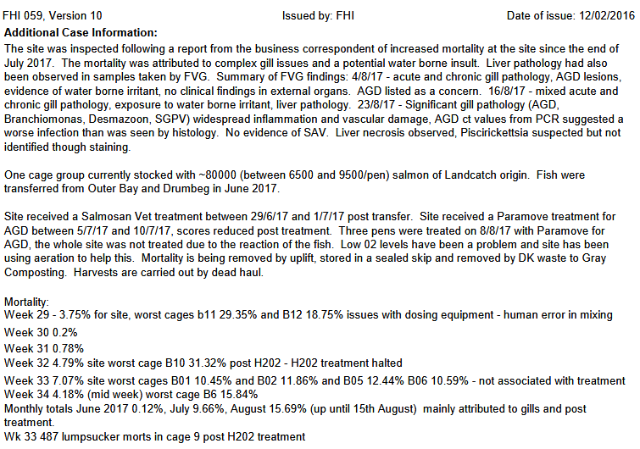
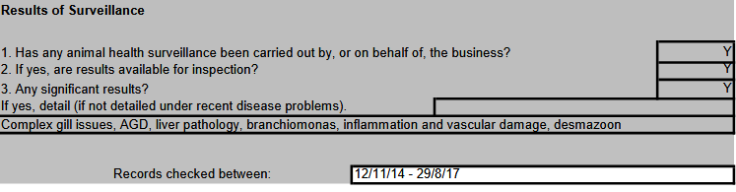
The FHI visit report also described "no membrane between heart and liver" and "haemorrhaging at the base of the pelvic fins" in sampled farmed salmon.

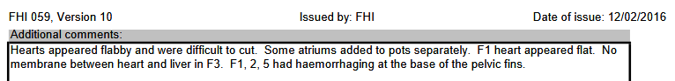

The FHI visit report for August 2017 detailed "severe complex gill issues with chronic and acute pathology", epitheliocystis, Candidatus Branchiomonas cysticola, Candidatus Syngnamydia salmonis, vascular damage, mild hepatic necrosis, Salmon gill poxvirus and Paranucleospora theridon.

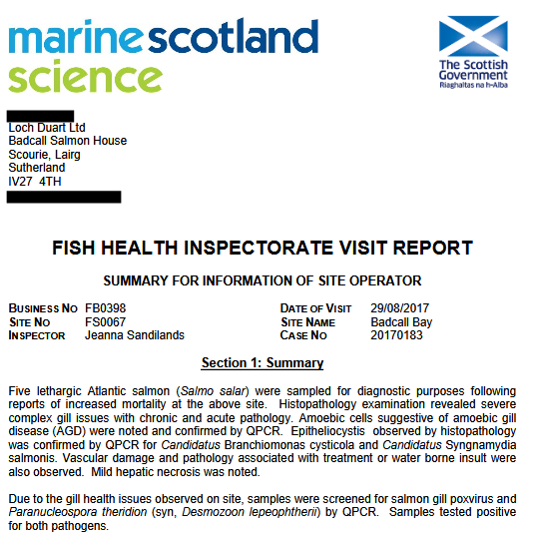

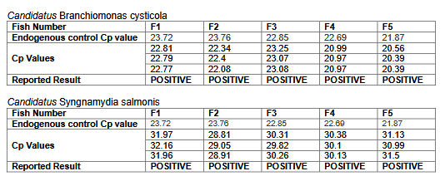
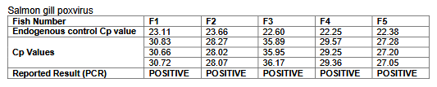
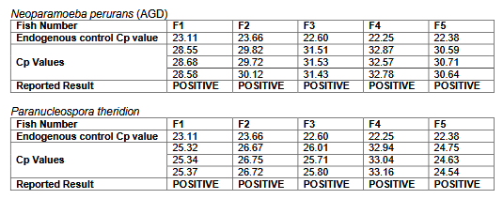

A FHI visit report for August 2017 for Loch Duart's salmon farm in Calva Bay detailed disease problems - including a mortality rate of 45.64% since input in some cages. "Worst affected will be harvested by next Monday (pens 22, 23, 25, 27, and 28 already harvested out)" stated the FHI visit report.
.

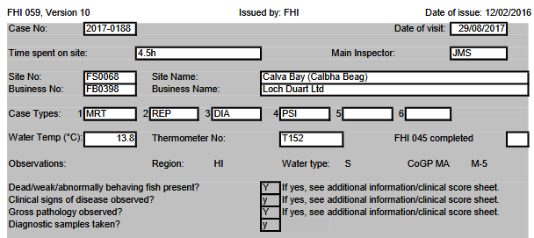

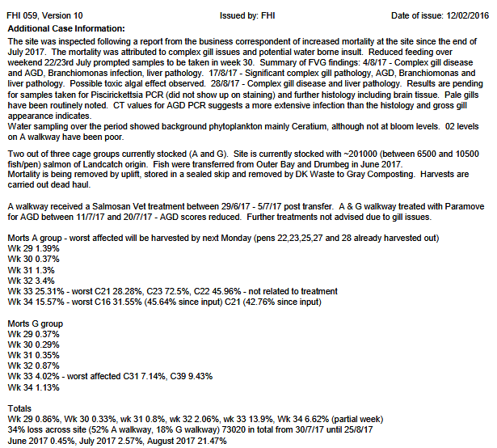

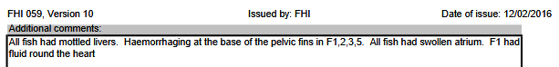
The FHI visit report for August 2017 detailed AGD, Candidatus Branchiomonas cysticola, Candidatus Syngnamydia salmonis, Salmon gill poxvirus and Paranucleospora theridon.

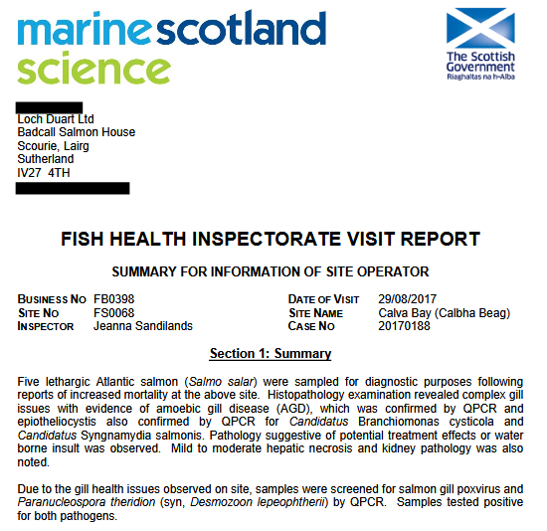

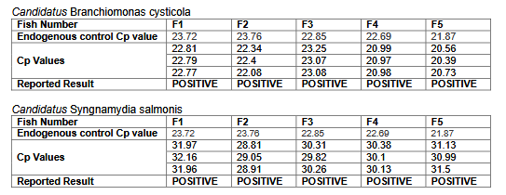
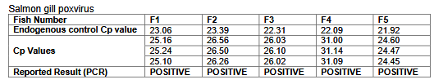
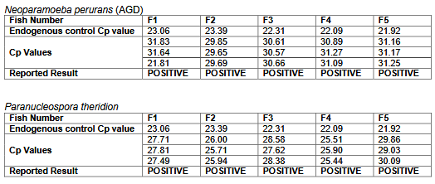

The FHI visit report for August 2017 also stated that the "worst affected cages are being harvested out":

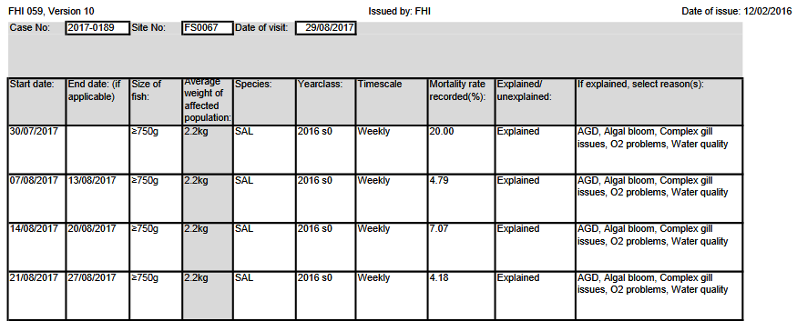

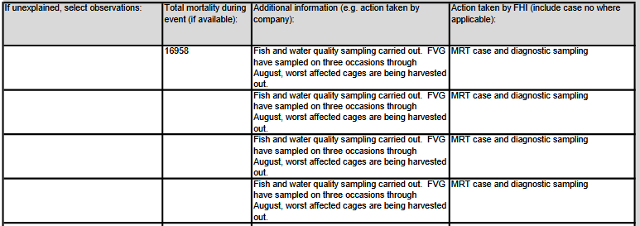

A FHI visit report for July 2017 reported "severe gill issues" at The Scottish Salmon Company's salmon farm in Loch Odhairn (Gravir).

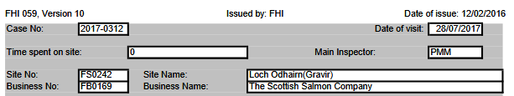
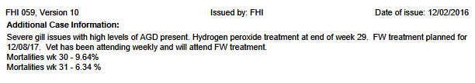

Mortalities were reported at over 110,000 in a two week period in July/August 2017.

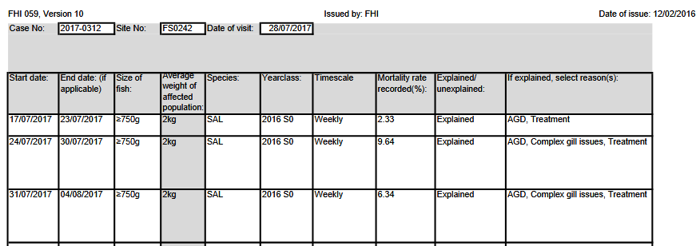

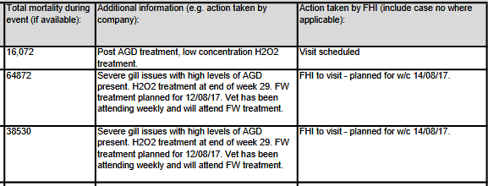

A FHI visit report for August 2017 for The Scottish Salmon Company's salmon farm at Inch Kenneth in Loch na Keal on the Isle of Mull detailed "very skinny" fish including one "deformed with a bent spine" and three out of the five farmed salmon sampled had "deformed hearts".

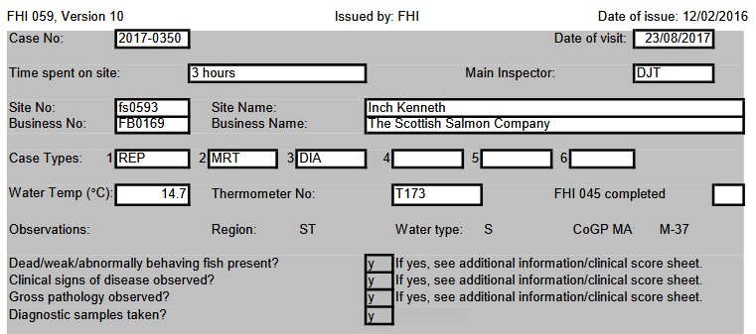

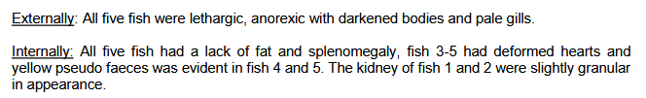

Disease problems included AGD, PD, Branchiomonas and microspoidean.

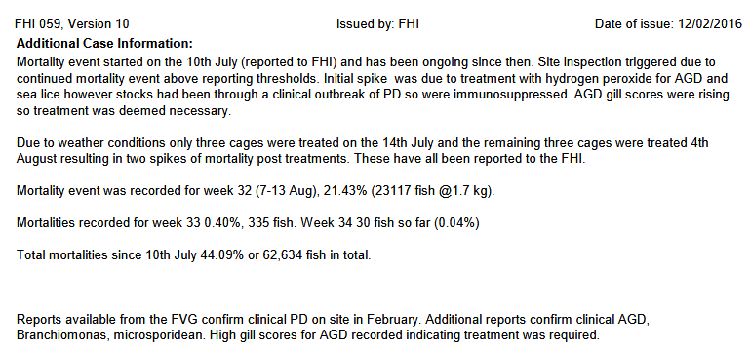

A FHI visit report for August 2017 for Cooke Aquaculture's salmon farm in the Bay of Vady in Orkney detailed early harvesting due to mortality problems. "Reports of increased mortality due to gill issues, site is being harvest out," stated the FHI report. "Reporting limit has been breached for five weeks."

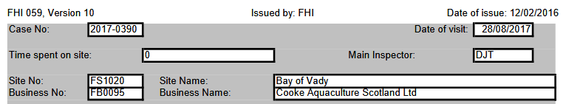

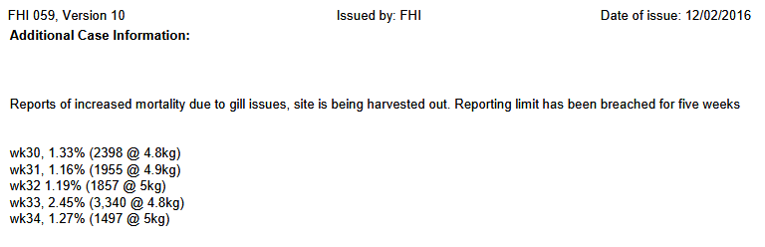

Mortalities were over 10,000 for a four-week period in July/August 2017 with "ongoing monitoring and harvesting of stocks".

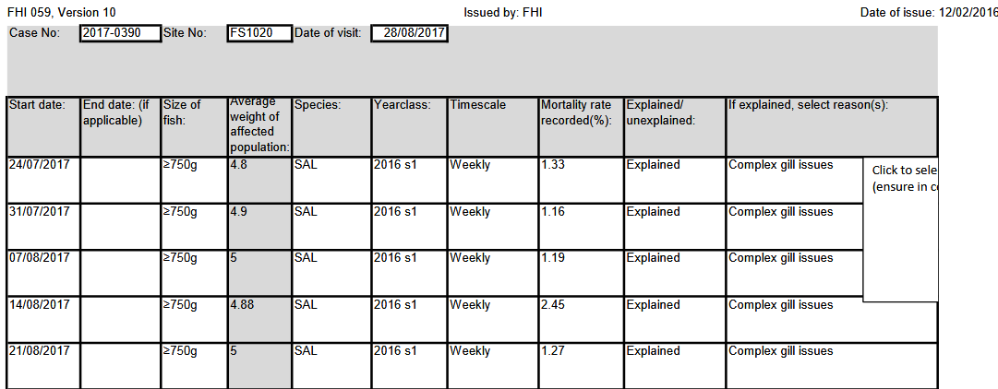

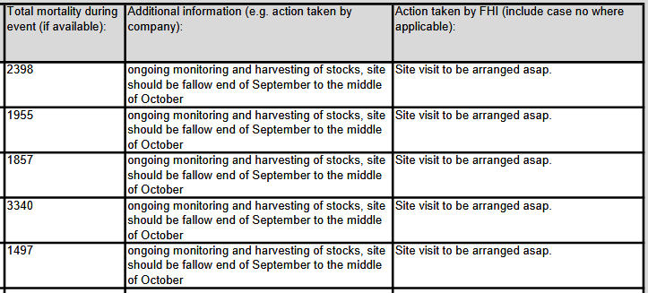
A FHI visit report for August 2017 for Cooke Aquaculture's salmon farm in Carness Bay in Orkney detailed over 20,000 mortalities in a six-week period. "Site is being harvested," stated the FHI report.

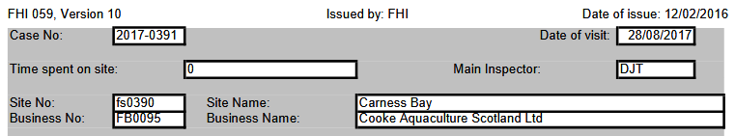

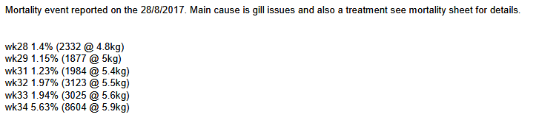

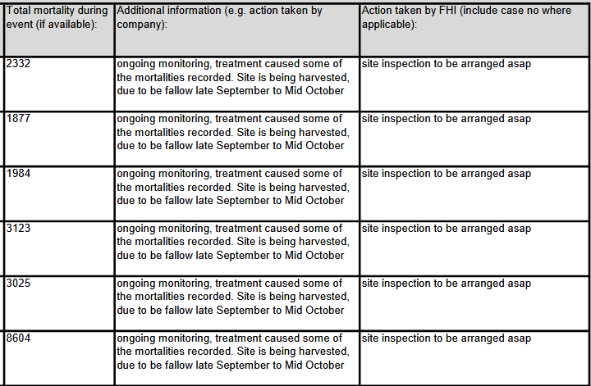

Cooke Aquaculture is no stranger to disease issues - with PRV causing problems in the United States. Read more via:
Washington state finds virus in Cooke Atlantic salmon, plans expanded testing
Cooke banned from restocking at US farm site
19 salmon that escaped from Cooke pens had PRV, tests suggest
100% of Escaped Atlantic Salmon Sampled in Puget Sound Test Positive for
Piscine Orthoreovirus (PRV)
Washington state finds PRV at Cooke farms, holds up transfer of 800,000 salmon
Case Information for 2016 included this reference to harvesting at The Scottish Salmon Company's farm at Furnace in Loch Fyne due to "gill pox issues" and rapidly rising mortality rates from 1.71% in Week 29 to 8.64% in Week 34 and 10.72% in Week 35:

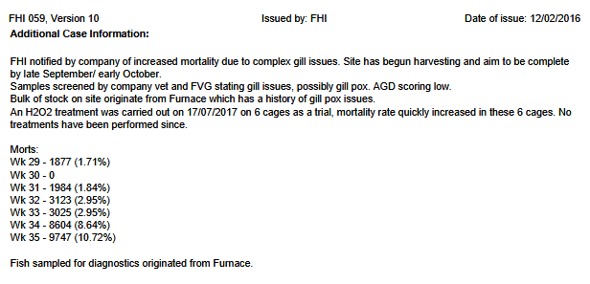

Thanks to the work of Salmon & Trout Conservation Scotland accessing sea lice data via FOI, Scotland's "liciest" have been named and shamed - including 61 salmon farms breaching lice limits between November 2016 and August 2017.

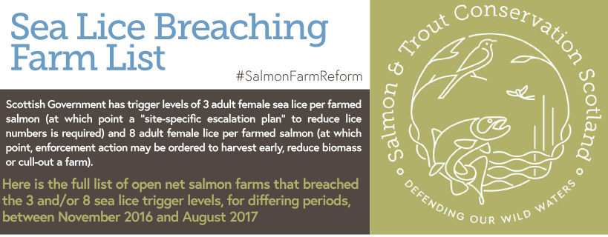
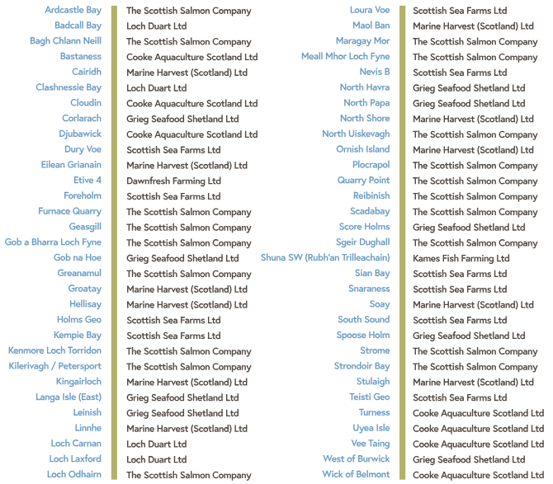

Read more via:
"Scotland’s worst sea lice offenders: Full Farm List"
"Scottish salmon sold by a range of supermarkets in the UK has sea lice up to 20 times acceptable limit - Tesco, Sainsbury’s and Co-op are among those who have stocked salmon from the worst affected farms"
"Scottish salmon farming's 'liciest' farms named and shamed"
"FOI Number Five – getting you the information they don’t want you to see!"

Shamefully, SEPA stopped collecting data on the numbers of dead farmed salmon following lobbying from the SSPO in 2013 who claimed publication would be "commercially damaging". Read more via:
"Scottish watchdog labelled ‘lapdog’ after agreeing to keep fish farm deaths secret"
"Public denied info on full scale of salmon deaths"
"Environment watchdog ‘gave in to industry’ over dead salmon"
"Farmed salmon killed by disease leaps to 8.5 million"

Despite the industry's reluctance to divulge details on diseases and mortalities, there is the prospect of further data making it possible to directly link early harvest with particular disease problems at specific sites. In February 2018, the Scottish Salmon Producers Organisation publicly pledged in oral evidence to the Scottish Parliament's Environment, Climate Change & Land Reform Committee to publish site specific data on lice, mortalities and diseases:
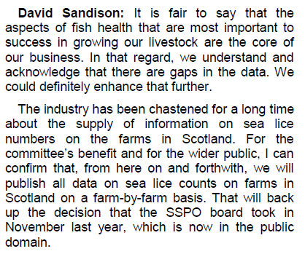



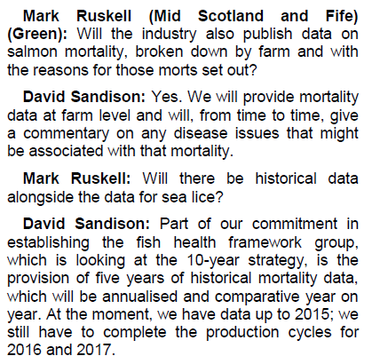

Read more via "Victory for Freedom of Information"

Nevertheless, when the Scottish Salmon Producers Organisation finally published site specific sea lice data in May 2018 it was immediately criticised by Salmon & Trout Conservation Scotland:

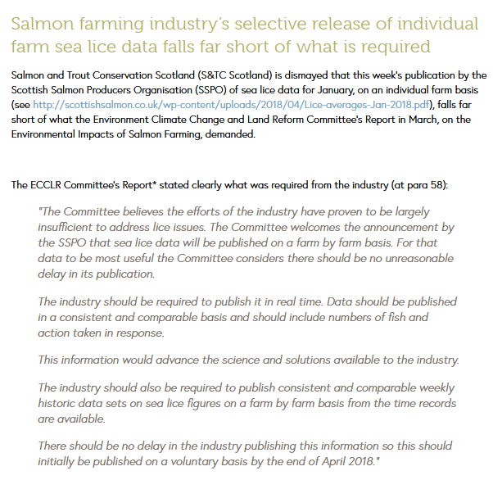
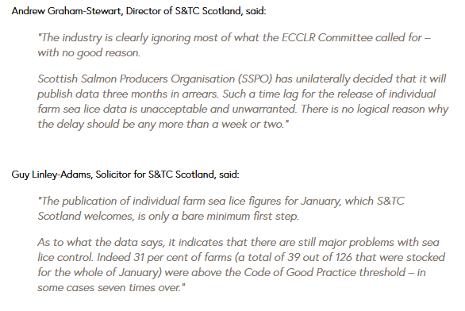

The SSPO's sea lice data for January 2018 details lice problems at the following sites (one lice per fish is the threshold):

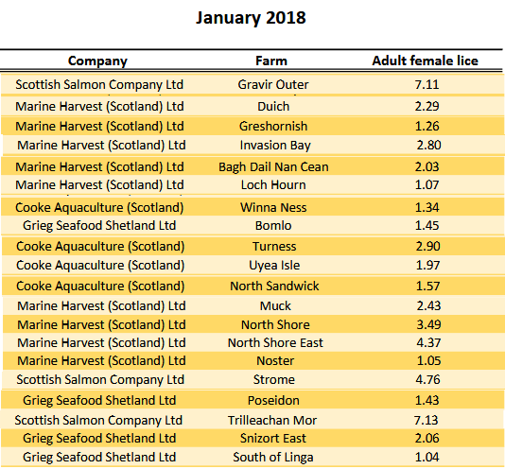

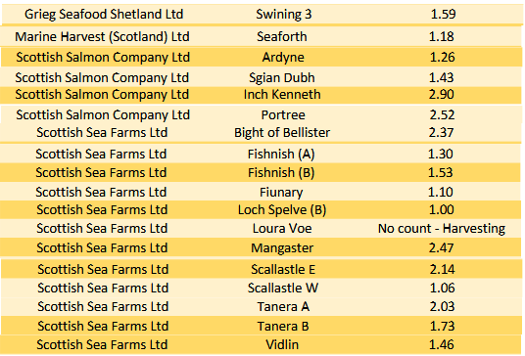

The ECCLR report (5 March 2018) also recommended the publication of disease and mortality data:

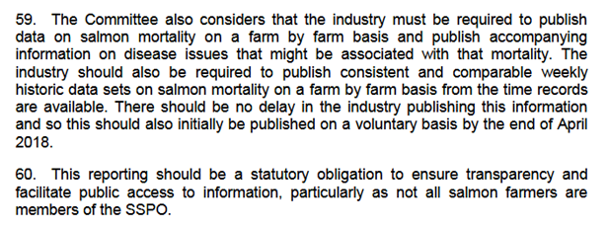

What we know for sure is that the average size of Scottish salmon farms is increasing. The latest fish farm survey (published in September 2017) shows that 82.8% of Scottish salmon farming production comes from sites producing over 1,000 tonnes (up from 73.6% in 2006).

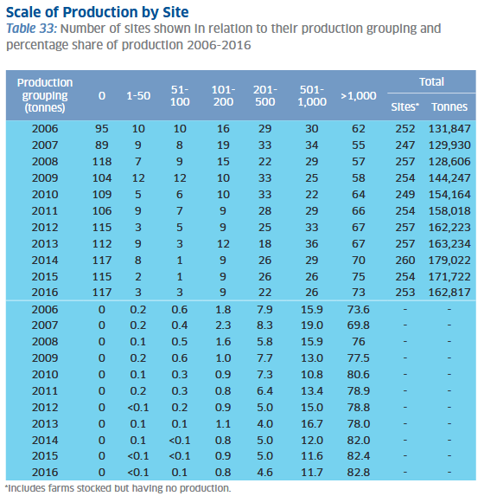

Read more via:
Supersized McSalmon - I'm Lovin' It Sings Fergus!
Big McSalmon, Large Lice & Toxic Chemicals - Supersized Salmon Goes Global!
Sunday Times: "Supersizing salmon farms in Scotland 'will be a disaster’"
SEPA proposes lifting biomass cap for Scottish salmon farms
Industry: no imminent plans for super-sized salmon farm
Outrage over secret plans to base world's biggest salmon farm in Scotland
Super-sized Scottish Salmon - 8,000 tonnes of trouble on the horizon!

Whether bigger salmon farm size means even bigger lice, disease and mortality problems remains to be seen. Scottish Salmon Watch will certainly be keeping a watching brief.

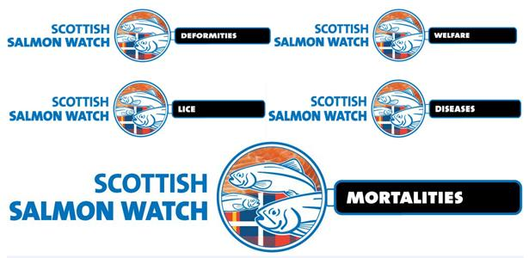
Earlier this month, Scottish Salmon Watch delivered a 42,000-strong petition to the Scottish Government calling for the testing of salmon farming operations for deadly diseases and viruses.

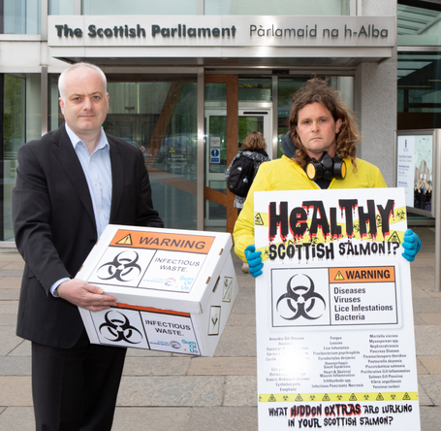

Read more via:
The National: "42,000 sign petition for tougher Scottish salmon farm testing"
Herald: "Salmon farms are turning Scotland's seas into an open sewer, claim campaigners"
SumOfUs: "Campaigners at Scottish Parliament call for wastewater testing at salmon farming operations to save wild fish"
Letter to Scottish Government re. Infectious Diseases in Salmon Farming Effluents
Risk of waterborne virus spread – review of survival of relevant fish and crustacean viruses in the aquatic environment and implications for control measures

BBC News reported (19 May 2018) trouble ahead for Scotland's disease-ridden salmon farming industry. "Last week, we learned the industry expects an 11% drop in output this year, as it struggles to get on top of sea lice and disease," reported BBC News (May 24 2018). "When either is found in a cage, salmon are harvested (or slaughtered, if you prefer) straight away, and much earlier than if they grew to their optimum marketable size."

Appendix 1: Production Cycles for Marine Cage Salmon Farms in Scotland

Data accessed via Scotland's Aquaculture web-site (via Monthly Biomass data) in May 2018 (data only available up to December 2017).

Please note that a harvest cycle of farmed salmon is taken from the first month biomass appears until the last month of active biomass (i.e. before the site is fallowed and there is zero biomass). Note also that this is not an exhaustive list of all production cycles in the periods listed - if a statistician with a great deal of time on their hands (or a PhD student) wished to analysis the data and carry out a year-by-year comparison all the data is publicly available online here.

Summary:

2013-2017 data: Overall Industry Average = 16.5 months

2002-2007 data: Overall Industry Average = 20.1 months

2013-2017 data:

Overall Industry Average = 16.5 months

Loch Duart: Average time at sea = 13.2 months
Cooke Aquaculture: Average time at sea = 13.5 months
Marine Harvest: Average time at sea = 16.2 months
The Scottish Salmon Company: Average time at sea = 18 months
Scottish Sea Farms: Average time at sea = 18 months
Grieg Seafood: Average time at sea = 19.1 months

Marine Harvest: Average time at sea = 16.2 months

Ardgour (Loch Linnhe): January 2016 to June 2017 (18 months)

Ardintoul (Loch Alsh): February 2015 to September 2016 (20 months)

Bagh Dail nan Ceann North and South (Sound of Jura): November 2015 to August 2016 (10 months)

Cairidh (Loch Ainort): March 2016 to September 2017 (17 months)

Callert (Loch Leven): January 2016 to September 2017 (19 months)

Camas an Leim (Torridon) (Loch Torridon): November 2015 to March 2017 (17 months)

Camus Glas (Loch Sunart): November 2014 to August 2016 (22 months)

Caolas a Deas East (Loch Shell): June 2015 to January 2016 (7 months)

Caolas a Deas West (Loch Shell): November 2014 to January 2016 (15 months)

Carradale (North) (Kilbrannan Sound): July 2016 to May 2017 (10 months)

Carradale (South) (Kilbrannan Sound): November 2015 to May 2017 (19 months)

Colonsay: September 2015 to April 2017 (20 months)

Creag an Sagairt West (Loch Hourn): August 2014 to February 2016 (19 months)

Duich (Loch Duich): February 2015 to August 2016 (19 months)

Erisort, North Shore East (Loch Erisort): May 2015 to June 2016 (14 months)

Erisort, North Shore West (Loch Erisort): December 2014 to June 2016 (19 months)

Gorsten (Loch Linnhe): November 2015 to June 2017 (20 months)

Greshornish (Loch Snizort): March 2015 to September 2016 (19 months)

Grey Horse Channel (Sound of Harris): October 2015 to February 2017 (17 months)

Groatay (Sound of Harris): May 2016 to May 2017 (13 months)

Hellisay (Sound of Hellisay): March 2014 to October 2015 (20 months)

Invasion Bay (Loch Sunart): November 2014 to May 2016 (19 months)

Isle of Ewe (Loch Ewe): September 2015 to March 2017 (19 months)

Kingairloch (Loch a Choire) (Loch Linnhe): May 2016 to July 2017 (15 months)

MacLeans Nose (Sound of Mull): August 2015 to May 2016 (10 months)

Maol Ban (Inner Sound): March 2016 to August 2017 (18 months)

Marulaig Bay (Loch Boisdale): February 2016 to August 2017 (19 months)

Noster (Loch Seaforth): April 2016 to October 2016 (7 months)

Poll na Gille (Sound of Jura): October 2014 to August 2016 (23 months)

Port na Cro (Shuna Sound): June 2017 to November 2017 (6 months)

Port na Moine Site 2 (North) (Loch Craignish): October 2015 to August 2017 (23 months)

Sconser (Sound of Raasay): February 2017 to June 2017 (5 months)

Seaforth (Loch Seaforth): April 2016 to October 2016 (7 months)

Skipport Outer (Ornish) (Loch Skipport): October 2015 to February 2017 (17 months)

Soay Sound (West Loch Tarbert): October 2015 to April 2017 (19 months)

Sron (Loch Alsh): February 2015 to June 2016 to (17 months)

Stulaigh Island (Loch Eynort): September 2015 to May 2017 (21 months)

Tabhaigh (Loch Erisort): August 2016 to November 2017 (16 months)

The Scottish Salmon Company: Average time at sea = 18 months

Aird Ardheslaig (Loch Sheildaig): January 2016 to October 2017 (22 months)

Ardcastle (Loch Fyne): December 2016 to June 2017 (19 months)

Ardgaddan (Loch Fyne): October 2015 to June 2017 (21 months)

Ardyne (Baigh au Sgairbh) (Loch Striven): February 2015 to September 2016 (20 months)

Druimyeon Bay (Sound of Gigha): October 2014 to April 2016 (19 months)

East Tarbert Bay (Sound of Gigha): March 2015 to January 2016 (11 months)

Eughlam North (Loch Roag): March 2015 to November 2016 (20 months)

Furnace (Loch Fyne): April 2016 to December 2016 (9 months)

Geasgill (Loch na Keal): September 2014 to March 2016 (19 months)

Glenan Bay (Loch Fyne): October 2015 to May 2017 (20 months)

Gob a Bharra (Loch Fyne): October 2015 to June 2017 (21 months)

Gometra (Loch Tuath): August 2014 to March 2016 (20 months)

Gousam (Loch Roag): April 2015 to November 2016 (20 months)

Gravir Outer (Loch Odhaim): October 2014 to April 2016 (19 months)

Greanamul (Sound of Greanamul): March 2016 to November 2017 (21 months)

Inch Kenneth (Loch na Keal): August 2014 to March 2016 (20 months)

Kenmore Bay (Loch a Chracaich) (Loch Torridon): January 2016 to August 2017 (20 months)

Kyles Vuia East (Loch Roag): February 2015 to August 2016 (19 months)

Loch Portree (Torvaig) (Sound of Raasay): September 2014 to February 2016 (18 months)

Maragay Mor (Loch Uiskevagh): October 2016 to November 2017 (14 months)

Meall Mhor (Loch Fyne): October 2015 to March 2017 (18 months)

Mid Strome (Loch Carron): September 2014 to December 2015 (16 months)

Petersport North (Loch a Laip): April 2016 to August 2017 (17 months)

Plocrapol (East Loch Tarbert): May 2016 to May 2017 (13 months)

Quarry Point (Loch Fyne): September 2015 to April 2017 (20 months)

Reibinish (East Loch Tarbert): September 2015 to June 2017 (22 months)

Rubha Stillaig (Loch Fyne): October 2015 to April 2017 (19 months)

Scadabay (Loch Grosebay): September 2015 to April 2017 (20 months)

Sgeir Dughall (Loch Torridon): November 2016 to August 2017 (10 months)

Sgian Dubh (Loch Striven): April 2015 to September 2016 (18 months)

St Molios (Lamlash Bay): February 2016 to September 2017 (20 months)

Strondoir Bay (Loch Fyne): September 2015 to April 2017 (20 months)

Strone Point (Loch Striven): March 2015 to September 2016 (19 months)

Taranaish (Loch Roag): March 2015 to October 2016 (20 months)

Tarbert South (Loch Fyne): September 2015 to May 2017 (21 months)

Trilleachan Mor (Loch Seaforth): October 2015 to November 2016 (14 months)

Tuath (Rubha na Gall) (Loch Tuath): October 2016 to October 2017 (13 months)

Uiskevagh North (Loch Uiskevagh): March 2016 to November 2017 (21 months)

Vacasay (Loch Roag): December 2015 to September 2016 (10 months)

Vuia Beag (Loch Roag): March 2015 to August 2016 (18 months)

Vuia Mor (Loch Roag): March 2015 to November 2016 (21 months)

Scottish Sea Farms: Average time at sea = 18 months

Achintraid (Kishorn Site 1) (Loch Kishorn): August 2014 to January 2016 (18 months)

Achnacroish (Walters,Lismore East) (Lynn of Lorn): January 2016 to April 2017 (16 months)

Allt a Chois (Kishorn North Shore) (Loch Kishorn): September 2016 to November 2017 (15 months)

Ardintigh (Nevis C) (Loch Nevis): November 2014 to March 2016 (17 months)

Bellister (Dury Voe): October 2014 to April 2016 (19 months)

Bloody Bay (Sound of Mull): December 2014 to July 2016 (20 months)

Camas Doun Point (Kishorn Site 2) (Loch Kishorn): November 2016 to November 2017 (13 months)

Charlottes Bay (Kerrara B) (Firth of Lorn): March 2016 to November 2017 (21 months)

Creran A (Loch Creran): March 2014 to June 2015 (16 months)

Creran B (Loch Creran): November 2015 to March 2017 (17 months)

Dubh Sgeir (Lismore North) (Loch Linnhe): February 2016 to September 2017 (20 months)

Dunstaffnage (Firth of Lorn): April 2016 to November 2017 (20 months)

Earnsaig (Nevis A) (Loch Nevis): May 2016 to August 2017 (16 months)

Eilean Fada Mor (Summer Isles): September 2015 to February 2017 (18 months)

Fishnish A (Sound of Mull): March 2015 to October 2016 (20 months)

Fishnish B (Sound of Mull): March 2015 to November 2016 (21 months)

Fuinary (Sound of Mull): April 2015 to November 2016 (20 months)

Kishorn Outer, Offshore of Airigh-drishaig (Loch Kishorn): May 2015 to June 2016 (14 months)

Loura Voe (Site 3) (Dury Voe): September 2014 to December 2015 (16 months)

Port na Moralachd (Lismore A) (Loch Linnhe): December 2015 to July 2017 (20 months)

Port na Moralachd (Lismore B) (Loch Linnhe): April 2016 to September 2017 (18 months)

Scallastle Bay (Sound of Mull): March 2015 to November 2016 (21 months)

Shuna (Loch Linnhe): March 2016 to November 2017 (21 months)

Sian Bay (Loch Erribol): February 2016 to August 2017 (19 months)

Spelve A (Balure) (Loch Spelve): April 2017 to November 2017 (8 months)

Spelve B (Dalnaha) (Loch Spelve): April 2016 to January 2017 (10 months)

Stoull (Nevis B) (Loch Nevis): May 2016 to November 2017 (19 months)

Tanera 1 (Summer Isles): September 2015 to February 2017 (18 months)

Tanera 2 (Summer Isles): August 2015 to February 2017 (19 months)

Toy Ness (Scapa Flow): May 2014 to January 2016 (21 months)

Veantrow Bay (Stronsay Firth): November 2014 to August 2016 (22 months)

Vidlin Outer (Vidlin Voe): March 2015 to August 2016 (18 months)

Wyre (Gairsay) (Gairsay Sound): September 2015 to July 2017 (23 months)

Loch Duart: Average time at sea = 13.2 months

Badcall Site 10 (North Eilean na Bearachd) (Eddrachillis Bay): May 2016 to April 2017 (12 months)

Badcall Site 11 (Eilean Riabhach) (Eddrachillis Bay): May 2017 to April 2017 (12 months)

Calbha Site 5 (Calbha Beag) (Eddrachillis Bay): January 2016 to September 2016 (9 months)

Calbha Site 6 (East Rubh a Mhucard) (Eddrachillis Bay): June 2017 to September 2017 (4 months)

Calbha Site 7 (North Calba Bay) (Eddrachillis Bay): September 2015 to April 2016 (8 months)

Caolas Loch Portain (Loch Maddy): April 2014 to February 2016 (21 months)

Droighniche (Eddrachillis Bay): September 2016 to June 2017 (10 months)

Drumbeg (Loch Dhrombaig) (Eddrachillis Bay): September 2016 to June 2017 (10 months)

Eilean Ard (Laxford Site 3) (Loch Laxford): October 2014 to December 2015 (15 months)

Eilean a Mhadaidh (Laxford Site 2) (Loch Laxford): October 2014 to May 2016 (20 months)

Ferramus (Loch Maddy): July 2015 to January 2016 (7 months)

Foindle East (Laxford Site 1) (Loch Laxford): October 2014 to December 2015 (15 months)

Nedd (Eddrachillis Bay): April 2015 to September 2015 (6 months)

Oldany (Eddrachillis Bay): March 2016 to July 2017 (17 months)

Reintraid (Loch a Chairn Bhain): January 2016 to December 2016 (12 months)

Sandavaig (South Ford) (Bagh Nam Faolean): October 2016 to September 2017 (12 months)

Sound of Harris (Groay-Lingay) (Sound of Harris): April 2015 to March 2017 (24 months)

South Ford (Gashernish) (Bagh Nam Faolean): March 2013 to November 2014 (21 months)

South Ford East (Gashernish East) (Bagh Nam Faolean): September 2013 to November 2014 (15 months)

Torgawn (Loch a Chairn Bhain): January 2016 to February 2017 (14 months)

Grieg Seafood: Average time at sea = 19.1 months

Bight of Foraness (Swinnister Voe): April 2015 to October 2016 (19 months)

Corlarach (Loch Dunvegan): September 2015 to May 2017 (21 months)

East of Papa Little (Swarbacks Minn): August 2014 to January 2016 (18 months)

Hamnavoe, Lunnaness (Off Lunnaness): July 2015 to September 2016 (15 months)

Leinish Bay (Loch Dunvegan): September 2015 to June 2017 (22 months)

Linga (South of Linga) (Yell Sound): April 2015 to December 2016 (21 months)

North Voe (Linga Sound): August 2014 to May 2016 (22 months)

Setterness North (Off Lunnaness): February 2015 to July 2016 (18 months)

Swining Voe Site 3 (Collafirth Ness) (Swinning Voe): March 2015 to August 2016 (18 months)

Taing of Railsborough (Cat Firth): October 2015 to February 2017 (17 months)

Cooke Aquaculture: Average time at sea = 13.5 months

Bastaness (Hascosay Sound): April 2016 to August 2016 (5 months)

Bay of Cleat North (Papa Sound): March 2015 to January 2017 (22 months)

Bay of Meil (Shapinsay Sound): February 2016 to December 2016 (11 months)

Bay of Vady (Rousay Sound): March 2017 to September 2017 (7 months)

Bow of Hascosay (Hascosay Sound): March 2014 to December 2015 (22 months)

Burrastow (Vaila Sound): May 2016 to April 2017 (12 months)

Carness Bay (The String): April 2017 to September 2017 (6 months)

Cava South (Scapa Flow): November 2016 to June 2017 (8 months)

Chalmers Hope (Scapa Flow): August 2016 to March 2017 (8 months)

Cloudin (Vaila Sound): September 2015 to June 2017 (22 months)

Djuba Wick (Colgrave Sound): April 2013 to February 2015 (23 months)

Flaeshins (Colgrave Sound): April 2015 to November 2016 (20 months)

Kirk Noust (Rousay Sound): November 2016 to April 2017 (6 months)

Lyrawa Bay (Scapa Flow): November 2016 to July 2017 (9 months)

Ness of Copister (Hamna Voe, Yell): February 2015 to December 2016 (23 months)

North Sandwick (Bluemull Sound): April 2015 to January 2016 (10 months)

Ouse Ness (Papa Sound): December 2016 to September 2017 (10 months)

Quanterness (West Shargun Shoal) (Wide Firth): December 2016 to July 2017 (8 months)

Stead of Aithness (Aith Voe): November 2014 to July 2016 (21 months)

Turness (Skuda Sound): October 2014 to September 2015 (12 months)

Uyea Isle (Uyea Sound): September 2015 to June 2017 (22 months)

West Fara (Scapa Flow): September 2016 to June 2017 (10 months)

2002-2007 data:

Overall Industry Average = 20.1 months

Grieg Seafood: Average time at sea = 19.4 months
Loch Duart: Average time at sea = 19.9 months
Scottish Sea Farms: Average time at sea = 20.3 months
Cooke Aquaculture: Average time at sea = 20.3 months
Marine Harvest: Average time at sea = 20.5 months

Marine Harvest: Average time at sea = 20.5 months

Arbhair (Loch Leurbost) (formerly Lewis Salmon): November 2002 to August 2004 (22 months)

Ardintoul (Loch Alsh): March 2003 to January 2005 (23 months)

Bunavoneader Inner (Ardhasaig) (West Loch Tarbert): November 2003 to August 2005 (22 months)

Cairidh (Loch Ainort): December 2004 to October 2006 (23 months)

Callert (Loch Leven): February 2004 to November 2005 (22 months)

Camas an Leim (Torridon) (Loch Torridon): April 2004 to December 2005 (21 months)

Camus Glas (Loch Sunart): February 2005 to November 2006 (22 months)

Duich (Loch Duich): March 2003 to December 2004 (22 months)

Eishort (Loch Eishort): April 2003 to March 2005 (24 months)

Geo Beag (West Loch Tarbert): November 2003 to July 2005 (21 months)

Gorsten (Loch Linnhe): February 2004 to November 2005 (22 months)

Greshornish (Loch Greshornish): November 2004 to August 2016 (22 months)

Hole Bay (Loch Sheilaviag): January 2002 to September 2003 (21 months)

Invasion Bay (Loch Sunart): February 2005 to December 2006 (23 months)

Kingairloch (Loch a Choire) (Loch Linnhe): March 2004 to November 2005 (21 months)

Lemreway (Shell Outer) (Loch Shell): March 2005 to June 2006 (16 months)

Maol Ban (Inner Sound): July 2005 to October 2006 (16 months)

Mid Loch Shell /Pairc - East (C & D cage groups) (Loch Shell): January 2003 to August 2004 (20 months)

Mid Loch Shell /Pairc - West (A & B cage groups) (Loch Shell): October 2002 to August 2004 (23 months)

North Bay (Loch Sheilavaig): January 2002 to September 2003 (21 months)

North Channel (Loch Sheilavaig): March 2004 to July 2005 (17 months)

Noster (Loch Seaforth) (formerly Stolt Sea Farm): March 2003 to October 2004 (20 months)

Pecam Bay (Loch Erisort) (formerly Stolt Sea Farm): July 2005 to August 2006 (14 months)

Poll na Gille (Sound of Jura) (formely Pan Fish): March 2003 to July 2004 (17 months)

Port na Cro (Shuna Sound) (formerly Lakeland Marine): November 2002 to June 2004 (20 months)

Rossay (East Loch Tarbert) (formerly Stolt Sea Farm): March 2004 to February 2006 (24 months)

Sconser (Balmeanach Bay) (Sound of Raasay): December 2002 to October 2004 (23 months)

Scotasay (East Loch Tarbert) (formerly Stolt Sea Farm): March 2004 to December 2005 (22 months)

Seaforth (Loch Seaforth) (formerly Stolt Sea Farm): March 2003 to October 2004 (20 months)

Sgeir Bhuidhe (Loch Erisort) (formerly Stolt Sea Farm): December 2002 to June 2004 (19 months)

Skipport (Outer) (Loch Skipport): July 2003 to June 2005 (24 months)

Soay Sound (West Loch Tarbert): January 2002 to August 2003 (20 months)

Sron (Loch Alsh): April 2003 to December 2004 (21 months)

Stattic Point (Little Loch Broom): December 2003 to November 2005 (24 months)

Tarner Island (Loch Bracadale) (formerly Stolt Sea Farm): February 2003 to April 2004 (15 months)

Vacassay (N.Uist) (Sound of Harris) (formerly Stolt Sea Farm): April 2004 to March 2005 (12 months)

West Loch Bracadale (Bharcasaig) (Loch Bracadale) (formerly Stolt Sea Farm): April 2003 to September 2004 (18 months)

Scottish Sea Farms: Average time at sea = 20.3 months

Achintraid (Kishorn Site 1) (Loch Kishorn): September 2002 to July 2004 (23 months)

Achnacroish (Walters,Lismore East) (Lynn of Lorn): July 2002 to December 2003 (18 months)

Allt a Chois (Kishorn North Shore) (Loch Kishorn): November 2002 to August 2004 (22 months)

Binna Ness (Stromness Voe) (formerly Slett Salmon): April 2003 to February 2005 (23 months)

Bloody Bay (Sound of Mull): April 2003 to December 2004 (21 months)

Brei Geo Inshore (Sandsound Voe): January 2002 to October 2003 (22 months)

Brei Geo Offshore (Sandsound Voe): January 2002 to February 2004 (26 months)

Bring Head (Hoy) (Scapa Flow) (formerly Orkney Sea Farms): March 2004 to December 2005 (22 months)

Camas Doun Point (Kishorn Site 2) (Loch Kishorn): October 2004 to July 2006 (22 months)

Charlottes Bay (Kerrara B) (Firth of Lorn): July 2002 to December 2003 (19 months)

Creran A (Loch Creran): July 2002 to December 2003 (18 months)

Creran B (Loch Creran): February 2004 to December 2005 (23 months)

Dubh Sgeir (Lismore North) (Loch Linnhe): October 2002 to November 2003 (14 months)

Dunstaffnage (Firth of Lorn): July 2002 to December 2003 (18 months)

Earnsaig (Nevis A) (Loch Nevis): April 2003 to February 2005 (23 months)

East of Burra Ness: March 2002 to April 2004 (26 months)

Eday Sound (Noust Geo) (formerly Orkney Sea Farms): August 2004 to December 2006 (29 months)

Eilean Fada Mor (Summer Isles): September 2003 to May 2005 (21 months)

Fishnish A (Sound of Mull): February 2003 to November 2004 (22 months)

Fishnish B (Sound of Mull): February 2003 to July 2004 (18 months)

Fiunary (Sound of Mull): March 2003 to November 2004 (21 months)

Flotta (Weisdale Voe): April 2003 to November 2004 (20 months)

Foreholm (Sandsound Voe): May 2002 to February 2004 (22 months)

Kempie Bay (Loch Erribol) (formerly Pan Fish): September 2002 to April 2004 (20 months)

Loura Voe (Site 3) (formerly Dury Salmon): March 2003 to October 2003 (8 months)

Mangaster Voe Inner (formerly D & J Salmon): March 2003 to March 2005 (25 months)

North of Hoy (Weisdale Voe): October 2002 to August 2004 (23 months)

Oban Bay (Ardentraive, Kerrera A) (Sound of Kerrera): July 2002 to October 2003 (16 months)

Pobie Sukka (Site A) (Ronas Voe) (formerly MJM Salmon): August 2004 to May 2005 (10 months)

Port na Moralachd (Lismore A) (Loch Linnhe): July 2002 to November 2003 (17 months)

Port nan Ledaig (Lismore B) (Loch Linnhe): March 2004 to November 2005 (21 months)

Puldrite Bay (Wide Firth) (formerly Orkney Sea Farms): February 2003 to February 2005 (25 months)

Scallastle Bay (Sound of Mull): February 2003 to August 2004 (19 months)

Shuna (Loch Linnhe): February 2004 to December 2005 (23 months)

Sian Bay (Loch Erribol) (formerly Pan Fish): May 2003 to September 2004 (17 months)

Spelve A (Balure) (Loch Spelve): December 2003 to July 2005 (20 months)

Spelve B (Dalnaha) (Loch Spelve): November 2003 to June 2005 (20 months)

Stoull (Nevis B) (Loch Nevis): April 2003 to February 2005 (23 months)

Tanera 1 (Summer Isles): October 2003 to June 2005 (21 months)

Tanera 2 (Summer Isles): May 2004 to June 2005 (14 months)

Toy Ness (Scapa Flow) (formerly Orkney Sea Farms): January 2003 to July 2004 (19 months)

Loch Duart: Average time at sea = 19.9 months

Badcall Site 10 (North Eilean na Bearachd) (Eddrachillis Bay): April 2004 to January 2006 (22 months)

Badcall Site 11 (Eilean Riabhach) (Eddrachillis Bay): April 2004 to December 2005 (21 months)

Badcall Site 9 (North Rubha Geisgil) (Eddrachillis Bay): October 2004 to May 2006 (20 months)

Calbha Site 5 (Calbha Beag) (Eddrachillis Bay): October 2003 to May 2005 (20 months)

Calbha Site 6 (East Rubh a Mhucard) (Eddrachillis Bay): April 2003 to January 2005 (22 months)

Calbha Site 7 (North Calba Bay) (Eddrachillis Bay): April 2003 to February 2005 (23 months)

Drumbeg (Loch Dhrombaig) (Eddrachillis Bay) (formerly Ardvar Salmon): October 2002 to September 2003 (12 months)

Eilean Ard (Laxford Site 3) (Loch Laxford): October 2002 to January 2004 (16 months)

Eilean a Mhadaidh (Laxford Site 2) (Loch Laxford): April 2005 to February 2007 (23 months)

Ferramus (Loch Maddy) (formerly Stolt Sea Farm): December 2002 to May 2004 (19 months)

Foindle East (Laxford Site 1) (Loch Laxford): October 2002 to April 2004 (19 months)

Nedd (Eddrachillis Bay) (formerly Drumbeg Salmon): April 2004 to December 2005 (21 months)

Oldany (Eddrachillis Bay) (formerly Ardvar Salmon): March 2002 to February 2004 (24 months)

Reintraid (Loch a Chairn Bhain) (formerly Drumbeg Salmon): September 2003 to December 2004 (16 months)

Sandavaig (South Ford) (Bagh Nam Faolean) (formerly Marine Harvest): December 2002 to January 2004 (14 months)

South Ford (Gashernish) (Bagh Nam Faolean) (formerly Marine Harvest): April 2004 to January 2006 (22 months)

Torgawn (Loch a Chairn Bhain) (formerly Drumbeg Salmon & Ardvar Salmon): April 2003 to March 2005 (24 months)

Grieg Seafood: Average time at sea = 19.4 months

Bight of Foraness (Swinnister Voe) (formerly Ayre Salmon): November 2002 to November 2004 (25 months)

Boatsroom Voe (formerly Setter Ness Salmon): April 2002 to February 2006 (23 months)

Brindister Crossroads (Clousta Voe) (formerly Westside Salmon): October 2002 to June 2004 (21 months)

Brindister Voe (formerly Westside Salmon): June 2002 to February 2004 (21 months)

Collafirth Delting Site 2 (Colla Firth) (formerly Collafirth Salmon): July 2004 to May 2005 (11 months)

Collafirth Delting Site 3 (Colla Firth) (formerly Collafirth Salmon): November 2003 to April 2005 (18 months)

Easter Score Holm (The Deeps) (formerly Cro Lax): May 2004 to February 2006 (23 months)

Leinish Bay (Loch Dunvegan) (formerly Glendale Salmon): November 2003 to August 2005 (22 months)

Linga (South of Linga) (Yell Sound) (formerly Ayre Salmon): April 2002 to January 2004 (22 months)

Muckle Roe East (Heights) (Busta Voe) (formerly Scord Salmon): April 2002 to February 2004 (23 months)

North Havra (The Deeps) (formerly Wast Banks Salmon): October 2003 to August 2005 (23 months)

North of Papa (The Deeps) (formerly North Atlantic Seafarms): May 2003 to March 2005 (23 months)

Papa, East Head of Scalloway (The Deeps) (formerly Punds Voe Salmon): October 2002 to August 2004 (23 months)

Roe Sound (formerly Scord Salmon): February 2003 to January 2004 (12 months)

Setter Voe (The Deeps) (formerly G Duncan Salmon): May 2004 to February 2006 (22 months)

Setterness East (Bomlo) (Off Lunnaness): March 2004 to January 2006 (23 months)

Setterness South (Off Lunnaness): March 2005 to December 2006 (22 months)

Spoose Holm (Oxna) (The Deeps) (formerly G Duncan): May 2005 to February 2007 (24 months)

Swining Voe Site 3 (Collafirth Ness) (Swinning Voe) (formerly Sweening Salmon): April 2002 to November 2003 (20 months)

Swinnister Voe (formerly Ayre Salmon): January 2002 to September 2003 (21 months)

Taing of Railsborough (Cat Firth) (formerly Wadbister Salmon): October 2003 to June 2005 (21 months)

Wadbister Inshore (Wadbister Voe): October 2003 to April 2005 (19 months)

West of Burwick (Bur Wick) (formely Hoove Salmon): March 2003 to October 2004 (20 months)

Cooke Aquaculture: Average time at sea = 20.3 months

Basta Voe North West (Kirkabister) (Basta Voe) (formerly Thompson Bros): April 2003 to January 2005 (22 months)

Basta Voe South (Basta Voe) (formerly Mainstream): April 2003 to October 2004 (19 months)

Bay of Cleat (Papa Sound) (formerly Westray Salmon): June 2002 to June 2004 (25 months)

Bay of Cleat North (Papa Sound) (formerly Westray Salmon): May 2004 to May 2006 (25 months)

Bay of Ham (Rousay Sound) (formerly Aquascot): April 2003 to November 2003 (8 months)

Bay of Meil (Shapinsay Sound) (formerly Mainstream): November 2002 to April 2004 (18 months)

Bay of Vady (Rousay Sound) (formerly Mainstream): March 2005 to February 2007 (24 months)

Bow of Hascosay (Hascosay Sound) (formerly Aquascot): July 2002 to December 2003 (18 months)

Bunya Sand (Mid Yell Voe) (formerly Aquascot): October 2002 to December 2003 (15 months)

Carness Bay (The String) (formerly Mainstream): October 2003 to October 2004 (13 months)

Chalmers Hope (Scapa Flow) (formerly Mainstream): March 2004 to March 2006 (25 months)

Cloudin (Vaila Sound) (formerly Hoganess Salmon): December 2003 to July 2005 (20 months)

Djuba Wick (Colgrave Sound) (formerly Mainstream): March 2003 to November 2004 (21 months)

Hogan (Site 1) (Gruting Voe) (formerly Hoganess Salmon): January 2003 to July 2004 (19 months)

Mid Taing (Gruting Voe) (formerly Hoganess Salmon): April 2004 to June 2005 (15 months)

Mid Yell Voe (formerly Mainstream): September 2004 to March 2006 (19 months)

North Sandwick (Bluemull Sound) (formerly Thompson Bros) : May 2004 to November 2005 (19 months)

Ore Bay (Scapa Flow) (formerly Mainstream): March 2003 to January 2005 (23 months)

Quanterness (West Shargun Shoal) (Wide Firth) (formerly Mainstream): April 2003 to October 2004 (19 months)

South of Holm of Heogland (Site 4) (Bluemull Sound) (formerly Lakeland Unst): March 2003 to June 2004 (16 months)

Stead of Aithness (Aith Voe) (formerly Mainstream): October 2003 to May 2005 (20 months)

Turness (Skuda Sound) (formerly Lakeland Unst): October 2002 to July 2004 (22 months)

West Fara (Scapa Flow) (formerly Mainstream): July 2004 to June 2005 (12 months)

Wick of Garth (Bluemull Sound) (formerly Lakeland Unst): April 2004 to November 2006 (30 months)

Wick of Vatsetter (Colgrave Sound) (Mainstream): April 2004 to December 2005 (21 months)

