Scottish Salmon Watch, 28 May 2018

EXPOSED: Early Harvesting at Scottish Salmon Farms Due to Disease & Mortalities

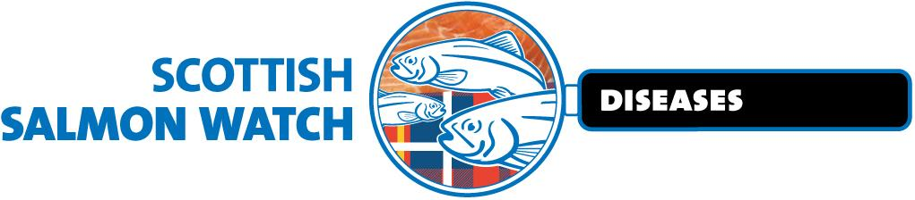

- 25 salmon farms identified as harvesting early due to diseases and mortalities

- Deaths due to disease 'masked' via early harvest claimed Scottish Parliament in March

- Data analysis reveals a shortening of production cycle from 20 to 16 months over the last decade

- Sites operated by Cooke Aquaculture shortened their production cycle by 6.8 months; Loch Duart sites by 6.7 months; Marine Harvest sites by 4.3 months and Scottish Sea Farms sites by 2.3 months

- Reasons for early harvesting included Amoebic Gill Disease, Salmon gill poxvirus, Anaemia, Microsporidia, Salmonid alphavirus, Piscine reovirus, Heart & Skeletal Muscle Inflammation, Proliferative Gill Disease, Pancreas Disease, Epitheliocystis, Paranucleospora theridon, Cardiomyopathy syndrome, Piscine myocarditis virus, Pasturella skyensis, Vibrio, Candidatus Branchiomonas cysticola, Candidatus Syngamydia salmonis, hepatic necrosis, sea lice and mortalities

"Scottish salmon farming is dead in the water," said Don Staniford, Director of Scottish Salmon Watch. "Infectious diseases, viruses, pathogens, lice infestations and mass mortalities are crippling the industry and forcing early harvesting. The data clearly shows that at least twenty-five salmon farms operated by Marine Harvest, The Scottish Salmon Company, Scottish Sea Farms, Cooke Aquaculture, Kames and Loch Duart have shortened production cycles to stem the tide of infection. No wonder salmon farming production in Scotland is forecast to decline by 11% this year. Shoppers should avoid the smorgasbord of salmon viruses, bacteria, pathogens and infectious diseases lurking in farmed salmon like the proverbial plague. Just say no to Scottish salmon."

A Media Backgrounder - "Hard Evidence: Fast-Tracking Disease-Ridden Scottish Salmon" - details early harvesting by at least 25 salmon farms during 2017 including:

Marine Harvest (11): Poll Na Gille (Sound of Jura); Linnhe; North Shore (Loch Erisort); Port Na Cro (Shuna Sound); Loch Alsh; MacLean's Nose (Sound of Mull); Invasion Bay (Loch Sunart); Caolas A Deas (Loch Shell); Soay (West Loch Tarbert); Loch Hourn; Ardintoul (Loch Alsh)

The Scottish Salmon Company (5): Loch Odhairn/Gravir; Loch Tuath; Druimyeon Bay (Sound of Gigha); Inch Kenneth (Loch na Keal); Vuia Beag (Loch Roag)
Scottish Sea Farms (4): Kishorn A (South); Kishorn B (North); Kishorn B (South) and Kishorn West (all Loch Kishorn)

Cooke Aquaculture (3): Stead of Aithness (Aith Voe); Bay of Vady (Rousay Sound); Carness Bay

Kames Fish Farming (1): Shuna SW/Rubh'an Trilleachain (Shuna Sound)

Loch Duart (1): Calva Bay/Calbha Beag (Eddrachillis Bay)

"Harvesting worst affected cages" and "Harvested worse cages, reducing biomass" reported Marine Harvest for Poll Na Gille (Sound of Jura) in November 2017 following problems with "complex gill issues", anaemia, "severe PGD pathology and extensive haemorrhaging". "Harvested worst affected cages first" reported Marine Harvest for Linnhe in June 2017.

"Decision taken quickly to empty site" and "Issues with gills and anaemia have lead to decision to harvest," reported Marine Harvest for Port Na Cro (Shuna Sound) in November 2017

Marine Harvest reported increases in mortality from nine sites in late October 2017 citing "Anaemia issues", "CMS" and "complex gill issue" which "are being managed through harvesting and treatment". "Some fish treated with antibiotics with some positive effect, plan to harvest out ASAP once below MRL [Maximum Residue Limit]," reported Marine Harvest in relation to North Shore (Loch Erisort).

"Site partially harvested to remove worst affected fish - remainder of site due to fallow by end of January 2018"; "Harvesting to reduce biomass" and "Harvesting worst affected cages and accelerated harvest of site" reported the Scottish Salmon Company in relation to Druimyeon Bay (Sound of Gigha) in December 2017.

"Planning to harvest out soon" and "worst effected cages (sic) harvested and reducing biomass" reported the Scottish Salmon Company in relation to Loch Tuath.

"Accelerated harvests"; "Biomass has been lowered but gill issues continuing" and "Site has harvested largest grade cages to lower biomass, gill health issues ongoing" reported the Scottish Salmon Company in relation to Loch Odhairn/Gravir. "Hoping to grade out poor doers to reduce biomass" reported the Scottish Salmon Company in relation to Inch Kenneth (Loch na Keal).

"Plans to move all fish to Eughlam in December," reported The Scottish Salmon Company in October 2017 following "complex disease issues" including Amoebic Gill Disease, Paranucleospora theridon, Salmon gill pox, Microsporidia, Salmonid Alphavirus and Epitheliocystis at Vuia Beag (Loch Roag).

"Harvesting is underway at affected cages to reduce risk"; "Five affected cages to be harvested out, harvesting underway" and "Site being harvested to reduce risk" reported Scottish Sea Farms in relation to Kishorn West in August and October 2017. "Site to begin harvesting early" reported Scottish Sea Farms in relation to Kishorn A (South) and Kishorn North in October 2017.
"Site is harvesting early" reported Scottish Sea Farms in relation to Kishorn B (North), Kishorn West and Kishorn B (South) in October 2017. "Harvesting out site, advised to avoid crowding" wrote Scottish Sea Farms as an action response to increased mortalities at Kishorn A (Loch Kishorn) in October 2017. "Harvesting worst affected cages first and site should be empty in next six weeks" and "Advised to accelerate harvest" reported Scottish Sea Farms in relation to Kishorn B (North) in October 2017.

"Advice from vets to accelerate harvests and not to attempted mechanical delousing in worst affected cages"; "Harvested out worst affected cages and should be empty within six weeks" and "Company may look at using Thermolicer/Hydrolicer to reduce lice levels while harvesting ongoing" reported Scottish Sea Farms in relation to Kishorn West in October 2017.

"Harvest has been accelerated by 1 months (sic) due to increased morts" and "Top sweep is being harvest first (sic) from the worst affected cages" reported Cooke Aquaculture in relation to Stead of Aithness (Aith Voe) in November 2017.

"Reports of increased mortality due to gill issues, site is being harvest out" and "Ongoing monitoring and harvesting of stocks" reported Cooke Aquaculture in relation to Bay of Vady (Rousay Sound) in August 2017 after over 10,000 mortalities in a four-week period.

"Site is being harvested" reported Cooke Aquaculture in relation to Carness Bay in August 2017 after over 20,000 mortalities in a six-week period due to gill issues.

"Biomass has been reduced with worst affected stock having been harvested," reported Kames Fish Farming in relation to Shuna SW (Rubh'an Trilleachain) in November 2017 following "complex gill issues", anaemia, salmon gill poxvirus, epitheliocystis, cardiomyopathy syndrome, piscine myocarditis virus, Paranucleospora theridon and Neoparamoeba perurans (AGD). "Harvest have been both live haul to Mallaig and dead haul."

"Worst affected cages are being harvested out" and "Worst affected will be harvested by next Monday (pens 22, 23, 25, 27, and 28 already harvested out)" reported Loch Duart's for Calva Bay/Calbha Beag (Eddrachillis Bay) in August 2017 following a mortality rate of 45.64% since input in some cages and disease problems including AGD, Candidatus Branchiomonas cysticola, Candidatus Syngnamydia salmonis, Salmon gill poxvirus and Paranucleospora theridon.

Read more via "Hard Evidence: Fast-Tracking Disease-Ridden Scottish Salmon"

Background:

"The overall number of deaths as a result of disease, ill health and stress may be masked by the early harvest of fish with disease or life threatening conditions," stated a report on the environmental impacts of salmon farming by the Scottish Parliament's Environment, Climate Change & Land Reform (ECCLR) Committee in March 2018. "This activity warrants further review." [1]

"Yes - there has been early harvesting, but if we had not harvested early, mortality rates could have been higher, so I do not think that it is a bad thing to have taken action to harvest early," admitted Grant Cumming, Managing Director of Grieg Seafood Shetland Ltd, in oral evidence on 2 May 2018 to the Rural Economy & Connectivity Committee as part of the Scottish Parliament's salmon farming inquiry [2].

'Scotland’s 10 Year Farmed Fish Health Framework' published on 23 May 2018 by the Scottish Government claimed: "The increased ability to grow larger smolts provides the opportunity to reduce the marine grow out phase of farmed salmon, thus reducing the time spent in sea and the length of exposure to marine challenges such as sea lice." [3]

BBC News reported (19 May 2018) trouble ahead for Scotland's disease-ridden salmon farming industry. "Last week, we learned the industry expects an 11% drop in output this year, as it struggles to get on top of sea lice and disease," reported BBC News (May 24 2018). "When either is found in a cage, salmon are harvested (or slaughtered, if you prefer) straight away, and much earlier than if they grew to their optimum marketable size."

Earlier this month, Scottish Salmon Watch delivered a 42,000-strong petition to the Scottish Government calling for the testing of salmon farming operations for deadly diseases and viruses.

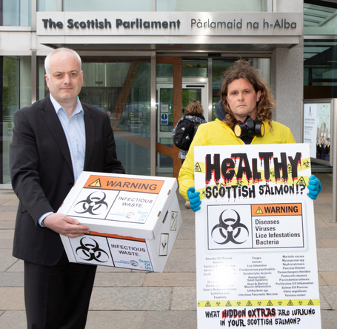

Read more via:
The National: "42,000 sign petition for tougher Scottish salmon farm testing"
Herald: "Salmon farms are turning Scotland's seas into an open sewer, claim campaigners"
SumOfUs: "Campaigners at Scottish Parliament call for wastewater testing at salmon farming operations to save wild fish"
Letter to Scottish Government re. Infectious Diseases in Salmon Farming Effluents
Risk of waterborne virus spread – review of survival of relevant fish and crustacean viruses in the aquatic environment and implications for control measures

Contact:

Don Staniford: 07771 541826 (dstaniford@gaaia.org)
Notes to Editors:

[1] In March, as part of the Environment, Climate Change & Land Reform (ECCLR) Committee's inquiry into the environmental impacts of salmon farming, the ECCLR Committee published a report on the environmental impacts of salmon farming which included:

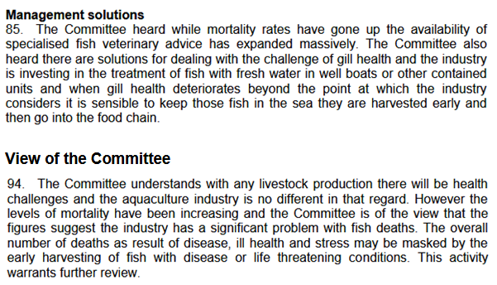

[2] The Rural Economy & Connectivity Committee's oral evidence on 2 May 2018, as part of the Scottish Parliament's salmon farming inquiry, included a discussion on 'early harvesting':

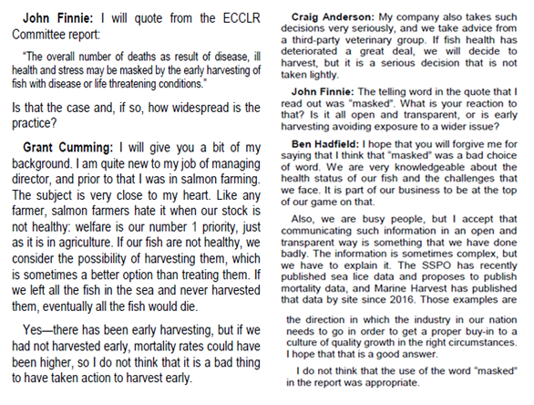

[3] 'Scotland’s 10 Year Farmed Fish Health Framework' published on 23 May 2018 claimed: "The increased ability to grow larger smolts provides the opportunity to reduce the marine grow out phase of farmed salmon, thus reducing the time spent in sea and the length of exposure to marine challenges such as sea lice."
