FOI Backgrounder (April 2017):

FOI Replies & FOI Requests Re. Mort Disposal (Scottish Government, European Commission, Scottish Environment Protection Agency & Local Authorities)

Please read in conjunction with 'Media Backgrounder: Mort Disposal of Scottish Farmed Salmon (May 2017)'.

Appendix 1: FOI reply from the Scottish Government (23 March 2017)

From: Ian.Cox@gov.scot [mailto:Ian.Cox@gov.scot]
Sent: 23 March 2017 16:49
To: salmonfarmingkills@gmail.com
Subject: RE: FOI - E - disposal of morts/dead farmed salmon since 1 Jan 2016 - Don Staniford - FoI/17/00148

Dear Mr Staniford

FOI/17/00148

Please find attached a response in relation to your Freedom of Information request dated 18 January 2017.

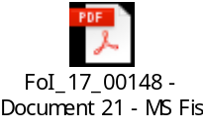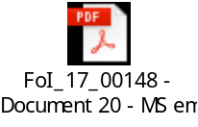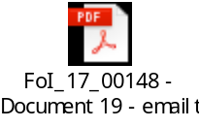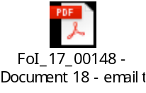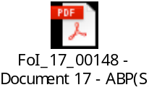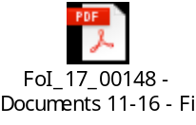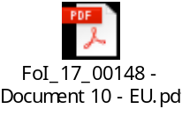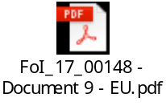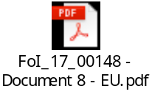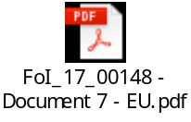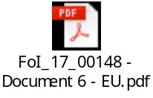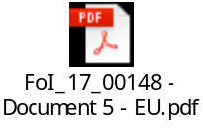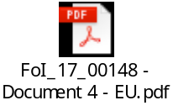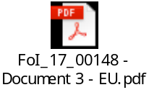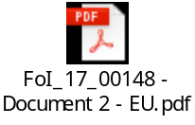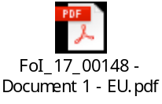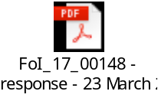

Kind regards

Ian Cox | Animal Health and Welfare Division | Disease Prevention Team
P Spur | Saughton House | Broomhouse Drive | EDINBURGH EH11 3XD
Tel. No. 0300 244 9813 | email: ian.cox@gov.scot



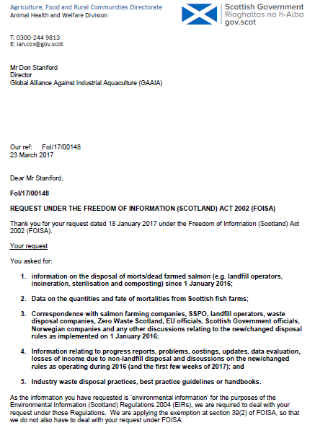

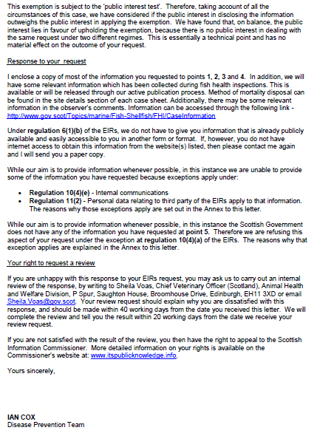

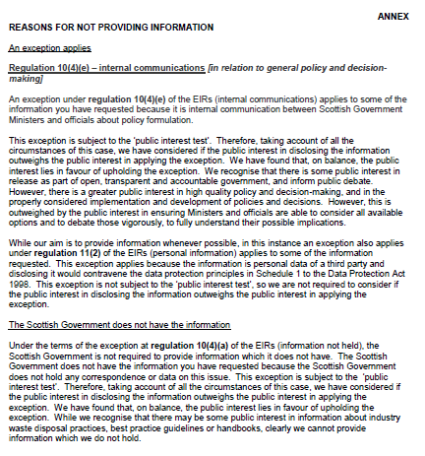

Appendix 2: FOI reply from DG SANCO

From: SANTE-CONSULT-A2@ec.europa.eu [mailto:SANTE-CONSULT-A2@ec.europa.eu]
Sent: 20 February 2017 15:54
To: salmonfarmingkills@gmail.com
Cc: SANTE-ACCESS-TO-DOCUMENTS@ec.europa.eu
Subject: Ares(2017)909436 - Partial disclosure - Your application for access to documents – Ref GestDem No 2017/551

Dear Mr Staniford,

Please find attached the transmission note accompanying the annexes you had requested and that you received earlier.

You will also receive everything by post.

Best regards
Catherine in the secretariat of unit A2.

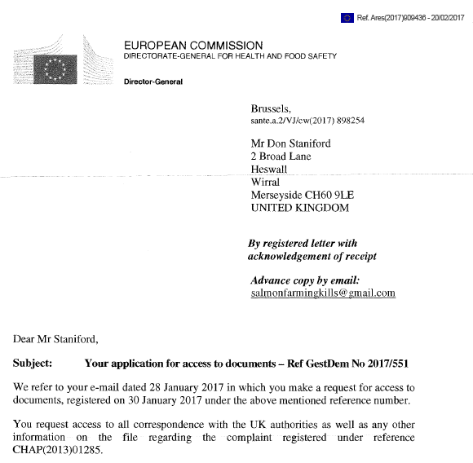

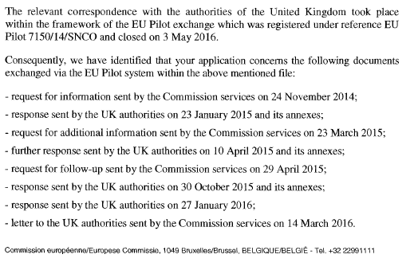
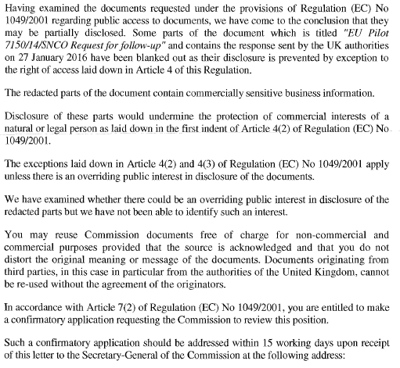

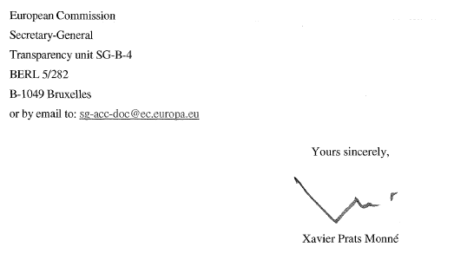

From: EC ARES NOREPLY [mailto:DIGIT-NOREPLYARES@ec.europa.eu]
Sent: 20 February 2017 15:15
To: STANIFORD Don (GAAIA - GLOBAL ALLIANCE AGAINST INDUSTRIAL AQUACULTURE)
Subject: Ares(2017)909436 - Partial disclosure - Your application for access to documents – Ref GestDem No 2017/551

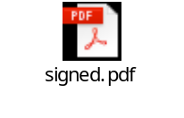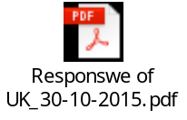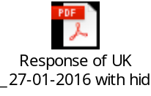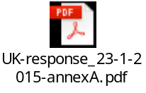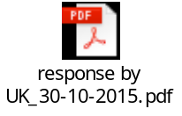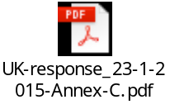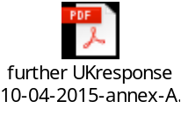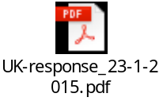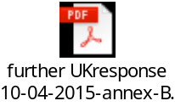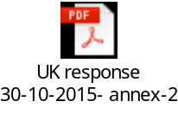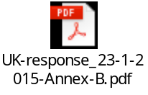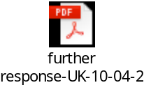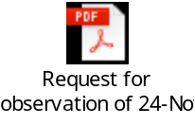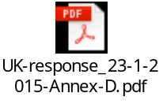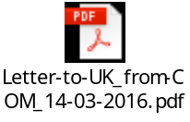

From: SANTE-CONSULT-A2@ec.europa.eu [mailto:SANTE-CONSULT-A2@ec.europa.eu]
Sent: 20 February 2017 13:52
To: salmonfarmingkills@gmail.com
Cc: SANTE-ACCESS-TO-DOCUMENTS@ec.europa.eu
Subject: Ares(2017)909436 regarding "Partial disclosure - Your application for access to documents – Ref GestDem No 2017/551"

Please find attached document Ares(2017)909436 regarding "Partial disclosure - Your application for access to documents – Ref GestDem No 2017/551"

Replies by e-mail must be addressed to: SANTE-CONSULT-A2@ec.europa.eu

ATTACHED:

 | UK-response_23-1-2015-Annex-C.xlsx | (31.5 KB)
 | signed | (89.9 KB)
 | UK-response_23-1-2015-Annex-D.pdf | (181.2 KB)
 | Request for observation of 24-Novembre-2014.doc | (45.4 KB)
 | further UKresponse 10-04-2015-annex-A.docx | (38.8 KB)
 | further UKresponse 10-04-2015-annex-B.pptx | (257.8 KB)
 | UK-response_23-1-2015-Annex-B.pdf | (2.0 MB)
 | Response of UK _27-01-2016 with hidden address.pdf | (91.5 KB)
 | further response-UK-10-04-2015.docx | (99.6 KB)
 | Letter-to-UK_from-COM_14-03-2016.doc | (25.2 KB)
 | UK-response_23-1-2015.docx | (379.4 KB)
 | request for follow-up- COM_29-04-2015.doc | (25.9 KB)
 | UK response 30-10-2015- annex-2 -Guidance.pdf | (239.8 KB)
 | Responswe of UK_30-10-2015.docx | (101.1 KB)
 | response by UK_30-10-2015.doc | (27.1 KB)
 | UK-response_23-1-2015-annexA.xlsx | (7.8 MB)
 | request for additional info by Com_23-3-2015.doc | (33.0 KB)

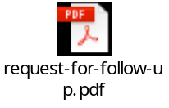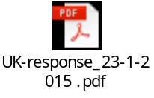

From: Don Staniford [mailto:salmonfarmingkills@gmail.com]
Sent: 28 January 2017 12:46
To: 'SANCO-CHAP@ec.europa.eu'
Subject: FOI request re. CHAP(2013)01285 - Kennedy complaint vs UK authorities on disposal of animal by-roducts from fish farms

Please provide information on Ewan Kennedy's complaint registered under reference number CHAP(2013)01285, against the United Kingdom on alleged infringements of Union legislation relating to the collection and disposal of animal by-products originating from fish farming in Scotland.
It is my understanding that the complaint was filed in April 2013 and the case handler was Ville Jämsä.
It is understood that the case file was closed in 2016.
The case was reported in April 2016 via:
"European Commission complaint over dead fish dumping forces rule change" (Evening Times)
"Complaint over dead fish dumping forces rule change" (Sunday Herald)

For example, an email from Ville Jämsä of the European Commission in June 2015 (enclosed in full below) included:

"Extensive correspondence has taken place between the Commission services and the UK authorities in the context of the EU Pilot investigation which was triggered by your complaint. I can inform you that the UK authorities have in this context presented an action plan which includes an envisaged amendment to the Animal By-Products (Enforcement) (Scotland) Regulations 2013 and improvements to the official control activities, in particular in relation to contingency planning for large scale fish mortality disposal. In order to maintain the necessary trust-based cooperation between the Member State and the Commission during the pending EU Pilot investigation, further details of the action plan submitted by the UK authorities cannot be explained at this stage. However, the timeline provided by the UK authorities shows, inter alia, that the legislative amendment is envisaged to enter into force by the end of year 2015. The Commission services are closely following up with the commitments of the UK authorities in this context."

Since this complaint closed in 2016 and the UK authorities have now made the necessary legislative amendments (which came into force on 1 January 2016) this "extensive correspondence" should therefore be publicly available.

For easy reference, here's the letter from the EC in May 2016 closing the case:

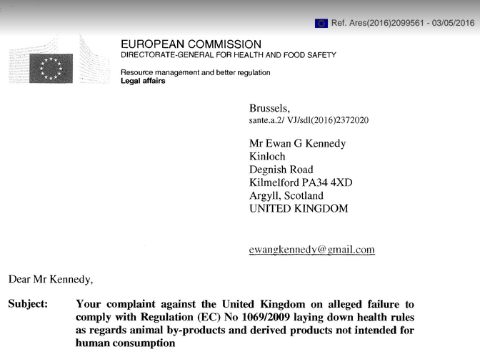

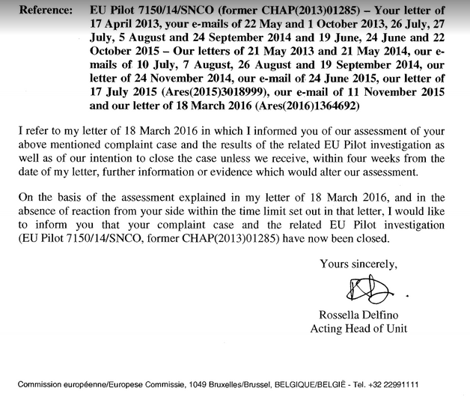

Please include all correspondence with the UK authorities as well as any other information on file.

Please consider this a request for information under the relevant Freedom of Information and Environmental Information Regulations.

Please provide this information electronically via email.

Please acknowledge receipt of this FOI request.

Many thanks and I look forward to a response shortly.

Thanks,

Don

Don Staniford

Director, Global Alliance Against Industrial Aquaculture (GAAIA): http://www.salmonfarmingkills.com

<((((º>`·.¸¸.·´¯`·.¸.·´¯`·...¸><((((º>¸.
·´¯`·.¸. , . .·´¯`·.. ><((((º>`·.¸¸.·´¯`·.¸.·´¯`·...¸><((((º>

From: <SANTE-CHAP@ec.europa.eu>
Date: 24 June 2015 at 08:52
Subject: Your complaint EU Pilot 7150/14/SNCO (former CHAP(2013)01285) concerning the UK
To: ewangkennedy@gmail.com
Cc: SANTE-CHAP@ec.europa.eu
Dear Mr Kennedy,
Thank you for your e-mail of 19 June 2015 in which you request for an update on the above mentioned complaint case.
As we informed you with our e-mail of 24 November 2014 (please, see attached), your complaint was transferred to the EU Pilot application under reference 7150/14/SNCO in order to request for information from the UK authorities.
Extensive correspondence has taken place between the Commission services and the UK authorities in the context of the EU Pilot investigation which was triggered by your complaint. I can inform you that the UK authorities have in this context presented an action plan which includes an envisaged amendment to the Animal By-Products (Enforcement) (Scotland) Regulations 2013 and improvements to the official control activities, in particular in relation to contingency planning for large scale fish mortality disposal. In order to maintain the necessary trust-based cooperation between the Member State and the Commission during the pending EU Pilot investigation, further details of the action plan submitted by the UK authorities cannot be explained at this stage. However, the timeline provided by the UK authorities shows, inter alia, that the legislative amendment is envisaged to enter into force by the end of year 2015. The Commission services are closely following up with the commitments of the UK authorities in this context.
I trust this information answers your questions.

Yours sincerely,

Ville Jämsä
Case handler

Appendix 3: FOI reply from SEPA (9 February 2017)

From: FOI Helpdesk [mailto:FOI.Mail@sepa.org.uk]
Sent: 09 February 2017 16:27
To: Salmonfarmingkills@gmail.com
Subject: Access to Information SEPA Response - [F:0187276]

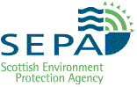
Dear Mr Staniford
REQUEST FOR INFORMATION

Please refer to the enclosed documents in relation to your request for information.

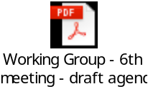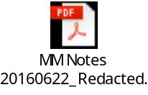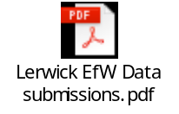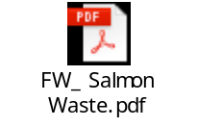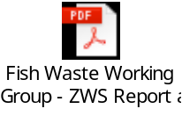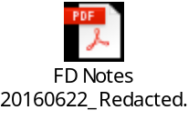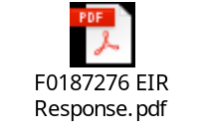

Regards

Michael Hampton
SEPA Access to Information team
Email: foi@sepa.org.uk
Tel: 01786 457700

Appendix 4: FOI reply from Shetland Isles Council (9 March 2017)

From: Jaine.Best@shetland.gov.uk [mailto:Jaine.Best@shetland.gov.uk]
Sent: 13 March 2017 11:14
To: salmonfarmingkills@gmail.com
Subject: RE: FAO Don Staniford Appeal re FOI

Good morning Mr Staniford
I enclose a copy of the two e-mails detailing the correspondence with SEPA.
Yours faithfully
Jaine Best

Attachments:

From: Osborn, Kevin [mailto:kevin.osborn@sepa.org.uk]
Sent: 14 November 2016 10:30
To: Spence William@Environmental Services
Subject: RE: Salmon Waste

Hi Will’m

You can landfill morts but they have to be pressure sterelised – morts & diseased fish are Category 2 Aquatic APB.

http://www.gov.scot/Topics/farmingrural/Agriculture/animal-welfare/ABPs/aquacultureABP/aquaticABPdisposal

I thought there had been some sort of relaxation of the regs but cant find anything confirming this.

Cheers

Kevin

Kevin Osborn
Environment Protection Officer
Scottish Environment Protection Agency
Shetland Office, The Esplanade, Lerwick, Shetland. ZE1 0LL
Tel: 01595 696926 Fax: 01595 696946 www.sepa.org.uk

The information contained in this email and any attachments may be confidential and is intended solely for the use of the intended recipients. Access, copying or re-use of the information in it by any other is not authorised. If you are not the intended recipient please notify us immediately by return email to postmaster@sepa.org.uk.

SEPA registered office:Strathallan House, Castle Business Park, Stirling, FK9 4TZ. Under the Regulation of Investigatory Powers Act 2000, the email system at SEPA may be subject to monitoring from time to time.

From: william.spence@shetland.gov.uk [mailto:william.spence@shetland.gov.uk]
Sent: 13 November 2016 17:34
To: Osborn, Kevin
Subject: Salmon Waste

Hi Kevin

You mentioned the other day that it might be possible that we can take salmon waste into Gremista Landfill. I am sure that if this is possible the salmon industry would much appreciate it because it would seem that they have plenty to dispose off.

Can you give me any guidelines on this and would there be any restrictions.

Cheers

W Spence
Executive Manager – Environmental Services

Shetland Islands Council
Environmental Services
Infrastructure Services Department
Gremista
Lerwick
Shetland
ZE1 0PX

Tel: 01595 745163/07766421052
Fax: 01595 745175
e-mail: william.spence@sic.shetland.gov.uk
Visit
http://www.shetland.gov.uk/waste/

From: Don Staniford [mailto:salmonfarmingkills@gmail.com]
Sent: 09 March 2017 19:35
To: Best Jaine@Governance & Law
Subject: RE: FAO Don Staniford Appeal re FOI

Sorry - this is not acceptable.

Please provide copies of the correspondence you refer to.

Thanks,

Don

From: Jaine.Best@shetland.gov.uk [mailto:Jaine.Best@shetland.gov.uk]
Sent: 09 March 2017 11:23
To: salmonfarmingkills@gmail.com
Subject: FAO Don Staniford Appeal re FOI

Good morning Mr Staniford.

Your appeal of 7th February 2017 was passed to me for attention.

I note your particular concerns in relation to the following paragraph from your original request :-
‘Please include correspondence with salmon farming companies, SSPO, landfill operators, waste disposal companies, Zero Waste Scotland, EU officials, Scottish Government officials, Norwegian companies and any other discussions relating to the new/changed disposal rules as implemented on 1st January 2016’.

I would confirm that the Executive Manager – Environmental Services has undertaken a search of the records held by Shetland Islands Council in relation to this issue and the only information falling within the scope of your request is a request from the Council to SEPA on 13th November 2016 about the possibility of disposal of salmon waste at the Gremista Landfill site.

SEPA responded to confirm that landfill morts require to be pressure sterilised - morts and diseased fish are category 2 Aquatic APB. The Council were directed to the undernoted website.

http://www.gov.scot/Topics/farmingrural/Agriculture/animal-welfare/ABPs/aquacultureABP/aquaticABPdisposal

I trust the above is of assistance

Your faithfully
Jaine Best, solicitor
Shetland Islands Council,
8 North Ness business Park,
Lerwick,
Shetland.
ZE1 OLZ

From: Don Staniford [mailto:salmonfarmingkills@gmail.com]
Sent: 20 February 2017 12:54
To: Nicolson Paula@Infrastructure Svs
Subject: RE: Salmon disposal

Paula,

Thanks - do you know what units the "weight" column is (e.g. tonnes or kg) for both Excel spreadsheets?

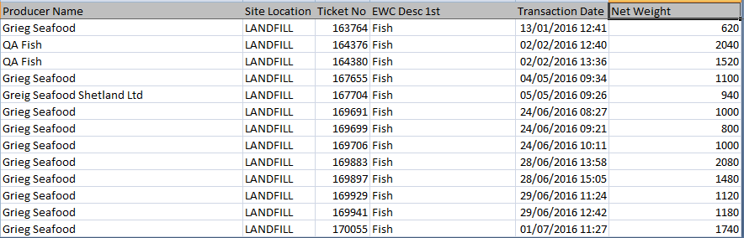

Both do not list the units.

Thanks,

Don

From: Paula.Nicolson@shetland.gov.uk [mailto:Paula.Nicolson@shetland.gov.uk]
Sent: 20 February 2017 11:58
To: salmonfarmingkills@gmail.com
Subject: Salmon disposal

Dear Mr Saniford

Attached is the information and companies that have dumped fish at the Landfill site and Energy Recovery Plant.

The Executive Manager for Environmental Services has asked me to pass this onto you

Thank you

Paula Nicolson
Clerical Officer
Infrastructure Services
Gremista
Lerwick
Tel: 744809

Attachments:



From: Paula.Nicolson@shetland.gov.uk [mailto:Paula.Nicolson@shetland.gov.uk]
Sent: 10 February 2017 09:00
To: salmonfarmingkills@gmail.com
Subject: RE: FOI request

Thank you for your emails I have passed them onto the Executive Manager from Environmental Services who is in overall charge of waste, I can give you his details if you would like to be in contact with him

I have asked him to make his reply a priority

Thank you

Paula

Paula Nicolson
Clerical Officer
Energy Recovery Plant
Gremista
Lerwick
745160

From: Don Staniford [mailto:salmonfarmingkills@gmail.com]
Sent: 09 February 2017 16:45
To: 'Paula.Nicolson@shetland.gov.uk'
Subject: RE: FOI request

Paula,

Please also check if anyone from SIC attended or phoned into this meeting?

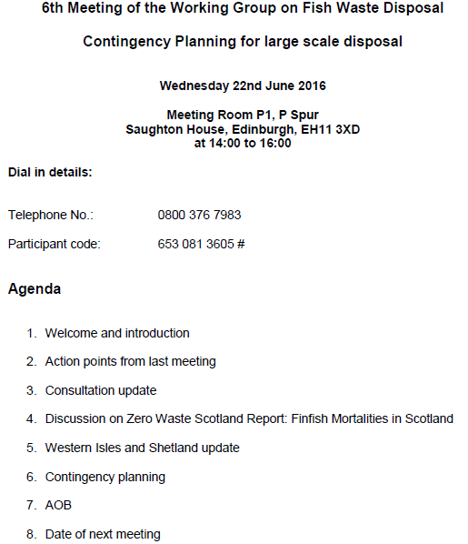

And if they have any documentation.

Thanks,

Don

From: Don Staniford [mailto:salmonfarmingkills@gmail.com]
Sent: 09 February 2017 16:40
To: 'Paula.Nicolson@shetland.gov.uk'
Subject: RE: FOI request

Ditto, this document disclosed by SEPA was not made available by SIC:

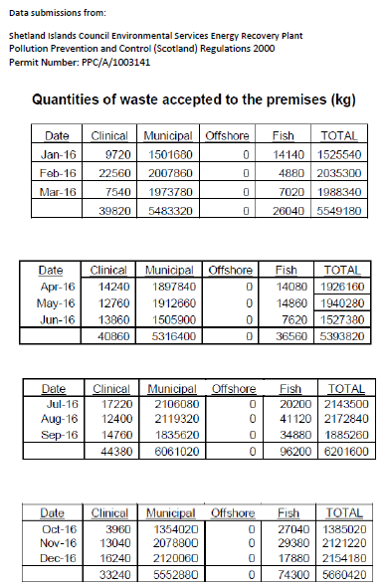

This begs the question: how many more documents are SIC hiding?

Thanks,

Don

From: Don Staniford [mailto:salmonfarmingkills@gmail.com]
Sent: 09 February 2017 16:37
To: 'Paula.Nicolson@shetland.gov.uk'
Subject: RE: FOI request

Paula,

Before a review/appeal is filed, could you please triple-check that SIC has provided all the documents requested?

For example, this email was made available by SEPA (in reply to a carbon copy FOI) but it was not made available by SIC:

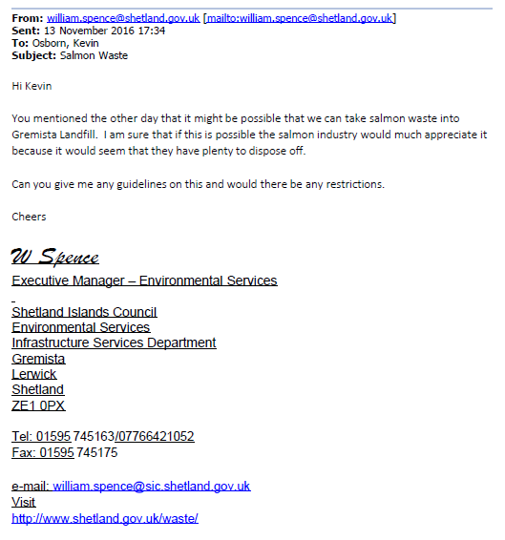

Why did SIC not make this available?

Are there other documents which should be made available?

Thanks,

Don

From: Don Staniford [mailto:salmonfarmingkills@gmail.com]
Sent: 07 February 2017 16:46
To: 'Paula.Nicolson@shetland.gov.uk'
Subject: RE: FOI request

Paula,

The attached letter does not seem to be complete.

Who, for example, wrote it and where is the signature?

Don

From: Paula.Nicolson@shetland.gov.uk [mailto:Paula.Nicolson@shetland.gov.uk]
Sent: 07 February 2017 16:29
To: salmonfarmingkills@gmail.com
Subject: FOI request

Dear Mr Staniford

I have asked the Executive Manger for Environmental Services to provide information for your request. The attached document is from the European Commission and there is email correspondence below relating to this. Our landfill site only accepted salmon until 30th June 2016. Salmon is disposed at our Energy Recovery Plant which is licensed by SEPA. We don’t have any correspondence with waste disposal companies as Shetland islands Council operates and manages both the Landfill site and the Energy Recovery Plant ( we only have one of each in Shetland). We have no current correspondence with any of the other organisations listed. At the Energy Recovery plant a Salmon company site will phone in and advise the staff if they have salmon to dispose of we have a daily limit of 3 tonnes, If we have reached our limit of that day we advise the company that they need to come another day.

I hope that answers your questions in full

Thank you

Paula

Paula Nicolson
Clerical Officer
Infrastructure Services
Gremista
Lerwick
Tel: 744809

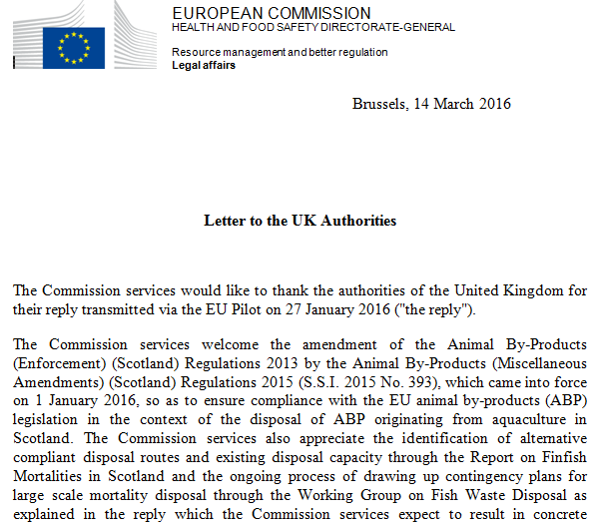
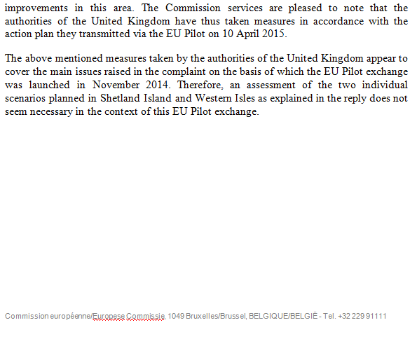

From: Grant Cumming [mailto:grant.cumming@griegseafood.com]
Sent: 24 March 2016 11:20
To: Spence William@Environmental Services
Cc: Sandison Maggie@Infrastructure Svs
Subject: FW: Grieg Seafood - outcome of European Commission derogation request

Hi William,

Please find attached confirmation from Scottish Government that the SIC landfill has been derogated to accept salmon waste until the end of June 2016. Please can you confirm if you will still be able to accept this waste and what quantities you will be able to take?

Best regards,

Grant

From: Ian.Cox@gov.scot [mailto:Ian.Cox@gov.scot]
Sent: 24 March 2016 11:11
To: Grant Cumming <grant.cumming@griegseafood.com>
Subject: RE: Grieg Seafood - outcome of European Commission derogation request

Hi Grant

This is the letter we received from the Commission and it’s the last paragraph you’re interested in outlining that they’re happy with the progress made to date.

Many thanks

Ian

IAN COX | TSEs and Animal By-Products
Disease Prevention Team | Animal Health and Welfare Division (P Spur)
Directorate for Agriculture Food and Rural Communities | Scottish Government
Saughton House, Broomhouse Drive, EDINBURGH, EH11 3XD

Tel: 0300 244 9813
Email: Ian.Cox@gov.scot

From: Paula.Nicolson@shetland.gov.uk [mailto:Paula.Nicolson@shetland.gov.uk]
Sent: 07 February 2017 15:13
To: salmonfarmingkills@gmail.com
Subject: RE: Appeal re. FOI re. disposal of morts/dead farmed salmon since 1 Jan 2016

Dear Mr Staniford

Thank you for your reply I am very sorry that you haven’t received all the information that you needed, I will go back to the Team Leader for Waste Management as he manages the landfill site and our waste to Energy Plant and ask him to provide further information regarding salmon disposal and get this to you as soon as possible

Thank you

Paula Nicolson
Clerical Officer
Infrastructure Services
Gremista
Lerwick
Tel: 744809

From: Don Staniford [mailto:salmonfarmingkills@gmail.com]
Sent: 07 February 2017 15:06
To: Nicolson Paula@Infrastructure Svs
Cc: foi
Subject: Appeal re. FOI re. disposal of morts/dead farmed salmon since 1 Jan 2016

Paula,

Please consider this a formal appeal.

GAAIA's FOI request of 18 January 2017 included:

"Please include correspondence with salmon farming companies, SSPO, landfill operators, waste disposal companies, Zero Waste Scotland, EU officials, Scottish Government officials, Norwegian companies and any other discussions relating to the new/changed disposal rules as implemented on 1 January 2016."

Where is this information?

Your response below is simply inadequate.

I can expand if necessary but it's blatantly obvious that the response from SIC does not comply with the FOI request and does not begin to provide all the information requested.

Please therefore provide the information originally requested.

Please provide a receipt for this FOI appeal.

Thanks,

Don

From: Paula.Nicolson@shetland.gov.uk [mailto:Paula.Nicolson@shetland.gov.uk]
Sent: 07 February 2017 09:52
To: salmonfarmingkills@gmail.com
Subject: FOI re. disposal of morts/dead farmed salmon since 1 Jan 2016

Dear Mr Staniford

Thank you for your freedom of information enquiry, the information that you requested regarding disposal of morts / dead salmon is detailed below:

Jan – Dec 2016
Disposal at Energy Recovery Plant: 233.10 tonnes
Disposal in Landfill: 16.62 tonnes

Jan 2017 –
ERP: 15.880 tonnes
Landfill: Zero.

I trust that this response meets your request. However, if you are dissatisfied with the way in which the Council has dealt with your request for information then you may ask the authority to review its actions and decisions in relation to your request, by submitting a formal appeal

Paula Nicolson
Clerical Officer
Infrastructure Services
Gremista
Lerwick
Tel: 744809

Appendix 5: FOI reply from Highland Council (15 February 2017)

From: Lawrence Jones [mailto:Lawrence.Jones@highland.gov.uk] On Behalf Of Community Services - Headquarters
Sent: 15 February 2017 11:28
To: salmonfarmingkills@gmail.com
Subject: HC0226-1133 - Disposal of morts/dead farmed salmon

Dear Mr Staniford,

Please find attached information in response to your recent freedom of information request HC0226-1133.

Regards,
Lawrence Jones
Customer Services Officer
Community Services
The Highland Council
HQ
Glenurquhart Rd
Inverness
IV3 5NX

Tel. no. 01463 252946

Mr Don Staniford  salmonfarmingkills@gmail.com | Lagan Ref: HC0226-1133  Tel: 01349 886606  Date: 15 February 2017

Dear Mr Staniford,

Request for information under the Freedom of Information (Scotland) Act 2002 or Environmental Information (Scotland) Regulations 2004

With regard to your request for information - Disposal of morts/dead farmed salmon
The Council has checked our records and we hold no information on disposal of morts/dead farmed salmon since January 2016.

Dead salmon from a fish farm fall into the animal by-product category and as such will not be collected for disposal by Highland Council waste services. This service, if required, may be delivered by the private waste collection providers in Highland. The Council’s Environmental Health team, who have a role in the enforcement of the Animal By-Product legislation, hold no information on disposal of morts/dead farmed salmon since January 2016. This includes no information as described in your request (correspondence and discussions).

The Scottish Government and the Animal and Plant Health Agency (APHA) have a key role in the enforcement of the Animal By-Product legislation and may be able to assist you with your queries.
Under Section 20 of the Freedom of Information (Scotland) Act 2002 and/or Regulation 16 of the Environmental Information (Scotland) Regulations 2004 (EIRs), you have the right to request that the Highland Council reviews any aspect of how it has dealt with your request. This requirement for review should be put in writing to the Freedom of Information Officer, Chief Executive’s Office, Glenurquhart Road, Inverness IV3 5NX, within 40 working days of receipt of this letter. The request should include details of the information requested and the aspects of the Highland Council’s response which you are not satisfied with.
If you are subsequently dissatisfied with the outcome of the Council's review, you have the right to appeal to the Scottish Information Commissioner under Section 47 of the Act (Regulation 17 of the EIRS), within six months of receiving the Council's review response.
Further guidance on information request reviews and right to appeal can be found on the Scottish Information Commissioner website at www.itspublicknowledge.info.

Yours sincerely,

Lawrence Jones on behalf of Environmental Health Manager

Appendix 6: FOI reply from Argyll & Bute Council (7 February 2017)

From: DIS Performance HQ [mailto:DISPerformanceHQ@argyll-bute.gov.uk]
Sent: 07 February 2017 16:57
To: salmonfarmingkills@gmail.com
Cc: 'argyll@messagestore.co.uk'
Subject: FOI Request argyllbuteir:6638 [OFFICIAL]
Classification: OFFICIAL
Dear Mr Staniford,

Request for information: Disposal of morts/dead farmed salmon
Reference: argyllbuteir:6638

I refer to your request for information which was dealt with in terms of the Environmental Information (Scotland) Regulations 2004.

Please see information below and attached in fulfillment of your request.

Please provide information on the disposal of morts/dead farmed salmon (e.g. landfill, incineration, sterilisation and composting) since 1 January 2016.

We have no information relating to the disposal of morts/dead farmed salmon. Our Waste Team have confirmed that we have not landfilled any morts/dead salmon since 1st January 2016. The regulations do not require the Council, as the animal health and welfare regulator, to maintain records containing this type of information. All aquaculture production businesses are required to keep a record of the number of aquaculture animals that have died in each epidemiological unit within that area (regulation 6 of the Aquatic Animal Health (Scotland) Regulations 2009). There is no requirement for these records to be made available for inspection by the public. Accordingly, we have no information to provide and therefore I have to advise that the information you requested is information not held by the Council and as such I must refuse your request in terms of Regulation 10(4)(a) of the EIRs.

Please include correspondence with salmon farming companies, SSPO, landfill operators, waste disposal companies, Zero Waste Scotland, EU officials, Scottish Government officials, Norwegian companies and any other discussions relating to the new/changed disposal rules as implemented on 1 January 2016. In this FOI reply, please include any data on the quantities and fate of mortalities from Scottish salmon farms.

Please find attached correspondence between the Council and Shanks relating to the ban on the disposal of fish waste to landfill. This follows work undertaken by the Council prior to the date of 1st January 2016. We have no information to provide on the quantities and fate of mortalities from Scottish salmon farms and therefore I have to advise that the information you requested is information not held by the Council and as such I must refuse your request in terms of Regulation 10(4)(a) of the EIRs.

Please also include any industry waste disposal practices, best practice guidelines or handbooks. For example, here's a document published online by the Scottish Government relating to Cooke Aquaculture's mortality removal and disposal: Please therefore also include information relating to progress reports, problems, costings, updates, data evaluation, losses of income due to non-landfill disposal and discussions on the new/changed rules as operating during 2016 (and the first few weeks of 2017).

We have no information to provide and therefore I have to advise that the information you requested is information not held by the Council and as such I must refuse your request in terms of Regulation 10(4)(a) of the EIRs.

If you are dissatisfied with the way in which your request for information has been dealt with you are entitled to request a review by writing to the Executive Director Customer Services, Argyll and Bute Council, Kilmory, Lochgilphead, Argyll PA31 8RT, or by email to foi@argyll-bute.gov.uk.

Your request for review must state your name and address for correspondence, specify the request for information to which your request for review relates and why you are dissatisfied with the response.

You must make your request for review not later than 40 working days after the expiry of the 20 working day period for response to your initial request by the Council, or not later than 40 working days after the receipt by you of the information provided, any fees notice issued or any notification of refusal or partial refusal.

If you make an application for review and remain dissatisfied with the way in which the review has been dealt with you are entitled to make an application to the Scottish Information Commissioner, Kinburn Castle, Doubledykes Road, St Andrews, Fife KY16 9DS (Tel: 01334 464610) for a further review. You can now do this online here - www.itspublicknowledge.info/Appeal.

You must make representation to the Scottish Information Commissioner no later than 6 months after the date of receipt by you of the notice or decision you are dissatisfied with or within 6 months of the expiry of the period of 20 working days from receipt by the Council of your request for review.

Yours sincerely

Ailsa Barr
DIS Performance HQ Team
Performance and Business Support
Development & Infrastructure Services
Argyll and Bute Council
Tel: 01546 604674 Fax: 01546 604678
DISPerformanceHQ@argyll-bute.gov.uk

From: Young, Willie (Animal Health) [mailto:William.Young@argyll-bute.gov.uk]
Sent: 14 March 2016 15:15
To: 'Gail Orr'
Subject: RE: Fish Waste [OFFICIAL]

Classification: OFFICIAL
Good Afternoon Gail,

Sorry for the delay in getting back to you. I also got a message from our Call Centre asking me to call you but I thought I’d be as well to email you and provide you with links to the relevant Scottish Government Guidance.

The simple answer to your question is that fish waste can no longer be disposed by landfilling it; and the Regulations relating to this came into force on 1st January 2016.

If you would like more detail you can:-
- access the legislation [The Animal By-Products (Miscellaneous Amendments) (Scotland) Regulations 2015] via the following link: http://www.legislation.gov.uk/ssi/2015/393/introduction/made
- access the Scottish Government’s Guidance on the Disposal of Aquaculture Animal By-Products via the following link: http://www.gov.scot/Topics/farmingrural/Agriculture/animal-welfare/ABPs/aquacultureABP

If you want to discuss this further or want more information please give me a call; I’ll be in the office all afternoon.

Hope this helps.

Regards,

Willie

Willie Young
Animal Health & Welfare Officer / Regulatory Services Officer (EH)
Animal Health / Environmental Health
Planning & Regulatory Services
Argyll and Bute Council

Tel: 01369 707122
Mobile: 07768 907 270
e: william.young@argyll-bute.gov.uk
w: www.argyll-bute.gov.uk

Argyll and Bute - Realising our potential together

From: Gail Orr [mailto:Gail.Orr@shanks.co.uk]
Sent: 07 March 2016 13:37
To: Young, Willie (Animal Health)
Subject: Fish Waste

Good afternoon Willie
I wonder if you could assist me please. I've been trying to find a definitive answer to the issue of fish waste disposal in landfill - I believe fish waste can no longer be land-filled after a certain date which I was advised to be 1st April 2016. Could you please confirm if this is correct and forward me the written details as I assume there must be guidance on this issue?
Many thanks
Gail Orr
Contract Operations Manager
Argyll & Bute PFI
Shanks Waste Management
Mob: 07836 535541
Appendix 7: FOI reply from North Ayrshire Council (1 February 2017)

From: Steven Ward [mailto:StevenWard@north-ayrshire.gov.uk]
Sent: 01 February 2017 15:55
To: salmonfarmingkills@gmail.com
Subject: Information Request - Our Ref : NAC/15810/2017 [OFFICIAL]

Dear Don Staniford
Subject : Freedom of Information (Scotland) Act 2002
Thank you for your request for information dated 24/01/2017, which was received by North Ayrshire Council on 24/01/2017.
We have now completed our research for the information you request and the responses to the questions submitted are listed below.
North Ayrshire Council do not offer ABP compliant disposal routes for finfish farming waste and would advise any waste producer who produces such waste to secure
suitable ABP compliant disposal solutions or seek advice from SEPA. North Ayrshire Council have not disposed of this waste type or corresponded with any such waste producers since January 2016.
Your right to seek a review
Should you be dissatisfied with the way in which North Ayrshire Council has dealt with your request, you have the right to ask us to review decisions.
Your request should explain why you wish a review to be carried out, and should be made within 40 working days of receipt of this letter. We will reply within 20 working days of receipt. Staff not involved in your original request will undertake the review. If you are not satisfied with the result of the review you then have the right to make a formal complaint to the Scottish Information Commissioner at http://www.itspublicknowledge.info/Appeal.
A request for a review should be made in writing to:
The Information Governance Manager
Democratic and Administration Services
Cunninghame House
Irvine
Ayrshire
KA12 8EE
Email : FreedomOfInformation@north-ayrshire.gov.uk
The supply of documents under the terms of the Freedom of Information (Scotland) Act 2002 does not give the applicant or whoever receives the information any right to re-use it in such a way that might infringe the Copyright, Designs and Patents Act 1988. This includes making multiple copies, publishing or otherwise distributing the information to other individuals and the public.
While efforts have been made to ensure the accuracy of this information, its accuracy is not warranted. In particular, the Council accepts no liability for onward sale or transfer of this information to any third party and for any reliance placed on such information by you or by a third party.
If you need further help please telephone Steven Ward on 01294 324798.
Yours sincerely
Steven Ward
FOI Co-ordinator
Appendix 8: FOI reply from Orkney Isles Council (30 January 2017)

From: Don Staniford [mailto:salmonfarmingkills@gmail.com]
Sent: 30 January 2017 14:10
To: 'foi'
Subject: RE: 2017-0075 FOI re. disposal of morts/dead farmed salmon since 1 Jan 2016

George,

It seems alarming that Orkney Islands Council does not know where all the dead farmed salmon in Orkney end up!

Perhaps OIC should investigate?

Don

From: Kate Russell-Duff [mailto:Kate.Russell-Duff@orkney.gov.uk] On Behalf Of foi
Sent: 30 January 2017 12:16
To: 'Don Staniford'
Cc: foi
Subject: RE: 2017-0075 FOI re. disposal of morts/dead farmed salmon since 1 Jan 2016

Dear Sir

Freedom of Information (Scotland) Act 2002 – Request for Information

I refer to your request for information dated 18 January 2017. Our reference is FOI 2017-0075.

Orkney Islands Council does not hold the information requested. Marine Scotland may hold the information and can be contacted at http://www.gov.scot/Topics/marine.

You have the right to request a review of the decision if you are not satisfied with the way we have handled your request. Please write to: Head of Legal Services, Corporate Services, Council Offices, School Place, Kirkwall, Orkney, KW15 1NY or email to foi@orkney.gov.uk to make this request. The law gives you up to 60 working days from when we received your enquiry or 40 working days from when you receive this correspondence, whichever is the later date.

Where the outcome of the review fails to resolve the matter to your complete satisfaction you have the right to apply to the Scottish Information Commissioner for a decision, within six months of the date of the decision to a request for a review, or within six months from when we should have responded to your request for a review, whichever is the later date.

Kind regards

George Vickers
Information Governance Officer
Corporate Services
Orkney Islands Council, Council Offices, Kirkwall, Orkney, KW15 1NY
Telephone: 01856 873535 Extension: 2162
www.orkney.gov.uk

Appendix 9: FOI request to various Government agencies (18 January 2017)

From: Don Staniford [mailto:salmonfarmingkills@gmail.com]
Sent: 18 January 2017 09:20
To: 'AccesstoInformation'
Subject: FOI re. disposal of morts/dead farmed salmon since 1 Jan 2016

Please provide information on the disposal of morts/dead farmed salmon (e.g. landfill, incineration, sterilisation and composting) since 1 January 2016.

Please include correspondence with salmon farming companies, SSPO, landfill operators, waste disposal companies, Zero Waste Scotland, EU officials, Scottish Government officials, Norwegian companies and any other discussions relating to the new/changed disposal rules as implemented on 1 January 2016.

As context, the Sunday Herald reported in April 2016:

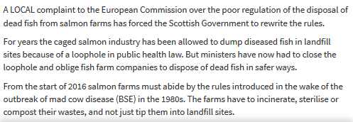

Read more via "European Commission complaint over dead fish dumping forces rule change"

The Evening Times reported in April 2016:

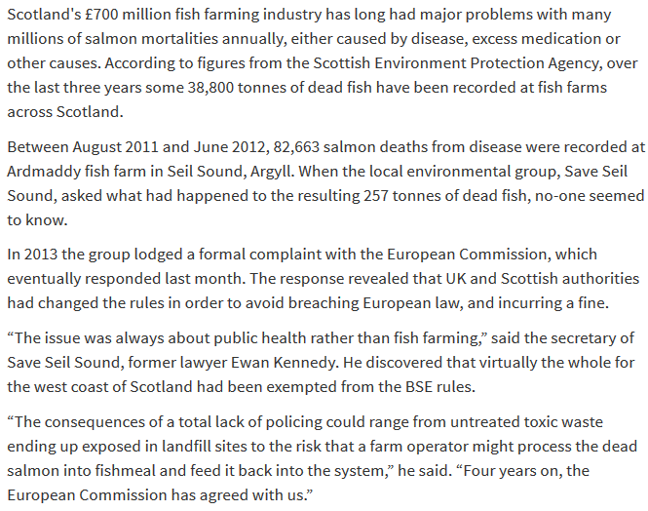

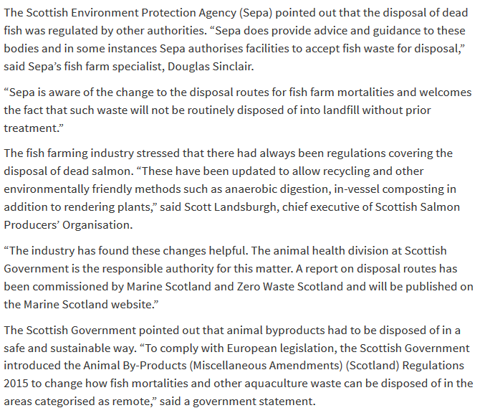

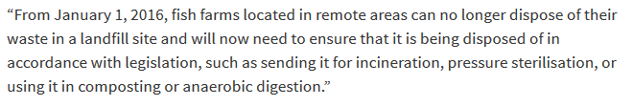

Read more via "European Commission complaint over dead fish dumping forces rule change"

The Sunday Herald also reported in 2013:
Argyll and Bute Council confirmed that it had “no policy” on the disposal of dead fish, as that was the responsibility of the fish farm. “They don’t tell us where they dispose of them, and they don’t have to,” said a council spokeswoman.
Sepa said that the disposal of dead animals was not an area where it had a “leading regulatory role”. It provided advice to councils and animal health authorities and, according to a spokesman, “does not have details of the disposal routes of mortalities arising at fish farms.”
Read more via "Where have all the dead fish gone?" and "Farmed salmon killed by disease leaps to 8.5 million"

A Scottish Government report - "Evaluation of Fish Waste Management Techniques" - published in 2005 included:

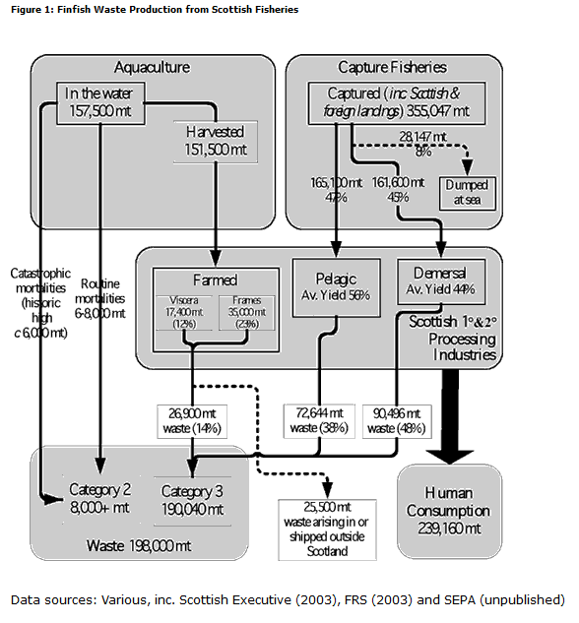

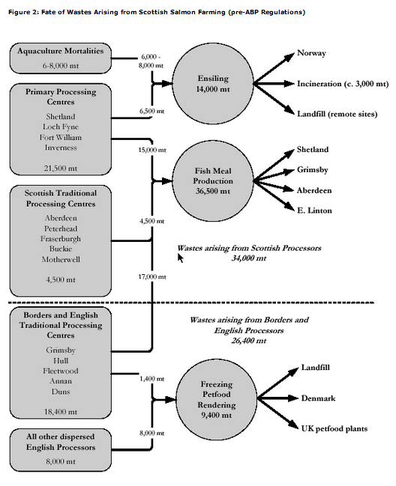

In this FOI reply, please include any data on the quantities and fate of mortalities from Scottish salmon farms.

Please also include any industry waste disposal practices, best practice guidelines or handbooks. For example, here's a document published online by the Scottish Government relating to Cooke Aquaculture's mortality removal and disposal:
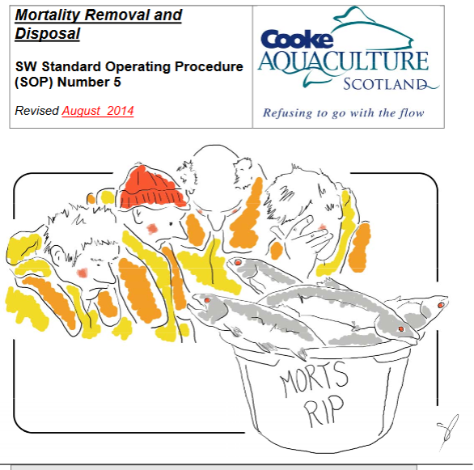

In 2015, the Scottish Government consulted on a change of policy re. disposal of morts - including:

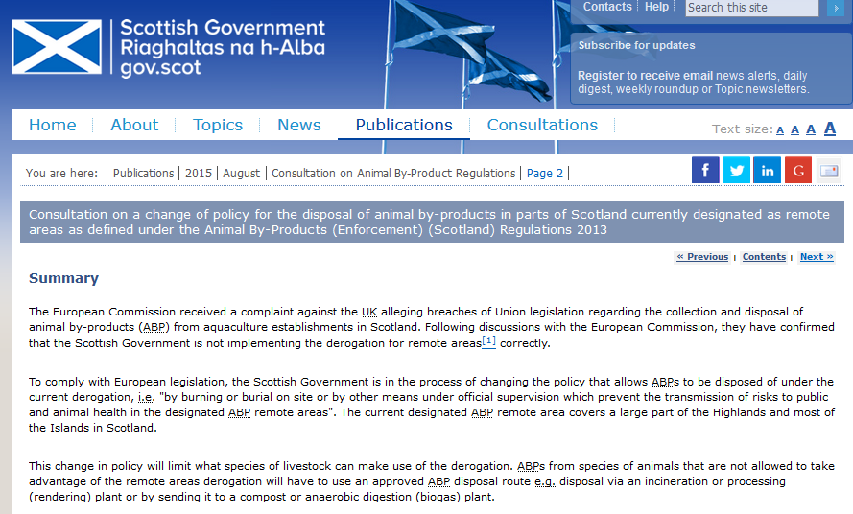

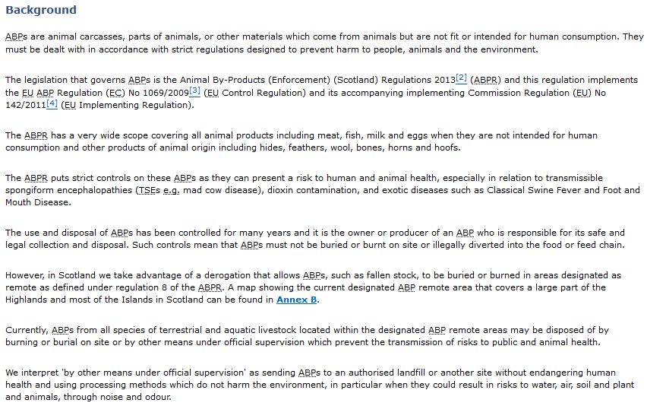

And:

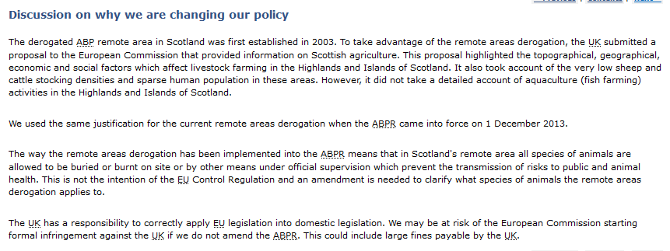

Read more via "Consultation on a change of policy for the disposal of animal by-products in parts of Scotland currently designated as remote areas as defined under the Animal By-Products (Enforcement) (Scotland) Regulations 2013"

The Scottish Parliament also addressed this issue in December 2015 via the Rural Affairs, Climate Change & Environment Committee - including an estimated cost increase of £2 million per year for the Scottish salmon farming industry (based on an average of 10,000 tonnes of morts per year):

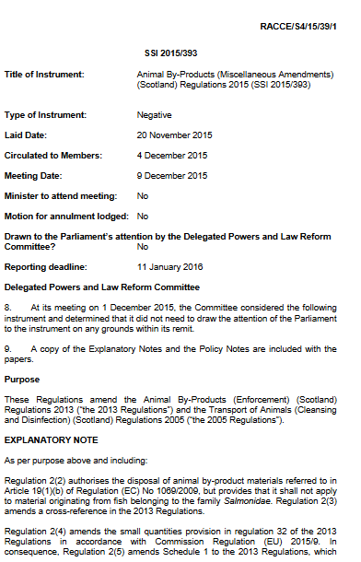

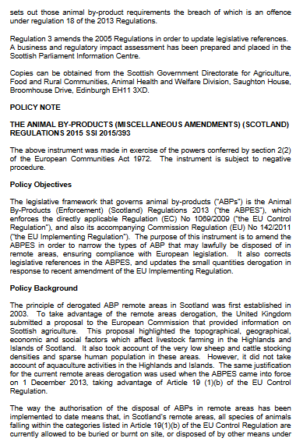

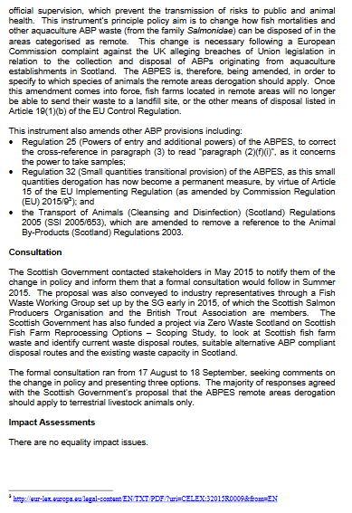

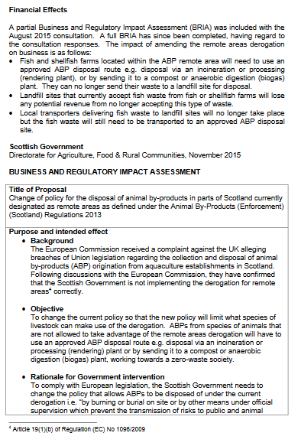

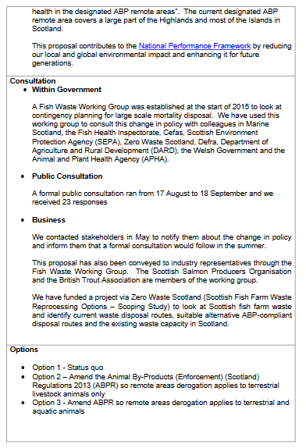

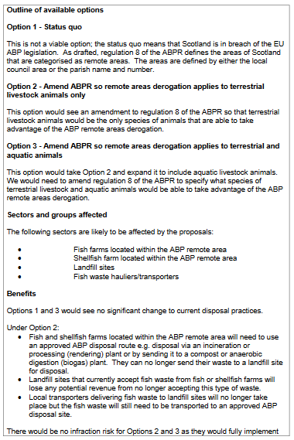

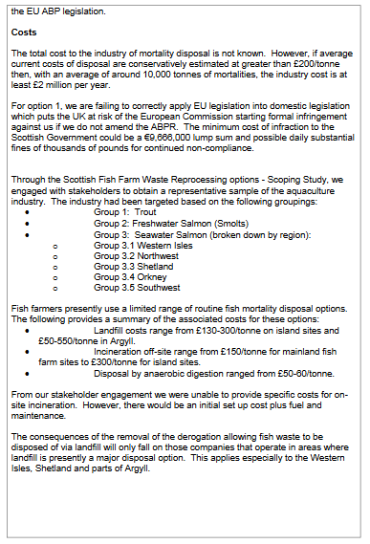

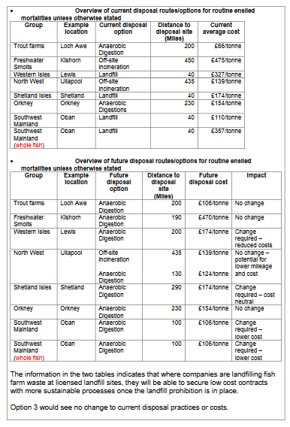

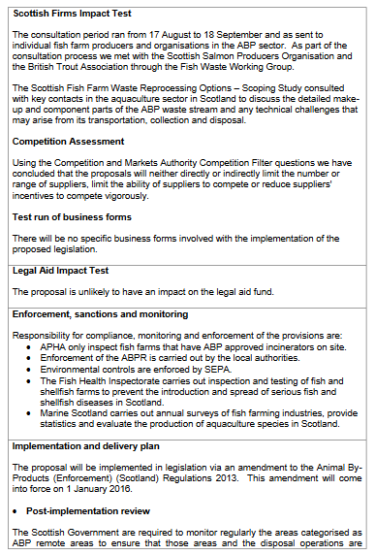

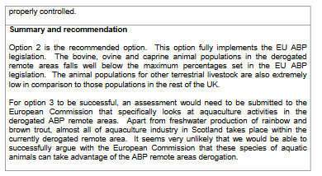

In January 2016, the Scottish introduced new 'Guidance on the Disposal of Aquaculture Animal By-Products':

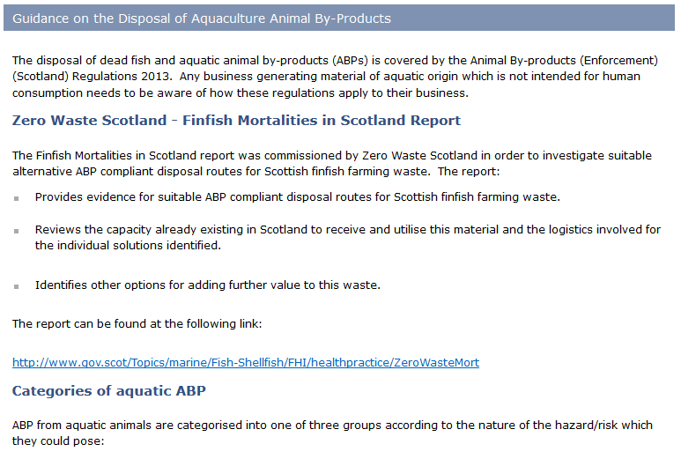
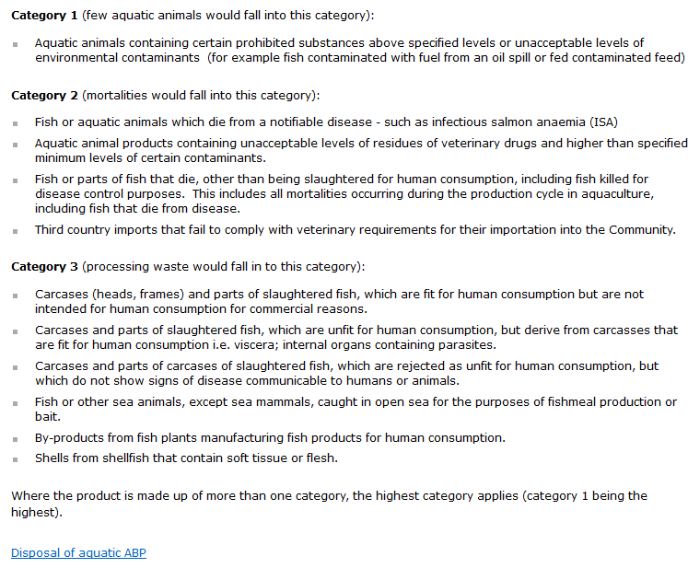

Read more via "Animal By-Products"

A "Zero Waste Report - Finfish Mortalities in Scotland" was published in January 2016:

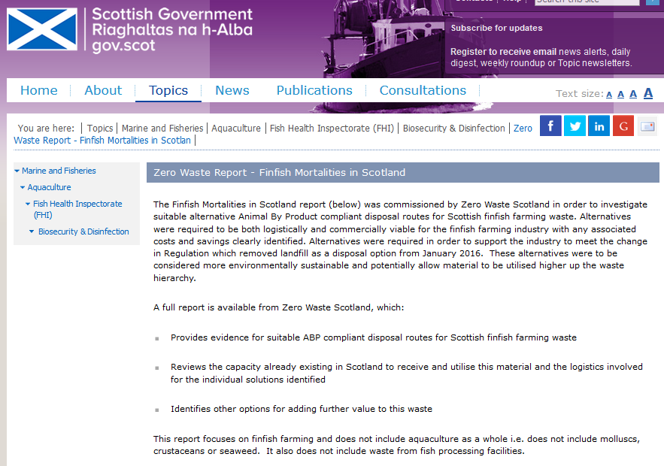

The Summary report: Finfish Mortalities in Scotland includes:

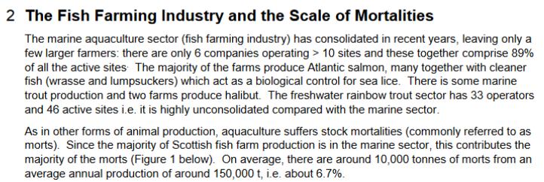

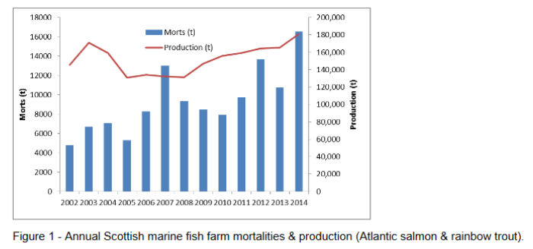

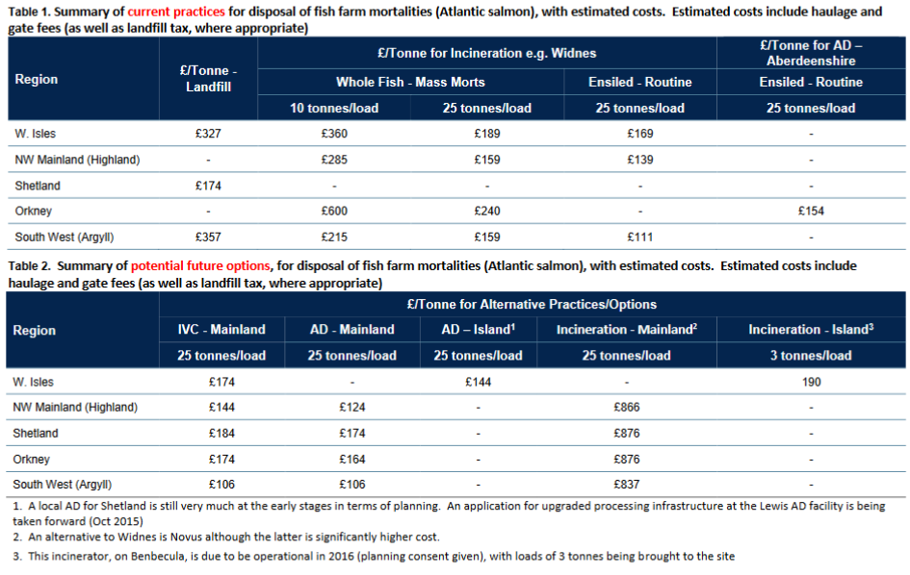

Read the full report online here - including:

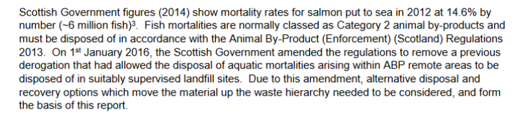

And:

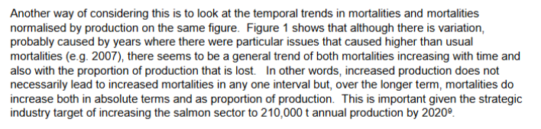

And:

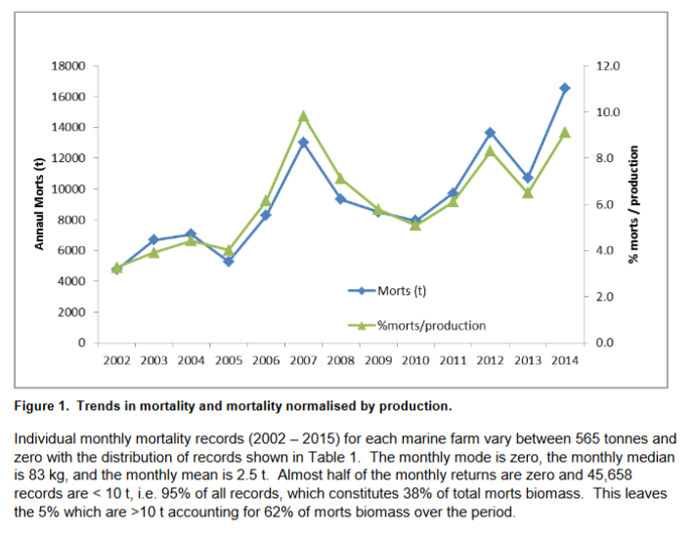

And:

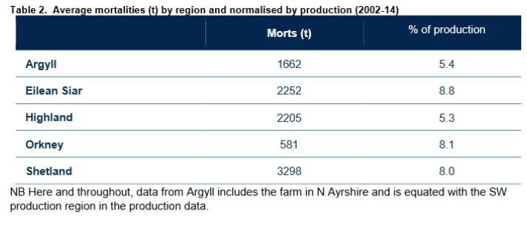

And:

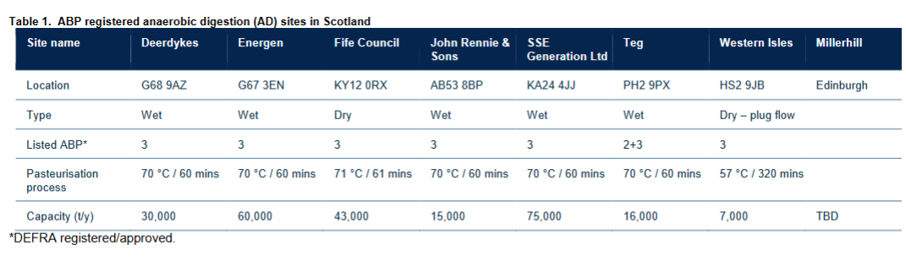

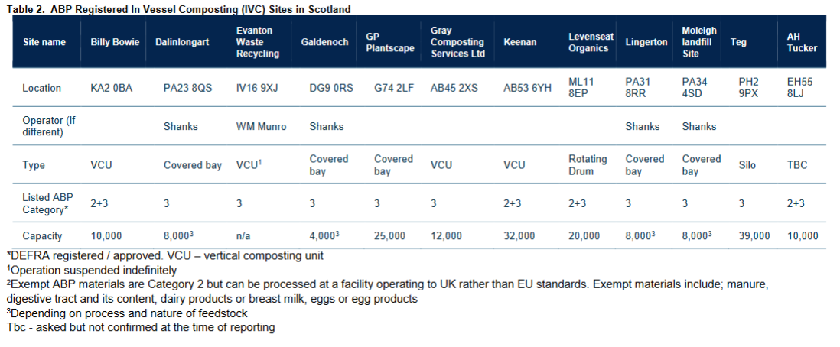

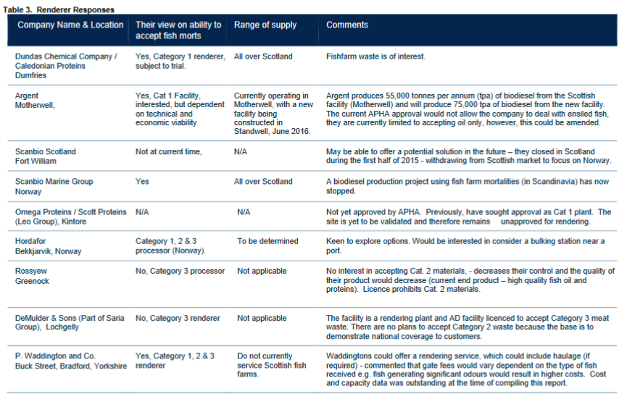

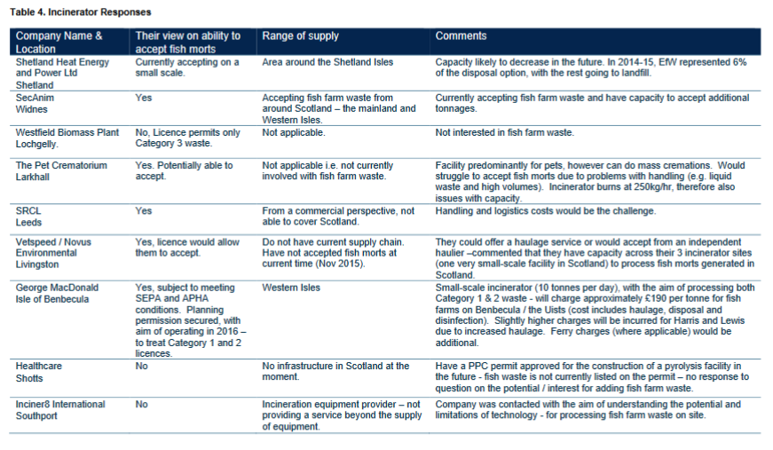

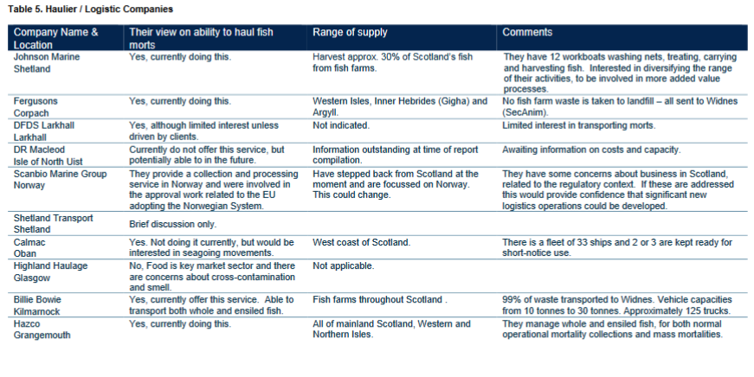

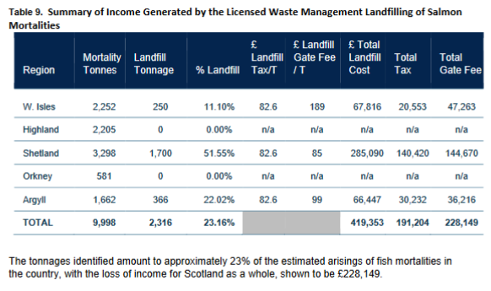

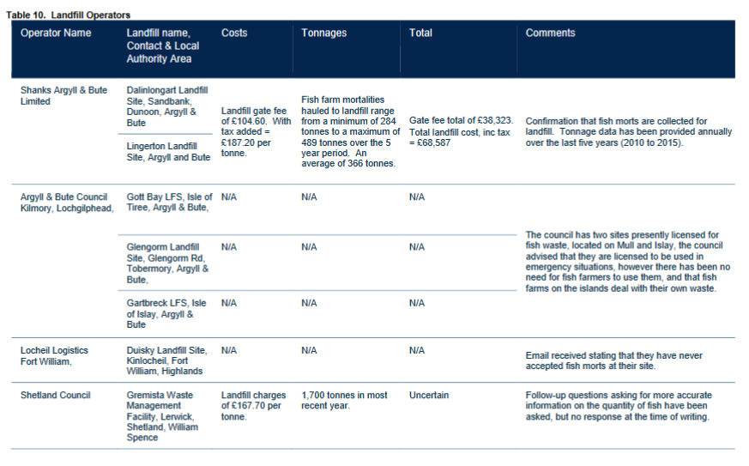

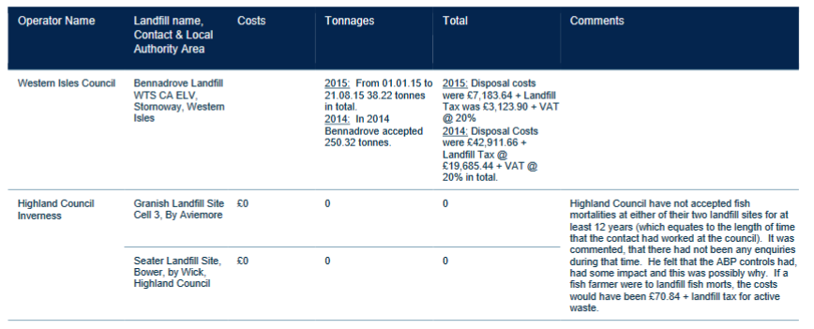

Please therefore also include information relating to progress reports, problems, costings, updates, data evaluation, losses of income due to non-landfill disposal and discussions on the new/changed rules as operating during 2016 (and the first few weeks of 2017).

Please consider this a request for information under the relevant Freedom of Information and Environmental Information Regulations including both the Freedom of Information (Scotland) Act 2002 and the Environmental Information (Scotland) Regulations 2004 (as well as any other new or other regulations which may be appropriate).

Please provide this information electronically.

Please acknowledge receipt of this FOI request.

Many thanks and I look forward to a response shortly.

Thanks,

Don

Don Staniford

Director, Global Alliance Against Industrial Aquaculture (GAAIA): http://www.salmonfarmingkills.com

<((((º>`·.¸¸.·´¯`·.¸.·´¯`·...¸><((((º>¸.
·´¯`·.¸. , . .·´¯`·.. ><((((º>`·.¸¸.·´¯`·.¸.·´¯`·...¸><((((º>

