DRAFT

FOI Dossier on Photographs of Diseased & Deformed Scottish Salmon (August 2018)

Summary:

Photographs of diseased and deformed Scottish salmon were disclosed by the Scottish Government in June 2018 and August 2018 following Freedom of Information requests by Global Alliance Against Industrial Aquaculture (GAAIA) and Scottish Salmon Watch.

Another FOI reply by the Scottish Government on 13 August 2018 revealed legal threats from salmon farming companies who objected to the disclosure of photographs. Lawyers acting for Scottish Sea Farms wrote to the Scottish Government in May 2018 stating that "our clients are very concerned about the proposed release". Disclosure "may be a breach of duty and actionable at law" argued lawyers acting for The Scottish Salmon Company in June 2018.

However, the Scottish Government's FOI advisers and Marine Scotland concluded that the photographs must be disclosed.

Specific Comments:

Scottish Sea Farms (the subject of 5 out of the 45 photos finally disclosed) wrote to the Scottish Government on 12 June 2018 asking that the photographs not be released into the public domain under FOI "in order to safeguard the safety of our personnel, protect our legitimate economic interest, and prevent loss of confidence in the product and the wider Scottish salmon farming industry."

Publication could "incite activists to take action against salmon producers and to harass or threaten our staff," continued Scottish Sea Farms. "Once in the public domain there will be no control on the use of the graphic images and how they are depicted, which their disclose [sic] would be likely to prejudice substantially public safety."

Scottish Sea Farms went on to argue that 'client confidentiality' precluded disclosure and referred to their Head of Veterinary Services who is also Senior Vice-President of the Fish Veterinary Society and "the principle of client confidentiality inherent in all veterinary work as set out in the Code of Professional Conduct for Veterinary Surgeons produced by the Royal College of Veterinary Surgeons. "The photographs are confidential due to the veterinary/client relationship," stated Scottish Sea Farms. "Scottish Sea Farms, being the owner of these animals, does not consent to these photographs, which were taken for valid and valuable scientific and veterinary diagnostic purposes being disclosed to the public."

[The current Senior Vice-President of the Fish Veterinary Society is Ronnie Soutar, Head of Veterinary Services at Scottish Sea Farms who has been on the board of the Scottish Society for the Prevention of Cruelty to Animals since at least 2014 and in June 2018 become Chair of the SSPCA]

"Disclosure of these photographs will prejudice substantially the confidentiality of commercial/industrial information by releasing information which is protected," continued Scottish Sea Farms (a Norwegian-owned company which aims to produce 26,000 tonnes of Scottish farmed salmon in 2018 rising to 40,000 "in the years to come"). "Release of such confidential information will have an adverse impact on Scottish Sea Farms' legitimate economic interests, should the photographs be used against us.....This exposes Scottish Sea Farms to reputational damage which could have an adverse impact on our legitimate economic interests."

[In December 2017, the BBC's 'One Show' broadcast shocking footage of diseased and dead farmed salmon from Scottish Sea Farms' operations in Loch Kishorn leaking on the road]

"There can be no possible public benefit to releasing photographs of our fish undergoing post-mortem investigation," concluded Scottish Sea Farms [name redacted - although we know that the Managing Director of Scottish Sea Farms is Jim Gallagher]. "The public, if interested in such images, can access anonymous stock images showing these types of pathology from academic and other sources. The photographs of our fish are meaningless to the untrained eye, other than for graphic depiction of pathology for the purposes of shock effect. There is no need for these images to be released and to do so will harm Scottish Sea Farms' commercial reputation as the photos are likely to be interpreted incorrectly and used against us."

Here's the Ferret's interpretation of some of the photos relating to Scottish Sea Farms:

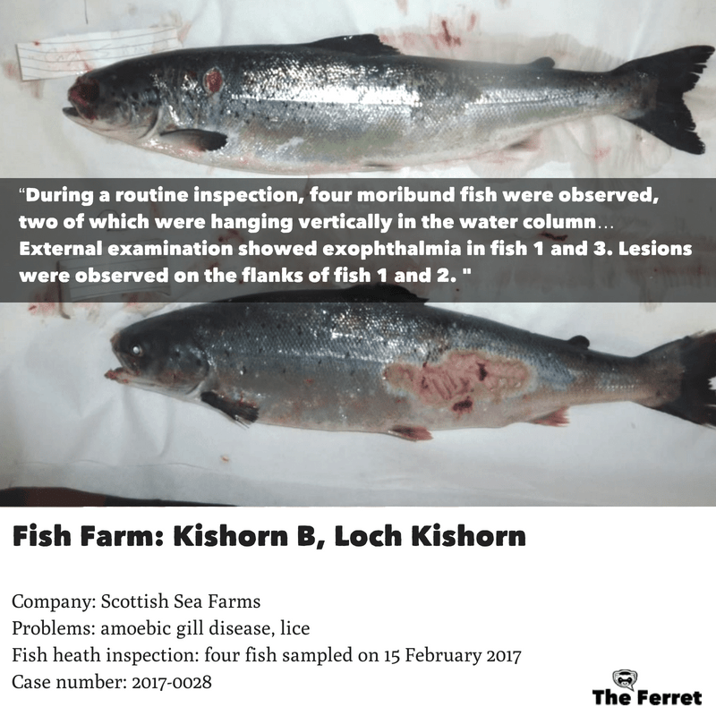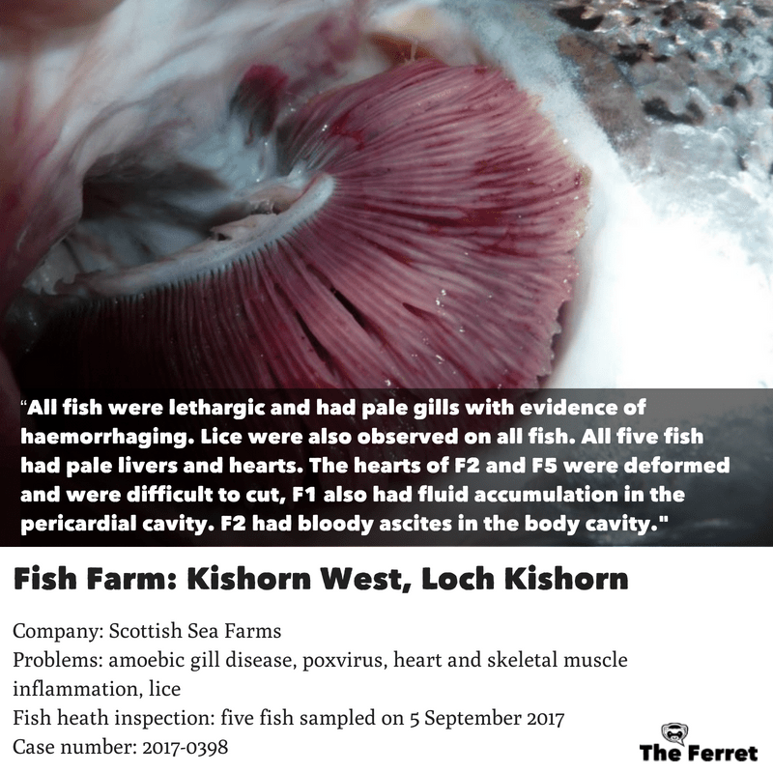

Here's one of the offending photos from Scottish Sea Farms published by Scottish Salmon Watch explained in context with Fisheries Health Inspectorate 'Case Information':

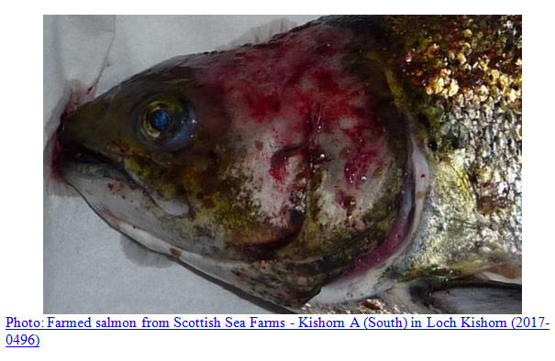

"The impact of such negative imagery would unjustly portray Scottish Sea Farms Ltd., and Scottish salmon farming in general in a negative perspective which will prejudice our legitimate economic interest through the loss of confidence in our product and that of the wider Scottish industry," argued a four-page legal submission dated 12 June 2018 from Scottish Sea Farms' lawyers Shepherd & Wedderburn (the name is redacted but George Frier is described in a 2016 article in Scottish Legal News as "SSF’s long standing adviser" - he is described in Chambers legal directory as a "no-nonsense lawyer who sees all the issues and does a good job of arguing his client's case").

Here's the legal argument from Scottish Sea Farms' lawyers at Shepherd & Wedderburn in full:
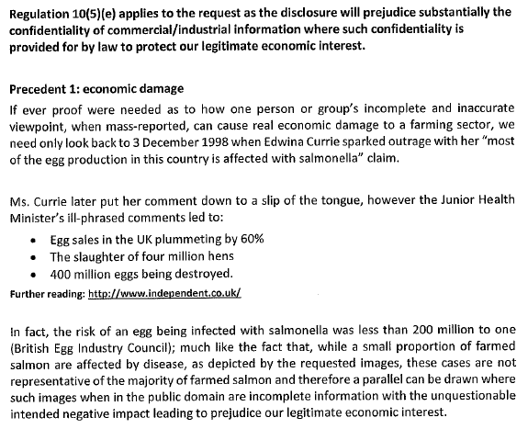

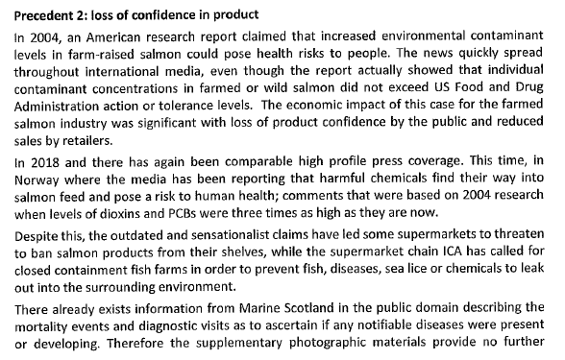
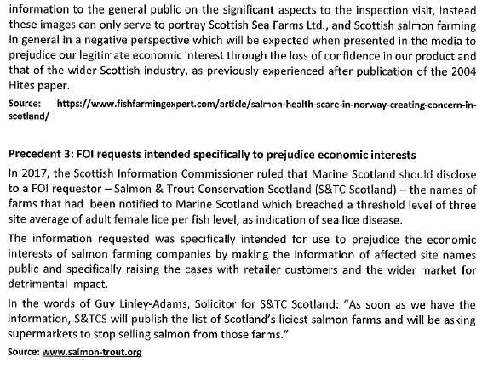
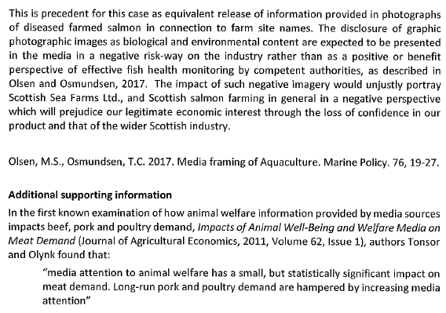
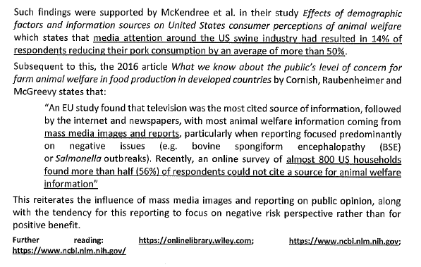

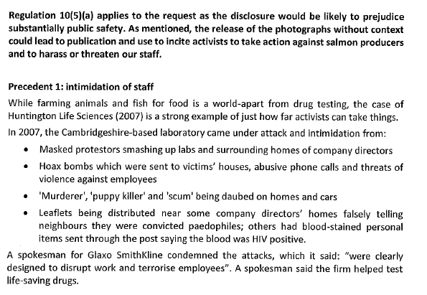

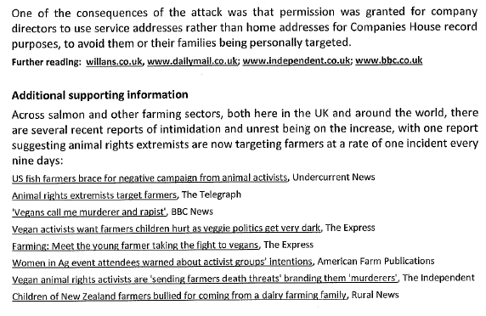

The Scottish Salmon Company (whose largest shareholder is a Swiss financial institution, is registered in Jersey, listed on the Norwegian stock exchange and is linked to Ukrainian propery tycoon Yury Lopatinsky, a leading figure in Moscow's financial scene since the mid-1990s and a neighbour of the First Minister of Scotland in Charlotte Square in Edinburgh) also objected to the photos being disclosed (the Scottish Salmon Company was the subject of 7 out of the 45 photos finally disclosed):

"The Scottish Salmon Company as the owner of these animals, do not consent to these images, which were taken for valid and valuable scientific and veterinary diagnostic purposes, being disclose to the public," wrote The Scottish Salmon Company in an email to the Scottish Government dated 1 June 2018 (the name is redacted but it is known that the CEO of The Scottish Salmon Company is Craig Anderson - 'Regional Director of the Year 2018'). "Disclosure of these photographs will therefore prejudice substantially TSSC's confidentiality of commercial/industrial information by releasing information which is protected. Release of such confidential information could have an economic impact on TSSC should the photographs be used against us.....They are at best meaningless to an untrained eye, at worst liable to deliberate or accidental misinterpretation and could easily be used against TSSC by the party who has made the request, in circumstances which do not take account of the context in which these photographs were taken. This exposes TSSC to reputational damage which could have an economic impact."

As context, here's Scottish Salmon Watch's interpretation of the photos:
EXPOSED: Gruesome Photos of Deformed & Diseased Scottish Salmon
Hard Evidence - Photos of Diseased & Deformed Scottish Salmon (June 2018)

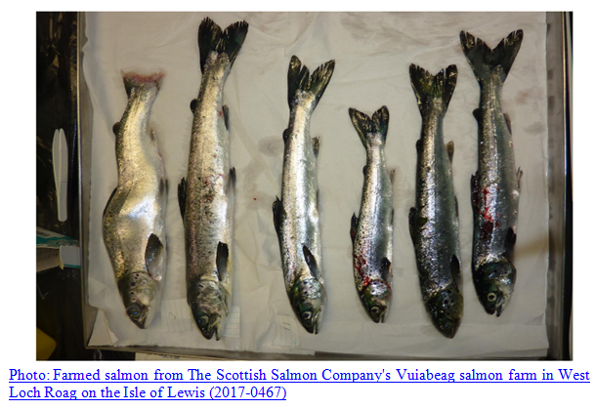

Here's The Ferret's interpretation of photographs of The Scottish Salmon Company:

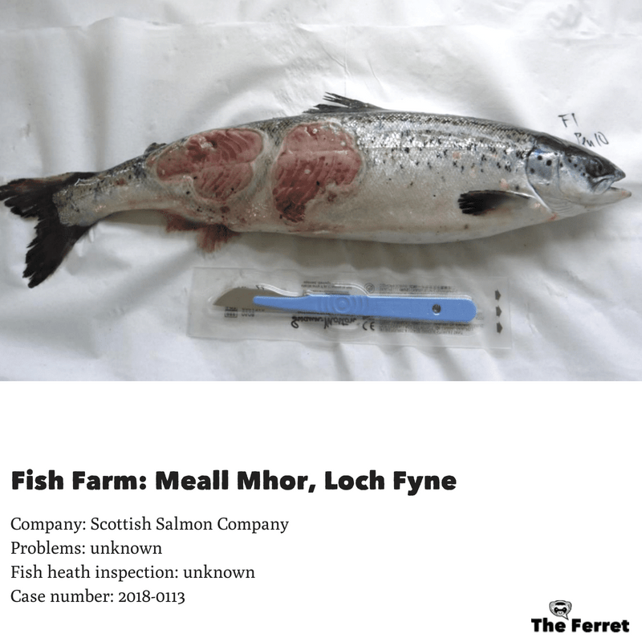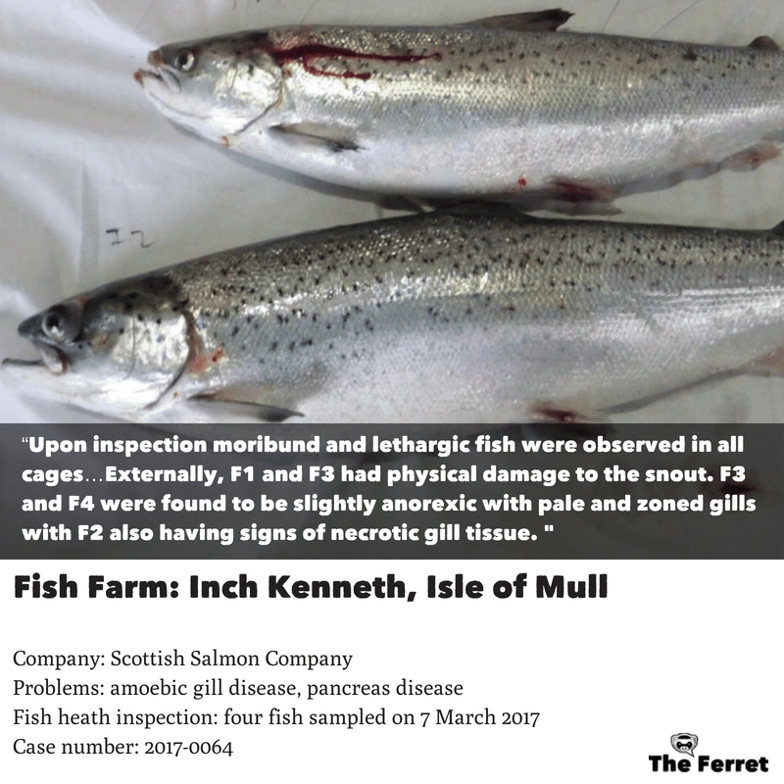
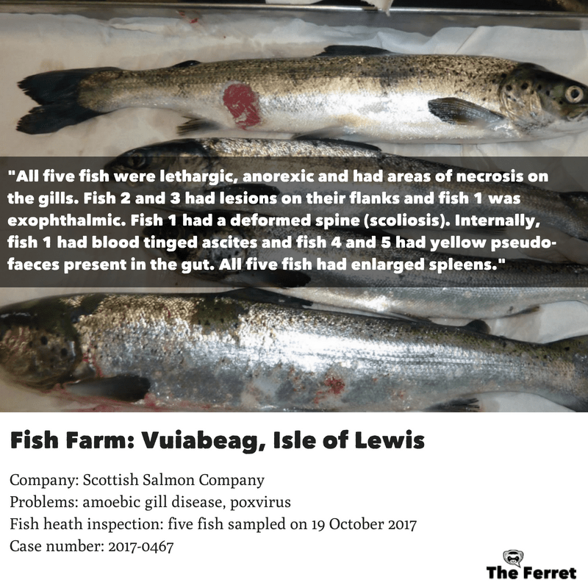

"There is no need for these images to be released and to do so will harm TSSC's commercial reputation as the photos will undoubtedly be interpreted incorrectly and used against us," continued The Scottish Salmon Company in an email to the Scottish Government dated 1 June 2018 (the contents of which bear a striking - almost word-for-word - similarity to the objections from Scottish Sea Farms). "Marine Scotland must question the reasoning behind a request for the release of such photos and the misleading damage that could result to TSSC's reputation."

[Note that an email from a Marine Scotland Science official - name redacted - dated 30 May 2018 also referred to a phone conversation with Dave Cockerill "who is extremely concerned over the proposed release" and "in his view there is no public interest of releasing the images which will be used out of context in an inflammatory way". Dave Cockerill's Linked in profile lists him as 'Biology Director' of the Scottish Salmon Company following a 12-year stint managing fish health for Marine Harvest Scotland where he collected an award from Scottish finance secretary John Swinney]

The Scottish Salmon Company's lawyers CMS Cameron McKenna Nabarro Olswang LLP (the world’s 6th largest law firm by lawyer headcount and 6th largest in the UK by revenue) submitted further legal comments to the Scottish Government on 13 June 2018 threatening that disclosure "may be a breach of duty and actionable at law":

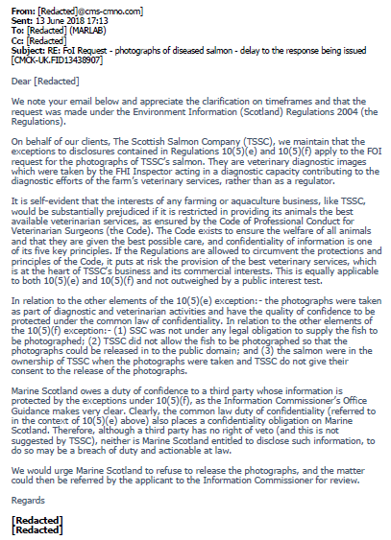
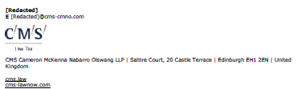

Marine Harvest, the subject of 22 of the 45 offending photos, did not raise an objection to publication (as far as the FOI disclosure itself is concerned - they could have made objections via phone calls or meetings).

Cooke Aquaculture, the subject of 4 photos, stated in an email dated 31 May 2018 to the Scottish Government: "I will pass this on, no really [sic] problems with the images being released. But you have to try."

Loch Duart, the subject of 4 photos, stated in an email dated 29 May 2018 to the Scottish Government: "Many thanks for the notification. We hope that it is being noted in the response some context - that these fish were killed for veterinary diagnostic testing by FHI in support of the investigation that was ongoing by the farm veterinarian and health team at the time."

Grieg Seafood, the subject of 3 photos, stated in an email dated 4 June 2018 to the Scottish Government (names redacted): "Thanks for keeping us informed. In our opinion the pictures attached do not resemble primary, clinical disease, rather physical injury with some secondary infection. I've read your further email so I'm aware of the decision to postpone release of this FOI."

The FOI disclosure also revealed that Scottish Government civil servants briefed the Cabinet Secretary for Rural Economy & Connectivity (Fergus Ewing) and Cabinet Secretary for the Environment, Climate Change and Land Reform (Roseanna Cunningham) as well as the Scottish Salmon Producers Organisation (SSPO) and salmon farming companies prior to disclosure of the photographs.

"Yesterday I contacted several companies (Marine Harvest, SSF, SSC, Loch Duart, Grieg, Cooke) to advise them of our proposal to release these photographs with copies of the images subject to release," wrote Marine Scotland Science (name redacted) to an unnamed person in an email marked 'High Importance' on 30 May 2018 (Scottish Salmon Watch asked the Scottish Government on 21 August 2018 for a FOI review of the refusal to disclose specific names of civil servants). "Today I have had several emails of concern regarding the proposed release including communications from Shepherd and Wedderburn LLP acting on behalf of Scottish Sea Farms. I have also spoken to Dave Cockerill of SSC who is extremely concerned over the proposed release and will also be instructing the company Solicitors to reflect that concern with a written submission before Friday 1 June. Attached communications received so far for your reference."

"As a way forward we need to lay out our justification for releasing these images and address the concerns of the individuals made," continued the email dated 30 May 2018 from Marine Scotland Science in Aberdeen. "This relates to justification for releasing photographs as information under the regulations; consideration of all the appropriate exceptions; context of the images (this was always going to be provided in the response). Comments raised by Dave Cockerill include the commercial harm and that in his view there is no public interest of releasing the images which will be used out of context in an inflammatory way."

"Fish farming companies....are extremely concerned about this release of information," wrote the Scottish Government's Aquaculture Health, Welfare and Innovation Policy Manger in an email to the Cabinet Secretary for Rural Economy & Connectivity (copied to the Cabinet Secretary for the Environment, Climate Change and Land Reform) dated 31 May 2018. "Two companies have asked legal representatives to contact Scottish Government directly."

"We are seeking advice from the FOI unit regarding untested exemptions in this case, for example commercial confidentiality," continued the Cabinet Briefing dated 31 May 2018. "We will not be releasing information until this process is complete and we will keep SpAds [Special Advisers] and Ministers up to date. There is a very large collection of fish images held by the fish health inspectorate and the result of this FOI will have implications on the release of further images."

"I am in consultation with colleagues within Scottish Government regarding this request," stated an email dated 31 May 2018 to Scottish Sea Farms from an unnamed Marine Scotland Science official (name redacted). "I will inform you and your clients before any response is made to this request. Given the level of communications I have had with stakeholders concerning this, it is probable that a reply to the request will not be issued in time to meet the 1 June deadline."

"Mr Ewing has noted and would welcome a discussion next week," stated an email dated 1 June 2018 from the Private Secretary of the Cabinet Secretary for Rural Economy & Connectivity.

"I note your concerns regarding the release of images in relation to economic interests," wrote an unnamed Marine Scotland Science official in an email to The Scottish Salmon Company dated 8 June 2018. "If there is any potential for substantial prejudice to economic interests, it would benefit use if you could provide further evidence of the harm which could be caused or has been caused (?) from the release or use of similar types of information. This may help support any argument made under this exception. Such evidence could include, but would not be limited to evidence which supports: the loss of confidence in your product; a detrimental impact to buyers contracts; a detrimental impact to consumer sales. Firm evidence associated with the release of these types of information would be most beneficial to supporting a case rather than just relaying [sic] upon the potential impact, although I appreciate this may not be available."

"I refer to our recent communications regarding FoI/18/01141 requesting photographs of diseased salmon in relation to FHI visits which is being handled under the Environmental Information (Scotland) Regulations 2004," wrote an unnamed Marine Scotland Science official in an email dated 12 June 2018 to the salmon farming companies impacted by the photographic disclosure (Marine Harvest, the Scottish Salmon Company, Scottish Sea Farms, Cooke Aquaculture, Grieg Seafood and Loch Duart) and the SSPO. "I acknowledge that several of you have made arguments, referencing the exceptions within the EIERs, objecting to the release of these images. We applied for an extension to this FOI and have consulted with our FoI unit who have provided expert guidance on this case. The arguments presented regarding exceptions within the EIRs have been carefully considered. It has been concluded that there are no justifiable exceptions which can be applied in this case and therefore we are required to publish these photographs. A more detailed justification will be provided to those who made such arguments in due course."

"It was always our intention to provide some context with respect to the images being released and this will be included as part of the response," continued the Marine Scotland Science official. "However, in our discussions some companies have expressed a desire to publish their own photographs relating to this FoI thereby allowing the use of their own narrative to accompany those images."

"We contacted the SSPO to discuss the potential for the PO [understood to be Producer Organisation] to publish these photos collectively on behalf of the individual companies," wrote Marine Scotland's Aquaculture Unit on 13 June 2018 in an email to the Cabinet Secretary for Rural Economy & Connectivity (copied to the Cabinet Secretary for the Environment, Climate Change and Land Reform). "The SSPO were not in favour of this approach and felt that the release of the photos by the PO could have the opposite of the intended effect, making it easier to sensationalise the images made available."

"We are also preparing for the eventuality that the photos are released and are working on the attached narrative to accompany the photos," continued the Cabinet Briefing. "We will keep Ministers updated. If the photos are to be released, lines will be prepared which draw upon the attached text in preparation for any media activity."

"I have communicated with you over the intention to release these photographs in response to the request received and whilst some stakeholders expressed no or limited concern regarding the same others have had concerns which have been more substantial," wrote Marine Scotland Science in an email to Marine Harvest, Scottish Sea Farms, the Scottish Salmon Company, Loch Duart, Grieg Seafood, Cooke Aquaculture and the SSPO dated 14 June 2018. "Marine Scotland has come to the conclusion that the photographs must be released in response to this FOI and will be done so along with the context which supplements this communication, provided in Annex 1. The release of information will be made on Friday 15 June at 1500 hrs."

"The decision on release remains solely for the public authority holding the information, taking into account of any third party views in so far as they help inform that decision," continued Marine Scotland Science (name redacted). "That said, a third party does not have a veto on disclosure of the information."

"I would like to thank you all for the assistance you have provided me in helping Marine Scotland handle this request," concluded Marine Scotland Science. "Where individuals have raised specific issues in connection with the exceptions of the EIRs a response is provided in Annex 2 of this email."

Annex 2 (emailed by the Scottish Government to salmon farming companies and the SSPO on 14 June 2018) presented Marine Scotland's arguments to support disclosure of the photographs:

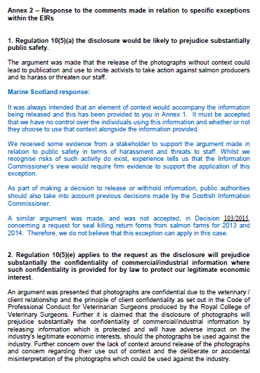

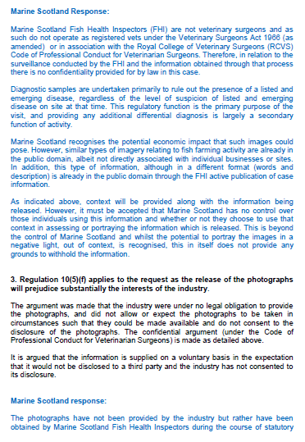

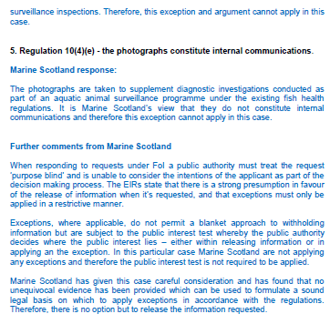

"After stakeholder consultation, none of the companies concerned have expressed the desire to publish these photographs themselves," wrote Marine Scotland Science on 15 June 2018 in an update for the Cabinet Secretary for Rural Economy & Connectivity.

Discussions between Marine Scotland and the FOI team at the Scottish Government finally concluded that the photos must be disclosed (despite Marine Scotland Science staff intent on finding "any way that the information could be withheld").

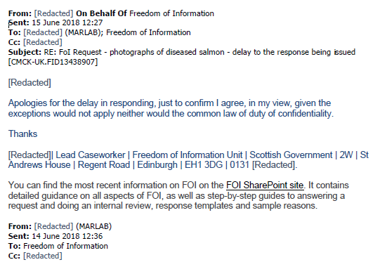
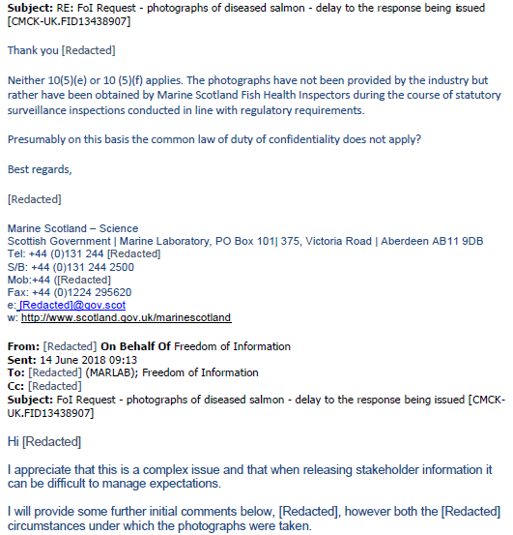

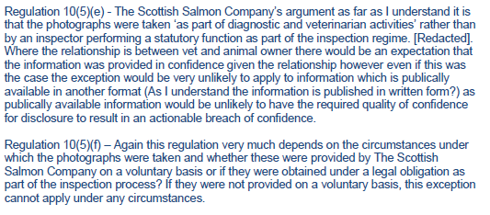

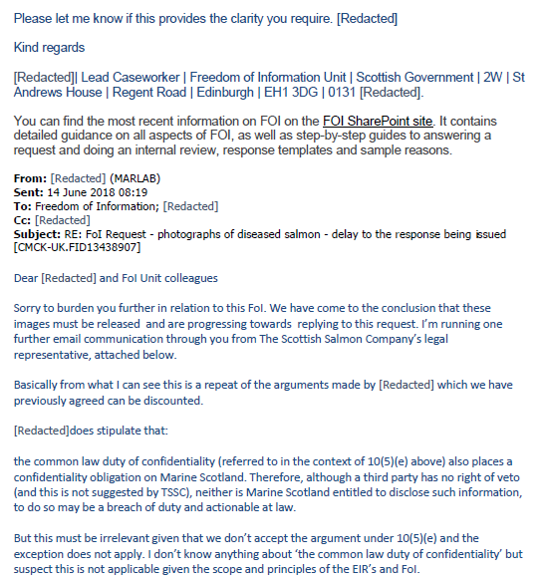
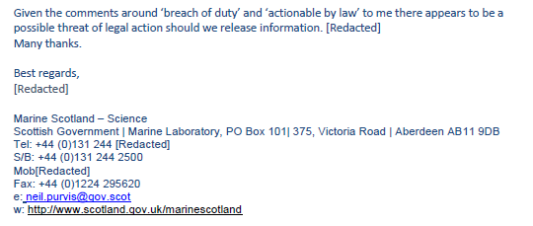

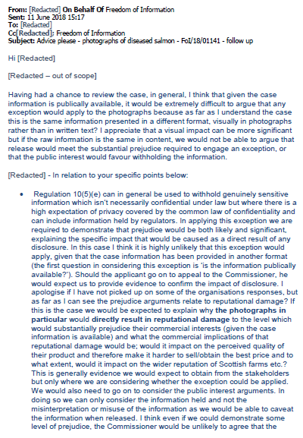
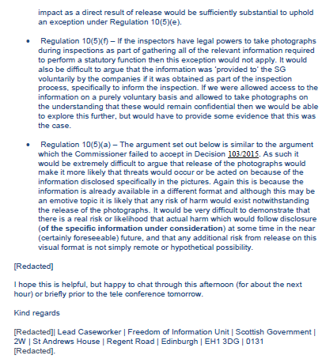

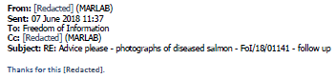
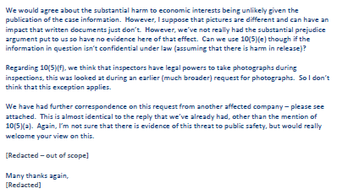

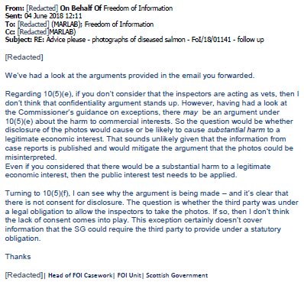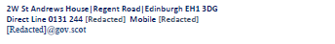

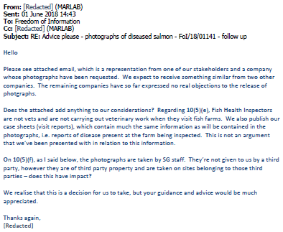

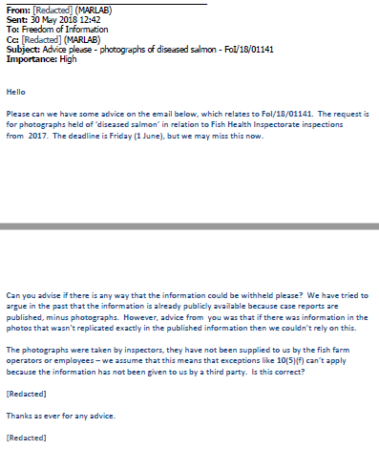

"With respect to FoI-18-01141 can we please remove 'Marine Harvest sites' from the title," stated an email from the Scottish Government to the Scottish Government (names redacted). "The request covers all fish farm companies back to beg 2017 and specifically Marine harvest back to beg of 2015. So if we just call it Photographs of diseased farmed salmon: EIR release - that would be fine."

Finally, an email dated 27 June 2018 from Marine Scotland Science briefed the salmon farming companies impacted by the photographic disclosure (Marine Harvest, the Scottish Salmon Company, Scottish Sea Farms, Cooke Aquaculture, Grieg Seafood and Loch Duart) and the SSPO on the publication of the photos via The Ferret, Scottish Salmon Watch and the Scottish Government:

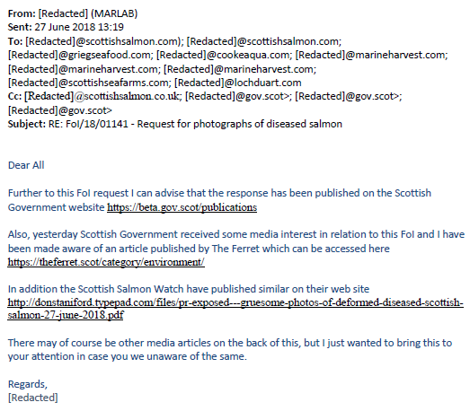

Other media articles on the back of this included:

These Recently Released Photos of Farmed Salmon May Scar You Forever
New photos expose shocking welfare issues on Scottish salmon farms
PHOTOS: Salmon Seen With Bloody Sores, Sea Lice, and More
GRAPHIC: More Proof That Fish Are Suffering in the Food Industry (Photos)

The photos were also used by OneKind in their report - "Fish Welfare on Scotland's Salmon Farms" - published in August 2018.

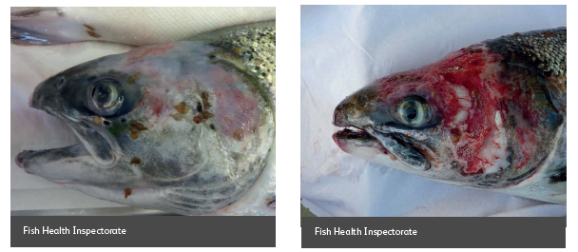

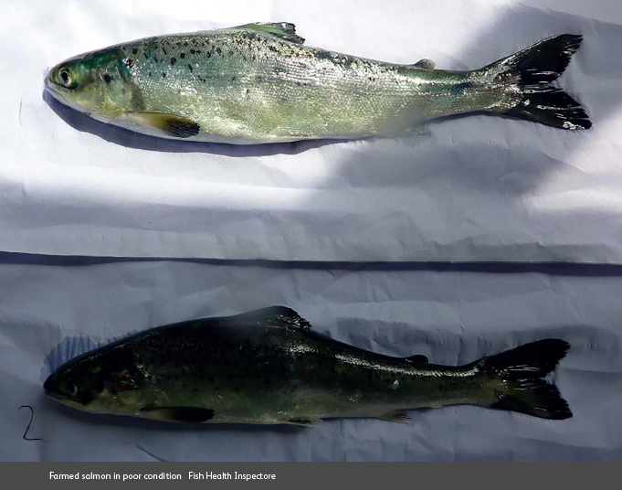

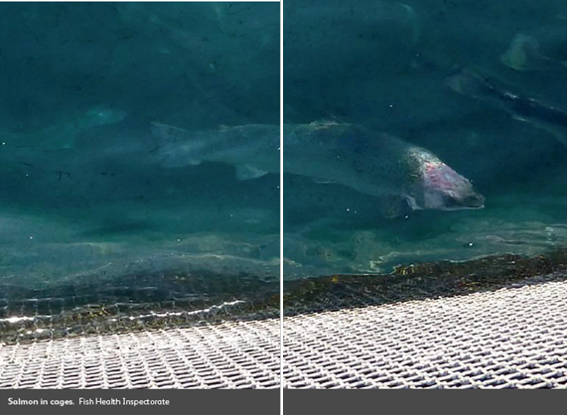

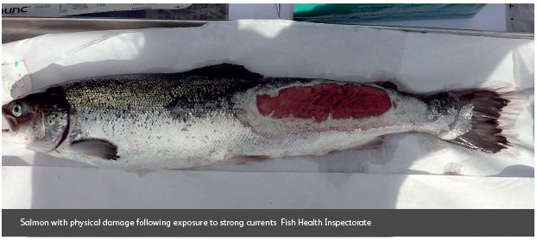

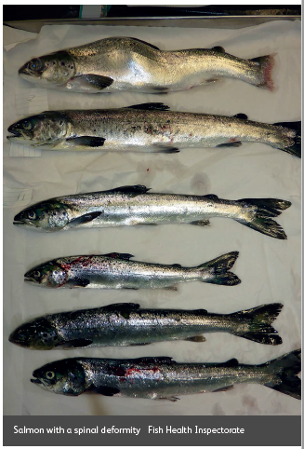

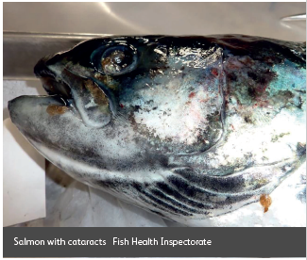

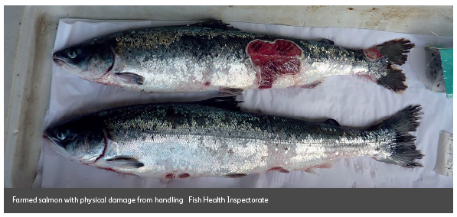

For specific documents disclosed via FOI please see Appendix. Please read more via:

Horror photos of farmed salmon spark legal threat
EXPOSED: Gruesome Photos of Deformed & Diseased Scottish Salmon
Hard Evidence - Photos of Diseased & Deformed Scottish Salmon (June 2018)
Hard Evidence: Photos of Diseased & Deformed Scottish Salmon (August 2018)

Background:

On 1 March 2018, the Global Alliance Against Industrial Aquaculture (GAAIA) filed a Freedom of Information (FOI) request asking the Scottish Government to "provide copies of photos of diseased farmed salmon held on file".

The FOI request specified: "Please include photos taken of salmon on farms in Scotland during site visits and Fish Health Inspections. Please include photos taken during post mortems and via laboratory tests and monitoring. For the definition of 'diseased' please include sea lice, infections, infestations, viruses, bacteria and other disease agents."

On 15 March 2018, the Scottish Government refused GAAIA's FOI request arguing that "photographs of diseased farmed salmon are widely available in the public domain."

In April 2018, following a request for a review by GAAIA, the Scottish Government asked that the FOI request be narrowed in scope. GAAIA subsequently narrowed down the scope of the FOI request to 2017 (all salmon farms) and to salmon farms operated by Marine Harvest since 2015.

On 15 June 2018, the Scottish Government finally disclosed photographs of 30 salmon farm inspections online via Dropbox which were published exclusively via The Ferret on 27 June 2018 .

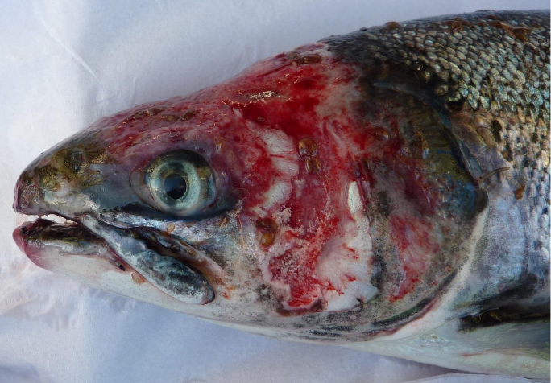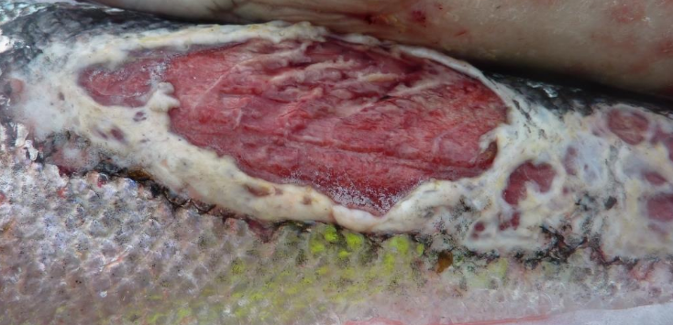
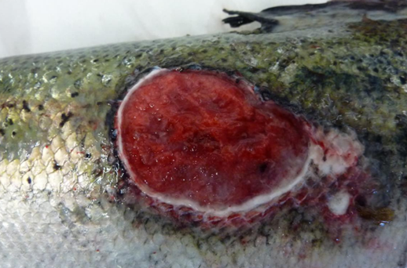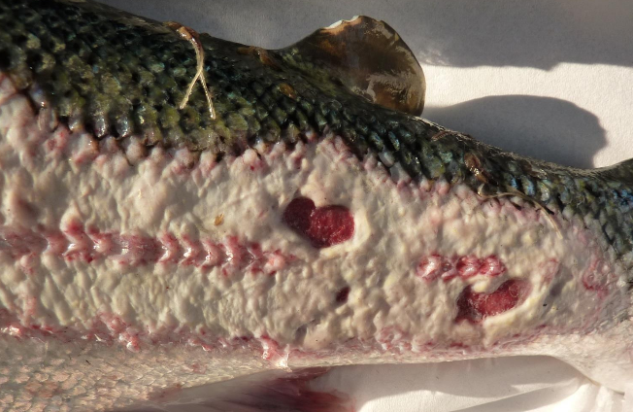
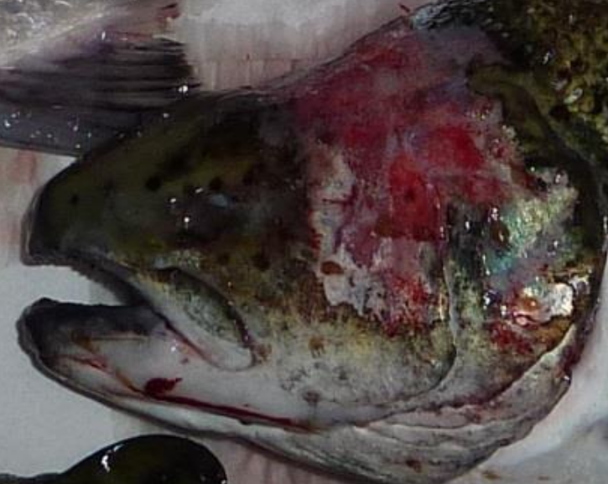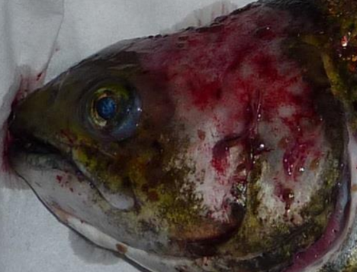
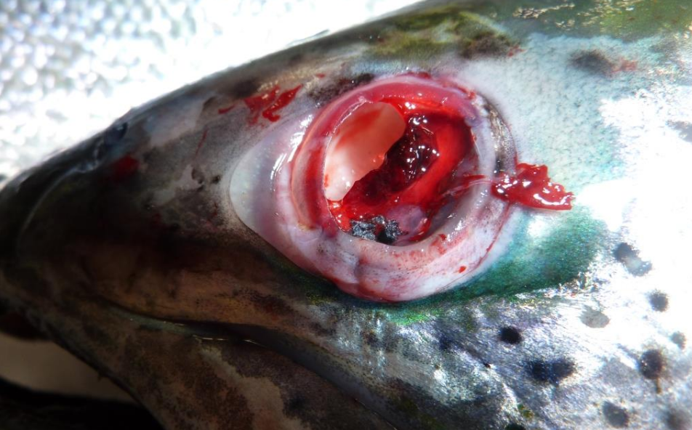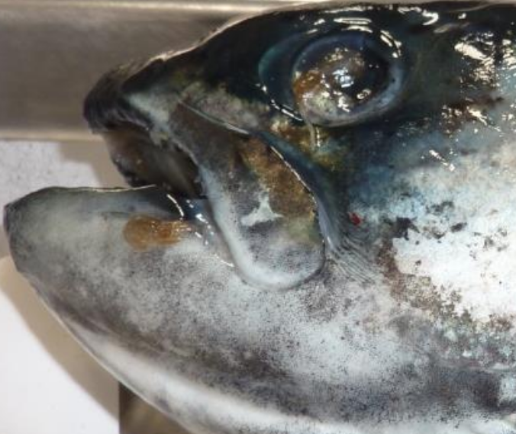

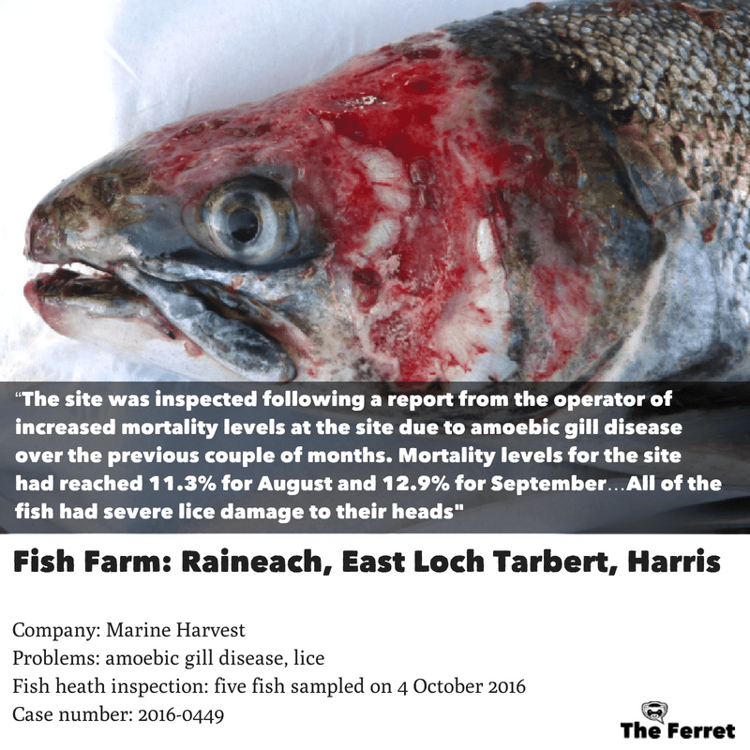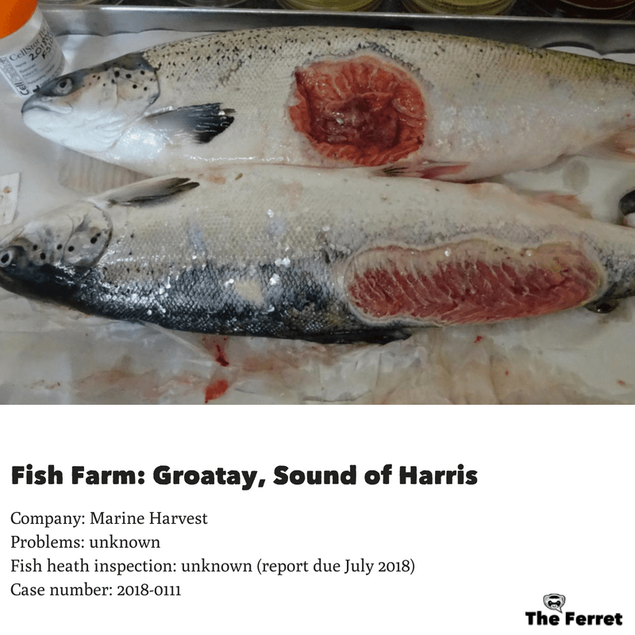
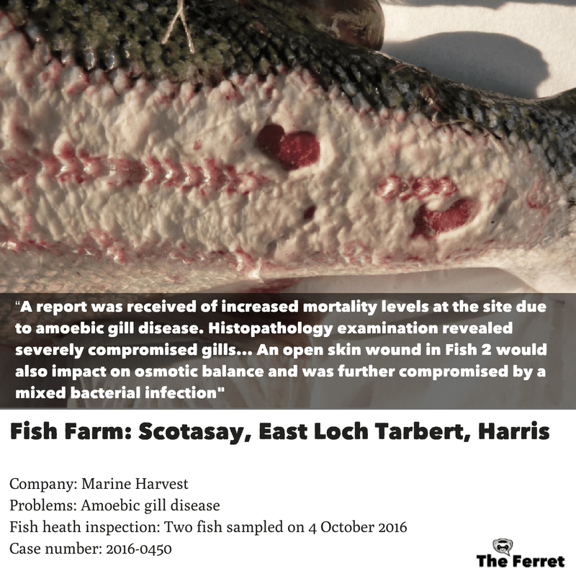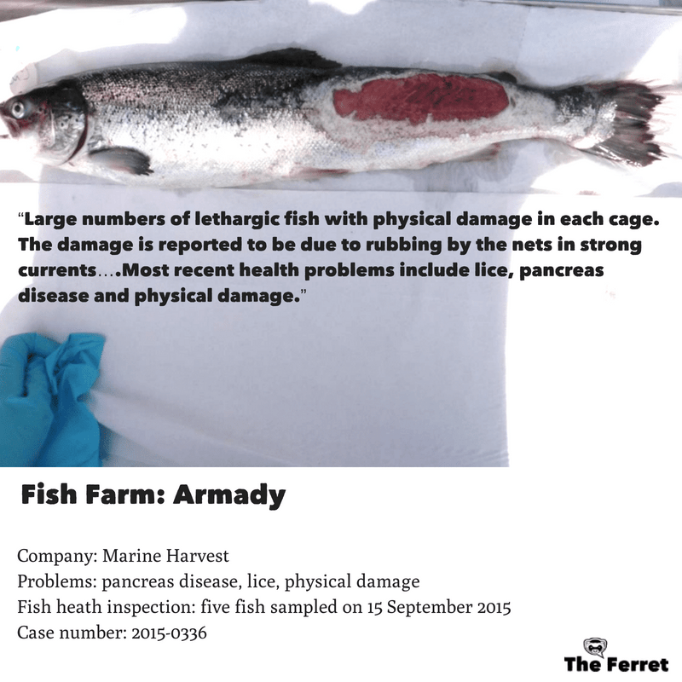

Read more via:

EXPOSED: Gruesome Photos of Deformed & Diseased Scottish Salmon
Hard Evidence - Photos of Diseased & Deformed Scottish Salmon (June 2018)

On 2 August 2018, the Scottish Government disclosed further photos following FOI requests filed by Scottish Salmon Watch on 28 June and 9 July 2018. The photos disclosed online via Dropbox related to further 14 Fisheries Health Inspection site visits in 2018 and 2016.

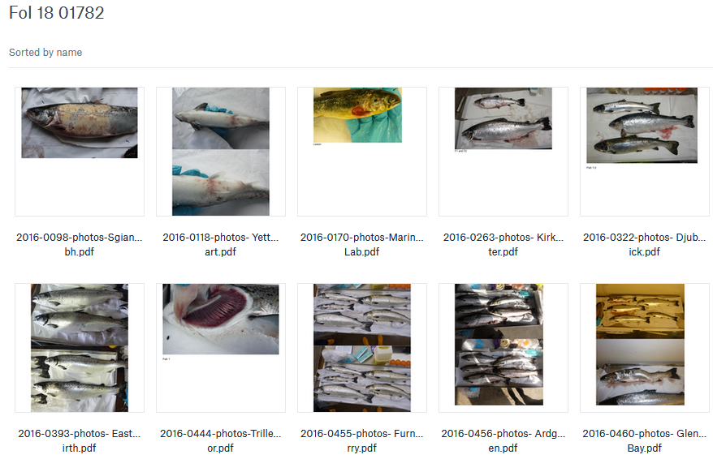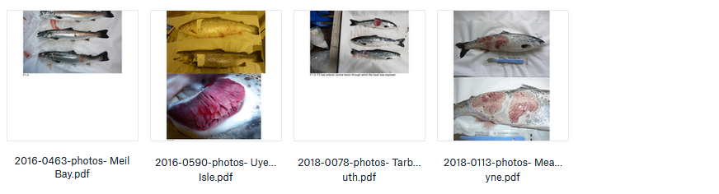

The photos included:

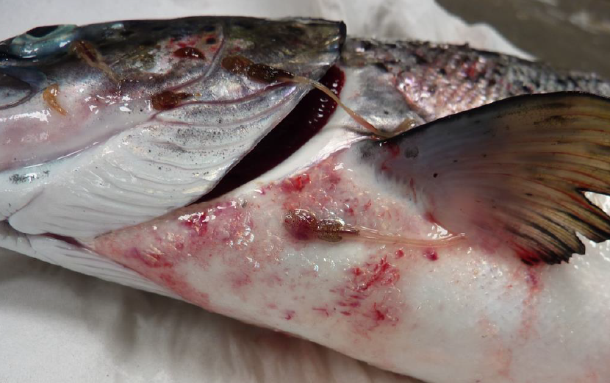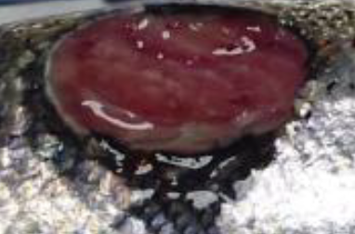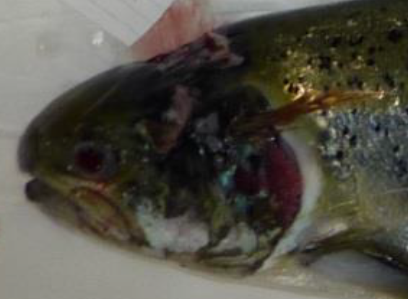
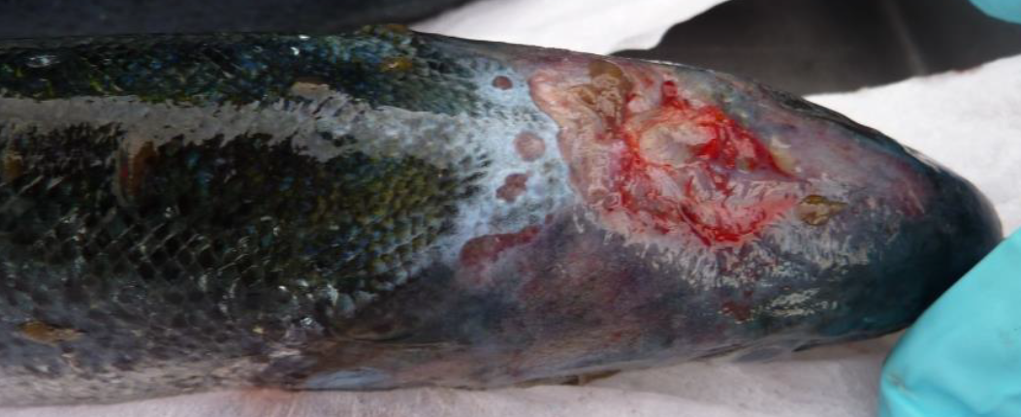

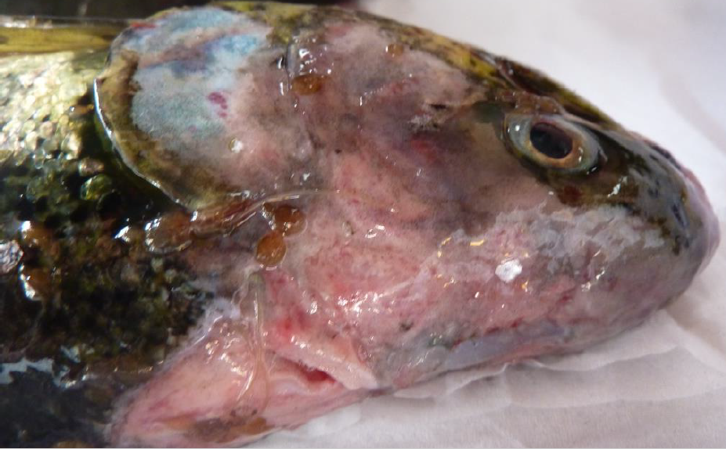
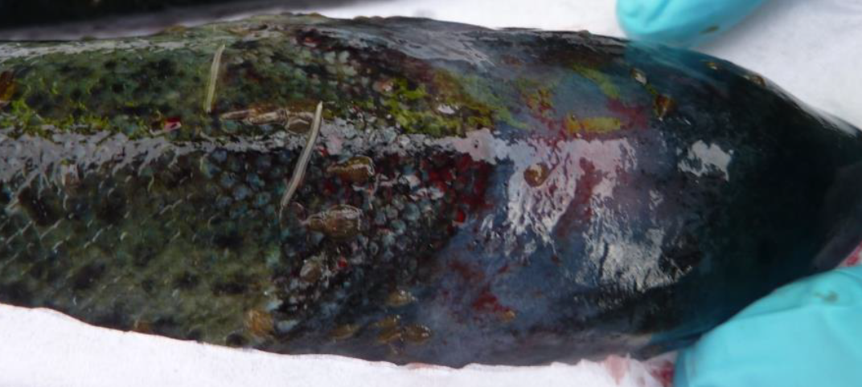
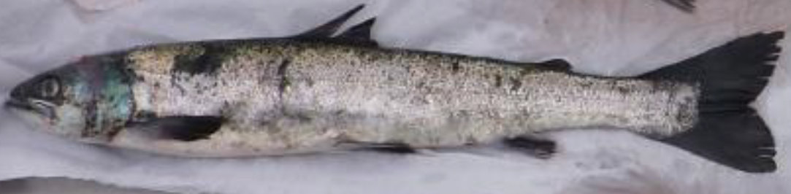
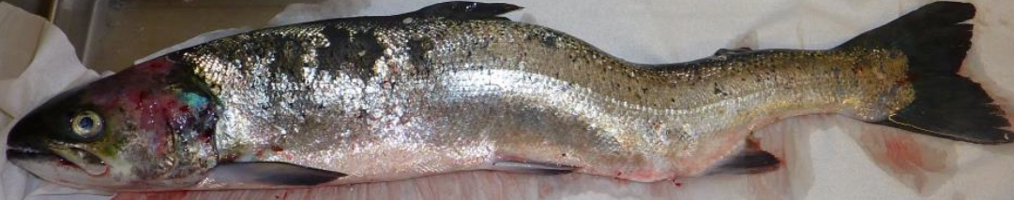

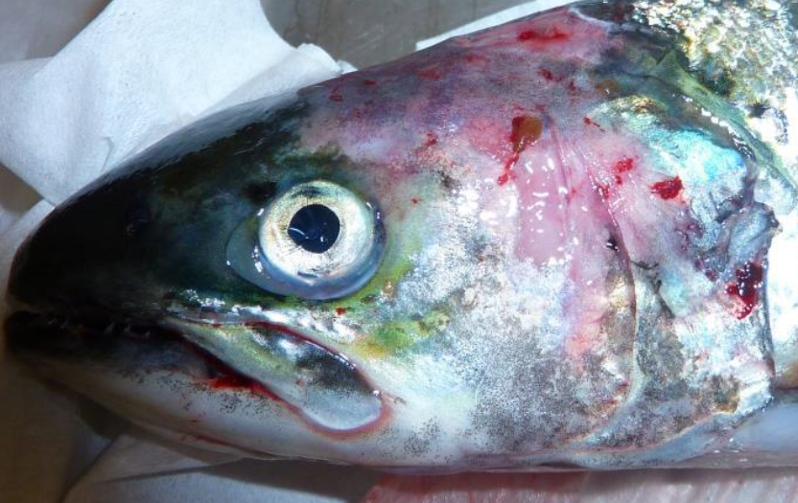
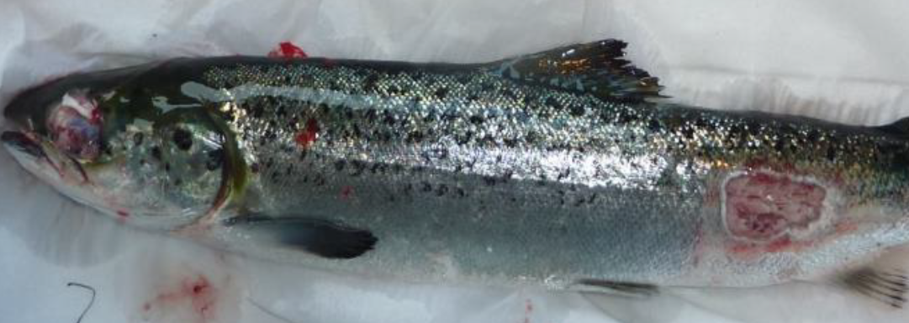
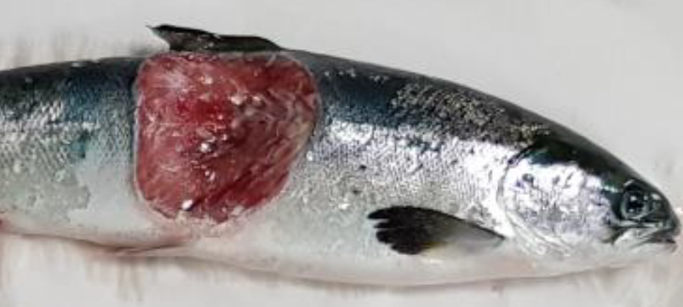

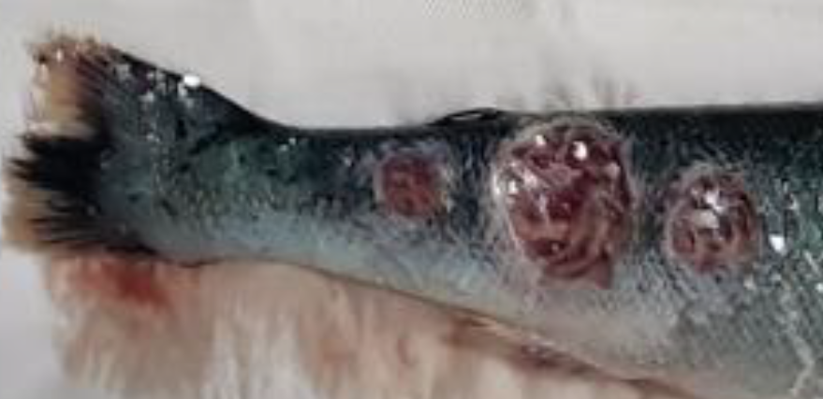
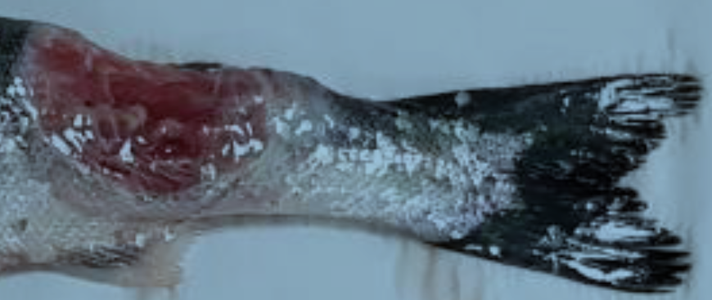
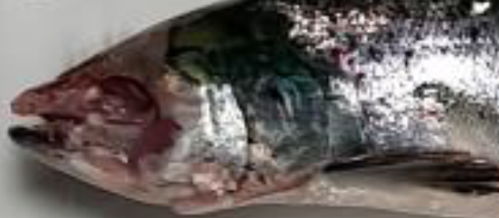
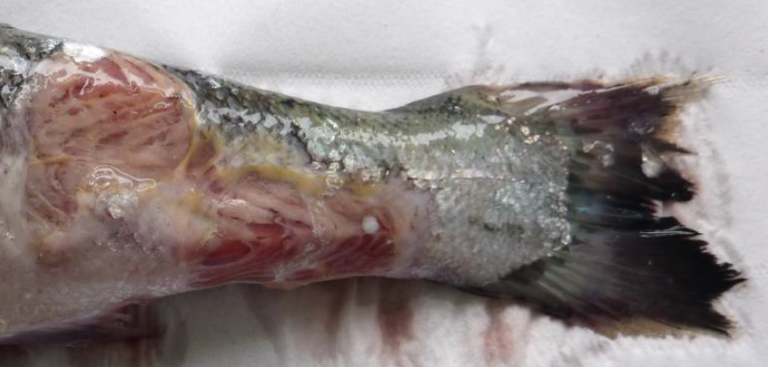
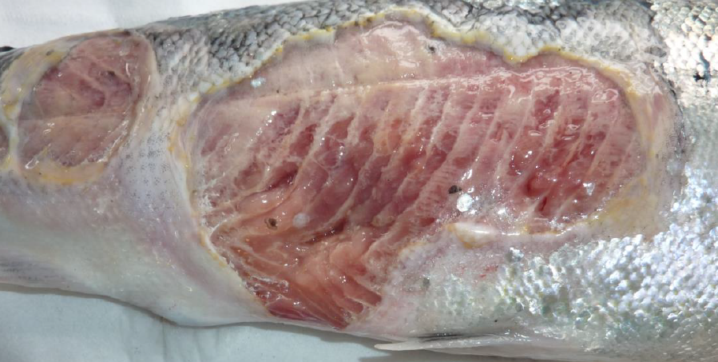
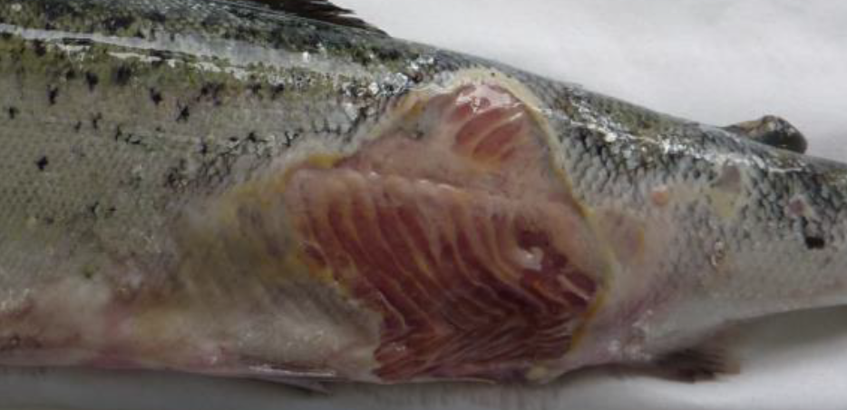

Read more via:

Hard Evidence: Photos of Diseased & Deformed Scottish Salmon (August 2018)

Appendix - FOI disclosures by the Scottish Government:

From: Neil.Purvis@gov.scot [mailto:Neil.Purvis@gov.scot]
Sent: 13 August 2018 20:35
To: salmonfarmingkills@gmail.com
Cc: Helen.McGregor@gov.scot
Subject: Response to FoI/18/01783 - RE: FOI re. photo publication and correspondence with salmon farming companies, RSPCA etc

Dear Don

In relation to your request of 28 June 2018 (FoI/18/01783), please find attached our response.

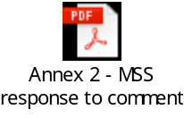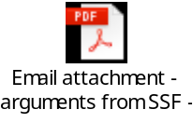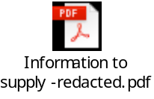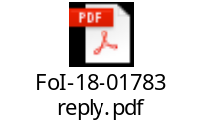

Regards,
Neil

Neil Purvis
Marine Scotland – Science
Scottish Government | Marine Laboratory, PO Box 101| 375, Victoria Road | Aberdeen AB11 9DB
Tel: +44 (0)131 244 3287
S/B: +44 (0)131 244 2500
Mob:+44 (0)777 5818 281
Fax: +44 (0)1224 295620
e: neil.purvis@gov.scot
w: http://www.scotland.gov.uk/marinescotland

From: Neil.Purvis@gov.scot [mailto:Neil.Purvis@gov.scot]
Sent: 02 August 2018 22:54
To: salmonfarmingkills@gmail.com
Cc: Helen.McGregor@gov.scot
Subject: Replies to FoI requests FoI/18/01782 and FoI/18/01869

Dear Don

In relation to your requests FoI/18/01782 and FoI/18/01869 please find the attached reply.

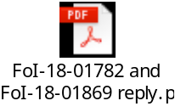

Regards,
Neil

Neil Purvis
Marine Scotland – Science
Scottish Government | Marine Laboratory, PO Box 101| 375, Victoria Road | Aberdeen AB11 9DB
Tel: +44 (0)131 244 3287
S/B: +44 (0)131 244 2500
Mob:+44 (0)777 5818 281
Fax: +44 (0)1224 295620
e: neil.purvis@gov.scot
w: http://www.scotland.gov.uk/marinescotland

From: Neil.Purvis@gov.scot [mailto:Neil.Purvis@gov.scot]
Sent: 15 June 2018 16:38
To: salmonfarmingkills@gmail.com
Cc: Helen.McGregor@gov.scot
Subject: RE: FoI/18/01141 - photos of diseased farmed salmon - acknowledgement and clarification

Dear Don

In relation to your request FoI-18-01141 of 14 April please find the attached response.

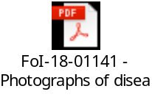

Regards,
Neil

Neil Purvis
Marine Scotland – Science
Scottish Government | Marine Laboratory, PO Box 101| 375, Victoria Road | Aberdeen AB11 9DB
Tel: +44 (0)131 244 3287
S/B: +44 (0)131 244 2500
Mob:+44 (0)777 5818 281
Fax: +44 (0)1224 295620
e: neil.purvis@gov.scot
w: http://www.scotland.gov.uk/marinescotland

