$camon $cotland, 13 February 2023

Grim Warning over UK’s Largest Salmon Farm
- £75 million proposal to farm 5,000 tonnes of salmon next to Grimsby FC
is “dead in the water” claim campaigners due to pollution, welfare & wildlife concerns

Campaigners are gearing up for a grim battle to sink a super-sized 5,000 tonne salmon farm which, if approved, would be the largest salmon farm in the UK (over 1,000 tonnes bigger than the largest salmon farm in Scotland and ten times England’s entire salmon farming production in 2020).

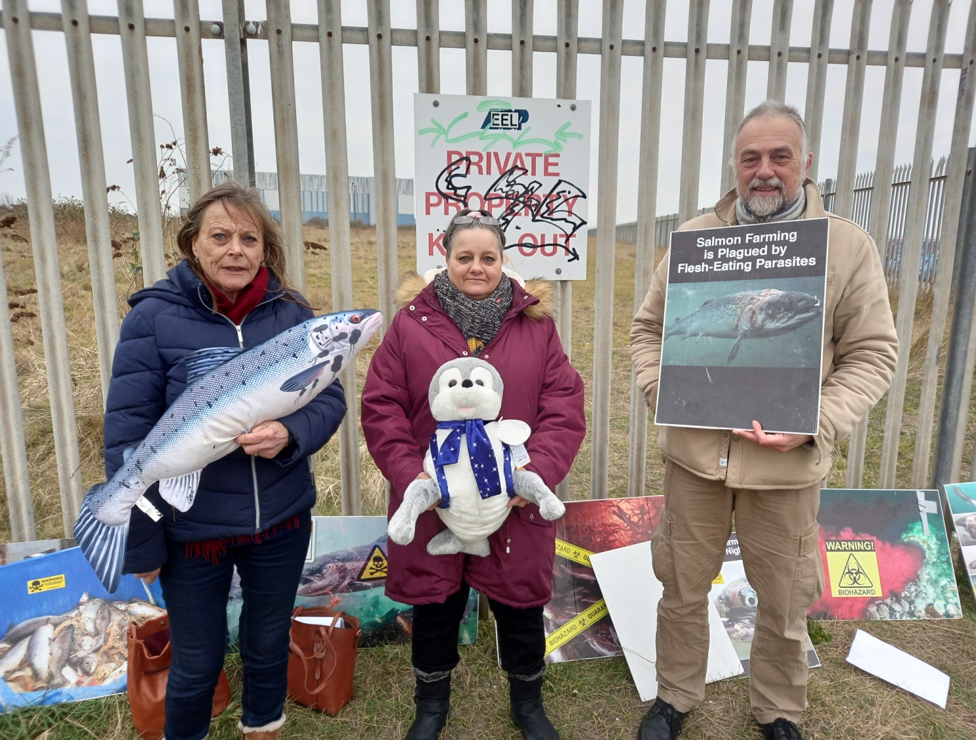

According to planning documents filed with North East Lincolnshire Council on 12 December 2022, the £75 million proposal by AquaCultured Seafood to farm salmon on a 40,000 square metre site next to Grimsby Football Club on the Humber Estuary (a RAMSAR site, Site of Special Scientific Interest, Special Area of Conservation and Special Protection Area) is estimated to generate 1,000 m3/day of effluents but no information has yet been provided on predicted mortalities, infectious diseases, the use of toxic chemicals, the number of fish, mitigation of the smell from dead salmon or how £75 million in investment will be raised [1].

Watch drone footage of the proposed site for AquaCultured Seafood’s 5,000 tonne salmon farm next to Grimsby Football Club and Cleethorpes Beach online here

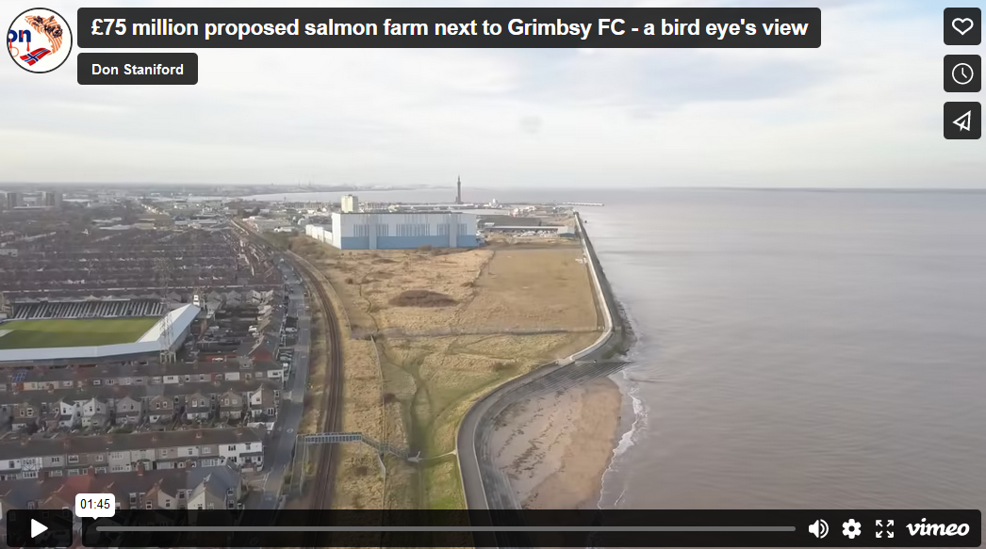

Watch an interview with concerned residents shot yesterday (12 February 2023) overlooking the proposed salmon farm online here (featuring Julie Edwards, John Mooney and Cllr Matthew Patrick)

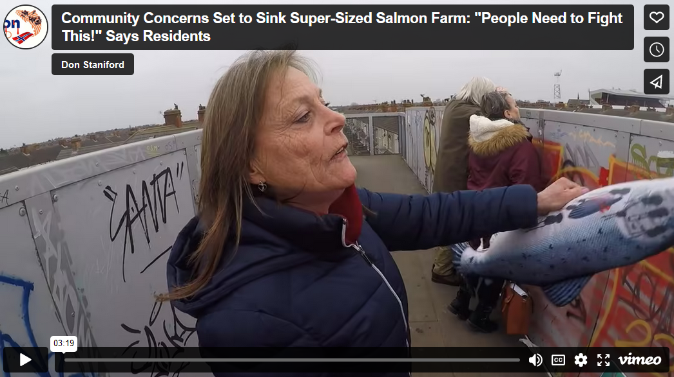
A proposed site plan filed in December 2022 by UMC architects on behalf of AquaCultured Seafood details over 50 tanks where salmon would be factory farmed close to Cleethorpes Beach and residential property:

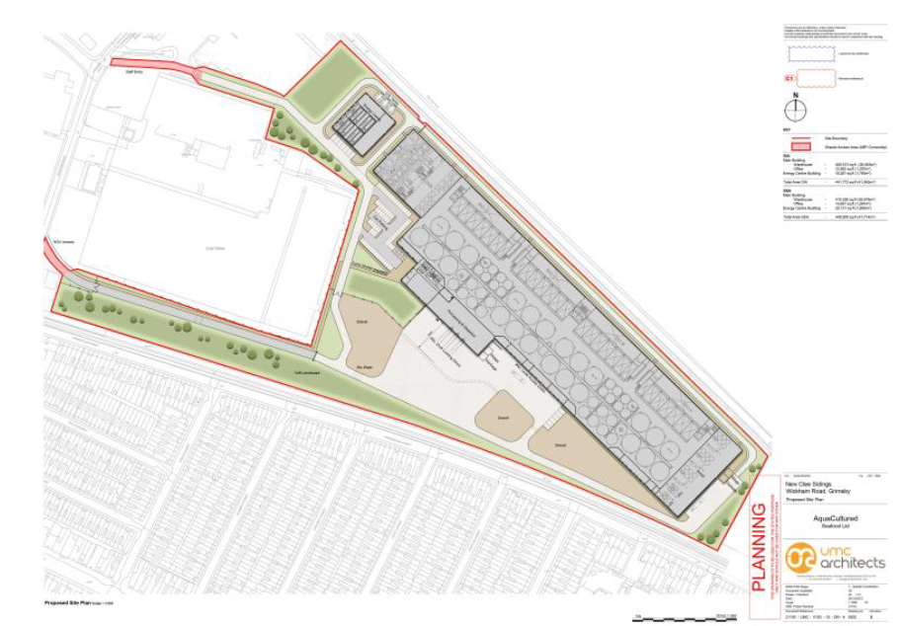

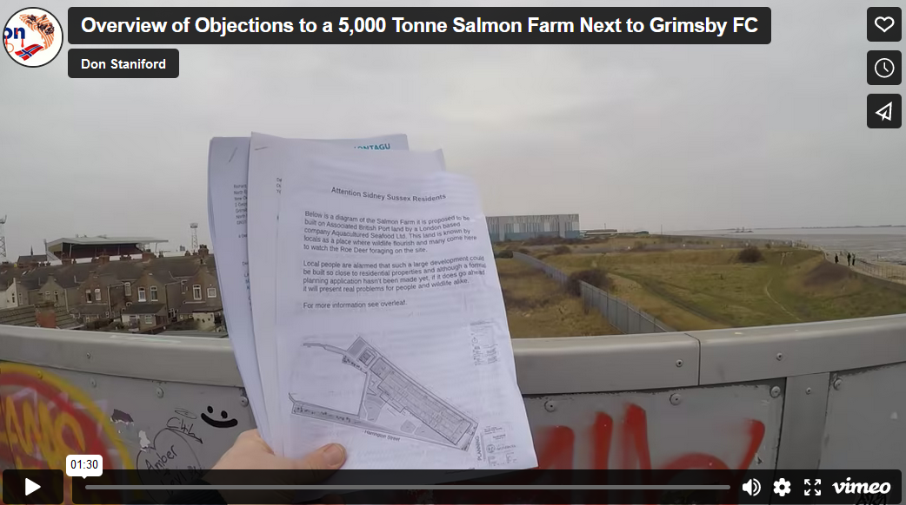
“The proposed development will require approximately 1,000 m3/day of freshwater and 1,000 m3/day of salt water,” wrote property consultancy Montagu Evans in a letter dated 9 December 2022 on behalf of James Fox-Davis (sic) of AquaCultured Seafood (james@aquacultured.co.uk). “Up to 1,000 m3/day of effluent will be generated from the aquaculture process.”

Companies House lists James Fox-Davies and Colin Craig Anderson as directors in AquaCultured Seafood. James Fox-Davies describes himself on Twitter as an ‘Aquaculture Evangelist’ whilst Colin Craig Anderson (also known as Craig Anderson) was outed by The Herald and The Ferret in November 2021 as hiring a private investigator to spy on activists during his tenure as Chief Executive of The Scottish Salmon Company (Bakkafrost) [2].

Local residents living near the proposed salmon farm question the wisdom of the industrial proposal and are setting up a protest group to fight the development.

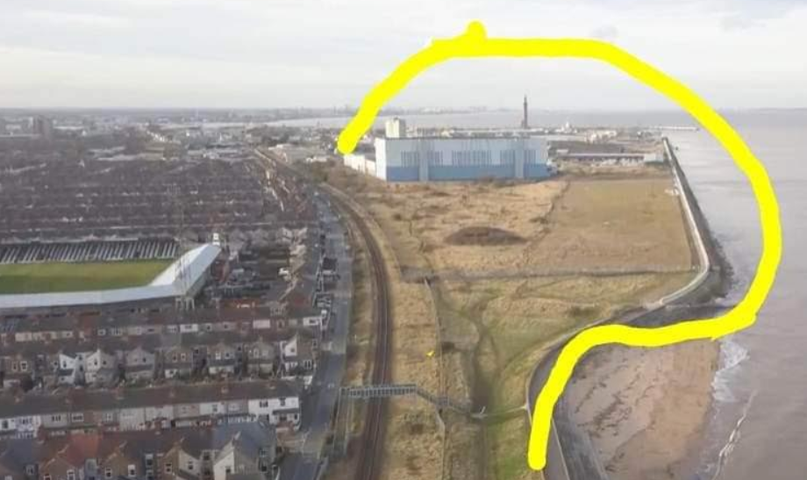

“I oppose the building of a big factory taking away land which is occupied by wildlife,” wrote Linda Calvert of Daubney St in Cleethorpes in an objection filed with North East Lincolnshire Council in January 2023. “It will be noisy and is too near housing which will cause disturbance to the people living along Harrington Street and Daubney and Barcroft Street.”

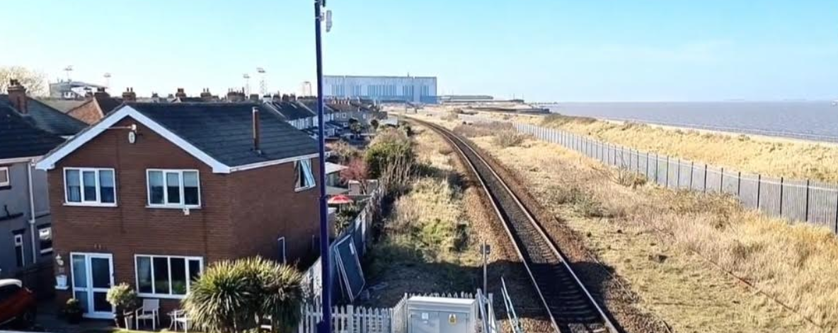
“Strongly object to a salmon farm being built on that land,” wrote Kim Harvey of Manchester St in Cleethorpes in an objection filed with North East Lincolnshire Council last month (25 January 2023). “Records going back 40 years of all the wild life flowers migration of birds, deer, foxes, insects. Also a flood plain. To close to houses apart from the smell and all the crap that will end up being pumped in the sea. The north wall walkway should be a route to the docks but met with a locked gate. The docks is falling apart. Big objections from many people. Keep your back handers to the pocket park project and leave the area alone!”

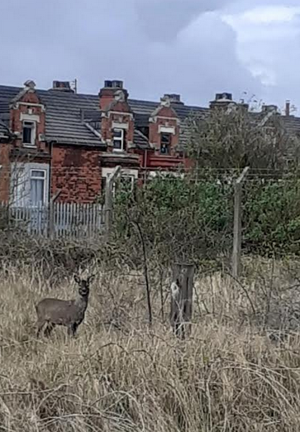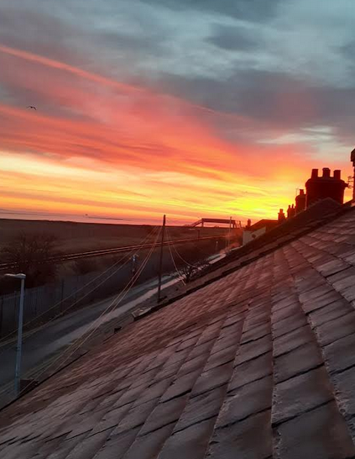

“I strongly object,” said Julie Edwards of Harrington St in Cleethorpes in an objection filed with North East Lincolnshire Council (26 January 2023). “The farm should be built out of town or on the docks on New Holland not next to people's homes where it is a danger. These green spaces need to be saved for future generations. People should listen to what nature is telling us before it's too late.”

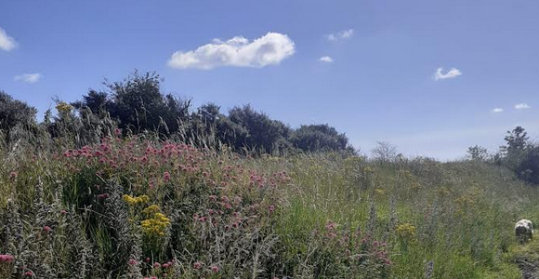
“Deer graze on the proposed salmon farm site and seals have been seen on the slipway to Cleethorpes beach,” said resident Lynn Sayles who is opposed to an industrial salmon farm on her doorstep. “Discharging huge amounts of effluents into the sea will undoubtedly impact on marine wildlife and beach tourism. Grimsby may have a fishy heritage but it is simply no place to locate a stinky salmon farm. AquaCultured should listen to local residents – as well as the foxes, birds, hedgehogs and wildflowers living on the proposed site - and ‘fish off’. North East Lincolnshire Council should be protecting the area as a wildlife park not promoting industrial fish farming.”

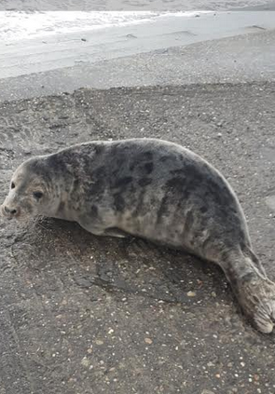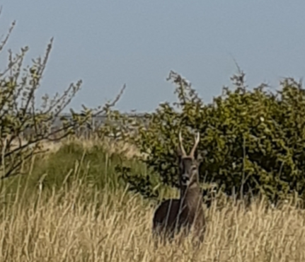
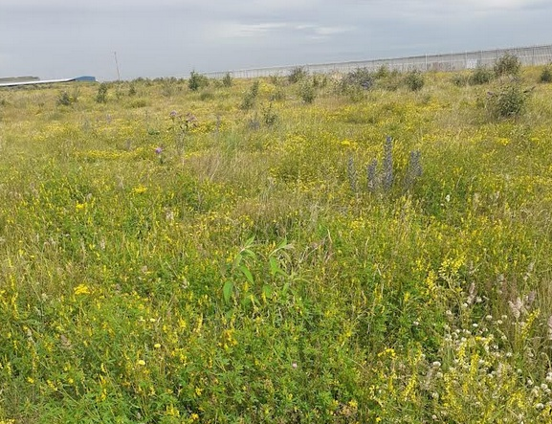

Here’s a 2-page leaflet prepared for local residents:
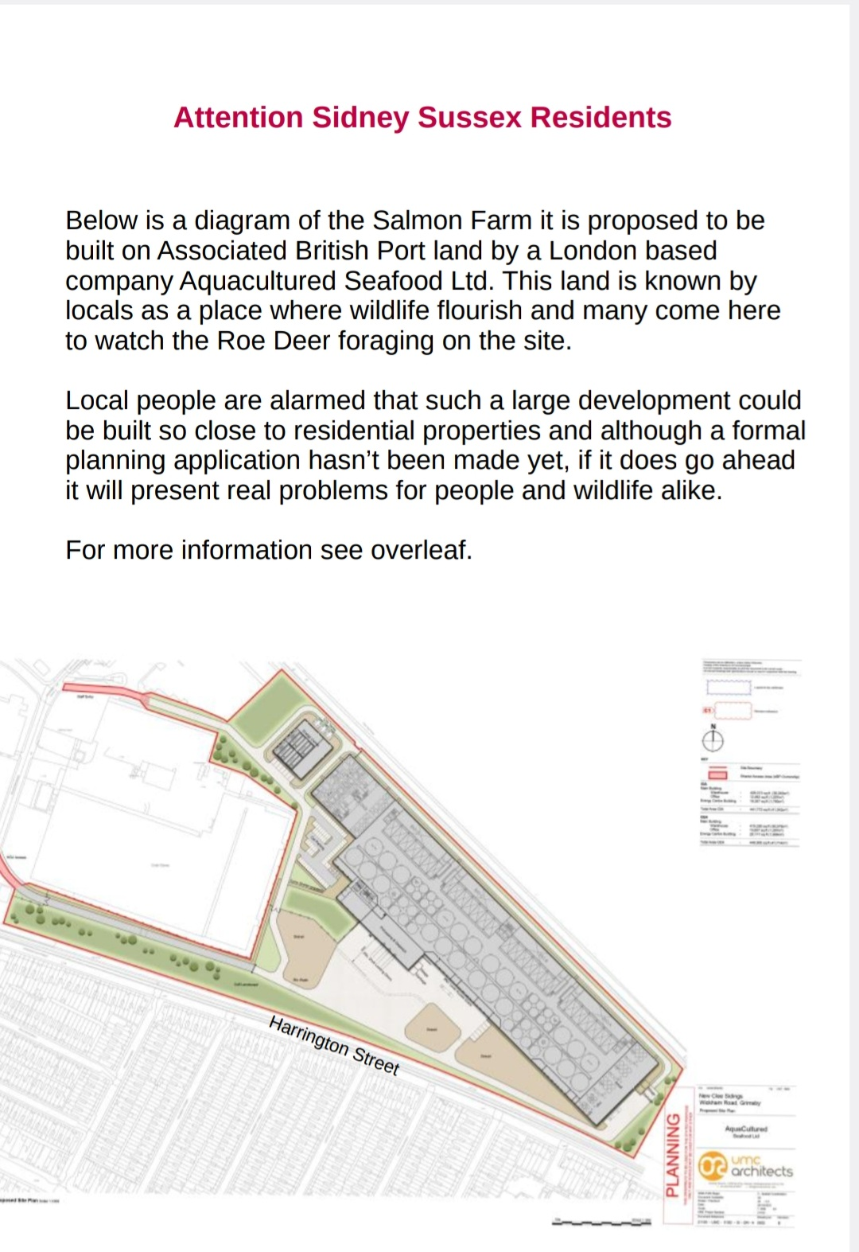
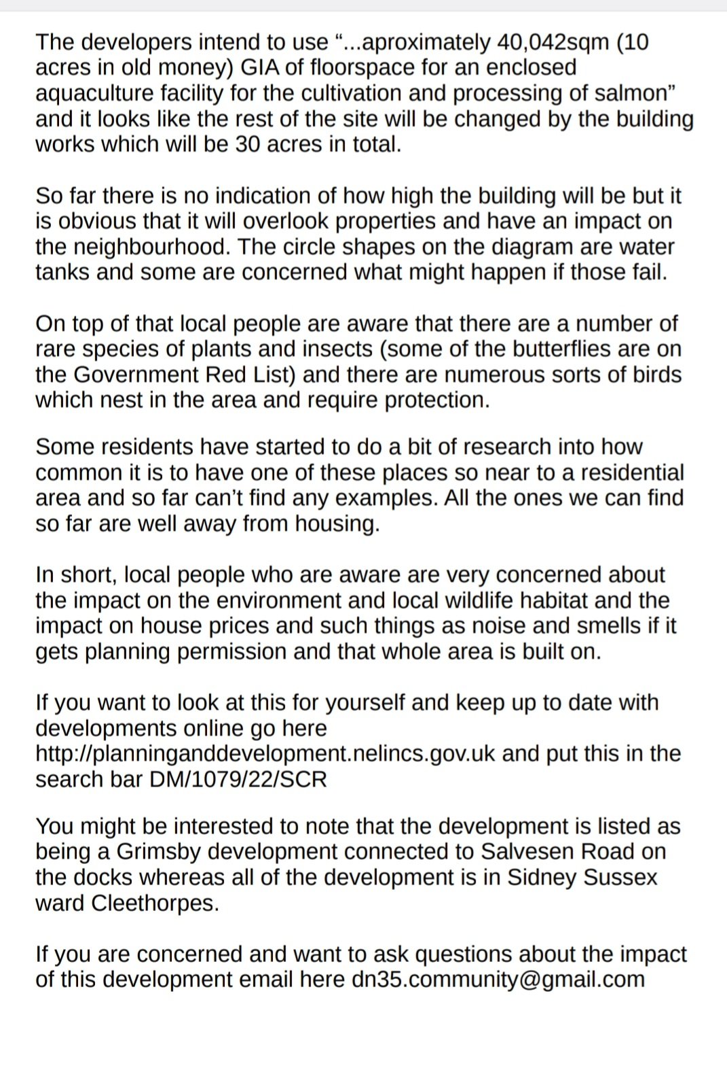
Here’s a Facebook post (10 February 2023) alerting people to the proposal:

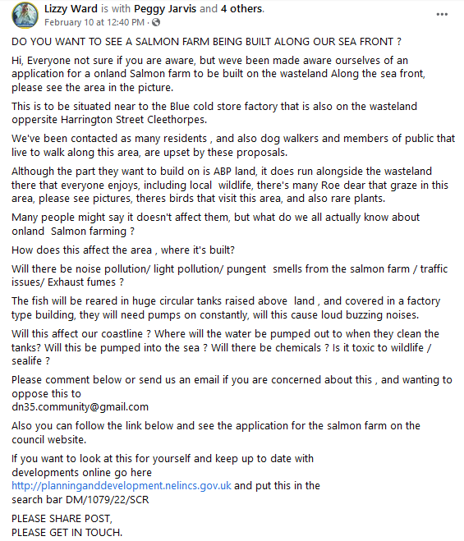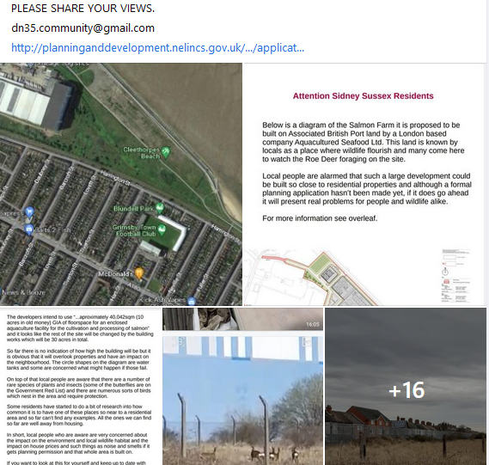
Watch an interview with local residents speaking outside the proposed site on 12 February 2023 online here (featuring John Mooney and Julie Edwards)

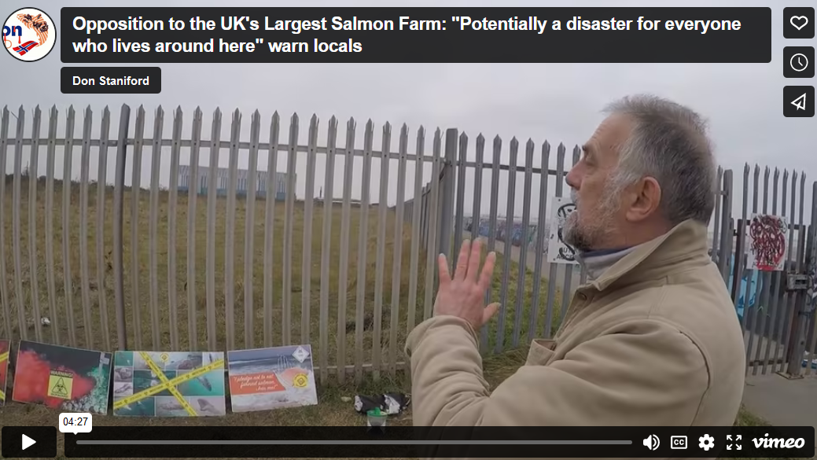

“It is Natural England’s advice, on the basis of the material supplied with the
consultation, that there are potential likely significant effects on statutorily designated
nature conservation sites or landscapes and further assessment is required,” commented Natural England in December 2022. “The proposed development is located within/partly within or has the potential for adverse effects on the following designated nature conservation sites or designated landscapes: Humber Estuary Site of Special Scientific Interest (SSSI), Humber Estuary Special Area of Conservation (SAC), Humber Estuary Special Protection Area (SPA),
Greater Wash Special Protection Area (SPA) and Humber Estuary Ramsar Site.”

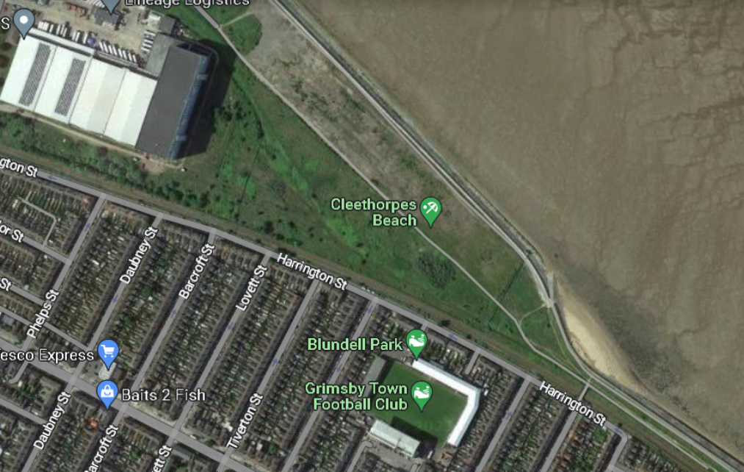
“Further details on process waste/effluent management in terms of odour control of the site would be expected” commented the Environmental Protection Team at North East Lincolnshire Council in December 2022.

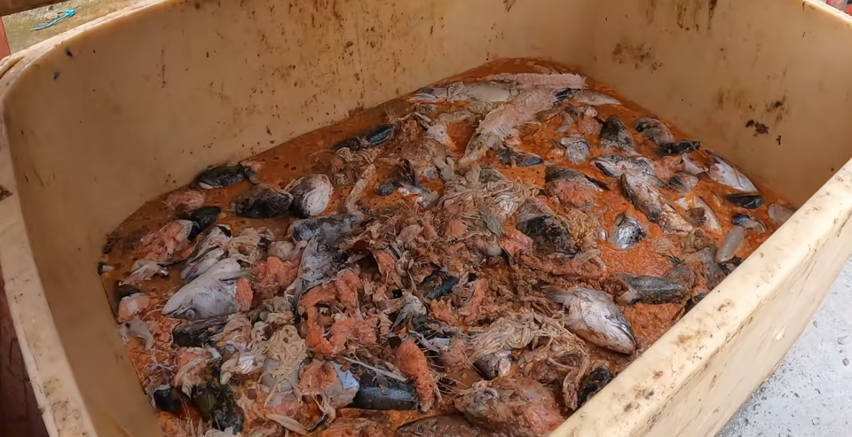

“The welfare nightmare of factory fish farming is a Hammer House of Horror story not a Brothers Grimm fairy tale with a happy ending,” said Don Staniford, Director of $camon $cotland who visited Grimsby yesterday (12 February 2023) to meet with concerned residents. “Even ‘Grimsby’ film star Sacha Baron Cohen would struggle to see the funny side of a torture chamber which kills between 50% of its stock.”

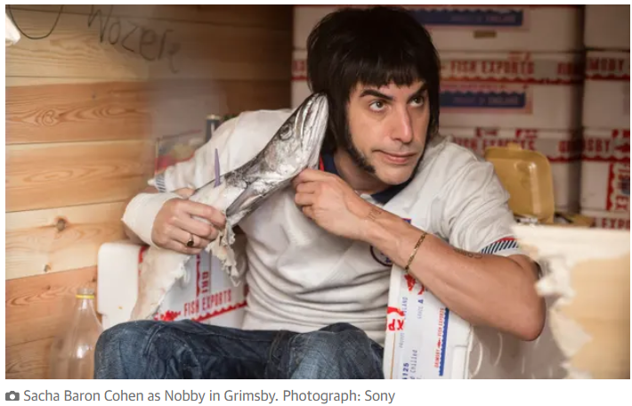

“Cramming millions of Atlantic salmon – the King of Fish – in closed cages is animal cruelty and a crime against nature. Community opposition has the power to stop this ethically and ecologically bankrupt proposal dead in its tracks. If this factory farm goes ahead, the crowd at Grimsby FC will need nose plugs to avoid the stench of farmed salmon and tourists will give Cleethorpes Beach a wide berth.”

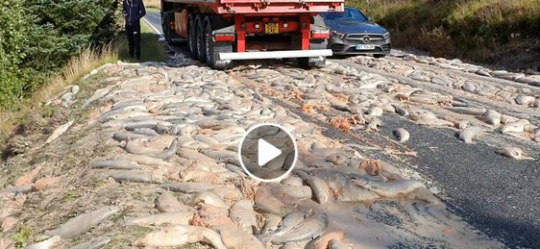

Don Staniford provided an overview of the concerns during his visit to the proposed salmon farm location on 12 February 2023 – online here

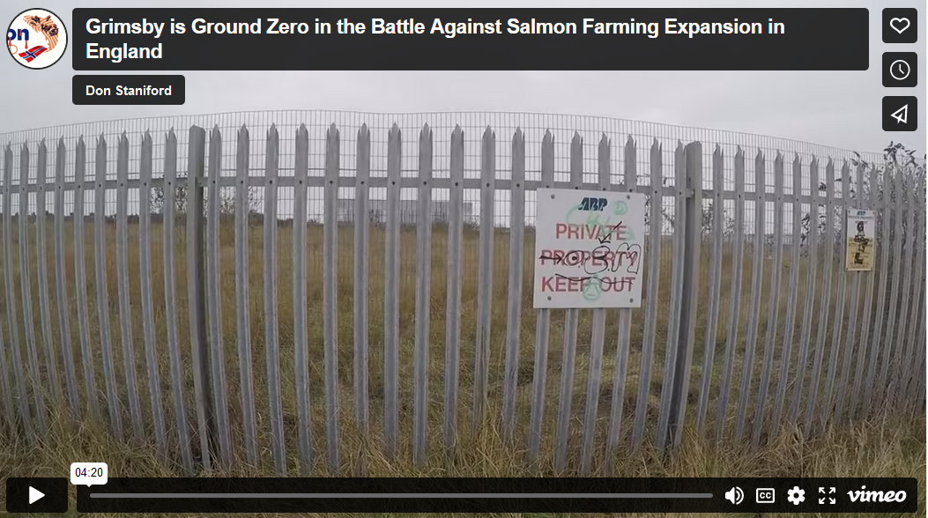
Data on mass mortalities piling up inside land-based salmon farms published on 1 February 2023 by the Scottish Government include weekly mortality events in excess of 1.5 million farmed salmon with death rates of up to 100% and disease problems such as Pancreas Disease, Fungus and Salmon Gill Pox:

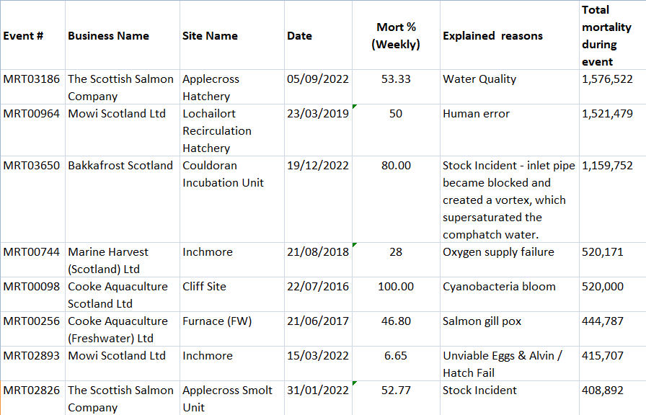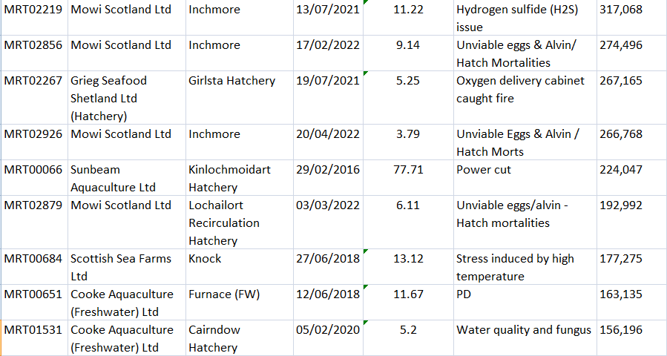

In October 2018, The Sunday Mail reported that 500,000 farmed salmon had died at Mowi's flagship hatchery at Inchmore - opened only a few months earlier by Scotland's Cabinet Secretary for Rural Economy, Fergus Ewing.

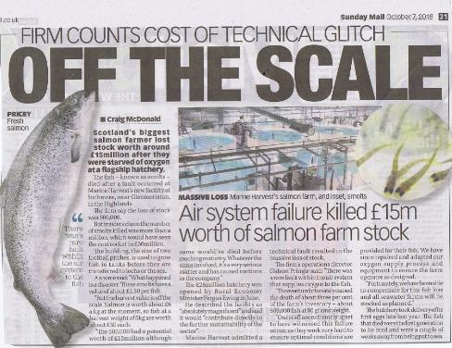

Infectious diseases, lice infestation and mass mortalities are plaguing salmon farms in Scotland – with The Observer newspaper reporting last month (15 January 2023) that 15 million salmon died on farms during 2022 (almost double the previous year).

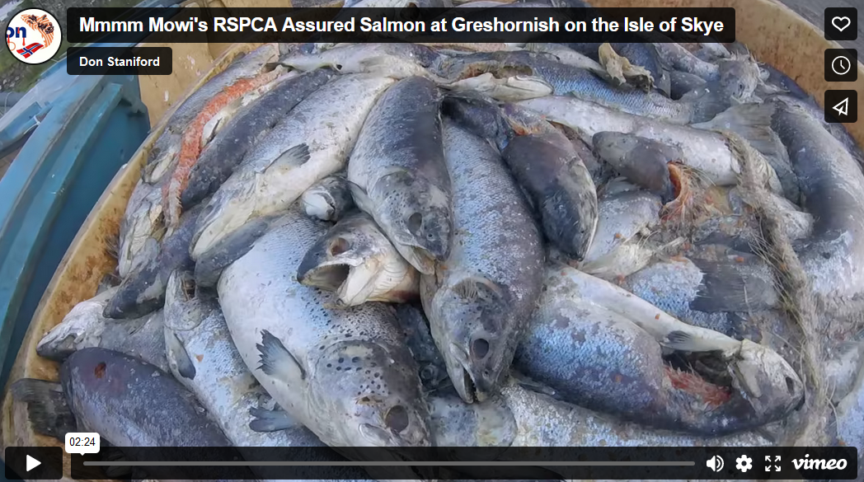

Shocking video footage exposing cruelty inside a land-based salmon farm can be watched via Animal Outlook online here

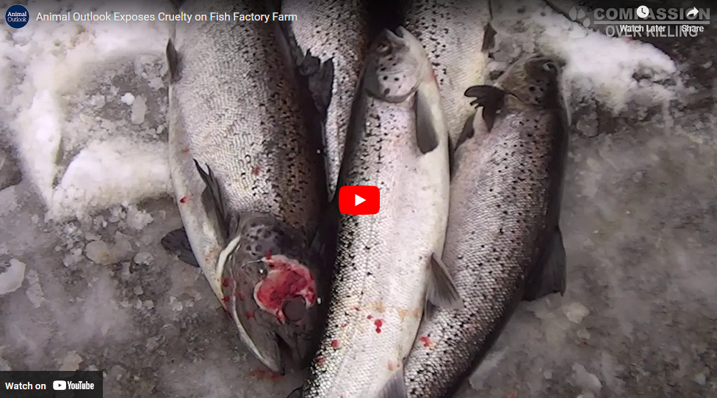

Video footage detailing welfare abuse and mass mortalities inside Scottish salmon farming can be watched via ‘FishyLeaks’ and Ecotricity:

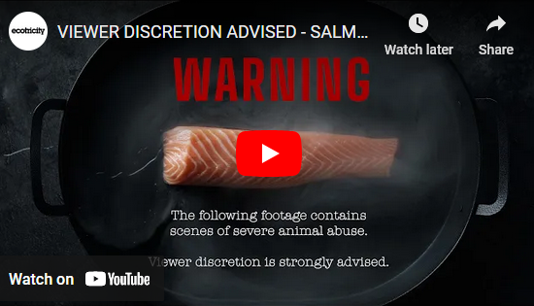

Dale Vince published gruesome video evidence of welfare abuse inside salmon farms last week (10 February 2023):

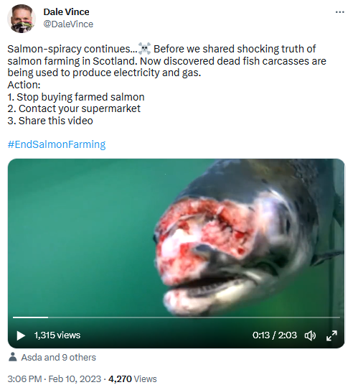

Leaked video footage shot by investigators for Compassion in World Farming shows disease-ridden salmon being dumped across Scotland:

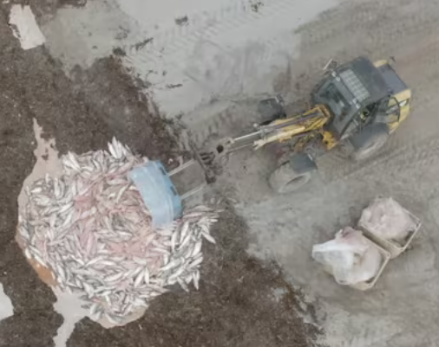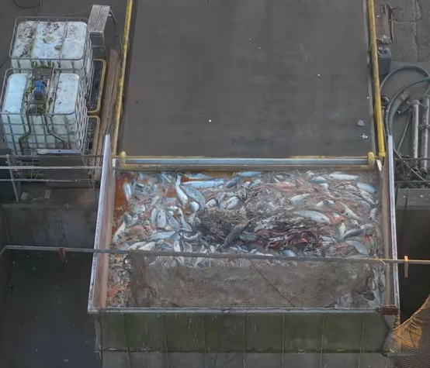
In January 2022, a whistleblower with a relative working inside the Applecross/Russel Burn land-based salmon farm operated by Bakkafrost Scotland (The Scottish Salmon Company) in Kishorn reported mass mortalities and welfare problems:

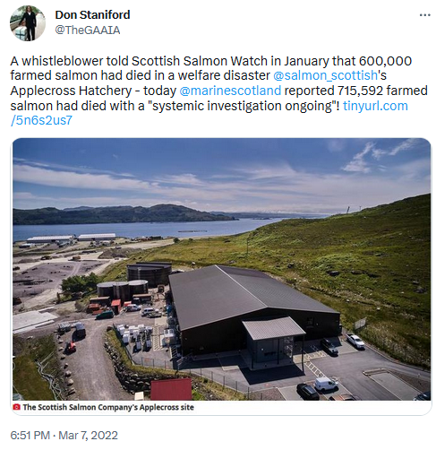

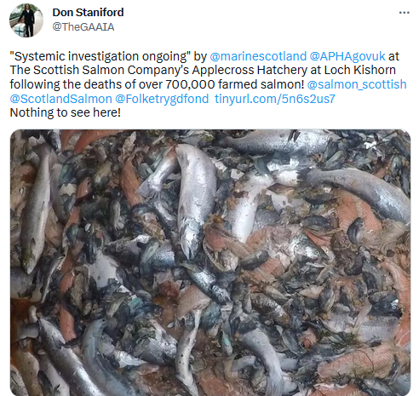
Video evidence of dead farmed salmon – dying in their millions inside land-based and sea cage salmon farms – has piled up all over the world and features on Netflix’s ‘Seaspiracy’.

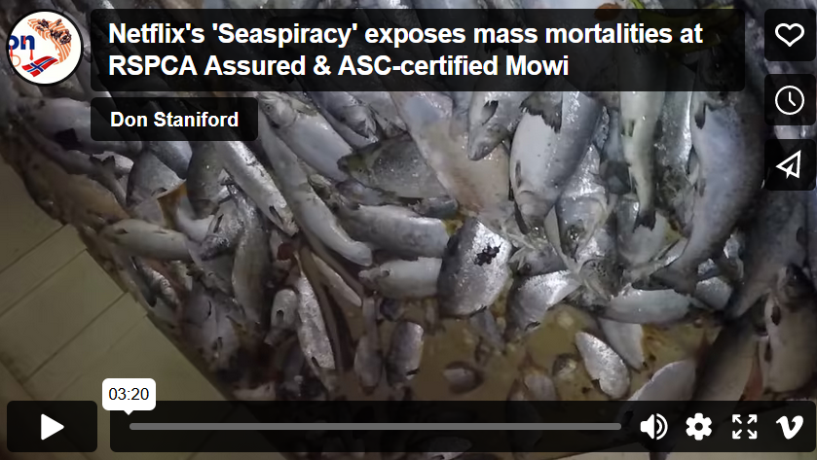

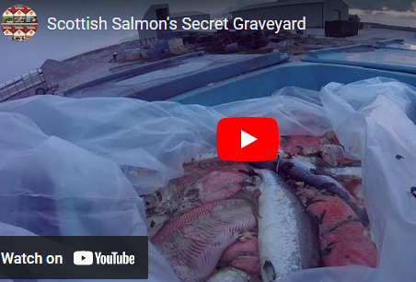

Nor does land-based salmon farming eliminate the use of toxic chemicals. Intrafish reported in October 2022:

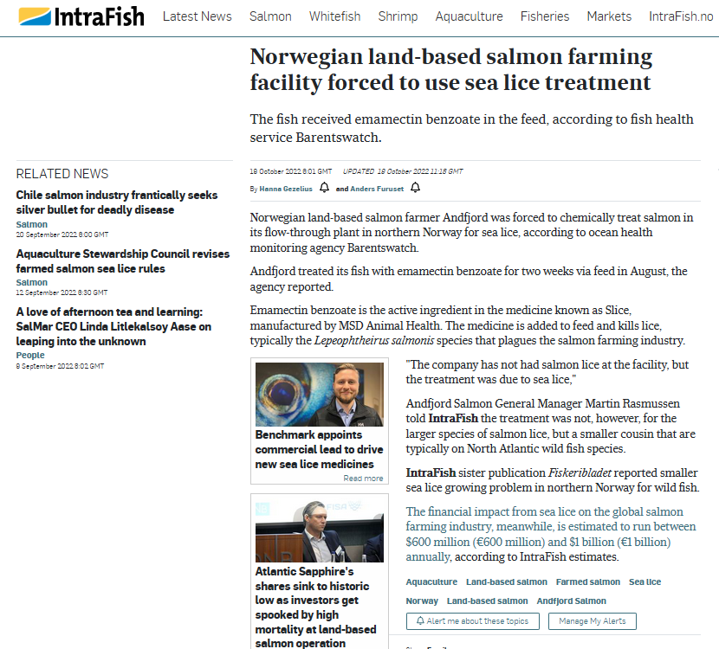

The use of the carcinogenic chemical Formaldehyde (Formalin) – used by Damien Hirst to pickle his art exhibits in and used by morgues to embalm corpses – is widely used in land-based salmon farms and hatcheries in Scotland.

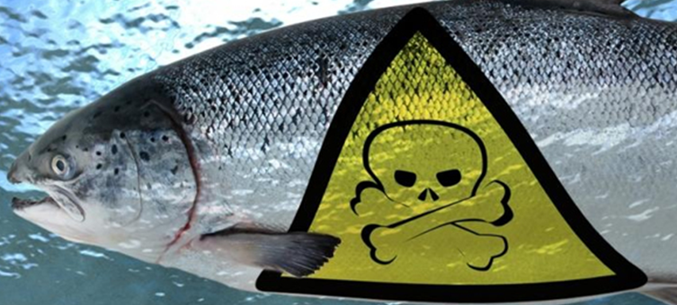
Further details on the horrors of land-based salmon farming can be found via:

A Florida fish farm destroyed 800,000 salmon. Did it break the law? Animal-rights nonprofit Animal Outlook wants the authorities to investigate aquaculture giant Atlantic Sapphire

Atlantic Sapphire reports “above normal and increasing” salmon mortalities - Land-based salmon farming pioneer Atlantic Sapphire has reported “above normal and increasing mortality in certain systems” – a setback that is likely to wipe out their projections to turn a profit in the near future

High nitrogen levels cause fish mortality at Atlantic Sapphire Denmark - lost approximately 227,000 fish in its grow-out RAS systems

Atlantic Sapphire reports another mass mortality - Land-based salmon producer Atlantic Sapphire has blamed human error for an incident that led to the death of 400 tonnes of salmon at its recirculation aquaculture system (RAS) in Denmark

'All fish lost' in blaze at Atlantic Sapphire Denmark: All fish being grown at Atlantic Sapphire’s on-land salmon farm in Denmark are expected to be lost after fire broke out at the plant last night, the company said

Atlantic Sapphire shares plunge after mortalities warning

“Getting it right can be tricky,” reported Science last week (9 February 2023) in an article showcasing land-based salmon farming and Atlantic Sapphire in particular. “In 2021, about 500,000 salmon died at the Florida facility after a clogged drain increased turbidity that may have generated deadly gases. The company’s output that year was just 2400 tons, far short of its long-range target. Other companies have faced protests over plans to build salmon farms in Maine and California. Some communities fear the farms will deplete precious groundwater, or pollute aquifers or surface waters with their waste. In Maryland, one firm canceled plans to build a farm after scientists said its wastewater could harm endangered sturgeon.”

“For oceangoing fish confined to tanks, stress is a constant risk, especially when they are handled. “When the fish don’t want to be moved, they can really hurt themselves,” says Åsa Maria Espmark, an aquaculture researcher with Nofima, the Norwegian food research institute (as quoted by Science).

“The Bluehouse project has not been all plain sailing,” reported BBC News in April 2021. “In July last year an issue with its water quality meant that, in the words of Mr Andreassen, "we faced a situation where we risked large [salmon] mortalities". To avoid this outcome, the company decided to "emergency harvest" 200,000 fish before they had reached their full 20-month-old maturity. Another design problem in March this year caused further fish deaths, the firm had to report. And earlier this month it was reported that three workers at the facility had to go to hospital for treatment following the release of an unknown gas.”

“Unsurprisingly, animal rights group People for the Ethical Treatment of Animals (Peta) is damning of Bluehouse and the 40 or so other firms developing such land-based fish farms around the world,” continued BBC News. “These include a planned barramundi farm in Arizona. "Fish farms [whether at sea, or on land] are pits of filth," says Dawn Carr, Peta's director of vegan corporate projects. "Fish are not fish fingers with fins, waiting to be cut apart, but feeling, thinking individuals capable of joy and pain, and they belong to themselves, not to humans. "Raising fish this way is wretchedly cruel and certainly unnecessary.”

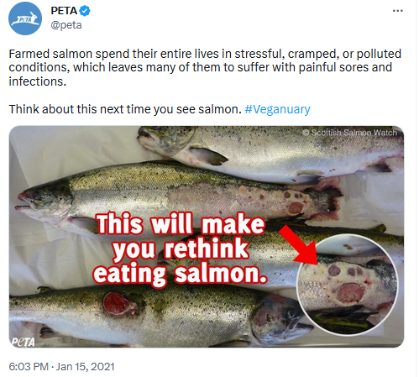

“Land based salmon farming has an appalling track record of mass mortalities, infectious diseases and environmental pollution,” concluded Staniford. “If approved, this 5,000 tonne salmon farm would be larger than any in Scotland [3] where the salmon farming industry is devastating local communities and polluting ecosystems. Do supporters of Grimsby FC really want a monster-sized salmon feedlot as their noxious neighbour? If this crazy proposal succeeds, the Mariners should rename themselves the Salmon Pharmers.”

According to a report published by Seafish in November 2020, Atlantic salmon farming production in England was only 500 tonnes in 2020 but is predicted to increase 28-fold to over 14,000 tonnes by 2040 [4].

It is not known how AquaCultured Seafood plan to find the £75 million in investment from to fund the proposed salmon farm. The only accounts filed by AquaCultured Seafood at Companies House in May 2022 (dated September 2021) detail a bank balance of only £16,887 [5].

Contact:

Don Staniford: 07771 541826 (salmonfarmingkills@gmail.com)

Notes to Editors:

[1] Access the planning documents online here

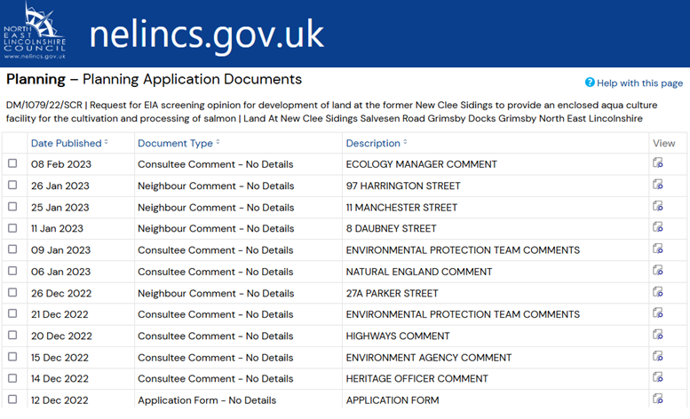

The documents include an application for a screening opinion by AquaCultured Seafood dated 9 December2022 (published on 12 December 2022) – including:

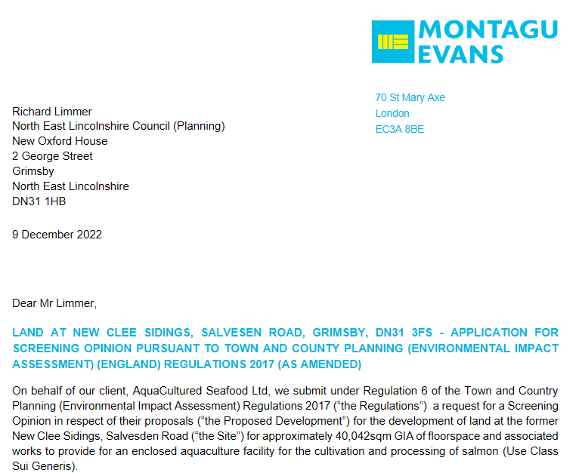

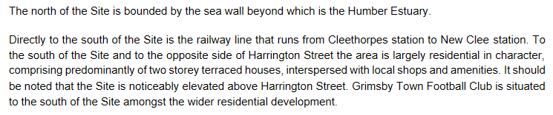

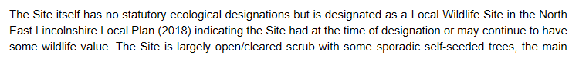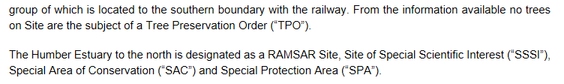

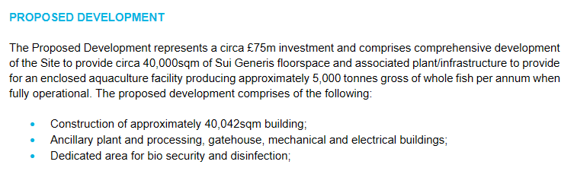

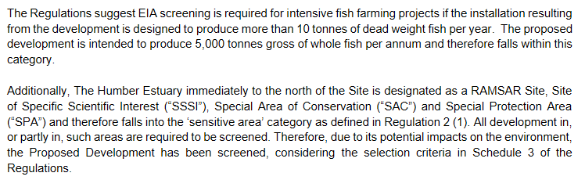

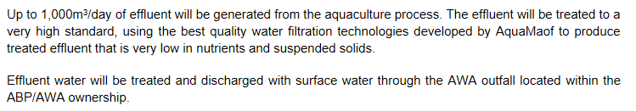

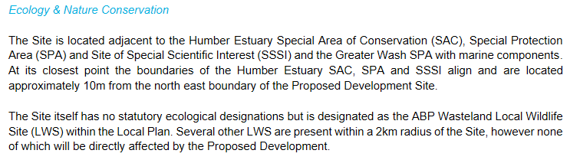

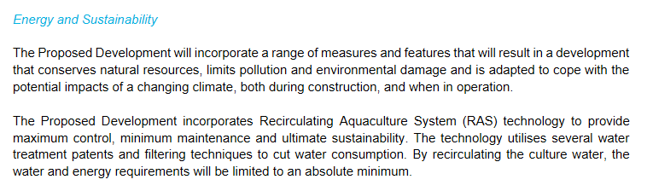

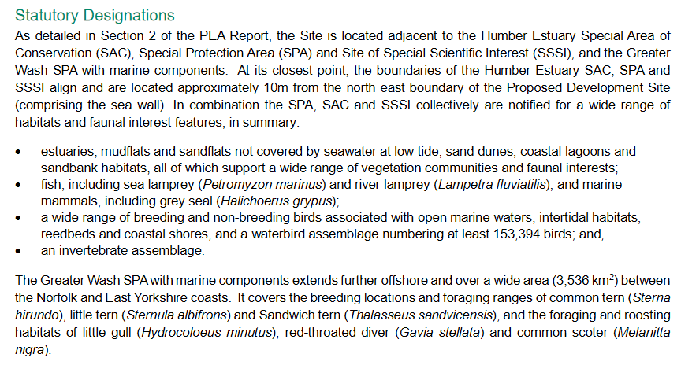

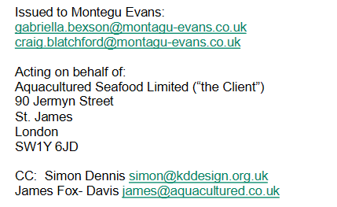

The Environmental Protection Team Comments (published on 21 December 2022) included: “Further details on process waste / effluent management in terms of odour control of the site would be expected”.
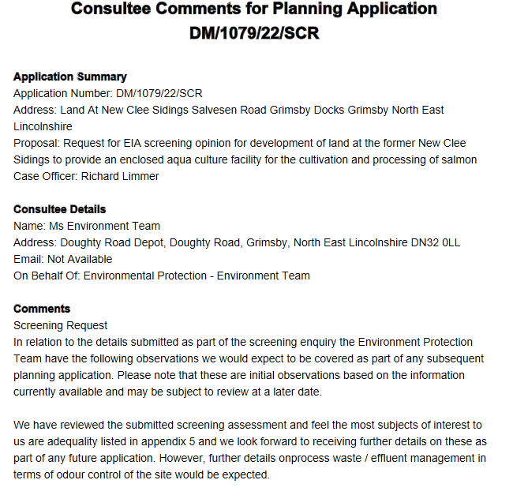

A letter from Natural England dated 15 December 2022 included:

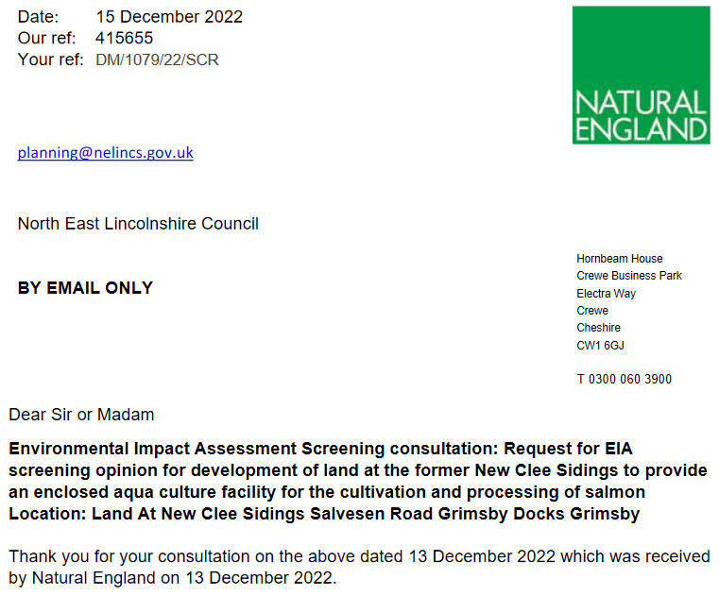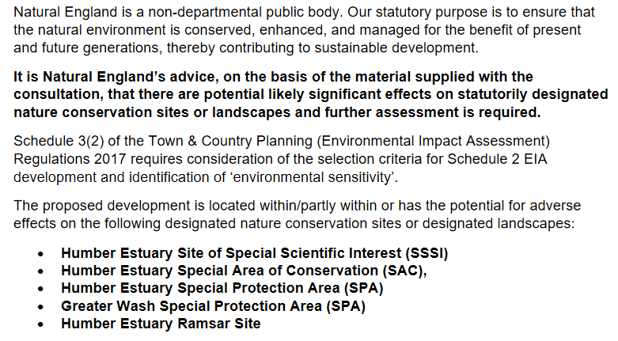
[2] Twitter: https://twitter.com/jamesfoxdavies

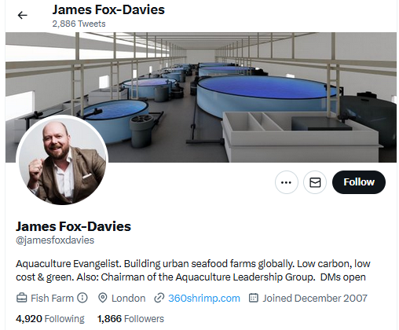

The website above links to https://360shrimp.com/about-us/

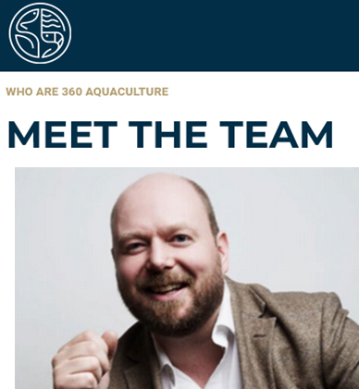

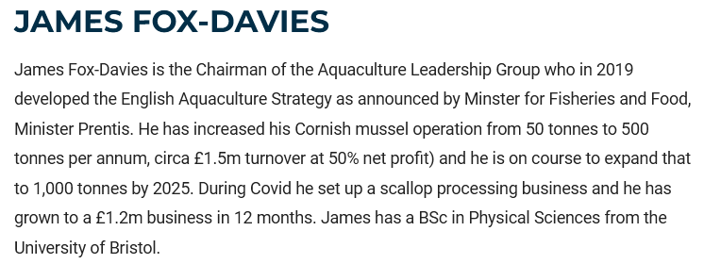

James Fox-Davies is listed by Seafish as Chair of the Aquaculture Leadership Group (representing Fowey Shellfish):

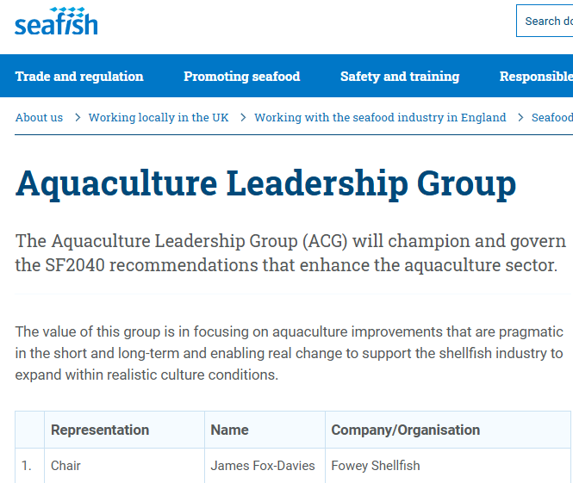

According to Companies House, James Fox-Davies (born in 1976) is listed as Director in three companies:

AQUACULTURED SEAFOOD LIMITED (12912274)
URBAN MUTTS HOTELS LIMITED (11233093)
FOWEY SHELLFISH COMPANY LIMITED (08053633)
Male model David Gandy was a co-director with James Fox-Davies in Urban Mutts Hotels.

Co-directors in AquaCultured Seafood along with James Fox-Davies include Michael Berthet, Stephen Clarke, Mark Edgley and Colin Craig Anderson (also known as Craig Anderson).

Colin Craig Anderson (born in October 1962) is a director in Loch Fyne Oysters along with Viacheslav Lavrentyev. Both are also directors in Associated Seafoods although he is listed as Craig Anderson (born October 1962).

Both Associated Seafoods and Loch Fyne Oysters are owned by ‘Moscow banker’ Yuri Lopatinsky – outed by the Sunday Mail in March 2022 as connected to Russian intelligence, a notorious KGB double agent and dodgy businessmen including Mohamed Amersi.

Read more via:
Lopatinsky's Laundromat - More Dirt on the "Mysterious Millionaire Oligarch With Links to Russian Spy" & Russian spy agencies!
EXPOSED: Lopatinsky's Laundromat - How Dirty Russian Money Corrupted $cottish $almon!
Yuri Lopatinsky: The $py Who Laundered $almoney for the Russian/Norwegian $almafia (& is a neighbour of the First Minister of Scotland)?

Craig Anderson, when Chief Executive of The Scottish Salmon Company (Bakkafrost Scotland), hired a private investigator to spy on activist Corin Smith and a second unnamed person (understood to be Don Staniford):

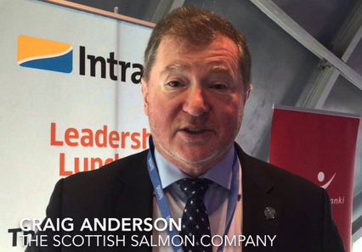

Herald/Ferret: "Scottish Salmon Company chief hired investigator to 'snoop' on fish farming critic"
The Spy Who Loved 'Scottish' Salmon - from Russia, Ukraine, Switzerland, Norway & the Faroes with Love for Salmoney!
Channel 4 News on Scottish Salmon Spying on Corin Smith!
According to Companies House, Craig Anderson was a director of a raft of now dissolved salmon farming companies including:

LOCH NESS (LACHS) LIMITED (SC109230)
HEBRIDEAN SALMON (SCOTLAND) LIMITED (SC368711)
WEST MINCH SALMON LIMITED (SC100097)
HIGHLAND FISH FARMERS LIMITED (SC055225)
PORTREE SALMON FARMERS LIMITED (SC023085)
SALMON FINANCE (SCOTLAND) LIMITED (SC407122)

Craig Anderson resigned as director of BAKKAFROST SCOTLAND LIMITED (SC107275); LOCH FYNE SMOKED SALMON LIMITED (SC376316); PIETERS UK LIMITED (SC220123); FJORD SEAFOOD SCOTLAND LTD. (SC151150) and ATLANTIC WEST SALMON COMPANY LIMITED (SC082196) in December 2019.

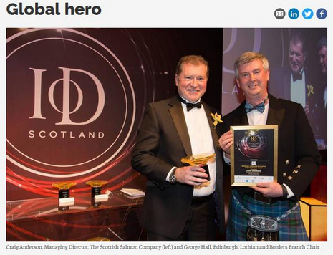

Craig Anderson (listed by Companies House as Colin Craig Anderson) resigned as director of SALMON SCOTLAND LTD (SC152347) and SCOTTISH QUALITY SALMON LIMITED (SC128163) in September 2016.

Craig Anderson (listed by Companies House as Colin Craig Anderson) was appointed director of AquaCultured Seafood in August 2022.

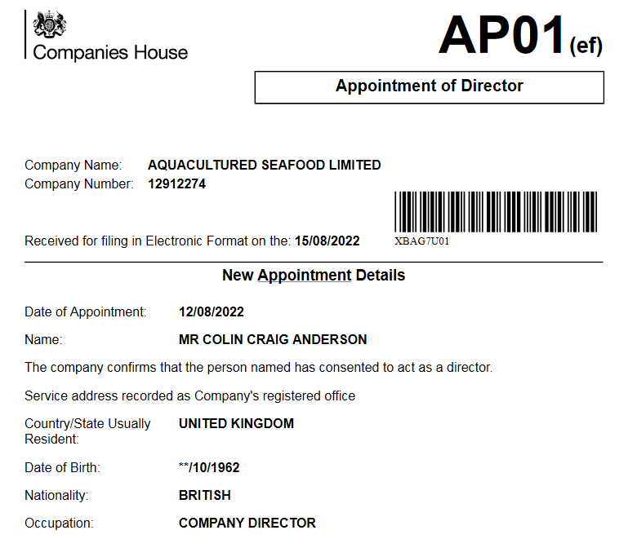

This document – submitted to Companies House via Associated Seafoods – confirms that Craig Anderson was born on 15 October 1962:

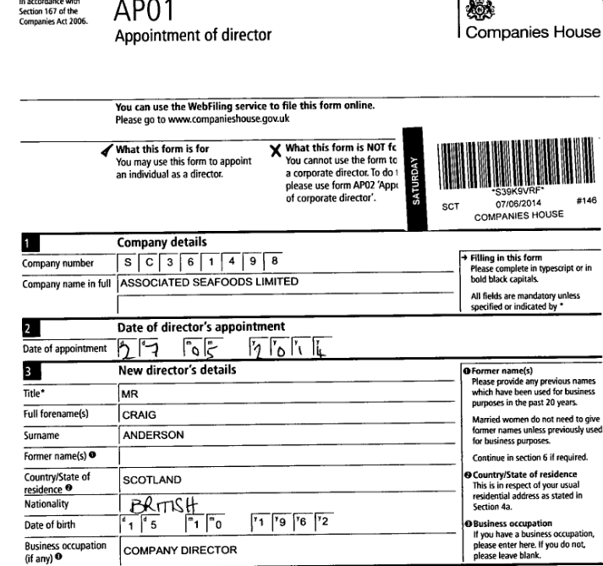

This document – submitted to Companies House via Loch Fyne Oysters – confirms that Colin Craig Anderson was born on 15 October 1962:

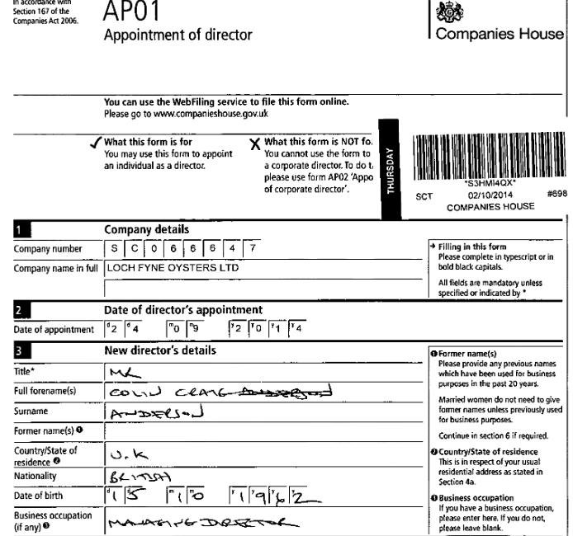

[3] Here’s the 50 largest salmon farms in Scotland – as detailed by the Scottish Environment Protection Agency (data published on 27 January 2023):

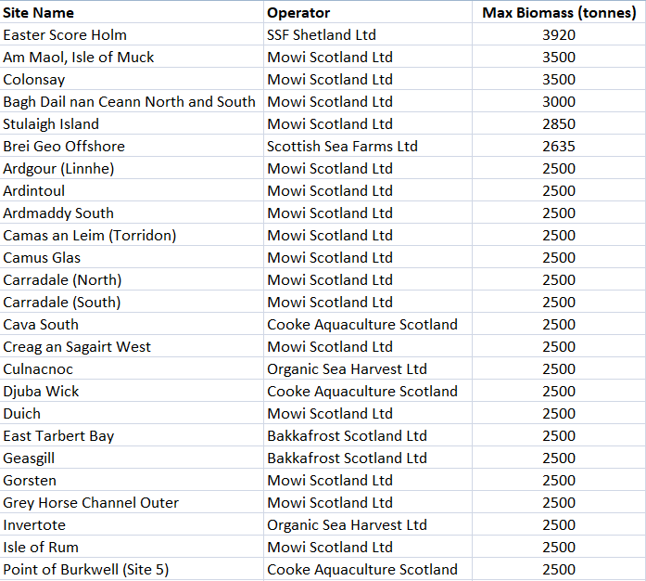
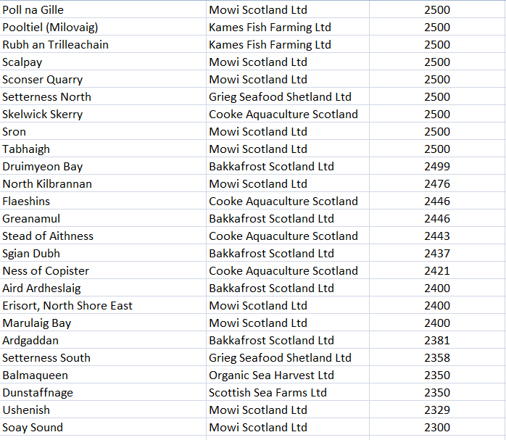

The Scottish Fish Farm Survey 2021 (published by the Scottish Government in October 2022) detailed 103 salmon farms producing less than 2,000 tonnes; 25 producing between 2,000 and 3,000 tonnes; 9 reporting between 3,000 and 4,000 tonnes; and only 3 salmon farms reporting over 4,000 tonnes of production in 2021:

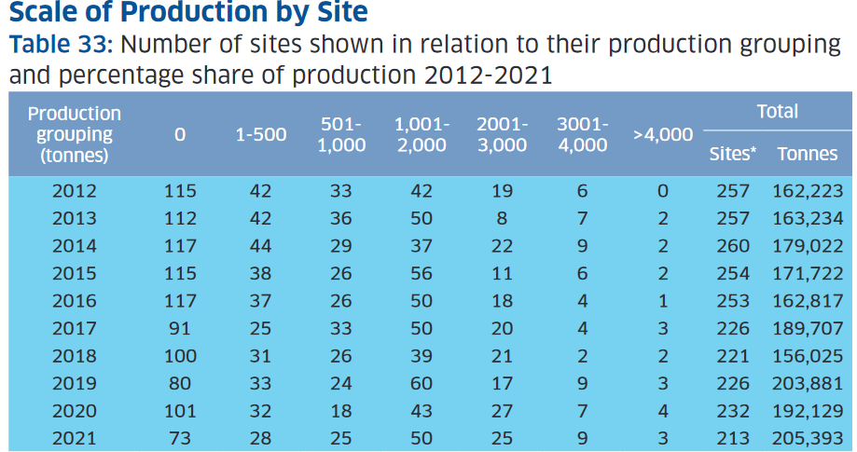

[4] The English Aquaculture Strategy – published by Seafish in November 2020 – included:

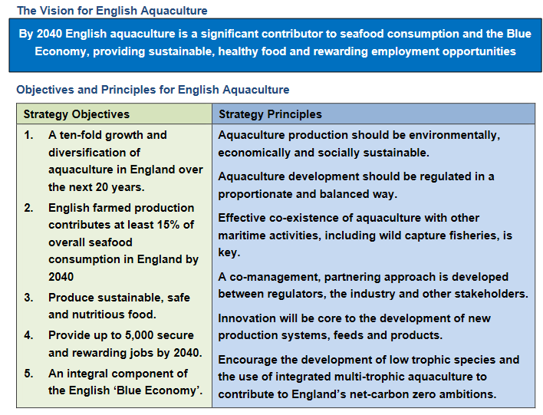

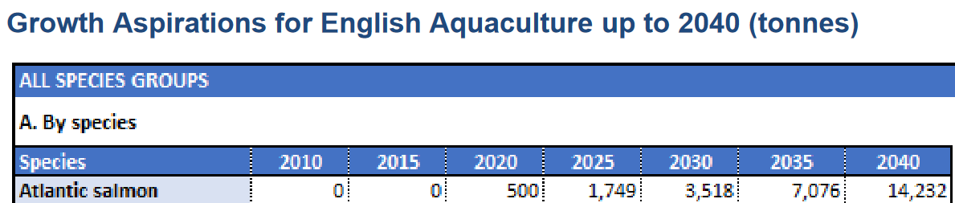

[5]

