Scottish Salmon Watch, 11 June 2018

Highlands & Islands Exposed
- FOI disclosure lifts lid on mass mortalities on Scottish salmon farms

- HIE identifies 'medium' level "reputational risk" to £362,000 mass mortality project (£161,000 funded by the taxpayer)

- BBC 'One Show' exposé of 'The Dead Salmon Run' triggers "careful consideration to the wording of a press release" since "industry critics will pick up on this as further evidence of the industry's failings"


Documents disclosed by Highlands & Islands Enterprise (HIE) via Freedom of Information (FOI) lift the lid on mass mortalities plaguing the Scottish salmon farming industry [1]:

- "Reputational risk is more likely to be medium rather than low; a week after the BBC ran two pieces on mortalities in salmon farms we are planning to approve a bulk handling system for mortalities," warn HIE. "We must consider that it is entirely possible industry critics will pick up on this as further evidence of the industry's failings"

- "The current practise of dealing with these events [mass mortalities] is not logistically integrated or properly bio-secure" admit Ferguson Transport

- "We would like to start this project ASAP as we are coming into the summer months that temperatures will rise and when mortalities/disease is most likely to happen within the farms" ask Ferguson Transport

- "Within our planning we also have to take into account the 2030 Vision of the Industry and its envisaged growth plan, therefore it would be anticipated that the mort numbers will also increase" predict Ferguson Transport

- "Unfortunately, mass mortality incidents are not particularly rare, and when they do occur, there isn't an efficient methodology or 'one stop shop' to deal with them" concede Ferguson Transport

- Ferguson Transport also cite in various documents the "Potential risk of cross contamination"; "Pathogen spread from affected farms"; "Mass mortalities will continue to increase"; and "Disaster response often expensive, protracted and sub-optimal"

"Mass mortalities now stand at over 25,000 tonnes - that's the equivalent of 2,500 haulage trucks loaded up for what the BBC 'One Show' coined 'The Dead Salmon Run'," said Don Staniford, Director of Scottish Salmon Watch. "That HIE is abusing public money to the tune of nearly £200,000 to bail out the disease-ridden industry is one issue. Another issue altogether is how HIE has been caught censoring and withholding damning documents. Scottish salmon farming is dead in the water due to infectious diseases and lice infestations with a mortality rate of a staggering 26.7% - an estimated 15-20 million 'morts' during 2017."
HIE's Document Dump:

Download documents obtained by Scottish Salmon Watch via FOI from Highlands & Islands Enterprise on 31 May 2018:
HIE FOI reply 31 May 2018 Ferguson #1 (41 page PDF)
HIE FOI reply 31 May 2018 Ferguson #2 (20 page PDF)

The documents include:

An email from Elaine Jamieson of Highland & Islands Enterprise (HIE) dated 20 December 2017 sought guidance "to ensure we position our Comms around this carefully, and consider sharing/liaising any press release with SSPO and Marine Scotland (as you think appropriate)". Writing to HIE colleagues and the Scottish Aquaculture Innovation Centre (SAIC) she stated:

"Reputational risk is more likely to be medium rather than low; a week after the BBC ran two pieces on mortalities in salmon farms we are planning to approve a bulk handling system for mortalities. We must consider that it is entirely possible industry critics will pick up on this as further evidence of the industry's failings - as they would see it."

Another email from Elaine Jamieson of Highland & Islands Enterprise (HIE) dated 20 December 2017 stated:

"I think it is of paramount importance that our respective Comms team liaise and that we issue a joint press release. My own thoughts are that timing might be better after Christmas. I can confirm that Charlotte has been briefed, and shares our concerns about positioning. Iain - can you please offer advice re. a pre-press release briefing with Marine Scotland and SSPO?"

An email dated 20 December 2017 from Helen Cameron of Highland & Islands Enterprise (HIE) to Ferguson Transport (notifying them of a grant up to £181,000 via a £362,000 project titled 'Integrated Aquaculture Rapid Mortality Recovery System') stated under 'Communications/press':

"We are conscious of the level of media attention around fish farming issues and, in particular, the recent BBC reports on the disposal of mortalities. In view of this we will be giving careful consideration to the wording of a press release on the approval of funds. If you were going to issue any company press releases could you liaise with our Communications team before doing so?"

[Watch the BBC One Show reporting on 'The Dead Salmon Run' on 11 & 12 December 2017 online here and online here]

"We anticipate that there could be some press interest in the story given recent media coverage of fish mortalities in the media," wrote HIE's Helen Cameron in an email to Ferguson Transport dated 28 February 2018 attaching a draft press release.

The FOI documents disclosed by HIE on 31 May 2018 did not include a draft press release but a press release was published by HIE on 13 March 2018 (a week after Scottish Salmon Watch's FOI request on 6 March 2018) - including:

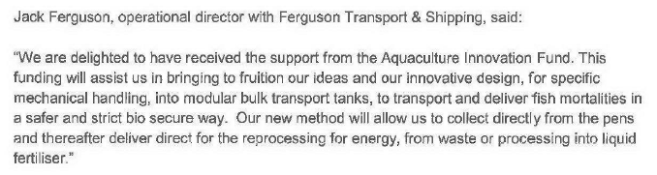

An email from Helen Cameron of HIE to Iain Sutherland of HIE dated 3 January 2018 stated: "Please note that changing the reputational risk to medium means that there are more mediums than lows so I have amended the overall risk rating to medium."

In January 2018, HIE changed the name of the project from 'Integrated Aquaculture Mass Mortality Recovery System' to 'Integrated Aquaculture Rapid Mortality Recovery System' following a suggestion from HIE's Iain Sutherland. "Echoing Iain's email," [which has been redacted] wrote Caroline Maclellan in an email to colleagues dated 8 January 2018. "Do we want to amend how this will be viewed in the public domain, we don't have to show on these the exact wording as it appears on HMS so happy to provide Kathy with an appropriate title for the grant approval which will be made public."

Here's a copy of the project description dated 20 February 2018:

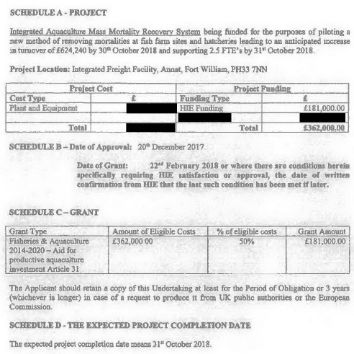
"Periodically, Fergusons have been called in by fish farm operators to deal with mass mortalities that can occur on fish farms which can range from 10's of tonnes to 100's of tonnes," wrote Ferguson Transport in a 'Market Assessment for Accelerating Aquaculture Innovation' dated 9 October 2017 to the Scottish Aquaculture Innovation Centre (SAIC). "The current practise of dealing with these events is not logistically integrated or properly bio-secure."

"Unfortunately, mass mortality incidents are not particularly rare, and when they do occur, there isn't an efficient methodology or 'one stop shop' to deal with them," wrote Ferguson Transport in a funding application in May 2017 to HIE's 'Accelerated Aquaculture Innovation' (AAI) Programme. "The current method of dealing with mass mortality incidents is costly and time consuming to fish farms, due to the abstraction of their staff from normal duties, the time it takes to arrange and to effect the logistics to deal with the clean-up itself (often whilst the crisis is escalating), and ultimately, the potential risk of cross contamination / not removing infected fish quickly enough."

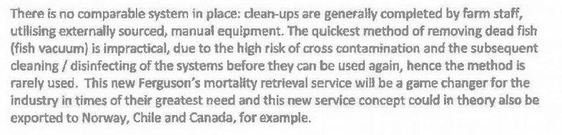

"Ferguson's work closely with Marine Harvest Scotland and therefore saw first-hand how no system was in place to deal with mass mortality events when a number of its farms was affected by AGD [Amoebic Gill Disease] in 2016," continued Ferguson Transport. "If the dead fish are not removed from the nets quickly, the nets start to be overloaded and drag downwards, creating further issues / ruined pens, etc. The longer the dead fish remain in the water, the more likely they are to create further health risk to other farm fish and into the wider environment."

"The value proposition for this innovation is therefore a closed system of clean up from farm to disposal site, in large volumes which will therefore reduce the environmental impact and pathogen spread from affected farms," continued Ferguson Transport. "This system will enable a fast-time clean-up process, which should assist not only in preservation of 'business as usual' for the companies, therefore helping to ensure the security of income for the businesses and their staff, but will also assist in removing diseased fish from our waters at large, assisting in conservation of our wild fish stocks."

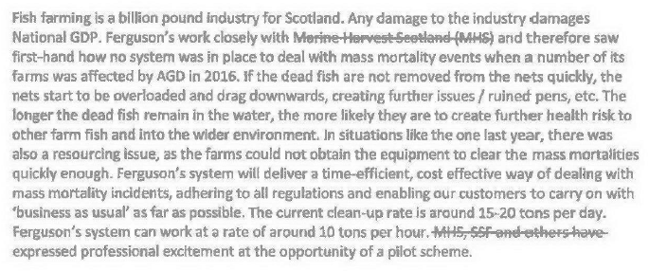
"We would like to start this project ASAP as we are coming into the summer months that temperatures will rise and when mortalities/disease is most likely to happen within the farms," wrote Ferguson Transport in an 'Expression of Interest' to HIE and SAIC on 7 July 2017.

Describing the "expensive, protracted and sub-optimal" process of dealing with mass mortality events, Ferguson Transport detailed in an 'Expression of Interest' to HIE and SAIC on 7 July 2017:

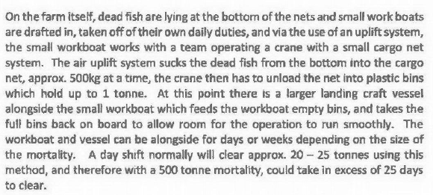

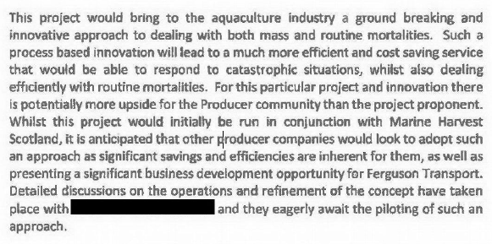

A letter from Ferguson Transport to HIE and SAIC dated 9 October 2017 referred to 1,000 full vehicle movements per year necessary to deal with 10,000 tonnes of mortalities (i.e. 10 tonnes per truck) admitting that "mort numbers will also increase."

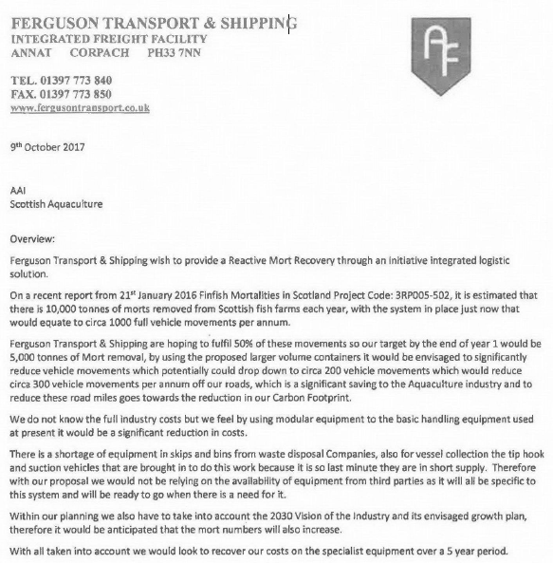

[In fact, during 2017 over 25,000 tonnes of dead Scottish salmon were reported on Scottish salmon farms according to official statistics published in March - that's the equivalent of ca. 2,500 full vehicle movements per annum [2].]

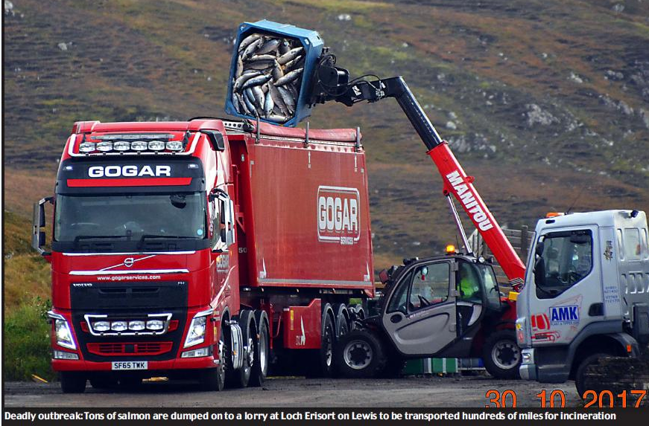
HIE's previous FOI reply to Scottish Salmon Watch dated 3 May 2018 [3] provided the following information:

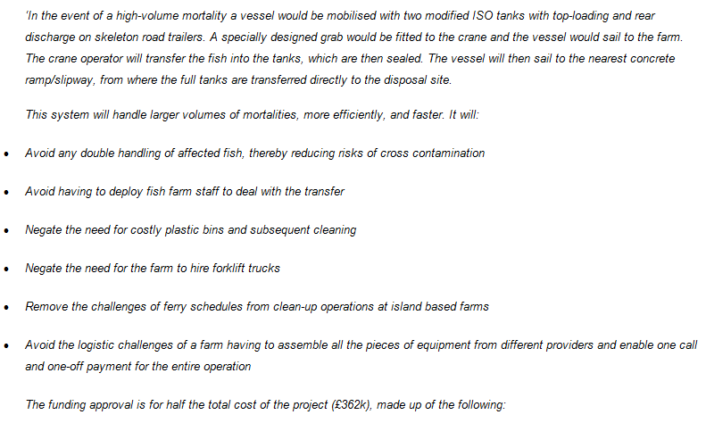
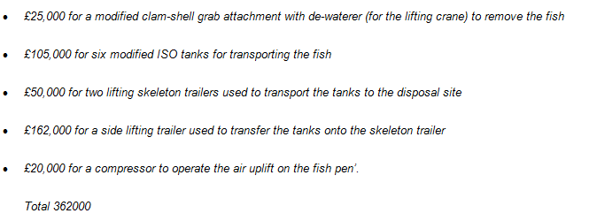

Here's a photo of the clamshell grab:

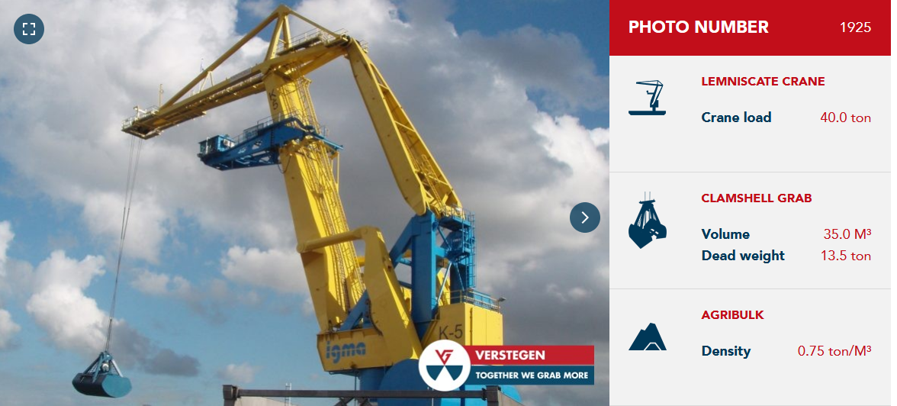

Here's photos of the modified ISO tank for transporting the dead farmed salmon:

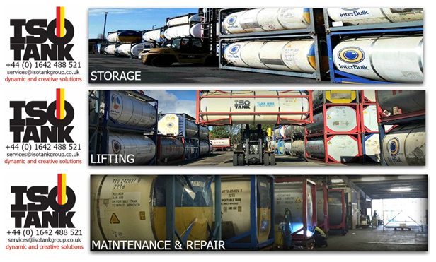

Following Scottish Salmon Watch's FOI in March 2018, HIE initially only disclosed a limited number of documents citing commercial confidentiality and internal correspondence of a ‘sensitive nature’ as reasons with withholding information. It was only after a formal request for a review in May 2018 that HIE finally disclosed further documents on 31 May 2018 [3].

Scottish Salmon Watch is now appealing to the Scottish Information Commissioner for the release of further documents withheld by HIE.

Background:

Read more on mass mortalities on Scottish salmon farms via:
Enterprise body under fire for cash handout to deal with dead salmon
Disease concern as Scots salmon farmers' produce "stomach-churning" record levels of fish deaths
Hard Evidence: Dossier of Data on Lice, Diseases & Mortalities at Scottish Salmon Farms
Scottish Salmon's Mort Mountain Leaps Over 10 Million - FOI reveals 2.3 million dead salmon at Marine Harvest farms in 2017
Thousands of fish thrown in a truck - and troubling new questions for salmon farms Parliamentary Question: to ask the Scottish Government how many farmed salmon have died in each year since 2012
First Minister questioned on leaking wastes from morts - call for a moratorium from Greens"
BBC's 'Dead Salmon Run' Opens Can of Worms
Millions of Scottish Salmon Going Up in Smoke
BBC's The One Show: "The Dead Salmon Run"
125,000 salmon die in disease outbreak at Lewis fish farms
Campaigners say 'no more salmon farms' after disease on Lewis kills 125,000 fish
A disgrace: Ten million salmon thrown away by fish farm industry in last year alone
Death rate at salmon farms doubles to 20m fish a year
Welfare fears after claim deaths of farmed salmon have doubled

In April 2018, The Herald reported:
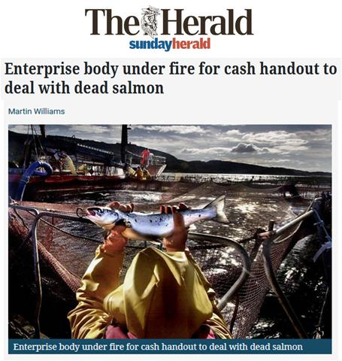
In May 2018, the Fish Site reported on a new mort recovery system called the Foover which "will recover up to 300 kg of morts in a single operation".

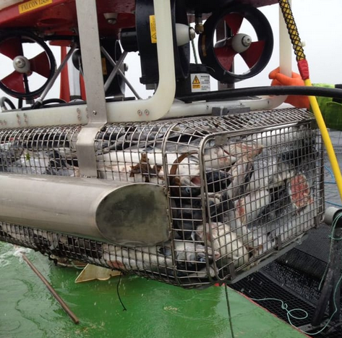
In May 2018, 'Scotland’s 10 Year Farmed Fish Health Framework' included:

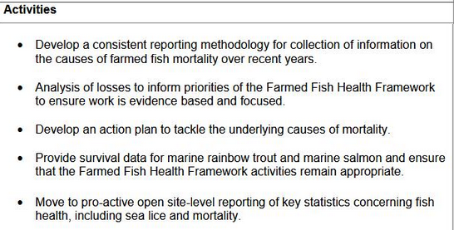

In May 2018, Scottish Salmon Watch delivered a 42,000-strong petition to the Scottish Government calling for testing of salmon farming operations for infectious diseases, viruses and pathogens.

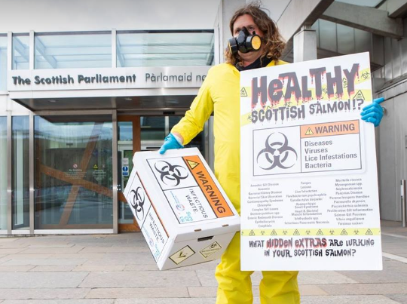

Read more via:
The National: "42,000 sign petition for tougher Scottish salmon farm testing"
Herald: "Salmon farms are turning Scotland's seas into an open sewer, claim campaigners"
SumOfUs: "Campaigners at Scottish Parliament call for wastewater testing at salmon farming operations to save wild fish"
Letter to Scottish Government re. Infectious Diseases in Salmon Farming Effluents
In January 2018, the Global Alliance Against Industrial Aquaculture filed a formal complaint with the European Commission for failure to police the transport of mortalities.

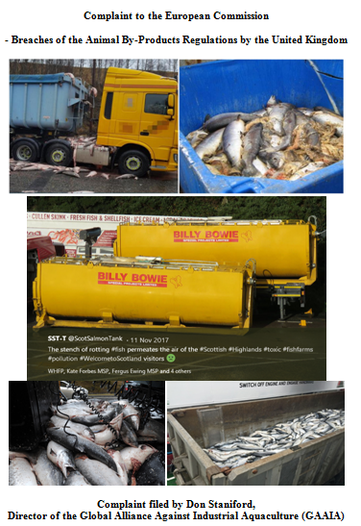

Read more via:
Diseased Salmon Slip Net & Spill on Road - Failure to police the transport of dead fish prompts EC complaint
Scots councils ‘failing to enforce EC laws on leaky salmon trucks’

Contact:

Don Staniford: 07771 541826 (dstaniford@gaaia.org)

Notes to Editors:

[1] Download documents obtained via FOI from Highlands & Islands Enterprise on 31 May 2018 via:
HIE FOI reply 31 May 2018 Ferguson #1 (41 page PDF)
HIE FOI reply 31 May 2018 Ferguson #2 (20 page PDF)
HIE FOI reply 31 May 2018 Covering letter

[2] Note that over 25,000 tonnes of mortalities were officially reported from Scottish salmon farms during 2017 - with higher mortalities reported in the Autumn months. Read data online here - including:

In early March 2018, SEPA made available all the mortality data (by weight) for 2017 via Scotland's Aquaculture database. An Excel spreadsheet of the data for mortalities during 2017 and back to 2002 - including graphs summarising the data - is available online here

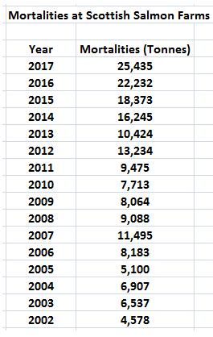

Marine Harvest reported the most mortalities in 2017 followed by the Scottish Salmon Company, Cooke Aquaculture, Scottish Sea Farms, Grieg Seafood and Loch Duart all with over 1,000 tonnes of dead farmed salmon:

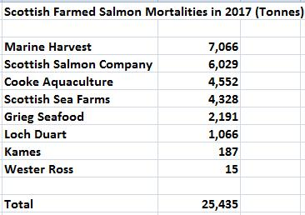

The worst monthly mortalities during 2017 were reported at the following salmon farming sites with Gravir Outer (Scottish Salmon Company) and Poll na Gille (Marine Harvest) featuring twice and most morts appearing in October/November:

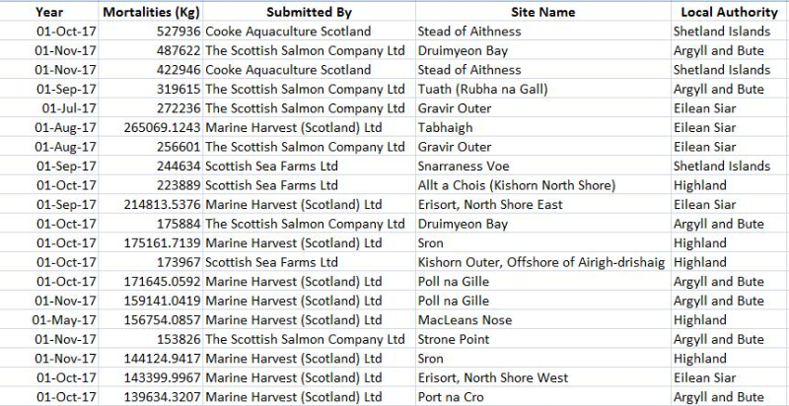

Mortalities spiked in late Summer with higher mortality rates reported during the Autumn months (September, October and November):

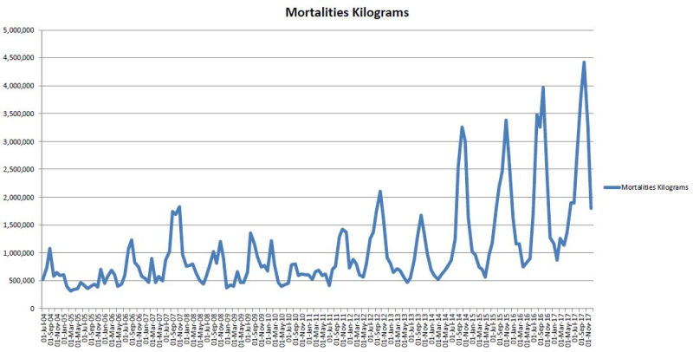

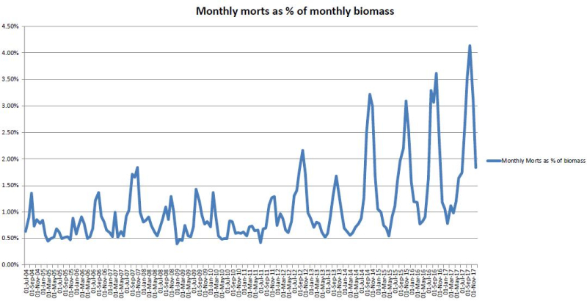

Note that the increase in mortalities cannot be explained simply as a function of an increase in salmon farming production - in fact the ratio of mortalities to salmon farming production is now the worst ever:

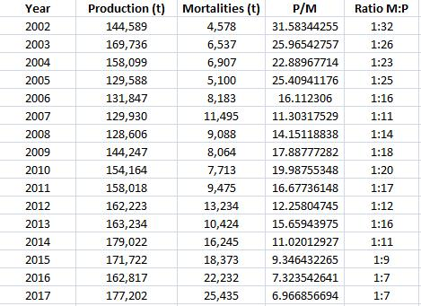

Download Excel spreadsheet in full online here

Online via Disease concern as Scots salmon farmers' produce "stomach-churning" record levels of fish deaths

[3] FOI correspondence between Highlands & Islands Enterprise following Scottish Salmon Watch's FOI request of 6 March 2018:

From: Craig Lawrence [mailto:no-reply@objectiveconnect.com]
Sent: 31 May 2018 10:28
To: salmonfarmingkills@gmail.com
Subject: 005 2019 Don Staniford Appeal Response - Objective Connect Invitation



Objective Connect Invitation



Dear salmonfarmingkills@gmail.com,

Craig Lawrence has invited you to the Workspace 005 2019 Don Staniford Appeal Response using Objective Connect.

Hi Don, Here are your documents I hope you receive them okay, Craig

To accept this invitation please complete the single step registration.


Thank you,
Objective Connect

GETTING STARTED

User Guide | How To Videos | FAQs | Assistance

From: Craig Lawrence [mailto:craig.lawrence@hient.co.uk]
Sent: 31 May 2018 10:14
To: Don Staniford (salmonfarmingkills@gmail.com)
Subject: FOI Review- Don Staniford
Importance: High



Dear Mr Staniford,

Attached is a review outcome letter from our Chief Executive. Please note we have three documents currently available for release which together contain a significant amount of information. I propose that these documents are shared electronically through our Objective Connect, if you are content with this I will send through a further separate e-mail to you providing simple guidelines on how to retrieve the information electronically.

Please let me know if you would prefer this option for the release of the additional information to you, alternatively the information could be posted out to you if you provide me with your full address details.

Kind regards

Craig

Craig Lawrence
Customer Service Improvement Manager

DD: +44 (0)1463 383073 | Mob: +44 (0)7393 006 990 | Reception: +44 (0)1463 245245

Highlands and Islands Enterprise | Iomairt na Gàidhealtachd ’s nan Eilean
An Lòchran, 10 Inverness Campus, Inverness, IV2 5NA

From: Don Staniford [mailto:salmonfarmingkills@gmail.com]
Sent: 04 May 2018 17:34
To: 'customer.service@hient.co.uk'
Cc: 'Craig Lawrence'
Subject: Review of FOI re. 'Integrated Aquaculture Rapid Mortality Recovery System' via Ferguson Transport (6 March 2018)

Please consider this a formal request re.FOI 'Integrated Aquaculture Rapid Mortality Recovery System' via Ferguson Transport dated 6 March 2018.

The FOI request is enclosed below along with the various replies and queries.

In essence, HIE's FOI reply smacks of shoddiness and unprofessionalism.

In specific terms, HIE have failed to provide basic information on the publicly-funded 'Integrated Aquaculture Rapid Mortality Recovery System'.

HIE's holding reply of 27 March asked for more time due to "the volume and complexity of the information requested". Yet when some information was finally disclosed on 2 May there was very little information at all.

When pressed further HIE disclosed some information on 3 May and cited "the press release which was previously issued by the HIE Communications Team to a Senior News Reporter at The Herald/Sunday Herald, once again this would have been run past HIE’s Senior Team before release and details HIE’s funding of the project the information is now in the public domain ".

However, no date was given for the 'press release', no email correspondence was disclosed and no original source material disclosed. Indeed, there is no indication where the information provided in HIE's email of 3 May was sourced from. Surely this information is contained in a project proposal by Ferguson Transport and via discussions and correspondence?

HIE's email of 2 May cited:

Commercial Information.

I have attached further information (above) which whilst relevant to your request is of a non-sensitive nature after due consideration, HIE has decided to withhold further information in full applying Regulation 10(5)(e) - Confidentiality of commercial or industrial information as the disclosure of this information will prejudice the legitimate and significant commercial and economic interests of the operator. Once again some of this information has been withheld under Regulation 11 (2) of the The Environmental Information (Scotland) Regulations 2004 Act where Personal data is exempt from disclosure if disclosure would contravene one or more data protection principles in schedule 1 of the Data protection Act 1998.

Whilst I appreciate that some information could be classed as commercially confidential, a blanket ban is a joke. For example, failing to disclose the original project proposals (please remember that this is public money), final agreed project and other discussions is manifestly unreasonable.

In conclusion, therefore, please review my FOI request of 6 March; namely:

" Please provide information on the 'Integrated Aquaculture Rapid Mortality Recovery System'......Please detail any correspondence on this matter, briefings, reports, emails, letters, budgets, proposals, photos, graphics and any other information relating to the 'Integrated Aquaculture Rapid Mortality Recovery System'."

I look forward to receiving the information requested nearly two months ago.

If you have any questions or require further information please do not hesitate to contact me.

Please acknowledge receipt of this review request.

Best fishes,

Don

Don Staniford

Director, Scottish Salmon Watch: https://scottishsalmonwatch.org/

Director, Global Alliance Against Industrial Aquaculture (GAAIA): http://www.salmonfarmingkills.com

Read my blog via http://donstaniford.typepad.com/my-blog

<((((º>`·.¸¸.·´¯`·.¸.·´¯`·...¸><((((º>¸.
·´¯`·.¸. , . .·´¯`·.. ><((((º>`·.¸¸.·´¯`·.¸.·´¯`·...¸><((((º>

From: Craig Lawrence [mailto:craig.lawrence@hient.co.uk]
Sent: 04 May 2018 09:22
To: Don Staniford
Subject: RE: EIR to HIE

Dear Mr Staniford,

We had provided the additional response below in good faith, your communication of the 2nd May 18 asked for HIE to ‘reconsider your non-reply’? If it is a review of our original response to you that you are looking to take place then please let me know.

Kind regards,

Craig

Craig Lawrence
Customer Service Improvement Manager

DD: +44 (0)1463 383073 | Mob: +44 (0)7393 006 990 | Reception: +44 (0)1463 245245
Highlands and Islands Enterprise | Iomairt na Gàidhealtachd ’s nan Eilean
An Lòchran, 10 Inverness Campus, Inverness, IV2 5NA

From: Don Staniford [mailto:salmonfarmingkills@gmail.com]
Sent: 03 May 2018 17:12
To: Craig Lawrence <craig.lawrence@hient.co.uk>
Subject: RE: EIR to HIE

Craig,

With respect, this was not a "further supplementary request".

My original FOI request of 6 March 2018 (enclosed below) stated:

"Please detail any correspondence on this matter, briefings, reports, emails, letters, budgets, proposals, photos, graphics and any other information relating to the 'Integrated Aquaculture Rapid Mortality Recovery System'."

Please therefore provide the information originally requested.

Best fishes,

Don

Don Staniford

Director, Scottish Salmon Watch: https://scottishsalmonwatch.org/

Director, Global Alliance Against Industrial Aquaculture (GAAIA): http://www.salmonfarmingkills.com

Read my blog via http://donstaniford.typepad.com/my-blog

<((((º>`·.¸¸.·´¯`·.¸.·´¯`·...¸><((((º>¸.
·´¯`·.¸. , . .·´¯`·.. ><((((º>`·.¸¸.·´¯`·.¸.·´¯`·...¸><((((º>

From: Craig Lawrence [mailto:craig.lawrence@hient.co.uk]
Sent: 03 May 2018 16:38
To: Don Staniford
Subject: EIR to HIE

Dear Mr Staniford,

Thank you for your further supplementary request for information on the Integrated Aquaculture Rapid Mortality Recovery System.

I have documented below the press release which was previously issued by the HIE Communications Team to a Senior News Reporter at The Herald/Sunday Herald, once again this would have been run past HIE’s Senior Team before release and details HIE’s funding of the project the information is now in the public domain.

‘In the event of a high-volume mortality a vessel would be mobilised with two modified ISO tanks with top-loading and rear discharge on skeleton road trailers. A specially designed grab would be fitted to the crane and the vessel would sail to the farm. The crane operator will transfer the fish into the tanks, which are then sealed. The vessel will then sail to the nearest concrete ramp/slipway, from where the full tanks are transferred directly to the disposal site.
This system will handle larger volumes of mortalities, more efficiently, and faster. It will:
· Avoid any double handling of affected fish, thereby reducing risks of cross contamination
· Avoid having to deploy fish farm staff to deal with the transfer
· Negate the need for costly plastic bins and subsequent cleaning
· Negate the need for the farm to hire forklift trucks
· Remove the challenges of ferry schedules from clean-up operations at island based farms
· Avoid the logistic challenges of a farm having to assemble all the pieces of equipment from different providers and enable one call and one-off payment for the entire operation
The funding approval is for half the total cost of the project (£362k), made up of the following:
· £25,000 for a modified clam-shell grab attachment with de-waterer (for the lifting crane) to remove the fish
· £105,000 for six modified ISO tanks for transporting the fish
· £50,000 for two lifting skeleton trailers used to transport the tanks to the disposal site
· £162,000 for a side lifting trailer used to transfer the tanks onto the skeleton trailer
· £20,000 for a compressor to operate the air uplift on the fish pen’.
Total 362000
I trust the above information will be of assistance to you. Under the Environmental Information Regulations 2004, you have the right to request a review of the way in which this request has been processed. Should you wish to exercise that right, you will need to contact us within 40 working days of receipt of this email. If you remain dissatisfied on completion of the review, you have the right to appeal to the Office of the Scottish Information Commissioner. – www.itspublicknowledge.info

Craig

Craig Lawrence
Customer Service Improvement Manager

DD: +44 (0)1463 383073 | Mob: +44 (0)7393 006 990 | Reception: +44 (0)1463 245245
Highlands and Islands Enterprise | Iomairt na Gàidhealtachd ’s nan Eilean
An Lòchran, 10 Inverness Campus, Inverness, IV2 5NA

From: Don Staniford [mailto:salmonfarmingkills@gmail.com]
Sent: 02 May 2018 22:59
To: Craig Lawrence <craig.lawrence@hient.co.uk>
Subject: Review request or simple reply to explain why no information?

Craig,

Why is no information on the Integrated Aquaculture Rapid Mortality Recovery System included in your FOI reply?

Perhaps I am missing something but I've not seen anything from HIE detailing what exactly the Integrated Aquaculture Rapid Mortality Recovery System is.

For example, where is a project description of the Integrated Aquaculture Rapid Mortality Recovery System?

My FOI asked for basic information on the Integrated Aquaculture Rapid Mortality Recovery System and it has still not been forthcoming.

Could you please re-consider your non-reply?

Best fishes,

Don

Don Staniford

Director, Scottish Salmon Watch: https://scottishsalmonwatch.org/

Director, Global Alliance Against Industrial Aquaculture (GAAIA): http://www.salmonfarmingkills.com

Read my blog via http://donstaniford.typepad.com/my-blog

<((((º>`·.¸¸.·´¯`·.¸.·´¯`·...¸><((((º>¸.
·´¯`·.¸. , . .·´¯`·.. ><((((º>`·.¸¸.·´¯`·.¸.·´¯`·...¸><((((º>

From: Craig Lawrence [mailto:craig.lawrence@hient.co.uk]
Sent: 02 May 2018 11:05
To: Don Staniford (salmonfarmingkills@gmail.com)
Subject: EIR to HIE

Dear Mr Staniford,

Thank you for your information request received by Highlands and Islands Enterprise (HIE) on the 7th March 2018 and subsequent clarification received on the 17th April 2018.

The relevant information requested is as follows;

‘ All information on the 'Integrated Aquaculture Rapid Mortality Recovery System'. (Including emails, reports, briefings, costings, grant applications, letters etc).

Your request has been considered under the Environmental Information Regulations 2004 (EIR). The information requested is ‘environmental information’ as it meets the definition set out in regulation 2(1)(c) of the EIR. This covers “measures (including administrative measures), such as policies, legislation, plans, programmes, environmental agreements, and activities affecting or likely to affect the elements and factors referred to in [2(1)](a) and (b)” including water, soil, land and landscape “as well as measures or activities designed to protect those elements”.

Internal Communications.

After careful consideration, we are able to release some of the information falling under your request in the form of emails and attachments to those e-mails, though these fall under the Regulation 10 (4) (e) regarding internal communications we have concluded that the public interest falls in favour of disclosure. Please note with regard to this e-mail correspondence some information has been withheld under Regulation 11 (2) of the The Environmental Information (Scotland) Regulations 2004 Act where Personal data is exempt from disclosure if disclosure would contravene one or more data protection principles in schedule 1 of the Data protection Act 1998.

HIE has however withheld wider internal information under Regulation 10(4)(e): Internal communications as this covers all internal correspondence of a ‘sensitive nature’, such as internal communications around HIE’s Appraisal process, it was felt that in this instance it was in the Public Interest not to release this information as it would adversely affect HIE’s policy-making process and ability to make decisions both now and in the future.

Commercial Information.

I have attached further information (above) which whilst relevant to your request is of a non-sensitive nature after due consideration, HIE has decided to withhold further information in full applying Regulation 10(5)(e) - Confidentiality of commercial or industrial information as the disclosure of this information will prejudice the legitimate and significant commercial and economic interests of the operator. Once again some of this information has been withheld under Regulation 11 (2) of the The Environmental Information (Scotland) Regulations 2004 Act where Personal data is exempt from disclosure if disclosure would contravene one or more data protection principles in schedule 1 of the Data protection Act 1998.

I trust the above information will be of assistance to you. Under the Environmental Information Regulations 2004, you have the right to request a review of the way in which this request has been processed. Should you wish to exercise that right, you will need to contact us within 40 working days of receipt of this email. If you remain dissatisfied on completion of the review, you have the right to appeal to the Office of the Scottish Information Commissioner. – www.itspublicknowledge.info

Kind regards,

Craig

Craig Lawrence
Customer Service Improvement Manager

DD: +44 (0)1463 383073 | Mob: +44 (0)7393 006 990 | Reception: +44 (0)1463 245245
Highlands and Islands Enterprise | Iomairt na Gàidhealtachd ’s nan Eilean
An Lòchran, 10 Inverness Campus, Inverness, IV2 5NA

From: Craig Lawrence
Sent: 27 March 2018 14:21
To: Don Staniford (salmonfarmingkills@gmail.com) <salmonfarmingkills@gmail.com>
Subject: EIR to HIE

Dear Mr Staniford,

Having looked again at your request Highlands and Islands Enterprise (HIE) will now look at processing your request in accordance with The Environmental Information (Scotland) Regulations Act 2004, as with FOISA legislation we will aim to respond as quickly as possible.

Please note however that in this case as the volume and complexity of the information requested makes it impractical to provide it within the original period previously stipulated it is now our intention as stated under EIR legislation to extend the response period from 20 to 40 working days

Should you have any queries in the meantime, please do not hesitate to get in touch - my details are below

Kind regards,

Craig

Craig Lawrence
Customer Service Improvement Manager

DD: +44 (0)300 013 4839 | Mob: +44 (0)7393 006 990 | Reception: +44 (0)1463 245245
Highlands and Islands Enterprise | Iomairt na Gàidhealtachd ’s nan Eilean
An Lòchran, 10 Inverness Campus, Inverness, IV2 5NA

From: Craig Lawrence
Sent: 07 March 2018 11:14
To: 'Don Staniford' <salmonfarmingkills@gmail.com>
Subject: FOI to HIE

Dear Mr Staniford,

Thank you for your email below received on the 6th March 2018 this will now be processed in accordance with the Freedom of Information (Scotland) Act 2002. We will aim to respond as quickly as possible but in any event within 20 working days from the date the enquiry was received this is subject to any clarification which may be requested by HIE.

Should you have any queries in the meantime, please do not hesitate to get in touch - my details are below.

Kind regards,

Craig

Craig Lawrence
Customer Service Improvement Manager

DD: +44 (0)300 013 4839 | Mob: +44 (0)7393 006 990 | Reception: +44 (0)1463 245245
Highlands and Islands Enterprise | Iomairt na Gàidhealtachd ’s nan Eilean
An Lòchran, 10 Inverness Campus, Inverness, IV2 5NA

From: Don Staniford [mailto:salmonfarmingkills@gmail.com]
Sent: 06 March 2018 16:23
To: Team - Customer Service <customer.service@hient.co.uk>
Subject: FOI re. 'Integrated Aquaculture Rapid Mortality Recovery System' via Ferguson Transport

Please provide information on the 'Integrated Aquaculture Rapid Mortality Recovery System'.

As context, HIE "approvals" to October to December 2017 included £362,000 for an 'Integrated Aquaculture Rapid Mortality Recovery System':

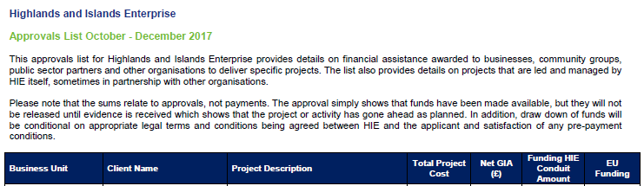

Online via: [PDF] December 2017 - Highlands and Islands Enterprise
www.hie.co.uk/common/handlers/download-document.ashx?id=0b021574-53c8...

Please detail any correspondence on this matter, briefings, reports, emails, letters, budgets, proposals, photos, graphics and any other information relating to the 'Integrated Aquaculture Rapid Mortality Recovery System'.

Please consider this a request for information under the relevant Freedom of Information and Environmental Information Regulations including both the Freedom of Information (Scotland) Act 2002 and the Environmental Information (Scotland) Regulations 2004 (as well as any other new or other regulations which may be appropriate).

Please provide this information electronically via email.

Please acknowledge receipt of this FOI request.

Many thanks and I look forward to a response shortly.

Best fishes,

Don

Don Staniford

Director, Scottish Salmon Watch: https://scottishsalmonwatch.org/

Director, Global Alliance Against Industrial Aquaculture (GAAIA): http://www.salmonfarmingkills.com

Read my blog via http://donstaniford.typepad.com/my-blog

