Roseanna Cunningham
Cabinet Secretary for the Environment, Climate Change and Land Reform
The Scottish Government
St. Andrew's House
Regent Road
Edinburgh
EH1 3DG
scottish.ministers@gov.scot
26 January 2018

Dear Cabinet Secretary,

Violation of 'A Code of Practice to avoid and minimise the impact of Infectious Salmon Anaemia' by Cooke Aquaculture Scotland

In view of this week's revelations (following the publication of FOI documents obtained from SEPA) that Cooke Aquaculture has been guilty of causing "gross" pollution due to "untreated overflow from blood water tanks" and "raw effluent" being discharged from their processing plant into Mid Yell Voe, could you please launch an investigation?

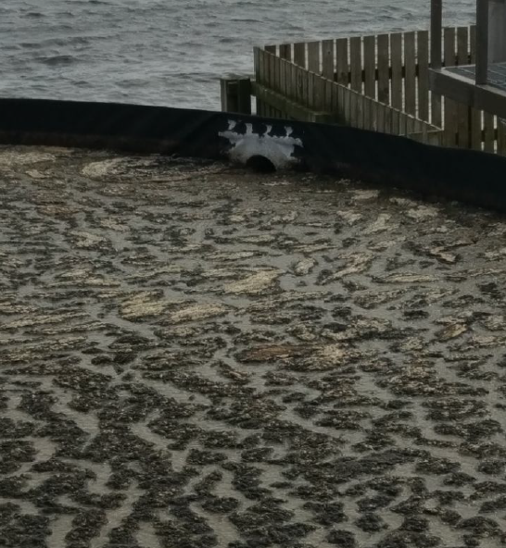

Photo: Overflowing blood water and "raw effluent" from Cooke's processing plant into Mid Yell Voe (download high res image online here)
The damning disclosure comes in the wake of a shocking video of blood water being discharged from a salmon farming processing plant in Canada which prompted an investigation by the BC Government. CTV News also reported in November 2017 that "The federal government has launched a review after tests showed a contagious fish virus in blood spewing into a B.C. waterway from a fish processing plant".

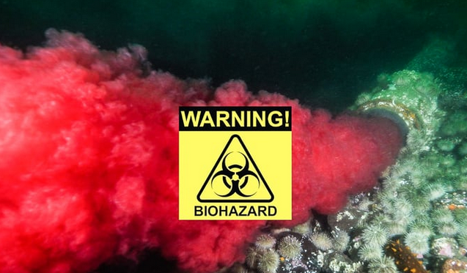

In particular, GAAIA maintains that Cooke Aquaculture, as a member of the Scottish Salmon Producers Organisation, is guilty of breaching the 'Code of Good Practice for Scottish Finfish Aquaculture' and 'A Code of Practice to avoid and minimise the impact of Infectious Salmon Anaemia'. You can read more via a letter to the SSPO (25 January 2018).

Cooke's processing plant discharging "untreated overflow from blood water tanks" and "raw effluent" in Mid Yell Voe is clearly not compliant with the 'Code of Good Practice for Scottish Finfish Aquaculture' (2015) - which includes in Chapter 6: Processing Sites:

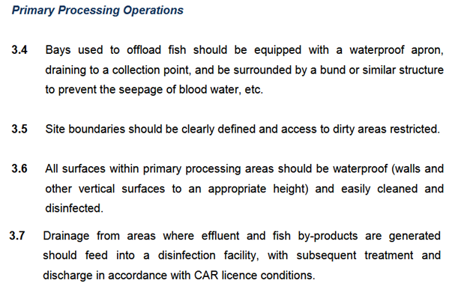

'A Code of Practice to avoid and minimise the impact of Infectious Salmon Anaemia' includes:

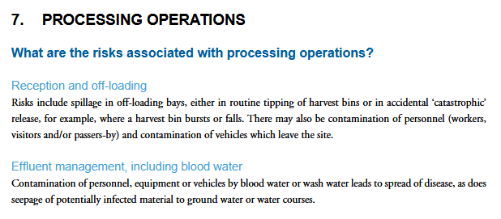

According to guidance from the Scottish Government on ISA: "Untreated effluent from processing plants has also been identified as being a particular risk":

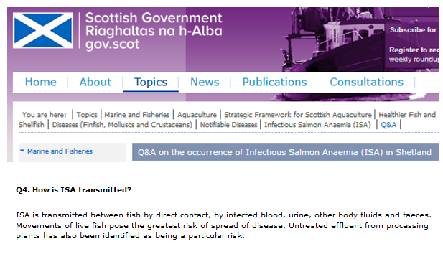

"The virus can be transmitted through water, but the highest risk factors for spread of disease are movement of live fish, discharge of untreated blood and contact with infected vehicles and equipment," states another Scottish Government fact-sheet.

According to Scottish Government advice on 'Biosecurity & Disinfection': "Following the outbreak of infectious salmon anaemia (ISA) in May 1998, the former Fisheries Research Services (FRS) Fish Health Inspectorate (FHI) (now Marine Scotland Science FHI) produced a disinfection guide, outlining strategies to minimise and prevent the spread of the virus, thereby reducing the spread of disease. In June 2006, version IV was produced and this guide should be regarded as best practice at fish farm sites and processing plants".

The 'Disinfection Guide Version IV: Practical Steps to Prevent the Introduction and Minimise Transmission of Diseases of Fish' (2006) states:

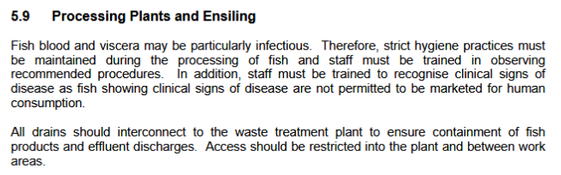
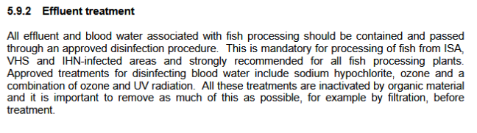
"Another important factor was the disinfection of processing plant effluent and the disinfection and sealing of well boats (CoGPWG 2006)," stated a report - 'Report into the epidemiology and control of and outbreak of infectious salmon anaemia in the Shetland Isles, Scotland' - published by Marine Scotland Science in 2010 following the outbreak of ISA in Shetland. "All waste from processing plants was disposed of by approved methods".

Discharging untreated blood water and raw effluent is clearly a recipe for disaster, constitutes a significant disease risk and represents a gross breach of the industry's code of practice as well as 'A Code of Practice to avoid and minimise the impact of Infectious Salmon Anaemia'. Lest it be forgotten that the spread of Infectious Salmon Anaemia cost Shetland salmon farmers ca. £1 million in 2008 and cost Scottish salmon farmers £30 million in 1998-9.

Hence GAAIA calls on the Scottish Government to investigate this issue including testing of Cooke Aquaculture's blood water effluent for infectious diseases and viruses.

The Scottish Government may also be interested in following up the 2014 report: "Scottish Sanitary Survey Review: Mid Yell Voe" which included:

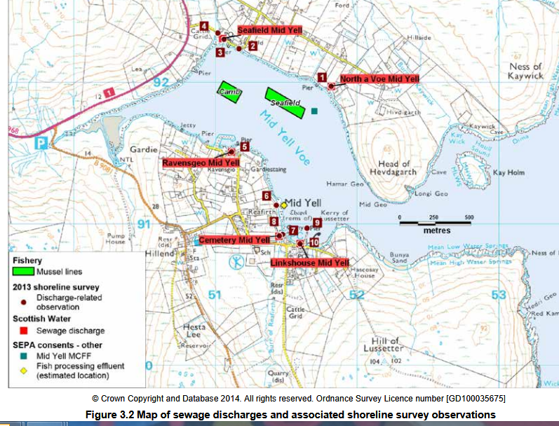

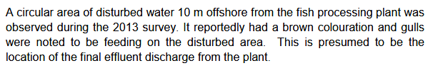

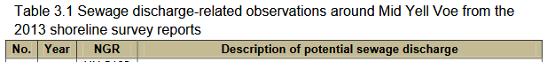
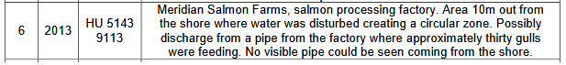

[Please note that Cooke Aquaculture bought Meridian in 2014]

Perhaps a new report could scrutinise the untreated sewage and "raw effluent" discharged from Cooke Aquaculture's "gross" salmon farming processing plant?

For ease of reference, the FOI documents obtained from SEPA are online via:

Environmental Event report re. "raw effluent" and overflowing "blood water" at Cooke's Mid Yell processing plant - January 2017
Photo: Overflowing blood water and "raw effluent" from Cooke's processing plant into Mid Yell Voe
"Poor" SEPA Assessment for "gross" breach at Cooke's Mid Yell processing plant - August 2017
SEPA action points to Cooke "to prevent the overflow discharging untreated effluent directly to Mid Yell Voe" - August 2017

You can also read more details via:

Undercurrent News: "Cooke Scotland plant found to have leaked blood water"
Shetland Times: "Salmon company reacts over 'blood water' issue"
Press Release: "Cooke's Untreated Blood Water is 'Gross' says SEPA"
BBC Radio Shetland on Cooke's "untreated blood water" in Scotland
BBC News: "Shetland salmon packing factory leaks 'blood water' into sea"

Yours sincerely,

Don Staniford

Director, The Global Alliance Against Industrial Aquaculture

Cc:

Terry A'Hearn: terry.ahearn@sepa.org.uk
Joyce Carr: Joyce.Carr@scotland.gsi.gov.uk
Tavish Scott: tavish.scott.msp@parliament.scot
Alistair Carmichael: carmichaela@parliament.uk
Mark Ruskell: mark.ruskell.msp@parliament.scot

