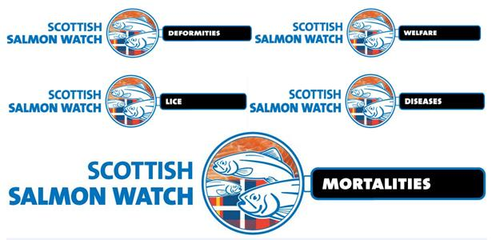
Cross-Party Group on Animal Welfare
Scottish Parliament
Holyrood Road
Edinburgh
EH99 SP
28 May 2018

Deaths, Deformities and Welfare Abuse at Scottish Salmon Farms During 2017
- Breach of the Animal Health & Welfare (Scotland) Act 2006?

Further to Scottish Salmon Watch's letter of 17 May 2018 regarding deaths at salmon farms due to the Thermolicer please be aware of damning data published on 27 April 2018 by the Scottish Government on deformities and welfare abuses on Scottish salmon farms.

The Fish Health Inspectorate's 'Case Information' (October - December 2017) details the latest enhanced inspections conducted under the Aquaculture and Fisheries (Scotland) Act 2007 - including reports of farmed salmon with deformed spines and hearts, cataracts, anorexia, lesions, necrotic gills, shortened jaws, damaged eyes, gillpox, evidence of erthrophagocytosis in the spleen, lamellar bleeding of the gills, multifocal hepatic necrosis, heart disease, haemorrhaging at the base of the pelvic fins and sea lice damage to the heads. Farmed salmon were reported "dead on the surface of the water" and with "sea lice grazing damage to heads". One lice-infested farmed salmon was reported "belly up as if concussed from banging".

For example, a Fish Health Inspection visit report from October 2017 for The Scottish Salmon Company's salmon farm at Vuia Beag in Loch Roag detailed a farmed salmon with a "deformed spine":

A "strong presence" of moribund, anorexic and lethargic farmed salmon in addition to lesions on the flank and a "medium presence" of necrotic gills was also reported:

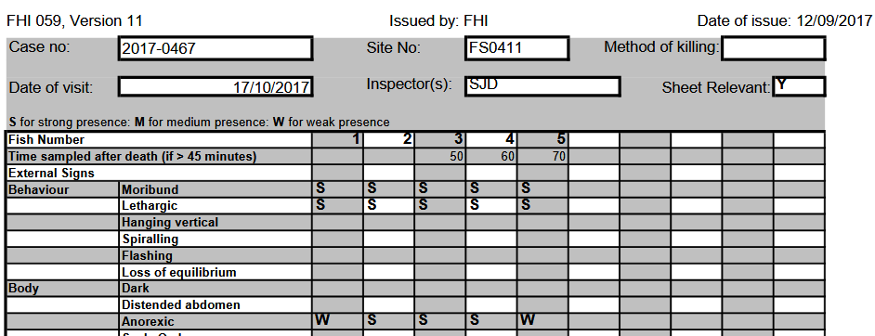

A FHI visit report from October 2017 for The Scottish Salmon Company's salmon farm at Vuia Mor in Loch Roag detailed a total mortality since input of 30.23% with 32,487 morts. Recent disease issues cited were PGD, AGD, Para Ther, Sal Gill pox, PD, HSMI, microsporidia and epitheliocystis.

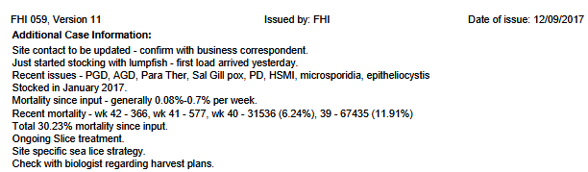

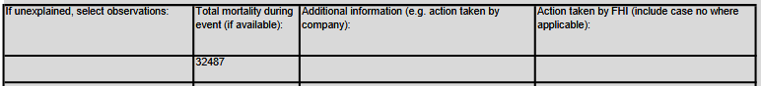

A FHI visit report from October 2017 for Marine Harvest's salmon farm at North Shore in Loch Erisort detailed a "presumptive Pasteurella skyensis diagnosis" and "pathology consistent with previous Pasteurella infections" as well as "some cadiomyopathy", Pancreas Disease, AGD (Amoebic Gill Disease), Salmon gill pox and ParaTher (Paranucleospora theridon):

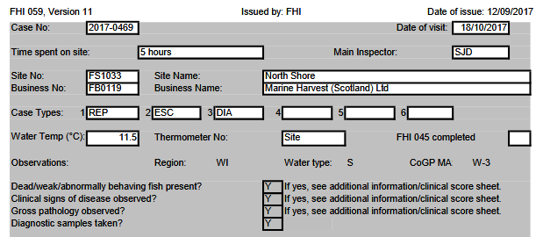

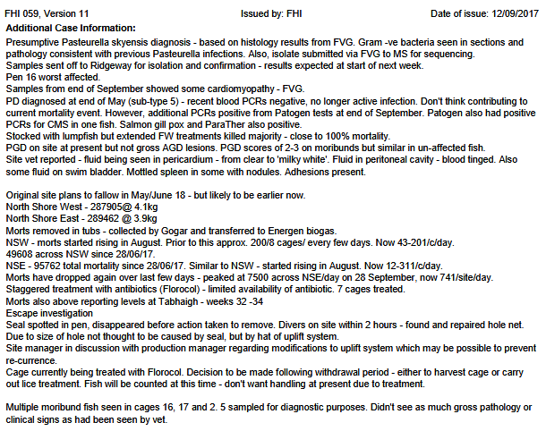

Deformities such as a "shortened upper jaw" and "eyes damaged" were also reported:

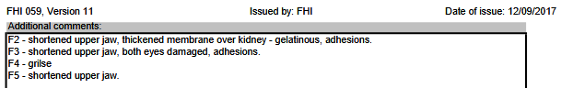

A FHI visit report from October 2017 for a salmon farm in Loch Kishorn (Kishorn A) operated by Scottish Sea Farms detailed disease problems including AGD, sea lice damage to the heads of farmed salmon, Paranucleospora theridon, salmon gillpox, Branchiomonas, lamellar bleeding of the gills, CMS and HSMI like pathology:

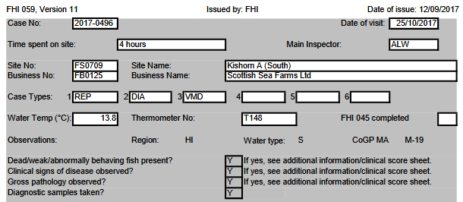

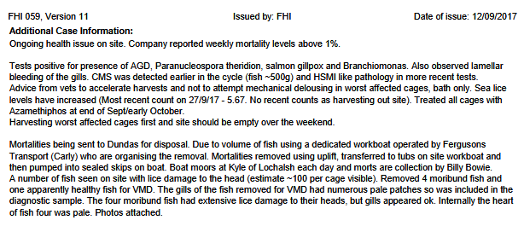
The FHI visit report from October 2017 for another salmon farm in Loch Kishorn (Kishorn B) operated by Scottish Sea Farms detailed similar disease problems including AGD, Paranucleospora theridon, salmon gillpox and Branchiomonas, lamellar bleeding of the gills and sea lice damage to the heads of farmed salmon.

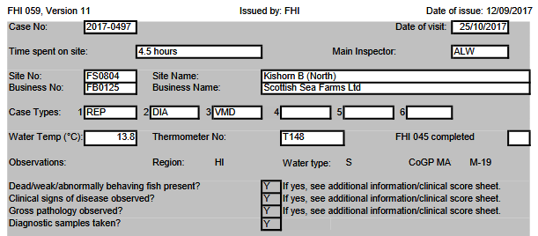

The FHI visit report (October 2017) for the Kishorn B (North) salmon farm operated by Scottish Sea Farms in Loch Kishorn stated: "Harvesting worst affected cages first and site should be empty in next six weeks".

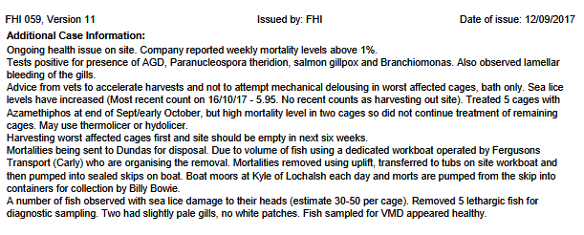

A FHI Fish Visit report dated November 2017 detailed disease problems at Cooke Aquaculture's salmon farm in the Stead of Aithness (Aith Voe) in Shetland.

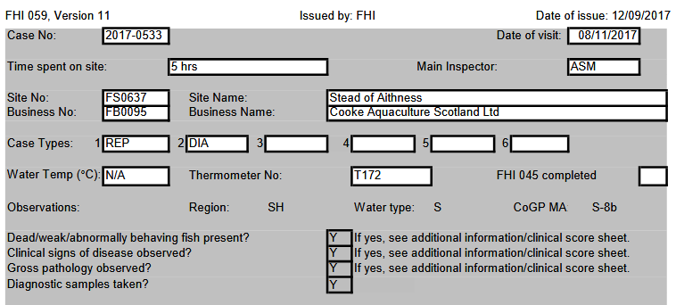

"Harvest has been accelerated by 1 months (sic) due to increased morts," detailed FHI Fish Visit report dated November 2017. "Top sweep is being harvest first (sic) from the worst affected cages."

"During the inspection of the stock on site there were many fish high in the water column," continued the FHI Fish Visit report dated November 2017. "Many fish were moribund and about 20-30 fish over the site were observed dead on the surface of the water."

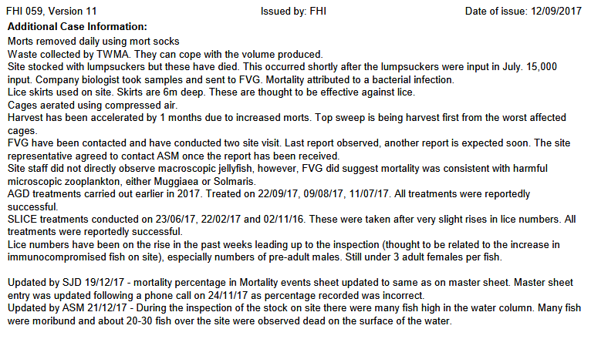

The mortality rate was reported as 11.52%.

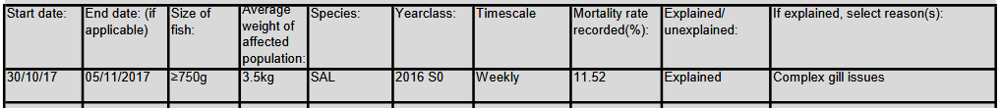

With total mortality of 58,590 farmed salmon.

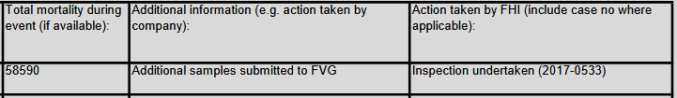

Marine Scotland Science detailed in their FHI Visit Report for November 2017 "pathology consistent with amoebic gill disease, presence of epitheliocystis and some features resembling salmon poxvirus" as well as mild hepatic necrosis and minor cardiomyopathy.

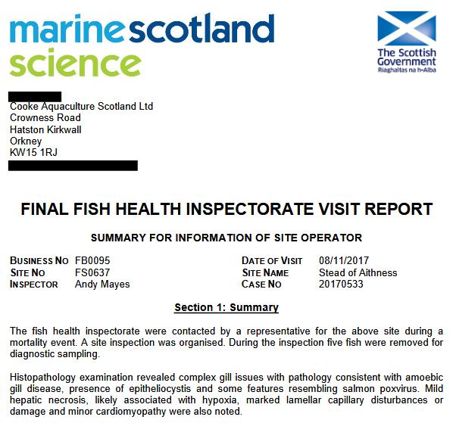

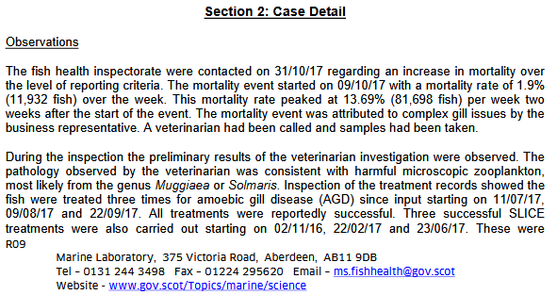

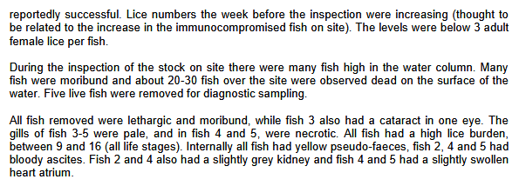

A FHI Fish Visit report dated November 2017 detailed disease problems at another Cooke Aquaculture salmon farm at East of Holm Heogland in Shetland - including "variable complex gill disease including PGD and lowlevel AGD"; "Low level HSMI type pathology" as well as Costia and branchiomonas.

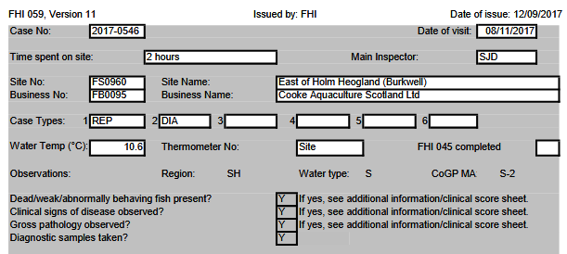
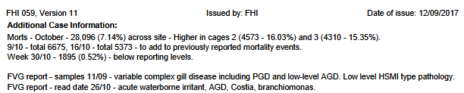

The FHI Fish Visit report dated November 2017 noted a pale/anaemic spleen and stated that the "heart lost shape when removed".

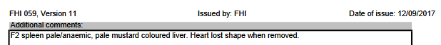

The FHI Fish Visit report dated November 2017 noted positive tests for Salmon gill poxvirus (SGPV), Piscine myocarditis virus (PMCV), Neoparamoeba perurans (AGD) and Paranucleospora theridon:

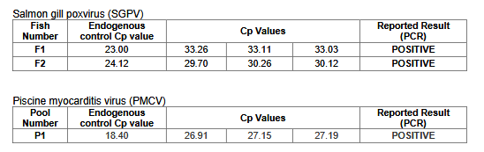
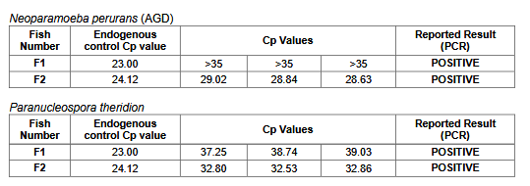

A FHI Fish Visit report for November 2017 detailed disease problems at another Cooke Aquaculture salmon farm at Winna Ness in Shetland - with over 30% mortality and "acute gill pathology".

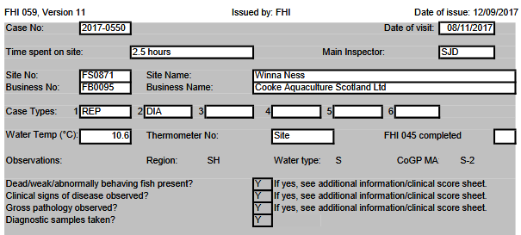
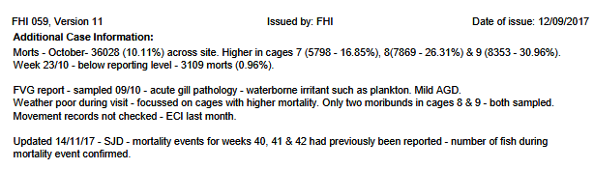

The FHI Fish Visit report for November 2017 detailed "complex gill issues", "pathology consistent with cardiomyopathy syndrome (CMS) and mild amoebic gill disease", "multifocal hepatic necrosis (likely associated with hypoxia)" and positive tests for Paranucleospora theridon (syn. Desmozoon lepeophtheri) and salmon gill poxvirus (SGPV).

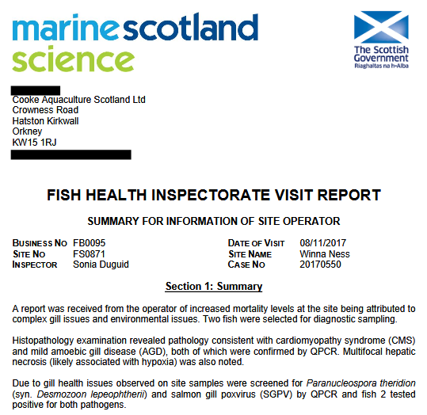
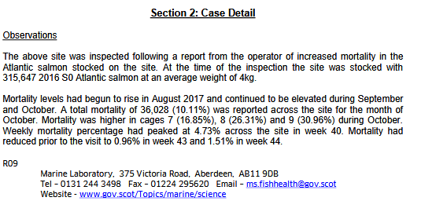

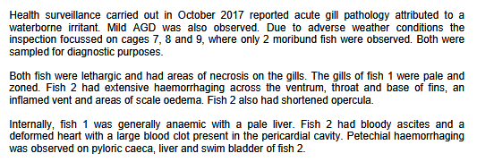

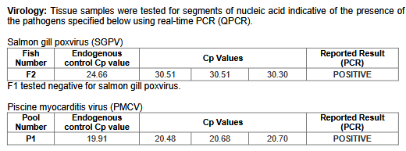

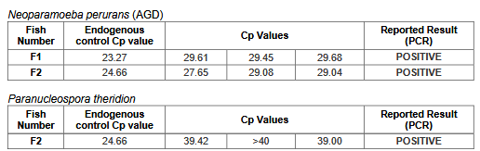

A FHI Fish Visit report dated November 2017 detailed disease problems at the Scottish Salmon Company's salmon farm at Portree on the Isle of Skye - including "complex gill issues", "anorexic and moribund fish", AGD, poxvirus and Desmozooan.

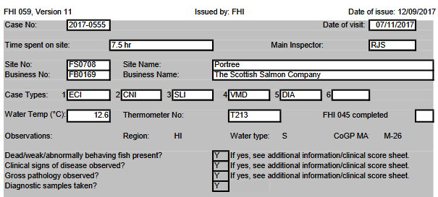

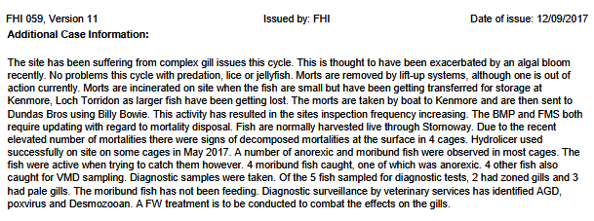

A FHI Fish Visit report dated November 2017 detailed disease problems at Marine Harvest's salmon farm in Loch Greshornish on the Isle of Skye - including 20-30 Caligus (sea lice) with farmed salmon reported as "belly up as if concussed from banging":

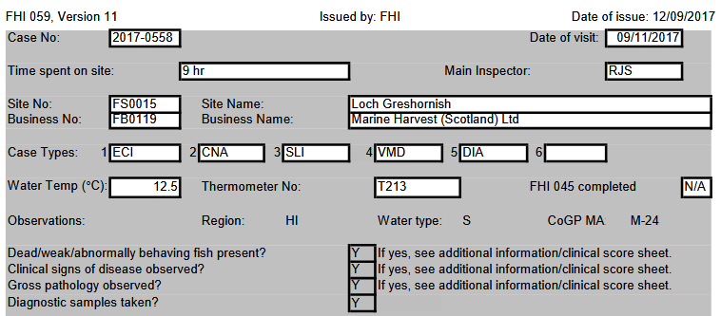
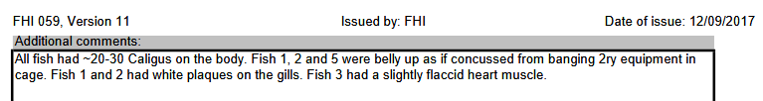

Marine Scotland Science's FHI Visit Report for November 2017 detailed "moribund and lethargic fish", "mild proliferative gill pathology with features consistent with amoebic gill disease (AGD), epitheliocystis, "anorexic poor-doing indivuduals" and positive tests for Neoparamoeba perurans, Paranucleospora theriodon (syn. Desmozoon lepeophtheri) and salmon gill poxvirus.
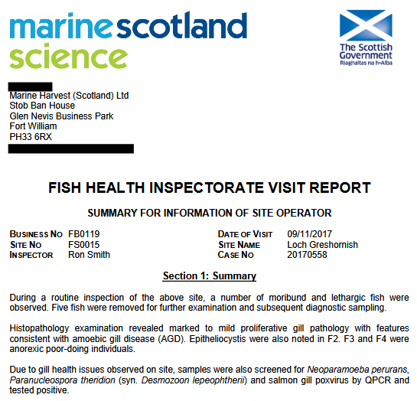
The report identified farmed salmon with cataracts and anorexia.

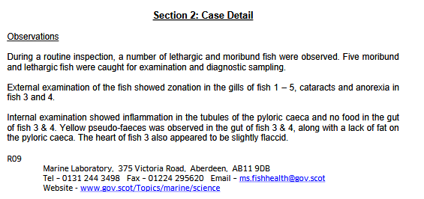

A FHI Fish Visit report dated November 2017 detailed disease problems at The Scottish Salmon Company's salmon farm at Strome Point in Loch Fyne - including AGD, gill issues and "large mortality" and "bacterial infection with V. anguillarum":

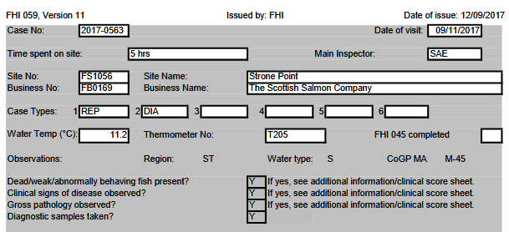

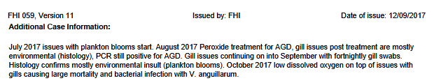

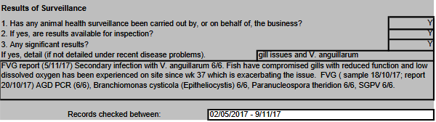

In terms of mortalities, The Scottish Salmon Company reported for Strome Point in Loch Fyne that "mortalities start to increase in the beginning of October" with 20-70 morts per day per cage and 3,000 - 6,000 per day per site:

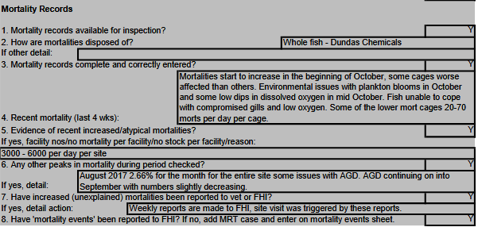

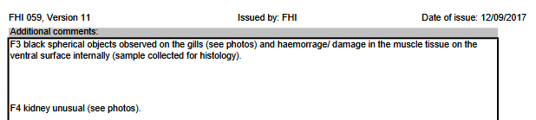

A FHI Fish Visit report dated November 2017 detailed disease problems at Marine Harvest's salmon farm at Poll Na Gille in the Sound of Jura - including "complex gill issues", anaemia, "severe PGD pathology and extensive haemorrhaging":

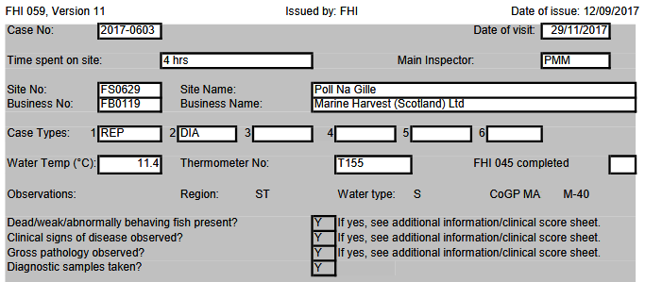

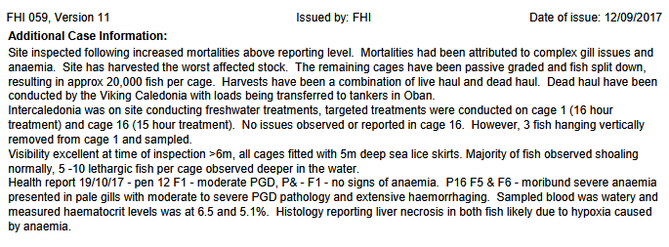

The mortality records stated that Marine Harvest had "harvested worse cages, reducing biomass":

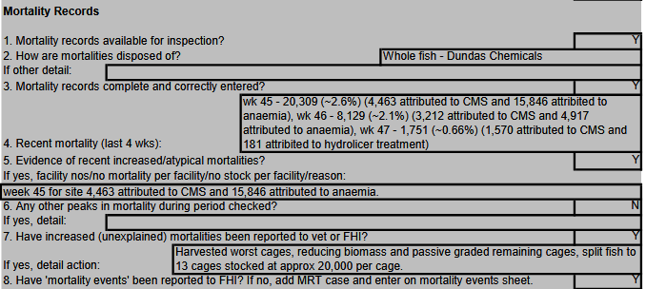

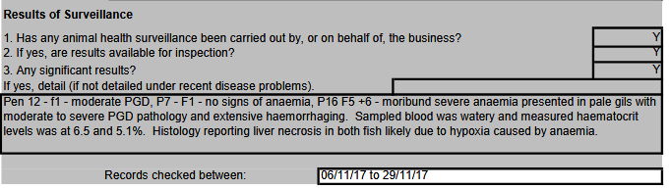

The FHI Fish Visit report for November 2017 detailed "complex gill issues and anaemia", "mild cardiomyopathy with features resembling cardiomyopathy syndrome (CMS) and the presence of the causative agent, piscine myocarditis virus (PMCV)" and reported a positive test for Paranucleospora theridon (syn. Desmozoon lepeophtheri). Over 60,000 mortalities were reported in a four-week period (Week 33 to 36).

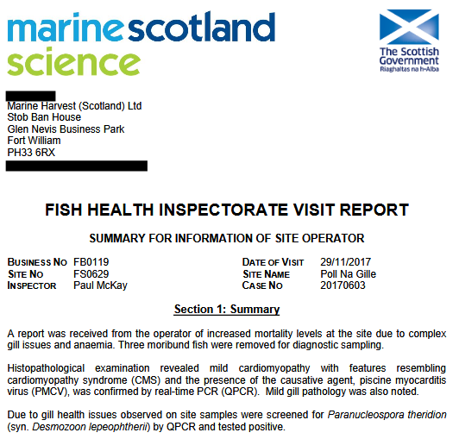

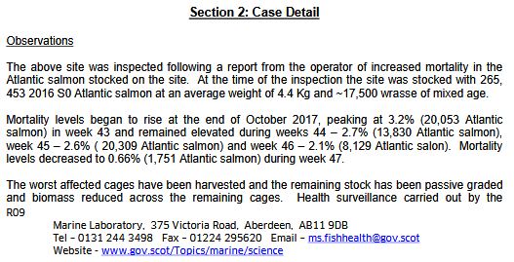

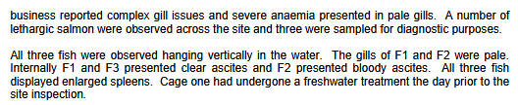
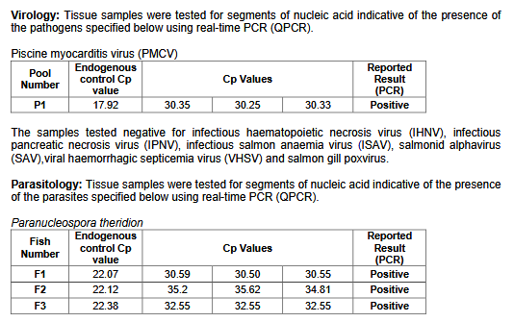

The FHI Fish Visit report signed off by stating that histopathological examination had found "some evidence of erthrophagocytosis" in the spleen, "mild diffuse hepatocyte vacuolation" in the liver, "mild pericarditis" in the heart and "lamellar congestion" in the gills.
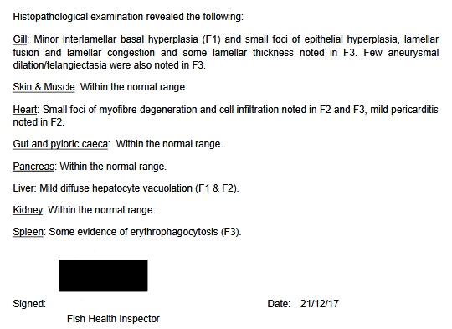

A FHI Fish Visit report for December 2017 detailed disease problems at The Scottish Salmon Company's salmon farm at Druimyeon Bay in the Sound of Gigha - including PGD, CMS and "sea lice grazing damage to heads".

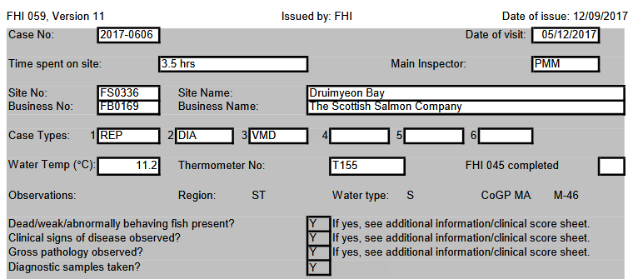

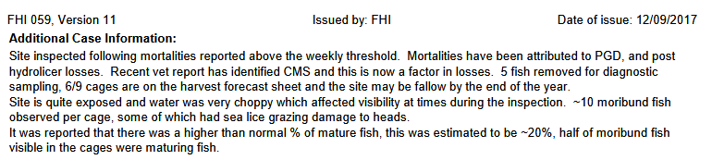
All five farmed salmon tested had a "strong presence" for moribund and lethargic behaviour.

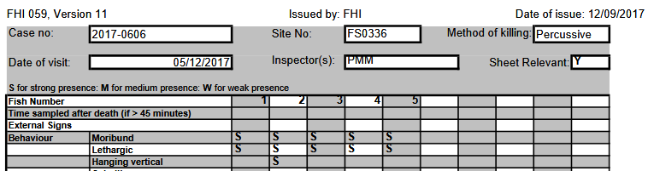

The FHI Fish Visit report for December 2017 reports all the usual suspects with over 30,000 mortalities in Week 43 citing problems such as PGD, CMS, AGD and PMCV.

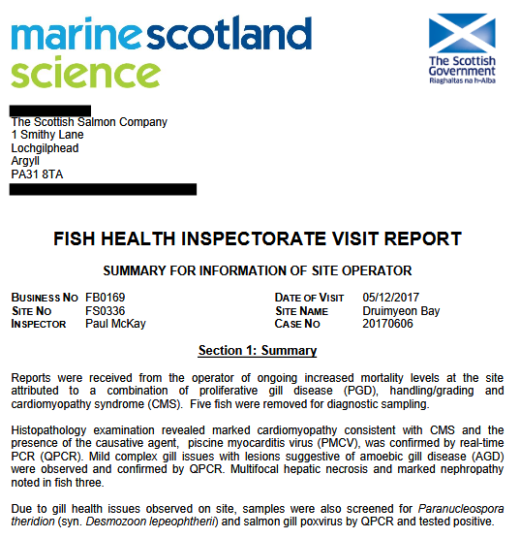
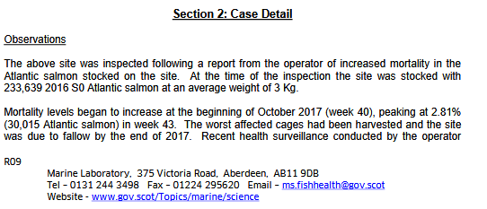

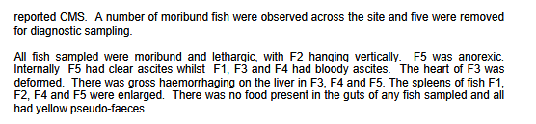

Case Information published by the Scottish Government's Fish Health Inspectorate for July to September 2017 includes a FHI visit report for Loch Duart's salmon farm in Badcall Bay.

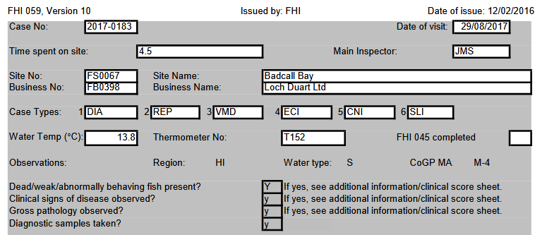

The report details AGD lesions as well as "significant gill pathology (AGD, Branchiomonas, Desmazoon, SGPV), widespread inflammation and vascular damage". "Piscirickettsia suspected but not identified though staining (sic)" stated the report. Mortality rates for some of the worst cages were over 30%.

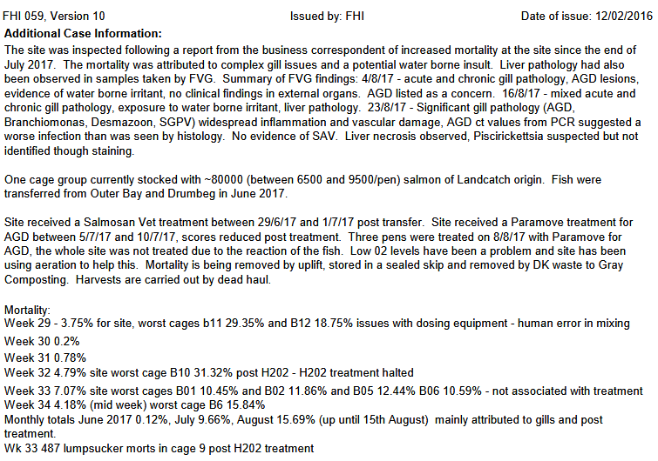
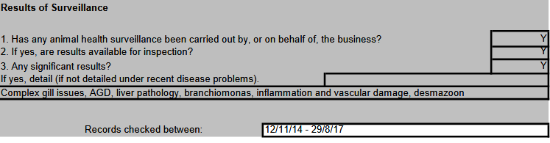

The FHI visit report also described "no membrane between heart and liver" and "haemorrhaging at the base of the pelvic fins" in sampled farmed salmon.

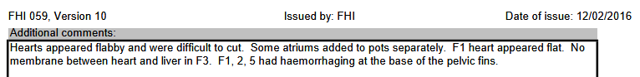

The FHI visit report for August 2017 detailed "severe complex gill issues with chronic and acute pathology", epitheliocystis, Candidatus Branchiomonas cysticola, Candidatus Syngnamydia salmonis, vascular damage, mild hepatic necrosis, Salmon gill poxvirus and Paranucleospora theridon.

A FHI visit report for August 2017 for The Scottish Salmon Company's salmon farm at Inch Kenneth in Loch na Keal on the Isle of Mull detailed "very skinny" fish including one "deformed with a bent spine" and three out of the five farmed salmon sampled had "deformed hearts".

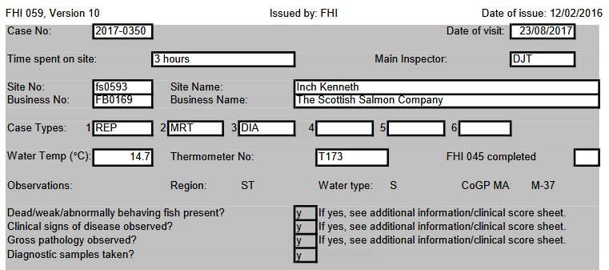

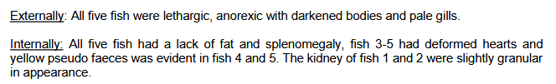

Disease problems included AGD, PD, Branchiomonas and microspoidean.

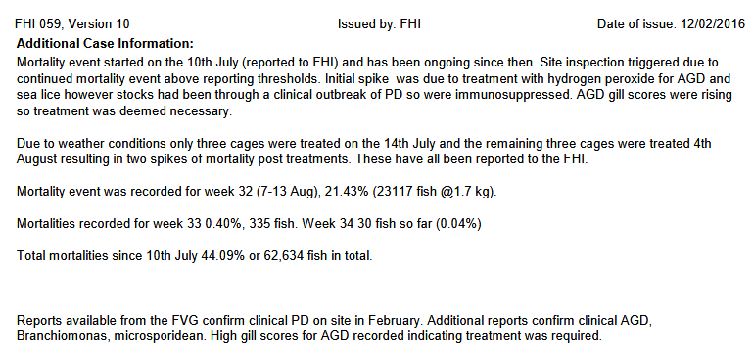

You can access all the data and FHI visit reports cited above via:
Hard Evidence: Fast-Tracking Disease-Ridden Scottish Salmon
EXPOSED: Early Harvesting at Scottish Salmon Farms Due to Disease & Mortalities
Scottish Salmon Watch is pleased that 'Farmed Fish' is on the agenda of your meeting on 5 June 2018. As background for that discussion you may also wish to read our written submission - 'Hard Evidence: Dossier of Data on Lice, Diseases & Mortalities at Scottish Salmon Farms' - to the Scottish Parliament's salmon farming inquiry.

The deaths, deformities, diseases and flagrant abuse of animal welfare on Scottish salmon farms raise the question whether a prosecution could be made via the Animal Health and Welfare (Scotland) Act 2006. Looking at the legislation is seems clear that given the suffering on Scottish salmon farms and mass mortalities that a strong case against 'Unnecessary Suffering' and 'Cruel Operations' could be made.

Even the most pro-salmon farming proponent would struggle to argue that cramming farmed salmon into disease-ridden cages is 'normal behaviour' or that farmed salmon's "need to be protected from suffering, injury and disease" is currently being met on Scotland's virus-laden and lice-infested salmon farms.

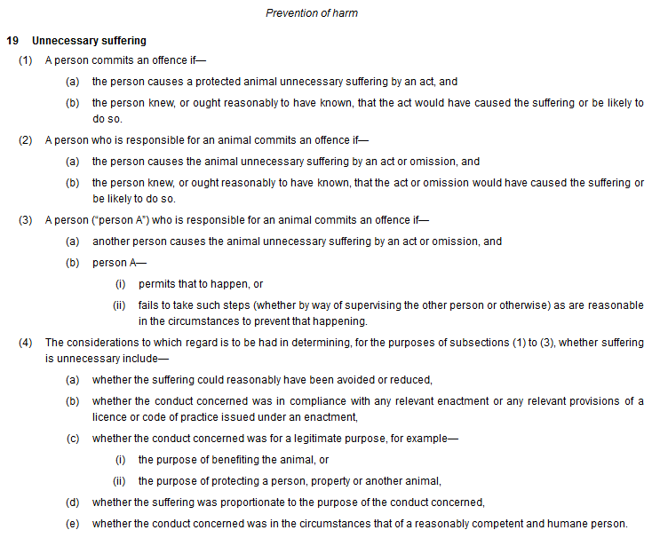
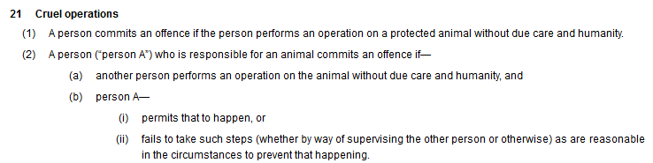

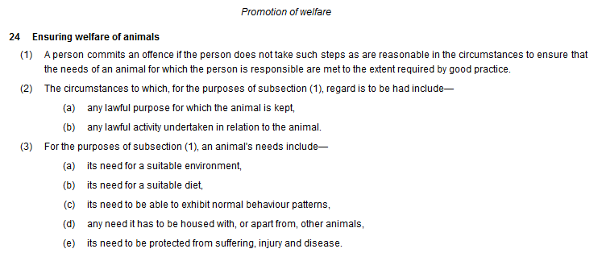

In conclusion, Scottish Salmon Watch encourages the Cross-Party Group on Animal Welfare to investigate the issue of welfare abuses on Scottish salmon (in particular the operation of the Thermolicer). You can find out more about the welfare nightmare on salmon farms online here and read today's disclosure via:

EXPOSED: Early Harvesting at Scottish Salmon Farms Due to Disease & Mortalities
Hard Evidence: Fast-Tracking Disease-Ridden Scottish Salmon

If you have any questions please do not hesitate to contact me.

Yours sincerely,

Don Staniford

Director, Scottish Salmon Watch



