Fergus Ewing
Cabinet Secretary for the Rural Economy and Connectivity
The Scottish Government
St. Andrew's House
Regent Road
Edinburgh
EH1 3DG
scottish.ministers@gov.scot
28 January 2018
Dear Cabinet Secretary,

EC Complaint re. Breaches of the Animal By-Products Regulations by the UK
- Failure to police the transport of diseased morts from salmon farms

Further to previous correspondence on the issue of the transportation of diseased farmed salmon morts and the leaking of fluid wastes from haulage trucks (read letter dated 17 January 2018; letter dated 15 January 2018; letter dated 10 January 2018 and letter from Mark Ruskell MSP dated 13 December 2017), please note that the Global Alliance Against Industrial Aquaculture (GAAIA) today filed a complaint to the European Commission regarding a breach of the Animal By-Products Regulations 2013 (ABPR) by the United Kingdom.

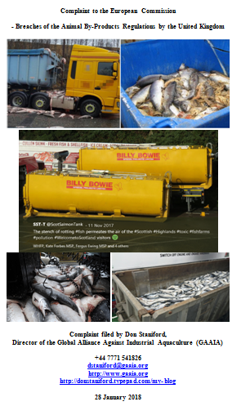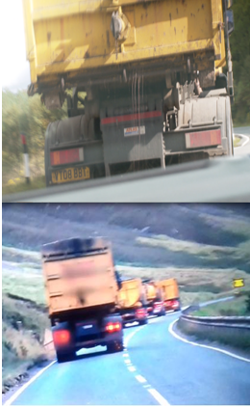

Read more via:
Sunday Times: "Scots councils ‘failing to enforce EC laws on leaky salmon trucks’"
Press Release: "Diseased Salmon Slip Net & Spill on Road - Failure to police the transport of dead fish prompts EC complaint"
GAAIA appreciates the fact that local authorities are the competent authority charged with policing the transportation of diseased morts from salmon farms and enforcing the regulations.

"APHA do not inspect or monitor the transport of salmon farm mortalities," said a FOI reply from the Animal & Plant Health Agency dated 9 January 2018. "The enforcement of the regulations is the responsibility of Local Authorities under the Animal By-Products (Enforcement) (England) Regulations 2013 and of the Scottish Government under The Animal By-Products (Enforcement) (Scotland) Regulations 2013".

"Police Scotland has no protocols with any local authority or operating company regarding the disposal of wastes from fish farms," said a FOI reply from Police Scotland dated 10 January 2018.

However, it is patently clear that local authorities are not investing time or resources into tracking fluid wastes leaking from haulage trucks with some local authorities even ignorant that the regulations apply to non-salmon farming regions. Documents obtained by GAAIA via Freedom of Information reveal:

"We don’t have the resources to carry out any monitoring or surveillance of these activities, we didn’t carry out any investigations into these activities in 2017," replied Argyll & Bute Council on 11 January 2018.

"Stirling Council would not be involved in this. This would be for Aquaculture Industry to respond to," replied Stirling Council on 26 January 2018 (GAAIA has since asked for a review pointing out that: "Salmon farms are clearly not located within Stirlingshire - however, the transport of dead farmed salmon does occur within your local authority").

"As you may be aware, East Ayrshire’s Trading Standards team are taking forward the investigation of vehicles leaking ABP with the transporter Billy Bowie. As they are leading on this matter, my team will not be taking forward any specific action on this particular case," replied Highland Council on 24 January 2018.

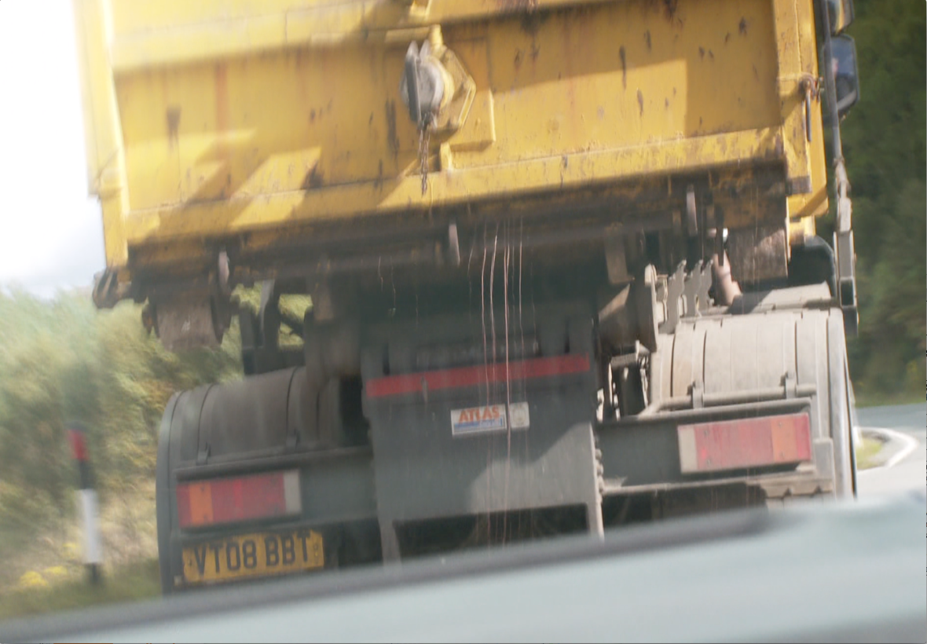
Photo: Fluids leaking from a Billy Bowie haulage truck transporting diseased farmed salmon from Loch Kishorn - broadcast by the BBC's 'The One Show' on 11 December 2017
"I am providing notice that under Section 17 of the Freedom of Information (Scotland) Act 2002 that the Council does not hold the information requested and so, is unable to comply with your request. I can advise that there are no salmon farms in Renfrewshire," replied Renfrewshire Council on 23 January 2018 (GAAIA replied: "It is patently obvious that there are no salmon farms in Renfrewshire! The FOI request relates to transport of dead fish from salmon farms to disposal sites across Scotland and in Northern England. Renfrewshire is cited in this case in October 2015 on the A737 (as reported by The Courier)."

"Shetland Islands Council has not had to issue any warning letters, complete any investigations, surveillance or monitoring in regard to the transport and disposal of salmon farm mortalities," replied Shetland Isles Council on 20 December 2017.

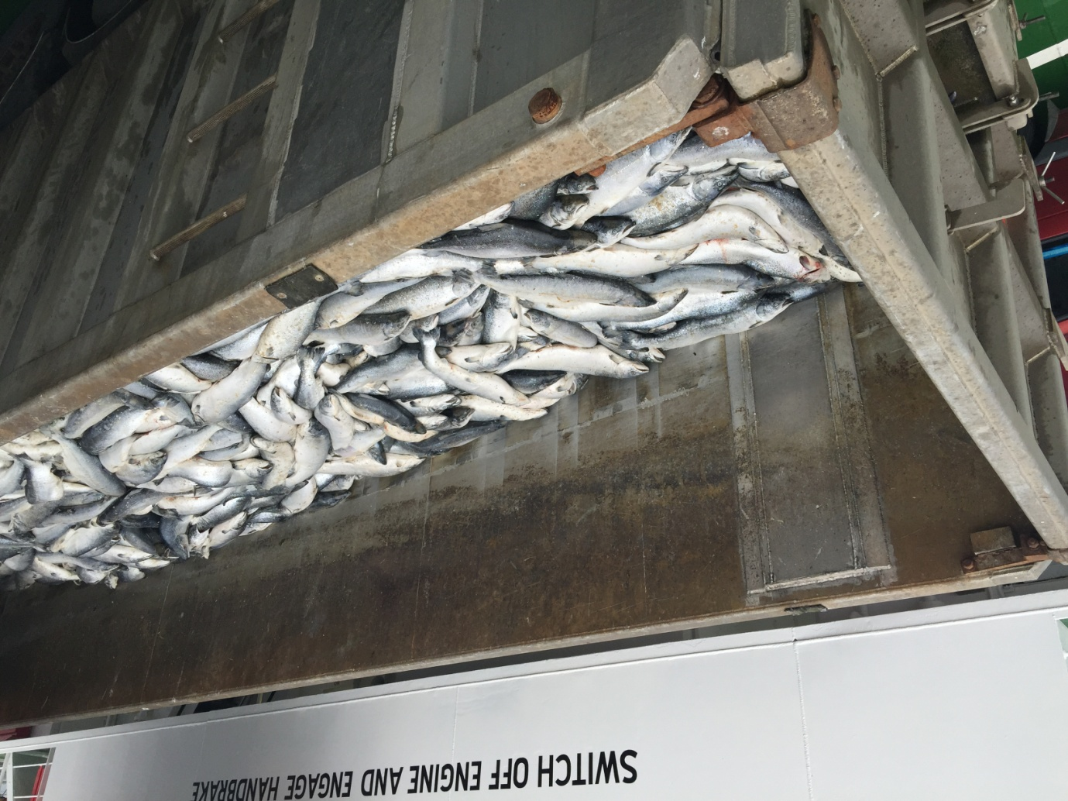
Photo: A truckload of dead salmon on the ferry 'Leirna' from Lerwick to the fishmeal factory in Bressay on 18th August 2015 (download high res image online here)

It is encouraging that one local authority (East Ayrshire) is now investigating the standards of the vehicles used to transport farmed salmon morts and compliance with the Animal By-Products Regulations 2013 (ABPR).

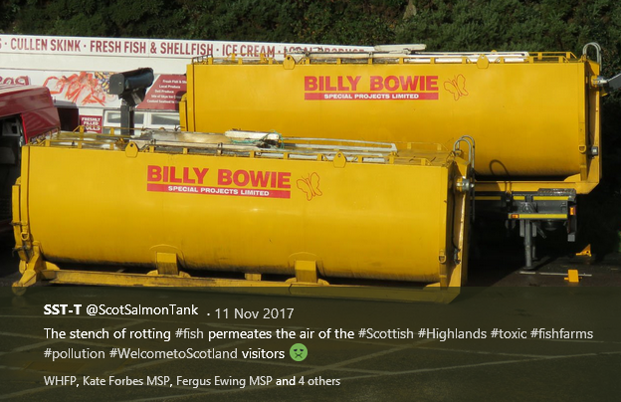

Nevertheless, GAAIA asks that the Scottish Government investigate this issue further and ensure that local authorities are enforcing the regulations. Hopefully, GAAIA's complaint to the European Commission will stem the tide of leaking fluids and disease-ridden wastes from Scotland's salmon farms.

Please note that despite the lack of official data on the number of morts since 2012 (SEPA stopped collating the data following lobbying from the Scottish Salmon Producers Organisation who claimed disclosure would be commercially damaging), GAAIA has accessed via FOI data on mort numbers at three salmon farming companies (Scottish Sea Farms, the Scottish Salmon Company and Marine Harvest Scotland) during 2017.

Data on Scottish Sea Farms - Scottish Sea Farms mort events in 2017 - details 356,082 morts in 46 separate reports/incidents during 2017 including the following worst cases:

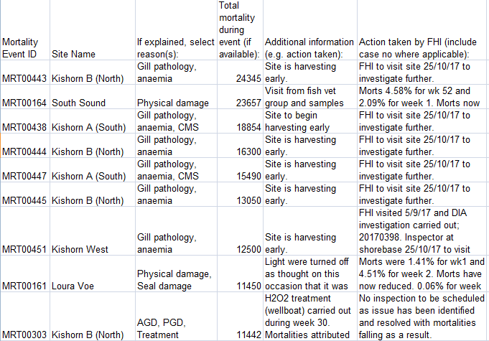
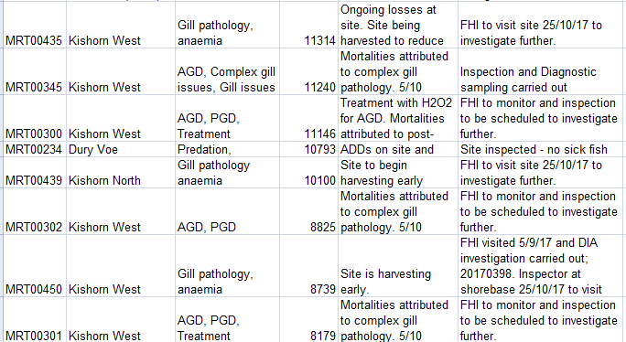

Data on the Scottish Salmon Company - Scottish Salmon Company mort events in 2017 - details 1,512,077 morts in 131 separate reports/incidents during 2017 including the following worst cases:
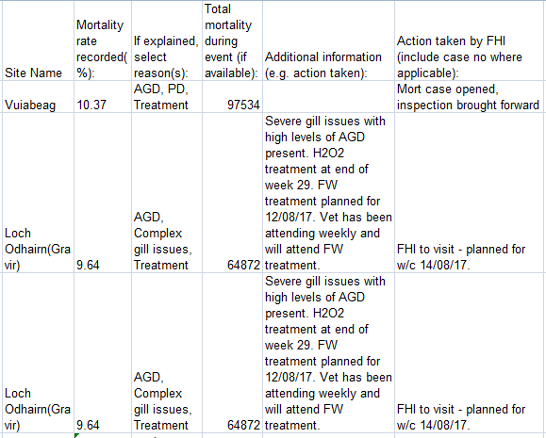
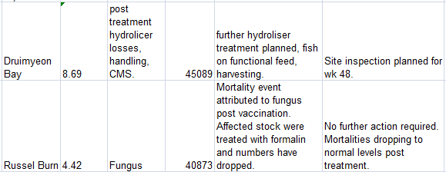
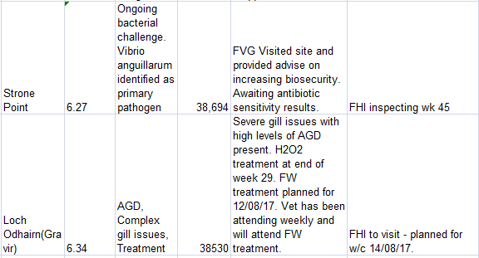

Data on Marine Harvest - Marine Harvest mort events in 2017 - details 572,488 morts in 56 separate reports/incidents during 2017 including the following worst cases:

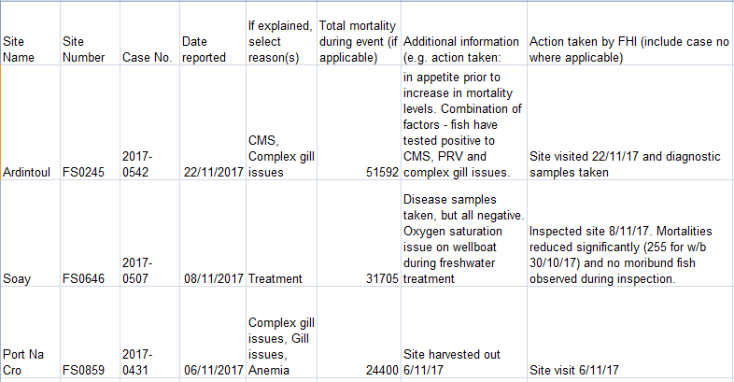
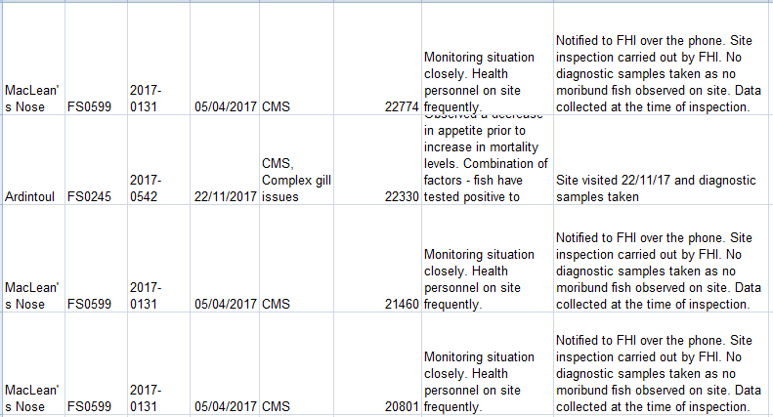
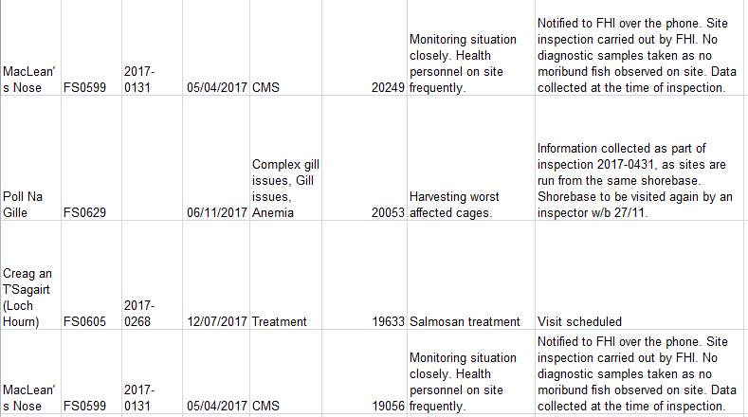

Another document details how Marine Harvest is experiencing increasing problems with mortalities linked to anaemia (not suspected to be linked to ISA), complex gill issues and cardiomyopathy syndrome (CMS):

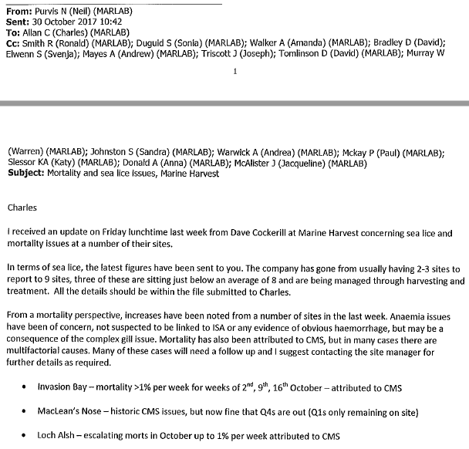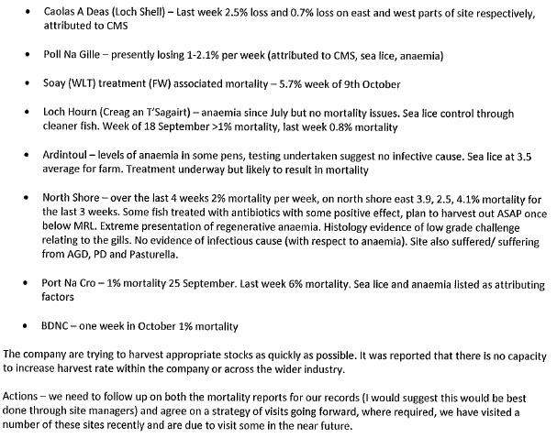
Marine Harvest's mort mountain is even plugging into the National Grid (read more via "Energy from dead salmon horrifies vegan activists" and "Vegans in shock at fish electricity: Energy firm SSE admitted generating power from dead salmon earlier this year"):

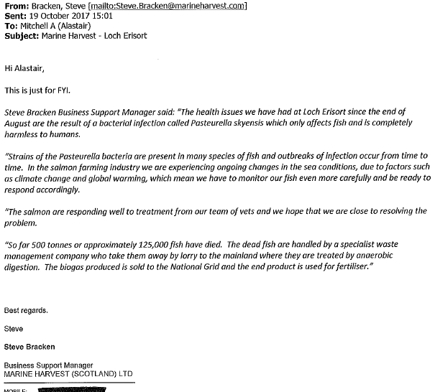

Read more via:
Press Release: "Diseased Salmon Slip Net & Spill on Road - Failure to police the transport of dead fish prompts EC complaint"
Sunday Times: "Scots councils ‘failing to enforce EC laws on leaky salmon trucks’"
Daily Mail: "Thousands of fish thrown in a truck - and troubling new questions for salmon farms"
"Parliamentary Question: to ask the Scottish Government how many farmed salmon have died in each year since 2012"
"First Minister questioned on leaking wastes from morts - call for a moratorium from Greens"
"BBC's 'Dead Salmon Run' Opens Can of Worms"
"Millions of Scottish Salmon Going Up in Smoke"
BBC's The One Show: "The Dead Salmon Run"
BBC's The One Show (Part 2)
"125,000 salmon die in disease outbreak at Lewis fish farms"
"Campaigners say 'no more salmon farms' after disease on Lewis kills 125,000 fish"
"A disgrace: Ten million salmon thrown away by fish farm industry in last year alone"
"Death rate at salmon farms doubles to 20m fish a year"
"Welfare fears after claim deaths of farmed salmon have doubled"
"Thermal treatment for lice blamed for salmon deaths"
"Poached alive - fish die as farm overheats water"
"Oops: fish farm firm kills 175,000 of its salmon by accident"
"European Commission complaint over dead fish dumping forces rule change"
"Scottish watchdog labelled ‘lapdog’ after agreeing to keep fish farm deaths secret"
"Farmed salmon killed by disease leaps to 8.5 million"
"Where have all the dead fish gone?"

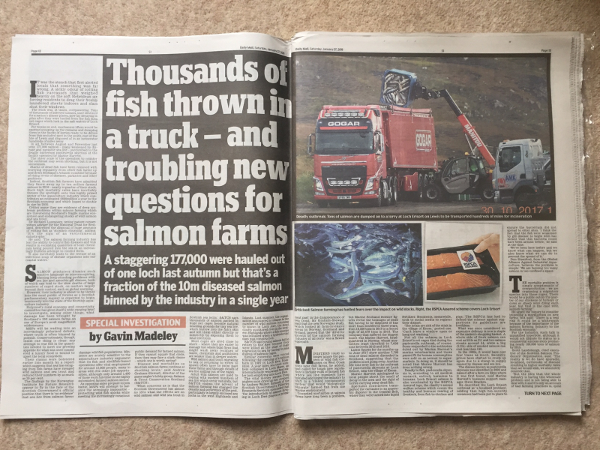

In conclusion, GAAIA asks that the Scottish Government and the Scottish Parliament's forthcoming inquiry into salmon farming investigates the issue of dead farmed salmon arising from Scotland's disease-ridden and lice-infested salmon farms. Scottish salmon farming has a huge mort mountain with over one in four farmed salmon dying and an estimated 20 million morts piling up across Scotland. It beggars belief that haulage trucks making 'The Dead Salmon Run' are not being properly policed.

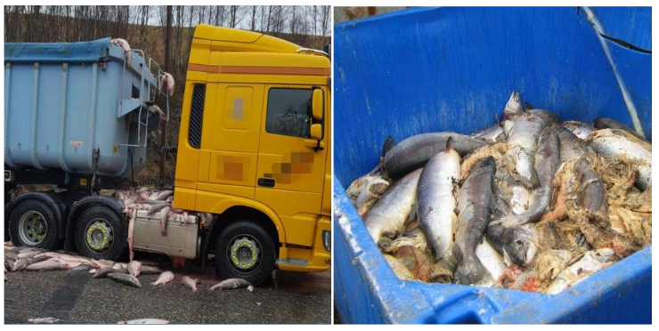

Yours sincerely,

Don Staniford

Director, The Global Alliance Against Industrial Aquaculture

Cc:

Roseanna Cunningham, Cabinet Secretary for the Environment, Climate Change and Land Reform: scottish.ministers@gov.scot
Mark Ruskell MSP: mark.ruskell.msp@parliament.scot
Kate Forbes MSP: kate.forbes.msp@parliament.scot
Graeme Dey MSP: mailto:graeme.dey.msp@parliament.scot
DEFRA: defra.helpline@defra.gsi.gov.uk
Animal & Plant Health Agency: enquiries@apha.gsi.gov.uk
COSLA: info@cosla.gov.uk
East Ayrshire Council: FOI@east-ayrshire.gov.uk
Highland Council: Alan.Yates@highland.gov.uk
Argyll & Bute Council: DISPerformanceHQ@argyll-bute.gov.uk
Shetland Islands Council: Paula.Nicolson@shetland.gov.uk
Orkney Isles Council: Kate.Russell-Duff@orkney.gov.uk
Comhairle nan Eilean Siar: foi@cne-siar.gov.uk
Dumfries & Galloway Council: FOI@dumgal.gov.uk
Stirling Council: LandIenquiries@stirling.gov.uk
Renfrewshire Council: kirsty.wright@renfrewshire.gov.uk
Lancashire County Council: CSSGFreedom@lancashire.gov.uk
Cumbria County Council: information.governance@cumbria.gov.uk
South Ayrshire Council: FOI@south-ayrshire.gov.uk
Scottish Borders Council: Kirsty.Lovatt@scotborders.gov.uk
South Lanarkshire Council: Michael.Barrett@southlanarkshire.gcsx.gov.uk
Perth & Kinross Council: FOI@pkc.gov.uk
Inverclyde Council: Lindsay.Carrick@inverclyde.gov.uk
North Lanarkshire Council: SmithSu@northlan.gov.uk

