
RSPCA
Wilberforce Way
Southwater
Horsham,
RH13 9RS
executive@rspca.org.uk
5 February 2020
RSPCA Assured Welfare Abuse on Salmon Farms

Scottish Salmon Watch would like to brief the RSPCA's executive team, Board of Trustees, ambassadors as well as patrons, vice-presidents and celebrity supporters on the systemic welfare abuse on RSPCA Assured salmon farms in Scotland. The message is a simple one - stop certifying factory farmed salmon via RSPCA Assured. The certification of farmed salmon via RSPCA Assured is bringing the RSPCA into disrepute and is endorsing welfare problems on salmon farms. Please end the torture now and stop the certification of salmon!

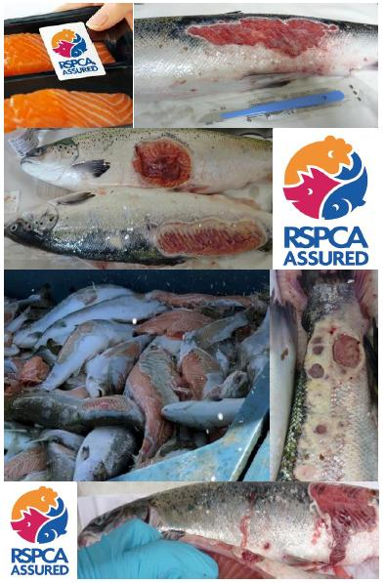
Scottish Salmon Watch do not think that the RSPCA's founding members Arthur Broome and Sir William Wilberforce (not to mention Her Majesty the Queen as royal patron of the RSPCA) would be so proud of the current state of salmon farming in Scotland as to award it the RSPCA Assured stamp of approval.

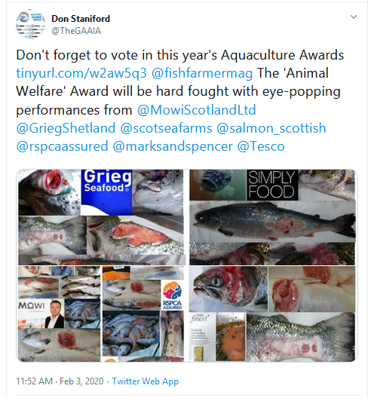

It is understood that RSPCA Assured certifies ca. 70% of salmon farming production in Scotland - including all Mowi (formerly Marine Harvest), Scottish Sea Farms and Cooke Aquaculture salmon farms.

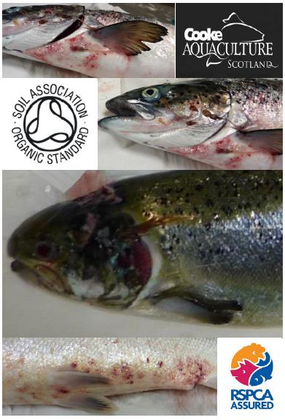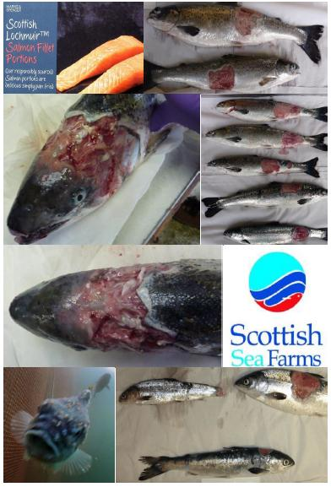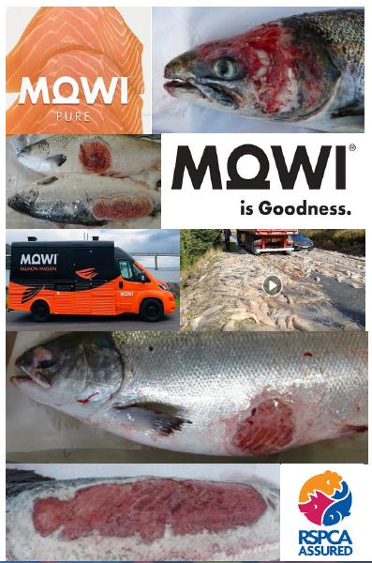
Scottish Salmon Watch believes that RSPCA Assured's rhetoric of "respect" and "compassion" is not matched by the reality of welfare problems endemic on salmon farms across Scotland.

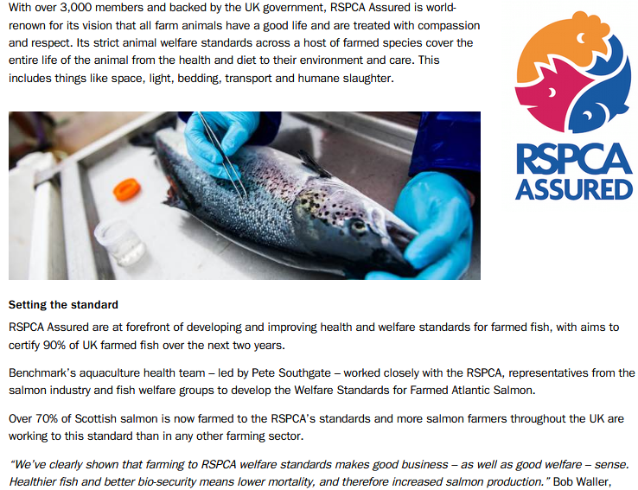

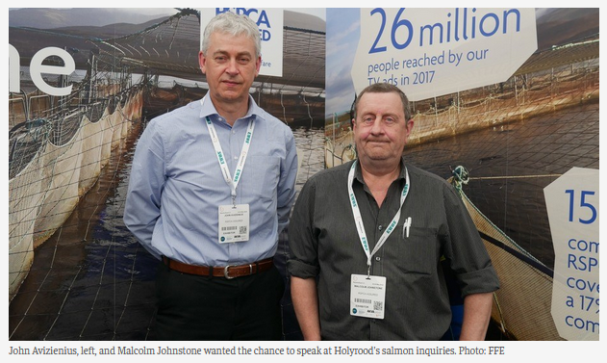
Does this look like an example of "good welfare" to you (download photo dossier in full online here)?

Mowi's Tabhaigh salmon farm in Loch Erisort (12 November 2019)

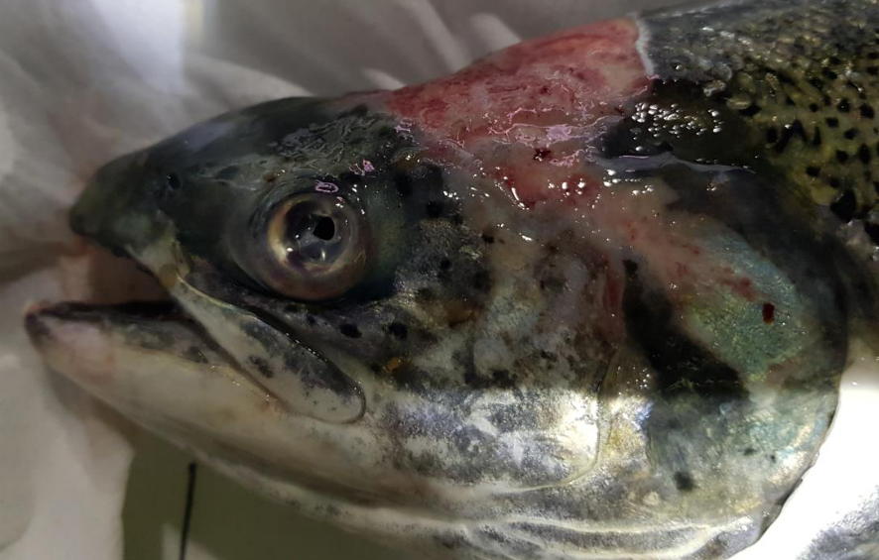
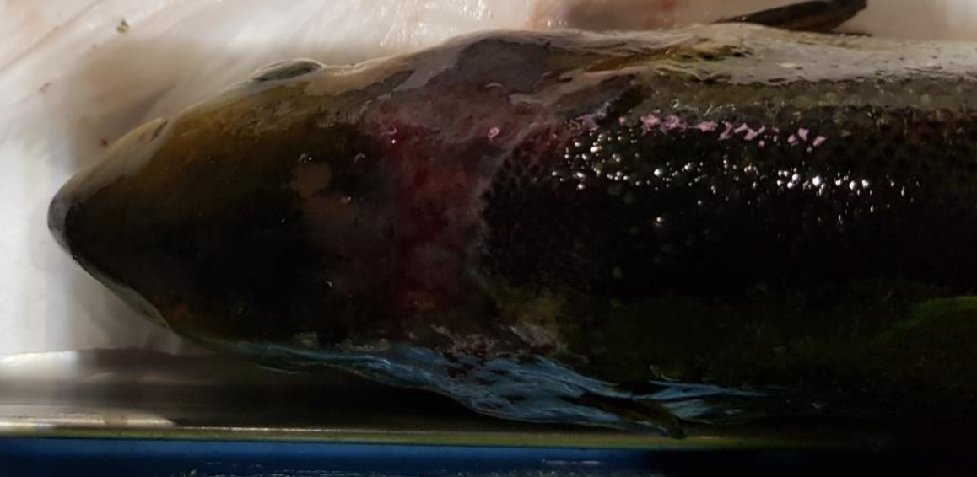

Please note that the RSPCA have consistently refused to supply a list of which salmon farms are certified via RSPCA Assured but Mowi, Scottish Sea Farms and Cooke have both publicly stated that their farms are RSPCA Assured. However, photographic evidence and 'Case Information' published by the Scottish Government's Fish Health Inspectorate offers precious little reassurance.
Does the RSPCA seriously endorse such systemic suffering of salmon?

Mowi's Port Na Cro salmon farm in Shuna Sound (23 October 2019)

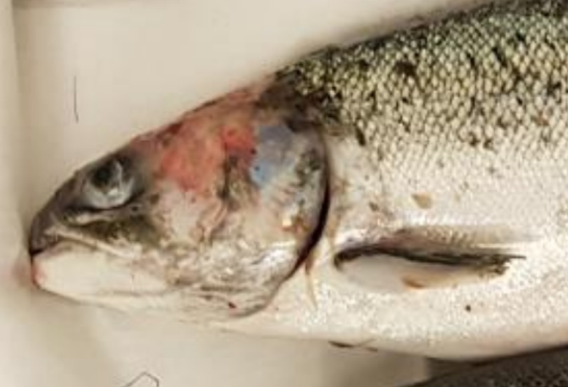

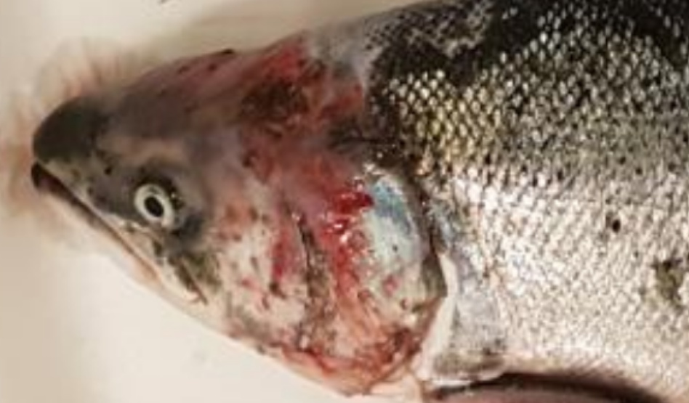

Mowi's Poll Na Gille salmon farm in the Sound of Jura (19 September 2019)

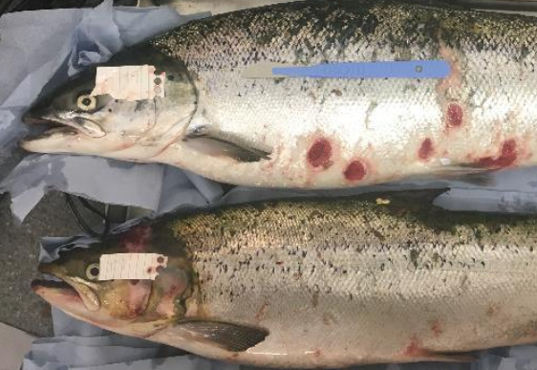

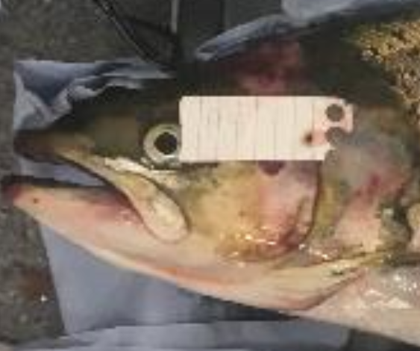
Mowi's Rum salmon farm off the Isle of Rum (9 July 2019)

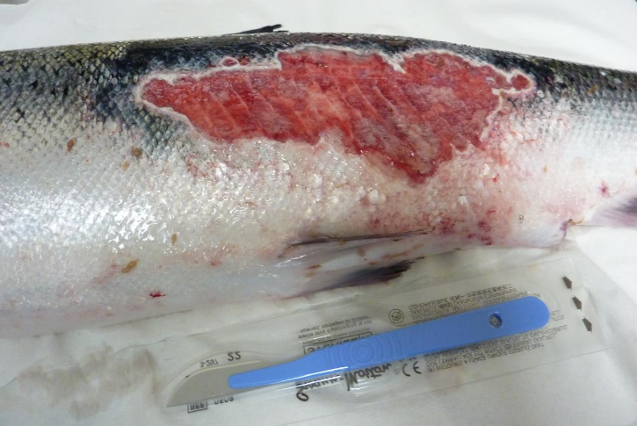

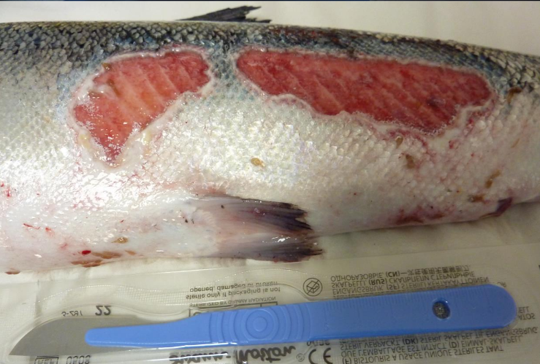

Mowi's Kingairloch salmon farm in Loch Linnhe (30 April 2019)

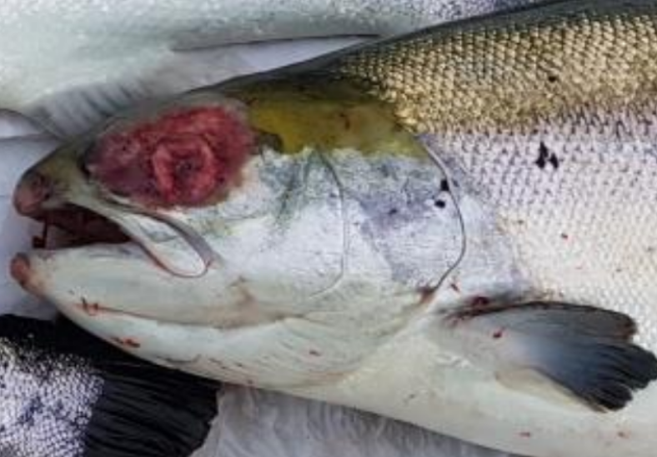
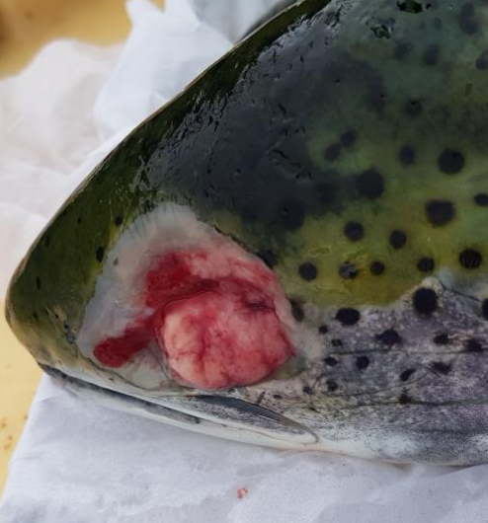
Mowi's Stulaigh salmon farm in Loch Eynort (5 June 2018)

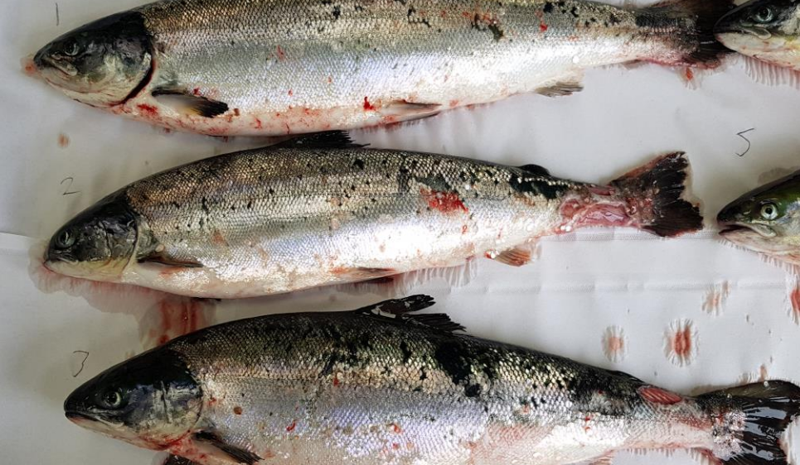

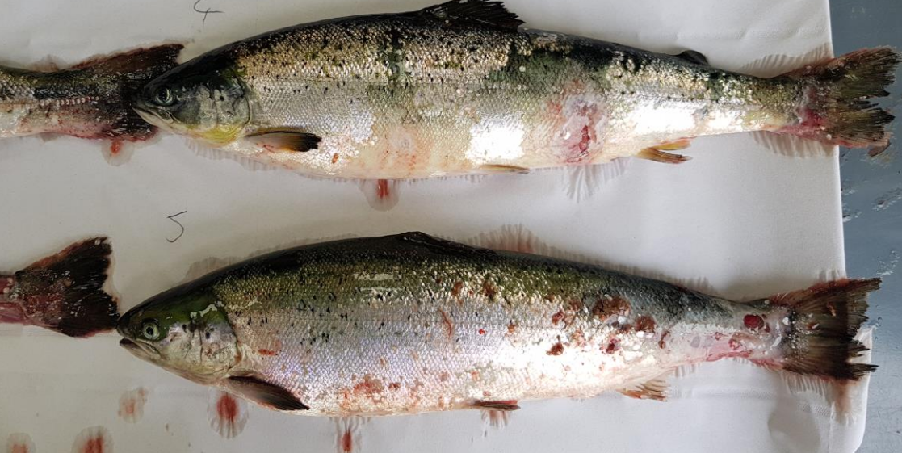

Mowi's Carradale salmon farm in Kilbrannan Sound (March 2018)

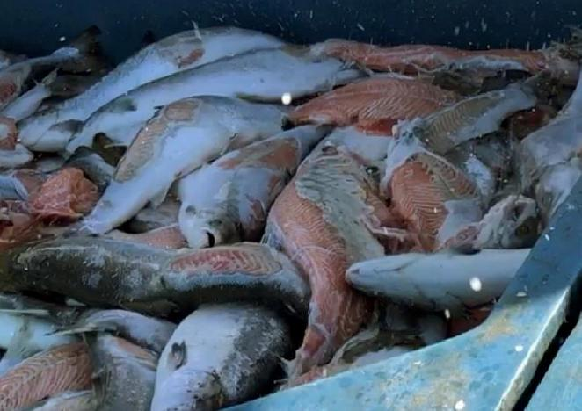
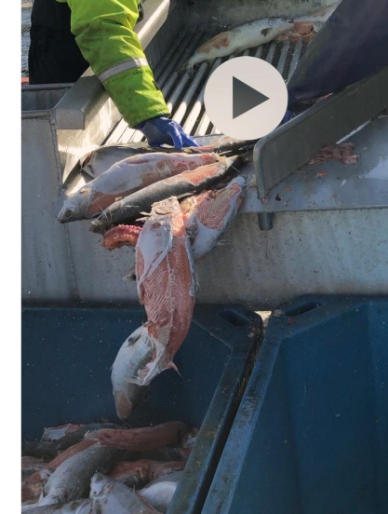

Mowi's Groatay salmon farm in the Sound of Harris (2018)

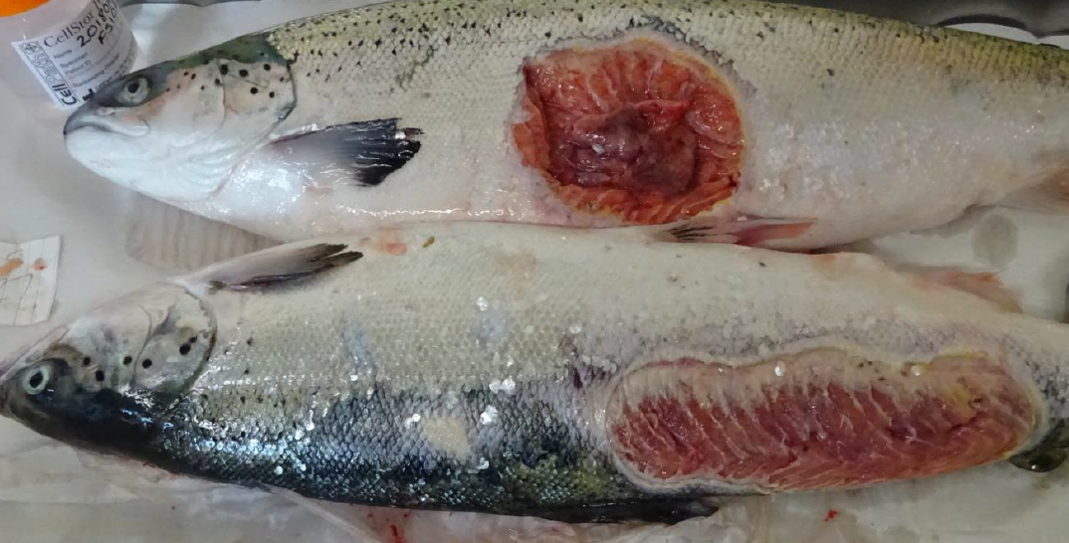
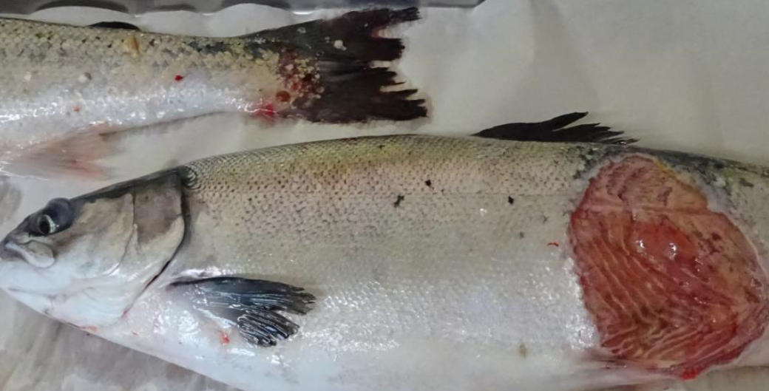
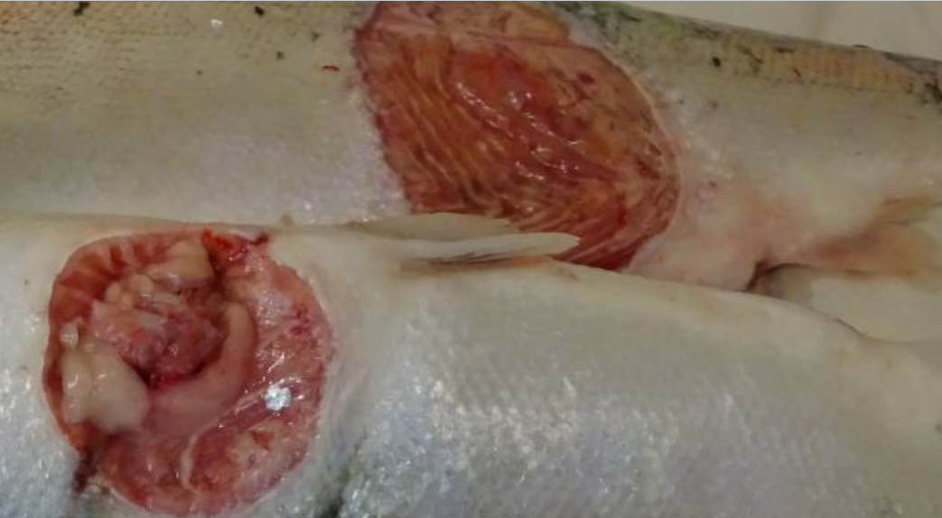
Mowi's Grey Horse Channel salmon farm in the Sound of Harris (2018)

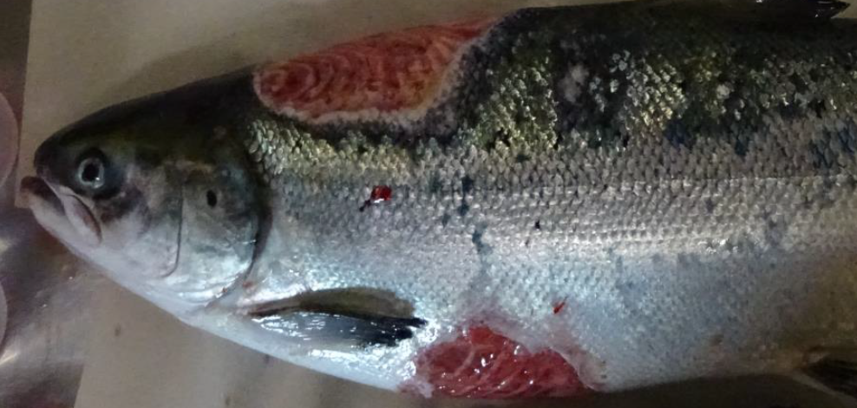

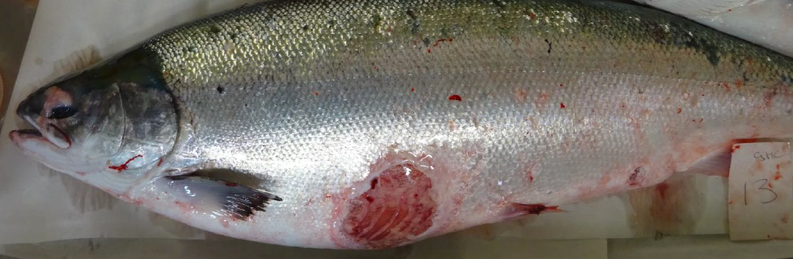

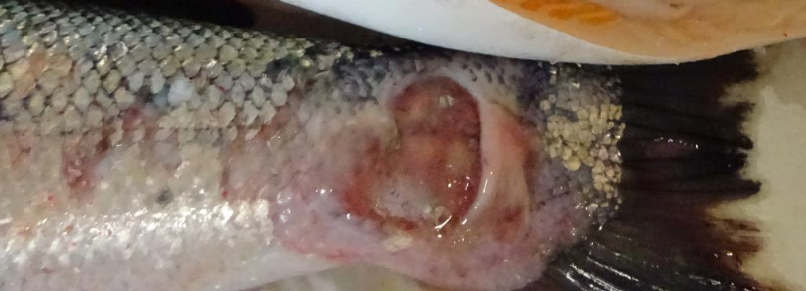

Scottish Sea Farms' Kishorn B salmon farm in Loch Kishorn (2017)

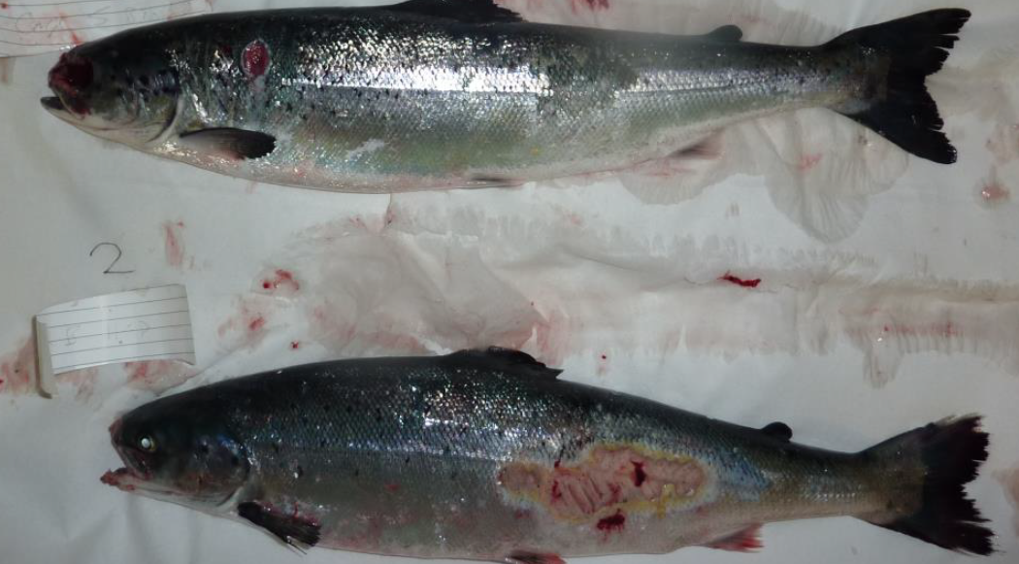

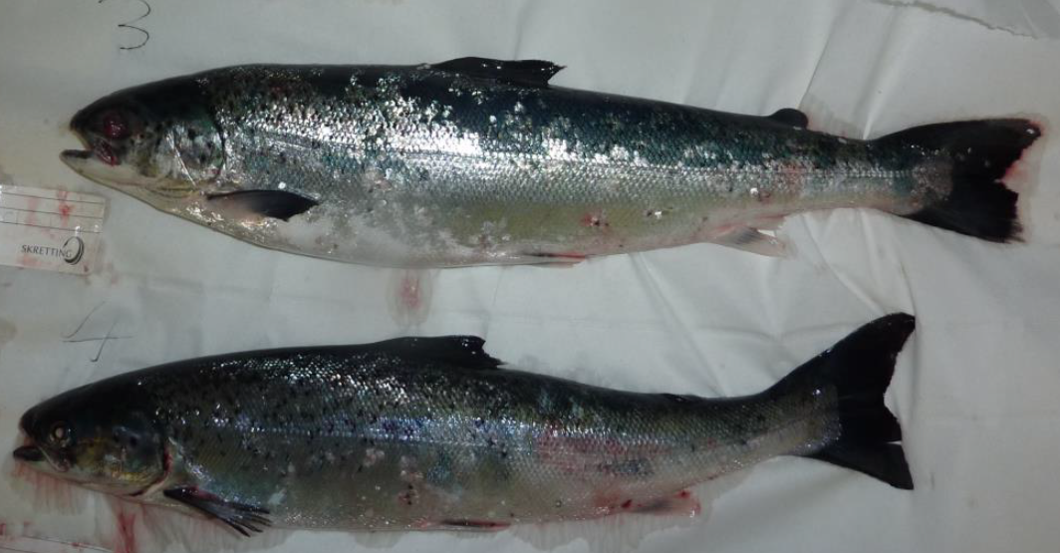

Mowi's Sron salmon farm in Loch Alsh (2017)

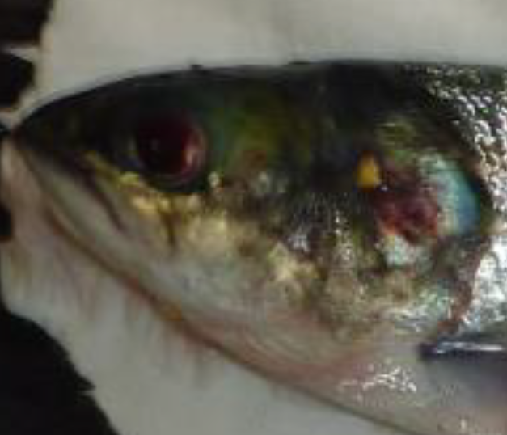

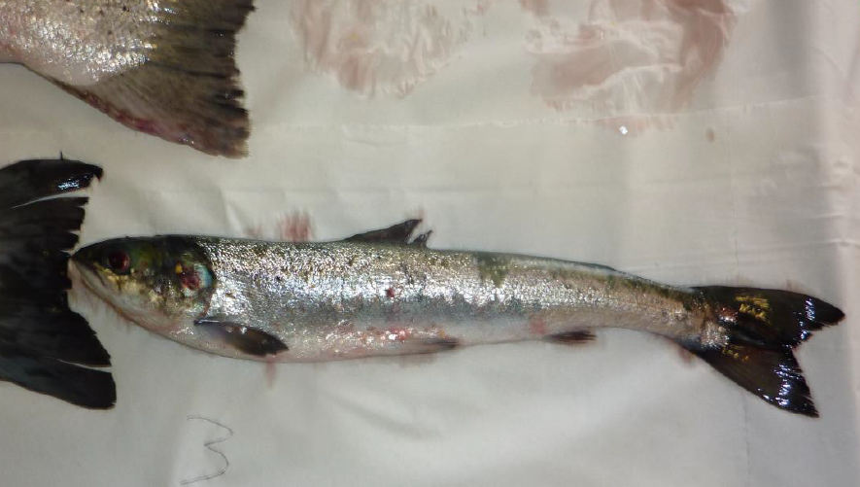

Mowi's North Shore salmon farm in Loch Erisort (2017)

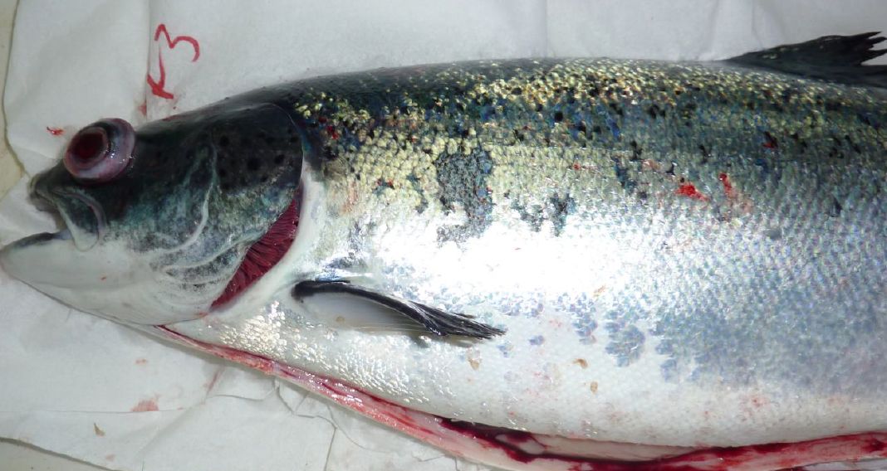

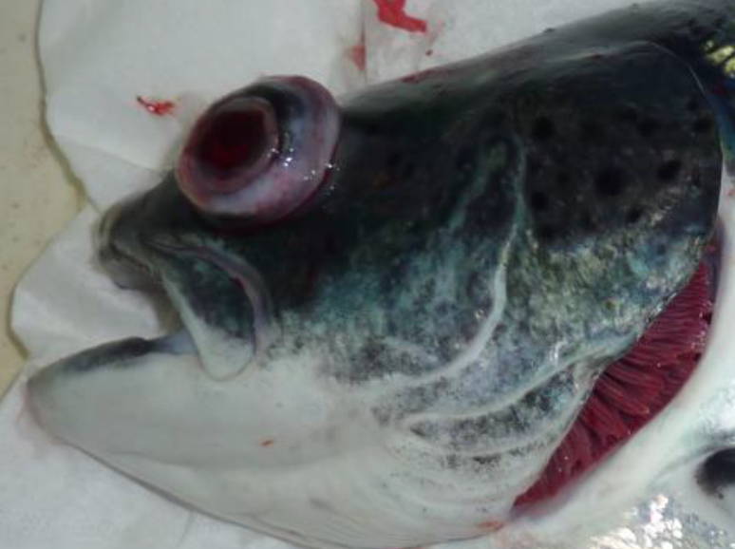

Scottish Sea Farms' Kishorn A salmon farm in Loch Kishorn (2017)

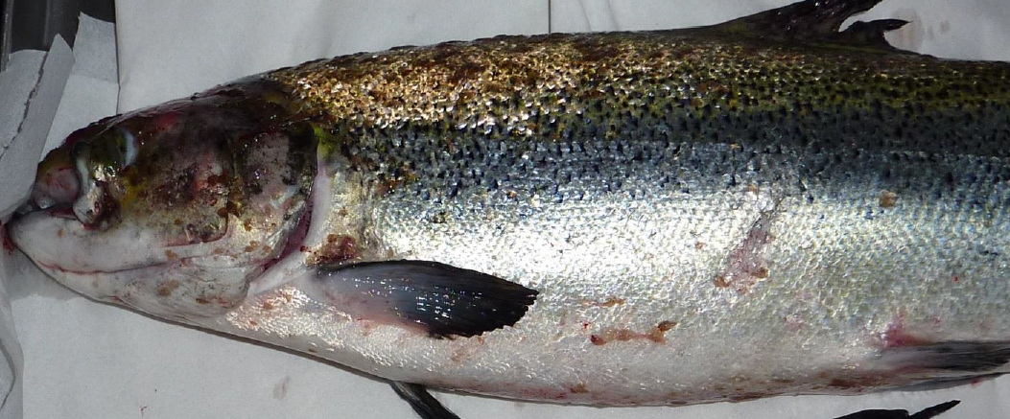

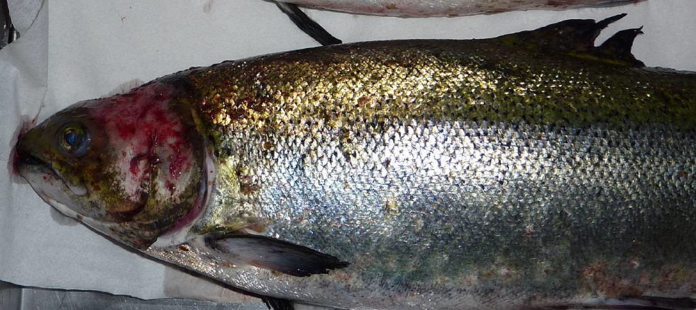

Cooke Aquaculture's Winna Ness salmon farm in Uyea Sound (2017)

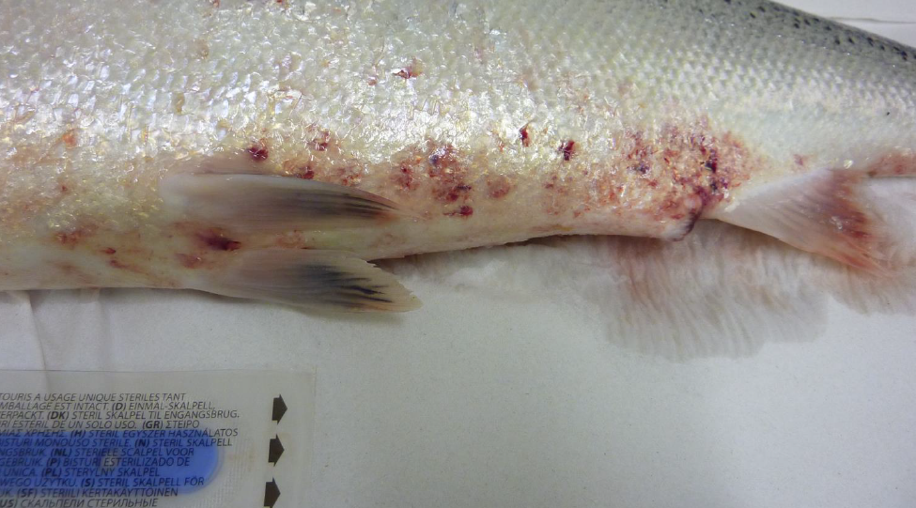

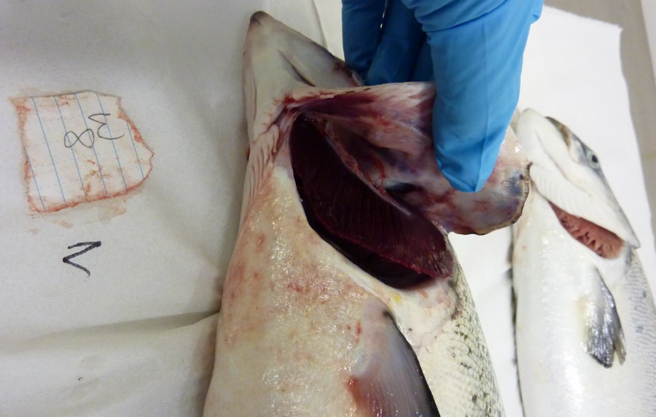

Cooke Aquaculture's Kirkabister salmon farm in Basta Voe (2016)

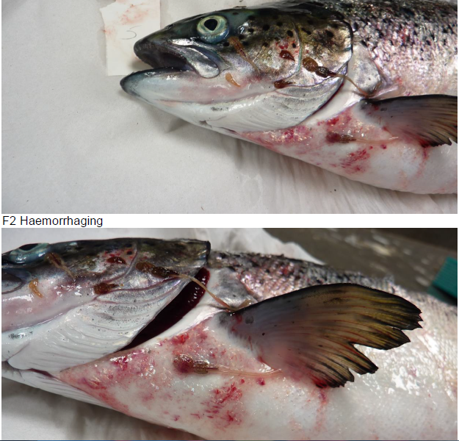

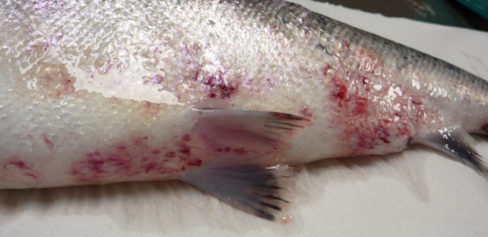

Cooke Aquaculture's Djuba Wick salmon farm in Colgrave Sound (2016)

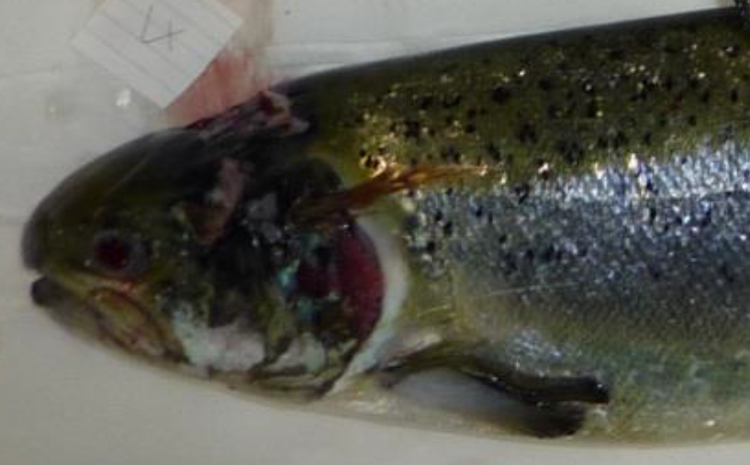

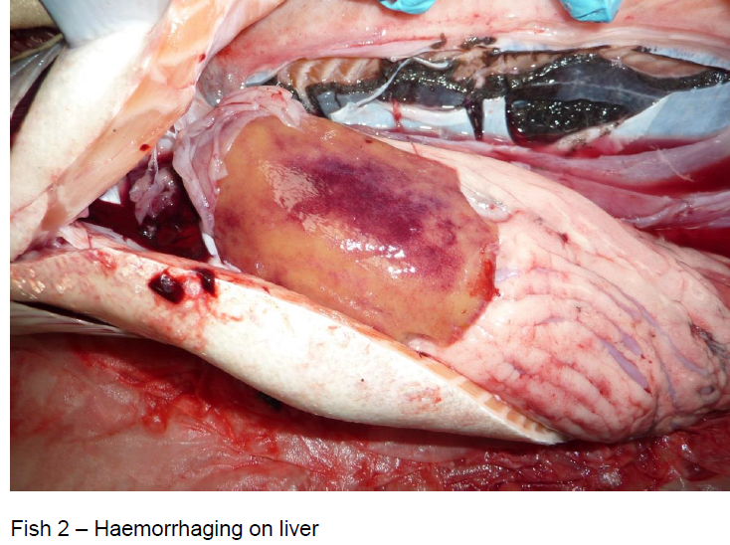

Cooke Aquaculture's Meil Bay salmon farm in Orkney (2016)

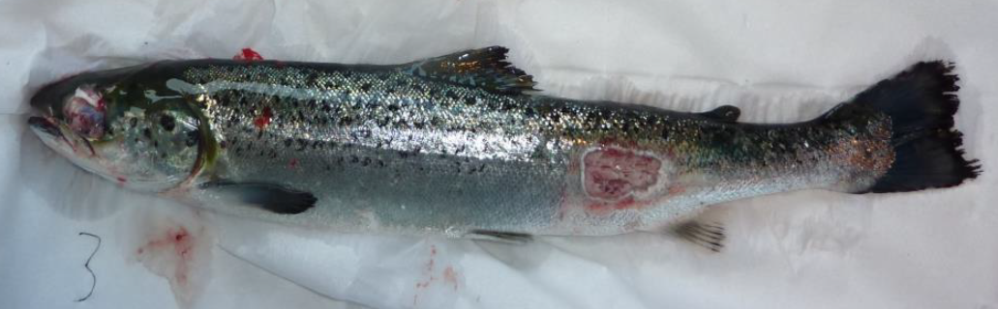

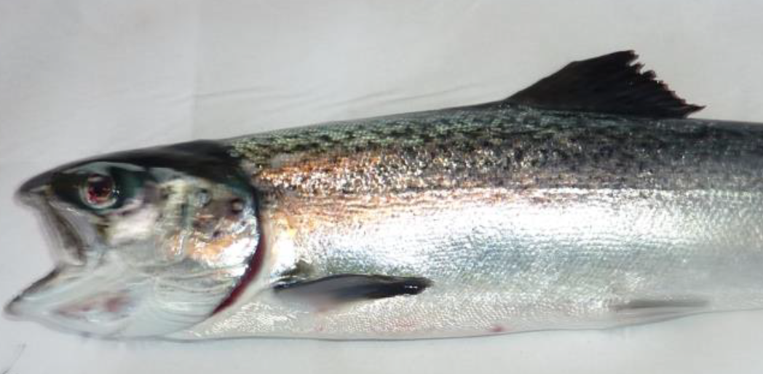

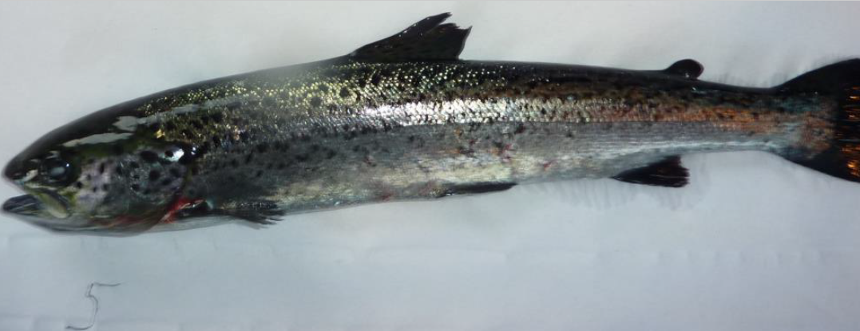

Mowi's Ardintoul salmon farm in Loch Alsh (2016)

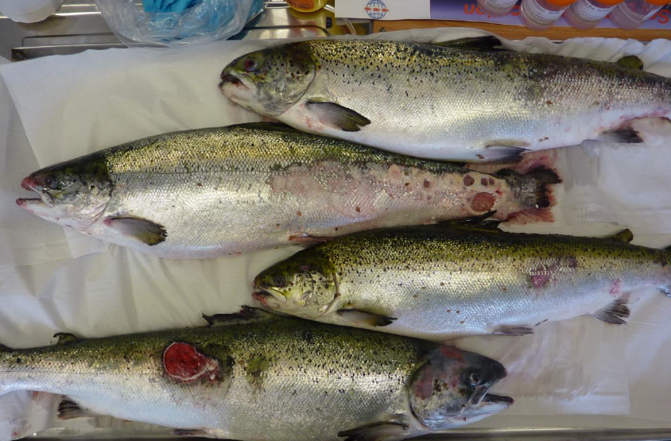
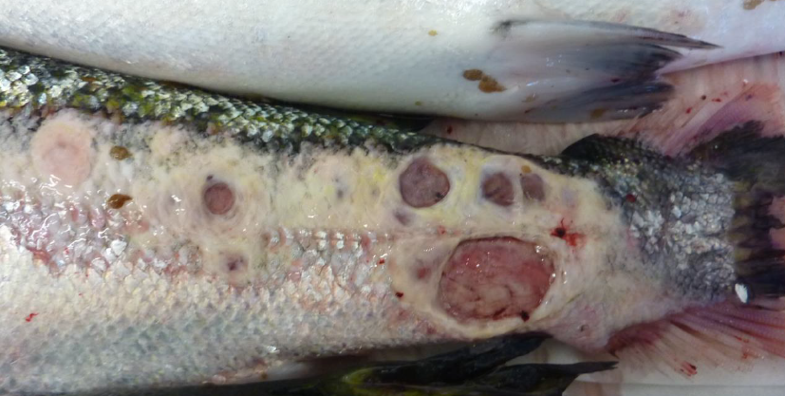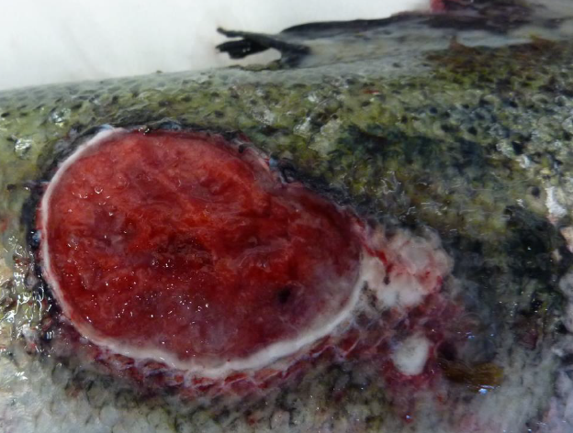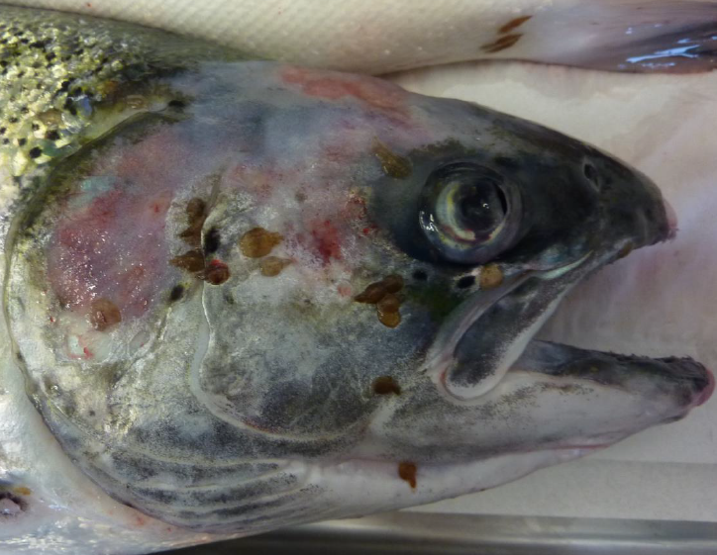

Mowi's Scotasay salmon farm, Isle of Harris (2016)

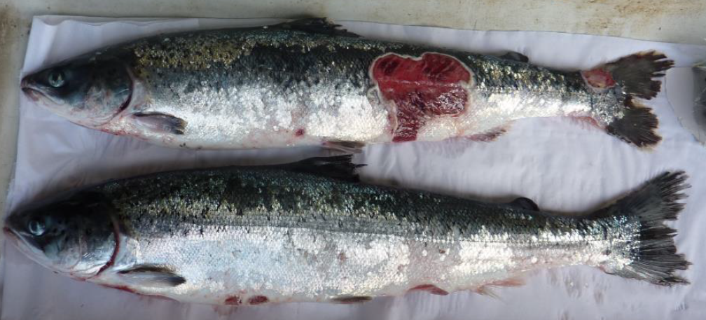

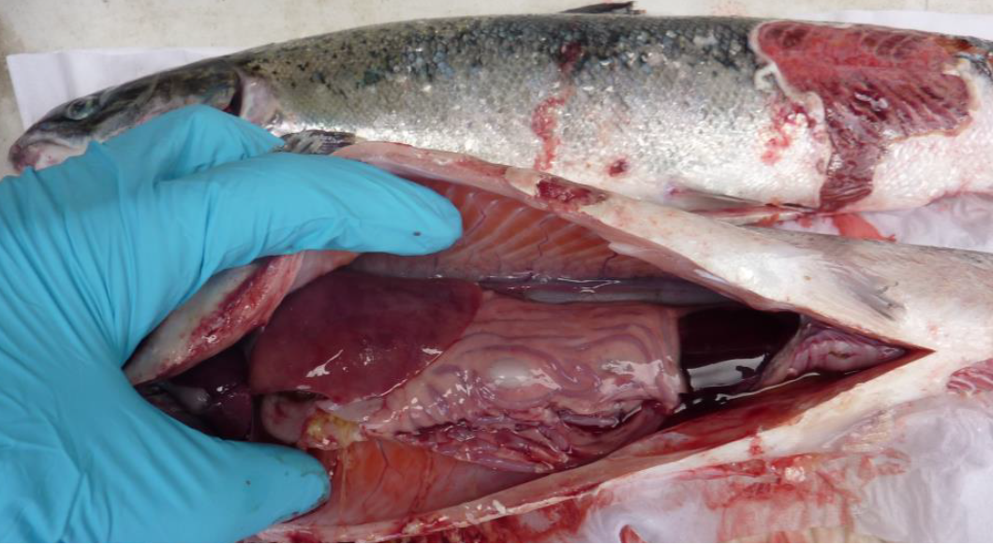

Mowi's Scotasay salmon farm in East Loch Tarbert (2nd inspection) (2016)

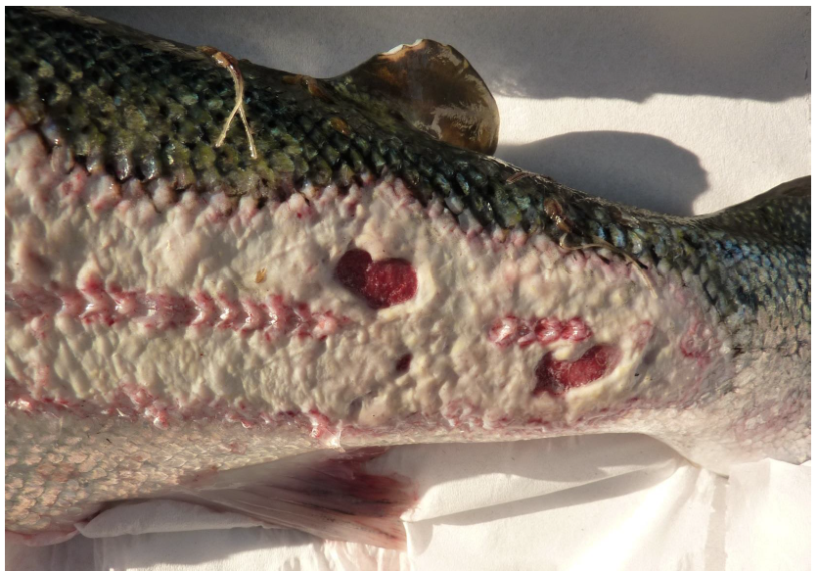

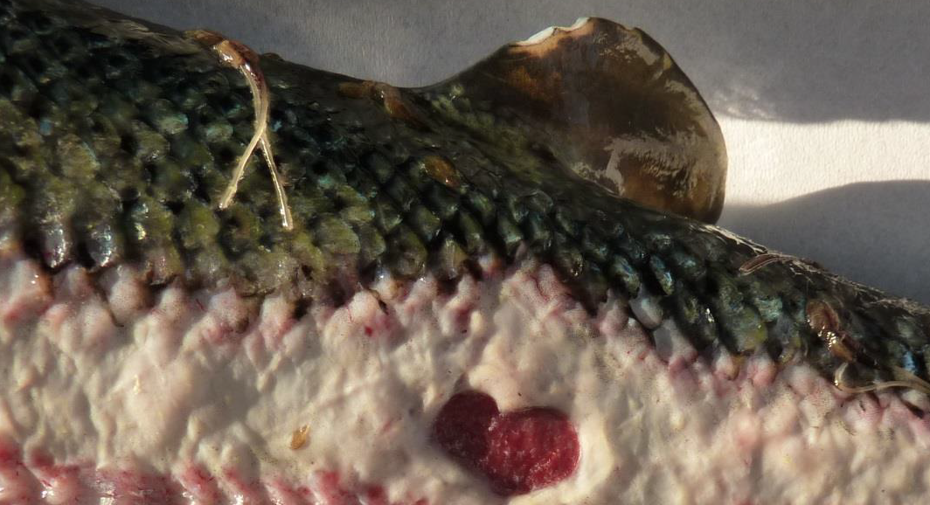

Mowi's Raineach salmon farm in East Loch Tarbert (2016)

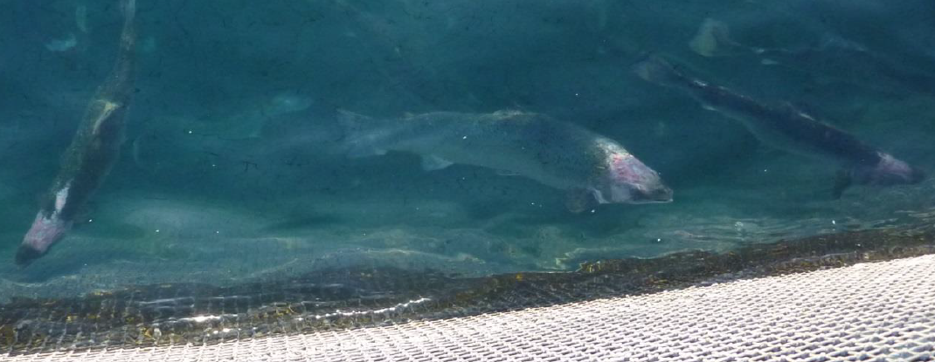
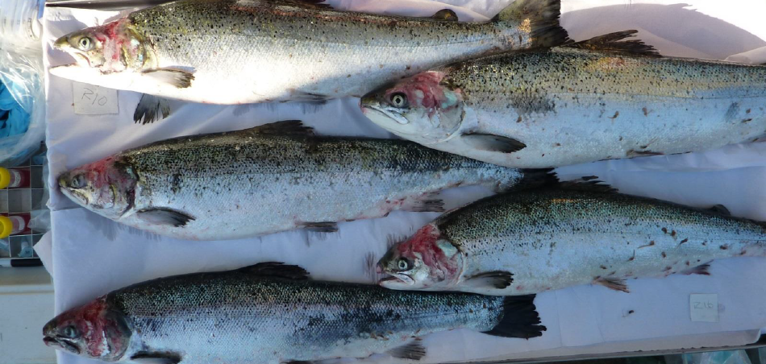
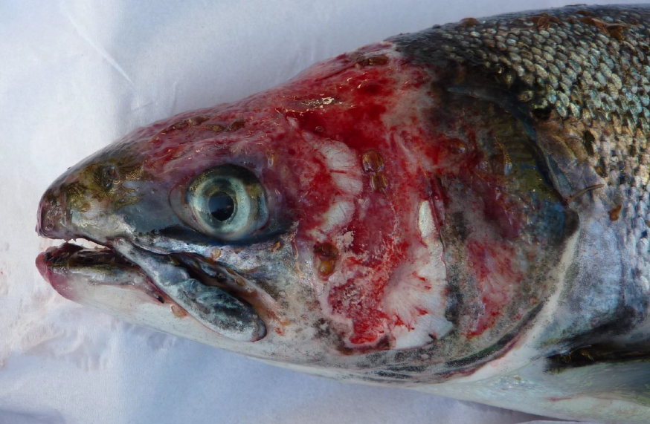

Scottish Sea Farms' Kishorn B salmon farm in Loch Kishorn (2015)

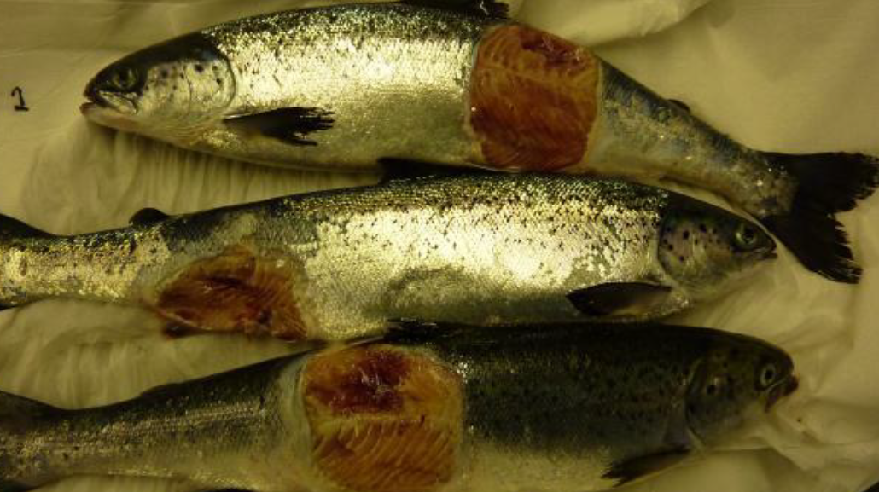
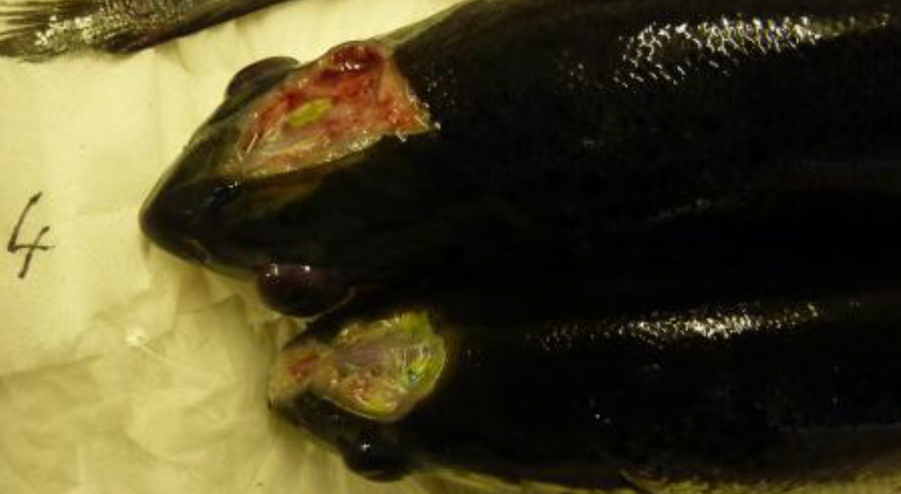
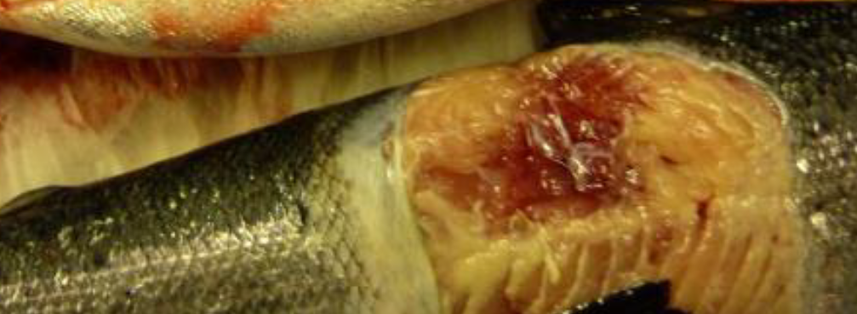
Scottish Sea Farms' Nevis B salmon farm in Loch Nevis (2015)

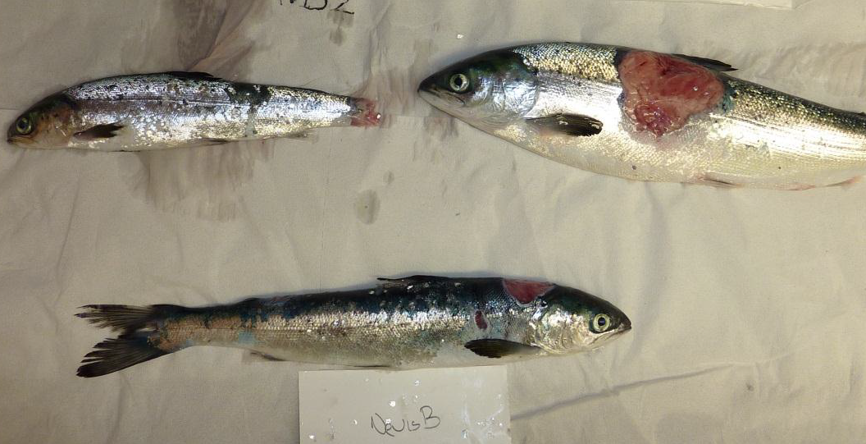

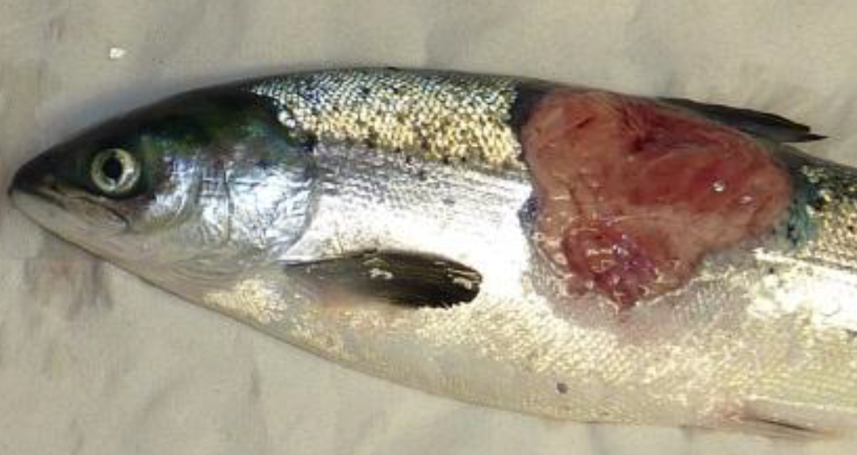

Scottish Sea Farms' Kishorn B salmon farm in Loch Kishorn (2nd inspection) (2015)

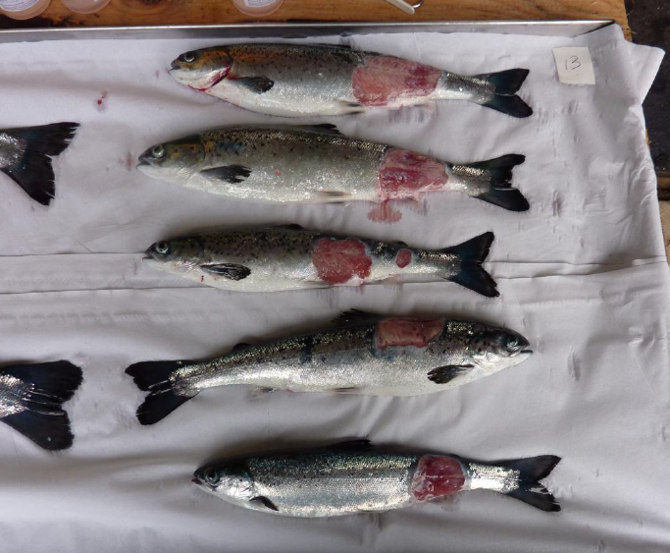

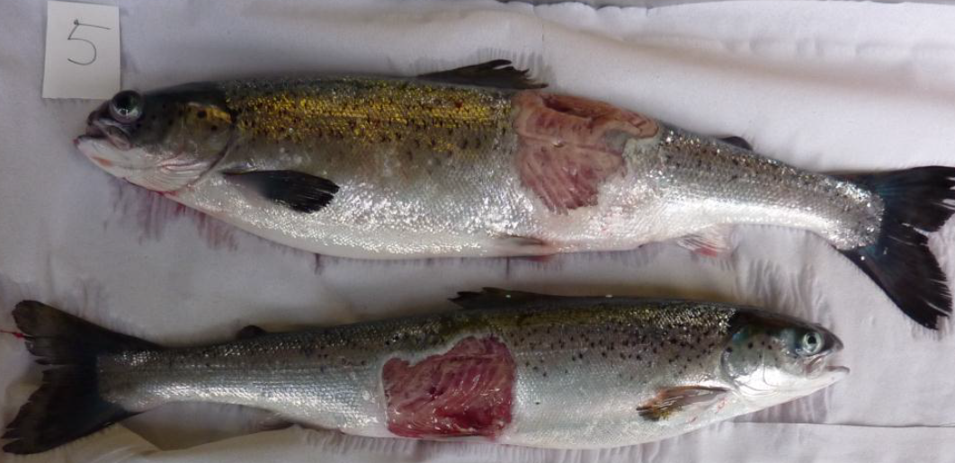

Mowi's Ardmaddy salmon farm in Seil Sound (2015)

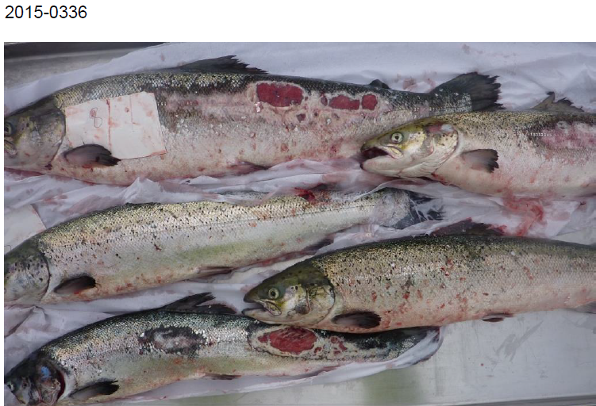

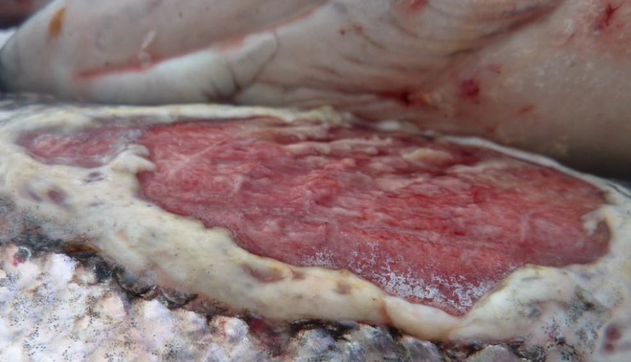

Mowi's Ardmaddy salmon farm in Seil Sound (2nd inspection) (2015)

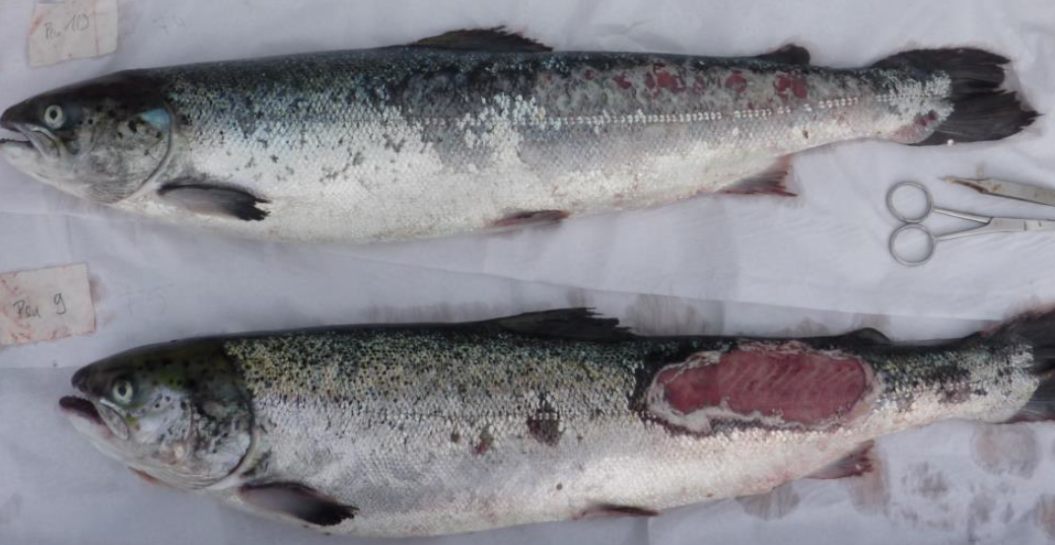

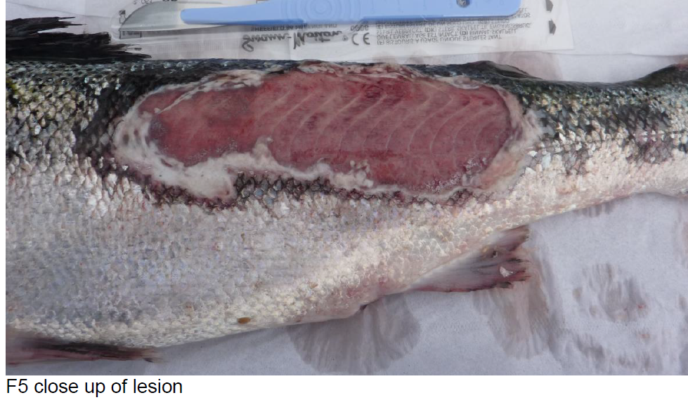

Scottish Sea Farms' Loch Arienas salmon farm in Highland region (2014)

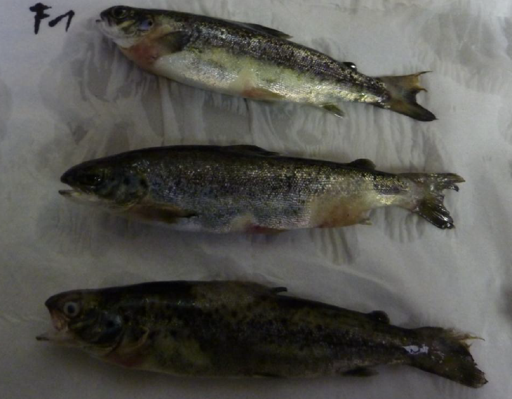
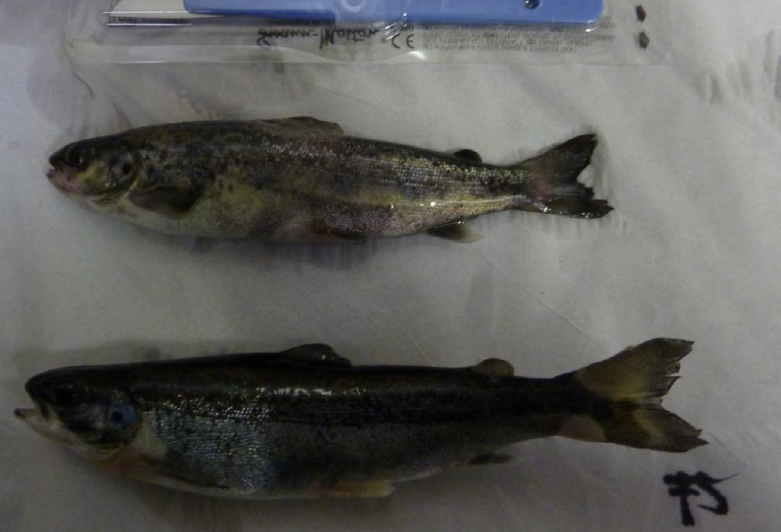
Scottish Sea Farms' Crooie salmon farm in Clift Sound (2013)

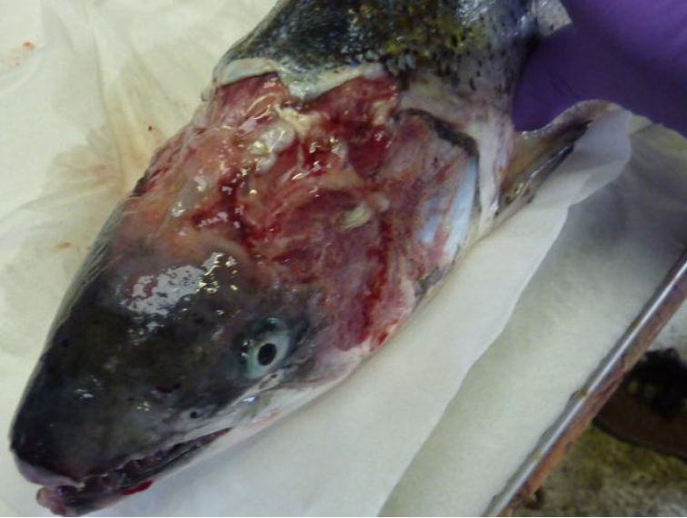

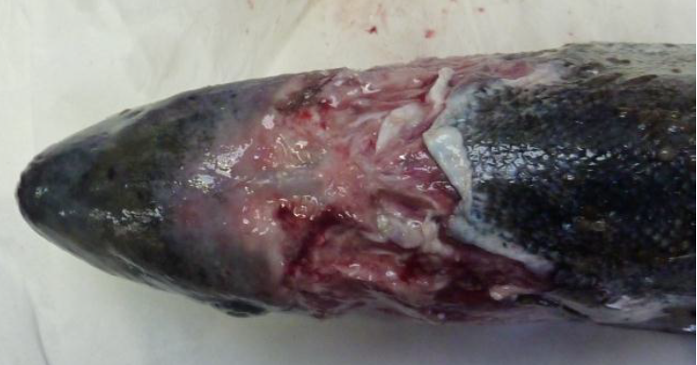

Read more via Photo Dossier of Diseased, Deformed & Abused Scottish Salmon. The Scottish Government's Fish Health Inspectorate publishes 'Case Information' on a monthly basis online here (2013-2019 data is archived online here). Photos have been made available via Freedom of Information - despite legal threats by salmon farming companies - back only to 2013.
Does the RSPCA's executive team, Board of Trustees, ambassadors and patrons, vice-presidents and celebrity supporters seriously think the RSPCA Assured farmed salmon showcased above have enjoyed the 'Five Freedoms' as detailed in the "RSPCA Welfare Standards for Farmed Atlantic Salmon" (February 2018)?

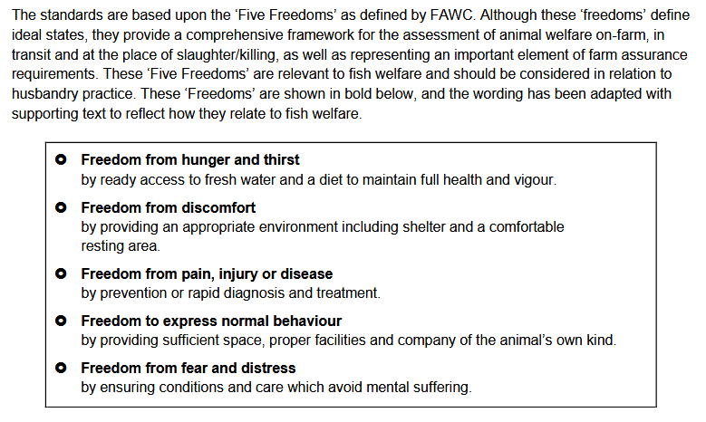

Fish welfare expert Dr. Lynne Sneddon of the University of Liverpool certainly does not think so.

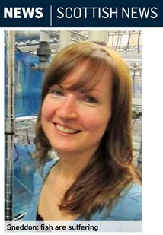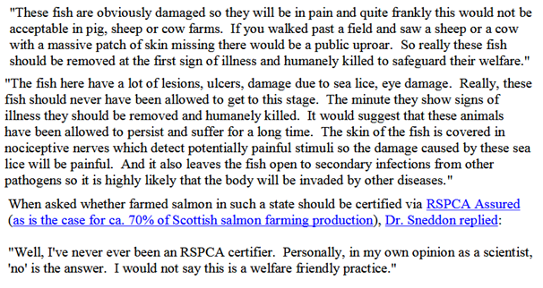
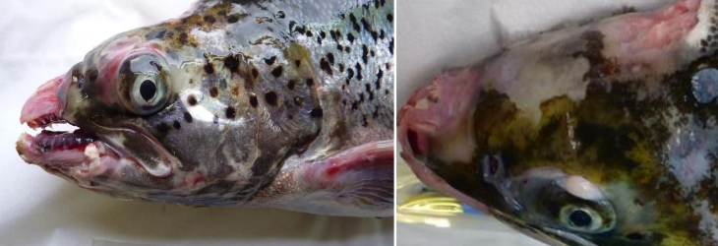
The disconnect between the photographic evidence of welfare abuse at RSPCA Assured salmon farms and the marketing of RSPCA Assured salmon raises serious questions.

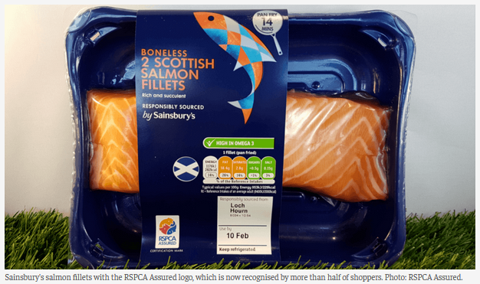

For example, when RSPCA Assured inspectors visit salmon farms how thorough are the annual inspections? Do inspectors use video surveillance to check on the welfare of the farmed salmon swimming in the cages or dead at the bottom of the nets? Do inspectors visit towards the end of the harvest cycle when welfare problems are at their worst? Are RSPCA Assured inspections independently audited? Are inspections unannounced?

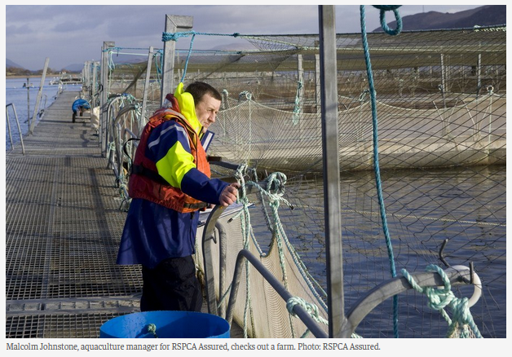
The damning photographic evidence and video surveillance seriously undermines the RSPCA's support for salmon farming. Here's video footage of the dead salmon at the bottom of a RSPCA Assured salmon farm operated by Mowi (watch more via BBC Panorama's 'Salmon Farming Exposed' broadcast in May 2019).

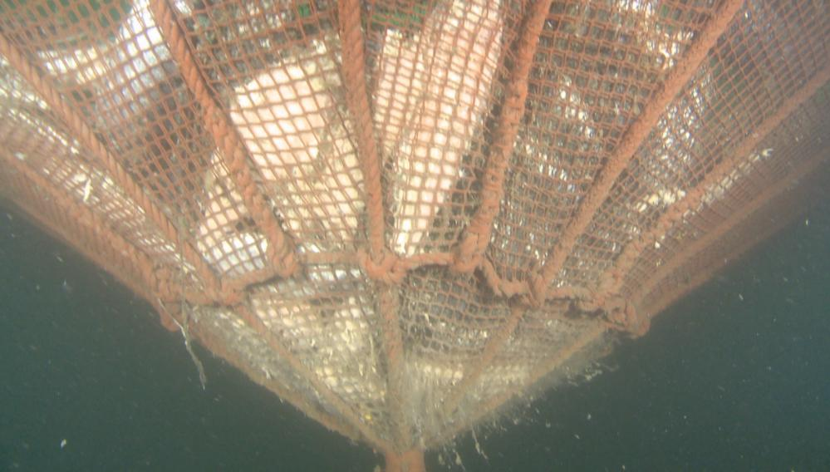

The RSPCA's web-site claims that the RSPCA standards "ensure the fish are healthier and less stressed".

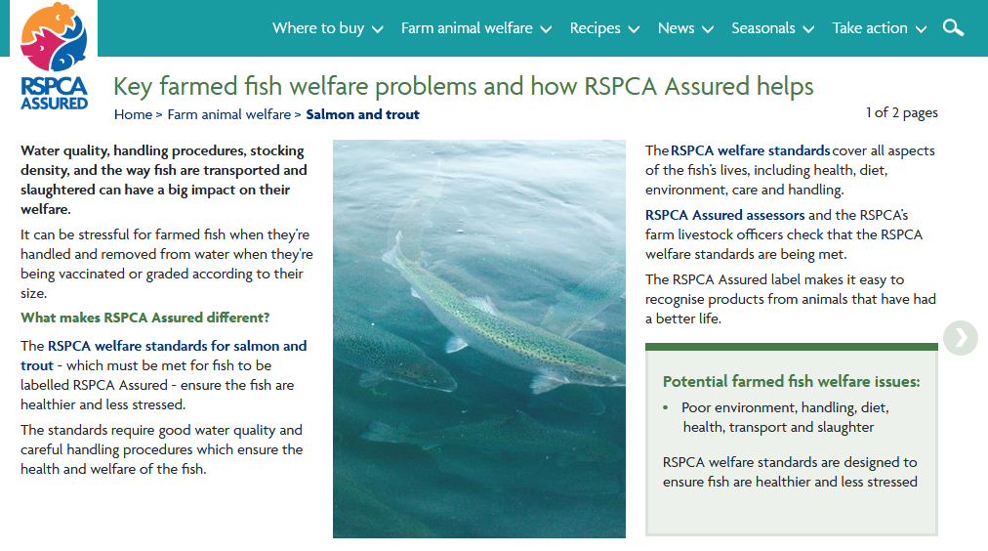

Do these RSPCA Assured salmon farmed by Mowi in Loch Linnhe look "healthier and less stressed" (the fact is that ca. 20-25% of farmed salmon die a horrible death each year)?

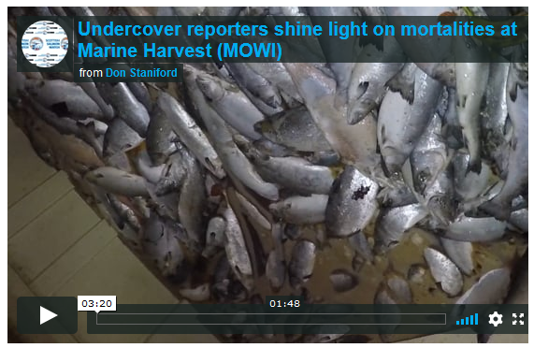

Does this 'cleaner fish' (filmed inside an RSPCA Assured salmon farm operated by Scottish Sea Farms on the Isle of Mull in August 2018) look healthy to you (the fact is that hundreds of thousands of wrasse and lumpsuckers die each year on salmon farms in Scotland)?

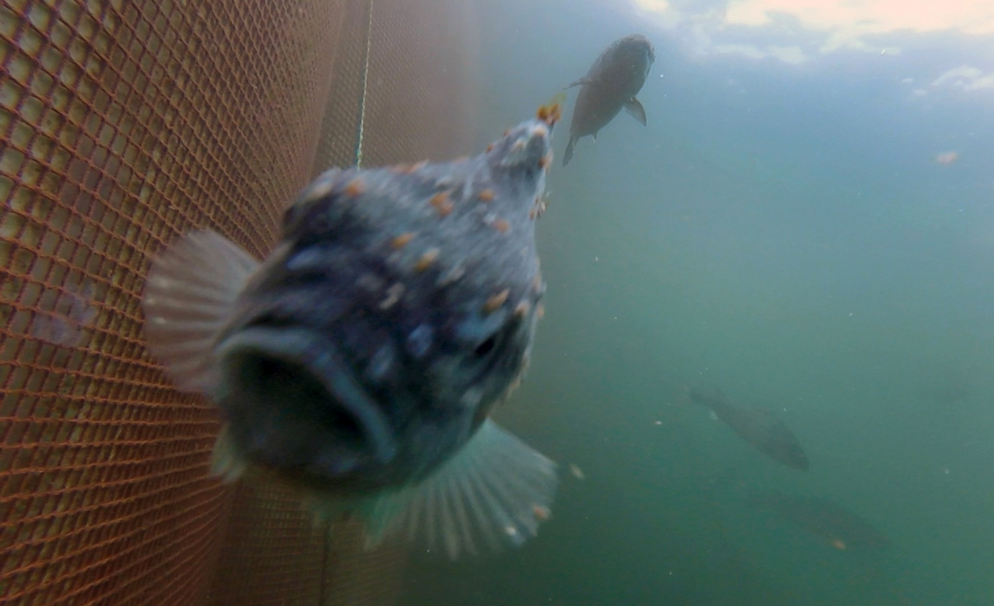
It is alarming to read on the RSPCA's web-site that "there are currently no plans to publish a revised version of the standards".

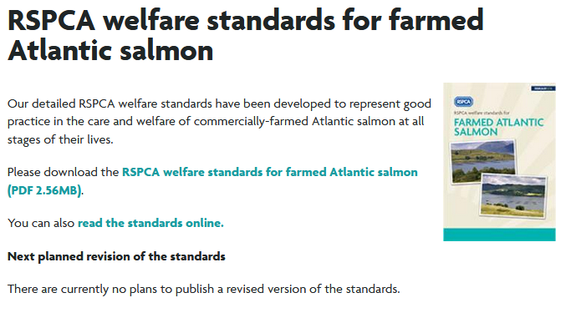

Has the RSPCA not read the recent scientific evidence published in the December 2019 issue of Veterinary & Animal Science detailing welfare problems due to the operation of the Thermolicer (used on salmon farms to kill lice parasites)?

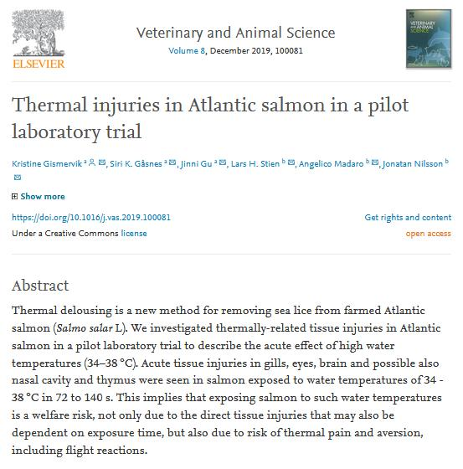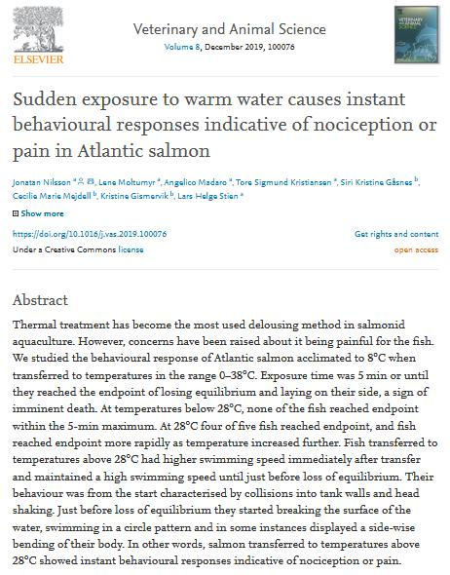

RSPCA representatives and ambassadors may wish to read more details via The Sunday Times (2 February 2020):

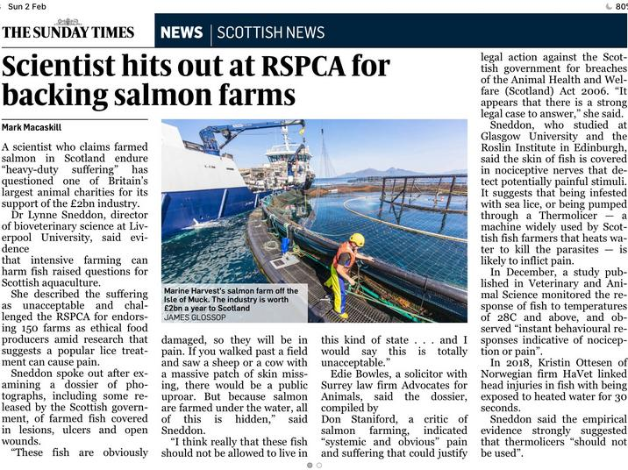

More context to the welfare abuse on salmon farms is available via video interviews with fish welfare expert Dr. Lynne Sneddon of the University of Liverpool:

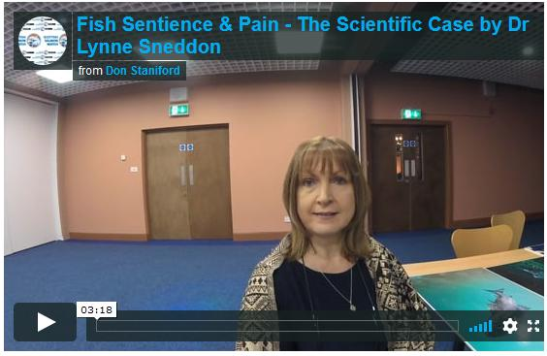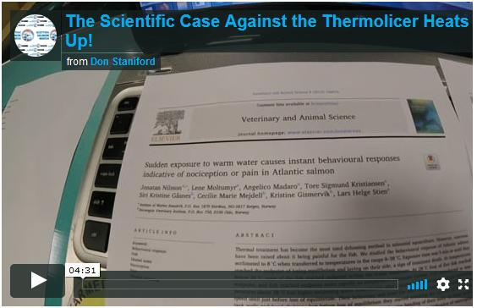
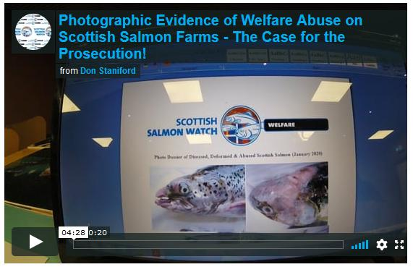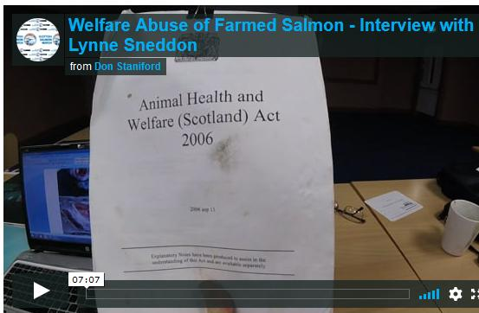
Video footage of a Thermolicer in operation at an RSPCA Assured salmon farm operated by Mowi in Loch Leven is available online here

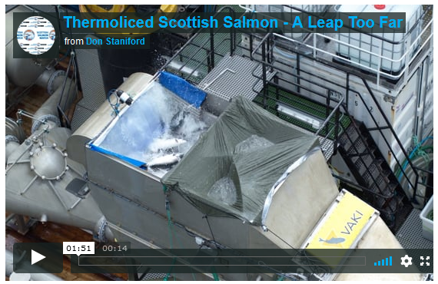

Video footage of thermal injuries due to heat also accompany the scientific papers published in December 2019 in Veterinary & Animal Science.

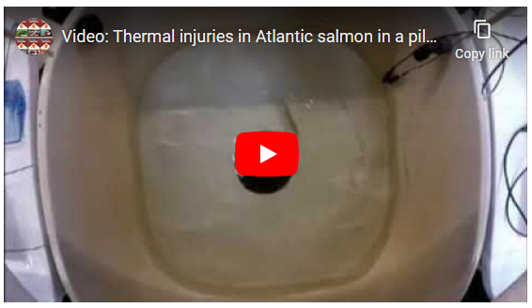

Perhaps the reason why RSPCA Assured (and Freedom Food before it) has given welfare assurance to ca. 70% of salmon farming production in Scotland is a financial vested interest?

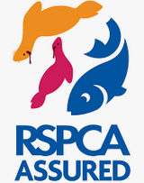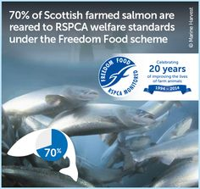
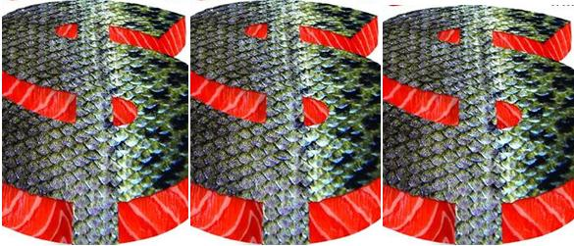

We understand from a report published by Salmon & Trout Conservation Scotland in 2017 that RSPCA Assured rakes in between £800,000 and £900,000 per annum in revenue from the certification of salmon farms in Scotland.

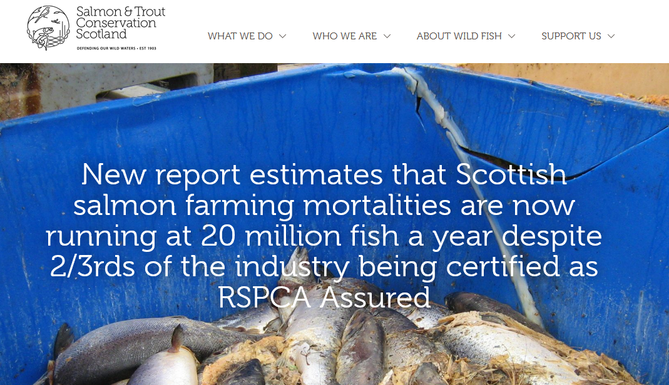
The report - "RSPCA Assured certification of Scottish farmed salmon" - included:

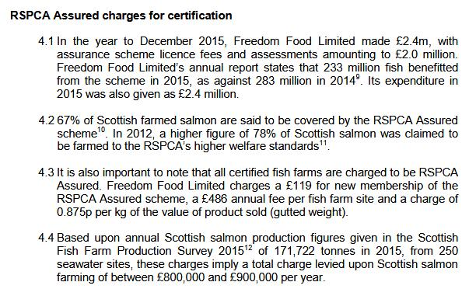

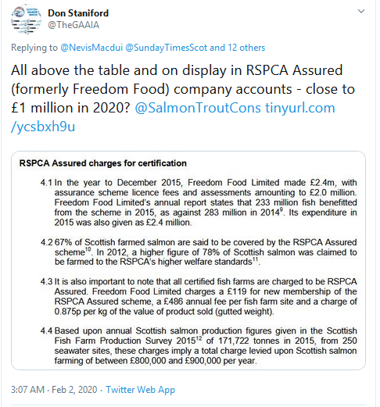
In addition to a financial interest, RSPCA Assured has a conflict of interest in terms of former salmon farming staff now employed by RSPCA Assured.

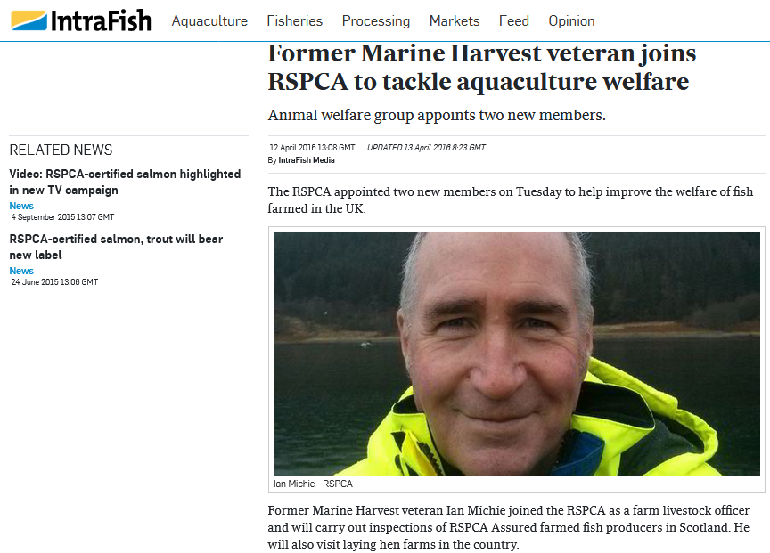

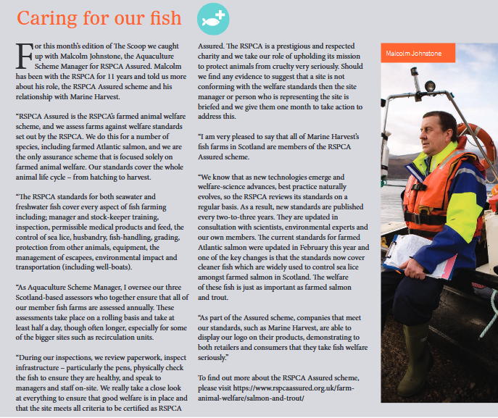
The close working relationship between RSPCA and Marine Harvest (re-named Mowi in 2019 due to negative consumer perception in the name Marine Harvest) raises alarm bells.

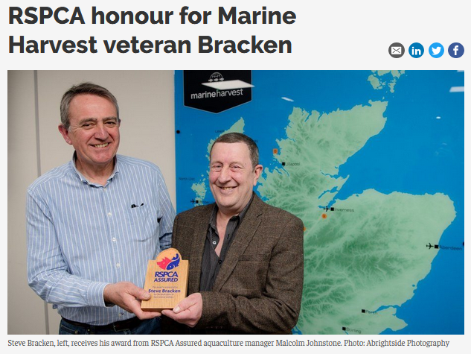

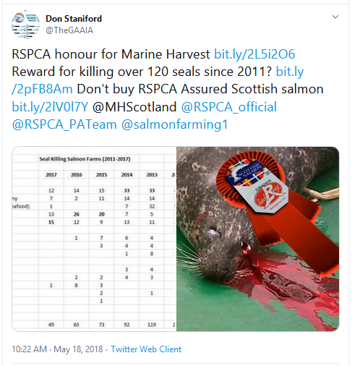
In fact, the composition of the RSPCA Salmon Standards Technical Groups reads like a who's who of salmon farming companies and fails to include representation by NGOs and independent scientific experts on fish welfare.

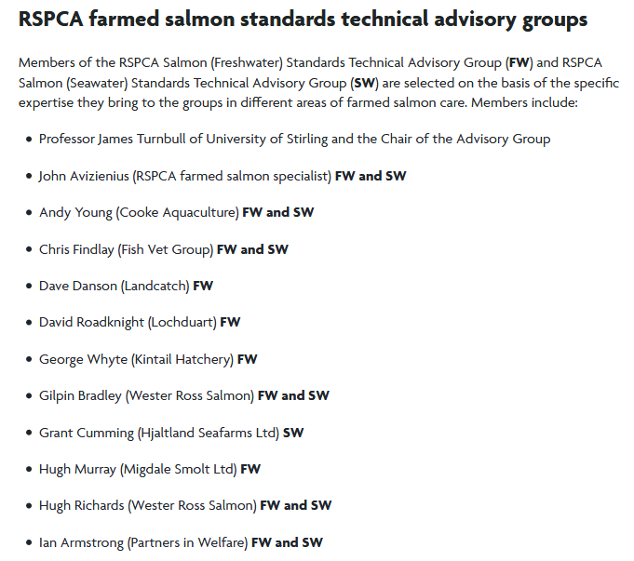
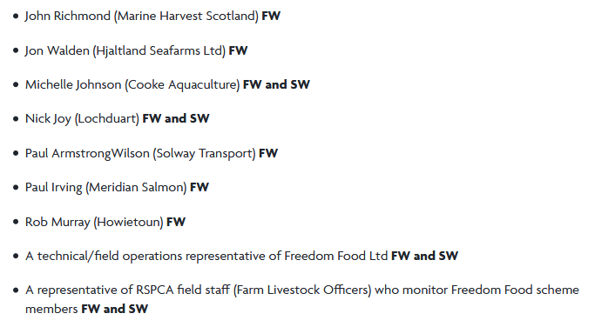
The RSPCA has previously attracted controversy over its support for the killing of seals at RSPCA Assured salmon farms. The Global Alliance Against Industrial Aquaculture reported in 2018:

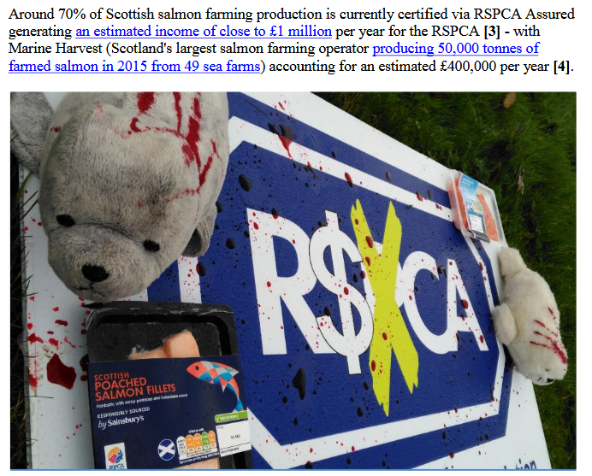

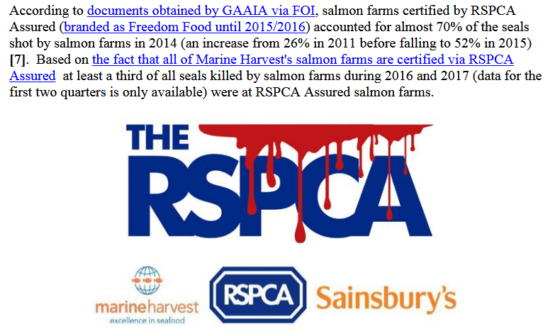
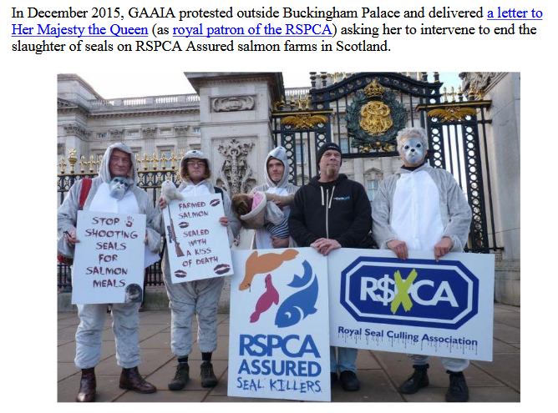

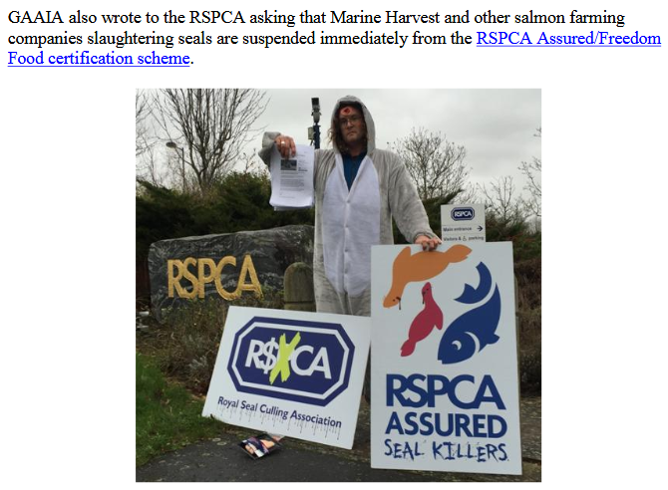

Here's extracts from the Global Alliance Against Industrial Aquaculture's letter to RSPCA Assured/Freedom Food in 2015 asking for a public commitment to end the inhumane practice of killing seals.

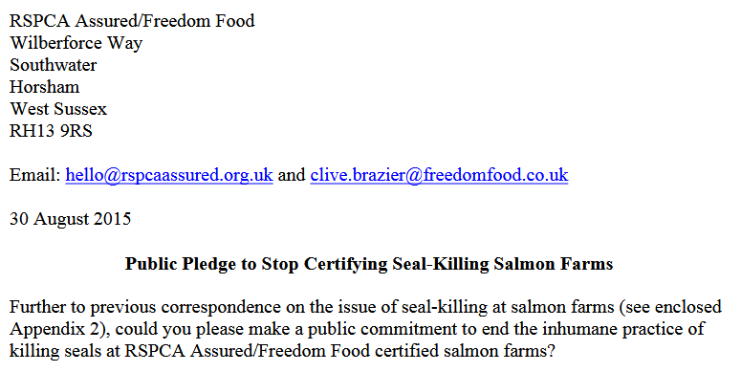

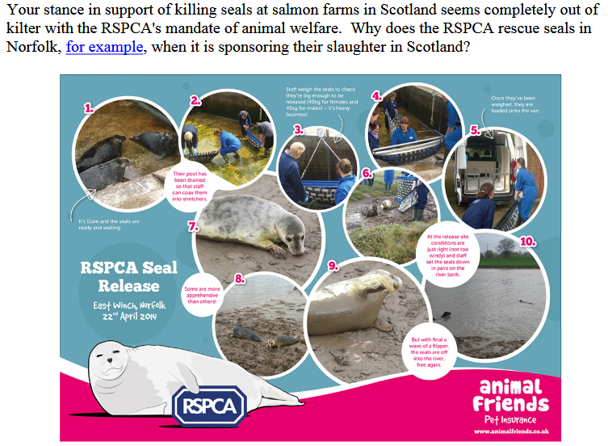

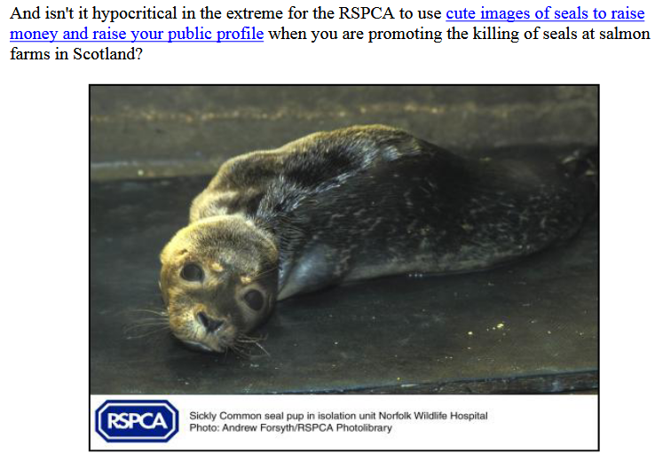

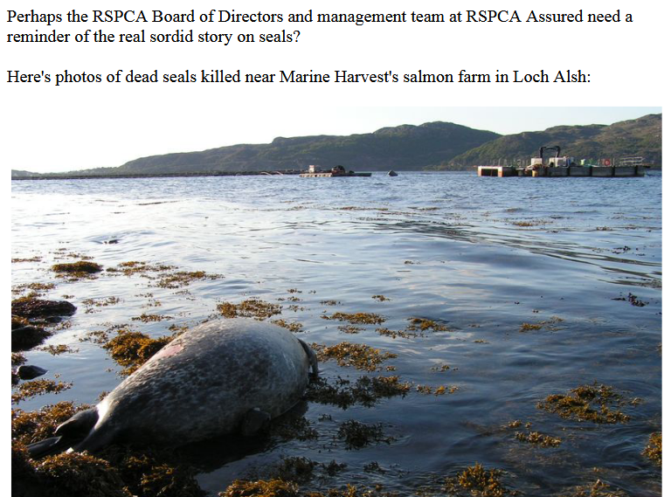

Undercurrent News reported in December 2015:

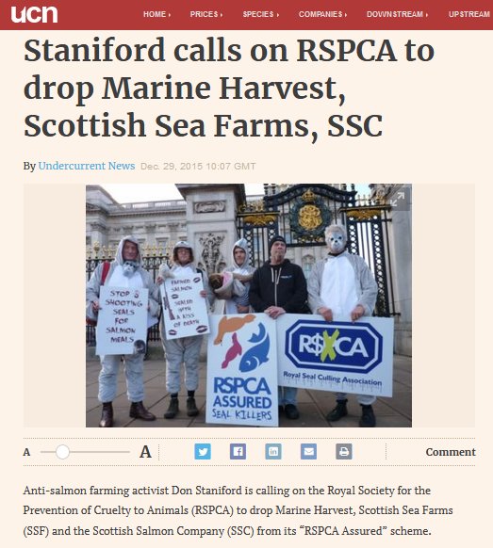
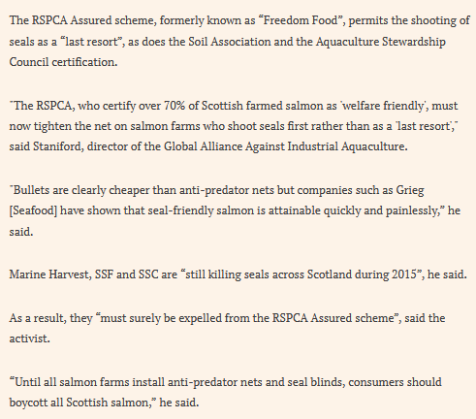
Sadly, in 2020 the RSPCA stills sanctions the killing of seals via RSPCA Assured salmon farms.

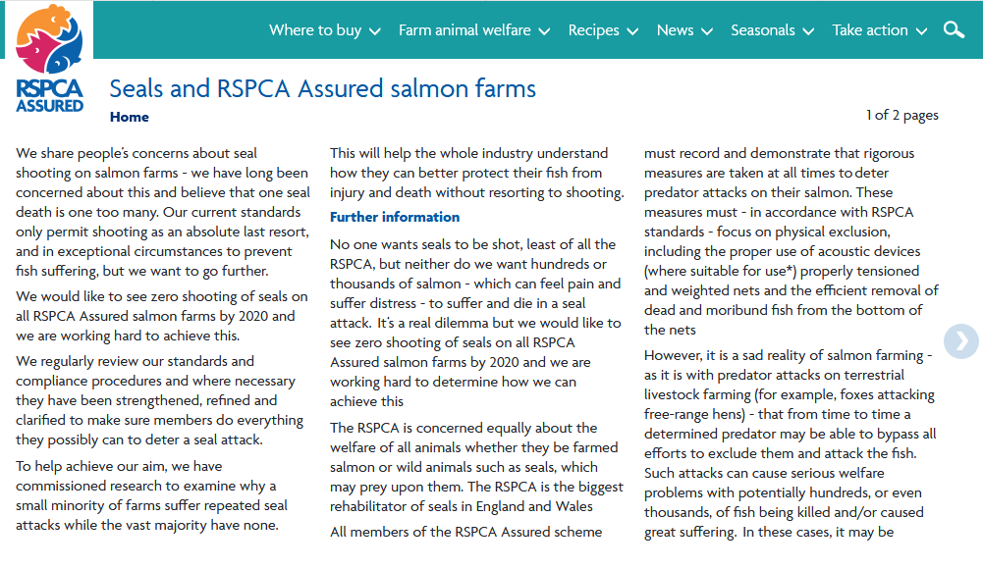

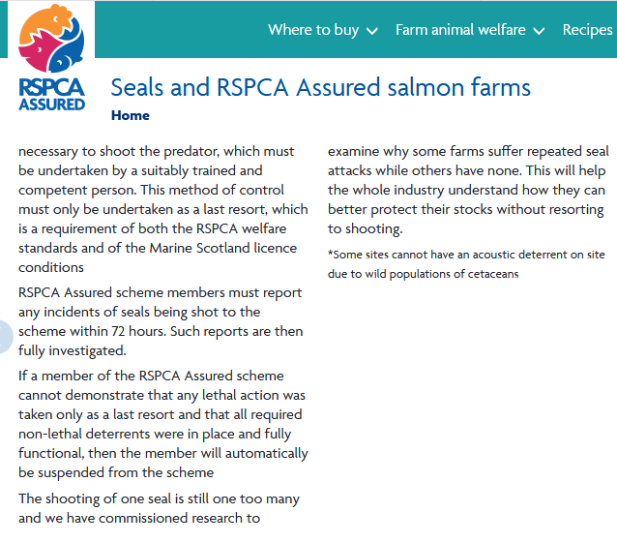
RSPCA Assured salmon farming companies lead the way in the killing of seals - with Marine Harvest (re-named Mowi on 1 January 2019), Cooke Aquaculture, Scottish Sea Farms and Loch Duart slaughtering grey and common seals at RSPCA Assured salmon farms across Scotland during 2019 according to official statistics published by the Scottish Government.

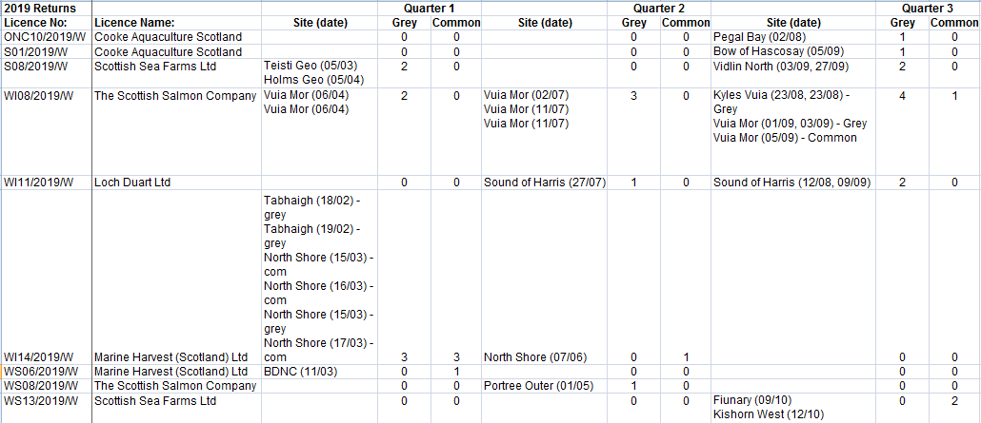
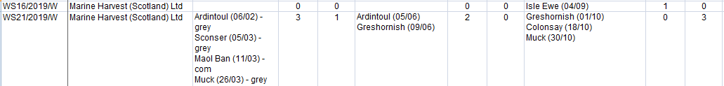

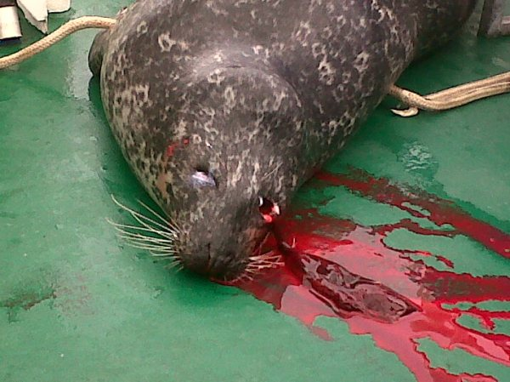
The RSPCA's certification of farmed salmon via Freedom Food and RSPCA Assured has also been long criticised in terms of pollution and lice infestation.



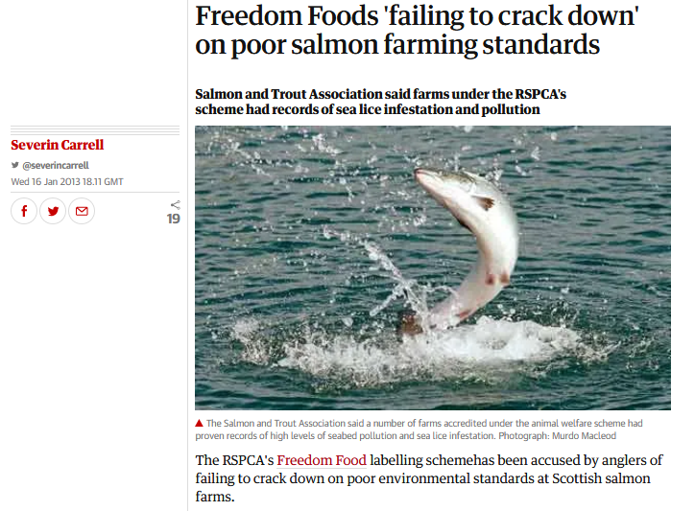

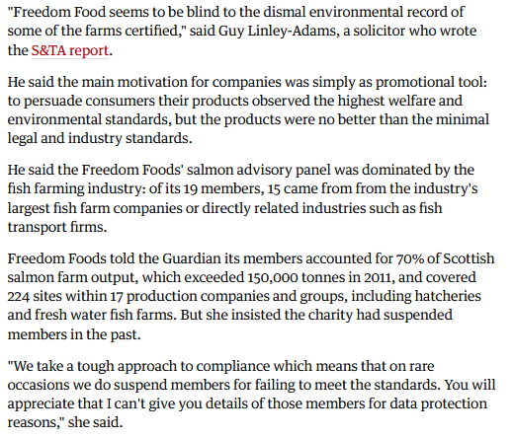
A damning report - 'Fish Welfare on Scotland's Salmon Farms' - published by OneKind in 2018 named and shamed RSPCA Assured Marine Harvest (since re-named Mowi) as operating the worst salmon farms in Scotland (Cooke featured in the list too along with RSPCA Assured Loch Duart).

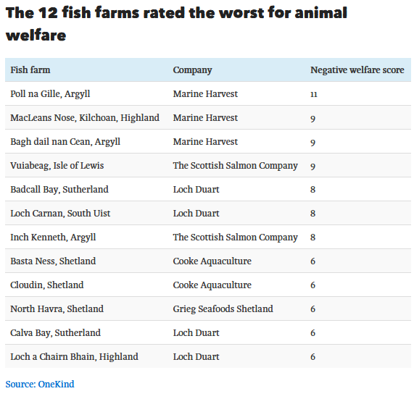

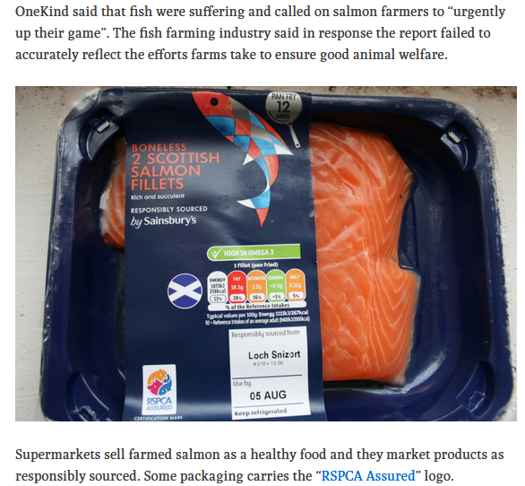
In 2019, the Ferret and Sunday National further showcased Mowi's welfare abuse at salmon farms certified as welfare-friendly via RSPCA Assured.
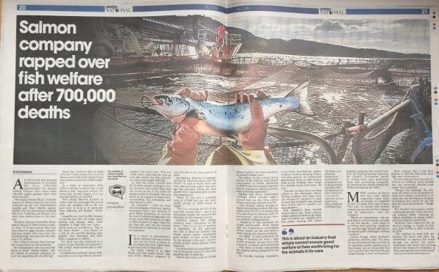
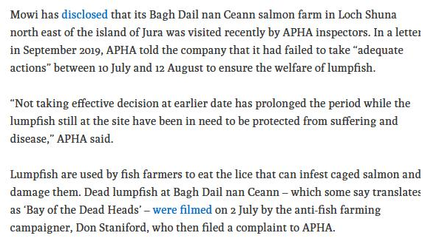
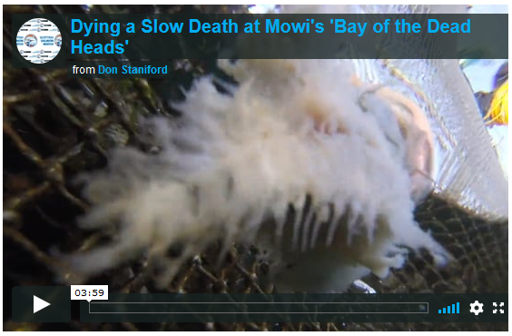
Scottish Salmon Watch would like to request a meeting with RSPCA officials next month in Edinburgh when the RSPCA host a 'Focus on Fish' workshop.

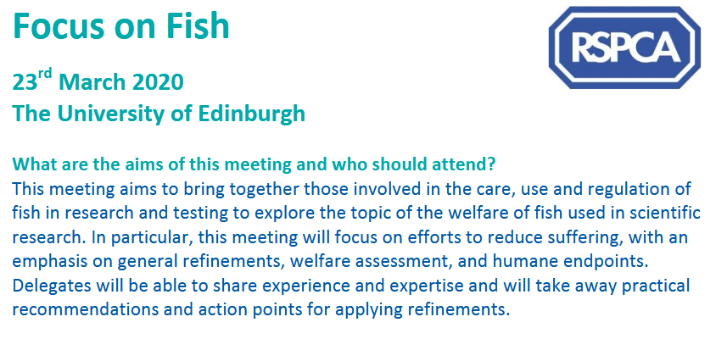

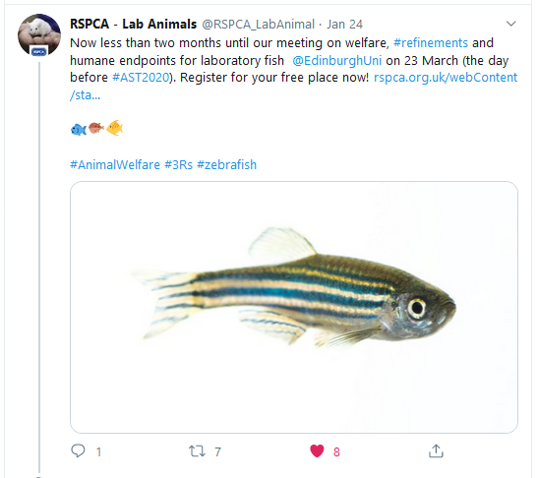

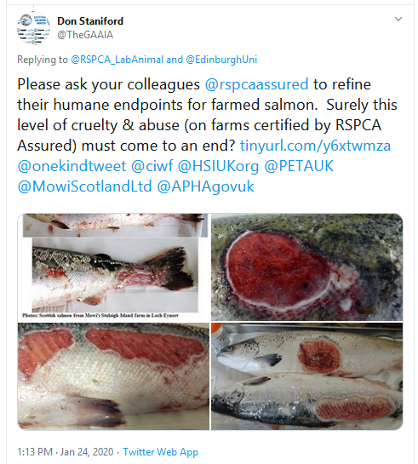

Hopefully we will not have to protest outside the meeting.

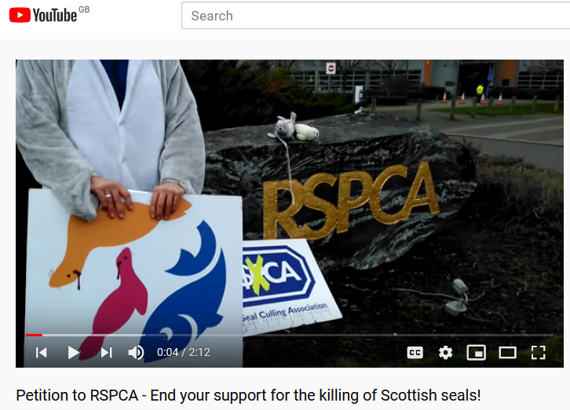
How the RSPCA has any sort of mandate or authority to operate in Scotland is unclear. The Scottish Society for the Prevention of Cruelty to Animals has itself been hijacked by the salmon farming industry with the Chair of the SSPCA a fish veterinarian with Scottish Sea Farms (a company with an appalling track record on welfare and featured by the BBC's One Show in 2017 in relation to mass mortalities and disease problems).

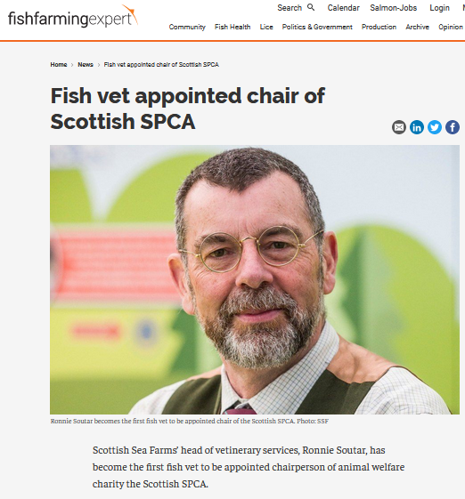

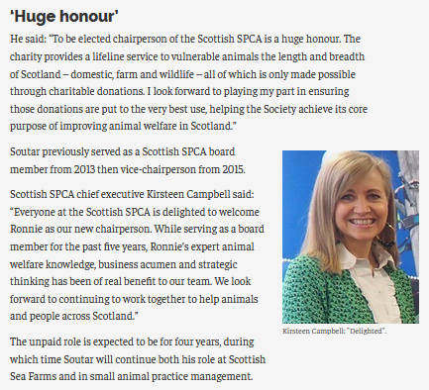
The SSPCA, like the RSPCA, has been lambasted for condoning welfare abuse on salmon farms.

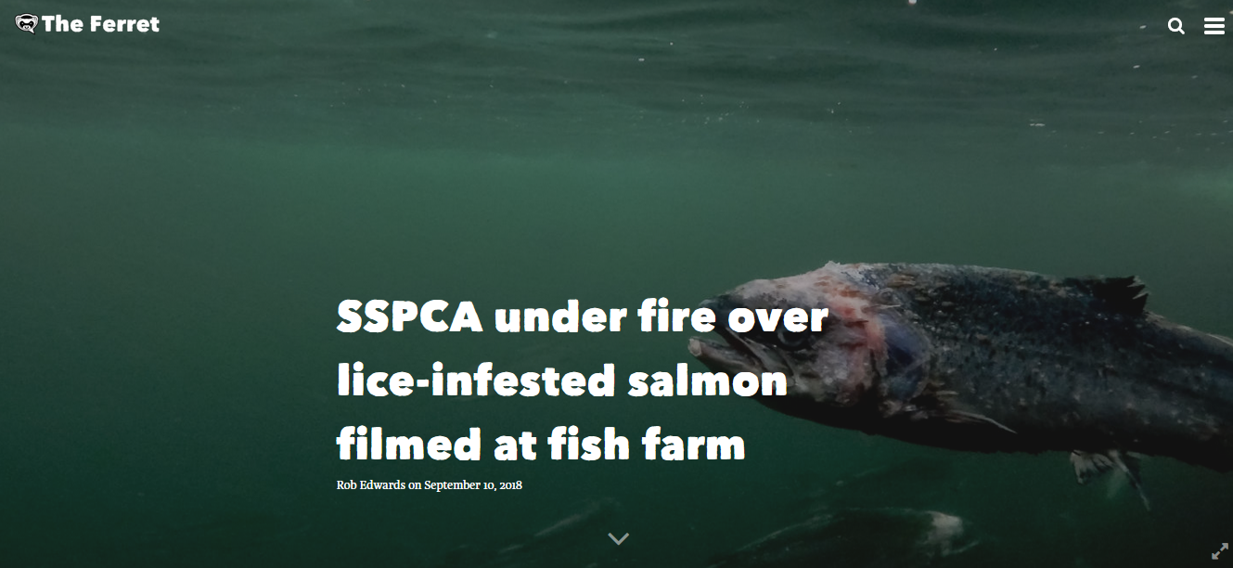
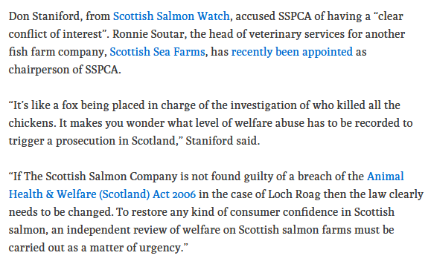
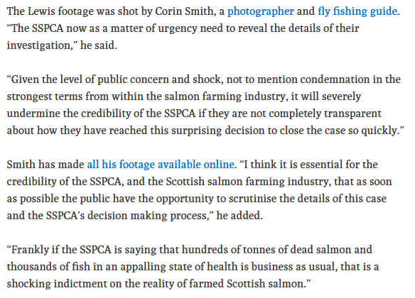
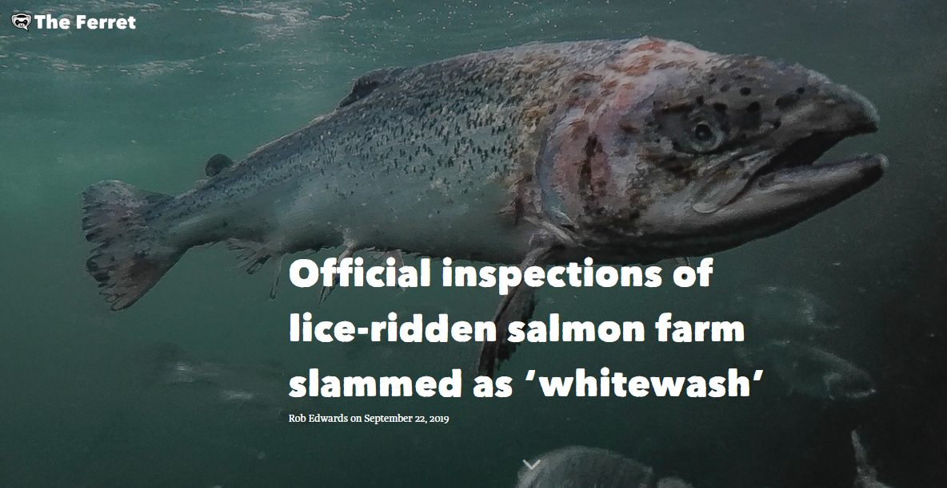

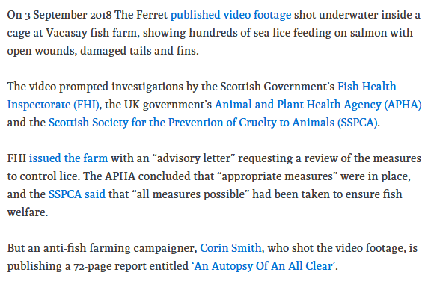
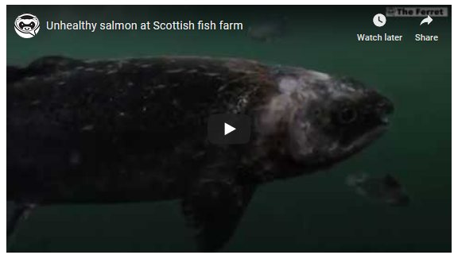
Even if the RSPCA has a legitimate jurisdiction in Scotland, it is clear that the RSPCA's mandate via RSPCA Assured (re-branded away from Freedom Foods in 2015) is "to prevent cruelty to animals by the promotion of humane farming". Documents published online via Companies House in relation to Freedom Food Limited includes the latest annual report for 2018 (published online in July 2019):

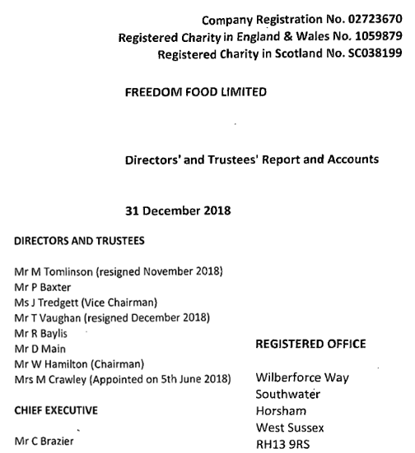

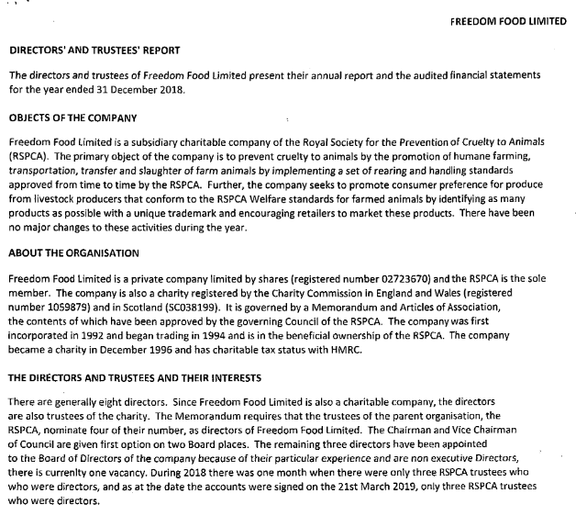
And how can the certification of salmon farms - earning RSPCA Assured close to one million pounds per annum - be seriously viewed as benefitting the public?

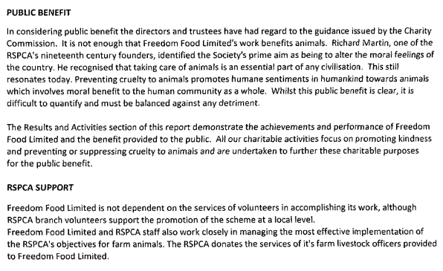

Strangely, it appears that there is no person listed at Companies House as legally responsible for the operation of Freedom Foods Limited (RSPCA Assured):

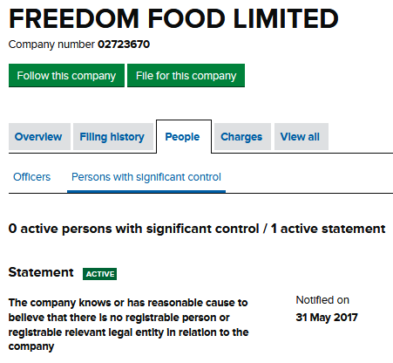

Who at the RSPCA is willing to step forward to publicly support the certification of factory salmon farms via RSPCA Assured?


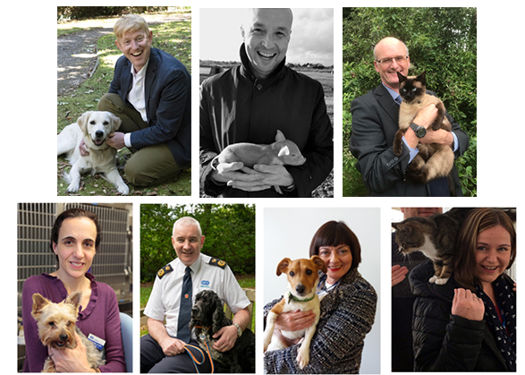





Who at the RSPCA is willing to be the face of Scottish salmon?

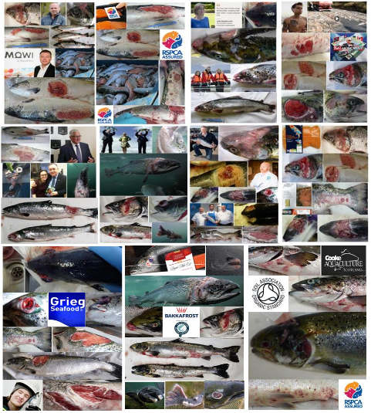

Did the RSPCA's ambassadors really sign up to condone the suffering of salmon via RSPCA Assured?


If the RSPCA's Board of Trustees seriously wished to "end the cruelty that animals suffer" (as stated in the RSPCA's mission) then surely they would send in inspectors to investigate animal cruelty and neglect on salmon farms rather than certify cruelty via RSPCA Assured?

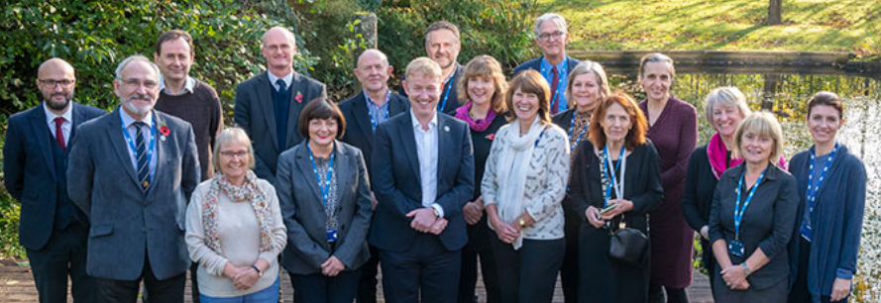

Scottish Salmon Watch believes that RSPCA Assured salmon farms are systematically breaching the Animal Health & Welfare (Scotland) Act 2006 in terms of Section 19 ("Unnecessary Suffering") and Section 24 ("Ensuring Welfare of Animals").

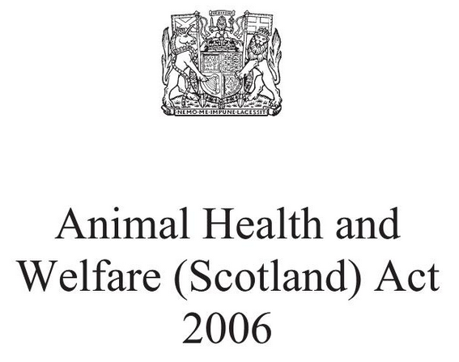

Scottish Salmon Watch asks that you pass this letter onto the RSPCA's executive team, Board of Trustees, ambassadors as well as patrons, vice-presidents and celebrity supporters to allow them all to have an input into the decision-making process. Surely common sense dictates that the RSPCA's principles of preventing cruelty are not sacrificed at the altar of corporate greed and blind profits for RSPCA Assured?
The latest filing at Companies House relating to shareholders of Freedom Food Limited lists the RSPCA as the sole shareholder:

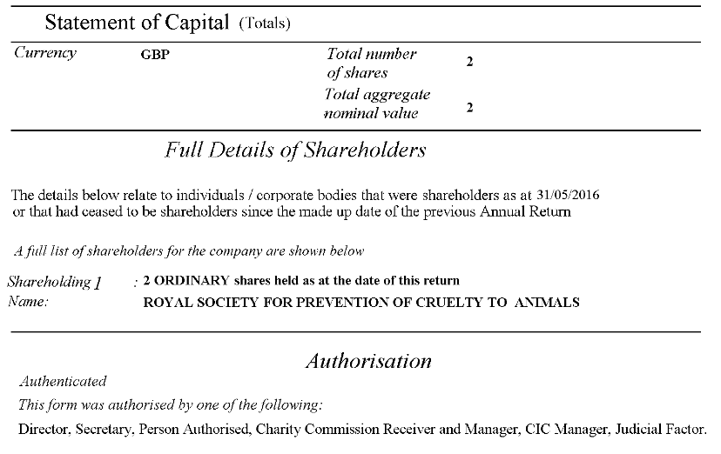

Freedom Food and RSPCA Assured appear to be solely controlled by the RSPCA.

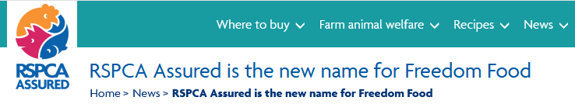
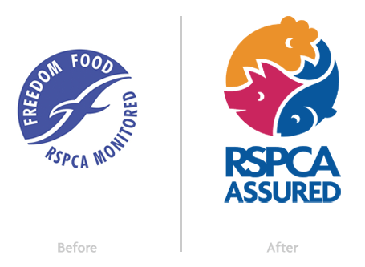
Scottish Salmon Watch concurs with Ewan Kennedy of Save Seil Sound that the RSPCA has a case to answer with the Charity Commission for England and Wales and perhaps also the Office of the Scottish Charity Regulator.

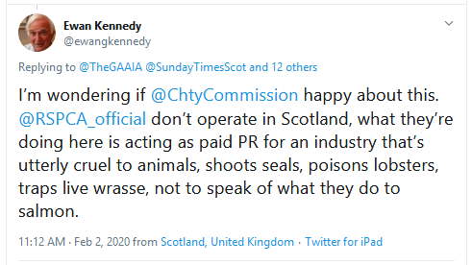

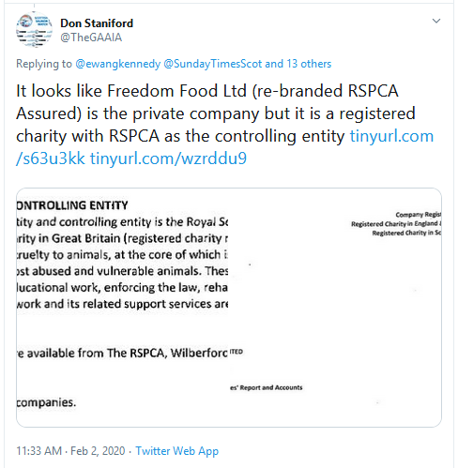

In conclusion, Scottish Salmon Watch recommends the immediate cessation of certification of salmon farms by RSPCA Assured and the withdrawal of the "RSPCA Welfare Standards for Farmed Atlantic Salmon" (February 2018).

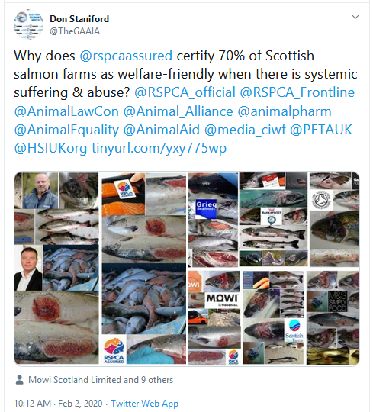

Scottish farmed salmon is a welfare nightmare which does not warrant certification by RSPCA Assured. Shame on the RSPCA executive and shame on RSPCA Assured for profiting at the expense of the welfare of farmed salmon. End the suffering of salmon now by pulling the plug on Scottish salmon including the Thermolicer torture chamber.

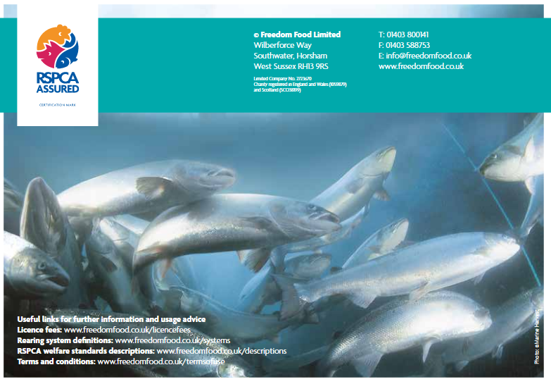
Please do not allow another 25 years of welfare abuse and pollution by Scottish salmon farms.


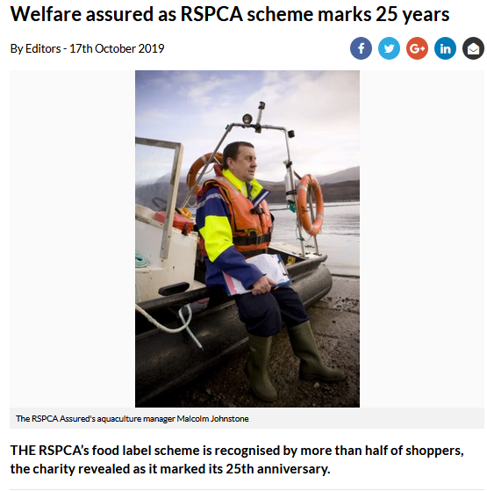

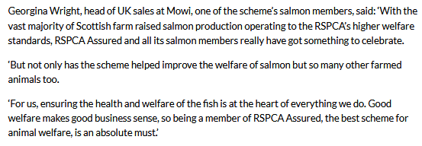

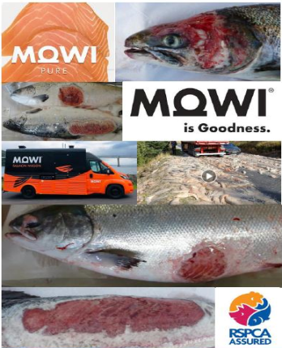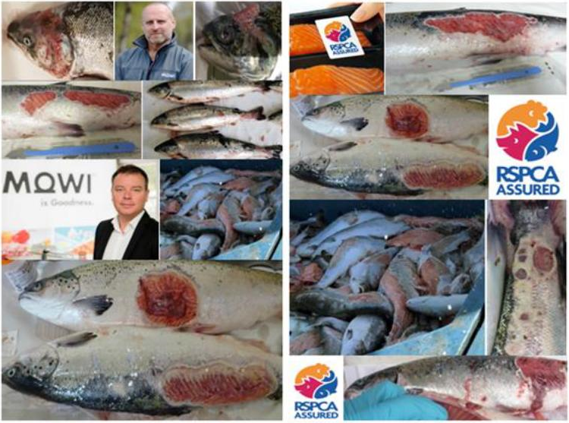
I am on 07771 541826 (salmonfarmingkills@gmail.com) if anyone at the RSPCA would like to discuss the issue of salmon farming and RSPCA Assured certification of Scottish salmon.

Yours sincerely,

Don Staniford

Director of Scottish Salmon Watch

For more background please read:

Sunday Times: "Scientist hits out at RSPCA for backing Scottish salmon farms"
Press Release: "Welfare Abuse on Scottish Salmon Farms - Legal Action Vs Scottish Ministers & Salmon Farming Companies"
Video Exclusive: Dr Lynne Sneddon on Welfare Abuse on Scottish Salmon Farms
Photo Dossier of Diseased, Deformed & Abused Scottish Salmon
The Faces of Scottish Salmon - the Ugly Truth Exposed
Media Backgrounder: The Welfare Nightmare of Scottish Salmon
Named: supermarkets selling salmon from ‘poor’ welfare firms
New report estimates that Scottish salmon farming mortalities are now running at 20 million fish a year despite 2/3rds of the industry being certified as RSPCA Assured
RSPCA Assured certification of Scottish farmed salmon
RSPCA Assured Seal Killers!
Freedom Foods 'failing to crack down' on poor salmon farming standards - Salmon and Trout Association said farms under the RSPCA's scheme had records of sea lice infestation and pollution

