

Cabinet Secretary for Environment, Climate Change and Land Reform
Cabinet Secretary for Rural Economy & Connectivity
The Scottish Government
St. Andrew's House
Regent Road
Edinburgh
EH1 3DG
31 May 2018
Dear Cabinet Secretaries,

Ban Imported Salmon Eggs (Ova) from Norway Due to Disease & Genetic Risks

Why is the Scottish Government allowing salmon eggs (ova) from Norway (and Iceland) to flood the Scottish salmon farming industry when the Norwegian Ministry of Climate & Environment has banned the import of ova from Scotland citing unacceptable disease and genetic risks under Norway's Nature Diversity Act?

Documents disclosed via Freedom of Information by the Scottish Government (24 May 2018) expose the "complete mockery of the brand 'Scottish Salmon". In a stinging attack the head of Scotland's largest salmon egg producer (owned by Dutch multinational Hendrix Genetics) accused the Scottish Government of taking a "massive risk" by allowing salmon eggs from Norway and Iceland to flood 'Scottish' salmon farms citing the danger of "transfer of ISA from infected countries such as Norway". Read more via Press Release: "Complete Mockery of the Brand 'Scottish Salmon'".

In a letter to Fergus Ewing (12 February 2018), Neil Manchester of Hendrix Genetics wrote:

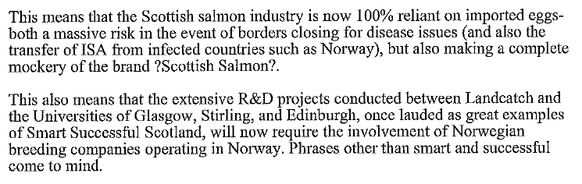

Scottish Salmon Watch urges the Scottish Government to ban imports of salmon eggs from Norway as a matter of urgency to safeguard what's left of the genetic integrity of Scottish salmon. It speaks volumes that the Norwegian Government is fighting to protect biodiversity and values wild salmon highly whilst the Scottish Government is happy to sell wild salmon down the river.
In February 2018, Norway's Ministry of Climate & Environment banned the import of Scottish salmon eggs citing risks of disease and genetic impacts of escapes under the Norwegian Nature Diversity Act.

"Farmed salmon with partial Scottish origin increases the likelihood of a negative impact on Norwegian wild populations above negative effects with Norwegian farmed strains," stated the 22-page letter of refusal. "There is a high probability that genetic mixing between Norwegian wild salmon and farmed salmon of partly Scottish origin will increase the loss of genetic diversity."

"This speaks for the Ministry's view that concern for biodiversity and wild salmon should be given significant weight in the case," continued Norway's Ministry of Climate & Environment. "The Ministry also refers to the value of Norwegian wild salmon as an ecosystem service, or a natural good."

Norway's Deputy Director General at the Ministry of Climate & Environment (Torbjørn Lange) cited a 2017 report by the Norwegian Institute of Nature Research (NINA). "Risk assessment of imports of partly Scottish salmon from Scotland to aquaculture in Norway" - authored by NINA scientists Sten Karlsson and Kjetil Hindar - concluded: "Based on proven genetic distances and that Scottish wild salmon is a separate genetic group different from that found in Norway, fished salmon with partly Scottish origin is considered to have an increased negative effect on wild salmon stocks in Norway."

Scientific research in Scotland has already shown that Norwegian genetic material is threatening the integrity of wild Scottish salmon. The Salmon & Trout Association reported in 2017:

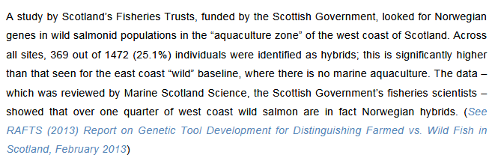

The University of the Highlands & Islands is continuing this work via the research project - "Domestication Genes in Atlantic Salmon: Identification of Markers":

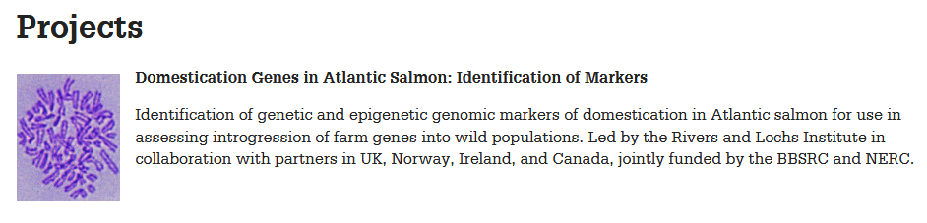
In May 2018, a PhD studentship was advertised by the University of Highlands & Islands to study "Salmon farming in Scotland: quantifying the actual levels of interbreeding and gene introgression of farm escapes with wild populations".

Scientific research published in 2017 reported that introgression of farmed salmon in wild populations in Norway could be as high as 47% (read more via "Half a century of genetic interaction between farmed and wild Atlantic salmon: Status of knowledge and unanswered questions").

In 2013, The Sunday Times reported that one in four wild Atlantic salmon from Scotland was genetically "tainted" by Norwegian fish following scientific research by Rivers & Fisheries Trusts Scotland. In 2013, The Sunday Times reported that "Scots fish are ‘Vikings with kilts on’". Read more via "Scottish Salmon's Great Escape".

Wester Ross Fisheries Trust reported in 2013:

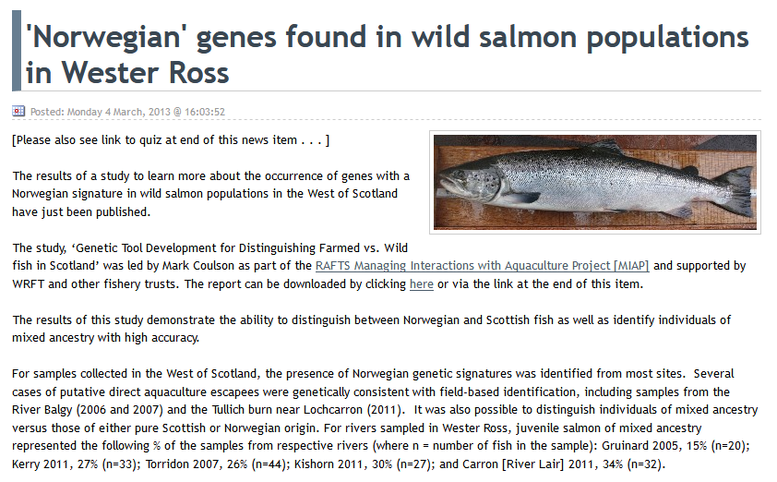

Scottish Salmon Watch filed a Freedom of Information request following a news snippet - "Norway keeps ban on import of Scottish roe" - published in February by Salmon Business which itself triggered a Parliamentary Question from Peter Chapman MSP and a Parliamentary Reply from the Cabinet Secretary for Rural Economy & Connectivity in late February 2018.

"We understand the Norwegian Government are reviewing the decision to ban the import of salmon eggs from Scotland," stated Fergus Ewing on 27 February 2018. "We are in dialogue with the Norwegian Authorities in order to understand the outcome of this review and I will raise the issue at a scheduled meeting with Per Sandberg, Norwegian Minister of Fisheries." This was in reply to a Parliamentary Question filed by Peter Chapman MSP on 19 February 2018: "To ask the Scottish Government what its response is to the Norwegian Government's reported decision to ban the import of salmon eggs from Scotland."
As background, the FOI disclosure by the Scottish Government on 24 May 2018 includes the following timeline:

March 2016: The Scottish Government (Alastair Mitchell) wrote to the Norwegian Government (Yngve Torgersen):

"I've been advised that a recent planned export of Landcatch eggs from Scotland to Norway was stopped by Norway's Environment Directorate on grounds that those eggs are non-Norwegian and are, therefore, an alien species under your regulations (they further allege other imports since June 2015 may have been illegal)."

May 2016: Neil Manchester, Managing Director of Hendrix Genetics (owners of Landcatch) wrote to the Scottish Government (Willie Cowan) asking that the Scottish Government "act in a reciprocal fashion regarding all imports of live salmon eggs and smolts from Norway". In other words, ban imports of salmon eggs and smolts from Norway.

June 2016: Neil Manchester, Managing Director of Hendrix Genetics (owners of Landcatch) wrote to the Scottish Government (Willie Cowan): "We have just received confirmation from the Fisheries Department in the Norwegian Government that they have rejected our appeal, and are upholding their decision to prevent the movement of salmon eggs from Scotland into Norway as they believe that mixing phylogeographic strains of salmon will have a serious impact on wild fish stocks."

Hendrix Genetics requested an assurance from the Scottish Government "that exactly the same challenges will be put to any application for the movement of live salmon eggs or smolts from Norway into Scotland, and that movements should only be permitted if it can be proven that the strain matches native Scottish strains of salmon."

June 2016: Michael Russell (now the Scottish Government's Minister for UK Negotiations on Scotland’s Place in Europe) wrote to Neil Manchester of Hendrix Genetics and Fergus Ewing (Cabinet Secretary for Rural Economy & Connectivity): "I had been alerted to the potential for this problem to arise and it is certainly now very pressing. I hope Fergus can find a way forward, perhaps by direct contact with the Norwegian Government but I am happy to raise it in the Parliament in the new session (we are now about to go into recess) if a solution has not been found by then."

July 2016: The Scottish Government wrote to Hendrix Genetics: "Scottish Government are going to follow this up as a matter of urgency with the Norwegian Government....In relation to the trade of imported Atlantic ova from Norway, Scottish Government do not consider Atlantic salmon ova of Norwegian origin to be an alien or locally absent species according to the definitions provided in the EU Regulation. We would therefore not consider any reciprocal action in this regard."

February 2018: Neil Manchester of Hendrix Genetics wrote to Fergus Ewing (email copied to Michael Russell): "In the press today it was reported that the Norwegian Environment Ministry issued a communique saying it will not allow the import of farmed salmon from Scotland for aquaculture in Norway, citing fears that escapees could 'further weaken' the country's wild salmon population. This coincides with Hendrix Genetics being issued with a 22 page letter explaining why Scottish genetics are seen as a threat to the Norwegian wild stocks and why their decision to ban our import of eggs from Scotland into Norway is final and not open to appeal."

"Thus, thanks in part to a spectacular lack of support from parties who should have shown an interest, our case is lost," continued the Managing Director of Hendrix Genetics. "The Landcatch breeding programme, established in 1980 by Sir William Lithgow, heavily funded during the 1990s through Scottish Enterprise, and the only independent Scottish salmon egg producer in existence, will now be terminated. This means that the Scottish salmon industry is now 100% reliant on imported eggs - both a massive risk in the event of borders closing for disease issues (and also the transfer of ISA from infected countries such as Norway), but also making a complete mockery of the brand 'Scottish Salmon'. This also means that the extensive R&D projects conducted between Landcatch and the Universities of Glasgow, Stirling and Edinburgh, once lauded as great examples of Smart Successful Scotland, will now require the involvement of Norwegian breeding companies operating in Norway. Phrases other than smart and successful come to mind."

March 2018: Neil Manchester of Hendrix Genetics emailed the Cabinet Secretary for Rural Economy & Connectivity (Fergus Ewing): "The point here is that if the Minister accepts this decision, and thereby the reasoning behind it, he must answer why he is unwilling to afford the same level of protection to wild salmon. Alternatively, since our independent salmon breeding and egg production business in Argyll has been destroyed by this decision and the time it has taken to reach it, I would hope that Scottish government would recognize this and act/react accordingly."

The Global Alliance Against Industrial Aquaculture (GAAIA) pointed out in a press release (16 April 2017) that:

- In 2016, 53% (22.6 million) of imported eggs were sourced from Norway via Aquagen (a company genetically fingered by a peer-reviewed scientific paper as the source of ISA outbreak in Chile)
- In 2016, Norwegian-owned Marine Harvest imported 14.5 million eggs - all from Norway - accounting for 34% of all egg imports
- In 2016, the Scottish Salmon Company imported 12.4 million eggs - again all from Norway - accounting for 30% of eggs imports
- No data for Scottish Sea Farms is available because "disclosure of this particular information would, or would be likely to, prejudice substantially the confidentiality of commercial information provided by Scottish Sea Farms and thus cause substantial harm to their commercial interests"
Download the FOI data from the Scottish Government as an Excel spreadsheet online here
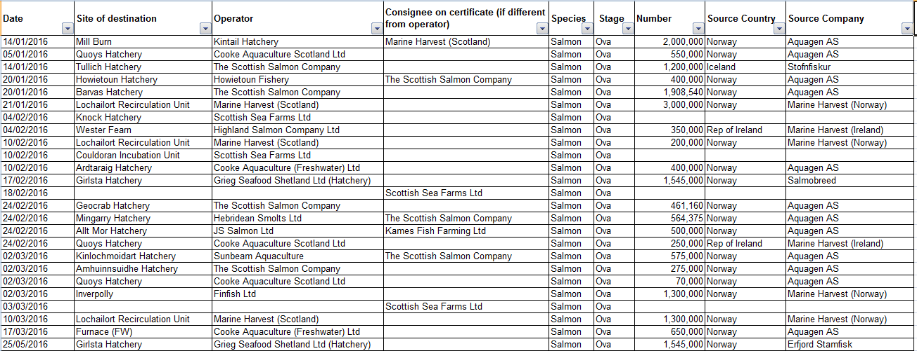
Read more via: Press Release: "Viking Invasion Taints 'Scottish' Salmon"

The latest data published by the Scottish Government in September 2017 reveals that 91% of 'Scottish' salmon is sourced via imported eggs from overseas (predominantly from Norway and Iceland).

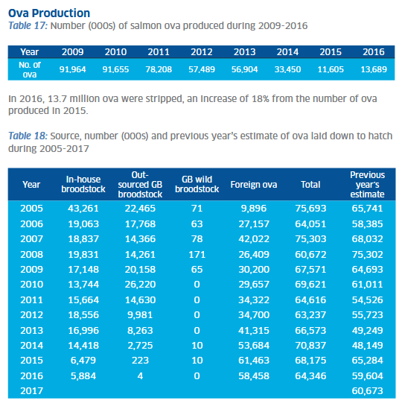
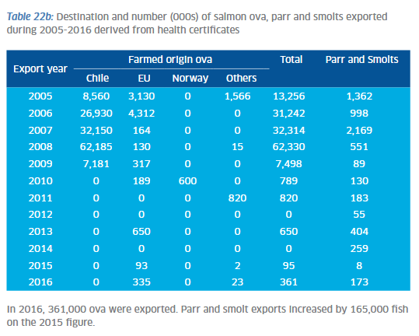

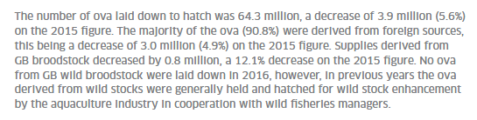

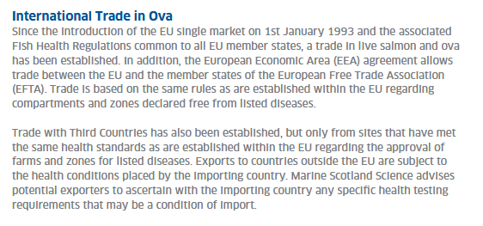

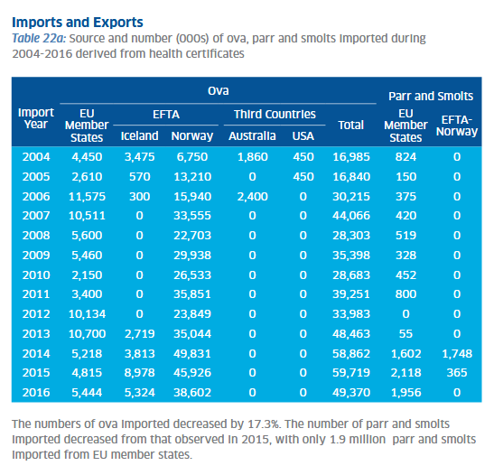

A paper published in the journal Aquaculture in 2016 revealed how Scottish salmon farming has been flooded by imports of foreign salmon eggs (ova) over the last few decades.

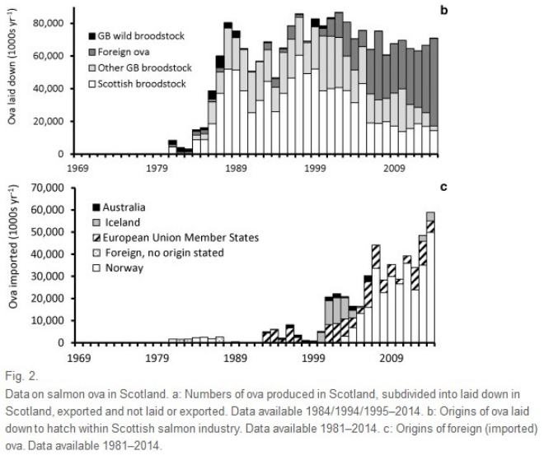
The Scottish Parliament's salmon farming inquiry briefly touched upon the issue in oral evidence from the predominantly Norwegian-owned salmon farming companies on 2 May:

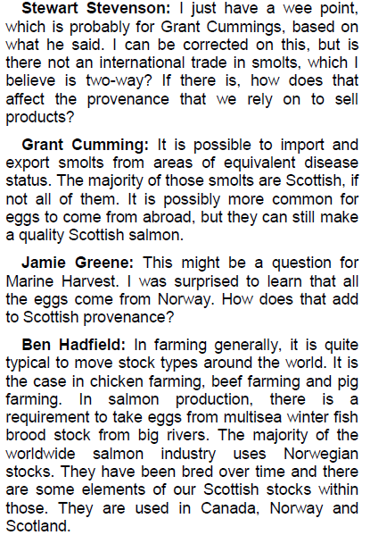

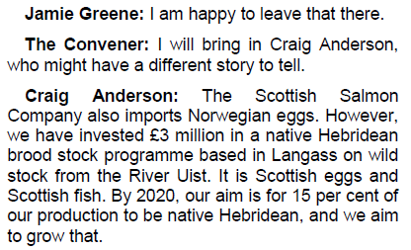

In conclusion, the reputation of the 'Scottish Salmon' brand is cracked beyond repair and is an international joke. When is the Scottish Government going to start protecting native wild salmon rather than protecting predominantly Norwegian companies importing Norwegian salmon eggs into Scotland to pass off to unsuspecting consumers as 'Scottish' salmon?

Do you still concur with the following statement in July by the Scottish Government?

"In relation to the trade of imported Atlantic ova from Norway, Scottish Government do not consider Atlantic salmon ova of Norwegian origin to be an alien or locally absent species according to the definitions provided in the EU Regulation. We would therefore not consider any reciprocal action in this regard"

'Scotland’s 10 Year Farmed Fish Health Framework' published earlier this month (23 May 2018) cites ova yet fails to tackle the issue of imports from Norway and Iceland (where infectious diseases carry, to steal the words of Neil Manchester of Hendrix Genetics, a massive risk):

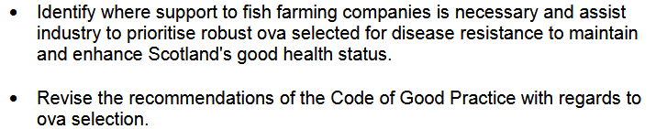

Why does the Scottish Government not immediately ban the import of ova from Norway?

Yours sincerely,

Don Staniford

Director, Scottish Salmon Watch


Cc:
Michael Russell MSP and Minister for UK Negotiations on Scotland's Place in Europe
Peter Chapman MSP
Mark Ruskell MSP

