MEDIA ADVISORY

Scottish Salmon Watch, 11 June 2018

Sounding Off About Scotland's Noisy Salmon Farms
- Turn Off Acoustic Deterrent Devices to Protect Cetaceans

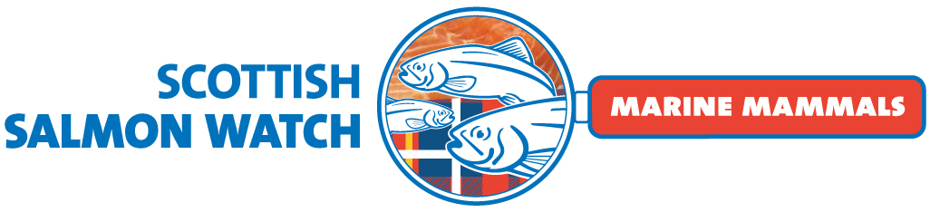

Campaigners are calling for a ban on the use of Acoustic Deterrent Devices (ADDs) - used on Scottish salmon farms to scare away seals - due to their impact on cetaceans including harbour porpoises and minke whales. A new report authored by the Scottish Association of Marine Science (SAMS) examining 'low frequency' ADDs is due be published via the Scottish Aquaculture Research Forum (SARF) later this month, perhaps even this week.

In response to complaints that ADDs used on salmon farms are 'recklessly disturbing' cetaceans and breaching the EC Habitats Directive, a "new generation" of low-frequency 'cetacean friendly' models have been assessed by a SARF project which was funded in 2016. The report - Low-frequency Acoustic Deterrent Devices and Porpoises (LEAP): Assessing potential impact of low-frequency Acoustic Deterrent Devices (ADDs) on cetaceans in Scottish coastal waters will be published "soon, possibly as early as mid- to late June" [1].

In a report on the environmental impacts of salmon farming published in March 2018 the Environment, Climate Change and Land Reform Committee recommended that "fish farms cannot use ADDs". In April 2018, the Hebridean Whale & Dolphin Trust's written submission to the Scottish Parliament's salmon farming inquiry cited new research on the impact of ADDs on minke whales even at low frequencies [2].

"Turning down the volume of ADDs will not solve the problem," said David Ainsley, a whale watching tourist operator. "Lower frequency ADDs may be less disturbing for porpoise but worse for dolphins and minke whales. The use of ADDs by salmon farms constitutes 'reckless disturbance' and is an offence under Scottish law and the EU Habitats Directive. As with the shooting of seals there must be a zero tolerance to ADDs."

"All current ADDs including the so-called 'cetacean friendly' models emit very loud noises well above the reported thresholds for disturbance and hearing damage to cetaceans," continued Ainsley who filed a complaint with the European Commission in April 2018. "This is why no ADDs can comply with the requirements of the law protecting cetaceans from disturbance and injury. Because ADDs are not very effective, seal shooting will continue until farms stop using ADDs and instead fit double-skinned anti-predator nets, as used in British Columbia where licenses are no longer being issued for ADDs."

ADDs were banned in British Columbia nearly twenty years ago with scientific research detailing significant impacts on cetaceans. "We're heard your concerns that the actions taken by salmon farmers to keep predators away from the fish pens can be harmful to wildlife," stated the BC Salmon Farmers Association in 2015. "All of our farms companies have voluntarily banned the use of firearms on their farms. Also, salmon farmers stopped using Acoustic Deterrent Devices before they were eventually banned in 2000."

The SARF report - Low-frequency Acoustic Deterrent Devices and Porpoises (LEAP): Assessing potential impact of low-frequency Acoustic Deterrent Devices (ADDs) on cetaceans in Scottish coastal waters - is authored by scientists working at the Scottish Association of Marine Science (SAMS) in Oban. Lead researcher Dr. Stephen Benjamins of SAMS told Scottish Salmon Watch (21 May 2018): "The report you are referring to is presently in the final stages of peer review. I would imagine the final version will be published by SARF soon, possibly as early as mid- to late June."

"The project has been quite delayed, but we are now at the final stages of peer review/Board approval," said SARF's secretary Richard Slaski in an email to Scottish Salmon Watch (22 May 2018). "Our best estimate is that it should be ready for publication on the SARF website by the end of the third week of June".

Scottish Natural Heritage stated on 20 April 2018 in reply to a Freedom of Information (FOI) request:

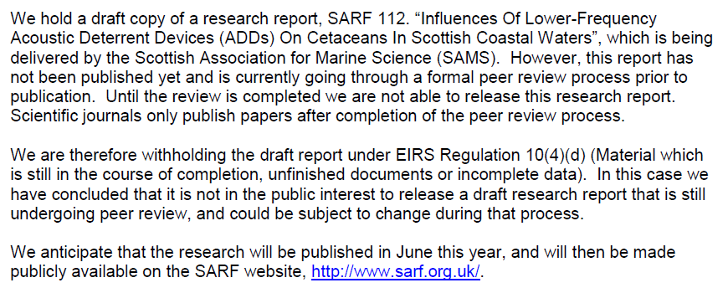

"This [SARF] project aimed to establish the effects of the use of lower frequency acoustic signals delivered by a new generation of 'cetacean friendly' ADD devices on harbour porpoises in the context of Scottish coastal waters aquaculture sites," writes Dr. Denise Risch of SAMS on her web-page.

"Marketing for these devices typically labels them as ‘cetacean friendly’ or ‘environmentally friendly’," stated the SARF project proposal dated April 2016. "While the theory behind these claims appears logical, there has been little field based assessment of their effects on cetaceans and validation of the claims made". SARF explained:

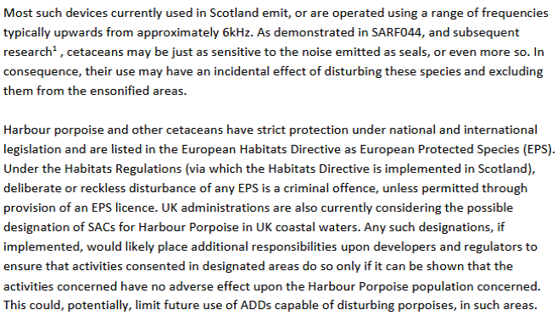

'Scotland’s 10 Year Farmed Fish Health Framework' (FFHF) published on 23 May 2018 included:
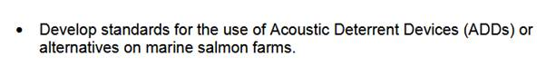

"We have offered SNH input into the planned working groups deriving from the FFHF and this is one area we would particularly hope to influence," said SNH's Cathy Tilbrook in an email to Scottish Salmon Watch (29 May 2018).

In April 2018, Cathy Tilbrook gave oral evidence to the Scottish Parliament's salmon farming inquiry admitting that SNH did not know if salmon farming was impacting on the marine environment.

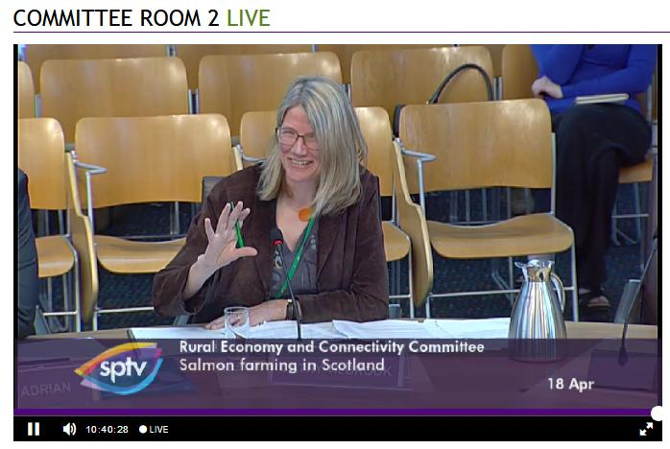

Read via Daily Mail: "We've no idea if we're curbing damage of fish farms, admit watchdogs"
On the issue of ADDs, SNH's Cathy Tilbrook testified to the Rural Economy & Connectivity Committee (18 April 2018) that "we have not yet got the answers":

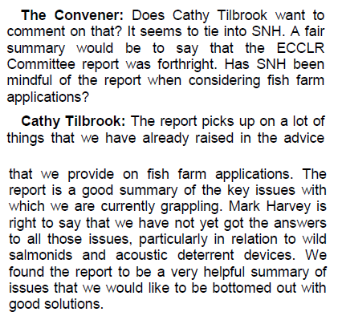

"The answer is breathtakingly simple," said Don Staniford, Director of Scottish Salmon Watch. "Ban all ADD's on salmon farms. This chimes with the requirements of the Aquaculture Stewardship Council's salmon standard, public commitments made by Marine Harvest, the recommendation of the Scottish Parliament's ECCLRC, Scotland's legal obligations via European law and the ban in British Columbia. Scientific research is screaming out - noisy ADDs used continuously by salmon farms are causing hearing damage to cetaceans even at low frequencies. The message to the Scottish Parliament and Scottish Government is loud and clear - don't just turn down the volume, turn the noise pollution off completely. As far as cetaceans are concerned, salmon farms should be seen and not heard!"

In May 2018, via oral evidence to the Scottish Parliament's salmon farming inquiry, Scotland's largest salmon farming company pledged that all Marine Harvest sites would be accredited by the Aquaculture Stewardship Council's salmon standard which prohibits the use of ADDs by 2020 (only one salmon farm in Loch Leven is currently ASC accredited out of 36 sites) [3].

In January 2017, the Joint Nature Conservation Committee (JNCC) in Aberdeen wrote to SNH in an attempt to input data from ADD use on salmon farms into the UK Marine Noise Registry (a commitment made in the UK Marine Strategy). "As yet we have been unable to collect data associated with ADD use at fish farms," explained JNCC in an email [4]. Scottish Salmon Watch has filed a FOI request for any data now collected.

Despite growing scientific evidence that ADDs are causing 'reckless disturbance' of cetaceans, the Scottish Government gave a ringing endorsement on BBC's Sunday Politics Scotland show in March 2018:

"The position which we all wish to see is every method used to scare seals away from cages and as the Minister responsible I am very pleased that technology now including the use of sonar devices means that it is now proving possible to do this in increasing occasions," said the Cabinet Secretary for Rural Economy & Connectivity (Fergus Ewing).


BBC News reported (25 March 2018):

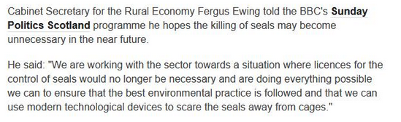

During oral evidence before the Environment, Climate Change & Land Reform Committee (ECCLRC) in February 2018, Mark Harvey of Highland Council claimed to be "trying to control ADD use":
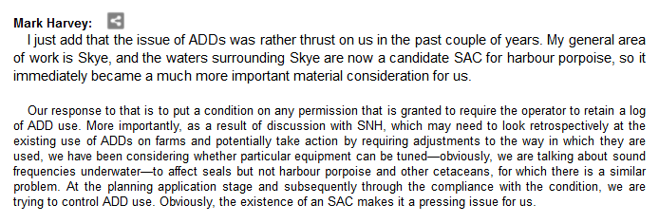

Documents obtained via FOI from Highland Council in March 2018 claim that Marine Harvest Scotland (MHS) is "moving in the right direction" in terms of "unregulated ADD noise" (according to emails from SNH in 2017) [5].

"The proposed ADD at Sconser Quarry is the low frequency TR1 so one of the less disturbing devices for harbour porpoise," reported SNH''s Alex Turner to Highland Council in July 2017. "The challenging issue relates to assessing existing unregulated ADD noise from the 3 x existing sites which use the more disturbing US3 devices. MHS are moving in the right direction on that too (better guidance and training for Farm Managers) but clearly that's much more difficult to address in planning terms."

A 'Predator Mitigation Plan' (August 2017) for Marine Harvest's new Isle of Rum salmon farm - approved by Highland Council in January 2018 - included:

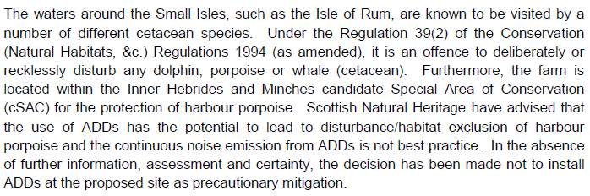

In a letter to Highland Council in August 2017, Grieg Seafood admitted: "ADDs have the potential to impact on the Harbour Porpoises covered by the Inner Hebrides and the Minches SAC and may result in disturbance/habitat exclusion".

In an email regarding ADD use at the Scottish Salmon Company's salmon farm in Portree Outer (obtained via FOI from Highland Council), SNH advised in January 2017: "The proposed system does not appear to meet our aim of minimising additional noise inputs into the cSAC. Rather than following the principle of being targeted to sound when seals are present, it appears that this device would sound intermittently most of the time".

Documents obtained via FOI last year from the Scottish Government revealed that 164 salmon farms use ADDs with 112 salmon farms where ADDs are listed as "Always On" [6].

Information disclosed by SNH in 2017 detailed companies and regions which use and do not use ADDs:
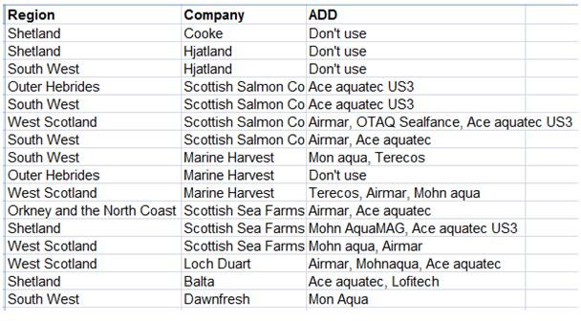
In May 2017, The Sunday Herald revealed:

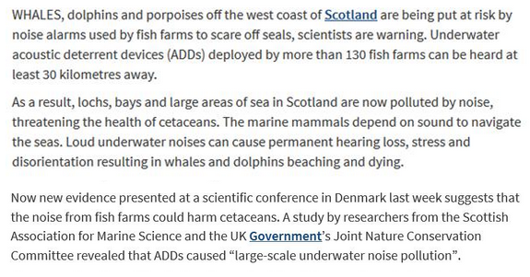

This research was presented at Ocean Noise in May 2017.

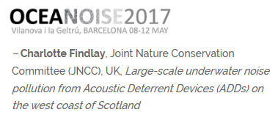
The scientific paper - "Large-scale underwater noise pollution from Acoustic Deterrent Devices (ADDs) on the West Coast of Scotland" - is still awaiting publication in a peer-reviewed journal.

SNH is also strangely silent on the impact of ADDs from salmon farms. Documents obtained from SNH via FOI in April 2018 [4] reveal that:

- Following media coverage in The Sunday Herald in May 2017 and an EC complaint filed by the Global Alliance Against Industrial Aquaculture (GAAIA), Cathy Tilbrook, Coastal & Marine Ecosystems Unit Manager, wrote to SNH colleagues:

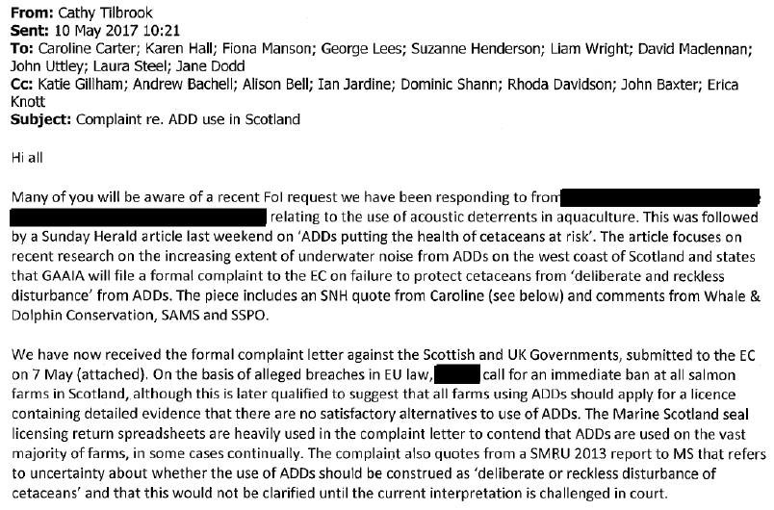

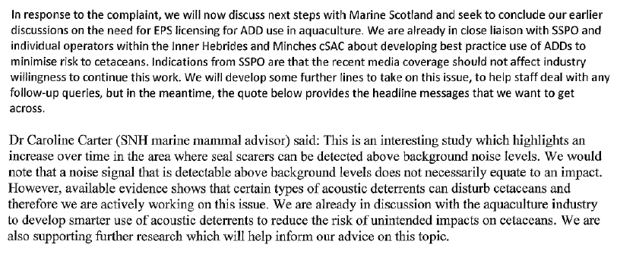

- In October 2017, SNH briefed the salmon farming industry on new research on far-field and near-field impacts of ADDs used by salmon farms and proposed a meeting in January 2018.

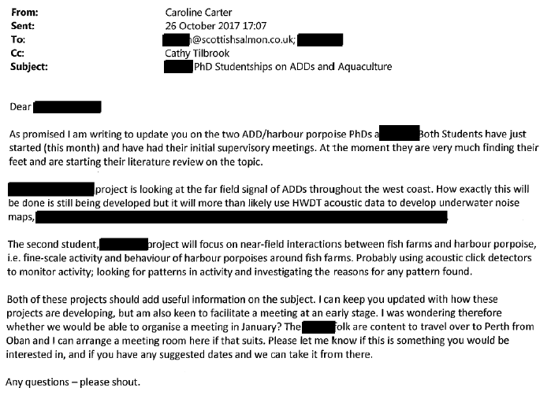

The SAMS web-site lists a new project - "Modelling underwater noise from acoustic deterrent devices to determine the extent of exposure and implications for the conservation of marine mammals" - by Charlotte Findlay funded by the European Social Fund via the University of Highlands & Islands.
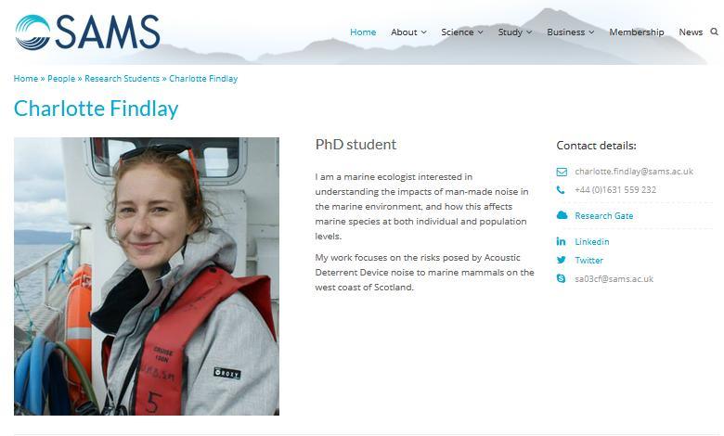
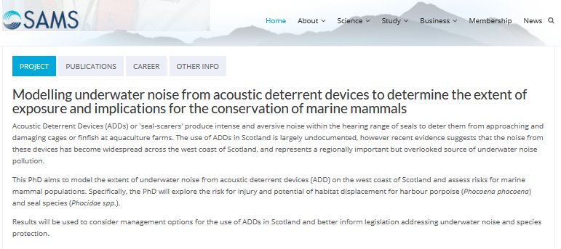

- In December 2017, Marine Scotland wrote to SNH regarding a meeting with ADD manufacturer Ace Aquatec which the Dundee-based company claimed is "cetacean friendly" and "was developed to avoid the sensitive hearing range of cetaceans". "He's obviously looking to get the device past various regulatory hurdles," said the redacted email.

- In January 2018, the following abstract was presented at the UK and Ireland Regional Student Chapter (UKIRSC) of the Society for Marine Mammalogy at the University of St Andrews:
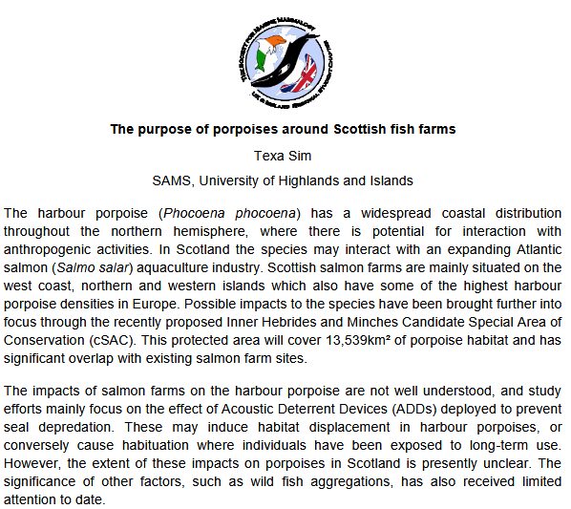

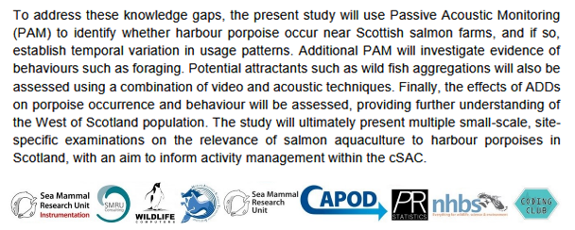

The SAMS web-site lists Texa Sim as funded by the Marine Alliance for Science and Technology for Scotland for a PhD "studying the occurrence of harbour porpoises around Scottish sea farms, with a focus on acoustic techniques to answer questions about their behaviour".

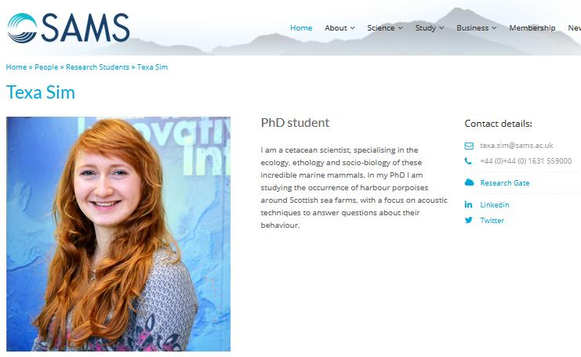
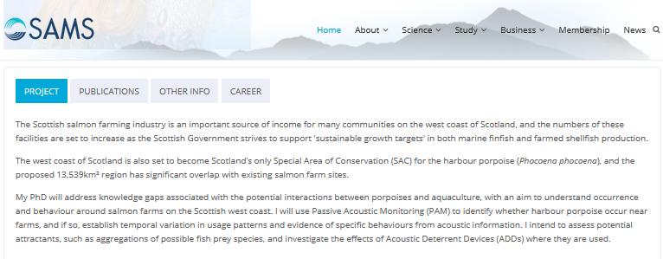
In November 2017, Ace Aquatec met with Fergus Ewing, Cabinet Secretary for Rural Economy & Connectivity. Fish Farming Expert reported in November 2017: "Ace Aquatec, which supplies seal scarers, biomass cameras and electric fish stunners to the salmon industry, has been shortlisted for a prestigious Queen’s Award for Enterprise" (in April 2018 it was announced that Ace Aquatec had won - read in The Courier via "Queen’s Award joy for city marine welfare firm").

In April 2018, Fergus Ewing was again deaf to the concerns of ADDs and was busy at the Seafood Expo Show in Brussels promoting ADDs manufactured by Ace Aquatec. The Courier reported (25 April 2018):


In May 2017 two Scottish Parliamentary motions tackled the issue of ADDs used on salmon farms - one filed by Claudia Beamish MSP:
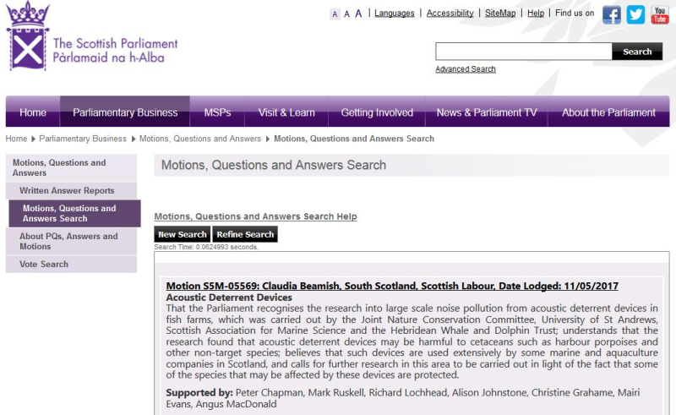
And a second filed by Maurice Golden MSP:
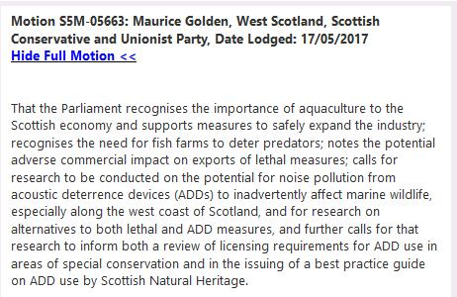
In 2014, a humpback whale was entangled in a salmon farm operated by Scottish Sea Farms in the Sound of Mull. "The post mortem findings are consistent with a peri-weaning, maternally-attached animal which underwent an acute death," reported Scotland's Rural College. "The observed pathology and stranding history would be consistent with the whale becoming trapped beneath a salmon pen and subsequently drowning" (read more via 'Salmon Farming Kills Whales').

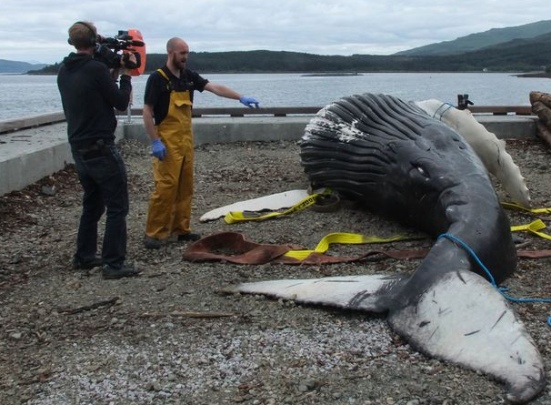
Read more via:

The National: "Warning salmon farm devices could hit wildlife tourism" (9 May 2018)
Press Release: "Deafening Impact of Salmon Farms on Cetaceans" (18 April 2018)
Scottish Parliament Motions on Acoustic Deterrent Devices (22 May 2017)
Press Release: "Cetaceans Sound Alarm On Salmon Farms - new research sparks EC complaint & call to ban Acoustic Deterrent Devices" (7 May 2017)
Sunday Herald: "Health of whales, dolphins and porpoises put at risk by underwater alarms" (7 May 2017)

Contact:

Don Staniford (07771 541826): dstaniford@gaaia.org

Notes to Editors:

[1]

From: Richard Slaski [mailto:r.slaski@sarf.org.uk]
Sent: 22 May 2018 10:48
To: 'Don Staniford'
Cc: 'Sandra Gray'
Subject: RE: SARF 112: "Influence of low frequency ADDs on cetaceans in Scottish coastal waters"

Hi Don,

The project has been quite delayed, but we are now at the final stages of peer review / Board approval. Our best estimate is that it should be ready for publication on the SARF website by the end of the third week of June.

Richard

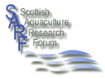
Richard Slaski
Secretariat
Scottish Aquaculture Research Forum (SARF)
PO Box 7223 Pitlochry PH16 9AF
Tel: 01738 479486
Company Registered in Scotland - SC267177
Charity Registered in Scotland - SC035745
EU State Aid Registration No: X939 2009
Website: www.sarf.org.uk

From: Don Staniford <salmonfarmingkills@gmail.com>
Sent: 21 May 2018 21:32
To: r.slaski@sarf.org.uk
Subject: SARF 112: "Influence of low frequency ADDs on cetaceans in Scottish coastal waters"

Richard,

Re. http://www.sarf.org.uk/cms-assets/documents/235749-572237.call-for-proposals-sarf112---influence

Do you have an update on the project?

Do you know when the final report will be published?

Dr Denise Risch of SAMS describes it as a 'past project' on her web-page: https://www.sams.ac.uk/people/researchers/risch-dr-denise/

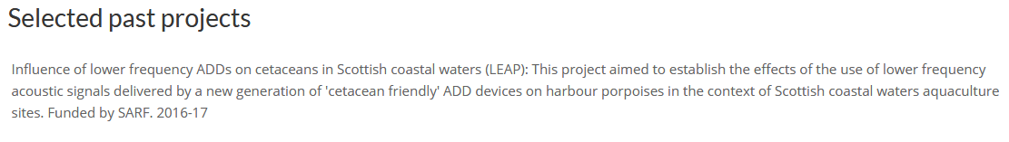

Best fishes,

Don

Don Staniford

Director, Scottish Salmon Watch: https://scottishsalmonwatch.org/

Director, Global Alliance Against Industrial Aquaculture (GAAIA): http://www.salmonfarmingkills.com

Read my blog via http://donstaniford.typepad.com/my-blog

<((((º>`·.¸¸.·´¯`·.¸.·´¯`·...¸><((((º>¸.
·´¯`·.¸. , . .·´¯`·.. ><((((º>`·.¸¸.·´¯`·.¸.·´¯`·...¸><((((º>

From: Steven Benjamins [mailto:Steven.Benjamins@sams.ac.uk]
Sent: 21 May 2018 17:57
To: Don Staniford
Subject: Re: SARF report?

Hello Mr. Staniford,
Thank you for your interest in our work. The report you are referring to is presently in the final stages of peer review. I would imagine the final version will be published by SARF soon, possibly as early as mid- to late June.
Regards,
Steven
Dr. Steven Benjamins
Marine Vertebrate Ecologist
SAMS (Scottish Association for Marine Science)
Oban
Argyll
Scotland
UK
PA37 1QA
Tel: +44(0)1631-559449 (office)
Tel: +44(0)1631-559000 (switchboard)
Fax: +44(0)1631-559001
E-mail address: Steven.Benjamins@sams.ac.uk
http://www.sams.ac.uk

From: Don Staniford <salmonfarmingkills@gmail.com>
Sent: 18 May 2018 10:07:42
To: Steven Benjamins
Subject: SARF report?

Dr Benjamins,

Please do you have a copy of the SARF reported cited on your web-page? https://www.sams.ac.uk/people/researchers/benjamins-dr-steven/

Current projects
Low-frequency Acoustic Deterrent Devices and Porpoises (LEAP): Assessing potential impact of low-frequency Acoustic Deterrent Devices (ADDs) on cetaceans in Scottish coastal waters (project lead). Funded by Scottish Aquaculture Research Forum. 2016-17

Best fishes,

Don

Don Staniford

Director, Scottish Salmon Watch: https://scottishsalmonwatch.org/

Director, Global Alliance Against Industrial Aquaculture (GAAIA): http://www.salmonfarmingkills.com

Read my blog via http://donstaniford.typepad.com/my-blog

<((((º>`·.¸¸.·´¯`·.¸.·´¯`·...¸><((((º>¸.
·´¯`·.¸. , . .·´¯`·.. ><((((º>`·.¸¸.·´¯`·.¸.·´¯`·...¸><((((º>

The SARF 'Call for Proposal' for "Influence of low frequency ADDs on cetaceans in Scottish coastal waters" dated April 2016 detailed:

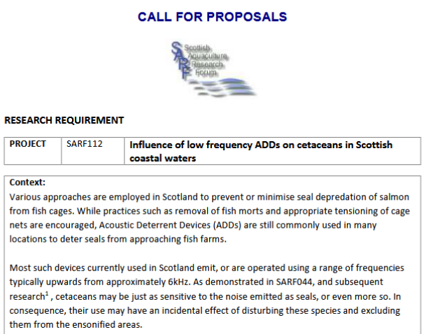
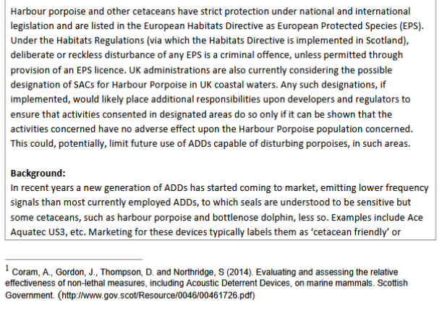

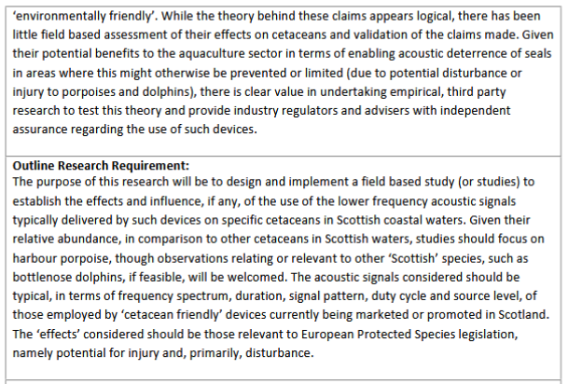
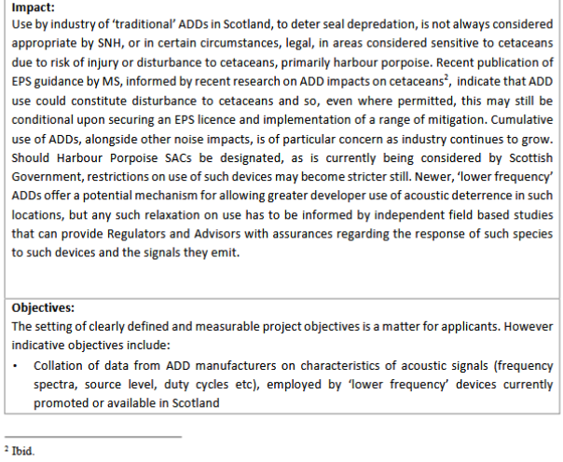

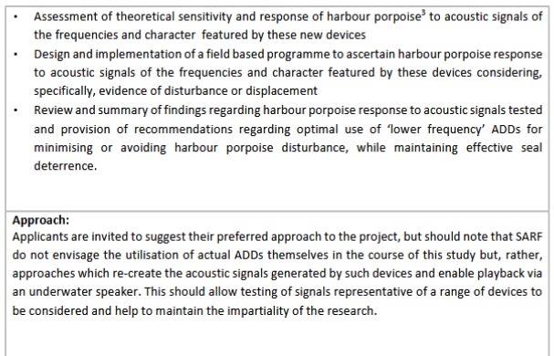
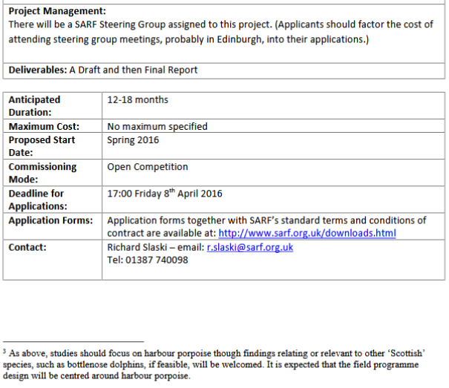

A SARF report - "Assessment of the impacts and utility of acoustic deterrent devices" - published in 2010 included:

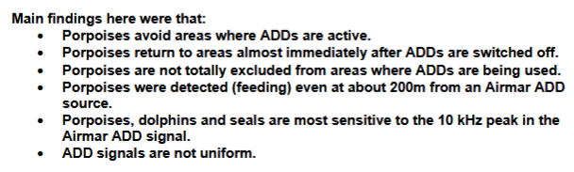
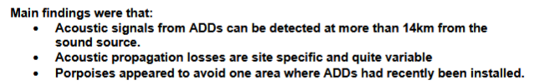

And:

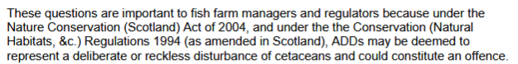

[2] "The claim is based on research into the effects of ADDs in keeping minke whales – a key draw for cruise services – away from offshore wind developments," reported The National (9 May 2018). "Published in November by the Carbon Trust, the paper found the species swims away from the gadgets even after they have been deactivated."

HWDT's written submission to the Scottish Parliament's salmon farming inquiry in April 2018 included:

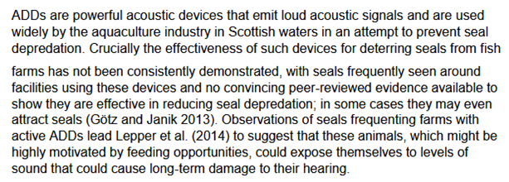

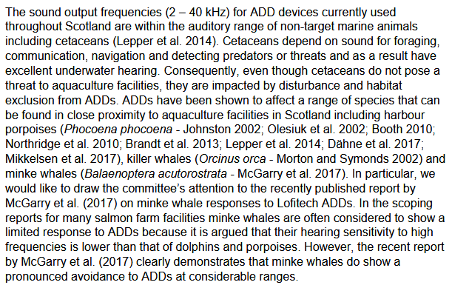

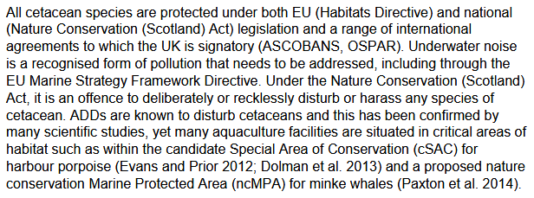

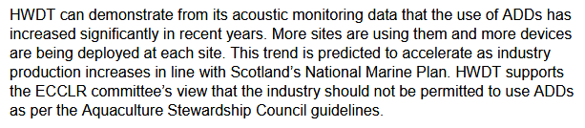

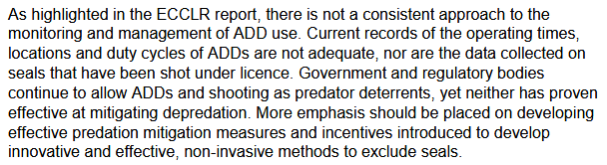

Read the report by the Carbon Trust's report - "Understanding the Effectiveness of Acoustic Deterrent Devices (ADDs) on Minke Whale (Balaenoptera acutorostrata), a Low Frequency Cetacean" - by McGarry et al (2017) online here

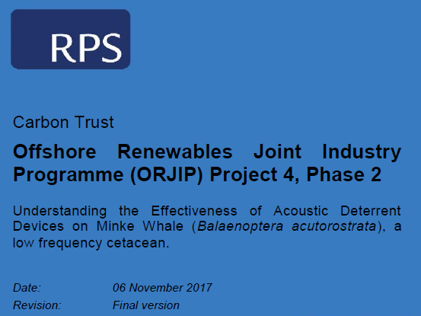
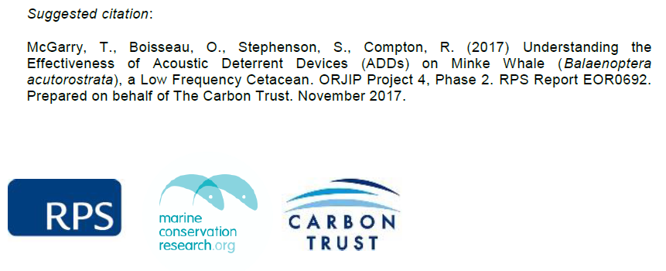

Tourist operator David Ainsley's written submission to the Scottish Parliament's salmon farming inquiry in April 2018 included:

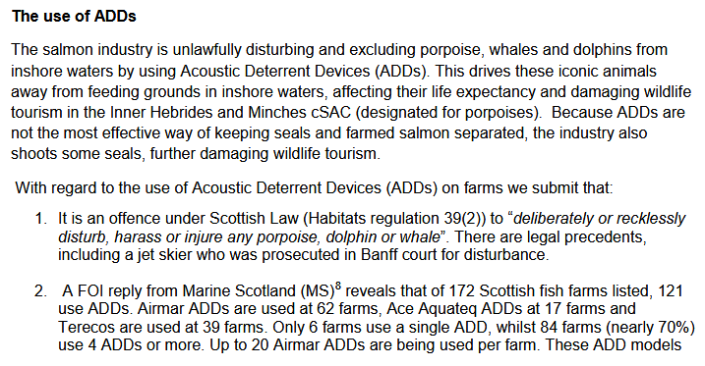

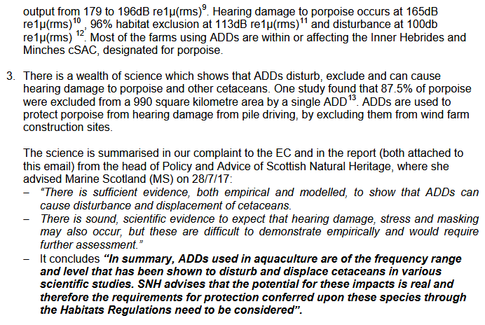

And:

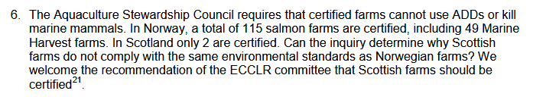

And:

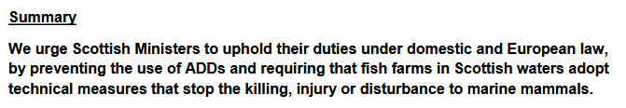

David Ainsley's written submission also attaches a complaint to the European Commission which includes:

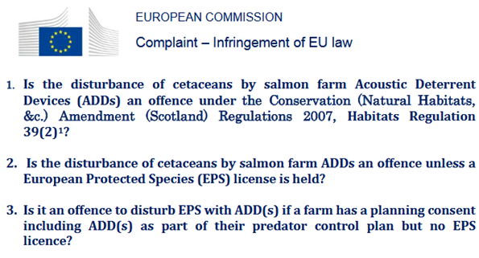

And:
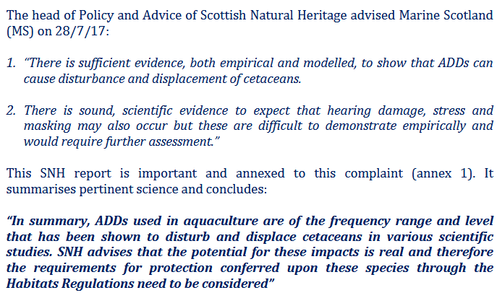

And:

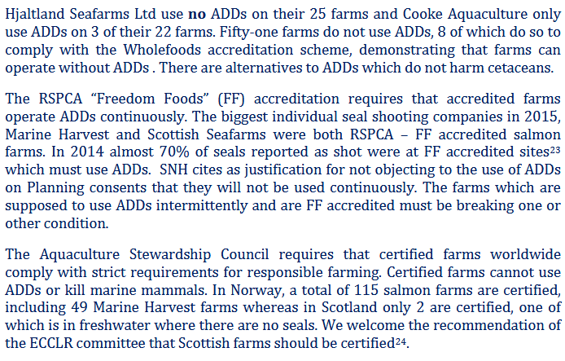

And:

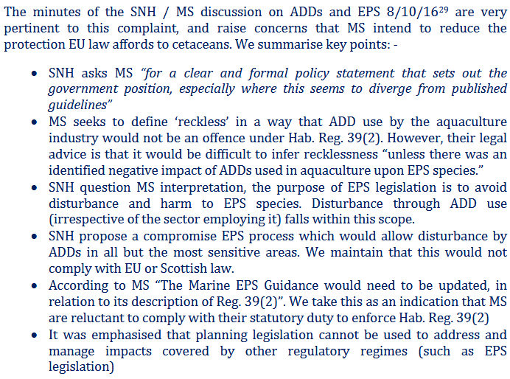
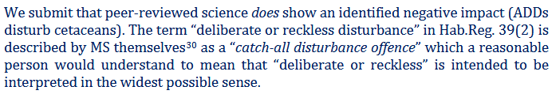

And:

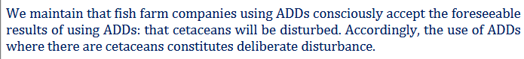

The Scottish Parliament's Environment, Climate Change & Land Reform Committee report on the environmental impacts of salmon farming (March 2018) included:

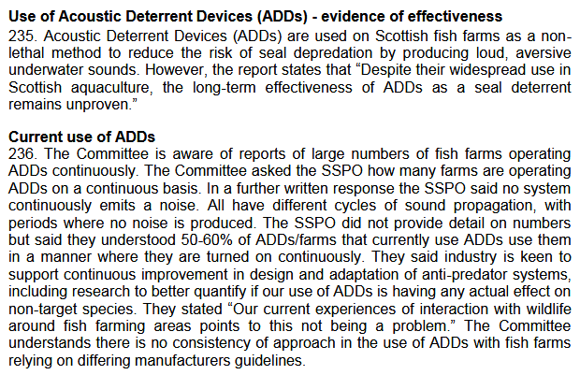

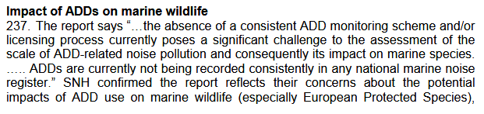
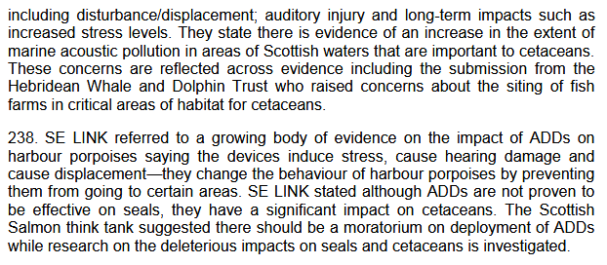
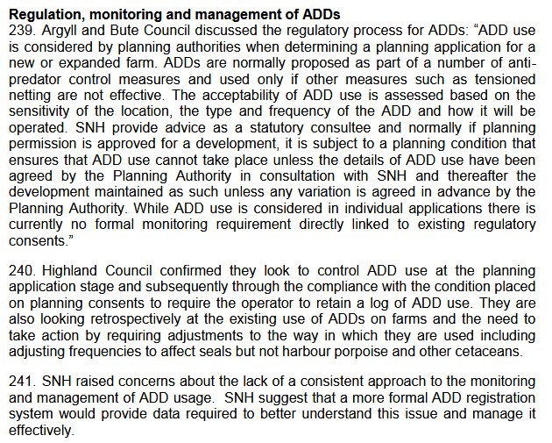
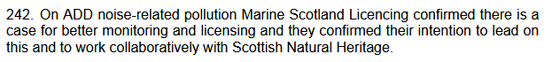
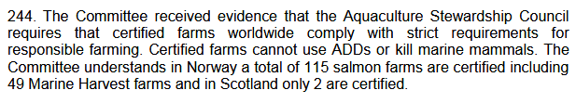
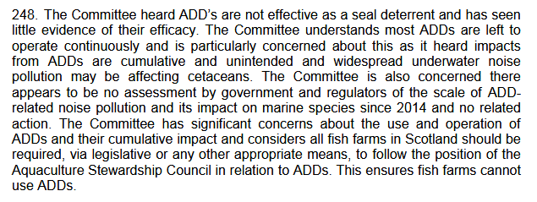

Whale & Dolphin Conservation state on their web-site:

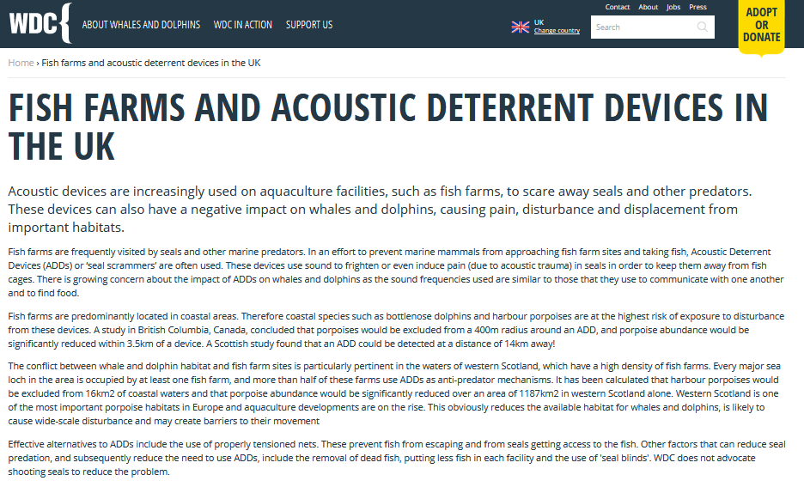

WDC's written submission to the Scottish Parliament's Environment, Climate Change & Land Reform Committee inquiry into the environmental impacts of salmon farming in February 2018 included:

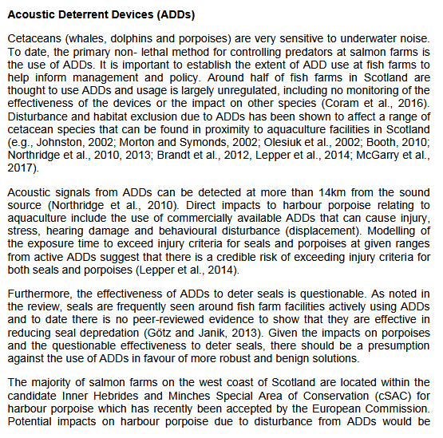

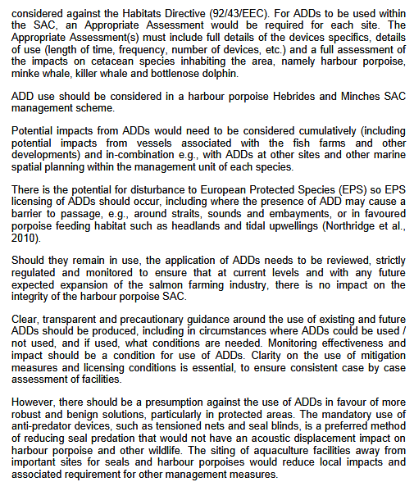

Whale & Dolphin Conservation's written submission to the Rural Economy & Connectivity's salmon farming inquiry in April 2018 included:

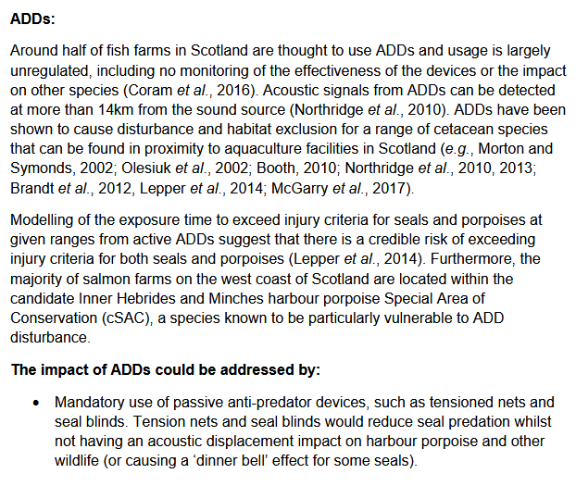

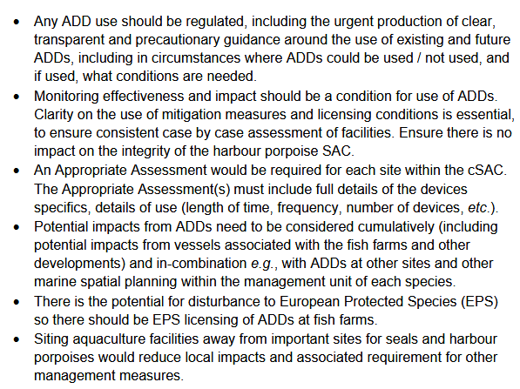

[3] The transcript of the Scottish Parliament's salmon farming inquiry on 2 May 2018 featured oral evidence from Ben Hadfield, Managing Director of Marine Harvest Scotland, including:

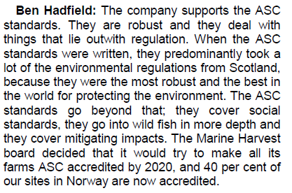
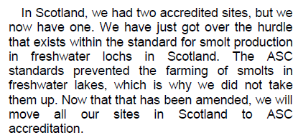

"Our plans for investment over the next five to 10 years will help us fulfill the strict criteria in the ASC standards and we aim to have all of our farms certified under the scheme by 2020," said the then Managing Director of Marine Harvest Scotland, Alan Sutherland in 2013.

In 2016, Marine Harvest "pledged to have all its farms Aquaculture Stewardship Council (ASC) certified by 2020" (read via "Marine Harvest Pledges 100% of Farms ASC Certified by 2020").

The latest version (April 2017) of the Aquaculture Stewardship Council's salmon standard includes:

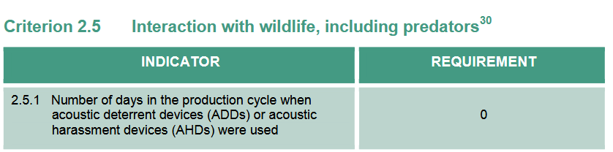

And by way of explanation:

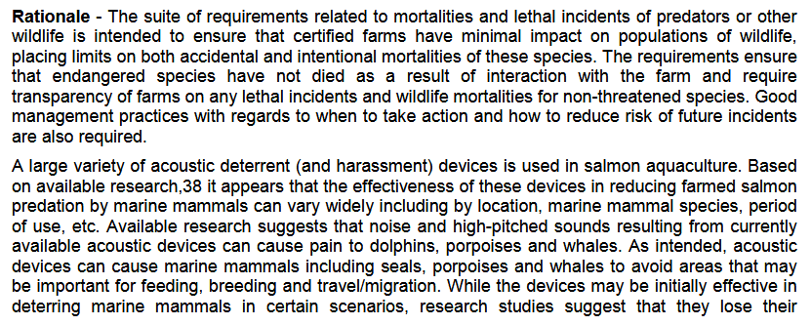
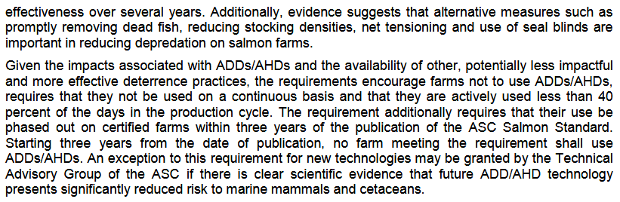

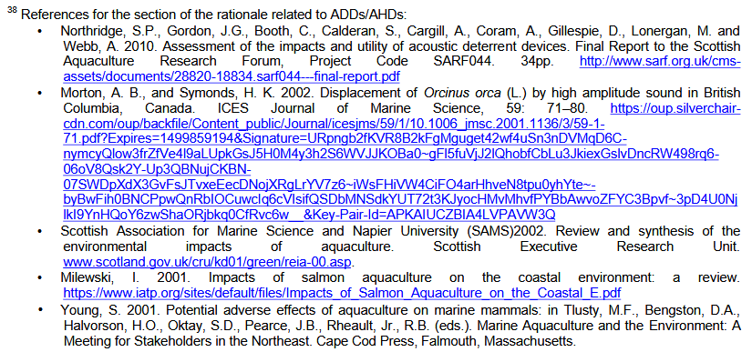

Download in full as a PDF online here

Here's correspondence with the ASC:

From: Daniela Ruz [mailto:Daniela.Ruz@asc-aqua.org] On Behalf Of Info
Sent: 01 June 2018 09:41
To: 'Don Staniford'
Subject: RE: Query re. salmon standard and ADD use

Dear Don,
Apologies for the delay in the answer.
From the auditing point of view the requirement is mandatory. In this case the indicator requires 0. If that is not the case in a farm, an NC should be raise.
About the footnote, I will flag it to the Standards team as the derogation is already expired after the third anniversary of the standard, that already happened. Thank you for pointing us that.
Let me know if you have additional questions.

Best regards,

Daniela Ruz
Programme Assurance Coordinator


NEW ADDRESS: HNK, Arthur van Schendelstraat 650| 3511 MJ Utrecht, The Netherlands
P.O Box 19107 | 3501 DC Utrecht, The Netherlands

T: +31(0)30 239.31.10
E: Daniela.Ruz@asc-aqua.org
I: www.asc-aqua.org

From: Bertrand Charron [mailto:Bertrand.Charron@asc-aqua.org]
Sent: 25 May 2018 21:55
To: Don Staniford
Subject: Re: Re. Query re. salmon standard and ADD use

Hi Don,
Quick reply: you can find the CAR 2.1. here: https://www.asc-aqua.org/wp-content/uploads/2017/07/ASC-Certification-and-Accreditation-Requirements-v.2.1_including-multi-site_clean-1.pdf

via this page: https://www.asc-aqua.org/what-you-can-do/get-certified/about-our-certification/

Best regards,
Bertrand

On 25 May 2018, at 19:03, Don Staniford <salmonfarmingkills@gmail.com> wrote:

Thanks. Much appreciated.

Re. Certification & Accreditation requirements v2.1

Where do I find those exactly?

Best fishes,

Don

Don Staniford

Director, Scottish Salmon Watch: https://scottishsalmonwatch.org/

Director, Global Alliance Against Industrial Aquaculture (GAAIA): http://www.salmonfarmingkills.com

Read my blog via http://donstaniford.typepad.com/my-blog

<((((º>`·.¸¸.·´¯`·.¸.·´¯`·...¸><((((º>¸.
·´¯`·.¸. , . .·´¯`·.. ><((((º>`·.¸¸.·´¯`·.¸.·´¯`·...¸><((((º>

From: Bertrand Charron [mailto:Bertrand.Charron@asc-aqua.org]
Sent: 25 May 2018 17:10
To: 'salmonfarmingkills@gmail.com'
Cc: Contessa Kellogg-Winters
Subject: Re. Query re. salmon standard and ADD use

Dear Don,

Thank you for your email and interest in the programme,

There are two versions of the Salmon Standard, v 1.0 and v1.1 that are relevant for your question.

Under version 1.0 it was allowed to us ADD/AHD for ≤ 40% of the days of the production cycle in which the devices are operational. This requirement was valid from the date of release of the Salmon stand v1.0 (June 2012) and the next three years after (as is written under indicator 2.5.1 and 2.5.2 of v1.0).

After three years of release—from July 2015 onwards—ADD/AHD are no longer allowed. This was embedded in indicator 2.5.1 in v1.0 and remains embedded under 2.5.1 in v1.1.

You are correct that the rationale under Criterion 2.5 in v1.1 indeed still includes the ≤40% requirement. This rationale applies to v1.0 but not to v1.1 and will therefore be corrected shortly. Perhaps is it needless to say that although this part of the rationale applies to v1.0, the following sentences: “The requirement additionally requires that their use be phased out on certified farms within three years of the publication of the ASC Salmon Standard. Starting three years from the date of publication, no farm meeting the requirement shall use ADDs/AHDs. An exception to this requirement for new technologies may be granted by the Technical Advisory Group of the ASC if there is clear scientific evidence that future ADD/AHD technology presents significantly reduced risk to marine mammals and cetaceans.” should remove all doubt as to what is required of farms, regardless of the version of the standard.

I would like to make you aware of our Certification & Accreditation requirements v2.1, which detail the certification requirements—i.e. the way that standard is applied by certifiers. This is important because it spells out the consequences for farms that do use ADD/AHD’s. If you need assistance interpreting these, or similar documents, or in case additional questions do arise,
Please feel free to contact me.

Bertrand

Bertrand Charron
Science & Sustainability Communications Manager

Aquaculture Stewardship Council (ASC)
HNK Utrecht Centraal Station
Arthur van Schendelstraat 650 |3511 MJ Utrecht, The Netherlands
P.O Box 19107 | 3501 DC Utrecht, The Netherlands

Email: Bertrand.Charron@asc-aqua.org
Web: www.asc-aqua.org

From: Don Staniford [mailto:salmonfarmingkills@gmail.com]
Sent: 21 May 2018 22:09
To: 'info@asc-aqua.org'
Subject: Query re. salmon standard and ADD use

Hopefully you can assist with a quick query re. the ADD indicator in your salmon standard.

I am clear that it states 0 under 'Requirement' and therefore assumed that ADD use was completely prohibited.

However, the text under 'Rationale' states that ADDs can be used "less than 40% of the days in the production cycle".

What is the correct position?

As full context, the latest version (April 2017) of the Aquaculture Stewardship Council's salmon standard includes:

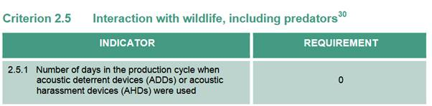

And by way of explanation:

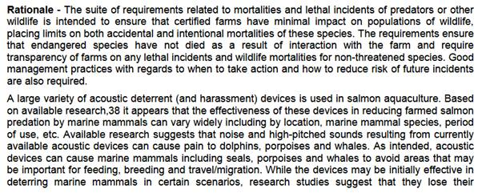
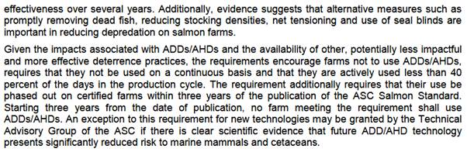

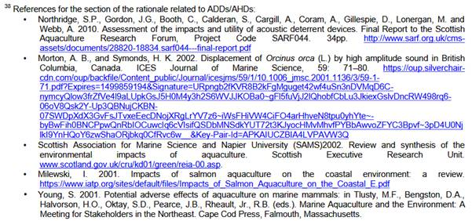

If I am missing something please let me know!

Best fishes,

Don

Don Staniford

Director, Scottish Salmon Watch: https://scottishsalmonwatch.org/

Director, Global Alliance Against Industrial Aquaculture (GAAIA): http://www.salmonfarmingkills.com

Read my blog via http://donstaniford.typepad.com/my-blog

<((((º>`·.¸¸.·´¯`·.¸.·´¯`·...¸><((((º>¸.
·´¯`·.¸. , . .·´¯`·.. ><((((º>`·.¸¸.·´¯`·.¸.·´¯`·...¸><((((º>

[4] A FOI reply from Scottish Natural Heritage dated 20 April 2018 included 14 MB of collated information (a 76-page PDF) - including:

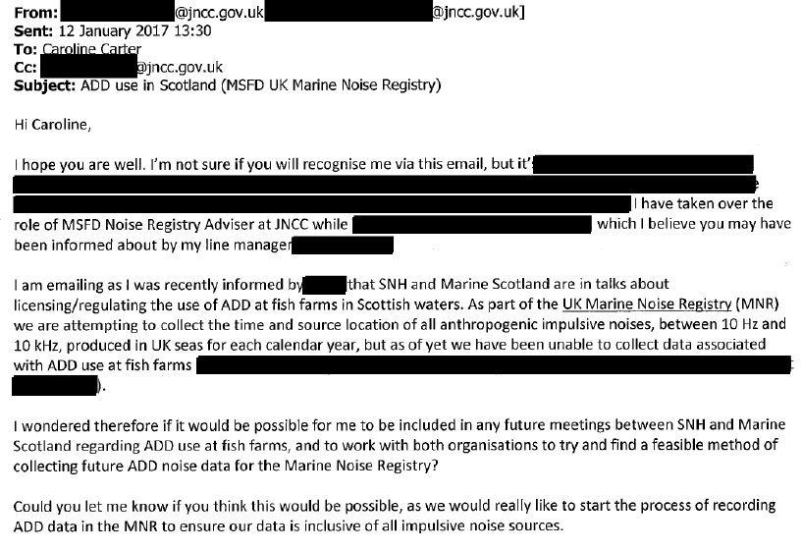

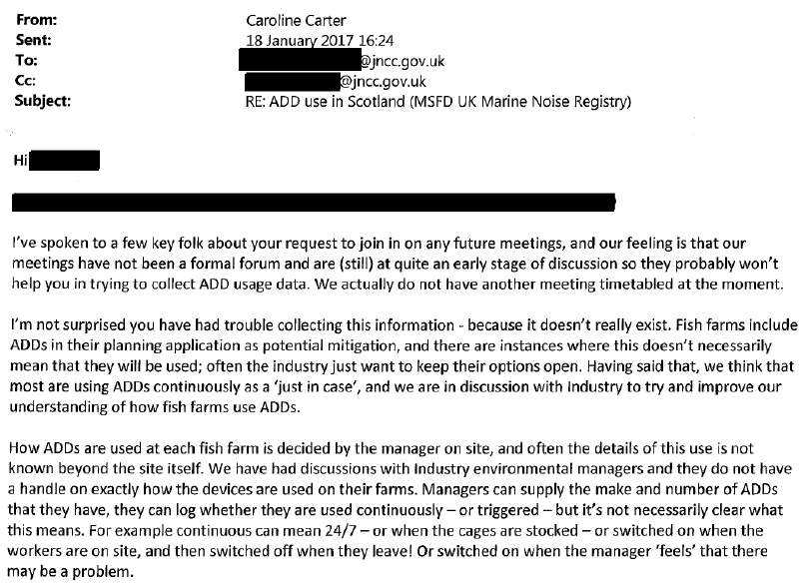

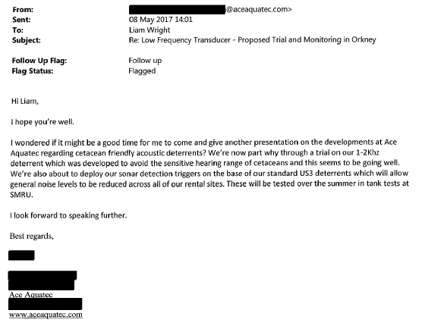

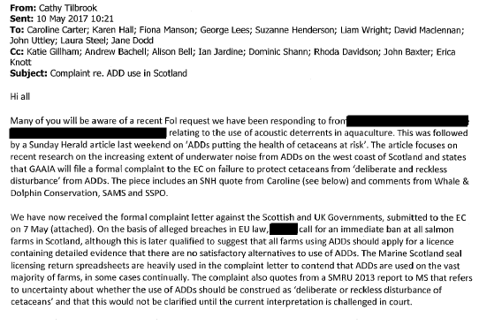
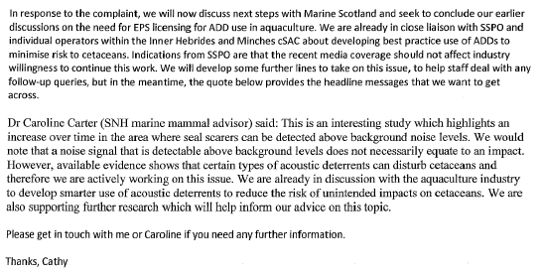

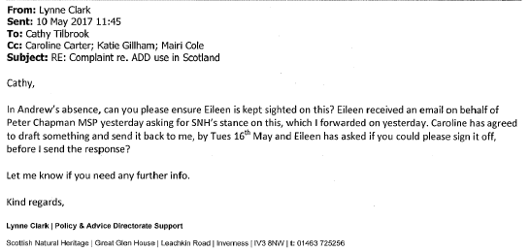
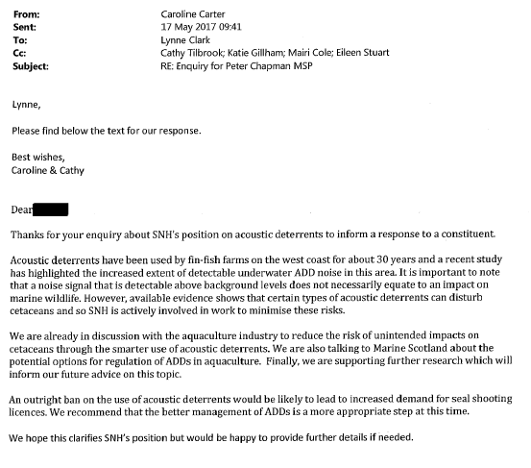

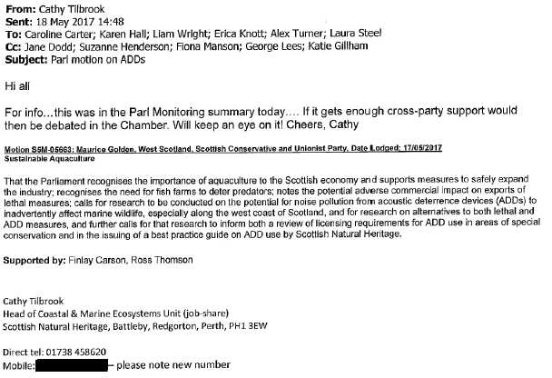
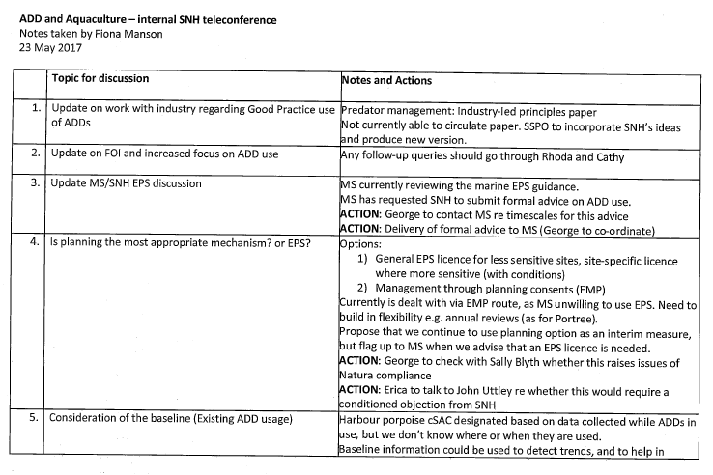
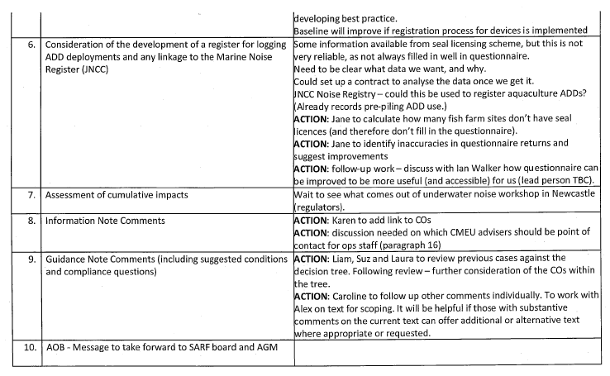

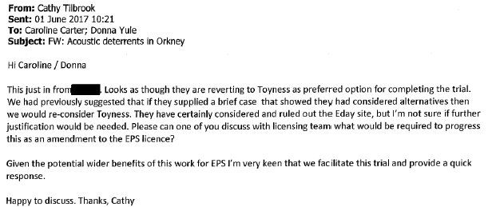

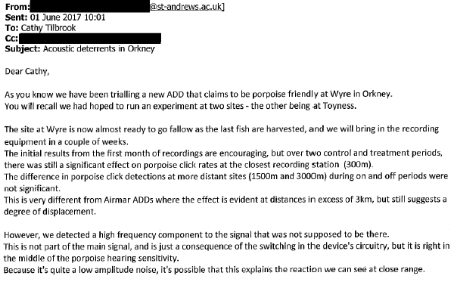
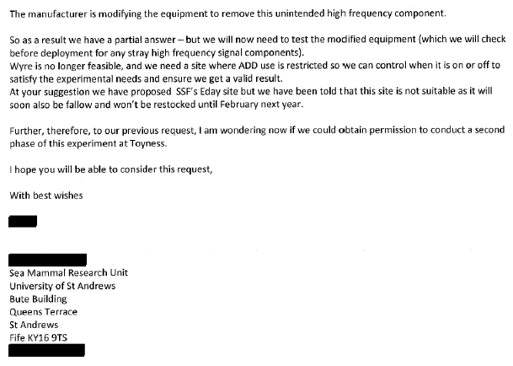

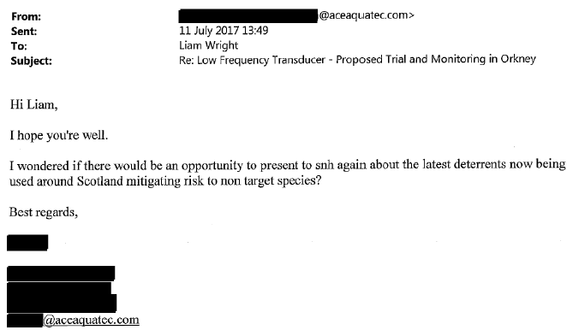

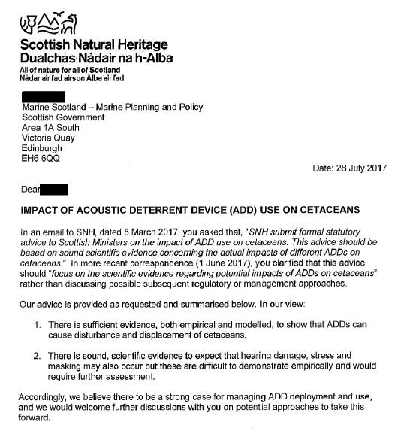
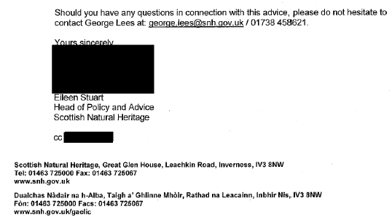

The 9-page Annex includes:

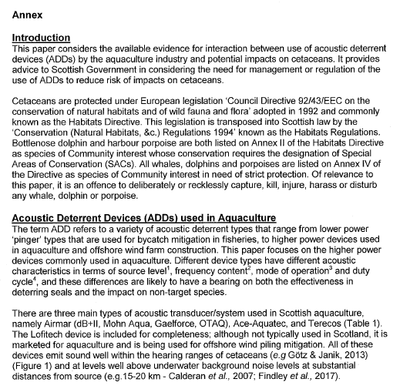

And concludes:

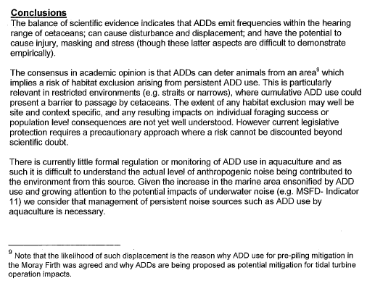

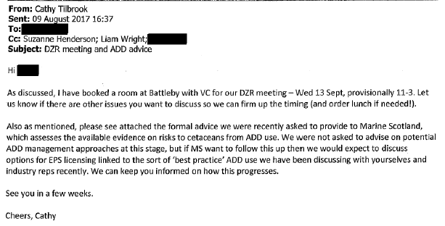

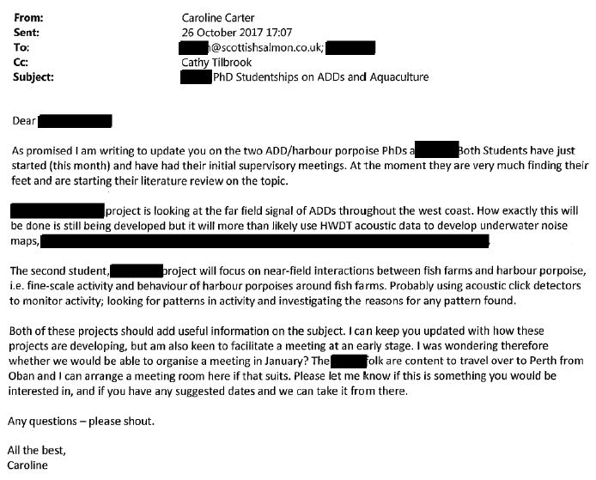

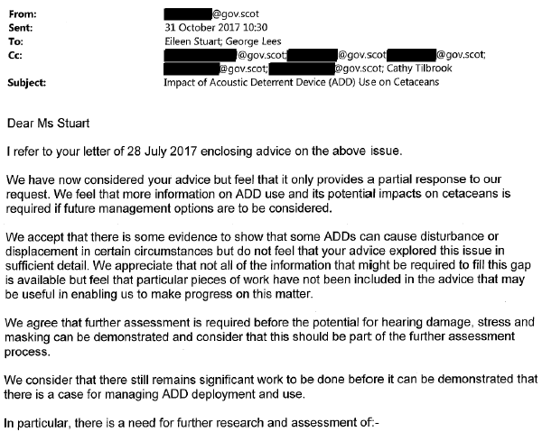
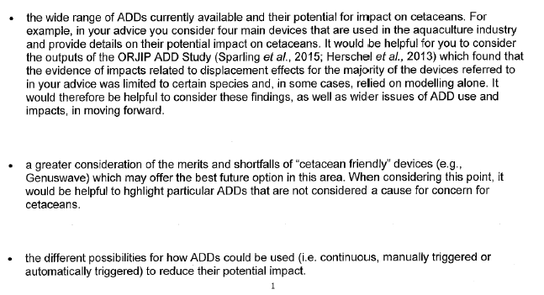

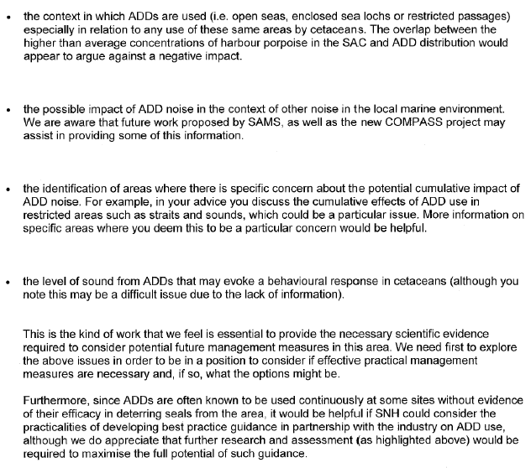
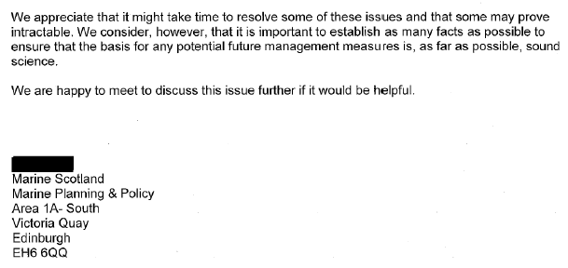

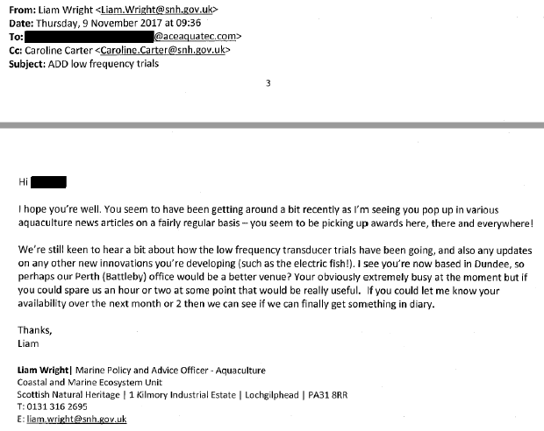

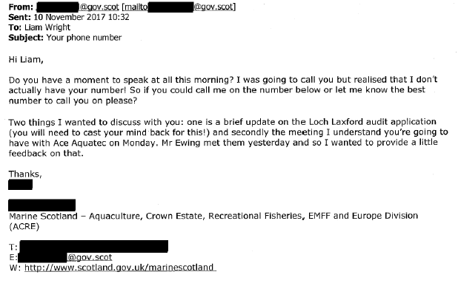
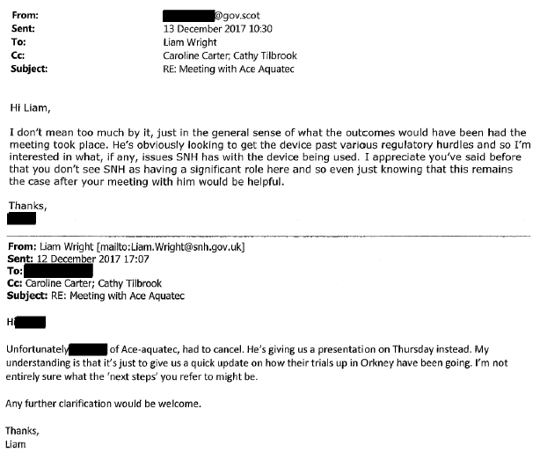

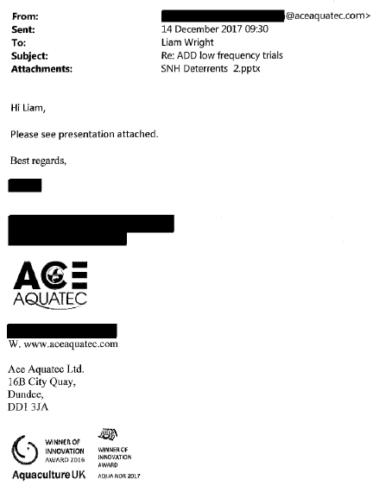

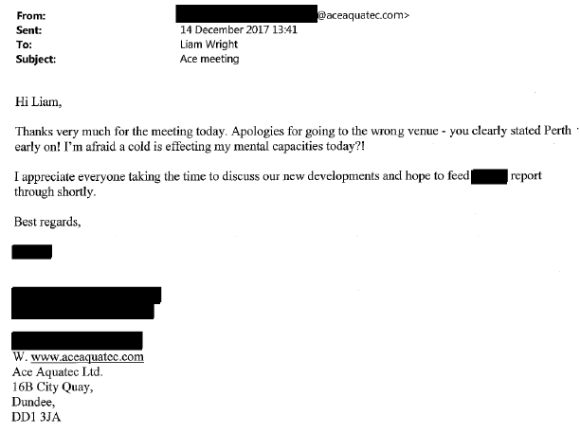

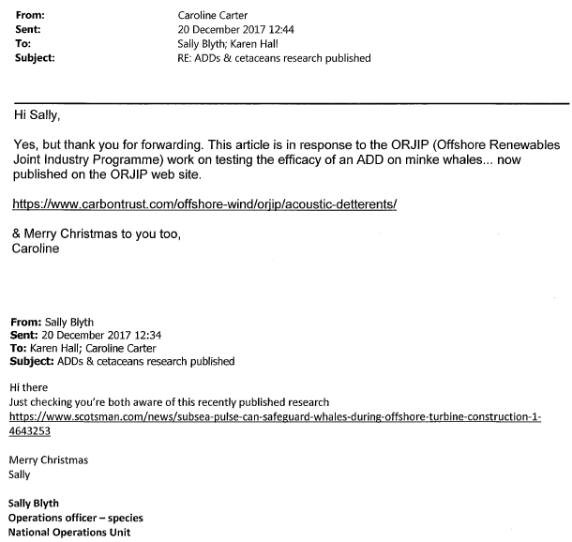

The Scotsman article is online here "Subsea pulse can safeguard whales during offshore turbine construction".

The Carbon Trust reported "New research builds confidence in wider use of Acoustic Deterrent Devices to safeguard marine mammals during offshore wind construction" (19 December 2017).

Read more via the Carbon Trust's "Efficacy of Acoustic Deterrent Devices" including Efficacy of acoustic deterrent devices - phase 1 report (PDF); The use of Acoustic Deterrents for the mitigation of injury to marine mammals during pile driving for offshore wind farm construction. ORJIP Project 4, Stage One of Phase Two (PDF) and Joint Statutory Nature Conservation Bodies Position Statement (PDF).

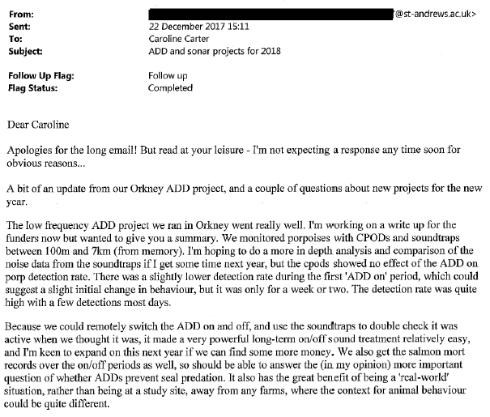
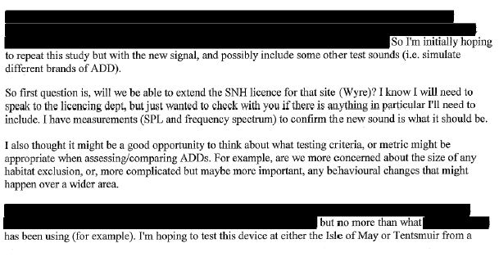
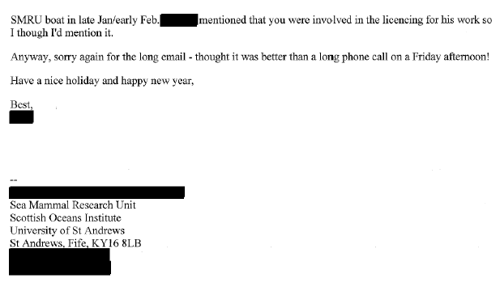

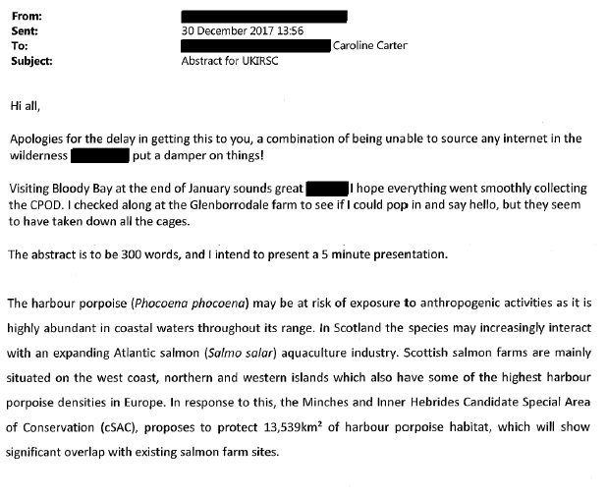
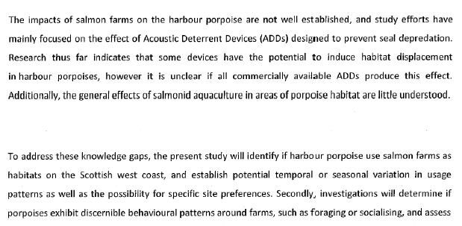

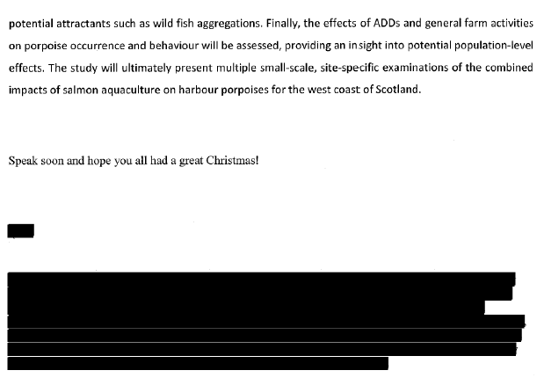

Here's an abstract presented by Texa Sim at the UK and Ireland Regional Student Chapter (UKIRSC) of the Society for Marine Mammalogy at the University of St Andrews:

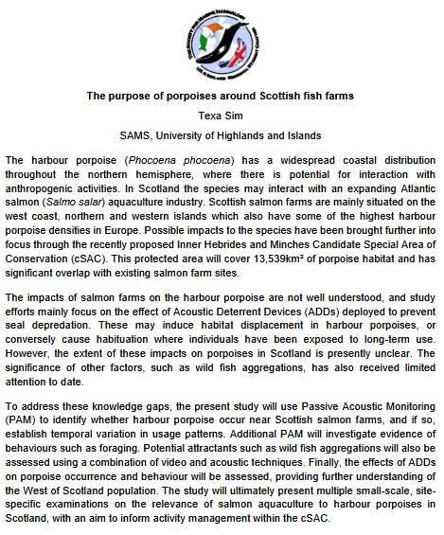

An undated report/presentation by SNH included:

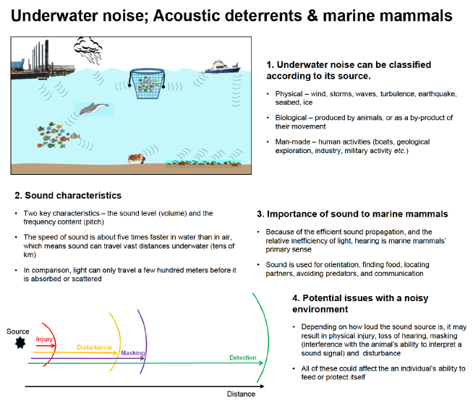

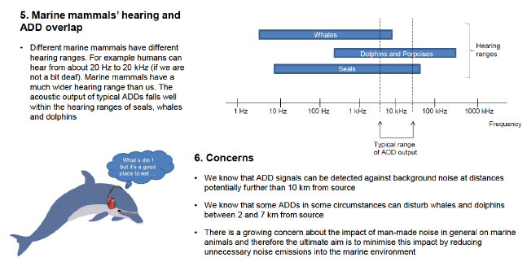

A undated report (perhaps the same as the six-point presentation above) includes:

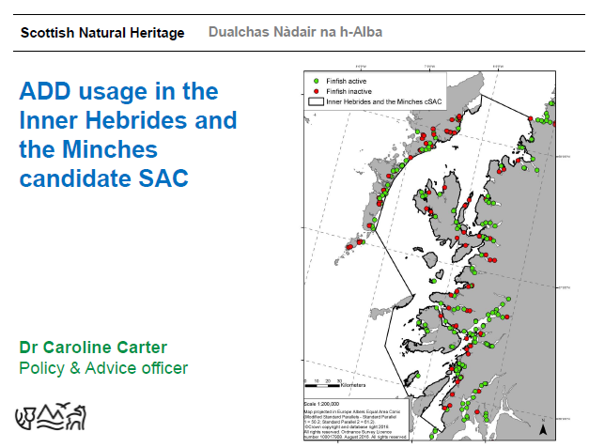

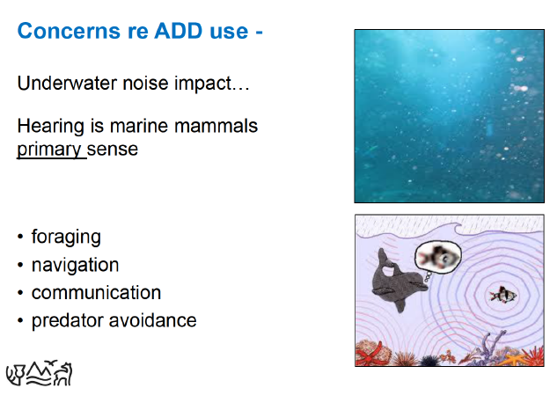

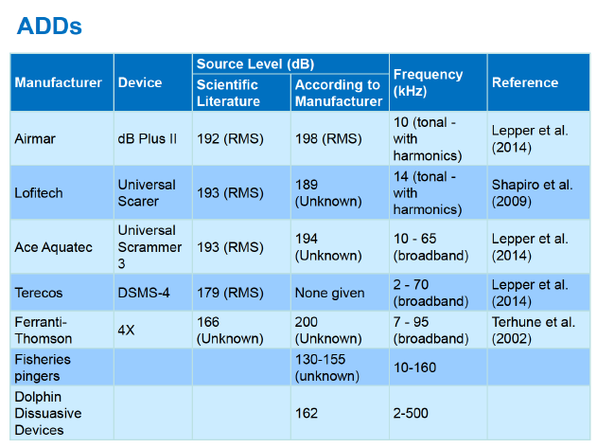

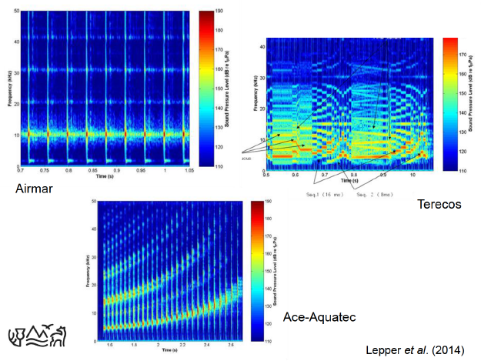

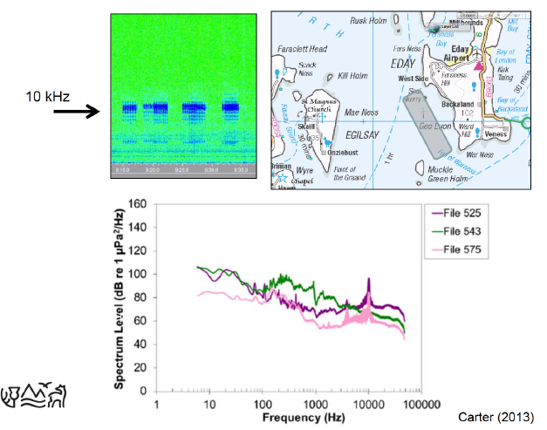

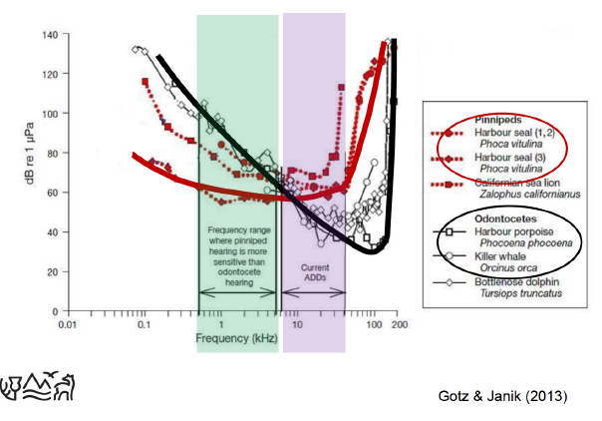

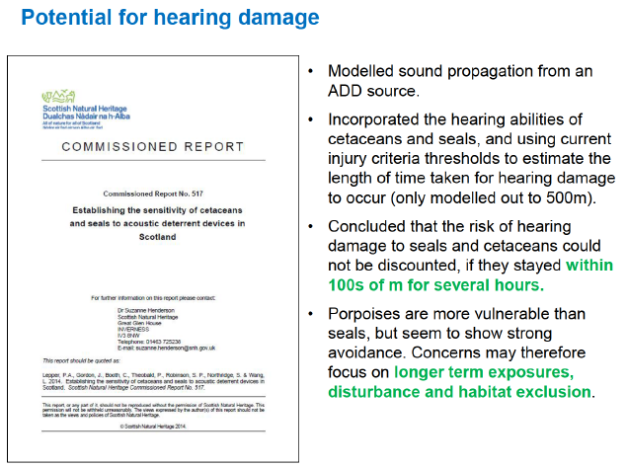

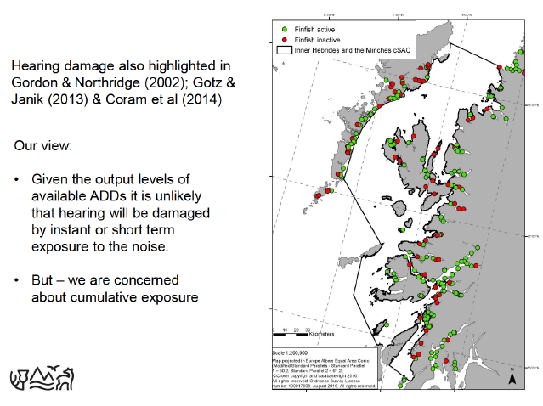
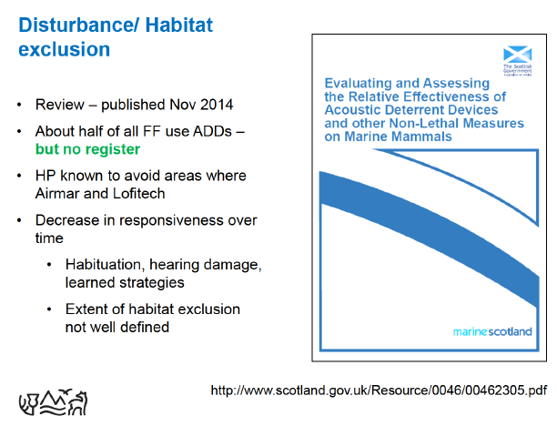

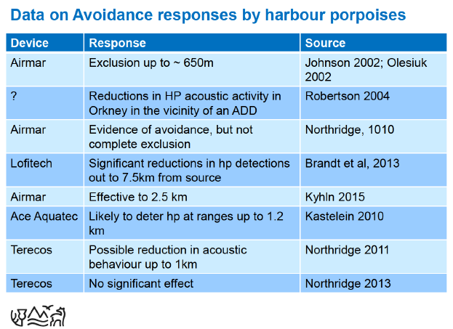

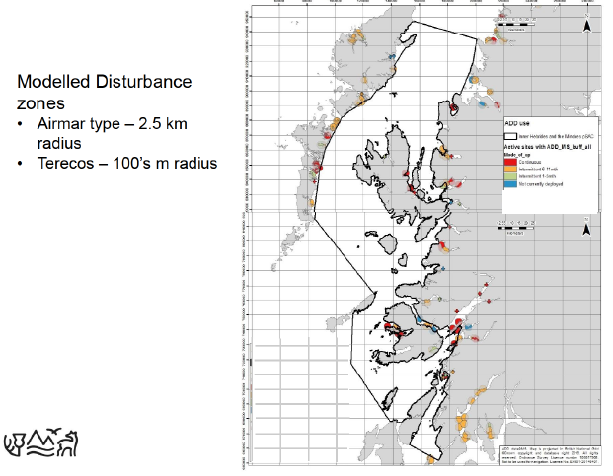

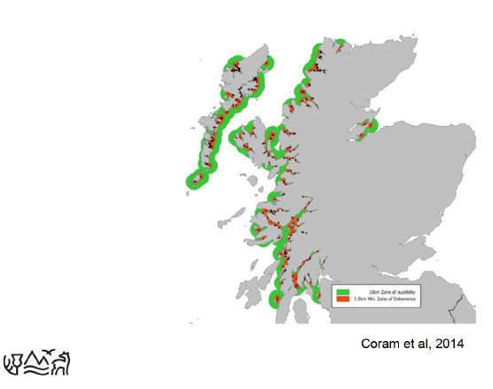

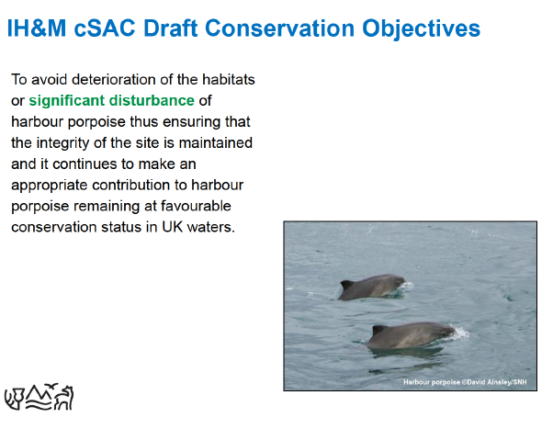
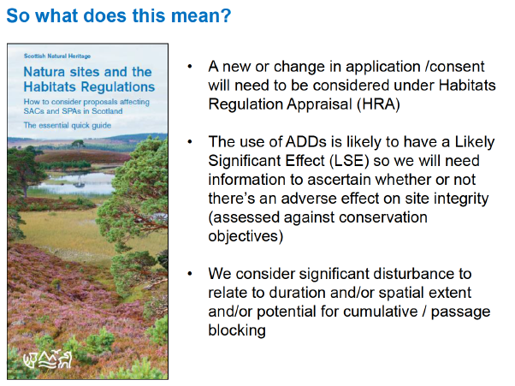

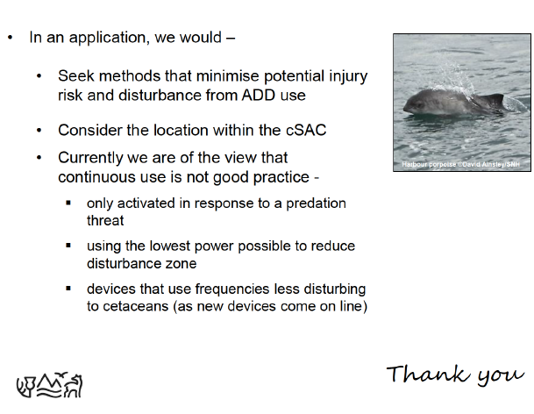

Download collated information (14 MB) in full online here

[5] A FOI reply from Highland Council dated 9 March 2018 included:

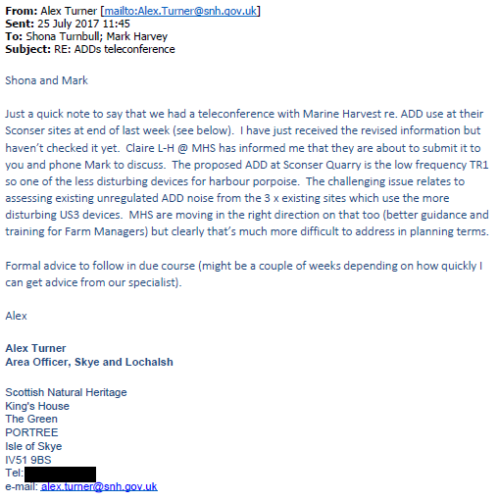

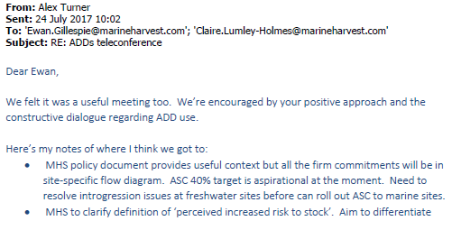
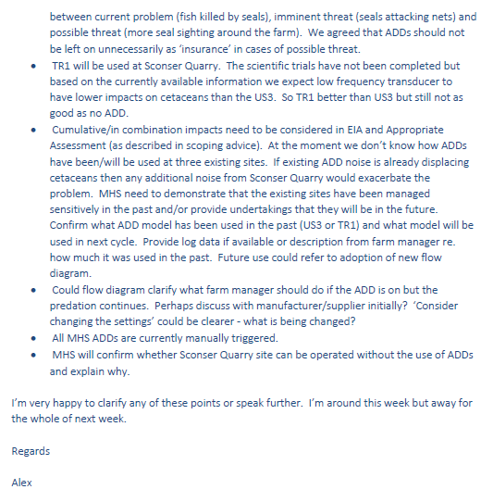

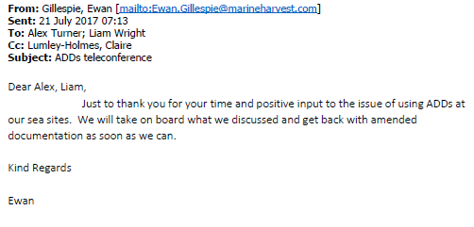

Documents available online here

Highland Council also disclosed a Marine Harvest report dated August 2017:
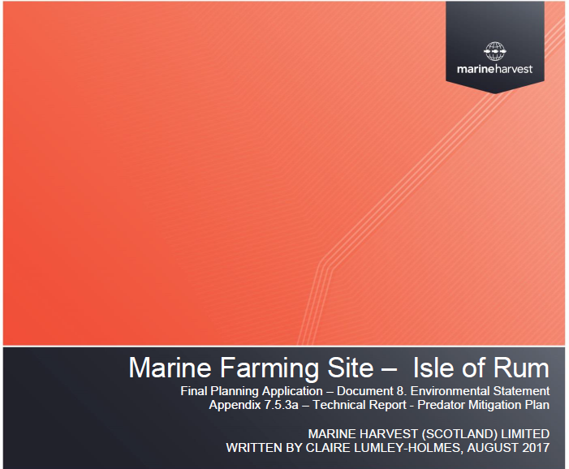
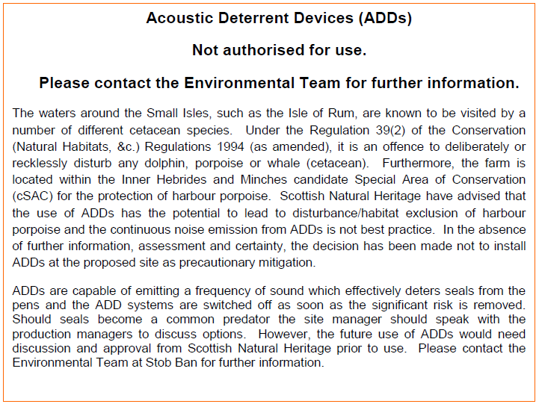

Download document online here

Other documents disclosed included correspondence with Grieg Seafood:

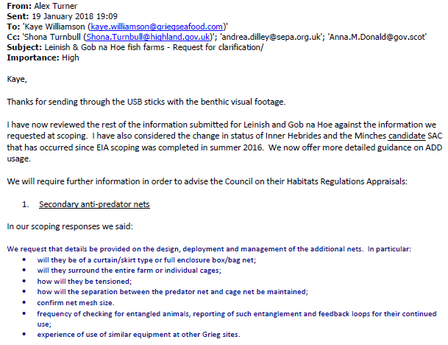
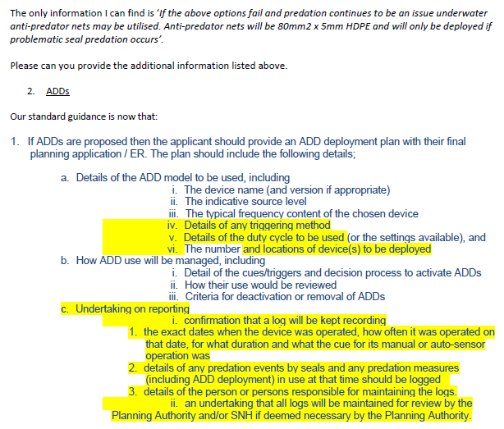
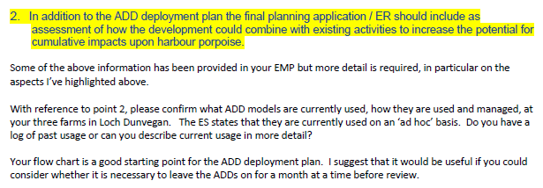

Documents available online here

Other documents disclosed included correspondence with the Scottish Salmon Company:

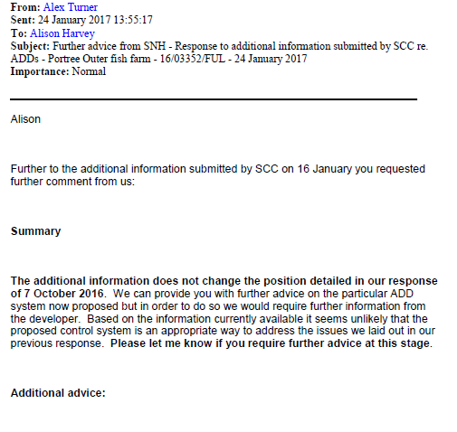
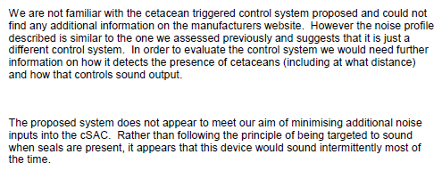
Documents available online here

Another document disclosed in relation to Grieg Seafood included:

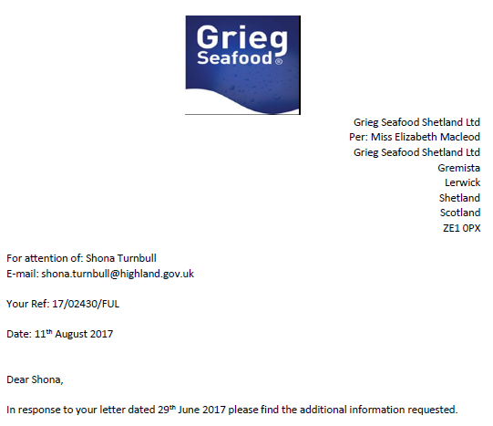

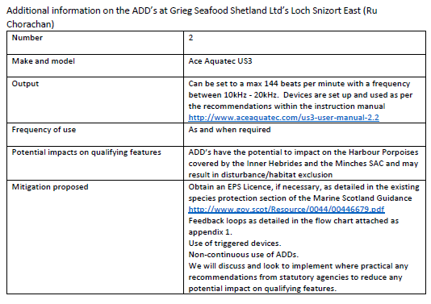

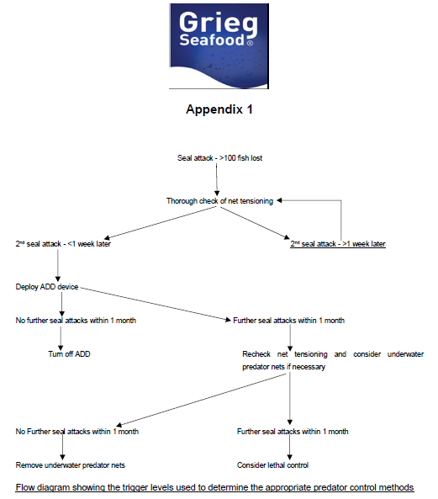

Document available online here

[6] FOI reply from the Scottish Government dated 2 June 2017 - including:

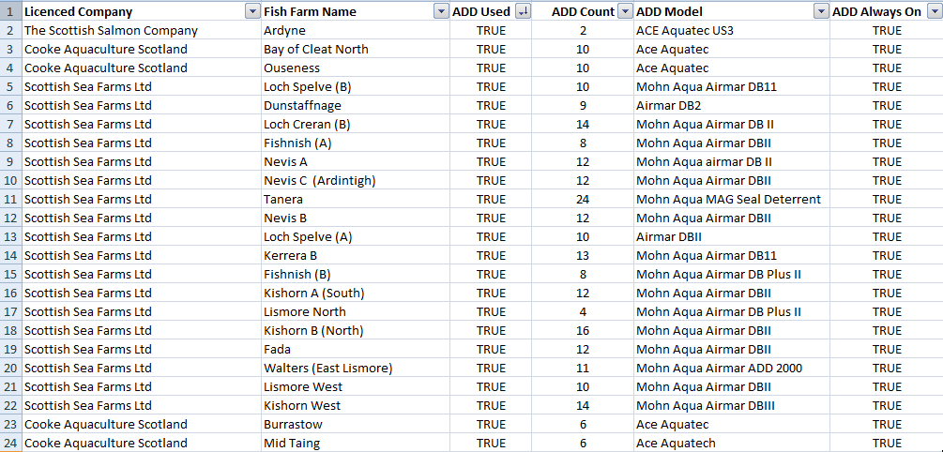
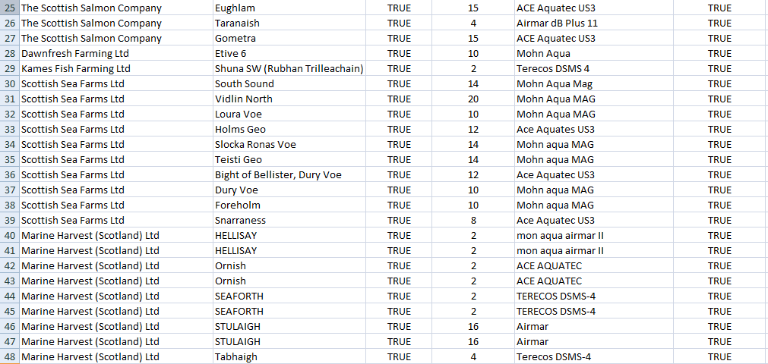
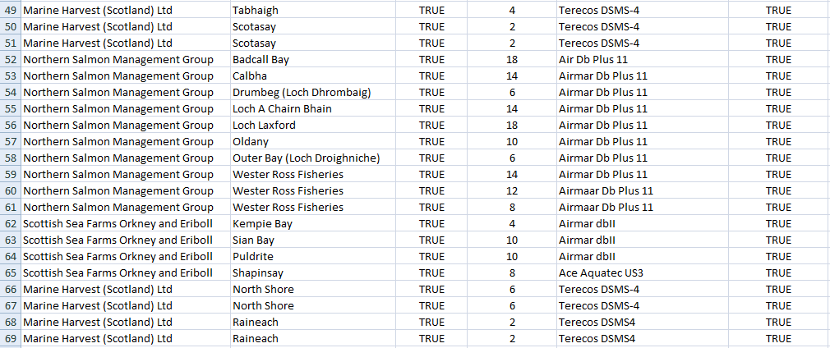
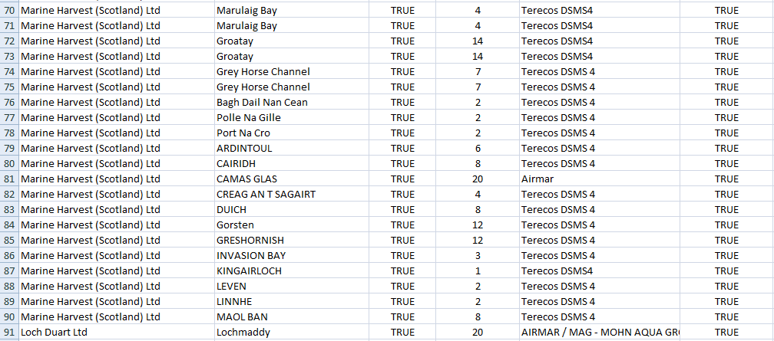
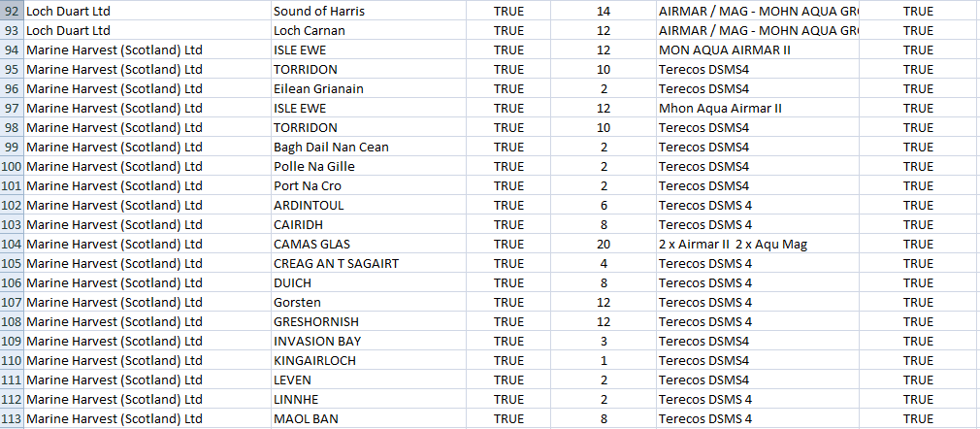
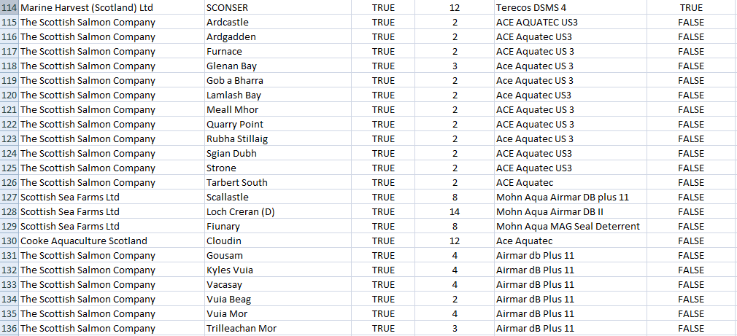
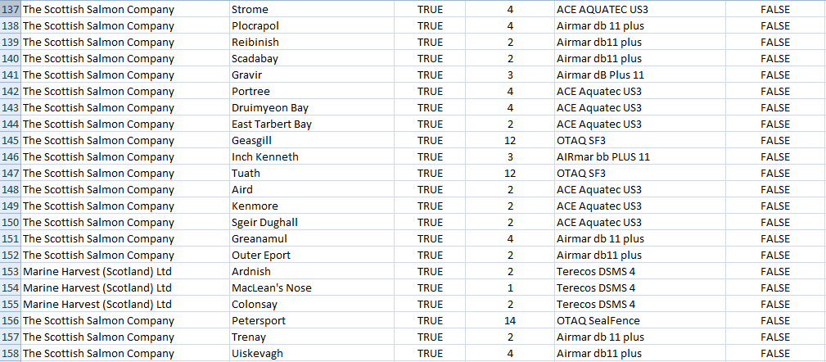
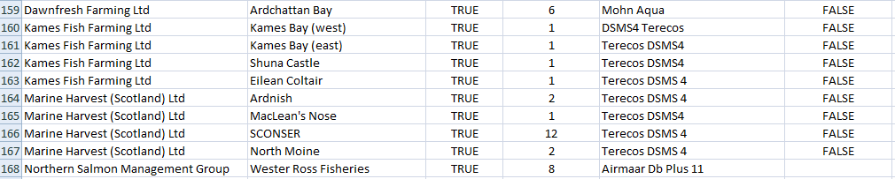

[Note that the Northern Salmon Management Group includes salmon farms operated by Loch Duart and Wester Ross Fisheries; Dawnfresh farm rainbow trout not salmon]

Download an Excel spreadsheet detailing ADD use on Scottish salmon farms online here and online here (edited version showing ADD use only)

Read more via Press Release: "Deafening Impact of Salmon Farms on Cetaceans" (18 April 2018)

