Scottish Salmon Watch

Media Backgrounder (May 2018)

Marine Harmfest Scotland

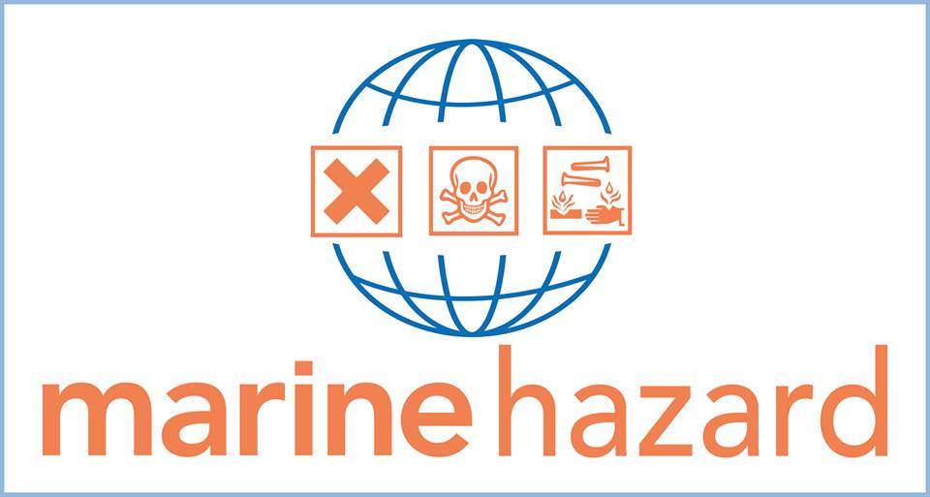

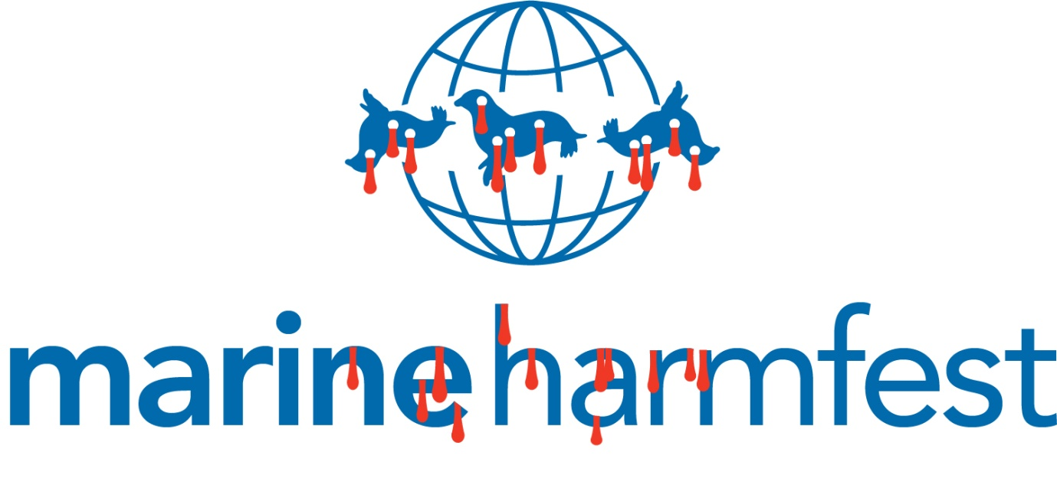

Slaughter of Seals - 121 seals killed between 2011 and 2017:

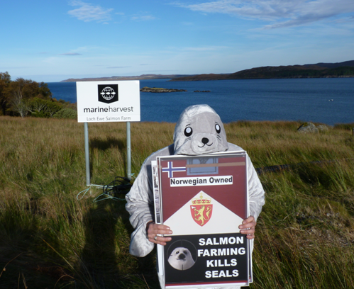
Here's a table detailing all the seals killed by salmon farms since 2011 - with Marine Harvest killing 121 seals between 2011 and 2017 (leading the way in 2016 with 26 seals killed):
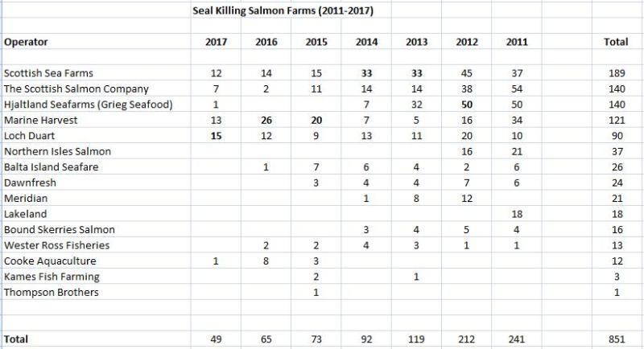
Download as an Excel spreadsheet online here
Read more via online via Seal Killing Data 2011-2017: Scottish Government Seal Licensing Returns
The Global Alliance Against Industrial Aquaculture reported in November 2017:
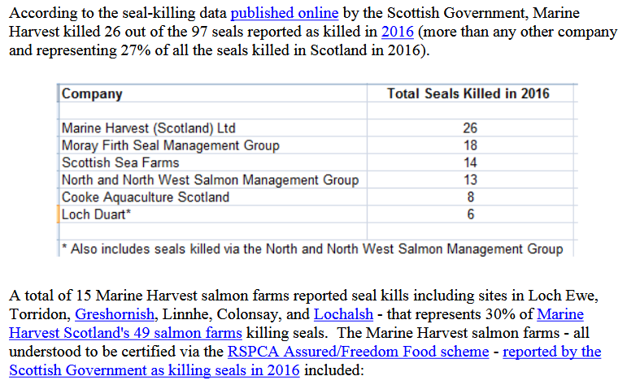
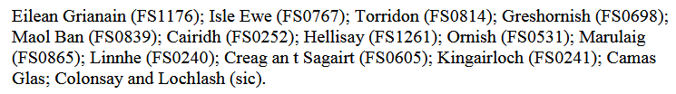
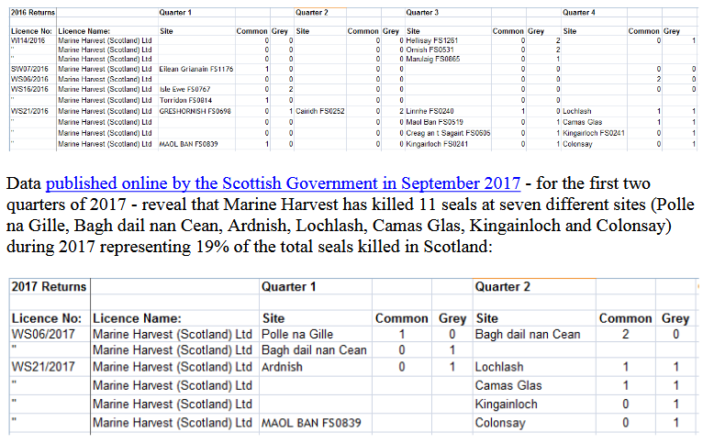

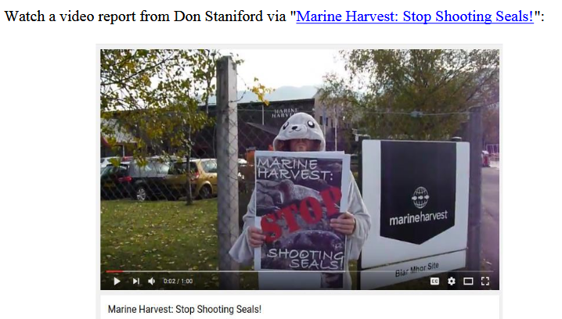

The Global Alliance Against Industrial Aquaculture reported in February 2018:

Marine Harvest's slaughter of seals in Loch Alsh - a Special Area of Conservation - attracted widespread condemnation:

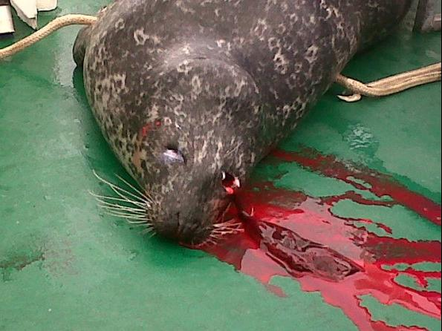

Headless seal corpses have also washed up near Marine Harvest's salmon farm in Loch Alsh (within the Loch Alsh 'Special Area of Conservation'):

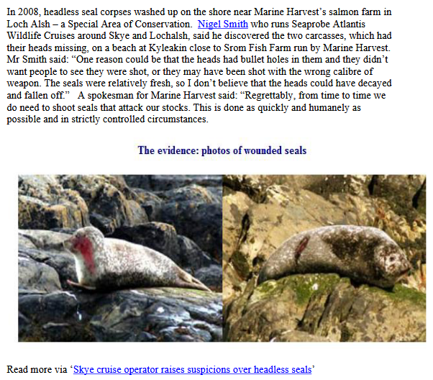

Read more via:

Sunday Herald: "Revealed: Scottish Government bid to exempt salmon farming from US seal-killing ban"
Press Release: "Carry on Killing Says RSPCA"
Press Release: "RSPCA in firing line over Marine Harvest's seal-killing spree in Scotland - 118 seals killed by Marine Harvest's RSPCA Assured farms since 2011"
"Marine Harvest: Scotland's #1 Seal Killer"

Use of Acoustic Deterrent Devices (ADDs) - 65 out of 164 in use with 58 "Always On":

Data obtained from the Scottish Government in June 2017 via FOI revealed that 164 salmon farms use ADDs with 112 salmon farms where ADDs are listed as "Always On". Of the 164 salmon farms using ADDs, Marine Harvest accounted for 65:

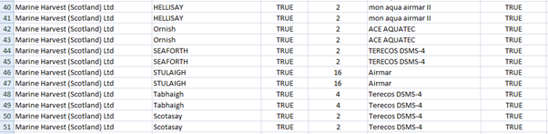
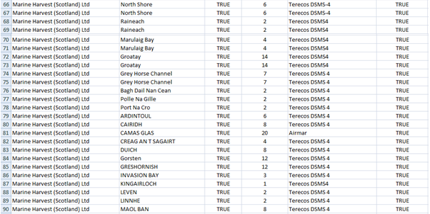
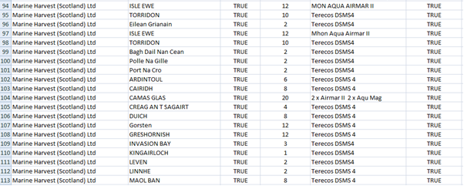

Download an Excel spreadsheet detailing ADD use on Scottish salmon farms online here and online here (edited version showing ADD use only). Read more via Press Release: "Deafening Impact of Salmon Farms on Cetaceans" (18 April 2018).
Toxic Chemical Use:

Data published via the Scotland's Aquaculture web-site (sourced from SEPA) reveal:

- 134 uses of Azamethiphos by Marine Harvest Scotland during 2017:

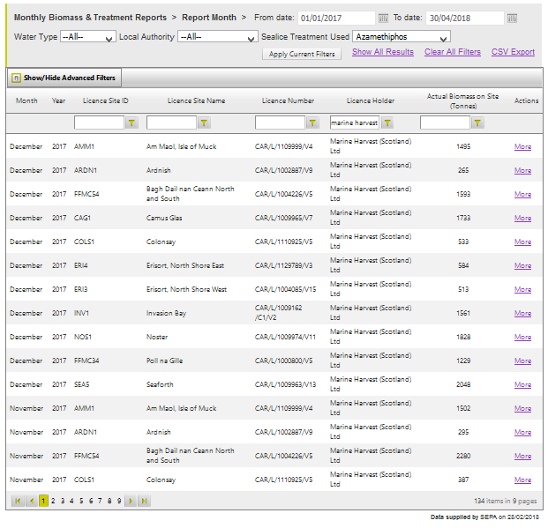
Download all the data online here

- 46 uses of Emamectin benzoate by Marine Harvest Scotland during 2017:

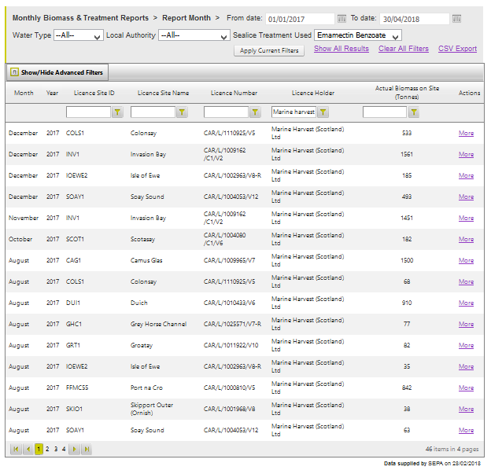
Download all the data online here

- 26 uses of Deltamethrin by Marine Harvest Scotland during 2017:

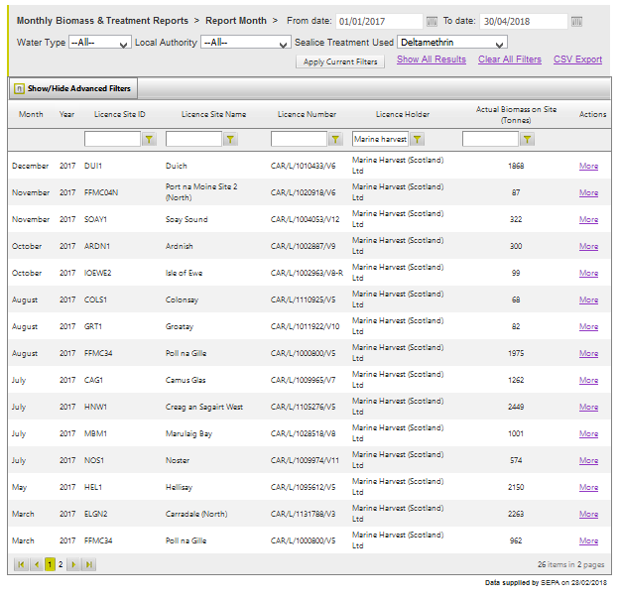
Download all the data online here

Documents obtained from SEPA via FOI on 27 April 2018 reveal the following uses of Azamethiphos (a toxic organophosphate) by Marine Harvest via well boats:
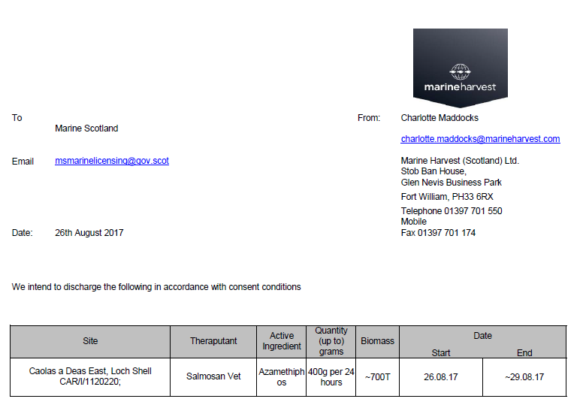

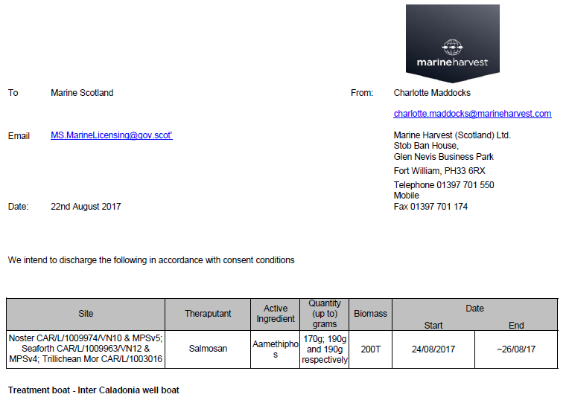

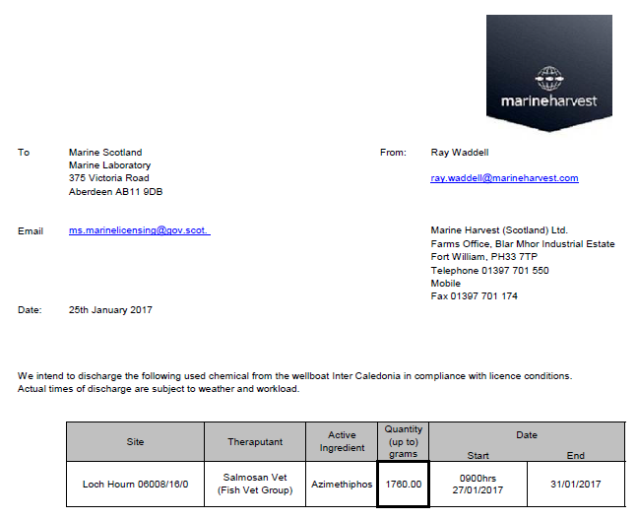
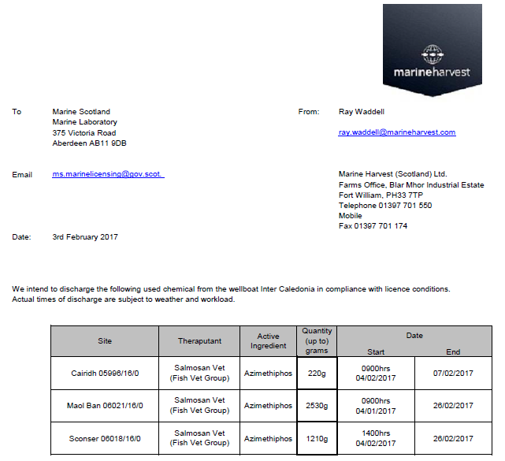

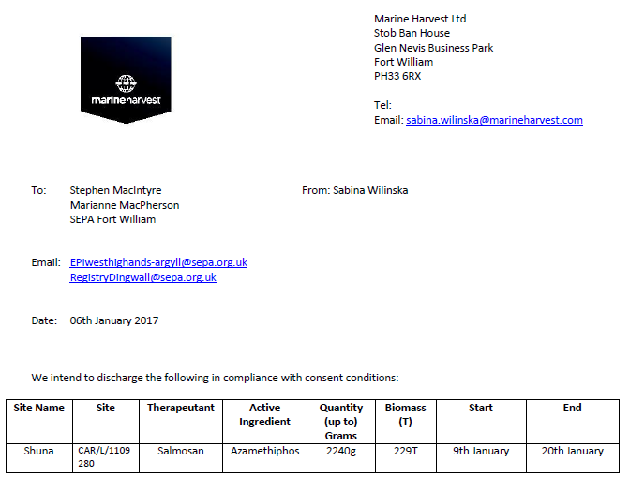

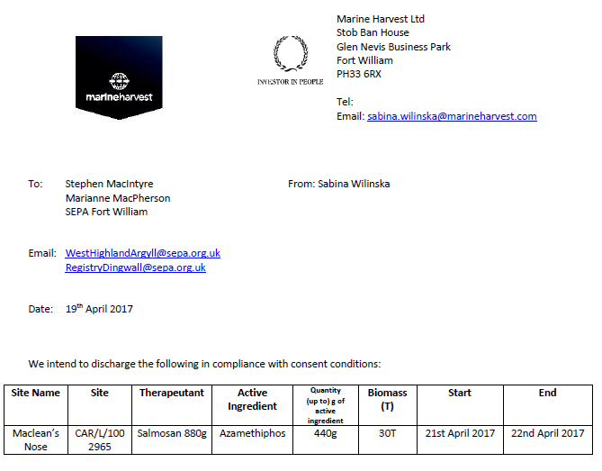

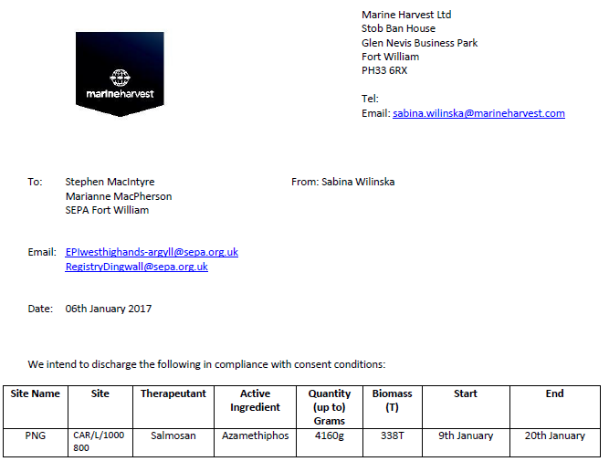

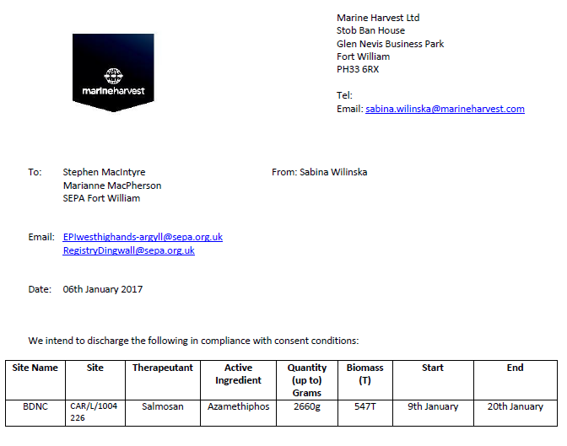

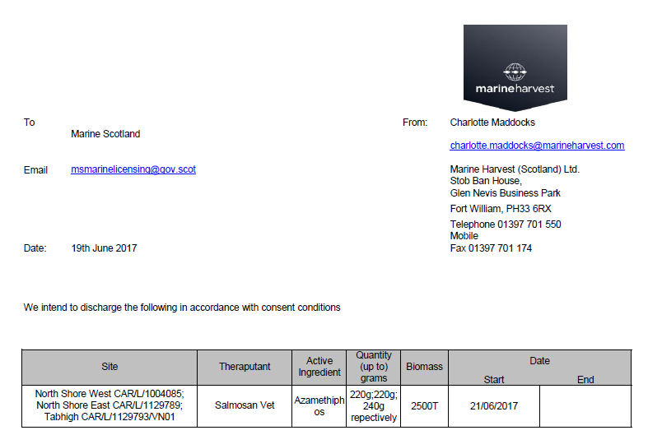

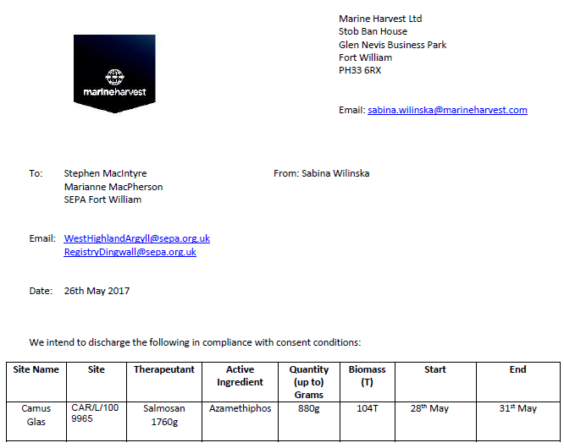

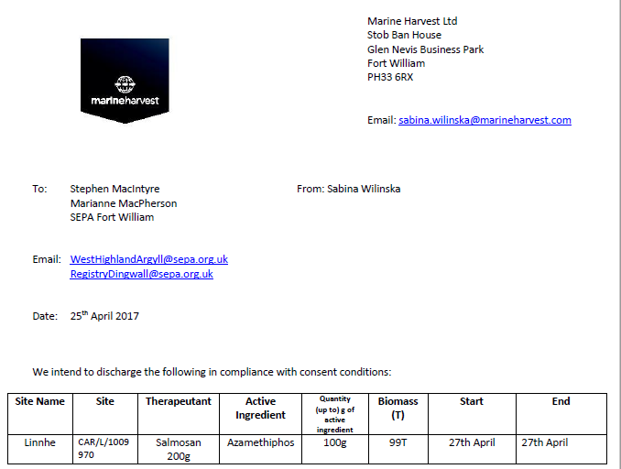

The Global Alliance Against Industrial Aquaculture reported in February 2018 via "The Scottish Salmon Polluters Organisation":

The use of toxic chemicals on Scottish salmon leapt 1000% over the last decade - with SSPO member producers winning gold medals for the use of Emamectin benzoate (shown to be lethal to lobsters), Teflubenzuron (now banned following evidence it can kill crabs, shrimp and lobsters), Azamethiphos (shown to cause neuromuscular dysfunction, hypoxia, metabolic disturbances and mortality in lobsters), Cypermethrin ("particularly toxic to crustacea") and Deltamethrin (fast-tracked for use by SEPA):
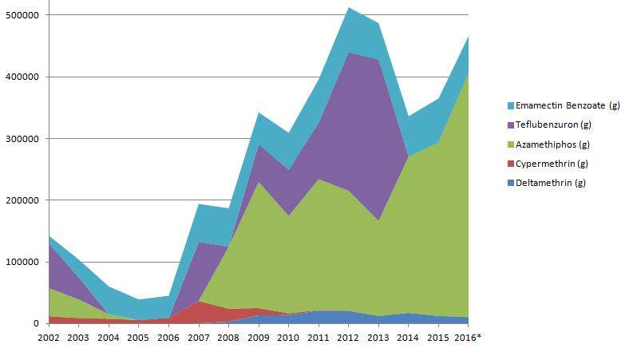

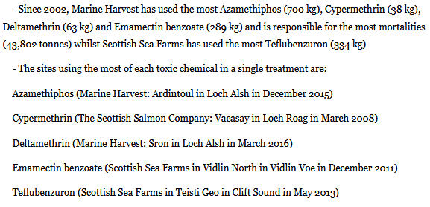

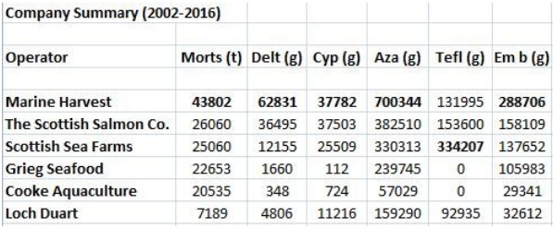

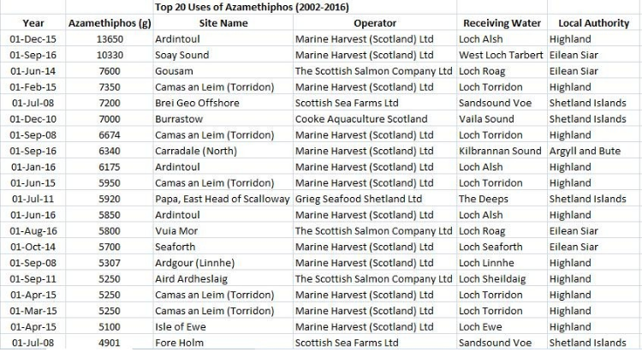

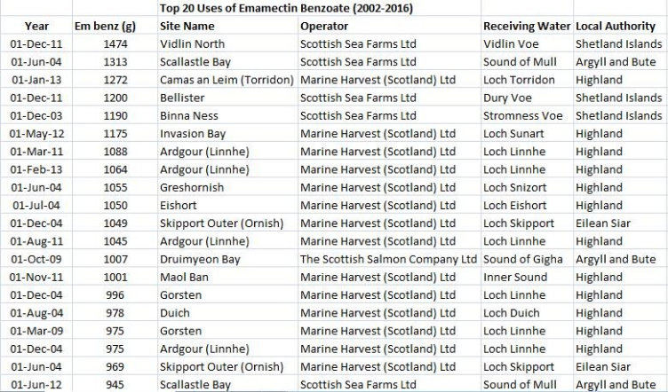

SSPO member producers have also been caught breaching SEPA's biomass limits (i.e. producing more salmon than permitted):

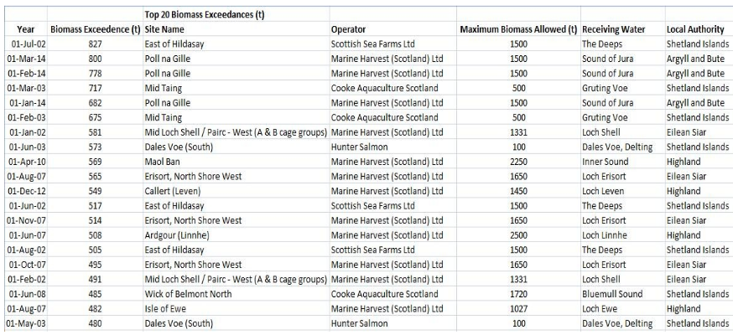

Read more via The Sunday Times: "Salmon industry toxins soar by 1000 per cent"; "Scottish Salmon's Lethal Legacy - Ten-fold Increase in Toxic Chemical Use in Ten Years"; Press & Journal: "Scottish salmon farming ‘fighting a losing battle’ against sea lice"; "Scottish fish farmers use record amounts of parasite pesticides" and "Sharp rise reported in Scots fish lice chemical".

Given the industry's reliance on drugs and chemicals it is not surprising that SSPO member producers have been caught by the Veterinary Medicines Directorate with chemical contamination of farmed salmon. Emamectin contamination of Scottish farmed salmon has now occurred at least eight times (including The Scottish Salmon Company in 2016 and 2012, Scottish Sea Farms in 2006 and Marine Harvest in 2005):
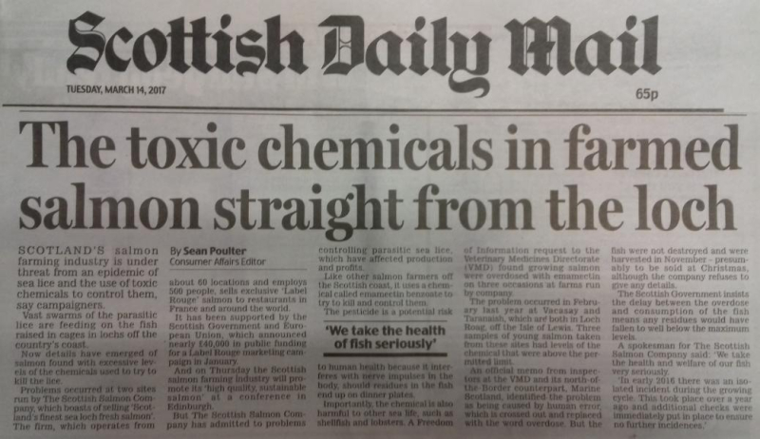
Read more via "Scottish Salmon Overdoses on Toxic Chemical"; Daily Mail: "The toxic chemicals in farmed salmon straight from the loch" and "Emamectin residues in farmed salmon"

For more details on the environmental impacts of toxic chemicals used by salmon farms read:

Fish Farmageddon: Scottish Salmon's Lethal Legacy - Ten-fold Increase in Toxic chemical Use in Ten Years
Scientific Backgrounder: Ecotoxicity & Chemical Resistance
Toxic Toilets: Salmon Farms Pollute Scotland's Lochs
Scottish Salmon Farming 101
Silent Spring of the Sea

Antibiotic & Hydrogen Peroxide Use in 2017:

Data obtained from SEPA via FOI on 4 April 2018 detailed the use of antibiotics and hydrogen peroxide at Marine Harvest sites during 2017 - including 3,333,356 litres of hydrogen peroxide; 206,800 grams of Aquatet (Oxytetracycline hydrochloride) and 314,351 grams of Florocol (Florfenicol):

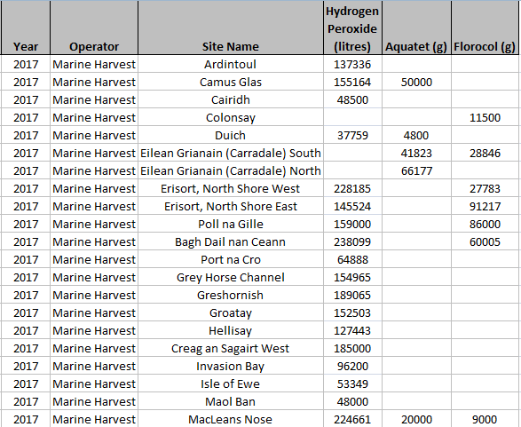
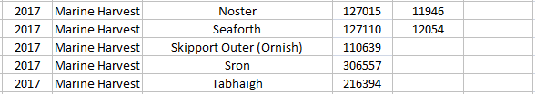

Excel spreadsheet detailing antibiotic and hydrogen peroxide use by Scottish salmon farms during 2017 available online here

Here's data detailing the top 20 sites using the largest quantities of hydrogen peroxide during 2015 (sourced from SEPA via FOI):

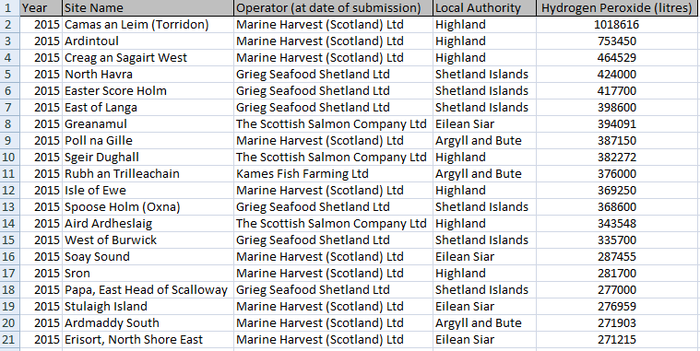

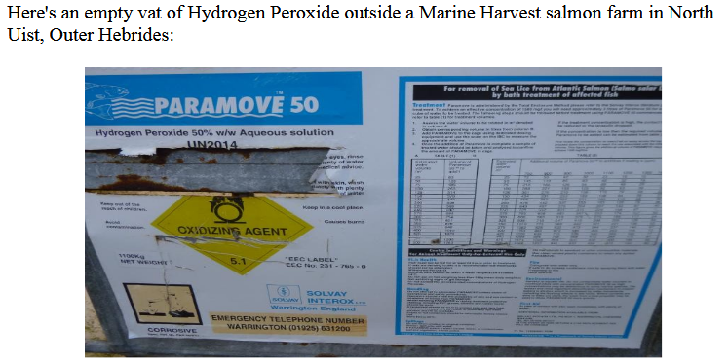

The Sunday Times reported (12 February 2017):

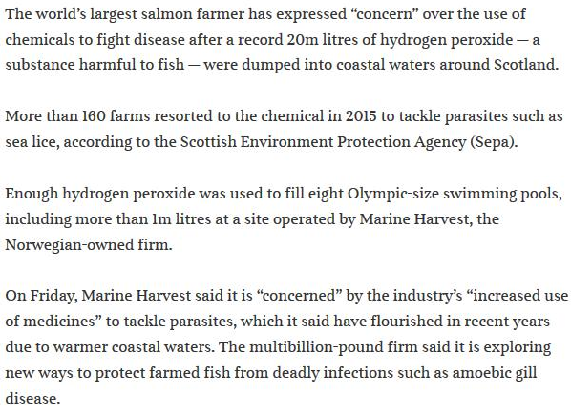

Here's data detailing salmon farms which used antibiotics in 2014-2015 (sourced from SEPA via FOI):

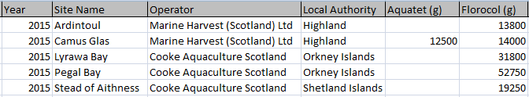

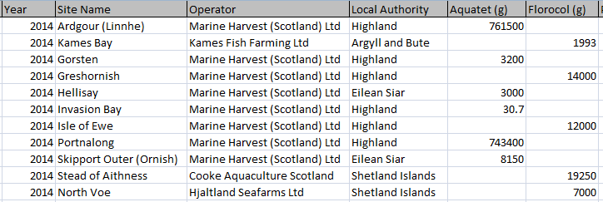

The Global Alliance Against Industrial Aquaculture reported in February 2018 via 'The Scottish Salmon Polluters Organisation':

Data on antibiotic use reveals that SSPO member producers are the biggest drug users:

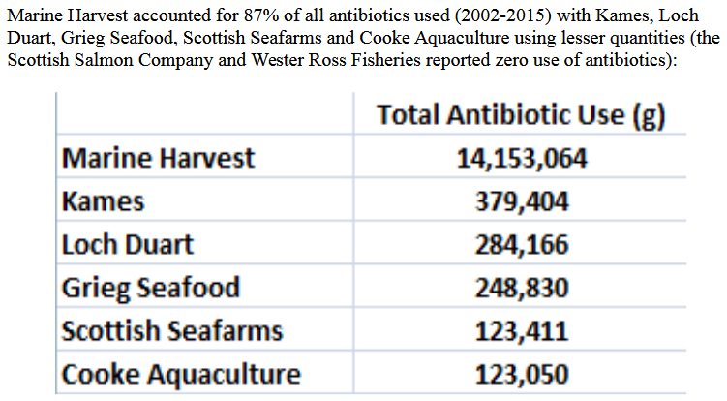

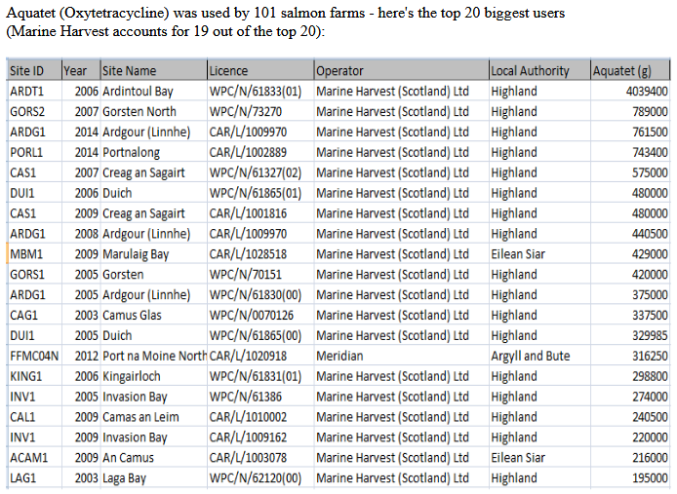

Read more via:

Antibiotic-ridden Scottish Salmon: FOI reveals of Oxytetracycline, Florfenicol, Amoxycillin and Fenbendazole

Failing Fish Farms - 9 salmon farms assessed by SEPA as "Poor" in 2016 and 13 failing sites in 2015:

The Global Alliance Against Industrial Aquaculture reported in February 2018 via 'The Scottish Salmon Polluters Organisation':

Data from SEPA ranked fish farms as 2nd worst out of "Scotland's polluting industries" - with SSPO member producers guilty of the vast majority of fish farm pollution breaches:

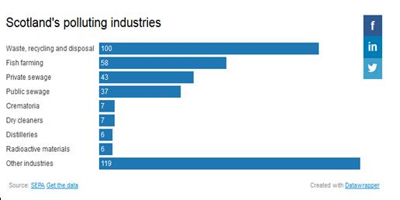
Read more via "Exposed: the 383 plants that pollute Scotland" and "Mapped: the hundreds of firms condemned for ‘poor’ pollution performance"
Almost a fifth (18%) of Scottish fish farms were classified by SEPA as failing and responsible for "at least one significant breach" in 2015. SSPO member Marine Harvest, Scotland's largest salmon farming company, was the worst operator with 13 "failing" salmon farms in 2015 (that's 27% of the 49 marine salmon farms operated by Marine Harvest).

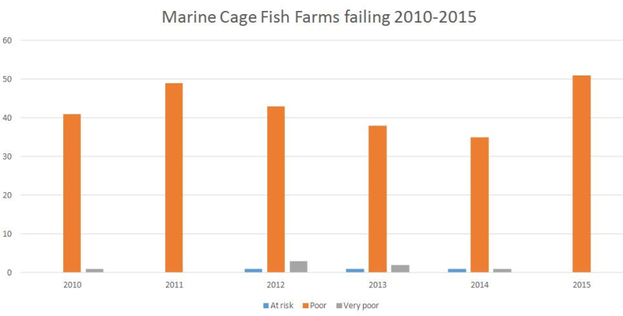

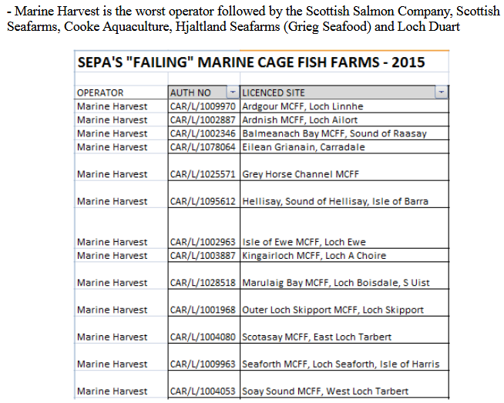

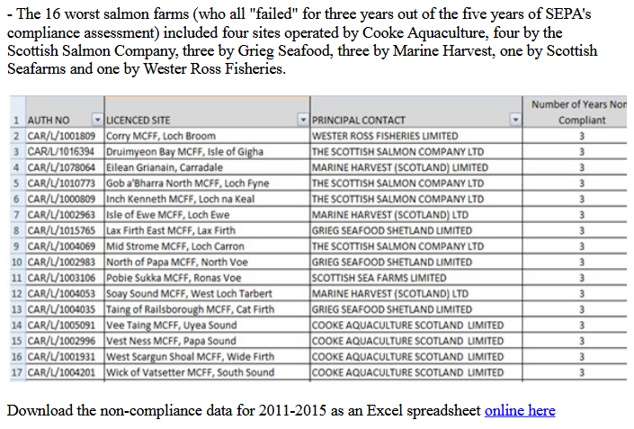

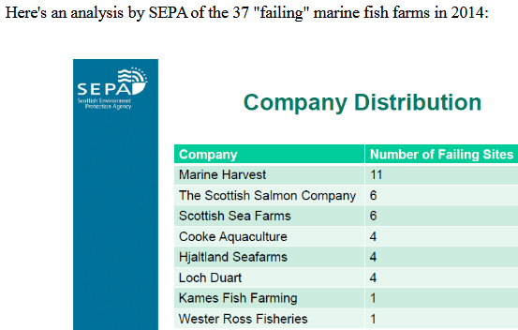

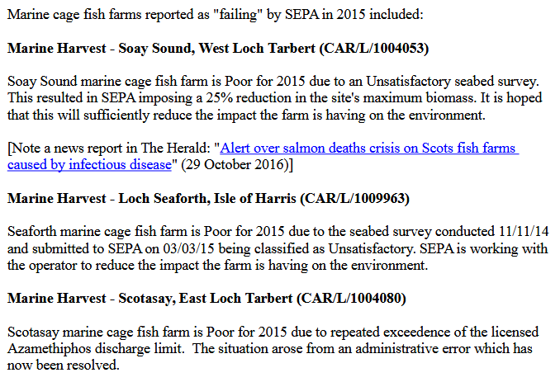
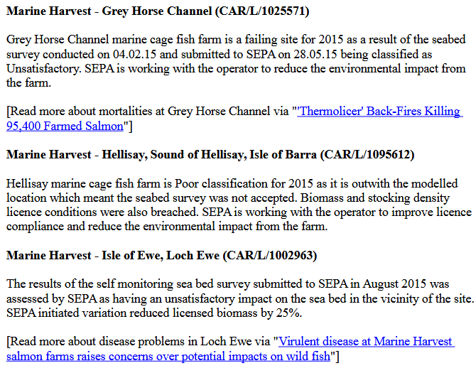

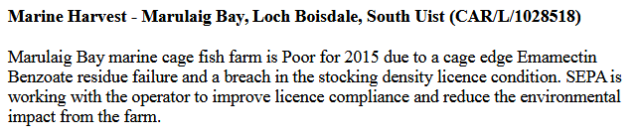

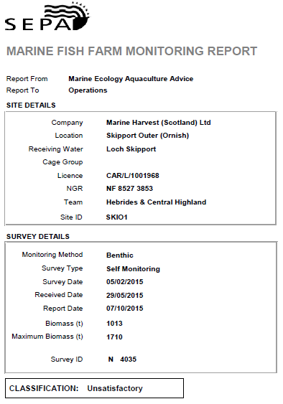

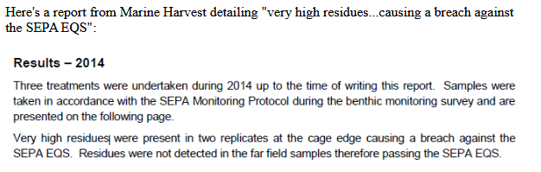
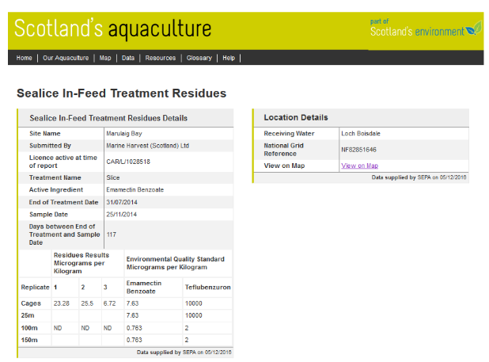

Read more via "Failing Fish Farms - 18% rated "poor" by SEPA in 2015"

In 2006, The Sunday Herald reported on "Scotland's 'dirty dozen'" ecologically risky companies - with Marine Harvest's processing plant in Fort William topping the list (i.e. the worst of the worst.

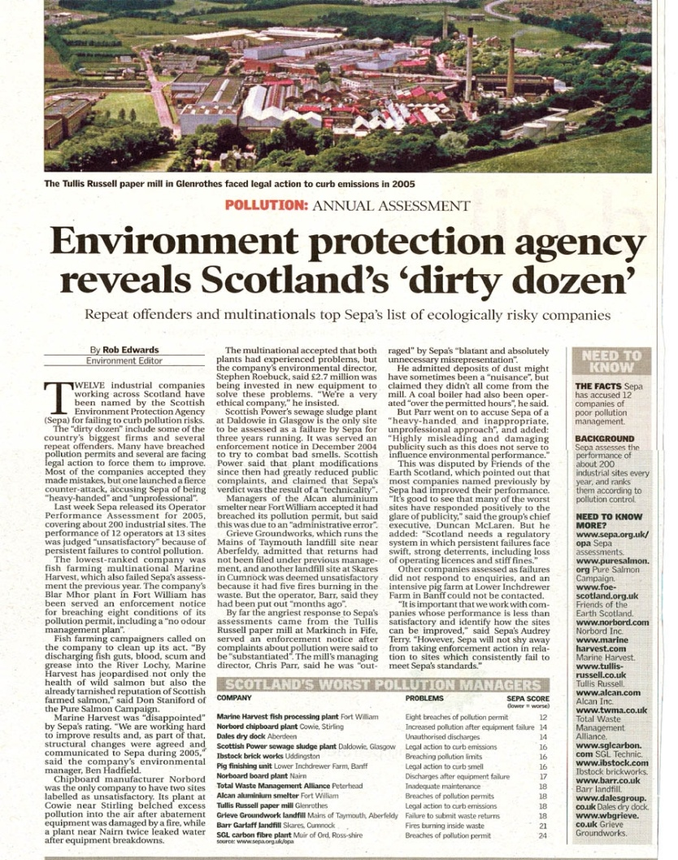
Compliance data for 2016 was requested via FOI from SEPA in February 2018 but has still not been fully replied to - preliminary data from SEPA indicates that Marine Harvest was responsible for 9 out of the 51 fish farms assessed as "Very Poor", "Poor" or "At Risk" in 2016:

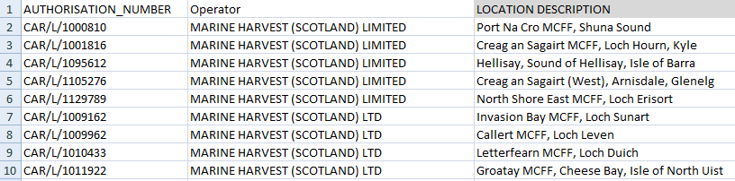

Read more via:
"Major sites rated 'poor' on environment protection" (BBC News, 15 February 2018)

Pollution Breaches:

The Global Alliance Against Industrial Aquaculture reported in February 2017:

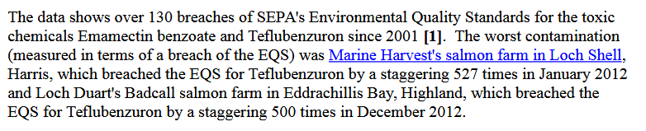

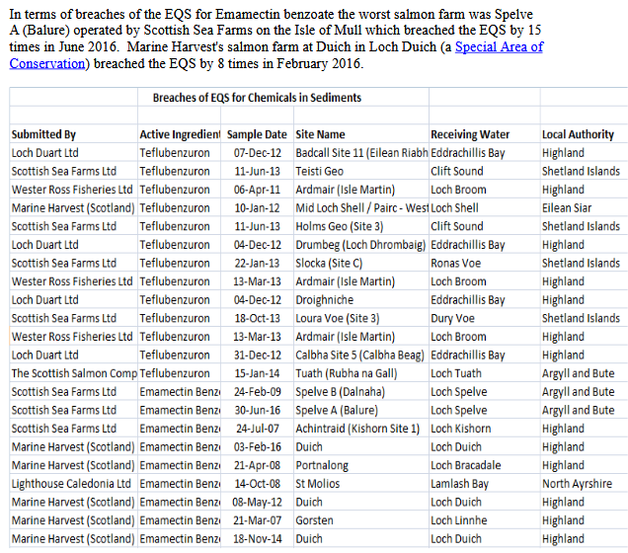

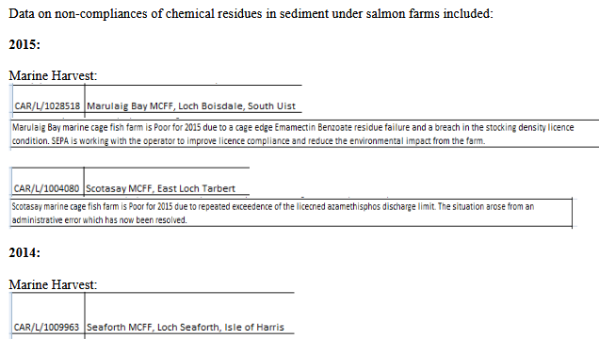
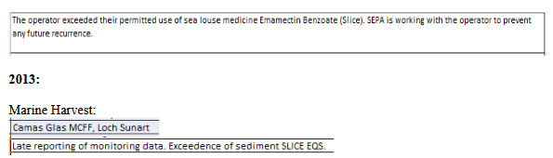

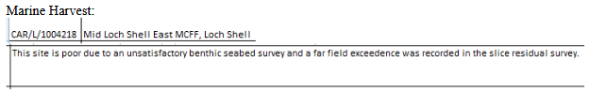

Read more via "Toxic Toilets: Salmon Farms Pollute Scotland's Lochs"

Marine Harvest polluted Loch Shell with the toxic pesticide Teflubenzuron (subsequently banned by SEPA) up to 450 times higher than recommended levels:

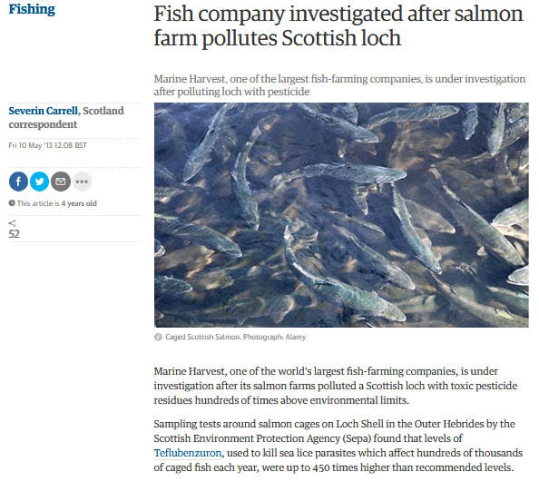

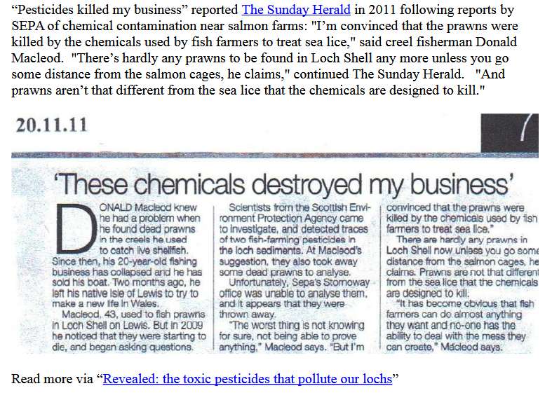

Read more via "Fish company investigated after salmon farm pollutes Scottish loch"; "Revealed: the dirty dozen salmon farms that contaminate lochs with pesticides" and "Revealed: the toxic pesticides that pollute our lochs" and "The drug that's meant to save Salmon but is killing the creatures on the Ocean floor"

In 2005, Marine Harvest was fined £4,000 for polluting the River Lochy with fish viscera, blood and congealed fats deposits, scum and grease:

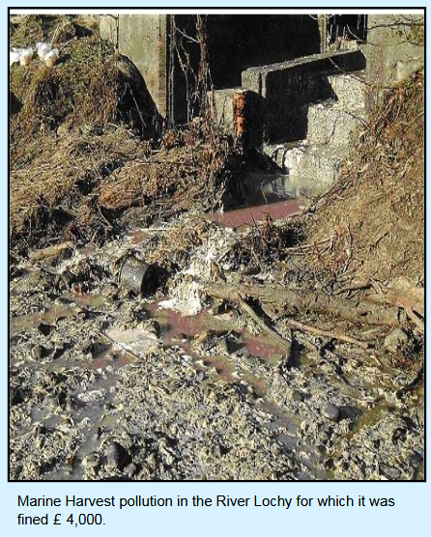

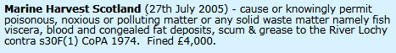

Read more via "Scottish Farmed Salmon Exposed"

Marine Harvest is certainly no stranger to breaching pollution limits:

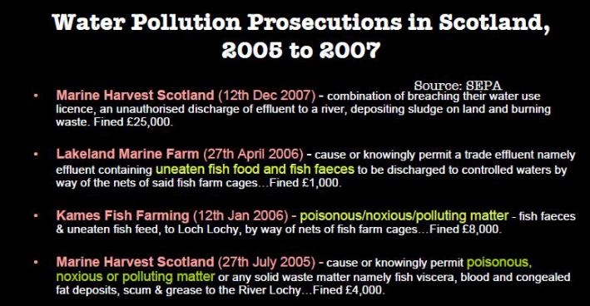

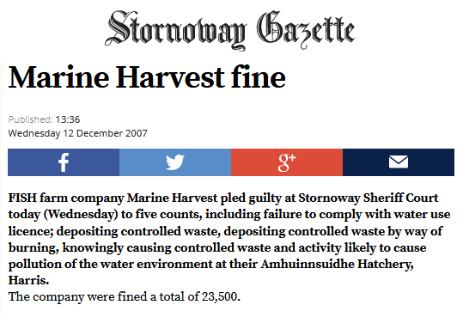

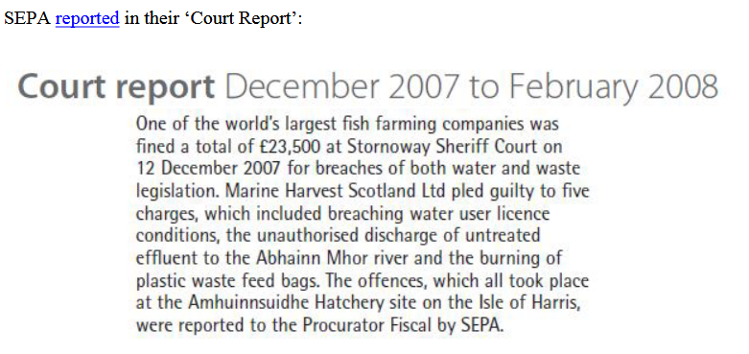

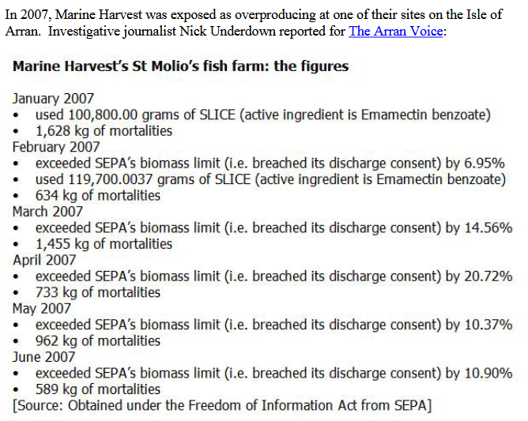

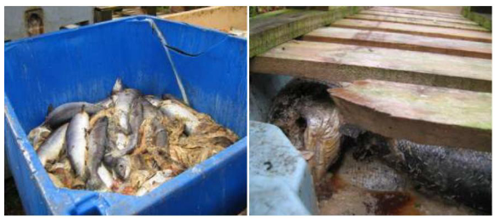

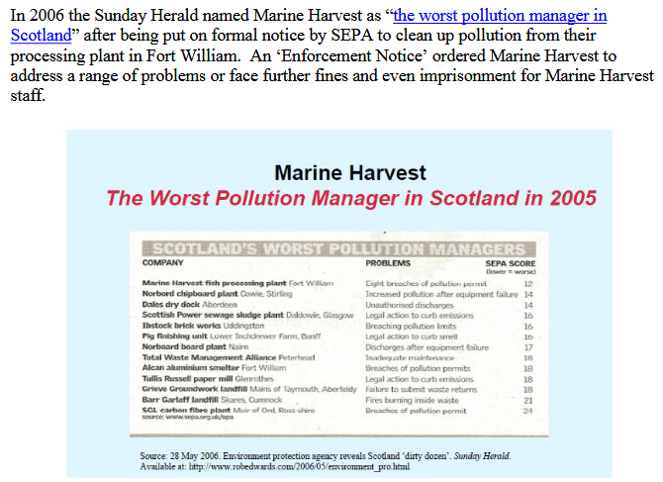

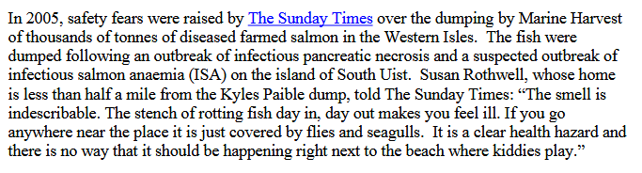

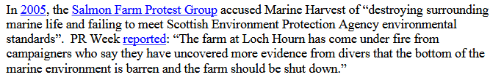

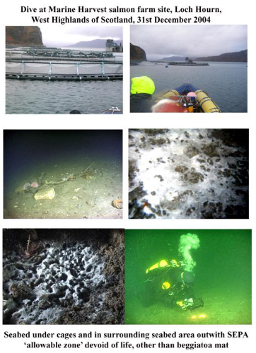

Lice, Disease & Mortalities:

A FOI reply by the Scottish Parliament in April 2018 (search for # 603922) - includes:

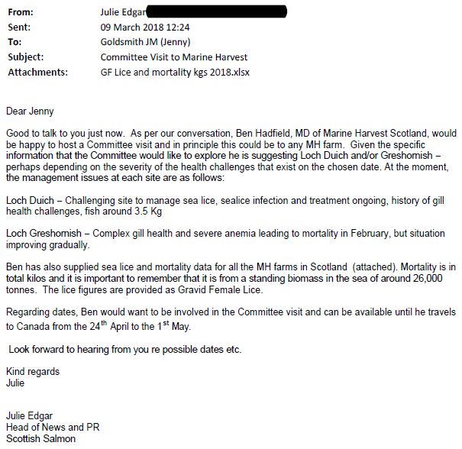
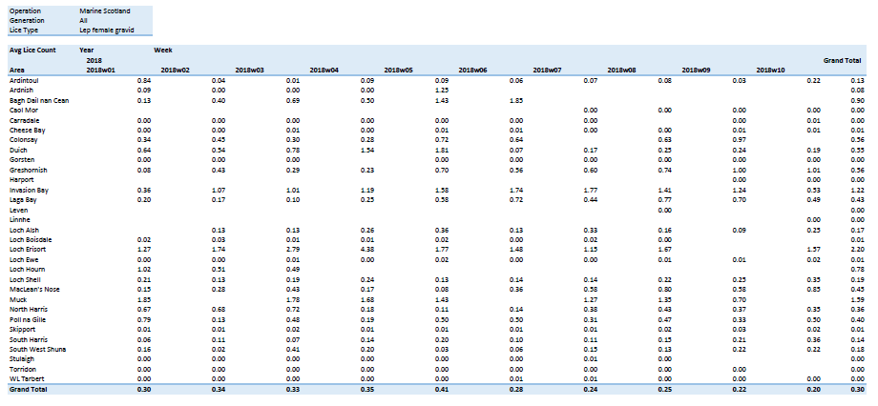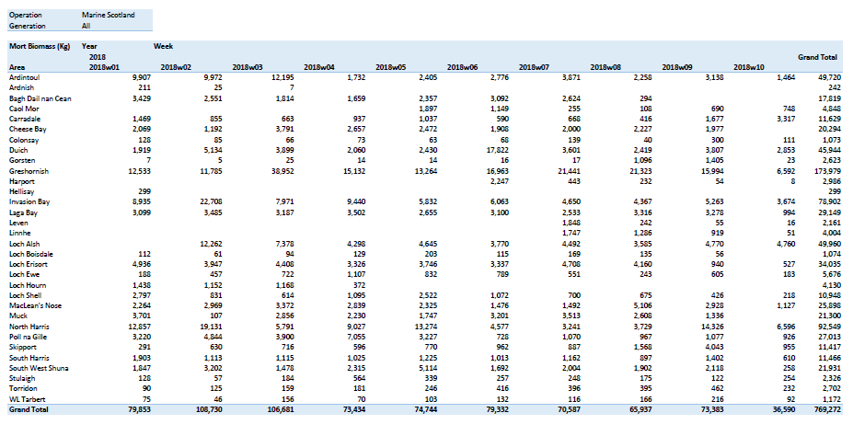
Download as a PDF online here

Scottish Salmon Watch's submission to the Scottish Parliament in March 2018 included:

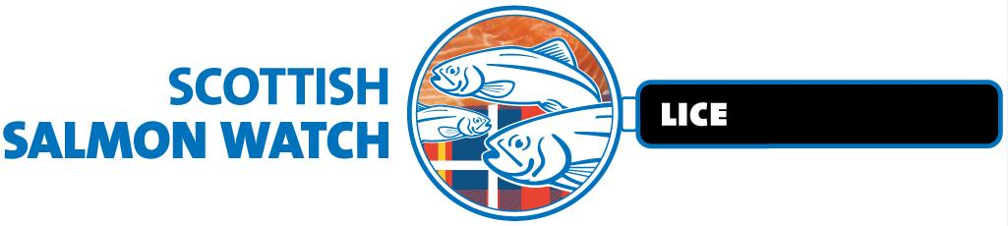

Thanks to Salmon & Trout Conservation's repeated FOI requests and appeal victory via the Scottish Information Commissioner site specific data on sea lice infestation on salmon farms is now available - with the following 61 salmon farms identified as breaching lice limits between November 2016 and December 2017.

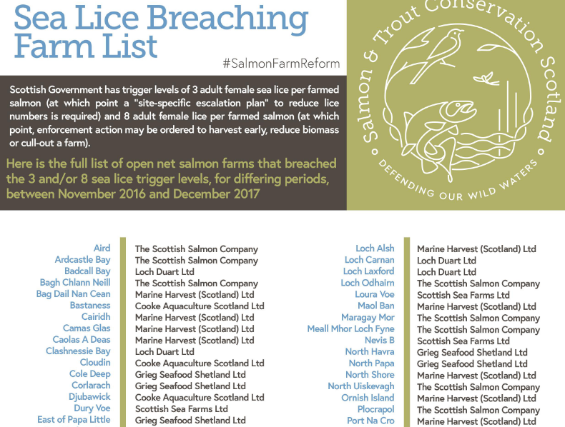
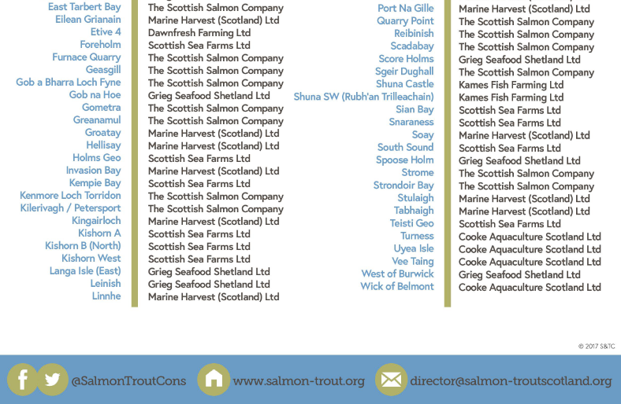

Read more via:

"Scottish salmon sold by a range of supermarkets in the UK has sea lice up to 20 times acceptable limit - Tesco, Sainsbury’s and Co-op are among those who have stocked salmon from the worst affected farms"
"Supermarket salmon riddled with sea lice - Ministers tried to bury figures showing a pest that can spread to and kill fish in the wild is rife in Scottish farms"
"Scottish salmon farming’s ‘liciest’ farms named and shamed"
"Scottish Ministers ordered to disclose names of Scotland’s ‘liciest’ salmon farms to Salmon & Trout Conservation Scotland"

A FOI reply by the Scottish Government in January 2018 also provided sea lice data:

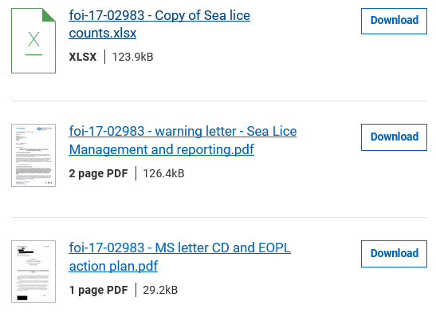

The FOI data disclosed by the Scottish Government included:

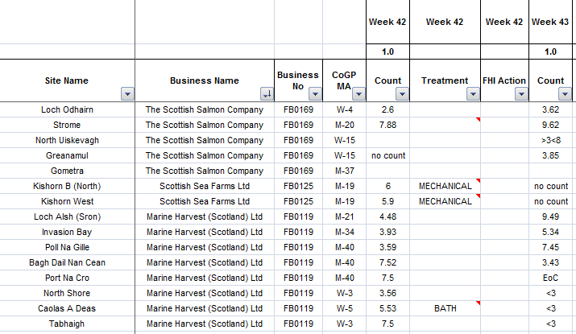

A FOI reply by the Scottish Government in March 2018 also detailed:

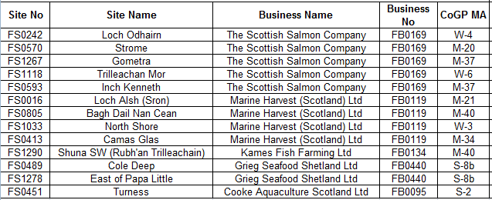

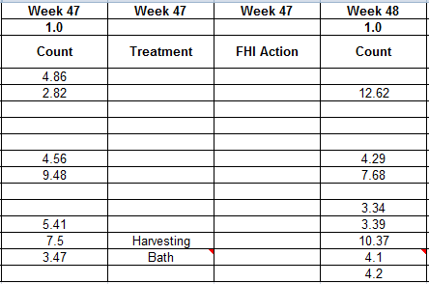

Download Excel spreadsheet online here

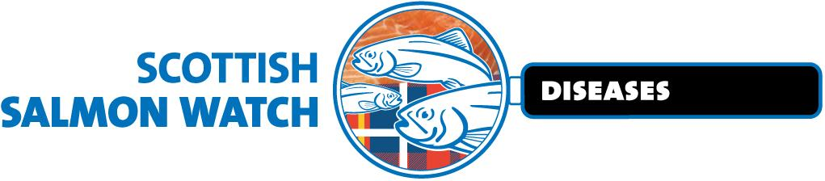

In February 2018, the Global Alliance Against Industrial Aquaculture published site specific disease data for 2017 sites operated by Scotland's three largest salmon farming companies (Marine Harvest, Scottish Sea Farms & the Scottish Salmon Company) via FOI replies from the Scottish Government - read online here.

The following reasons for mortalities were reported during 2017: Salmon Gill poxvirus, Paranucleospora theridion, gill pathology, complex gill issues, Vibrio anguillarum, Proliferative Gill Disease, Amoebic Gill Disease, Pancreas Disease, fungus, cardiomyopathy syndrome, Haemorrhagic smolt syndrome, HSMI, Enteric redmouth disease, anaemia and deaths due to the Hydrolicer, Thermolicer, hydrogen peroxide treatment, Salmosan treatment, freshwater post treatment, physical damage, plankton, water quality issues, algal bloom, seal predation and jellyfish.

In summary:

Marine Harvest mort events in 2017 - The Excel spreadsheet details 572,488 mortalities in 56 separate reports/incidents during 2017 - including:

24 reported as CMS
22 reported as Gill Diseases (Gill Pathology, AGD, PGD, gill issues and complex gill issues)
18 reported as Treatment
13 reported as Anaemia
4 reported as PD

The top twenty mortality events reported by Marine Harvest in 2017 (up to November) were:

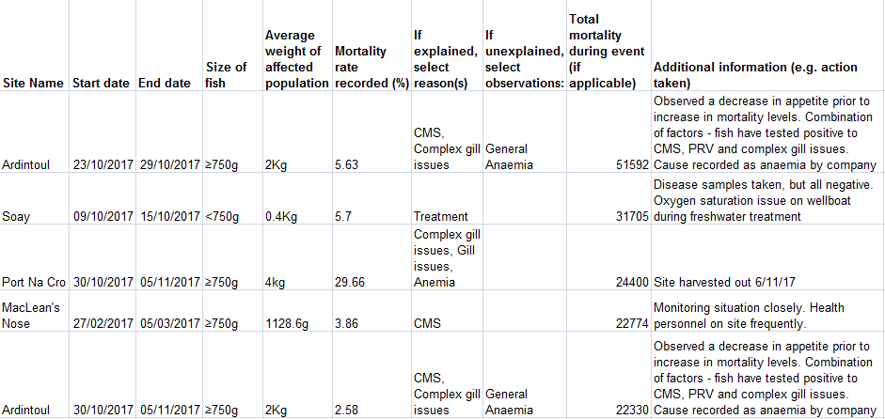
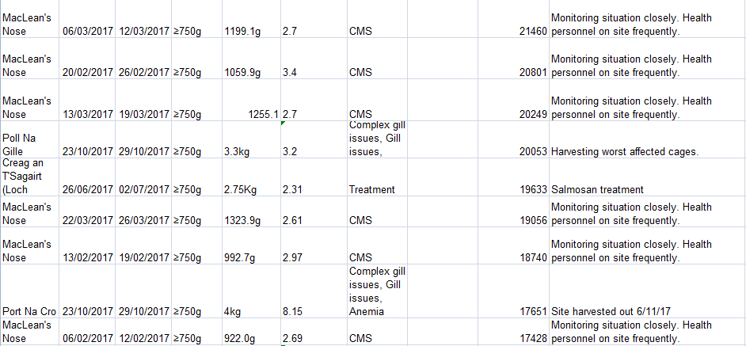
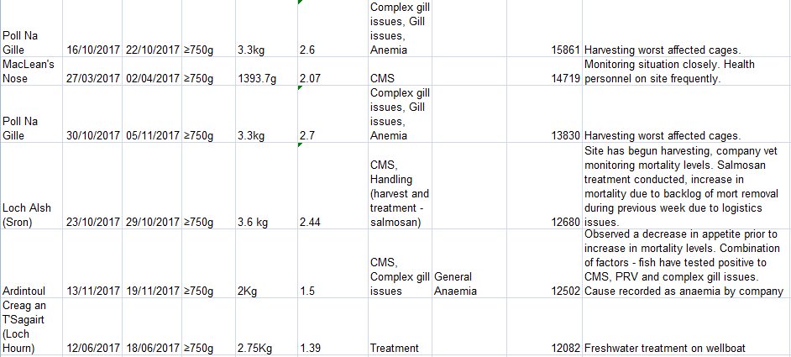

'Case Information' published by the Scottish Government's Fish Health Inspectorate (the latest data available is for April to June 2017) includes details of very high mortality at Marine Harvest's MacLeans Nose salmon farm due to Cardiomyopathy syndrome (CMS).

An email obtained via FOI from the Scottish Government revealed that Marine Harvest was experiencing increases in mortality from a number of sites in late October 2017 citing "Anaemia issues", "CMS" and "complex gill issue":

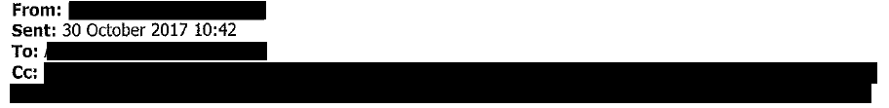
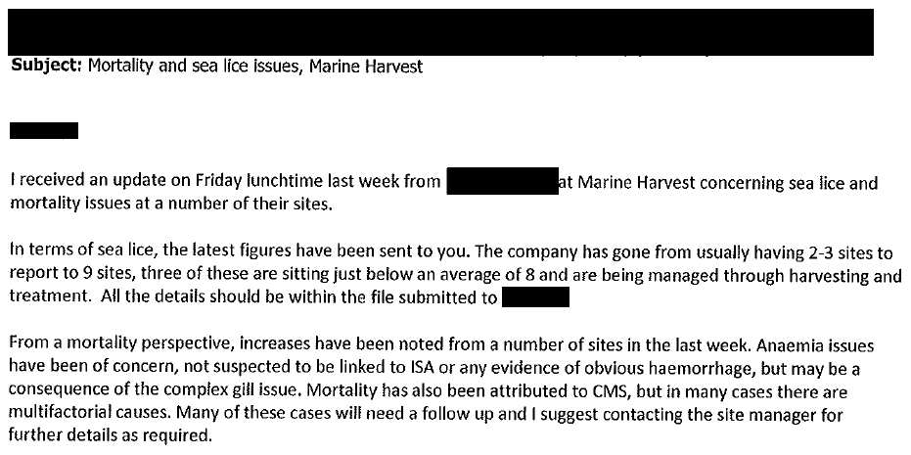
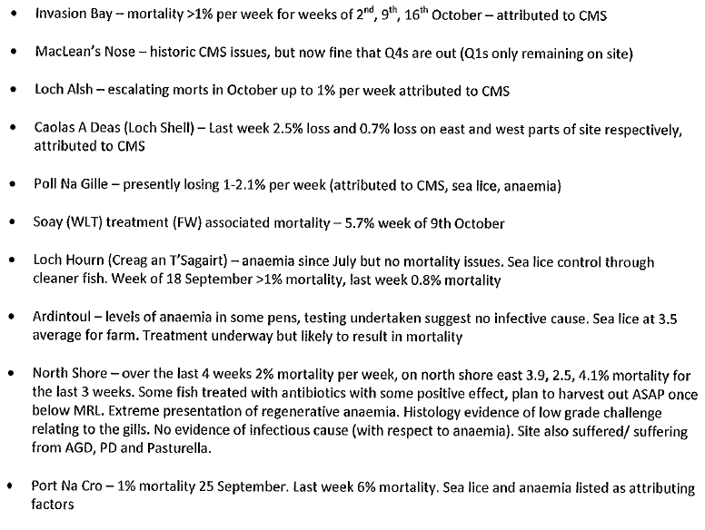
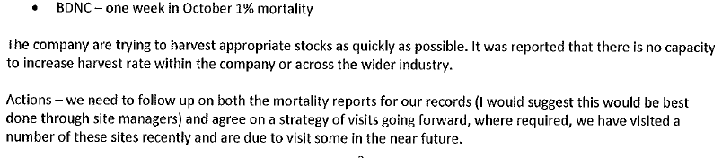

The latest mortality and disease data published on Marine Harvest's web-site is for September 2017 - including:

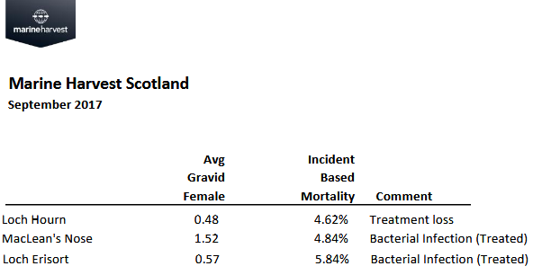

Data for August 2017 includes:

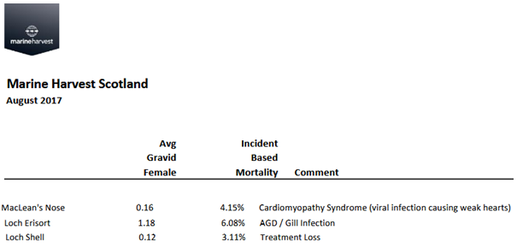

Other data published monthly by Marine Harvest indicates that Cardiomyopathy Syndrome (CMS) started causing mortality problems at MacLean's Nose in February 2017 (10.79% mortality) with problems continuing in March 2017 (11.17% mortality - with 4.02% mortality also reported at Loch Alsh); April 2017 (12.6% and 3.79% at Loch Alsh); May 2017 (13.96%); June 2017 (9.77%) and July 2017 (4.07%).

An FOI reply from the Scottish Government in February 2018 detailed Marine Harvest's North Shore salmon farm as being affected by Pasteurella skyensis in 2017:

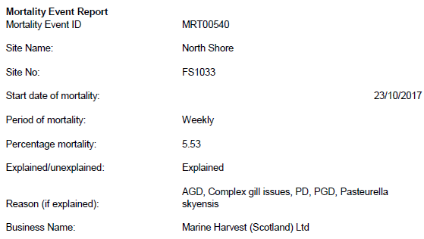

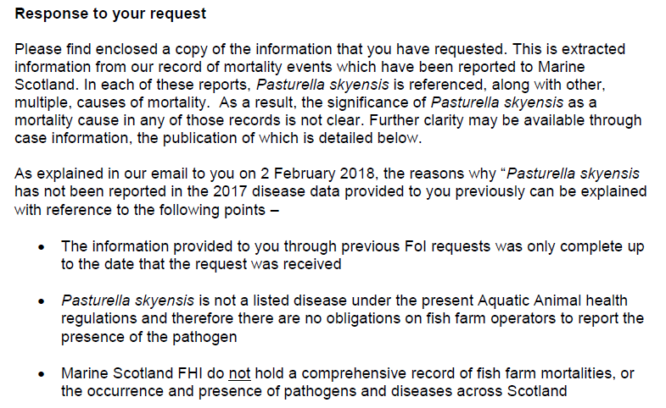
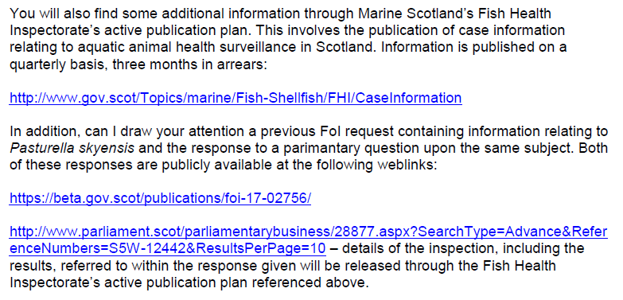

The Case Information referred to above is available online here
The previous FOI request is available online here
The Parliamentary Question is available online here

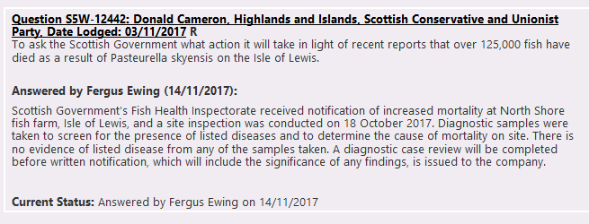

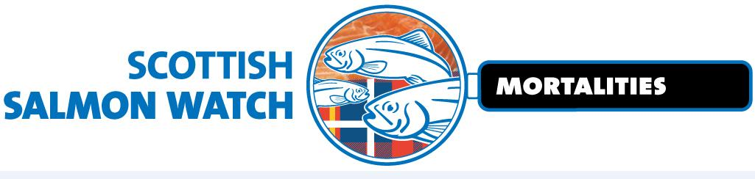

Mortality data obtained via by the Global Alliance Against Industrial Aquaculture from SEPA revealed that Marine Harvest had 2.29 million mortalities (4,211 tonnes) during 2017 (up to September).

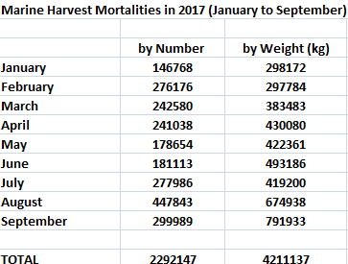

Download Excel spreadsheet: Marine Harvest mort numbers & weights (Jan to Sept 2017)

The data also revealed that the ten biggest monthly losses at Marine Harvest salmon farms during 2017 (up to September) were:

149,949 at Colonsay in August (reported via Scotland's Aquaculture as 12,439kg)
97,235 at MacLeans Nose in March (reported via Scotland's Aquaculture as 107,760 kg)
87,914 at MacLeans Nose in April (reported via Scotland's Aquaculture as 135,641kg)
85,147 at MacLeans Nose in May (reported via Scotland's Aquaculture as 156,754kg)
76,913 at Tabhaigh in August (reported via Scotland's Aquaculture as 265,069kg)
70,627 at MacLeans Nose in February (reported via Scotland's Aquaculture as 67,757kg)
62,747 at Erisort (North Shore East) in September (reported via Scotland's Aquaculture as 214,813kg)
48,620 at Soay Sound in August (reported via Scotland's Aquaculture as 3,645kg)
41,946 at Creag an Sagairt West in June (reported via Scotland's Aquaculture as 116,536kg)
41,615 at Ardintoul in February (reported via Scotland's Aquaculture as 4599kg)

The 100 worst salmon farm sites for mortalities (by weight and month) between 2002 and 2017 were:

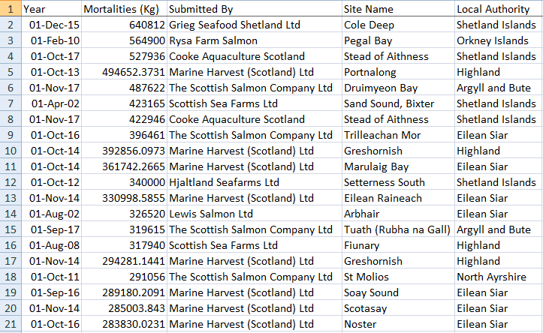
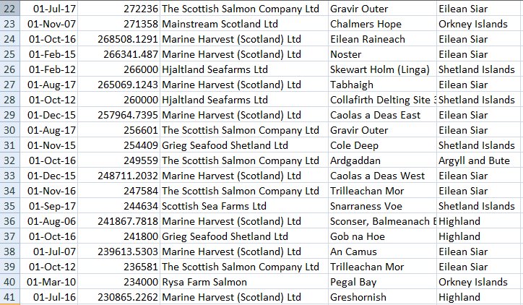
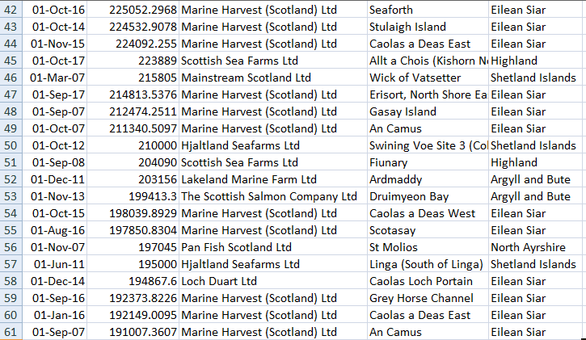
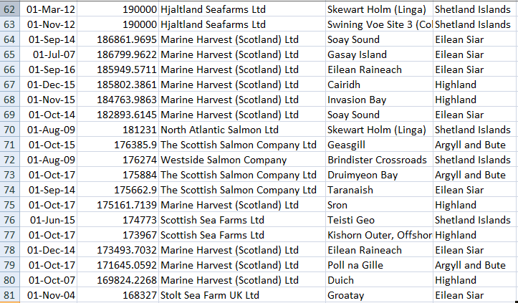
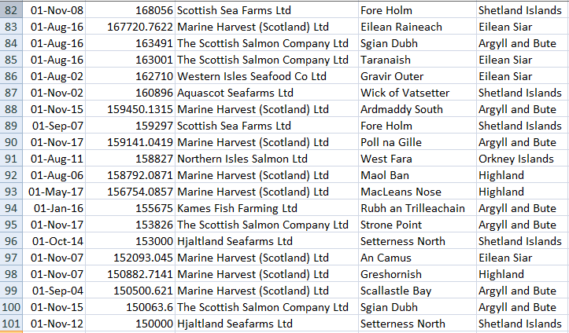

Download 2017 Excel SEPA data from Scotland's Aquaculture Database with summary tables & graphs

Marine Harvest had the most mortalities followed by the Scottish Salmon Company, Cooke Aquaculture, Scottish Sea Farms, Grieg Seafood and Loch Duart all with over 1,000 tonnes of dead farmed salmon in 2017:

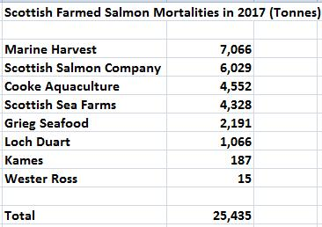

The worst monthly mortalities during 2017 were reported at the following salmon farming sites with Gravir Outer (Scottish Salmon Company) and Poll na Gille (Marine Harvest) featuring twice with most morts appearing in October/Novermber:

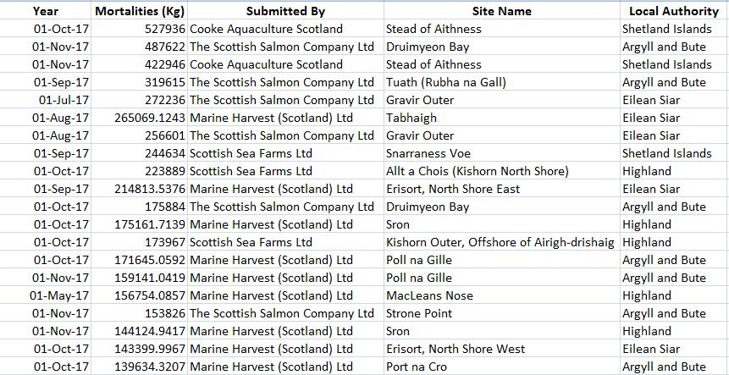

Read more via "The Herald: "Video: Disease concern as Scots salmon farmers' produce 'stomach-churning' record levels of fish deaths ".

Other data on mortalities include this 'Mortality Event Report' obtained by GAAIA from the Scottish Government via FOI detailing 60,000 morts at Marine Harvest's Soay farm in 2016 due to hydrogen peroxide treatment for Amoebic Gill Disease:
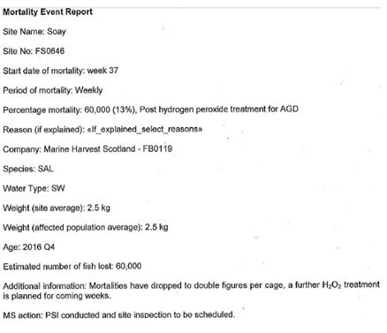
Nearly 100,000 farmed salmon were 'Thermoliced' to death by Marine Harvest during 2016:
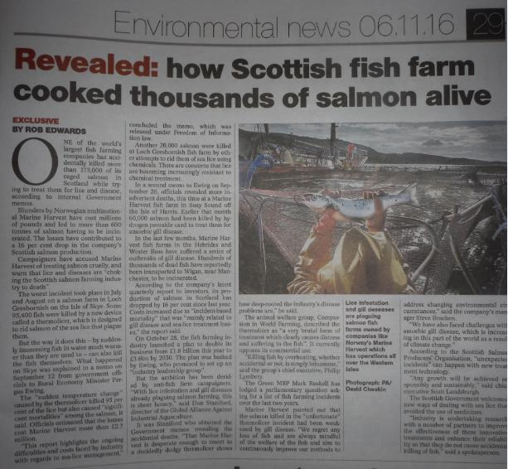
Read more via "'Thermolicer' Back-Fires Killing 95,400 Farmed Salmon"; Fish farm firm kills 175,000 salmon by accident; "Oops: fish farm firm kills 175,000 of its salmon by accident" and "Thousands of fish poached alive in lice treatment bungle"

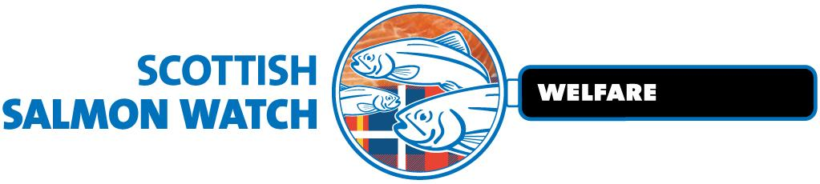

Mortality events reported by Marine Harvest in 2017 include three cases involving over 20,000 dead salmon due to using a Thermolicer:

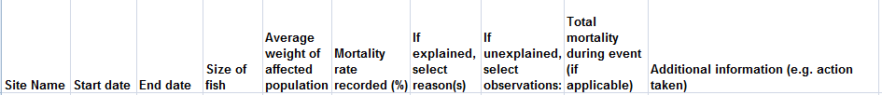

Online via: "Scottish Salmon's Mort Mountain Leaps Over 10 Million - FOI reveals 2.3 million dead salmon at Marine Harvest farms in 2017".

An FOI reply from the Scottish Government in November 2017 also detailed: "Salmon mortality rates at farming sites 1997-2016".

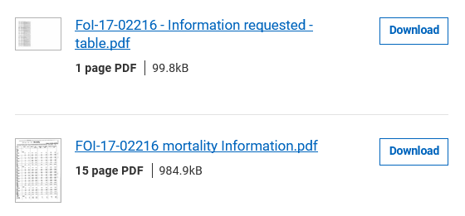
The mortality and disease data disclosed included:

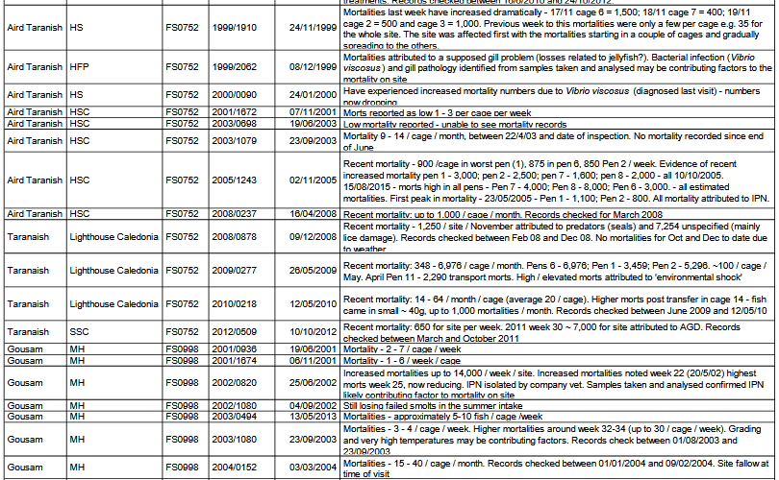
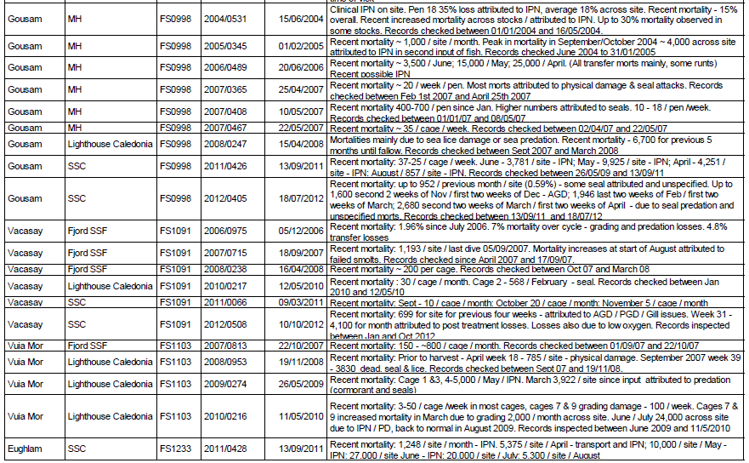

And the FOI reply detailed various 'Mortality Reason Reports':
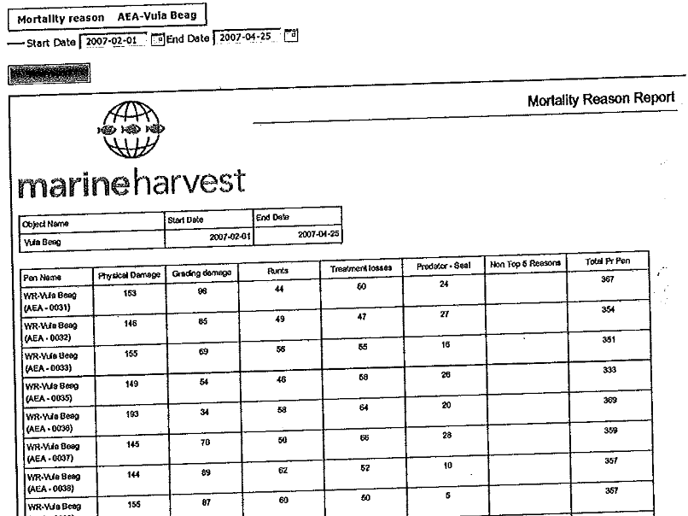

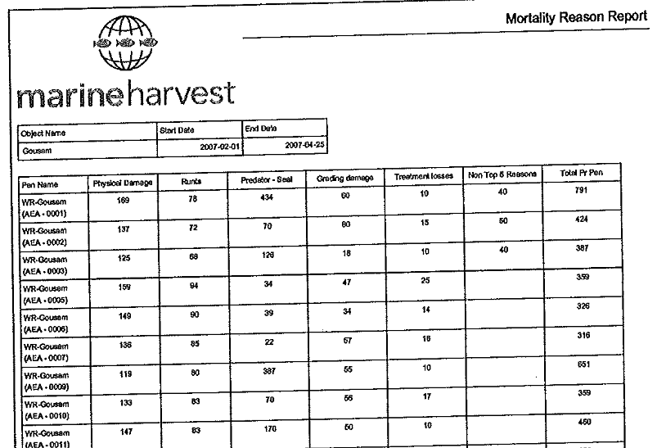

Read more via:
Hard Evidence: Dossier of Data on Lice, Diseases & Mortalities at Scottish Salmon Farms
Data on Mortalities & Diseases at Scottish Salmon Farms
Scottish Salmon's Mort Mountain Leaps Over 10 Million - FOI reveals 2.3 million dead salmon at Marine Harvest farms in 2017

"About 125,000 salmon have died due to a disease outbreak at two fish farms on the Isle of Lewis," reported BBC Scotland in October 2017. "Marine Harvest confirmed that the sites in Loch Erisort have been hit by the bacterium Pasturella Skyensis". "Macleans Nose in Loch Sunart, where salmon have also been exposed to AGD, is believed to be infected by Pasteurella skyensis, too," reported Fish Update in October 2017.

"A staggering 177,000 were hauled out of one loch [Erisort] last autumn," reported The Daily Mail in January 2018.

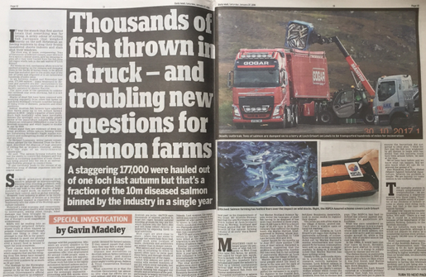
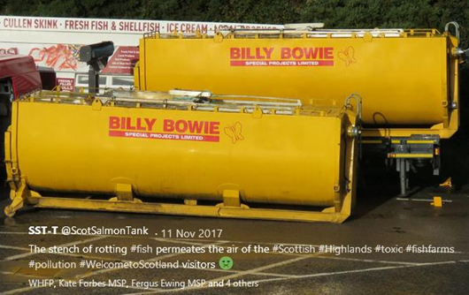

Download high res images via Photo Gallery: Dead Salmon from Scotland's Disease-Ridden Salmon Farms

