Media Backgrounder: Mort Disposal of Scottish Farmed Salmon (May 2017)

Ewan Kennedy - The €10 Million Mort Man

Following a complaint by Ewan Kennedy of Save Seil Sound to the European Commission in 2013, the UK Government avoided a fine of nearly €10 million (£8.2 million) and "possible daily substantial fines of thousands of pounds for continued non-compliance" for breaching a Directive on the disposal of Scottish farmed salmon mortalities since 2003.

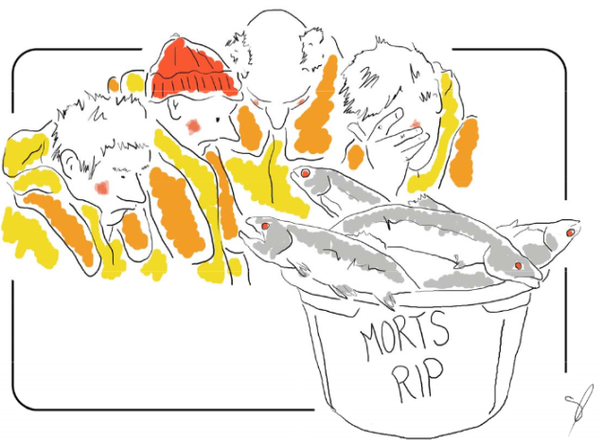

Implementation of the EC Directive - after 13 years of non-compliance by disposing of morts via landfill rather than incineration or ensiling - has cost Scottish landfill sites an estimated £228,149.

Mort disposal costs the industry "at least £2 million per year" but the changes (made from 1 January 2016) may have lead to cost reductions for some companies who "will be able to secure low cost contracts with more sustainable processes".

In Shetland, morts are now macerated and ensiled in a central storage point from where the waste is "collected by a specialist waste carrying vessel and taken to Norway for disposal".

Mortalities in 2016 are estimated at 20,000 tonnes (around 10 million farmed salmon) with a mortality rate in the sea of 23.7% (according to the latest data published by the Scottish Government).

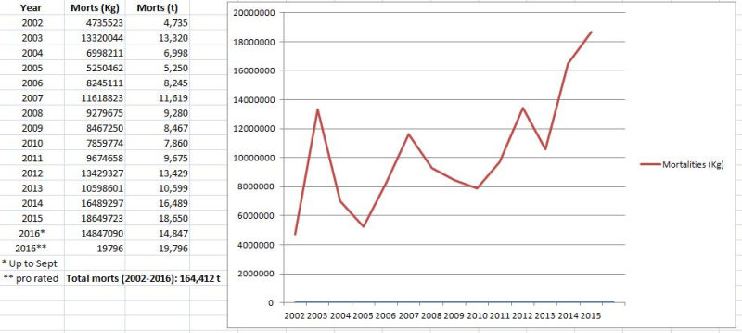

Since 2002, a total of 164,412 tonnes of dead farmed salmon (equivalent to Scotland's salmon farming production in 2013) has occurred on Scottish salmon farms.

There seems to be a general trend of both mortalities increasing with time and also with the proportion of production that is lost (i.e. morts increase both in absolute terms and as proportion of production).

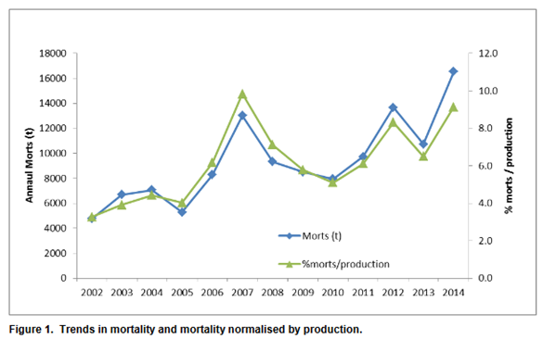

Please read in conjunction with 'FOI Backgrounder: FOI Replies & FOI Requests Re. Mort Disposal (Scottish Government, European Commission, Scottish Environment Protection Agency & Local Authorities)' [download Word version with links to all the documents online here]

Summary:

1) An EC Complaint by Save Seil Sound in 2013 forced the Scottish Government to introduce new rules on mort disposal in 2016
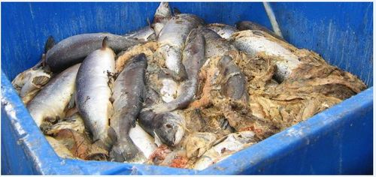
Photo: Dead farmed salmon from a Marine Harvest salmon farm, Isle of Arran

2) The EC Complaint could have cost the Scottish salmon farming industry an infraction fine of €9,666,000 and "possible daily substantial fines of thousands of pounds for continued non-compliance"

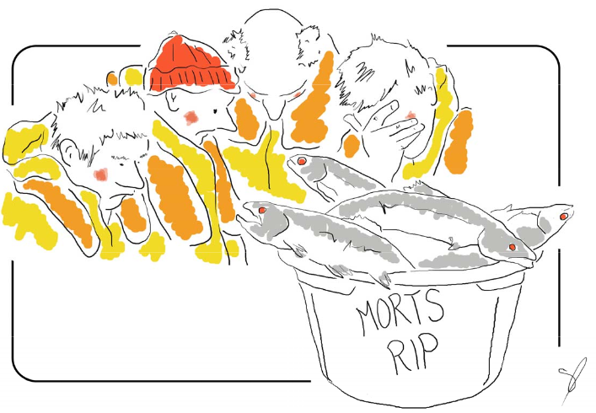

3) Since 2003, the UK have breached an EU Directive on the disposal of morts. In 2015, the EC complaint prompted the Scottish Government to consult on a change of policy to avoid "large fines"

4) In January 2016, the Scottish introduced new 'Guidance on the Disposal of Aquaculture Animal By-Products' and published the new report: "Zero Waste Report - Finfish Mortalities in Scotland"

5) Mortalities in 2016 are estimated at 20,000 tonnes (around 10 million farmed salmon) with a mortality rate in the sea of 23.7% (according to the latest data published by the Scottish Government)

6) The Scottish Government proposed a six-month derogation in Shetland (i.e. landfill disposal of morts was allowed in Shetland until July)

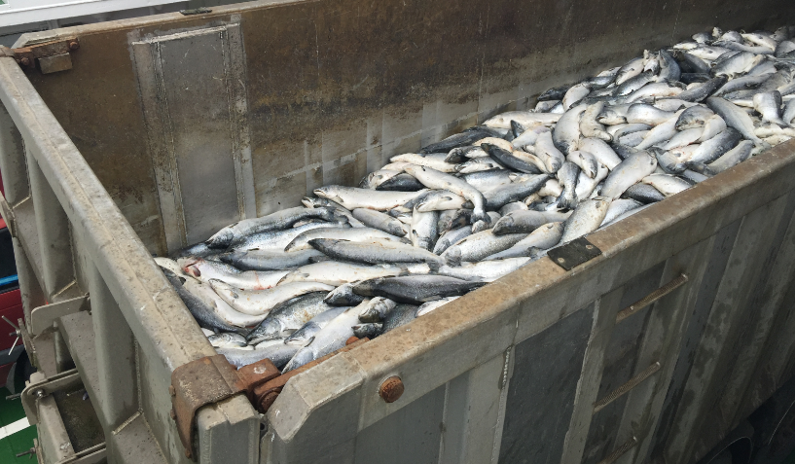

Photo: Dead farmed salmon from Grieg Seafood in Shetland

7) An unnamed company in the Western Isles also requested a six month derogation

8) The Scottish Salmon Producers Organisation issued 'General Guidance on the Disposal of Fish' in August 2015

==================================================================================================================================

1) EC Complaint by Save Seil Sound in 2013 forces the Scottish Government to introduce new on mort disposal in 2016

The Sunday Herald and Evening Times reported in April 2016:

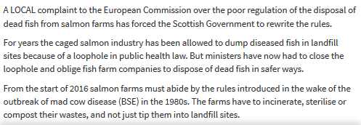

Read more via "European Commission complaint over dead fish dumping forces rule change"

The complaint to the European Commission was made by Ewan Kennedy of Save Seil Sound in 2013. The complaint included:

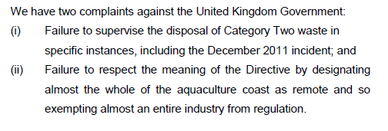

And:

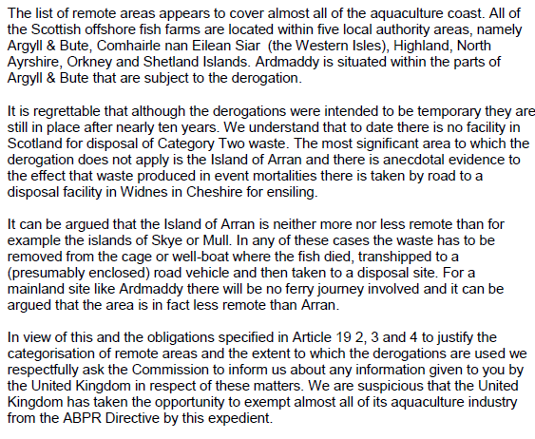

Read the EC complaint by Save Seil Sound in full online here

Read a letter from the EC to the UK Government summarising the complaint in 2014 online here

Read more background via:

"European Commission complaint over dead fish dumping forces rule change" (The Evening Times, 10 April 2016)
"Where have all the dead fish gone?" (The Sunday Herald, 10 February 2013)
"Farmed salmon killed by disease leaps to 8.5 million" (The Sunday Herald, 10 February 2013)
"Scottish watchdog labelled ‘lapdog’ after agreeing to keep fish farm deaths secret" (The Sunday Herald, 10 October 2013)

2) The EC Complaint could have cost the Scottish salmon farming industry an infraction fine of €9,666,000 and "possible daily substantial fines of thousands of pounds for continued non-compliance"

The Scottish Parliament addressed the disposal of morts in December 2015 via the Rural Affairs, Climate Change & Environment Committee - citing an estimated cost increase of at least £2 million per year for the Scottish salmon farming industry (based on an average of 10,000 tonnes of morts per year):

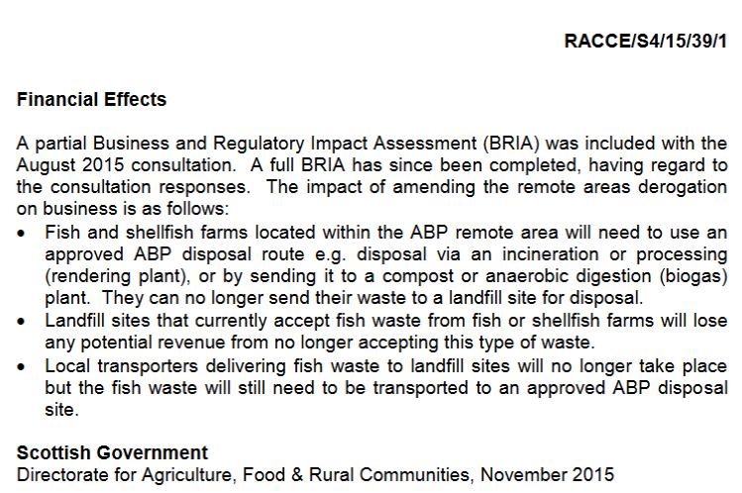

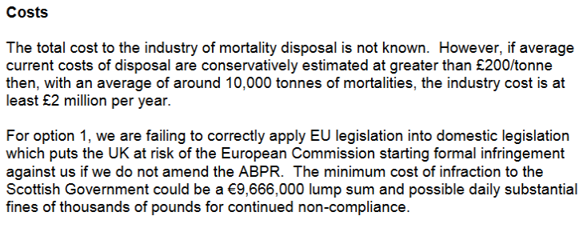

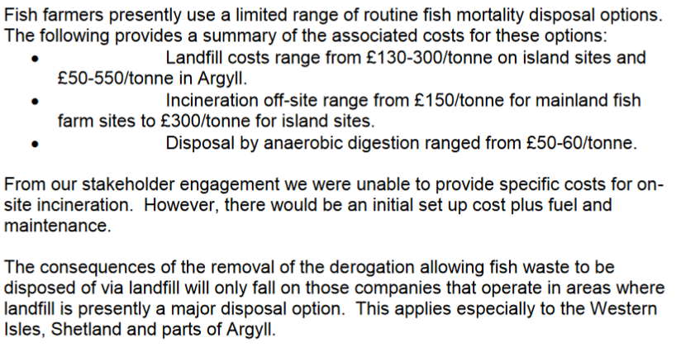

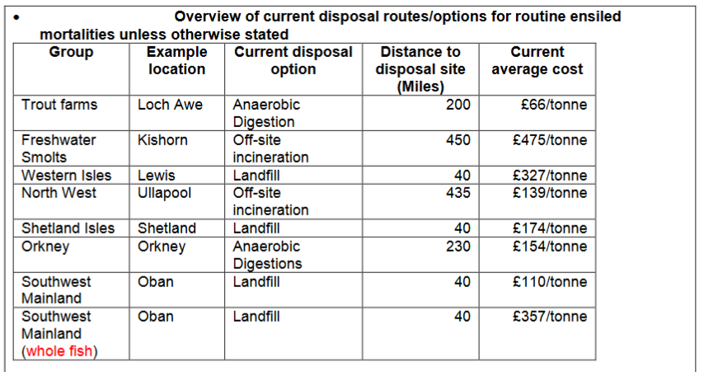
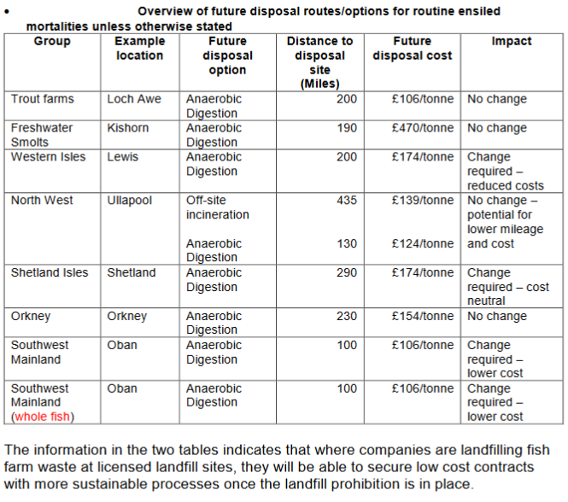

3) Since 2003, the UK have breached an EU Directive on the disposal of morts. In 2015, the EC complaint prompted the Scottish Government to consult on a change of policy to avoid "large fines"

The Scottish Government consultation in 2015 included:

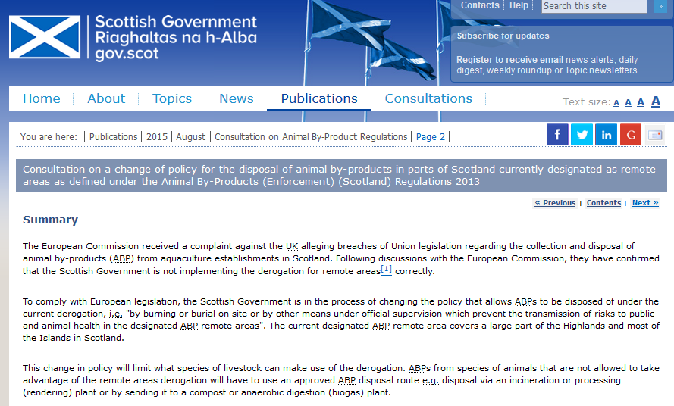

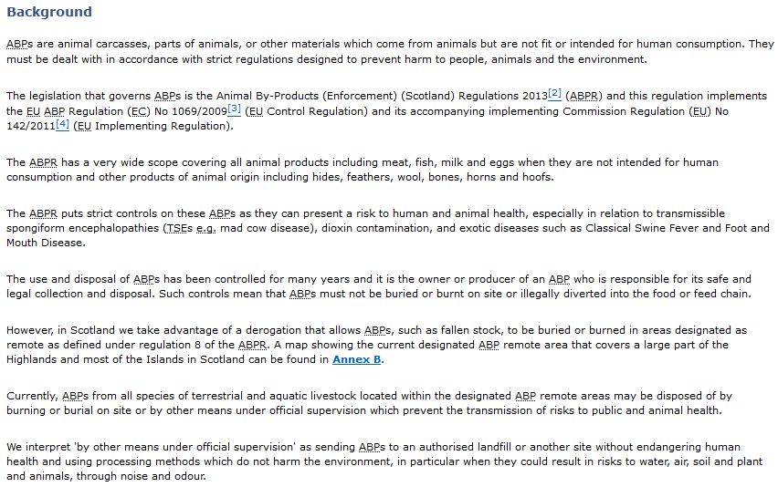

And:

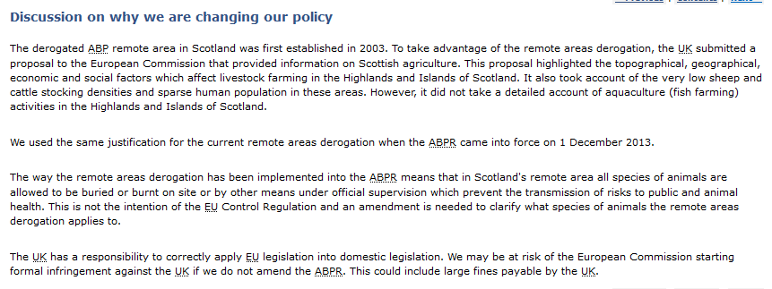

Read more via "Consultation on a change of policy for the disposal of animal by-products in parts of Scotland currently designated as remote areas as defined under the Animal By-Products (Enforcement) (Scotland) Regulations 2013

4) In January 2016, the Scottish introduced new 'Guidance on the Disposal of Aquaculture Animal By-Products' and published the new report: "Zero Waste Report - Finfish Mortalities in Scotland":

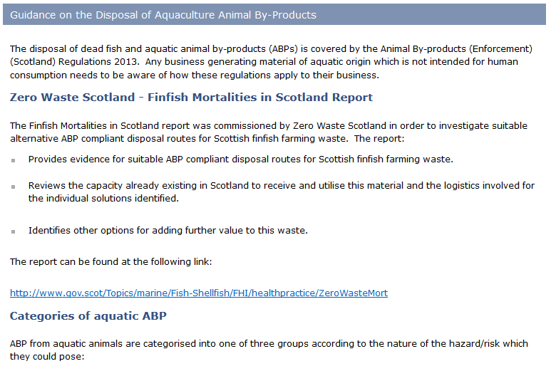
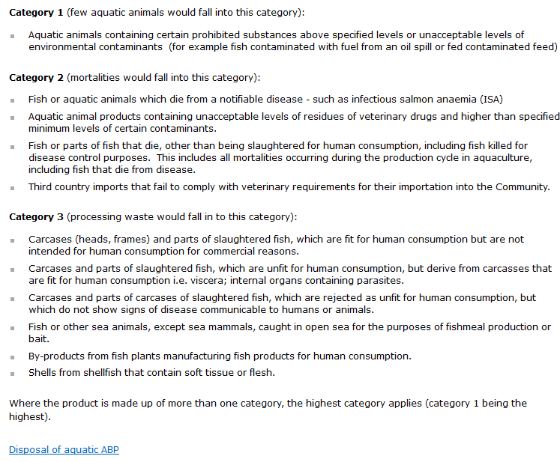

Read more via "Animal By-Products"

A "Zero Waste Report - Finfish Mortalities in Scotland" was published in January 2016:

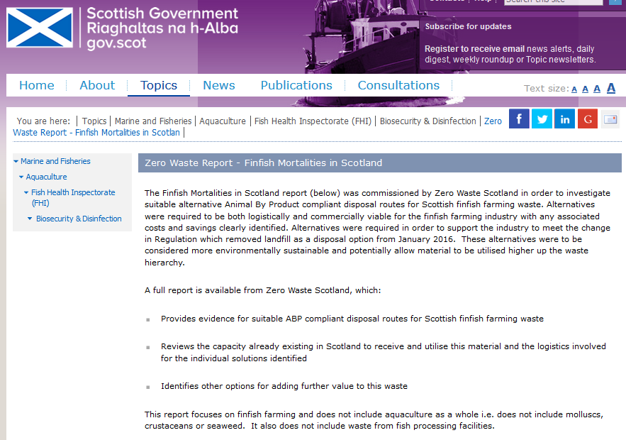

The Summary report: Finfish Mortalities in Scotland includes:

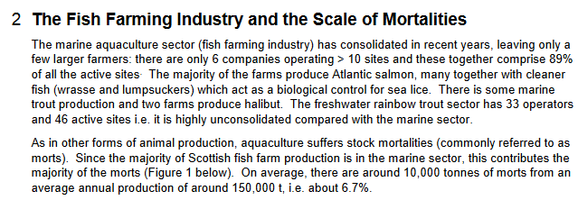

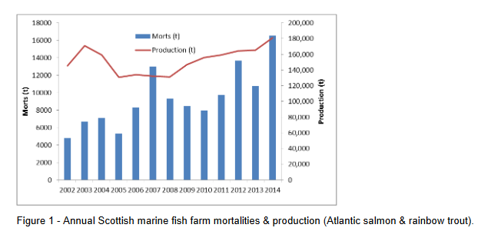

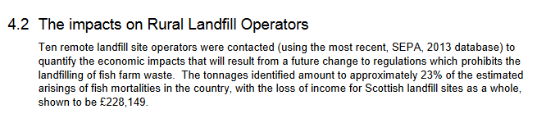

Read the full report online here - including:

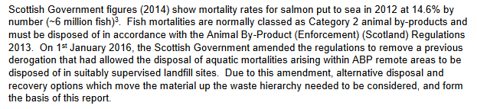

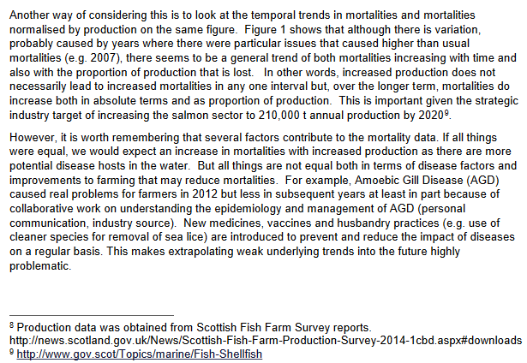

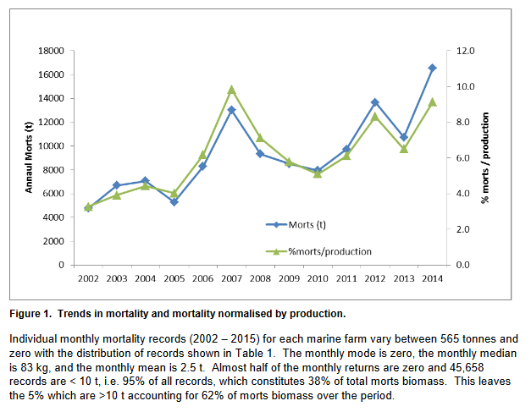

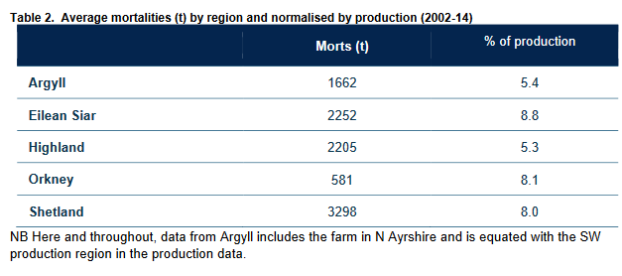

5) Mortalities in 2016 are estimated at 20,000 tonnes (around 10 million farmed salmon) with a mortality rate in the sea of 23.7% (according to the latest data published by the Scottish Government)

Mortalities for Scottish salmon farms in 2015 were 18,650 tonnes (2016 data pro-rated up to September is nearly 20,000 tonnes). Since 2002, a total of 164,412 tonnes of dead farmed salmon (equivalent to Scotland's salmon farming production in 2013) has occurred on Scottish salmon farms:
The above data is source from SEPA: http://donstaniford.typepad.com/my-blog/2017/01/fish-farmageddon-scottish-salmon-loses-chemicals-arms-race-.html

And here's mortality vs production data sourced from the latest Scottish Government 2015 Fish Farm Production Survey:

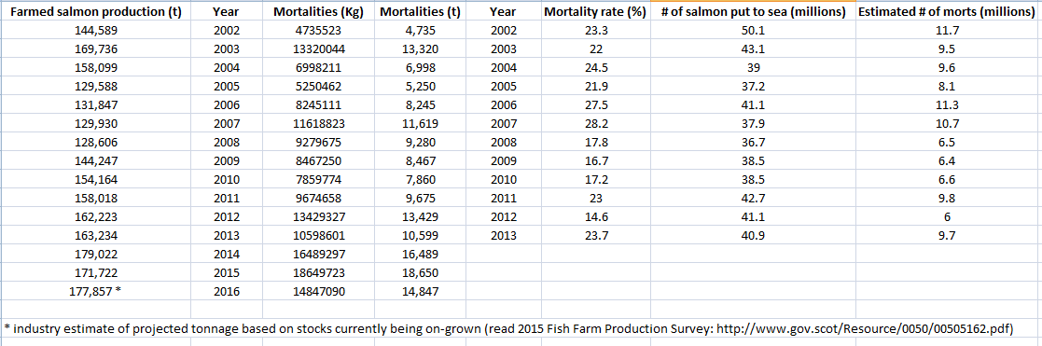

Note that SEPA stopped reporting actual numbers of dead farmed salmon in 2013 following lobbying from the Scottish salmon farming industry.

The Sunday Herald reported in February 2013:

"The number of salmon killed by diseases at Scottish fish farms leapt to over 8.5 million last year, sparking fresh doubts about the sustainability of the £1 billion industry. New figures released by SEPA reveal that losses from all salmon farms have reached nearly ten per cent of their production. The main problem has been the spread of Amoebic Gill Disease, blamed by some on the warmer seas caused by climate pollution. A mountain of 13,627 tonnes of dead fish had to be disposed of in 2012 by 230 fish farms along the west coast and on the islands, compared to 9,717 tonnes in 2011 and 7,159 tonnes in 2010."
The huge rise in fish farm deaths
year / tonnes of dead fish / number
2012 / 13,627 / 8.5 million
2011 / 9,717 / 6.8 million
2010 / 7,159 / 5.5 million

The Sunday Herald reported in October 2013:
"Scotland’s environment watchdog has bowed to pressure from the salmon farming industry to keep the number of fish killed by diseases secret, according to internal correspondence seen by the Sunday Herald. SEPA agreed to delete information on millions of fish deaths from a public database on fish farming launched this month because the Scottish Salmon Producers Organisation argued it would be commercially damaging."
Monthly mortalities (by weight only not number) for every salmon farm in Scotland are available online via the Scotland's Aquaculture database. For example, one of the latest data entries details nearly 3,000 kg of morts at Marine Harvest's salmon farm on the Isle of Muck:

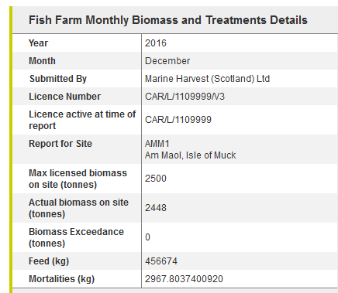

Another data entry details 123,454 kg of morts at Marine Harvest's salmon farm in Loch Greshorrnish in August 2016:

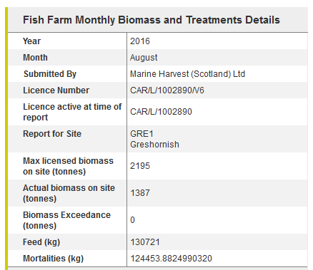

In November 2016, The Sunday Herald revealed that 95,400 farmed salmon had died at Marine Harvest's salmon farm in Loch Greshornish in July and August 2016 following a 'Thermolicer' treatment.

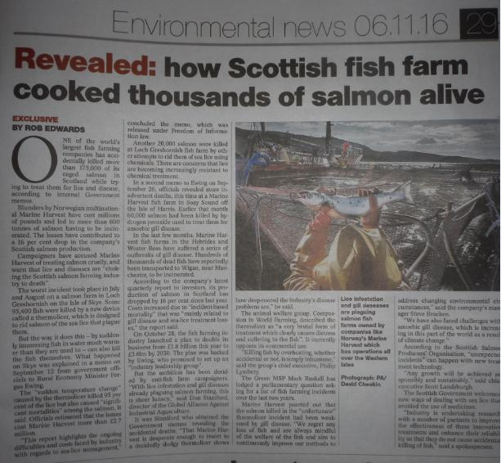

6) The Scottish Government proposed a six-month derogation in Shetland (i.e. landfill disposal of morts was allowed in Shetland until July)

In October 2015, the Scottish Government proposed a six month derogation in Shetland:

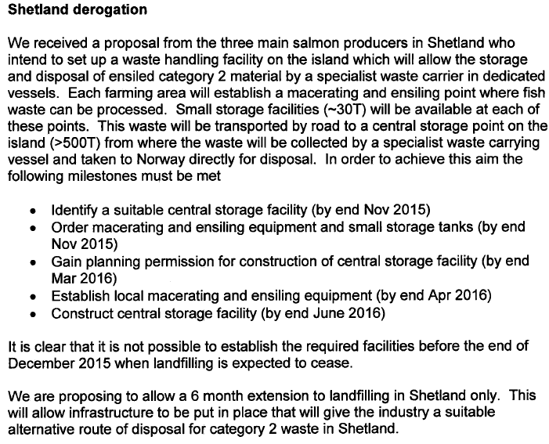

7) An unnamed company in the Western Isles also requested a six month derogation:

An update for the European Commission from the Scottish Government in January 2016 included:
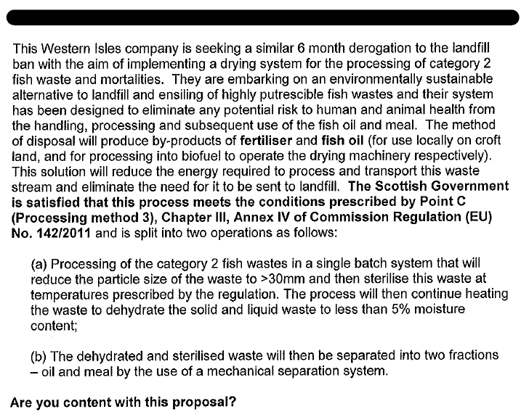

8) The Scottish Salmon Producers Organisation issued 'General Guidance on the Disposal of Fish' in August 2015:

The SSPO's guidance (August 2015) included:

