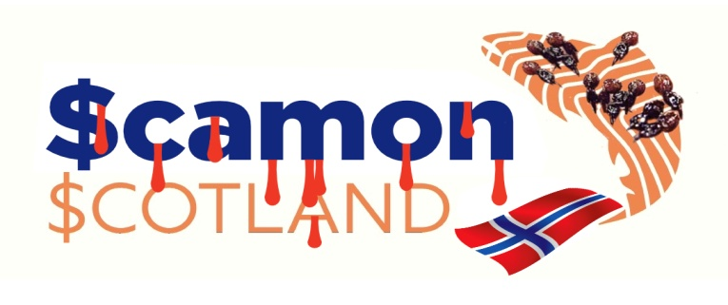
Marks & Spencer
Waterside House
35 North Wharf Road
London
W2 1NW
steve.rowe@marks-and-spencer.com
steve.mclean@marks-and-spencer.com
food.pressoffice@marks-and-spencer.com
14 February 2022

Dear M&S,
Infectious Salmon Anaemia & Piscine Reovirus in M&S’s
‘Responsibly Sourced’ RSPCA Scottish Salmon

How many of your Scottish salmon – understood to be exclusively supplied by Scottish Sea Farms (Norskott Havbruk) – are infected with diseases, pathogens and viruses such as Infectious Salmon Anaemia, Piscine Reovirus, Proliferative Gill Disease (Piscichlamydia), Salmon Gill Poxvirus and Amoebic Gill Disease?

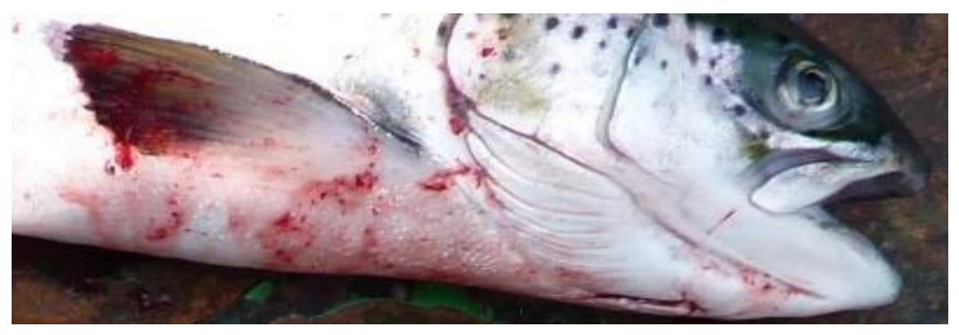

M&S has no doubt been notified by the Scottish Government and Scottish Sea Farms that Infectious Salmon Anaemia was officially reported to the World Organization for Animal Health in September 2021 following a positive case in Loch Spelve wher 369,195 salmon were listed as ‘susceptible’ (the farm where M&S pioneered their fake ‘Lochmuir’ brand).

How many of these ISA-infected farmed salmon were sold to unsuspecting consumers by M&S?

Data published by the Scottish Government’s Fish Health Inspectorate on 7 February 2022 details 18 ‘Mortality Event Reports’ involving 93,655 dead farmed salmon at Norwegian-owned Scottish Sea Farms in Loch Spelve during 2021 with a weekly peak mortality of 5.1% in early September and a cumulative mortality rate of 33% (i.e. one in three farmed salmon dying) according to further data published by Salmon Scotland. Here’s the 18 ‘Mortality Event Reports’ at the RSPCA Assured Loch Spelve salmon farm which pioneered M&S’s fake Lochmuir label (in chronological order – latest first):

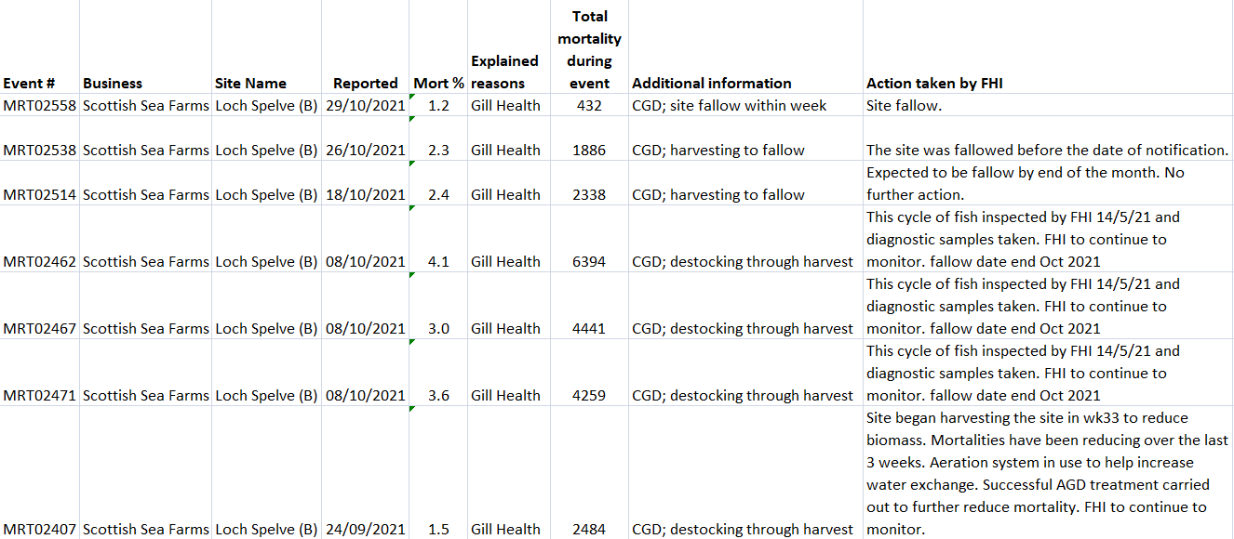

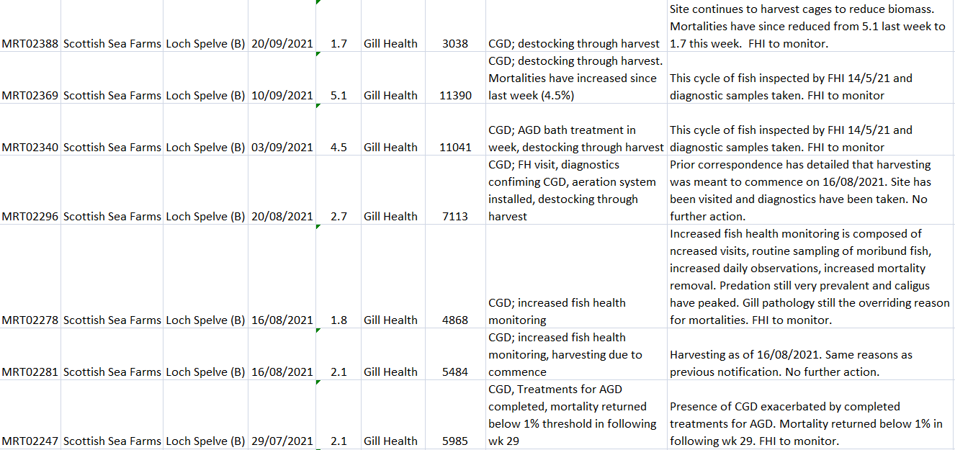

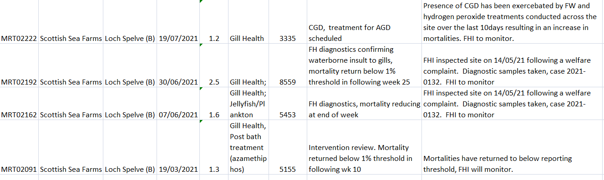

So if 33% died and there were over 350,000 farmed salmon on site at RSPCA Assured Loch Spelve in May 2021 then that leaves well over 200,000 farmed salmon which were harvested and sold into the marketplace. How many of these virus-laden farmed salmon were sold by M&S?

M&S reported in December 2020 that Scottish salmon is “a firm favourite for families across the country” but do they know that M&S salmon is sourced from disease-ridden salmon farms where toxic chemicals are used and lice-infestation is rife?

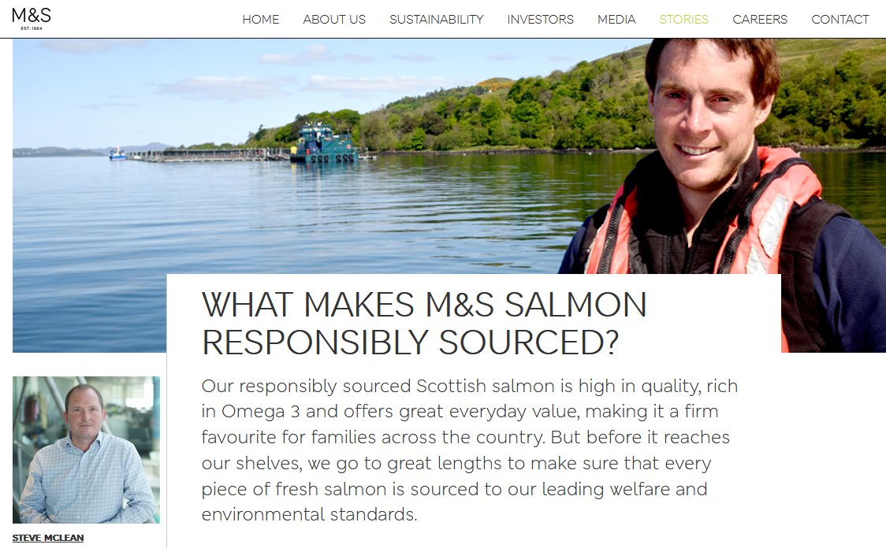
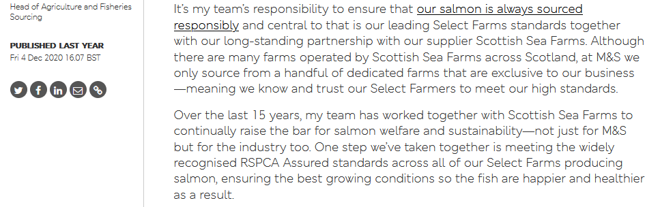

How can M&S seriously justify the reference above to “healthier” Scottish salmon when Scottish Sea Farms is lice-infested, disease-ridden and suffers from alarming mortality rates?

Scottish Sea Farms – co-owned by Norwway’s SalMar and Leroy via Norskott Havbruk - reported mortalities in Loch Spelve due to Gill Health, Complex Gill Disease (CGD), losses due to the organophosphate Azamethiphos (a lobster-killing toxic chemical) and Hydrogen peroxide treatments (another toxic chemical shown by peer-reviewed science to be lethal to shellfish and seaweed).

Mortality data published in October 2021 by Salmon Scotland (formerly the Scottish Salmon Producers Organisation) detailed cumulative mortality of 32.8% at the Loch Spelve salmon farm operated by Scottish Sea Farms with 7.5% monthly mortality recorded October 2021 (9.3% monthly mortality was recorded in September 2021; 13.4% monthly mortality recorded in August 2021; 6.4% monthly mortality recorded in July 2021; 4.9% monthly mortality recorded in June 2021 and 2.9% monthly mortality recorded in May 2021 – the month when the Scottish Government first reported ISA at the site):

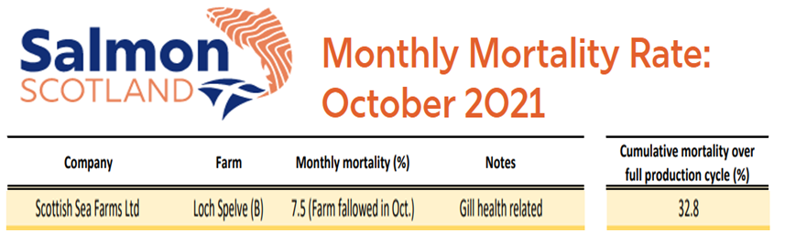

Data published online via ‘Scotland’s Aquaculture’ details shows lice infestation peaked in early June 2021 following the OIE report detailing ISA in Loch Spelve in May 2021:

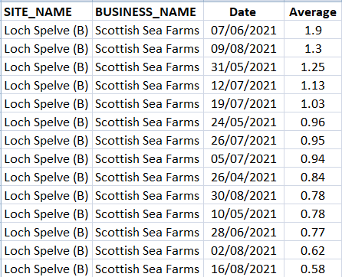

Data on the use of toxic chemicals published via Scotland’s Aquaculture (sourced from returns submitted each month by salmon farming companies to the Scottish Environment Protection Agency) details how Loch Spelve salmon farm is the biggest user since January 2019 of the lobster-killing chemical Deltamethrin at all Scottish Sea Farms sites:

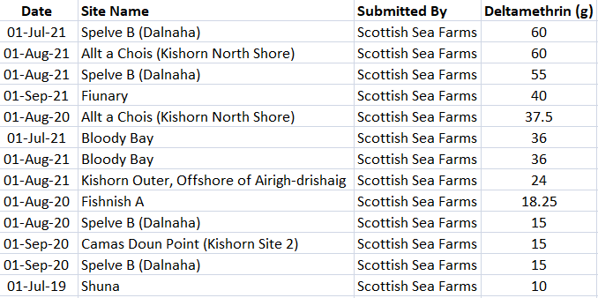
Data published via Scotland’s Aquaculture shows that the Loch Spelve salmon farm is also a huge user of the shellfish-killing organophosphate chemical Azamethiphos – here’s the highest uses at Scottish Sea Farms sites since January 2019:

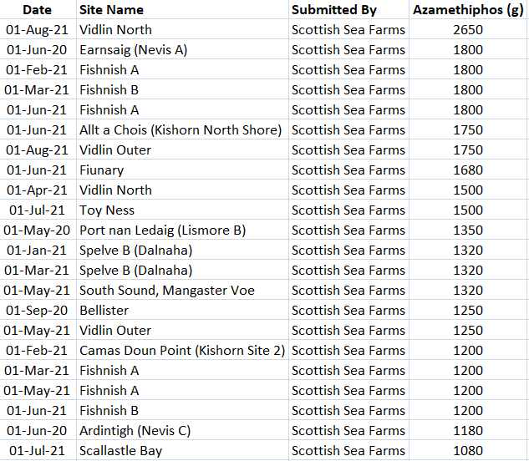

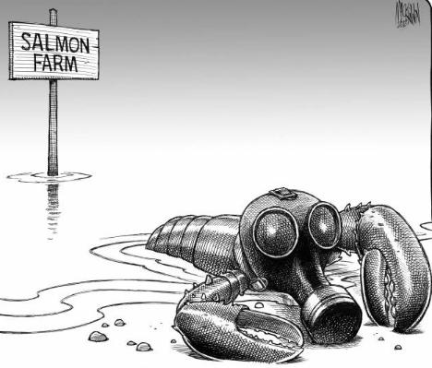

Here’s the FHI ‘Case Information’ report for Loch Spelve detailing the inspection on 14 May 2021 – including reference to Salmonid Gill Pox, Amoebic Gill Disease, Proliferative Gill Disease, Piscine Reovirus, Branchiomonas cysticola (Piscichlamydia), Moritella viscose, Vibrio, Photobacterium, Neoparamoeba perurans, necrosis, dermatitis and Infectious Salmon Anaemia:

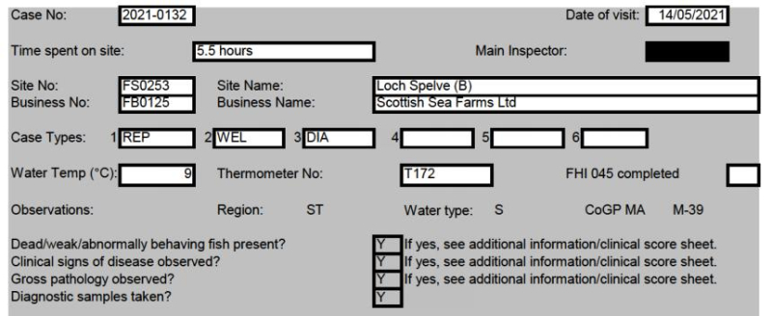
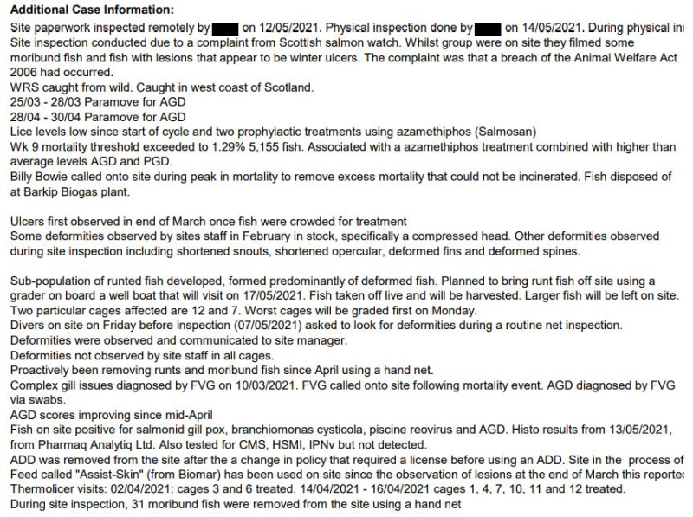
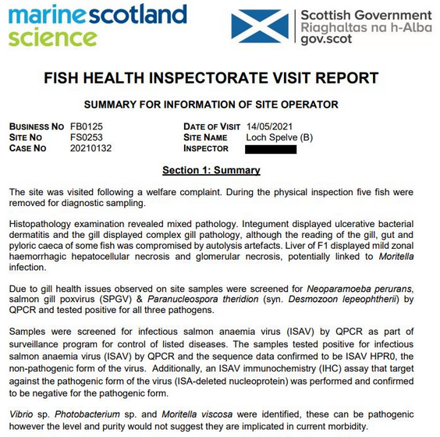
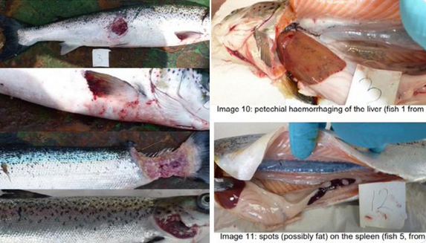
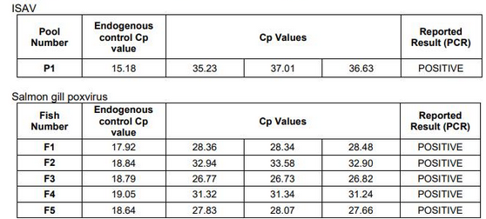
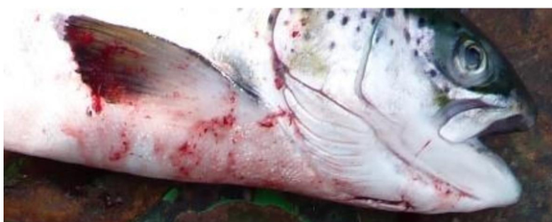
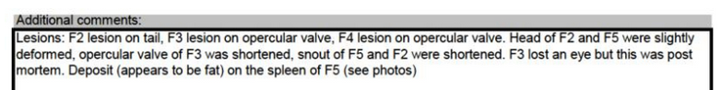
The Fish Health Inspectorate’s ‘Case Information’ which details 369,195 on site at the Loch Spelve salmon farm was not published until August 2021 and was first publicized in August 2021 by Scottish Salmon Watch via:

Breaking News: ISA reported at RSPCA Assured Scottish Sea Farms on the Isle of Mull
Damning Disease Report for RSPCA Assured Scottish Sea Farms in Loch Spelve
Letter to Scottish Ministers re. ISA in Scottish Salmon

Scottish Salmon Watch reported in December 2021 that 7% of Scottish farmed salmon tested positive for ISA between 2002 & 2012 (396 out of 5,395 samples).

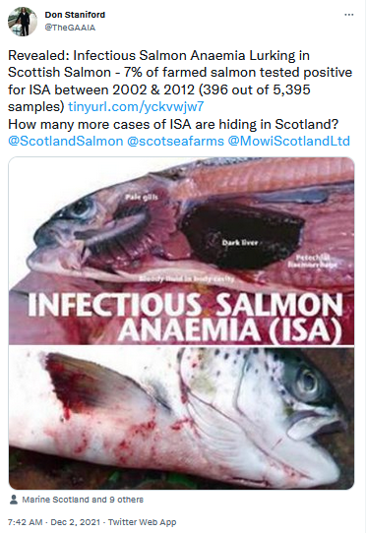

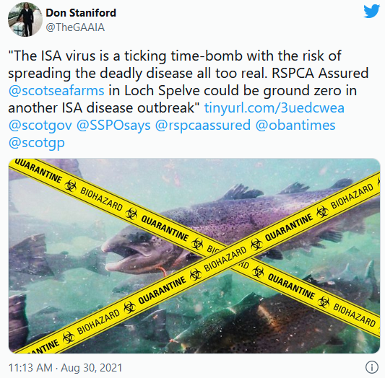
Fish Farmer reported in December 2021 that SalMar (co-owner of Scottish Sea Farms) had been hit by ISA in Norway:
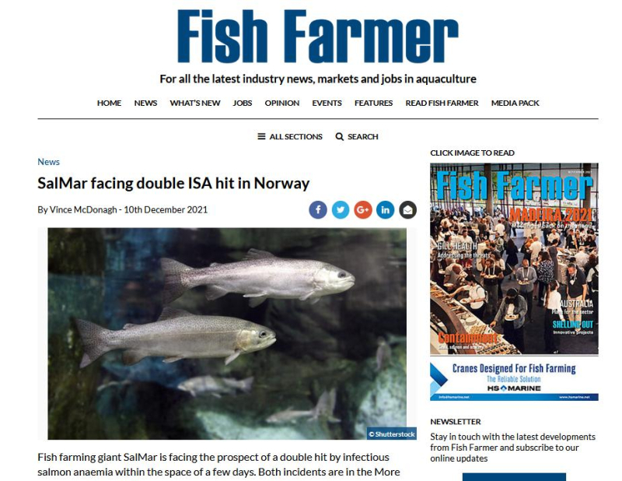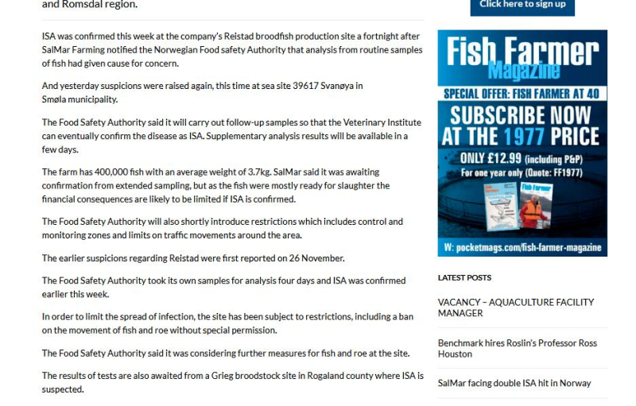
In terms of mass mortalities (by weight), here’s the top 30 worst Scottish Sea Farms sites since January 2019 with Loch Spelve featuring five times (according to data published via Scotland’s Aquaculture) and the October 2019 mass mortality ranked 5th worst and a mass mortality of 127 tonnes at Loch Spelve in August 2021 and another 78 tonnes of morts at Loch Spelve in September 2021 (data for October to December 2021 is expected to be published online next month):

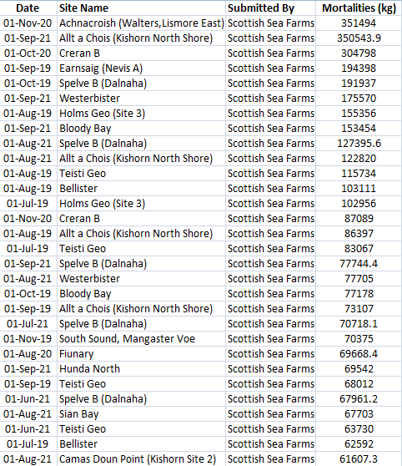

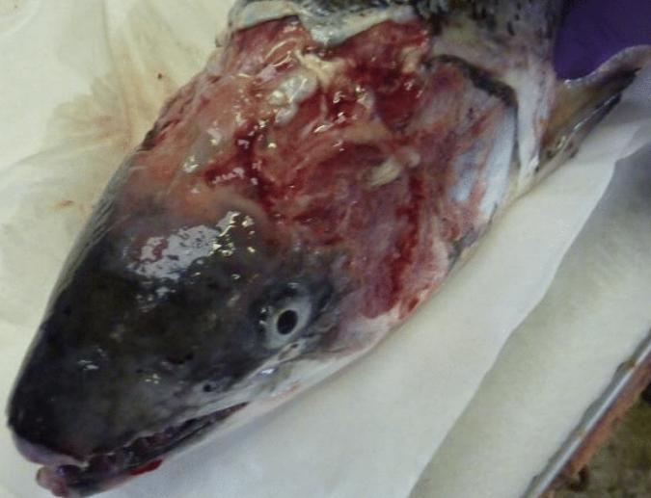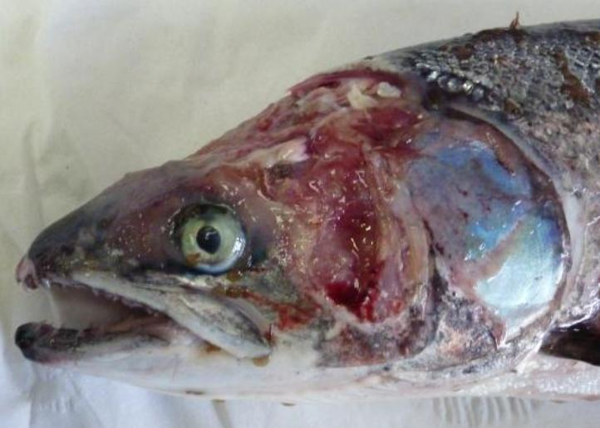

Scottish Salmon Watch reported in December 2021 that mortality rates at Scottish Sea Farms averaged ca. 14% with some sites – including Loch Spelve, Creran and Kishorn - reporting significantly higher mortality rates:

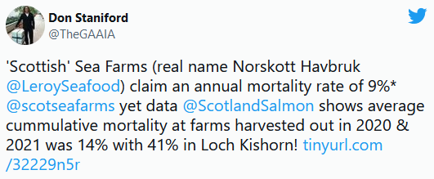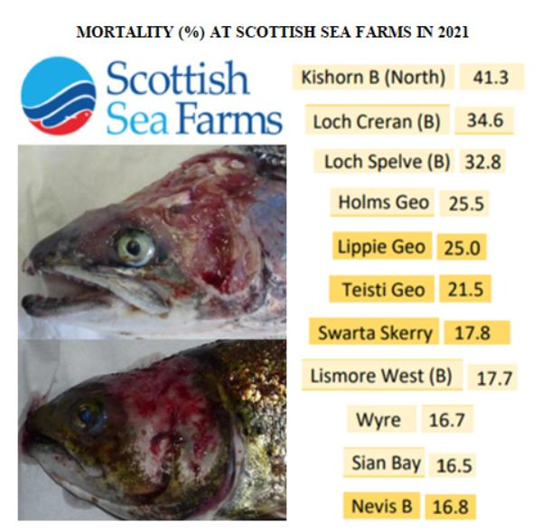
Suffice to say that Scamon Scotland (formerly Scottish Salmon Watch) disagrees with M&S’s green claims. In November 2021, Scottish Salmon Watch filed complaints against supermarkets – including M&S - with Trading and Advertising Standards for false advertising and deceptive marketing of “responsibly farmed” and “responsibly sourced” Scottish salmon.
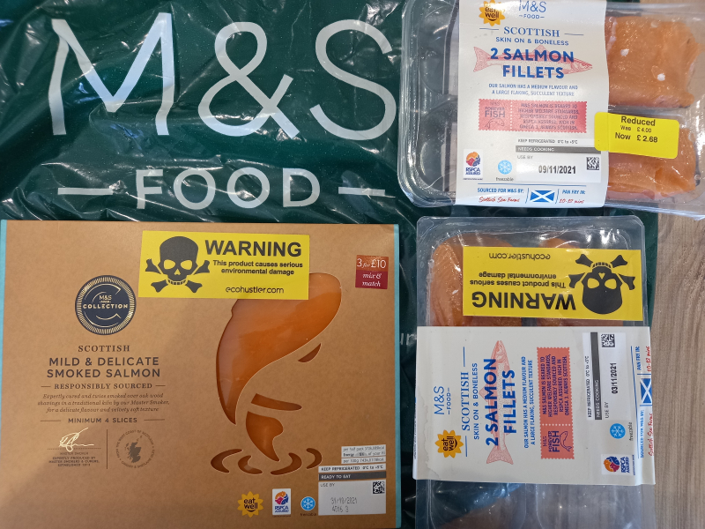
Scottish Salmon Watch’s complaints are online via:
Complaint to the Competition & Markets Authority and Trading Standards Vs Supermarkets (Aldi, ASDA, Lidl, M&S, Morrisons, Sainsbury’s, Tesco & Waitrose) for deceptive marketing of ‘Responsibly Farmed’ & ‘Responsibly Sourced’ Scottish Salmon (19 November 2021)

Hard Evidence Submitted with CMA & Trading Standards Complaint (19 November 2021)

Read more via:
Bullshit Called on M&S's "Responsibly Sourced" Scottish Salmon!
Ecohustler sticks it to "responsibly sourced" Scottish salmon sold by M&S!
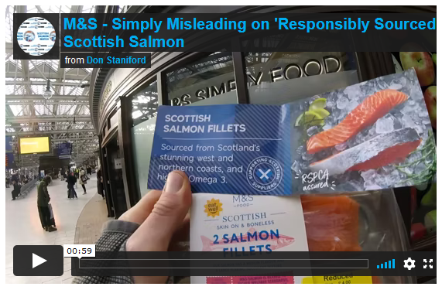
Shame on M&S for greenwashing virus-laden Scottish salmon. M&S’s ‘responsibly sourced’ RSPCA Assured Scottish salmon belongs in the bin not in your shopping basket.

Surely M&S should stop sourcing from Scottish Sea Farms? Do you really think that consumers want to eat virus-laden pink poison on a plate?

Read more via a blog published earlier today:
Anyone for M&S’s Virus-Laden Scottish Salmon (don’t worry, it’s “responsibly sourced” & RSPCA Assured)?!

Yours sincerely,

Don Staniford

Director, Scamon Scotland

