Scottish Salmon Watch, 21 May 2018

Paxo Stuffs Scottish Salmon
- TV documentary features broadside from Jeremy Paxman

A documentary featuring hard-hitting British broadcaster Jeremy Paxman fires a broadside against 'contemptible' salmon farming which "doesn't really care very much about the environmental damage it inflicts". "The terrible cost of salmon farms is that you cannot raise creatures in those conditions without having collateral consequences," argues Jeremy Paxman in 'Under the Surface'. "They're prone to disease and in order to stop them getting disease you have to use poison. And then the poison affects other fish. So it's very very simple."

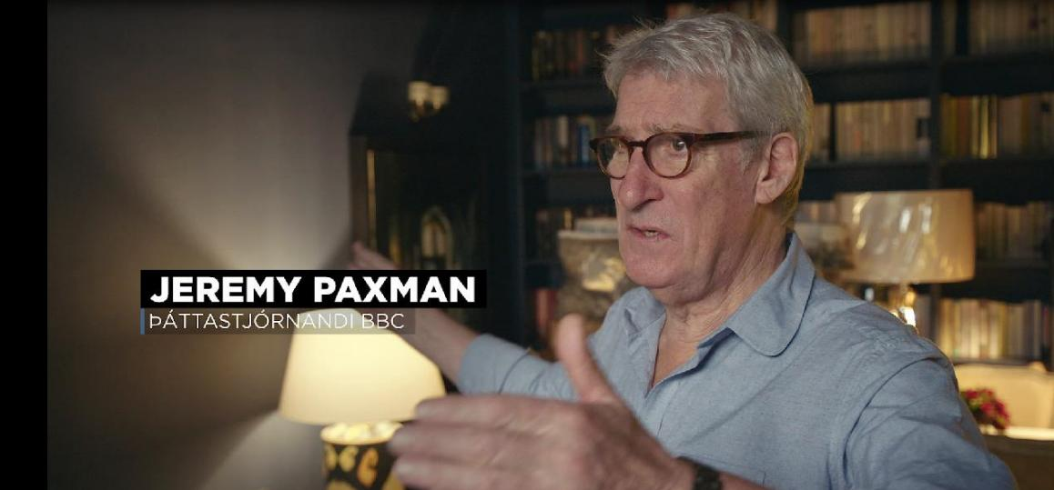

The documentary premiered on the Icelandic National Broadcasting Service (Ríkisútvarpið or RÚV for short) on 13 May and is now being pitched globally for screening worldwide.

"I think there's absolutely no reason to think that anything different is going to happen in Iceland to what happened in Scotland," cautions Paxman "This is huge business that doesn't really care very much about the environmental damage it inflicts. So I think if you guys let these men expand at-sea salmon farms in the way they want to do it you are fools."

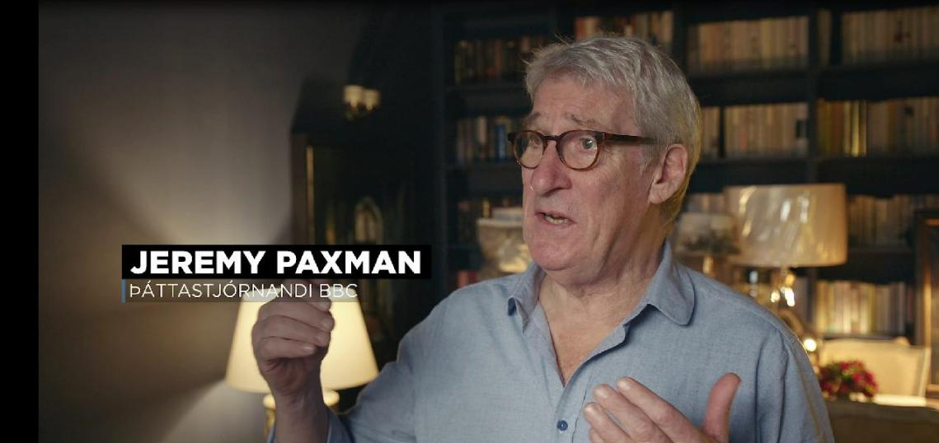
"This is big business doing what it wants," concludes Paxman. "All you can do is bring attention to these things so people can make an informed judgment. You can whistle for the Scottish Government to do anything, you can probably whistle for the Icelandic Government to do anything. There's nothing Government's like more than a promise of employment and a promise of being loved by a big powerful vested interest. I think it's contemptible".



Watch a trailer of the film online via the producer's Facebook page:

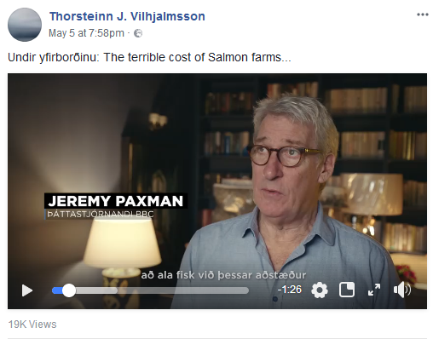

Don Staniford Tweeted:

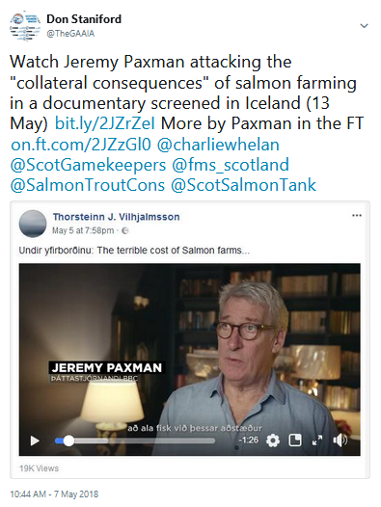

The documentary cites an article - 'The Terrible Cost Scotland's Salmon Farms' - published in The Financial Times in August 2018 in which the award-winning broadcaster argues that "salmon farms have done enormous harm":

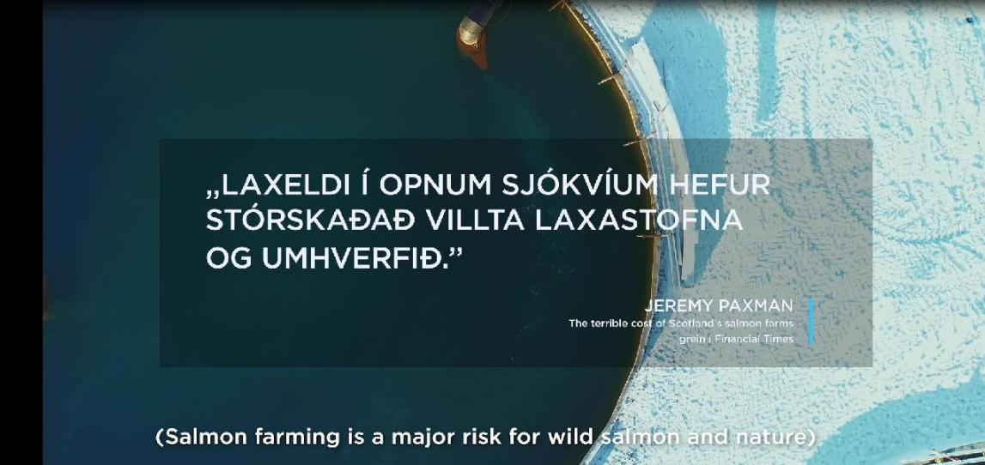

Writing in The Financial Times in August 2018, Paxman pulled no punches:

"The 250 salmon farms on the western coast of Scotland may be set in one of the most magnificent wildernesses in Europe, but the farmed salmon has no freedom. A single circle of mesh measuring 40 metres across may contain up to almost 70,000 fish; on a farm of 12 cages that is getting on for a million fish. It is like a series of floating battery hen sheds."

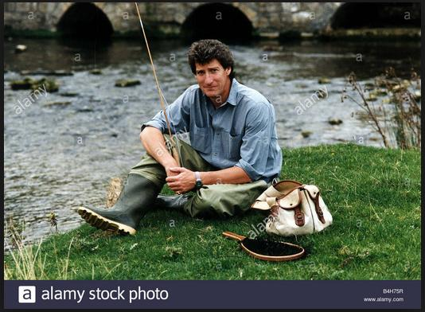

"But when you rear fish in the quantities necessary to meet growing demand, you start playing with the environment," Paxman continued. "Confining naturally migratory and carnivorous animals in packed pens produces enormous quantities of faeces, which covers the seabed beneath. The cages provide ideal breeding grounds for the sea louse, which, smaller than a fingernail, eats into the salmon’s skin and either directly or indirectly (by exposing them to infections) kills them."

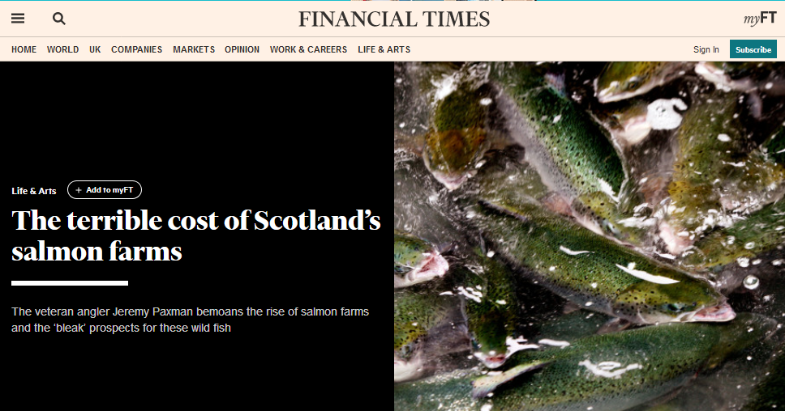

"The Terrible Cost of Scotland's Salmon Farms" (Financial Times, 12 August 2017)
"Salmon farming has done ‘enormous harm’ to fish and environment, warns Jeremy Paxman" (Daily Telegraph, 12 August 2017)
"Paxman: Fish farms 'battery hen sheds that float on water" (Daily Mail, 14 August 2017)
Salmon farming in Iceland is growing fast but at 16,000 to 18,0000 tonnes is still a tenth of the size of Scotland's salmon farming industry (177,202 tonnes was the official Government forecast for 2017).

However, lice infestation, infectious disease and mass mortalities are impacting on Scottish salmon farming production with job losses reported by Scotland's largest operator, Marine Harvest, in January 2018.

BBC News reported (19 May 2018):

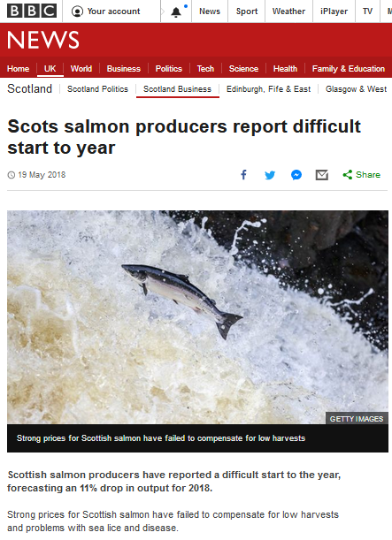

Read more via "Big drop forecast in Scottish salmon harvests" (Fish Farming Expert, 15 May 2018)

Don Staniford Tweeted (18 May 2018):

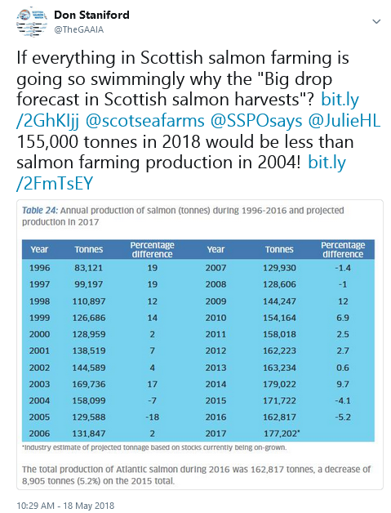

"Scottish salmon farming is dead in the water due to infectious diseases, lice infestations and mass mortalities," said Don Staniford, Director of Scottish Salmon Watch. "Little wonder that anglers like Jeremy Paxman are rising up against the Scottish Government's reckless plans for expanding salmon farming. I'd love to see the 'contemptible' Scottish salmon farming industry get a good grilling on BBC's Question Time. The industry simply does not have any answers to the growing problems of escapes, lice, diseases, waste pollution, toxic chemicals and the killing of seals."

Contact:

Don Staniford: 07771 541826 (dstaniford@gaaia.org)

Read the latest news via:
- Reported Versus Reality - 'Inaccuracies' Rebutted by Scottish Salmon Watch
- Letter to the Cross-Party Group on Animal Welfare
- UK Government's 'Sustainable Seas Inquiry'
- The National: "42,000 sign petition for tougher Scottish salmon farm testing"
- Herald: "Salmon farms are turning Scotland's seas into an open sewer, claim campaigners"
- SumOfUs: "Campaigners at Scottish Parliament call for wastewater testing at salmon farming operations to save wild fish"
- Supersized McSalmon - I'm Lovin' It Sings Fergus!
- Hard Evidence: Dossier of Data on Lice, Diseases & Mortalities at Scottish Salmon Farms

