The Global Alliance Against Industrial Aquaculture, 13 December 2017

BBC's 'Dead Salmon Run' Opens Can of Worms
- Questions loom for Scottish Parliamentary inquiry

Following this week's BBC investigation into Scottish salmon farming (broadcast on BBC 1's 'The One Show on Monday & Tuesday), campaigners are calling on the Scottish Government, Scottish Environment Protection Agency and Scottish Parliament to tackle the growing problems of salmon farming.

The Global Alliance Against Industrial Aquaculture (GAAIA) is writing to SEPA and the Scottish Government demanding the publication of mortality figures which are estimated to have doubled over the last four years to over 20 million [1]. In 2013, SEPA bowed to pressure from the Scottish Salmon Producers Organisation to keep the number of dead salmon secret claiming it "could be used to the commercial detriment or competitive market disadvantage of the companies submitting the data".

"The public surely has a right to know how many diseased fish are dying on Scotland's lice-ridden salmon farms," said Don Staniford, Director of the Global Alliance Against Industrial Aquaculture (GAAIA) who was interviewed for The One Show. "The industry has been dragged kicking and screaming to publish damning data on escapes, lice infestation, toxic chemicals and seal killings via appeals to the Scottish Information Commissioner. Yet it still hides behind a cloak of 'commercial confidentiality' with regards to Scottish salmon's burgeoning mort mountain. It's time to come clean on the scale of the salmon farming industry's disease, lice and mortality problems. Hopefully next year's Scottish Parliamentary inquiry can finally open the can of worms that is Scottish salmon."



"We as salmon farmers are acutely aware of how bad the situation is," admitted Gilpin Bradley, Chairman of the Scottish Salmon Producers Organisation on last night's BBC 1 'One Show'.

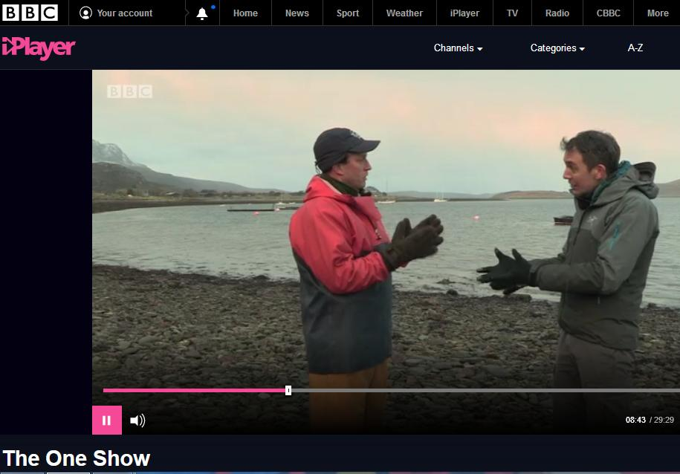

"Do you accept that in terms of lice, that lice from salmon farms are killing wild fish?" asked BBC reporter Joe Crowley. "That's pretty evocative language Joe to say that we're killing," replied Bradley.

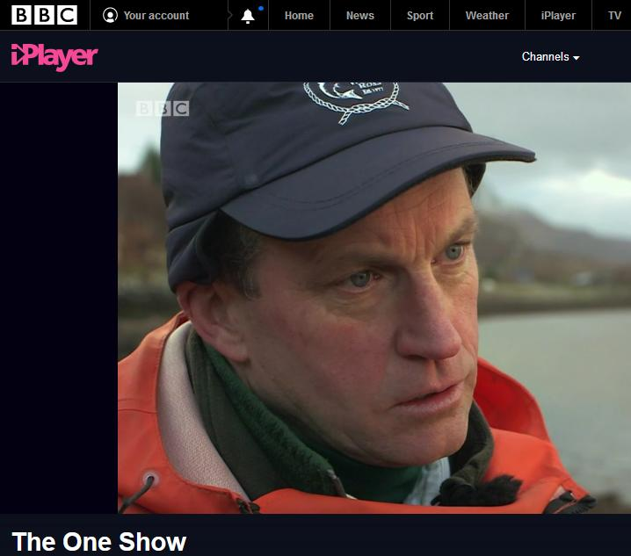
"Sea lice emanating from salmon farms are killing wild fish," said Andrew Graham-Stewart of Salmon & Trout Conservation Scotland on the BBC's 'One Show' (12 December 2017).

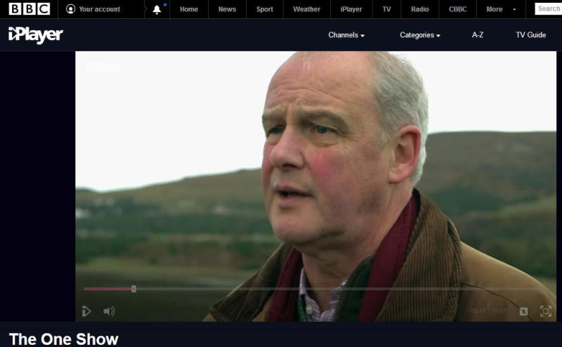

Following the BBC's broadcast on Monday of images of fluid wastes leaking from a haulage truck (operated by Billy Bowie) transporting dead farmed salmon from Loch Kishorn via Fort William to Dumfries (believed to be the Dundas Chemical Co at Mosspark), GAAIA has questioned whether there has been a breach of the Animal By-Products (Enforcement) (Scotland) Regulations 2013.

"It is abundantly clear from the BBC footage broadcast last night (starts at 3 minutes 22 seconds) that there is leakage from at least one of the haulage tankers," wrote GAAIA in emails to the Scottish Government, Department for Environment, Food & Rural Affairs and Animal and Plant Health Agency and Highland Council.

"What I'm seeing here is shocking but it isn't illegal nor uncommon," says BBC reporter Joe Crowley as he is driving behind the Billy Bowie tankers/trucks. "OK, the tanker and the first skipper-lorry have just left the salmon farm and they're both full of salmon. In fact, I can see some horrible fluid coming out of the back of one of them and it smells vile"


"Surely this is not "leak proof" and therefore constitutes a breach of the Animal By-Products (Enforcement) (Scotland) Regulations 2013?" asked GAAIA [2].

"Questions must urgently be asked about the industry's bio-security measures to prevent the spread of infectious diseases," concluded Don Staniford, Director of the Global Alliance Against Industrial Aquaculture (GAAIA). "Tourists coming to the West coast of Scotland do not want to see trucks laden with rotting salmon dripping with wastes. If you're served Scottish salmon over the festive period please throw it in the rubbish bin where it belongs. Join the boycott against farmed salmon."

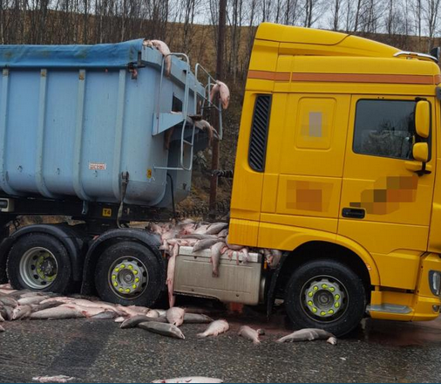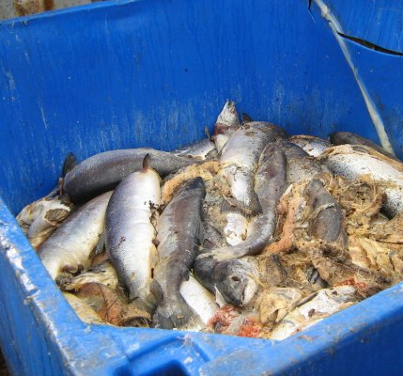

More details via:

BBC's The One Show (Part 2)
Press Release: "Millions of Scottish Salmon Going Up in Smoke"
BBC's The One Show: "The Dead Salmon Run"
Press Release: "Red Light for Scottish salmon: Scotland is ranked worst in the world"
25 Years of Scottish Salmon Shame
25 Reasons to Boycott Scottish Salmon
"Red Alert for Label Rouge - Lousy Label Goes Rogue"

Contact:

Don Staniford (Tel: 07771 541826; email: dstaniford@gaaia.org)

Notes to Editors:

[1] Figures published by The Sunday Herald in 2013 revealed that mortalities on Scottish fish farms had leapt from 5.5 million in 2010 to 8.5 million in 2012. In July 2017, Salmon & Trout Conservation estimated the number of dead salmon on Scottish salmon farms had "almost doubled in the last four years" estimating that "over 41 million fish died during 2015 and 2016, an average of over 20 million fish per annum" (read more via "Death rate at salmon farms doubles to 20m fish a year").

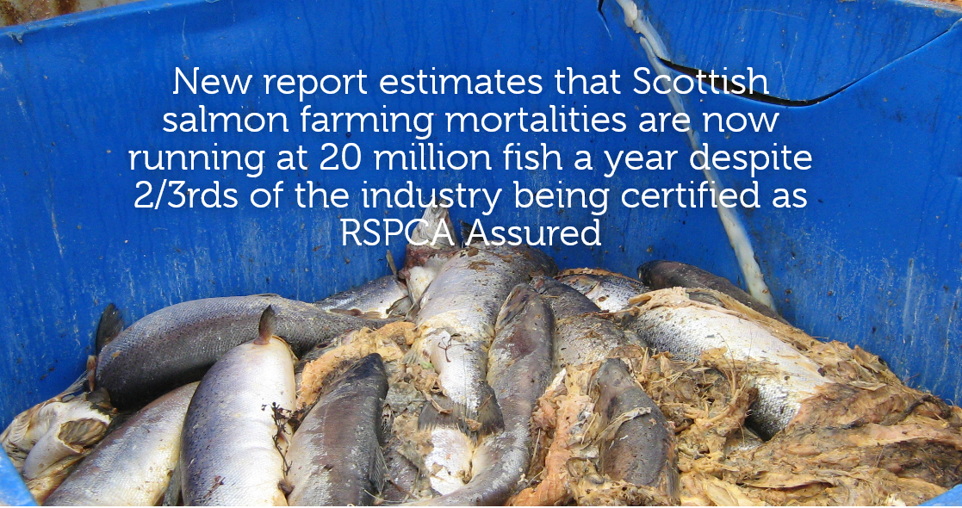

The Sunday Herald reported in October 2017: "Official figures reveal the tonnages of dead fish that had to be disposed of has more than doubled from 10,599 in 2013 to a record high of 22,479 in 2016". "The Scottish fish farming industry has admitted that it threw away up to ten million salmon last year – nearly a quarter of its stock – because of diseases, parasites and other problems," reported Rob Edwards. "Critics estimate the total number of dead, discarded salmon last year to have been between 10m and 20m. But the industry says it sustained losses of 'between 6 and 10 million fish, depending on their size'" (read more via "A disgrace: Ten million salmon thrown away by fish farm industry in last year alone").

The latest statistics published by the Scottish Government in September 2017 reveal a mortality rate of 26.7% for 2014 (2015 figures will not be published until September 2018). Mortality rates in some regions is even higher - with salmon farms in the Western Isles reporting 42.8% and Shetland reporting 31.9% mortality for 2016 (read more via Scottish Fish Farm Production Survey 2016 - see Tables 28 & 30). Monthly data on mortalities (by weight only) are published online via the Scotland's Aquaculture web-site.

Read more via Press Release: "Millions of Scottish Salmon Going Up in Smoke"

Here's a table of mortality rates (and estimated number of morts) since 2002 using the data published via Scottish Fish Farm Production Survey 2016:

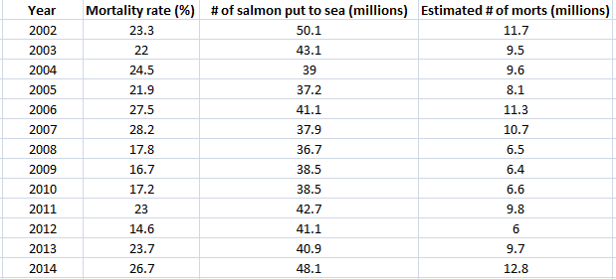

Download Excel spreadsheet online here

Data on mortalities was made available by SEPA via FOI for the period 2002 to 2016 (up to September):

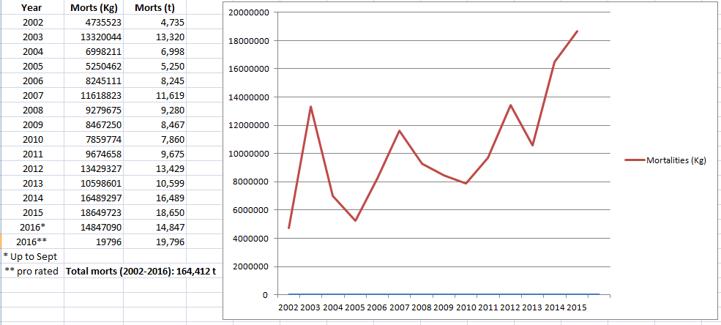

The twenty worst salmon farms in terms of mortalities for the period 2002 to September 2016 were:

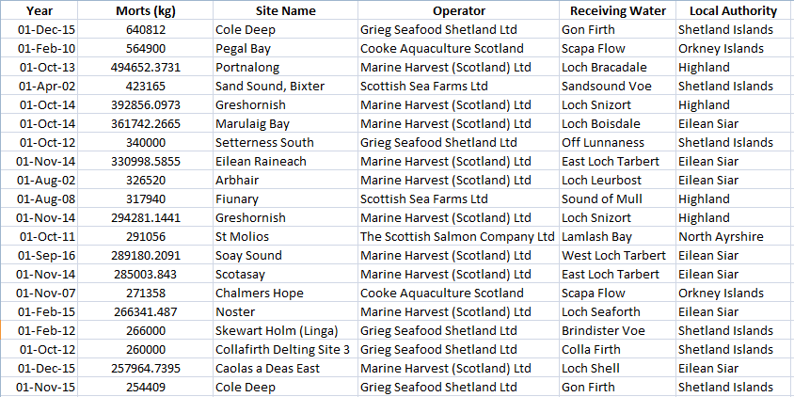

Read more via Press Release: Scottish Salmon's Lethal Legacy

[2] Guidance issued by the Department for Environment, Food & Rural Affairs and Animal and Plant Health Agency in 2014 stated under 'Vehicle Hygiene & Storage': "When you’re transporting animal by-products (ABPs) or any ABP derived products, you must make sure you: use vehicles and containers that are covered and leak-proof".

In November 2016, a Parliamentary Question filed by Mark Ruskell MSP asked "where and by whom containers of diseased salmon morts are checked for biosecurity compliance during their journey from farm to final disposal, and how many such journeys have taken place in each of the last three years".

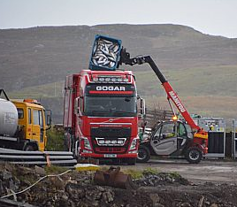

"Vehicles used for transporting salmon morts to a disposal site must be approved or registered under the Animal By-Products (Enforcement) (Scotland) Regulations 2013 (ABPR)," replied Fergus Ewing, Cabinet Secretary for the Rural Economy and Connectivity, in December 2016. "The operators of these vehicles must ensure that salmon morts be collected and transported in sealed new packaging or covered leak-proof containers."

Another Parliamentary Question and reply in November 2016 also stressed when transporting Animal By-Products transporters must ensure that they "use vehicles and containers that are covered and leak-proof".

