The Global Alliance Against Industrial Aquaculture, 26 January 2018

Cooke's Untreated Blood Water is "Gross" says SEPA
- "Poor" processing plant pollutes Mid Yell Voe in Shetland

Cooke Aquaculture is guilty of causing "gross" pollution in Scotland due to "untreated overflow from blood water tanks" and "raw effluent" being discharged from their processing plant into Mid Yell Voe. The disclosure of documents obtained via Freedom of Information from the Scottish Environment Protection Agency [1] has prompted environmental campaigners to call on the Scottish Salmon Producers Organisation to expel Cooke Aquaculture due to breaches of the industry's code of practice relating to the spread of infectious diseases [2] (read GAAIA's letter to the SSPO online here).

The damning disclosure comes in the wake of a shocking video of blood water being discharged from a salmon farming processing plant in Canada which prompted an investigation by the BC Government. CTV News also reported in November 2017 that "The federal government has launched a review after tests showed a contagious fish virus in blood spewing into a B.C. waterway from a fish processing plant".

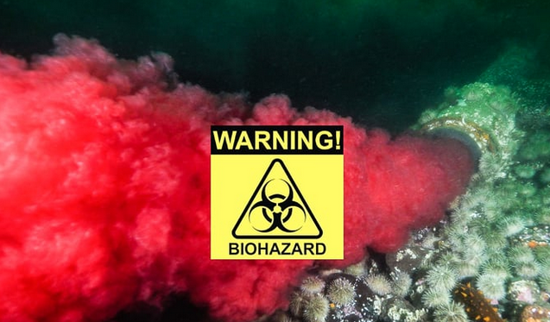

"Too many Cooke's salmon spoils the loch," said Don Staniford, Director of the Global Alliance Against Industrial Aquaculture and author of 'Scottish Salmon Farming 101'. "Discharging untreated blood water and raw effluent is a recipe for disaster, constitutes a significant disease risk and represents a gross breach of the industry's code of practice. Cooke Aquaculture should surely now be expelled from the Scottish Salmon Producers Organisation as was the case with Grieg Seafood in 2014. Lest it be forgotten that the spread of Infectious Salmon Anaemia cost Shetland salmon farmers ca. £1 million in 2008 and cost Scottish salmon farmers £30 million in 1998-9. Sadly, Cooke is growing accustomed to flouting environmental and public health regulations - in Scotland as well as in Canada and in the United States. People buying Cooke's farmed salmon have blood on their hands."

The FOI documents obtained by GAAIA [1] reveal:

- SEPA's assessment of Cooke's Mid Yell processing factory in August 2017 was rated "Poor" due to one "Gross" and two "Significant" breaches reported as "Untreated overflow from blood water tanks discharging down bank & into Mid Yell Voe". SEPA reported that there was an "Environmental Event notification of odour from plant" and "Operation of blood water treatment plant not operating properly - improvement required".

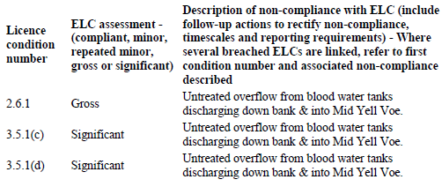

- SEPA's 'Action Points' to Cooke Aquaculture in August 2017 included: "It was also evident that small amounts of effluent from the blood water storage tanks was discharging directly to Mid Yell Voe, without treatment, via what were assumed overflow pipes. You were aware of this problem and are to put in place remedial actions to prevent the overflow discharging untreated effluent directly to Mid Yell Voe"

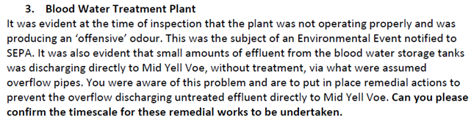

- An 'Environmental Event Notification' in January 2017 complained that "Over the last 6 months hundreds of litres of Hyphochlorous Acid - labelled 'Harmful to Marine Environment has been added to the blood water silos at the Mid Yell packing station. As can be seen from the accompanying photograph this is overflowing into the sea. The majority of the raw effluent has been flowing directly into the sea as the water treatment works have no chance of coping with the quantity involved due to the design flaw."

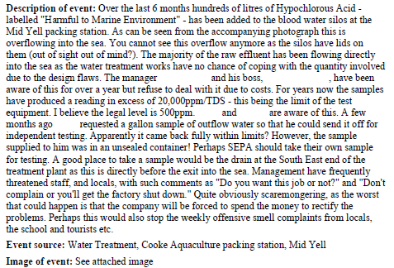

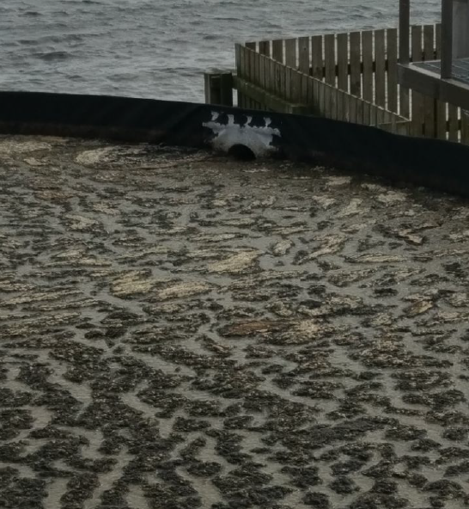
Photo: Overflowing blood water and "raw effluent" from Cooke's processing plant into Mid Yell Voe (download high res image online here)
Canadian-owned Cooke Aquaculture Scotland is a member of the Scottish Salmon Producers Organisation and must therefore abide by the industry's 'Code of Good Practice for Scottish Finfish Aquaculture' and 'A Code of Practice to avoid and minimise the impact of Infectious Salmon Anaemia'. Cooke Aquaculture Scotland's web-site boasts of accreditation via the 'Code of Good Practice for Scottish Finfish Aquaculture'.

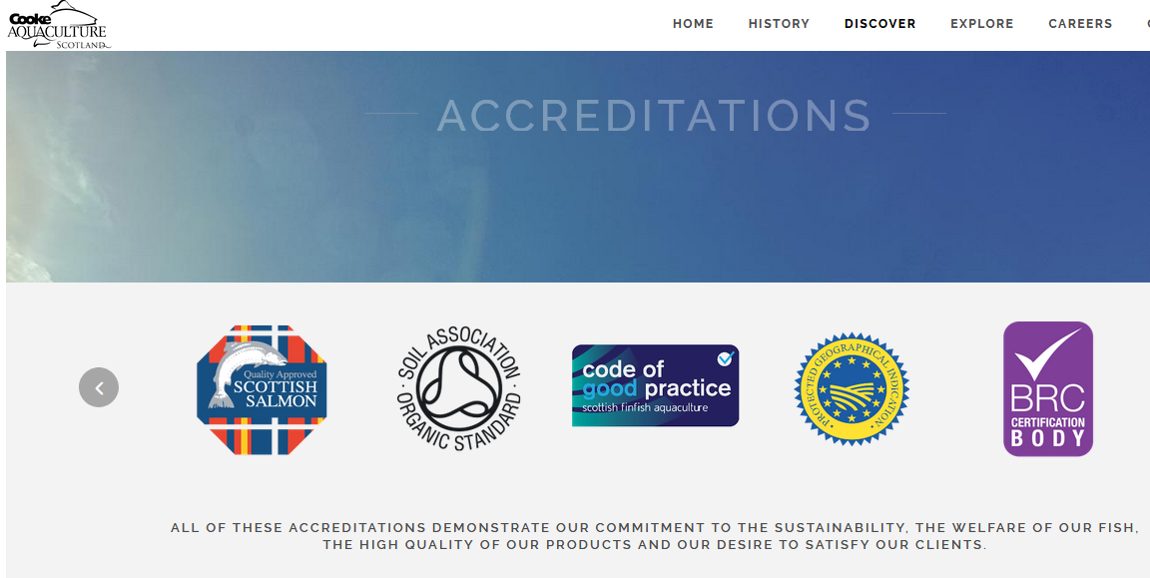

However, Cooke's processing plant discharging "untreated overflow from blood water tanks" and "raw effluent" in Mid Yell Voe is clearly not compliant with the 'Code of Good Practice for Scottish Finfish Aquaculture' (2015) - which includes in Chapter 6: Processing Sites:

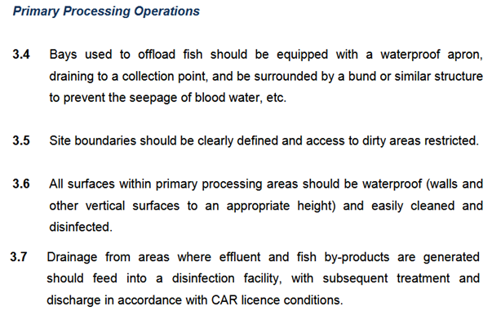

'A Code of Practice to avoid and minimise the impact of Infectious Salmon Anaemia' includes:

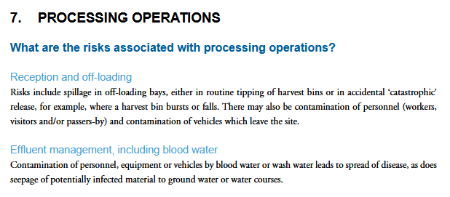

According to guidance from the Scottish Government on ISA: "Untreated effluent from processing plants has also been identified as being a particular risk":

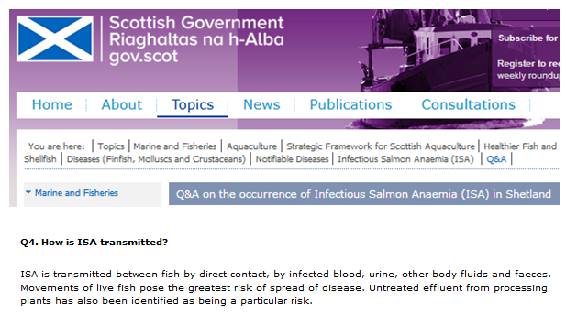

"The virus can be transmitted through water, but the highest risk factors for spread of disease are movement of live fish, discharge of untreated blood and contact with infected vehicles and equipment," states another Scottish Government fact-sheet.

According to Scottish Government advice on 'Biosecurity & Disinfection': "Following the outbreak of infectious salmon anaemia (ISA) in May 1998, the former Fisheries Research Services (FRS) Fish Health Inspectorate (FHI) (now Marine Scotland Science FHI) produced a disinfection guide, outlining strategies to minimise and prevent the spread of the virus, thereby reducing the spread of disease. In June 2006, version IV was produced and this guide should be regarded as best practice at fish farm sites and processing plants".

The 'Disinfection Guide Version IV: Practical Steps to Prevent the Introduction and Minimise Transmission of Diseases of Fish' (2006) states:

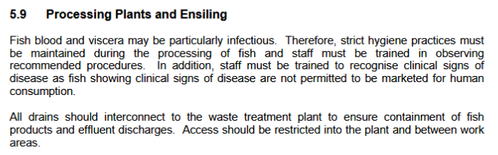
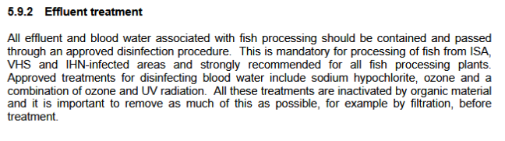
"Another important factor was the disinfection of processing plant effluent and the disinfection and sealing of well boats (CoGPWG 2006)," stated a report - 'Report into the epidemiology and control of and outbreak of infectious salmon anaemia in the Shetland Isles, Scotland' - published by Marine Scotland Science in 2010 following the outbreak of ISA in Shetland. "All waste from processing plants was disposed of by approved methods".

In 2014, the Scottish Salmon Producers Organisation expelled Grieg Seafood (Hjaltland Seafarms) because it had been importing smolts from Norway without putting them in quarantine which represented "a serious contravention of an industry code of good practice" (read more via "Industry body expels Shetland salmon producer Hjaltland" and "Salmon firm defiant after SSPO expulsion").

"Responsibility towards the environment is essential for the sustainability of aquaculture operations and is an established theme in Cooke Aquaculture Scotland," claims Cooke Aquaculture Scotland. "The strong tidal currents of Yell and Unst create the perfect conditions for the fish to be firm and muscular," continues their web-site.

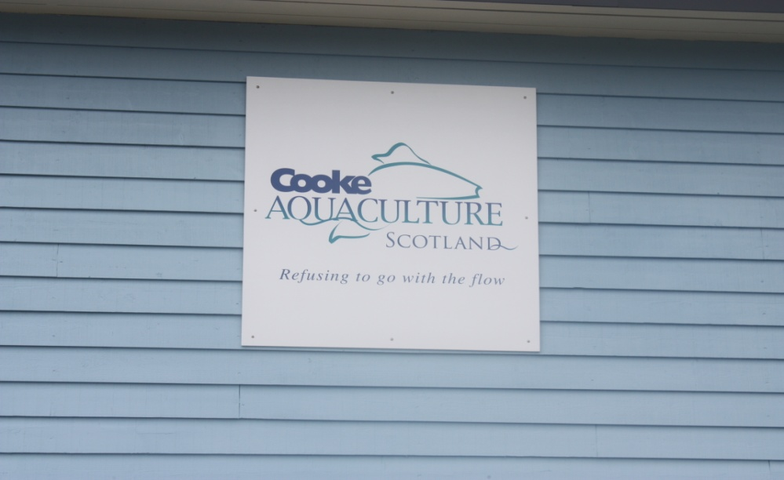
Cooke Aquaculture's marketing tag-line is perhaps unsurprisingly: "Refusing to go with the flow".
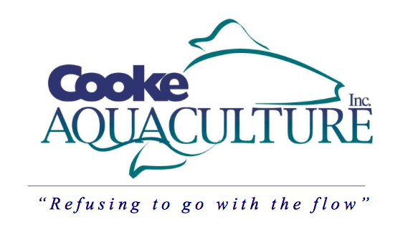

In an interview in 2017 - "How Cooke Aquaculture Became a Big Fish from a Small Pond" - Cooke's CEO Glenn Cooke said:

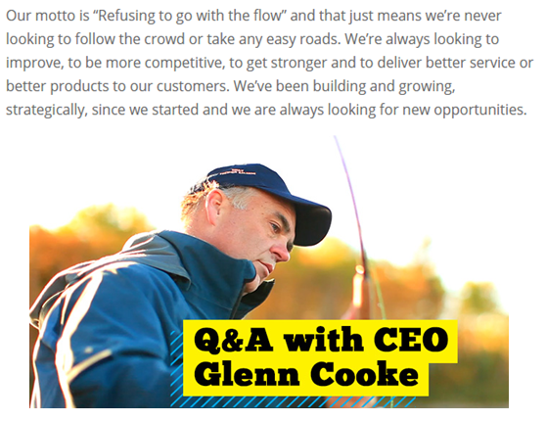

Cooke's "aggressive expansion" in Canada, Scotland, Chile and the United States led to CEO Glenn Cooke being awarded Intrafish Media's 'Person of the Year' in 2016. "Whilst all this kind of growth can sometimes lead to shortcuts, Cooke hasn't taken away," claimed Intrafish. "He has embraced sustainability in both conventional and non-conventional ways."

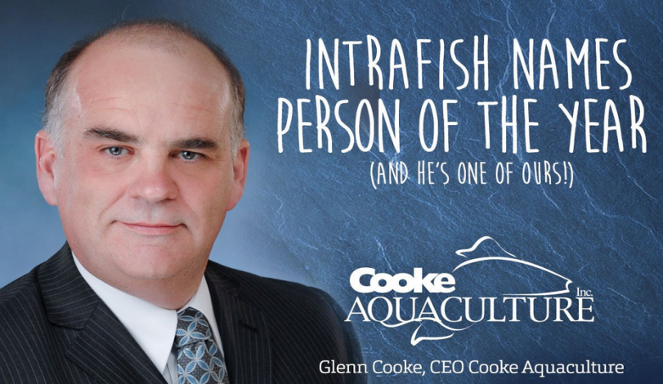
If Intrafish's 'non-conventional' definition of sustainability encompasses environmental pollution, mass escapes, illegal chemical use, regulatory violations and the spread of infectious diseases then Cooke is truly the epitome of sustainability and warrants all the accreditations which embellish Cooke's commitment to sustainability.

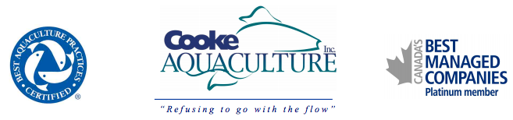
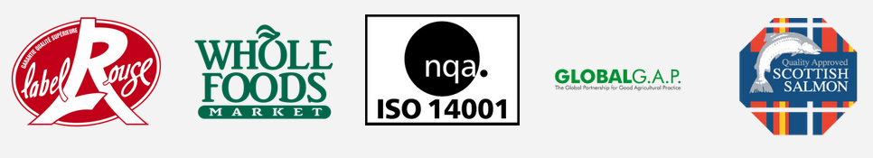
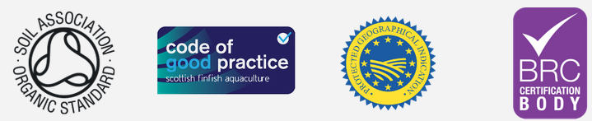

Cooke Aquaculture is certainly no stranger to swimming against the flow - in Scotland as well as Canada, the United States and Chile (read more via "Cooke Aquaculture - A Litany of Complaint Against This Fish Farm Company"):

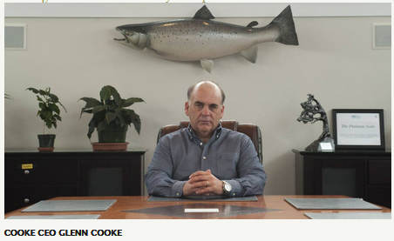

- In Canada, Cooke's legacy to Jordan Bay and other areas in Nova Scotia is plastic pollution (watch videos dated January 2018 via "Cooke Aquaculture's legacy to Jordan Bay, Shelburne County, Nova Scotia" and "Cooke Aquaculture creating plastic pollution on our shores, in our oceans and our food" - other videos on Cooke Aquaculture available online here).

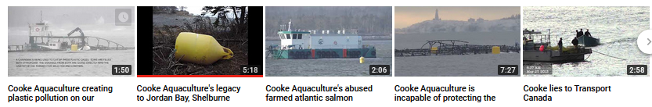
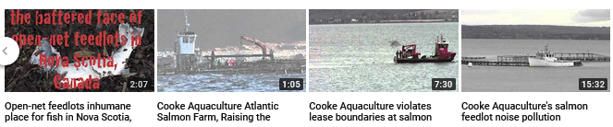

- In the United States, Cooke was fined $8,000 in December 2017 by the Washington Department of Ecology for water quality violations including: "unlawfully discharging polluting matter into state waters"; "pressure washing equipment, nets, and vehicles over the water and allowing wastewater to enter Puget Sound"; "changing boat engine oil over the water"; "failing to put safeguards in place to protect water quality" and "failing to correct water quality violations when directed" (read more via "Cooke fined for water quality violations at Bainbridge Island net pen facility" and "Cooke Aquaculture fined over repeated water quality violations").
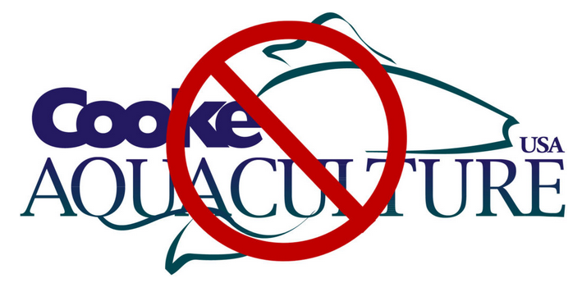

- In the United States, Cooke was ordered by the Washington Department of Natural Resources in December 2017 to close down its salmon farm in Port Angeles due to "clear breaches" which "endanger the public" (read more via "Violations prompt Washington state to cancel Atlantic salmon farm lease at Port Angeles", "Salmon escape leads Cooke into legal fight with Washington state", "Escaped Atlantic salmon found 42 miles up Skagit River and "Native tribes left to clean up after Cooke Aquaculture salmon escape in the Pacific").

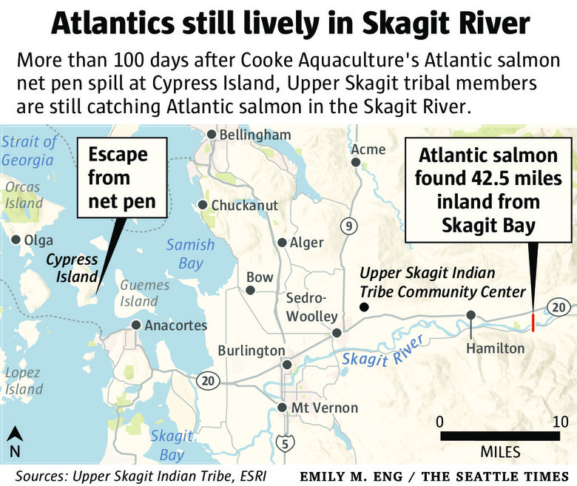

- In Canada, the Canadian Food Inspection Agency recalled farmed salmon from Cooke's subsidiary True North due to Listeria contamination in November 2017 (read more via "Cooke's True North recalls salmon flakes over listeria contamination").

- In Canada, ISA was reported at Cooke's salmon farming operation in Newfoundland in October 2017 (read more via "ISA virus prompts salmon harvest on Newfoundland's south coast" and "Cooke speeds up salmon harvest due to ISA virus detection").

- In Scotland, six of Cooke's sites feature amongst the sixty "liciest" salmon farms with Bastaness, Cloudin, Turness, Vee Taing, Wick of Belmont and Djubawick named and shamed in November 2017 by Salmon & Trout Conservation as breaching sea lice trigger levels between November 2016 and August 2017.

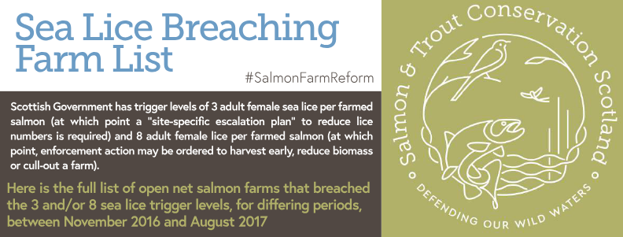
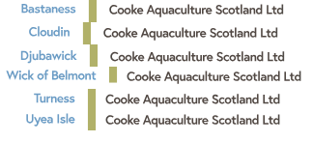
Read more via "Scotland's worst sea lice offenders - full farm list"

- In the United States, the Wild Fish Conservancy launched a legal action against Cooke Aquaculture in August 2017 following the escape of up to 250,000 farmed salmon which represented "blatantly negligent violations of the National Pollutant Discharge Elimination System" (read more via "Cooke facing legal action over fish escape"; "Cooke Aquaculture's standards questioned after salmon escape near B.C." and "Problems mount for Cooke Aquaculture on U.S. West Coast").

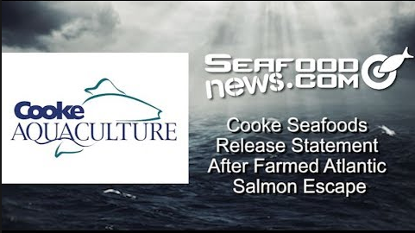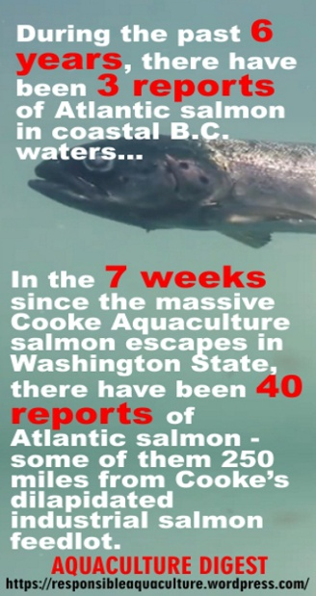

- In Canada, CTV News reported in March 2017 that there were "huge numbers of dead fish around Cooke Aquaculture in Shelburne Harbour, Nova Scotia" (read more via "Accusations against Cooke Aquaculture", "'Super-chill' suspected in massive Cooke Aqua fish kills"; "N.S. salmon farm renewal stirs up neighbours" and "Cooke Aquaculture, government misleading public on Jordan Bay salmon farm damage, says activist").

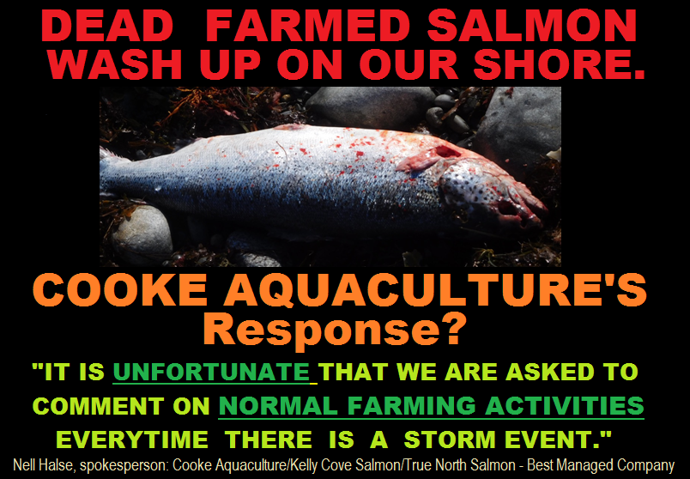

- In Scotland, data disclosed by SEPA for 2011-2015 revealed that of the 16 worst salmon farms (who all "failed" for three years out of the five years of SEPA's compliance assessment) four sites were operated by Cooke Aquaculture - with 9 salmon farms and one freshwater site assessed by SEPA as "Poor" ("Non-Compliant") in 2015:

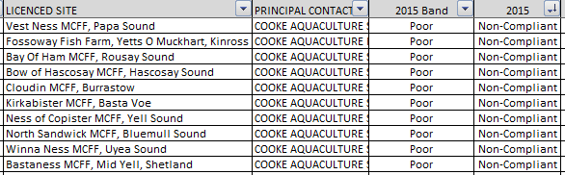

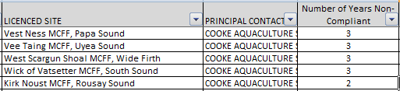

Read more via "Failing Fish Farms - 18% rated "poor" by SEPA in 2015"

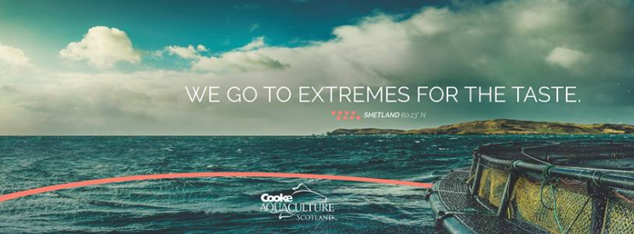

- In Chile, an outbreak of Infectious Salmon Anaemia was reported at Cooke's subsidiary Salmones Cupquelan in Aysen in 2015 (read more via "Sernapesca confirms new ISA outbreak at Cooke's Chile operations", "Cooke Aquaculture farms hit by ISA in Chile's Aysen region" and "More disease woes for Cooke Aquaculture").
- In Canada, Cooke was caught on camera dumping wastes into a harbour in Nova Scotland in March 2015 (watch video via "Cooke Aquaculture using Nova Scotia's harbours as a dump").
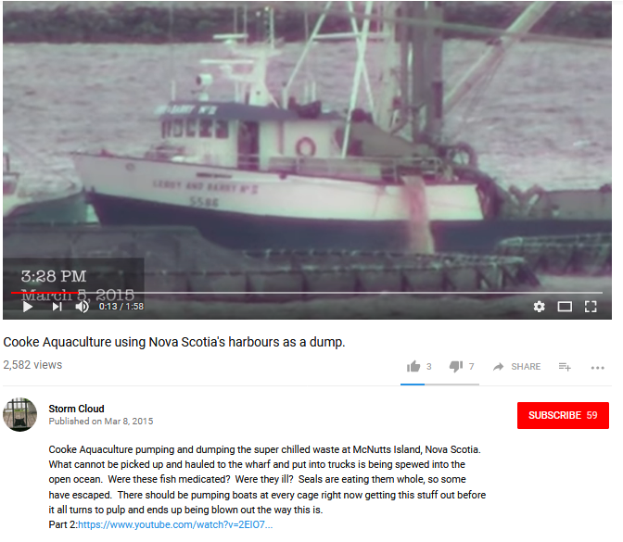

- In Chile, an estimated 600,000 farmed salmon were affected by the discovery of Infectious Salmon Anaemia virus at Cooke's Ballena IV salmon farm in Aysen in 2013 (read more via "ISA confirmed at Cooke site in Chile").

- In Canada, Cooke's subsidiary Kelly Cove Salmon was ordered to pay $500,000 in 2013 after pleading guilty to two charges in connection with the deaths of hundreds of lobsters in the Bay of Fundy from an illegal pesticide (read more via "Cooke Aquaculture to pay $490,000 after illegal pesticides kill lobsters in Canada"; "Environment Canada raids Cooke Aquaculture offices"; "Cooke slapped with $40,000 fine" and "Cooke executives charged with illegal pesticide use").

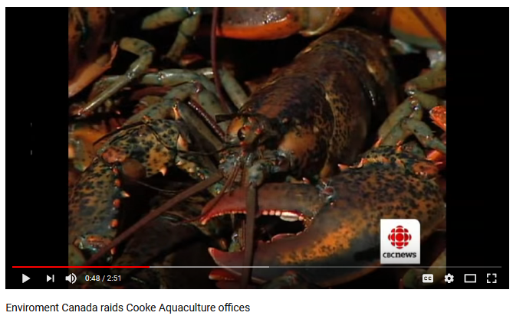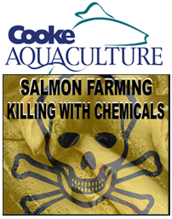

- In Canada, an outbreak of Infectious Salmon Anaemia at a Cooke facility in Shelburne resulted in the company destroying 700,000 fish in 2012 (read more via "Cooke Aquaculture Allowed to Process Diseased Salmon"; "Cooke: Anemia-infected fish can be sold like other farmed salmon", "Another ISA outbreak at Cooke salmon farm?" and "Another town fighting fish farms").

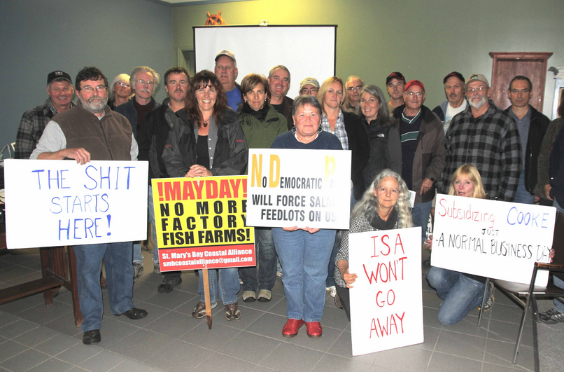

If awards were presented to polluters, Cooke Aquaculture would be laden down with gold, silver and bronze medals.

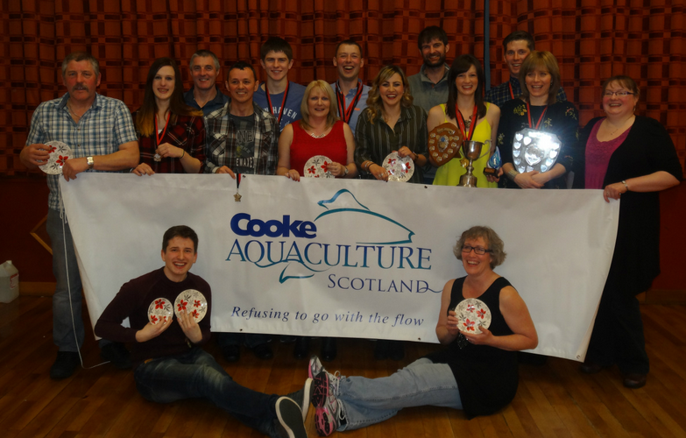

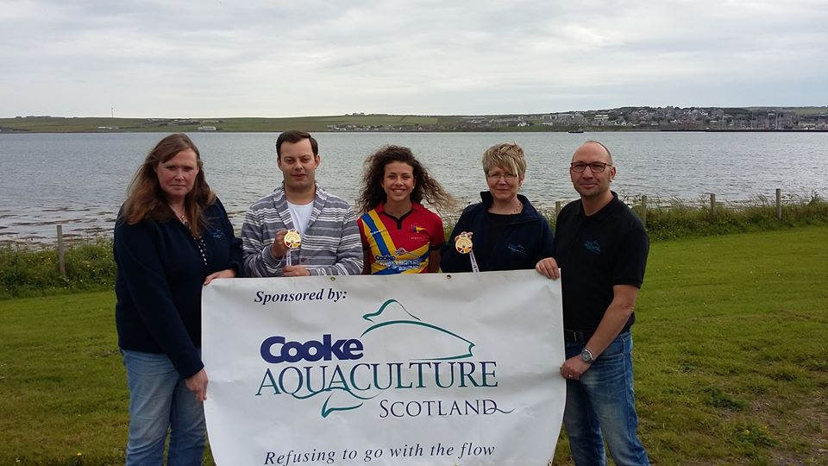

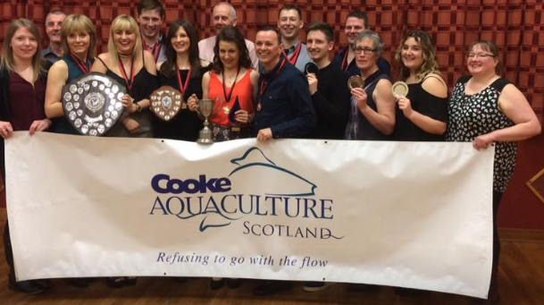

"Perhaps Cooke Aquaculture Scotland should invest more time and money in preventing pollution and stopping the flow of untreated blood water and raw effluents rather than buying off local communities with blood money via waterproof coats for schoolchildren, climbing equipment, scooters and tennis rackets, badminton sponsorship, swimming trips, hi-viz vests for the Brownies, Senior Citizen lunch clubs, Help from Home fund, football tracksuits, netball strips, fishing competitions, Kung Fu club, Highland dancing, riding club and chocolate eggs?" concluded Staniford [3]. "Cooke's farmed salmon leaves a bad taste in the mouth."

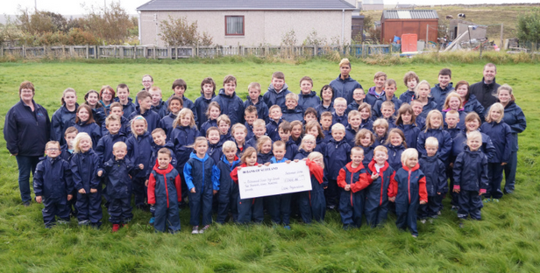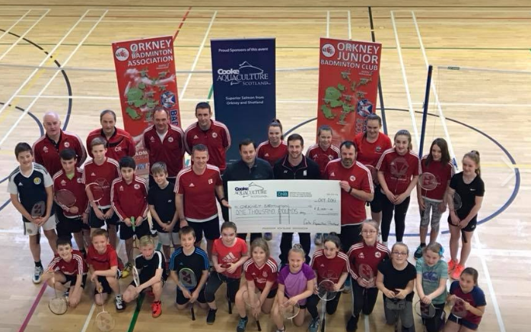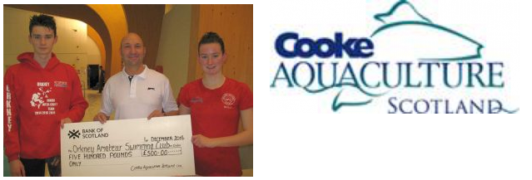
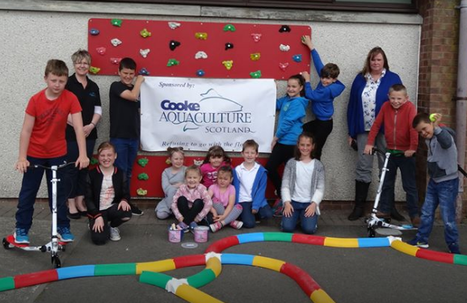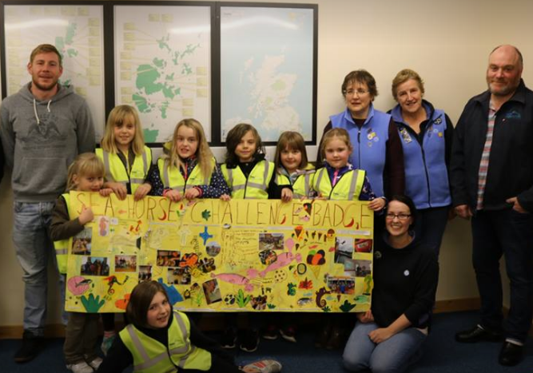
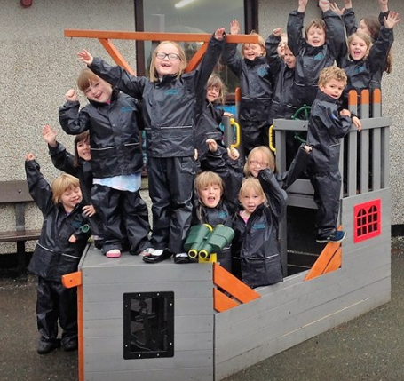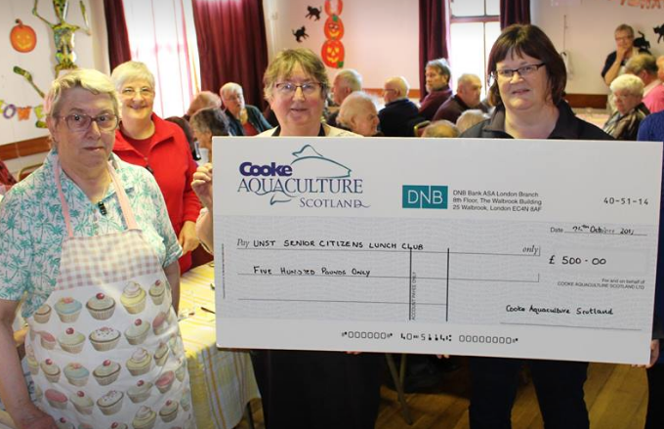
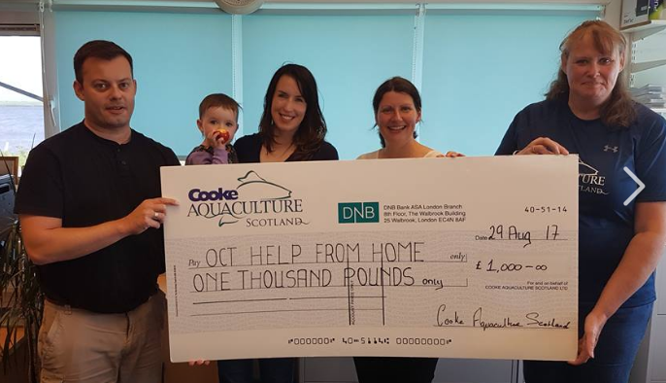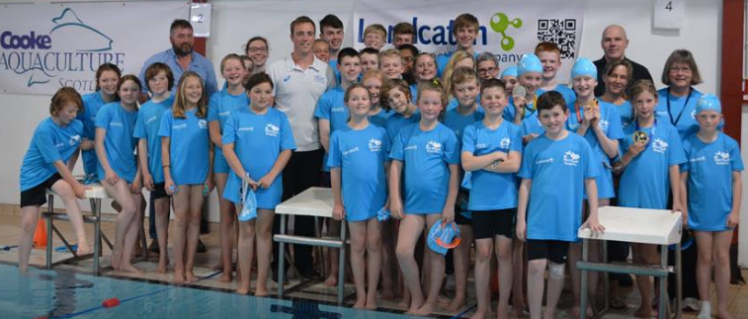
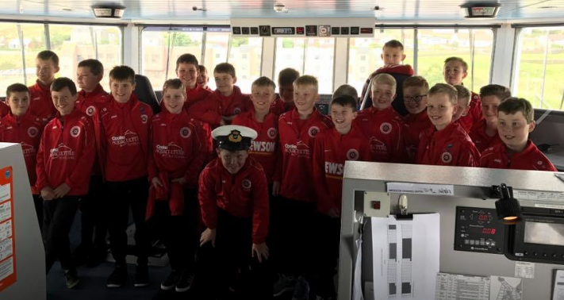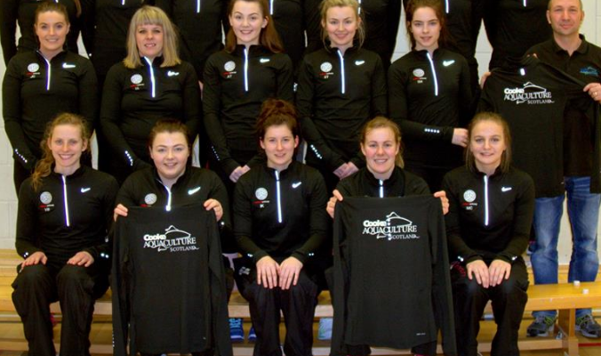
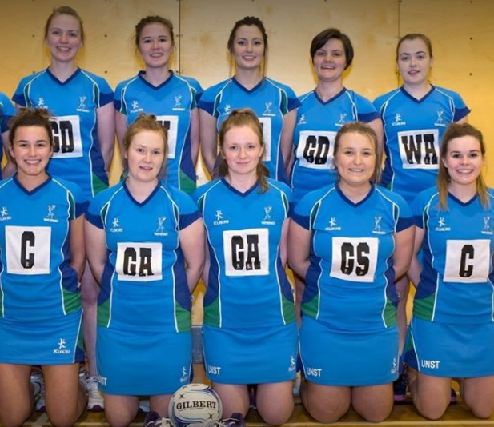
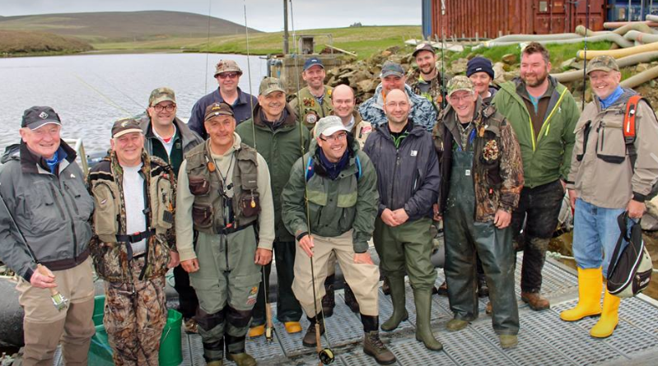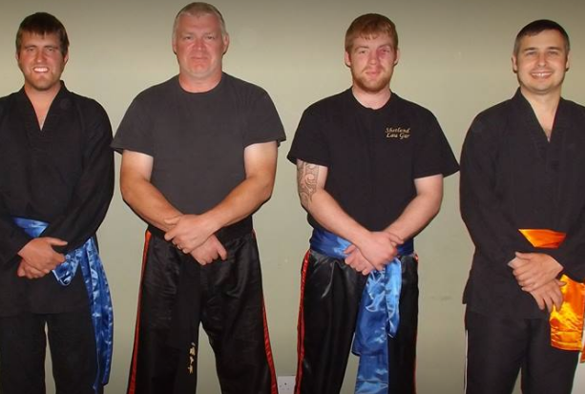
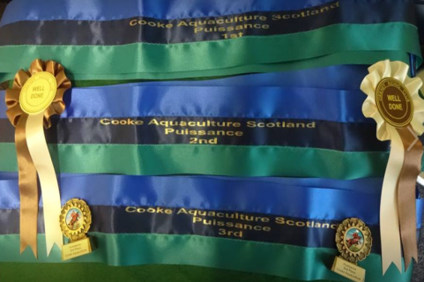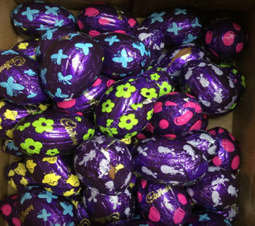

As SEPA's 'Environmental Event' report in January 2017 concluded:

"Management have frequently threatened staff, and locals, with such comments as 'Do you want this job or not?' and 'Don't complain or you'll get the factory shut down'. Quite obviously scaremongering, as the worst that could happen is that the company will be forced to spend the money to rectify the problems. Perhaps this would also stop the weekly offensive smell complaints from locals, the school and tourists etc."

Contact:

Don Staniford (07771 541826 and dstaniford@gaaia.org)

Notes to Editors:

[1] Download the FOI documents in full via:

Environmental Event report re. "raw effluent" and overflowing "blood water" at Cooke's Mid Yell processing plant - January 2017

Photo: Overflowing blood water and "raw effluent" from Cooke's processing plant into Mid Yell Voe

"Poor" SEPA Assessment for "gross" breach at Cooke's Mid Yell processing plant - August 2017

SEPA action points to Cooke "to prevent the overflow discharging untreated effluent directly to Mid Yell Voe" - August 2017

FOI request from GAAIA (12 December 2017) and FOI replies from SEPA (23 & 15 January 2018):

From: Access to Information Enquiries [mailto:FOI.Mail@sepa.org.uk]
Sent: 23 January 2018 09:35
To: 'Don Staniford'
Subject: RE: Access to Information SEPA Response - [F:0188310]



Dear Don
Thank you for the email and apologies for the oversight. Please see attached for a copy of the photo referred to in the document.
Kind regards
Michael

Michael Hampton
Access to Information Team
Information Governance, Performance and Innovation Portfolio
t: 01786 452484 e: michael.hampton@sepa.org.uk

From: Don Staniford [mailto:salmonfarmingkills@gmail.com]
Sent: 22 January 2018 11:57
To: Access to Information Enquiries <FOI.Mail@sepa.org.uk>
Subject: RE: Access to Information SEPA Response - [F:0188310]

Could you please provide a copy of the photograph and "attached image" referred to in this Environmental Event (as disclosed in SEPA's FOI reply of 15 January)?
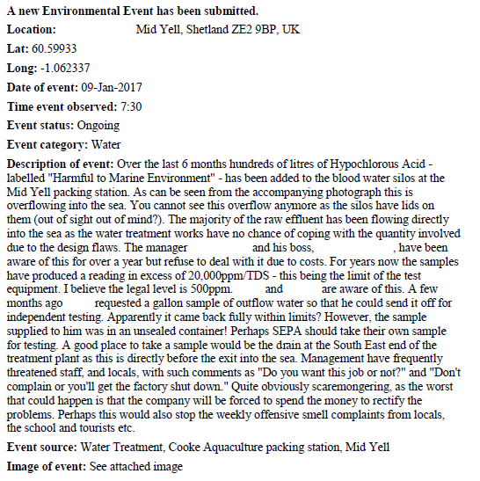

Presumably it was an oversight not to include this photograph.

Best fishes,

Don

Don Staniford

Director, Global Alliance Against Industrial Aquaculture (GAAIA): http://www.salmonfarmingkills.com

Read my blog via http://donstaniford.typepad.com/my-blog

<((((º>`·.¸¸.·´¯`·.¸.·´¯`·...¸><((((º>¸.
·´¯`·.¸. , . .·´¯`·.. ><((((º>`·.¸¸.·´¯`·.¸.·´¯`·...¸><((((º>

From: FOI Helpdesk [mailto:FOI.Mail@sepa.org.uk]
Sent: 15 January 2018 15:12
To: Salmonfarmingkills@gmail.com
Cc: foi@sepa.org.uk
Subject: Access to Information SEPA Response - [F:0188310]
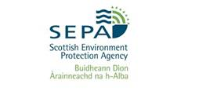
Dear Mr Staniford

REQUEST FOR INFORMATION

Please refer to the enclosed documents in relation to your request for information.

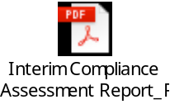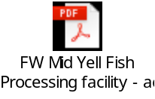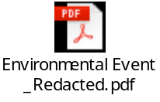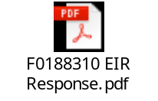

Regards

Cara Everitt
SEPA Access to Information team
Email: foi@sepa.org.uk
Tel: 01786 457700

From: Don Staniford [mailto:salmonfarmingkills@gmail.com]
Sent: 12 December 2017 05:44
To: 'AccesstoInformation'
Subject: FOI re. processing plant waste effluents & pollution since 1 Jan 2017

Please provide information relating to salmon processing plant waste effluents and pollution during 2017.

This may include the following processing plants operated by/for the salmon farming industry:

- Marine Harvest, Fort William
- Scottish Sea Farms, South Shian
- Scottish Salmon Company, Cairndow
- Cooke Aquaculture, Yell
- Wester Ross Fisheries, Dingwall
- Marine Harvest, Rosyth
- Cooke Aquaculture, Kirkwall
- Grieg Seafood/Hjaltland Seafarms, Lerwick
- Edinburgh Salmon Company, Dingwall

Please include any warning letters, breaches of pollution, photos, sampling, emails with company officials and other information relating to salmon processing plant waste effluents and pollution since 1 January 2017.

Please include any internal and external discussions concerning the "blood water" video footage and news coverage. In Canada, the issue of discharges of blood water spreading infectious diseases is a hot topic following video footage published last month by Tavish Campbell.

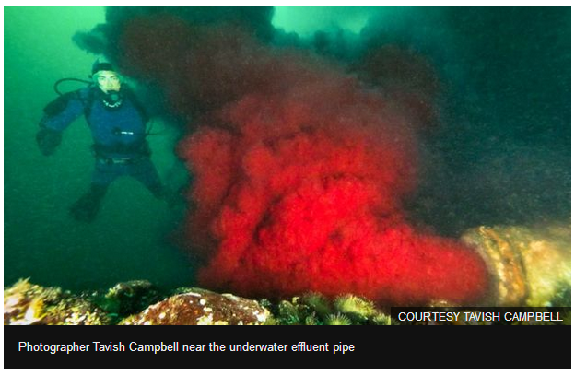

Read more via Bloody sewage from Canada fish plant 'threatens' wild salmon

Please consider this a request for information under the relevant Freedom of Information and Environmental Information Regulations including both the Freedom of Information (Scotland) Act 2002 and the Environmental Information (Scotland) Regulations 2004 (as well as any other new or other regulations which may be appropriate).

Please provide this information electronically via email.

Please acknowledge receipt of this FOI request.

Many thanks and I look forward to a response shortly.

Best fishes,

Don

Don Staniford

Director, Global Alliance Against Industrial Aquaculture (GAAIA): http://www.salmonfarmingkills.com

Read my blog via http://donstaniford.typepad.com/my-blog

<((((º>`·.¸¸.·´¯`·.¸.·´¯`·...¸><((((º>¸.
·´¯`·.¸. , . .·´¯`·.. ><((((º>`·.¸¸.·´¯`·.¸.·´¯`·...¸><((((º>

Summary of the documents disclosed by SEPA on 15 January 2018:

Complaint logged with SEPA in January 2017 re. "hundreds of litres of Hyphochlorous Acid - labelled 'Harmful to Marine Environment.....overflowing into the sea" and "weekly offensive smell complaints from locals, the school, tourists etc":

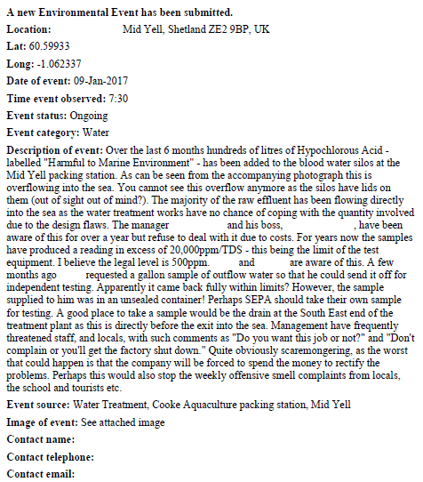

Photo: Overflowing blood water and "raw effluent" from Cooke's processing plant into Mid Yell Voe (download high res image online here)

SEPA's "Poor" assessment of Cooke's Mid Yell processing factory in August 2017 (due to more than one "gross or repeated minor breaches") which included one "gross" breach for "untreated overflow from blood water tanks discharging down bank & into Mid Yell Voe"):

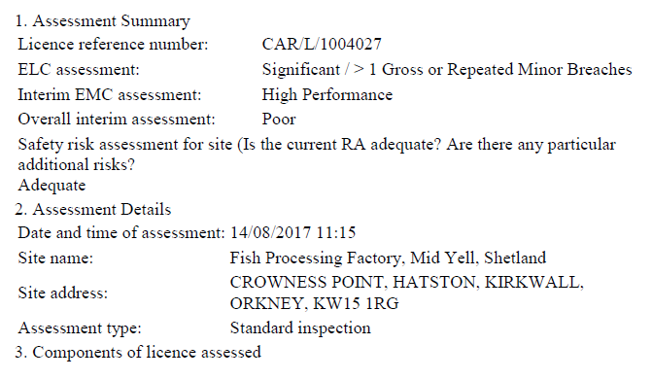
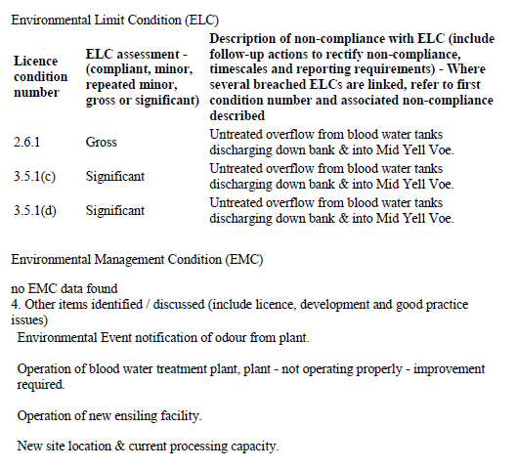

Email exchange between SEPA and Cooke re. action points following the above site visit - including from SEPA:

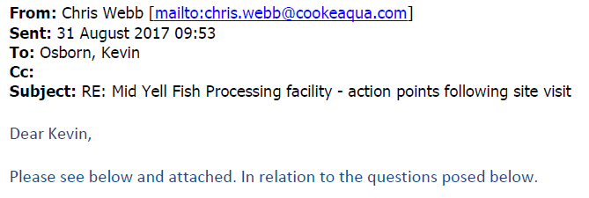

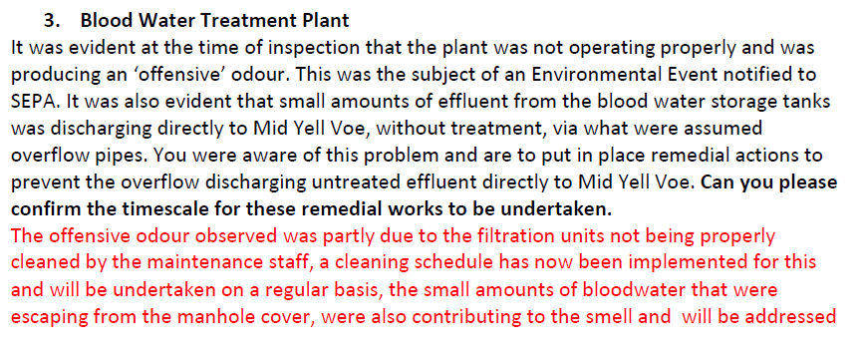
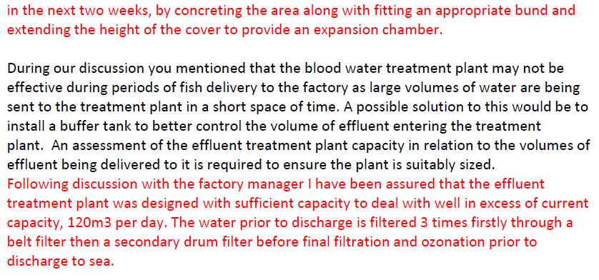
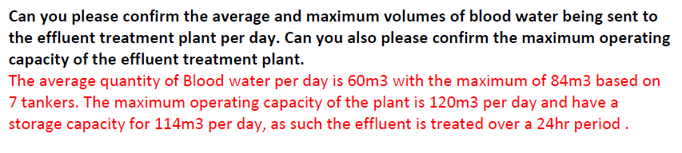

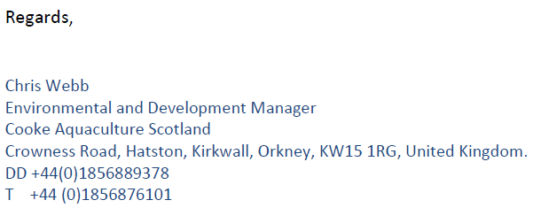

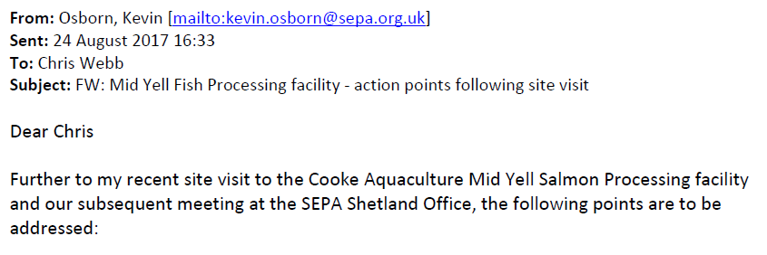

[Body of email in the email above replied to by Chris Webb of Cooke]

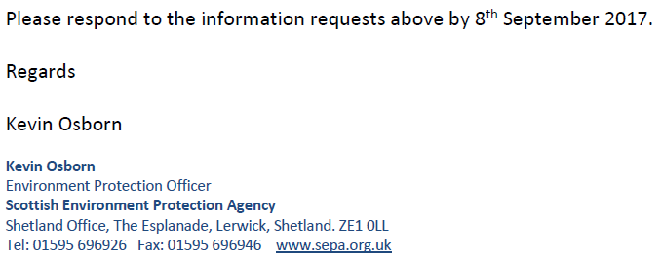

[2] Read a Letter to the SSPO re violation of Code of Practice by Cooke Aquaculture in Mid Yell Voe (25 January 2018)

Read more via: "Code of Good Practice for Scottish Finfish Aquaculture"

Chapter 6: Processing Sites includes:

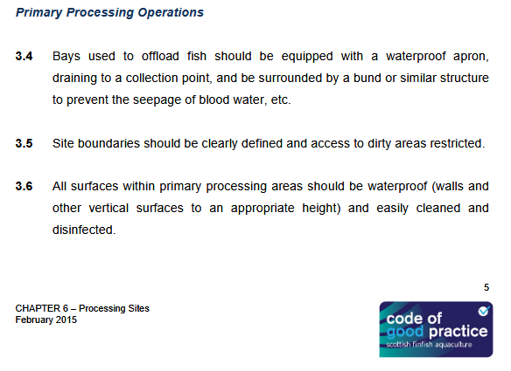

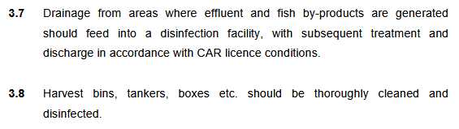

Read more via: "A Code of Practice to avoid and minimise the impact of Infectious Salmon Anaemia"

Includes:

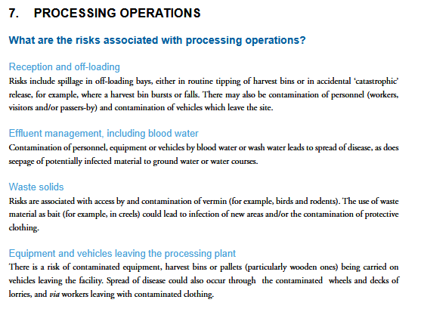

[3] Photos from Cooke Aquaculture Scotland's Facebook page:


