Scottish Salmon Watch, 27 July 2018

Failing Fish Farms: Scotland's Worst Salmon Farms Named & Shamed

- 51 sites including Marine Harvest's Loch Leven salmon farm promoted by Prince Charles & Scotland's first salmon farm to be certified by the ASC (now expired)

Documents disclosed by the Scottish Environment Protection Agency (SEPA) via Freedom of Information (FOI) expose the poor practices of Scotland's worst salmon farms. In February, BBC News revealed that 51 fish farms in Scotland were failing to comply with environmental protection measures yet SEPA failed to name the companies responsible. In July, SEPA finally disclosed documents naming and shaming the salmon farming companies guilty of non-compliance during 2016 [1].

Scottish Salmon Watch can now reveal that Scottish salmon's worst operator is Norwegian-owned Scottish Sea Farms with 10 fish farms failing SEPA's compliance assessment in 2016 (with 9 farms assessed as "Poor" and one as "Very Poor"). Norwegian-owned Marine Harvest and Canadian-owned Cooke Aquaculture closely follow both with 9 failing fish farms and Jersey-registered and Swiss-owned the Scottish Salmon Company with 6 failing fish farms (all are members of the Scottish Salmon Producers Organisation).

One of Marine Harvest's 9 salmon farms rated as "Poor" was Loch Leven - the first salmon farm in Scotland to be certified by the Aquaculture Stewardship Council and one of only two ASC-certified farms in Scotland before its certification expired in February 2018. Marine Harvest's other ASC-certified site in Loch Linnhe has had its certification "cancelled" according to the ASC and expires in November - with another three salmon farms operated by Marine Harvest (Duich, Loch Alsh & Ardintoul) also having their ASC-certification "cancelled" [2]. Marine Harvest's farm in Loch Leven was visited by Prince Charles in 2016 who said it "has set the benchmark" and described the operations as "sustainable".

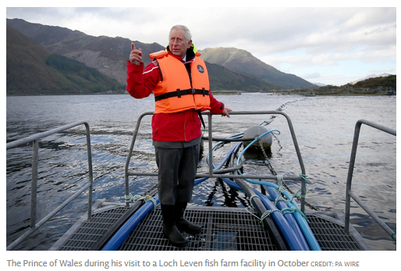

Marine Harvest's salmon farm in Loch Duich - a Special Area of Conservation supposedly protected under EU Law - was ranked "Poor" by SEPA due to a significant failure for contamination of sediments with residues of the toxic chemical Emamectin benzoate.
Two of Scottish Sea Farms' 10 salmon farms rated as "Very Poor" or "Poor" were located at Fishnish in the Sound of Mull - the site of the killing a humpback whale in 2014 and exceedance of lice limits in January 2018. Fishnish A salmon farm "failed repeatedly" according to SEPA with "6 consecutive unsatisfactory surveys since 2006" and Fishnish B had "3 consecutive unsatisfactory surveys since 2010" leading to SEPA imposing a conditional reduction in biomass on both sites.

Another Scottish Sea Farm site in Loch Spelve at Balure on the Isle of Mull was rated "Very Poor" due to exceedance of the Environmental Quality Standard for residues of Emamectin benzoate (a toxic chemical known to kill lobsters) and evidence of drug over-dosing.

One of the Scottish Salmon Company's 6 salmon rated as "Poor" was Gometra salmon farm off the Isle of Mull - a site controversially approved back in 2012 despite a campaign calling it "dangerous" and a "blight on the horizon". Another "Poor" salmon farm operated by the Scottish Salmon Company is located at Inch Kenneth in Loch na Keal on the Isle of Mull - described by SEPA as failing all benthic surveys since 2002.

Cooke Aquaculture's hatchery in Furnace was rated "Poor" for effluent discharge failures into Loch Fyne whilst Wester Ross Fisheries - a company with a long history of pollution breaches - had two salmon farms assessed by SEPA as "Poor" due to 'unsatisfactory' benthic pollution in Little Loch Broom and Loch Broom.

"Salmon farms across Scotland are riding roughshod over environmental regulations," said Don Staniford, Director of Scottish Salmon Watch. "Even the best salmon farm Scotland has to offer - Marine Harvest's Loch Leven farm championed by Prince Charles and certified by the Aquaculture Stewardship Council - has been officially ranked by SEPA as 'Poor'. How embarrassing - shame on Scottish salmon!"

"Expanding salmon farming in Scotland yet further with a doubling or even trebling by 2030 would be sheer lunacy," continued Staniford. "Hopefully the forthcoming report into salmon farming by the Scottish Parliament's Rural Economy & Connectivity Committee - expected 'in the early autumn' - will clamp down on the poor practices endemic in Scottish salmon farming. SEPA should immediately close down all salmon farms guilty of systematic non-compliance and perennial poor performance."

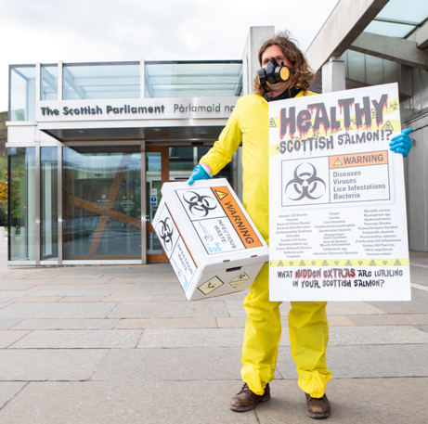
Contact:

Don Staniford (Director of Scottish Salmon Watch): 07771 541826 (dstaniford@gaaia.org)
Background:

On 15 February 2018, Don Staniford filed a FOI request with SEPA asking for site specific information on the 51 fish farms rated as "at risk", "poor" or "very poor" in 2016. On 2 July 2018, SEPA finally provided over 210 MB of data apologizing for the "extended delay" (FOI requests should be dealt with within 28 days). See Appendix and Note [1] for more details.

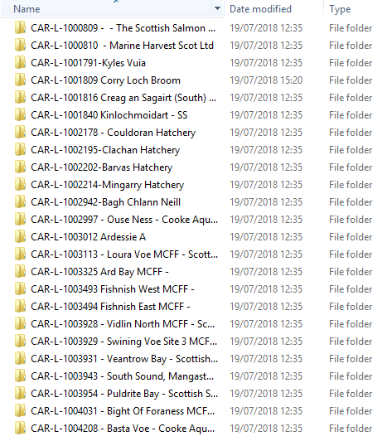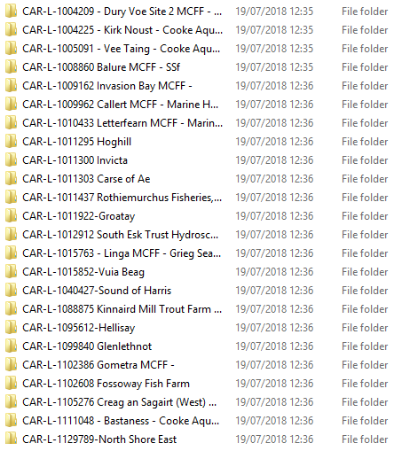

Of the 51 fish farms failing SEPA's pollution limits in 2016 there were 10 sites operated by Scottish Sea Farms, 9 by Cooke Aquaculture, 9 by Marine Harvest, 6 by the Scottish Salmon Company, 3 by Grieg Seafood, 2 by Hebridean Smolts, 2 by Wester Ross Fisheries and 1 by Loch Duart.

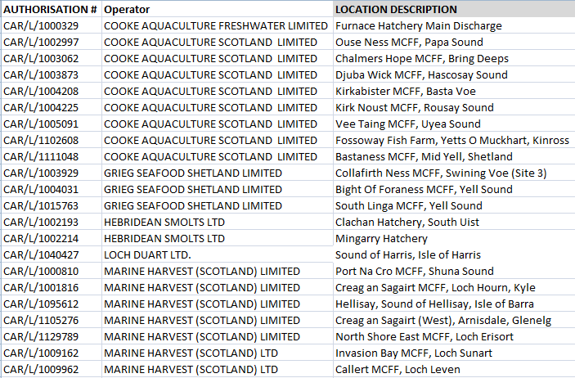
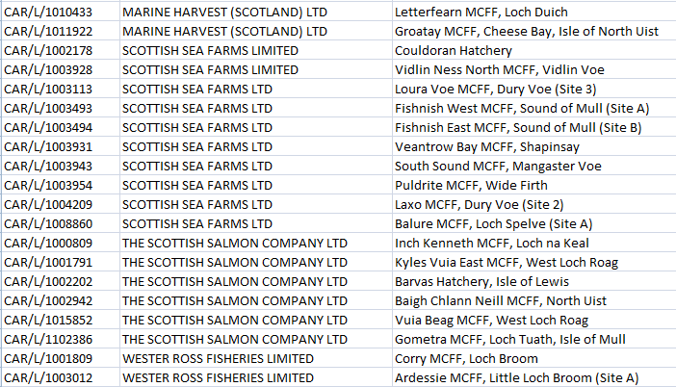

Download Excel spreadsheet obtained from SEPA via Operators List

In February 2017, the Global Alliance Against Industrial Aquaculture published FOI data from SEPA for failing fish farms in 2015 and back to 2010.

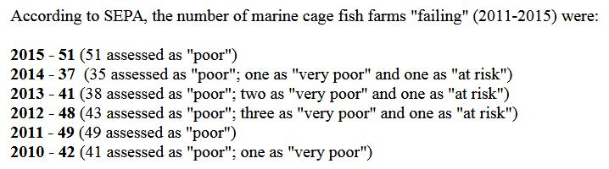

Read more via "Failing Fish Farms - 18% rated "poor" by SEPA in 2015"

More background on pollution by Scottish salmon farming via:

The Scottish Environment Pollution Agency
"Very Serious Pollution" at The Scottish Salmon Company
The Scottish Salmon Polluters Organisation (SSPO)
Loch Duart - The (Really Not Very) Sustainable Salmon Company
BBC News: "Shetland salmon packing factory leaks 'blood water' into sea"
Cooke's Untreated Blood Water is 'Gross' says SEPA
Scottish Salmon Farming 101
Red Alert for Label Rouge - Lousy Label Goes Rogue
25 Years of Scottish Salmon Shame
Toxic Toilets: Salmon Farms Pollute Scotland's Lochs

Read more via Scottish Salmon Watch
Notes to Editors:

[1] Over 210 MB of documents disclosed by SEPA on 2 July 2018 (mailed as a memory stick) included:

Scottish Sea Farms:

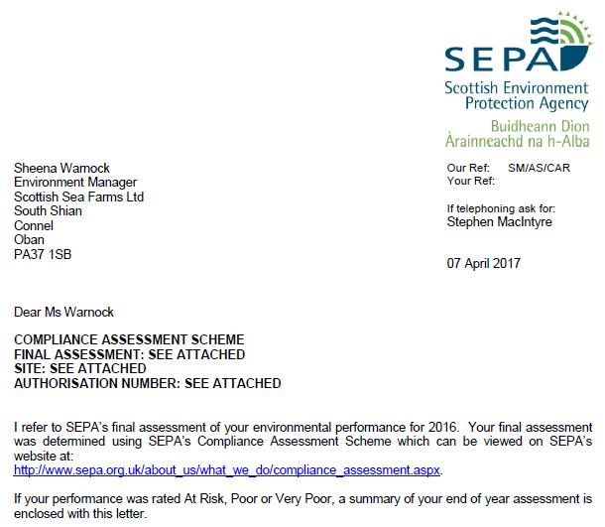

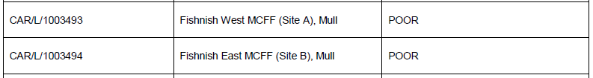

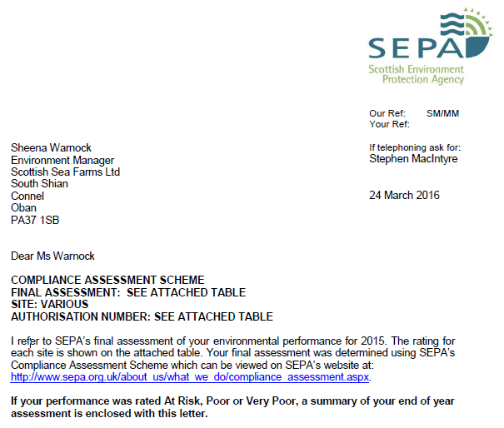

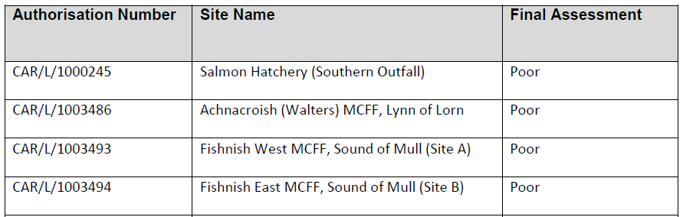

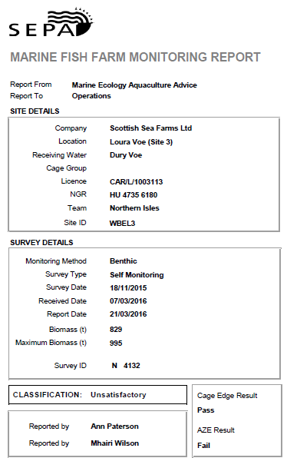

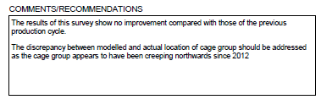

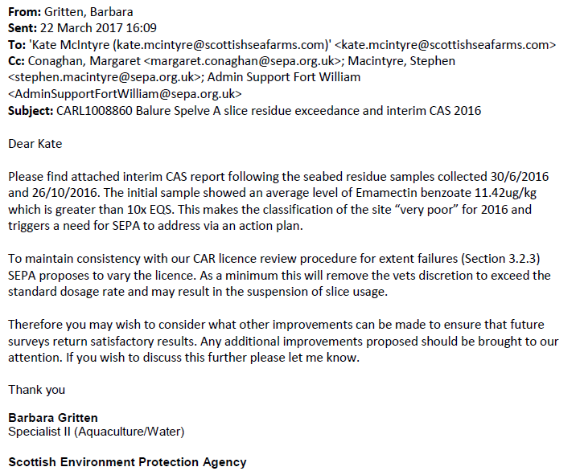

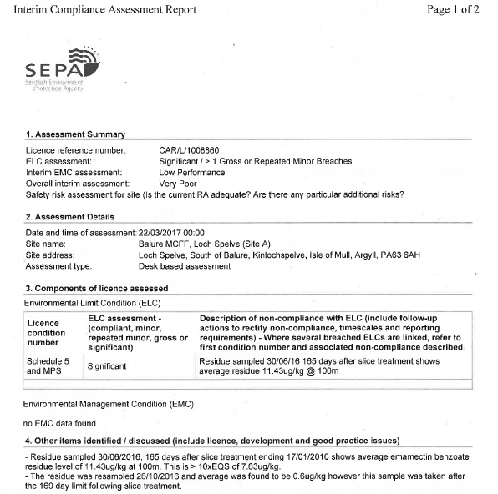

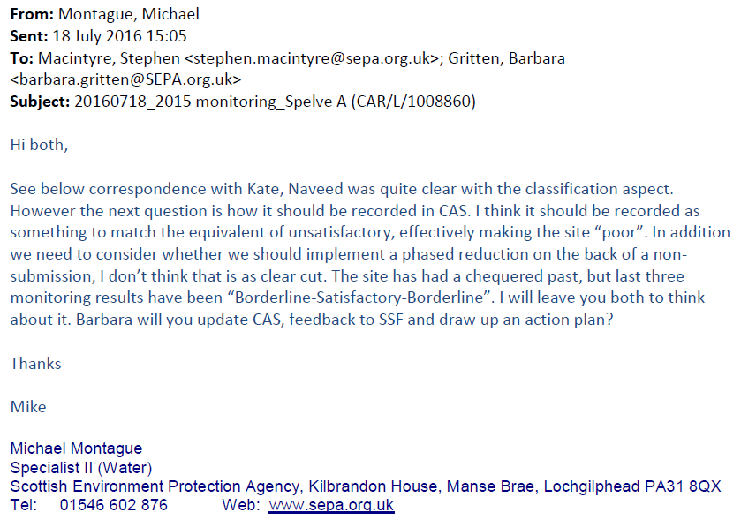

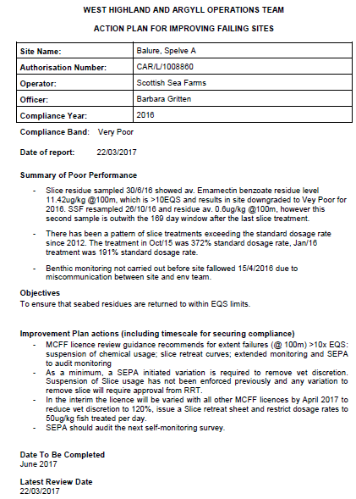

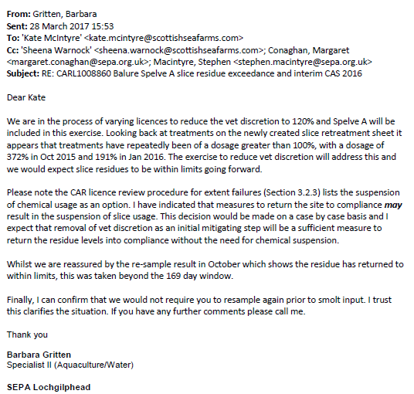

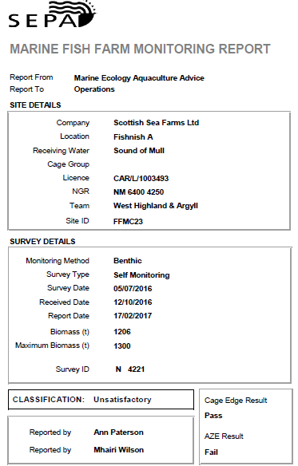

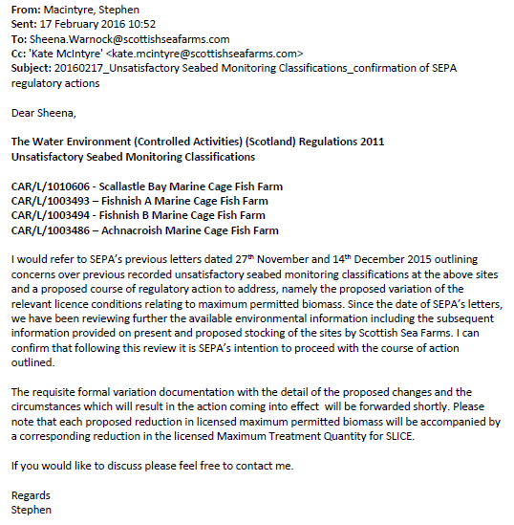

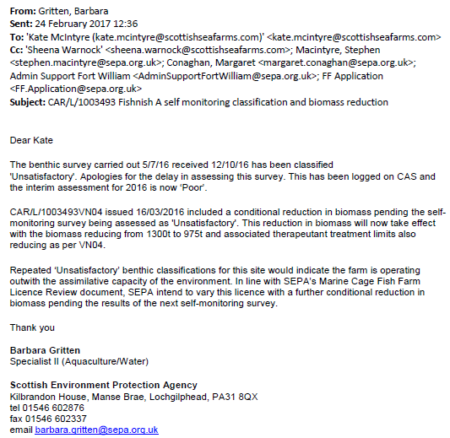

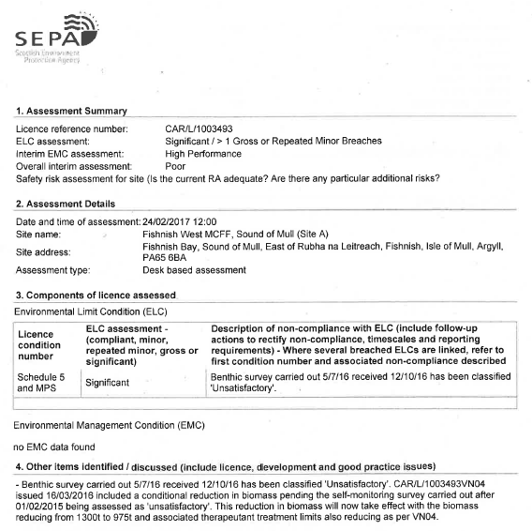

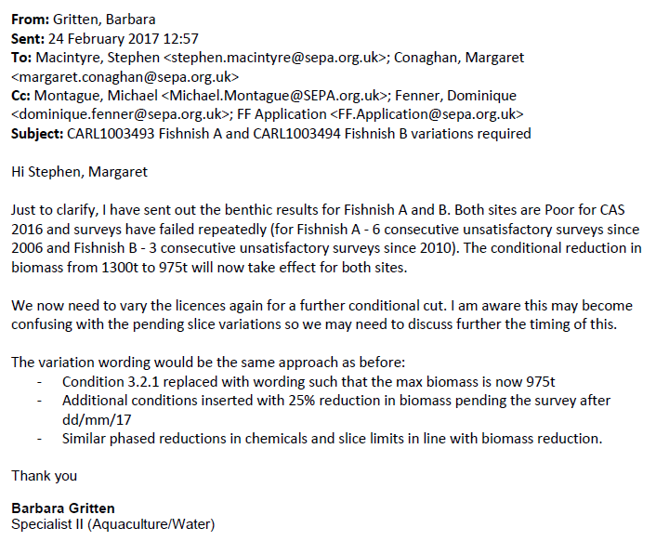

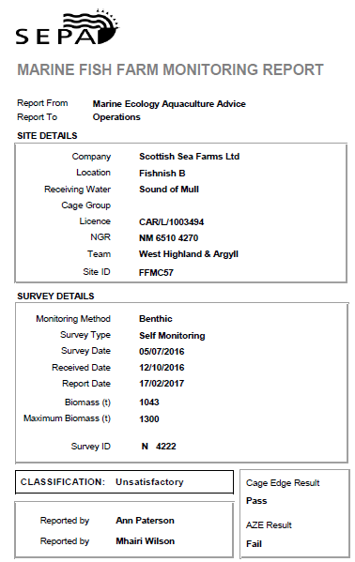

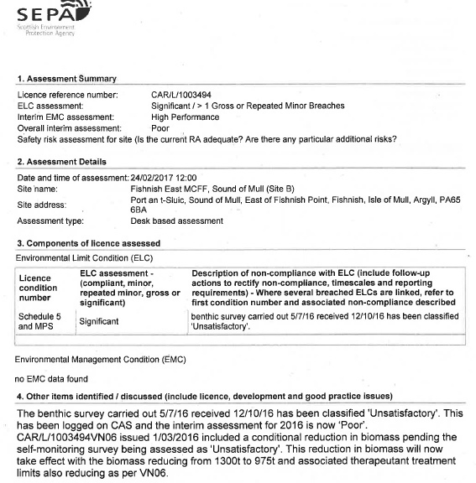

Marine Harvest:

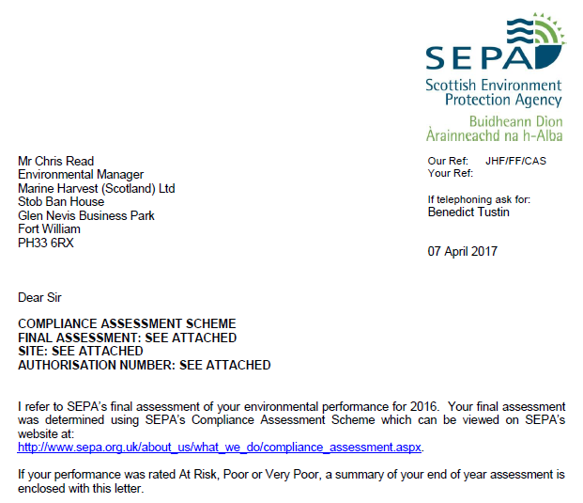

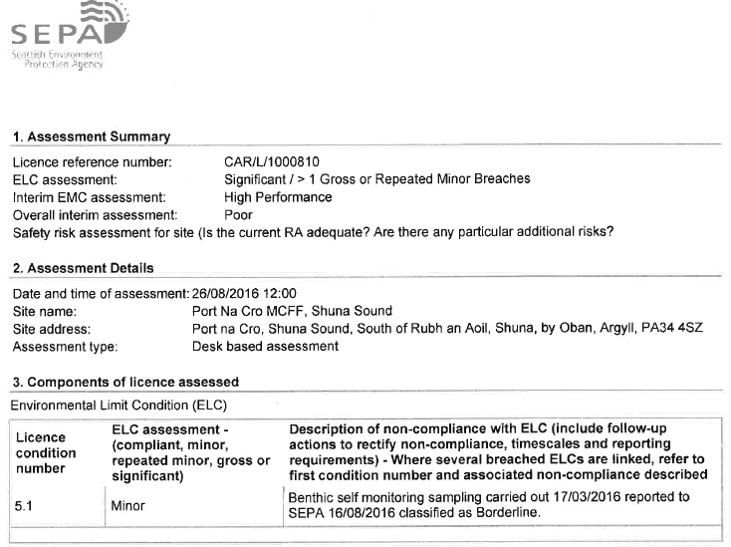

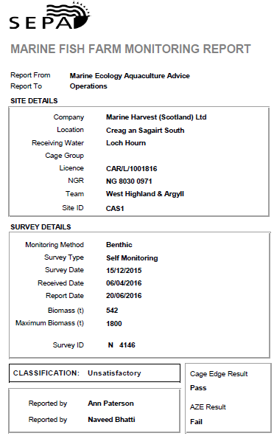
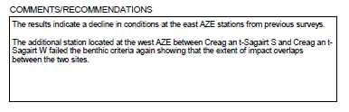

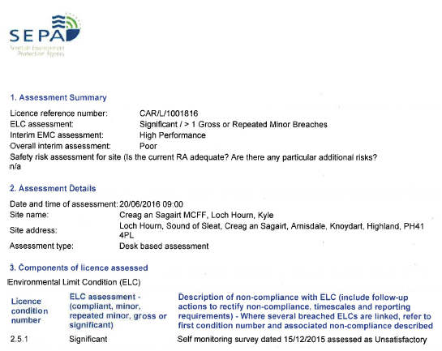

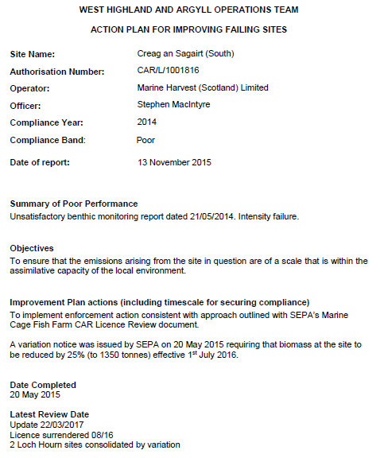

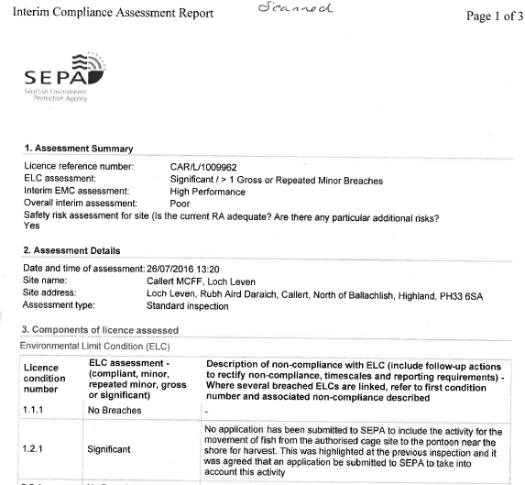

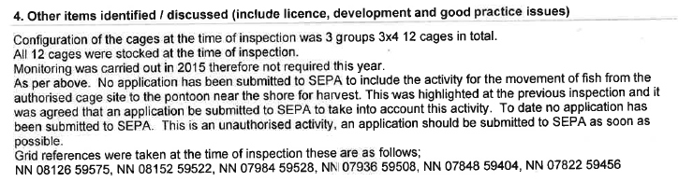

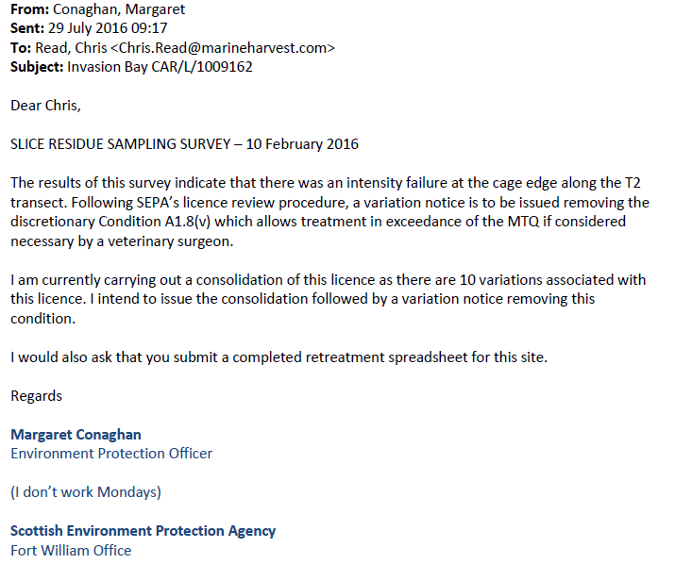
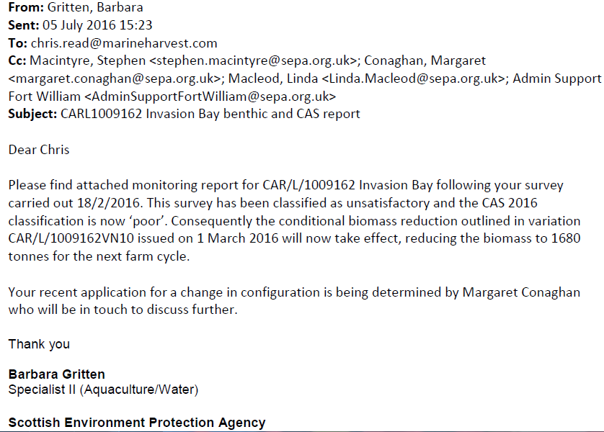

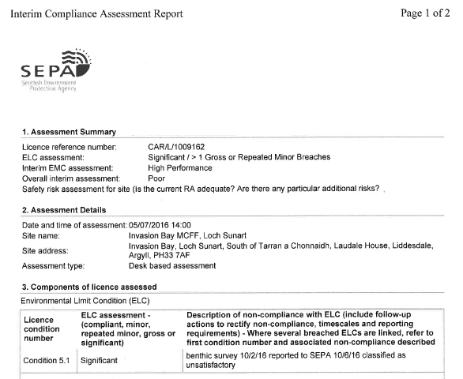

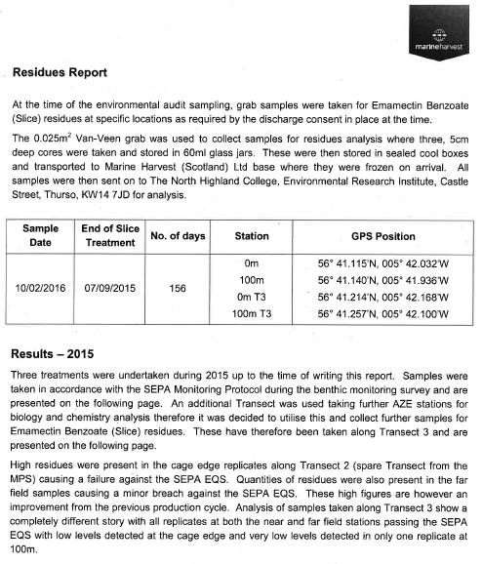

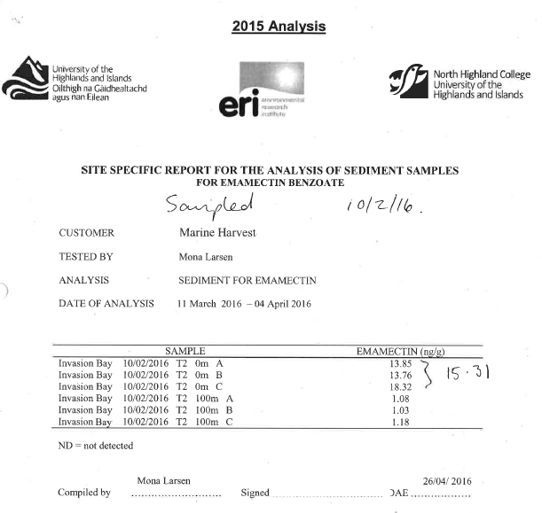

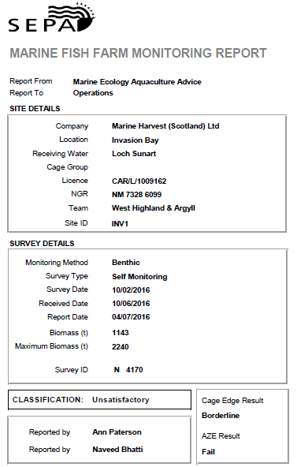

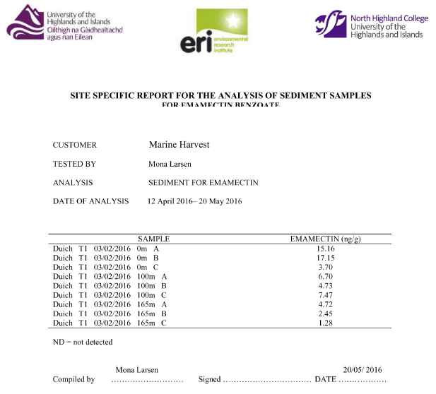
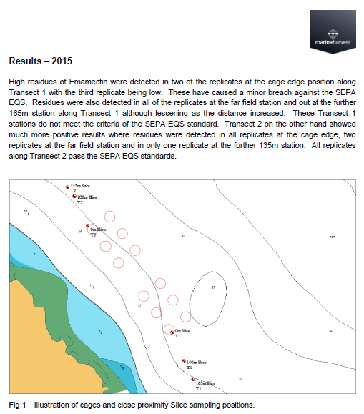

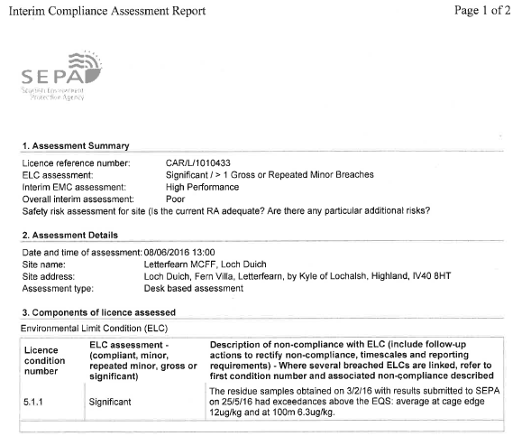

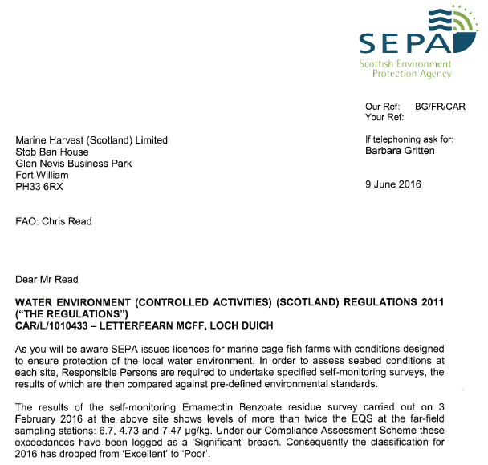
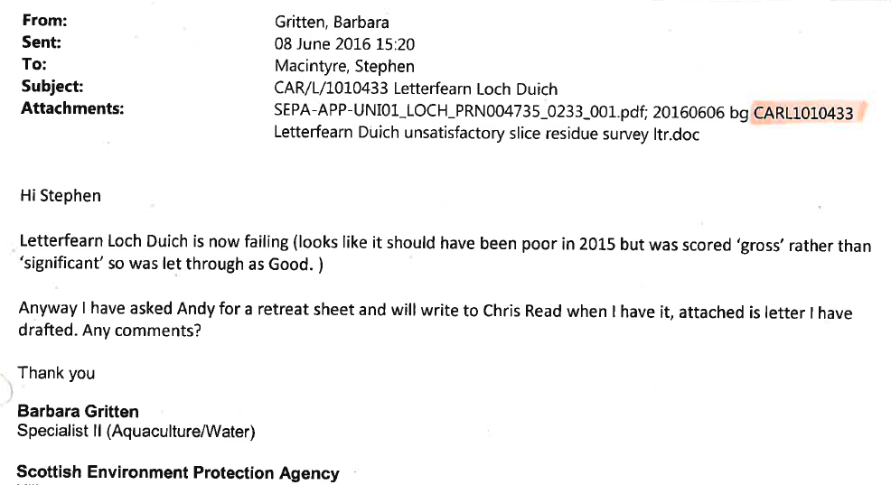

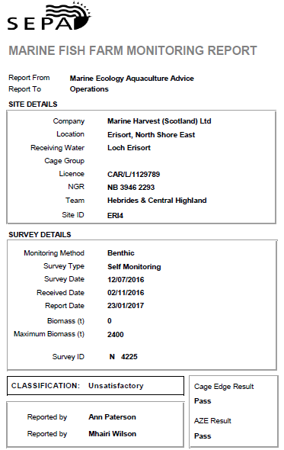

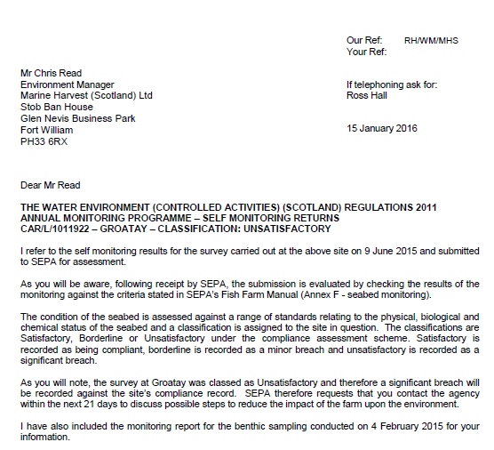
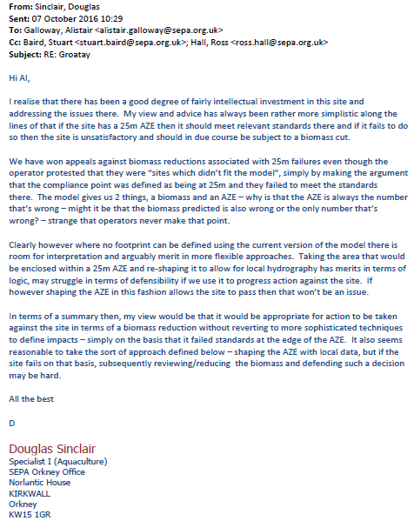

The Scottish Salmon Company:

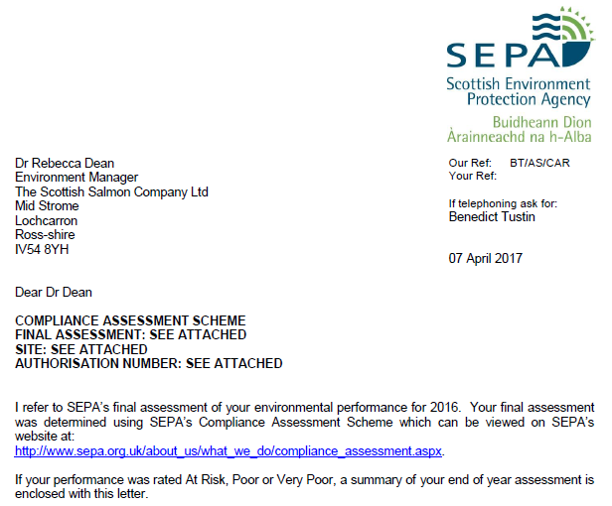

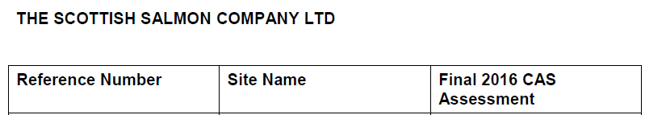
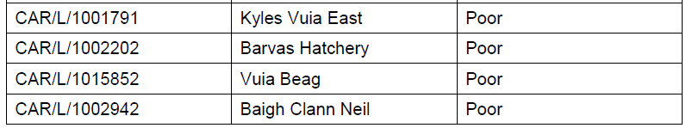
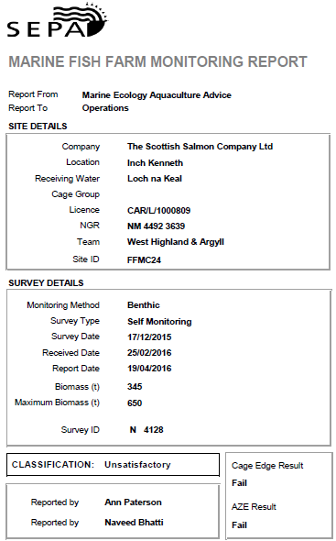

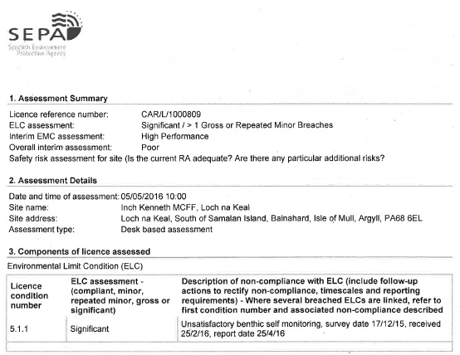

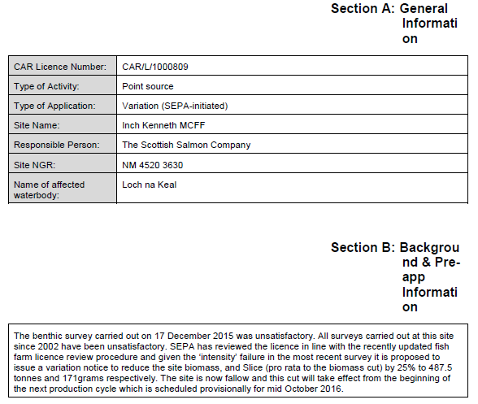
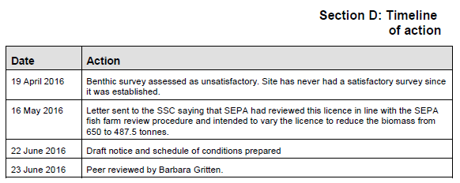

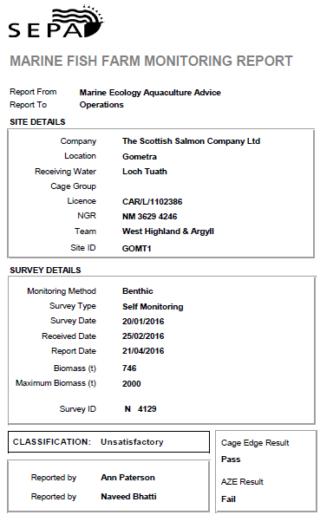

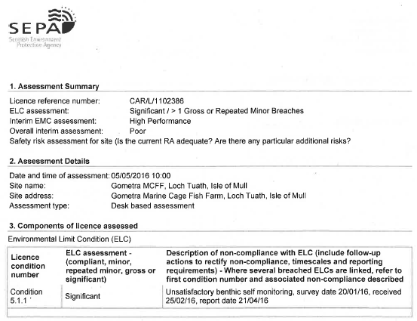

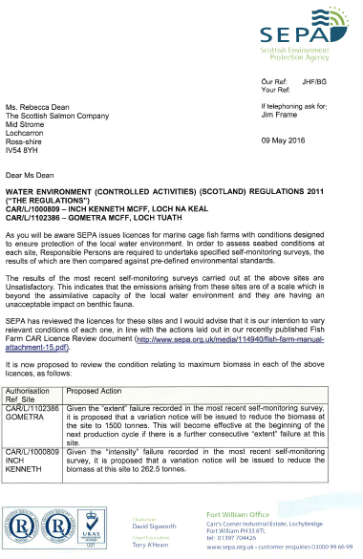

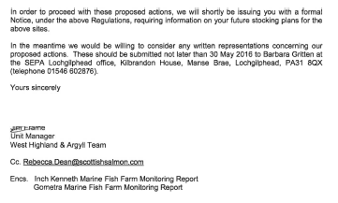

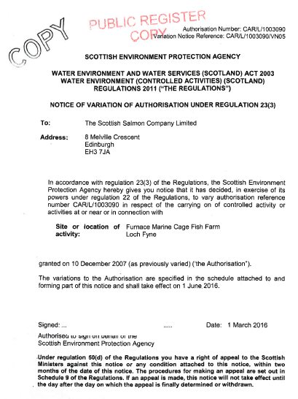

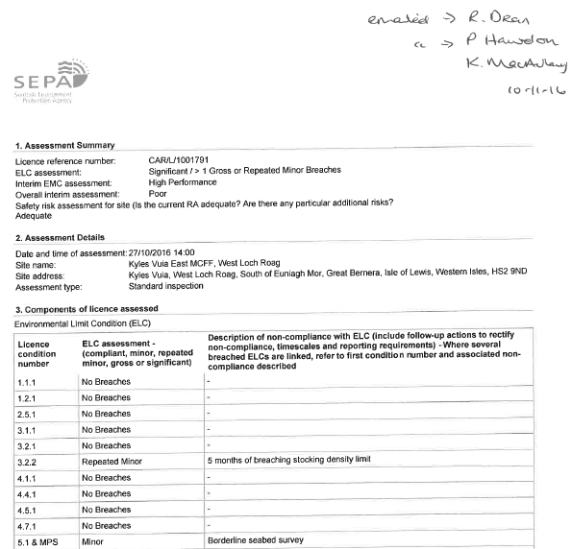

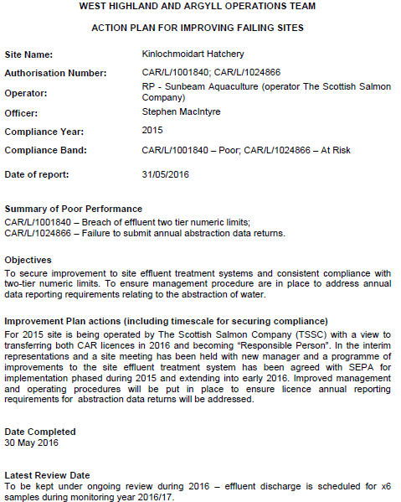

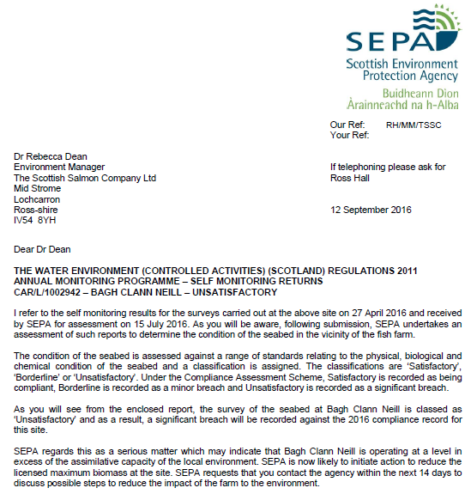

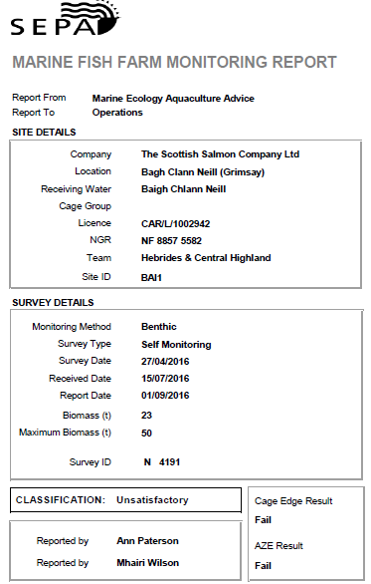

Cooke Aquaculture:

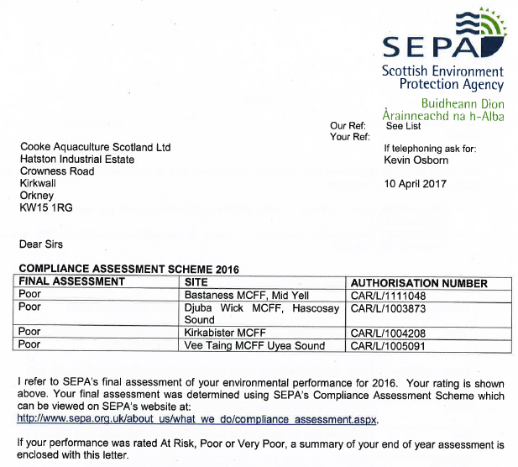
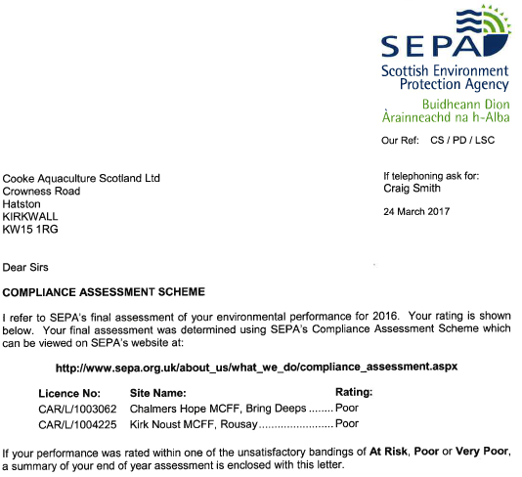

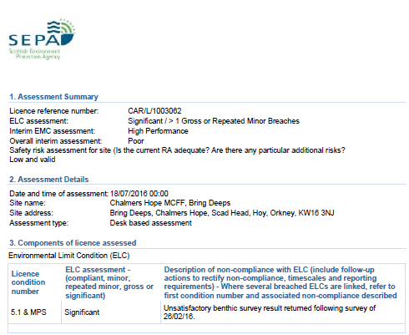
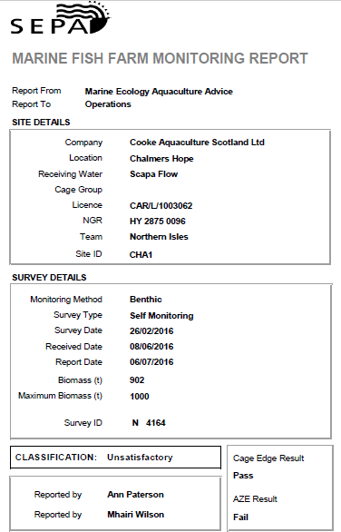

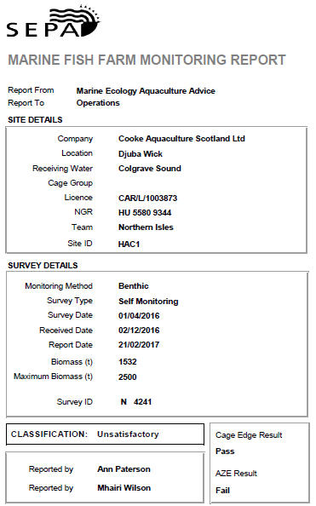

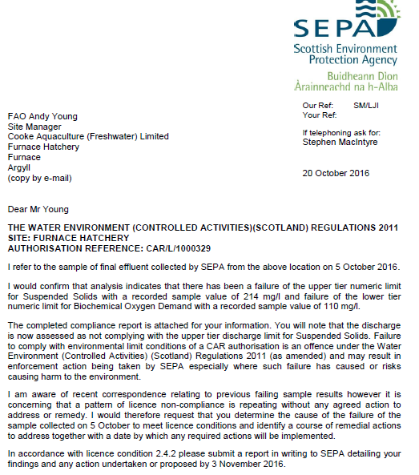

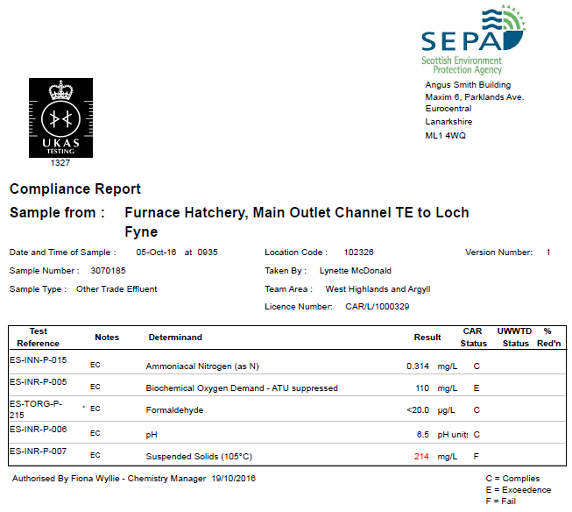

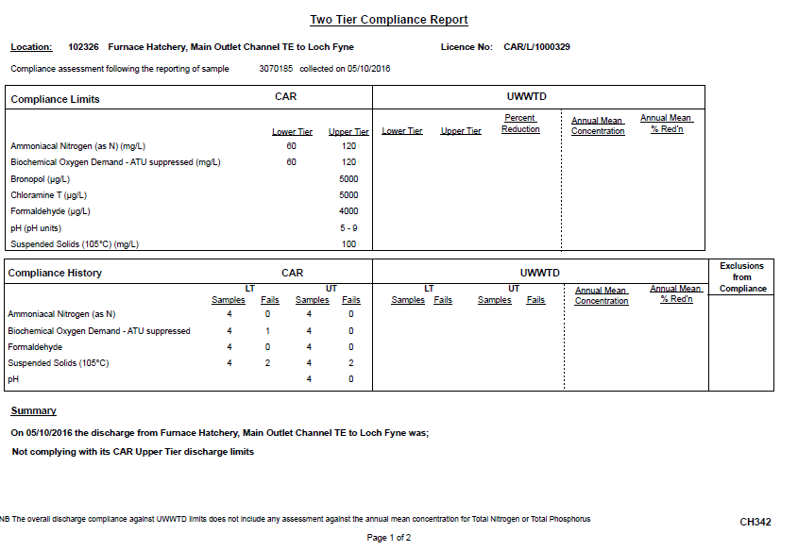

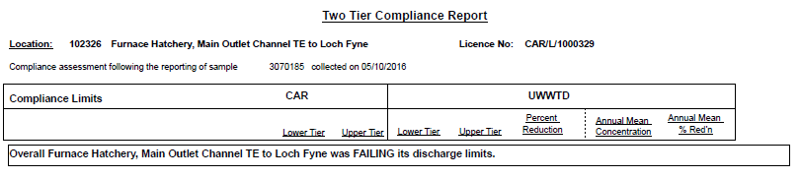

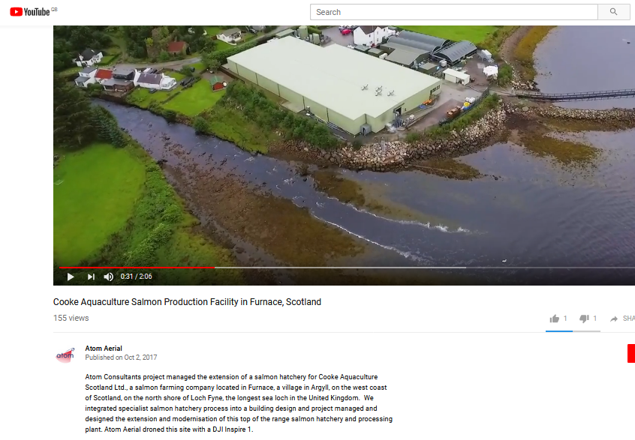

Wester Ross Fisheries:

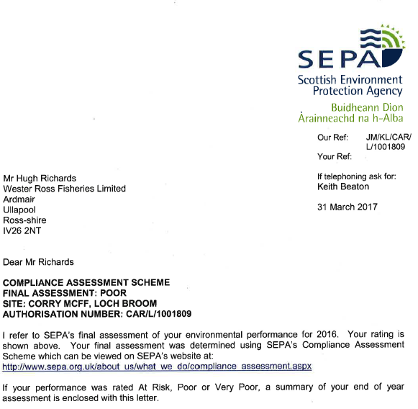
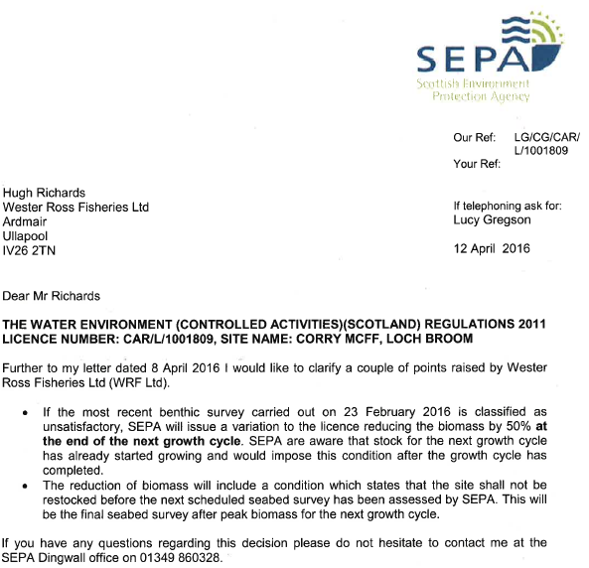

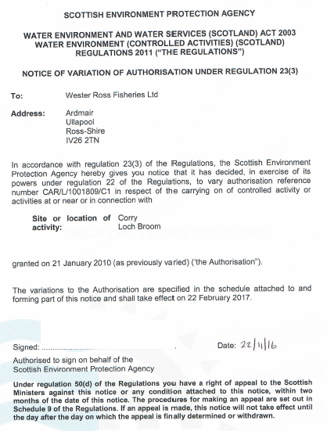

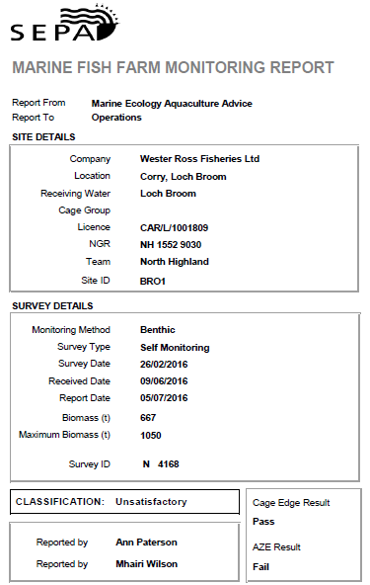

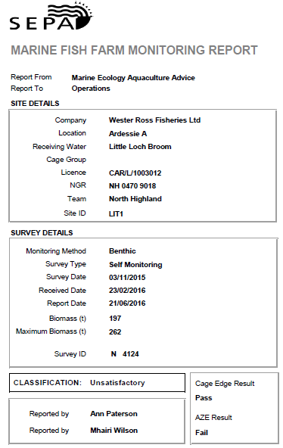
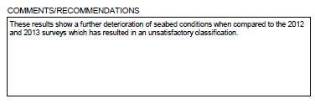

Loch Duart:

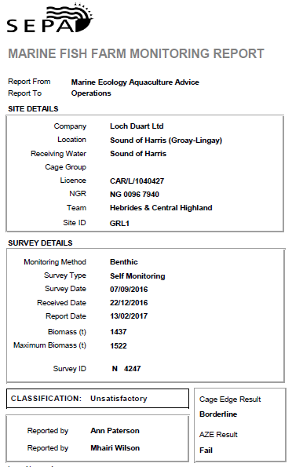
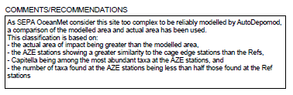

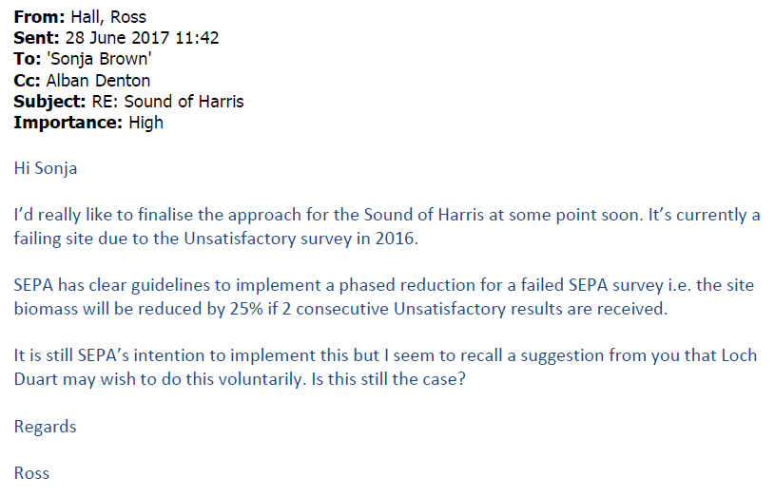
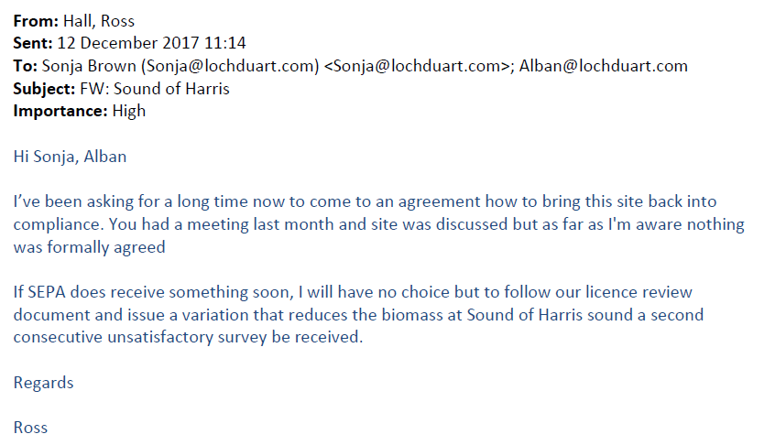

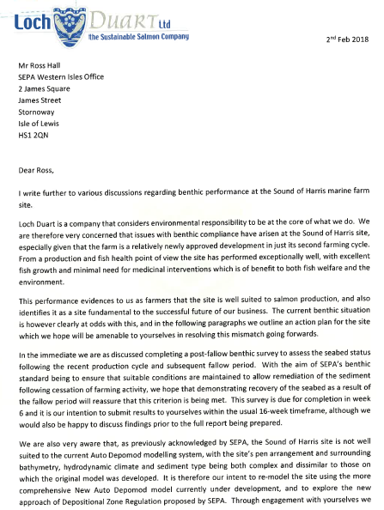

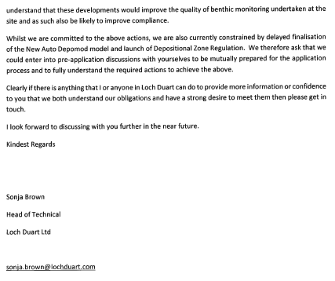

[2] Search for 'United Kingdom' and 'Atlantic salmon' via http://asc.force.com/Certificates/

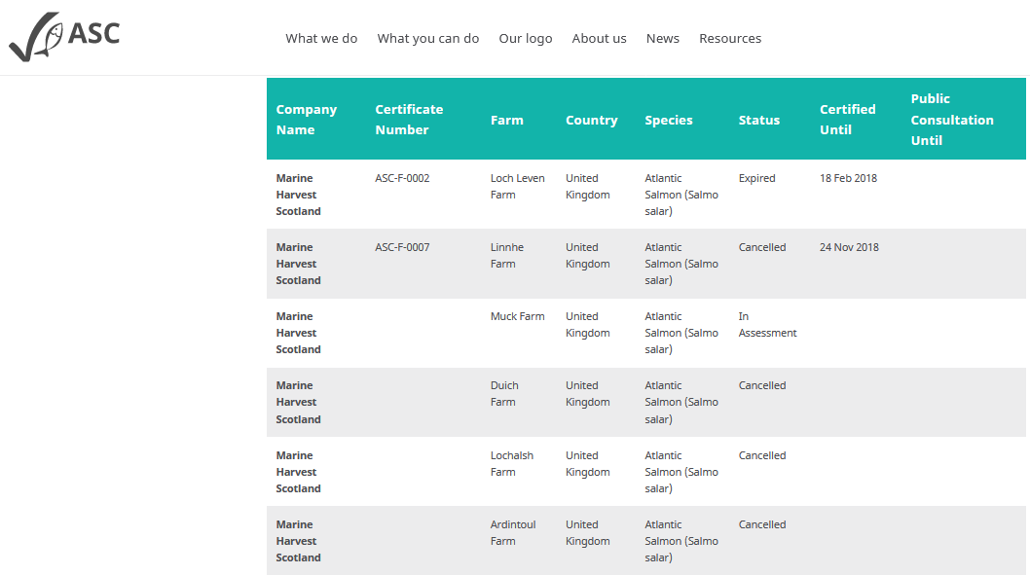

Appendix 1: FOI correspondence
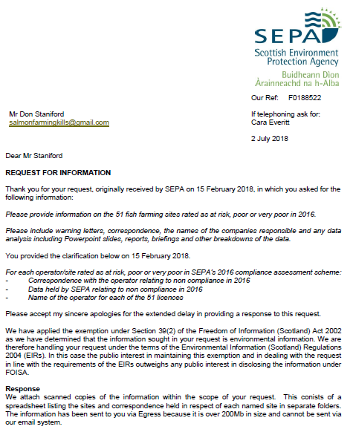
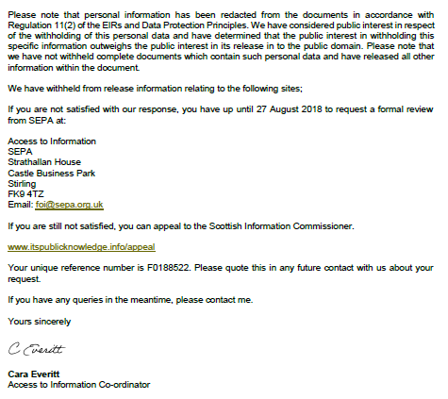

From: Don Staniford [mailto:salmonfarmingkills@gmail.com]
Sent: 15 February 2018 14:51
To: 'Access to Information Enquiries'
Subject: RE: Access to Information SEPA Clarification - [F:0188522]

Thanks.
As a friendly suggestion, next year it would be much easier if SEPA just named the company/operator and had a "company/operator" search facility via http://apps.sepa.org.uk/compliance/

The failure to name the companies smacks of censorship and gives a whiff of SEPA hiding polluters from public scrutiny - not to mention leads to more FOIs.
Best fishes,

Don

Don Staniford

Director, Global Alliance Against Industrial Aquaculture (GAAIA): http://www.salmonfarmingkills.com

Read my blog via http://donstaniford.typepad.com/my-blog

<((((º>`·.¸¸.·´¯`·.¸.·´¯`·...¸><((((º>¸.
·´¯`·.¸. , . .·´¯`·.. ><((((º>`·.¸¸.·´¯`·.¸.·´¯`·...¸><((((º>

From: Access to Information Enquiries [mailto:FOI.Mail@sepa.org.uk]
Sent: 15 February 2018 14:18
To: 'Don Staniford'
Subject: RE: Access to Information SEPA Clarification - [F:0188522]

Hi Don
Thanks for the email.
We understand you have requested the following information:
For each operator/site rated as at risk, poor or very poor in SEPA’s 2016 compliance assessment scheme:
- Correspondence with the operator relating to non compliance in 2016
- Data held by SEPA relating to non compliance in 2016
- Name of the operator for each of the 51 licences
Please submit further clarification if we have misunderstood any part of your request.
We will issue a formal acknowledgment once we have received confirmation.
Kind regards
Michael
Michael Hampton
Access to Information Coordinator
Information Governance, Performance and Innovation Portfolio
t: 01786 452484 e: michael.hampton@sepa.org.uk

From: Don Staniford [mailto:salmonfarmingkills@gmail.com]
Sent: 15 February 2018 14:10
To: Access to Information Enquiries <FOI.Mail@sepa.org.uk>
Subject: RE: Access to Information SEPA Clarification - [F:0188522]

Thanks.
Just in relation to the 2016 non-compliances.
Best fishes,

Don

Don Staniford

Director, Global Alliance Against Industrial Aquaculture (GAAIA): http://www.salmonfarmingkills.com

Read my blog via http://donstaniford.typepad.com/my-blog

<((((º>`·.¸¸.·´¯`·.¸.·´¯`·...¸><((((º>¸.
·´¯`·.¸. , . .·´¯`·.. ><((((º>`·.¸¸.·´¯`·.¸.·´¯`·...¸><((((º>

From: FOI Helpdesk [mailto:FOI.Mail@sepa.org.uk]
Sent: 15 February 2018 14:02
To: Salmonfarmingkills@gmail.com
Subject: Access to Information SEPA Clarification - [F:0188522]

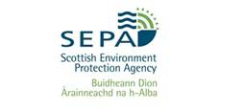

Dear Mr Staniford
CLARIFICATION OF REQUEST FOR INFORMATION

Thank you for your request.

We are writing with regard to your request, received by SEPA on 15/02/2018 in which you ask for the following information:

Please provide information on the 51 fish farming sites rated as at risk, poor or very poor in 2016.

Please include warning letters, correspondence, the names of the companies responsible and any data analysis including Powerpoint slides, reports, briefings and other breakdowns of the data.

Unfortunately we are unable to deal with your request without some clarification of the information that you are looking for.

We understand you have requested warning letters and correspondence relating to each site. Please clarify if you are requesting all correspondence between SEPA and each site operator or if the correspondence specifically relates to each of the inspections conducted in 2016 and detailed on SEPA's compliance website.

We note you have also requested data analysis of the data. Please clarify what data you are referring to.

Once we have received these details, we will be pleased to respond to your request within 20 working days at the latest.

Your unique reference number is F0188522. Please quote this in any future contact with us about your request.

If you have any queries please contact us using the details below.

Regards

Michael Hampton
SEPA Access to Information team
Email: foi@sepa.org.uk
Tel: 01786 457700

From: Don Staniford [mailto:salmonfarmingkills@gmail.com]
Sent: 15 February 2018 13:14
To: 'AccesstoInformation'
Subject: FOI re. 51 fish farms rated as at risk, poor or very poor in 2016

Please provide information on the 51 fish farming sites rated as at risk, poor or very poor (as reported by BBC News) in 2016.

Please include warning letters, correspondence, the names of the companies responsible and any data analysis including Powerpoint slides, reports, briefings and other breakdowns of the data.

SEPA's Enforcement Report published today does not name the companies responsible.

Searching the SEPA compliance web-page finds three sites assessed as "Very Poor" in 2016 - but there are no details of the companies responsible:

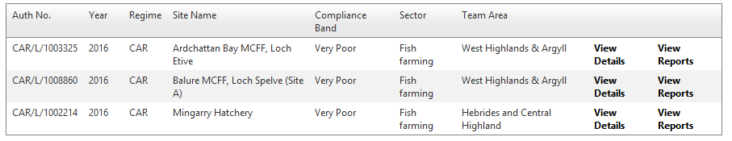

Searching the SEPA compliance web-page finds 41 sites assessed as "Poor" in 2016 - but there are no details of the companies responsible:

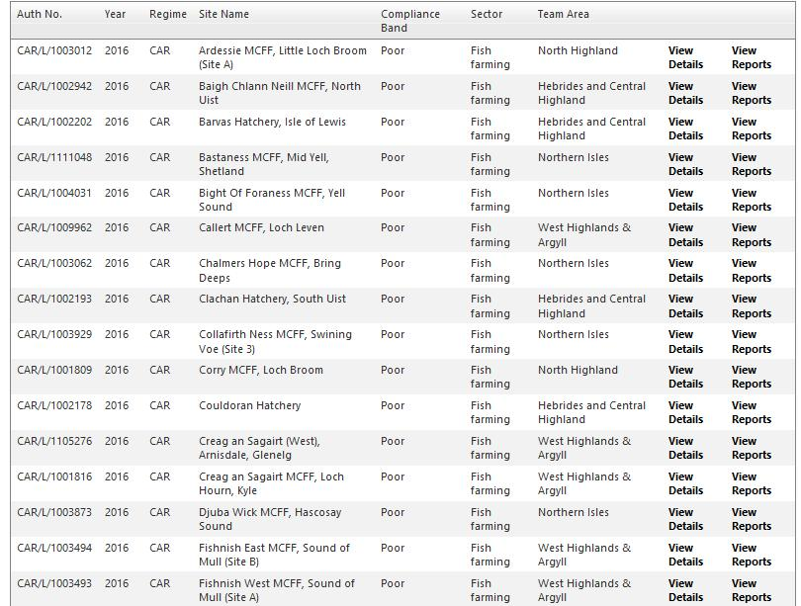
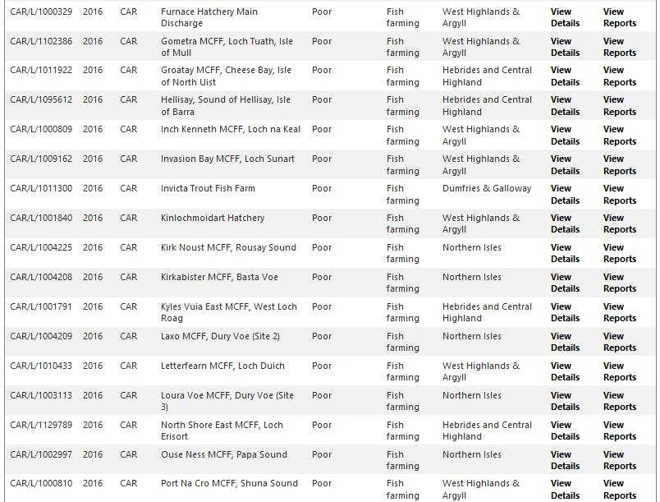
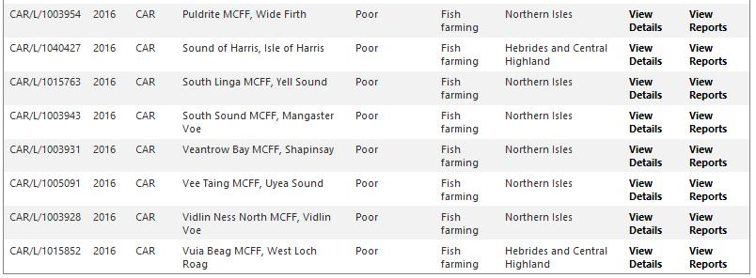

Searching the SEPA compliance web-page finds 7 sites assessed as "At Risk" in 2016 - but there are no details of the companies responsible:

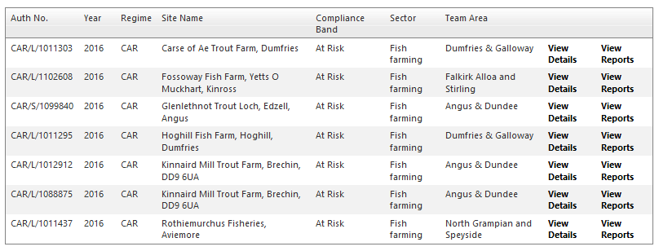

Please consider this a request for information under the relevant Freedom of Information and Environmental Information Regulations including both the Freedom of Information (Scotland) Act 2002 and the Environmental Information (Scotland) Regulations 2004 (as well as any other new or other regulations which may be appropriate).

Please provide this information electronically via email.

Please acknowledge receipt of this FOI request.

Many thanks and I look forward to a response shortly.

Best fishes,

Don

Don Staniford

Director, Global Alliance Against Industrial Aquaculture (GAAIA): http://www.salmonfarmingkills.com

Read my blog via http://donstaniford.typepad.com/my-blog

<((((º>`·.¸¸.·´¯`·.¸.·´¯`·...¸><((((º>¸.
·´¯`·.¸. , . .·´¯`·.. ><((((º>`·.¸¸.·´¯`·.¸.·´¯`·...¸><((((º>

