The Global Alliance Against Industrial Aquaculture, 5 February 2018

Scottish Salmon's Mort Mountain Leaps Over 10 Million

- FOI reveals 2.3 million dead salmon at Marine Harvest farms in 2017
- Gill Diseases, Cardiomyopathy Syndrome, Treatment & Anaemia are biggest killers
- Pasteurella skyensis now causing losses as Marine Harvest cuts jobs

Exclusive data obtained via Freedom of Information (FOI) from the Scottish Environment Protection Agency (SEPA) reveals that Scotland's largest salmon farming operator Marine Harvest suffered losses of 2.3 million farmed salmon (4,211 tonnes) during the first nine months of 2017 [1] - with the deadly heart disease Cardiomyopathy Syndrome (CMS), Gill Disease (including Amoebic Gill Disease and Proliferative Gill Disease), treatment losses (including deaths due to the Thermolicer and toxic chemicals) and Anaemia listed as the biggest killers [2].

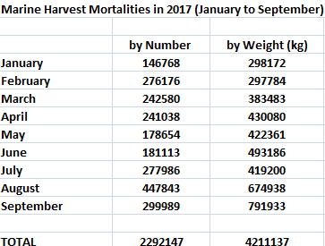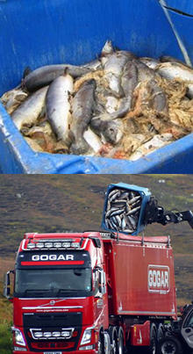

Download Excel spreadsheet: Marine Harvest mort numbers & weights (Jan to Sept 2017)

The FOI data obtained from SEPA reveals that the ten biggest monthly losses at Marine Harvest salmon farms during 2017 (up to September) were as follows:

149,949 at Colonsay in August (reported via Scotland's Aquaculture as 12,439kg)
97,235 at MacLeans Nose in March (reported via Scotland's Aquaculture as 107,760 kg)
87,914 at MacLeans Nose in April (reported via Scotland's Aquaculture as 135,641kg)
85,147 at MacLeans Nose in May (reported via Scotland's Aquaculture as 156,754kg)
76,913 at Tabhaigh in August (reported via Scotland's Aquaculture as 265,069kg)
70,627 at MacLeans Nose in February (reported via Scotland's Aquaculture as 67,757kg)
62,747 at Erisort (North Shore East) in September (reported via Scotland's Aquaculture as 214,813kg)
48,620 at Soay Sound in August (reported via Scotland's Aquaculture as 3,645kg)
41,946 at Creag an Sagairt West in June (reported via Scotland's Aquaculture as 116,536kg)
41,615 at Ardintoul in February (reported via Scotland's Aquaculture as 4599kg)
Marine Harvest's salmon farm at Colonsay hit the headlines in 2012 when The Sunday Herald reported "has promised to give the 120 residents £50,000 up front and £10,000 a year thereafter if they vote for 12 salmon cages" (read more via "Company under fire for fish farm island “bribes”").

"About 125,000 salmon have died due to a disease outbreak at two fish farms on the Isle of Lewis," reported BBC Scotland in October 2017. "Marine Harvest confirmed that the sites in Loch Erisort have been hit by the bacterium Pasturella Skyensis". "Macleans Nose in Loch Sunart, where salmon have also been exposed to AGD, is believed to be infected by Pasteurella skyensis, too," reported Fish Update in October 2017.

"A staggering 177,000 were hauled out of one loch [Erisort] last autumn," reported The Daily Mail in January 2018.

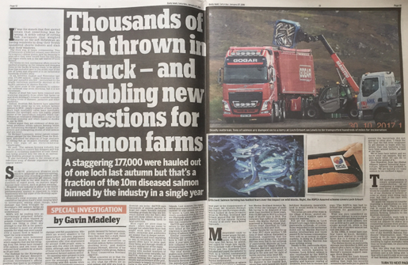
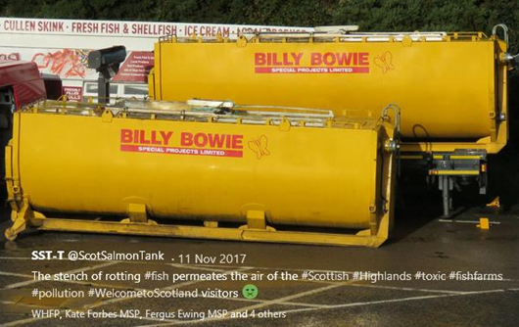

Download high res images via Photo Gallery: Dead Salmon from Scotland's Disease-Ridden Salmon Farms
"Scottish salmon's mort mountain is leaping well over 10 million diseased salmon each year and perhaps as high as 20 million," said Don Staniford of the Global Alliance Against Industrial Aquaculture. "This shocking new data blows the industry's claims that they are dealing with diseases out the water. Digesting the litany of infectious diseases reported at Marine Harvest, Scottish Sea Farms and The Scottish Salmon Company is enough to put even the most ardent supporter of salmon farming off their fish supper. The Scottish Parliament needs to take immediate action to reduce production on Scottish salmon farms which are ridden with diseases such as Amoebic Gill Disease, Cardiomyopathy syndrome, Pancreas Disease, Pasturella skyensis and Anaemia. Consumers who care about what they eat and how their food was farmed should boycott cheap and nasty Scottish salmon."

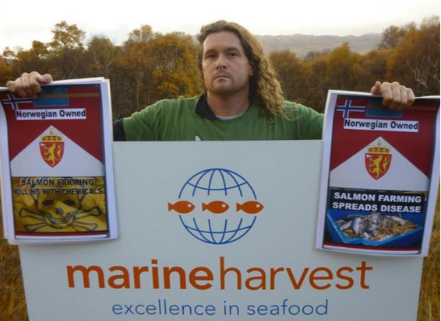

"Scottish salmon farming is welfare nightmare," said John Robins of Animal Concern. "The fact is that over 10 million salmon are dying each year on Scotland's lice-infested farms with a mortality rate of 26.7% - that's over 22,000 tonnes of dead salmon in 2016 with infectious diseases making forecasts for 2017 even worse. The general public would be horrified if over a quarter of our cows, pigs, chickens or sheep were dying. Little wonder the BBC's 'The One Show' featured the issue of diseased salmon leaking from haulage trucks on their 'The Dead Salmon Run'. It is equally shocking that the RSPCA certify 70% of Scottish farmed salmon farm as welfare friendly."

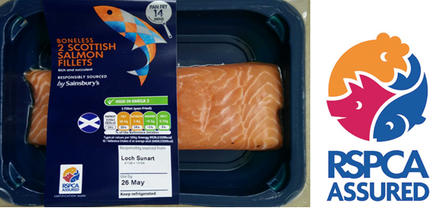

[Graphic: RSPCA Assured salmon sourced from Marine Harvest's disease-ridden operations in Loch Sunart]
Further data obtained via FOI from the Scottish Government reveals that Scotland's three largest salmon farming companies (Marine Harvest, Scottish Sea Farms and the Scottish Salmon Company) reported the following reasons for mortalities during 2017: Salmon Gill poxvirus, Paranucleospora theridion, gill pathology, complex gill issues, Vibrio anguillarum, Proliferative Gill Disease, Amoebic Gill Disease, Pancreas Disease, fungus, cardiomyopathy syndrome, Haemorrhagic smolt syndrome, HSMI, Enteric redmouth disease, anaemia and deaths due to the Hydrolicer, Thermolicer, hydrogen peroxide treatment, Salmosan treatment, freshwater post treatment, physical damage, plankton, water quality issues, algal bloom, seal predation and jellyfish [2].

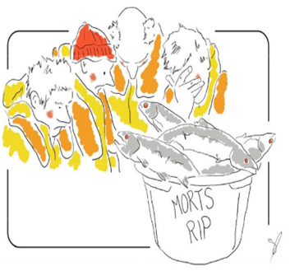

The top twenty mortality events reported by Marine Harvest in 2017 (up to November) were:

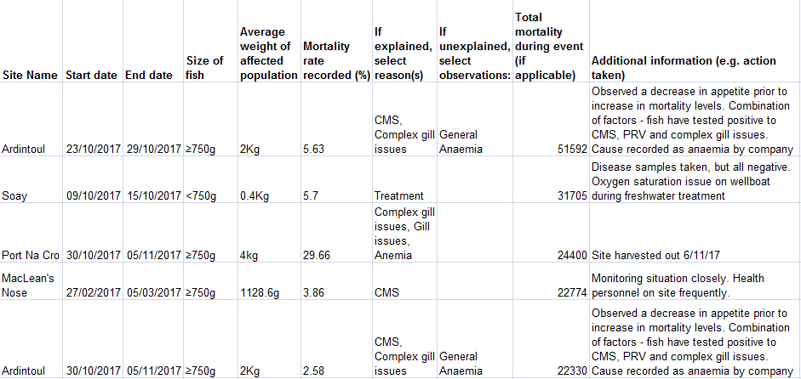
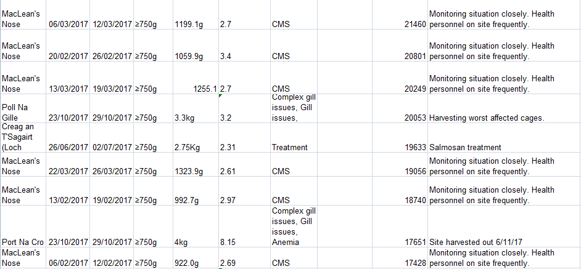
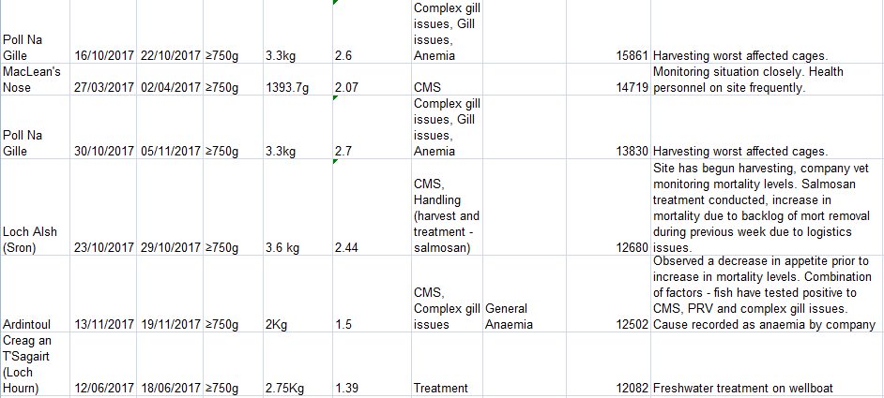

The top ten mortality events reported by the Scottish Salmon Company in 2017 (up to November) were:

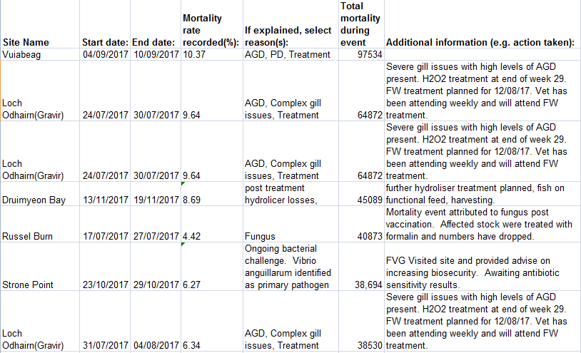
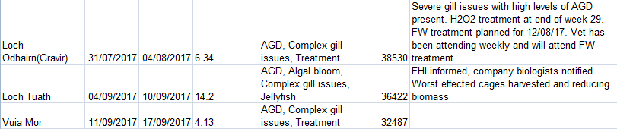

The top ten mortality events reported by Scottish Sea Farms in 2017 (up to November) were:

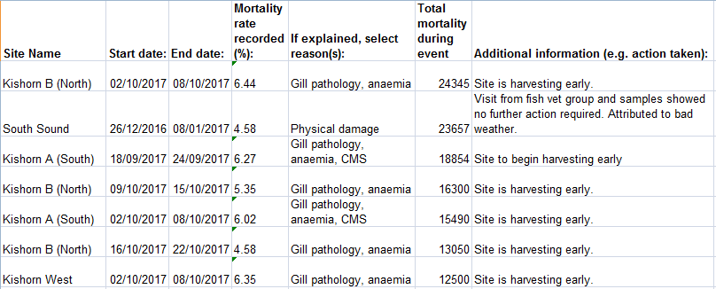
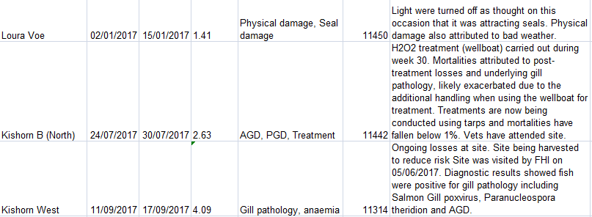

This data (which is not an exhaustive list of all mortalities but merely reported 'mortality events') suggests that Marine Harvest's mortality rate may even be lower than some other companies:

Scottish Salmon Company mort events in 2017 - The Excel spreadsheet details 1,512,077 mortalities in 131 separate reports/incidents during 2017 - including:

85 reported as Gill Diseases (Gill Pathology, AGD, PGD, gill issues and complex gill issues)
41 reported as Treatment
14 reported as CMS
11 reported as PD (Pancreas Disease)

Marine Harvest mort events in 2017 - The Excel spreadsheet details 572,488 mortalities in 56 separate reports/incidents during 2017 - including:

24 reported as CMS
22 reported as Gill Diseases (Gill Pathology, AGD, PGD, gill issues and complex gill issues)
18 reported as Treatment
13 reported as Anaemia
4 reported as PD

Scottish Sea Farms mort events in 2017 - The Excel spreadsheet details 356,082 mortalities in 46 separate reports/incidents during 2017 - including:

27 reported as Gill Diseases (Gill Pathology, AGD, PGD, gill issues and complex gill issues)
18 reported as Anaemia
14 reported as Treatment
7 reported as CMS

Background:

This is the first time site specific information on the number of mortalities has been published since 2012 when SEPA stopped collecting and collating the data. SEPA's decision followed lobbying by the Scottish Salmon Producers Organisation (who claimed in a letter that publication "could be used to the commercial detriment or competitive market disadvantage of the companies submitting the data").

The FOI data disclosed by SEPA [1] provides strong evidence that well over 10 million farmed salmon died on Scottish salmon farms during 2017 (in 2015 Marine Harvest produced "more than 50,000 tonnes" and in 2017 salmon farming production in Scotland is predicted to be 177,000 tonnes - putting Marine Harvest's share of Scottish salmon farming production at ca. 30%).

If we assume that Marine Harvest produced 50,000 tonnes in 2017 (based on Marine Harvest's statement in January 2018 that "fewer salmon are expected to be harvested this year") then this Norwegian-owned company represented ca. 28% of Scottish salmon farming production in 2017.

Adding mortalities for October to December 2017 increases the total mortalities for 2017 from 2.29 million to over 3 million (average monthly mortality is 250,000 fish). However, mortalities for Marine Harvest during 2017 could be ca. 3.5 million since we know Marine Harvest were experiencing mort problems at Erisort and other farms late into October (the photo below was taken on 30 October 2017).



From the mortality data from SEPA it is also clear that the weight of dead farmed salmon rises throughout 2017 with 298 tonnes in January rising to 493 tonnes in June, 675 tonnes in August and 792 tonnes in September (Download Excel spreadsheet: Marine Harvest mort numbers & weights (Jan to Sept 2017).

In any case, a figure of well over 10 million mortalities for the Scottish salmon farming industry as a whole during 2017 is entirely justifiable (and could be as high as the 20 million mortalities claimed by Salmon & Trout Conservation in a report published in June 2017).

Amoebic Gill Disease (AGD), Proliferative Gill Disease (PGD), Chlamydia and other conditions listed as "complex gill issues" and "gill pathology" have decimated Scottish salmon farming over the last decade (read more via "Gill Diseases: Scottish Salmon's Dirty Big Secret"; "Chlamydia and gill disease ravage Scottish salmon: GAAIA"; "Fit for the Queen - Loch Duart’s Chlamydia-Contaminated Salmon?"; "Characterization of “Candidatus Piscichlamydia salmonis” (Order Chlamydiales), a Chlamydia-Like Bacterium Associated With Epitheliocystis in Farmed Atlantic Salmon (Salmo salar)"; "Characteristics of chlamydia-like organisms pathogenic to fish" and "Characterization of ‘Candidatus Syngnamydia salmonis’ (Chlamydiales, Simkaniaceae), a bacterium associated with epitheliocystis in Atlantic salmon (Salmo salar L.)").

Pasturella skyensis was first reported on Scottish salmon farms in 2002 with another scientific paper co-authored by scientists at the University of Glasgow published in 2015. Cardomyopathy Syndrome (CMS) was first reported on Scottish salmon farms in 2000 with Scottish Quality Salmon (the forerunner to the Scottish Salmon Producers Organisation) claiming "there is no cause for concern" in an interview with The Independent newspaper (read more via Notes [3] and [4]).

'Case Information' published by the Scottish Government's Fish Health Inspectorate (the latest data available is for April to June 2017) includes details of very high mortality at Marine Harvest's MacLeans Nose salmon farm due to Cardiomyopathy syndrome (CMS).
The Fish Health Inspectorate's mortality report following an inspection in April 2017 states that "Billy Bowie collects CMS fish" (Billy Bowie is the haulage company exposed as leaking diseased salmon by the BBC's 'The One Show' and The Daily Mail leading to an EC complaint for breach of the Animal By-Products Regulations and investigation by East Ayrshire Council). The FHI report also details 30% mortality of cleaner fish - lumpfish - due to "mobile bacteria" requiring treatment with antibiotics (read more via Sunday Times: 'Clean Fish' Bring Danger of Disease to Salmon Farms) [4].

An email obtained via FOI from the Scottish Government revealed that Marine Harvest was experiencing increases in mortality from a number of sites in late October 2017 citing "Anaemia issues", "CMS" and "complex gill issue":


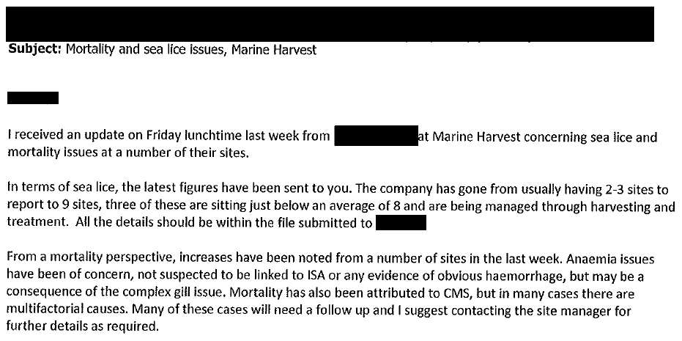
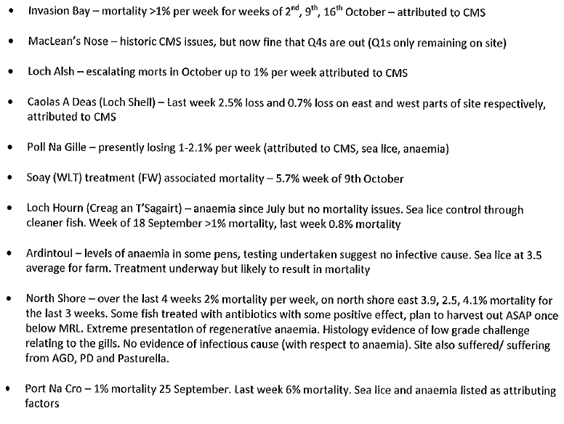
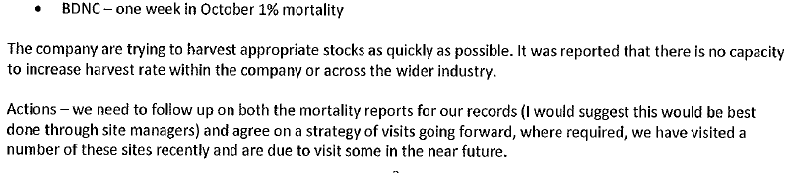

The latest mortality and disease data published on Marine Harvest's web-site is for September 2017 - including:

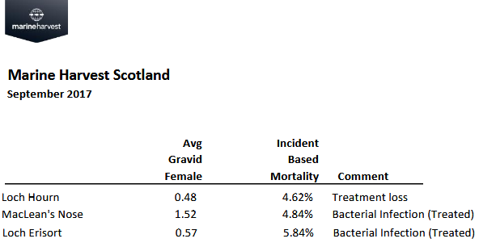

Data for August 2017 includes:

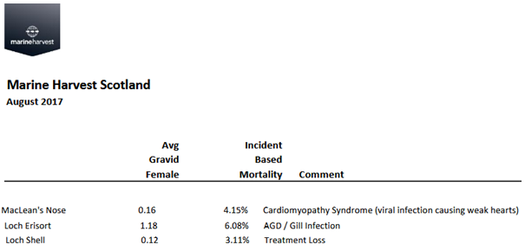

Other data published monthly by Marine Harvest indicates that Cardiomyopathy Syndrome (CMS) started causing mortality problems at MacLean's Nose in February 2017 (10.79% mortality) with problems continuing in March 2017 (11.17% mortality - with 4.02% mortality also reported at Loch Alsh); April 2017 (12.6% and 3.79% at Loch Alsh); May 2017 (13.96%); June 2017 (9.77%) and July 2017 (4.07%).

The FOI data also reveals over 135,000 dead salmon due to mechanical treatments with the Thermolicer killing 45,000 and the Hydrolicer killing 90,000 fish:

- Mortality events reported by Marine Harvest in 2017 include three cases (in Creag an T'Sagairt, Cairidh & Caolas A Deas) involving over 20,000 dead salmon due to using a Thermolicer.

- Mortality events reported by Scottish Sea Farms in 2017 include six cases (in Nevis C, Nevis B, Nevis A & South Sound) involving over 25,000 dead salmon due to using a Thermolicer.

- Mortality events reported by the Scottish Salmon Company in 2017 include eight cases (Driumyeon Bay, Sgian Dubh, Sgeir Dughall, North Uiskevagh, Kenmore & Inch Kenneth) involving 90,000 dead salmon due to using a Hydrolicer.

In 2006, The Sunday Herald revealed that 95,400 salmon died at Marine Harvest's Loch Greshornish farm on Skye due to the Thermolicer with a further 6,000 salmon dying at farm operated by Grieg Seafood in North Havra, Shetland [5].

Previous data accessed via FOI from SEPA by Rob Edwards of The Sunday Herald revealed that there were 8.5 million mortalities in 2012, 6.8 million in 2011 and 5.5 million in 2010.
Estimates of mortalities since 2012 range between "20 million" (based on a report published in June 2017 by Salmon & Trout Conservation assuming that each dead farmed salmon weighed 1kg - i.e. 20,000 tonnes of mortalities = 20 million fish) and "losses of between 6 to 10 million" (Scott Landsburgh of the Scottish Salmon Producers Organisation quoted in The Sunday Herald in October 2017). Data collated by Rob Edwards for The Sunday Herald reported that the weight of mortalities had increased from 10,599 tonnes in 2013 to 22,479 in 2016 - suggesting that the number of mortalities also doubled between 2013 and 2016.

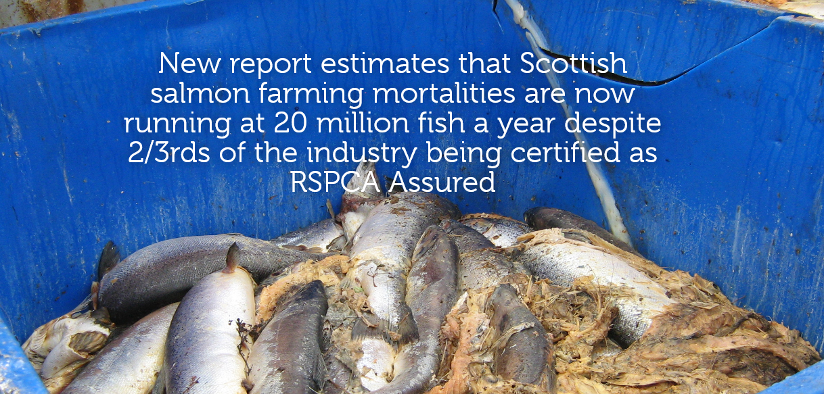

Data on the weight of mortalities from 2002 to 2016 was also obtained via FOI from SEPA - revealing a leap from 7,860 tonnes in 2010 to 18,650 tonnes in 2015.

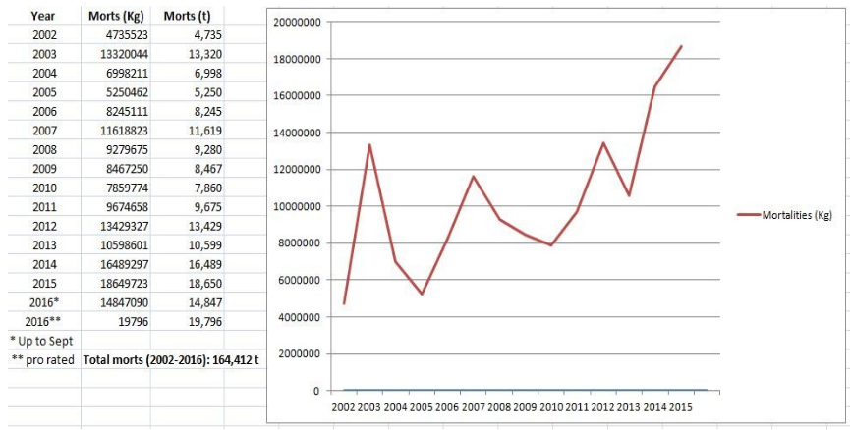

The Sunday Herald reported in October 2017:

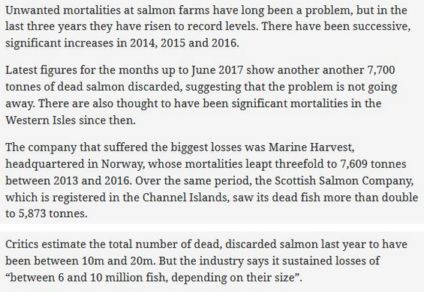

In the absence of official statistics the best available source of data is the annual Scottish Fish Farm Production surveys published by Marine Scotland Science. This data was cited by Fergus Ewing in a Scottish Parliamentary Reply in January 2018 - reporting a mortality rate at Scottish salmon farms is a staggering 26.7% (five times higher than the 5% mortality tolerated on intensive chicken farms) with an estimated 12.85 million mortalities in 2014.

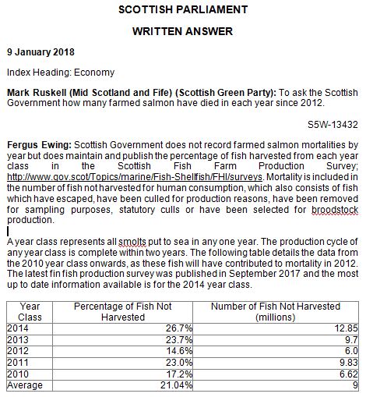

Despite the public availability of such damning data, Dr. Adam Hughes of the Scottish Association of Marine Science (SAMS) told the Scottish Parliament's inquiry into the environmental impacts of salmon farming (30 January 2018) that "welfare standards are very high at the moment" and "Scotland probably has a lower mortality rate" (than other countries such as Chile and Norway):

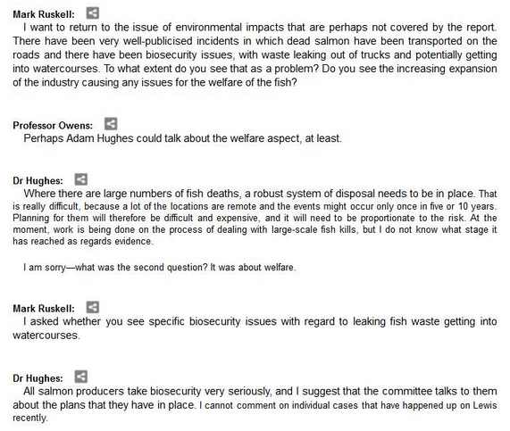
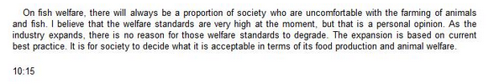
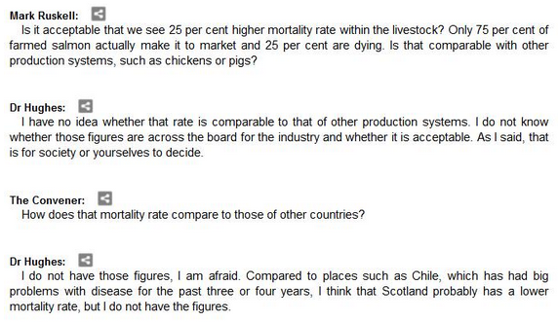
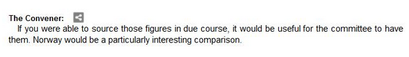
Read more via: Transcript of Scottish Parliament inquiry into the environmental impacts of salmon farming

Recent data for mortalities in Norway reveal that 56 million farmed salmon died in 2016 (download the data via the Norwegian Directorate of Fisheries). Norway produced 1.17 million tonnes of farmed salmon in 2016 compared to 162,000 tonnes in Scotland in 2016 (i.e. Norway produced over 1 million tonnes more than Scotland).

GAAIA has written to the Scottish Parliament questioning the accuracy of the evidence from Dr. Hughes. GAAIA suggested that Compassion In World Farming (CIWF) may take issue too - read more on the welfare problems of salmon farming via:

"Welfare fears after claim deaths of farmed salmon have doubled"
"Scottish intensive salmon farming plumbs new depths"
"Salmon farming welfare raised at industry event"
"Scottish salmon farms our chemicals on parasites"
"Farmageddon: the true cost of cheap meat"
"The welfare of farmed fish"
"Closed Waters: the welfare of farmed Atlantic salmon"
"In Too Deep - why fish farming needs urgent welfare reform"

GAAIA has also written to SEPA and the Scottish Government demanding that annual data - detailing site-specific mortalities - is published immediately and shared with the Scottish Parliament as part of their ongoing inquiry into salmon farming.

Shamefully, the Scottish Government's 'Scotland's Aquaculture' database contains zero information on diseases (including sea lice). Salmon & Trout Conservation fought for years to force the disclosure of site-specific sea lice data and finally won a case in September 2017 with the Scottish Information Commissioner ordering publication. In October 2017, damning data on sea lice infestation rates was published online - detailing 62 salmon farms breaching the lice limits including 19 sites operated by The Scottish Salmon Company, 11 operated by Marine Harvest, 10 by Scottish Sea Farms, 7 by Cooke Aquaculture and 4 by Loch Duart (all members of the Scottish Salmon Producers Organisation).

Read more via:
"FOI Number Five – getting you the information they don’t want you to see!"
"Scottish salmon farming’s ‘liciest’ farms named and shamed"
"Scotland’s worst sea lice offenders: Full Farm List"

Data on infectious diseases was disclosed by the Scottish Government via FOI for the years 2010-2012 but FOI requests since then have been largely refused with the Scottish Government directing GAAIA to the Fish Health Inspectorate's 'Case Information' where disease data is available since 2013 [6].

Data on diseases and mortalities at Marine Harvest salmon farms during 2016 was accessed via FOI - including:

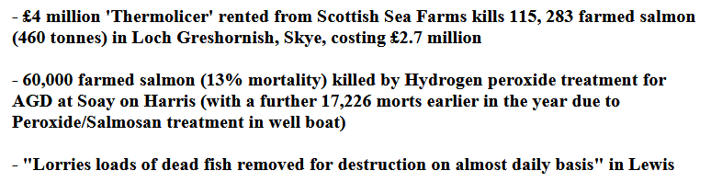
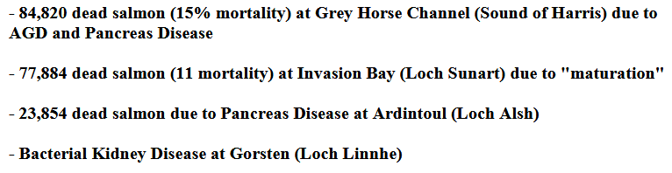

Read more via:
Press Release: 'Thermolicer' Back-Fires Killing 95,400 Farmed Salmon
FOI Backgrounder: Mortalities & Disease at Marine Harvest during 2016 - FOI reply from Scottish Government (28 October 2016)

Contact:

Don Staniford (07771 541826 and dstaniford@gaaia.org)

More background on mortalities on Scottish salmon farms is available via:

Data on Mortalities & Diseases at Scottish Salmon Farms
Photo Gallery: Dead Salmon from Scotland's Disease-Ridden Salmon Farms
Press Release: "Diseased Salmon Slip Net & Spill on Road - Failure to police the transport of dead fish prompts EC complaint"
Sunday Times: "Scots councils ‘failing to enforce EC laws on leaky salmon trucks’"
Daily Mail: "Thousands of fish thrown in a truck - and troubling new questions for salmon farms"
Scottish Salmon Farming 101
"Parliamentary Question: to ask the Scottish Government how many farmed salmon have died in each year since 2012"
"First Minister questioned on leaking wastes from morts - call for a moratorium from Greens"
"BBC's 'Dead Salmon Run' Opens Can of Worms"
"Millions of Scottish Salmon Going Up in Smoke"
BBC's The One Show: "The Dead Salmon Run"
BBC's The One Show (Part 2)
"125,000 salmon die in disease outbreak at Lewis fish farms"
"Campaigners say 'no more salmon farms' after disease on Lewis kills 125,000 fish"
"A disgrace: Ten million salmon thrown away by fish farm industry in last year alone"
"Death rate at salmon farms doubles to 20m fish a year"
"Welfare fears after claim deaths of farmed salmon have doubled"
"Thermal treatment for lice blamed for salmon deaths"
"Poached alive - fish die as farm overheats water"
"Oops: fish farm firm kills 175,000 of its salmon by accident"
"European Commission complaint over dead fish dumping forces rule change"
"Scottish watchdog labelled ‘lapdog’ after agreeing to keep fish farm deaths secret"
"Farmed salmon killed by disease leaps to 8.5 million"
"Where have all the dead fish gone?"

Notes to Editors:

[1] FOI reply from SEPA dated 29 January 2018:

From: FOI Helpdesk [mailto:FOI.Mail@sepa.org.uk]
Sent: 29 January 2018 15:12
To: Salmonfarmingkills@gmail.com
Cc: FOI.Mail@sepa.org.uk
Subject: Access to Information SEPA Response - [F:0188339]

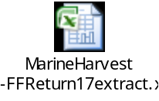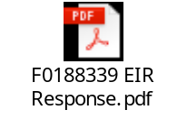

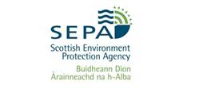
Dear Mr Staniford

REQUEST FOR INFORMATION

Please refer to the enclosed documents in relation to your request for information.

Regards

Cara Everitt
SEPA Access to Information team
Email: foi@sepa.org.uk
Tel: 01786 457700

The information contained in this email and any attachments may be confidential and is intended solely for the use of the intended recipients. Access, copying or re-use of the information in it by any other is not authorised. If you are not the intended recipient please notify us immediately by return email to postmaster@sepa.org.uk

SEPA registered office: Strathallan House, Castle Business Park, Stirling, FK9 4TZ. Under the Regulation of Investigatory Powers Act 2000, the email system at SEPA may be subject to monitoring from time to time

[2] FOI replies from the Scottish Government dated 13 December 2017 and 18 January 2018:

Download Excel spreadsheets via:
Marine Harvest mort events in 2017
Scottish Salmon Company mort events in 2017
Scottish Sea Farms mort events in 2017

Diseased Mortalities at Scottish Sea Farms:

Scottish Sea Farms mort events in 2017

From: Neil.Purvis@gov.scot [mailto:Neil.Purvis@gov.scot]
Sent: 18 January 2018 15:28
To: salmonfarmingkills@gmail.com
Cc: Helen.McGregor@gov.scot
Subject: FW: FOI - E - FOI re. morts & disease at Scottish Sea Farms during 2017 - Don Staniford

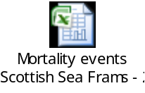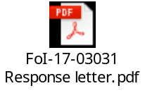

Dear Don,

FoI-17-03031

In response to your request of 14 December 2017 (FoI-1703031) please find the attached response and information provided.

Regards,
Neil

Neil Purvis
Marine Scotland – Science
Scottish Government | Marine Laboratory, PO Box 101| 375, Victoria Road | Aberdeen AB11 9DB
Tel: +44 (0)131 244 3287
S/B: +44 (0)131 244 2500
Mob:+44 (0)777 5818 281
Fax: +44 (0)1224 295620
e: neil.purvis@gov.scot
w: http://www.scotland.gov.uk/marinescotland

The Excel spreadsheet details 356,082 morts in 46 separate reports/incidents during 2017 including the following worst cases:

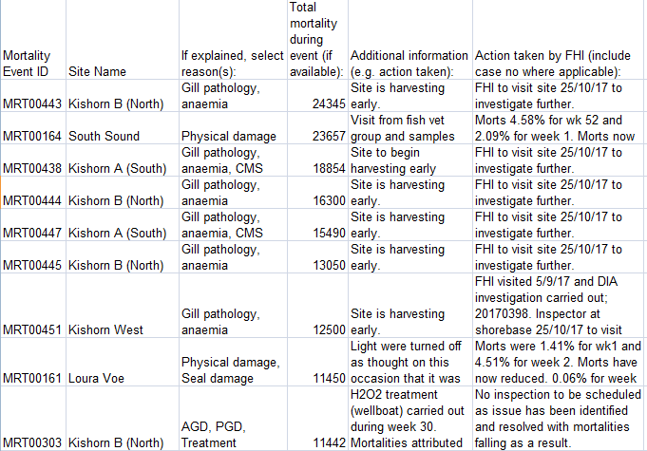
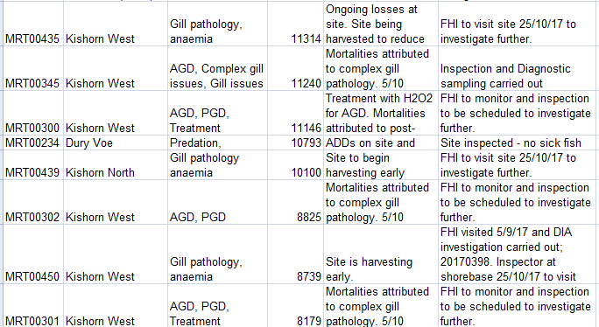

From: Don Staniford [mailto:salmonfarmingkills@gmail.com]
Sent: 14 December 2017 23:24
To: Central Enquiry Unit <CEU@gov.scot>
Subject: FOI re. morts & disease at Scottish Sea Farms during 2017

Please provide information on mortalities and diseases at salmon farms operated by Scottish Sea Farms during 2017.

Please include emails and correspondence with Scottish Sea Farms on the issue of mortalities and diseases - including Mortality Event Reports, Marine Laboratory inspection reports, warning letters, Excel spreadsheets collating data and other information since 1 January 2017.

Please consider this a request for information under the relevant Freedom of Information and Environmental Information Regulations including both the Freedom of Information (Scotland) Act 2002 and the Environmental Information (Scotland) Regulations 2004 (as well as any other new or other regulations which may be appropriate).

Please provide this information electronically via email.

Please acknowledge receipt of this FOI request.

Many thanks and I look forward to a response shortly.

Best fishes,

Don

Don Staniford

Director, Global Alliance Against Industrial Aquaculture (GAAIA): http://www.salmonfarmingkills.com

Read my blog via http://donstaniford.typepad.com/my-blog

<((((º>`·.¸¸.·´¯`·.¸.·´¯`·...¸><((((º>¸.
·´¯`·.¸. , . .·´¯`·.. ><((((º>`·.¸¸.·´¯`·.¸.·´¯`·...¸><((((º>

Since 2014, Scottish Sea Farms has operated three salmon farms in Loch Kishorn.
According to monthly data published via Scotland's Aquaculture web-site, mortality is significant:

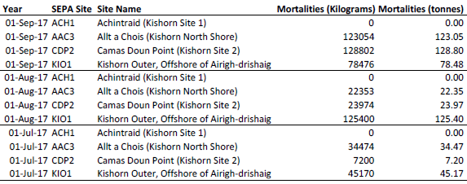

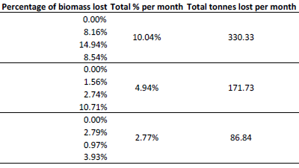

Download as a PDF online here

Please note:

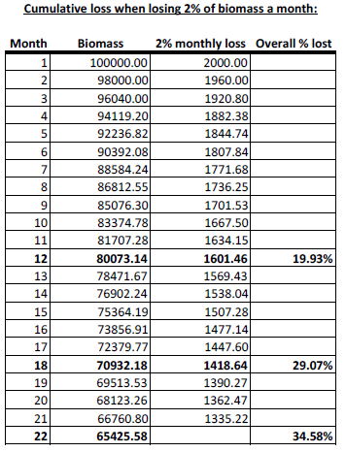

Download as a PDF online here

When questioned by the Scottish Salmon Think Tank, the Scottish Government's Fish Health Inspectorate (Tel: 01312 444 010) gave the following information:

1 Mortalities.

1.1 Are you (FHI) able to disclose the approximate total quantity of mortalities trans-shipped or proposed to be trans-shipped from Kyle pier for disposal during this present case? If you are unable to do so, when would you anticipate such disclosure might be made?

The FHI do not hold details of total numbers of mortalities removed from site for disposal. Animal by-product disposal is regulated by the Animal and Plant Health Agency (APHA), further details can be found here
https://www.gov.uk/guidance/transporting-animal-by-products

The FHI may record details of increased or unexplained mortalities occurring at aquaculture sites as part of routine inspections. Details of increased or unexplained mortalities are held within case information which is published on a quarterly basis. As well as case information and inspection reports, a list of all sites inspected during the quarter is published. Further details can be found here
http://www.gov.scot/Topics/marine/Fish-Shellfish/FHI/CaseInformation

If or when information is held by the FHI as part of our surveillance in relation to this issue it would be released as part of our quarterly publication process.

1.2 Are you able to disclose the site from which the aforementioned morts originate, and if you are unable to do so, when would you anticipate such disclosure might be made?

To our knowledge the waste in the sealed containers originated from fish farm sites in Loch Kishorn.

1.3 Are you able to disclose the possible cause(s) of the mortalities and if unable to do so, when would you anticipate such disclosure might be made?

Mortality information provided to the FHI from farms in Loch Kishorn assign mortalities due to gill pathology, cardiomyopathy syndrome (CMS) and anaemia. In addition, any case information recorded during routine surveillance at the fish farm sites in Loch Kishorn will be published as described.

[Please note that the Fish Health Inspectorate's Case Information does not currently provide data beyond June 2017]

Diseased Mortalities at the Scottish Salmon Company:

Scottish Salmon Company mort events in 2017

From: Neil.Purvis@gov.scot [mailto:Neil.Purvis@gov.scot]
Sent: 18 January 2018 15:27
To: salmonfarmingkills@gmail.com
Cc: Helen.McGregor@gov.scot
Subject: FW: FOI - E - FOI re. morts & disease at Scottish Salmon Company during 2017 - Don Staniford

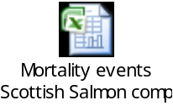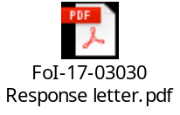

Dear Don,

FoI-17-03030

In response to your request of 14 December 2017 (FoI-1703030) please find the attached response and information provided.

Regards,
Neil

Neil Purvis
Marine Scotland – Science
Scottish Government | Marine Laboratory, PO Box 101| 375, Victoria Road | Aberdeen AB11 9DB
Tel: +44 (0)131 244 3287
S/B: +44 (0)131 244 2500
Mob:+44 (0)777 5818 281
Fax: +44 (0)1224 295620
e: neil.purvis@gov.scot
w: http://www.scotland.gov.uk/marinescotland

The Excel spreadsheet details 1,512,077 morts in 131 separate reports/incidents during 2017 including the following worst cases:

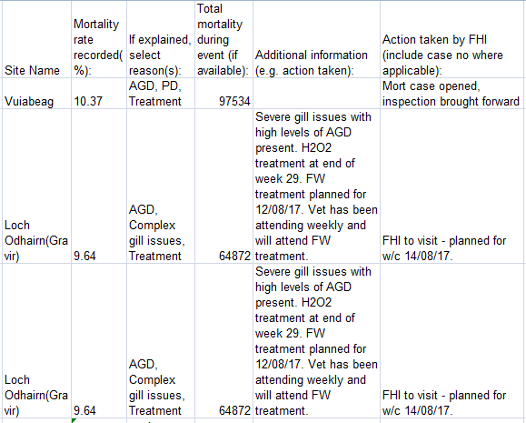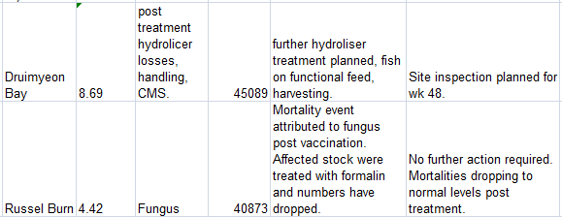
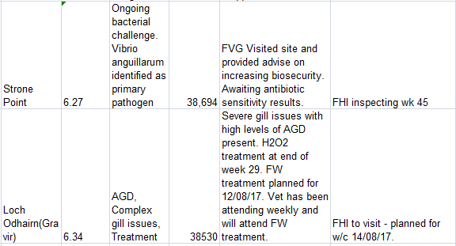

From: Don Staniford [mailto:salmonfarmingkills@gmail.com]
Sent: 14 December 2017 23:25
To: Central Enquiry Unit <CEU@gov.scot>
Subject: FOI re. morts & disease at Scottish Salmon Company during 2017

Please provide information on mortalities and diseases at salmon farms operated by the Scottish Salmon Company during 2017.

Please include emails and correspondence with the Scottish Salmon Company on the issue of mortalities and diseases - including Mortality Event Reports, Marine Laboratory inspection reports, warning letters, Excel spreadsheets collating data and other information since 1 January 2017.

Please consider this a request for information under the relevant Freedom of Information and Environmental Information Regulations including both the Freedom of Information (Scotland) Act 2002 and the Environmental Information (Scotland) Regulations 2004 (as well as any other new or other regulations which may be appropriate).

Please provide this information electronically via email.

Please acknowledge receipt of this FOI request.

Many thanks and I look forward to a response shortly.

Best fishes,

Don

Don Staniford

Director, Global Alliance Against Industrial Aquaculture (GAAIA): http://www.salmonfarmingkills.com

Read my blog via http://donstaniford.typepad.com/my-blog

<((((º>`·.¸¸.·´¯`·.¸.·´¯`·...¸><((((º>¸.
·´¯`·.¸. , . .·´¯`·.. ><((((º>`·.¸¸.·´¯`·.¸.·´¯`·...¸><((((º>

Diseased Mortalities at Marine Harvest Scotland:

Marine Harvest mort events in 2017

From: Neil.Purvis@gov.scot [mailto:Neil.Purvis@gov.scot]
Sent: 13 December 2017 16:46
To: salmonfarmingkills@gmail.com
Cc: Helen.McGregor@gov.scot
Subject: FOI - E - morts & disease at Marine Harvest during 2017 - Don Staniford (FoI/17/0772)

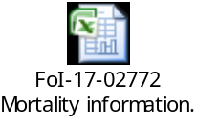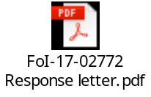

Dear Don,

Please see attached in response to your request of 14 November 2017.

Regards,

Neil

Neil Purvis
Marine Scotland – Science
Scottish Government | Marine Laboratory, PO Box 101| 375, Victoria Road | Aberdeen AB11 9DB
Tel: +44 (0)131 244 3287
S/B: +44 (0)131 244 2500
Mob:+44 (0)777 5818 281
Fax: +44 (0)1224 295620
e: neil.purvis@gov.scot
w: http://www.scotland.gov.uk/marinescotland

The Excel spreadsheet details 572,488 morts in 56 separate reports/incidents during 2017 including the following worst cases:

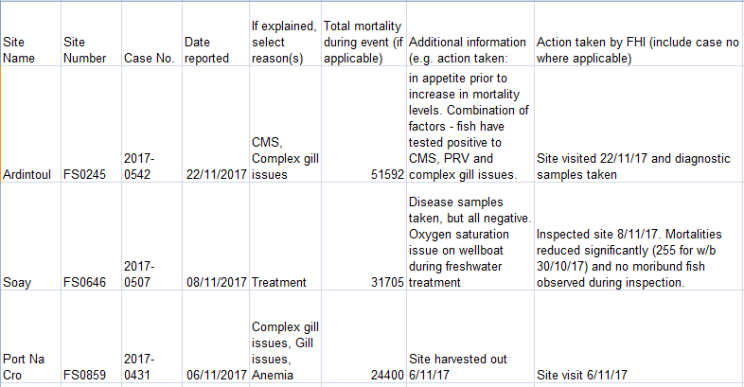
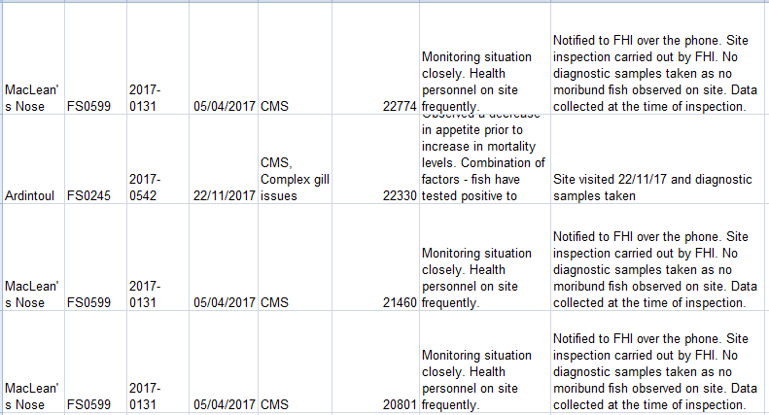
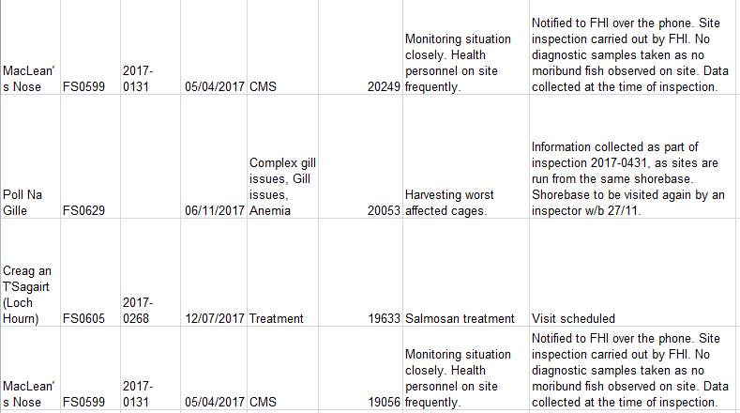

Another FOI document - Download FOI-17-02772-Marine Harvest Correspondence - details how Marine Harvest is experiencing increasing problems with mortalities linked to anaemia (not suspected to be linked to ISA), complex gill issues and cardiomyopathy syndrome (CMS):

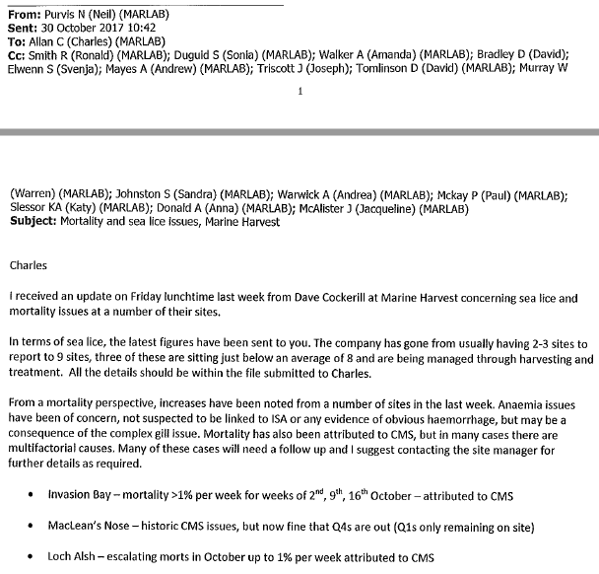
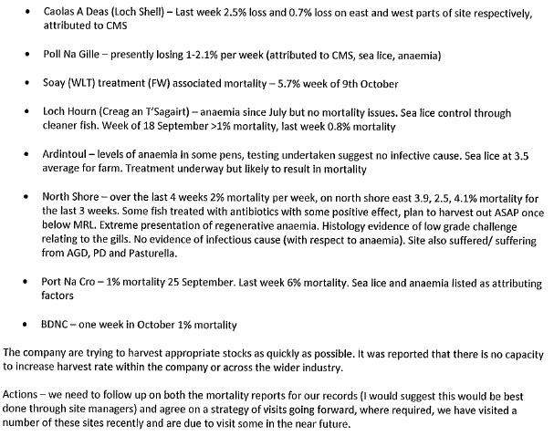

Marine Harvest's mort mountain is plugging into the National Grid (read more via "Energy from dead salmon horrifies vegan activists" and "Vegans in shock at fish electricity: Energy firm SSE admitted generating power from dead salmon earlier this year"):

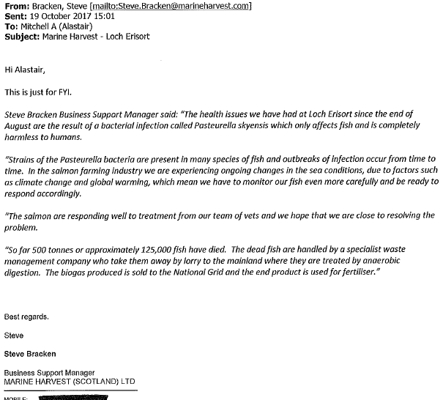

From: Don Staniford [mailto:salmonfarmingkills@gmail.com]
Sent: 14 November 2017 14:35
To: Central Enquiry Unit <CEU@gov.scot>
Subject: FOI re. morts & disease at Marine Harvest during 2017

Please provide information on mortalities and diseases at Marine Harvest fish farms during 2017.

Please include emails and correspondence with Marine Harvest on the issue of mortalities and diseases - including Mortality Event Reports, Marine Laboratory inspection reports, warning letters and other information since 1 January 2017.

As background, a Tweet dated 10 November 2017 included:
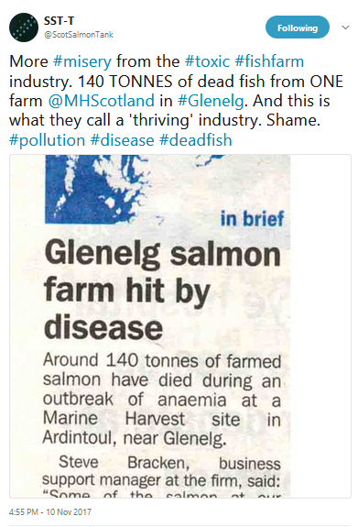

Here's the West Highland Free Press article from 10 November 2017:

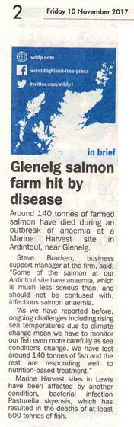

Other media reports refer to mortalities and diseases at other Marine Harvest salmon farms - including:

BBC News (20 October 2017):

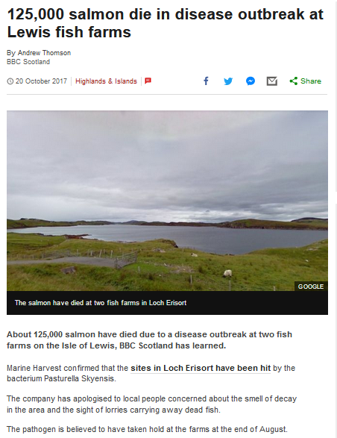

The Sunday Herald (8 October 2017):

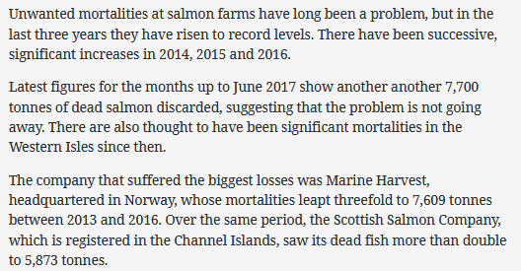

Marine Harvest also reported high mortality at Loch Hourn and MacLean's Nose in June 2017:

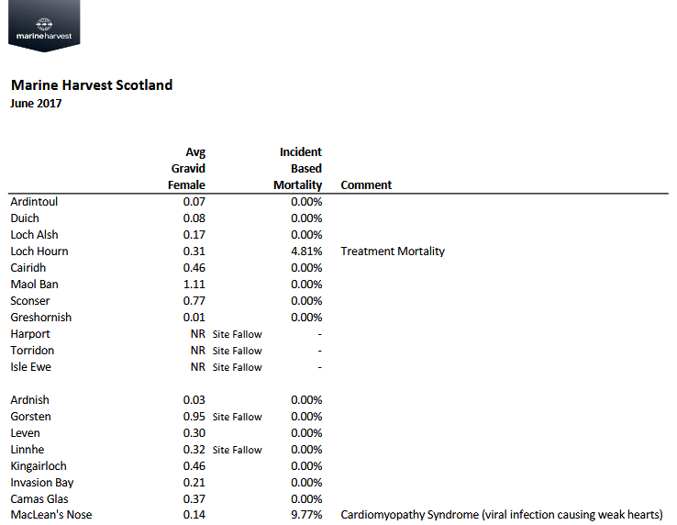

And Marine Harvest reported high mortality in April 2017 at Loch Alsh:

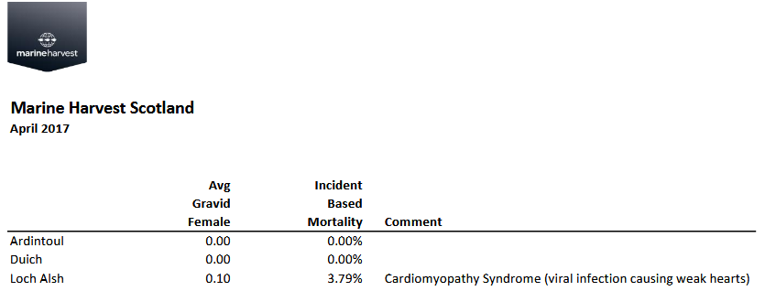

In February 2017, the Scottish Government also disclosed "Information on mortalities and disease problems at Marine Harvest during 2016".

Please consider this a request for information under the relevant Freedom of Information and Environmental Information Regulations including both the Freedom of Information (Scotland) Act 2002 and the Environmental Information (Scotland) Regulations 2004 (as well as any other new or other regulations which may be appropriate).

Please provide this information electronically via email.

Please acknowledge receipt of this FOI request.

Many thanks and I look forward to a response shortly.

Best fishes,

Don

Don Staniford

Director, Global Alliance Against Industrial Aquaculture (GAAIA): http://www.salmonfarmingkills.com

Read my blog via http://donstaniford.typepad.com/my-blog

<((((º>`·.¸¸.·´¯`·.¸.·´¯`·...¸><((((º>¸.
·´¯`·.¸. , . .·´¯`·.. ><((((º>`·.¸¸.·´¯`·.¸.·´¯`·...¸><((((º>

[3] Amoebic Gill Disease, Infectious Pancreatic Necrosis, Furunculosis, Infectious Salmon Anaemia, Pancreas Disease and other deadly diseases have ravaged Scottish salmon farms killing millions of fish:

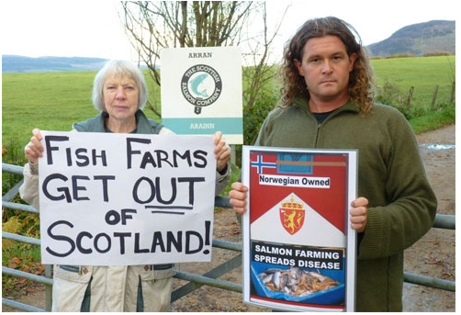

Read more on AGD, IPN, HSMI, ISA and PD via:

"Gill Diseases: Scottish Salmon's Dirty Big Secret"; "Infectious pancreatic necrosis virus in Scottish Atlantic salmon farms, 1996–2001"; "An outbreak of disease resembling heart and skeletal muscle inflammation in Scottish farmed salmon, Salmo salar L., with observations on myocardial regeneration"; "Surveillance for infectious salmon anaemia virus HPR0 in marine Atlantic salmon farms across Scotland"; "Analysis of a company's production data to describe the epidemiology and persistence of pancreas disease in Atlantic salmon (Salmo salar L.) farms off Western Scotland"

Read more on Pasteurella skyensis via:

"125,000 salmon die in disease outbreak at Lewis fish farms"; "Disease kills 125,000 salmon on Lewis fish farm"; "Campaigners say 'no more salmon farms' after disease on Lewis kills 125,000 fish"; "Pasteurella skyensis sp. nov., isolated from Atlantic salmon (Salmo salar L.)" and "Characterization of two groups of Pasteurella skyensis isolates from Atlantic salmon, Salmo salar L., based on serotype and 16S rRNA and rpoB gene partial sequences"

[4] 'Case Information' published by the Scottish Government's Fish Health Inspectorate (the latest data available is for April to June 2017) includes details of very high mortality at Marine Harvest's MacLean's Nose salmon farm due to Cardiomyopathy syndrome (CMS).

The Fish Health Inspectorate's mortality report following an inspection in April 2017 states that "Billy Bowie collects CMS fish" (Billy Bowie is the haulage company exposed as leaking diseased salmon by the BBC's 'The One Show' and The Daily Mail leading to an EC complaint for breach of the Animal By-Products Regulations and investigation by East Ayrshire Council).

The FHI report also details 30% mortality of cleaner fish - lumpfish - due to "mobile bacteria" requiring treatment with antibiotics (read more via Sunday Times: 'Clean Fish' Bring Danger of Disease to Salmon Farms and "New pathogen discovered in lumpfish" ).

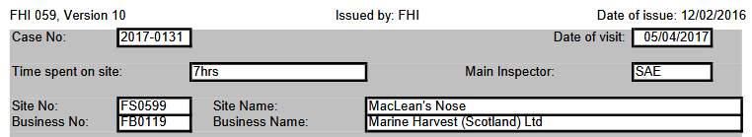

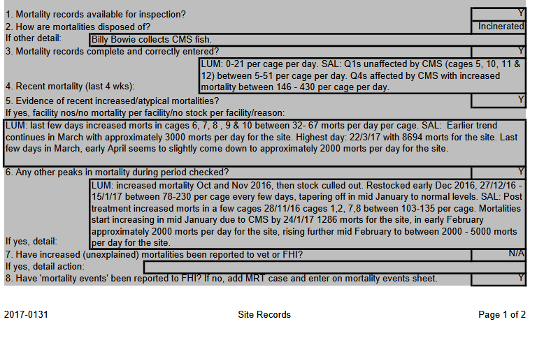

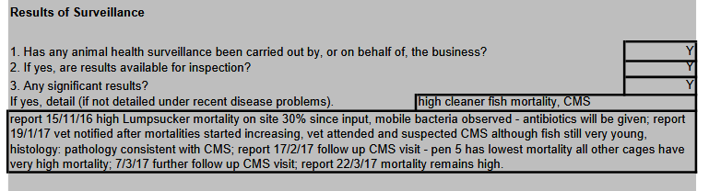

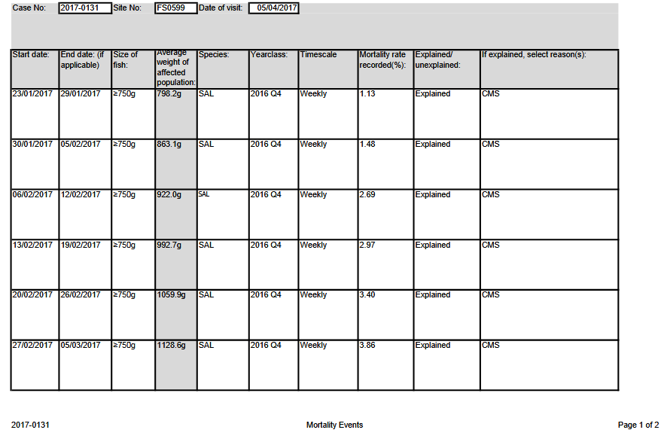

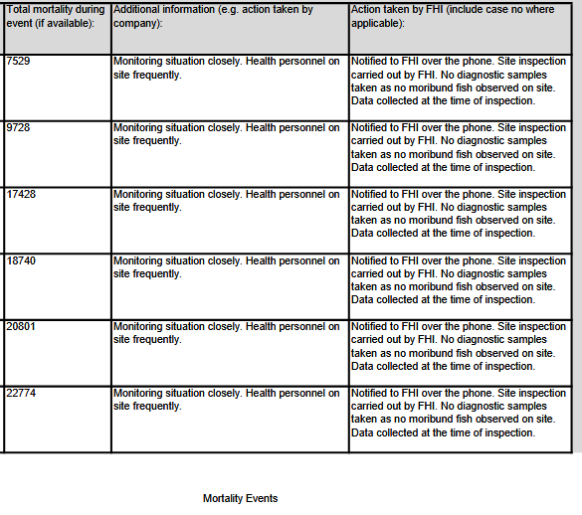

Information obtained from the Scottish Government via FOI in March 2017 included:

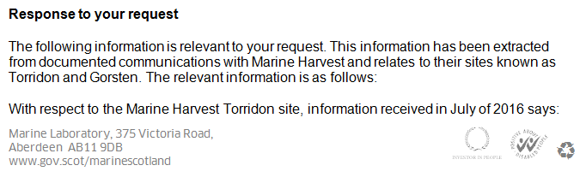
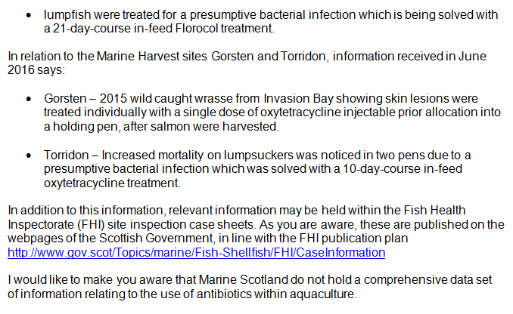

In October 2017, the Fish Health Group hired a fish health specialist (Marta Alarcón) with a strong background in researching Cardiomyopathy Syndrome (CMS) in Atlantic salmon and diseases in lumpfish.

"Lumpfish are now the second most cultured fish species in Norway after salmon – in less than eight years the industry has been able to grow from producing a few thousand to more than 20 million," said Marta Alarcón in an article headlined 'Fish Vet Group lands CMS and lumpfish specialist'. "This expansion, while positive, has also led to increasing disease outbreaks and welfare problems. I have worked in the diagnostics of lumpfish diseases and consider this something of a goldmine – there is always something to learn with each new case. The problems we see in Norway are similar to the ones they are facing in Iceland or Scotland."

A scientific paper - "Cardiomyopathy syndrome in Atlantic salmon Salmo salar L.: A review of the current state of knowledge" - published in the Journal of Fish Diseases in 2017 included:

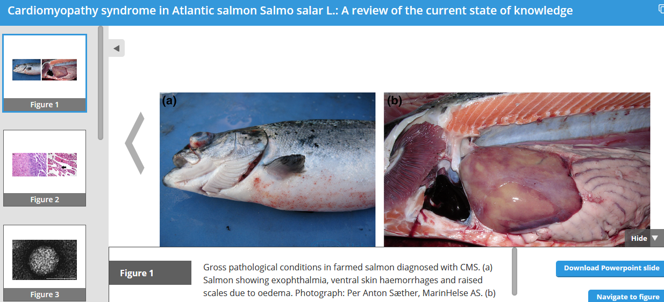

The scientific paper also reported:

"In 2007, Marine Harvest Norway (MHN) reported a biological loss of 1200 tonnes of salmon due to CMS during a 6-month period. Assuming that this was representative for the industry and that MHN accounted for 25% of the total Norwegian production, the overall CMS-related loss for the Norwegian salmon industry was estimated to more than € 25 million (NOK 200 million) that year (http://www.fhf.no/prosjektdetaljer/?projectNumber=900261)."

"Since 2007, the number of CMS cases reported by NVI and private laboratories has increased (Hjeltnes et al., 2016), and more fish are probably affected per case today as the number of fish per location has more than doubled. In addition, both production expenditures and sales prices of salmon have risen (Olafsen, Winter, Olsen, & Og Skjermo, 2012) (http://www.fiskeridir.no/English/Aquaculture/Statistics). Accordingly, the economic impact of CMS remains undisputable, and the potential for financial benefit through the introduction of efficient control measures is considerable."

"The presence of PMCV in an escaped farmed salmon captured in River Numedalslågen (Ct value of 15) suggests that the virus can be spread by farmed salmon escapees (Biering & Garseth, 2013)....... As for other infectious salmon diseases, the probability of developing CMS increases with the length of time in the sea, increasing cohort size and infection pressure. CMS in previous cohorts is also identified as a risk factor (Bang Jensen et al., 2013). The latter factor could be caused by survival of the virus in the environment, for instance in wild or escaped farmed salmon (Biering & Garseth, 2013; Garseth et al., 2012), or it could reflect factors associated with the particular sea site, such as management and environmental conditions (Bang Jensen et al., 2013). The presence of PMCV in cleaner fish, as recently reported from an Irish salmon sea site, represents another potential risk factor especially if the cleaner fish are reused or moved between sites or cages (Scholz et al., 2017)."

In 2000, The Independent newspaper reported on the first case of CMS in Scotland with the Scottish salmon farming association (Scottish Quality Salmon - now called the Scottish Salmon Producers Organisation) quoted as saying: "There is no cause for concern":

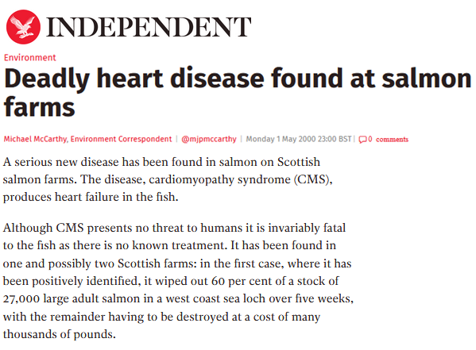
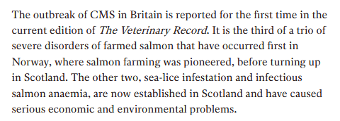
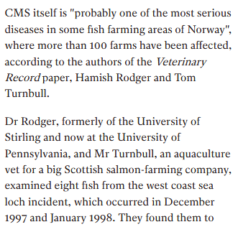
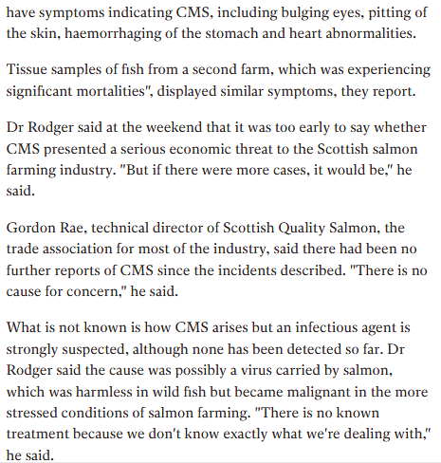

A SARF report published in 2007 included:

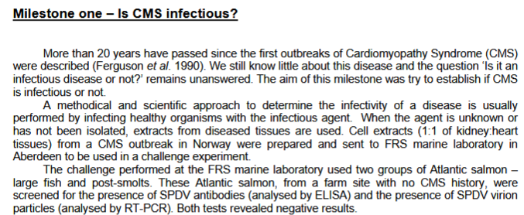

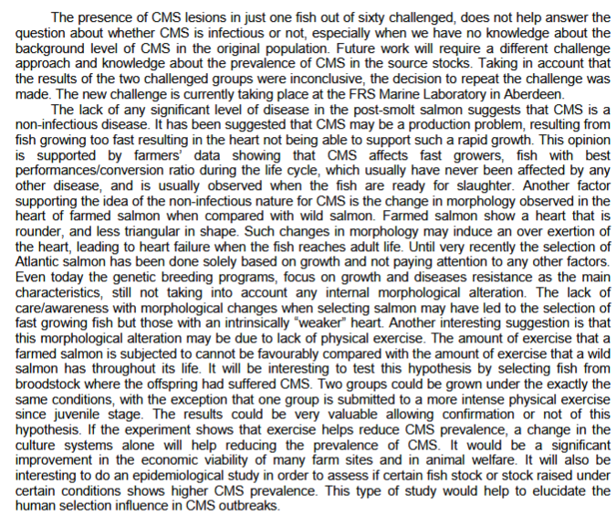

A short communication - "Cardiomyopathy syndrome in farmed Scottish salmon" - published in The Veterinary Record in 2000 detailed 60% mortality at a salmon farm in Scotland due to CMS between December 1997 and January 1998.

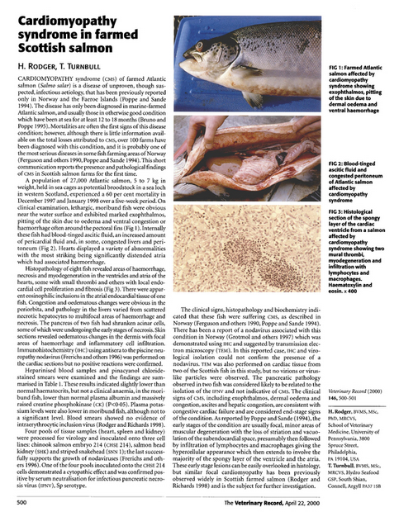

[5] Nearly 100,000 farmed salmon were 'Thermoliced' to death by Marine Harvest during 2016:
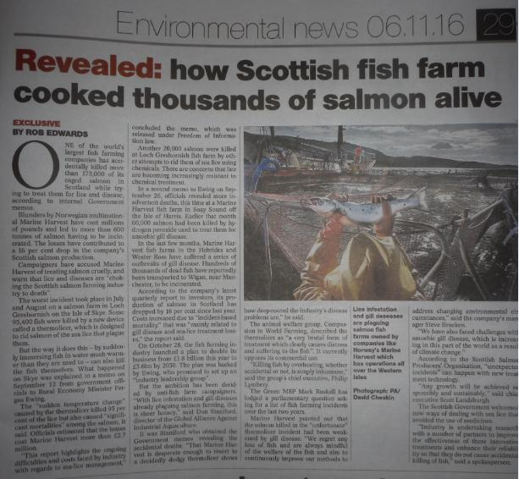

Read more via "'Thermolicer' Back-Fires Killing 95,400 Farmed Salmon"; Fish farm firm kills 175,000 salmon by accident; "Oops: fish farm firm kills 175,000 of its salmon by accident" and "Thousands of fish poached alive in lice treatment bungle"

A Thermolicer treatment caused the deaths of 5,794 salmon at Grieg Seafood Shetland’s North Havra site in November 2016:

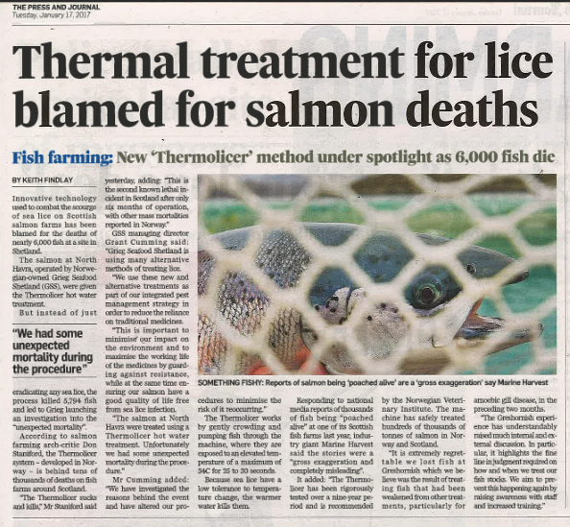

Read more via "Thermal treatment for lice blamed for salmon deaths" and "Treatment leads to morts in Shetland"

Mortality events reported by the Scottish Salmon Company in 2017 include eight cases involving 90,000 dead salmon due to using a Hydrolicer:

Mortality events reported by Scottish Sea Farms in 2017 include six cases involving over 25,000 dead salmon due to using a Thermolicer:

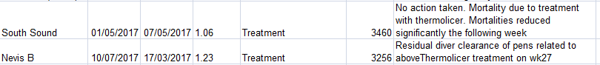

Mortality events reported by Marine Harvest in 2017 include three cases involving over 20,000 dead salmon due to using a Thermolicer:

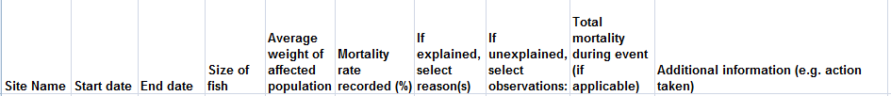

In January 2018, a fish vet from Norway "highlighted major head injuries she has seen to fish treated with warm water delousing machinery". "No matter what non-drug method you use for delousing, it kills," said Kristin Ottesen in a report by Fish Farming Expert. "Same if it’s Skamik, FLS, Thermolicer and Optilice" (read more via "Vet warns of head injury risk to fish during delousing").

In November 2016, following the deaths of 95,000 farmed salmon at a Marine Harvest farm in Loch Greshornish, Compassion In World Farming's Chief Executive Philip Lymbery stated:

"The Thermolicer procedure involves crowding the fish used to the cold coastal waters of Scotland, pumping them into heated water and then dumping them back into their seawater cages. Salmon would never normally experience such sudden temperature changes. Little wonder that so many seem to have died as a result. Killing fish by overheating, whether accidental or not, is simply inhumane. The use of rough handling and heat treatment to tackle problems of sea lice is unacceptable on welfare grounds...... The Thermolicer appears to be a brutal treatment which has not been subjected to a full and proper welfare assessment. It involves a series of steps which are inherently stressful and will cause poor welfare to the fish. Improved design and management could reduce this stress but cannot be expected to eliminate it. Any treatment system should be subjected to properly conducted welfare analysis before its use is permitted. Having taken a close interest in the welfare of farmed fish for over 25 years now, I am shocked anew by these latest reports. I call on the industry to abandon such heat-shock methods in favour of better rearing conditions for the fish. And the sooner the better."

Compassion in World Farming's scientific assessment of the Thermolicer prepared by Phil Brooke (Scientific Manager - research and education) in November 2016 included:

"The Thermolicer appears to be a brutal treatment which has not been subjected to a full and proper welfare assessment. It involves a series of steps which are inherently stressful and will cause poor welfare to the fish..... We have seen one report from the Norwegian Veterinary Institute ("Thermal de-licing of salmonid fish - documentation of fish welfare and effect") which documented statistically significant increases in:
- snout injury following treatment. It is suggested that this should be caused by the effects of crowding the fish before pumping onto the Thermolicer vessel
- fin damage
- scale damage following treatment on one of the sites
- cataracts on one site 3 weeks after treatment
......... As far as we are aware, no thorough peer-reviewed analysis of the welfare impact of Thermolicer treatment is available. Until this has been carried out, Compassion in World Farming is opposed to any commercial use of this treatment."

The use of the Thermolicer has been questioned by Mark Ruskell MSP in the Scottish Parliament:

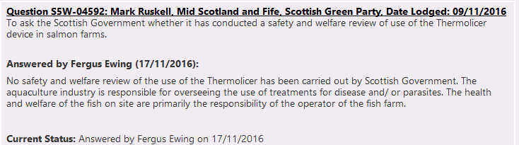

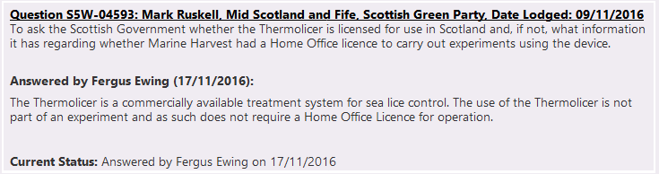

In November 2016, the Norwegian Food Safety Authority (Mattilsynet) launched a project assessing the welfare implications of the Thermolicer:

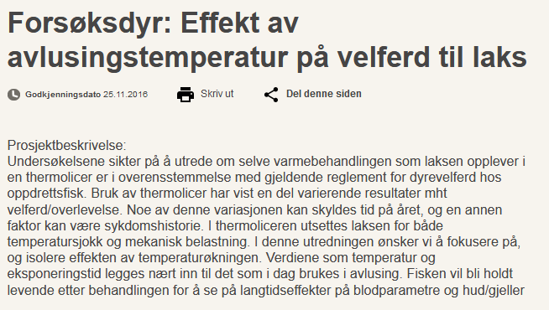

[6] Up-to-date data on diseases on Scottish salmon farms is not readily accessible - but we know from previous data accessed via FOI that diseases increased significantly between 1980 and 2007:

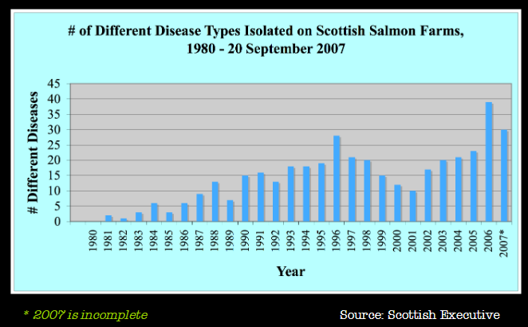

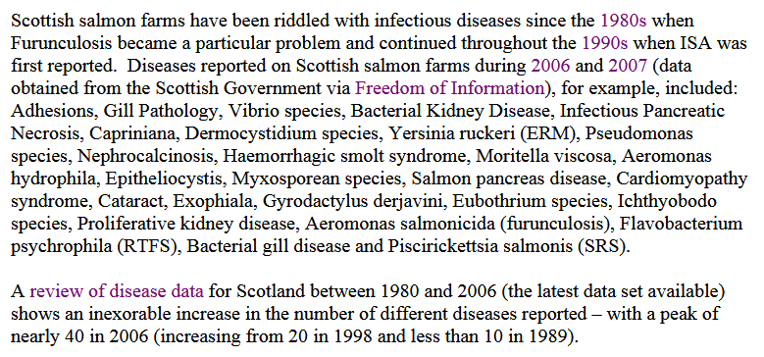

Download data obtained via FOI from the Scottish Government via:

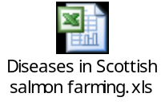

Read more via "Gaining Transparency: using the FOIA process to track down data on the impacts of fish farming"; "Fish Farmageddon: The Infectious Salmon Aquacalypse" and "The Infectious Salmon Aquacalypse"

Excerpt from "Scottish Farmed Salmon Exposed" (2008):

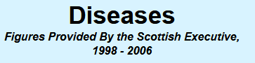
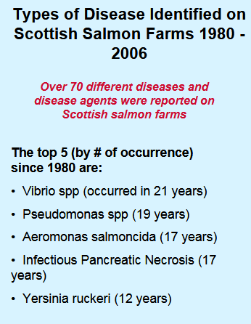
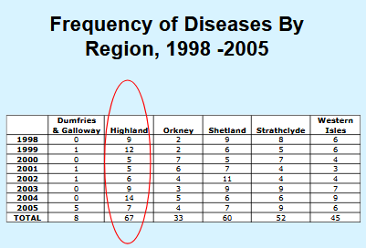

Disease data accessed via FOI in 2012 includes:
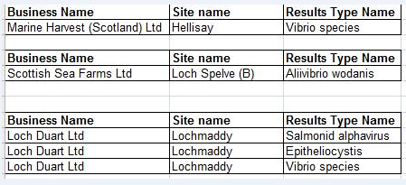
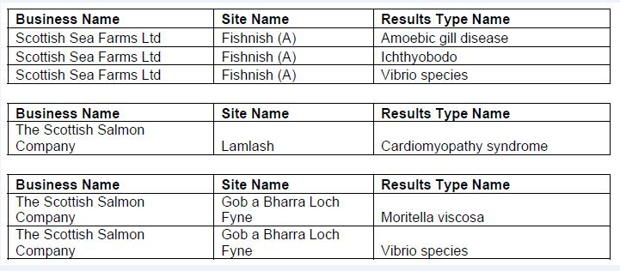

And data for 2011 includes:

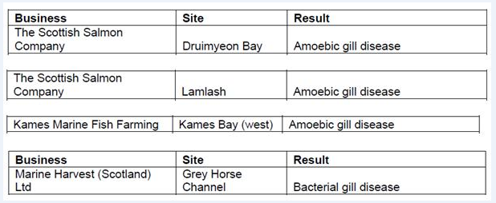

And data for 2010 includes:

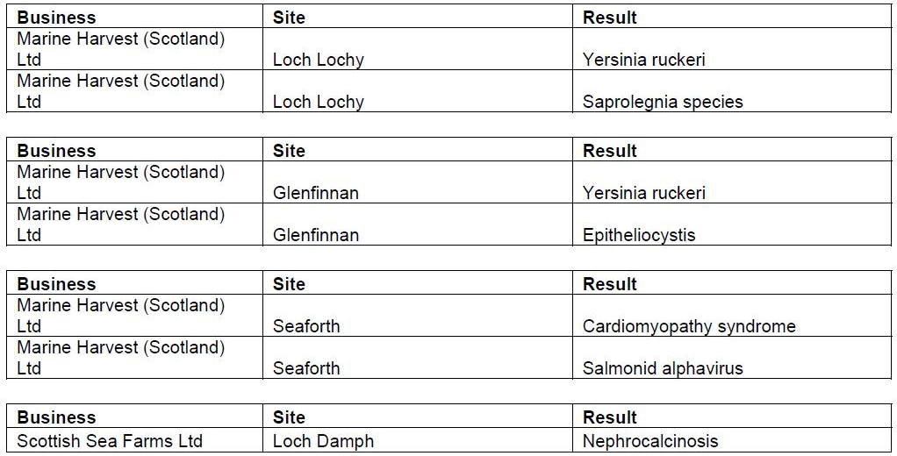

And data for 2009 includes:

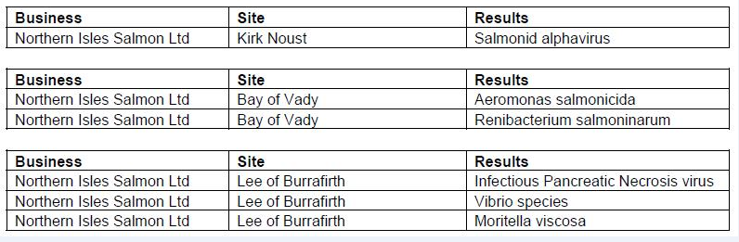

And data for 2008 includes:

