The Global Alliance Against Industrial Aquaculture, 28 January 2018

Diseased Salmon Slip Net & Spill on Road
- Failure to police the transport of dead fish prompts EC complaint

Following a BBC exposé on 'The One Show' broadcast last month, campaigners are calling on local authorities and the Scottish Government to properly police the transport of mortalities from Scotland's disease-ridden salmon farms.

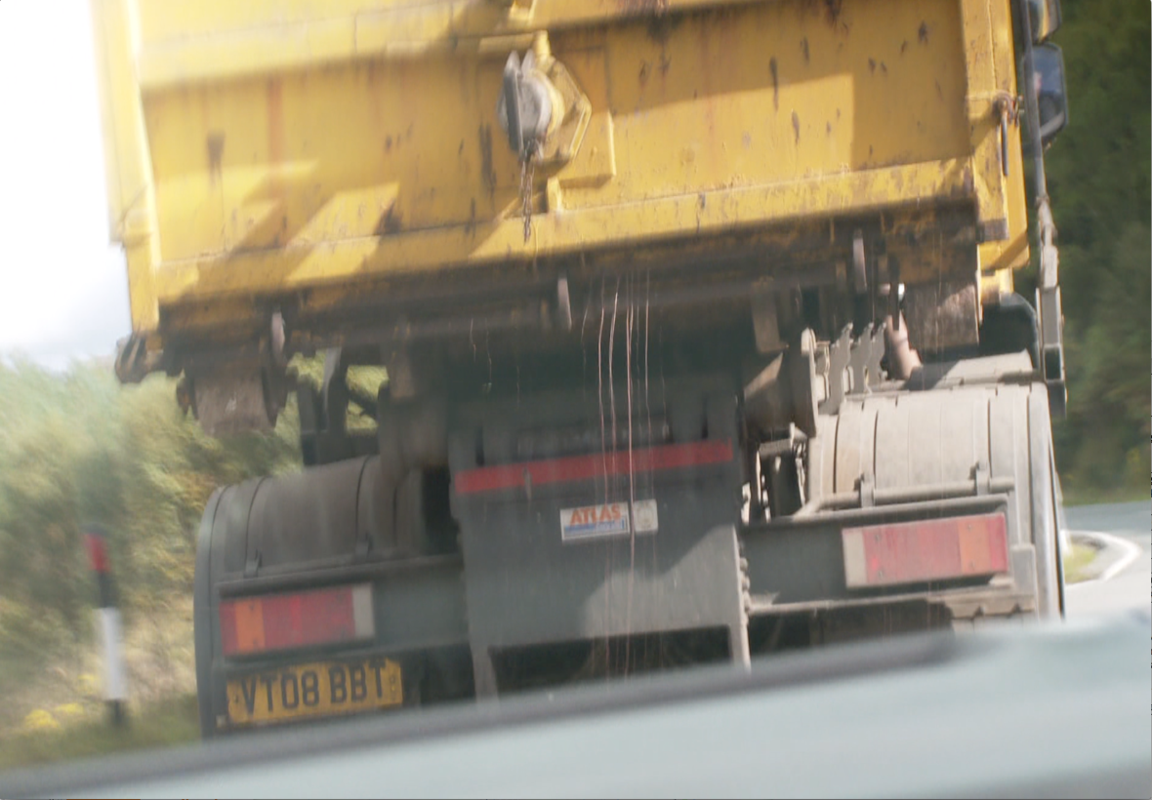
Photo: Fluids leaking from a Billy Bowie haulage truck transporting diseased farmed salmon from Loch Kishorn - broadcast by the BBC's 'The One Show' on 11 December 2017

The Global Alliance Against Industrial Aquaculture (GAAIA) has filed a complaint to the European Commission regarding a breach of the Animal By-Products Regulations by the United Kingdom. GAAIA has also written to the Scottish Government requesting an urgent investigation into disease-ridden mortalities from Scottish salmon farms (Download Letter to Fergus Ewing 28 Jan 2018).

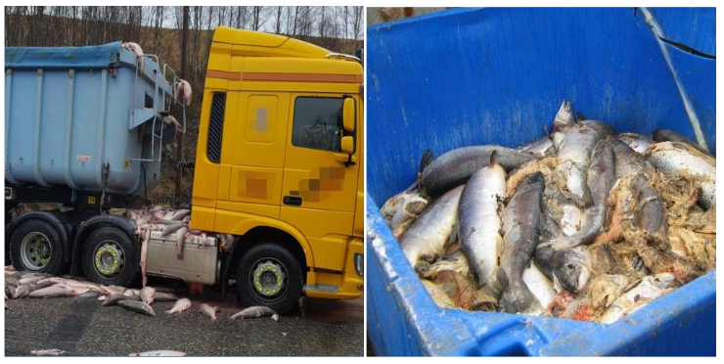

Read more via:
Sunday Times: "Scots councils ‘failing to enforce EC laws on leaky salmon trucks’"
Daily Mail: "Thousands of fish thrown in a truck - and troubling new questions for salmon farms"
One local authority (East Ayrshire) is now investigating the standards of the vehicles used to transport farmed salmon morts and compliance with the Animal By-Products Regulations 2013 (ABPR).

Footage from the BBC screened on 11 December 2017 showed a haulage truck operated by Billy Bowie flouting the law by leaking fluids from diseased salmon farmed by Scottish Sea Farms in Loch Kishorn (read more via Scottish Sea Farms mort events in 2017). There have been other reported cases of farmed salmon spilling onto roads across Scotland including the A9.

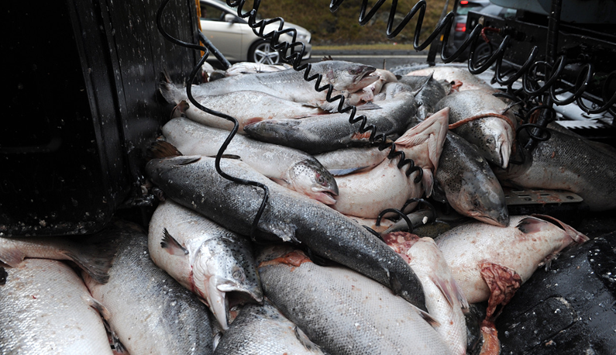
Photo: Salmon spill on the A9 in March 2017 (download high res image online here)

Documents obtained via Freedom of Information (FOI) reveal that local authorities are failing to enforce the regulations with some citing a lack of resources and others completely ignorant [1]:

"We don’t have the resources to carry out any monitoring or surveillance of these activities, we didn’t carry out any investigations into these activities in 2017," replied Argyll & Bute Council on 11 January 2018.

"Stirling Council would not be involved in this. This would be for Aquaculture Industry to respond to," replied Stirling Council on 26 January 2018 (GAAIA has since asked for a review pointing out that "salmon farms are clearly not located within Stirlingshire - however, the transport of dead farmed salmon does occur within your local authority").

"As you may be aware, East Ayrshire’s Trading Standards team are taking forward the investigation of vehicles leaking ABP with the transporter Billy Bowie. As they are leading on this matter, my team will not be taking forward any specific action on this particular case," replied Highland Council on 24 January 2018.

"I am providing notice that under Section 17 of the Freedom of Information (Scotland) Act 2002 that the Council does not hold the information requested and so, is unable to comply with your request. I can advise that there are no salmon farms in Renfrewshire," replied Renfrewshire Council on 23 January 2018 (GAAIA replied: "It is patently obvious that there are no salmon farms in Renfrewshire! The FOI request relates to transport of dead fish from salmon farms to disposal sites across Scotland and in Northern England. Renfrewshire is cited in this case in October 2015 on the A737 (as reported by The Courier)."

"Shetland Islands Council has not had to issue any warning letters, complete any investigations, surveillance or monitoring in regard to the transport and disposal of salmon farm mortalities," replied Shetland Isles Council on 20 December 2017.

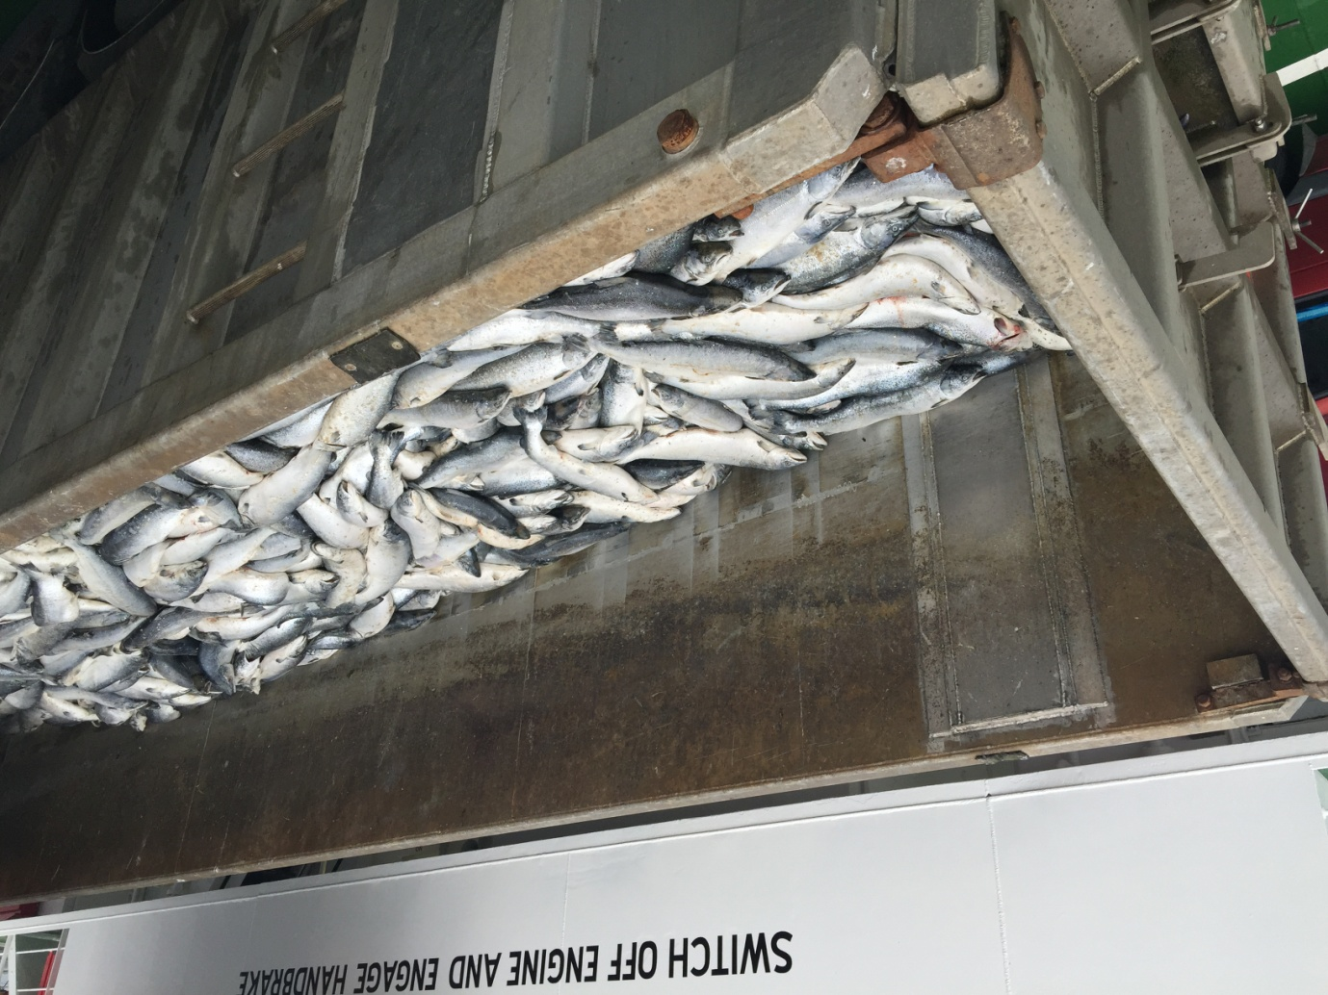
Photo: A truckload of dead salmon on the ferry 'Leirna' from Lerwick to the fishmeal factory in Bressay on 18th August 2015 (download high res image online here)

Other local authorities have either not replied or did not possess any information even though local authorities are charged by law with enforcing the legislation.

"APHA do not inspect or monitor the transport of salmon farm mortalities," said a FOI reply from the Animal & Plant Health Agency dated 9 January 2018. "The enforcement of the regulations is the responsibility of Local Authorities under the Animal By-Products (Enforcement) (England) Regulations 2013 and of the Scottish Government under The Animal By-Products (Enforcement) (Scotland) Regulations 2013".

"Police Scotland has no protocols with any local authority or operating company regarding the disposal of wastes from fish farms," said a FOI reply from Police Scotland dated 10 January 2018.

Following a complaint by GAAIA in December 2017, the Scottish Government contacted East Ayrshire Council inquiring about the condition of the vehicles being used to transport the salmon mortalities not being complaint with the ABPR and reported "that they would be investigating the standards of the vehicles used by the transport company". A letter to GAAIA dated 17 January 2018 from the Scottish Government included:

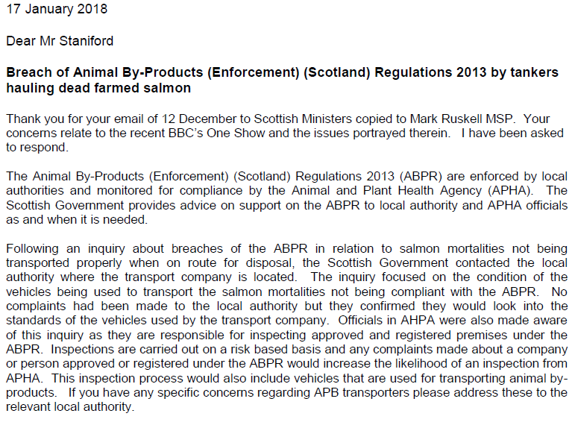

A similar letter to Mark Ruskell MSP, Fergus Ewing (Cabinet Secretary for Rural Economy & Connectivity) dated 10 January 2018 stated [2]:

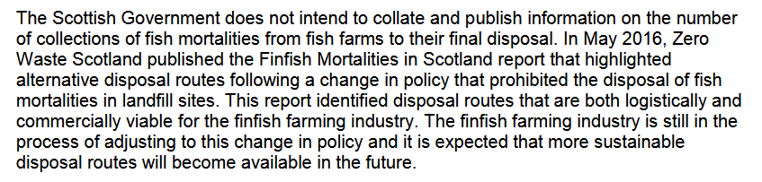
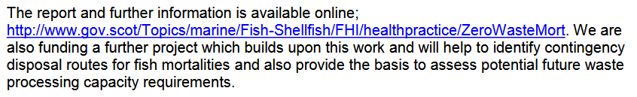

"Not only are haulage companies flouting the regulations but local authorities are failing to enforce the law," said Don Staniford, Director of the Global Alliance Against Industrial Aquaculture (GAAIA) and author of 'Scottish Salmon Farming 101'. "Scottish salmon farming has a huge mort mountain with over one in four farmed salmon dying and an estimated 20 million morts piling up across Scotland. It beggars belief that haulage trucks making 'The Dead Salmon Run' are not being properly policed. Scottish salmon farming stinks and leaves a bad taste in the mouth."

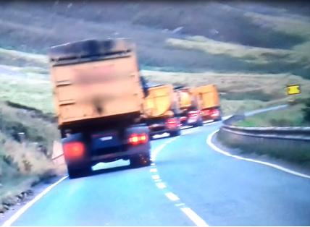

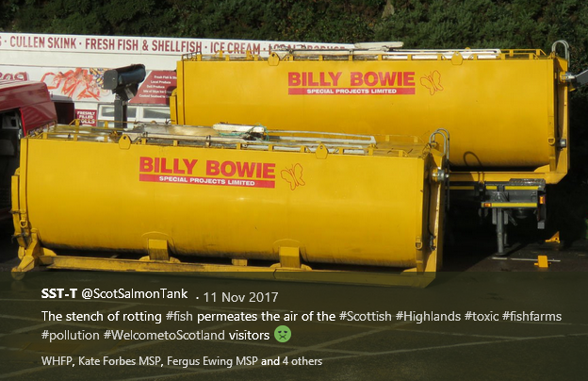
Background:

Guidance issued by the Department for Environment, Food & Rural Affairs and Animal and Plant Health Agency in 2014 stated under 'Vehicle Hygiene & Storage': "When you’re transporting animal by-products (ABPs) or any ABP derived products, you must make sure you: use vehicles and containers that are covered and leak-proof".

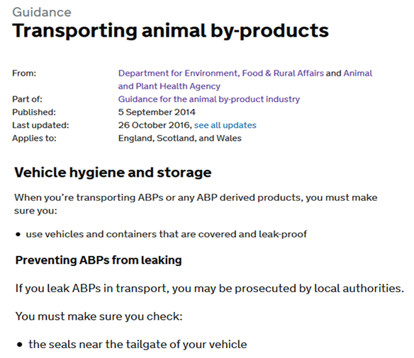

Following the BBC's broadcast of images of fluid wastes leaking from a haulage truck (operated by Billy Bowie - registration number VT08 BBT) transporting dead farmed salmon from Loch Kishorn via Fort William to Dumfries (believed to be the Dundas Chemical Co at Mosspark), GAAIA questioned whether there has been a breach of the Animal By-Products (Enforcement) (Scotland) Regulations 2013.

"It is abundantly clear from the BBC footage broadcast last night (starts at 3 minutes 22 seconds) that there is leakage from at least one of the haulage tankers," wrote GAAIA in emails to the Scottish Government, Department for Environment, Food & Rural Affairs and Animal and Plant Health Agency and Highland Council dated 12 December 2017.

"What I'm seeing here is shocking but it isn't illegal nor uncommon," says BBC reporter Joe Crowley as he is driving behind the Billy Bowie tankers/trucks. "OK, the tanker and the first skipper-lorry have just left the salmon farm and they're both full of salmon. In fact, I can see some horrible fluid coming out of the back of one of them and it smells vile"



"Surely this is not "leak proof" and therefore constitutes a breach of the Animal By-Products (Enforcement) (Scotland) Regulations 2013?" asked GAAIA.

Download high res images via:
Photo: Screen grab #1 from BBC's 'The One Show' on 11 December 2017
Photo: Screen grab #2 from BBC's The One Show' on 11 December 2017

Other incidents where the Animal By-Products (Enforcement) (Scotland) Regulations 2013 may have been breached due to leakage include:

March 2017: Salmon spilled on A9 in Perthshire (as reported by ITV News; The Evening Telegraph, BBC News and The Courier & Advertiser)

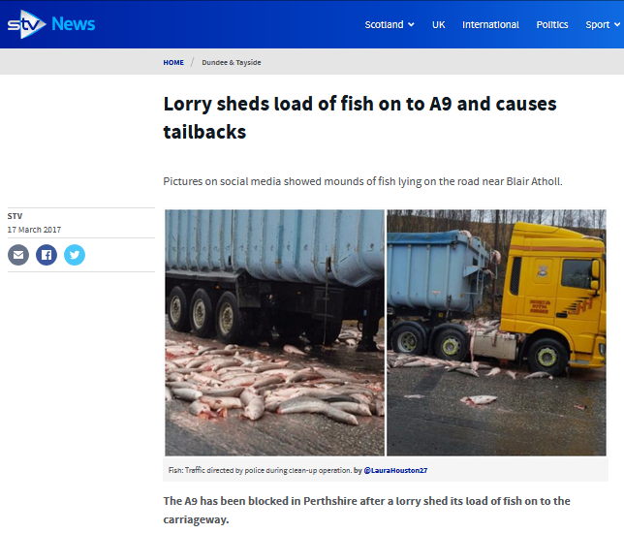
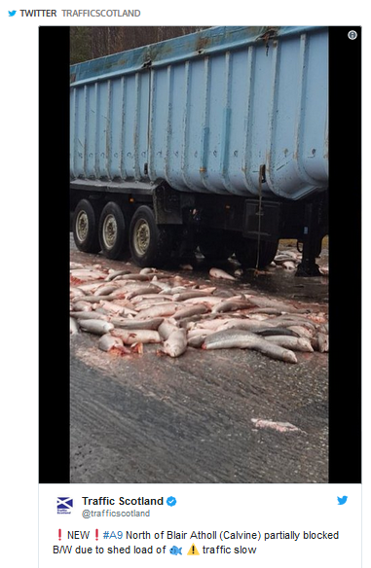

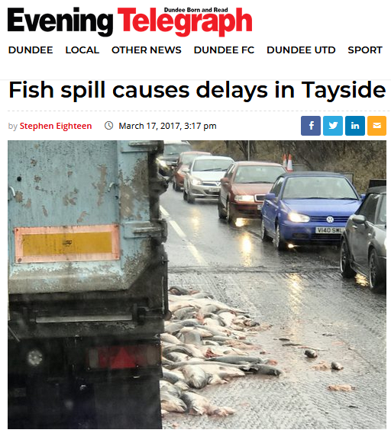
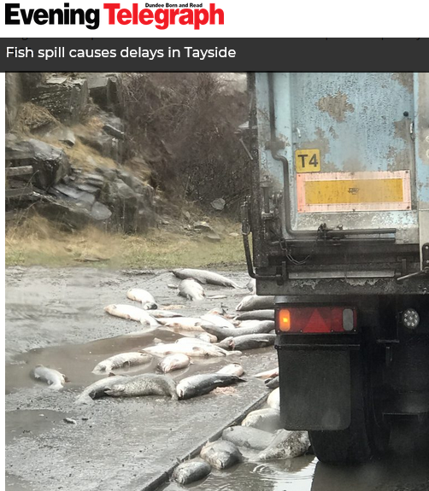

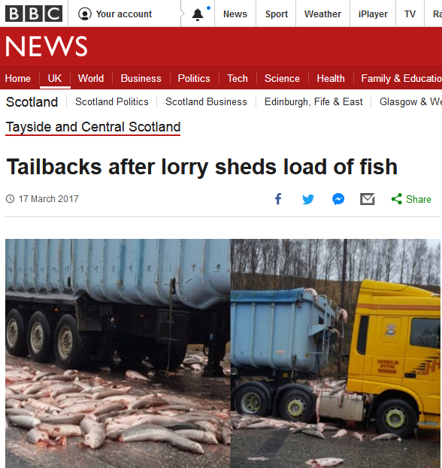
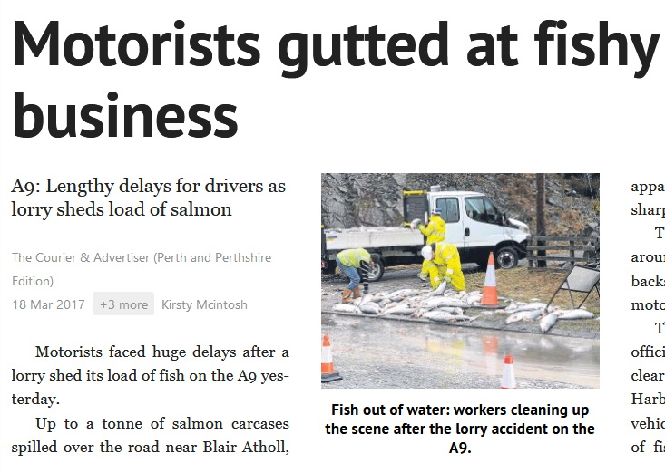

November 2015: A9 (as reported by Alan Beaton)

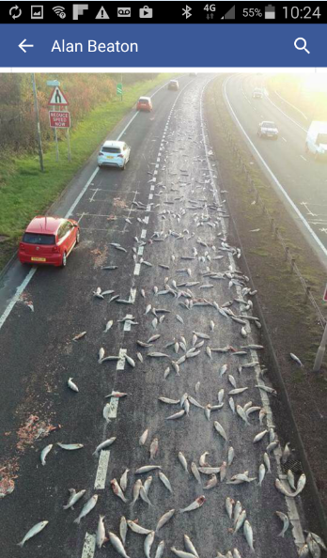

October 2015: A737 (as reported by The Courier)

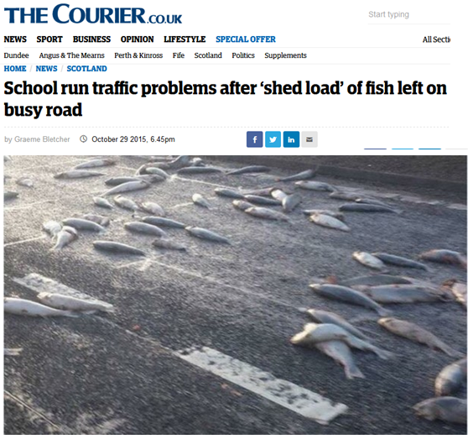

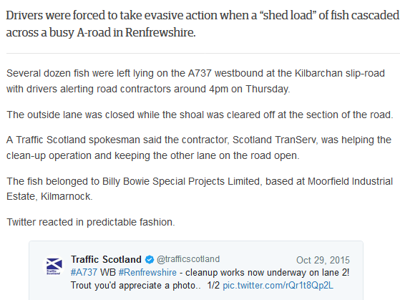

August 2015: Shetland (photograph published by The Daily Telegraph)

Photo: A truckload of dead salmon on the ferry 'Leirna' from Lerwick to the fishmeal factory in Bressay on 18th August 2015 (download high res image online here)
Last month, the First Minister of Scotland was questioned in the Scottish Parliament on leaking wastes from dead farmed salmon.
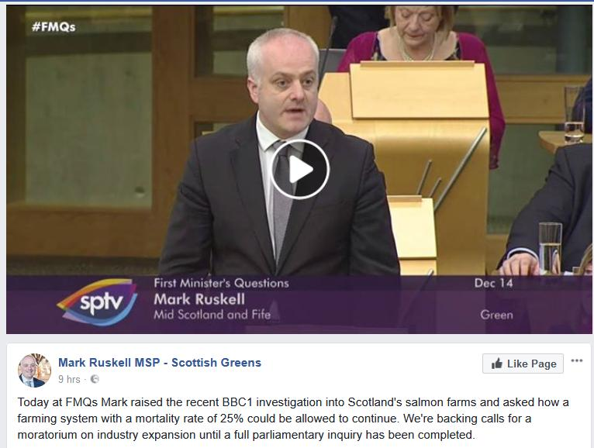
Mark Ruskell MSP also wrote to the Cabinet Secretary for the Rural Economy & Connectivity regarding biosecurity concerns around the transportation of salmon morts [3].

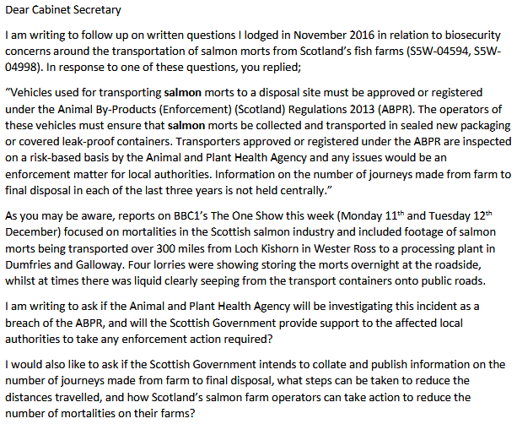
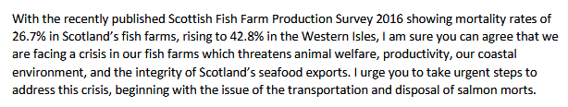

In November 2016, a Parliamentary Question filed by Mark Ruskell MSP asked "where and by whom containers of diseased salmon morts are checked for biosecurity compliance during their journey from farm to final disposal, and how many such journeys have taken place in each of the last three years".

"Vehicles used for transporting salmon morts to a disposal site must be approved or registered under the Animal By-Products (Enforcement) (Scotland) Regulations 2013 (ABPR)," replied Fergus Ewing, Cabinet Secretary for the Rural Economy and Connectivity, in December 2016. "The operators of these vehicles must ensure that salmon morts be collected and transported in sealed new packaging or covered leak-proof containers."

Another Parliamentary Question and reply in November 2016 also stressed when transporting Animal By-Products transporters must ensure that they "use vehicles and containers that are covered and leak-proof".

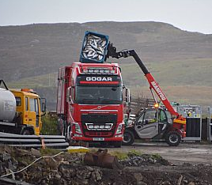

The mortality rate at Scottish salmon farms is a staggering 26.7% (five times higher than the 5% mortality tolerated on intensive chicken farms) with an estimated 20 million farmed salmon dying each year:
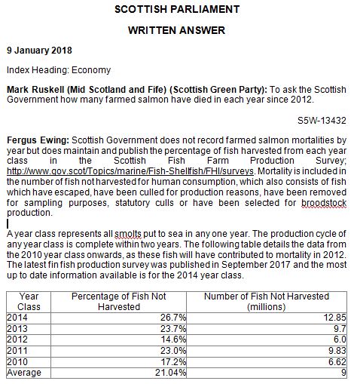
Last month, GAAIA wrote to SEPA and the Scottish Government demanding the publication of mortality figures which are estimated to have doubled over the last four years to over 20 million. In 2013, SEPA bowed to pressure from the Scottish Salmon Producers Organisation to keep the number of dead salmon secret claiming it "could be used to the commercial detriment or competitive market disadvantage of the companies submitting the data" [4].

Despite a lack of annual data on the number of morts since 2012, GAAIA has accessed via FOI data on mort numbers during 2017 at Scotland's three largest salmon farming companies (Scottish Sea Farms, the Scottish Salmon Company and Marine Harvest Scotland) - with the following reasons for mortality listed: gill pathology, complex gill issues, Vibrio anguillarum, Proliferative Gill Disease, Pancreas Disease, fungus, cardiomyopathy syndrome, Haemorrhagic smolt syndrome, Enteric redmouth disease, anaemia and deaths due to the Hydrolicer, Thermolicer and hydrogen peroxide treatment [5].

Download the mort data via:
Marine Harvest mort events in 2017
Scottish Salmon Company mort events in 2017
Scottish Sea Farms mort events in 2017
Data published by the Norwegian Government reveals that 56 million farmed salmon died in Norway in 2016 - up from 43.6 million in 2014; 25.7 million in 2004 and 9.3 million in 1994 (read more via "56 millioner laks døde i oppdrettsmerdene i 2016") [6].

More background information on mortalities on Scottish salmon farms is available via Scottish Salmon Farming 101 [7].

Read more via:
Daily Mail: "Thousands of fish thrown in a truck - and troubling new questions for salmon farms"
"Parliamentary Question: to ask the Scottish Government how many farmed salmon have died in each year since 2012"
"First Minister questioned on leaking wastes from morts - call for a moratorium from Greens"
"BBC's 'Dead Salmon Run' Opens Can of Worms"
"Millions of Scottish Salmon Going Up in Smoke"
BBC's The One Show: "The Dead Salmon Run"
BBC's The One Show (Part 2)
"125,000 salmon die in disease outbreak at Lewis fish farms"
"Campaigners say 'no more salmon farms' after disease on Lewis kills 125,000 fish"
"A disgrace: Ten million salmon thrown away by fish farm industry in last year alone"
"Death rate at salmon farms doubles to 20m fish a year"
"Welfare fears after claim deaths of farmed salmon have doubled"
"Thermal treatment for lice blamed for salmon deaths"
"Poached alive - fish die as farm overheats water"
"Oops: fish farm firm kills 175,000 of its salmon by accident"
"European Commission complaint over dead fish dumping forces rule change"
"Scottish watchdog labelled ‘lapdog’ after agreeing to keep fish farm deaths secret"
"Farmed salmon killed by disease leaps to 8.5 million"
"Where have all the dead fish gone?"

Contact:

Don Staniford (07771 541826 and dstaniford@gaaia.org)

Notes to Editors:

[1] Documents obtained via FOI include:

Letter from the Scottish Government (15 January 2018):

- including:

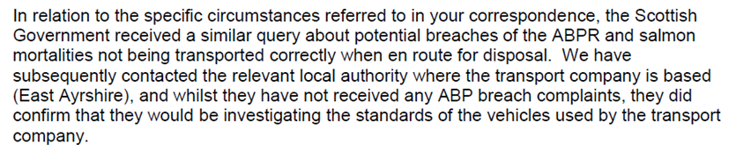

Letter from the Animal & Plant Health Agency (9 January 2018):

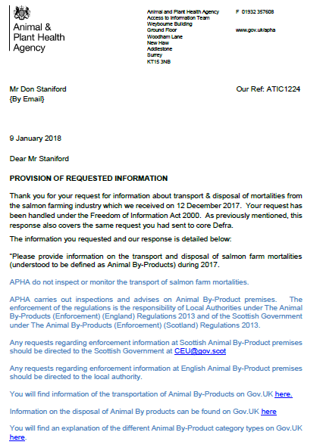

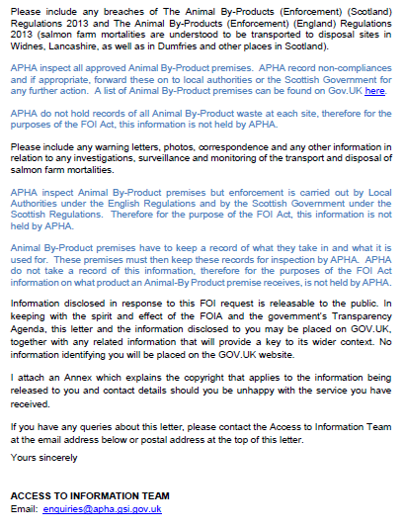

Letter from Police Scotland (10 January 2018):

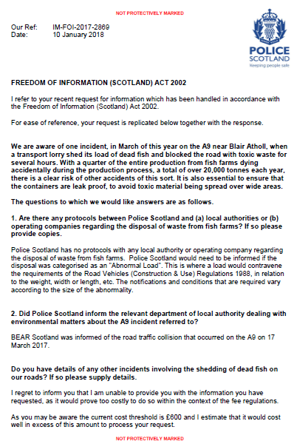

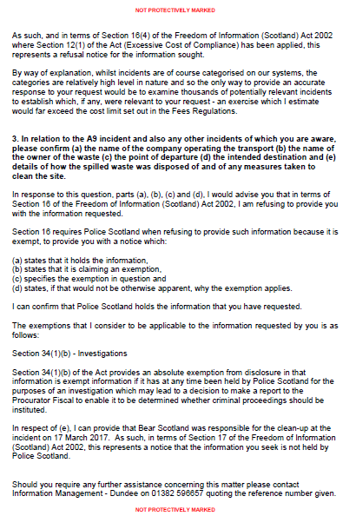

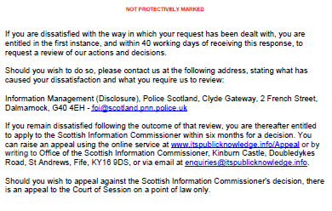

Here's the FOI requests filed by GAAIA with local authorities in December 2017:

From: Don Staniford [mailto:salmonfarmingkills@gmail.com]
Sent: 12 December 2017 08:26
To: 'foi@highland.gov.uk'
Subject: FOI re. transport & disposal of morts from the salmon farming industry during 2017

Please provide information on the transport and disposal of salmon farm mortalities (understood to be defined as Animal By-Products) during 2017.

Please include any breaches of The Animal By-Products (Enforcement) (Scotland) Regulations 2013 and The Animal By-Products (Enforcement) (England) Regulations 2013 (salmon farm mortalities are understood to be transported to disposal sites in Widnes, Lancashire, as well as in Dumfries and other places in Scotland).

Please include any warning letters, photos, correspondence and any other information in relation to any investigations, surveillance and monitoring of the transport and disposal of salmon farm mortalities.

Guidance issued by the Department for Environment, Food & Rural Affairs and Animal and Plant Health Agency in 2014 stated under 'Vehicle Hygiene & Storage': "When you’re transporting animal by-products (ABPs) or any ABP derived products, you must make sure you: use vehicles and containers that are covered and leak-proof..... If you leak ABPs in transport, you may be prosecuted by local authorities."

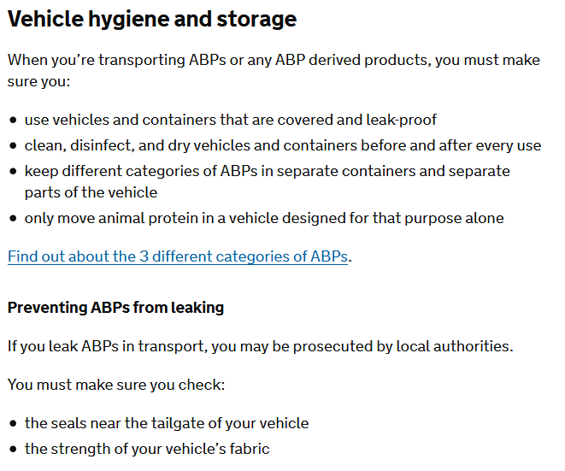

Online via https://www.gov.uk/guidance/transporting-animal-by-products

The Global Alliance Against Industrial Aquaculture (GAAIA) believes that there are a number of potential breaches of the Animal By-Products (Enforcement) (Scotland) Regulations 2013 - including a case featured last night by the BBC's The One Show (see enclosed query/complaint enclosed below for more details).

Please consider this a request for information under the relevant Freedom of Information and Environmental Information Regulations including both the Freedom of Information (Scotland) Act 2002 and the Environmental Information (Scotland) Regulations 2004 (as well as any other new or other regulations which may be appropriate).

Please provide this information electronically via email.

Please acknowledge receipt of this FOI request.

Many thanks and I look forward to a response shortly.

Best fishes,

Don

Don Staniford

Director, Global Alliance Against Industrial Aquaculture (GAAIA): http://www.salmonfarmingkills.com

Read my blog via http://donstaniford.typepad.com/my-blog

<((((º>`·.¸¸.·´¯`·.¸.·´¯`·...¸><((((º>¸.
·´¯`·.¸. , . .·´¯`·.. ><((((º>`·.¸¸.·´¯`·.¸.·´¯`·...¸><((((º>

Dumfries & Galloway Council replied on 12 January 2018:

"Dumfries and Galloway Council's Environmental Standards can advise that, in accordance with Regulation 10(4)(a) of the Environmental Information (Scotland) Regulations 2004, they do not hold any information in relation to your request."

Argyll & Bute Council replied on 11 January 2018:

"No such information is held by the Council and as such I must refuse your request in terms of Regulation 10(4)(a) of the EIRs. We did not receive any reports of breaches of this legislation during 2017; we don’t have the resources to carry out any monitoring or surveillance of these activities, we didn’t carry out any investigations into these activities in 2017. Therefore I have to advise that the information you requested is information not held by the Council and as such I must refuse your request in terms of Regulation 10(4)(a) of the EIRs."

Orkney Islands Council replied on 11 January 2018:

"Orkney Islands Council holds no information on the transport and disposal of salmon farm mortalities, nor have we received any allegations or complaints alleging any breaches of The Animal By-Products (Enforcement) (Scotland) Regulations 2013 and The Animal By-Products (Enforcement) (England) Regulations 2013 with respect to our premises."

Orkney Islands Council previously replied on 21 December 2017:

"The Environmental Health Department is not aware of any breaches of the Animal By-Products (Enforcement) (Scotland) Regulations 2013 in relation to the salmon industry in Orkney. From routine food hygiene visits to the one approved processing plant in Orkney all fish by-products (mainly intestines and other internal organs from the gutting process) are collected in sealed tanks and then transported for suitable disposal. Very few fish die from damage before they are stunned and gutted."

Comhairle nan Eilean Siar replied on 22 December 2017:

"Morts transported by carriers registered with APHA and landfilled on islands or transported to approved premises on the mainland. No confirmed breaches. Swabs from a road surface in the area were sampled to determine whether the cause of multiple traffic incidences at that location was related to an alleged spillage of fish waste from tanker transport. Results showed no signs of fish oil present."

Shetland Isles Council replied on 20 December 2017:

"The tonnage is 119.420 and came from two companies. The two annual waste transfer notes are attached. Shetland Islands Council have had no breaches of the regulations as requested. Shetland Islands Council has not had to issue any warning letters, complete any investigations, surveillance or monitoring in regard to the transport and disposal of salmon farm mortalities."

[2] Here's a letter to GAAIA from the Scottish Government dated 17 January 2018:

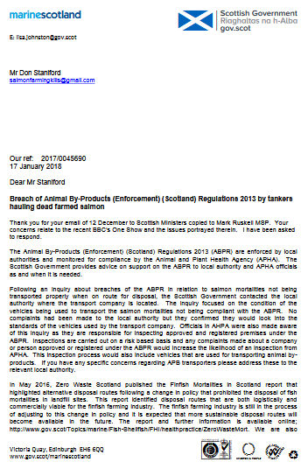

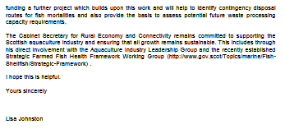
Download as a PDF online here

Here's a letter to GAAIA from the Scottish Government dated 15 January 2018:

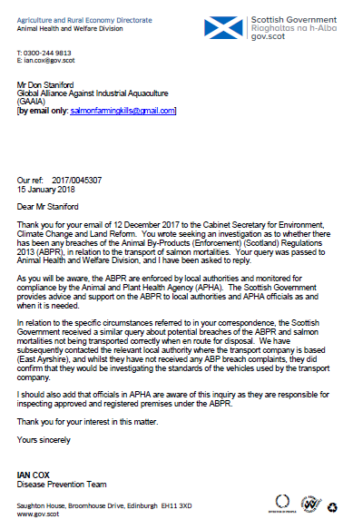

Download as a PDF online here

Here's GAAIA email of 12 December 2017:

From: Don Staniford [mailto:salmonfarmingkills@gmail.com]
Sent: 12 December 2017 07:35
To: 'scottish.ministers@gov.scot'
Cc: 'Ruskell M (Mark), MSP'
Subject: Breach of Animal By-Products (Enforcement) (Scotland) Regulations 2013 by tankers hauling dead farmed salmon?

Following the BBC's broadcast of images of wastes leaking from a haulage truck transporting dead and diseased farmed salmon from Loch Kishorn via Fort William to Dumfries (believed to be the Dundas Chemical Co at Mosspark), the Global Alliance Against Industrial Aquaculture (GAAIA) is concerned that the Animal By-Products (Enforcement) (Scotland) Regulations 2013 have been breached.

Guidance issued by the Department for Environment, Food & Rural Affairs and Animal and Plant Health Agency in 2014 stated under 'Vehicle Hygiene & Storage': "When you’re transporting animal by-products (ABPs) or any ABP derived products, you must make sure you: use vehicles and containers that are covered and leak-proof..... If you leak ABPs in transport, you may be prosecuted by local authorities."

Online via https://www.gov.uk/guidance/transporting-animal-by-products

It is abundantly clear from the BBC footage broadcast last night (starts at 3 minutes 22 seconds) that there is leakage from at least one of the haulage tankers (operated by Billy Bowie: http://billybowietankers.co.uk/):

"What I'm seeing here is shocking but it isn't illegal nor uncommon," says BBC reporter Joe Crowley as he is driving behind the Billy Bowie tankers/trucks. "OK, the tanker and the first skipper-lorry have just left the salmon farm and they're both full of salmon. In fact, I can see some horrible fluid coming out of the back of one of them and it smells vile"

Surely this is not "leak proof" and therefore constitutes a breach of the Animal By-Products (Enforcement) (Scotland) Regulations 2013?

When questioned by the BBC's One Show, the Scottish Government's Fish Health Inspectorate gave the following information:

1 Mortalities.

1.1 Are you (FHI) able to disclose the approximate total quantity of mortalities transshipped or proposed to be transshipped from Kyle pier for disposal during this present case? If you are unable to do so, when would you anticipate such disclosure might be made?

The FHI do not hold details of total numbers of mortalities removed from site for disposal. Animal by-product disposal is regulated by the Animal and Plant Health Agency (APHA), further details can be found here https://www.gov.uk/guidance/transporting-animal-by-products
The FHI may record details of increased or unexplained mortalities occurring at aquaculture sites as part of routine inspections. Details of increased or unexplained mortalities are held within case information which is published on a quarterly basis. As well as case information and inspection reports, a list of all sites inspected during the quarter is published. Further details can be found here http://www.gov.scot/Topics/marine/Fish-Shellfish/FHI/CaseInformation
If or when information is held by the FHI as part of our surveillance in relation to this issue it would be released as part of our quarterly publication process.

1.2 Are you able to disclose the site from which the aforementioned morts originate, and if you are unable to do so, when would you anticipate such disclosure might be made?

To our knowledge the waste in the sealed containers originated from fish farm sites in Loch Kishorn.

1.3 Are you able to disclose the possible cause(s) of the mortalities and if unable to do so, when would you anticipate such disclosure might be made?

Mortality information provided to the FHI from farms in Loch Kishorn assign mortalities due to gill pathology, cardiomyopathy syndrome (CMS) and anaemia. In addition, any case information recorded during routine surveillance at the fish farm sites in Loch Kishorn will be published as described.

2 Transportation Matters. Under the Aquatic Animal Health Regulations, I understand that authorisation is required from FHI for “the movement of any aquaculture animal or any aquaculture animal product into or out of the area in respect of which the business operates”.

As stated previously, the Aquaculture Production Businesses are authorised to operate under the Aquatic Animal Health (Scotland) Regulations 2009. As part of this authorisation it is a condition that a record is maintained of the movement of any aquaculture animal or any aquaculture animal product into or out of the area in respect of which the business operates. Only when an initial or confirmed designation notice is in place to control a listed or emerging disease would authorisation be required for the movement of any aquaculture animal or product thereof into or out of the area covered by the notice.

2.1 Are you aware of the level of bio-security maintained by the vehicles used in the transportation of morts generally?
2.2 Is the bio-security of vehicles governed by regulation, or is it self regulatory?
2.3 Is there a minimum specification for the container units of vehicles carrying morts for Category 1 Disposal?
2.4 Are the vehicles used certified as compliant in terms of bio-security and if so what checks are made to ensure continued compliance?

Aquaculture Production Businesses work to the requirements of the Industry’s Code of Good Practice which includes developing and implementing a veterinary health and welfare plan and biosecurity plan. All businesses authorised to operate under the Aquatic Animal Health (Scotland) Regulations 2009 must have in place a biosecurity measures plan to ensure that the operation of the business does not lead to an unacceptable risk of spreading disease.

As stated previously the regulation of animal by-product disposal is undertaken by APHA. As far as the FHI are aware there is no category 1 waste being disposed of by Scottish fish farms. Please contact APHA for details of category 1 animal by-product disposal.

2.5 Are authorisations for movement always granted in advance of the movement of morts? If that is not the case please explain why.

As stated previously aquaculture production businesses maintain records of the disposal of aquaculture animal products, which are made available for inspection during routine surveillance. Only when an initial or confirmed designation notice is in place to control a listed or emerging disease would authorisation be required for the movement of any aquaculture animal or product thereof into or out of the area covered by the notice.

We hope this has clarified your questions on animal by-product waste disposal from aquaculture sites.

Regards,
Andrew Mayes
Fish Health Inspector | Aquaculture & Fish Health
Marine Scotland - Science
Scottish Government | Marine Laboratory | 375 Victoria Road | Aberdeen | AB11 9DB
Tel: +44 (0)1312 444 010
S/B: +44 (0)1312 442 500
E-mail: andrew.mayes@gov.scot
w: http://www.gov.scot/Topics/marine

[Please note that the Fish Health Inspectorate's Case Information does not currently provide data beyond June 2017]

In November 2016, a Parliamentary Question filed by Mark Ruskell MSP asked "where and by whom containers of diseased salmon morts are checked for biosecurity compliance during their journey from farm to final disposal, and how many such journeys have taken place in each of the last three years".

"Vehicles used for transporting salmon morts to a disposal site must be approved or registered under the Animal By-Products (Enforcement) (Scotland) Regulations 2013 (ABPR)," replied Fergus Ewing, Cabinet Secretary for the Rural Economy and Connectivity, in December 2016. "The operators of these vehicles must ensure that salmon morts be collected and transported in sealed new packaging or covered leak-proof containers."

Another Parliamentary Question and reply in November 2016 also stressed when transporting Animal By-Products transporters must ensure that they "use vehicles and containers that are covered and leak-proof".

The Loch Kishorn case captured on camera by the BBC is surely not an isolated incident and may represent industry-wide malpractice.

In November 2017, the Scottish Salmon Think Tank Tweeted:
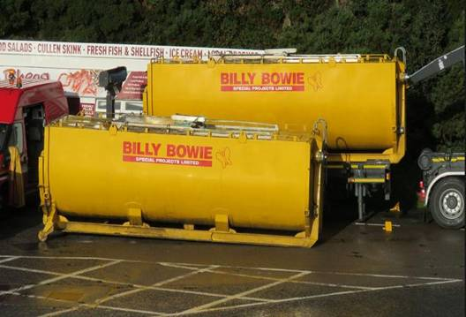
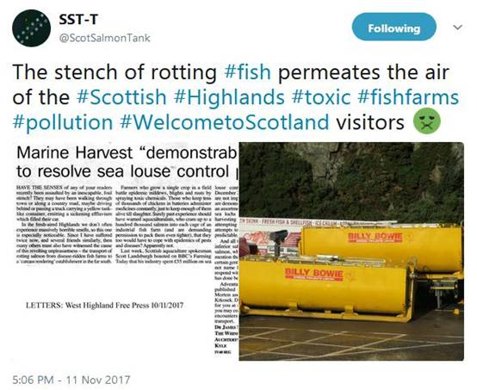
The Scottish Think Tank reported:
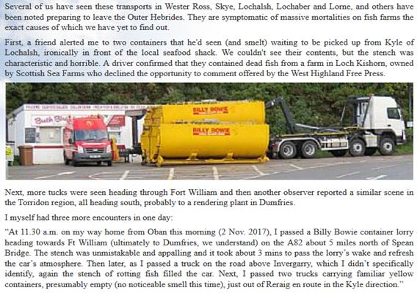
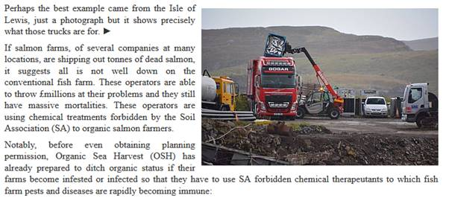

Other incidents where leakage from haulage trucks/tankers has taken place are understood to have taken place in the Western Isles where mass mortalities in recent months have led to the leakage of "slime" onto the road (the company involved is understood to have been Gogar Logistics).

Apparently there is photographic evidence and Comhairle nan Eilean Siar may have come out to clean up after the leakage. The only information GAAIA has at the moment (although we will be filing FOIs) is this snippet from a concerned citizen:

The trucking company (at least from the pic I have seen) taking fish from L Erisort is Gogar. A local informed me that recently there were cases (within a v short time period) of cars (at least half a dozen) going off the road on the main Stornoway road just north of the junction with the minor road from L Erisort. I understand this was due to fish waste and slime on the road surface. Apparently the council came out to disperse it.

If GAAIA receives further details I will forward.

BBC News reported in October 2017: "About 125,000 salmon have died due to a disease outbreak at two fish farms on the Isle of Lewis, BBC Scotland has learned. Marine Harvest confirmed that the sites in Loch Erisort have been hit by the bacterium Pasturella Skyensis" (read more via "125,000 salmon die in disease outbreak at Lewis fish farms").

BBC News reported earlier in October 2017: "Lorry loads of dead fish are being collected from a sea loch on the Isle of Lewis after suffering a bacterial infection, the BBC understands.....Locals have raised concerns about the smell of rotting fish at the shore" (read more via "Thousands of salmon on Lewis killed by infection").

More background is available via:
Press Release: "Millions of Scottish Salmon Going Up in Smoke"
BBC's The One Show: "The Dead Salmon Run"

In conclusion, could you please investigate whether there has been a breach or breaches of the Animal By-Products (Enforcement) (Scotland) Regulations 2013 in relation to the transport of salmon morts?

Please feel free to pass this query/complaint onto the appropriate person or agency.

Any follow up information would be much appreciated.

Yours sincerely,

Don Staniford

Director, Global Alliance Against Industrial Aquaculture (GAAIA): http://www.salmonfarmingkills.com

Read my blog via http://donstaniford.typepad.com/my-blog

<((((º>`·.¸¸.·´¯`·.¸.·´¯`·...¸><((((º>¸.
·´¯`·.¸. , . .·´¯`·.. ><((((º>`·.¸¸.·´¯`·.¸.·´¯`·...¸><((((º>

[3] Here's a letter from Mark Ruskell MSP to the Cabinet Secretary dated 13 December 2017:

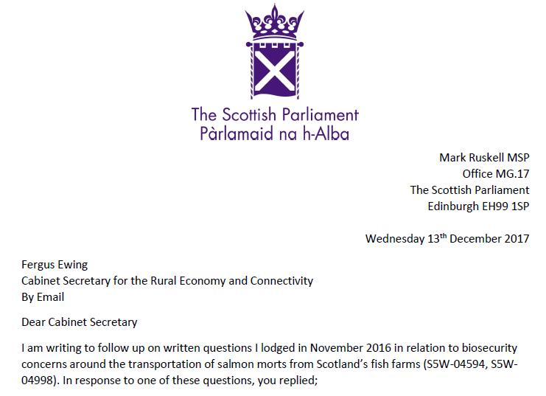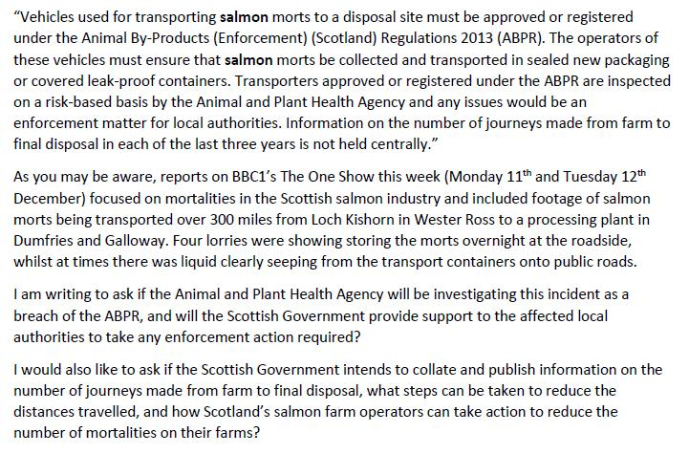
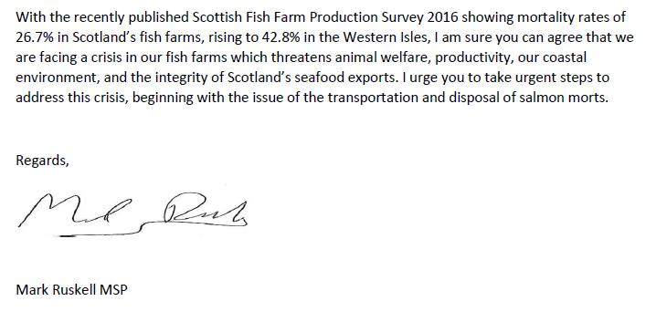
Download letter as a PDF online here
Read more via "First Minister questioned on leaking wastes from morts - call for a moratorium from Greens"

Here's the reply dated 10 January 2018 from Fergus Ewing:

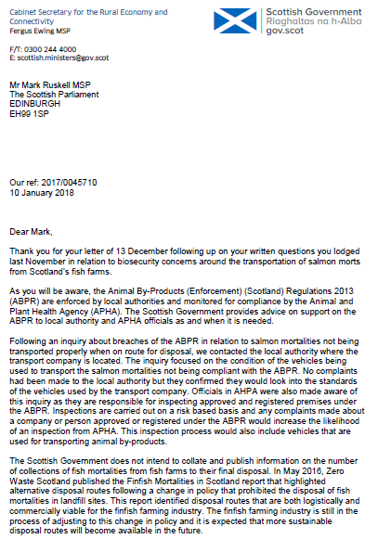

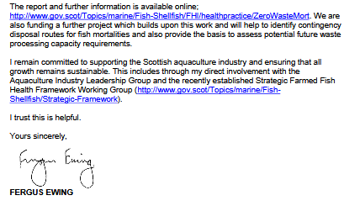

[4] Email from GAAIA to SEPA's CEO Terry A'Hearn:

From: Don Staniford [mailto:salmonfarmingkills@gmail.com]
Sent: 15 December 2017 14:28
To: 'terry.ahearn@sepa.org.uk'
Cc: 'andrew.rosie@sepa.org.uk'; 'douglas.sinclair@sepa.org.uk'; 'hazel.macleod@sepa.org.uk'; 'stuart.baird@sepa.org.uk'; 'michael.montague@sepa.org.uk'; 'janet.davies@sepa.org.uk'; 'Mackinnon, Alison'; 'mark.wells@sepa.org.uk'; 'kevin.macnaught@sepa.org.uk'; 'lorraine.moffat@sepa.org.uk'; 'Anderson, Anne'; 'jenny.faichney@sepa.org.uk'; 'rdixon@foe-scotland.org.uk'; 'bob@bdownes.com'; 'margaret.mclean@sepa.org.uk'; 'jennifer.mcwhirter@sepa.org.uk'; 'donna.brodie@sepa.org.uk'; 'jo.green@sepa.org.uk'; 'denise.carroll@sepa.org.uk'; 'fraser.lovell@sepa.org.uk'; 'Catherine.cunningham@sepa.co.uk'; 'publicrelations@sepa.org.uk'
Subject: Number of farmed salmon morts (2013-2017)?

Terry,

Will you please reconsider SEPA's position of not forcing the disclosure of the number of farmed salmon mortalities?

In view of the recent rise in farmed salmon mortalities - estimated to have doubled in the last four years to perhaps over 20 million - and the ongoing media exposure surely it is incumbent upon SEPA to revise its position?

As context, The Sunday Herald reported in 2013:

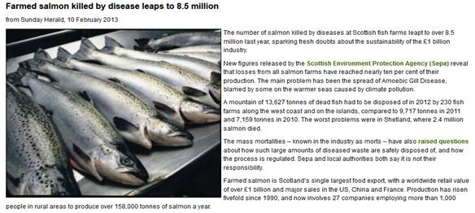

Annual mortality data for 2010-2012 was provided by SEPA:

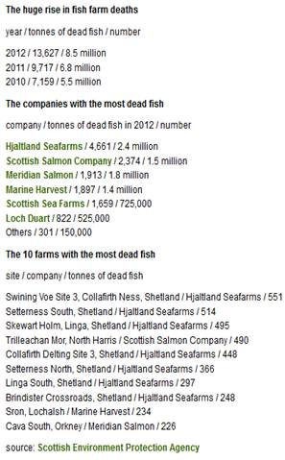

The spreadsheet summarising fish farm mortalities in 2010, 2011 and 2012 released by SEPA can be downloaded here (188KB Excel)

For 2012, here's the worst sites in terms of # of morts:

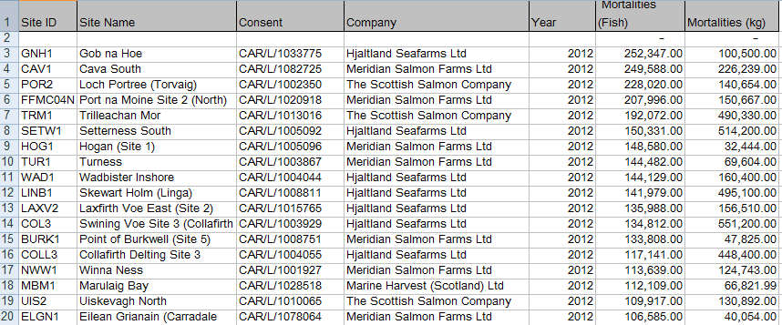

However, later in 2013 SEPA bowed to pressure from the Scottish Salmon Producers Organisation to keep the number of dead salmon secret:

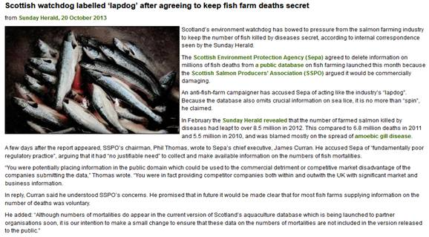

Read more via "Public denied info on full scale of salmon deaths" and "Scottish watchdog labelled ‘lapdog’ after agreeing to keep fish farm deaths secret"

Here's the letter from SSPO Chair, Phil Thomas (download as a PDF online here):

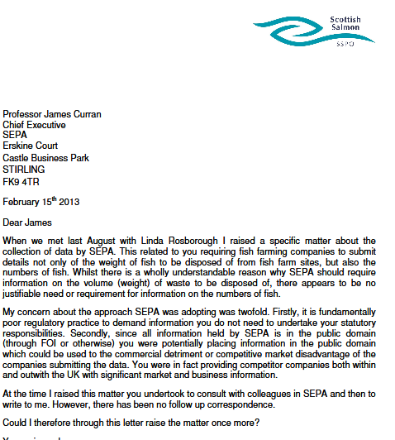

And here's the reply from your predecessor James Curran, Chief Executive of SEPA (download as a PDF online here):

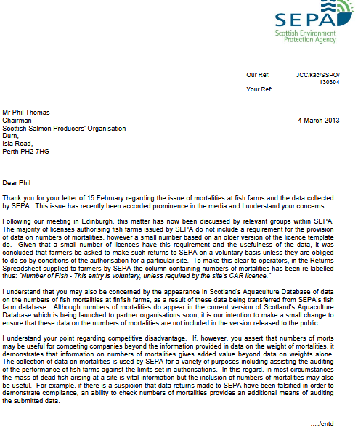

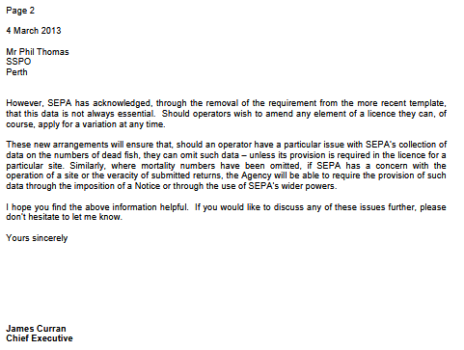

Please note that GAAIA also filed a FOI with SEPA earlier this afternoon asking for information on the number of mortalities since 2012.

A FOI reply from the Scottish Government received on 13 December 2017 discloses some information on mortalities at Marine Harvest sites (detailing 572,488 morts in 56 separate reports/incidents thus far during 2017). Please see attached Excel spreadsheet.

Other FOI requests filed with the Scottish Government have also asked for similar mortality data for sites operated by Scottish Sea Farms and the Scottish Salmon Company.

For more background on Scottish salmon's growing mort mountain please see:

First Minister questioned on leaking wastes from morts - call for a moratorium from Greens
Press Release: "BBC's 'Dead Salmon Run' Opens Can of Worms"
BBC's The One Show (Part 2)
Press Release: "Millions of Scottish Salmon Going Up in Smoke"
BBC's The One Show: "The Dead Salmon Run"

Best fishes,

Don

Don Staniford

Director, Global Alliance Against Industrial Aquaculture (GAAIA): http://www.salmonfarmingkills.com

[5] Despite no official data on the number of morts since 2012, GAAIA has accessed via FOI some data on mort numbers at three salmon farming companies (Scottish Sea Farms, the Scottish Salmon Company and Marine Harvest Scotland) during 2017:
Marine Harvest mort events in 2017
Scottish Salmon Company mort events in 2017
Scottish Sea Farms mort events in 2017

Diseased Mortalities at Scottish Sea Farms:

Scottish Sea Farms mort events in 2017

From: Neil.Purvis@gov.scot [mailto:Neil.Purvis@gov.scot]
Sent: 18 January 2018 15:28
To: salmonfarmingkills@gmail.com
Cc: Helen.McGregor@gov.scot
Subject: FW: FOI - E - FOI re. morts & disease at Scottish Sea Farms during 2017 - Don Staniford

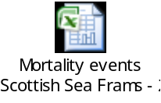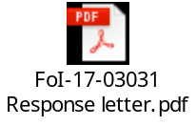

Dear Don,

FoI-17-03031

In response to your request of 14 December 2017 (FoI-1703031) please find the attached response and information provided.

Regards,
Neil

Neil Purvis
Marine Scotland – Science
Scottish Government | Marine Laboratory, PO Box 101| 375, Victoria Road | Aberdeen AB11 9DB
Tel: +44 (0)131 244 3287
S/B: +44 (0)131 244 2500
Mob:+44 (0)777 5818 281
Fax: +44 (0)1224 295620
e: neil.purvis@gov.scot
w: http://www.scotland.gov.uk/marinescotland

The Excel spreadsheet details 356,082 morts in 46 separate reports/incidents during 2017 including the following worst cases:

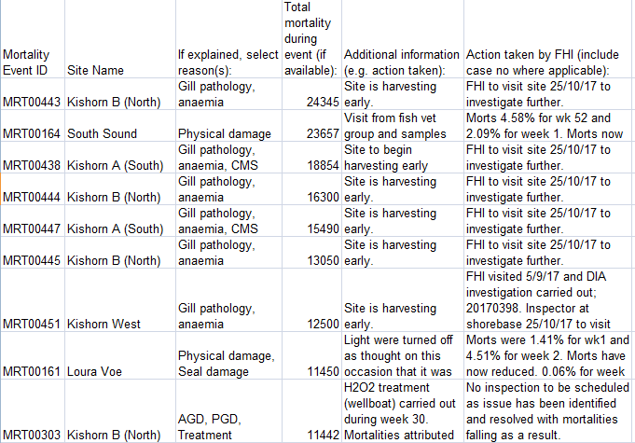
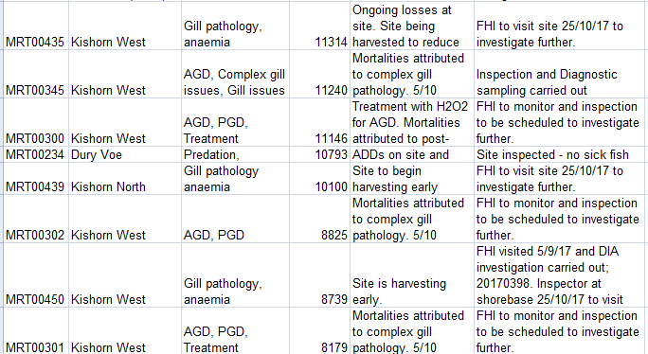

From: Don Staniford [mailto:salmonfarmingkills@gmail.com]
Sent: 14 December 2017 23:24
To: Central Enquiry Unit <CEU@gov.scot>
Subject: FOI re. morts & disease at Scottish Sea Farms during 2017

Please provide information on mortalities and diseases at salmon farms operated by Scottish Sea Farms during 2017.

Please include emails and correspondence with Scottish Sea Farms on the issue of mortalities and diseases - including Mortality Event Reports, Marine Laboratory inspection reports, warning letters, Excel spreadsheets collating data and other information since 1 January 2017.

Please consider this a request for information under the relevant Freedom of Information and Environmental Information Regulations including both the Freedom of Information (Scotland) Act 2002 and the Environmental Information (Scotland) Regulations 2004 (as well as any other new or other regulations which may be appropriate).

Please provide this information electronically via email.

Please acknowledge receipt of this FOI request.

Many thanks and I look forward to a response shortly.

Best fishes,

Don

Don Staniford

Director, Global Alliance Against Industrial Aquaculture (GAAIA): http://www.salmonfarmingkills.com

Read my blog via http://donstaniford.typepad.com/my-blog

<((((º>`·.¸¸.·´¯`·.¸.·´¯`·...¸><((((º>¸.
·´¯`·.¸. , . .·´¯`·.. ><((((º>`·.¸¸.·´¯`·.¸.·´¯`·...¸><((((º>

Since 2014, Scottish Sea Farms has operated three salmon farms in Loch Kishorn.
According to monthly data published via Scotland's Aquaculture web-site, mortality is significant:

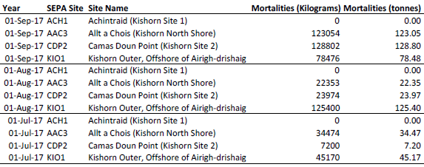

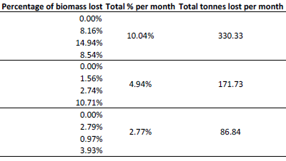

Download as a PDF online here

Please note:

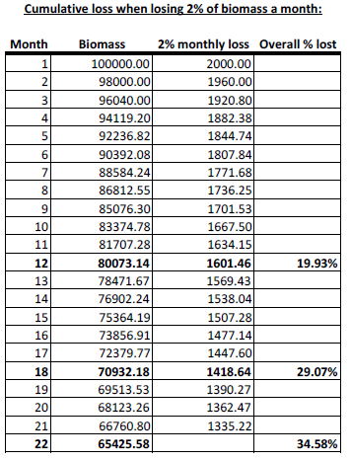

Download as a PDF online here

When questioned by the Scottish Salmon Think Tank, the Scottish Government's Fish Health Inspectorate (Tel: 01312 444 010) gave the following information:

1 Mortalities.

1.1 Are you (FHI) able to disclose the approximate total quantity of mortalities trans-shipped or proposed to be trans-shipped from Kyle pier for disposal during this present case? If you are unable to do so, when would you anticipate such disclosure might be made?

The FHI do not hold details of total numbers of mortalities removed from site for disposal. Animal by-product disposal is regulated by the Animal and Plant Health Agency (APHA), further details can be found here
https://www.gov.uk/guidance/transporting-animal-by-products

The FHI may record details of increased or unexplained mortalities occurring at aquaculture sites as part of routine inspections. Details of increased or unexplained mortalities are held within case information which is published on a quarterly basis. As well as case information and inspection reports, a list of all sites inspected during the quarter is published. Further details can be found here
http://www.gov.scot/Topics/marine/Fish-Shellfish/FHI/CaseInformation

If or when information is held by the FHI as part of our surveillance in relation to this issue it would be released as part of our quarterly publication process.

1.2 Are you able to disclose the site from which the aforementioned morts originate, and if you are unable to do so, when would you anticipate such disclosure might be made?

To our knowledge the waste in the sealed containers originated from fish farm sites in Loch Kishorn.

1.3 Are you able to disclose the possible cause(s) of the mortalities and if unable to do so, when would you anticipate such disclosure might be made?

Mortality information provided to the FHI from farms in Loch Kishorn assign mortalities due to gill pathology, cardiomyopathy syndrome (CMS) and anaemia. In addition, any case information recorded during routine surveillance at the fish farm sites in Loch Kishorn will be published as described.

[Please note that the Fish Health Inspectorate's Case Information does not currently provide data beyond June 2017]

Diseased Mortalities at the Scottish Salmon Company:
Scottish Salmon Company mort events in 2017

From: Neil.Purvis@gov.scot [mailto:Neil.Purvis@gov.scot]
Sent: 18 January 2018 15:27
To: salmonfarmingkills@gmail.com
Cc: Helen.McGregor@gov.scot
Subject: FW: FOI - E - FOI re. morts & disease at Scottish Salmon Company during 2017 - Don Staniford

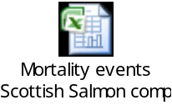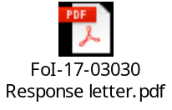

Dear Don,

FoI-17-03030

In response to your request of 14 December 2017 (FoI-1703030) please find the attached response and information provided.

Regards,
Neil

Neil Purvis
Marine Scotland – Science
Scottish Government | Marine Laboratory, PO Box 101| 375, Victoria Road | Aberdeen AB11 9DB
Tel: +44 (0)131 244 3287
S/B: +44 (0)131 244 2500
Mob:+44 (0)777 5818 281
Fax: +44 (0)1224 295620
e: neil.purvis@gov.scot
w: http://www.scotland.gov.uk/marinescotland

The Excel spreadsheet details 1,512,077 morts in 131 separate reports/incidents during 2017 including the following worst cases:

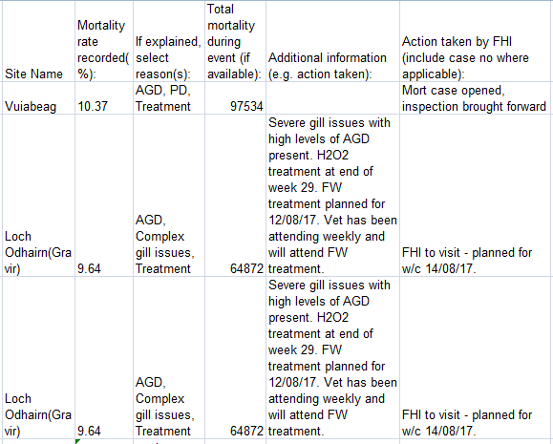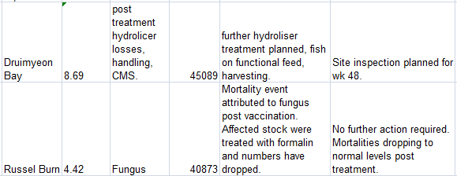
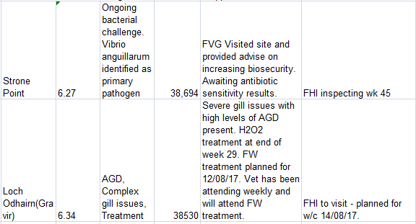

From: Don Staniford [mailto:salmonfarmingkills@gmail.com]
Sent: 14 December 2017 23:25
To: Central Enquiry Unit <CEU@gov.scot>
Subject: FOI re. morts & disease at Scottish Salmon Company during 2017

Please provide information on mortalities and diseases at salmon farms operated by the Scottish Salmon Company during 2017.

Please include emails and correspondence with the Scottish Salmon Company on the issue of mortalities and diseases - including Mortality Event Reports, Marine Laboratory inspection reports, warning letters, Excel spreadsheets collating data and other information since 1 January 2017.

Please consider this a request for information under the relevant Freedom of Information and Environmental Information Regulations including both the Freedom of Information (Scotland) Act 2002 and the Environmental Information (Scotland) Regulations 2004 (as well as any other new or other regulations which may be appropriate).

Please provide this information electronically via email.

Please acknowledge receipt of this FOI request.

Many thanks and I look forward to a response shortly.

Best fishes,

Don

Don Staniford

Director, Global Alliance Against Industrial Aquaculture (GAAIA): http://www.salmonfarmingkills.com

Read my blog via http://donstaniford.typepad.com/my-blog

<((((º>`·.¸¸.·´¯`·.¸.·´¯`·...¸><((((º>¸.
·´¯`·.¸. , . .·´¯`·.. ><((((º>`·.¸¸.·´¯`·.¸.·´¯`·...¸><((((º>

Diseased Mortalities at Marine Harvest Scotland:

Marine Harvest mort events in 2017

From: Neil.Purvis@gov.scot [mailto:Neil.Purvis@gov.scot]
Sent: 13 December 2017 16:46
To: salmonfarmingkills@gmail.com
Cc: Helen.McGregor@gov.scot
Subject: FOI - E - morts & disease at Marine Harvest during 2017 - Don Staniford (FoI/17/0772)

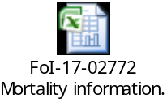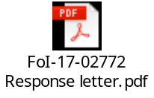

Dear Don,

Please see attached in response to your request of 14 November 2017.

Regards,

Neil

Neil Purvis
Marine Scotland – Science
Scottish Government | Marine Laboratory, PO Box 101| 375, Victoria Road | Aberdeen AB11 9DB
Tel: +44 (0)131 244 3287
S/B: +44 (0)131 244 2500
Mob:+44 (0)777 5818 281
Fax: +44 (0)1224 295620
e: neil.purvis@gov.scot
w: http://www.scotland.gov.uk/marinescotland

The Excel spreadsheet details 572,488 morts in 56 separate reports/incidents during 2017 including the following worst cases:

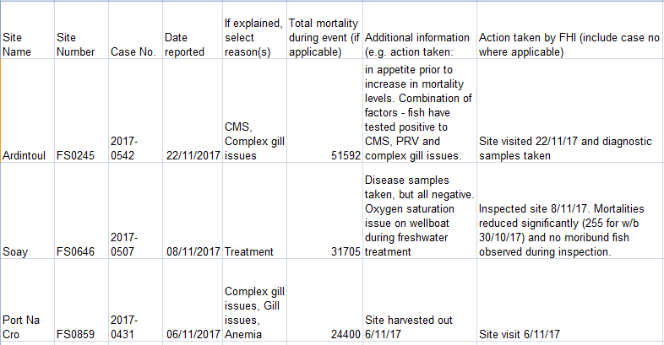
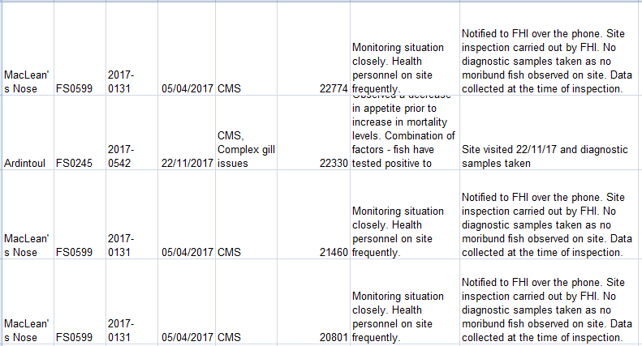
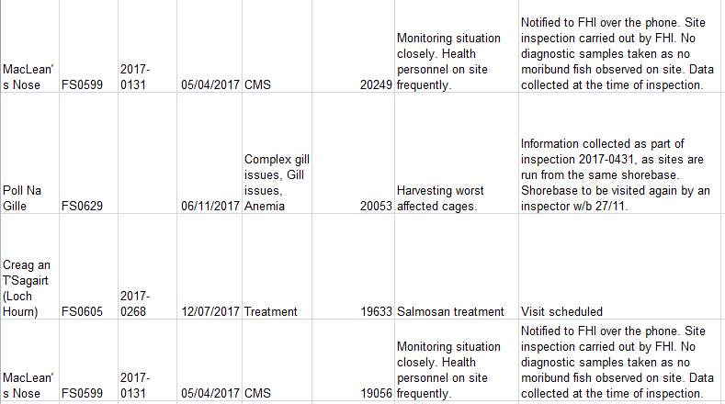

Another document details how Marine Harvest is experiencing increasing problems with mortalities linked to anaemia (not suspected to be linked to ISA), complex gill issues and cardiomyopathy syndrome (CMS):

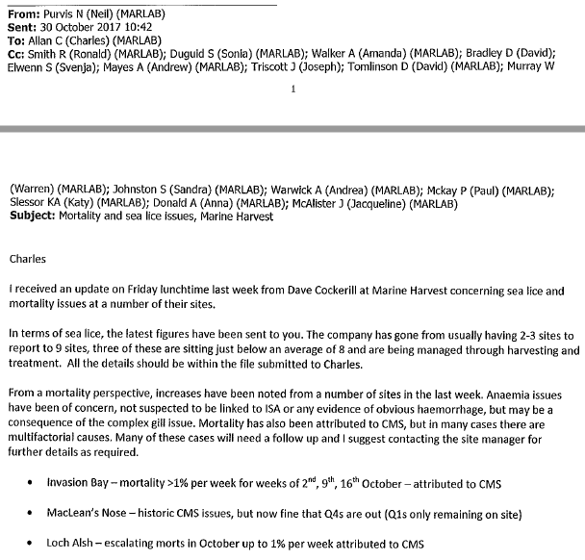
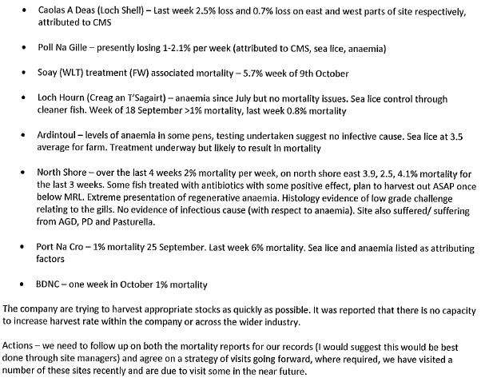

Marine Harvest's mort mountain is plugging into the National Grid (read more via "Energy from dead salmon horrifies vegan activists" and "Vegans in shock at fish electricity: Energy firm SSE admitted generating power from dead salmon earlier this year"):

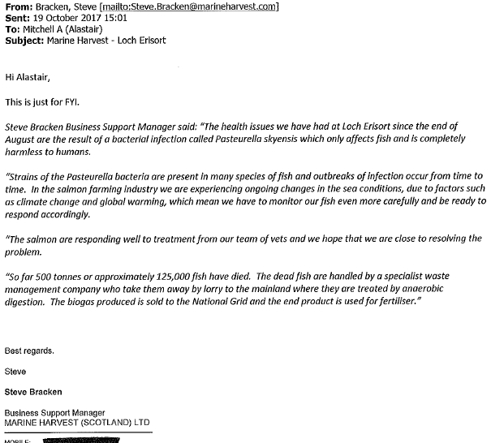

From: Don Staniford [mailto:salmonfarmingkills@gmail.com]
Sent: 14 November 2017 14:35
To: Central Enquiry Unit <CEU@gov.scot>
Subject: FOI re. morts & disease at Marine Harvest during 2017

Please provide information on mortalities and diseases at Marine Harvest fish farms during 2017.

Please include emails and correspondence with Marine Harvest on the issue of mortalities and diseases - including Mortality Event Reports, Marine Laboratory inspection reports, warning letters and other information since 1 January 2017.

As background, a Tweet dated 10 November 2017 included:
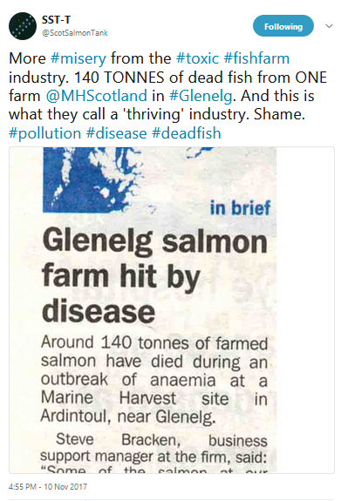

Here's the West Highland Free Press article from 10 November 2017:

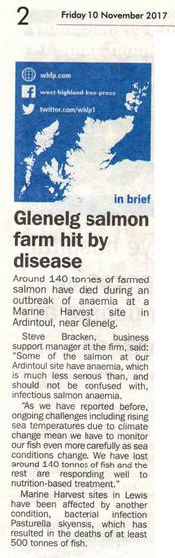

Other media reports refer to mortalities and diseases at other Marine Harvest salmon farms - including:

BBC News (20 October 2017):

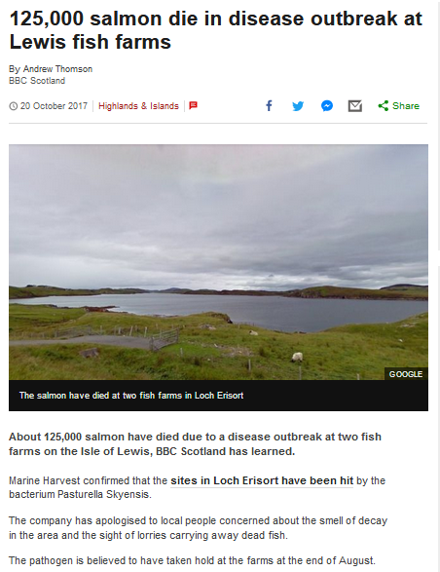

The Sunday Herald (8 October 2017):

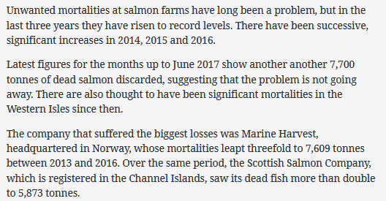

Marine Harvest also reported high mortality at Loch Hourn and MacLean's Nose in June 2017:

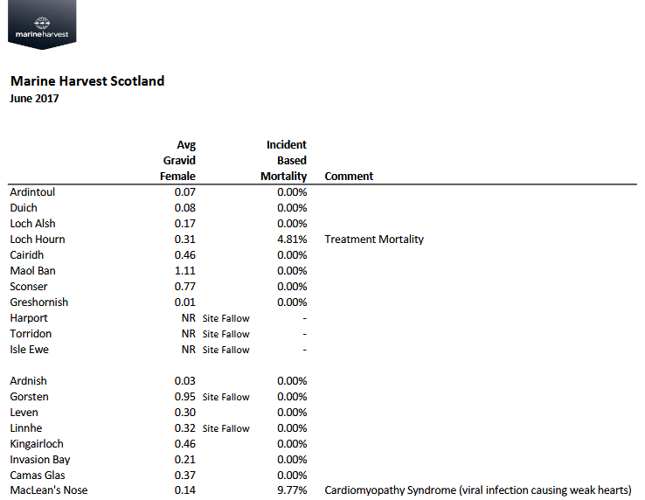

And Marine Harvest reported high mortality in April 2017 at Loch Alsh:

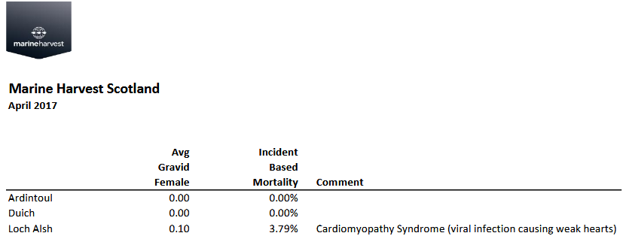

In February 2017, the Scottish Government also disclosed "Information on mortalities and disease problems at Marine Harvest during 2016".

Please consider this a request for information under the relevant Freedom of Information and Environmental Information Regulations including both the Freedom of Information (Scotland) Act 2002 and the Environmental Information (Scotland) Regulations 2004 (as well as any other new or other regulations which may be appropriate).

Please provide this information electronically via email.

Please acknowledge receipt of this FOI request.

Many thanks and I look forward to a response shortly.

Best fishes,

Don

Don Staniford

Director, Global Alliance Against Industrial Aquaculture (GAAIA): http://www.salmonfarmingkills.com

Read my blog via http://donstaniford.typepad.com/my-blog

<((((º>`·.¸¸.·´¯`·.¸.·´¯`·...¸><((((º>¸.
·´¯`·.¸. , . .·´¯`·.. ><((((º>`·.¸¸.·´¯`·.¸.·´¯`·...¸><((((º>

[6] Information published online by the Directorate of Fisheries:

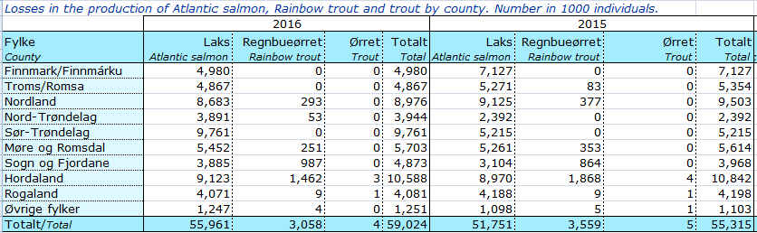

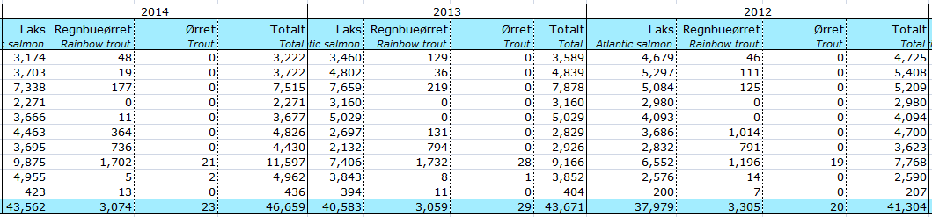

Download Excel spreadsheet via Tap i produksjonen 1997-2016

[7] Extract from Scottish Salmon Farming 101 (January 2018):

8) Mass mortalities leapt to over 20,000 tonnes (an estimated 20 million fish) in 2017:

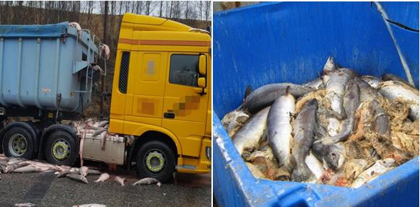

Read more via "Millions of Scottish Salmon Going Up in Smoke" and "Scottish Salmon's Lethal Legacy"

12) Wastes are leaking from haulage trucks transporting dead farmed salmon:

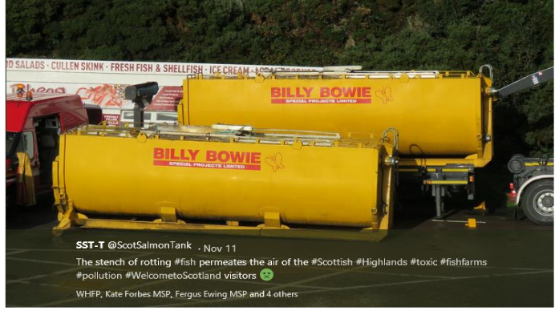

Read more via "First Minister questioned on leaking wastes from morts - call for a moratorium from Greens" and "BBC's 'Dead Salmon Run' Opens Can of Worms"

9) Amoebic Gill Disease, Infectious Pancreatic Necrosis, Furunculosis, Infectious Salmon Anaemia, Pancreas Disease and other deadly diseases have ravaged Scottish salmon farms killing millions of fish:

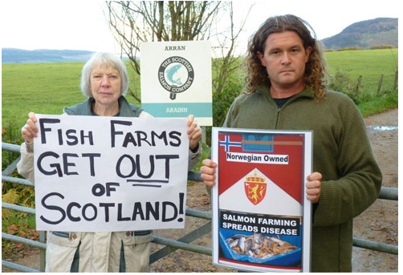

Read more via "Gill Diseases: Scottish Salmon's Dirty Big Secret"; "Infectious pancreatic necrosis virus in Scottish Atlantic salmon farms, 1996–2001"; "An outbreak of disease resembling heart and skeletal muscle inflammation in Scottish farmed salmon, Salmo salar L., with observations on myocardial regeneration"; "Surveillance for infectious salmon anaemia virus HPR0 in marine Atlantic salmon farms across Scotland"; "Analysis of a company's production data to describe the epidemiology and persistence of pancreas disease in Atlantic salmon (Salmo salar L.) farms off Western Scotland" and "Cardiomyopathy syndrome in farmed Scottish salmon"

Pasteurella skyensis killed 125,000 farmed salmon in Loch Erisort in 2017:
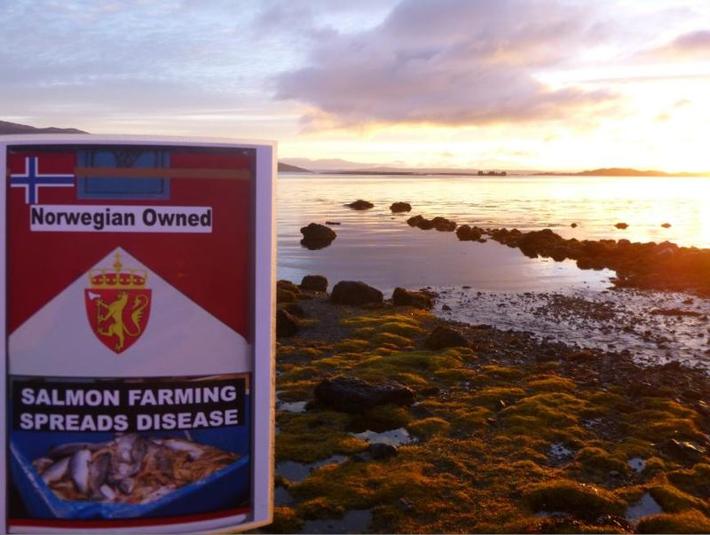
Read more via "125,000 salmon die in disease outbreak at Lewis fish farms"; "Disease kills 125,000 salmon on Lewis fish farm"; "Campaigners say 'no more salmon farms' after disease on Lewis kills 125,000 fish"; "Pasteurella skyensis sp. nov., isolated from Atlantic salmon (Salmo salar L.)" and "Characterization of two groups of Pasteurella skyensis isolates from Atlantic salmon, Salmo salar L., based on serotype and 16S rRNA and rpoB gene partial sequences"

51) Nearly 100,000 farmed salmon were 'Thermoliced' to death by Marine Harvest during 2016:
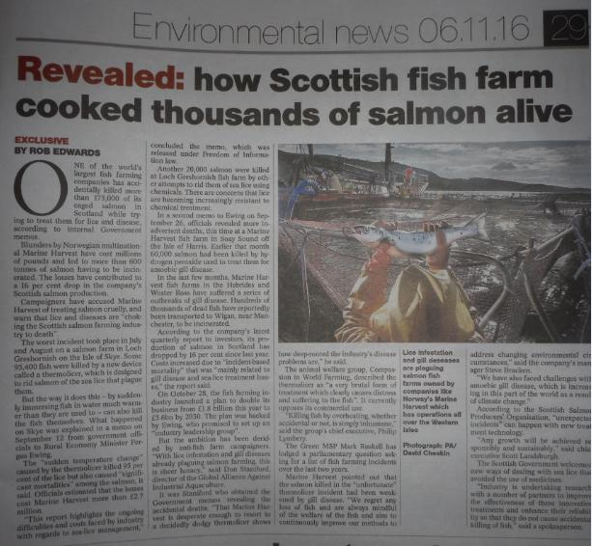
Read more via "'Thermolicer' Back-Fires Killing 95,400 Farmed Salmon"; Fish farm firm kills 175,000 salmon by accident; "Oops: fish farm firm kills 175,000 of its salmon by accident" and "Thousands of fish poached alive in lice treatment bungle"

52) A Thermolicer treatment caused the deaths of 5,794 salmon at Grieg Seafood Shetland’s North Havra site in November 2016:

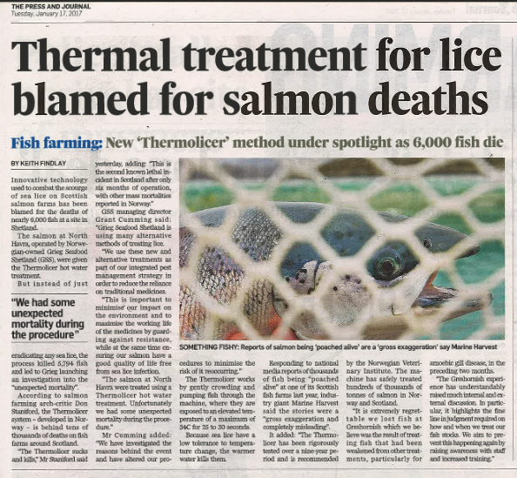

Read more via "Thermal treatment for lice blamed for salmon deaths" and "Treatment leads to morts in Shetland"

53) Scottish salmon farms represent a welfare nightmare with mass mortalities, high stocking densities, so-called 'death crowns' due to lice infestation and other problems:

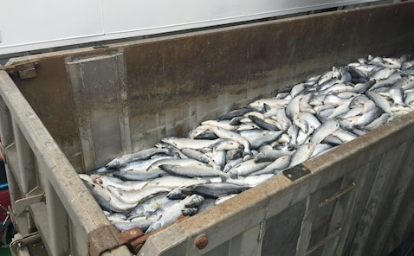

Read more via Compassion In World Farming: Why fish farming needs urgent welfare reform; "Welfare fears after claim deaths of farmed salmon have doubled"; "Closed Waters: the welfare of farmed Atlantic salmon"; "Salmon farming welfare raised at industry event" and "Farmageddon"

55) In December 2016, the Scottish Green Party called for a moratorium on Scottish salmon farming:
Read more via First Minister questioned on leaking wastes from morts - call for a moratorium from Greens
Instead of expanding salmon farming yet further, the Scottish Government should be curbing production and that means immediately closing down disease-ridden salmon farms.
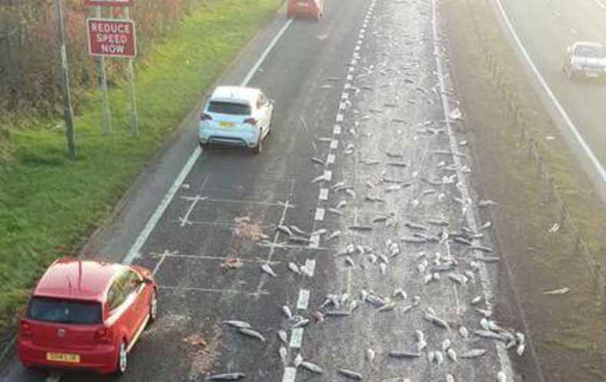
Read more via "Aquaculture Growth to 2030: a strategic plan for farming Scotland's seas"; "New innovation roadmap outlines pathway for Scottish aquaculture growth"; "Scottish Aquaculture: a view towards 2030"; "New strategy launched to 'double' size of aquaculture"; "New Strategy to Double Size of Scotland’s £1.8 billion Aquaculture Sector"; "Call for curb in fish farms as study shows pest risk to wild fish"; "Salmon Farming Moratorium: Letter to the First Minister of Scotland"; "Scotland's salmon farms face strict curbs"
78) SEPA stopped collecting data on the numbers of dead farmed salmon following lobbying from the SSPO in 2013 who claimed publication would be "commercially damaging":
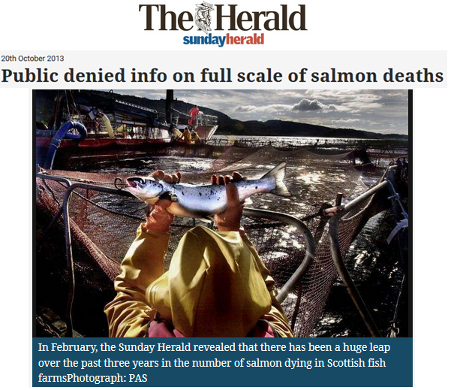
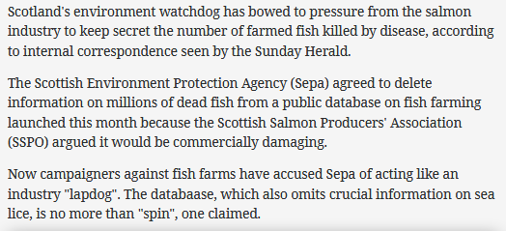

Read more via "Scottish watchdog labelled ‘lapdog’ after agreeing to keep fish farm deaths secret"; "Public denied info on full scale of salmon deaths"; "Environment watchdog ‘gave in to industry’ over dead salmon"; "Farmed salmon killed by disease leaps to 8.5 million"; "Fish farmers 'blocked' vital safety study"; "Salmon firms 'hiding damning reports'" and "Keeping salmon farming problems secret"


94) Mass mortalities from salmon farms are piling up so high that their carcasses are used to generate electricity:

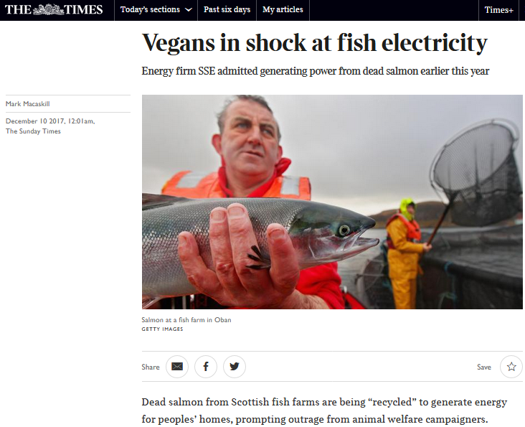

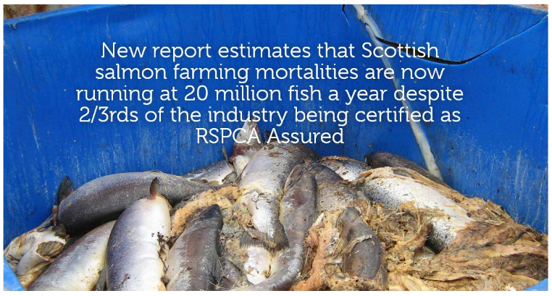

Read more via "Vegans in shock at fish electricity"; "Energy from dead salmon horrifies vegan activists" and "Millions of Scottish Salmon Going Up in Smoke"

