Scottish Salmon Watch, 31 May 2018

Complete Mockery of the Brand 'Scottish Salmon'

- Norway bans import of Scottish salmon eggs citing disease risks & genetic impacts under the Nature Diversity Act
- Scotland ignores "massive risk" of disease & "is now 100% reliant on imported eggs"

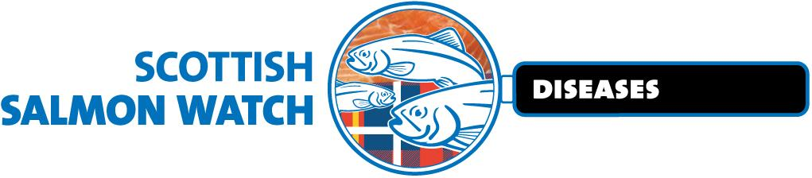

Documents disclosed via Freedom of Information by the Scottish Government (24 May 2018) expose the "complete mockery of the brand 'Scottish Salmon'". In a stinging attack the head of the only independent Scottish salmon egg producer (Landcatch) accused the Scottish Government of taking a "massive risk" by allowing salmon eggs from Norway and Iceland to flood 'Scottish' salmon farms citing the danger of "transfer of ISA from infected countries such as Norway" [1].

Read Exclusively in today's National via "Government 'failing to protect Scottish salmon'"

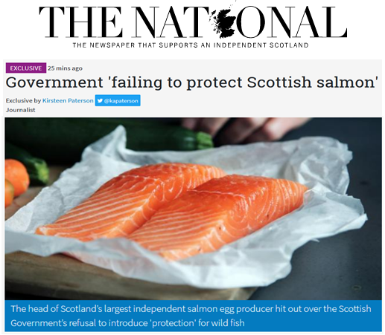
In February 2018, Norway's Ministry of Climate & Environment banned the import of Scottish salmon eggs citing risks of disease and genetic impacts of escapes under the Norwegian Nature Diversity Act.

"This means that the Scottish salmon industry is now 100% reliant on imported eggs - both a massive risk in the event of borders closing for disease issues (and also the transfer of ISA from infected countries such as Norway), but also making a complete mockery of the brand 'Scottish Salmon'," stated the email to Fergus Ewing dated 12 February 2018.

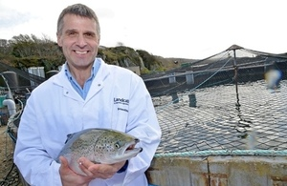

"Phrases other than smart and successful come to mind" wrote Neil Manchester, Managing Director of Hendrix Genetics (owner of Landcatch), in an email to the Cabinet Secretary for Rural Economy & Connectivity pointing out that "the extensive R&D projects conducted between Landcatch and the Universities of Glasgow, Stirling and Edinburgh, once lauded as great examples of Smart Successful Scotland, will now require the involvement of Norwegian breeding companies operating in Norway."

"Farmed salmon with partial Scottish origin increases the likelihood of a negative impact on Norwegian wild populations above negative effects with Norwegian farmed strains," stated the 22-page letter of refusal dated 9 February 2018 from Norway's Ministry of Climate & Environment to Hendrix Genetics. "There is a high probability that genetic mixing between Norwegian wild salmon and farmed salmon of partly Scottish origin will increase the loss of genetic diversity."

"This speaks for the Ministry's view that concern for biodiversity and wild salmon should be given significant weight in the case," continued Norway's Ministry of Climate & Environment. "The Ministry also refers to the value of Norwegian wild salmon as an ecosystem service, or a natural good."

Norway's Deputy Director General at the Ministry of Climate & Environment (Torbjørn Lange) cited a 2017 report by the Norwegian Institute of Nature Research (NINA). "Risk assessment of imports of partly Scottish salmon from Scotland to aquaculture in Norway" - authored by NINA scientists Sten Karlsson and Kjetil Hindar - concluded: "Based on proven genetic distances and that Scottish wild salmon is a separate genetic group different from that found in Norway, fished salmon with partly Scottish origin is considered to have an increased negative effect on wild salmon stocks in Norway."

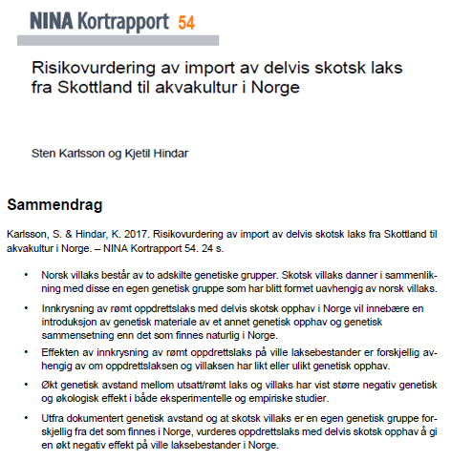

Scottish Salmon Watch filed a Freedom of Information request following a news snippet - "Norway keeps ban on import of Scottish roe" - published in February by Salmon Business which itself triggered a Parliamentary Question from Peter Chapman MSP and a Parliamentary Reply from the Cabinet Secretary for Rural Economy & Connectivity in late February 2018 [2].

"We understand the Norwegian Government are reviewing the decision to ban the import of salmon eggs from Scotland," stated Fergus Ewing on 27 February 2018. "We are in dialogue with the Norwegian Authorities in order to understand the outcome of this review and I will raise the issue at a scheduled meeting with Per Sandberg, Norwegian Minister of Fisheries." This was in reply to a Parliamentary Question filed by Peter Chapman MSP on 19 February 2018: "To ask the Scottish Government what its response is to the Norwegian Government's reported decision to ban the import of salmon eggs from Scotland."

To muddy the waters of so-called 'Scottish' salmon even further, Hendrix Genetics is a Dutch multinational who bought Landcatch, Scotland's largest independent salmon-breeding company in 2011. The Press & Journal reported in 2014: "Landcatch was taken over by Hendrix in 2011 after being sold by Port Glasgow-based Lithgows – the industrial and shipbuilding company owned by the Lithgow family, which farms at Ormsary Estate, at Lochgilphead" (read more via a profile in The Herald in 2012: "Cutting-edge firm making waves in salmon industry").

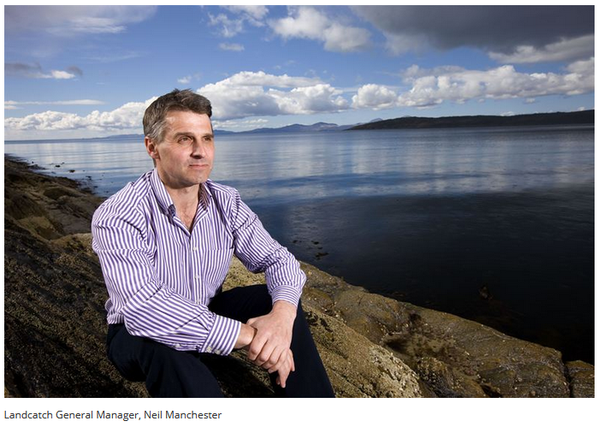

"The reputation of the 'Scottish Salmon' brand is cracked beyond repair," said Don Staniford, Director of Scottish Salmon Watch. "This is extremely embarrassing for the Scottish Government and is an example of how 'Smart Successful Scotland' is in reality a stupid failure. Norwegian salmon farming companies now have a stranglehold over 'Scottish' salmon farming flooding Scotland with salmon eggs from Norway yet the Norwegian Government has banned imports of Scottish salmon eggs citing 'massive risks' of disease and genetic impacts. The Scottish Government should ban imports of salmon eggs from Norway and Iceland as a matter of urgency to safeguard what's left of the genetic integrity of Scottish salmon. It speaks volumes that the Norwegian Government is fighting to protect biodiversity and values wild salmon highly whilst the Scottish Government is happy to sell wild salmon down the river."

The latest data published by the Scottish Government in September 2017 reveals that 91% of 'Scottish' salmon is sourced via imported eggs from overseas (predominantly from Norway and Iceland) [3].
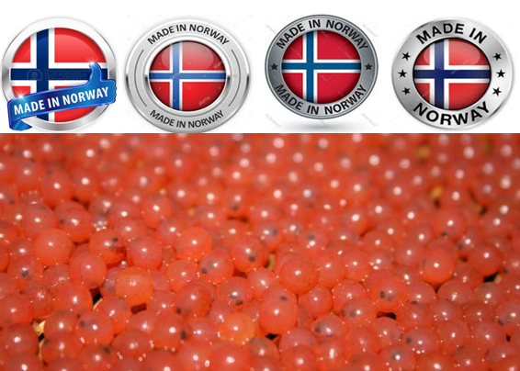
"So-called 'Scottish' salmon is a sham, scam and a consumer con," continued Staniford, author of 'Scottish Salmon Farming 101'. "The provenance of salmon from Scotland is more Norwegian than Scottish. If you dare look under a Scottish salmon's kilt you'll see a viking helmet not a tartan jockstrap. Scottish salmon should be stamped with 'Made in Norway' not the Scottish flag. Beware slippery salmon salesmen flogging 'Scottish' salmon off the back of a lorry."
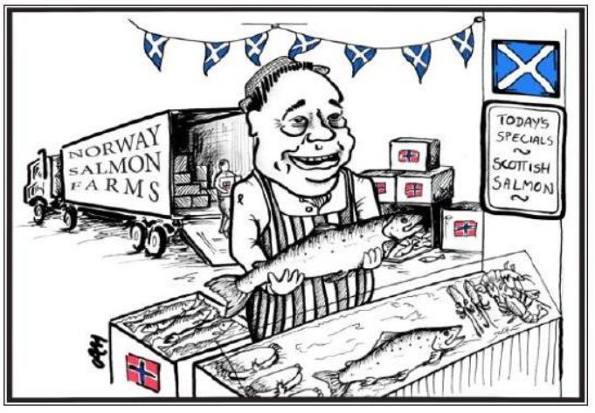

Read a letter sent earlier today by Scottish Salmon Watch to the Scottish Government calling for a ban on salmon egg imports online here

Take the Scottish Salmon Company's 'Tartan Salmon' which claims "Scottish provenance" but in 2016 imported 12.4 million salmon eggs - all from Norway - accounting for 30% of eggs imports. The Scottish Salmon Company is registered in Jersey, listed on the Oslo Stock Exchange and the citizenship of the largest shareholders is listed as from Switzerland, Norway, Monaco, Luxembourg, Belgium, Finland, Sweden, Ireland and Denmark. The Scottish Salmon Company has Board of Directors from Norway, Latvia and Russia and was spawned following a £30 million investment from Ukrainian banker Yuri Lopatinsky (described by The Scotsman newspaper as "a leading figure in Moscow's financial scene" whose investment firm is "based in Bermuda" and who has a property portfolio in Charlotte Square in Edinburgh, home of Scotland's First Minister).
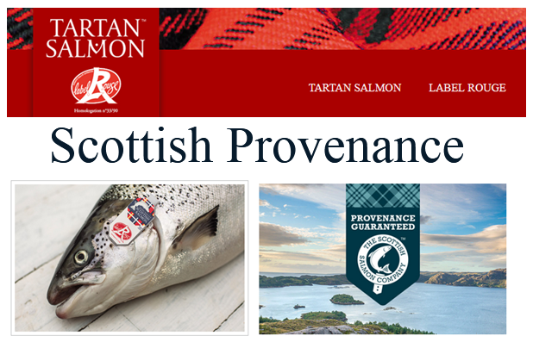

On 4 March 2018, Neil Manchester of Hendrix Genetics emailed the Cabinet Secretary for Rural Economy & Connectivity (Fergus Ewing):

"The point here is that if the Minister accepts this decision, and thereby the reasoning behind it, he must answer why he is unwilling to afford the same level of protection to wild salmon. Alternatively, since our independent salmon breeding and egg production business in Argyll has been destroyed by this decision and the time it has taken to reach it, I would hope that Scottish government would recognize this and act/react accordingly."

The documents disclosed via Freedom of Information by the Scottish Government (24 May 2018) included a Cabinet Briefing dated 7 March 2018 prepared for a meeting with Per Sandberg, Norway's Minister of Fisheries:

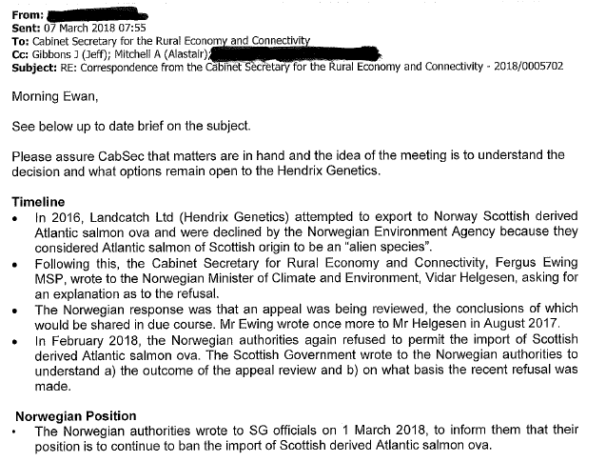
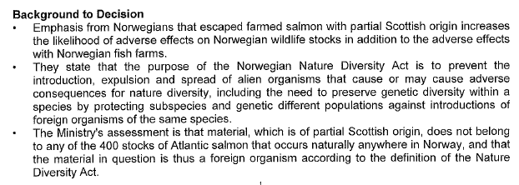

An email from Norway's Deputy Director General at the Ministry of Climate & Environment (Torbjørn Lange) dated 1 March 2018 to the Scottish Government explained:

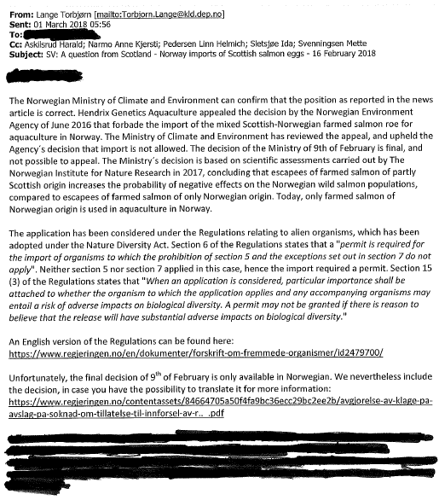

Scottish Salmon Watch today (31 May 2018) filed a new FOI request with the Scottish Government for further information on this issue.



Media Backgrounder:

The Scottish Parliament's salmon farming inquiry briefly touched upon the issue in oral evidence from the predominantly Norwegian-owned salmon farming companies on 2 May:

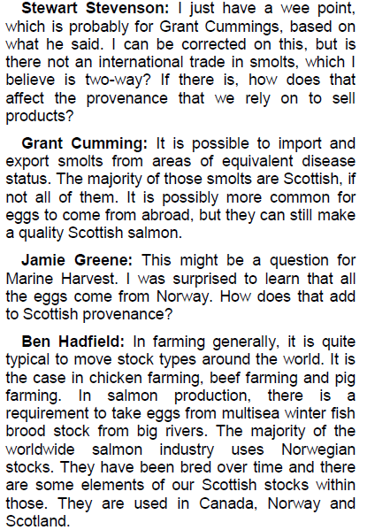

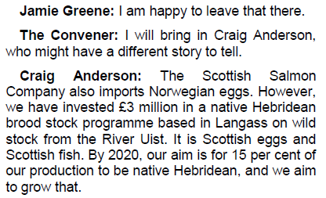
A paper published in the journal Aquaculture in 2016 revealed how Scottish salmon farming has been flooded by imports of foreign salmon eggs (ova) over the last few decades.

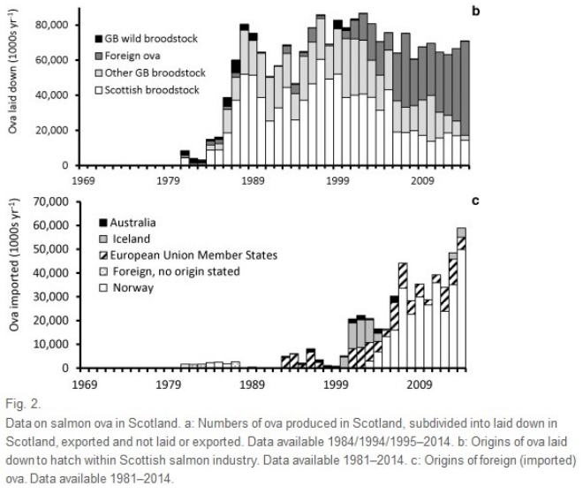

Last year the Global Alliance Against Industrial Aquaculture (GAAIA), asked the Scottish Government to stop imports of salmon eggs from Norway. Fisheries Information Service reported (18 April 2017):
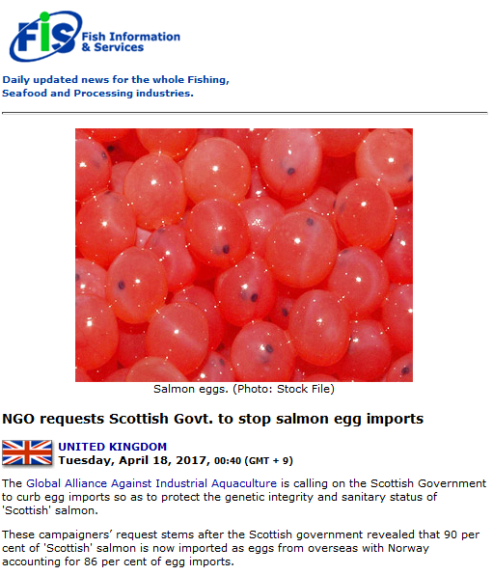
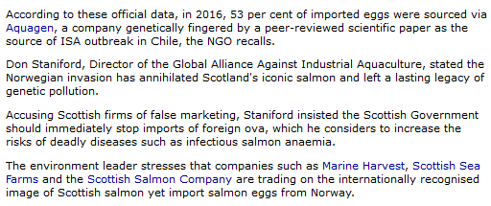
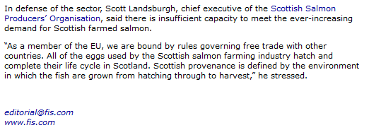
The Sunday Times reported via 'Tartan imposters' charge as fish egg imports hit 90% in April 2017:

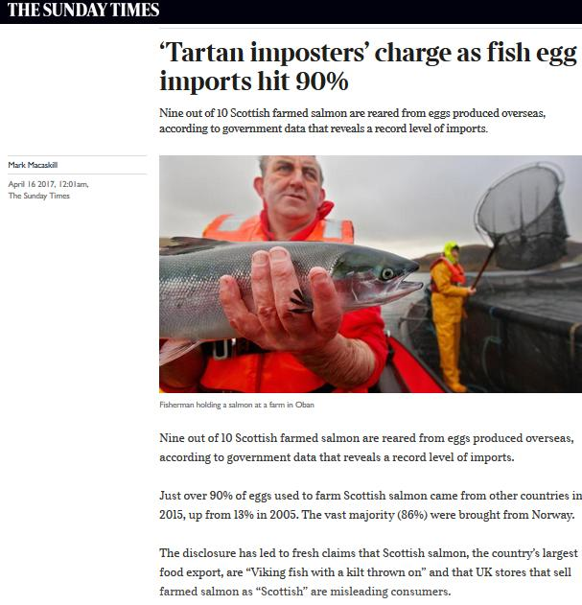

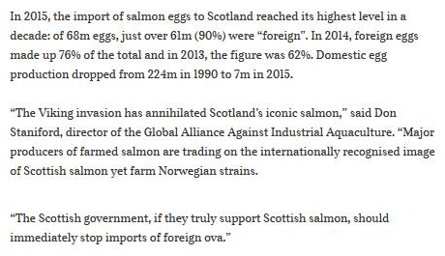

The Global Alliance Against Industrial Aquaculture (GAAIA) pointed out in a press release (16 April 2017) that:

- In 2016, 53% (22.6 million) of imported eggs were sourced from Norway via Aquagen (a company genetically fingered by a peer-reviewed scientific paper as the source of ISA outbreak in Chile)
- In 2016, Norwegian-owned Marine Harvest imported 14.5 million eggs - all from Norway - accounting for 34% of all egg imports
- In 2016, the Scottish Salmon Company imported 12.4 million eggs - again all from Norway - accounting for 30% of eggs imports
- No data for Scottish Sea Farms is available because "disclosure of this particular information would, or would be likely to, prejudice substantially the confidentiality of commercial information provided by Scottish Sea Farms and thus cause substantial harm to their commercial interests"
Download the FOI data from the Scottish Government as an Excel spreadsheet online here
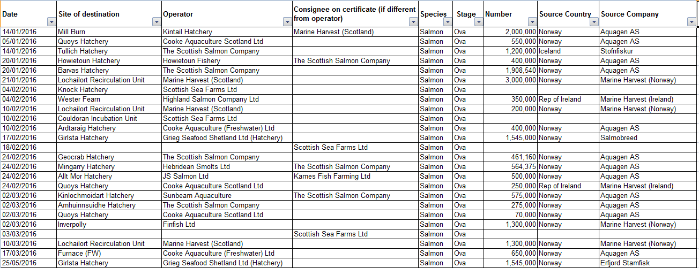
Read more via: Press Release: "Viking Invasion Taints 'Scottish' Salmon"

In 2013, The Sunday Times reported that one in four wild Atlantic salmon from Scotland was genetically "tainted" by Norwegian fish following scientific research by Rivers & Fisheries Trusts Scotland. In 2013, The Sunday Times reported that "Scots fish are ‘Vikings with kilts on’".

In 2014, The Sunday Times exposed Tesco's scam in selling imported salmon from Norway as '100% Scottish'. In 2014, Scotland On Sunday reported how "Supermarkets sell Norwegian fish as ‘Scots’ salmon" prompting complaints by Protect Wild Scotland to Trading Standards and the Competition & Markets Authority.

In May 2018, The Seattle Times reported:

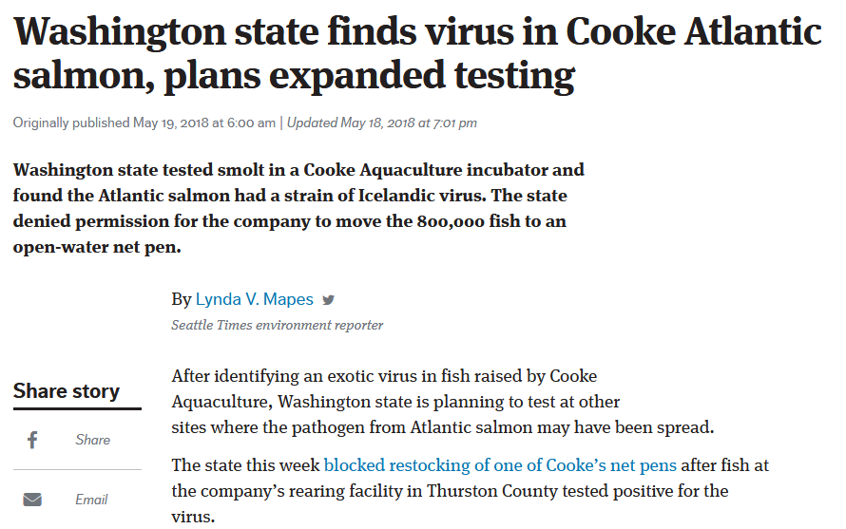

In August 2017, Intrafish reported:

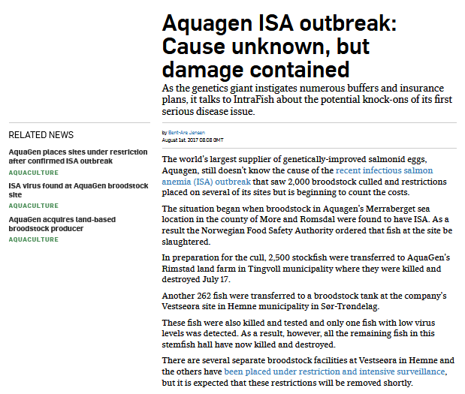

In July 2017, Aquagen reported:

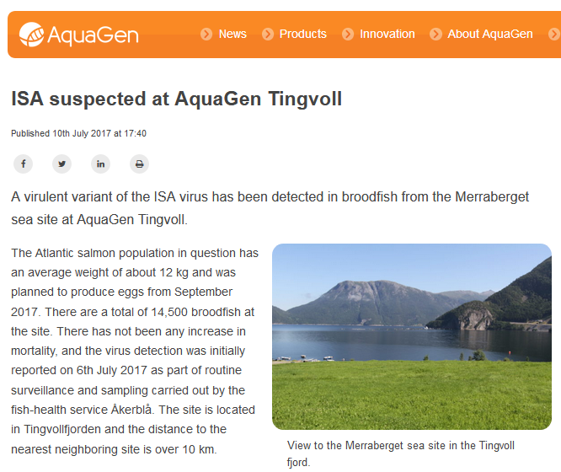

In 2011, The New York Times reported via "Norwegians Concede a Role in Chilean Salmon Virus":

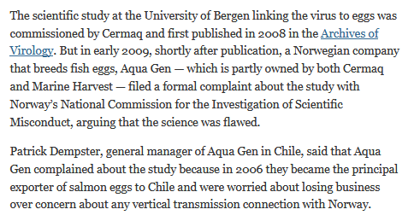

In 2008, Fish Farming Expert reported:

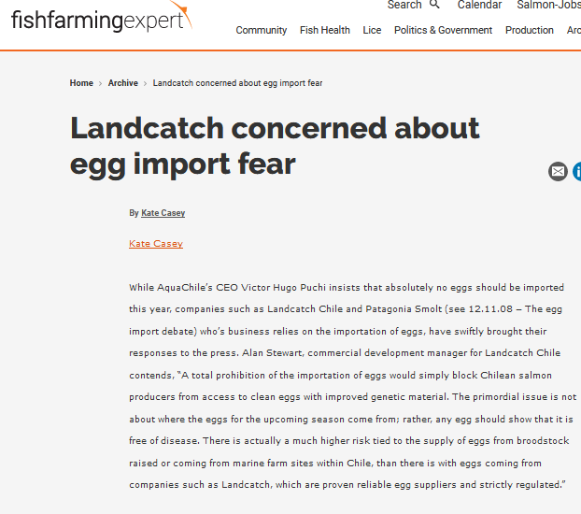

Contact:

Don Staniford: 07771 541826 (dstaniford@gaaia.org)



Notes to Editors:

[1] FOI disclosure from the Scottish Government dated 24 May 2018 - read the documents online here (45-page PDF) and the covering letter online here

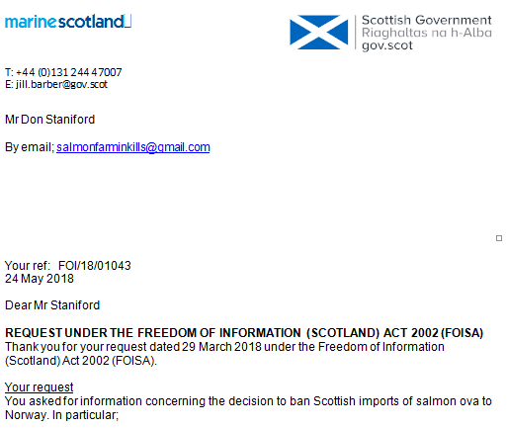
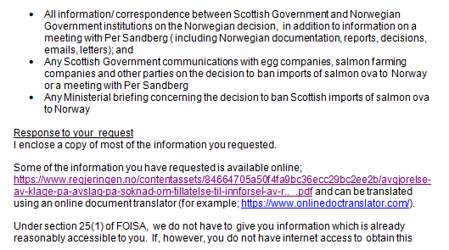

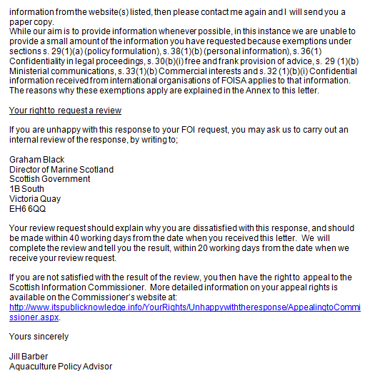

Read the covering letter from the Scottish Government dated 24 May 2018 online here

Read a 22-page letter from the Norwegian Government to Hendrix Genetics outlining the reasons for refusal (the letter dated 9 February 2018 was signed by Torbjørn Lange, Deputy Director General of the Norwegian Ministry of Climate and Environment).

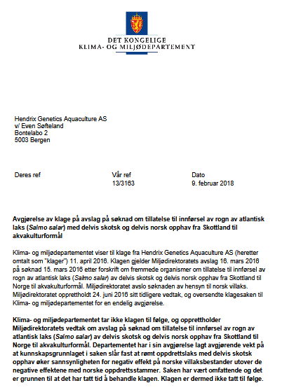

Translate into English via Online Doc Translator.

The letter cites a 2017 report by the Norwegian Institute for Nature Research (NINA): "Risikovurdering av import av delvis skotsk laks fra Skottland til akvakultur i Norge" (Risk assessment of imports of partly Scottish salmon from Scotland to aquaculture in Norway)

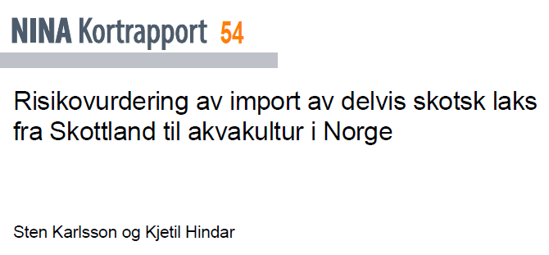

Here's an English translation of the abstract (via Google Translate):

Karlsson, S. and Hindar, K. 2017. Risk assessment of imports of partly Scottish salmon from Scotland to aquaculture in Norway. - NINA Short Report 54. 24 s.
• Norwegian wild salmon consists of two distinct genetic groups. Scottish villax, in comparison with these, forms a separate genetic group that has been formed independently of Norwegian wild-salmon.
• The inclusion of escaped farmed salmon with partial Scottish origin in Norway will entail an introduction of genetic material of a different genetic origin and genetic composition than is found naturally in Norway.
• The effect of the inclusion of escaped farmed salmon on wild salmon stocks differs depending on whether farmed salmon and wild salmon have the same or different genetic origin.
• Increased genetic distance between exposed / escaped salmon and wild salmon has shown a greater negative genetic and ecological effect in both experimental and empirical studies.
• Based on proven genetic distances and that Scottish wild salmon is a separate genetic group different from that found in Norway, fished salmon with partly Scottish origin is considered to have an increased negative effect on wild salmon stocks in Norway.

The documents disclosed via FOI by the Scottish Government on 24 May 2018 included (in chronological order):

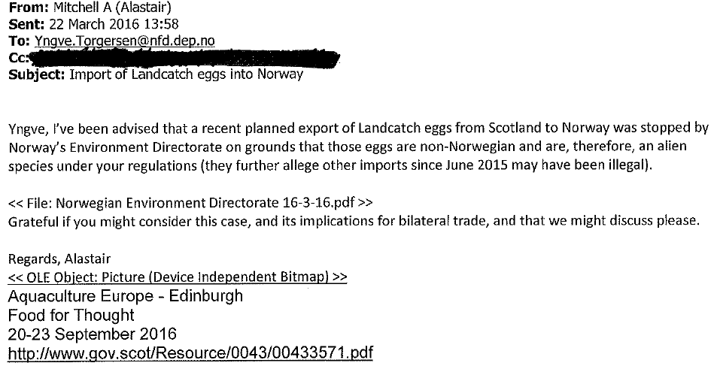

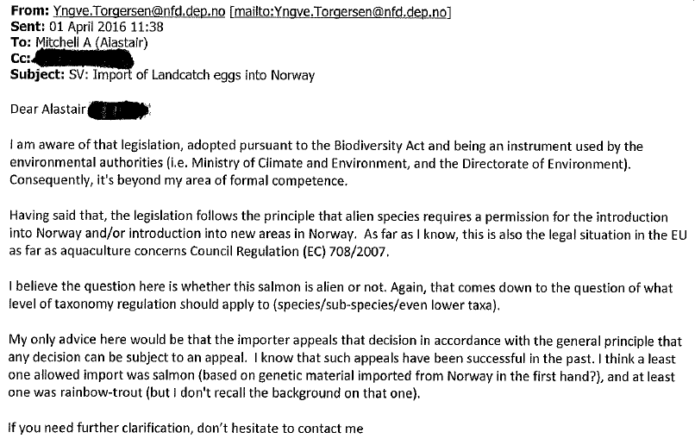

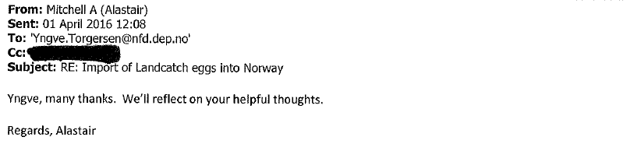

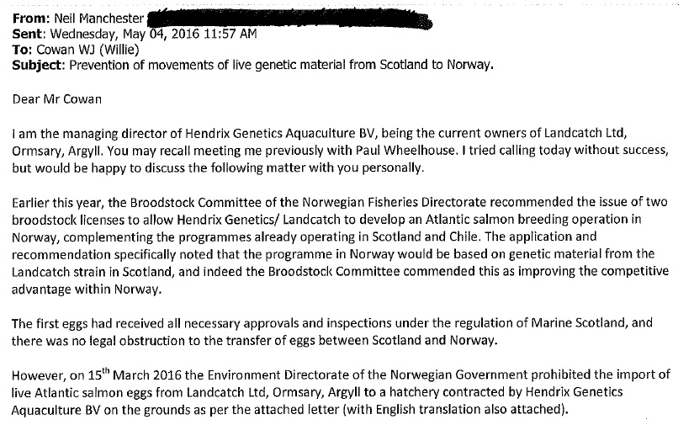

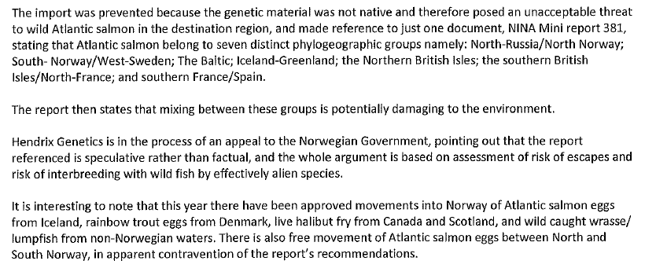
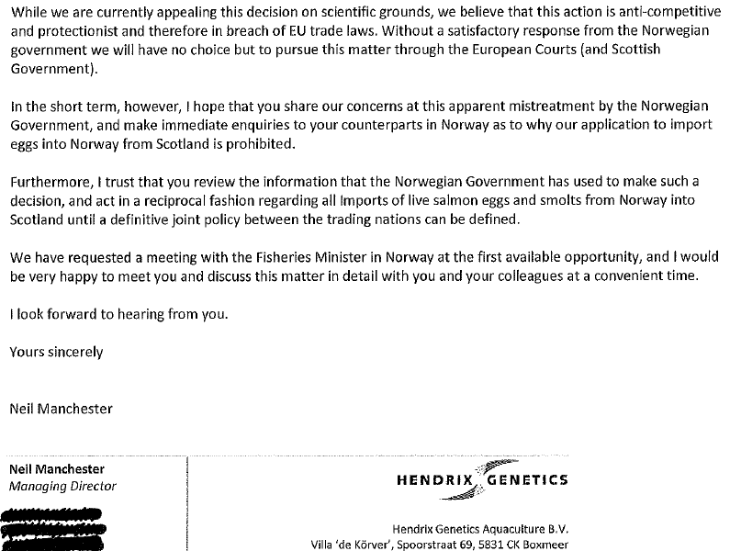

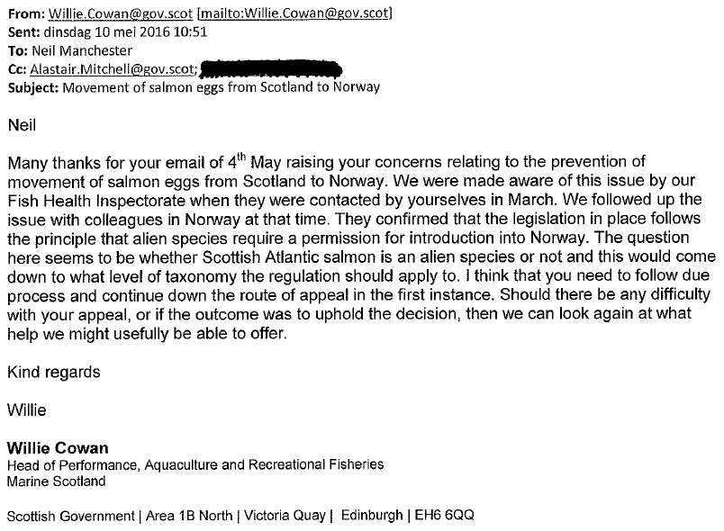

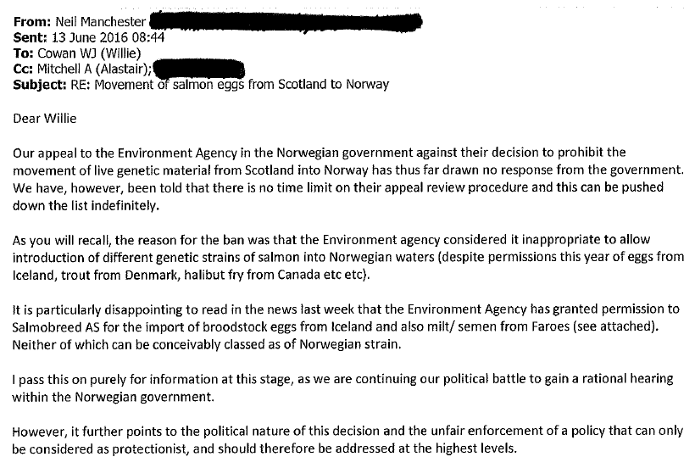
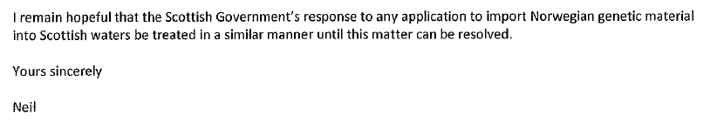

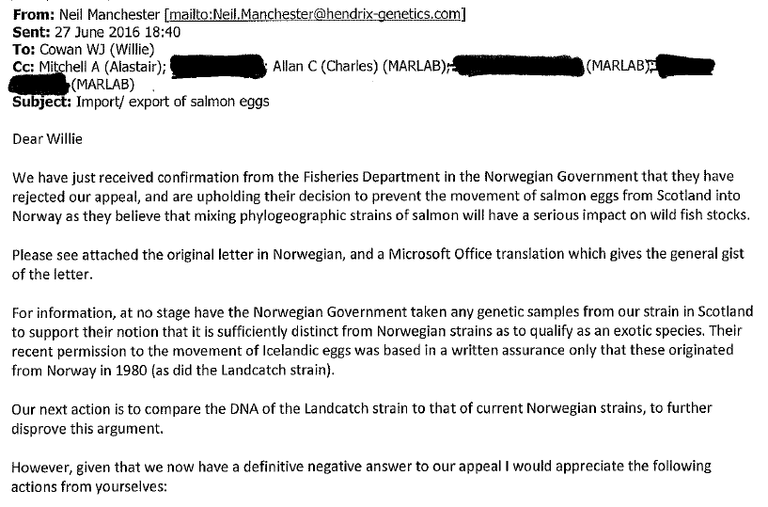
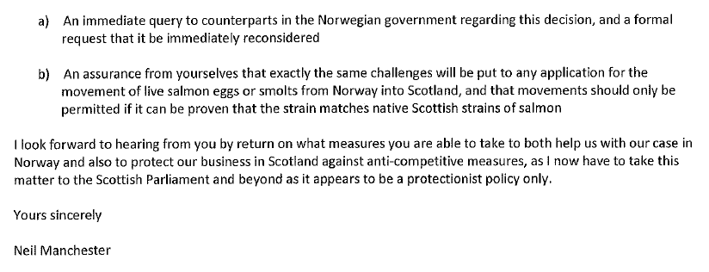

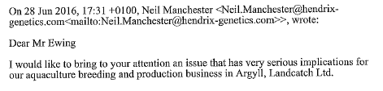
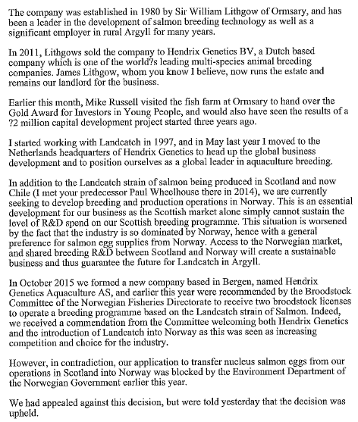

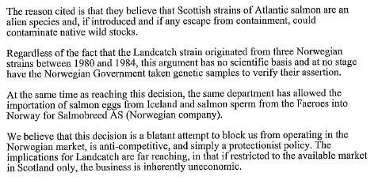
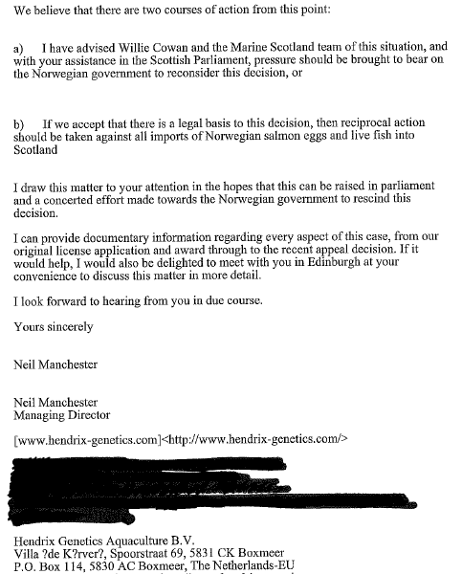

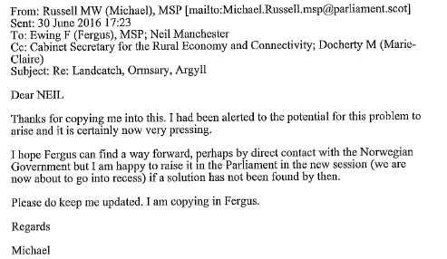

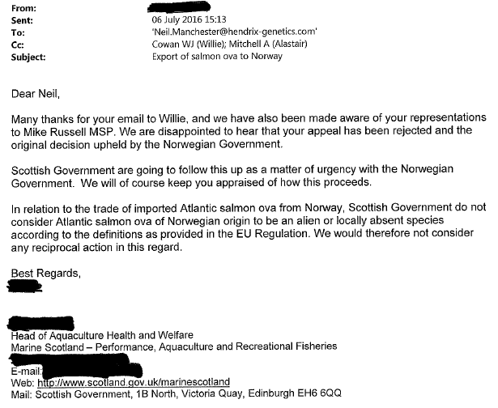

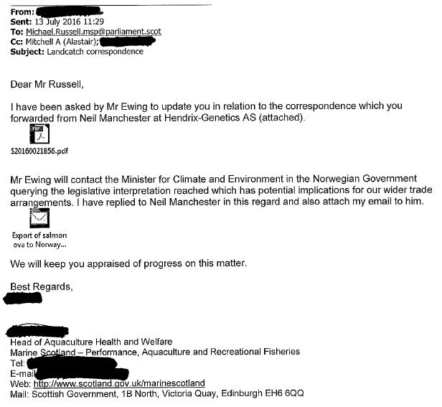

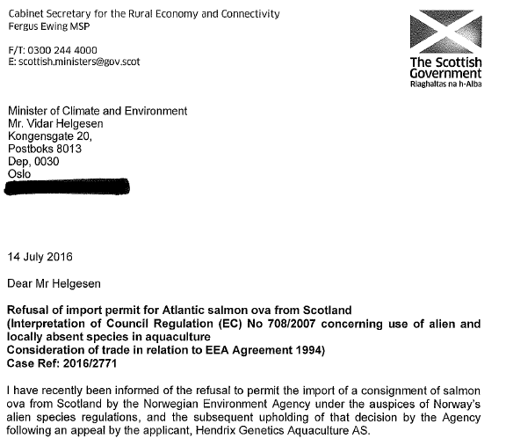
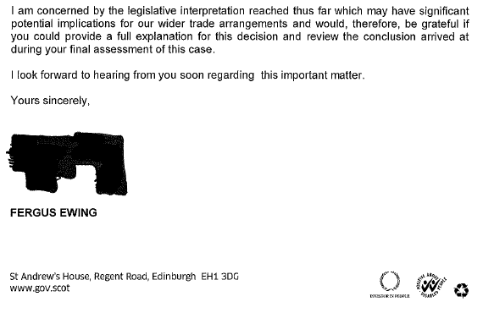

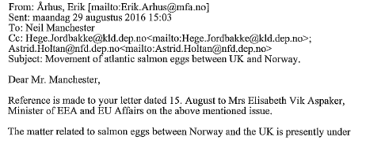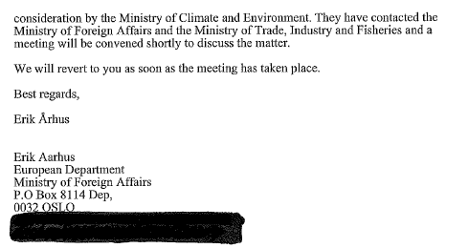

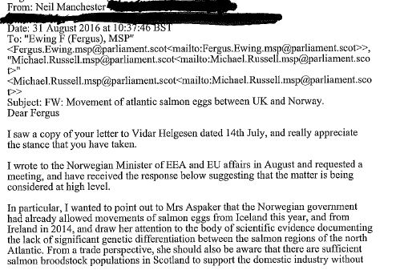
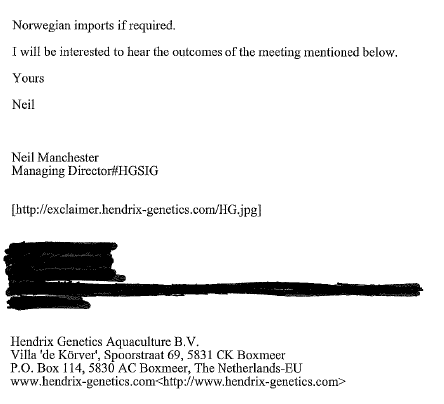

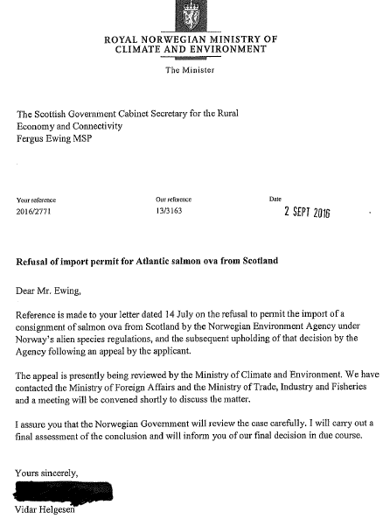

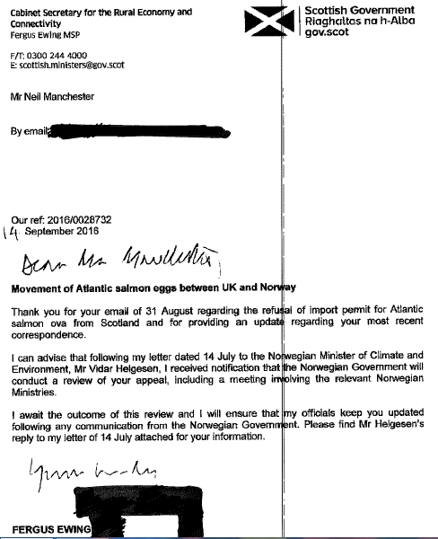

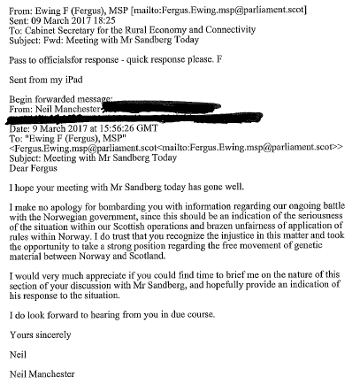

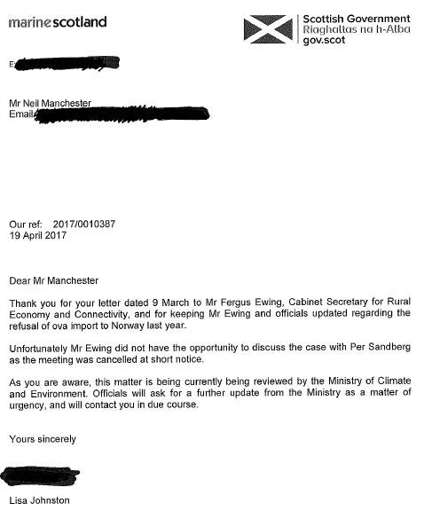

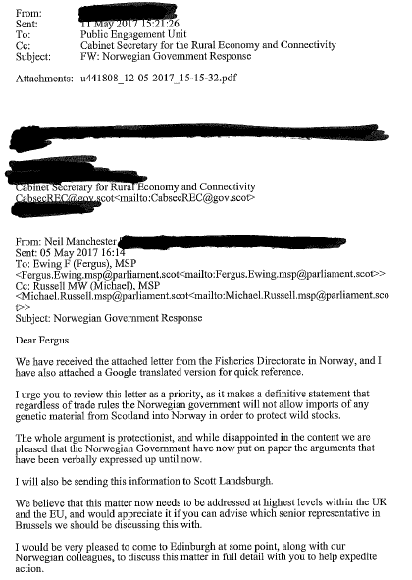

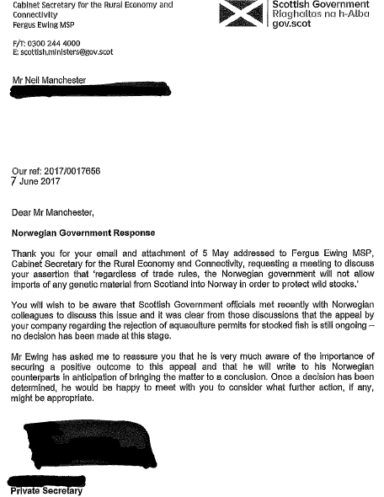

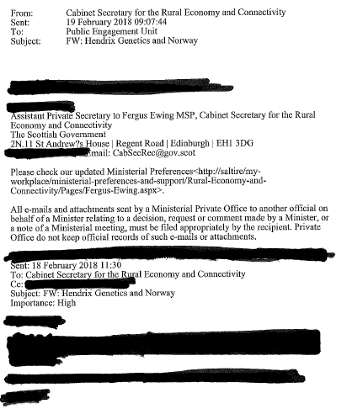

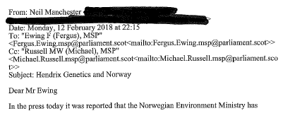
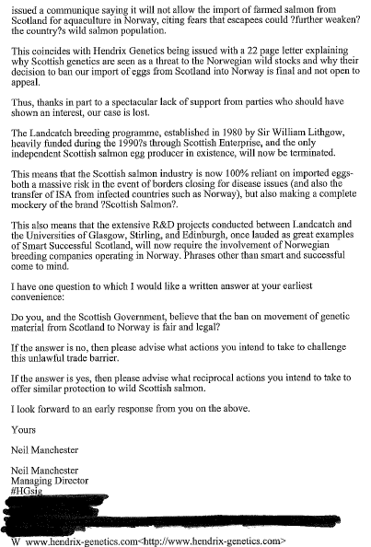

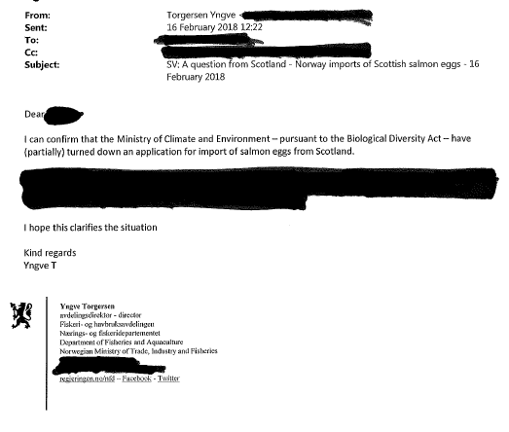

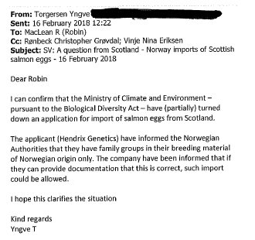
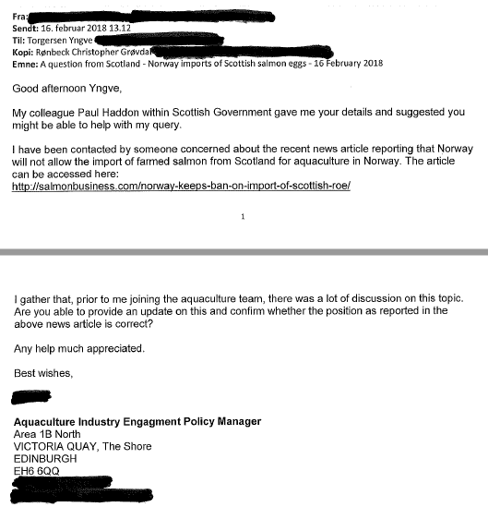

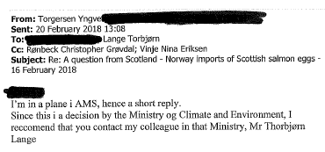
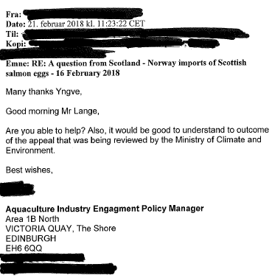

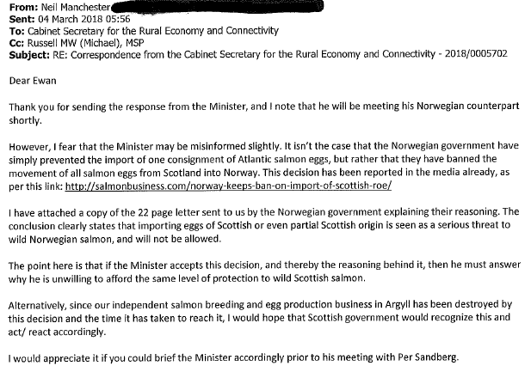

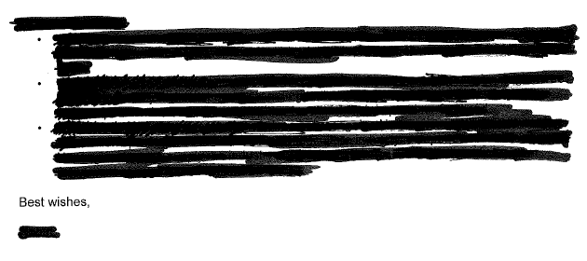

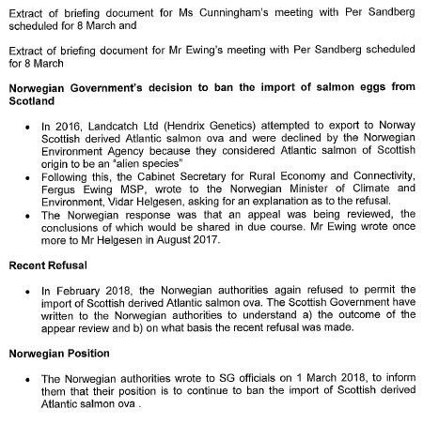

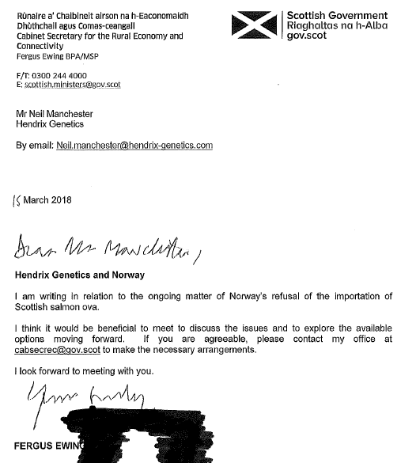

Read the FOI disclosure from the Scottish Government on 24 May 2018 in full online here

[2]

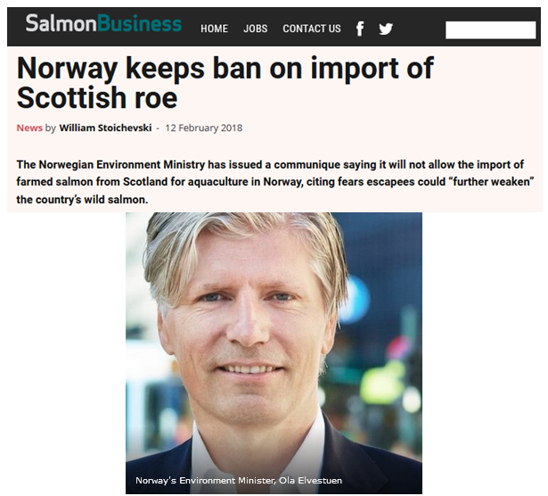
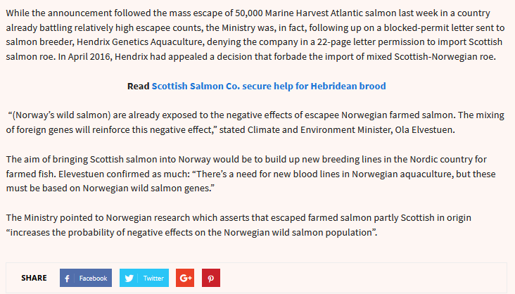

Read via "Norway keeps ban on import of Scottish roe" (Salmon Business, 12 February 2018)

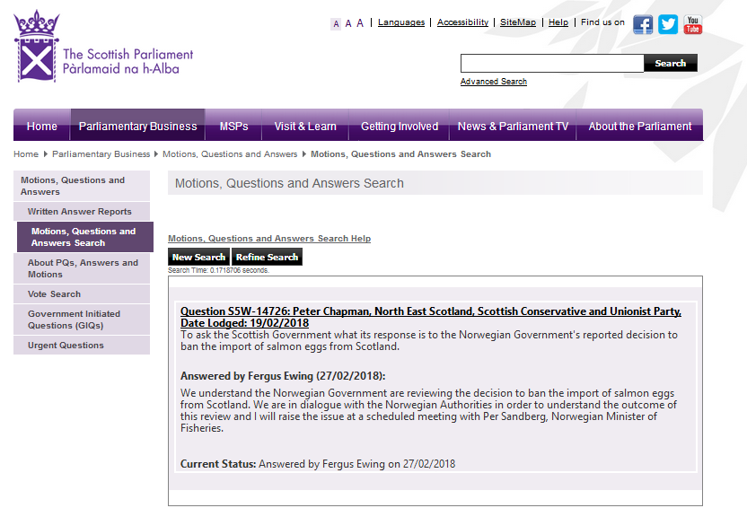

Read the Scottish Parliamentary reply and question online here

[3] The Scottish Government's latest fish farm survey for 2016 (published in September 2017) reveals:

