The Global Alliance Against Industrial Aquaculture, 4 January 2018

Carry on Killing Says RSPCA
- Updated standards still sanction slaughter of seals across Scotland

The RSPCA is under fire for sanctioning the slaughter of seals on Scottish salmon farms - with Sainsbury's supplier Marine Harvest leading the killing with over a hundred seals killed since 2011.

Read more via today's Herald: "RSPCA attacked for fresh support for Scots seal shooting to protect salmon"

Publication of updated RSPCA welfare standards for farmed Atlantic salmon was due to take place on 30 November 2017 but has been delayed until 20 February 2018. The updated RSPCA standards still permit the killing of seals - although there is now more devil in the details including more rigorous reporting of dead seals and bullets used [1].
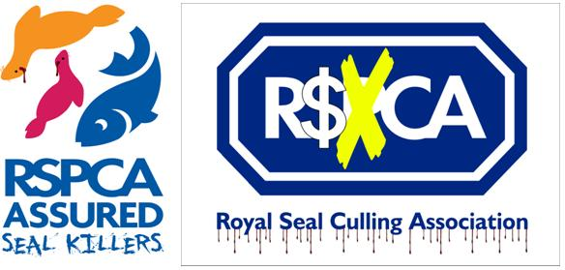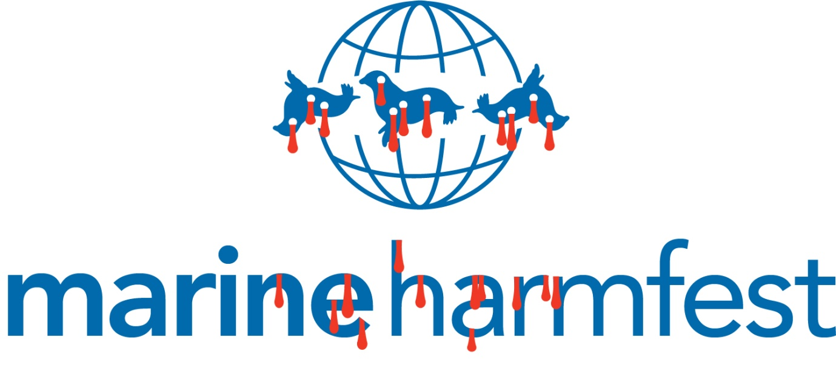
"When you buy Scottish salmon stamped as RSPCA Assured logo, you can be assured that seals were killed at farms across Scotland," said Don Staniford, Director of the Global Alliance Against Industrial Aquaculture. "Sainsbury's supplier Marine Harvest is Scotland's #1 seal killer and all of their salmon farms in Scotland are certified via the RSPCA Assured scheme. Shame on Sainsbury's and the RSPCA for sanctioning the slaughter of seals. Don't buy Scottish salmon or you'll have the blood of dozens of seals on your hands!"
The updated RSPCA standards include records of bullets used and "the reason for the shooting":

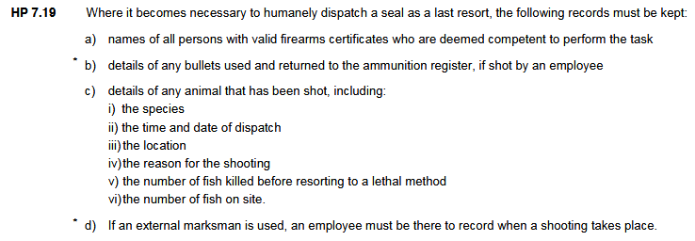

Here's the RSPCA's new seal cull form:

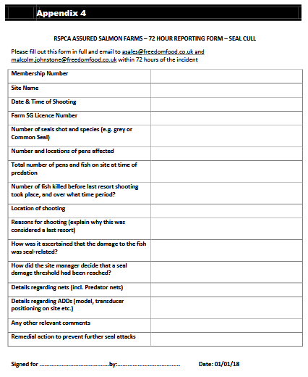

The RSPCA have refused to provide a list of salmon farms certified via the RSPCA Assured (formerly Freedom Foods) scheme. However, during lobbying to the Scottish Parliament in December 2017, Marine Harvest admitted that 100% of their salmon is certified via RSPCA Assured [2].

Ben Hadfield, Managing Director of Marine Harvest Scotland, told The Sunday Times in June 2017: "If seals keep attacking the fish, then, like a farmer kills foxes, we shoot them."
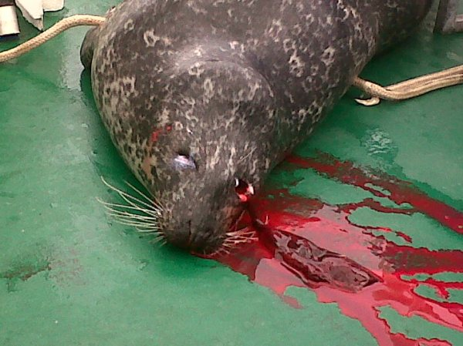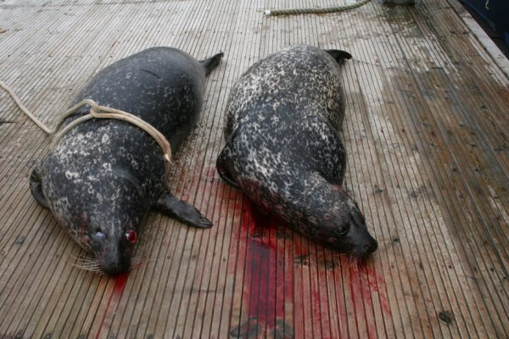
Photos: Seals killed near Marine Harvest's salmon farm in Loch Alsh Special Area of Conservation (download high res images online here and online here)
Around 70% of Scottish salmon farming production is currently certified via RSPCA Assured generating an estimated income of close to £1 million per year for the RSPCA [3] - with Marine Harvest (Scotland's largest salmon farming operator producing 50,000 tonnes of farmed salmon in 2015 from 49 sea farms) accounting for an estimated £400,000 per year [4].

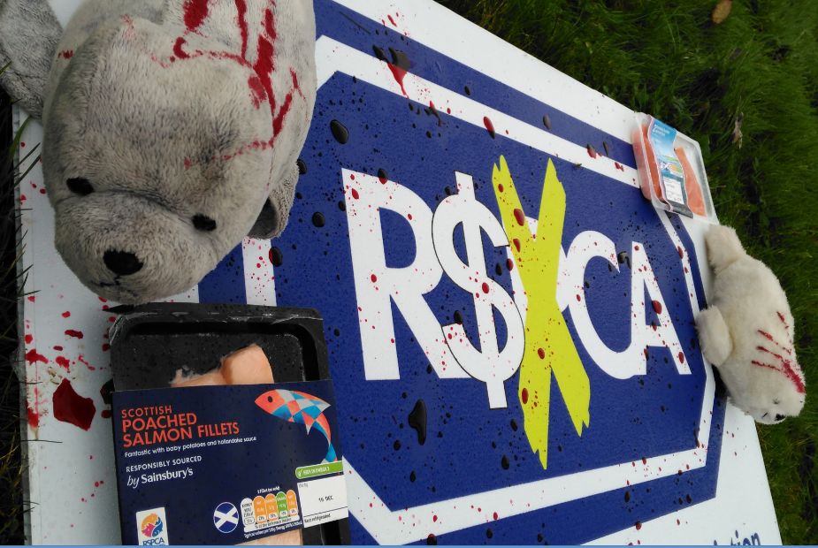

Marine Harvest certainly has a close relationship with the RSPCA - with former Marine Harvest employee Ian Michie now working for RSPCA Assured and two Marine Harvest staff represented on the RSPCA's farmed salmon standards technical advisory groups [5]. Here's the cast of Carry On Killing Seals:



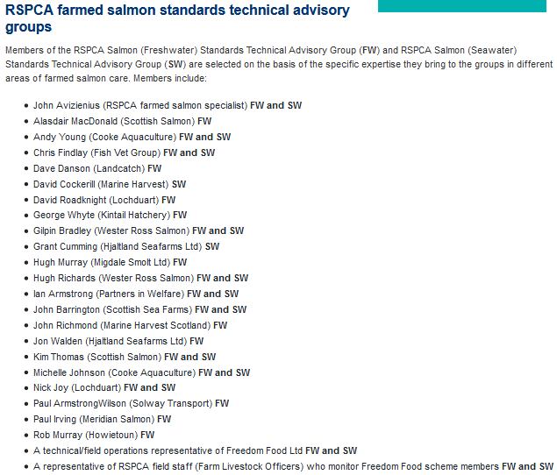

Sainsbury's have a close relationship with both Marine Harvest and the RSPCA. Sainsbury's stated in 2017 that "all our farmed salmon is RSPCA Assured" and referred to "our Scottish supplier Marine Harvest" (a Norwegian-owned multinational controlled by Norway's John Fredriksen).

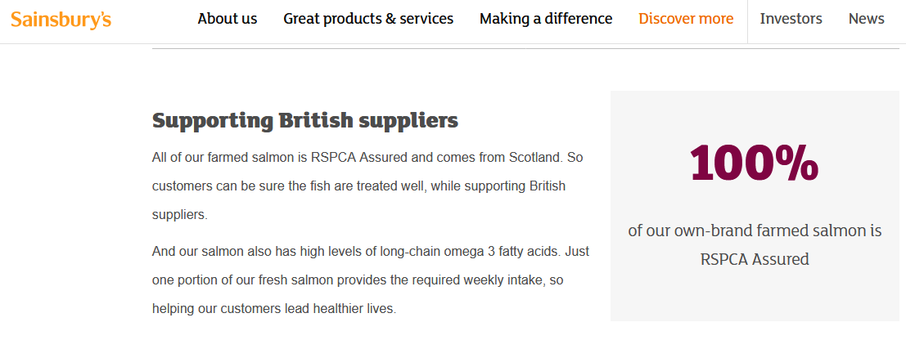
Aquaculture and Fisheries Manager at Sainsbury’s, Ally Dingwall, is also a former employee of Marine Harvest [6]. He claimed in 2013: "Sainsbury's is the largest UK retailer of responsibly sourced RSPCA Freedom Food Salmon".

According to documents obtained by GAAIA via FOI, salmon farms certified by RSPCA Assured (branded as Freedom Food until 2015/2016) accounted for almost 70% of the seals shot by salmon farms in 2014 (an increase from 26% in 2011 before falling to 52% in 2015) [7]. Based on the fact that all of Marine Harvest's salmon farms are certified via RSPCA Assured at least a third of all seals killed by salmon farms during 2016 and 2017 (data for the first two quarters is only available) were at RSPCA Assured salmon farms.

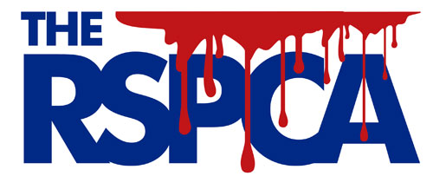

Since 2011, Marine Harvest has killed 118 seals shooting up from 5 seals killed in 2013 to 26 in 2016 and 11 thus far in 2017 (*data for the first two quarters is only available):

2011: 34 seals killed by Marine Harvest Scotland (459 in total; 241 by fish farms)
2012: 16 seals killed by Marine Harvest Scotland (433 in total; 208 by fish farms)
2013: 5 seals killed by Marine Harvest Scotland (274 in total; 105 by fish farms)
2014: 7 seals killed by Marine Harvest Scotland (205 in total; 80 by fish farms)
2015: 19 seals killed by Marine Harvest Scotland (160 in total; 79 by fish farms)
2016: 26 seals killed by Marine Harvest Scotland (97 in total; 75 by fish farms)
2017*: 11 seals killed by Marine Harvest Scotland (58 in total; 37 by fish farms)

Total (2011-2017): 1686 seals killed (825 seals killed by fish farms; 118 by Marine Harvest)

According to seal-killing data published online by the Scottish Government (annual data on the killing of seals in Scotland is available online for the years 2011-2016 and the first six months of 2017), Marine Harvest killed 26 out of the 97 seals reported as killed in 2016 (more than any other company and representing 27% of all the seals killed in Scotland in 2016).

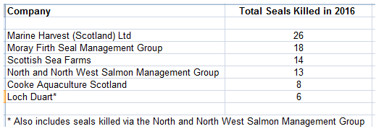

A total of 15 Marine Harvest salmon farms reported seal kills including sites in Loch Ewe, Torridon, Greshornish, Linnhe, Colonsay, and Lochalsh - that represents 30% of Marine Harvest Scotland's 49 salmon farms killing seals. The Marine Harvest salmon farms - all understood to be certified via the RSPCA Assured/Freedom Food scheme - reported by the Scottish Government as killing seals in 2016 included:

Eilean Grianain (FS1176); Isle Ewe (FS0767); Torridon (FS0814); Greshornish (FS0698); Maol Ban (FS0839); Cairidh (FS0252); Hellisay (FS1261); Ornish (FS0531); Marulaig (FS0865); Linnhe (FS0240); Creag an t Sagairt (FS0605); Kingairloch (FS0241); Camas Glas; Colonsay and Lochlash (sic).

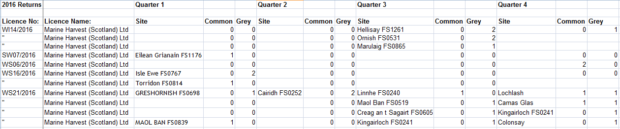

Data published online by the Scottish Government in September 2017 - for the first two quarters of 2017 (Q3 2017 data is expected soon) - reveal that Marine Harvest has killed 11 seals at seven different sites (Polle na Gille, Bagh dail nan Cean, Ardnish, Lochlash, Camas Glas, Kingainloch and Colonsay) during 2017 representing 19% of the total seals killed in Scotland:

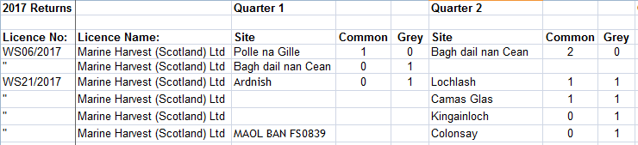

Here's site specific data for the 19 seals killed by Marine Harvest in 2015:

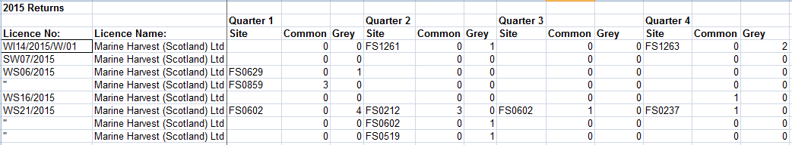

Here's site specific data for the 16 seals killed by Marine Harvest in 2012:

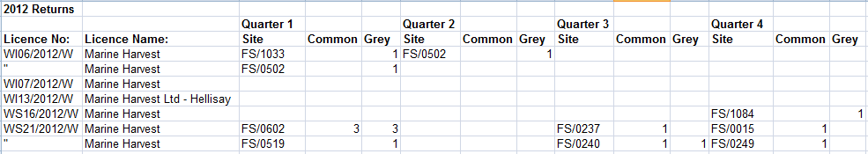

Here's site specific data for the 34 seals killed by Marine Harvest in 2011:

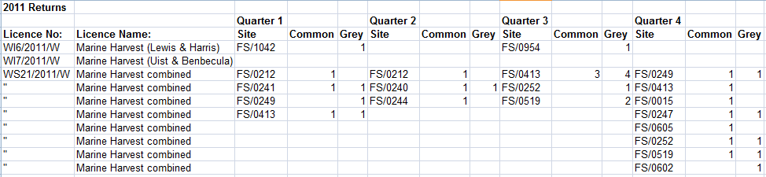

In October 2017, Marine Harvest posted photos of an RSPCA event at the Palace of Westminster showcasing their RSPCA Assured farmed salmon:

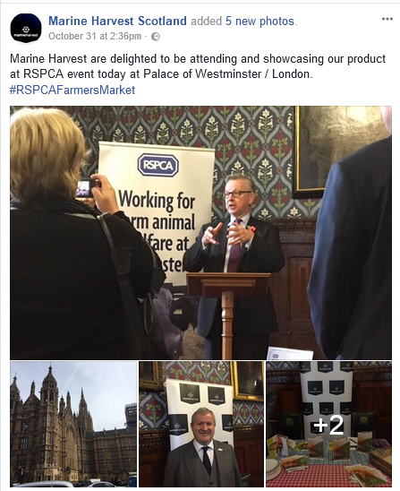

In November 2017, GAAIA wrote to Theresa Villiers MP (as host of the event) and Michael Gove, Secretary of State for Environment, Food and Rural Affairs (a speaker at the event) asking them to intervene to end the slaughter of seals at Marine Harvest salmon farms and to ask the RSPCA to withdraw RSPCA Assured certification from seal killing salmon farms.

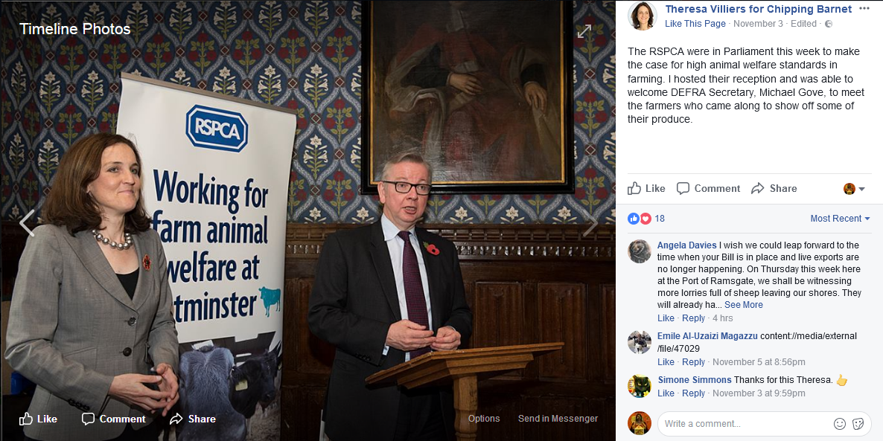
GAAIA also wrote to the RSPCA asking that Marine Harvest and other salmon farming companies slaughtering seals are suspended immediately from the RSPCA Assured/Freedom Food certification scheme.

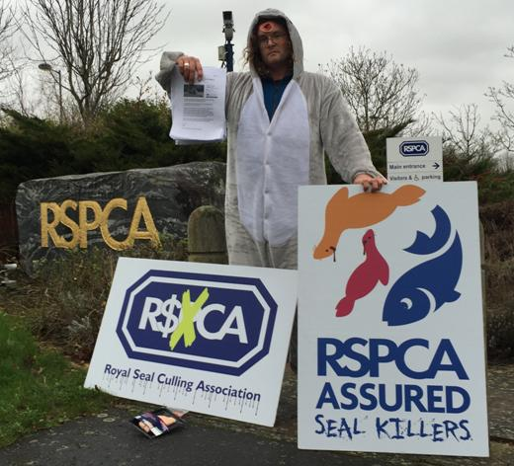

In December 2015, GAAIA protested outside Buckingham Palace and delivered a letter to Her Majesty the Queen (as royal patron of the RSPCA) asking her to intervene to end the slaughter of seals on RSPCA Assured salmon farms in Scotland.
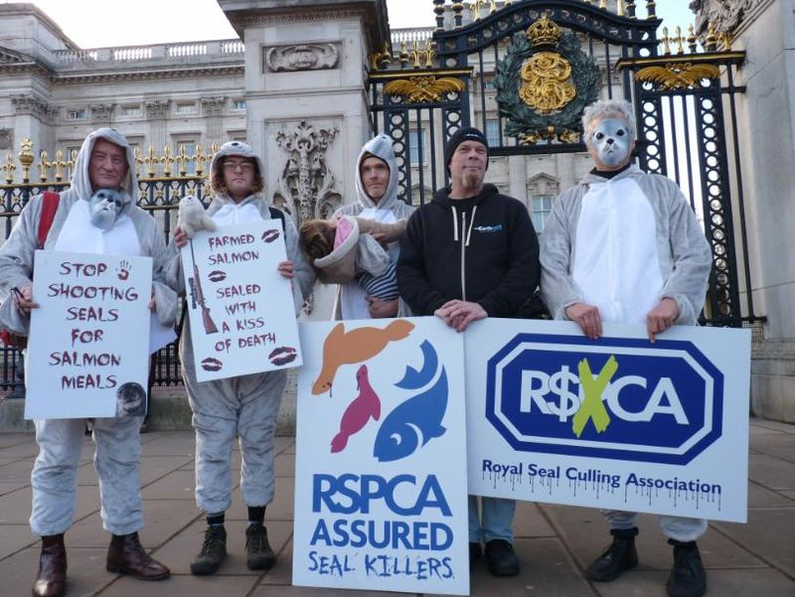
Watch a video report shot outside the RSPCA's head office - online here
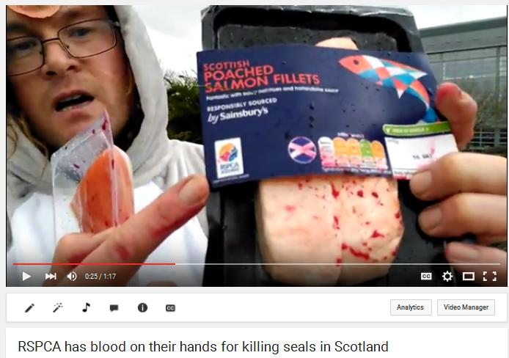

Watch a video report from Don Staniford via "Marine Harvest: Stop Shooting Seals!":
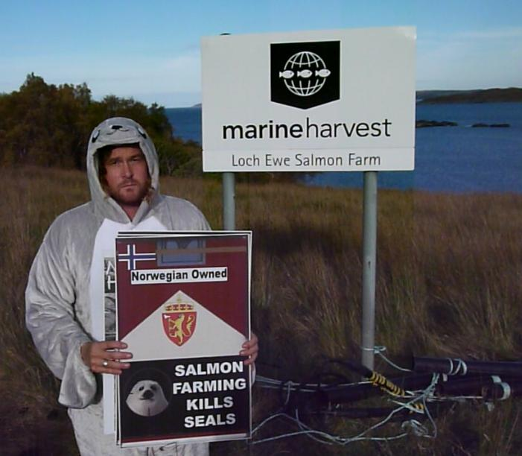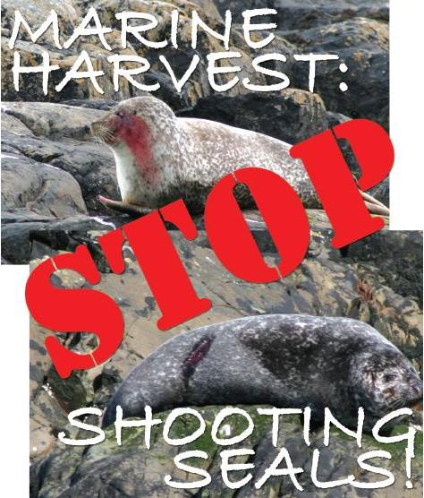
Contact:

Don Staniford (07771 541826 and dstaniford@gaaia.org)

Background News:

"RSPCA attacked for fresh support for Scots seal shooting to protect salmon"
Press Release: "RSPCA in firing line over Marine Harvest's seal-killing spree in Scotland - 118 seals killed by Marine Harvest's RSPCA Assured farms since 2011"
The Scotsman: "Fish farms kill more seals as industry tries to save salmon"
Sunday Times: "Fish farms under fire for seal death toll"
UK seal population under threat for salmon-farming industry
Fish farms shoot dozens of seals to save salmon bound for 'ethical' Waitrose and M&S supermarkets
"Marine Harvest: Scotland's #1 Seal Killer"
Sunday Times: "Seals shot to save Waitrose salmon"
SSPO seeks clarity over seal shooting export threat
Herald: "US warning over continued killing of seals by Scots fish farms"
Seal-killing salmon farms caught in cross-hairs of Scottish Parliament
Take Scotland's Seals Out of the Cross Hairs!
"All At Sea: Seal-Killing Salmon Farms"
"The Two Billion Dollar Salmon Ban"
"Sunday Herald: "Scotland's 'trigger-happy' salmon farmers risk losing £200m US export market""
"Seal of Approval for U.S. Ban on Salmon"
"Staniford calls on RSPCA to drop Marine Harvest, Scottish Sea Farms, SSC"
Press Release: "Closing the Net On 'Seal-Friendly' Scottish Salmon - last orders on the RSPCA's abuse of 'last resort' killing of seals?"
Herald: "RSPCA defend record as anti-seal cull campaigners allege salmon farms are not 'last resort' killers"
Dear RSPCA, please wash the blood of Scottish seals off your hands!
Video Message to the RSPCA - stop the killing of seals on salmon farms!
Photos: RSPCA Assured Seal Killers!
"Anti-salmon farm campaigners petition Queen over RSPCA’s seal-shooting sanction"
Petition to the RSPCA: End your support for the killing of Scottish seals!
Press Release: "RSPCA Savaged Over Seal Killing in Scotland"
Letter to Her Majesty the Queen
RSPCA Assured Seal Killers!
RSPCA upsets people by saying seal shooting is OK
RSPCA attacked for its policy on seal shooting
RSPCA: Seals should be shot as an 'absolute last resort' to protect salmon
RSPCA warns Scottish salmon farmers to shoot fewer seals

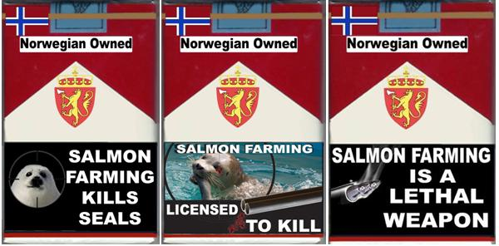
High resolution images:

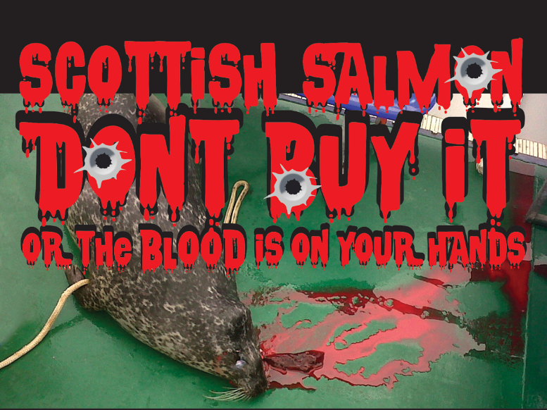

Download PDF online here

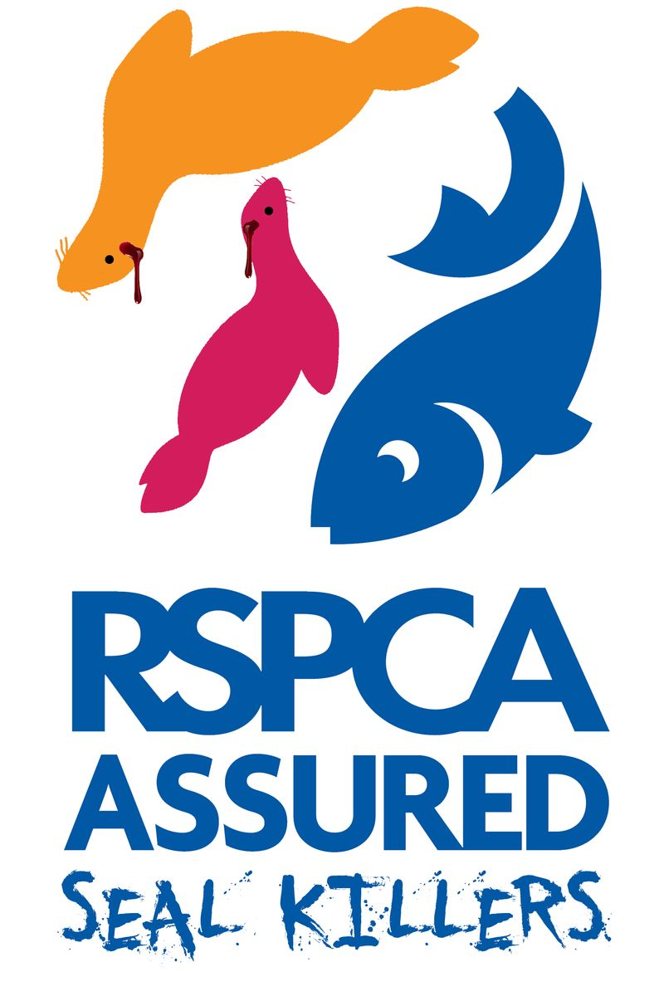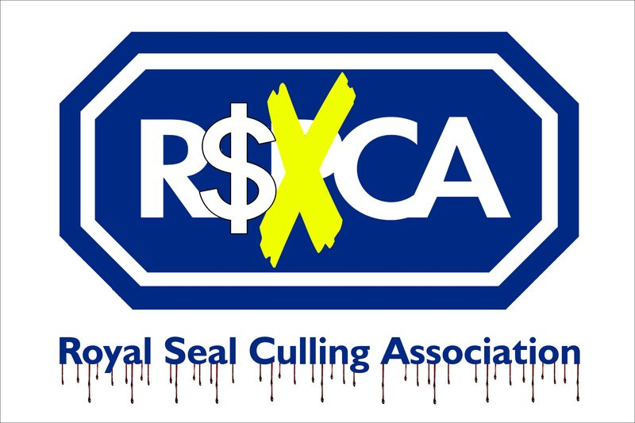

Download PDFs online here and online here
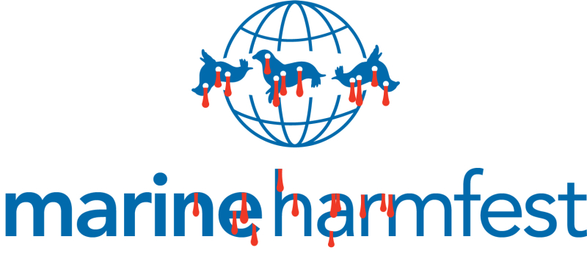
Download PDF online here
Notes to Editors:

[1] In August 2017 the RSPCA published an update of their welfare standards for farmed Atlantic salmon - with the new standards scheduled to come into effect on 30 November 2017:

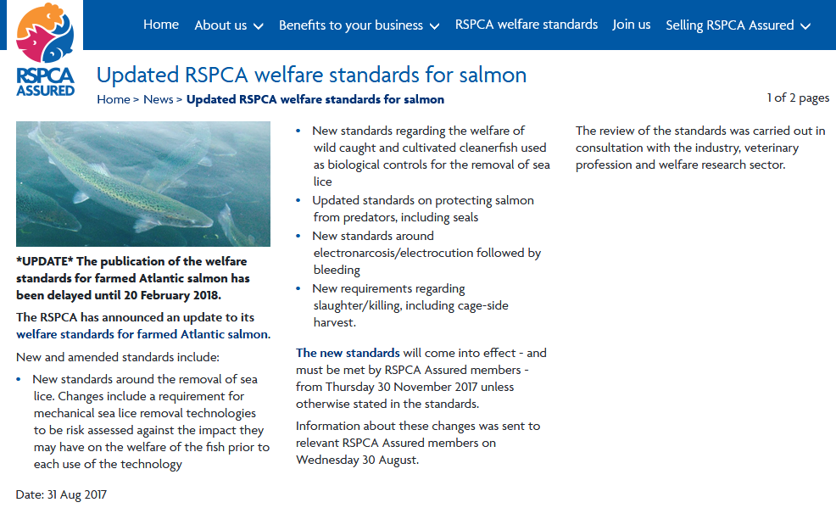

However in December 2017 the RSPCA announced a delay on the new standards until 20 February 2018:

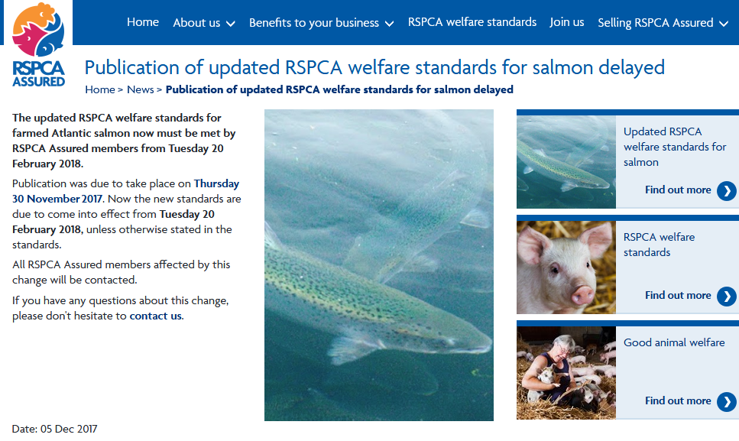
The RSPCA's update to their welfare standards for farmed Atlantic salmon includes:

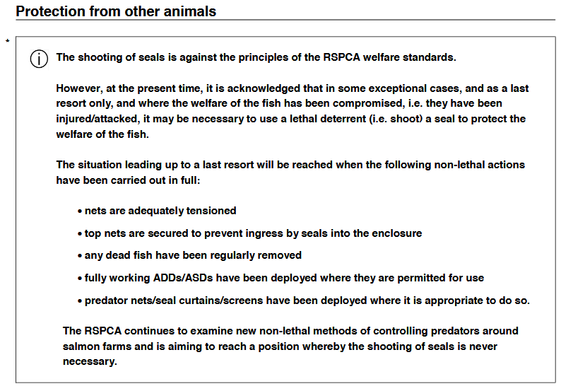

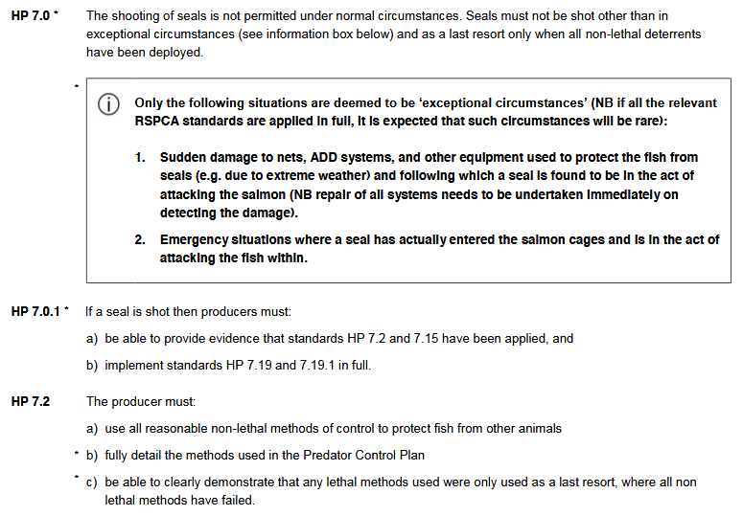

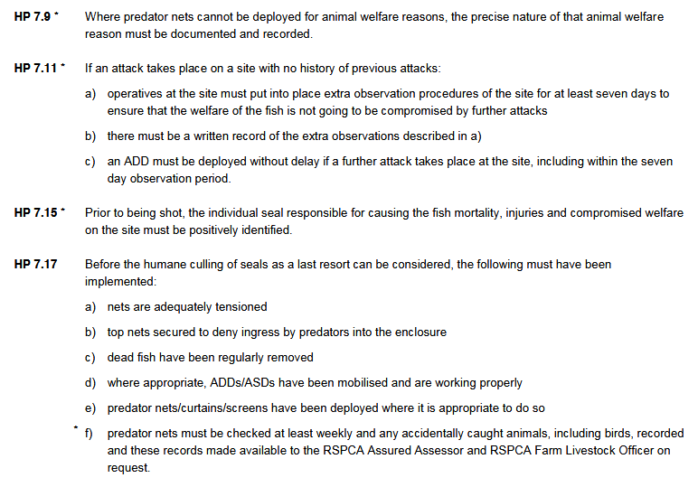
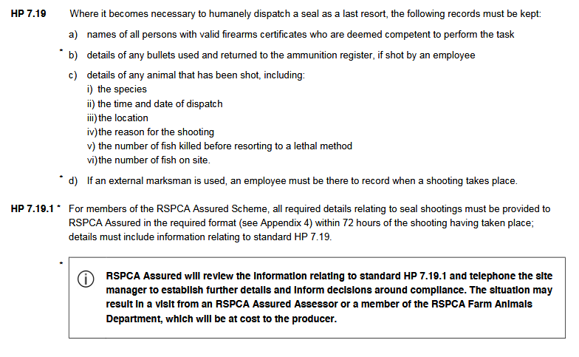

Read in full online here
For more details on the RSPCA's welfare standards for farmed Atlantic salmon (September 2015) please read online here
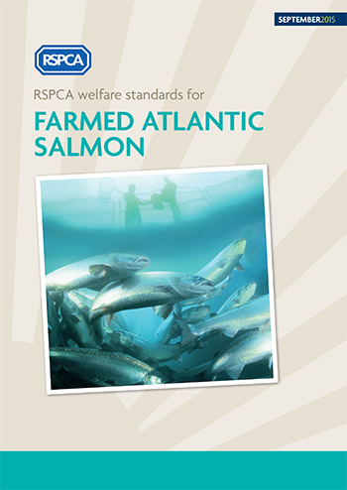
Here's the relevant sections of the RSPCA's standards sanctioning seal-killing:
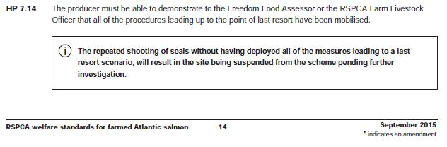
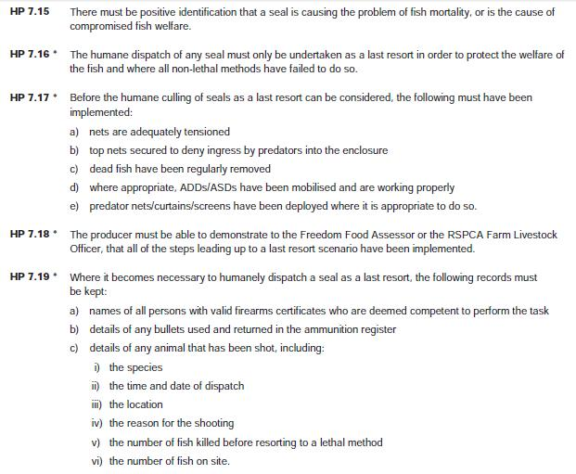
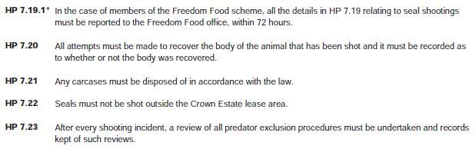

In June 2015, the RSPCA made "key changes" but maintained their shoot-to-kill policy on seals: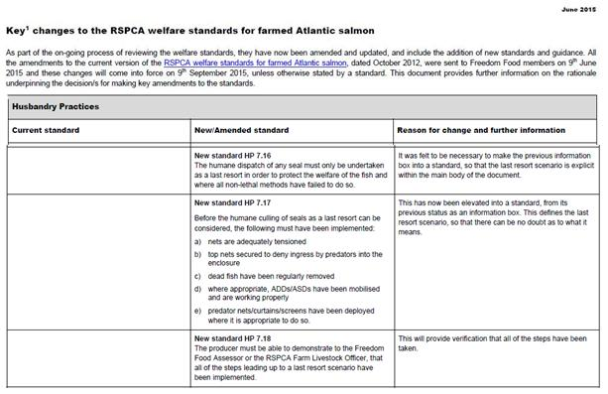
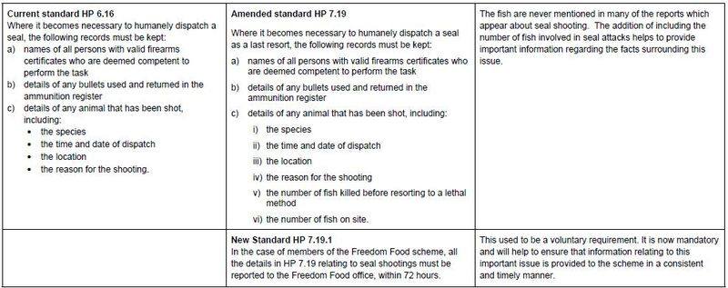
Download as a PDF online here

For more background on RSPCA Assured/Freedom Food salmon farms killing seals read RSPCA/Freedom Food & Seal Killing FOI Backgrounder (May 2017) and RSPCA Assured Seal Killers!

[2] Here's an email from Marine Harvest's Managing Director Ben Hadfield to MSPs and MPs:

From: MacKay, Jayne <Jayne.MacKay@marineharvest.com>
Sent: Thursday, December 21, 2017 10:22:56 AM
To: Adam G (George), MSP; Adamson C (Clare), MSP; Allan A (Alasdair), MSP; Arthur T (Tom), MSP; Baillie J (Jackie), MSP; Baker C (Claire), MSP; Balfour J (Jeremy), MSP; Ballantyne M (Michelle), MSP; Beamish C (Claudia), MSP; Beattie C (Colin), MSP; Bibby N (Neil), MSP; Bowman B (Bill), MSP; Briggs M (Miles), MSP; Brown KJ (Keith), MSP; Burnett A (Alexander), MSP; Cameron D (Donald), MSP; Campbell AE (Aileen), MSP; Carlaw J (Jackson), MSP; Carson F (Finlay), MSP; Chapman P (Peter), MSP; Coffey W (Willie), MSP; Cole-Hamilton A (Alex), MSP; Constance A (Angela), MSP; Corry M (Maurice), MSP; Crawford B (Bruce), MSP; Cunningham R (Roseanna), MSP; Davidson R (Ruth), MSP; Denham A (Ash), MSP; Dey G (Graeme), MSP; Doris B (Bob), MSP; Dornan J (James), MSP; Dugdale K (Kezia), MSP; Ewing A (Annabelle), MSP; Ewing F (Fergus), MSP; Fabiani L (Linda), MSP; Fee M (Mary), MSP; Findlay N (Neil), MSP; Finnie J (John), MSP; FitzPatrick J (Joe), MSP; Forbes K (Kate), MSP; Fraser M (Murdo), MSP; Freeman J (Jeane), MSP; Gibson K (Kenneth), MSP; Gilruth J (Jenny), MSP; Golden M (Maurice), MSP; Gougeon M (Mairi), MSP; Grahame C (Christine), MSP; Grant R (Rhoda), MSP; Gray I (Iain), MSP; Greene J (Jamie), MSP; Greer R (Ross), MSP; Griffin M (Mark), MSP; Halcro Johnston J (Jamie), MSP; Hamilton R (Rachael), MSP; Harper E (Emma), MSP; Harris A (Alison), MSP; Harvie P (Patrick), MSP; Haughey C (Clare), MSP; Hepburn J (Jamie), MSP; Hyslop F (Fiona), MSP; Johnson D (Daniel), MSP; Johnstone A (Alison), MSP; Kelly J (James), MSP; Kerr L (Liam), MSP; Kidd B (Bill), MSP; Lamont J (Johann), MSP; Lennon M (Monica), MSP; Lochhead R (Richard), MSP; Lindhurst G (Gordon), MSP; Lochhead R (Richard), MSP; Lockhart D (Dean), MSP; Lyle R (Richard), MSP; MacDonald A (Angus), MSP; MacDonald G (Gordon), MSP; Macdonald L (Lewis), MSP; MacGregor F (Fulton), MSP; Macintosh K (Ken), MSP; Mackay D (Derek), MSP; Mackay R (Rona), MSP; Macpherson B (Ben), MSP; Maguire R (Ruth), MSP; Marra J (Jenny), MSP; Martin G (Gillian), MSP; Mason J (John), MSP; Mason T (Tom), MSP; Matheson M (Michael), MSP; McAlpine J (Joan), MSP; McArthur L (Liam), MSP; McDonald M (Mark), MSP; McKee I (Ivan), MSP; McKelvie C (Christina), MSP; McMillan SM (Stuart), MSP; McNeill P (Pauline), MSP; Mitchell M (Margaret), MSP; Mountain E (Edward), MSP; Mundell O (Oliver), MSP; Neil A (Alex), MSP; Paterson G (Gil), MSP; Rennie W (Willie), MSP; Robison S (Shona), MSP; Ross G (Gail), MSP; Rowley A (Alex), MSP; Rumbles M (Mike), MSP; Ruskell M (Mark), MSP; Russell MW (Michael), MSP; Sarwar A (Anas), MSP; Scott J (John), MSP; Scott T (Tavish), MSP; Simpson G (Graham), MSP; Smith EA (Elaine), MSP; Smith E (Elizabeth), MSP; Smyth C (Colin), MSP; Somerville S (Shirley-Anne), MSP; Stevenson S (Stewart), MSP; Stewart A (Alexander), MSP; Stewart D (David) MSP; Stewart K (Kevin), MSP; Sturgeon N (Nicola), MSP; Swinney J (John), MSP; Todd M (Maree), MSP; Tomkins A (Adam), MSP; Torrance D (David), MSP; Watt M (Maureen), MSP; Wells A (Annie), MSP; Wheelhouse P (Paul), MSP; White S (Sandra), MSP; Whittle B (Brian), MSP; Wightman A (Andy), MSP; Yousaf H (Humza), MSP
Cc: Roberts, Ian
Subject: Newsletter from Marine Harvest

Good morning,

Please find attached our first newsletter. We hope you enjoy it and if you have any queries please do not hesitate to get in touch.

Best wishes for the Festive Season,

Regards

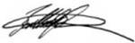

Ben Hadfield
Managing Director

Jayne MacKay
PA to MD / Communications Assistant
MARINE HARVEST SCOTLAND LTD
––––––––––––––––––––––––––––––––
MOBILE: +44 7717 802370
DIRECT: +44 1397 715061
MAIL: jayne.mackay@marineharvest.com
––––––––––––––––––––––––––––––––
OFFICE: Stob Ban House
Glen Nevis Business Park
Fort William, PH33 6RX
Scotland, UK

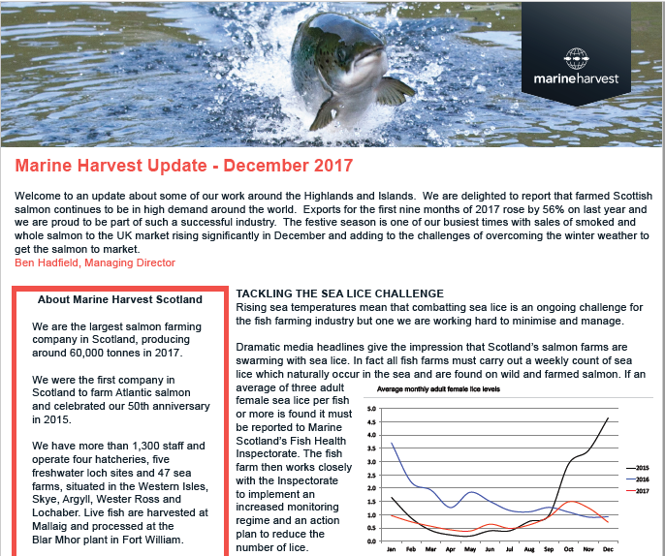
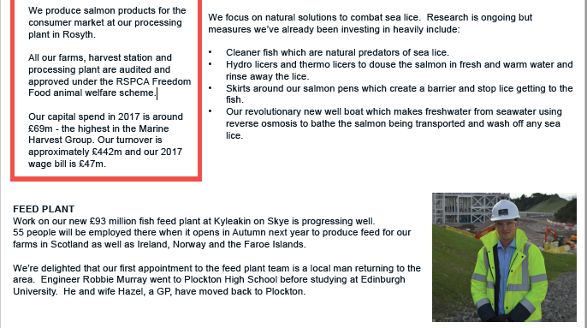

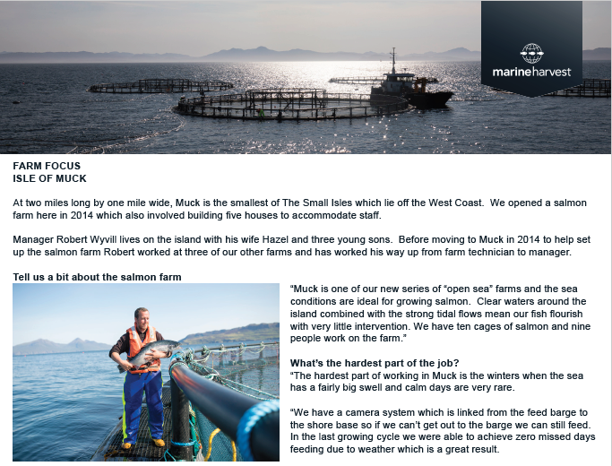
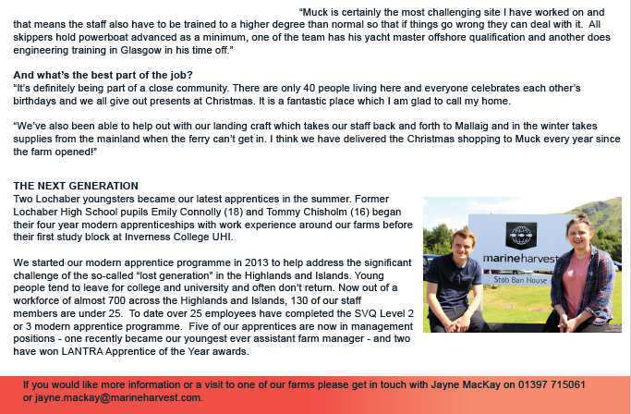

Download as a PDF online here

[3] A report - "RSPCA Assured Certification of Scottish Farmed Salmon" - published by Salmon & Trout Conservation Scotland in June 2017 included:

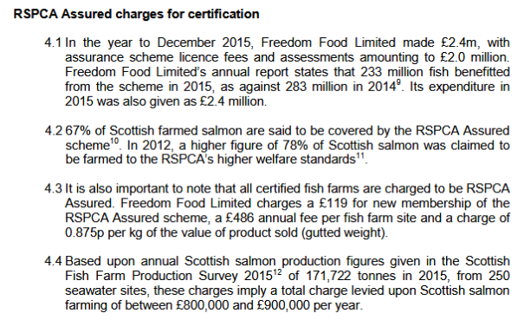
[4] The RSPCA has stubbornly refused to name which salmon farms are certified via the RSPCA Assured (formerly Freedom Food) scheme. A report - "RSPCA Assured Certification of Scottish Farmed Salmon" - published by Salmon & Trout Conservation Scotland in June 2017 included:
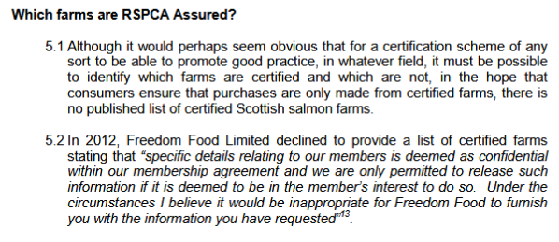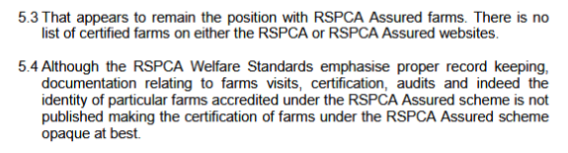
Freedom Food's General Manager Clive Brazier told GAAIA in January 2015:
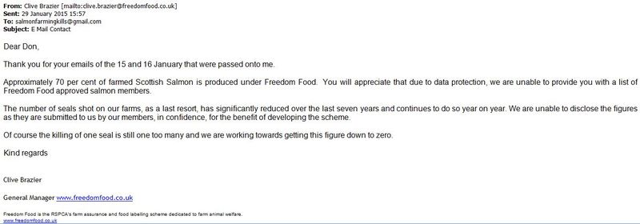
[In July 2016, Clive Brazier became chief executive of RSPCA Assured]

However, we know by Marine Harvest's own admission in December 2017 that all of Marine Harvest's 49 sea farms are certified via RSPCA Assured and we know that Marine Harvest produced "more than 50,000 tonnes" of farmed salmon in Scotland in 2015.

According to the latest Scottish Government 'Scottish Fish Farm Production Survey 2016' published in September 2017, a total of 171,722 tonnes of farmed salmon was produced in 2015 (predicted to rise to 177,202 tonnes in 2017).

Hence if Marine Harvest produced 57,000 tonnes in 2015 that would have equated with a third of Scottish farmed salmon production.

Moreover, if only 70% of Scottish farmed salmon is certified via RSPCA Assured but all of Marine Harvest's salmon farms are accredited then Marine Harvest could account for almost half of all RSPCA-certified farmed salmon production (70% of 171,722 tonnes is 120,205 tonnes).

Since the RSPCA's income from salmon farming is estimated at between £800,000 to £900,000 per year then Marine Harvest could account for ca. £400,000.

[5] Fish Update reported in April 2016:
"Ian Michie has joined the RSPCA as a Farm Livestock Officer carrying out inspections of RSPCA Assured farmed fish producers in Scotland". He was a salmon farm manager for Marine Harvest for 18 years and was aquaculture manager with Young’s Seafood for 11 years."
Fish Farmer magazine reported in May 2016:

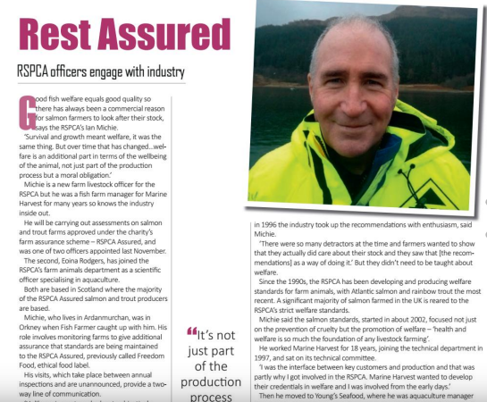
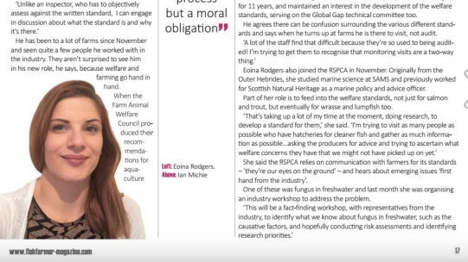

[6] "Animal welfare is vital to us at Sainsbury’s – and that applies as much in water as it does on land. That’s why all our farmed salmon is RSPCA Assured," claimed Sainsbury's in 2017 who also referred to "our Scottish supplier Marine Harvest".

In 2015, Marine Harvest poached a £100 million Sainsbury's contract from Young's Seafood (racking up huge losses in the process).

According to Fisheries Information Service:

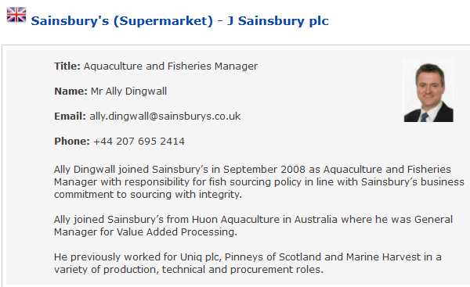

In 2008, The Guardian reported: "The retailer Sainsbury's has also promised it will phase out suppliers associated with seal shooting". Andy Ottaway of the Seal Protection Action Group said in a press release: "We are calling on Sainsbury’s and other major retailers to use their considerable purchasing power to persuade Scottish salmon producers to stop shooting our seals".

Intrafish reported back in 2010:

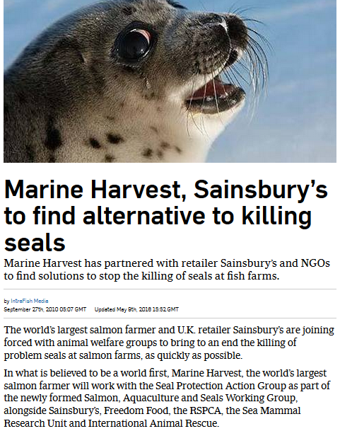
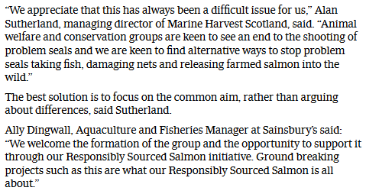

Sainsbury's pledged action following a campaign by the Seal Protection Groups coalition - who published the following leaflet in 2008:

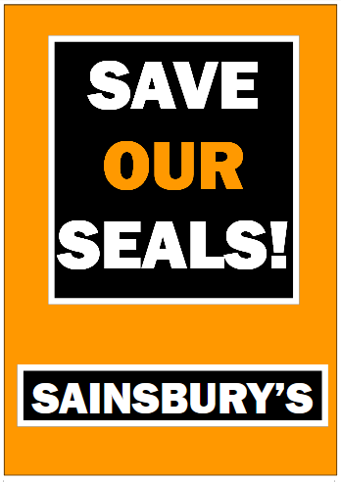

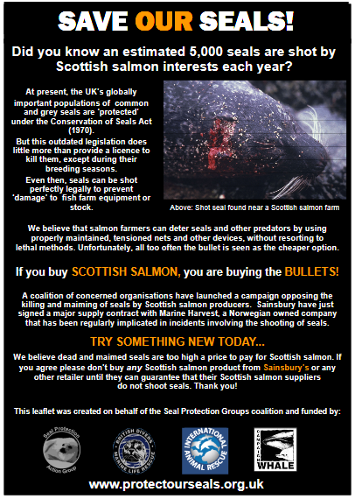

This led to a joint press release claiming that: "Salmon farmers, retailers and animal welfare groups are joining forces to bring to an end the killing of problem seals at salmon farms as quickly as possible":

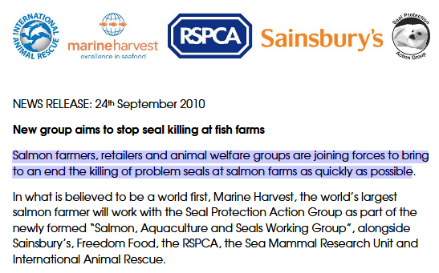

A decade later Sainsbury's is still sourcing salmon from Marine Harvest's seal-killing salmon farms.
RSPCA Assured promote on their web-site a recipe by Rosie Curtis of Marine Harvest (omitting to mention the fact that their supplier Marine Harvest still kills seals).
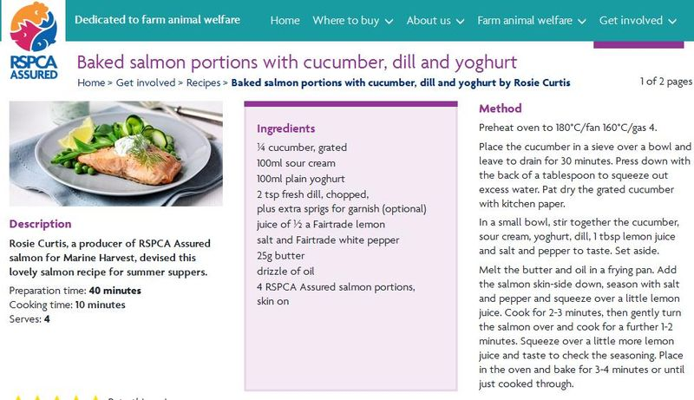
Sainsbury's have long promoted Marine Harvest's 'Food Food' salmon (using celebrity chef Jamie Oliver in adverts):

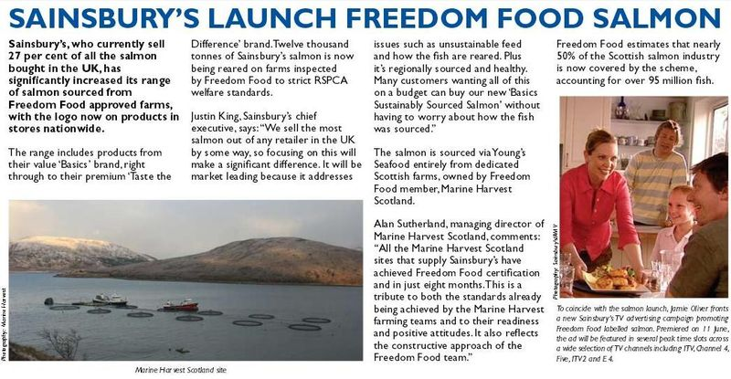

In 2005, Jamie Oliver was asked to apologize after promoting Marine Harvest's polluted salmon farm in Loch Hourn in an advert for Sainsbury's (read more via "Campaigners want polluted salmon farm endorsed by Oliver to be shut" and "Fat Lady calls Naked Chef 'whore' over Sainsbury's salmon").

In 2005, Marine Harvest was shamed over the slaughter of seals in Loch Alsh (a Special Area of Conservation). Watch a video report via "Marine Harvest's Slaughter of Seals in Loch Alsh, Scotland".

In 2008, headless seal corpses were washed up near Marine Harvest's salmon farm in Loch Alsh.

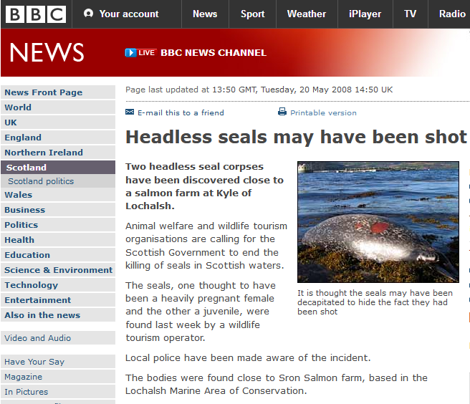

In 2015, GAAIA wrote to retailers including Sainsbury's urging an immediate ban on seal killing on salmon farms.

[7] A report - RSPCA/Freedom Food & Seal Killing FOI Backgrounder - published by GAAIA in May 2017 included:

"Data obtained from SNH (Download SNH FOI 25 April 2017 document #7) does at least name seven Freedom Food salmon farms - including Marine Harvest's Colonsay salmon farm which did not use either Acoustic Deterrent Devices (ADDs) or APNs yet shot one grey seal in 2016:
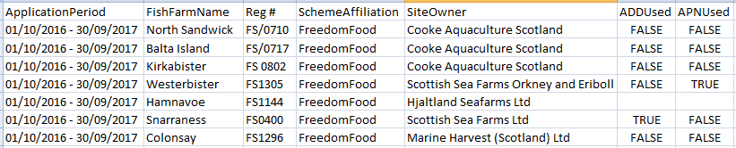
The report also included:

"The latest data (published online by the Scottish Government) on seals killed by salmon farms during 2016 reveals that at least 26 salmon farms killed seals but have not reported the use of Anti-Predator Nets (APN) in the last two licensing periods (encompassing 2015 and 2016 - as defined by SNH FOI 25 April 2017 document #5 and SNH FOI 25 April 2017 document #7) casting doubt on the definition of "last resort" (i.e. salmon farmers are reaching for bullets before nets):

Bight of Bellister (Scottish Sea Farms)
Cairidh (Marine Harvest)
Camas Glas (Marine Harvest)
Colonsay (Marine Harvest)
Creag an t Sagairt (Marine Harvest)
Eilean Grianain (Marine Harvest)
Gometra (The Scottish Salmon Company)
Greshornish (Marine Harvest)
Hellisay (Marine Harvest)
Holms Geo (Scottish Sea Farms)
Isle Ewe (Marine Harvest)
Kingairloch (Marine Harvest)
Linnhe (Marine Harvest)
Lochalsh (Marine Harvest)
Loch Carnan (Marine Harvest)
Maol Ban (Marine Harvest)
Marulaig (Marine Harvest)
Ornish (Marine Harvest)
Shapinsay (Scottish Sea Farms)
Slocka Ronas Voe (Scottish Sea Farms)
Spelve A (Scottish Sea Farms)
Sound of Harris (Loch Duart)
Swarta Skerry (Balta Island Seafare)
Taranaish (The Scottish Salmon Company)
Vidlin North (Scottish Sea Farms)
Winna Ness (Cooke Aquaculture)

Additionally, five more salmon farms may have not used APNs during 2016 (it is impossible to say for sure given the lack of synchronicity between the data sets):

Djubawick (Cooke Aquaculture)
Fuinary (Scottish Sea Farms)
Kishorn West (Scottish Sea Farms)
Stead of Aithness (Cooke Aquaculture)
Walters/East Lismore (Scottish Sea Farms)
- Note that all bar one (Balta Island Seafare's Swara Skerry site) of the 31 salmon farms listed above are accredited to the SSPO's Code of Good Practice (as member companies of the SSPO: Cooke Aquaculture (Scotland); Loch Duart Ltd; Marine Harvest (Scotland); The Scottish Salmon Company; and Scottish Seafarms) which claims that killing of seals "must only ever be as an act of last resort".
- If "all the fish are farmed to RSPCA Freedom Food standards" as claimed by Scottish Sea Farms then why are seals killed at the following sites where anti-predator nets are NOT used?:
Bight of Bellister; Holms Geo; Shapinsay; Slocka Ronas Voe; Spelve A and Vidlin North

- If Marine Harvest abides by "last resort" seal-killing (as it claimed in The Herald newspaper in April 2017) then how does Marine Harvest explain the 22 seals it killed during 2016 at the following sites where anti-predator nets where NOT used ("bi catch concerns" (sic) was the reason given)?:

Cairidh; Camas Glas; Colonsay; Creag an t Sagairt; Eilean Grianain; Greshornish; Hellisay; Isle Ewe; Kingairloch; Linnhe; Lochalsh; Loch Carnan; Maol Ban; Marulaig and Ornish".

