The Global Alliance Against Industrial Aquaculture, 11 December 2017

Millions of Scottish Salmon Going Up in Smoke
- BBC's 'The One Show' exposes Scotland's 'Dead Salmon Run'

The burning issue of infectious diseases, lice infestations and mass mortalities on Scottish salmon farms was showcased tonight by The One Show on primetime on BBC 1 - watch online here

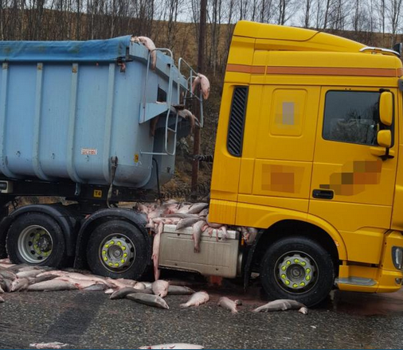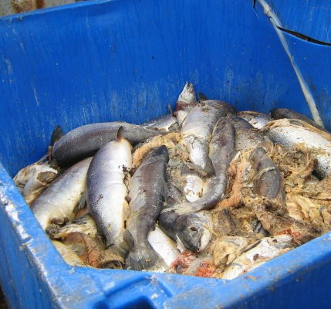

The One Show featured footage of a convoy of haulage trucks carrying dead fish dripping with wastes away from Loch Kishorn (where Scottish Sea Farms operates three salmon farms reported by the Fish Health Inspectorate to be affected by gill pathology, cardiomyopathy syndrome and anaemia) [1]. Scottish Sea Farms is owned by the Norwegian corporations Leroy and SalMar and is the exclusive supplier of Marks & Spencer's fake Lochmuir salmon.

"This is the dirty side of the salmon farming industry," said BBC reporter Joe Crowley. "A lorry has just turned up to pick up that big skip full of dead fish - but what I was not expecting was also a tanker arriving and they're simply vacuuming vast quantities of dead fish straight out of the bins and you can hear the weight of them rattling and banging as they're sucked up into the tanker."


"Last year nearly 22,500 thousand tonnes of salmon died on Scottish farms - double what it was just three years earlier," continued Crowley who followed a convoy of trucks hauling dead salmon from Loch Kishorn to Dumfries for disposal. "The dead salmon run is back on again. There is something very stark about this very ugly cargo of dead fish winding its way through this beautiful, majestic countryside."

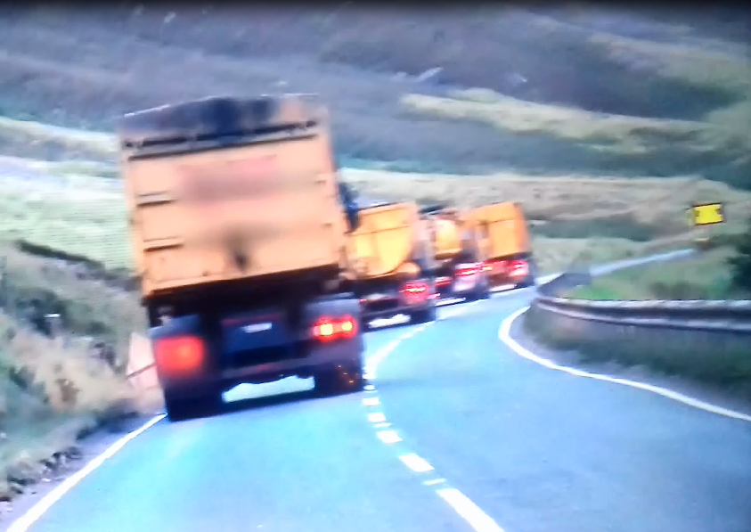

"Shoppers who buy Scottish salmon this Christmas have the blood of millions of dead fish on their hands," said Don Staniford, Director of the Global Alliance Against Industrial Aquaculture (GAAIA) who was interviewed for The One Show.

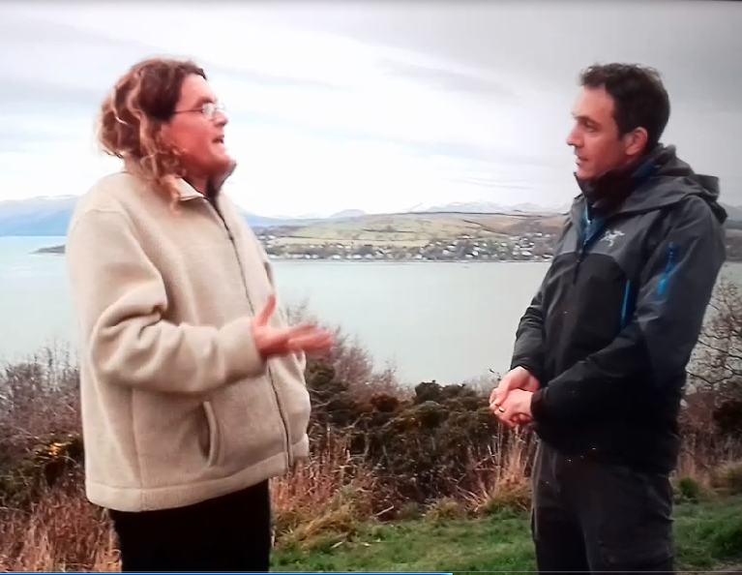

"Lice infestations and infectious disease outbreaks on Scotland's filthy fish farms are spewing out dead salmon on a horrific scale. Tourists coming to the West coast of Scotland do not want to see trucks laden with rotting salmon dripping with wastes. Questions must urgently be asked about the industry's bio-security measures to prevent the spread of infectious diseases."

Mass mortalities from Scotland's lice-infested salmon farms could now stand at over 20 million fish per year - that's over 22,000 tonnes of 'morts' with an annual mortality rate over a quarter [2].

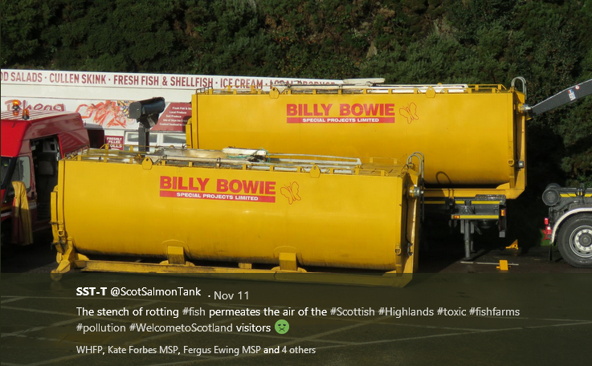

The mortality rate on Scottish salmon farms is estimated to be five times higher than on chicken farms. Whilst the mortality rate on Scottish salmon farms is 26.7% according to the latest Scottish Government fish farm survey, the mortality rate on UK chicken farms is less than 5%.

Following the BBC's broadcast of images of wastes leaking from a haulage truck transporting dead farmed salmon from Loch Kishorn, GAAIA will be asking whether the Animal By-Products (Enforcement) (Scotland) Regulations 2013 have been breached. Guidance issued by the Department for Environment, Food & Rural Affairs and Animal and Plant Health Agency in 2014 stated under 'Vehicle Hygiene & Storage': "When you’re transporting animal by-products (ABPs) or any ABP derived products, you must make sure you: use vehicles and containers that are covered and leak-proof".


In November 2016, a Parliamentary Question filed by Mark Ruskell MSP asked "where and by whom containers of diseased salmon morts are checked for biosecurity compliance during their journey from farm to final disposal, and how many such journeys have taken place in each of the last three years".

"Vehicles used for transporting salmon morts to a disposal site must be approved or registered under the Animal By-Products (Enforcement) (Scotland) Regulations 2013 (ABPR)," replied Fergus Ewing, Cabinet Secretary for the Rural Economy and Connectivity, in December 2016. "The operators of these vehicles must ensure that salmon morts be collected and transported in sealed new packaging or covered leak-proof containers."

Another Parliamentary Question and reply in November 2016 also stressed when transporting Animal By-Products transporters must ensure that they "use vehicles and containers that are covered and leak-proof":

In Canada, the issue of discharges of blood water spreading infectious diseases is a hot topic following shocking video footage published last month by Tavish Campbell.

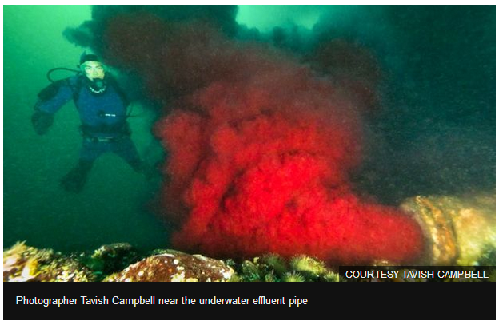

Read more via Bloody sewage from Canada fish plant 'threatens' wild salmon

"Scottish salmon's burgeoning mort mountain could soon rival Ben Nevis and the carcasses of dead salmon would help rebuild Hadrian's Wall," continued Staniford. "Millions of farmed salmon being burned in incinerators gives a whole new meaning to smoked Scottish salmon. If you're served Scottish salmon over the festive period please throw it in the rubbish bin where it belongs. Join the boycott against farmed salmon."

The Times reported today (11 December 2017): "Tens of thousands of farmed fish which died from parasites or disease have been recycled into renewable energy. The fish carcasses are sent to anaerobic digestion plants that use bacteria to break down organic matter to produce biogas. This is then burnt to generate electricity which goes to the National Grid" (read more via "Energy from dead salmon horrifies vegan activists").

The Sunday Times reported yesterday:

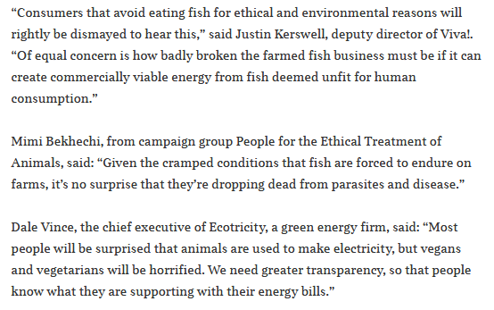

Read more via "Vegans in shock at fish electricity: Energy firm SSE admitted generating power from dead salmon earlier this year"

The National reported today (11 December 2017): "A 'catastrophic' failure of the salmon run in Argyll’s largest and most closely monitored river has prompted demands for the closure of some fish farms and a review of the expansion of the industry" (read more via "Call for closure of fish farms after 'catastrophic' drop in salmon numbers").

"Instead of doubling aquaculture production by 2030, the Scottish Government should be drastically reducing salmon farming production and closing Scotland's liciest farms," concluded Staniford. "Hopefully the Scottish Parliament's forthcoming inquiry will open up the can of worms that is Scottish salmon farming."

GAAIA will also ask the Scottish Environment Protection Agency to overturn its 2013 decision to keep the number of dead salmon secret following lobbying by the salmon farming industry who argued that disclosure would be commercially damaging.

For a media backgrounder on mass mortalities at Scottish salmon farms see Note [3].

Contact:

Don Staniford (Tel: 07771 541826; email: dstaniford@gaaia.org)

Notes to Editors:

[1] Since 2014, Scottish Sea Farms has operated three salmon farms in Loch Kishorn.
According to monthly data published via Scotland's Aquaculture web-site, mortality is significant:

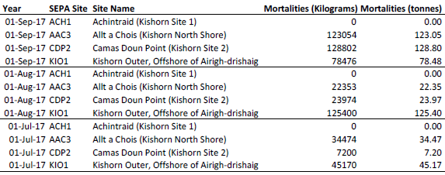

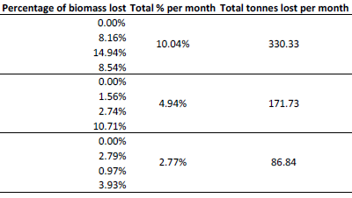

Download as a PDF online here

Please note:

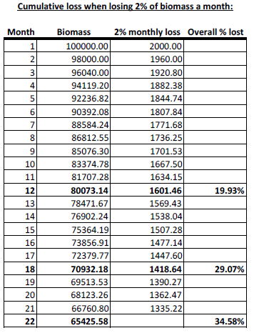

Download as a PDF online here

When questioned by the BBC's One Show, the Scottish Government's Fish Health Inspectorate (Tel: 01312 444 010) gave the following information:

1 Mortalities.

1.1 Are you (FHI) able to disclose the approximate total quantity of mortalities trans-shipped or proposed to be trans-shipped from Kyle pier for disposal during this present case? If you are unable to do so, when would you anticipate such disclosure might be made?

The FHI do not hold details of total numbers of mortalities removed from site for disposal. Animal by-product disposal is regulated by the Animal and Plant Health Agency (APHA), further details can be found here
https://www.gov.uk/guidance/transporting-animal-by-products

The FHI may record details of increased or unexplained mortalities occurring at aquaculture sites as part of routine inspections. Details of increased or unexplained mortalities are held within case information which is published on a quarterly basis. As well as case information and inspection reports, a list of all sites inspected during the quarter is published. Further details can be found here
http://www.gov.scot/Topics/marine/Fish-Shellfish/FHI/CaseInformation

If or when information is held by the FHI as part of our surveillance in relation to this issue it would be released as part of our quarterly publication process.

1.2 Are you able to disclose the site from which the aforementioned morts originate, and if you are unable to do so, when would you anticipate such disclosure might be made?

To our knowledge the waste in the sealed containers originated from fish farm sites in Loch Kishorn.

1.3 Are you able to disclose the possible cause(s) of the mortalities and if unable to do so, when would you anticipate such disclosure might be made?

Mortality information provided to the FHI from farms in Loch Kishorn assign mortalities due to gill pathology, cardiomyopathy syndrome (CMS) and anaemia. In addition, any case information recorded during routine surveillance at the fish farm sites in Loch Kishorn will be published as described.

[Please note that the Fish Health Inspectorate's Case Information does not currently provide data beyond June 2017]

Scottish Sea Farms (formerly called Hydro Seafoods) was the source of the first outbreak of Infectious Salmon Anaemia (ISA) in Scotland which originated in Loch Nevis in 1998 and spread to a total of 11 salmon farms with a further 34 salmon farms suspected on the Scottish west coast mainland, Skye, Orkney, Shetland and the Western Isles. The outbreak of ISA cost £100 million and led to the loss of 200 jobs.

"In the unlikely event that infectious salmon anaemia is found, Scottish salmon farmers work closely with the regulatory authorities with the aim of minimising any immediate impacts, and ensuring that it is eliminated as rapidly as possible," said Scott Landsburgh of the Scottish Salmon Producers’ Organisation in March 2017. "All of the measures already in place in Scotland meet the requirements of EU fish health legislation, having been reviewed and strengthened following two previous occurrences of ISA a number of years ago, and we are confident that, should ISA be detected in the future, we are well placed to deal with it quickly and effectively."

[2] The latest statistics published by the Scottish Government in September 2017 reveal a mortality rate of 26.7% for 2014 (2015 figures will not be published until September 2018). Mortality rates in some regions is even higher - with salmon farms in the Western Isles reporting 42.8% and Shetland reporting 31.9% mortality for 2016 (read more via Scottish Fish Farm Production Survey 2016 - see Tables 28 & 30).

Monthly data on mortalities (by weight only) are published online via the Scotland's Aquaculture web-site. Data on the number of mortalities was available from SEPA until 2013 when it bowed to pressure from the Scottish Salmon Producers Organisation to keep the number of dead salmon secret due to its commercially damaging nature.

Official figures published by The Sunday Herald in 2013 revealed that 8.5 farmed salmon died in 2012 compared to 5.5 million in 2010. The Sunday Herald reported in October 2017 that there have been successive, significant increases in 2014, 2015 and 2016. "Critics estimate the total number of dead, discarded salmon last year to have been between 10m and 20m," reported Rob Edwards. "But the industry says it sustained losses of “between 6 and 10 million fish, depending on their size”.

Here's a table of mortality rates (and estimated number of morts) since 2002 using the data published via Scottish Fish Farm Production Survey 2016:

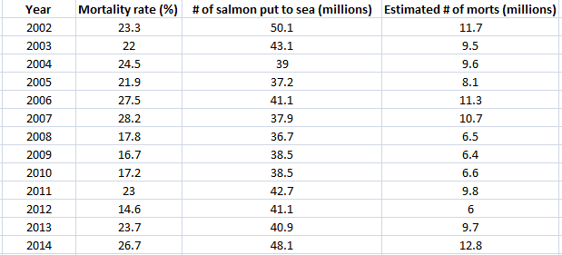

Download Excel spreadsheet online here

Data on mortalities was made available by SEPA via FOI for the period 2002 to 2016 (up to September):

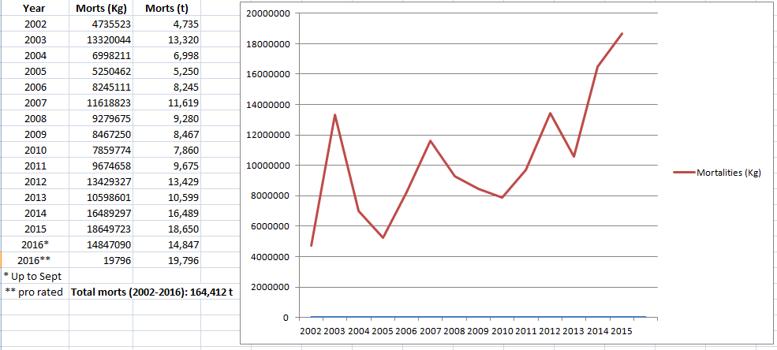

The twenty worst salmon farms in terms of mortalities for the period 2002 to September 2016 were:

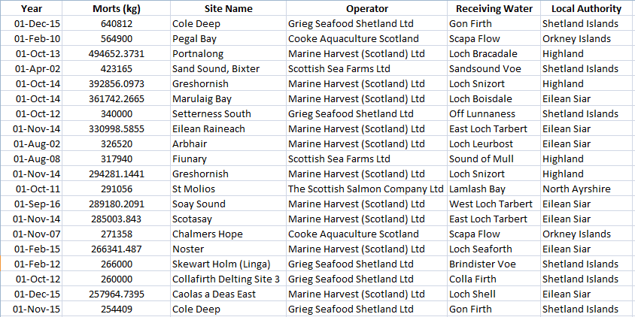

Read more via Press Release: Scottish Salmon's Lethal Legacy

[3] In November 2017, the Scottish Salmon Think Tank Tweeted:
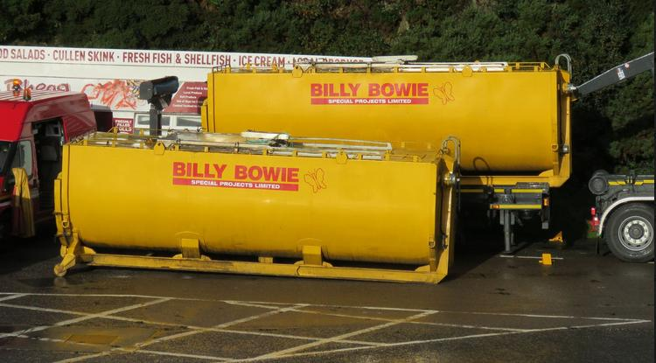
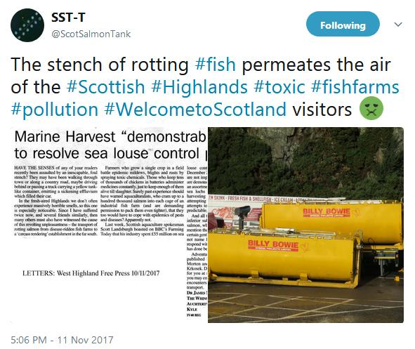
The Scottish Think Tank reported:
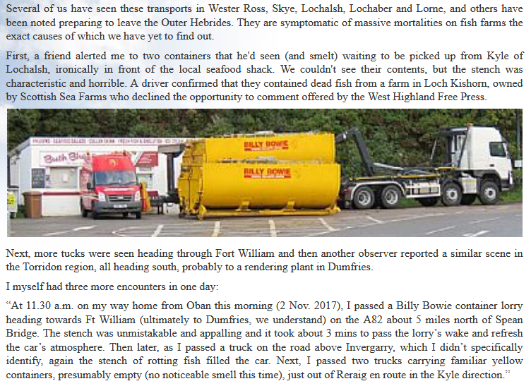
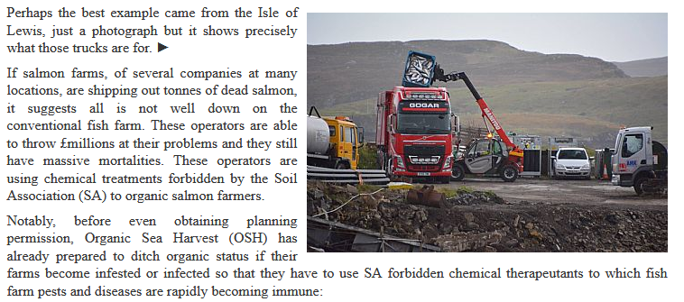
Another Tweet from the Scottish Salmon Think Tank detailed an article in the West Highland Free Press:

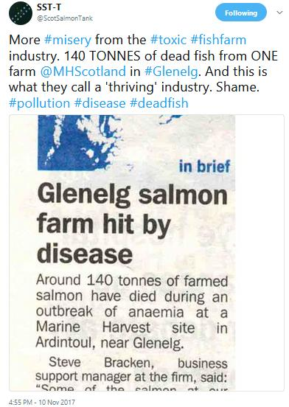
Read more via Letter: "Marine Harvest 'demonstrably failing' to resolve sea louse control problem"

BBC News reported in October 2017: "About 125,000 salmon have died due to a disease outbreak at two fish farms on the Isle of Lewis, BBC Scotland has learned. Marine Harvest confirmed that the sites in Loch Erisort have been hit by the bacterium Pasturella Skyensis" (read more via "125,000 salmon die in disease outbreak at Lewis fish farms").

BBC News reported earlier in October 2017: "Lorry loads of dead fish are being collected from a sea loch on the Isle of Lewis after suffering a bacterial infection, the BBC understands.....Locals have raised concerns about the smell of rotting fish at the shore" (read more via "Thousands of salmon on Lewis killed by infection").

The Sunday Herald reported in October 2017: "Official figures reveal the tonnages of dead fish that had to be disposed of has more than doubled from 10,599 in 2013 to a record high of 22,479 in 2016. Most are transported south to be burnt at an incinerator in Widnes near Warrington in northwest England..... The company that suffered the biggest losses was Marine Harvest, headquartered in Norway, whose mortalities leapt threefold to 7,609 tonnes between 2013 and 2016. Over the same period, the Scottish Salmon Company, which is registered in the Channel Islands, saw its dead fish more than double to 5,873 tonnes" (read more via "A disgrace: Ten million salmon thrown away by fish farm industry in last year alone").

The Times reported in July 2017: "The number of salmon dying on Scottish fish farms has doubled to 20 million a year because of parasites, diseases, and overcrowding in their cages, a campaign group claimed yesterday. For every seven fish that reach supermarket shelves one will have died on the farm, according to research by the Salmon & Trout Conservation Trust, which questioned how farms could be endorsed by the RSPCA given the levels of mortality" (read more via "Death rate at salmon farms doubles to 20m fish a year").

In July 2017, Salmon & Trout Conservation published a report - RSPCA Assured certification of Scottish farmed salmon estimating mortalities at 20 million per year:

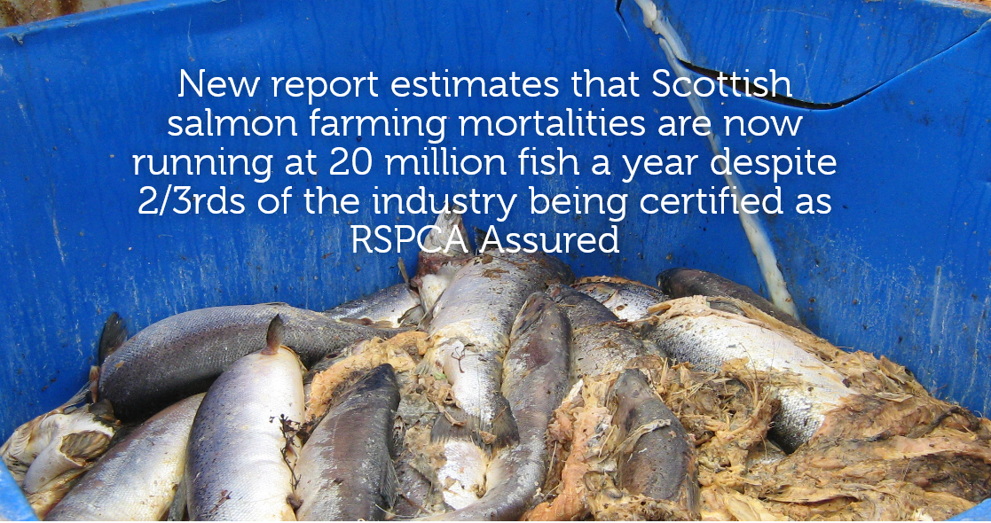

"A new report for S&TC Scotland on RSPCA Assured certification of Scottish farmed salmon reveals that Scottish salmon farming mortalities as a percentage of total production have almost doubled in the last four years," stated the press release. On the basis of official data, the report estimates that over 41 million fish died during 2015 and 2016, an average of over 20 million fish per annum."

The Times reported in June 2017: "More than a million salmon died in a Scottish sea loch last year because of a plague of sea lice at commercial farms" (read more via "A million salmon die in lice plague").

Marine Harvest Scotland has published mortality reports during 2017 - including 4.81% treatment mortality at Loch Hourn and 9.77% mortality at MacLean's Nose due to Cardiomyopathy Syndrome (viral infection causing weak hearts) in June 2017 and 13.96% mortality at MacLean's Nose due to Cardiomyopathy Syndrome (viral infection causing weak hearts) in May 2017.

The Daily Telegraph reported in November 2016: "Thousands of salmon were poached alive when a lice treatment process at Scottish fish farms went disastrously wrong, it has emerged. More than 175,000 salmon died when the water they were swimming in was overheated, prompting calls for those responsible to be prosecuted for cruelty" (read more via "Thousands of fish poached alive in lice treatment bungle that could hit Christmas salmon prices" and "Oops: fish farm firm kills 175,000 of its salmon by accident").

The Herald reported in October 2016: "Conservationists have called for government action after raising concerns that hundreds of thousands of fish have died from an infectious disease in salmon farms in Hebrides and Wester Ross. The Salmon and Trout Conservation Scotland has called on Scottish ministers to intervene to protect wild fish after an outbreak of Amoebic Gill Disease (AGD). It is understood that four farm sites have been affected including West Loch Tarbert and East Loch Tarbert on Harris, Loch Greshornish on Skye and the Isle of Ewe in Wester Ross. Marine Harvest salmon farms have been particularly affected, it is said" (read more via "Alert over salmon deaths crisis on Scots fish farms caused by infectious disease").

The Sunday Herald reported in 2013:

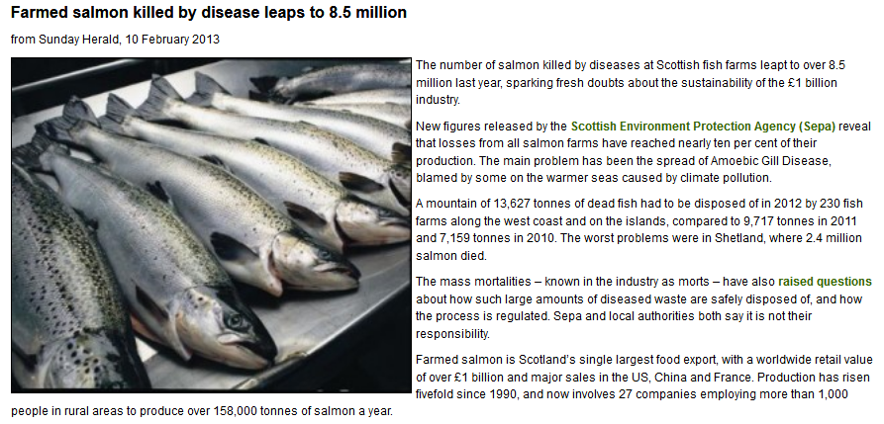

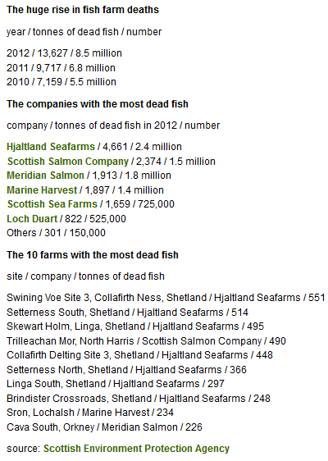

However, later in 2013 the Scottish Environment Protection Agency bowed to pressure from the Scottish Salmon Producers Organisation to keep the number of dead salmon secret:

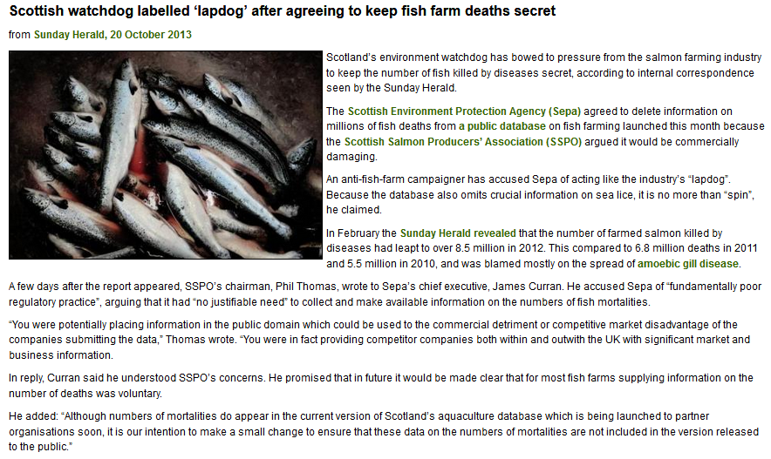

Read more via "Public denied info on full scale of salmon deaths" and "Scottish watchdog labelled ‘lapdog’ after agreeing to keep fish farm deaths secret"
In 2012, GAAIA published a report - "Gill Diseases: Scottish Salmon's Dirty Big Secret" - detailing mass mortalities due to gill diseases (read news story via "Chlamydia and gill disease ravage Scottish salmon: GAAIA"):

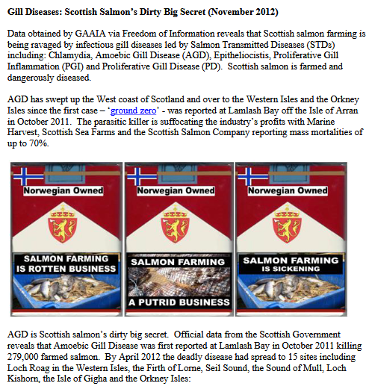

Download report in full online here

