Scottish Scamon, 14 February 2022

Anyone for M&S’s Virus-Laden Scottish Salmon
(don’t worry, it’s “responsibly sourced” & RSPCA Assured)?!
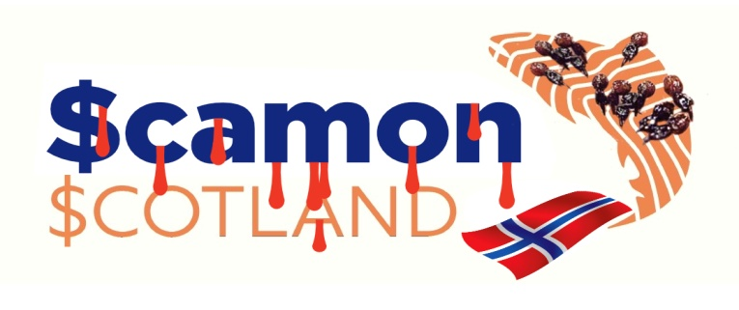

- Letter to M&S calls for boycott of Scottish Sea Farms
- Scottish Sea Farms (supplier to M&S) reported 93,655 dead salmon
at ISA-infected site in Loch Spelve on the Isle of Mull (33% mortality rate) during 2021
- 18 ‘Mortality Event Reports’ filed with the Scottish Government for ISA site during 2021
- Complex Gill Disease cited as primary cause of mass mortalities but ISA reported
to World Organization for Animal Health (OIE) in September 2021
- OIE report by Scottish Government detailed ‘Infection/Infestation limited to one or more zones’ and listed 369,195 ‘susceptible’ farmed Atlantic salmon
- Secret filming by Scottish Salmon Watch in Loch Spelve in May 2021 triggered Scottish Government inspection report & subsequent report to OIE

Marks & Spencer is being challenged to reveal how many virus-laden Scottish salmon have been sold to unsuspecting shoppers. Last week (10 February), Scamon Scotland revealed that Infectious Salmon Anaemia (ISA) had been officially reported at M&S supplier Scottish Sea Farms (Norskott Havburk) in Loch Spelve in May 2021 with 369,195 fish listed as ‘susceptible’ to the deadly virus. Scamon Scotland today (14 February 2022) wrote to M&S asking how many RSPCA Assured Scottish salmon marketed as “responsibly sourced” were infected with ISA.

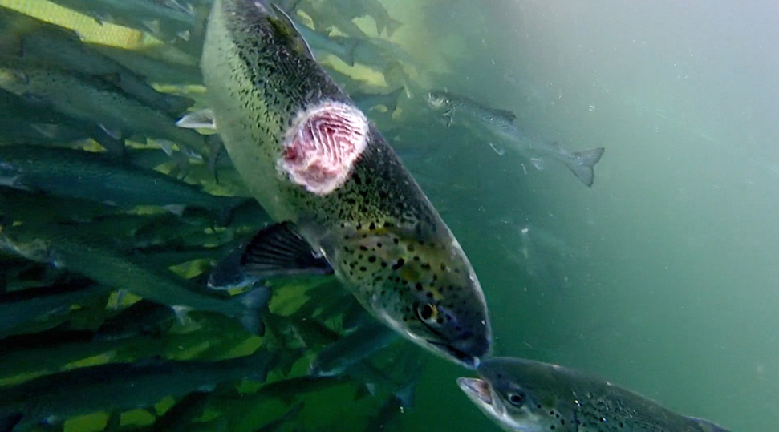

Data published by the Scottish Government’s Fish Health Inspectorate on 7 February 2022 details 18 ‘Mortality Event Reports’ involving 93,655 dead farmed salmon at Norwegian-owned Scottish Sea Farms in Loch Spelve during 2021 with a weekly peak mortality of 5.1% in early September and a cumulative mortality rate of 33% (i.e. one in three farmed salmon dying) according to further data published by Salmon Scotland. Here’s the 18 ‘Mortality Event Reports’ at the RSPCA Assured Loch Spelve salmon farm which pioneered M&S’s fake Lochmuir label (in chronological order – latest first):

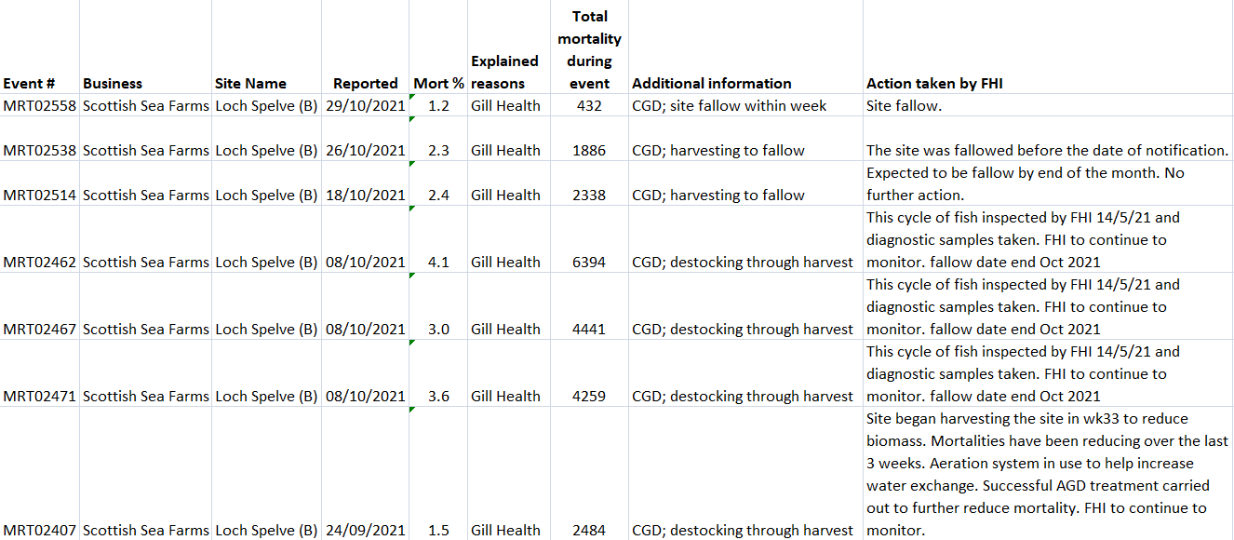

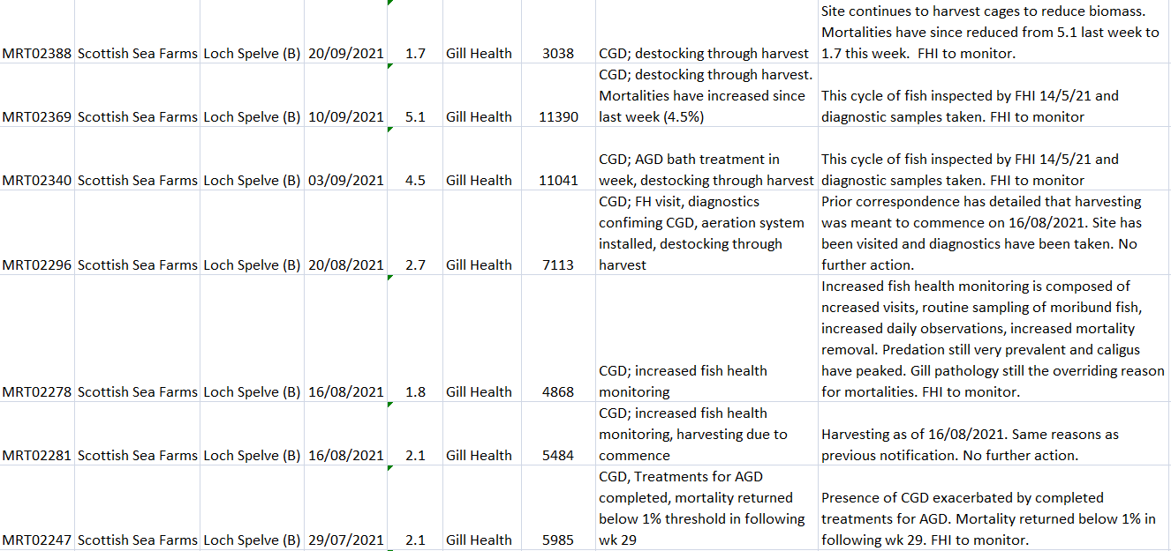
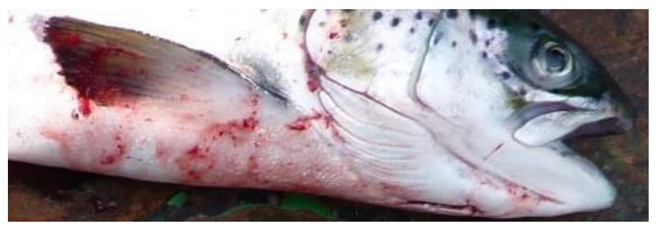

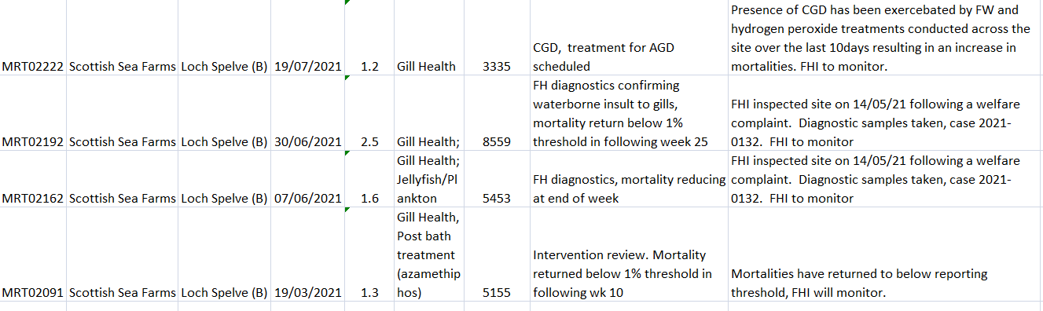

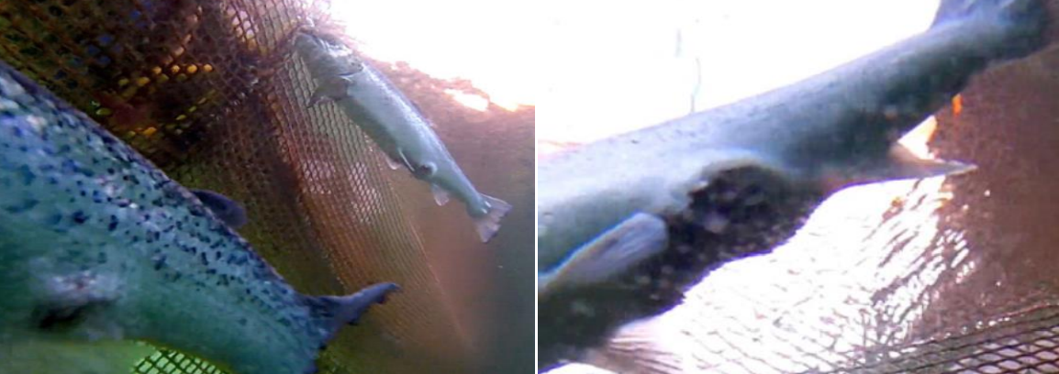

Scottish Sea Farms – co-owned by Norwway’s SalMar and Leroy via Norskott Havbruk - reported mortalities in Loch Spelve due to Gill Health, Complex Gill Disease (CGD), losses due to the organophosphate Azamethiphos (a lobster-killing toxic chemical) and Hydrogen peroxide treatments (another toxic chemical shown by peer-reviewed science to be lethal to shellfish and seaweed).
Mortality data published in October 2021 by Salmon Scotland (formerly the Scottish Salmon Producers Organisation) detailed cumulative mortality of 32.8% at the Loch Spelve salmon farm operated by Scottish Sea Farms with 7.5% monthly mortality recorded October 2021 (9.3% monthly mortality was recorded in September 2021; 13.4% monthly mortality recorded in August 2021; 6.4% monthly mortality recorded in July 2021; 4.9% monthly mortality recorded in June 2021 and 2.9% monthly mortality recorded in May 2021 – the month when the Scottish Government first reported ISA at the site):

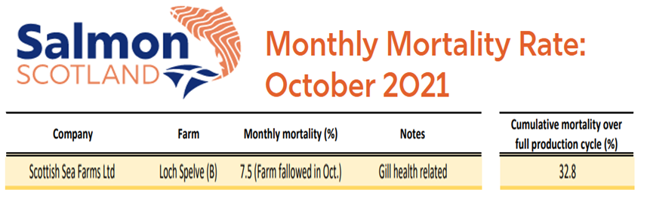

Data published online via ‘Scotland’s Aquaculture’ details shows lice infestation peaked in early June 2021 following the OIE report detailing ISA in Loch Spelve in May 2021:

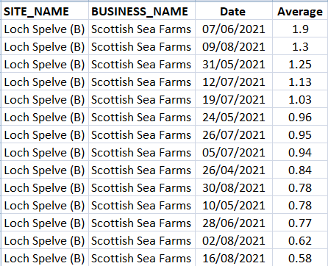
Here’s the FHI ‘Case Information’ report for Loch Spelve detailing the inspection on 14 May 2021 – including reference to Salmonid Gill Pox, Amoebic Gill Disease, Proliferative Gill Disease, Piscine Reovirus, Branchiomonas cysticola (Piscichlamydia), Moritella viscose, Vibrio, Photobacterium, Neoparamoeba perurans, necrosis, dermatitis and Infectious Salmon Anaemia:

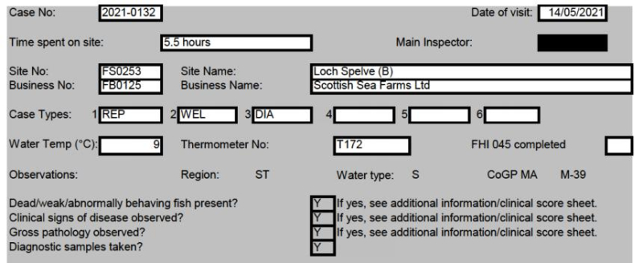
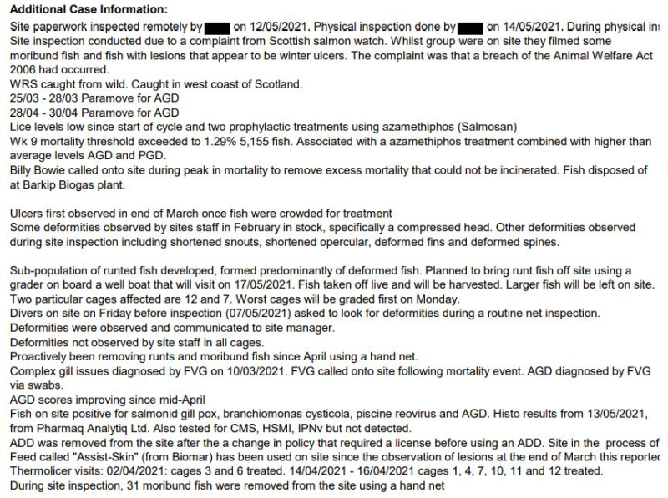
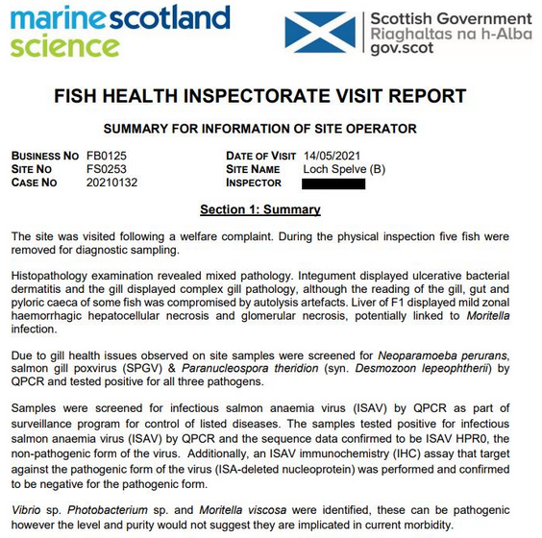
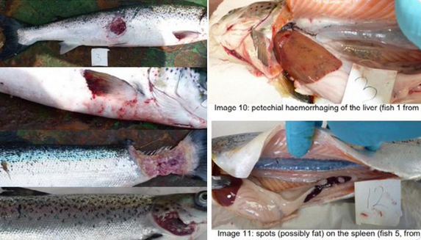
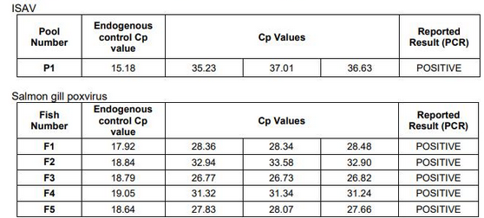
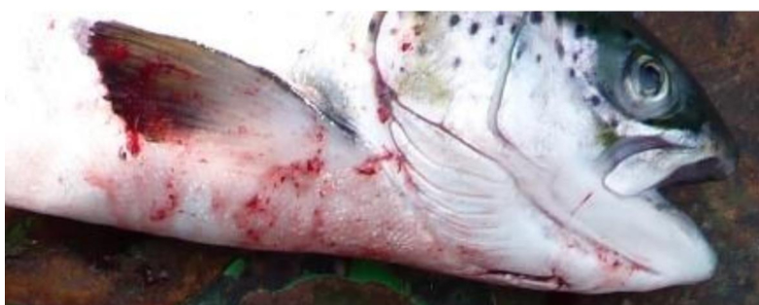
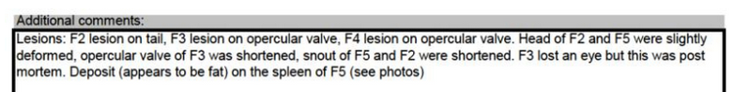
The Fish Health Inspectorate’s ‘Case Information’ which details 369,195 on site at the Loch Spelve salmon farm was not published until August 2021 and was first publicized in August 2021 by Scottish Salmon Watch via:

Breaking News: ISA reported at RSPCA Assured Scottish Sea Farms on the Isle of Mull
Damning Disease Report for RSPCA Assured Scottish Sea Farms in Loch Spelve
Letter to Scottish Ministers re. ISA in Scottish Salmon
Scottish Salmon Watch reported in December 2021 that 7% of Scottish farmed salmon tested positive for ISA between 2002 & 2012 (396 out of 5,395 samples).

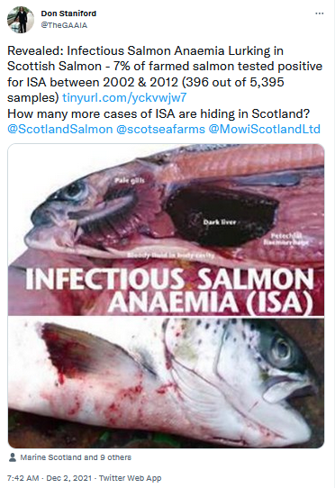

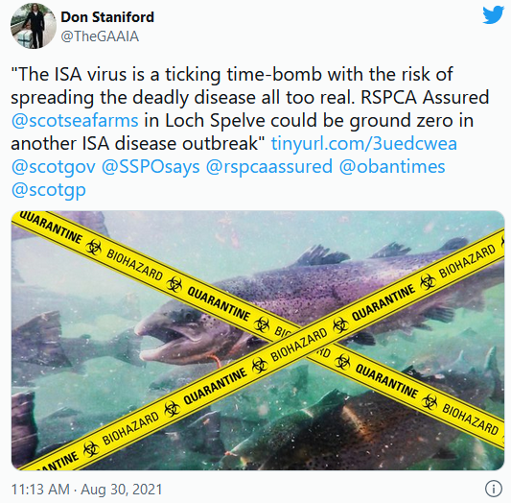
Fish Farmer reported in December 2021 that SalMar (co-owner of Scottish Sea Farms) had been hit by ISA in Norway:
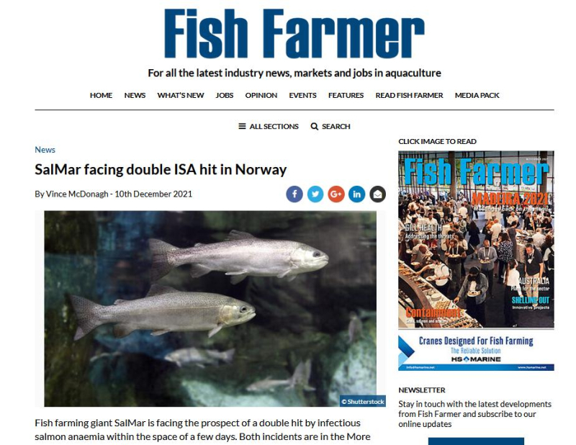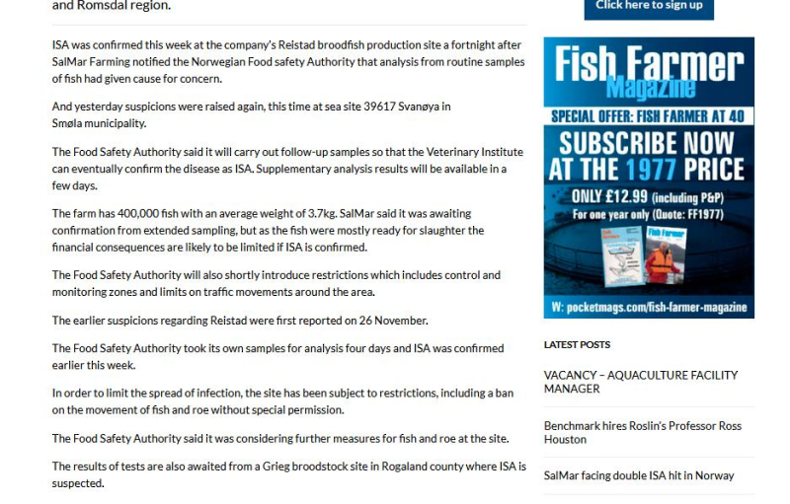
In June 2019, Scottish Salmon Watch reported that over half the farmed salmon tested by Marine Scotland Science were positive for Piscine Reovirus (linked to Heart & Skeletal Muscle Inflammation in farmed salmon).
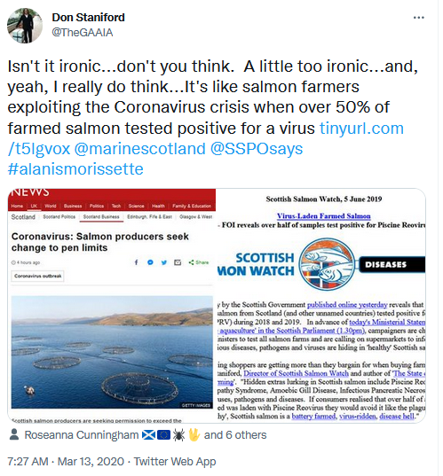

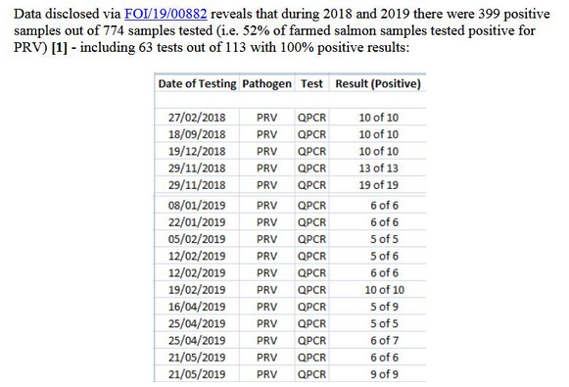
Data on the use of toxic chemicals published via Scotland’s Aquaculture (sourced from returns submitted each month by salmon farming companies to the Scottish Environment Protection Agency) details how Loch Spelve salmon farm is the biggest user since January 2019 of the lobster-killing chemical Deltamethrin at all Scottish Sea Farms sites:

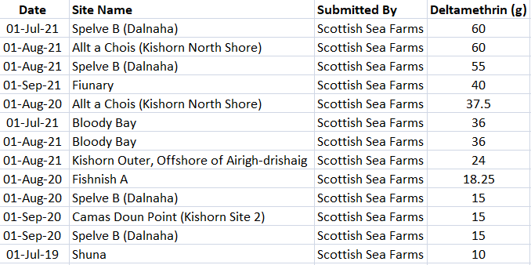

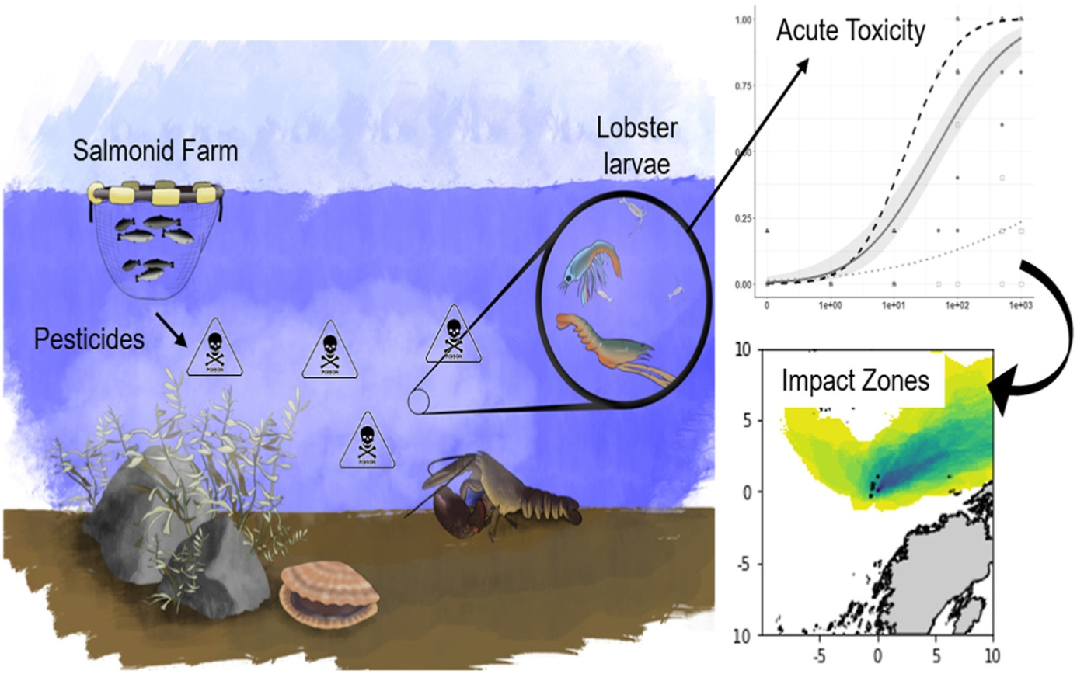

Data published via Scotland’s Aquaculture shows that the Loch Spelve salmon farm is also a huge user of the shellfish-killing organophosphate chemical Azamethiphos – here’s the highest uses at Scottish Sea Farms sites since January 2019:

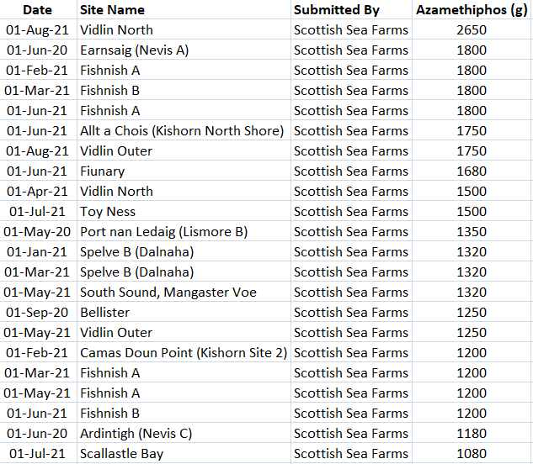

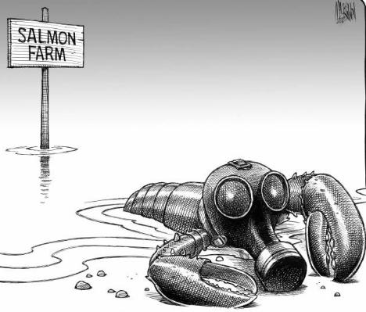

Loch Spelve salmon farm has not reported the use of the shellfish-killing chemical Emamectin benzoate since January 2019 – perhaps because back in 2009 environmental monitoring by SEPA found residues of Emamectin benzoate at over 20 times the Environmental Quality Standard!

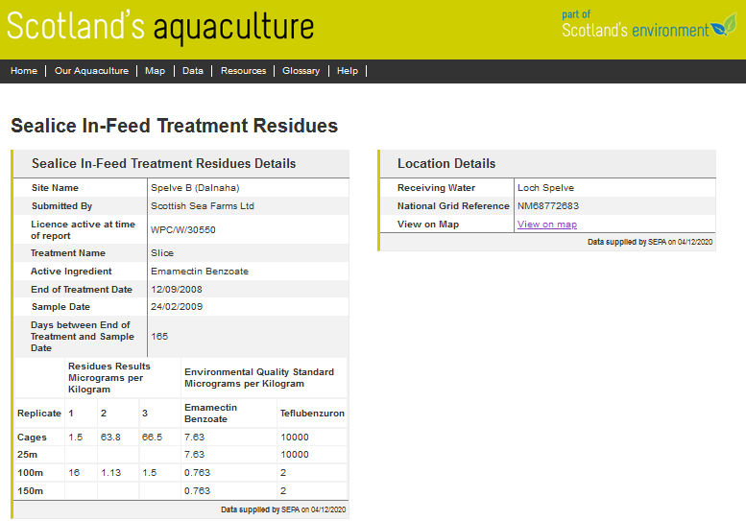
Norwegian giant Scottish Sea Farms (Norskott Havbruk) reported the use of 10 doses of Emamectin benzoate and one dose of Azamethiphos over two cycles at Lismore East salmon farm in 2020 and 2018:
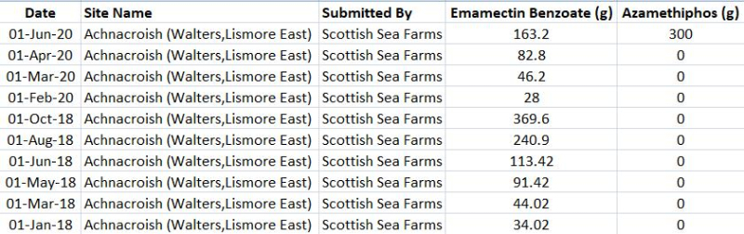
Read more via Toxic Scottish Salmon - Chemical Use Doubles Since 2018!
The Ferret reported in December 2021:

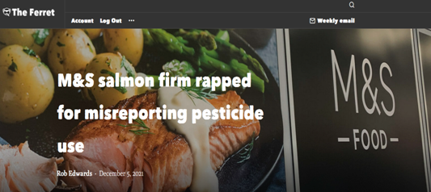

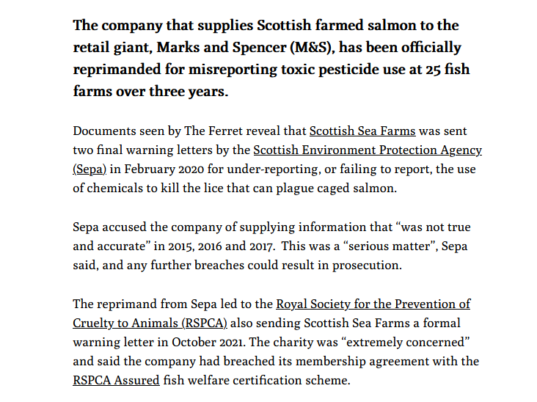
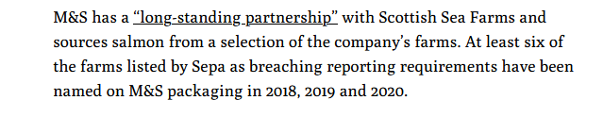
Scottish Sea Farms has failed to report numbers of mass mortalities as well as the use of toxic chemicals.

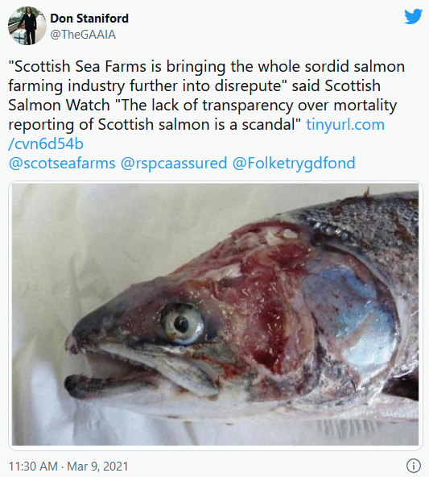
Mortality numbers are still missing for Loch Spelve which suffered over 177,000 mass mortalities in late 2019:
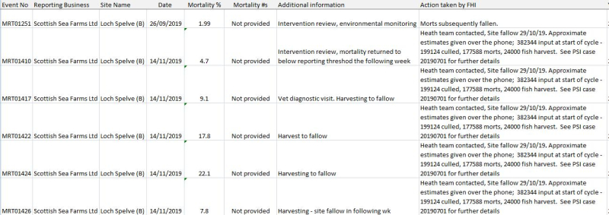
Scottish Salmon Watch reported in February 2020:

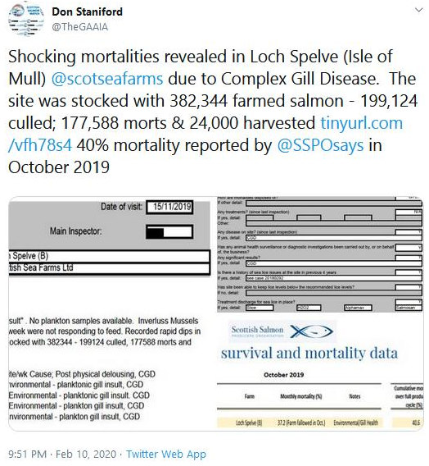

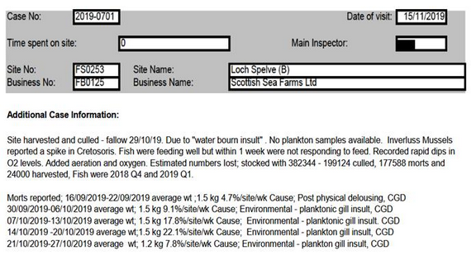
According to the Fish Health Inspection report of Loch Spelve salmon farm in November 2019, a staggering 199,124 farmed salmon were culled and a whopping 177,588 farmed salmon were reported as dead in what is believed to be one of the biggest die offs in recent years. It seems mortalities started on 16 September 2019 and continued throughout October until 29 October 2019 when the site became fallow. Yet the Fish Health Inspectorate was not officially informed until 14 November 2019 and an 'inspection' took place over the phone on 15 November 2019 with a letter sent to Scottish Sea Farms on 16 November 2019.
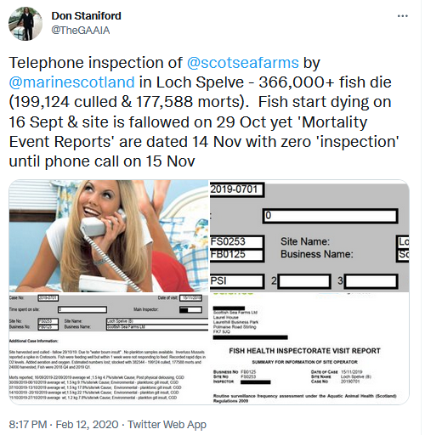

It was not until 3 March 2020 that the Scotland's Aquaculture web-site published data on the weight of mortalities in Loch Spelve in October 2019 - a staggering 192 tonnes (data on the number of mortalities has not been published since 2013 following industry lobbying claiming that disclosure would be 'commercially damaging')!

In terms of mass mortalities (by weight), here’s the top 30 worst Scottish Sea Farms sites since January 2019 with Loch Spelve featuring five times (according to data published via Scotland’s Aquaculture) and the October 2019 mass mortality ranked 5th worst and a mass mortality of 127 tonnes at Loch Spelve in August 2021 and another 78 tonnes of morts at Loch Spelve in September 2021 (data for October to December 2021 is expected to be published online next month):

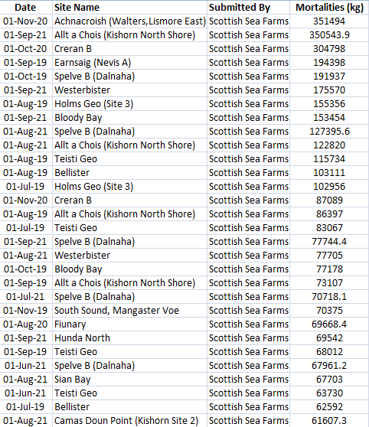

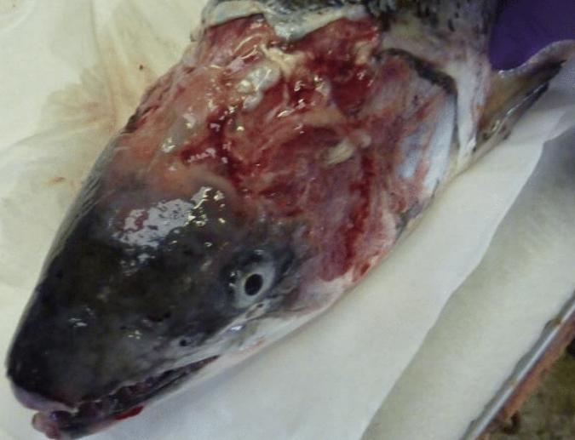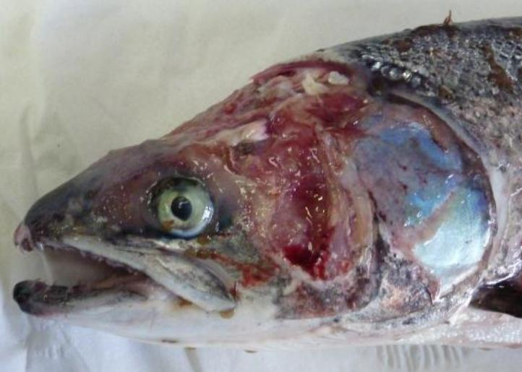
Scottish Salmon Watch reported in December 2021 that mortality rates at Scottish Sea Farms averaged ca. 14% with some sites – including Loch Spelve, Creran and Kishorn - reporting significantly higher mortality rates:

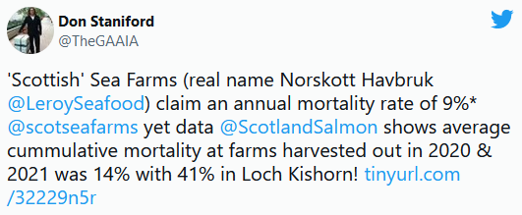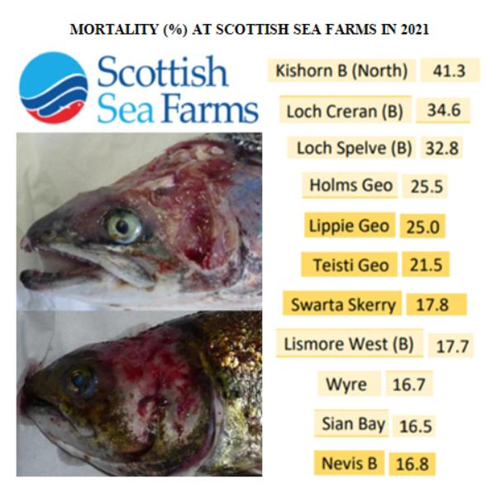
When Scottish Salmon Watch filmed inside the Loch Spelve salmon farm on 7 May 2021 they found clear evidence of welfare abuse which led to a temporary suspension of the site from the RSPCA Assured scheme (read the welfare complaint dated 10 May 2021 online here).

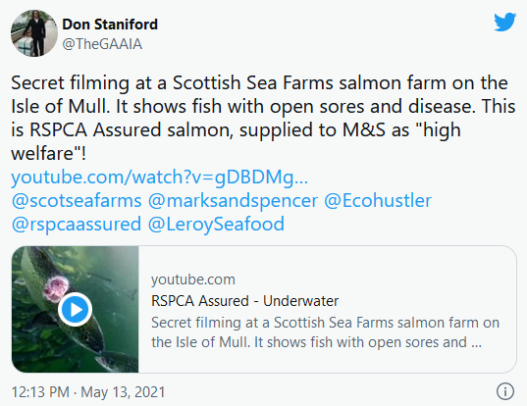

What was not known at the time was that this was video footage of the first reported case of ISA on a Scottish salmon farm since 2012.

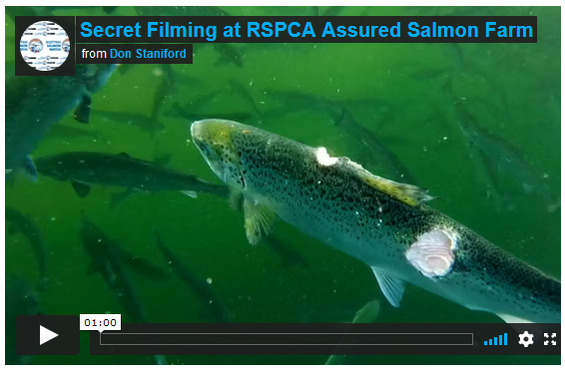
Scottish Salmon Watch reported in June 2021 how M&S had dropped their fake ‘Lochmuir’ brand – which was pioneered by Scottish Sea Farms in Loch Spelve – in favour of RSPCA Assured accreditation.

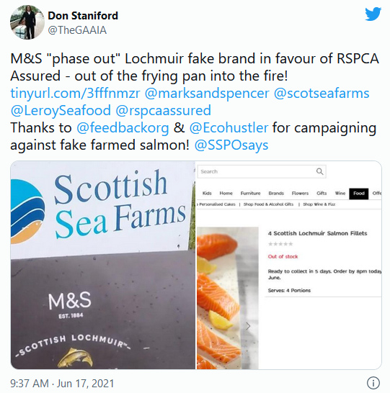

In November 2021, Scottish Salmon Watch filed complaints against supermarkets – including M&S - with Trading and Advertising Standards for false advertising and deceptive marketing of “responsibly farmed” and “responsibly sourced” Scottish salmon.
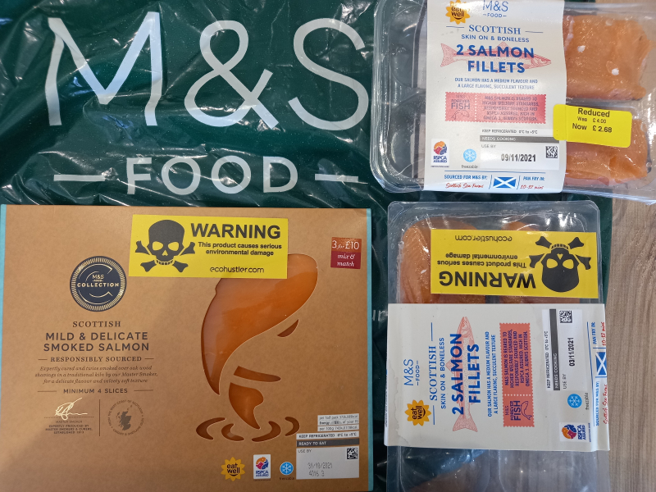
Read more via:
Bullshit Called on M&S's "Responsibly Sourced" Scottish Salmon!
Ecohustler sticks it to "responsibly sourced" Scottish salmon sold by M&S!
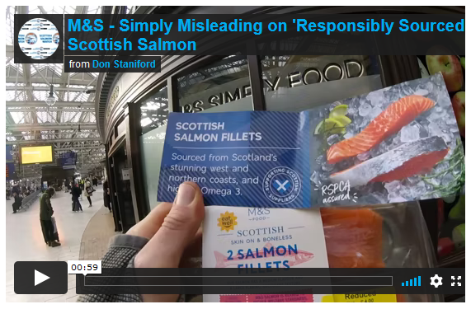
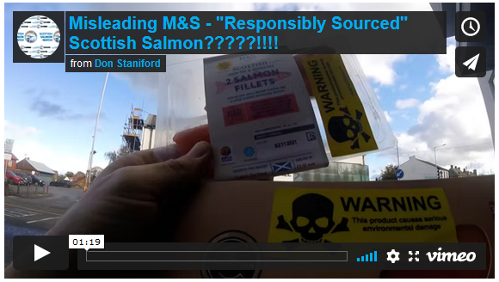

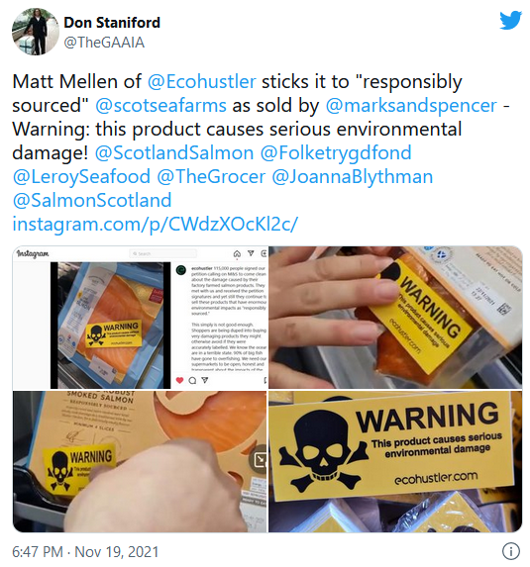

“Shame on M&S and other supermarkets for greenwashing virus-laden Scottish salmon,” said Don Stanford, Director of Scamon Scotland. “Consumers should boycott Scottish salmon – even RSPCA Assured and ‘responsibly sourced’ – like the proverbial plague. Scottish salmon is a disease-ridden, virus-laden and lice-infested health disaster. M&S’s Scottish salmon belongs in the bin not in your shopping basket. Please tell M&S that Infectious Salmon Anaemia, Piscine Reovirus and other nasties lurking in Scottish salmon is not ‘healthy’ food. I wouldn’t serve Scottish salmon to my dog, cats or even my mother-in-law.”

Read a copy of Scamon Scotland’s letter to M&S (14 February 2022) online here

Contact:

Don Staniford: 07771 541826 (salmonfarmingkills@gmail.com)

