Press Update – 24 December 2012

“Frankenfish Hit Shelves”/“Biotech Cheers”/“AK Senators Oppose GM Salmon”/“Begich Alarmed by FDA Report” – online here

Please support the global campaign against salmon farming – donate online here

Please find enclosed a press update (articles in full as PDF online via here)

“Don’t eat farmed organic salmon this Christmas!” (Salmon Farms Ireland, 24 December)

“Ready to eat - the first GM fish for the dinner table: US decision after 17-year battle over fast-growing salmon could pave way for same step in Britain” (The Independent, 24 December)

“Super-salmon that are genetically modified to grow twice as fast a step closer to our dining table” (The Daily Telegraph, 24 December)

“Genetically modified 'Frankenfish' set to hit shelves after FDA finds salmon that grows twice as fast as normal poses no threat to human health” (The Daily Mail, 23 December)

“Super salmon shares to leap” (Sunday Times, 23 December)

“Salmon giant caught on European competition hook as deal nets 36% of Scottish production” (Sunday Herald, 23 December)

“Salmon Sales Exceed £22 Million” (Hamilton Advertiser, 23 December)

“Sea lice debate turns directly confrontational” (For Argyll, 23 December)

“Trout Unlimited wary of genetically engineered salmon” (The Spokesman Review, 23 December)

“Biotech cheers U.S. GMO salmon study” (UPI, 22 December)

“FDA Misses the Boat in Signaling Approval of Genetically-Engineered Salmon” (National Geographic, 22 December)

“Frankenfish salmon not harmful per FDA/GMO salmon egg sales plan alarms environmentalists ” (The Examiner, 22 December)

“AK senators oppose genetically-modified salmon” (Anchorage Daily News, 22 December)

“Begich Alarmed by FDA Report on Frankenfish: Calls on Alaskans to Make Public Their Opposition to GE Salmon” (Political News, 22 December)

“Genetically altered salmon are safe, FDA says” (The Washington Post, 22 December)

“Transgenic fish wins US regulatory backing: A fast-growing salmon moves closer to approval after a fishy delay” (Nature, 22 December)
“Alaska Delegation Fillets GM Salmon Report” (KTUU News, 21 December)

“Anti- salmon farm environmentalist punished” (Fish Farming Xpert/Norwegian Fish Farmer, 21 December)

“Bankruptcy now ‘highly unlikely’ for AquaBounty” (Intrafish, 20 December)

Including in The Daily Mail (23 December):

Sen. Lisa Murkowski, R-Alaska: "This is especially troubling as the agency is ignoring the opposition by salmon and fishing groups, as well as more than 300 environmental, consumer and health organizations"

From Political News (22 December):

“Sen. Mark Begich, Chairman of the Senate Subcommittee on Oceans and Fisheries, blasted the announcement by the Food and Drug Administration (FDA) on its draft report finding that genetically engineered salmon holds “no significant impact” on the environment or public health.
“The notion that consuming Frankenfish is safe for the public and our oceans is a joke,” Begich said. “I will fight tooth and nail with my Alaska colleagues to make sure consumers have a clear choice when it comes to wild and sustainable versus lab-grown science projects.”

From KTUU News (21 December):

“Rep. Don Young said he hoped to pass labeling requirements meant to keep the modified fish off the market. “In the 113th Congress, I plan to reintroduce legislation that will at a bare minimum require genetically engineered salmon to be labeled to ensure that the public knows what they are purchasing at the grocery store and feeding to their families,” Young said.

From The Washington Post (22 December):

“You keep those damn fish out of my waters. It will ruin what I think is one of the finest products in the world,” Young said in an interview, saying he fears that the spread of fish farms could eventually contaminate the wild salmon industry in Alaska. He wants to force delays in any FDA approval. “If I can keep this up long enough, I can break that company,” he said, referring to AquaBounty, “and I admit that’s what I’m trying to do.”

Watch a video on GE salmon via CBC News online via GMO salmon egg sales plan alarms environmentalists

From George Leonard writing in National Geographic (22 December):

“Given FDA’s action yesterday and NOAA’s failure to prohibit GE fish in its aquaculture policy, the time has come for Congress to intervene. Congress should work to pass Senator Mark Begich’s PEGASUS Act or similar legislation that requires FDA to take the environmental risks seriously before approving GE fish. If Congress doesn’t act soon, the nation’s ocean may suffer from FDA’s efforts to chart a course for GE salmon.”

From The Independent (24 December):

“The verdict clears one of the last remaining hurdles for GM salmon to be lawfully sold and eaten in the US and will put pressure on salmon producers in Britain and Europe to follow suit. Successive chief scientists to the UK Government, as well as science institutions such as the Royal Society, have endorsed the concept of GM technology as a tool for increasing food production in the 21st Century, but consumer opposition has so far blocked the approval of GM food for the dinner table.

Several government bodies including the advisory committees on the release of GM organisms and on novel foods and processes would have to review the technology before it was approved in the UK. Supporters of the technology believe the GM salmon will make it not only easier and cheaper to produce farmed salmon, but that it could also be better for the environment because they can be grown on land-based fish farms.”

Support the boycott of farmed salmon online here

Watch video reports from Scotland and Ireland online here!

Please support the global campaign against salmon farming – donate online via http://www.gofundme.com/donstaniford



Best fishes and a Merry Fishmas!

Don

Remember: Global News Updates are now archived and available in full online here (scroll down to the end for a Global News Archive)!

==================================================================

Salmon Farms Ireland, 24 December 2012



http://www.salmonfarmsireland.com/2012/12/happy-christmas.html?spref=fb

The Independent, 24 December 2012

Ready to eat: the first GM fish for the dinner table
US decision after 17-year battle over fast-growing salmon could pave way for same step in Britain

Steve Connor
A GM salmon which grows twice as fast as ordinary fish could become the first genetically-modified animal in the world to be declared officially safe to eat, after America's powerful food-safety watchdog ruled it posed no major health or environmental risks.
The US Food and Drug Administration (FDA) said it could not find any valid scientific reasons to ban the production of GM Atlantic salmon engineered with extra genes from two other fish species – a decision that could soon lead to its commercial production.
The verdict clears one of the last remaining hurdles for GM salmon to be lawfully sold and eaten in the US and will put pressure on salmon producers in Britain and Europe to follow suit.
Successive chief scientists to the UK Government, as well as science institutions such as the Royal Society, have endorsed the concept of GM technology as a tool for increasing food production in the 21st Century, but consumer opposition has so far blocked the approval of GM food for the dinner table.
Several government bodies including the advisory committees on the release of GM organisms and on novel foods and processes would have to review the technology before it was approved in the UK.
Supporters of the technology believe the GM salmon will make it not only easier and cheaper to produce farmed salmon, but that it could also be better for the environment because they can be grown on land-based fish farms.
Sir John Beddington, the current chief scientist, warned two years ago of a "perfect storm" of growing human numbers, climate change and food shortages, where it would be "very hard to see how it would be remotely sensible to justify not using new technologies such as GM".
GM opponents, however, argue that the introduction of the fast-growing salmon creates risks for both human health and the environment. They also argue that the salmon will be the start of concerted efforts to create other GM animals for human consumption, which could raise serious questions about animal welfare.
The FDA had already indicated the salmon was fit for human consumption. But in a draft environmental assessment written in May and published on Friday following inquiries by The Independent, it goes further by declaring that the production of the GM fish is unlikely to have any detrimental impact on the wider environment.
Opponents of the GM salmon – which some have dubbed the "Frankenfish" – have argued it could escape into the wild, interbreed with wild fish and undermine the genetics of the endangered Atlantic salmon, the "king of fishes" grown on fish farms in the UK.
However, the company behind the GM AquAdvantage salmon emphasised that the genetically engineered fish will be only be grown as sterile females and kept in secure containers on land.
In its draft assessment prepared as part of a New Animal Drug Application (NADA), the FDA agrees that the possibility of GM salmon escaping from fish farms is extremely remote and that interbreeding with wild salmon is equally unlikely.
The possibility of the GM salmon escaping into rivers and the sea from land-based fish farms is "extremely remote", the FDA said.
"[The] FDA has made the preliminary determination it is reasonable to believe that approval of the AquAdvantage salmon NADA will not have any significant impacts on the quality of the human environment of the United States (including populations of endangered Atlantic salmon) when produced and grown under the conditions of use for the proposed action," it concludes.
Anti-GM groups last night raised concerns about the report. Peter Riley, of the pressure group GM Freeze, said: "The sterility system does not guarantee that there will be no escapes into the wild and some of them will be fully fertile. It's also debatable whether anyone wants to buy GM salmon, even in the US, if it is properly labelled."
The FDA also states the two other US Government agencies responsible for overseeing laws on endangered species – the National Marine Fisheries Service and the US Fish and Wildlife Service – have agreed with the FDA's assessment that there will be "no effect" on wild Atlantic salmon or its habitat.
In its report, the FDA warns that if final approval is not given by the US Government, other countries may still develop GM Atlantic salmon.
The research into the GM salmon goes back to the late 1980s and it has gone through 17 years of bureaucratic wrangling over whether it should be approved for human consumption. The FDA indicated in 2010 that it would declare the GM salmon safe to eat but the issue was then kicked into the Washington long grass, which some have put down to nervousness on the part of the White House in the run-up to this year's Presidential election.
AquaBounty Technologies, the Massachusetts biotechnology company that developed the GM salmon, has become increasingly irritated by the delays to its application, which have caused severe strains on its finances.
Last September, the company's chief executive, Ron Stotish, expressed his anger with the FDA, which promised in May this year that it would soon publish its environmental assessment, on which the approval of the application rests.
"We are frustrated and disappointed in the delay, and we feel the FDA and US administration have a responsibility to inform us why they have not yet released the environmental assessment and moved forward our application," Mr Stotish said.
A spokeswoman for the FDA said: "The draft environmental assessment is an interim step in the overall evaluation of the application and is not a decision on the application itself."

Animal farm: a technological revolution
1972: Scientists use special enzymes to snip fragments of DNA – genes – from one microbe and insert or "recombine" them into another microbe. The revolution in recombinant DNA begins with the creation of the first GM organism.
1980: Laboratory mice with genes inserted from other individuals become the first genetically modified "transgenic" animals. Dozens of other experimental species, from pigs and chickens to frogs and fish, follow over the next two decades.
1989: The AquAdvantage founder salmon is created by micro-injecting a fragment of DNA from an ocean pout fish and a Chinook Pacific salmon into a fertilised Atlantic salmon egg.
1995: AquaBounty Technologies begins the lengthy process of applying for official US Government approval to develop the AquAdvantage salmon commercially.
2002: The first commercially viable GM animal is created from two species by Nexia Biotechnologies in rural Quebec. The "spider-goat" has a single gene from a golden orb-weaving spider which means its milk contains spiders silk, five times the strength of steel, which is used for making bullet proof vests.
2009: The US Food and Drug Administration issues its final guidance to the GM industry on rules governing the regulation of genetically engineered animals, which clarifies its status as the chief statutory and regulatory body for GM animals.
2011: British scientists create chickens which don't spread bird flu by inserting an artificial gene that introduces a small part of the flu virus into the bird. This gives them the virus, but prevents them from spreading it.
2012: A genetically modified cow in New Zealand is the first to produce milk with no Beta-lactoglobulin (BLG), the protein that is thought to be responsible for allergic reactions. Meanwhile, Chinese scientists create a GM cow whose milk includes omega-3 fats, normally found in fish.
May 2012: The US Food and Drug Administration completes its environmental assessment of the GM salmon but delays publication of the draft report until 21 December 2012.
http://www.independent.co.uk/news/science/ready-to-eat-the-first-gm-fish-for-the-dinner-table-8430639.html

The Daily Telegraph, 24 December 2012

Super-salmon that are genetically modified to grow twice as fast a step closer to our dining table

A controversial genetically engineered salmon has moved a step closer to the dining table after an American food watchdog said it was unlikely to pose a threat to the environment or humans.

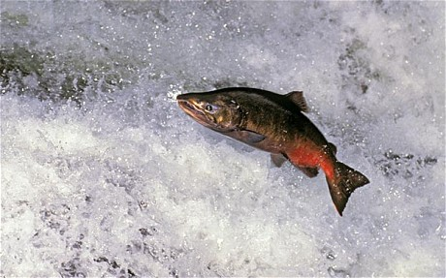
Super-salmon that grow twice as fast being developed Photo: ALAMY

By Richard Alleyne
The US Food and Drug Administration (FDA) said the GM eggs would produce fish with the potential to grow to market size in half the time of conventional salmon.
If it gets a final go-ahead, it would be the first food from a transgenic animal – one whose genome has been altered – to be approved by the FDA, Reuters reports.
The AquAdvantage Atlantic salmon egg was developed by AquaBounty Technology to speed up production to meet global seafood demand.
In a draft environmental assessment, the FDA affirmed earlier findings that the biotech salmon was not likely to be harmful. It said it would take comments from the public on its report for 60 days before making a final decision on approval.
"With respect to food safety, FDA has concluded that food from AquAdvantage salmon is as safe as food from conventional Atlantic salmon, and that there is a reasonable certainty of no harm from consumption," the FDA assessment states.
AquaBounty officials said they were caught by surprise by the news that its product was a step closer to approval as years of controversy had followed the company's application for a go-ahead from the regulator.
They said they did not know the timing or details of the process the FDA will follow following the 60-day comment period.
"We are encouraged that the environmental assessment is being released and hope the government continues the science-based regulatory process," said AquaBounty Chief Executive Ronald Stotish.
Critics say the new salmon is a "dangerous experiment" and have pressured the FDA to reject it.
They say the FDA has relied on outdated science and substandard methods for assessing the new fish.
"We are deeply concerned that the potential of these fish to cause allergic reactions has not been adequately researched," said Michael Hansen, a scientist at the Consumers Union.
"FDA has allowed this fish to move forward based on tests of allergenicity of only six engineered fish, tests that actually did show an increase in allergy-causing potential."
There were also concerns the FDA would not require the genetically modified salmon to be labelled as such, and some critics said they may file a lawsuit to prevent what they fear could be the imminent approval of the engineered fish.
"Congress can still keep FDA from unleashing this dangerous experiment," said Wenonah Hauter, executive director of Food & Water Watch, a consumer advocacy group. "Although this latest FDA decision is a blow to consumer confidence, we encourage everyone to contact their members of Congress and demand this reckless decision be overturned."
The Center for Food Safety, another non-profit consumer protection group, was highly critical of the FDA report, and officials said they might sue the regulator over the issue.
"It is extremely disappointing that the Obama Administration continues to push approval of this dangerous and unnecessary product," said Andrew Kimbrell, executive director of the Center for Food Safety. "The GE salmon has no socially redeeming value. It's bad for the consumer, bad for the salmon industry and bad for the environment."
The FDA spokesman Morgan Liscinsky said no final decisions have been made on labelling or on the application for approval.
"The release of these materials is not a decision on whether food from AquAdvantage Salmon requires additional labelling; nor is it a decision on the new animal drug application currently under review. It also does not provide a final food safety determination," Liscinsky said.
The AquAdvantage salmon would be an all-female population with eggs produced in a facility on Prince Edward Island in Canada and shipped to a "grow-out facility" in Panama, where they would be reared to market size and harvested for processing.
http://www.telegraph.co.uk/news/uknews/9764433/Super-salmon-that-are-genetically-modified-to-grow-twice-as-fast-a-step-closer-to-our-dining-table.html

The Daily Mail, 23 December 2012

Genetically modified 'Frankenfish' set to hit shelves after FDA finds salmon that grows twice as fast as normal poses no threat to human health
- Fish would be the first genetically altered animal approved for food anywhere in the world
- The AquaAdvantage salmon has an added growth hormone from the Pacific Chinook salmon that allows the fish to produce growth hormone all year long
By Daily Mail Reporter
A salmon genetically modified to grow twice as fast as normal earning a nickname of ‘Frankenfish’ has been approved by federal health regulators making it the first scientifically engineered animal for human consumption.

The Food and Drug Administration on Friday released its environmental assessment of the AquaAdvantage salmon, a faster-growing fish which has been subject to a contentious, yearslong debate at the agency.

The document concludes that the fish 'will not have any significant impacts on the quality of the human environment of the United States.' Regulators also said that the fish is unlikely to harm populations of natural salmon, a key concern for environmental activists.

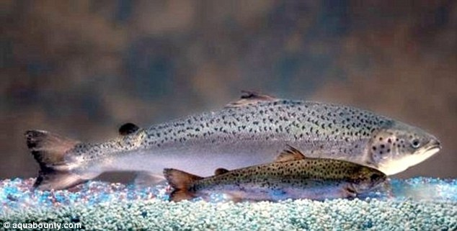

Growth spurt: The overwhelming size comparison of a genetically modified AquAdvantage Salmon, compared to a non-transgenic Atlantic salmon sibling in the foreground of the same age, are seen

The FDA will take comments from the public on its report for 60 days before making it final.

The FDA said more than two years ago that the fish appears to be safe to eat, but the agency had taken no public action since then. Executives for the company behind the fish, Maynard, Mass.-based Aquabounty, speculated that the government was delaying action on their application due to push-back from groups who oppose genetically modified food animals.

Experts view the release of the environmental report as the final step before approval.

'We are encouraged that the environmental assessment is being released and hope the government continues the science-based regulatory process,' AquaBounty said in a statement.

If FDA regulators clear the salmon, as expected, it would be the first genetically altered animal approved for food anywhere in the world.

Critics call the modified salmon a 'frankenfish.' They worry that it could cause human allergies and the eventual decimation of the natural salmon population if it escapes and breeds in the wild. Others believe breeding engineered animals is an ethical issue.



Restrictions: Some of the fish eggs are seen which are born all female and sterile, though AquaBounty says a small percentage may still be able to breed

AquaBounty has maintained that the fish is safe and that there are several safeguards against environmental problems. The fish would be bred female and sterile, though a very small percentage might still be able to breed. The company said the potential for escape is low. The
FDA backed these assertions in documents released in 2010.

Since its founding in 1991, Aquabounty has burned through more than $67 million developing the fast-growing fish. According to its midyear financial report, the company had less than $1.5 million in cash and stock left. It has no other products in development.

Genetically engineered – or GE – animals are not clones, which the FDA has already said are safe to eat. Clones are copies of an animal. In GE animals, the DNA has been altered to produce a desirable trait.

The AquaAdvantage salmon has an added growth hormone from the Pacific Chinook salmon that allows the fish to produce growth hormone all year long. The engineers were able to keep the hormone active by using another gene from an eel-like fish called an ocean pout that acts like an 'on' switch for the hormone. Typical Atlantic salmon produce the growth hormone for only part of the year.

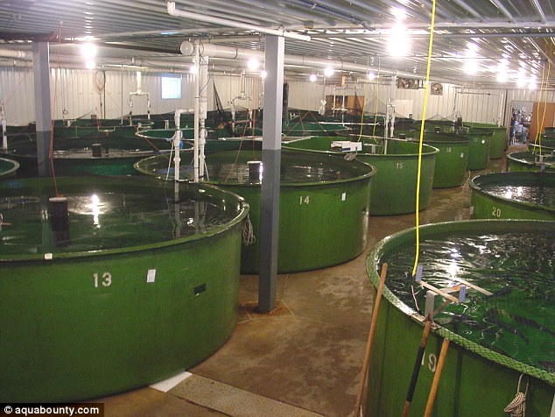
Method: The AquaAdvantage salmon, seen growing in their facility's tanks, has an added growth hormone from the Pacific Chinook salmon that allows the fish to produce growth hormone all year long

It is still unclear whether the public will have an appetite for the fish if it is approved. Genetic engineering is already widely used for crops, but the government until now has not considered allowing the consumption of modified animals. Although the potential benefits – and profits – are huge, many people have qualms about manipulating the genetic code of other living creatures.

If the salmon are eventually approved for sale, consumers may not even know they are eating them. According to federal guidelines, the fish would not be labeled as genetically modified if the agency decides it has the same material makeup as conventional salmon. AquaBounty says that genetically modified salmon have the same flavor, texture, color and odor as the conventional fish, and the FDA so far has not shown any signs of disagreeing.

Wenonah Hauter, director of the advocacy group Food and Water Watch, said forgoing labeling not only ignores consumers' rights to know what they are eating, but 'is simply bad for business, as many will avoid purchasing any salmon for fear it is genetically engineered.'

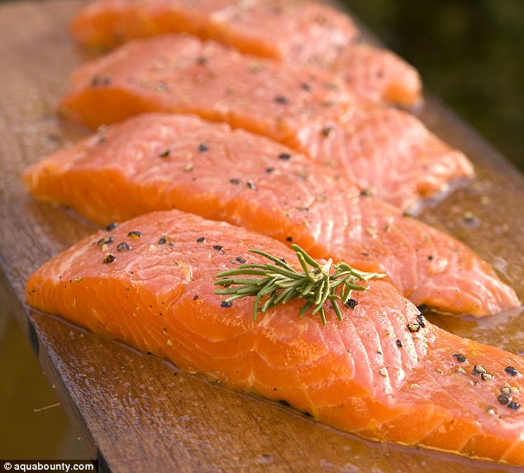

No change: AquaBounty says that genetically modified salmon have the same flavor, texture, color and odor as the conventional fish, and the FDA so far has not shown any signs of disagreeing

Hauter urged members of Congress to block the impending approval of the fish. Congressional opposition to the engineered fish has so far been led by members of the Alaska delegation, who see the modified salmon as a threat to the state's wild salmon industry.
Sen. Lisa Murkowski, R-Alaska, said Friday she is working to convince fellow senators that approval for the fish should be stopped.

'This is especially troubling as the agency is ignoring the opposition by salmon and fishing groups, as well as more than 300 environmental, consumer and health organizations,' she said of the preliminary approval.

http://www.dailymail.co.uk/news/article-2252379/AquaAdvantage-Frankenfish-salmon-set-hit-shelves-FDA-finds-super-growing-fish-safe-eating.html

Sunday Times, 23 December 2012

Super salmon shares to leap

Danny Fortson
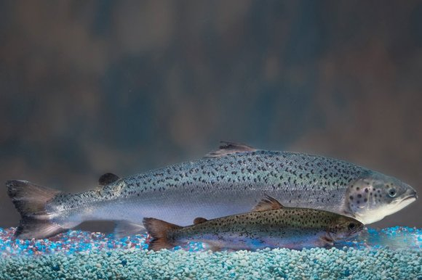AquaBounty’s salmon, rear, is the same age as the non-genetically modified salmon in front (AP)
SHARES in the firm behind a new breed of genetically modified “super salmon” are set to soar after US regulators concluded that the fish were safe for the environment. AquaBounty Technologies, an American firm listed in London, has developed salmon fish that grow to full size in half the usual time.
On Friday the US Food and Drug Administration (FDA) published its draft environmental assessment, one of the last hurdles before the fish are allowed to enter the food supply. A two-month public consultation will follow.
Approval will also raise the stakes in the battle for the firm. Intrexon Corporation, based in Maryland, has bought 47% of AquaBounty’s shares and recently made an offer to buy the rest.
Article in full via http://www.thesundaytimes.co.uk/sto/business/Companies/article1181944.ece

Read also in the Sunday Times:

“Stand-off over super salmon” (9 December 2012)

“America swallows super salmon” (18 November 2012)

Sunday Herald, 23 December 2012

Salmon giant caught on European competition hook as deal nets 36% of Scottish production


Steven Vass
Deputy Business Editor, Sunday Herald
MARINE Harvest, the biggest salmon farmer in Scotland, is facing an investigation by European competition authorities after buying a dominant stake in rival Morpol last week.
The deal increases Oslo-listed Marine Harvest's share of Scottish salmon production from 23% to 36%, territory that often triggers objections to perceived market dominance.
The investigation raises the prospect of a repeat of the situation after the three-way merger of Marine Harvest, Pan Fish and Fjord Seafood in 2006, which brought together over 40% of the market and was only accepted on condition that Pan Fish Scotland be sold.
This was demanded not by the UK authorities, who waived the deal through, but by those in France, a big salmon customer. The divestment created Lighthouse Caledonia, since renamed The Scottish Salmon Company. The Sunday Herald understands managers involved in the Marine Harvest/Morpol deal are anticipating history could repeat itself.
Tom Seaman, co-founder of industry site Undercurrent News, said: "I'm pretty confident that they won't be able to keep everything in the UK.
"They will probably have to pick the worst-performing 20,000 tonnes [out of about 62,000] and get rid of them. Having said that, most of their operations are quite good so it could lead to a decent opportunity for one of the other companies."
Oddgeir Oddsen, head of Norwegian salmon egg producer SalmoBreed, was in charge of Pan Fish Scotland at the time of the 2006 merger. He thought the deal might be accepted since the combined market share will not be quite as high this time.
But he said: "It's not good for people like us who supply salmon farms because there are fewer and fewer players in the industry in Scotland. It's not good for customers either. When I came to Scotland in 2004, there were a lot more farming companies.
"It's different from Norway, where there are a lot more smaller companies. The Norwegian industry has enjoyed much more support from the banks and the government."
Ivan Vindheim, finance director of Marine Harvest, said: "We have to file an application to the European competition authority. Then it's up to them if we can have it or not. We won't speculate on that, but our starting point is that we want to own Morpol as a whole. We don't want to divest anything."
He added that in global terms, the deal only increased Marine Harvest's share of production from 22% to around 23.5%.
Marine Harvest has so far bought 49.5% of Polish-based Morpol, although it is hoping to buy the rest of the company in the coming weeks. Morpol's Scottish salmon farms are concentrated in Orkney and Shetland but its main business is salmon smoking, most of which happens in Poland.
The deal will mean that four of the big five salmon producers in Scotland are controlled by Norwegian interests, leaving the Edinburgh-based Scottish Salmon Company as the only exception.
http://www.heraldscotland.com/business/company-news/salmon-giant-caught-on-european-competition-hook-as-deal-nets-36-of-scottish-production.19729303

Hamilton Advertiser, 23 December 2012

Salmon Sales Exceed £22 Million
Smoked salmon has firmly established itself on festive menus as sales exceed those of Christmas puddings, according to research.
A total of £22.5 million was spent on the fish last Christmas, £1.5 million more than the total spent on Christmas pudding.
Research by retail analysts Kantar Worldpanel found that sales of smoked salmon have been increasing for the last four years and peak in the four weeks of December.
Almost 25 million portions were eaten last Christmas in restaurants and homes, with Scottish produced salmon proving particularly popular.
Mark Warrington, managing director of Meridian Salmon Group, said: "It's no surprise to us that smoked salmon has outsold Christmas puddings - so it's not just the turkey that's been given a stuffing this year. We all should be proud that Scottish salmon is fast becoming as firm a favourite in households as The Queen's Speech."
The total annual smoked salmon market in 2011 was worth £117 million, increasing from £90 million in 2008. Producers expect sales to grow again this year, but it has a long way to go to match sales of turkey. Customers spent £113.5m on the traditional Christmas dinner centrepiece over the festive period last year, according Kantar Worldpanel.
Mark Thomson, business unit director at Kantar Worldpanel, said: "Shoppers now spend more on smoked salmon than they do on Christmas pudding.
"The value of sales is rising, with the total amount people spend on smoked salmon increasing the last four festive periods and the four-week Christmas period accounts for over 19% of smoked salmon sales throughout the year."
Stewart McLelland, chief executive of the Scottish Salmon Company said: "It's heartening to hear that sustainably-sourced Scottish salmon increasingly has pride of place next to old favourites like the sprouts and turkey in homes throughout Scotland, England and Wales this Christmas.
"I have no doubt that smoked salmon's popularity will continue to grow this Christmas. Who knows, you might even see it on the table instead of turkey next year."
http://www.hamiltonadvertiser.co.uk/news/breaking-news/2012/12/23/salmon-sales-exceed-22-million-51525-32484324/

For Argyll, 23 December 2012

Sea lice debate turns directly confrontational
It’s not an everyday occurrence, anywhere, to find a prominent, highly respected and much awarded professor accusing an ancient university of scandalously misleading the nation, but it happened here in Scotland last month.
The professor’s outburst was prompted by the publication of a study in the publishing arm of the Royal Society, itself a respected institution, one would have thought.
Based on research by an international group of scientists, this study suggested that sea lice are responsible for 39% of the mortalities amongst salmon in the Northeast Atlantic Ocean.
The press release issued by St Andrews University to accompany publication said: ‘This high per cent mortality attributable to sea lice was unexpected.
‘The salmon aquaculture industry has long placed a high priority on controlling sea lice on their captive salmon – but these results do emphasise the need for the industry to not only maintain the health of their own stocks, but also to minimise the risk of cross-infection of wild fish.’
The study can be read in full here.
A response from the aquaculture industry was to be expected – but the ferocity with which it was delivered perhaps wasn’t.
Professor Phil Thomas, Chair of the Scottish Salmon Producers Organisation, said: ‘This story has now been exposed as a scandal – it is a major blunder by the University of St Andrews. The institution has misled the nation.
‘For a prominent Scottish University like St Andrews to behave in this way is inexcusable, whatever its need for publicity. To make these wholly incorrect and unjustifiable claims damages both the scientific reputation of the individuals concerned and the institution.
‘But worse, it erodes the already shaky public confidence in science and scientists and that is ultimately to the detriment of Scotland.’
The researchers did not wither under this fire and did not withdraw the study findings.
They did clarify that the study did not actually state that fish farms were the sole source of the sea lice that were killing the wild fish. The inference remained, however, that fish farms could be a contributory cause.
Fast forward a few weeks and we find Professor Thomas giving evidence to the Rural Affairs, Climate Change and Environment Committee of the Scottish Parliament (RACCE) and returning to his theme. The exchange is worth quoting in some detail.
One tricky issue that is often lost in the debate is that there seems to be an assumption that sea lice come from fish farms. Sea lice are already there.
For many fish farmers, the most problematic issue is when a run of mature wild fish come in, as they bring in sea lice – there is a sea lice strike on farms. In that situation, there can be rapid increases in sea lice numbers.
The difficulty is that, when wild runs of salmon come in from the sea with heavy infestations of lice, the transfer of lice from the wild salmon to the farmed salmon tends to be a mixture of lice at different stages, including lice that are quite close to maturity as well as lice that are at the free swimming stage.
Nigel Don: ‘Up to now, I understood that lice did not transfer except when they were in their first stages, when they are so small that they get out and about – the idea of a bloom was mentioned.
‘However, Phil Thomas is suggesting that mature fish coming back from the sea bring lice at different stages and that lice at later stages in their development might transfer at that point. That is not what I thought that everybody else had told me. I thought that a mature louse would not transfer. Was I wrong?’
Professor Thomas: ‘Without getting too complicated, there are two different types of sea lice, one of which often comes in not on salmonids but on other fish species. It can transfer in a range of ways. However, you are right in thinking that the predominant route of transfer is through the free swimming stage.’
It’s a pity that the RACCE Committee didn’t explore this further, as a few short sentences are barely enough to explain something obviously complicated.
For those of us like myself, a non-scientist member of the public who wants to understand why our wild salmon are disappearing, this conflict is most unhelpful, falling far short of constructive debate.
It cannot be helpful to those, like the MSPs on the RACCE Committee, who have to produce a report to the Scottish Parliament, either.
The ways of nature are of course a mystery to most lay people. At the risk of being accused of anthropomorphism, it seems to me inherently improbable for a mature sea louse, firmly attached by suction to a returning salmon, travelling at speed, suddenly to decide to jump ship in the vicinity of a fish farm and make a break for it to another host.
For this to happen to such an extent that it would represent a major threat to the farmed fish seems even more unlikely.
Before the recent exchange I had tried to educate myself about sea lice and had learned, as had Nigel Don MSP, that sea lice were a form of tiny marine crustacean that went through a number of changes in their lifecycle; and that only in two or three of these stages were they capable of travelling about.
Further reading and discussions with some marine biologists of my acquaintance have only confirmed that this is correct.
In their earliest stage as plankton they are propelled by water movements until, if successful in finding a host, they become anchored to it by a filamentous thread.
In later stages they suck onto the surface of the fish only through being dorso-ventrally flattened.
Although the pre-adult and adult stages are called ‘mobiles’ that word refers to their grazing activity on the host fish and not their ability to swim around at liberty. They are very weak swimmers and stand more chance of being eaten by big fish than getting aboard them. It has also been shown that mature sea lice only survive in sea water for very brief periods after being separated from the host.
In the final paragraph quoted above, Professor Thomas seems to be saying that of the ‘two types of sea lice’ it is the one that infects fish other than salmon that brings in the mature lice. This would rather contradict the earlier statement that the wild salmon rather than those other fish bring them in.
In European waters there are indeed two types of sea louse, Lepeoptheirus salmonis (Leps) and Caligus elongatus (Caligus), the former specific to salmon and the latter usually found on non-salmonids.
There seems to be no evidence at all of Leps transferring from wild salmon or salmonids to caged fish. There are apparently some reported instances of Caligus suddenly appearing on caged salmon when shoals of mackerel, herring, saithe or other shoaling fish swim past (Costello, paper published by the Royal Society B on 8 July 2009). Often these fish are attracted into the area by the presence of food and surround the cages.
A useful information resource is at the University of Prince Edward Island where academics, partly funded by Canada’s massive fish farming industry, are researching how to deal with the threat to caged fish from sea lice. It’s instructive that their work concentrates exclusively on Leps rather than Caligus and I found no reference to sea lice strikes.
This suggests both that ‘sea lice strikes’, if they happen at all, do not involve wild salmon and that any that do happen are probably rather minor and do not involve Leps.
Most biologists believe that the primary seat of infection of salmon and sea trout with lice is by juvenile infective stages when the smolts leave the rivers in the Spring to enter into the salty coastal waters for the first time.
Before the arrival of fish farms on the aquaculture coast of West Scotland there would always have been some wild salmon and sea trout along the coast to ensure supplies of sea lice larvae to infect them.
Arguably the arrival of fish farms on an industrial scale has changed all that, with enormous populations of mature salmon present, year round, in coastal areas. It seems logical to infer a connection between these and the high death rate of wild salmon from sea lice infestation identified in the Royal Society B study.
Whatever the cause there is no dispute over the seriousness of the problem. It is made worse by the fact that sea lice are now developing an immunity to the pesticide that has mainly been used to kill them in recent years, Emamectine Benzoate, otherwise known as SLICE.
In a recent talk Dr Mark Fast of the University of Prince Edward Island said: ’1999 was the year the aquaculture industry gained what would be its most powerful tool in the fight against sea lice. It’s called SLICE. It’s an in-feed treatment that, for a time, acted like a silver bullet. It was so effective that as a researcher studying sea lice, I found it difficult to harvest sea lice from salmon in an aquaculture environment. I just couldn’t find them. It worked that well.
‘SLICE’s effectiveness started to seriously wane around 2008. The sea lice were adapting. The previous two summers had been worse than ever. Sea lice were partying even harder than they were in 1999.’
Dr Fast predicts that the industry will develop effective vaccines to replace SLICE in seven to ten years and cocktails of other less effective solutions before then – but none of this will directly benefit the native fish.
For environmentalists the main worry in all this is for the future of the native salmon and sea trout that are native to Scotland – the wonderful wild creatures that contribute to our national image and that also spearhead the marketing effort of the caged fish industry that may be harming them.
There is an urgent need for less invective and more research to find out what is truly going on.
This article is by a guest writer who is clearly well informed but who wishes to remain anonymous. The writer’s identity is irrelevant to the argument, which is evidence based, with sources given.
http://forargyll.com/2012/12/sea-lice-debate-turns-directly-confrontational/

The Spokesman Review, 23 December 2012

Trout Unlimited wary of genetically engineered salmon

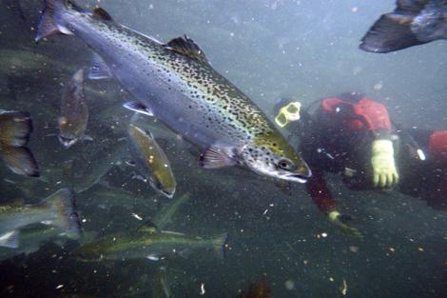

FISHERIES — Trout Unlimited officials are disturbed by this week's news that the federal Food and Drug Adminstration finds no danger in raising or eating farmed salmon genetically engineered to grow twice as fast as natural salmon.

Here's the statement from TU:

Trout Unlimited is concerned that the Food and Drug Administration’s ‘finding of no significant impact’ is a premature ‘green light’ for the eventual production of genetically engineered salmon for human consumption. First, we want to ensure that threats to wild salmon populations from genetically engineered salmon are understood and completely prevented, both for the protection of economically vital commercial salmon fishing industry and the growing recreational salmon fishing sector.

Second, we want to ensure that a more detailed environmental impact review isn’t the more
appropriate process for this issue rather than a simple FDA environmental assessment, which is far less thorough (and, frankly, is the FDA the correct agency to analyze environmental impact?).
Third, prior to permit approval it must be clear that an effective regulatory framework exists so that impacts to wild fisheries and aquatic ecosystems are prevented, and future permit applications receive an appropriate level of scientific analysis and public scrutiny to understand and avoid environmental risk.

Trout Unlimited will be reviewing the environmental assessment and finding of no significant impact to see whether an adequate analysis of potential threats has been completed by the agencies with expertise in aquatic ecosystems.

http://www.spokesman.com/blogs/outdoors/2012/dec/23/trout-unlimited-wary-genetically-engineered-salmon/

UPI, 22 December 2012

Biotech cheers U.S. GMO salmon study

WASHINGTON, Dec. 22 (UPI) -- The biotech industry said a U.S. government report on genetically engineered salmon would move the technology closer to the market.
The Food and Drug Administration Friday released a draft report on so-called AquAdvantage salmon that concluded they were safe to eat and would not harm the environment.
"It certainly looks good for the fish moving forward," David Edwards, director of animal biotechnology for the Biotechnology Industry Organization, told the Los Angeles Times. "It shows that the Obama administration is willing to move forward on these technologies and allow the United States to be the leader that we should be."
The 158-page FDA report looked at plans by Aqua Bounty of Maryland to farm raise Atlantic salmon, which grow faster than wild salmon thanks to a growth-hormone gene from the Chinook salmon that was spliced into the DNA of the AquAdvantage fish.
The Times said the report looked only at the Aqua Bounty plan, which would raise GMO salmon in separate tanks in Canada and Panama rather than in pens built in the ocean.
Opponents of GMO foods have said the so-called Frankenfish would crowd out native species of salmon. They accused the Obama administration of releasing the report close to Christmas in hopes it would get little notice in the media.
The biotech industry was not deterred by the narrow scope of the report and predicted it would re-energize the potentially lucrative GMO research industry in the United States.
http://www.upi.com/Science_News/2012/12/22/Biotech-cheers-US-GMO-salmon-study/UPI-30041356201897/

National Geographic, 22 December 2012

FDA Misses the Boat in Signaling Approval of Genetically-Engineered Salmon

Posted by George Leonard in Ocean Views

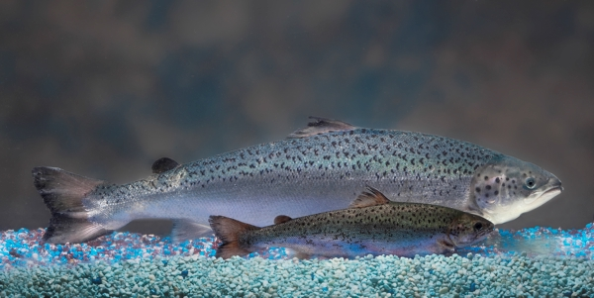
Transgenic vs non-transgenic salmon Copyrigh t© 2009, Barrett & MacKay Photo All rights reserved.
Just as I was getting ready to head out for my Christmas break yesterday, my email Inbox signals that the Federal Food and Drug Administration (FDA) has released its recommendation to approve the first-ever, genetically-engineered animal for human consumption. For those who track the FDA, they know this isn’t unusual – the agency often makes controversial rulings right before the holidays, when decision makers, media and the public are trying to have some well-deserved downtime with their families. Today was a kind of an unwelcome, fishy Christmas surprise, nestled among the garland and mistletoe.
Make no mistake: GE salmon is controversial. Since September 2010, when this issue exploded on the national stage, there has been unprecedented pushback on plans to grow an engineered variant of farmed Atlantic salmon for the U.S. market. Over 400,000 public comments in opposition have been sent to the FDA. Forty members of Congress called for a full Environmental Impact Statement before approval was granted. Ocean Conservancy and our colleagues similarly called for a complete analysis – that asks and answers the full range of tough questions – before the government allows private industry to head off down a path of genetically-engineering our seafood supply. But with today’s release, the agency basically blew all of us off.
One might think that FDA’s 158-page analysis contains all the information we need to feel comfortable about GE fish in our seafood supply. It doesn’t. As their 5-page summary states, the agency intentionally narrowed the scope of the analysis and thus completely missed the boat. FDA makes clear that it is green lighting only one small facility in Canada and another in Panama to grow out this novel fish, which will then be sent to the U.S. for processing and sale. While Ocean Conservancy is deeply concerned that FDA has not undertaken a state-of-the-art risk assessment on this particular facility, it is the larger ramifications of this initial approval that have always been the more important issue. No viable business can be built on growing only a small number of fish in Panama. But if this initial approval paves the way for a massive expansion of GE fish farming, both here in the U.S. and around the world, then we have the makings of a real moneymaker – and potentially big environmental problems.
The global salmon farming industry is entirely based in the ocean, where floating cages fatten fish for market. The environmental impacts of net-pen salmon farming are well established, where escapes are commonplace and disease can be rampant when fish are overcrowded. While this initial application to grow GE salmon is for land-based facilities, the prospect of even larger profits from growing GE salmon in the ocean will certainly create pressure for approval in these more environmentally risky systems in the future.
The U.S. is poorly equipped to deal with this future scenario. In June 2011, NOAA Administrator Dr. Jane Lubchenco released a National Aquaculture Policy to guide how marine aquaculture proceeds in our ocean waters. While the policy includes some strong environmental provisions, it does not categorically prohibit the growing of GE fish in the ocean. It should.
Given FDA’s action yesterday and NOAA’s failure to prohibit GE fish in its aquaculture policy, the time has come for Congress to intervene. Congress should work to pass Senator Mark Begich’s PEGASUS Act or similar legislation that requires FDA to take the environmental risks seriously before approving GE fish.
If Congress doesn’t act soon, the nation’s ocean may suffer from FDA’s efforts to chart a course for GE salmon.
http://newswatch.nationalgeographic.com/2012/12/22/fda-misses-the-boat-in-signaling-approval-of-genetically-engineered-salmon/

The Examiner, 22 December 2012

Frankenfish salmon not harmful per FDA (Video)

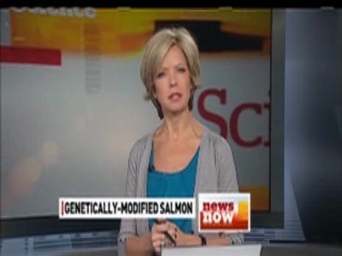
GMO salmon egg sales plan alarms environmentalists



Rachel Dillin, Strange News Examiner
The FDA declared that frankenfish salmon would not harm the environment, according to a Dec. 22 Christian Science Monitor report. The FDA released a report that said the genetically modified fish would not harm the environment, which means they are closer to being approved.
The FDA's report concerned the AquaAdvantage salmon, which grows more quickly than regular salmon. The FDA report concluded that the so-called frankenfish salmon,
"will not have any significant impacts on the quality of the human environment of the United States."
In 60 days, the FDA report will be final. This report is most likely the final step before the FDA approves the genetically modified fish safe for the U.S. Obviously many groups are not thrilled about that.
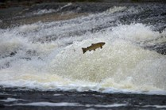
Salmon attempt to leap up the fish ladder in the river Etterick on October 31, 2012 in Selkirk, Scotland. Could genetically modified salmon cause them harm?
Photo credit: Photo by Jeff J Mitchell/Getty Images
There is a concern that genetically modified food can harm, not only the environment, but also humans. At this point, it appears as if much of the long-term safety is being tested on people right now as more and more genetically modified foods make it into the food supply. The worry is that these foods may cause human allergies, and that they could cause the natural versions of the food to die out.
If this genetically modified fish is eventually approved, do you think you will consume it? Does it seem like frakenfish salmon to you, or a smart way to produce more food?
http://www.examiner.com/article/frankenfish-salmon-not-harmful-per-fda

Anchorage Daily News, 22 December 2012

AK senators oppose genetically-modified salmon
ANCHORAGE, Alaska — Alaska's congressional delegation is opposing a federal report that says a genetically modified salmon that grows twice as fast as normal is unlikely to harm the environment.
The Food and Drug Administration on Friday released its draft environmental assessment, clearing the way for the first approval of a genetically engineered animal for human consumption.
KTUU-TV reports (http://is.gd/u6fAQG) many Alaskans see them as a threat to wild fish.
Sen. Mark Begich on Friday warned of the dangers of what he called "Frankenfish," and said he'll fight to make sure consumers have clear choices.
Sen. Lisa Murkowski noted widespread opposition by salmon and fishing groups, as well as environmental, consumer and health organizations.
Rep. Don Young said he hoped to pass labeling requirements meant to keep the modified fish off the market.
http://www.adn.com/2012/12/22/2732470/ak-senators-oppose-genetically.html

Political News, 22 December 2012

Begich Alarmed by FDA Report on Frankenfish
Calls on Alaskans to Make Public Their Opposition to GE Salmon
Sen. Mark Begich, Chairman of the Senate Subcommittee on Oceans and Fisheries, blasted the announcement by the Food and Drug Administration (FDA) on its draft report finding that genetically engineered salmon holds “no significant impact” on the environment or public health.
“The notion that consuming Frankenfish is safe for the public and our oceans is a joke,” Begich said. “I will fight tooth and nail with my Alaska colleagues to make sure consumers have a clear choice when it comes to wild and sustainable versus lab-grown science projects.”
Sen. Begich has been protesting against the FDA’s march in favor of genetically modified salmon since he came to the Senate. Begich is calling on all Alaskans to participate in the ongoing public comment period and let the FDA know how they feel about Frankenfish. Public comment opens next Wednesday and Begich will publicize the mechanism for public comment when it becomes available.”
With loose findings that the modified fish are “unlikely” to harm the environment, the FDA draft Environmental Assessment (EA) is a step towards approving GE salmon for sale in the U.S. Alaska is the world’s largest producer of wild, sustainably-harvested salmon.
“People want to know they are eating natural, healthy, wild salmon,” Begich said. “Today’s assessment by the FDA imperils families and fisherman.”
Begich has been a vocal skeptic of introducing Frankenfish into the nation’s food supply, citing concerns about threats to the environment and public health. The damaging impacts of other invasive species released into the environment are well known. There are concerns that the consumer’s right to know what they’re buying and eating is being ignored.
“The FDA shouldn’t be making decisions on marine fisheries,” Begich said. “Today’s report is by no means the final say on this issue. I will continue to fight hard against these genetic mutations whose only purpose is purely for profit. Americans deserve to know the health and environmental superiority of wild Alaska seafood and not be fooled into thinking GE fish is somehow equivalent.”
Begich introduced the Prevention of Escapement of Genetically Altered Salmon in the United States, which would have prohibited the sale of Frankenfish unless the National Oceanic and Atmospheric Administration (NOAA) issued a finding that production of Frankenfish would have no significant impact or found to be consistent with the National Environmental Protection Act.
The 2007 FDA reauthorization act required a report to Congress on the potential impacts of genetically modified fish on the environment generally. They have yet to submit a written report to Congress.
“I am also concerned that the FDA is continuing to disregard the will of Congress,” Begich said. “It seems incredibly irresponsible to be moving forward on Frankenfish before they’ve taken a step back, consulted with experts on marine fisheries, and considered the potential impacts more broadly.”
Public opposition to the approval of Frankenfish is strong. Last year, 93 groups representing fishermen, consumers and others signed a letter in opposition to the Frankenfish proposal. Polling data suggests even broader rejection of GE salmon among potential consumers.

http://politicalnews.me/?id=19800&keys=GENETICALLY-ALTERED-SALMON-FRANKENFISH

Washington Post, 22 December 2012

Genetically altered salmon are safe, FDA says
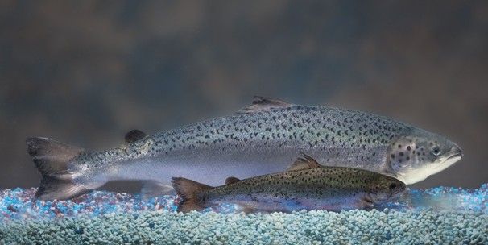
AquaBounty Technologies/AP - This undated 2010 handout photo provided by AquaBounty Technologies shows two same-age salmon, a genetically modified salmon, rear, and a non-genetically modified salmon, foreground. Salmon that's genetically modified to grow twice as fast as normal could soon show up on your dinner plate — if the company that makes the fish can stay afloat.
By Brady Dennis
Salmon that has been genetically engineered to grow twice as fast as its natural counterpart inched a little closer toward the nation’s dinner tables on Friday.
The Food and Drug Administration released its findings that the fish do not pose a threat to the environment and are “as safe as food from conventional Atlantic salmon.”
That removed a key hurdle for a Massachusetts-based company seeking to market the modified salmon, which critics derisively have dubbed “Frankenfish.”
But the move also reignited a long-running debate over whether a nation that already grows and consumes genetically modified plants such as corn and soybeans is prepared to make a similar leap when it comes to animals.
Food-safety activists, environmental groups and traditional salmon fishing industries are staunchly opposed to such a step and are part of a broader global struggle over the use of genetically modified foods.
Countries in the European Union have banned some genetically modified foods outright and instituted tight labeling requirements on foods that contain modified ingredients. Countries such as Russia, Japan and Peru also have instituted restrictions on genetically altered foods.
AquAdvantage, the fast-growing fish at the center of the controversy in the United States, is an Atlantic salmon that contains a growth hormone from a Chinook salmon and has been given a gene from the ocean pout, an eel-like fish. The result is a fish that grows larger and faster than traditional salmon.
Under the company’s proposal, no modified salmon would actually be produced in America. The eggs would be produced at a facility on Prince Edward Island in Canada and shipped to another facility in Panama, where they would be harvested and processed. In its assessment, the FDA said the likelihood that the altered fish could escape containment and reproduce in the wild is “extremely remote.”
Friday’s assessment could pave the way for ultimate approval of the engineered fish. The FDA must first take comments from the public on its report for 60 days before finalizing it. After that, the agency will decide whether to give AquaBounty the green light to begin marketing its fish to Americans.
“We’re encouraged by this milestone, and we’re grateful that they’ve elected to continue a science-based process,” Ronald Stotish, president of AquaBounty Technologies, said in an interview. “We think this is progress.”
Friday’s determination echoes findings from two years ago, when the FDA held days of public hearings and convened panels of scientists, staff members and industry officials to consider potential impacts of the altered salmon.
Since then, the approval process for the fish has remained at a virtual standstill. But the public fight over it has churned on.
Some consumer and environmental conservation groups have claimed that the FDA has failed to fully scrutinize the product and its potential effects. Lawmakers on Capitol Hill, particularly those from the Northwest, have backed legislation that would ban the fish outright or require specific labeling about its origins.
“The notion that consuming Frankenfish is safe for the public and our oceans is a joke,” Sen. Mark Begich (D-Alaska) said in a statement Friday. “I will fight tooth and nail with my Alaska colleagues to make sure consumers have a clear choice when it comes to wild and sustainable versus lab-grown science projects. . . . Today’s report is by no means the final say on this issue.”
Rep. Don Young (R-Alaska) was more blunt.
“You keep those damn fish out of my waters. It will ruin what I think is one of the finest products in the world,” Young said in an interview, saying he fears that the spread of fish farms could eventually contaminate the wild salmon industry in Alaska. He wants to force delays in any FDA approval.
“If I can keep this up long enough, I can break that company,” he said, referring to AquaBounty, “and I admit that’s what I’m trying to do.”
So far, he appears to have had some success. Stotish said his company has cut back to about a dozen employees, down from more than 30, while awaiting the government’s approval.
The nonprofit Center for Food Safety also sharply criticized the FDA’s assessment, calling the decision “premature and misguided.”
“It is extremely disappointing that the Obama Administration continues to push approval of this dangerous and unnecessary product,” executive director Andrew Kimbrell said in a statement.
Meanwhile, industry executives and some agency scientists insist that there is no discernible difference between the altered salmon and wild salmon. Stotish has argued that his salmon would help bolster the world’s food supply, lower prices and require fewer resources — all in a safe and sustainable way.
Scientists at the FDA have generally seemed to agree, at least thus far. In a briefing document ahead of the public hearings in 2010, FDA staffers wrote, “We have found no biologically relevant difference between food from [AquaBounty salmon] and conventional Atlantic salmon.”
How long a final approval might take is anyone’s guess.
AquaBounty first applied for permission to sell its genetically altered fish in 1995, and even by FDA standards, its application has moved at a glacial pace in recent years.
“Because this is a first-of-kind application, FDA’s goal is to be as comprehensive as possible in its evaluation and anticipate all outcomes,” FDA spokeswoman Morgan Liscinsky said Friday.
Gregory Jaffe, director of biotechnology at the Center for Science in the Public Interest, said he understands the agency’s caution but believes the approval process has been excessively long.
“Applicants have a right to a timely, scientifically justified decision,” said Jaffe, who participated in the 2010 hearings about AquAdvantage and said he had no real safety concerns with the product.
He said the current fight is less about a relatively small company than about a critical concept — whether the United States should embrace genetically engineered animals for consumption and what the implications of that might be on a large scale.
For now, those answers will have to wait. Jaffe said that even if AquaBounty wins approval for its genetically modified fish, its limited production capacity means that it would make up only a tiny fraction of the U.S. market.
At least for now.
“This is not going to become the majority of our salmon overnight,” Jaffe said. “It won’t be as hard as winning the lottery, but it will be hard to find a modified salmon steak.”
http://www.washingtonpost.com/national/health-science/genetically-altered-salmon-are-safe-fda-says/2012/12/21/36a20512-4b90-11e2-b709-667035ff9029_story.html

Nature, 22 December 2012

Transgenic fish wins US regulatory backing
A fast-growing salmon moves closer to approval after a fishy delay.
- Amy Maxmen
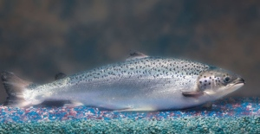
Transgenic AquAdvantage salmon grow twice as fast as wild Atlantic salmon.
Barrett & McKay Photography / AquaBounty
The first genetically engineered (GE) animal for human consumption — a fast-growing salmon — has come a step closer to the dinner table, with a piece of paperwork posted online today by the US Food and Drug Administration (FDA).
The FDA’s draft environmental assessment concludes that the fish poses no foreseeable risk to nature. After 60 days of public comment, the FDA may issue a final assessment and approval — at which time AquaBounty, of Maynard, Massachusetts, can begin selling the fish.
However, the draft assessment was dated 4 May, suggesting that the FDA had kept its conclusions under wraps for several months. Advocates on both sides of the issue speculate that political interference may be responsible. “I think it was controversial, and it was an election year,” says Patty Lovera, assistant director of Food and Water Watch, a Washington DC group opposed to GE food animals. An FDA spokeswoman, Morgan Liscinsky, declined to comment on accusations that the process had been politicized, and says it’s possible that the agency could request further studies after the public comment period.
Delays would not shock AquaBounty’s CEO, Ron Stotish, whose company has been seeking FDA approval for the fish since 1995. When he was alerted to the decision today, he didn’t initially believe it. “I said, ‘I’ll wait until I see it because I’ve received calls like this before and it never happened,’” he says. The FDA has reviewed more than 50 safety studies, including one that shows the engineered salmon poses no more of an allergic potential than a wild salmon. The engineered Atlantic salmon contains an active growth-hormone gene from a Chinook salmon that allows it to reach market weight in 18 months rather than three years.
Anti-GE groups still have a long list of concerns. Lovera would like to see more studies done on the potential health risks of the salmon, published in peer-reviewed journals and conducted by scientists with no affiliation to AquaBounty. However, it’s not clear where the money to conduct such tests would come from, as federal research funding rarely supports GE animals.

Related stories
- Politics holds back animal engineers
- Animals engineered with pinpoint accuracy
- Transgenic fish go large
The GE salmon are currently kept within enclosed, inland tanks to prevent the small risk that the nearly sterile females will breed with wild salmon. But Lovera still worries that once the fish are approved, manufacturers will file for permits to keep them within nets in the open ocean in order to lower costs. “This is basically the final step and we think the FDA has given a strong signal that they will accept the fish, and that is a mistake,” she says.
Stotish counters that as part of their application, AquaBounty has promised to not sell the fish to farmers who do not have enclosed, inland tanks. After 17 years and $60 million spent trying to win FDA approval, Stotish is still cautious. ”We are not so foolish to think that this process will suddenly be normal for us,” he says.
Journal name:
Nature
DOI:
doi:10.1038/nature.2012.12130

http://www.nature.com/news/transgenic-fish-wins-us-regulatory-backing-1.12130

KTUU, 21 December 2012

Alaska Delegation Fillets GM Salmon Report

By Chris Klint | Channel 2 News
ANCHORAGE, Alaska — Alaska’s congressional delegation was united in its opposition Friday to a draft report from the federal Food and Drug Administration saying that the nation’s health and environment wouldn’t be significantly harmed by genetically modified salmon.
The fish, introduced by Massachusetts biotechnology firm AquaBounty, are engineered to grow much larger than wild salmon -- but many Alaskans see them as a threat to both the market for and the existence of wild fish.
Sen. Mark Begich said Friday that the FDA’s draft environmental assessment was the first step toward the release of what he called “Frankenfish” into the environment, comparing such an act to the devastation wrought in the wild by invasive species.
“The notion that consuming Frankenfish is safe for the public and our oceans is a joke,” Begich said. “I will fight tooth and nail with my Alaska colleagues to make sure consumers have a clear choice when it comes to wild and sustainable (fish) versus lab-grown science projects.”
Sen. Lisa Murkowski shared Begich’s concerns, pointing out widespread opposition to the new fish.
“I am concerned with the recent news that FDA is moving forward with the approval of genetically modified fish,” Murkowski said in a Friday statement. “This is especially troubling as the agency is ignoring the opposition by salmon and fishing groups, as well as more than 300 environmental, consumer and health organizations.”
Rep. Don Young said he hoped to pass labeling requirements meant to keep the modified fish off the market.
“In the 113th Congress, I plan to reintroduce legislation that will at a bare minimum require genetically engineered salmon to be labeled to ensure that the public knows what they are purchasing at the grocery store and feeding to their families,” Young said.
Begich says the FDA is required by a 2007 reauthorization bill to submit a report on the potential impacts of genetically modified salmon -- a report it hasn’t yet delivered.
Contact Chris Klint
http://articles.ktuu.com/2012-12-21/aquabounty_35959466

Fish Farming Xpert, 21 December 2012

Anti- salmon farm environmentalist punished



Canada: Don Staniford's “open disrespect for the witnesses and disdain for the court and the judicial process” costs him court fees for Mainstream Canada
Odd Grydeland
Many people familiar with the salmon farming industry and the Canadian justice system were shaking their heads last September when Mr. Staniford was acquitted on a charge of making defamatory statements about Mainstream Canada and its salmon farming practices in British Columbia. According to an article in the Vancouver Sun by Larry Pynn at that time; Supreme Court of B.C.Justice Elaine Adair wrote in her judgment: “Although I have concluded that Mr. Staniford’s statements are defamatory of Mainstream, I have concluded that he should succeed on his defence of fair comment. She described him as “akin to a zealot,” someone who will say almost anything to further his agenda. “Virtually anything that conflicts with his view and vision is wrong, bad, disgraceful and worse.”
Adair added: “I agree with Mainstream that Mr. Staniford does not, in fact, do anything to conceal the spite, ill will and contempt he holds for industrial aquaculture and salmon farming in general. I think the evidence is overwhelming in this regard. Mr. Staniford’s Internet postings are filled with insulting and demeaning comments and cruel caricatures. He ignores and disdainfully dismisses peer-reviewed science ... when the conclusions conflict with his own views. The language in his publications ... is extreme, inflammatory, sensationalized, extravagant and violent.” During the trial Mr. Staniford also was reported to accuse a First Nations band of taking "blood money" from Mainstream.
Today comes a report from Keven Drewsof The Canadian Press that explains that Mr. Staniford may not yet be able to celebrate his previously proclaimed victory inside the Canadian justice system to the extent he previously had contemplated;
A salmon-farming critic may have won a recent defamation case in B.C. Supreme Court, but he's now facing a hefty bill after being rebuked financially for his conduct during the same trial. Justice Elaine Adair awarded British-born Don Staniford only 25 per cent of his costs Wednesday and ordered him to pay Mainstream Canada, the salmon-farming company and plaintiff in the case, $8,300 for court fees,
That's even though the court usually awards costs to the winning party. The case went to trial earlier this year over a 2011 campaign that included images of cigarette packages with statements that read "Salmon Farming Kills Like Smoking." "I have concluded that Mr. Staniford's open disrespect for the witnesses and disdain for the court and the judicial process are deserving of rebuke," said Adair, who noted court rules allowed her to censure Staniford for his actions.
Adair said that during the 20-day trial, Staniford mocked the physical appearances of witnesses, accused a First Nations band of taking "blood money," compared the trial to a "kangaroo court," and relaunched his website campaign using a service provider outside of Canada. The judge said that while Staniford "claims to be a champion of free speech," he "cruelly and publicly mocks" people who have different opinions. She also pointed out examples of his "passive aggression."
What the ruling means financially remains unknown because the activist's lawyer, David Sutherland, declined comment, saying he was reviewing the decision and the case is under appeal. In September, though, Staniford said the court case cost him about $100,000 even with his lawyer, David Sutherland, working at a reduced rate. "The defence of free speech is sadly not free but it is a price worth paying," Staniford said in an email to The Canadian Press. "Win, lose or draw the defence of truth and fair comment is a fight worth fighting." Laurie Jensen, a spokeswoman for Mainstream Canada, said no court dates have yet been set for the appeal.
http://fishfarmingxpert.com/index.php?page_id=76&article_id=97265

Intrafish, 20 December 2012

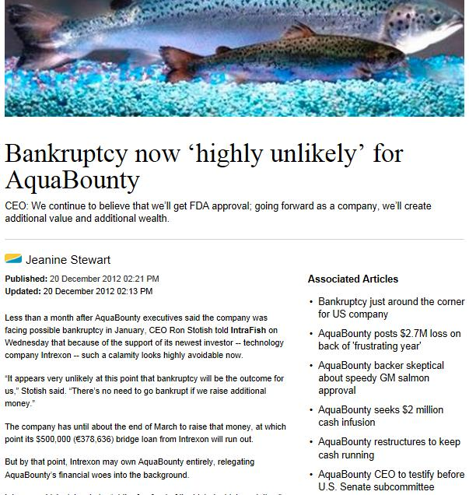
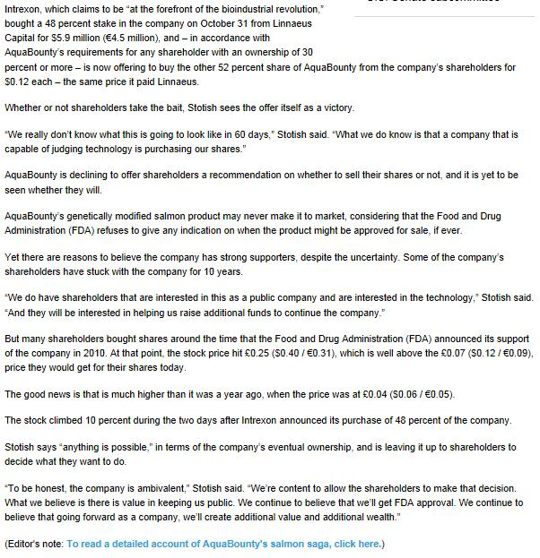

http://www.intrafish.com/global/news/article1361153.ece

Subscribe to Intrafish via http://www.intrafish.com/subscription/
==================================================================

Global News Archive:

News updates are now archived and available in full – online here!

Global News Updates include the 'Salmon Wars' raging against filthy feedlots in Canada, Chile, Norway, Scotland, Ireland, New Zealand, United States and Australia:

17 December - “Boycott Urged”/“Gathering Ireland”/“Senseless Destruction”/“AGD Alert”/“Sea of Protest”/“Filthy Fish Farms OUT!” - online here

12 December - “Feck Off to Fish Farms”/“GM Salmon May Sink”/“ISA Allegations”/“Seal-Shooting Salmon Farmers”/“Opposition Mounts” – online here

21 November - “Showdown Looming”/“Fish Farm Fight”/“A Difficult 2013 Forecast”/“Devastating Impact” – online here

13 November - “Suffocating the Sounds”/“Skye Waters Against”/“Lice Death Claims”/“Battle Norwegian Fish Farms” – online here

7 November - “Flesh-Eating Lice”/“Chlamydia & Gill Disease”/“Strong Opposition”/“Risky Salmon Farms”/“Scotland’s Salmon Wars” - online here

2 November - “Flying the Flag”/”Cohen Report”/“Curb Fish Farm Impact”/“Loggerheads” - online here

1 November - “Justice Cohen Gets Tough”/“Freeze On Farms”/“Cross-Appeal Vs Cermaq” - online here

31 October - “Watch Live”/“Cohen Report Tracker”/“Flying the Flag”/“Report Released Today” - online here

30 October - “Here Comes Cohen!”/“Probe Shows Need for Reform”/“Uncalled-for Attack”/“Respected Scientist” - online here

28 October - “Deadline Looms”/“Mystery Illness”/“Mass Sickness”/“Not Defamatory Enough” - online here

23 October - “Halt Fish Farm Growth”/“Disease Hits Cermaq”/“Like Cancer”/“Is Truth a Tactic?”- online here

18 October - “Teen Fights Salmon Farms”/“Lawsuit Threat”/“Cermaq Appeal”/”Health Indicators Worsen” – online here

15 October - “Sicko Salmon”/“Farms & Disease”/“PR Disaster”/“Passionate Pleas” – online here

3 October - “Salmonella Outbreak”/Activist Wins”/“Boaties Protest”/“Lynch Mob” - online here

28 September - “Judgment Day”/“Salmon Sludge Fouls Hearing”/“Students Oppose Farms” - online here

24 September - “Flotilla Protest”/“Shooting Seals Row”/“Farm Not Welcome” - online here

11 September - “Dirty Secrets”/“FishyLeaks: Toxic Toilets”/“Disease Risk” - online here

29 August - “Virus Trackers”/“Compensation Culture”/“Say No to 9 New Salmon Farms” - online here

8 August - “Legal Strategy”/“Wave of Controversy”/“IHN Virus” - online here

3 August - “Fatal Virus Detected in BC”/“Fish Farm Quarantined” - online here

31 July - “IHN Virus Spreads”/“Norway’s Olympic Mascot”/”Playing With Fire” - online here

20 July - “Norwegian Fish Farm Virus Found in BC”/”ISA Confirmed”/“A Fishy Tale” - online here

17 July - “FishyLeaks”/“ISA in BC”/“Scotland’s Secrets” - online here

13 July - “Aquaculture PR Wars”/“Beware Mother Nature”/“Trouble Brewing” - online here

11 July - "Salmon Wars Are Here"/"Smoking Gun"/"Canada disease cleanup" - online here

9 July - "Killer Panda"/"Quarantined Salmon to be Destroyed"/"PR War Waged" - online here!

6 July - "CFIA quarantines fish farm"/"Parasite found in Norwegian-owned salmon" - online here!

4 July - "Parasite-ridden salmon sold in BC stores"/"95% of BC salmon is BAP certified" - online here!

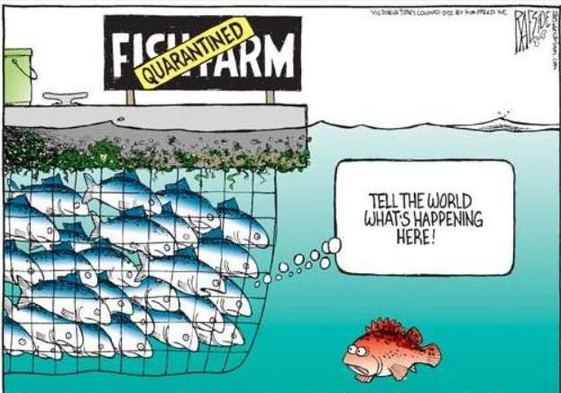

Please support the global campaign against salmon farming – donate via http://www.gofundme.com/donstaniford

So long and thanks for all the fish!

<((((º>`·.¸¸.·´¯`·.¸.·´¯`·...¸><((((º>¸.
·´¯`·.¸. , . .·´¯`·.. ><((((º>`·.¸¸.·´¯`·.¸.·´¯`·...¸><((((º>

