Scottish Salmon Farming
101

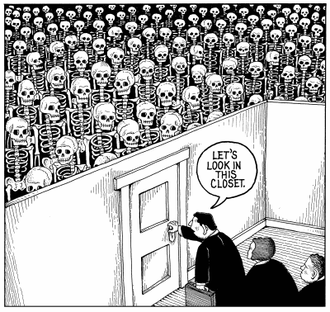

"You asked me once, what was in Room 101. I told you that you knew the answer already. Everyone knows it. The thing that is in Room 101 is the worst thing in the world" (George Orwell's Nineteen Eighty-Four)

Media Backgrounder (January 2018)

by Don Staniford

Global Alliance Against Industrial Aquaculture
As a prelude to the Scottish Parliament's inquiry into salmon farming (scheduled to start "in early 2018"), please find enclosed a basic overview of Scottish salmon farming in 101 bullet points.

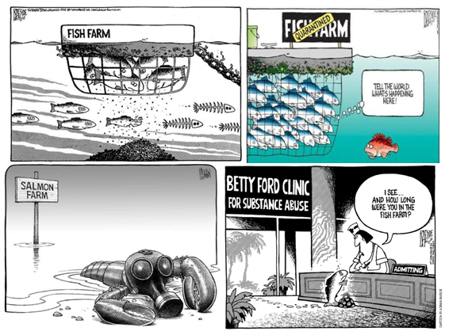
Read more background via:
25 Years of Scottish Salmon Shame
25 Reasons to Boycott Scottish Salmon
The Scotsman: "Call for curb in fish farms as study shows pest risk to wild fish";
"New scientific study underlines damage to wild salmon and sea trout populations from salmon farm parasites – in Scotland, Norway and Ireland
"Fish farm lice are killing wild salmon"
"First Minister questioned on leaking wastes from morts - call for a moratorium from Greens" "BBC's 'Dead Salmon Run' Opens Can of Worms"
"Scottish salmon farming's 'liciest' farms named and shamed"
"Millions of Scottish Salmon Going Up in Smoke"
"Campaigners say 'no more salmon farms' after disease on Lewis kills 125,000 fish"
"Red Alert for Label Rouge - Lousy Label Goes Rogue"
"Media Backgrounder: Scotland's Silent Spring of the Sea"
"Scottish Salmon's Lethal Legacy"
"Scottish Salmon's Great Escape"
"Gill Diseases: Scottish Salmon's Dirty Big Secret"
"Media Backgrounder: Chemical Culture in Scotland"
"Fish Farmageddon: The Infectious Salmon Aquacalypse"
1) Salmon farms kill wild fish:

Over two decades of peer-reviewed scientific research has proved beyond reasonable doubt that lice-infested salmon farms kill wild fish.

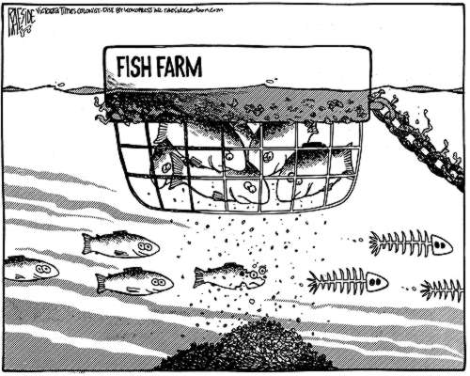

Read more via "The Weight of Scientific Evidence: Sea Lice & Salmon Farms"; "Impacts of salmon lice emanating from salmon farms on wild Atlantic salmon and sea trout" and "Fish farm lice are killing wild salmon"

2) Salmon farms spread infectious diseases:

Salmon farms are reservoirs and incubators for a raft of infectious diseases such as sea lice, Amoebic Gill Disease, Infectious Pancreatic Necrosis and Infectious Salmon Anaemia.

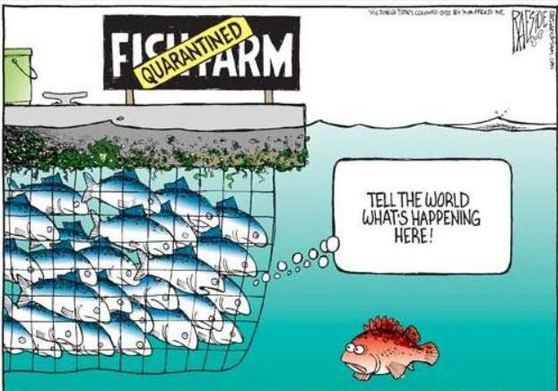

Read more via "Fish Farmageddon: The Infectious Salmon Aquacalypse" and "Scottish salmon farming's 'liciest' farms named and shamed"
3) Salmon farms kill seals:

Scottish salmon farms have killed over 800 seals since 2011 - with over 110 seals killed by Marine Harvest (a company certified via RSPCA Assured).

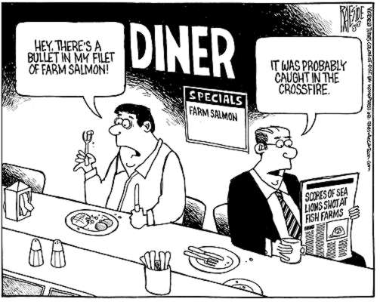

Read more via "Carry on killing says RSPCA"; "RSPCA in firing line over Marine Harvest's seal-killing spree in Scotland - 118 seals killed by Marine Harvest's RSPCA Assured farms since 2011"; "The Killing Farms" and "RSPCA Assured Seals Killers!"

4) Salmon farms kill shellfish:

The toxic chemicals used on salmon farms have been shown by peer-reviewed scientific studies to kill shellfish including lobsters.

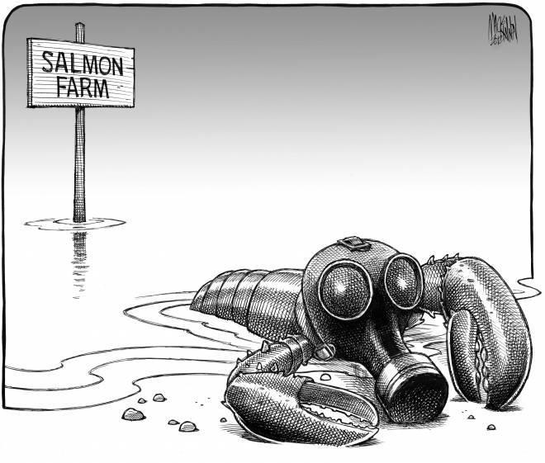
Read more via "Scientific Backgrounder: Ecotoxicity & Chemical Resistance"; "Damning Report on Toxic Salmon Farms Buried - SEPA finally acts on lobster-killing chemical"; "Towards Understanding of the Environmental Impact of a Sea Lice Medicine - the PAMP Suite" and "Silent Spring of the Sea"

5) Farmed salmon are addicted to a cocktail of drugs:

Scottish salmon farms use a cocktail of pesticides, anti-parasitics, therapeutants, antibiotics, medicines and other drugs.

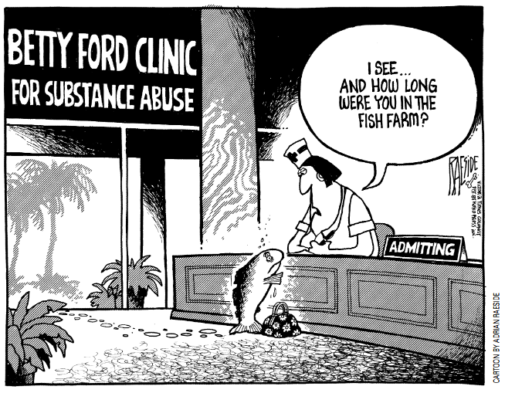

Read more via "Media Backgrounder: Scotland's Silent Spring of the Sea" and "Media Backgrounder: Chemical Culture in Scotland"

6) Scottish farmed salmon is contaminated with cancer-causing chemicals:

Science magazine reported in 2004 that Scottish farmed salmon was so contaminated with cancer-causing chemicals that it was safe to eat only three times per year.

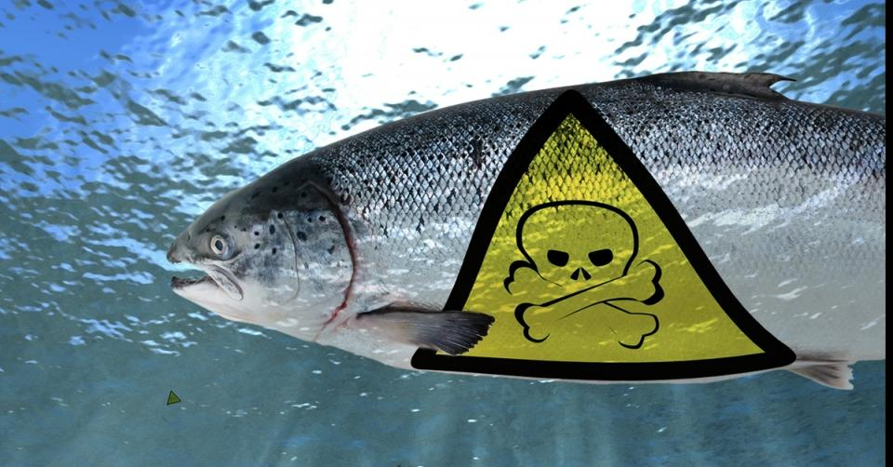

Read more via "Scottish farmed salmon 'is full of cancer toxins'"; "Farm salmon linked to cancer chemicals" and "Global Assessment of Organic Contaminants in Farmed Salmon"

7) Nearly 4 million farmed salmon have escaped in over 200 incidents since 1998 leading to genetic pollution of wild salmon:

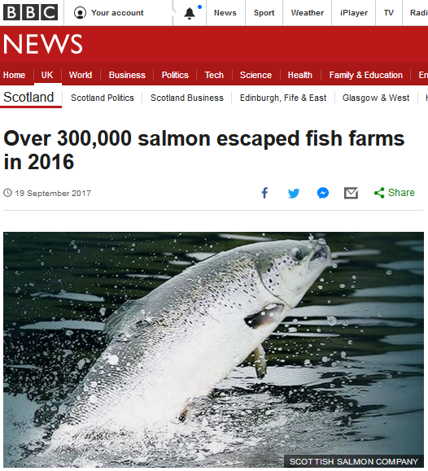

Read more via "Scottish Salmon's Great Escape" and "Scotland's Aquaculture: Fish Escapes"

8) Mass mortalities leapt to over 20,000 tonnes (an estimated 20 million fish) in 2017:

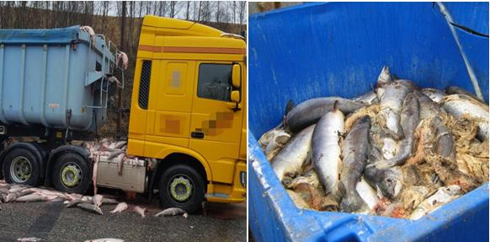

Read more via "Millions of Scottish Salmon Going Up in Smoke" and "Scottish Salmon's Lethal Legacy"
9) Amoebic Gill Disease, Infectious Pancreatic Necrosis, Furunculosis, Infectious Salmon Anaemia, Pancreas Disease and other deadly diseases have ravaged Scottish salmon farms killing millions of fish:

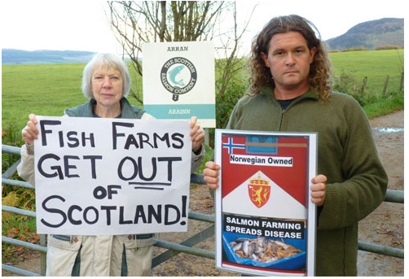

Read more via "Gill Diseases: Scottish Salmon's Dirty Big Secret"; "Infectious pancreatic necrosis virus in Scottish Atlantic salmon farms, 1996–2001"; "An outbreak of disease resembling heart and skeletal muscle inflammation in Scottish farmed salmon, Salmo salar L., with observations on myocardial regeneration"; "Surveillance for infectious salmon anaemia virus HPR0 in marine Atlantic salmon farms across Scotland"; "Analysis of a company's production data to describe the epidemiology and persistence of pancreas disease in Atlantic salmon (Salmo salar L.) farms off Western Scotland" and "Cardiomyopathy syndrome in farmed Scottish salmon"

Pasteurella skyensis killed 125,000 farmed salmon in Loch Erisort in 2017:
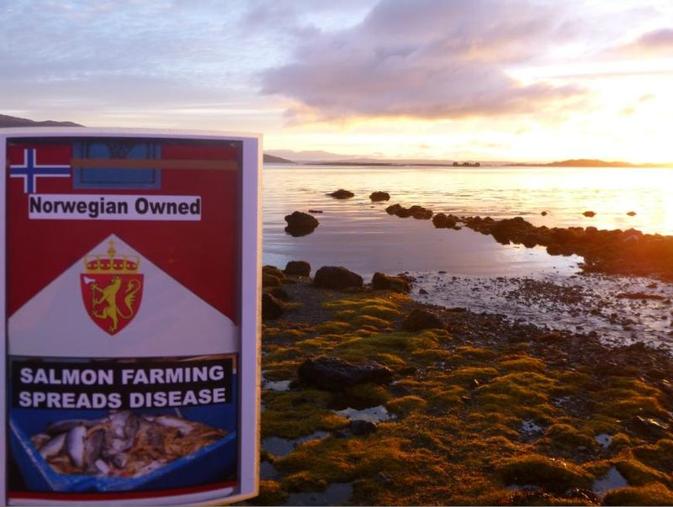
Read more via "125,000 salmon die in disease outbreak at Lewis fish farms"; "Disease kills 125,000 salmon on Lewis fish farm"; "Campaigners say 'no more salmon farms' after disease on Lewis kills 125,000 fish"; "Pasteurella skyensis sp. nov., isolated from Atlantic salmon (Salmo salar L.)" and "Characterization of two groups of Pasteurella skyensis isolates from Atlantic salmon, Salmo salar L., based on serotype and 16S rRNA and rpoB gene partial sequences"
10) Extracting information has been an onerous task due to the secrecy of the Scottish Government and Scottish salmon farming industry - but there have been notable victories via Freedom of Information forcing disclosure of damning documents and data on diseases, lice infestation, toxic chemicals, escapes, mass mortalities and seals killed:

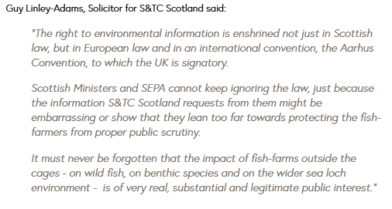
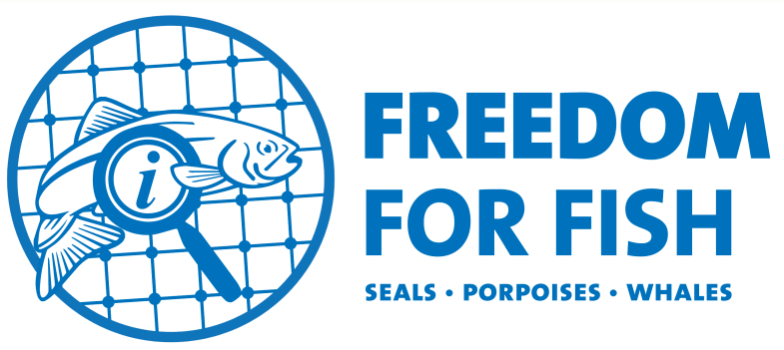

Read more via "FOI Number Five – getting you the information they don’t want you to see!"; "Scottish salmon farming’s ‘liciest’ farms named and shamed"; "Scotland’s worst sea lice offenders: Full Farm List"; "Revealed: Scandal of 45 Scottish lochs trashed by pollution"; "Campaigners welcome ruling on seal shooting disclosure"; "Victory: Disclosure of Seal-Killing Salmon Farm Data Ordered by 21 August"; "FishyLeaks: Scottish Salmon Infested With Parasites - Sea Lice Data Reveals 1001 Reasons to Boycott Farmed Salmon"; "FishyLeaks: Scottish Salmon's Toxic Toilets Named & Shamed"; Scottish Information Commissioner Decision 182/2006 Mr Bruce Sandison and the Fisheries Research Services - Request for information relating to the escape of salmon from an Orkney fish farm; "Gaining Transparency: using the FOIA process to track down data on the impacts of fish farming"
11) Salmon farms have polluted 45 lochs around Scotland:

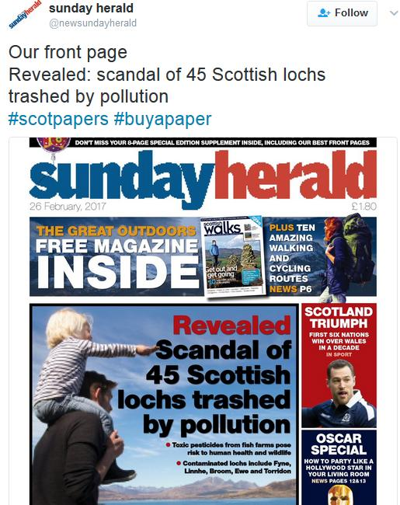

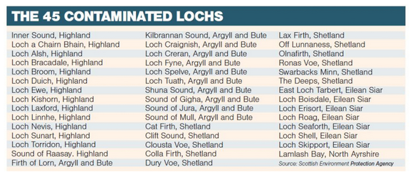

Read more via "Revealed: Scandal of 45 Scottish lochs trashed by pollution"

12) Wastes are leaking from haulage trucks transporting dead farmed salmon:

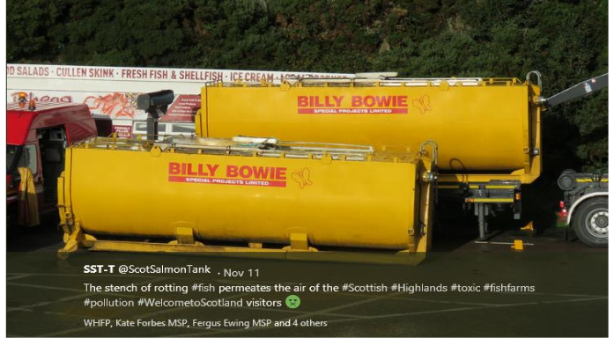

Read more via "First Minister questioned on leaking wastes from morts - call for a moratorium from Greens" and "BBC's 'Dead Salmon Run' Opens Can of Worms"

13) Lice-infestation on Scottish salmon farms is running out of control:

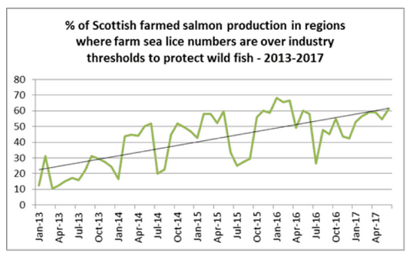

Read more via "Scottish salmon farming's 'liciest' farms named and shamed" and "Scottish salmon sold by a range of supermarkets in the UK has sea lice up to 20 times acceptable limit"
14) Seven companies accounted for 99% of Scottish salmon farming production in 2016 - with 82% of production coming from salmon farms producing over 1,000 tonnes:

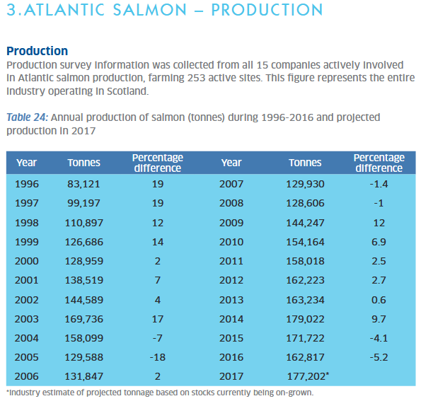

Production is increasingly concentrated in the hands of a small number of multinationals (mostly Norwegian-owned, headed by Marine Harvest) - with 15 companies (but only 10 actually produced farmed salmon) in 2016 compared to 106 in 1996.

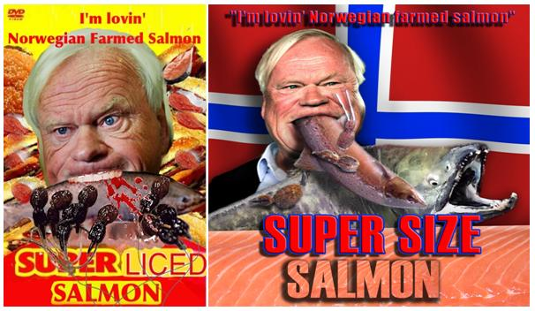

Read more via "Scottish Fish Farm Production Survey 2016" and "Scottish Fish Farms Annual Production Survey 1996"
15) Salmon farms are getting bigger and bigger with super-sized salmon farms producing up to 8,000 tonnes coming to Scotland soon:

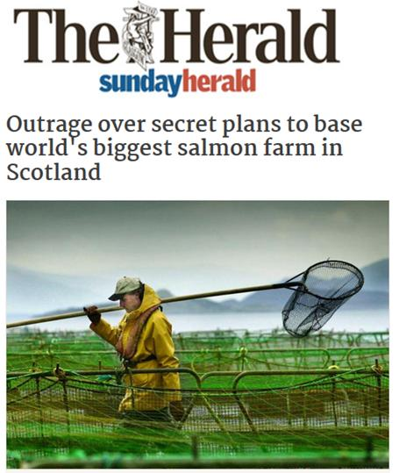

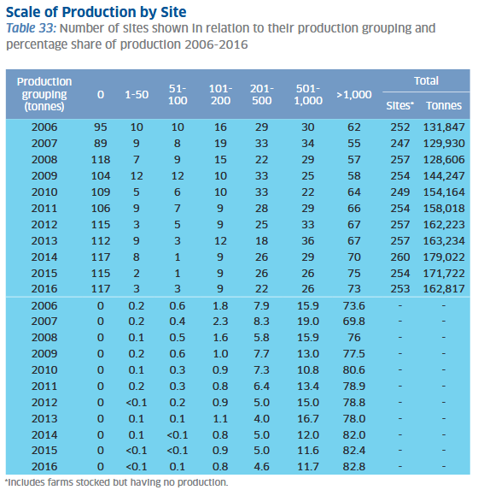

Read more via "Outrage over secret plans to base world's biggest salmon farm in Scotland"; "Super-sized Scottish Salmon - 8,000 tonnes of trouble on the horizon!" and "Trends during development of Scottish salmon farming: An example of sustainable intensification?"
16) Foreign-owned companies control over 90% of Scottish salmon farming production:

Scottish salmon farming production in 2016 was 162,817 tonnes in 2016 - with ca. 150,000 tonnes coming from foreign-owned companies (Marine Harvest, Grieg Seafood, Scottish Sea Farms, Scottish Salmon Company and Cooke Aquaculture).

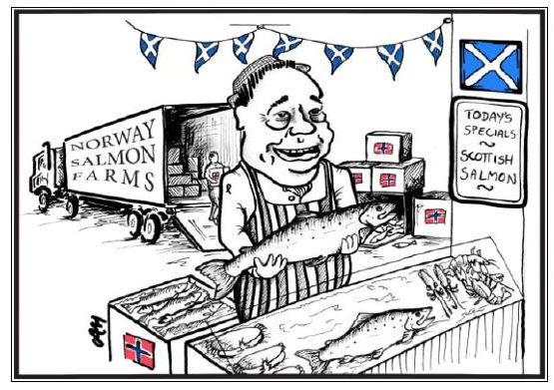

Norwegian-owned Marine Harvest produced more than 50,000 tonnes of Scottish farmed salmon in 2015 - that represents around 30% of Scottish salmon farming production. Other Norwegian-owned companies include Scottish Sea Farms (28,000 tonnes in 2016) and Grieg Seafood (22,000 tonnes production capacity).

The Scottish Salmon Company - registered in Jersey with the largest shareholder listed as a Swiss financial institution (linked to "Ukrainian banker" Yuri Lopatinsky) - exceeds 25,000 tonnes in production. Canadian-owned Cooke Aquaculture produced 22,500 tonnes of Scottish farmed salmon in 2016.

Loch Duart (5,200 tonnes in 2016) and Wester Ross Fisheries (2,000 tonnes in 2016) are both believed to be Scottish owned along with Kames (ca. 2,000 tonnes).

Read more via "Marine Harvest Scotland"; "Grieg Seafood Shetland"; "Scottish Sea Farms see profits rise"; "The Scottish Salmon Company: Largest Shareholders"; "Interview: Stewart McLelland, chief executive of the Scottish Salmon Company"; "Scottish Salmon Company: Environmental Policy"; "Cooke Aquaculture of Canada buys Shetland salmon producer"; "Loch Duart lands fifth vessel"; "Wester Ross Fisheries increases profit to £1.4m"; "Scottish Fish Farm Production Survey 2016"; "Exposed: the madness of the great international salmon swap" and "The Great International Salmon Swap"

17) 90% of 'Scottish' salmon is imported as eggs with Norway accounting for 86% of egg imports:
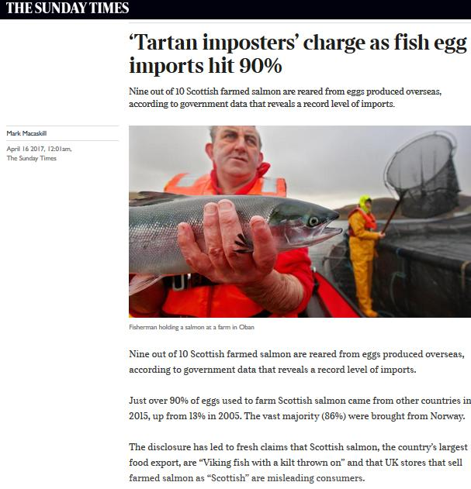
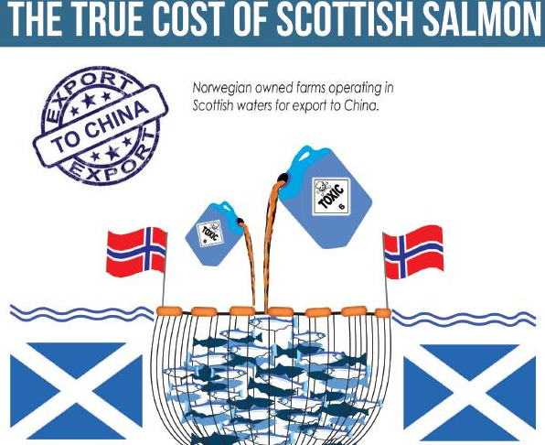
Read more via "Viking Invasion Taints 'Scottish' Salmon"; "Invasion of the Viking Salmon Hits Scotland!"; "Supermarkets sell Norwegian fish as ‘Scots’ salmon" and "UK retailers accused of selling Norway salmon as Scottish"
18) A genetic study found one in four 'wild' Scottish salmon contain DNA from Norwegian fish (due to interbreeding via mass escapes from salmon farms):

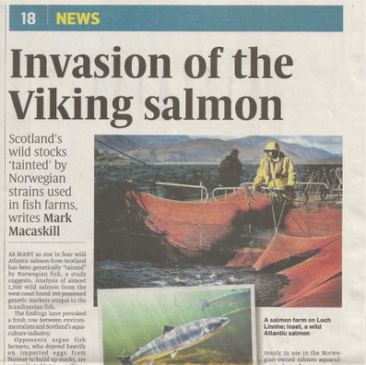

Read more via "Fish farms are 'wiping out Scotland's wild salmon'" and "Report on Genetic Tool Development for Distinguishing Farmed vs Wild Fish in Scotland"

19) The Royal Society of London reported in 2003 that repeated escapes of farmed salmon could cause an "extinction vortex" in wild fish":

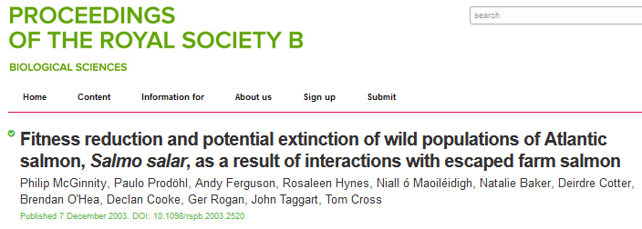

Read more via "Fitness reduction and potential extinction of wild populations of Atlantic salmon, Salmo salar, as a result of interactions with escaped farm salmon"; "Wild salmon put at risk as a million farmed fish escape" and "The salmon scandal they tried to ignore"

20) There is an East-West divide with wild salmon already extinct in many rivers on the West Coast of Scotland (where there are dozens of salmon farms compared to a ban on the East Coast):

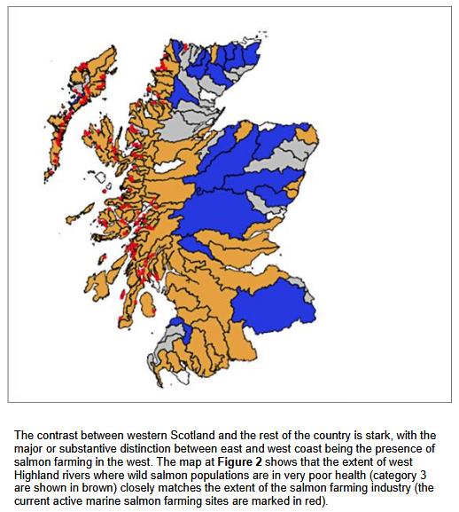

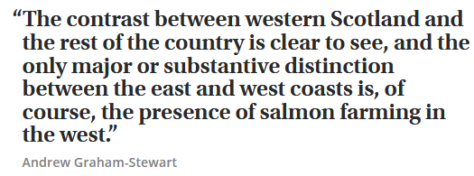

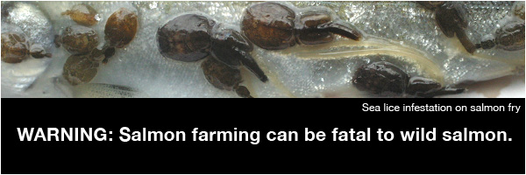
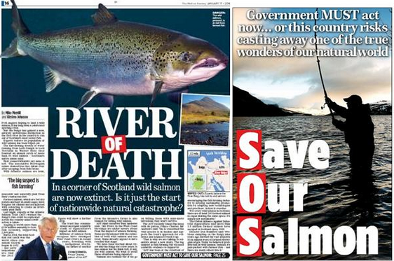
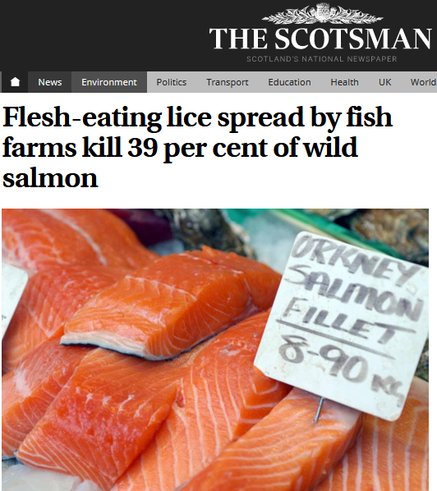

Read more via: "Salmon 'extinct' in 14 Highland rivers"; "Fish farms are destroying wild Scottish salmon, says leading environmentalist"; "Save Scottish Salmon: Stop Norwegian Salmon Farms Killing Wild Fish!"; "Cull of the Wild"; "The Control of Sea Lice in Fish Farms in Scotland, 2013-2015"; "Mounting evidence of need to modernise salmon farming – collapse of salmon run in South-West Highlands" and "Map: Wild salmon dangerously scarce in Highland rivers"
21) The 'Scotland's Aquaculture' database provides a useful resource of information on mortalities; toxic chemicals; feed use; discharges of copper, zince, nitrogen and phosphorus; biomass exceedances and escapes (although data on sea lice and infectious diseases is less accessible and data on the killing of seals is published elsewhere by the Scottish Government):

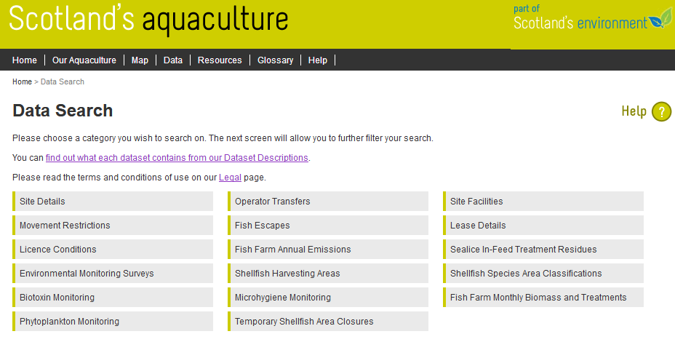
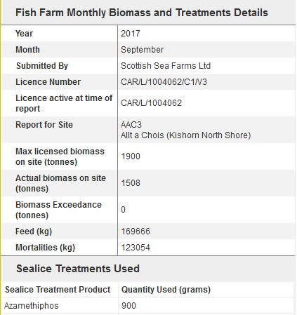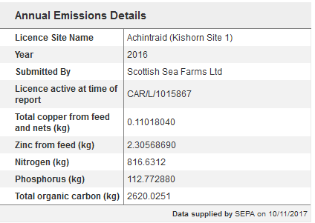

Access more data via "Scotland's Aquaculture database"; Scottish Fish Farm Production Survey 2016 (and annual surveys since 1979); Seal Licensing & Returns; Fish Health Management Reports; FishyLeaks; "Mapped: the 45 lochs polluted by fish farm pesticides"; "Mapped: every Scottish salmon farm that shot seals"; "Scottish salmon farming’s ‘liciest’ farms named and shamed" and "Trends during development of Scottish salmon farming: An example of sustainable intensification?"
22) 'Organic' salmon is "making a mockery of organic standards":

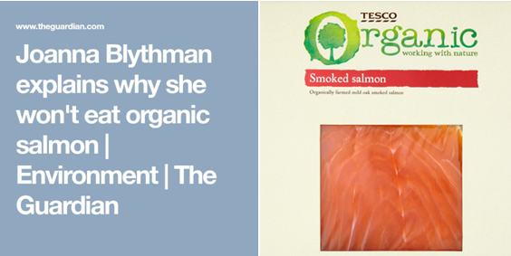

Read more via "Why organic salmon is causing a nasty smell"; "Concern over organic salmon farms" and "Organic scamon: the greenwashing of toxic farmed salmon"

Organic salmon production in Scotland is less than 4,000 tonnes (representing 2% of Scottish salmon farming production) with only 5 salmon farms registered as 'organic':

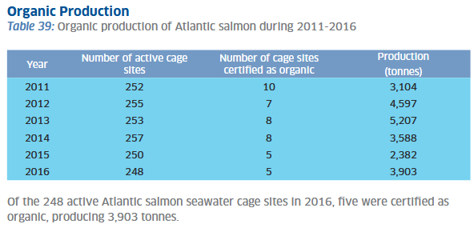

Read more via "Scottish Fish Farm Production Survey 2016"
23) Scotland's 'Yes Ministers' are rubber-stamping salmon farming expansion:

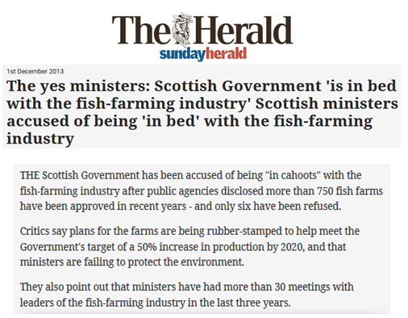

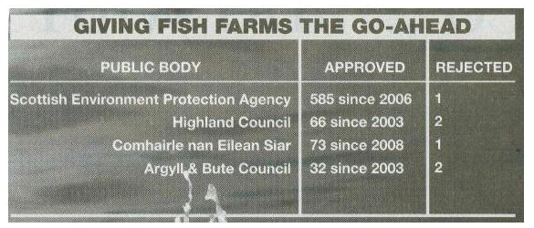

Read more via "The yes ministers: Scottish Government 'is in bed with the fish-farming industry' Scottish ministers accused of being 'in bed' with the fish-farming industry"; "Scottish ministers accused of being ‘in bed’ with the fish farming industry" and "Continued salmon farm expansion in Arran’s MPA"
24) Loch Duart - the so-called 'Sustainable Salmon Company' - uses a cocktail of toxic chemicals and operates some of Scotland's "liciest" salmon farms:

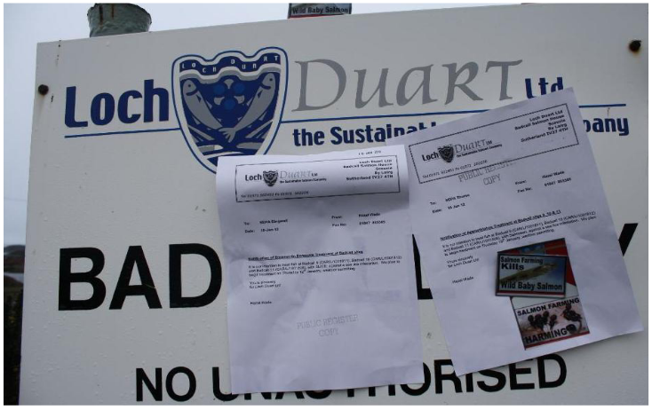

Read more via "Loch Duart - the Toxic Salmon Company"; "Scottish salmon farming's 'liciest' farms named and shamed" and "Scotland's Aquaculture" (search 'Loch Duart')

25) Listeria contamination has plagued Scottish salmon (including Loch Duart):

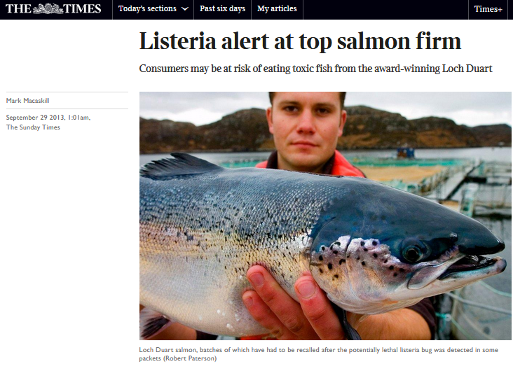

Read more via "Listeria Contamination in Farmed Salmon"; "Listeria found in smoked salmon"; "Listeria alert at top salmon firm"; "America in new Scots salmon health scare"; "Waitrose pulls salmon in listeria alarm"; "Smoked salmon industry practices and their association with Listeria monocytogenes"; "Hong Kong Listeria Warning for Scottish Salmon"; "Deadly bug discovered in salmon"
26) Supermarkets are looking to feed farmed salmon on chicken parts:

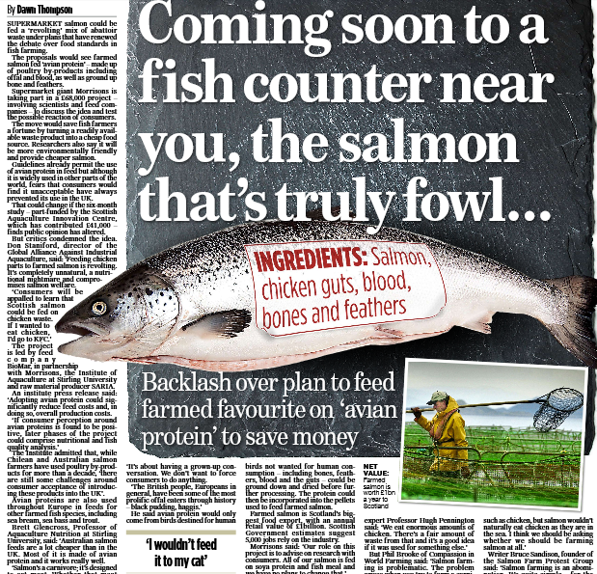

Read more via Mail On Sunday: "Coming soon to a fish counter near you, the salmon that's truly fowl...." and "Will it Fly: Avian proteins could help reduce costs and help the industry grow but only if the market is ready"

27) The supermarket chain Morrisons is working with the University of Stirling to encourage the use of chicken parts in Scottish salmon:

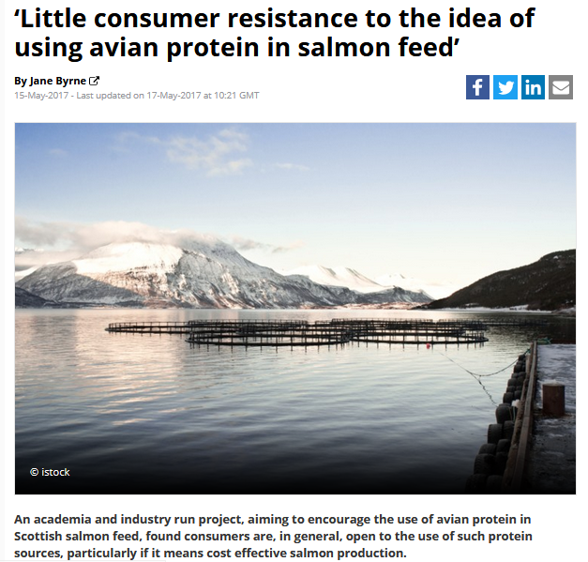

Read more via "Little consumer resistance to the idea of using avian protein in salmon feed"

Others are convinced that feeding salmon on chicken parts is a recipe for ruin:

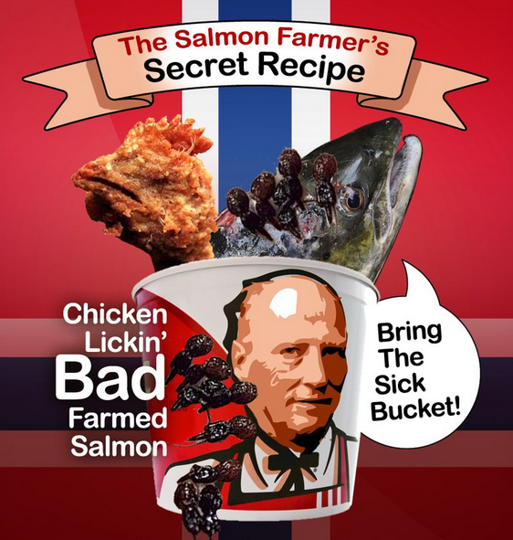

Read more via "Backlash against chicken and pork in farmed fish"
28) Scottish salmon is infested with lice:

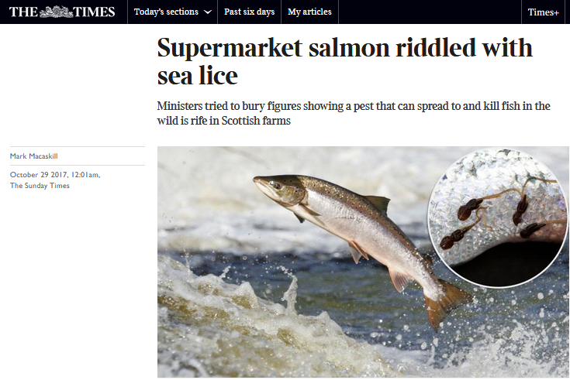

Read more via "Supermarket salmon riddled with sea lice"

29) Scottish salmon's "liciest" farms include sites operated by the Scottish Salmon Company, Loch Duart, Marine Harvest, Cooke Aquaculture and Scottish Sea Farms (all members of the Scottish Salmon Producers Organisation):

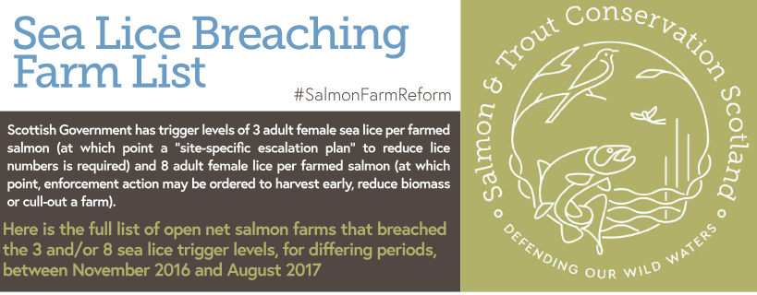
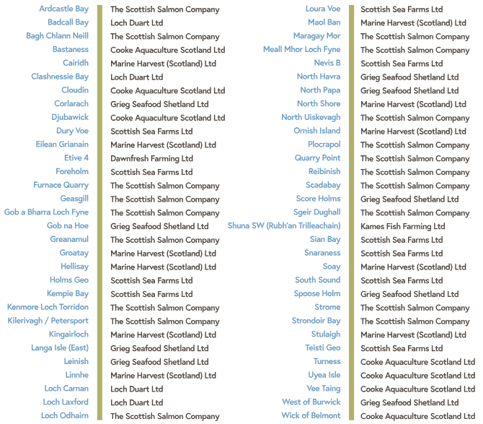

Read more via "Scottish salmon farming's 'liciest' farms named and shamed"

30) Scottish Salmon's 'Label Rouge' scheme - promoted by the Scottish Salmon Producers Organisation - should be renamed 'Label Louse':

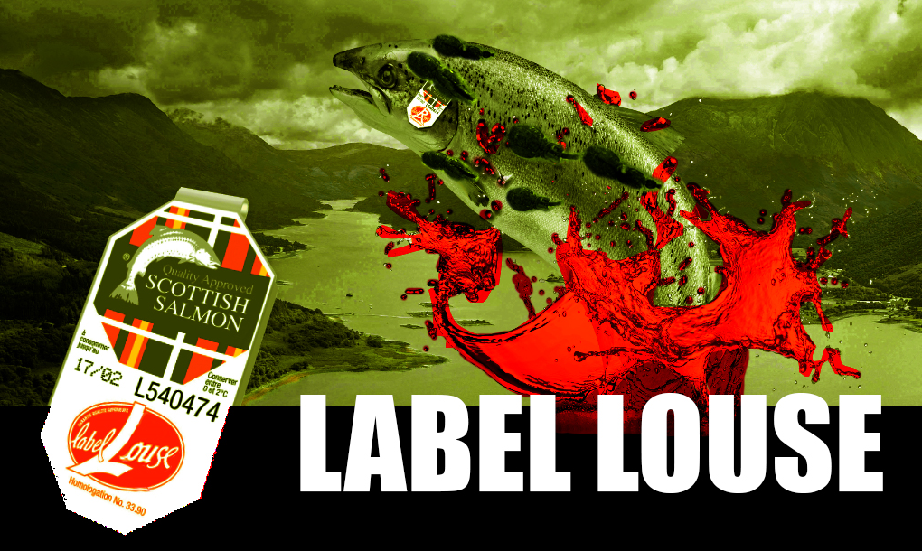

Read more via "Red Alert for Label Rouge - Lousy Label Goes Rogue"

31) Levels of beneficial omega-3 oils in farmed salmon have halved in five years.....

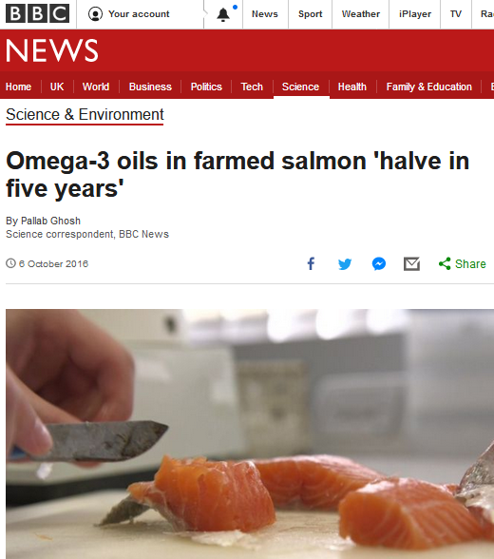

Read more via Omega-3 oils in farmed salmon 'halve in five years'

......with scientists at the University of Stirling feeding genetically modified plants which produce Omega-3 to farmed salmon:

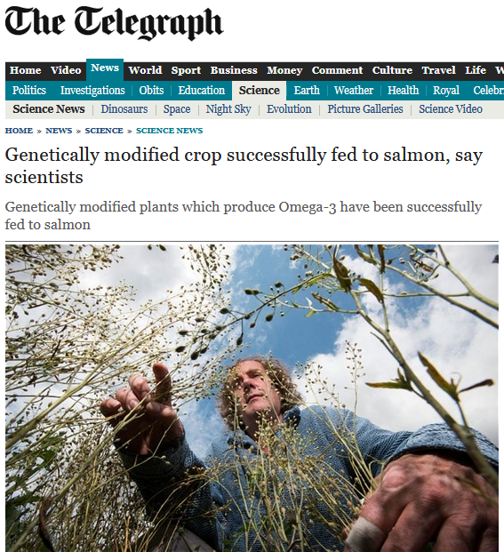

Read more via "Genetically modified crop successfully fed to salmon, say scientists"
32) Farmed salmon contains toxins including DDT, PCBs, flame retardants and insecticides:

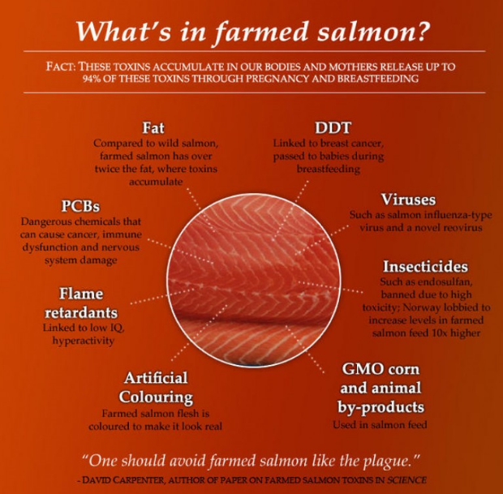
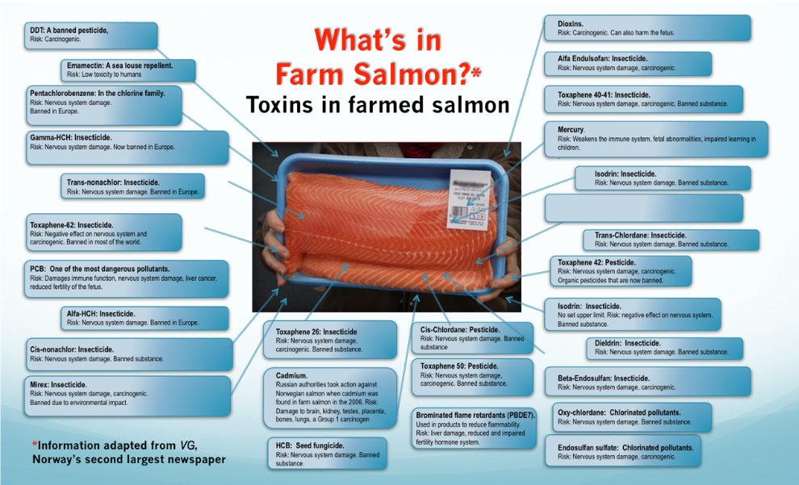

Read more via "What's in Farmed Salmon"; "A Threat to Your Child's Health" and "Are You Trading Your Omega-3s for PCBs with Your Choice of Salmon?"
33) Farmed salmon is the most contaminated food on the supermarket shelf:
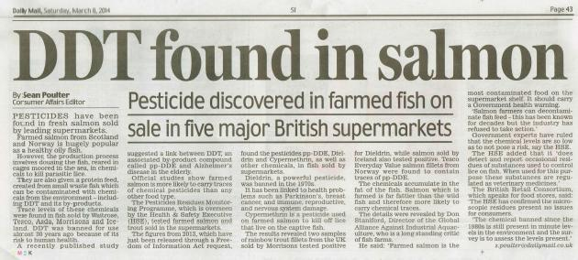
Read more via: "Farmed & Dangerous Salmon - the most contaminated food on the supermarket shelf"; "Supermarket Scamon: Pesticide Contamination of Farmed Salmon"; "Farmed Salmon — One of the Most Toxic Foods in the World?" and "Farm salmon is now most contaminated food on shelf "

34) Diesel contamination of Scottish farmed salmon led to a supermarket recall in 2008:

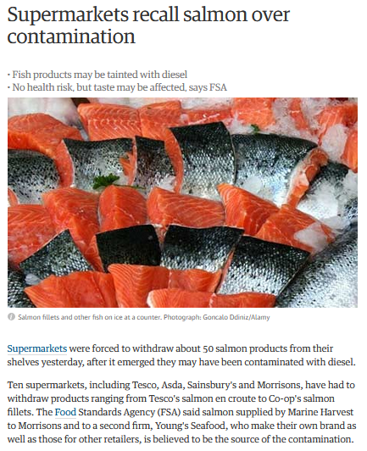

Read more via "Supermarkets recall salmon over contamination" and "Salmon products recalled from supermarkets"
35) Contamination with polychlorinated biphenyls (PCBs) has been found under salmon farms in Scotland (as well as in the flesh of Scottish farmed salmon):

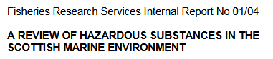
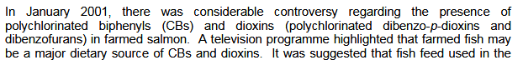
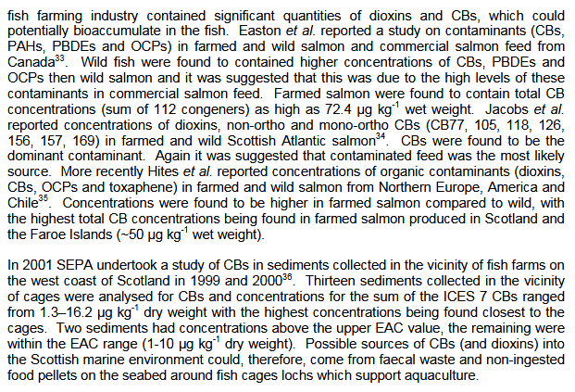
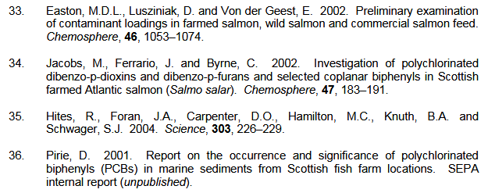

Read more via "A review of hazardous substances in the Scottish marine environment"; "Unintentional use of organic contaminants in aquaculture and impact on sediments"
36) In 2017 the Expert Committee on Pesticide Residues in Food detected the banned carcinogen DDT in Scottish farmed salmon on sale in supermarkets across the UK (including Aldi, ASDA, Budgens, Marks & Spencers and Morrisons):

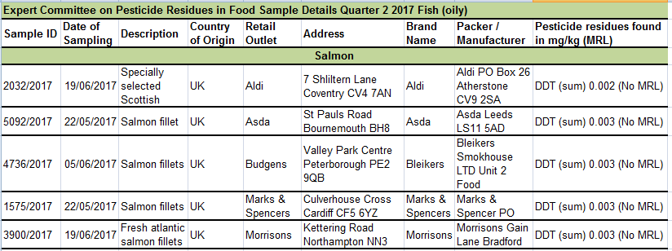

Read more via "Pesticide residues in food: quarterly monitoring results for 20170"; "Pesticide Residues in Food: Q2 2017"; "DDT may quadruple breast cancer risk"; "Farmed salmon linked to cancer risk"; "Cancer warning over Scottish farmed salmon"; "Health fear over farmed salmon"; "Salmon poison alert"; "Scottish farmed salmon is 'full of cancer toxins'"; "The salmon scandal they tried to ignore"; "Consumption advisories for salmon based on risk of cancer and noncancer health effects" and "DDT found in salmon: Pesticide discovered in farmed fish on sale in five major British supermarkets"

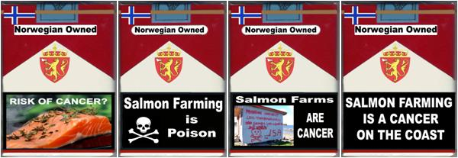

37) Emamectin contamination of Scottish farmed salmon has now occurred at least eight times (including Scottish Salmon Company in 2016 and 2012, Lakeland Marine in 2010, Skelda Salmon in 2009, Scottish Sea Farms in 2006 and Marine Harvest in 2005):
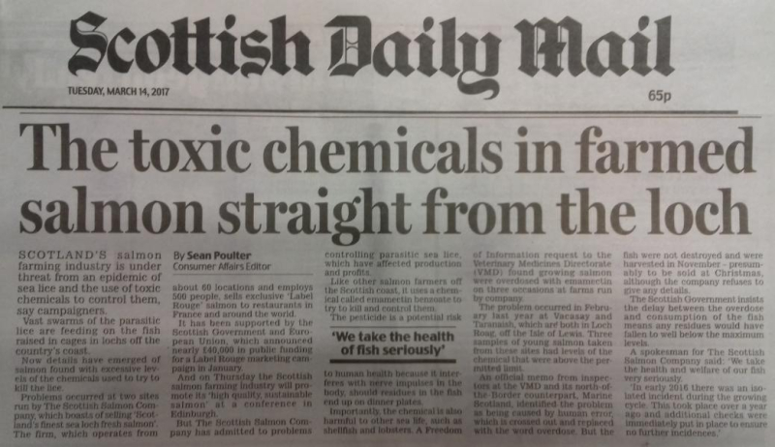
Read more via "Scottish Salmon Overdoses on Toxic Chemical"; Daily Mail: "The toxic chemicals in farmed salmon straight from the loch" and "Emamectin residues in farmed salmon"
Malachite green - a banned carcinogen - has also contaminated Scottish farmed salmon:
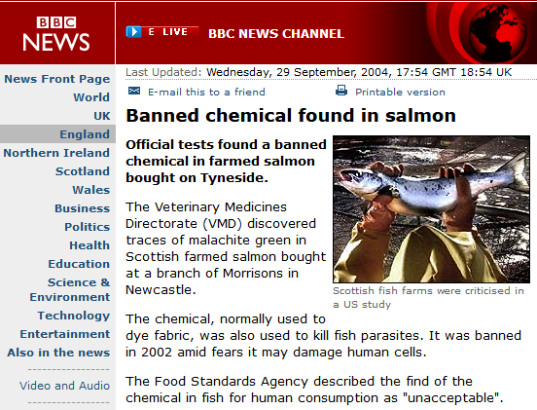

Read more via "Contaminated salmon on sale to public"; "Banned chemical found in salmon" and "'Toxic' salmon faces EU-wide sales ban"
38) Whales, dolphins and porpoises on the West Coast of Scotland are being put at risk by noise alarms used by salmon farms to scare off seals:

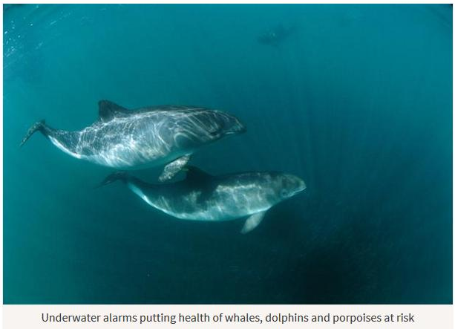

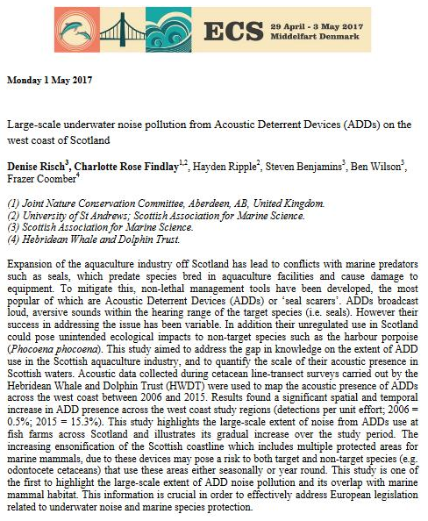
Read more via Sunday Herald: "Health of whales, dolphins and porpoises put at risk by underwater alarms" ; "Cetaceans Sound Alarm On Salmon Farms - new research sparks EC complaint & call to ban Acoustic Deterrent Devices" and "Large-scale underwater noise pollution from Acoustic Deterrent Devices (ADDs) on the west coast of Scotland"
39) Scottish salmon farmers risk losing £200 million per year in exports to the United States if the industry continues killing seals:
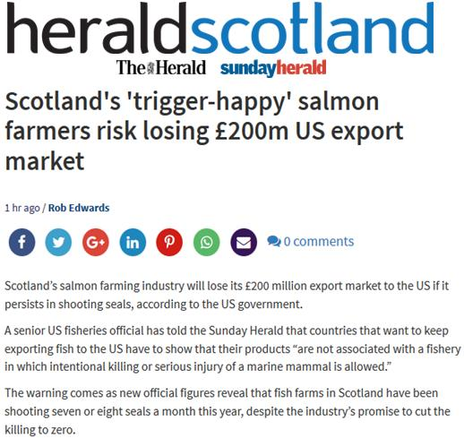
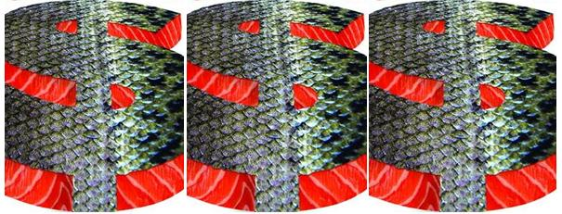
Read more via Sunday Herald: "Scotland's 'trigger-happy' salmon farmers risk losing £200m US export market"; "US warning over continued killing of seals by Scots fish farms"; "The $2 Billion Dollar Salmon Ban"; "Salmon chiefs seek clarity on possible US ban"; "Import ban on Scottish fisheries set to cost £200m a year"; "Seal of Approval for U.S. Ban on Salmon"; "Five-Year stay of execution for Scottish salmon's serial killers - US outlaws killing of marine mammals by 2022"; "US ban on lethal Scottish salmon - £200 million in exports killed off by seal slaughter"
40) Over 250 salmon farms litter the West Coast and the Highlands & Islands of Scotland - with the North-West accounting for 30% of salmon farming production in 2016 followed by Shetland (22%), South West (21%), Western Isles (18%) and Orkney (8%):
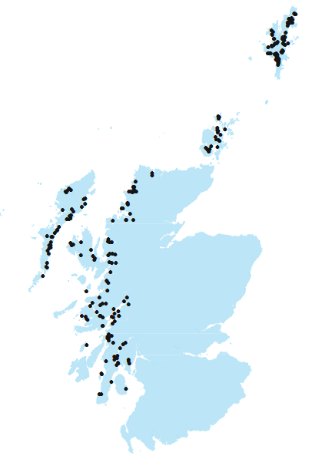

Read more via Scottish Fish Farm Production Survey 2016
41) Waste pollution from salmon farms is killing off the sea bed:

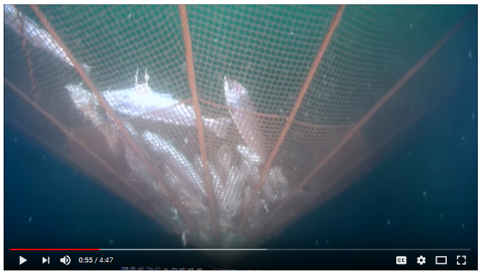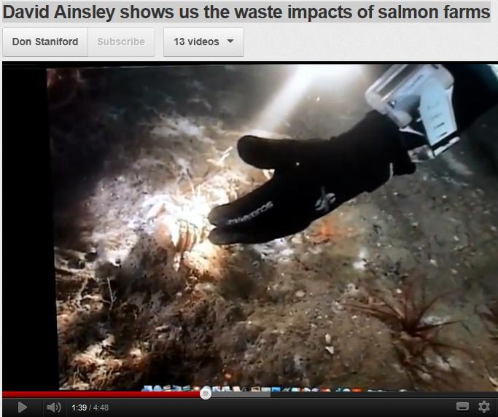
More via "David Ainsley shows us the waste impacts of salmon farms"; "Shame Below the Waves"; "Pollution fears over fish farms"; "Factors Affecting Benthic Impacts at Scottish Fish Farms" and "Benthic Recovery Project"

42) Scientific research has shown that salmon farms impact on maerl beds:

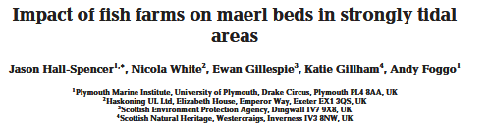
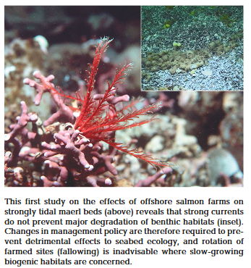

Read more via "Impact of fish farms on maerl beds in strongly tidal areas"; "Investigation into the impact of marine fish farm deposition on maerl beds"; "A Big Fish In A Small Pond"; "Fish farm threatens rare marine life"

43) Scientific research published in 2018 details "considerable evidence" of a link between salmon farms and the spread of lice to wild Atlantic salmon and sea trout:

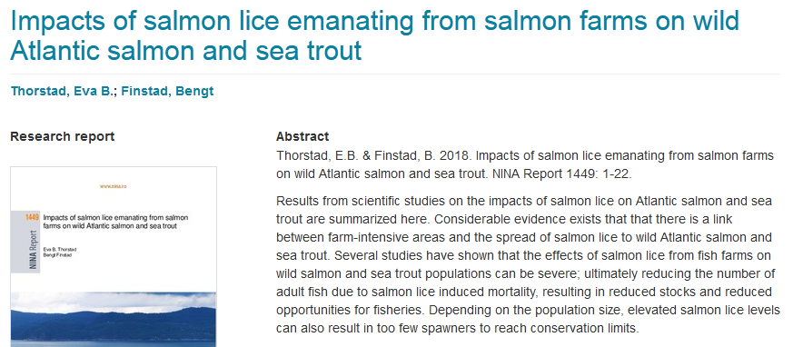

Read more via: "Impacts of salmon lice emanating from salmon farms on wild Atlantic salmon and sea trout"; "Report backs negative sea louse claims"; The Scotsman: "Call for curb in fish farms as study shows pest risk to wild fish"; "New scientific study underlines damage to wild salmon and sea trout populations from salmon farm parasites – in Scotland, Norway and Ireland"; Daily Mail: "Up to third of wild salmon 'eaten alive by fish farm lice'"; "Fish farm lice are killing wild salmon" and "EC Complaint concerning the failure of the UK to draw up and take appropriate measures pursuant to the Marine Strategy Framework Directive in relation to the impact of sea lice emanating from Scottish marine salmon farms on wild Atlantic salmon and sea trout"

44) Antibiotic use on Scottish salmon farms represents a public health risk:

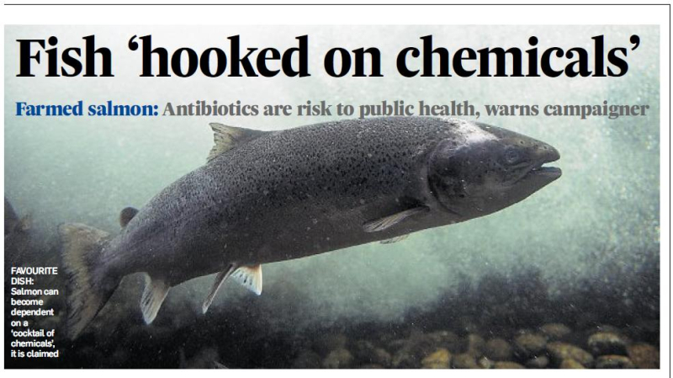

Read more via "Antibiotic-ridden Scottish Salmon: FOI reveals of Oxytetracycline, Florfenicol, Amoxycillin and Fenbendazole" and "Fish 'hooked on chemicals"
45) Consumption of farmed salmon has been linked to obesity and diabetes:

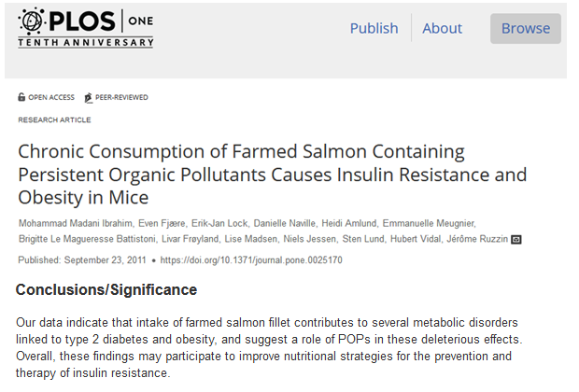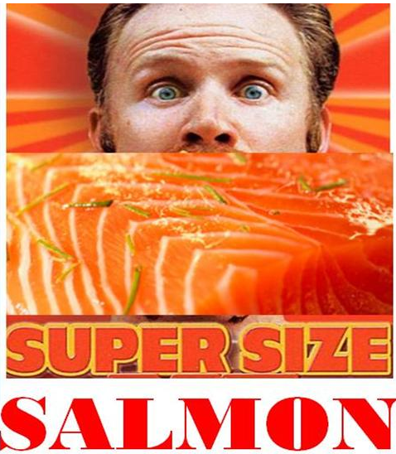

Read more via Chronic Consumption of Farmed Salmon Containing Persistent Organic Pollutants Causes Insulin Resistance and Obesity in Mice

46) "Never eat farmed salmon!" warned Dr. Jerome Ruzzin of the University of Bergen following scientific research showing farmed salmon was the most contaminated:

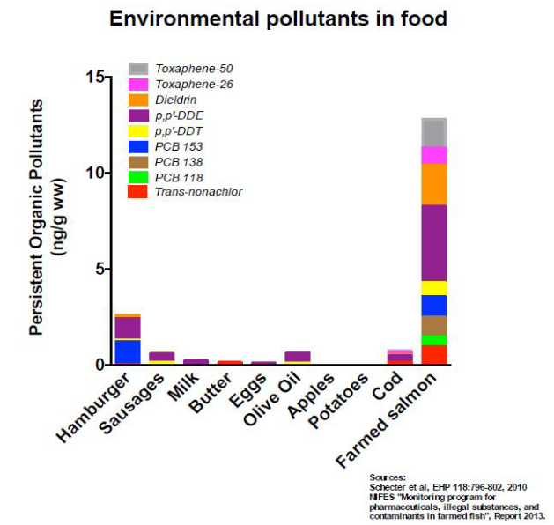

More details via "Fillet Oh Fish" and "Farmed & Dangerous Salmon - the most contaminated food on the supermarket shelf"
47) Almost a fifth (18%) of Scottish fish farms were classified by the Scottish Environment Protection Agency as failing and responsible for "at least one significant breach" in 2015:

Norwegian-owned Marine Harvest, Scotland's largest salmon farming company, is the worst operator with 13 "failing" salmon farms in 2015 (that's 27% of the 49 marine salmon farms operated by Marine Harvest).

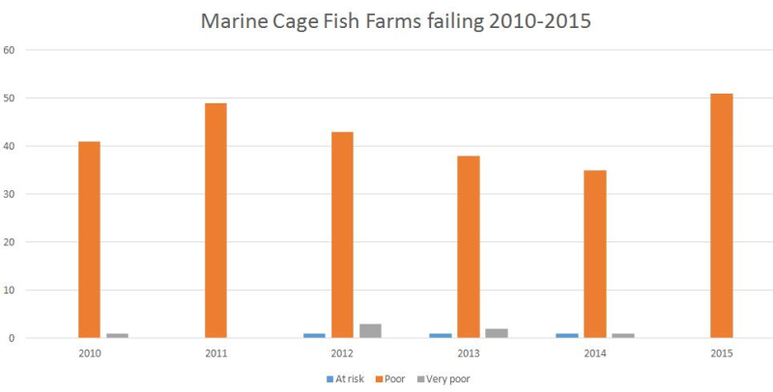

Read more via "Failing Fish Farms - 18% rated "poor" by SEPA in 2015"

48) Data from SEPA ranked fish farms as 2nd worst out of "Scotland's polluting industries":

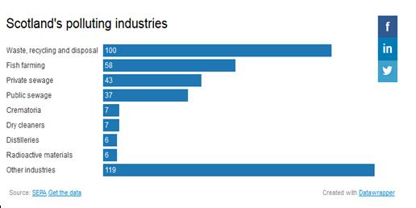
Read more via "Exposed: the 383 plants that pollute Scotland" and "Mapped: the hundreds of firms condemned for ‘poor’ pollution performance"
49) Toxic chemical use on Scottish salmon leapt 1000% over the last decade:
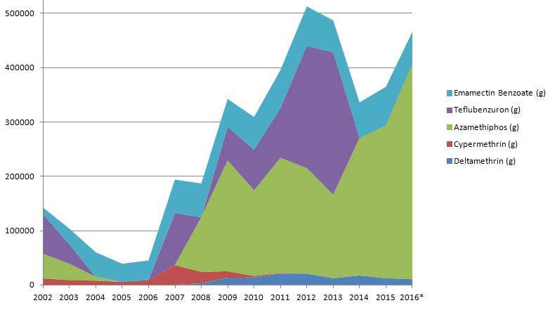
Read more via The Sunday Times: "Salmon industry toxins soar by 1000 per cent"; "Scottish Salmon's Lethal Legacy - Ten-fold Increase in Toxic Chemical Use in Ten Years"; Press & Journal: "Scottish salmon farming ‘fighting a losing battle’ against sea lice"; "Scottish fish farmers use record amounts of parasite pesticides" and "Sharp rise reported in Scots fish lice chemical"

The use of Hydrogen peroxide on Scottish salmon farms has also sky-rocketed:

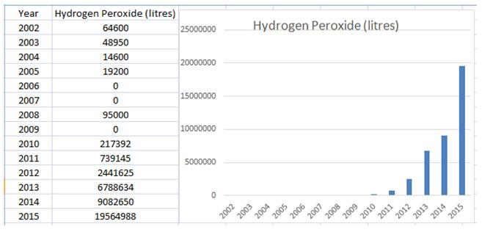
Read more via The Sunday Times: "Record chemical use ‘of concern’ to salmon giant" and "Sky-Rocketing Chemical Use on Scottish Salmon Farms"
50) Toxic chemicals used by "junkie" salmon farms include the cancer-causing Dichlorvos, the poisonous paint TBT and lobster-killing Teflubenzuron (all now banned)......

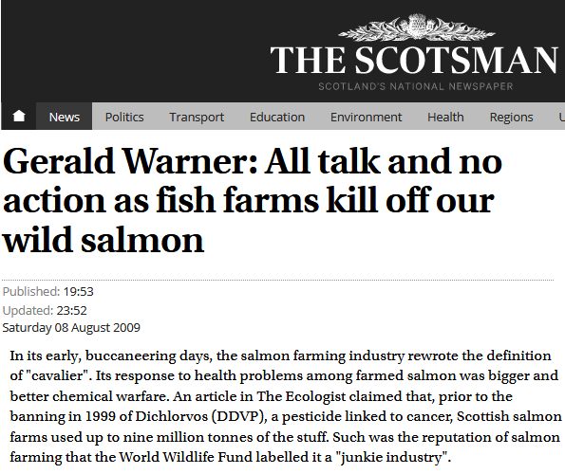

Read more via "Insecticide ban amid cancer fears"; "Fly Spray Ban Urged as Cancer Fears Rise"; "Nuvan use in salmon farming–the antithesis of the Precautionary Principle";
"Tin from paint is found in salmon flesh"; "Accumulation of butyltins in muscle tissue of chinook salmon reared in sea pens treated with tri-n-butyltin"; "Sea louse control in Scotland, past and present"; "All talk and no action as fish farms kill off our wild salmon"; "Toxic pesticide again in use on salmon farms"; "Critics question safety of Calicide use at Scottish salmon farms"; "Effects of teflubenzuron on sediment processing by members of the Capitella species-complex"; "The drug that's meant to save Salmon but is killing the creatures on the Ocean floor"; "Mortality and deformities in European lobster (Homarus gammarus) juveniles exposed to the anti-parasitic drug teflubenzuron"; "Media backgrounder: Chemical Culture in Scotland" and "Fish Farmageddon: Scottish Salmon's Lethal Legacy"

..............with new chemicals now in the pipeline:

Read more via "New lice bath ‘100% effective’ and pollution-free"; "Patent sought for neonicotinoid-based sea louse treatment"; "New sea louse treatment nears commercial launch" and "A new generation of biocides for control of crustacea in fish farms"
51) Nearly 100,000 farmed salmon were 'Thermoliced' to death by Marine Harvest during 2016:
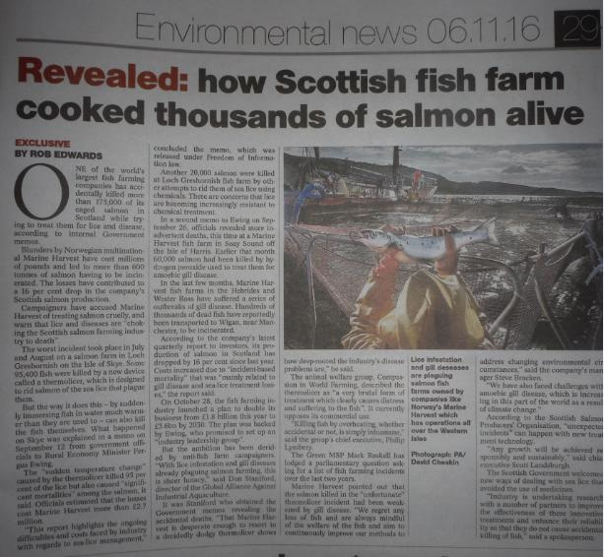
Read more via "'Thermolicer' Back-Fires Killing 95,400 Farmed Salmon"; Fish farm firm kills 175,000 salmon by accident; "Oops: fish farm firm kills 175,000 of its salmon by accident" and "Thousands of fish poached alive in lice treatment bungle"

52) A Thermolicer treatment caused the deaths of 5,794 salmon at Grieg Seafood Shetland’s North Havra site in November 2016:

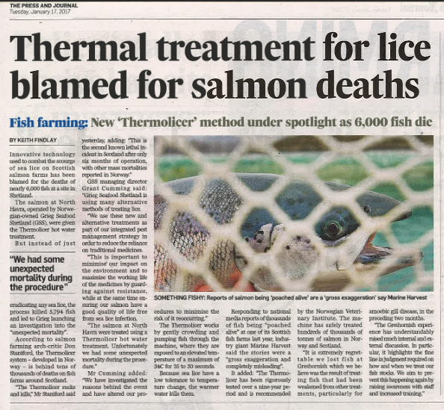

Read more via "Thermal treatment for lice blamed for salmon deaths" and "Treatment leads to morts in Shetland"

53) Scottish salmon farms represent a welfare nightmare with mass mortalities, high stocking densities, so-called 'death crowns' due to lice infestation and other problems:

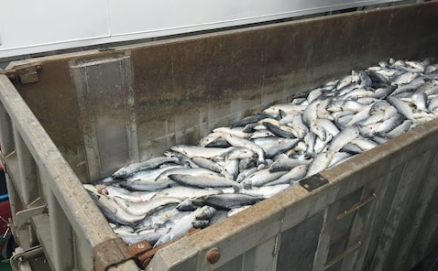

Read more via Compassion In World Farming: Why fish farming needs urgent welfare reform; "Welfare fears after claim deaths of farmed salmon have doubled"; "Closed Waters: the welfare of farmed Atlantic salmon"; "Salmon farming welfare raised at industry event" and "Farmageddon"
54) The mortality rate at Scottish salmon farms is a staggering 26.7% (five times higher than the 5% mortality tolerated on intensive chicken farms):

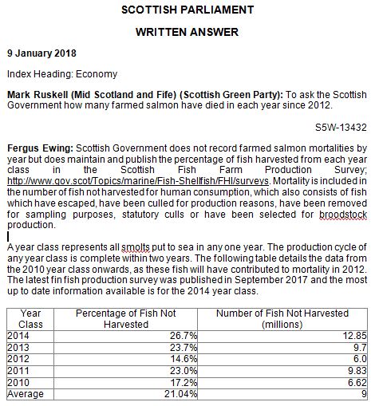
Read more via "Parliamentary Question: to ask the Scottish Government how many farmed salmon have died in each year since 2012" and "Death rate at salmon farms doubles to 20m fish a year"

55) In December 2016, the Scottish Green Party called for a moratorium on Scottish salmon farming:
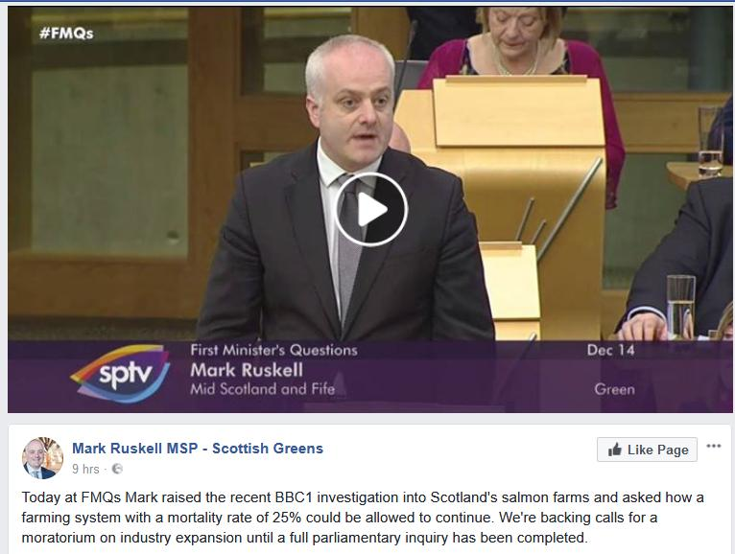
Read more via First Minister questioned on leaking wastes from morts - call for a moratorium from Greens
Instead of expanding salmon farming yet further, the Scottish Government should be curbing production and that means immediately closing down disease-ridden salmon farms.
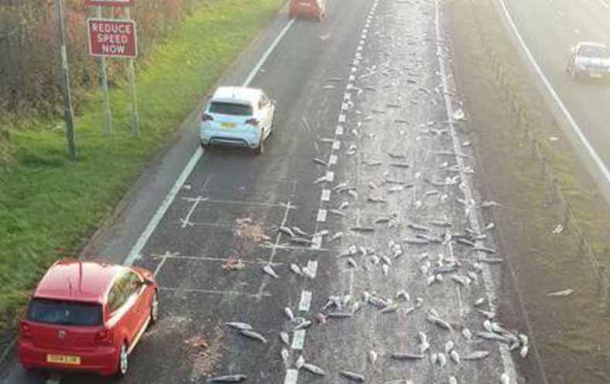
Read more via "Aquaculture Growth to 2030: a strategic plan for farming Scotland's seas"; "New innovation roadmap outlines pathway for Scottish aquaculture growth"; "Scottish Aquaculture: a view towards 2030"; "New strategy launched to 'double' size of aquaculture"; "New Strategy to Double Size of Scotland’s £1.8 billion Aquaculture Sector"; "Call for curb in fish farms as study shows pest risk to wild fish"; "Salmon Farming Moratorium: Letter to the First Minister of Scotland"; "Scotland's salmon farms face strict curbs"
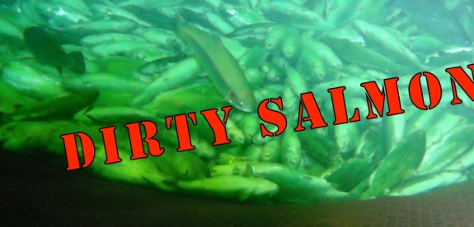
55) "Scotland's farmed salmon industry stinks" reported The Grocer in 2017 in an article by award-winning food writer Joanna Blythman:

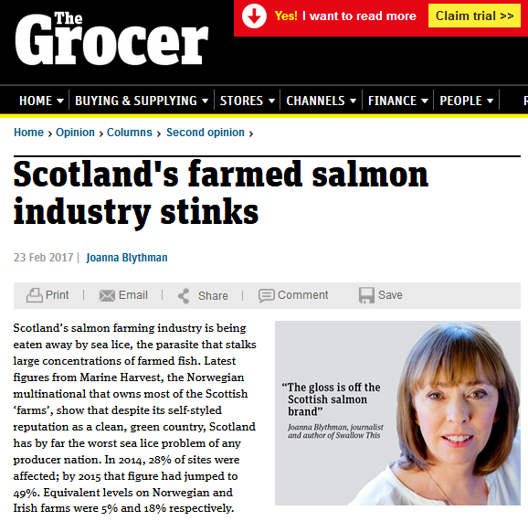

Read more via The Grocer: ‘Scotland’s Farmed Salmon Industry Stinks’ and "Salmon farming morts"
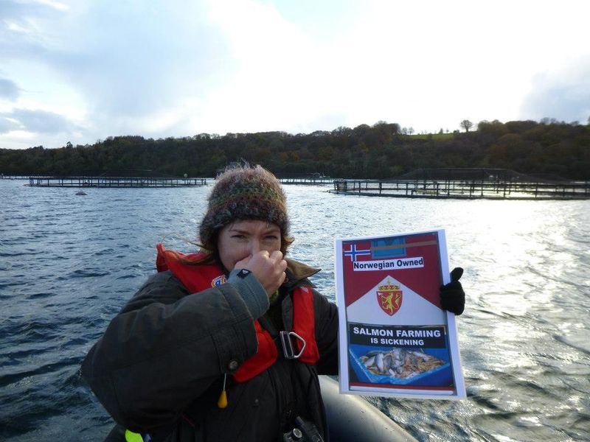
Read more via "Ground Zero in Scotland's Salmon Wars"
56) Hjaltland Sea Farms (owned by the Norwegian multinational Grieg Seafood) was kicked out of the Scottish Salmon Producers Organisation for importing smolts without quarantine:
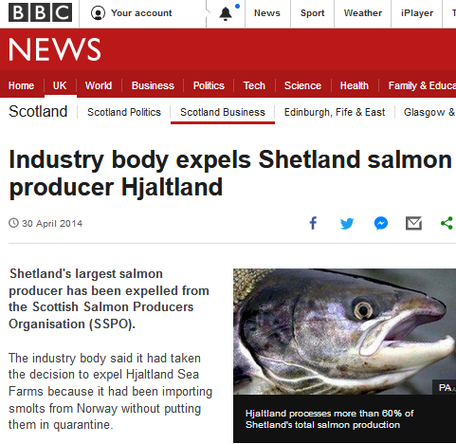

Read more via "Industry body expels Shetland salmon producer Hjaltland" and "Salmon firm defiant after SSPO expulsion"

57) Ardessie Salmon were kicked out of Scottish Quality Salmon for illegal chemical use:
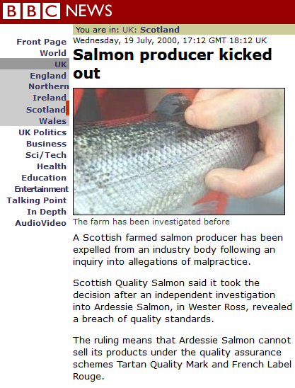

Read more via "'Illegal poison' used on salmon"; "Illegal chemical 'used on salmon'" and "Salmon producer kicked out"
58) Scottish Sea Farms was guilty of "serious violations" of food safety rules on pesticides in salmon:

"Your firm's aquaculture farmed salmon appear to be adulterated," the US Food & Drug Administration said, "in that the products have been prepared, packed, or held under conditions whereby they may have been rendered injurious to health."
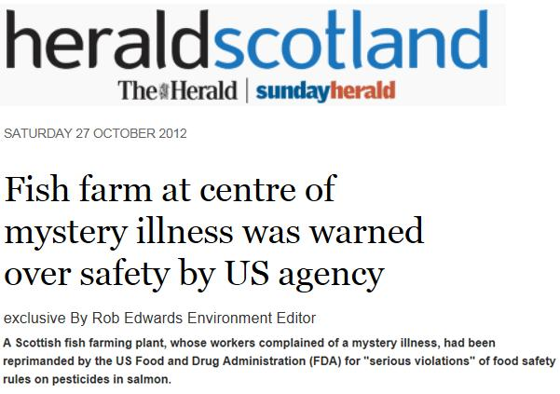
Read more via FDA Health Warning for Scottish Farmed Salmon and Salmon Farming is Sickening: FDA warning for "adulterated" Scottish farmed salmon "injurious to health"

59) Scottish Salmon Company was caught out calling a local community a "vipers nest" in leaked documents:

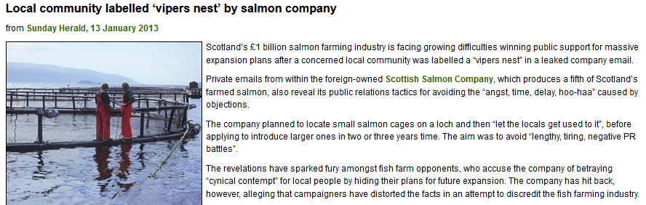

Read more via "Local community labelled ‘vipers nest’ by salmon company"

60) Wester Ross Fisheries were dropped by ASDA due to concerns over its environmental impact - including benthic pollution and sea lice infestation:

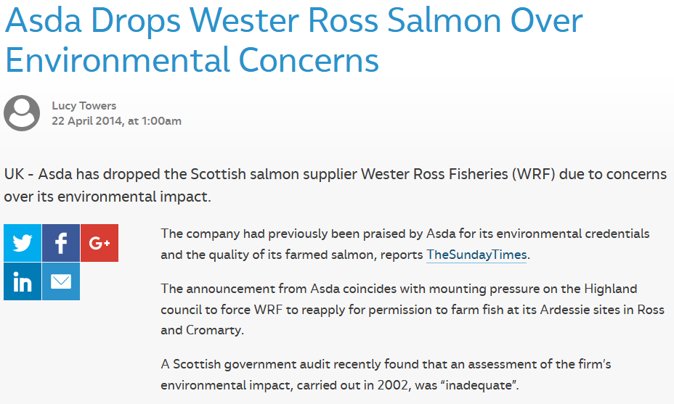
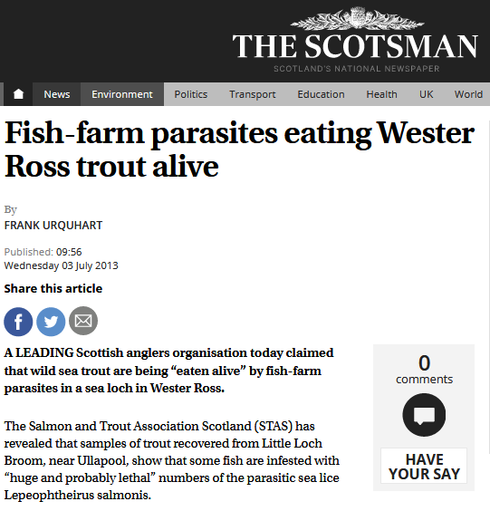

Read more via "Asda axes salmon from ‘problem’ WRF"; "'Unsatisfactory' Wester Ross Salmon: Over a decade of non-compliance"; "Prizes for polluting fish farm under fire"; "Wester Ross fish farms under fire over sea lice outbreaks" and "Fish-farm parasites eating Wester Ross trout alive"

61) Marine Harvest's slaughter of seals in Loch Alsh - a Special Area of Conservation - attracted widespread condemnation:

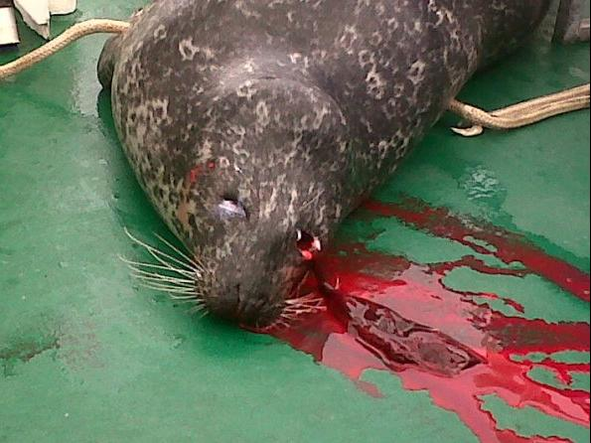

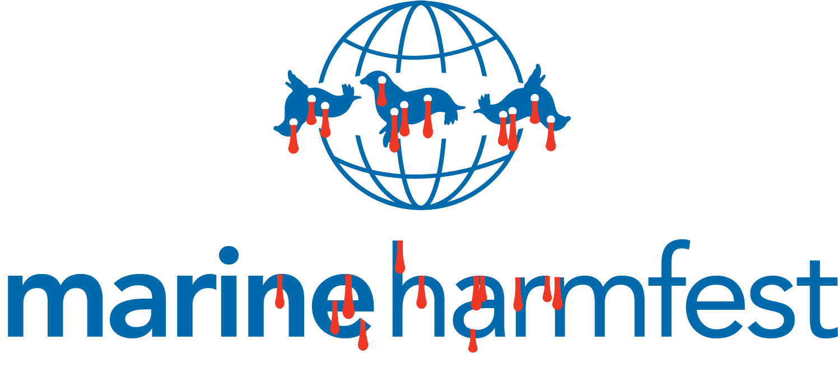
More details via "Scottish Fish Farmers Slaughter Seals"; "Marine Harvest's Slaughter of Seals in Loch Alsh, Scotland"; "Seal killing concern at fish farm"; "Marine Harvest: Scotland's #1 Seal Killer" and "RSPCA in firing line over Marine Harvest's seal-killing spree in Scotland"
62) Marine Harvest was fined £4,000 for polluting the River Lochy with fish viscera, blood and congealed fats deposits, scum and grease:

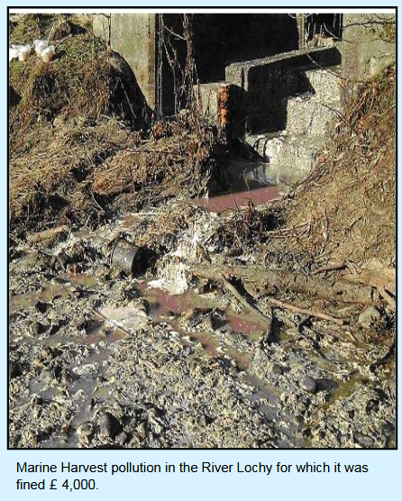

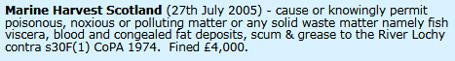

Read more via "Scottish Farmed Salmon Exposed"
63) Marine Harvest polluted Loch Shell with the toxic pesticide Teflubenzuron (subsequently banned by SEPA) up to 450 times higher than recommended levels:

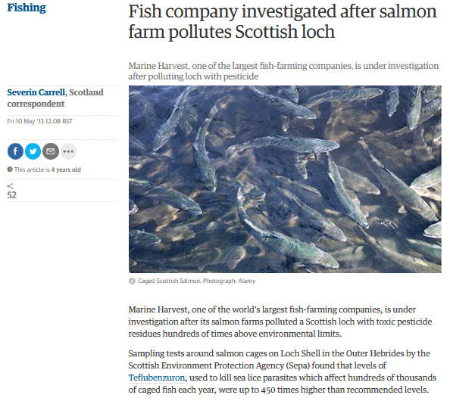
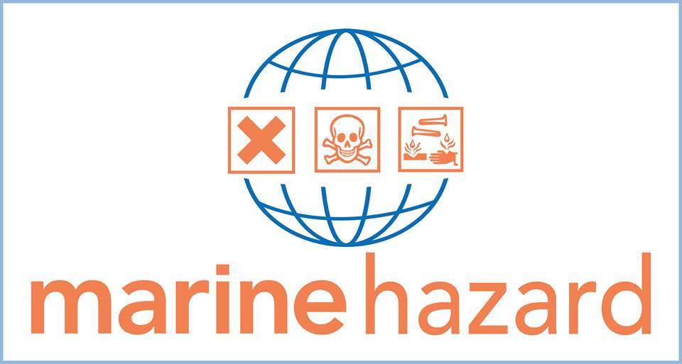

Read more via "Fish company investigated after salmon farm pollutes Scottish loch"; "Revealed: the dirty dozen salmon farms that contaminate lochs with pesticides" and "Revealed: the toxic pesticides that pollute our lochs" and "The drug that's meant to save Salmon but is killing the creatures on the Ocean floor"
64) Deaths at salmon farms have cost the industry dearly:

BBC News reported in 2012 that Scottish Sea Farms had been fined £333,335 following the deaths of two workers - that's around £166,700 each for the lives of Scottish Sea Farms worker Campbell Files and engineer Arthur Raikes.
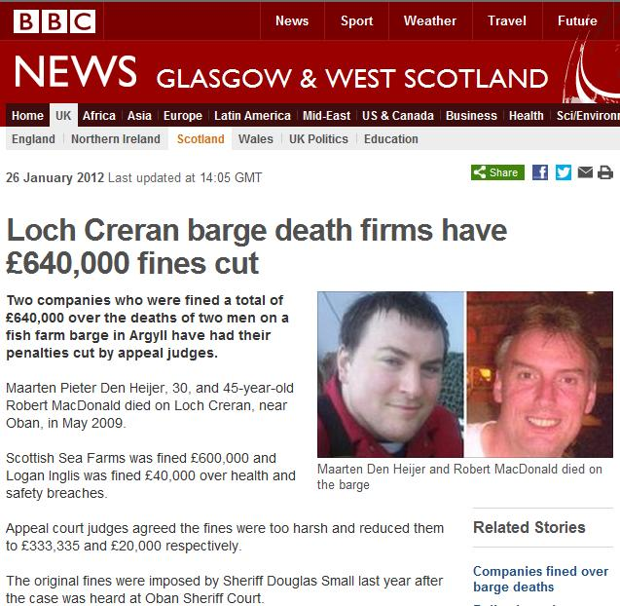

"Following the incident on 11 May 2009, inspectors from the Health and Safety Executive (HSE) discovered Scottish Sea Farms had failed to suitably prepare staff for working in the small, sealed chambers on the Loch Creran barge," reported the BBC.

Speaking after the conclusion of the case, HSE principal inspector Barry Baker said: "These two men were trying to help save their colleague's life when they tragically lost their own. Aquaculture is an important industry in Scotland and one that we can be very proud of, however, we must not forget that the marine environment is dangerous and unforgiving. The deaths in this case should have been avoided - the risks should have been identified and a clear and safe system of work prepared."

Read more via "Firms fined £640,000 over Loch Creran barge deaths"; "Loch Creran barge death firms have £640,000 fines cut" and "Barge pair ‘died in two minutes’"

65) "Filthy" and "Insanitary" Scottish farmed salmon "unfit for human consumption" was rejected by the US Food & Drug Administration in 2003:
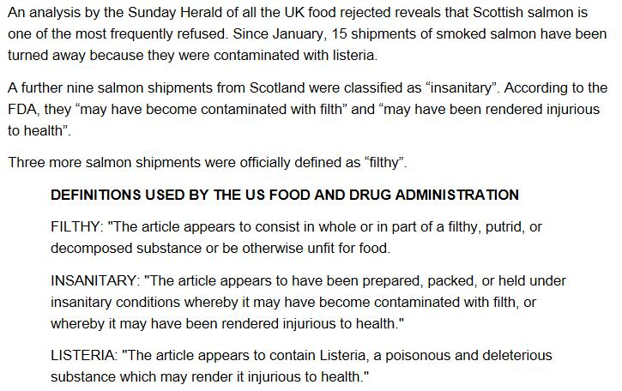
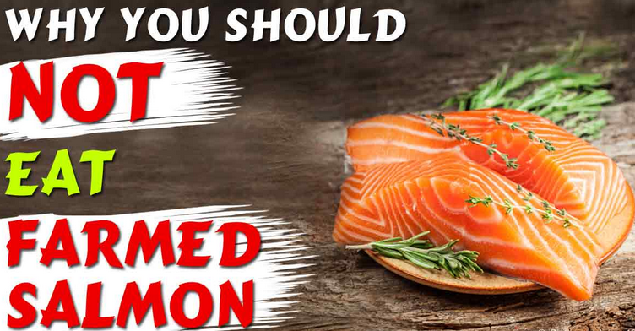
Read more via "US rejects 'filthy' Scottish salmon" and ""Insanitary" and "Filthy" Farmed Salmon: United States refuses imports of Irish and Scottish salmon"
66) RSPCA Assured (formerly Freedom Food) certify 70% of Scottish farmed salmon yet still have problems with infectious diseases, mortalities, benthic pollution as well as killing seals:

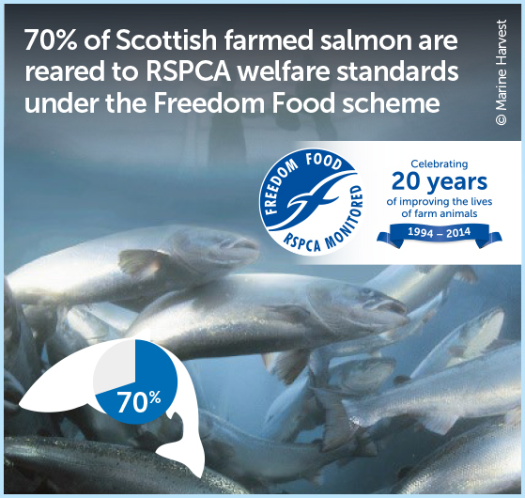
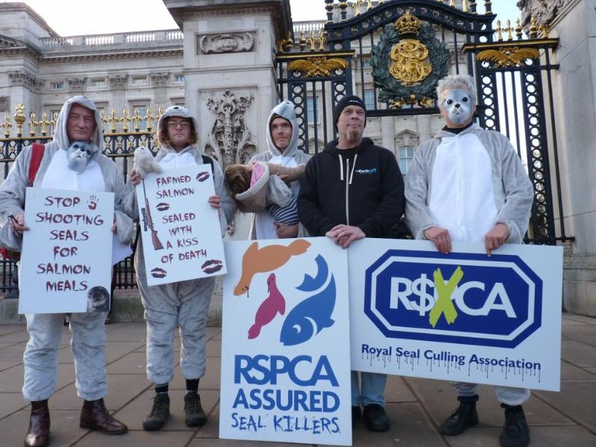
Read more via "RSPCA Assured Seal Killers!"; "Marine Harvest: Scotland's #1 Seal Killer"; "RSPCA in firing line over Marine Harvest's seal-killing spree in Scotland; "Freedom Foods 'failing to crack down' on poor salmon farming standards" and "RSPCA Assured Certification of Scottish Farmed Salmon"
67) Uo-to-date data on diseases on Scottish salmon farms is not readily accessible - but we know from previous data accessed via FOI that diseases increased significantly between 1980 and 2007:

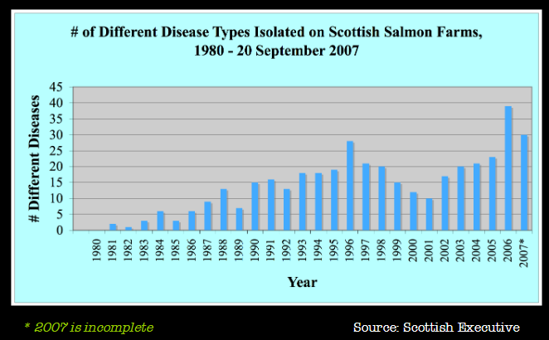

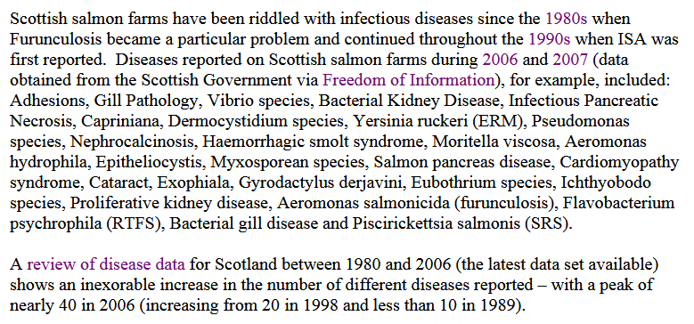

Read more via "Gaining Transparency: using the FOIA process to track down data on the impacts of fish farming"; "Fish Farmageddon: The Infectious Salmon Aquacalypse" and "The Infectious Salmon Aquacalypse"
68) Only two of Scotland's salmon farms are currently certified via the Aquaculture Stewardship Council with one more "in assessessment" - despite claims by Marine Harvest in 2013 that all of their farms (49 in total) would be certified by 2020:

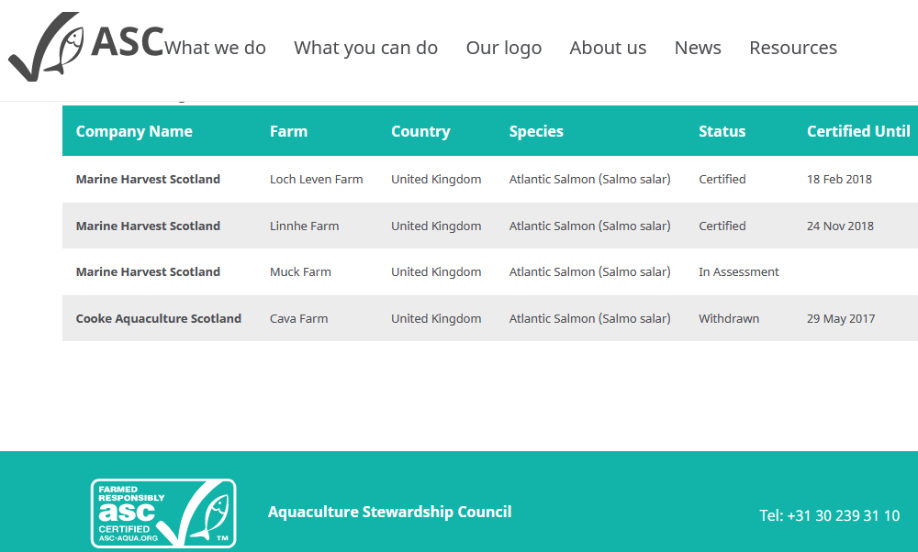

Read more via "Abominable Salmon Council - buyer beware!"; "Aquaculture Stewardship Council" "Scottish salmon farm first in UK to get ASC certification"; "Salmon farming: Scotland's largest company commits to reducing its environmental impacts"; "Salmon firm Marine Harvest faces call to move fish farms"; "Updated Salmon Standard starts to take shape" and "WWF Greenwashes Marine Harvest"

69) Label Rouge is not an environmental or welfare standard (and permits the use of artificial colourings, toxic chemicals, lice infestation, killing of seals etc):
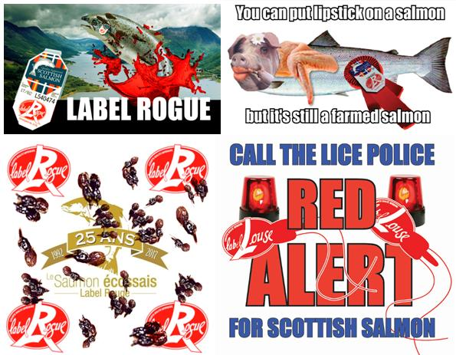
Read more via SSPO admit Label Rouge "is not a standard designed to assess environmental or animal welfare criteria"; "Concerns Over Label Rouge Salmon Certification" and "Red Alert for Label Rouge - Lousy Label Goes Rogue"
70) Scottish salmon was ranked the worst in the world by Seafood Watch in 2017:

Farmed salmon from Scotland is ranked as the world's worst - according to assessments by Seafood Watch in 2017 which recommended avoiding farmed salmon from Scotland, Norway, Chile and Atlantic Canada. The red ranking for Scottish farmed salmon - which scored a woeful 2.65 out of 10 - was attributed to poor performance in terms of chemicals, disease and escapes.

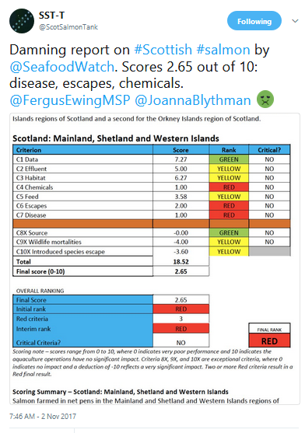

Read more via "Red Light for Scottish salmon: Scotland is ranked worst in the world"; The Sunday Times: "US report approves only Orkney salmon farms" and "Seafood Watch: Atlantic salmon - Scotland"

71) The use of antibiotics in salmon farming is increasing the risk of antibiotic resistance:
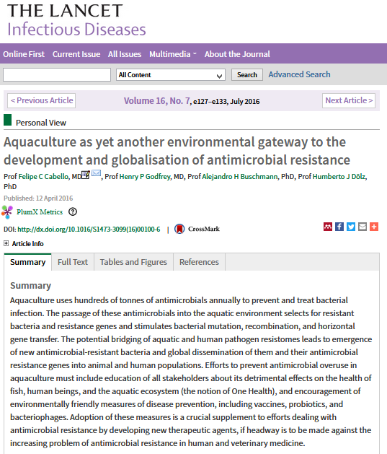

Read more via "Aquaculture as yet another environmental gateway to the development and globalisation of antimicrobial resistance"; "The Rising Tide of Antimicrobial Resistance in Aquaculture: Sources, Sinks and Solutions"; "Antibiotic resistance could spread through feed at fish farms"; "Salmon Aquaculture and Antimicrobial Resistance in the Marine Environment"; "Heavy use of prophylactic antibiotics in aquaculture: a growing problem for human and animal health and for the environment"; "How do third party certifications control the use of antibiotics in global salmon aquaculture?" and Antibiotic use in aquaculture: development of antibiotic resistance–potential for consumer health risks

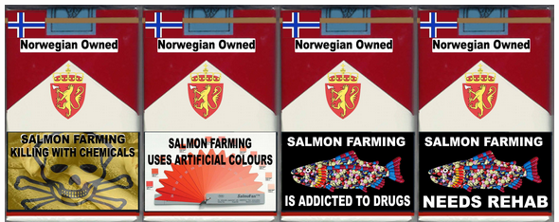
72) SEPA ditched plans in 2016 to ban a toxic pesticide following lobbying from the Scottish Government and the salmon farming industry:

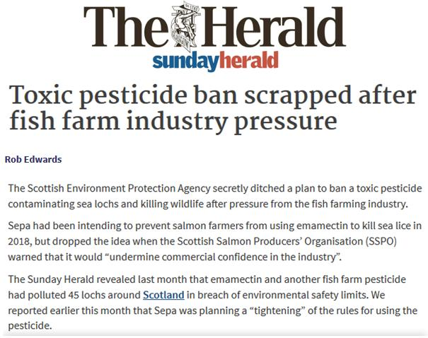

Read more via "Pesticide report suppressed after freedom of information warning"; "How the Scottish Government ‘nuanced’ away fish farm pesticide ban"; The Ferret: "Revealed: secret role of US drug company in fish farm pesticide row"; "Slicegate: Anatomy & Chronology of an Environmental Lobotomy"
73) The use of the toxic chemical Emamectin benzoate (SLICE) increased six-fold between 2002 and 2015:
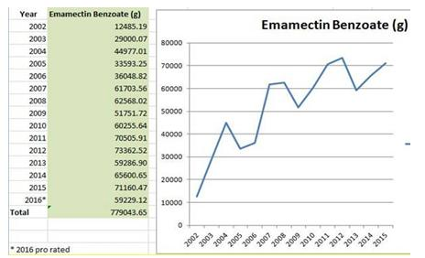
Read more via "Damning Report on Toxic Salmon Farms Buried - SEPA finally acts on lobster-killing chemical" ;"Crackdown on fish farm pesticides after Sunday Herald investigation" and "Toxic Toilets: Salmon Farms Pollute Scotland's Lochs"
74) Salmon farming is engaged in a 'chemicals arms race' with shellfish considered collateral damage in the industry's 'war on sea lice':

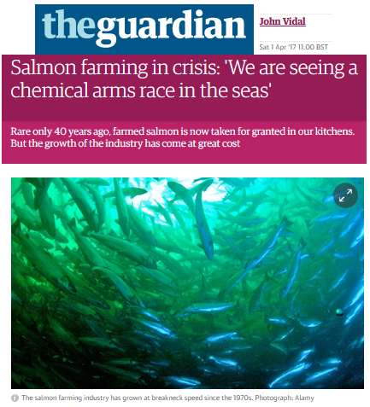

Read more via "Salmon farming in crisis: 'We are seeing a chemical arms race in the seas' "; "Salmon farming has done 'enormous harm' to fish and the environment warns Jeremy Paxman"; "The terrible cost of Scotland’s salmon farms"; "Salmon industry toxins soar by 1000 per cent"; "Scottish salmon farms pour chemicals on parasites" and "Scottish salmon farming revolution that has left the seas awash with toxic chemicals"

Lice are now becoming resistant to the toxic chemicals used on salmon farms leading to calls for immediate action.
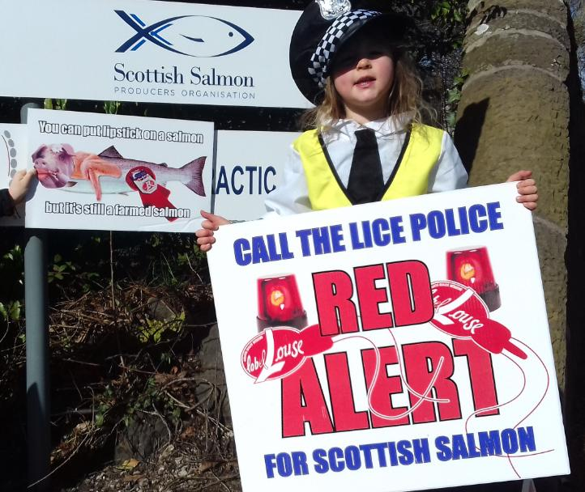
Read more via "Scientific Backgrounder: Ecotoxicity & Chemical Resistance" and The Courier: "Salmon farming protest at industry headquarters"
75) A scientific paper published by Nature in December 2017 "provides evidence for the first time that sea lice can override the protective effects of vaccination against a bacterial pathogen in Atlantic salmon, reducing the survival and growth of vaccinated fish and concomitantly increasing bacterial load and clinical signs of disease when compared to fish with a single infection":

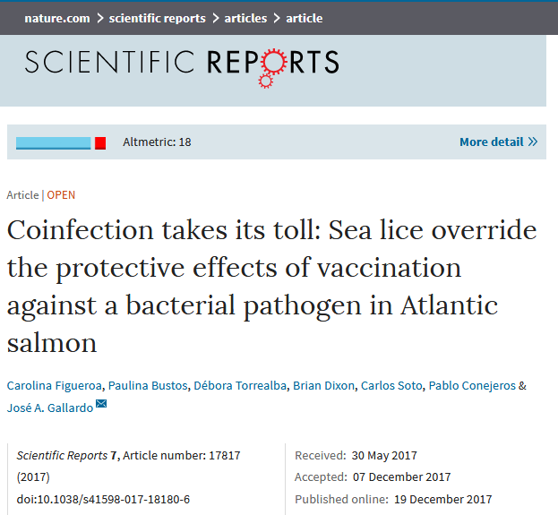

Read more via "Coinfection takes its toll: Sea lice override the protective effects of vaccination against a bacterial pathogen in Atlantic salmon"

76) In simple terms, sea lice infestation on salmon farms sucks life away:

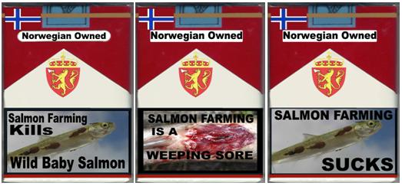

Read more via "Impacts of salmon lice emanating from salmon farms on wild Atlantic salmon and sea trout" and "Plagues of parasitic sea lice depleting world's salmon stocks"
77) Salmon farming drains our global oceans of wild fish for feed - leading to a net loss of marine protein:

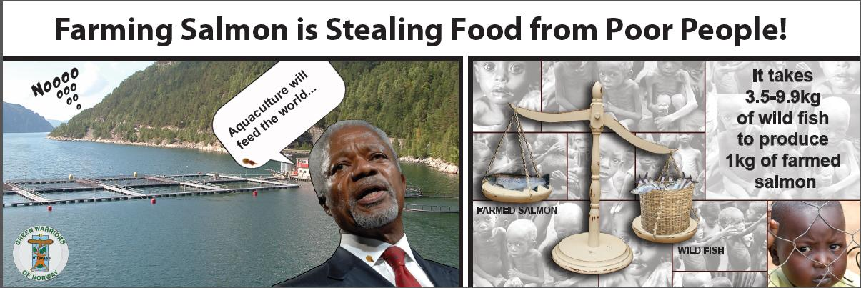

More details via "Farming Salmon is Stealing Food from Poor People & Our Oceans"; "Letter to Kofi Annan"; "The Greed of Feed – the hidden cost of your cheap farmed salmon"; "Greed of Feed: what's feeding our cheap farmed salmon?" and "Hugh Fearnley-Whittingstall tackles farmed salmon feed controversy"

According to Dr. Daniel Pauly of the University of British Columbia, salmon farming "robs Peter to pay Paul" stealing precious protein away from hungry people in Latin America and Africa:
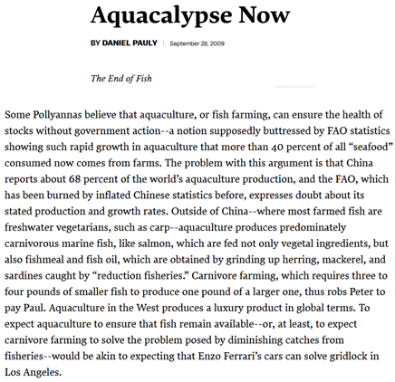

Read more via "Aquacalypse Now"; "Fish As Food: A Love Affair, Issues Included"; "Feed Matters: Satisfying the Feed Demand of Aquaculture"; "Fishing for Aquaculture: Non-Food
Use of Small Pelagic Forage Fish - A Global Perspective" and "Fish Matters: Importance of Aquatic Foods in Human Nutrition and Global Food Supply"
78) SEPA stopped collecting data on the numbers of dead farmed salmon following lobbying from the SSPO in 2013 who claimed publication would be "commercially damaging":
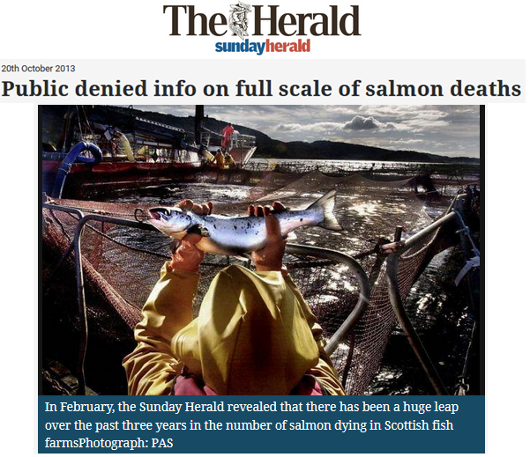
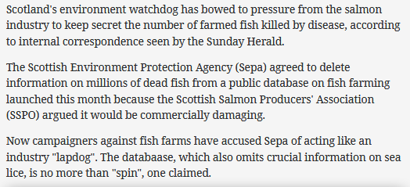

Read more via "Scottish watchdog labelled ‘lapdog’ after agreeing to keep fish farm deaths secret"; "Public denied info on full scale of salmon deaths"; "Environment watchdog ‘gave in to industry’ over dead salmon"; "Farmed salmon killed by disease leaps to 8.5 million"; "Fish farmers 'blocked' vital safety study"; "Salmon firms 'hiding damning reports'" and "Keeping salmon farming problems secret"

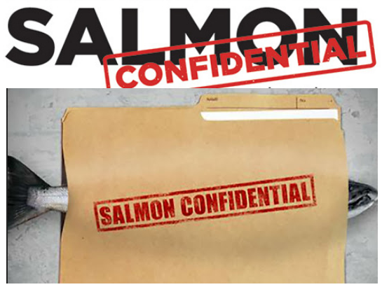
79) Salmon farmers in Shetland were charged with animal cruelty after poisoning more than 6,000 farmed salmon with toxic chemicals (the same farm subsequently faced legal action for trapping and killing seals):

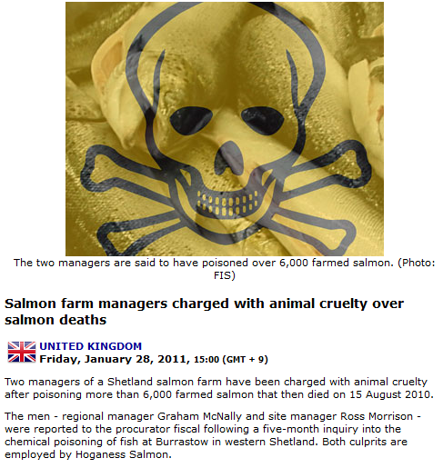

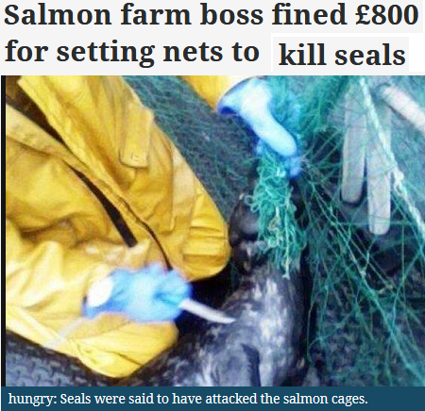

Read more via "Cruelty charges over Shetland salmon farm deaths"; "Salmon farm managers charged with animal cruelty over salmon deaths"; "Hoganess Salmon managers face new charges"; "Salmon farm managers suspended"; "Salmon farm boss had seal-trap nets - manager fined after Scottish SPCA raid"; "Ex salmon manager fined over seal nets" and "Salmon farm boss fined £800 for setting nets to kill seals"

80) The Scottish Salmon Think Tank asks you to take a moment to think about the problems of salmon farming in Scotland:

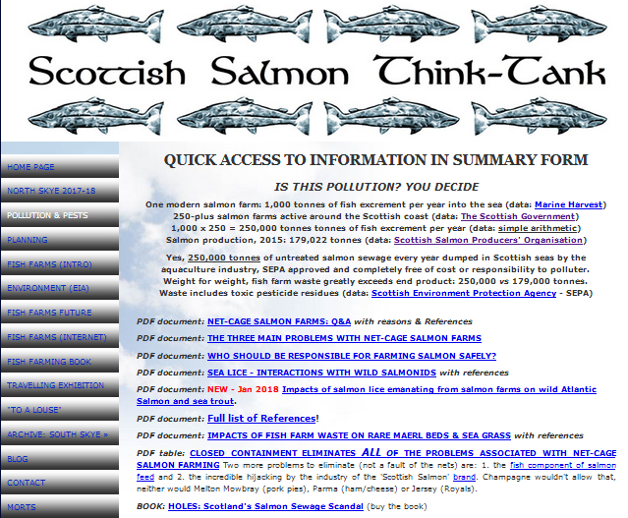

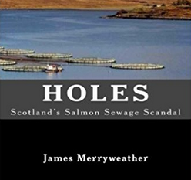

Read more via "Scottish Salmon Think Tank"
81) Farmed salmon is fattier than pizza...................
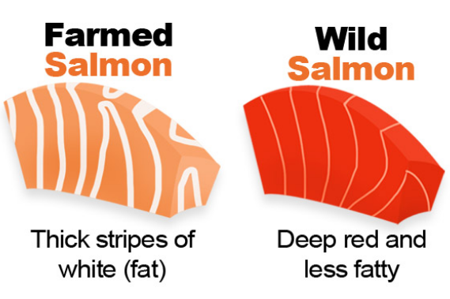

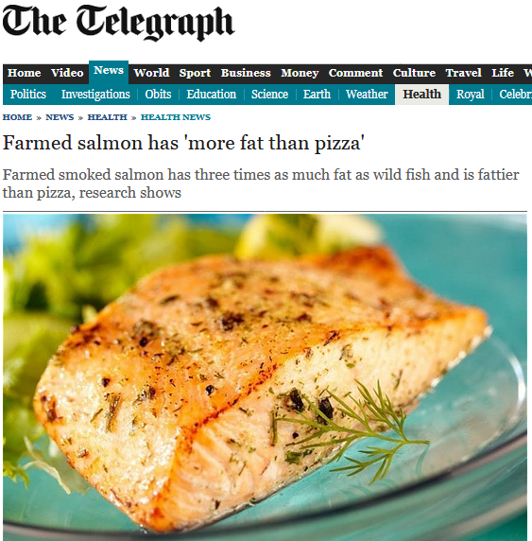

Read more via Farmed salmon has 'more fat than pizza'; "Smoked salmon could be worse for you than a margherita pizza because of high fat content" and Picture of what farmed salmon vs wild salmon sashimi looks like. Know which you're eating!

...........and a world removed from natural wild salmon:
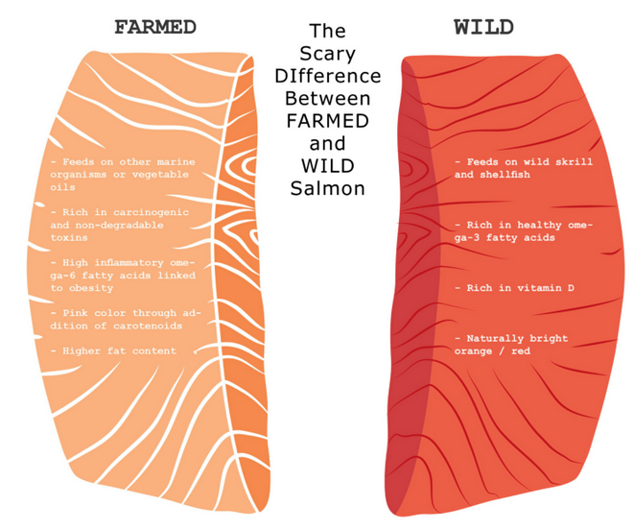
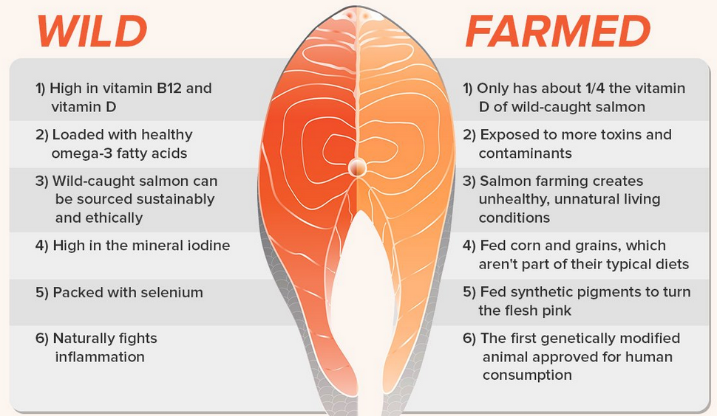

Read more via "Farmed Vs Wild Salmon"; "The Scottish Salmon Scam: complaints filed with Trading Standards and the Competition & Markets Authority"; "Appendix 1: The Scottish Salmon Scam"; "Supermarkets sell Norwegian fish as ‘Scots’ salmon"
82) Farmed salmon contains higher levels of cancer-causing dioxins and dioxin-like PCBs than other foods:

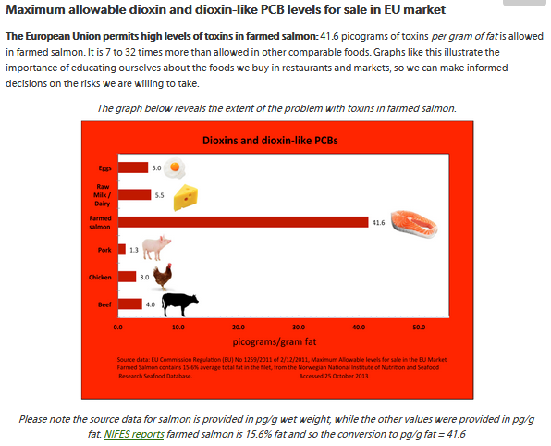

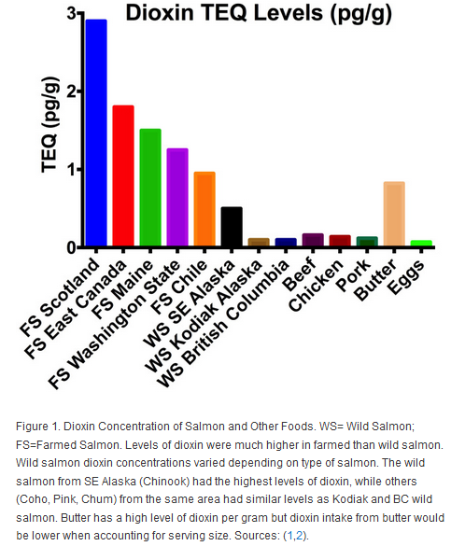

Read more via "What's in farmed salmon"; "A Threat to Your Child's Health"; "Dioxin in Salmon Presents Serious Health Concerns" and "Global Assessment of Organic Contaminants in Farmed Salmon"

83) Salmon farming has impacted Scotland's marine environment and wild fisheries since the rapid expansion of salmon farms in the 1980s:

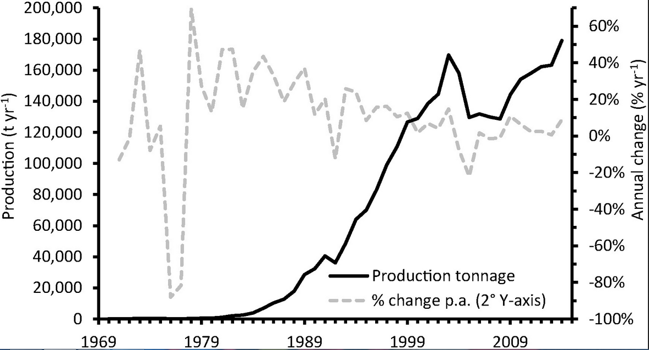

Read more via: "Self-pollution by Scottish salmon farms?" (1989); "Nuvan use in salmon farming The antithesis of the precautionary principle" (1989); "Marine Salmon Farming In Scotland: A Review" (1990); "Leaping in the Dark – A Review of the Environmental Impacts of Marine Salmon Farming in Scotland and Proposals for Change" (1997); "Scotland’s Secret – Aquaculture, Nutrient Pollution, Eutrophication and Toxic Blooms" (2000); "The One That Got Away – Marine Salmon Farming In Scotland" (2001); "Bitter Harvest: a call for reform in Scottish aquaculture" (2001); "Sea cage fish farming: an evaluation of environmental and public health aspects (the five fundamental flaws of sea cage fish farming)" (2002); "Assessing and managing the impacts of marine salmon farms on wild Atlantic salmon in western Scotland: identifying priority rivers for conservation" (2003); "Scottish Farmed Salmon Exposed" (2007); "Scottish salmon farming under attack in new film"; "Aquaculture Information Pack" (2013); "25 Years of Scottish Salmon Shame" (2017) and "Media Backgrounder: Scotland's Silent Spring of the Sea" (2017)

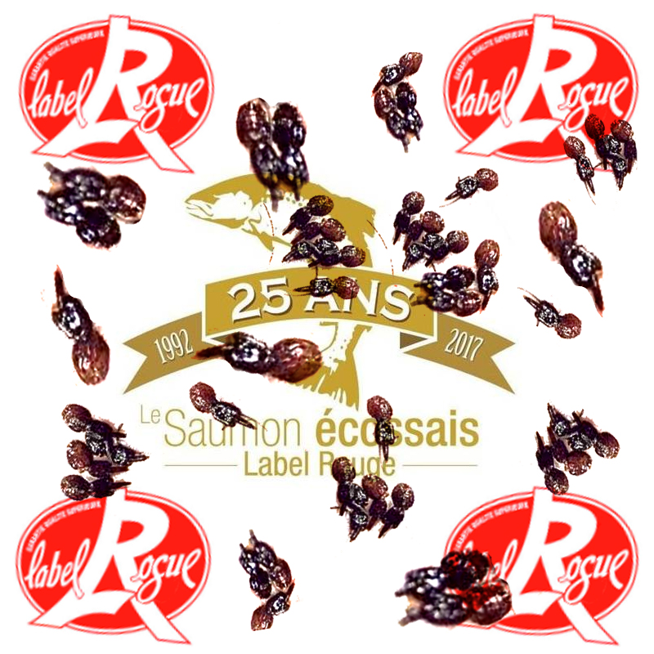
84) Farmed salmon are deaf due to accelerated growth:

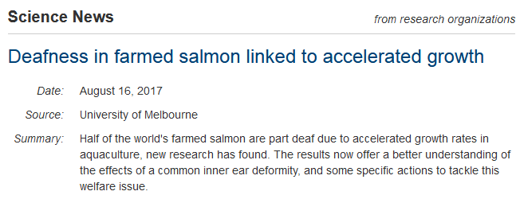
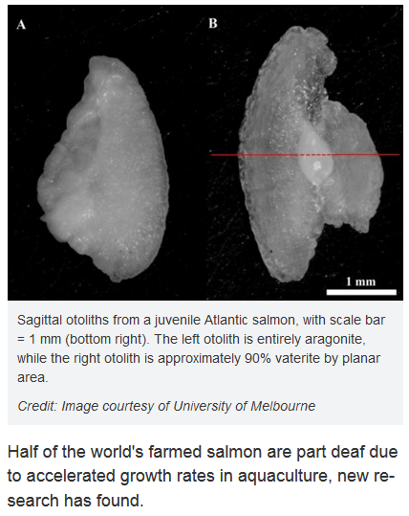

Read more via "Deafness in farmed salmon linked to accelerated growth"; "More than 95 per cent of adult farmed fish are deformed" and "We're Farming Our Salmon to Deaf"

85) Insect-fed Scottish salmon is set to make your flesh creep:

In the desperate search for alternative feed supplies the industry is looking towards insect feeds - but will farmed salmon fed on cockroaches or maggots fly with UK consumers?

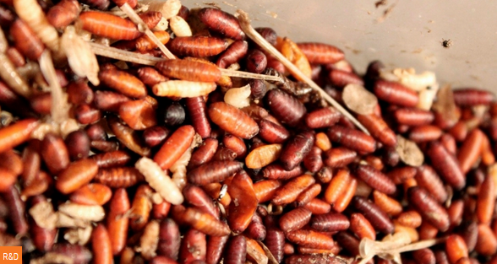

Read more via: "The feasibility of using insects in salmon feed in Scotland"; "Insect meal in salmon feeds"; "Start-up receives funds for salmon insect feed"; "Aquafeed fly farmer creates a buzz in business" and "Attitudes towards the use of insect-derived materials in Scottish salmon feeds"

86) The increasing use of vegetable protein in salmon feed is compromising fish health and flesh quality:

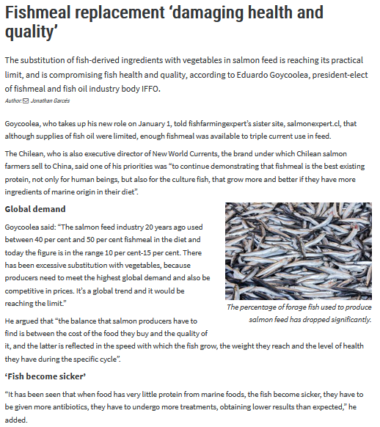

Read more via: "Fishmeal replacement ‘damaging health and quality’"; "Fisheries challenged by rising cost of fish oil in feed"; "Scottish Salmon to get sustainable wheat feed" and "Impact of sustainable feeds on omega-3 long-chain fatty acid levels in farmed Atlantic salmon, 2006–2015"
87) Despite trials of genetically engineered salmon in Loch Fyne in the 1990s the industry claims to oppose genetic engineering and thus far "there is no GM food used to farm Scottish salmon" - but the switch to GM feed "is seen as most likely happening by 2020" according to a report by scientists at the University of Stirling:

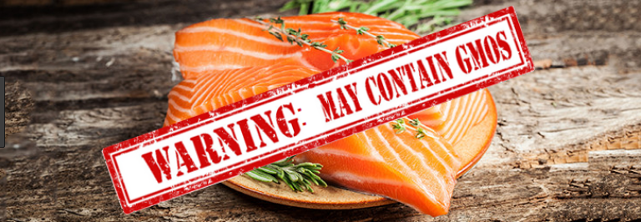

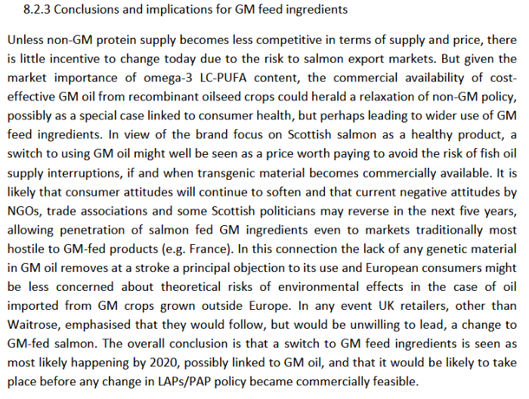

Read more via "Fish farmers told 'reject GM salmon'"; "Giant GM salmon on the way"; "GM salmon prompts safety pledge"; "Monster scare for fish farmers"; "GM fish fail to hook Scottish salmon farmers"; "Q&A on Omega 3 levels in Farmed Salmon"; "GM crop ban: how Scottish salmon – and public health – could have benefited from this technology"; "Genetically engineered salmon goes on sale for the first time" and "SARF: Production of high quality healthy farmed salmon from a changing raw material base with special reference to a sustainable Scottish industry"
88) Salmon feed contains Ethotoxyquin - a flame retardant manufactured by Monsanto which is "very toxic to aquatic life" and has been linked to cancer of the stomach, kidneys, bladder and colon:

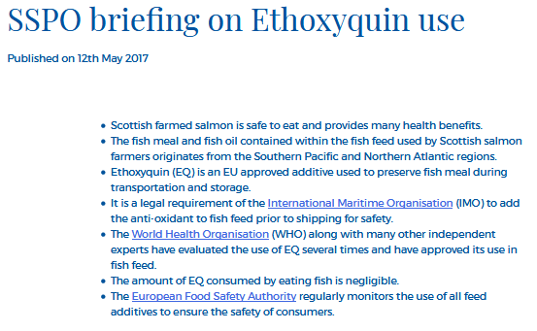
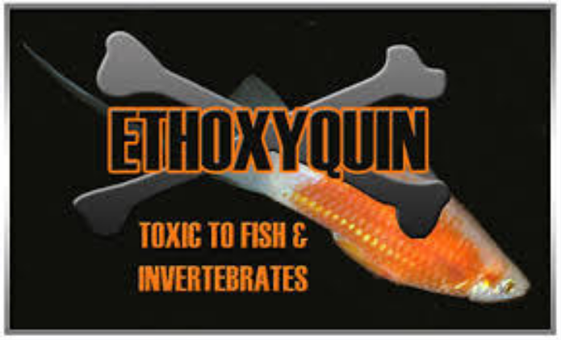

Read more via "SSPO briefing on Ethoxyquin use"; "Ethoxyquin as anti-oxidant in fishmeal and fish feeds - Facts"; "How healthy is farmed salmon and what is ethoxyquin?"; "Levels of synthetic antioxidants (ethoxyquin, butylated hydroxytoluene and butylated hydroxyanisole) in fish feed and commercially farmed fish"; "European Parliament: Health risk from Norwegian farmed salmon"; "Ethotoxyquin in fish feed"; "Ethoxyquin in Salmon"; "IFFO on Ethotoxyquin"; "Ethoxyquin — toxicity, side effects, diseases and environmental impacts"; "DNA damage induced by ethoxyquin in human peripheral lymphocytes"; "Ethoxyquin, The Silent Killer Hiding In Your Fish Food"; "Green Warriors of Norway: Ethotoxyquin" and "Hepatic metabolism, phase I and II biotransformation enzymes in Atlantic salmon (Salmo Salar, L) during a 12 week feeding period with graded levels of the synthetic antioxidant, ethoxyquin"
89) Farmed salmon feed contains artificial colourings such as Canthaxanthin (E161g) which has been linked to eye defects:

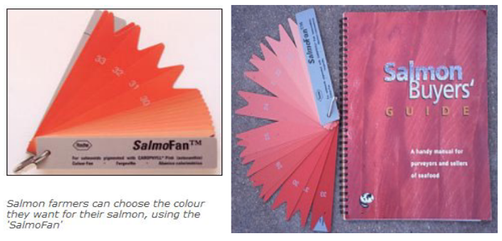

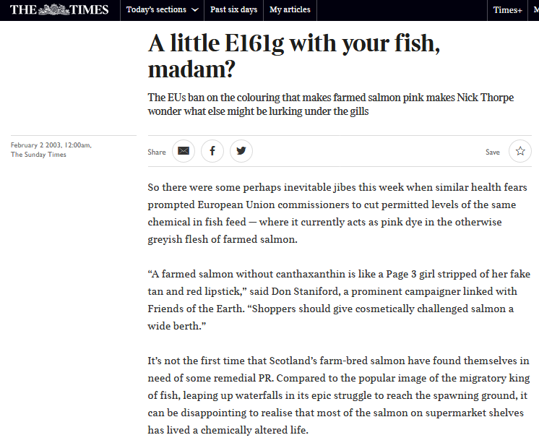

Read more via "Ugly In Pink: Cosmetically Challenged Farmed Salmon"; "Pink Poison"; "Salmon pink becomes a grey area for EU"; "Silent Spring of the Sea"; "A little E161g with your fish, madam?"
90) Salmon farming is an environmnetal and public health disaster and should carry a Government health warning like cigarettes - rather than promted by the Government as a healthy and nutritious product:
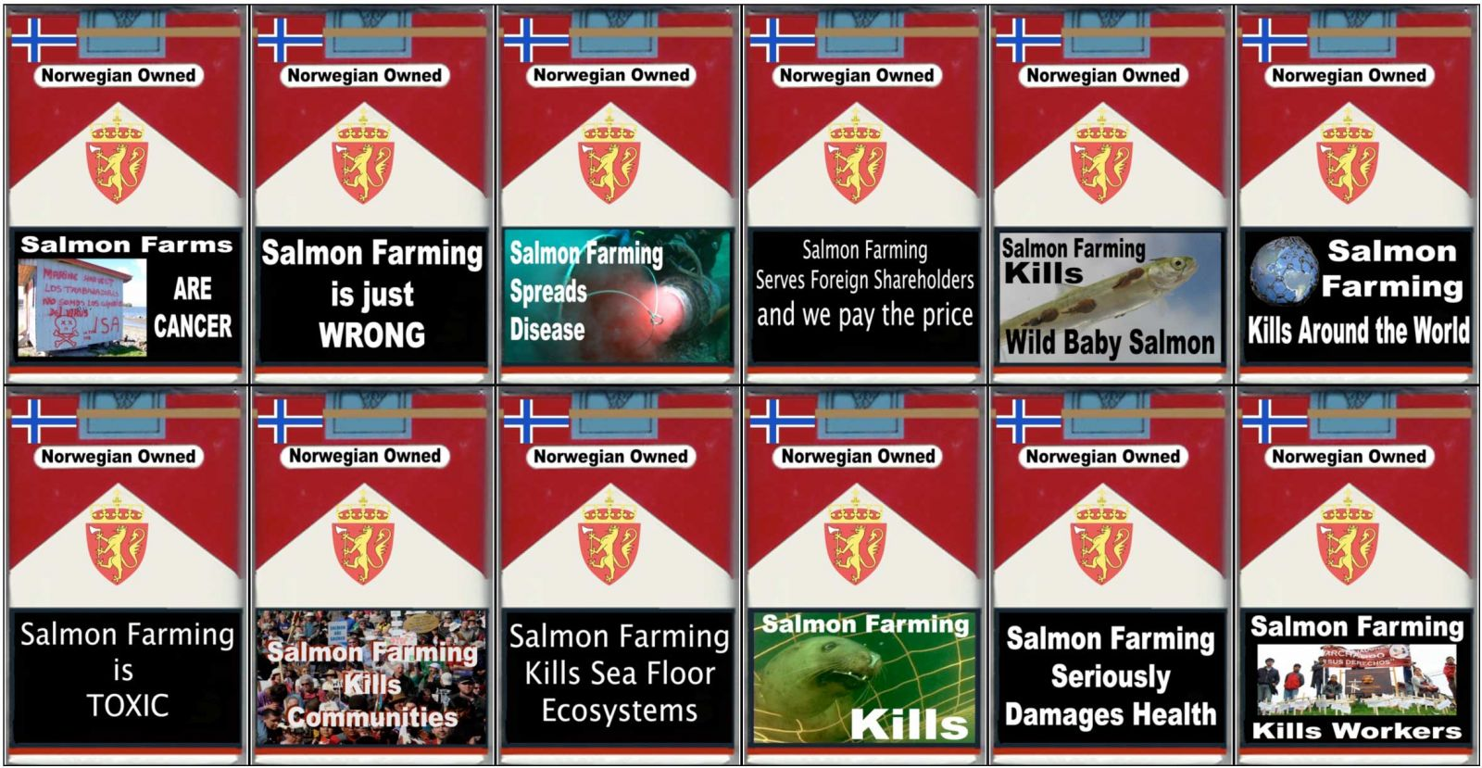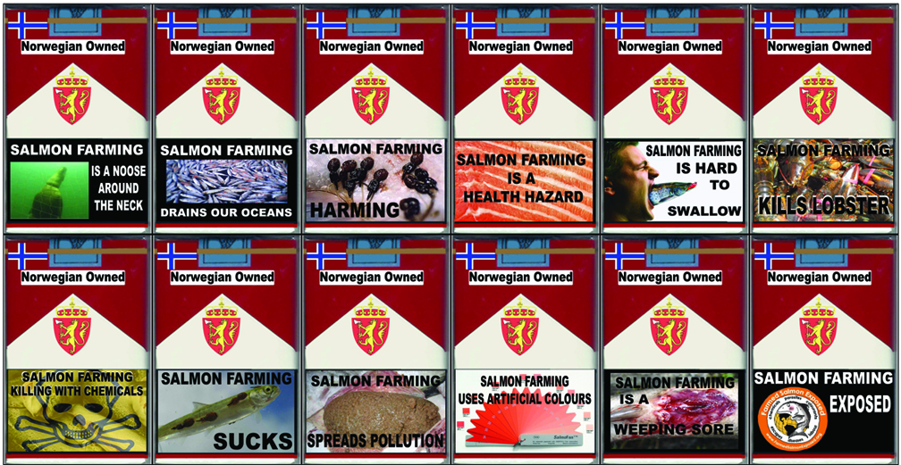
Read more via "Salmon farming kills"; "Silent Spring of the Sea"; "A Big Fish in a Small Pond"; "The Five Fundamental Flaws of Sea Cage Fish Farming"; "Scottish Farmed Salmon Exposed"; "Everything You Should Know About Salmon Farming"; "Sea Cage Fish Farming: an evaluation of environmental and public health aspects"
91) Tesco was caught out selling Norwegian farmed salmon as '100% Scottish'

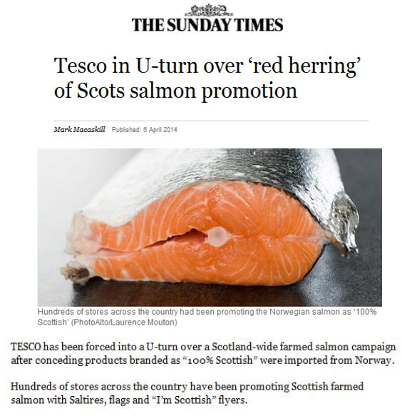
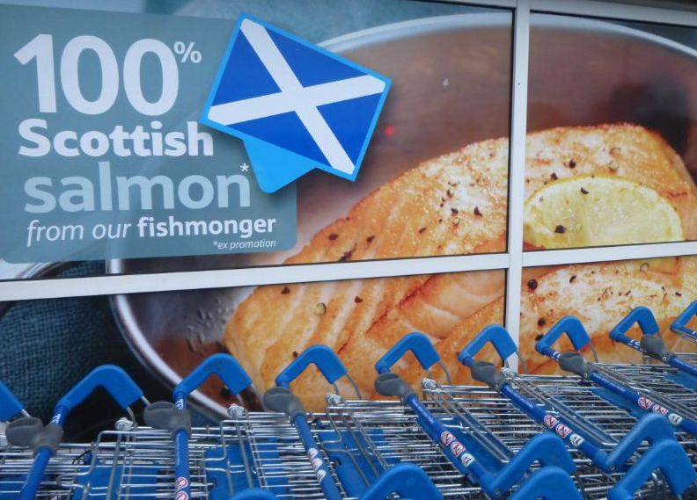

Read more via "Tesco's 'Scottish' Salmon Scam Exposed!"; "Tesco in U-turn over 'red herring' of Scots salmon promotion"; "Tesco blames wrong signage for salmon marketed as Scottish" and "Tesco forced to axe marketing campaign after it emerged salmon labelled '100% Scottish' was imported from Norway"
If only retailers were honest when marketing farmed salmon............

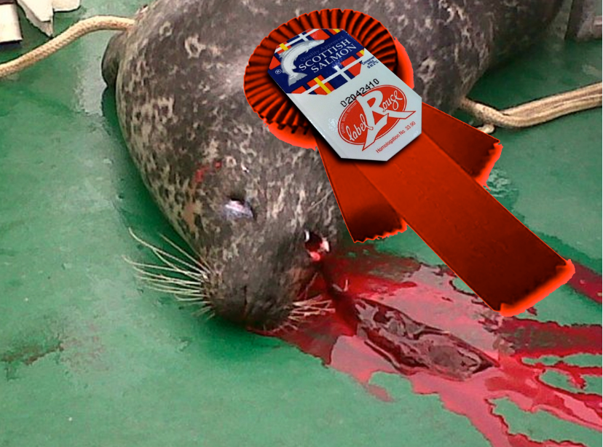
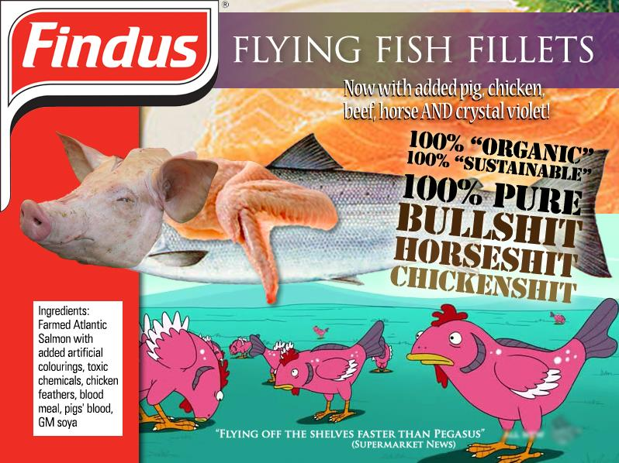
92) Norway is a sharing, generous and giving nation - infectious diseases such as Infectious Salmon Anaemia have been introduced to Scotland by Norwegian companies:

The first outbreak of Infectious Salmon Anaemia (ISA) was traced to Norwegian-owned Hydro Seafoods (now Scottish Sea Farms) in Loch Nevis in 1998 and spread to a total of 11 salmon farms with a further 34 salmon farms suspected on the Scottish west coast mainland, Skye, Orkney, Shetland and the Western Isles. The first ISA outbreak cost £100 million and led to the loss of 200 jobs.

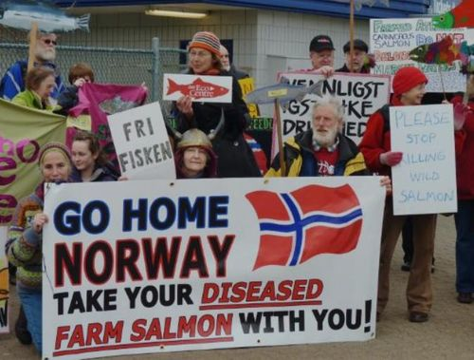

A suspected outbreak of ISA was reported at a farm operated by Norwegian-owned Marine Harvest in Loch Sheilavaig, South Uist, in 2004. A second confirmed outbreak of ISA in Scotland occurred in Shetland in 2009 at Norwegian-owned Grieg Seafood wiping out £20 million in value.

Read more via "Engulfed by a deadly tide"; "Report details disease links"; "Lethal fish infection spreads"; "Suspected ISA outbreak in Scotland"; Report into the epidemiology and control of an outbreak of infectious salmon anaemia in the Shetland Islands, Scotland"; "Fish virus detected at third farm"; "Disease costs Grieg dearly"; "Fourth ISA case"; "Deadly salmon infection detected"; "ISA back to haunt fish farmers"; "Norwegians concede a role in Chilean salmon virus"; "ISA - Diary of Disease Disaster" and "Fish Farmageddon: The Infectious Salmon Aquacalypse"
93) Waste pollution from salmon farms has been linked to eutrophication, hypernutrification and toxic algal blooms - with Scottish salmon farms discharging more sewage wastes than Scotland's population of 5.4 million:

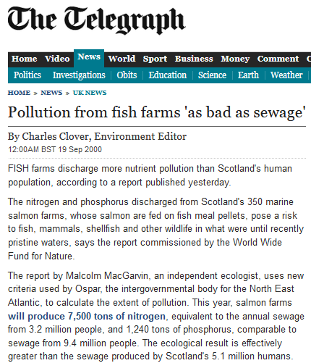

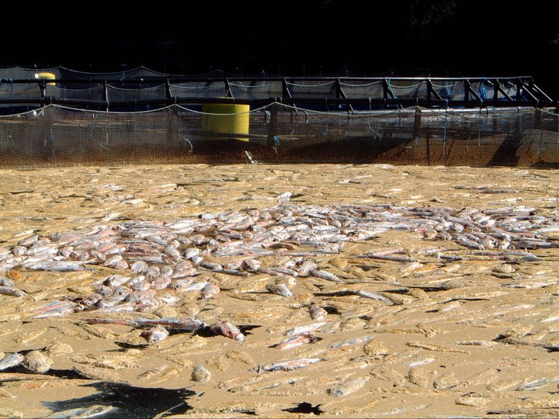

Read more via "The Interactions Between Fish Farming and the Algal Communities of Scottish Waters: A Review"; "Harmful Algal Bloom Communities in Scottish Coastal Waters: Relationship to Fish Farming and Regional Comparisons – A Review"; "Impact of salmonid pen aquaculture on hard substrates"; "Pollution from fish farms 'as bad as sewage'"; "Poison blamed on fish farms; Expert critical of officials" and "Scotland's Secret: Aquaculture, Nutrient Pollution, Eutrophication and Toxic Blooms"

94) Mass mortalities from salmon farms are piling up so high that their carcasses are used to generate electricity:

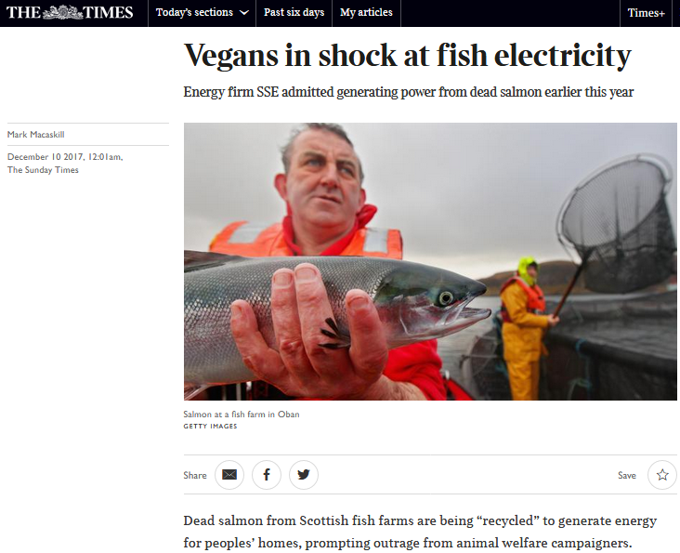

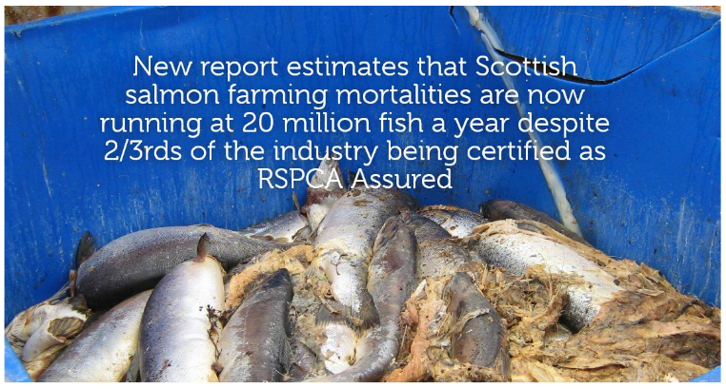

Read more via "Vegans in shock at fish electricity"; "Energy from dead salmon horrifies vegan activists" and "Millions of Scottish Salmon Going Up in Smoke"
95) Sea trout (as well as wild salmon) have been devastated by Scottish salmon farms:

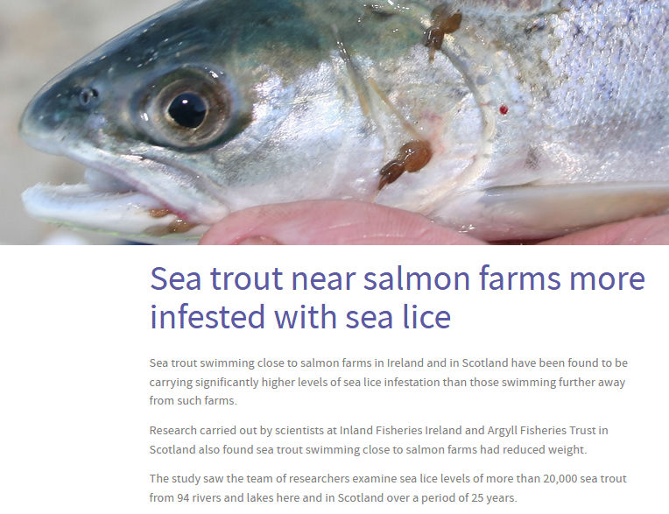
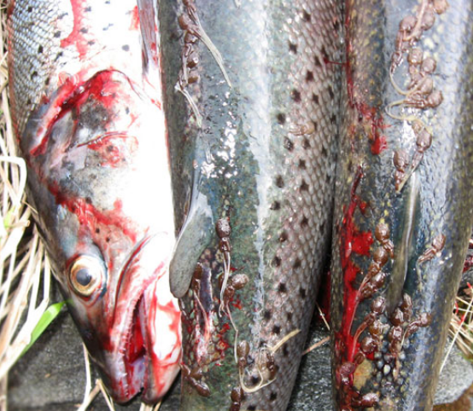

Read more via "Sea trout near salmon farms more infested with sea lice"; "New research finds salmon farming contributes to sea lice infestation on sea trout as valuable stocks decline"; "New study finds that sea lice from salmon farms can cause a 50% reduction in runs of wild Atlantic salmon"; "Assessing and Managing the Impacts of Marine Salmon Farms on Wild Atlantic Salmon in Western Scotland: Identifying Priority Rivers for Conservation"; "Summary of information relating to impacts of salmon lice from fish farms on wild Scottish sea trout and salmon"; "Aquaculture and environmental drivers of salmon lice infestation and body condition in sea trout" and "Effects of salmon lice Lepeophtheirus salmonis on wild sea trout Salmo trutta - a literature review"
96) A humpback whale died in a salmon farm operated by Scottish Sea Farms in the Sound of Mull:

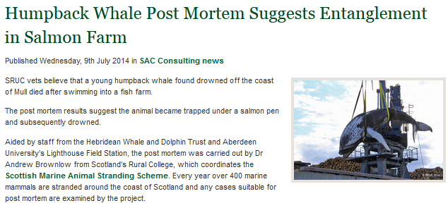
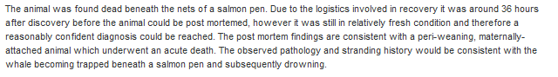

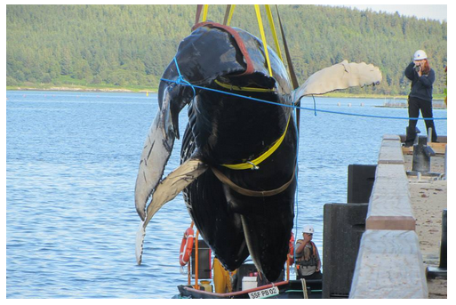

Read more via "Salmon Farming Kills Whales!"; "Humpback Whale Post Mortem Suggests Entanglement in Salmon Farm"; "Humpback Whale died after swimming into fish farm" and "Whale drowned after being trapped under salmon pen"
97) The King of Fish is being "farmed to death":



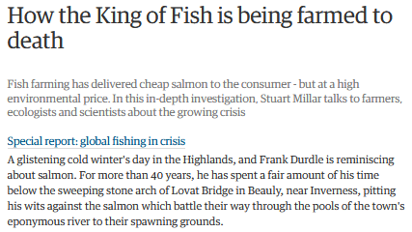
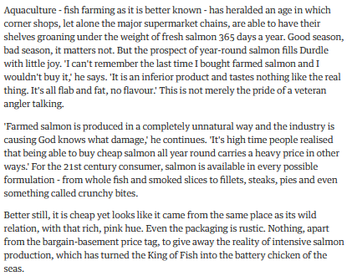
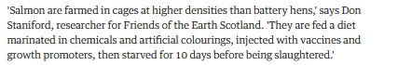
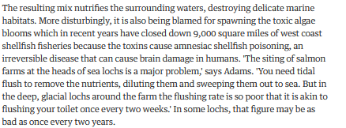

Read more via "How the King of Fish is being farmed to death"
98) The use of 'cleaner-fish' is impacting on wild fish populations and increasing disease risks:

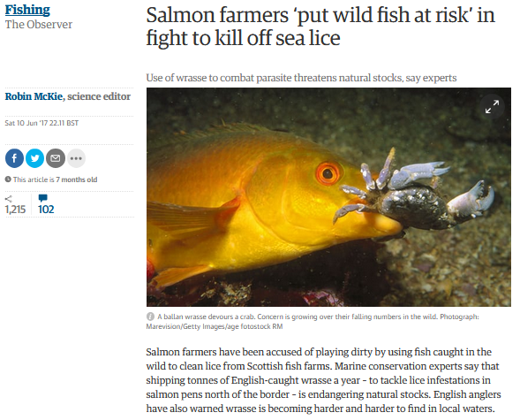

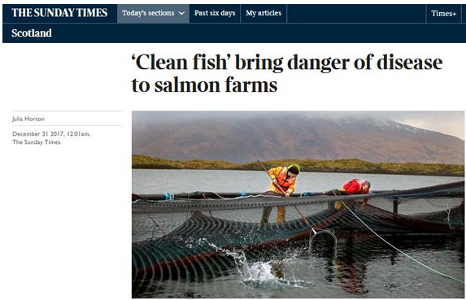

Read more via "Salmon farmers ‘put wild fish at risk’ in fight to kill off sea lice"; "Cleaner fish that keep farmed salmon healthy at risk of wipe-out" and Sunday Times: "‘Clean fish’ bring danger of disease to salmon farms"
99) The only truly 'green' thing about Scottish salmon is radioactive contamination:

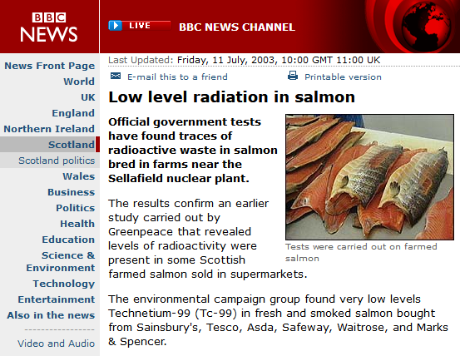

Read more via "Low level radiation in salmon"; "Tests reveal radioactive waste in Scottish salmon"; "Radioactive waste found in supermarket salmon"; "Radioactive waste 'found in salmon'"; "Anger over fish radiation find" and "Sellafield waste in salmon is 'no risk to consumers'"

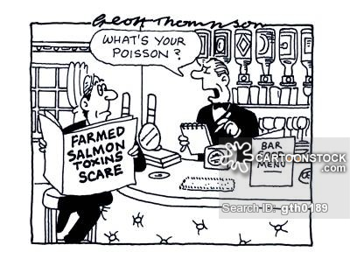
100) The scandal of Scottish salmon farming warrants front-page news coverage:

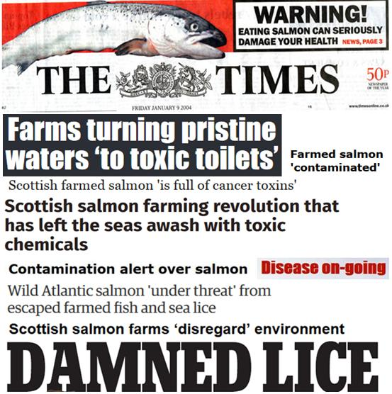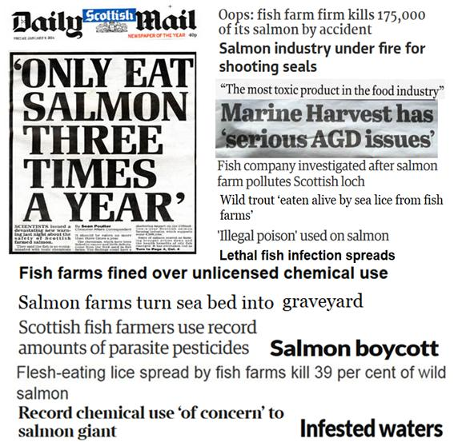

Read more via "25 Years of Scottish Salmon Shame"; "Spinning Scottish Salmon: We Live in Shameless Times" and "Spinning Farmed Salmon"
101) "Sustainable" and "responsible" do not even belong in the same sentence as Scottish salmon:

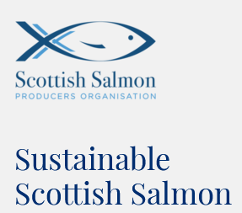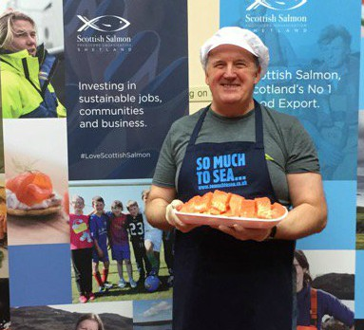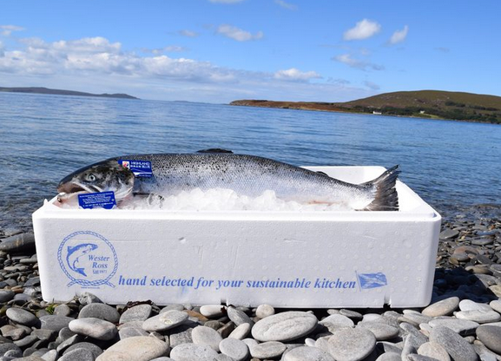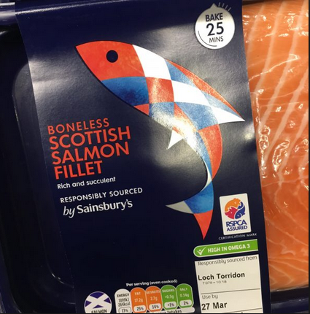
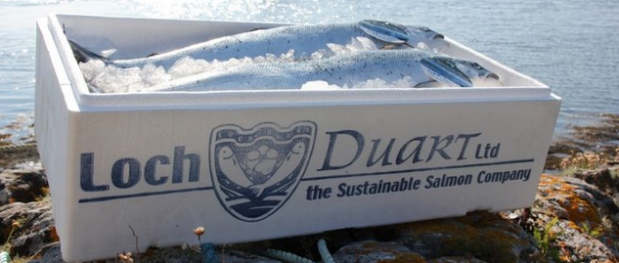

Read more via "Sustainable Scottish Salmon"; "Scottish Salmon Farming: A Sustainable Industry"; "Scottish Salmon's Sustainability Scam"; "Unbridled expansion of fish farms is not sustainable" and "25 Reasons to Boycott Scottish Salmon"
