BLAR mHOR OPERATIONS  STANDARD OPERATING PROCEDURE(SOP) |  |  | 
Title |  |  |  | Version Number
OPERATIONS-SOP-YARD-HARVEST BIN PREPARATION |  |  |  | 8
Revised or amended date | 01/08/2022 | Next revision date |  | 01/08/2023
The instruction within this document is a guide only and should be an accompaniment to practical training
This document shall only be amended by designated persons on the authorisation of the Processing Departmental Manager

Purpose: To ensure that all bins and lids are in a clean condition and free from damage. Aby upewnić się, że wszystkie pojemniki oraz pokrywki są czyste oraz nie posiadają żadnych uszkodzeń.
Responsibility: Yard Staff Pracownicy yardu
Yard Supervisor Kierownik yardu
Health and Safety: Risk Assessment RA Ocena Ryzyka RA
References: Packaging Storage
Harvest Bin Cleaning and Storage
Preparation of Disinfectant 2% Solution

Approved Chemicals Used & Dilution |  |  |  | Equipment | Comments
Product | Use/Dosage % | Symbol | Hazard | Equipment | Comments
Steriklenz 5 | 2% |  | 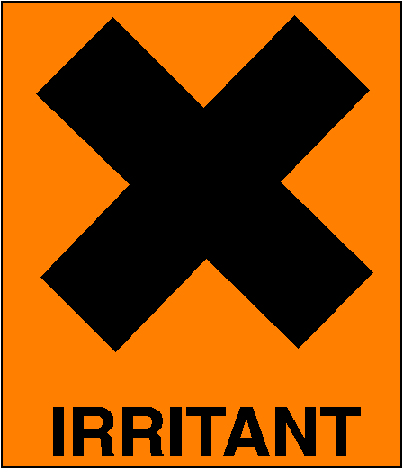 | Pressure Washer | Used to spray required surfaces. Używac do spryskiwania wymaganych powierzchni.  Used to sanitizing recirculation system. Używac do dezynfekcji system do recyrkulacji.

PPE Required
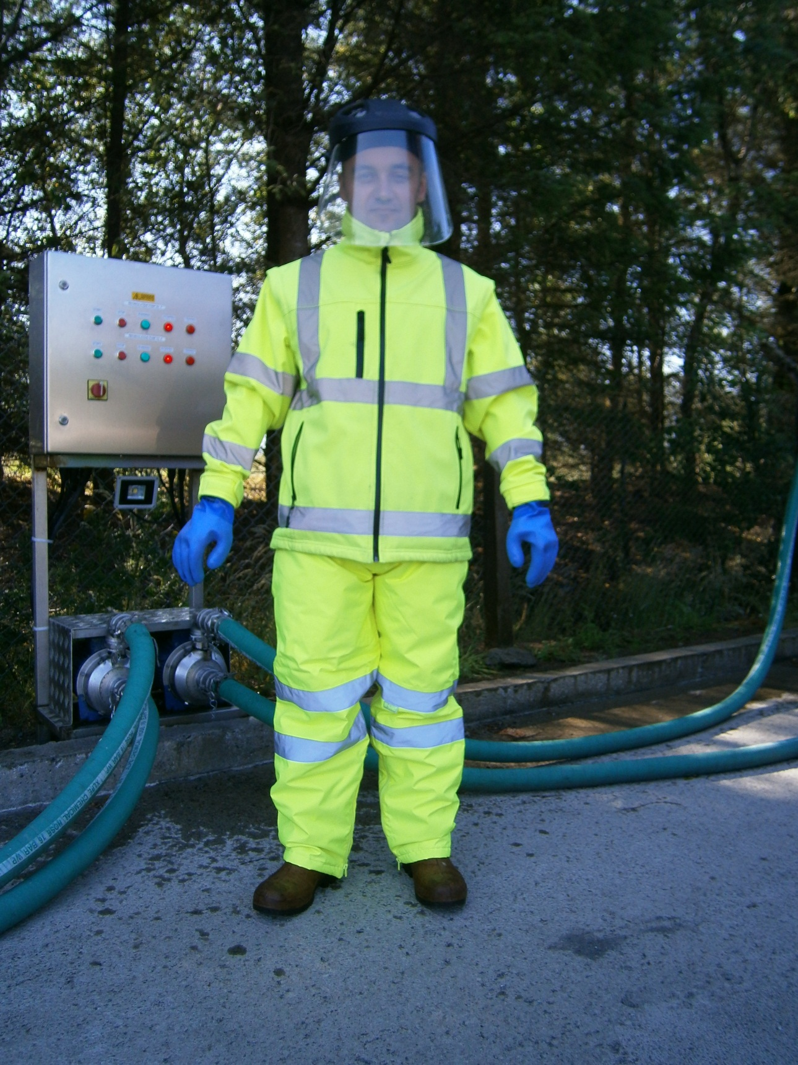
VISOR, GOGGLES
(when working with chemicals)
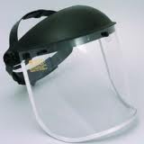

SAFETY BOOTS
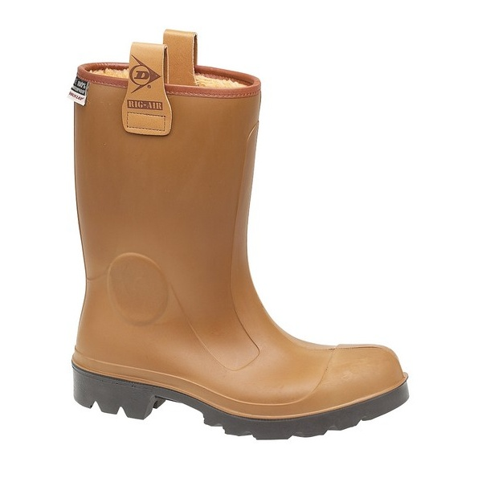

PROTECTIVE CLOTHING
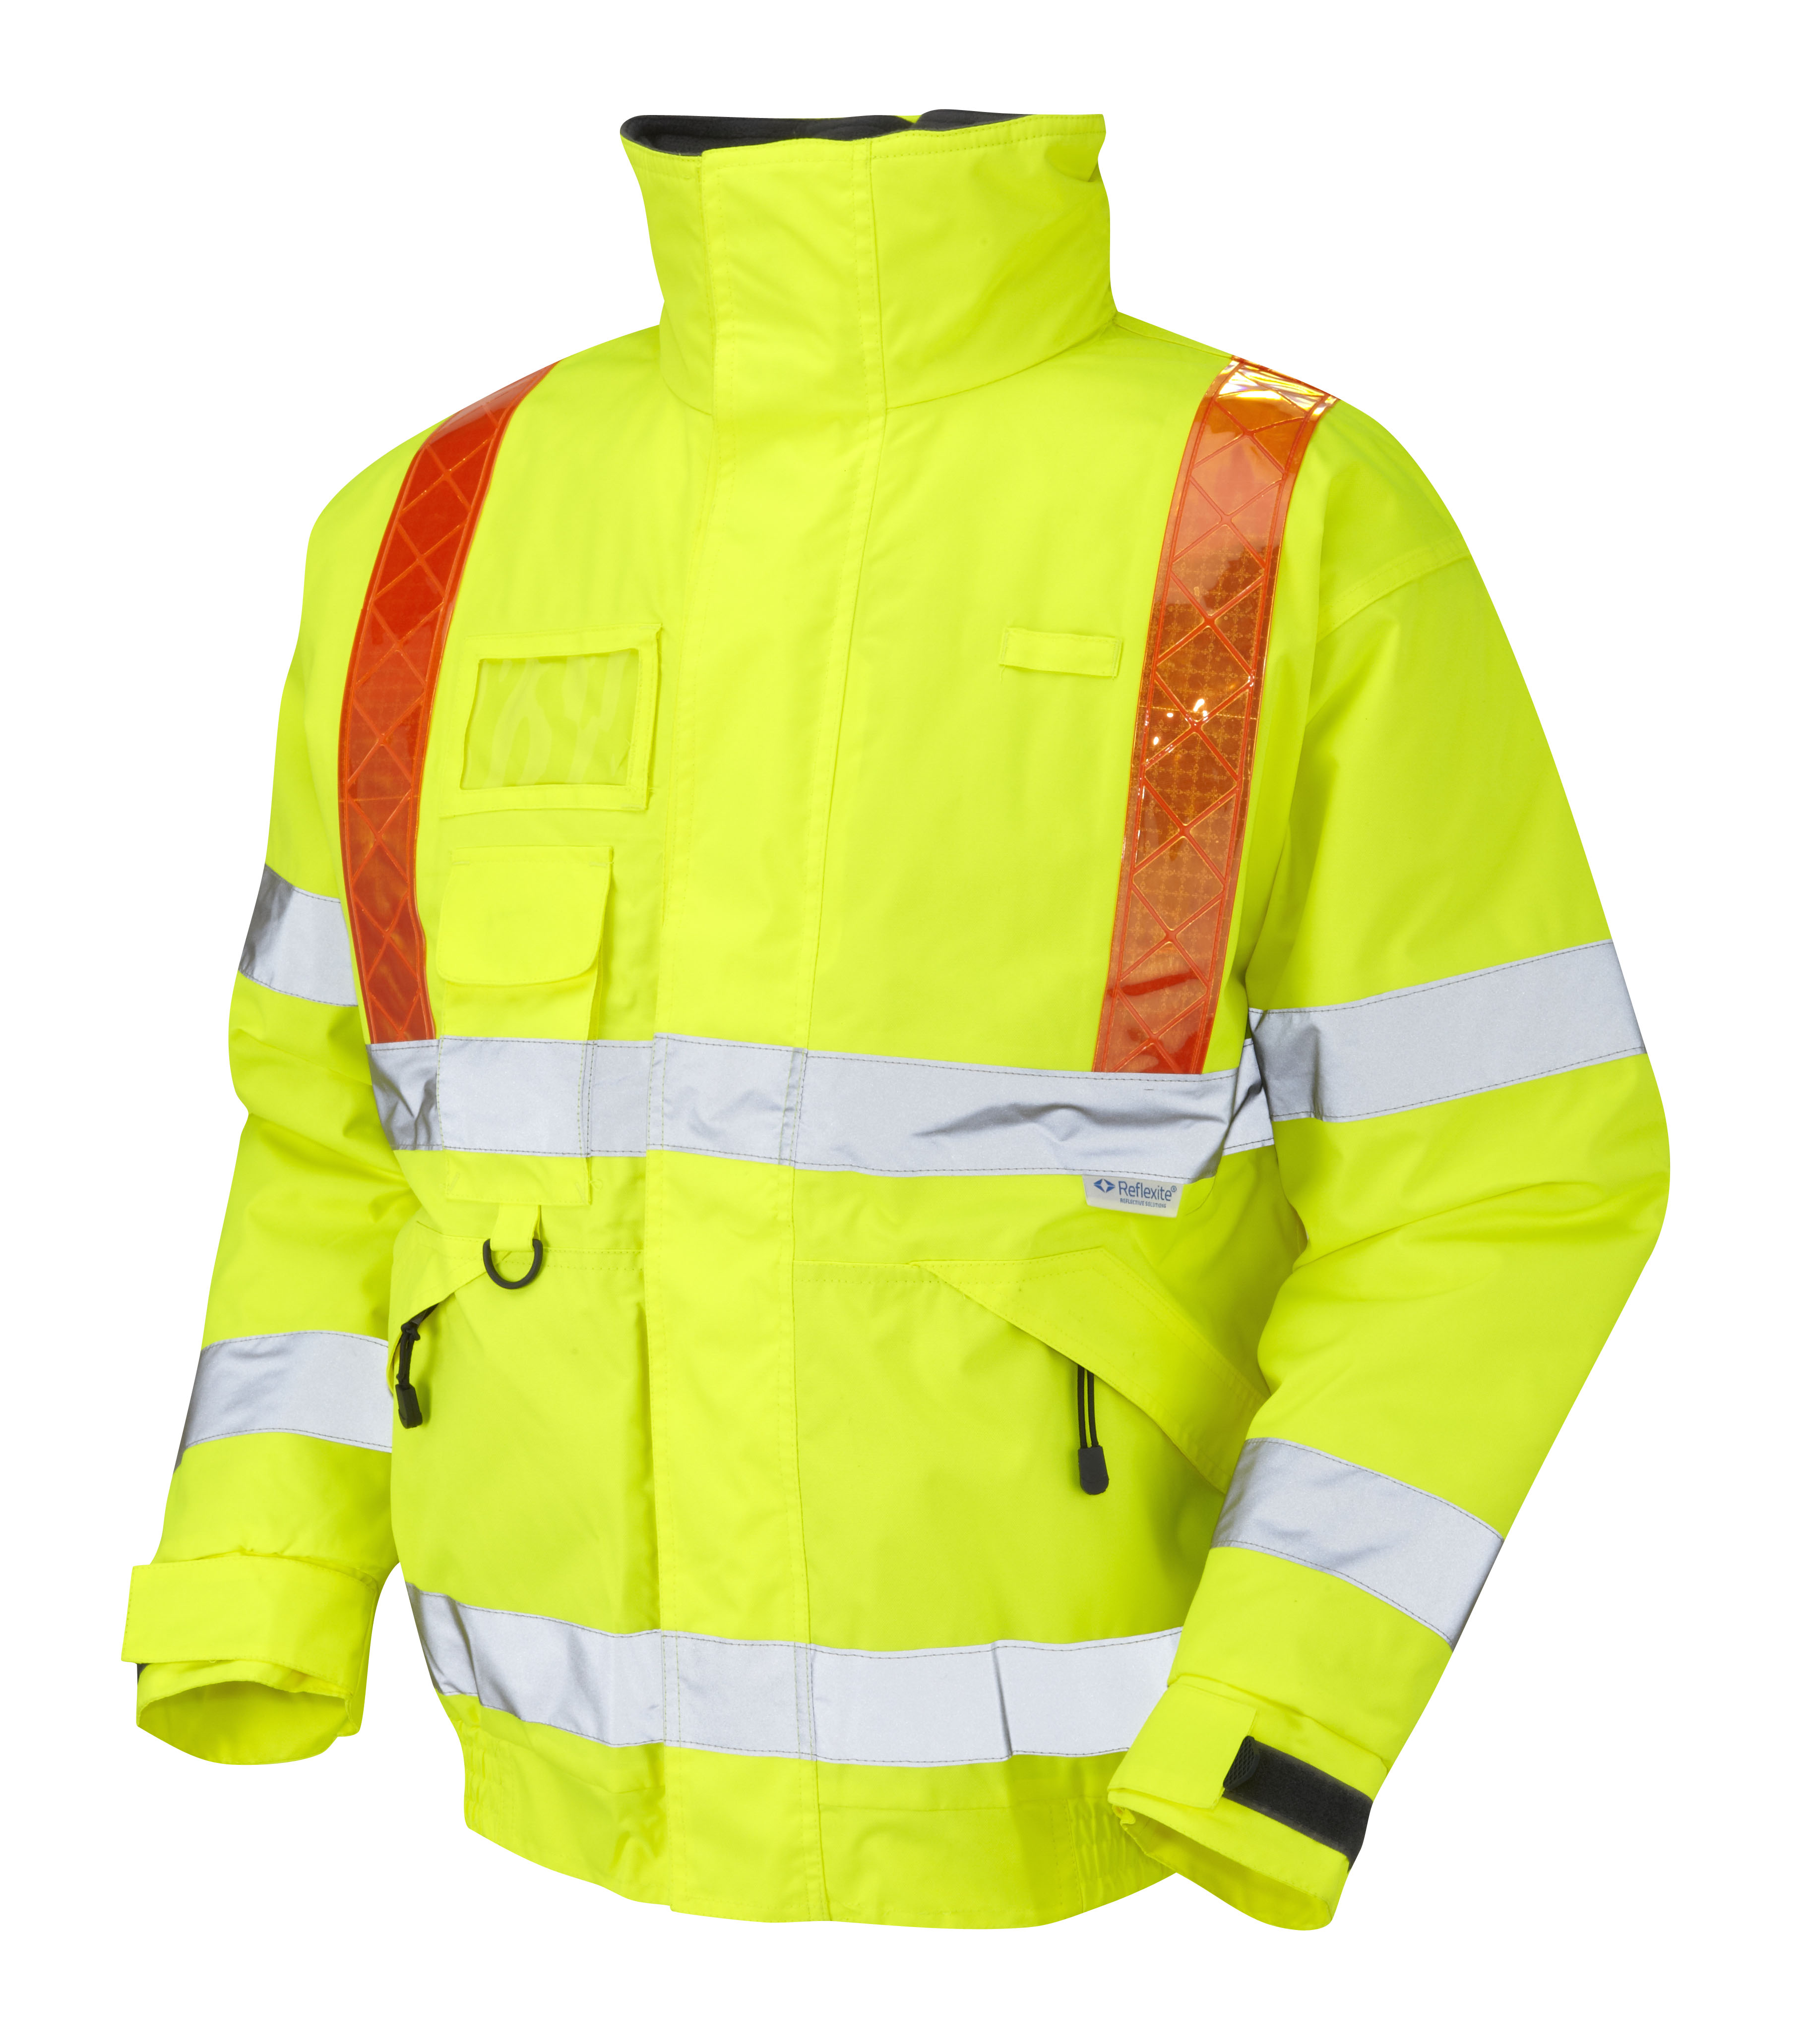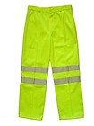

GLOVES


A visual inspection of the bin, lid, elastic bands and plastic plugs must be done prior to harvest bin preparation to ensure that all components are clean and undamaged. If Yard Staff notice any damage to any bin or lid they must take the item out of service and inform a supervisor. Damaged elastic bands or plastic plugs must be replaced. If there is any doubt regarding cleanliness of a bin it must be cleaned as per SOP- Harvest bins cleaning and storage
Przed wyścieleniem pojemnika foliowymi workami należy dokonać oględzin pojemnika pod kątem czystości oraz uszkodzeń. Jeżeli pracownik zauważy uszkodzenia pojemnika bądź pokrywki musi wycofać przedmiot z eksploatacji. Jeeli uszkodzeniu uległy gumowe opaski bądź plastikowe zatyczki należy wymienić je na nowe. W przypadku jakichkolwiek wątpliwości co do czystości pojemnika bądź pokrywki należy dokonać ponownego mycia tak jak opisano w instrukcji SOP -”Harvets bins cleaning and storage”.

- Remove lid from the bin. Zdejmij pokrywkę z pojemnika.

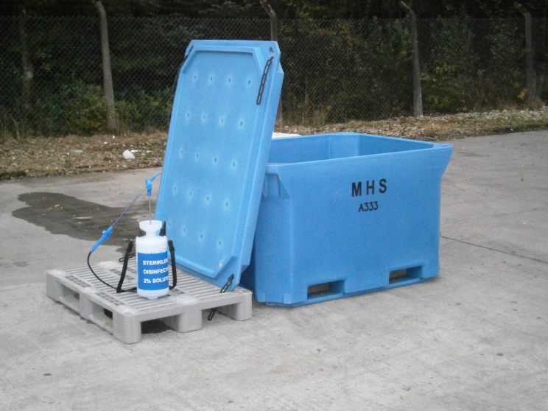

- All bin and lid surfaces must be thoroughly disinfected using a pressure washer and approved disinfectant. Disinfectant must be prepared as described in SOP- Preparation of disinfectant 2% solution.
Używając spryskiwacza zdezynfekuj dokładnie wszystkie powierzchnie pojemnika oraz pokrywki. Dezynfektant przygotuj tak jak opisano w instrukcji pracy SOP- “Preparation of disinfectant 2% solution”.
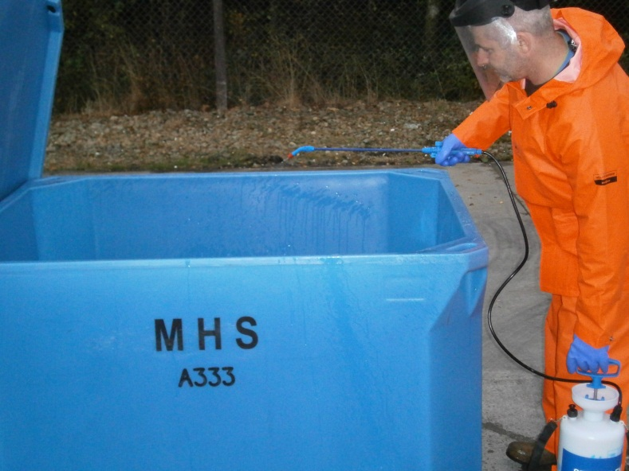

- Once clean, two white harvest bin liners should then fitted within the bin and stretched over the sides. Make sure that the liners not touch the floor. Always use clean gloves. Używając dwóch białych worków wyściel pojemnik naciągajac worki na zewnętrzne ściany pojemnika. Upewnij się, że worki nie dotykaja podłoża. Zawsze używaj czyste rękawice.

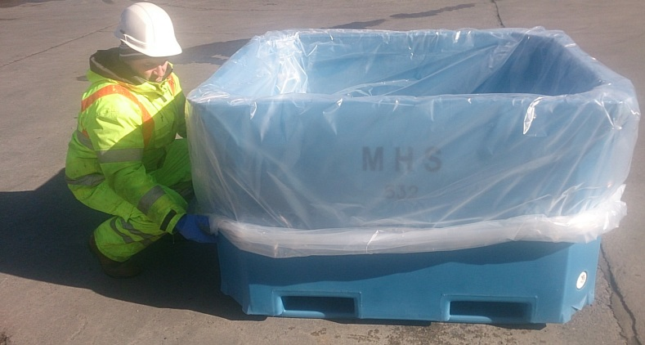

- White liners are stored in the packaging store as described in SOP- Packaging storage
Białe worki są przechowywane w wyznaczonym kontenerze tak jak opisano w instrukcji SOP- “Packaging storage”

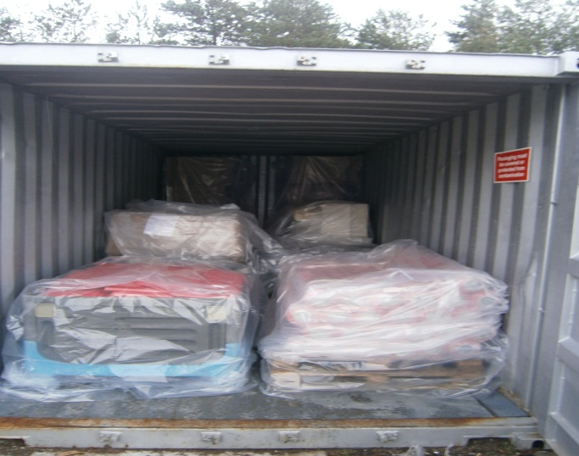

- Completed bin is ready to fill with flake ice or iced slurry Pojemnik jest gotowy do napełnienia lodem bądź sleszem
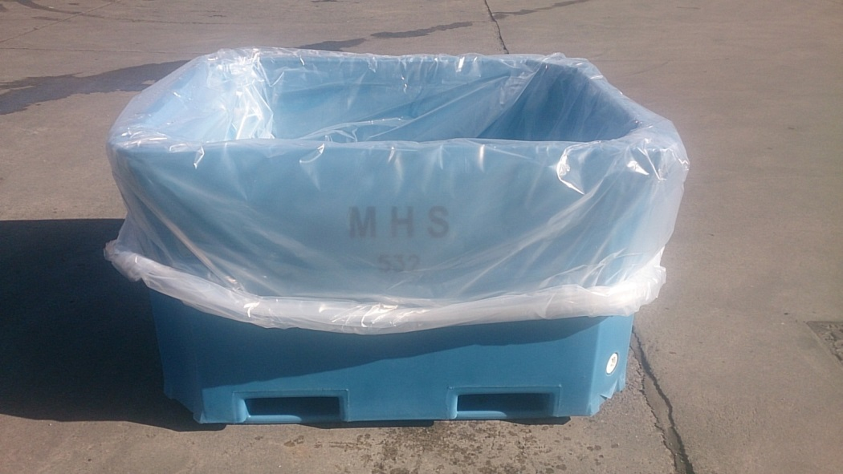

RISK ASSESMENT
YARD

HARVEST BINS PREPARATION RA
RISK |  | PERSON AT RISK | SIGNIFICANT HAZARDS | RISK |  |  |  | RISK CONTROL MEASURES | RESIDUAL RISK
 |  | PERSON AT RISK | SIGNIFICANT HAZARDS | L | S |  | DR | RISK CONTROL MEASURES | L | S | DR
CHEMICALS |  | YARD STAFF | Risk from disinfectant used for disinfect bin and lid | 3 | 2 |  | 6 | PPE  Chemical handling training | 1 | 2 | 2
REPETIVE STRAIN INJURY(R.S.I.) |  | YARD STAFF | N/A |  |  |  |  | N/A
UPPER LIMB DISORDER (U.L.D) |  | YARD STAFF | N/A |  |  |  |  | N/A
MANUAL HANDLING |  | YARD STAFF | Risk of strains from handling lids | 3 | 4 |  | 12 | Manual handling training | 2 | 4 | 8
KNIVES |  | YARD STAFF | N/A |  |  |  |  | N/A
AEROSOLS |  | YARD STAFF | N/A
SLIPS TRIPS & FALLS |  | YARD STAFF | Wet slippery surfaces could cause slips , trips or falls which can be exasperated by severe winter conditions. | 3 | 3 |  | 9 | Compulsory slips, trips & falls awareness training gritting, gritting, squeegees | 2 | 3 | 6
MACHINERY |  | YARD STAFF | N/A |  |  |  |  | N/A
COLD CONDITONS |  | YARD STAFF | Extremely cold outside temperatures could cause injury | 4 | 3 |  | 12 | Compulsory use of Yard PPE  Thermal underwear & gloves available  Increased breaks | 2 | 2 | 4
CONGESTED AREAS |  | YARD STAFF | Fork truck and lorry movements. | 3 | 5 |  | 15 | PPE, Signage, procedures | 1 | 5 | 5
PRESSURISED SYSTEMS |  | YARD STAFF | N/A |  |  |  |  | N/A
CONFINED SPACES |  | YARD STAFF | N/A |  |  |  |  | N/A
WORKING AT HEIGHT |  | YARD STAFF | N/A |  |  |  |  | N/A
FORKTRUCKS |  | YARD STAFF | Risk of collision with persons or Vehicles | 3 | 5 |  | 15 | Compulsory Forklift training  Compulsory Yard personnel , contractor & visitor PPE which includes at minimum Hard Hat & Fluorescent vest  Fork truck audible reverse alarm  Before use check sheet | 2 | 4 | 8
Low 1 to 9 Medium 10 to 16 (Action) High 17 to 25 (STOP)
Risk is the significant hazards identified
Residual risk is the level of risk that remains after suitable and sufficient control measures are introduced

