BLAR mHOR OPERATIONS  STANDARD OPERATING PROCEDURE(SOP) |  |  | 
Title |  |  |  | Version Number
OPERATIONS-SOP-YARD-HARVEST BINS CLEANING AND STORAGE |  |  |  | 8
Revised or amended date | 01/08/2022 | Next revision date |  | 01/08/2023
The instruction within this document is a guide only and should be an accompaniment to practical training
This document shall only be amended by designated persons on the authorisation of the Processing Departmental Manager

Purpose: To maintain harvest bins in a clean and hygienic condition. W celu zapewnienia odpowiedniej czystosci binow.
Responsibility: Yard Operatives / Supervisor Pracownik Yardu / Kierownik
Health and Safety: Risk Assessment RA Ocena Ryzyka RA

References: Operation High Pressure Washer
Harvest Bins Cleaning Schedule
Yard Chemical in Use
Yard Soak Bin Preparation
Yard Preparation of Disinfectant 2% Solution

Approved Chemicals Used & Dilution |  |  |  | Equipment | Comments
Product | Use/Dosage % | Symbol | Hazard | Equipment | Comments
SUPERKLENZ | 5% | ALKALINE |  | Soak bin | Used to soak plastic plugs .
CHLOROFOAM | 4-6% | CHLORINATED ALKALINE |  | Dema Foamer | Used for main clean.
STERIKLENZ 5 | 2% | DISINFECTANT  DISINFECTANT  DISINFECTANT |  | Soak bin, pressure sprayer | Used for disinfection of cleaned equipment.

PPE Required:
RESPIRATOR MASK (WHEN WORKING WITH CHEMICALS)
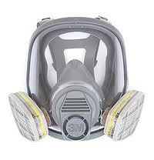

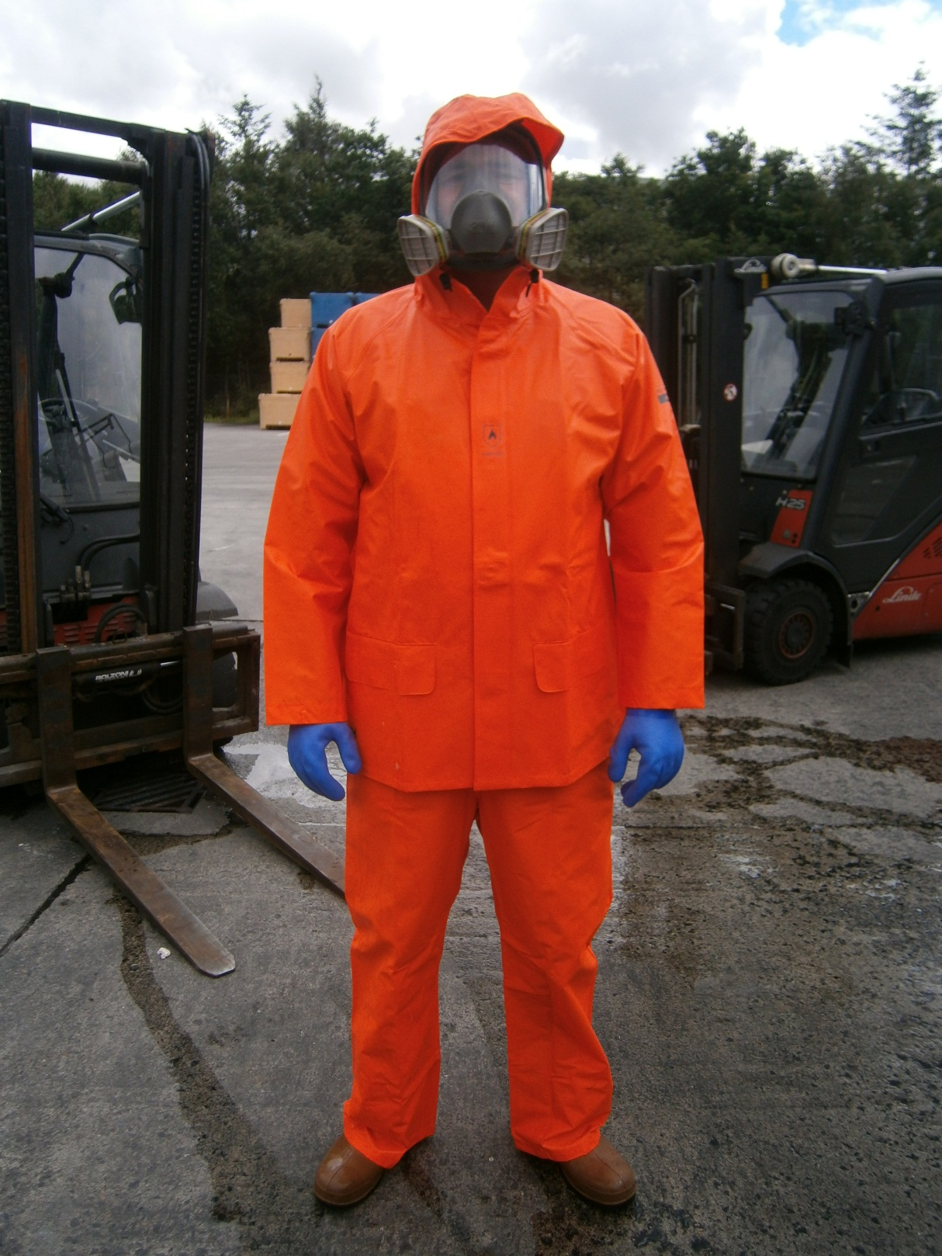
WATERPROOF GEAR
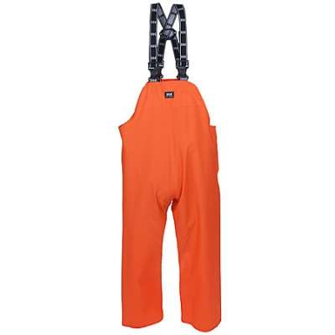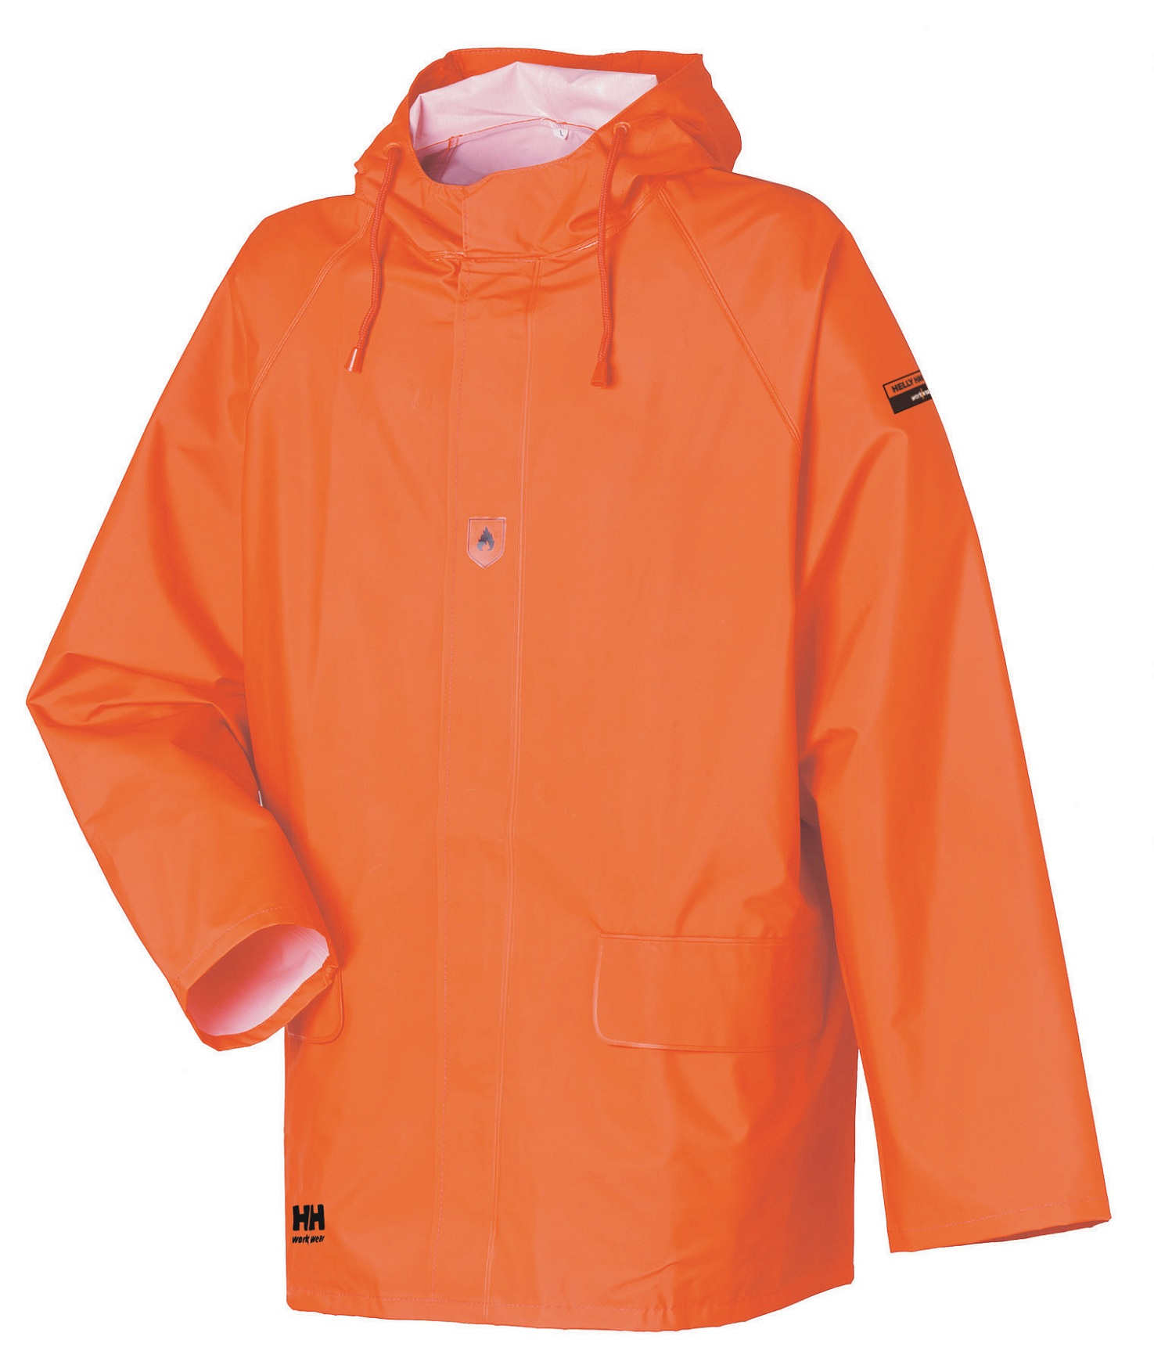

GLOVES


SAFETY BOOTS
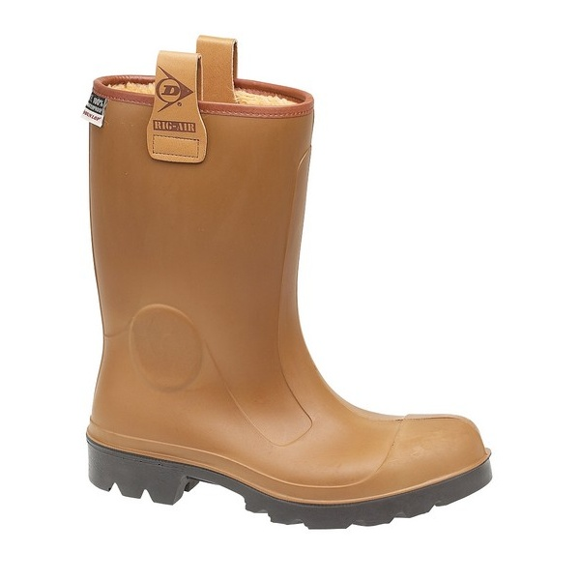

BINS CLEANING PROCEDURE:
- Using a forklift truck, transfer the required bins to the bin wash zone located next to the CIP bay. Przetransportuj bin do strefy przaznaczonej do mycia binow.

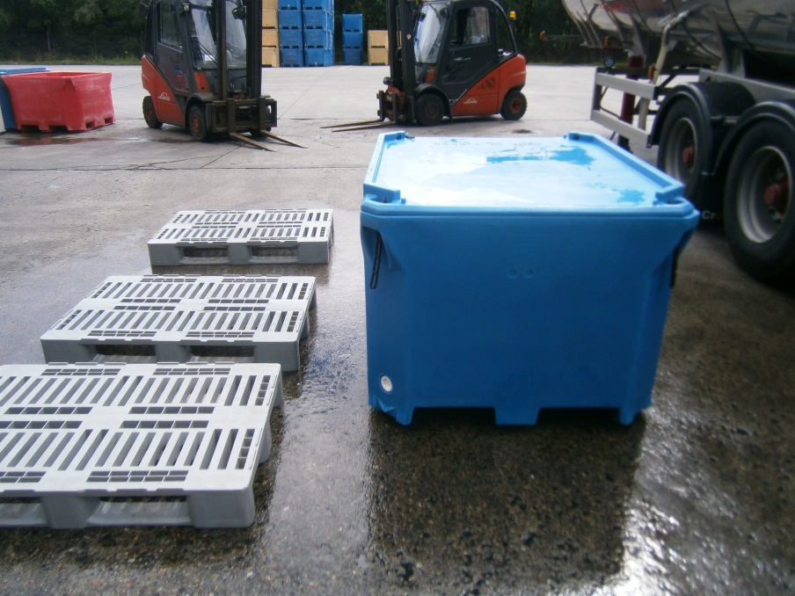

- Remove lid from the bin and place it adjacent to the bin. Zdejmij pokrywke, nastepnie oprzyj ja w pozycji pionowej o pojemnik.

- Unscrew plastic plugs located in the bottom of the bin ,next put them in to the designated soak bin with 5 % solution of approved chemicals. Odkrec plastikowe zatyczki znajdujace sie na dole pojemnika, zamocz je w pojemniku z 5% roztworem zatwierdzonych chemikali.

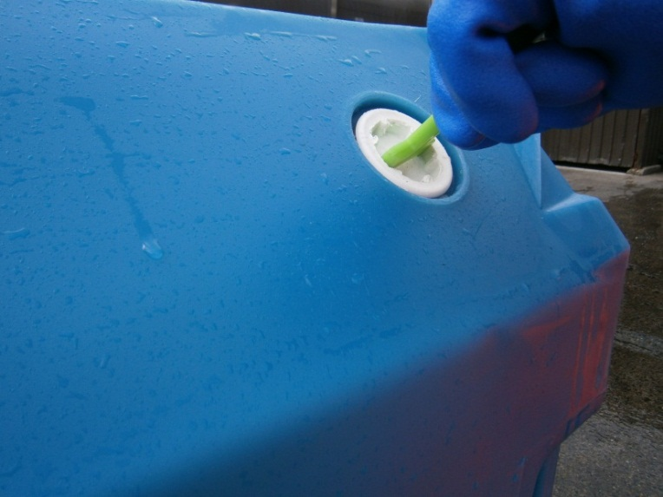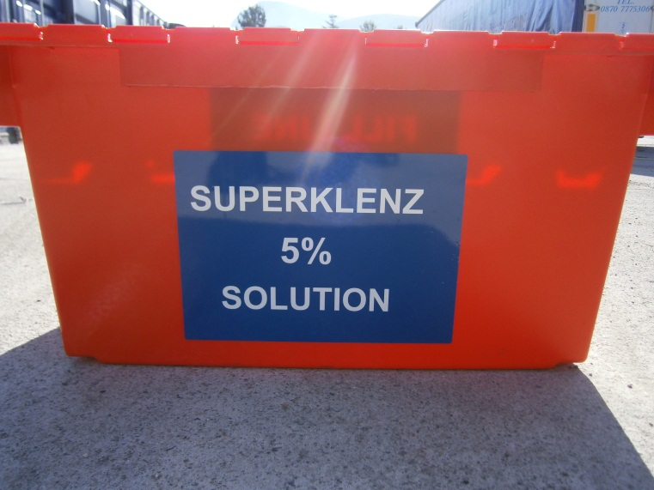

- Pre-clean Gross Debris Removal. Using a power washer lance, wash thoroughly both sides of the lid then place it on the clean plastic pallet. Next, wash all external sides of the bin working from the top to the bottom. Once finished, place the bin on the clean plastic pallet on its side. Wash bottom of the bin then clean thoroughly all internal surfaces. Pay particular attention to the corners and threaded holes Mycie wstepne Usuwanie Zanieczyszczen. Za pomoca myjki wysokocisnieniowej umyj dokladnie obie strony pokrywki. Nastepnie umiesc pokrywke na wczesniej przygotowanej czystej plastikowej palecie. Przy uzyciu myjki wysokocisnieniowej umyj wszystkie zewnetrzne sciany pojemnika. Zawsze myj z gory do dolu. Nastepnie poloz pojemnik bokiem na wczesniej przygotowanej czystej palecie plastikowej.. Za pomoca myjki wysokocisnieniowej umyj spod oraz wnetrze pojemnika. Zwroc szczegolna uwage na narozniki oraz na gwintowane otwory

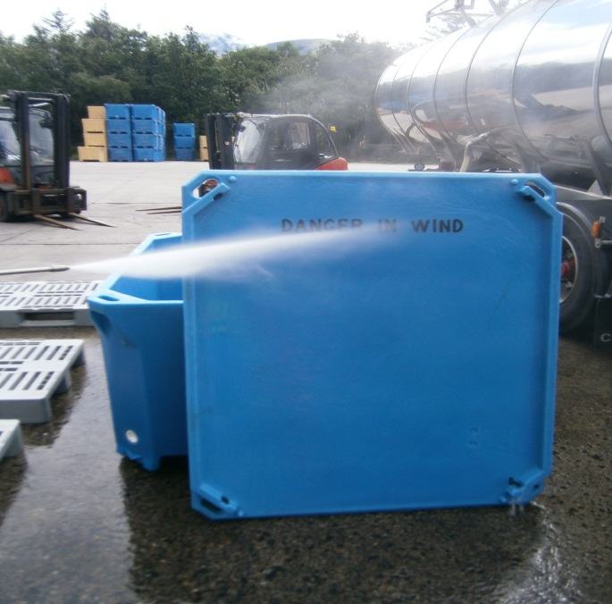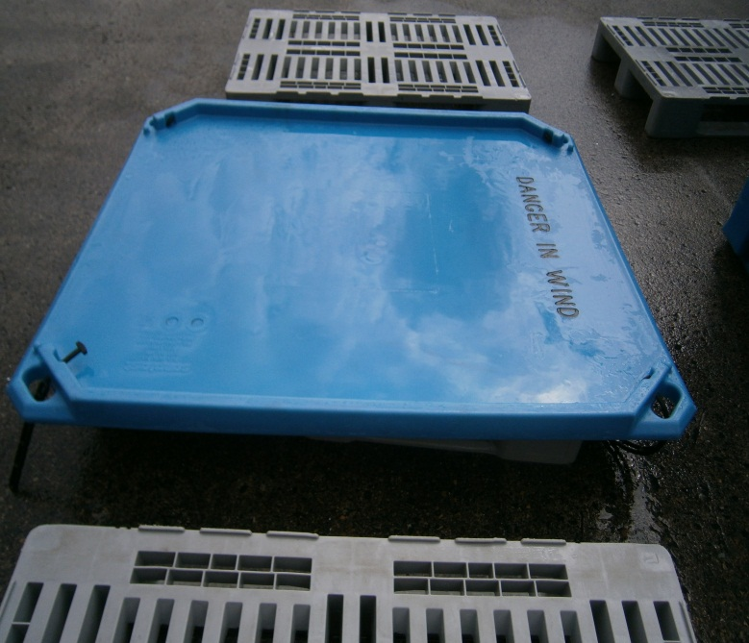

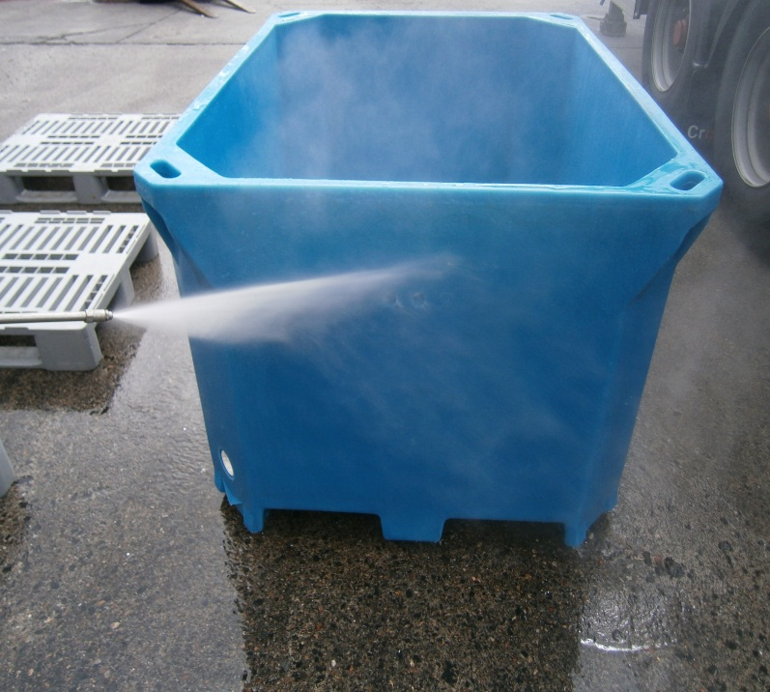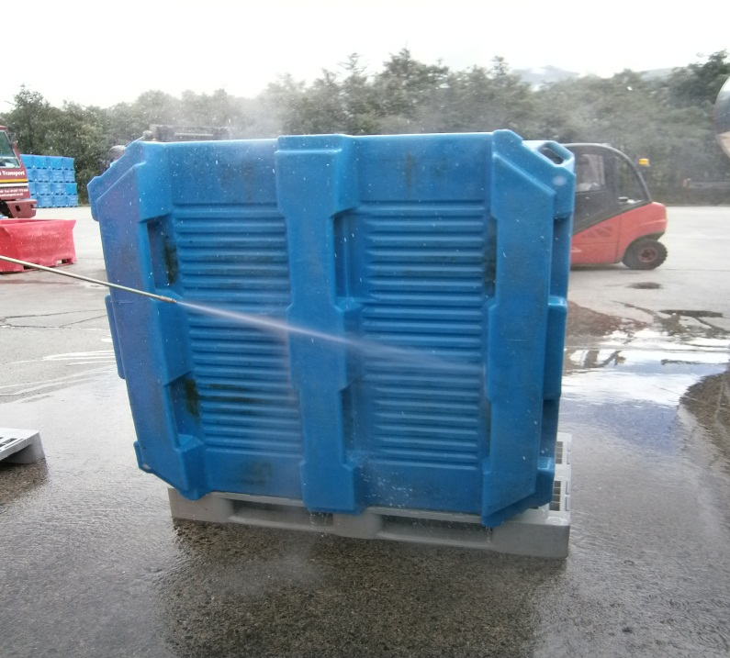
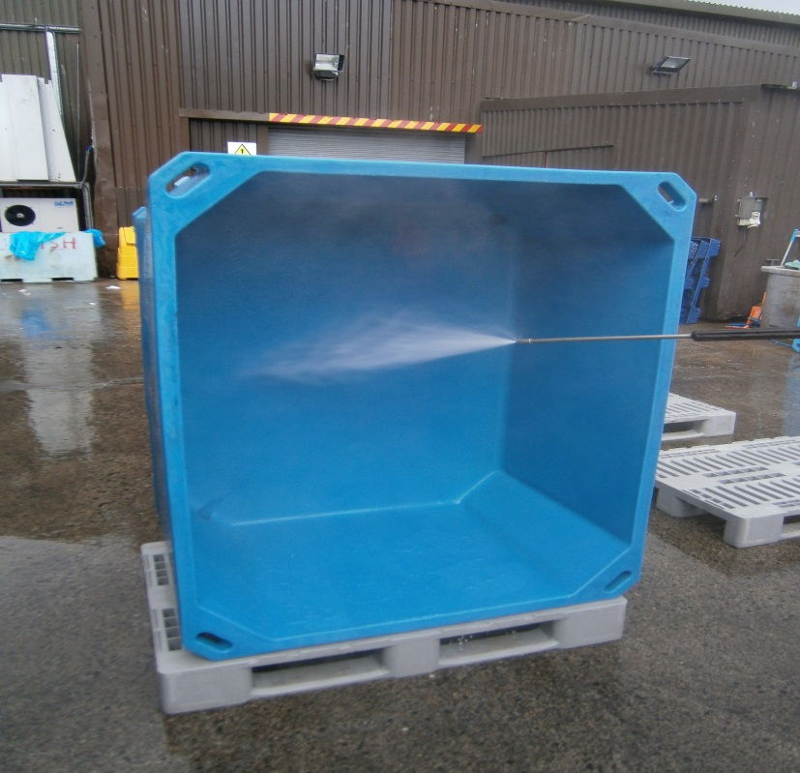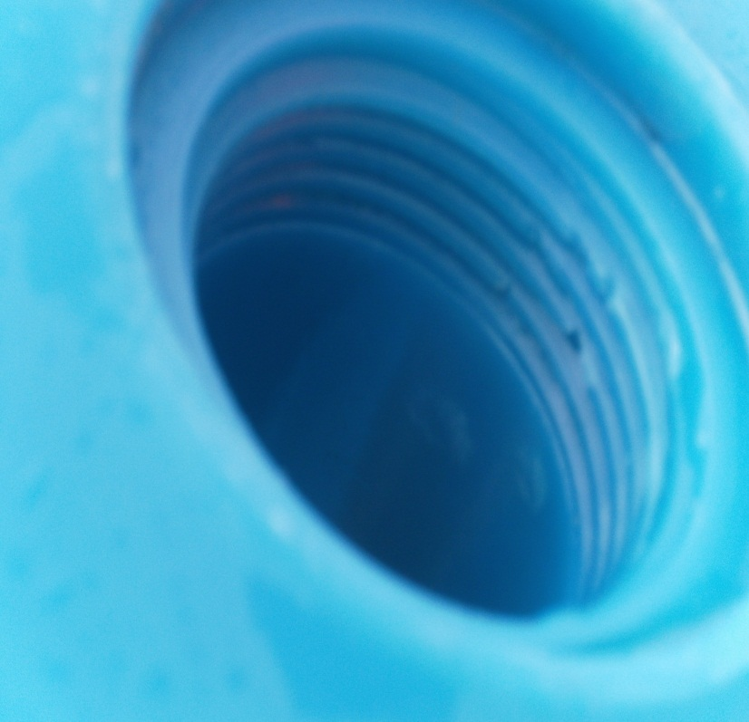

- Main Clean Detergent Application. Using the air foamer, apply foam detergent working from the bottom to the top on both sides of the lid and on all external and internal bin surfaces. Ensure that all surfaces are fully covered by foam and left for the recommended contact time. If necessary use a green pad for additional cleaning.
Czysczenie przy pomocy detrgentu. Przy uzyciu spieniacza nanies detergent z dolu do gory na obydwie strony pokrywki oraz na wszystkie zewnetrzne oraz wewnetrzne powierzchnie pojemnika. Upewnij sie ze czyszone powierzchnie sa calkowicie pokryte piana oraz ze pozostaja w kontakcie przez rekomendowany czas kontaktu.
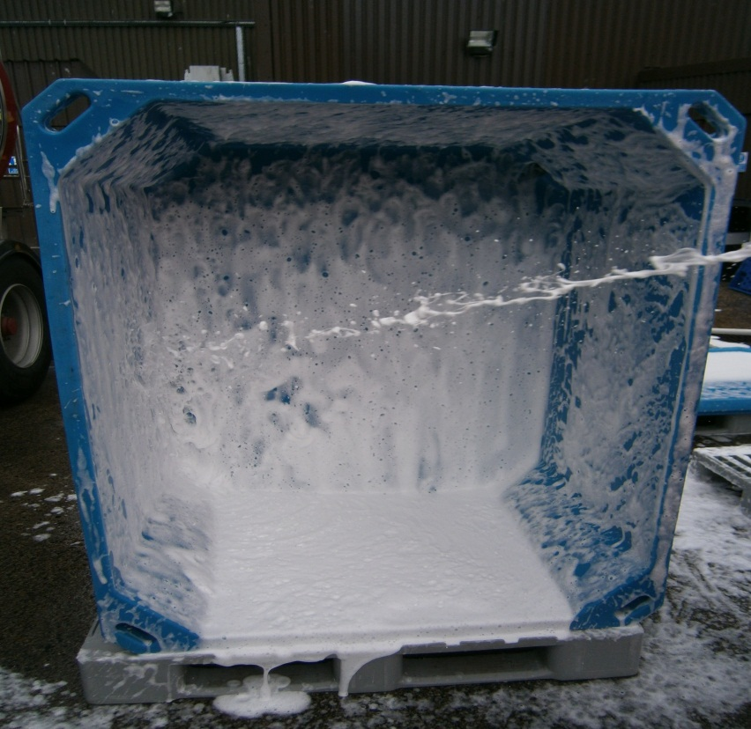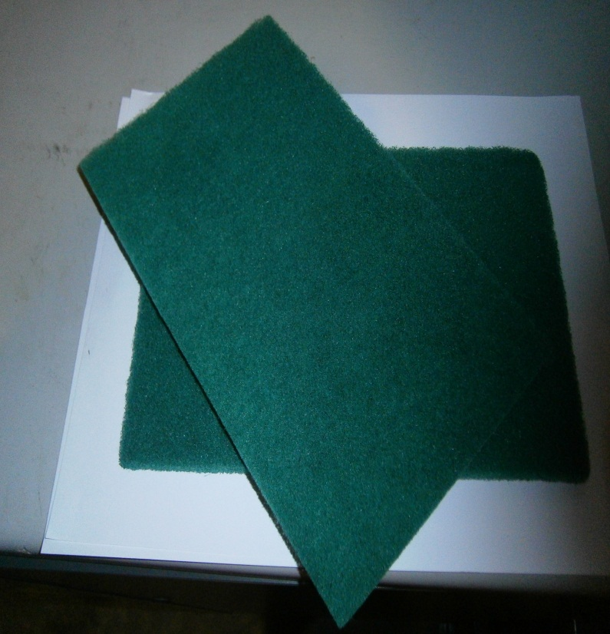
- Hot water rinse. Using power washer lance rinse with hot water both sides of lid and all external and internal bin surfaces. Przy uzyciu myjki wysokocisnieniowej splukakj goraca woda obydwie strony pokrywki oraz zenetrzne i wewnetrzne poeierzchnie bina.

- Plastic Plugs. Brushing, green padding. Using a brush or green pad, thoroughly clean the plastic plugs. Once finished, rinse with clean water then place in designated soak bin with 2 % solution of approved disinfectant. Za pomoca szczotek badz zielonych scierek umyj dokladnie plastikowe korki. Po umyciu splucz czysta woda a nastepnie zamocz w pojemniku z 2% roztworem dezynfektantu.

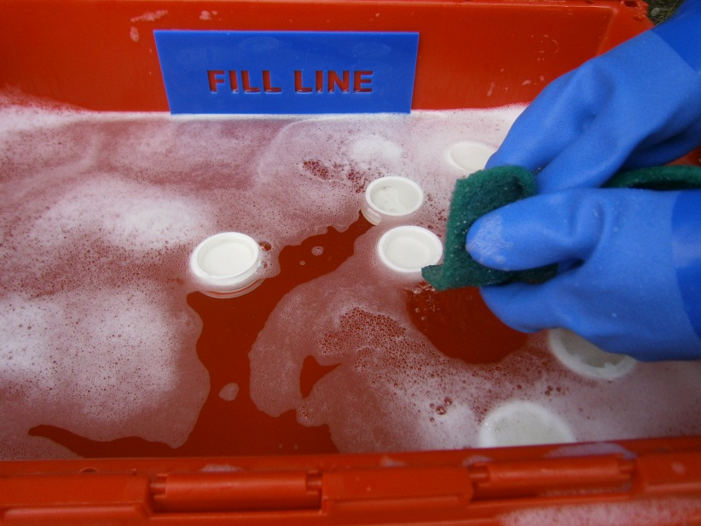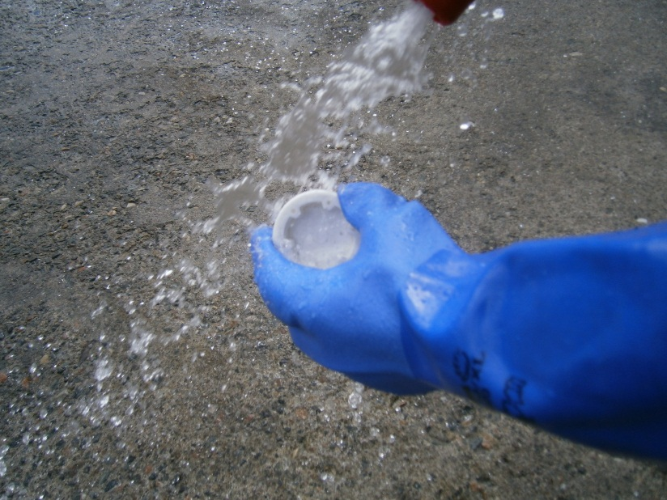

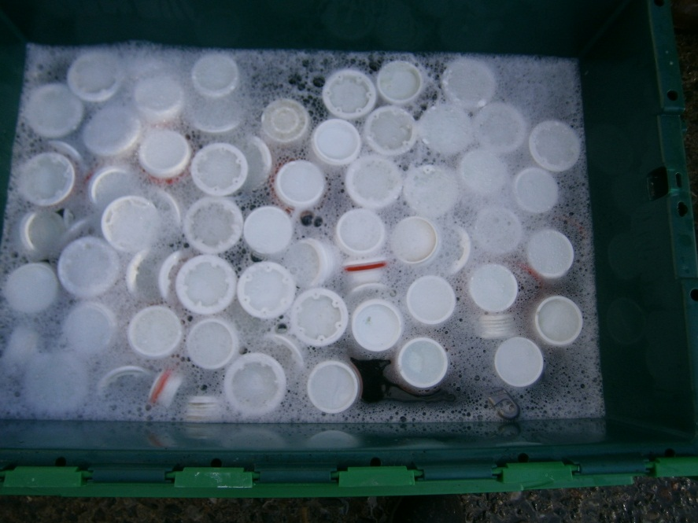

- After cleaning, replace the lid and secure with elastic bands, screw on plastic plugs. Po ukonczeniu mycia przykryj pojemnik pokrywka oraz zabezpiecz gumowymi opaskami, wkrec plastikowe korki.

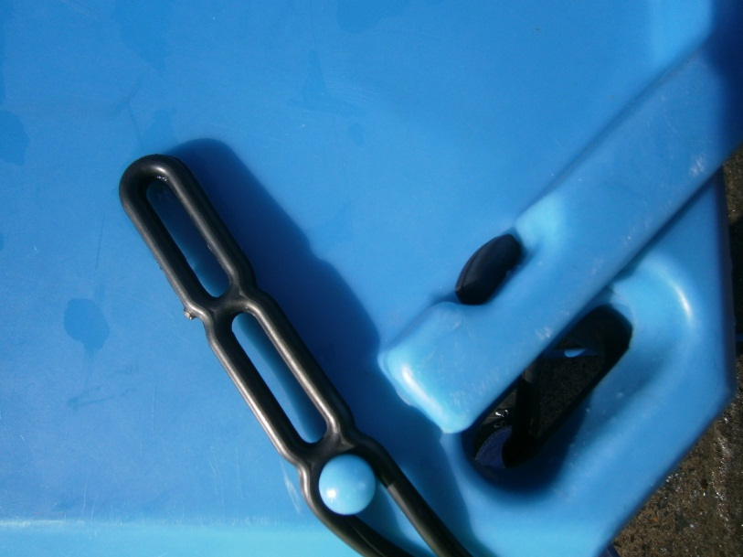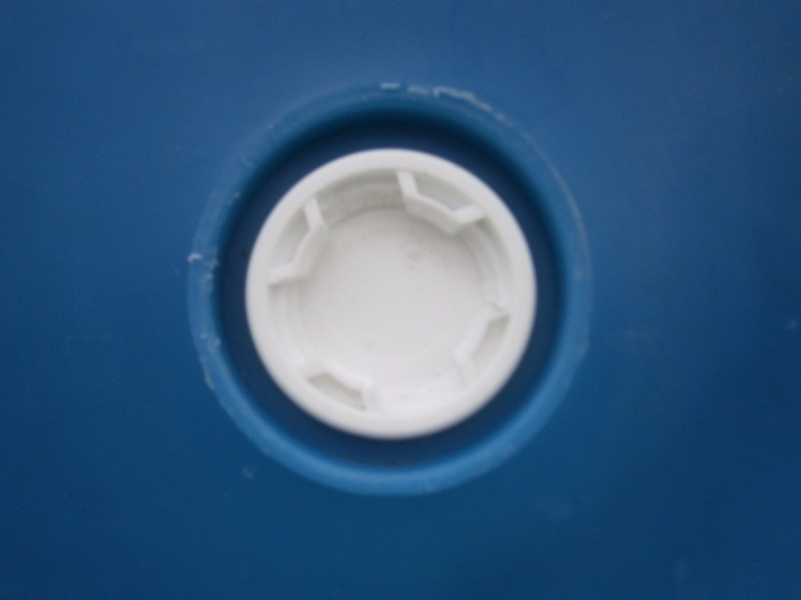

If, during cleaning or storage, a Hygiene Operator notices any damage to a bin or lid they must take the item out of service and inform a supervisor Jezeli podczas mycia badz magazynowania, pracownik zauwazy uszkodzenia pojemnika badz pokrywki musi wycofacac przedmiot z eksploatacji oraz poinformowac kierownika

STORAGE:
Using a fork-lift truck carefully stack clean bins in the designated area in the yard. Harvest bins may be stacked up to 4 levels high. Extra care must be taken whilst stacking. Never stack bins unless the lid has not been closed and secured with elastic bands. Przy pomocy wozka widlowego ustaw pojemniki w wyznaczonej do tego strefie. Pojemniki moga byc ustawiwane na wysokosc czterech pieter. Nigdy nieodstawiaj pojemnikow jezeli pokrywka niezostala odpowiednio zabezpieczina za pomoca elastycznych opasek.

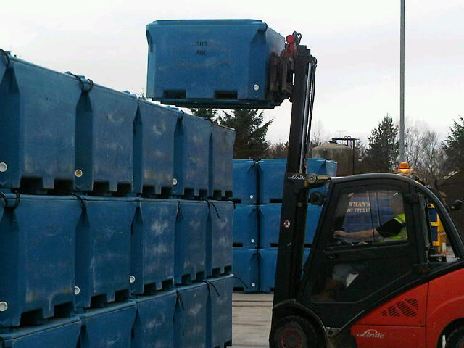

RISK ASSESMENT
YARD
HARVEST BIN CLEANING AND STORAGE RA
RISK |  | PERSON AT RISK | SIGNIFICANT HAZARDS | RISK |  |  |  | RISK CONTROL MEASURES | RESIDUAL RISK
 |  | PERSON AT RISK | SIGNIFICANT HAZARDS | L | S |  | DR | RISK CONTROL MEASURES | L | S | DR
CHEMICALS |  | TBO | Risk from chemicals used for cleaning bins as stated in MSDS. | 3 | 4 |  | 12 | PPE  Chemical handling training | 1 | 4 | 4
REPETIVE STRAIN INJURY(R.S.I.) |  | N/A | N/A |  |  |  |  | N/A
UPPER LIMB DISORDER (U.L.D) |  | N/A | N/A |  |  |  |  | N/A
MANUAL HANDLING |  | TBO | Risk of strains from handling lids and bins | 3 | 4 |  | 12 | Manual handling training | 1 | 4 | 4
KNIVES |  | N/A | N/A |  |  |  |  | N/A
AEROSOLS |  | N/A | N/A
SLIPS TRIPS & FALLS |  | TBO | Wet slippery surfaces could cause slips , trips or falls which can be exasperated by severe winter conditions. | 3 | 3 |  | 9 | Compulsory slips, trips & falls awareness training gritting, gritting, squeegees | 2 | 3 | 6
MACHINERY |  | TBO | N/A |  |  |  |  | N/A
COLD CONDITONS |  | TBO | Extremely cold outside temperature | 4 | 3 |  | 12 | Compulsory use of Yard PPE  Thermal underwear & gloves available  Increased refreshment breaks | 2 | 3 | 6
CONGESTED AREAS |  | N/A | Fork truck and lorry movements. | 3 | 5 |  | 15 | PPE, Signage, procedures | 1 | 5 | 5
PRESSURISED SYSTEMS |  | N/A | Risk of injury from air lines. | 2 | 4 |  | 8 | P.P.E, staff training and procedures. | 1 | 4 | 4
CONFINED SPACES |  | N/A | N/A |  |  |  |  | N/A
WORKING AT HEIGHT |  | TBO | N/A |  |  |  |  | N/A
FORKTRUCKS |  | Yard Operative | Risk of collision with persons or Vehicles | 3 | 5 |  | 15 | Compulsory Forklift training  Compulsory Yard personnel , contractor & visitor PPE which includes at minimum Hard Hat & Fluorescent vest  Fork truck audible reverse alarm  Before use check sheet | 2 | 4 | 8
Low 1 to 9 Medium 10 to 16 (Action) High 17 to 25 (STOP)
Risk is the significant hazards identified
Residual risk is the level of risk that remains after suitable and sufficient control measures are introduced

