BLAR mHOR OPERATIONS  STANDARD OPERATING PROCEDURE(SOP) |  |  | 
Title |  |  |  | Version Number
OPERATIONS-SOP - HARVESTING-ON SITE HARVEST PROCEDURE |  |  |  | 9
Revised or amended date | 01/08/2022 | Next revision date |  | 01/08/2023
The instruction within this document is a guide only and should be an accompaniment to practical training
This document shall only be amended by designated persons on the authorisation of the Processing Departmental Manager

Purpose: To ensure all fish are harvested in accordance to Mowi and RSPCA Welfare Standards For farmed Atlantic Salmon Celem instrukcji jest zapewnienie wysokich standardow polawianej ryby, zgodnie ze standardami Mowi oraz RSPCA Welfare Standards For farmed Atlantic Salmon
Responsibility: Al staff and On Site Harvest Supervisor. Wszyscy pracownicy oraz kierownik zespolu.
Health and Safety: Risk Assessment- Working Over Water Ocena Ryzyka Praca na wodzie
Risk Assessment SOP- On site harvest procedure Ocena Ryzyka SOP- “On site harvest procedure Appropriate PPE to be worn Należy stosowac adekwatne ubranie ochronne
References: RSPCA Welfare Standards For farmed Atlantic Salmon Standardy RSPCA dla hodowlanego łososia atlantyckiego LOG-On Site Harvest Oxygen Check Sheet Karta do monitorowania tlenu LOG-Start Up Check Sheet Karta sprawdzajaca przed rozpoczeciem polowu LOG-Close Down Check Sheet Karta sprawdzajaca po zakaczeniu polowu LOG- Knives Check Sheet Karta do kontroli stanu nozy Fish Stun Check Log Karta sprawdzajaca ogluszacze przed polowem ATP Sampling Log Karta zapisu rezultatow probek ATP wem

PERSONAL PROTECTIVE EQUIPMENT

ODZIEZ OCHRONNA

Personal protective equipment is to be used at all times and will vary according to specific tasks. Osobista odziez ochronna musi byc uzywana podczas wykonywania pracy i moze sie roznic w zaleznosci od wykonywanej pracy.

On shore: High visibility clothing and protective footwear,gloves (blue colour), protective headweare. Praca na ladzie: Odziez odblaskowa,obuwie ochronne,rekawice (kolor niebieski),kask.
Off shore: In accordance with Risk Assesment ‘Workin over water’,gloves (blue colour). Praca na wodzie: Odziez odblaskowa,obuwie ochronne, kaski, kamizelki ratunkowe,rekawice (kolor niebieski).
Slaughter: Waterproof clothing, gloves (orange colour), ear defenders, optional eye protection, hair net. Uboj: Odziez wodoodporna,rekawice (kolor pomaranczowy), ochrona sluchu,w razie potrzeby okulary ochronne, siatka na glowe

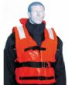 | 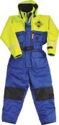 |  | 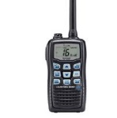
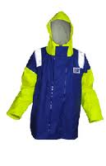 | 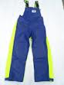 |  | 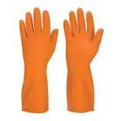
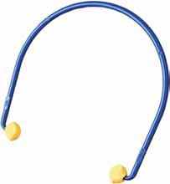 | 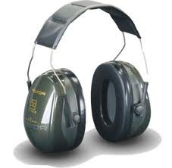 | 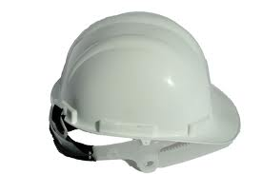 | 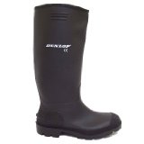

Listed below is the sequence of tasks required for on shore harvests.

- Generator
Generator
Start generator to commence electricity supply for air compressor,fish pump and power washer. Wlacz generator w celu uzyskania zasilania do kompresorow powietrza,myjki wysokocisnieniowej oraz pompy.
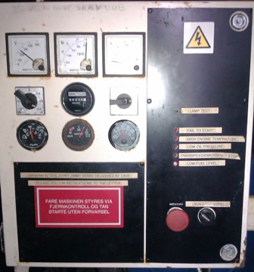
Generator is only used when harvesting at day time to prevent electrical overloads on site. Generator jest uzywany podczas polowow w ciagu dnia w celu unikniecia przeciazenia elektrycznego
- Compressor.
Kompresor.
Prior to starting the compressor a check must be made of all connecting hoses on the compressor and air receiver, to ensure they are in good condition and connected securely. Przed uruchomieniem kompresora upewnij sie ze wszystki weze oraz ich polaczenia sa zamocowane odpowiednia oraz bezpieczn do uzycia.
Only then can the compressor be started, simply by pressing the Green start button. Po wykonaniu wyzej wymienionych czynnosci mozna wlaczyc kompresor.

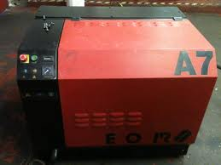
- Air receiver

Once the compressor has started check the pressure gauge on the Air Receiver to make sure the pressure is increasing. Po wlaczeniu kompresora upewnij sie za pomaca wskaznika cisnienia znajdujacego sie na gorze tanka ze cisnienie powietrza w tanku wzrasta.
The pressure indicate must be between 8 bar and 10 bar. Cisnienie powietrza powinno wynosic od 8 do 10 barow.
If the required pressure is not met then a check of all connecting hoses and compressor must be made. Jezeli cisnienie powietrza jst niewystarczajace sprawdz szczelnosc wezy oraz ich polaczen.

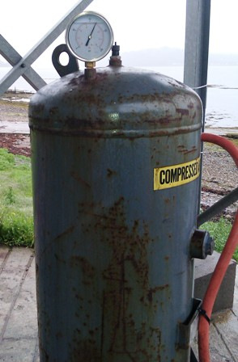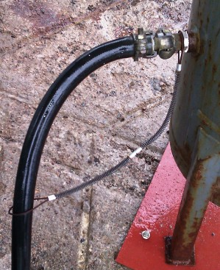
- Air Dryer
Uzdatniacz powietrza.

Connect Air Dryer to the Air Receiver . Podlacz uzdaczniacza powietrza do Tanka przechowujacego skompresowane powietrze.

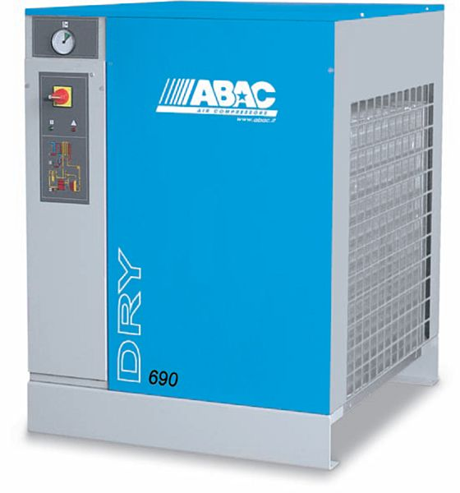

- Stunners Ogluszcze
Prior to crowding fish a thorough check must be made of all the stunners to ensure they are working correctly. Results to be recorded on Log Sheet Fish Stun Check Przed rozpoczeciem podnoszenia sieci upewnij sie ze ogluszcze sa sprawne i gotowe do uzycia. Wyniki musza byc zapisane na karie sprawdzajacej

After all on shore checks have been made staff can commence off shore preparations. Po ukonczeniu wszystkich prac na ladzie zaloga moze przystapic do prac na wodzie.
The correct PPE is compulsory
Pamietaj o odziezy ochronnej

- Oxygen Meter Urzadzenie do monitorowania tlenu

Sensor must be placed in the water prior to crowding the fish. Oxygen level must be monitored during harvest and recorded on Oxygen Check Sheet LOG Przed rozpoczeciem wyciagania sieci umiesc sensor w wodzie,ilosc tlenu musi byc kontrolowana podczas trwania polowow i zapisywana na karcie sprawdzajacej
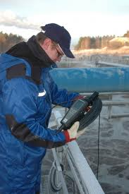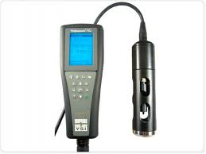

- Oxygen hose. Dozowanie tlenu
The oxygen hose is to be placed into the water after connecting to the oxygen pack with quick release hoses. Za pomoca szybkozlaczki podlacz urzdzenie do dozowania tlenu z butlami z tlenem nastepnie umiesc w wodzie.
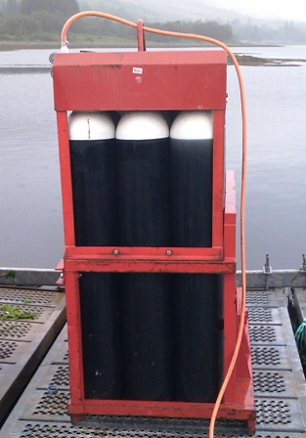
The oxygen pack is to ensure fish receive enough oxygen during the crowding procedure. Dozowanie tlenu ma za zadenie zapewnienie ryba wystarczajacej ilosci tlenu podczas polowu.
- Sea Crane Operations.
Dzwig morski.
The blue shark hose and funnel is then to be lowered into the fish pen with the Sea Crane ( operators must be qualified to use the Sea Crane). Za pomoca dzwigu umiesc lej oraz niebieska rure w klatce z ryba.
The shark hose and funnel once submerged must then be secured in position. Po umieszczeniu leja oraz rury zabezpiecz je odpowiednia za pomoca lin.
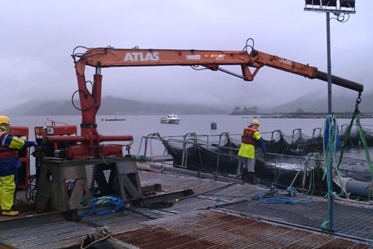
- Fish Crowding Gromadzenie ryb
This must be done in accordance with RSPCA Welfare Standards For farmed Atlantic Salmon Czynnosc ta musi byc wykonana zgodnie ze standartami RSPCA dla hodowlanego łososia atlantyckiego
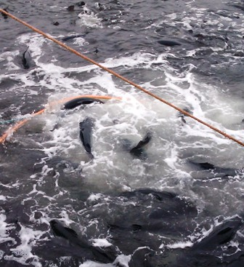
10. Fish Escape Valve Zawor
The fish escape valve is to be used when are any problems during the harvest so that any fish in the pipeline can be returned to the mobile pen. Zawor uzywany jest do przetransferowania ryby z rur do klatki w razie pojawienia sie problemow w trakcie polowu.

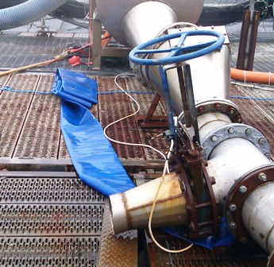
11. Fish Pump
Pompa
First ensure the submersible pump has been lowered into the water. Upwewnij sie ze pompa zanurzeniowa jest umieszczona w wodzie.
Eensure the Fish Escape valve is closed, only then can the fish pump be switched on. Upewnij sie ze zawor do uwolnienia ryby jest zamkniety, nastepnie wlacz pompe.
Once the fish has been correctly crowded they can be pumped to the killing station after. ensuring the Fish Escape valve is closed. Po prawidlowym wyciagnieciu sieci ryba moze byc przetransferowana za pomoca pompy do miejsca uboju.
The fish pump will automatically pump fish to the killing station. Pompa bedzie transferowac rybe do miejsca uboju automatycznie.
Operators in the harvest station should ensure the start/stop button is working correctly. Zaloga musi miec pewnosc ze start/stop przycisk jest sprawny i gotowy do uzycia.

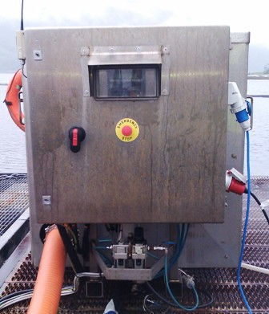
- Stunning and bleeding
Oglszanie i wykrwawianie

All fish arrive into the Killing Station and placed in percussive RB6 stunners to render them unconscious; once fish has been unconscious automatic bleeder will cut the gills. When using MT5 stunners manual bleeding must be done within 10 seconds of fish being manually Ryba przetransferowana z klatki do stacji uboju musi byc w jak najkrotszym czasie ogluszona za pomoca pneumatycznych ogluszczy RB6. Po ogluszeniu automatyczny noz przetnie skrzela w celu umozliwienia wyrwawienia sie ryby.Przy uzyciu ogluszaczy MT5 reczne podcinanie skrzeli musi byc wykonae w ciagu 10 sekund
- Manual Bleeding
Reczne podcinanie skrzeki

3gill arches must be cut with no nicking of the gill cover 3 skrzela musza byc podciete w celu prawidlowego wykrwawienia.
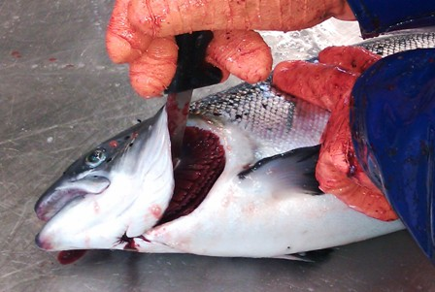

Once this operation has been completed the fish can then be placed into the tanker harvest bins. Nastepnie umiesc rybe w cysternie badz pojemniku przeznaczonym do trasportu ryb.

POST HARVEST OPERATIONS

Once the required amount of fish has been harvested it is necessary to ensure no fish remain within the pump pipeline. Po ukonczeniu polowu nalezy upewnic sie ze rurocig sluzacy do transportu ryb z klatki do ubojni jest pusty.
The oxygen pack can now be switched off and the Air Ring removed form the fish pen. Dozowanie tlenu moze byc zakonczone.
A handle net is placed over the end of the shark hose and funnel after the insertion of a sponge ball. The sponge ball will ensure the pipeline can be flushed of all remaining fish whilst the net placed over the shark hose and funnel will prevent anymore fish entering the pipeline. Wrzuc gabke do leja nastepnie zabezpiecz go za pomoca recznej siatki. Gabka ma na celu upewnieni sie ze w pompie oraz rurociagu niepozostala zadna ryba.
This procedure is to be repeated two times. Powtorz dzialanie dwukrotnie.
Once the pipeline is clear of fish, the fish pump can be switched off and the fish escape valve can be opened in order to drain the pipeline of any remaining sea water. Po upewnieniu sie ze rurociag jest pusty wylacz pompe i otworz zawor (escape valve).
The Shark hose and funnel can now be removed from the water with the Sea Crane and secured to the raft. Wyciagnij z klatki lej wraz z niebieska rura i za pomoca lin zabezpiecz do tratwy.

At the end of the shift IBC with Waste Water must br transported to Blar Mhor Processing Plant and decanted to the Effluent Plant for Water Treatment
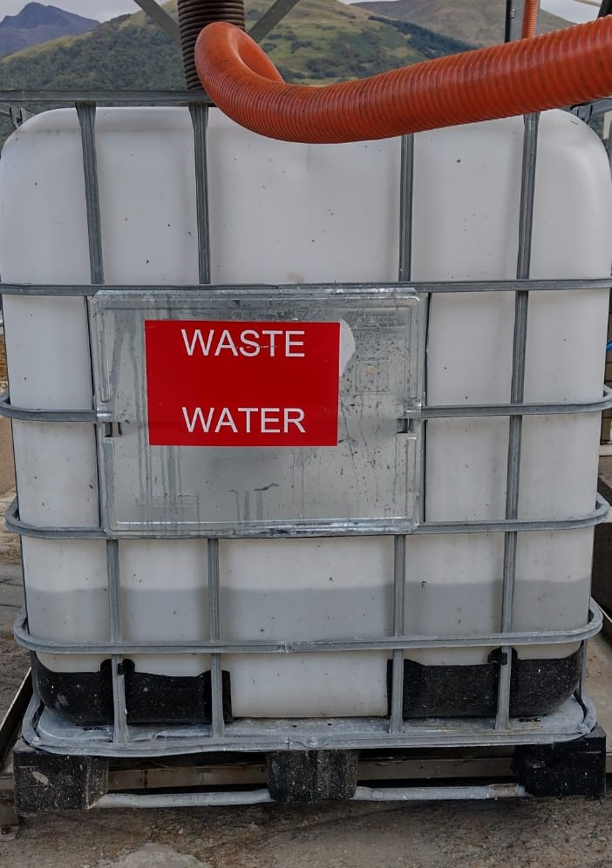

RISK ASSESMENT
ON SITE-HARVEST
On Site Harvest Procedure
RISK | PERSON AT RISK | SIGNIFICANT HAZARDS | RISK |  |  | RISK CONTROL MEASURES |  | RESIDUAL RISK
RISK | PERSON AT RISK | SIGNIFICANT HAZARDS | L | S | DR |  |  |  | L | S | DR
Fish Crowding  Crane Operations  Fish Monitoring | All Staff | Working over water – risk of drowning / cold water shock  Hypothermia | 3 | 5 | 15 |  | Mowi Working over water policy,  Life Preservers,  Staff Training (Sea Survival),  PPE (and PPE pre use check),  First Aid personnel part of harvest team |  | 3 | 3 | 9
Power Boat Operations | All Staff | Risk of drowning / cold water shock,  Risk of hypothermia,  Risk of injury due to incorrect operation / handling | 3 | 5 | 15 |  | Mowi Boat Policy,  RYA Power Boat Training,  PPE (and PPE pre use check),  First Aid personnel part of harvest team |  | 3 | 3 | 9
Lifting Operations  (Sea Crane -  Loadalls ) | All Staff | Risk due to failed equipment,  Risk due to incorrect operation / manoeuvres,  Further risks and hazards identified in Crane Operations RA | 2 | 5 | 10 |  | Mowi Fork Truck Operation Risk Assessment,  Mowi approved training (RTITB),  On Site Harvest procedure,  Pre use check for all lifting equipment  PPE (and PPE pre use check),  First Aid personnel part of harvest team,  Father control measures identified in Crane Operations RA |  | 1 | 5 | 5
Manual Handling | All Staff | Risk due to incorrect lifting techniques, repetitive lifting, lifting excessive loads, Risk of injury due to incorrect handling / usage of diesel fuel. | 4 | 4 | 16 |  | Mowi training programme  Staff awareness,  Lifting aids (Winches, Lift trucks etc.),  PPE (and PPE pre usecheck),  First Aid personnel part of harvest team |  | 2 | 4 | 8
Fish Stunning | Harvest Staff | A risk of injury to hands from the MT4 stunners firing mechanism | 4 | 4 | 16 |  | Only trained personnel to operate the MT4 stunners,  Stunners to be regularly maintained,  A trained first aider to be part of the harvest team,  Operators must not open access lids to stunners whilst in operation,  Operators must not insert their hands inside stunners whilst in operation |  | 4 | 2 | 8
Fish bleeding | Harvest Staff | The risk of harvest operators getting cut when using knifes | 5 | 4 | 20 |  | Only trained harvest personnel will use knifes to bleed the fish  First aid kit will be available  A trained first aider will be part of the harvest team  Appropriate PPE to be worn |  | 4 | 2 | 8
Night time working / Working in low level light | All staff | Inherent risks due to working at night or in low level lights conditions :  -Slips trips falls.  -Working over water  -Working with machinery | 4 | 5 | 20 |  | Start-up check sheet  Adequate lighting to be maintained at all times in all areas of operations  High visibility clothing issued as PPE  Safety helmets fitted with head torches  High standard of housekeeping to be maintained |  | 2 | 3 | 6
Cold Conditions | All Staff | Extremely cold outside temperature | 4 | 3 | 12 |  | PPE  Thermal underwear & gloves available  Increased breaks |  | 2 | 3 | 6
Pressurised System | All Staff | Risk of injury from airlines | 2 | 4 | 8 |  | P.P.E, staff training and procedures. |  | 1 | 4 | 4
Repetitive Strain Injury (R.S.I.) | All Staff | The risk of back and neck problems due to prolonged periods standing and bending over the tables | 4 | 4 | 16 |  | Staff rotation will be as per current protocol  Staff will take sufficient breaks |  | 2 | 4 | 8
Hazardous Substances Handling | All Staff | Risk due to contact with diesel fuel. | 3 | 3 | 9 |  | All fuels stored in suitable, identifiable and designated containers  PPE (and PPE pre use check)  First Aid personnel part of harvest team |  | 1 | 3 | 3
Low 1 to 9 Medium 10 to 16 (Action) High 17 to 25 (STOP)
Risk is the significant hazards identified
Residual risk is the level of risk that remains after suitable and sufficient control measures are introduced

