BLAR mHOR OPERATIONS  STANDARD OPERATING PROCEDURE(SOP) |  |  | 
Title |  |  |  | Version Number
OPERATIONS-SOP-TANKER BAY- PRODUCT HOLD YARD |  |  |  | 8
Revised or amended date | 01/08/2022 | Next revision date |  | 01/08/2023
The instruction within this document is a guide only and should be an accompaniment to practical training
This document shall only be amended by designated persons on the authorisation of the Processing Departmental Manager

Purpose: To ensure any tanker(s) and / or bin(s) which are suspected of having a food safety issue have been isolated to prevent the product being processed.
Aby zagwarantowac ze jakakolwiek cysterna(y) badz pojemnik(i) w ktorych nistnieje obawa bezpieczenstwa produktu (losos) zostana odpowiednio odizolowane.
Responsibility: Operations Manager Menadzer Operacyjny
Yard Supervisor Kierownik Yardu
Yard Staff Pracownicy Yardu
Health and Safety: Product Hold Yard RA Karta Oceny Ryzyka
References: PRO Food Safety Incident Hold Procedure Yard PRO Incydent zwiazany z bezpieczenstwem zywnosci.
LOG Food Safety Incident Log
LOG Incydent zwiazany z bezpieczenstwem zywnosci log

PPE Required
HELMET
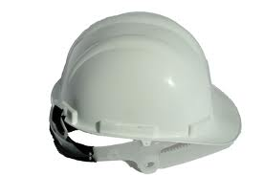

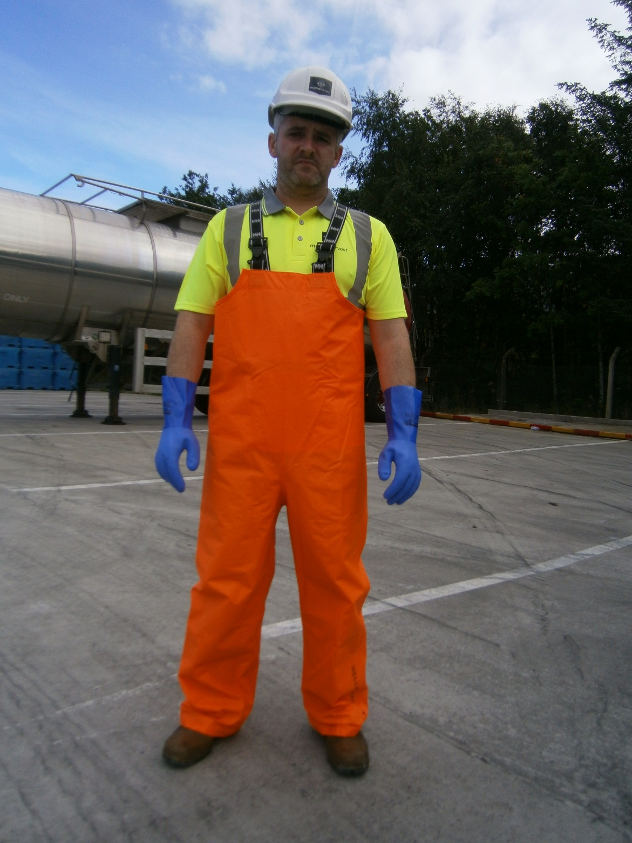
HIGH VISIBLE VEST, CLOTHES
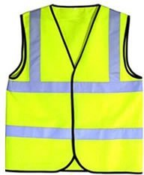

SAFETY BOOTS
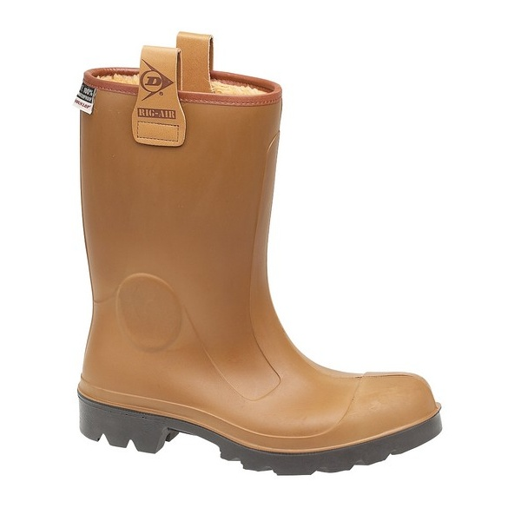

GLOVES


Isolation of Tankers: Odizolwanie cystern:
- Using a safety cones kit, cordone off any tanker(s) which are suspected of having a food safety issue. Przy uzyciu tasmy oraz pacholkow odgrodz cysterny ktore ogoa zawierac zagrozony product (losos)
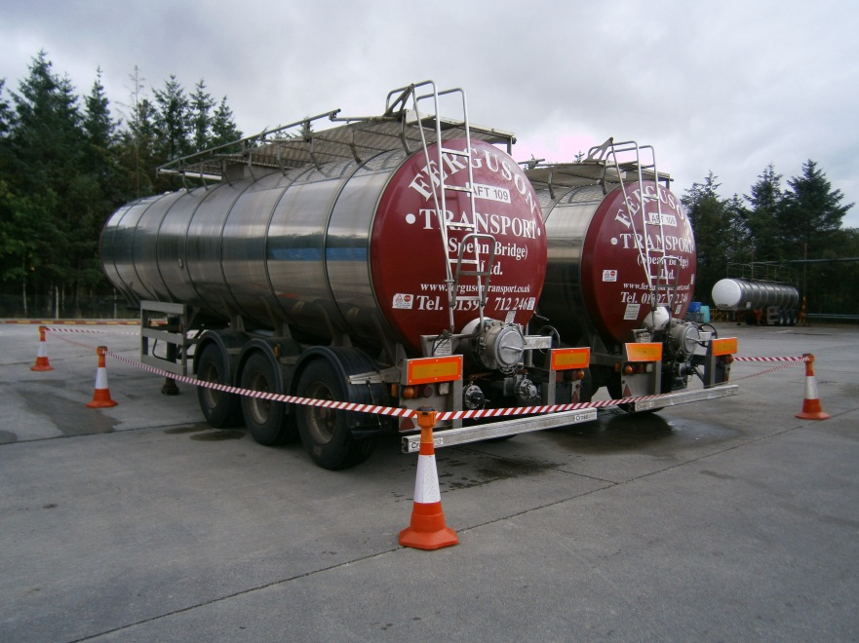

- Place ON HOLD sign on the rear 10” tanker guillotine valve. Umiesc znak HOLD ON na tylnim zaworze gilotynowym.

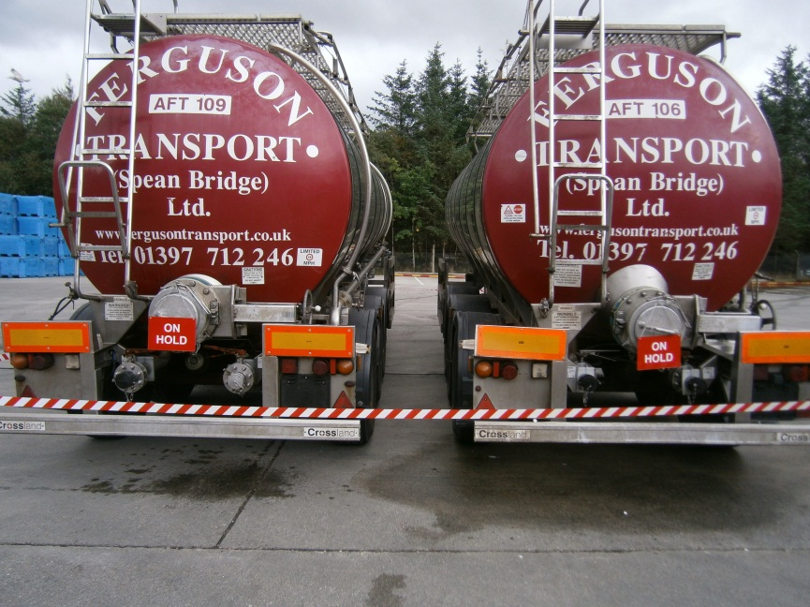
ON HOLD Signs

Isolation of Bins: Odizolowanie binow:

- Using a safety cones kit, cordone off any bin(s) which are suspected of having a food safety issue Przy uzyciu tasmy oraz pacholkow odgrodz pojemniki ktore moga zawierac zagrozony product (losos).
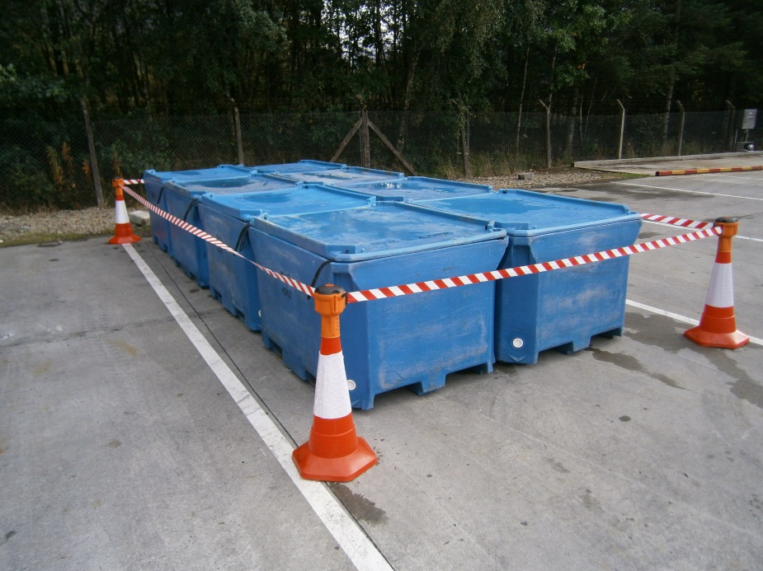
- Display ON HOLD signs. Umiesc znaki HOLD ON.
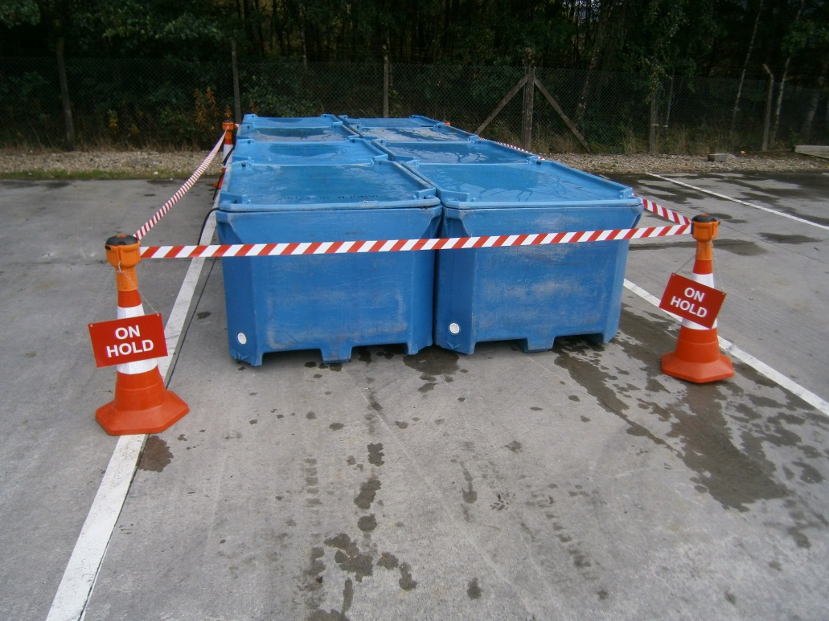
ON HOLD Signs

RISK ASSESMENT
YARD

FOOD SAFETY INCIDENT PRODUCT HOLD YARD

RISK | PERSON AT RISK | SIGNIFICANT HAZARDS | RISK |  |  | RISK CONTROL MEASURES | RESIDUAL RISK
RISK | PERSON AT RISK | SIGNIFICANT HAZARDS | L | S | DR | RISK CONTROL MEASURES | L | S | DR
CHEMICALS |  | N/A |  |  |  | N/A
REPETIVE STRAIN INJURY(R.S.I.) |  | N/A |  |  |  | N/A
UPPER LIMB DISORDER (U.L.D) |  | N/A |  |  |  | N/A
MANUAL HANDLING | YARD STAFF | Risk of strains from handling harvest bins lids | 3 | 4 | 12 | Manual handling training | 2 | 4 | 8
KNIVES |  | N/A |  |  |  | N/A
AEROSOLS |  | N/A
SLIPS TRIPS & FALLS | YARD STAFF | Wet slippery surfaces could cause slips , trips or falls which can be exasperated by severe winter conditions. | 3 | 3 | 9 | Compulsory slips, trips & falls awareness training gritting, gritting, squeegees | 2 | 3 | 6
MACHINERY |  | N/A |  |  |  | N/A
COLD CONDITONS | YARD STAFF | Extremely cold outside temperature | 4 | 3 | 12 | Compulsory use of Yard PPE  Thermal underwear & gloves available  Increased breaks | 2 | 3 | 6
CONGESTED AREAS | YARD STAFF | Fork truck and lorry movements. | 3 | 5 | 15 | PPE, Signage, procedures | 1 | 5 | 5
PRESSURISED SYSTEMS |  | N/A |  |  |  | N/A
CONFINED SPACES | YARD STAFF | N/A |  |  |  | N/A
WORKING AT HEIGHT | YARD STAFF | N/A |  |  |  | N/A
FORKTRUCKS | YARD STAFF | Risk of collision with persons or Vehicles | 3 | 5 | 15 | Compulsory Forklift training  Compulsory Yard personnel , contractor & visitor PPE which includes at minimum Hard Hat & Fluorescent vest  Fork truck audible reverse alarm  Before use check sheet | 2 | 4 | 8
Low 1 to 9 Medium 10 to 16 (Action) High 17 to 25 (STOP)
Risk is the significant hazards identified
Residual risk is the level of risk that remains after suitable and sufficient control measures are introduced

