BLAR mHOR OPERATIONS  STANDARD OPERATING PROCEDURE(SOP) |  |  | 
Title |  |  |  | Version Number
OPERATIONS-SOP-YARD-FISH EVACUATION |  |  |  | 6
Revised or amended date | 01/08/2022 | Next revision date |  | 01/08/2023
The instruction within this document is a guide only and should be an accompaniment to practical training
This document shall only be amended by designated persons on the authorisation of the Processing Departmental Manager

Purpose: This Work Instruction is in place to ensure that in the event of a tanker not being finished before the end of production, all fish are evacuated from the fish pump delivery system.
Instrukcja ma na celu zapewnienie prawidlowego oproznienia system do rozladunku cystern z ryba w przypadku gdy cysterna niezostanie oprozniona do konca
Responsibility: Yard Operatives Pracownik Yardu
Health and Safety: Risk Assessment RA Ocena Ryzyka RA
References: SOP “Fish pump Hygiene”
PPE Required
HELMET
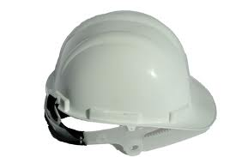

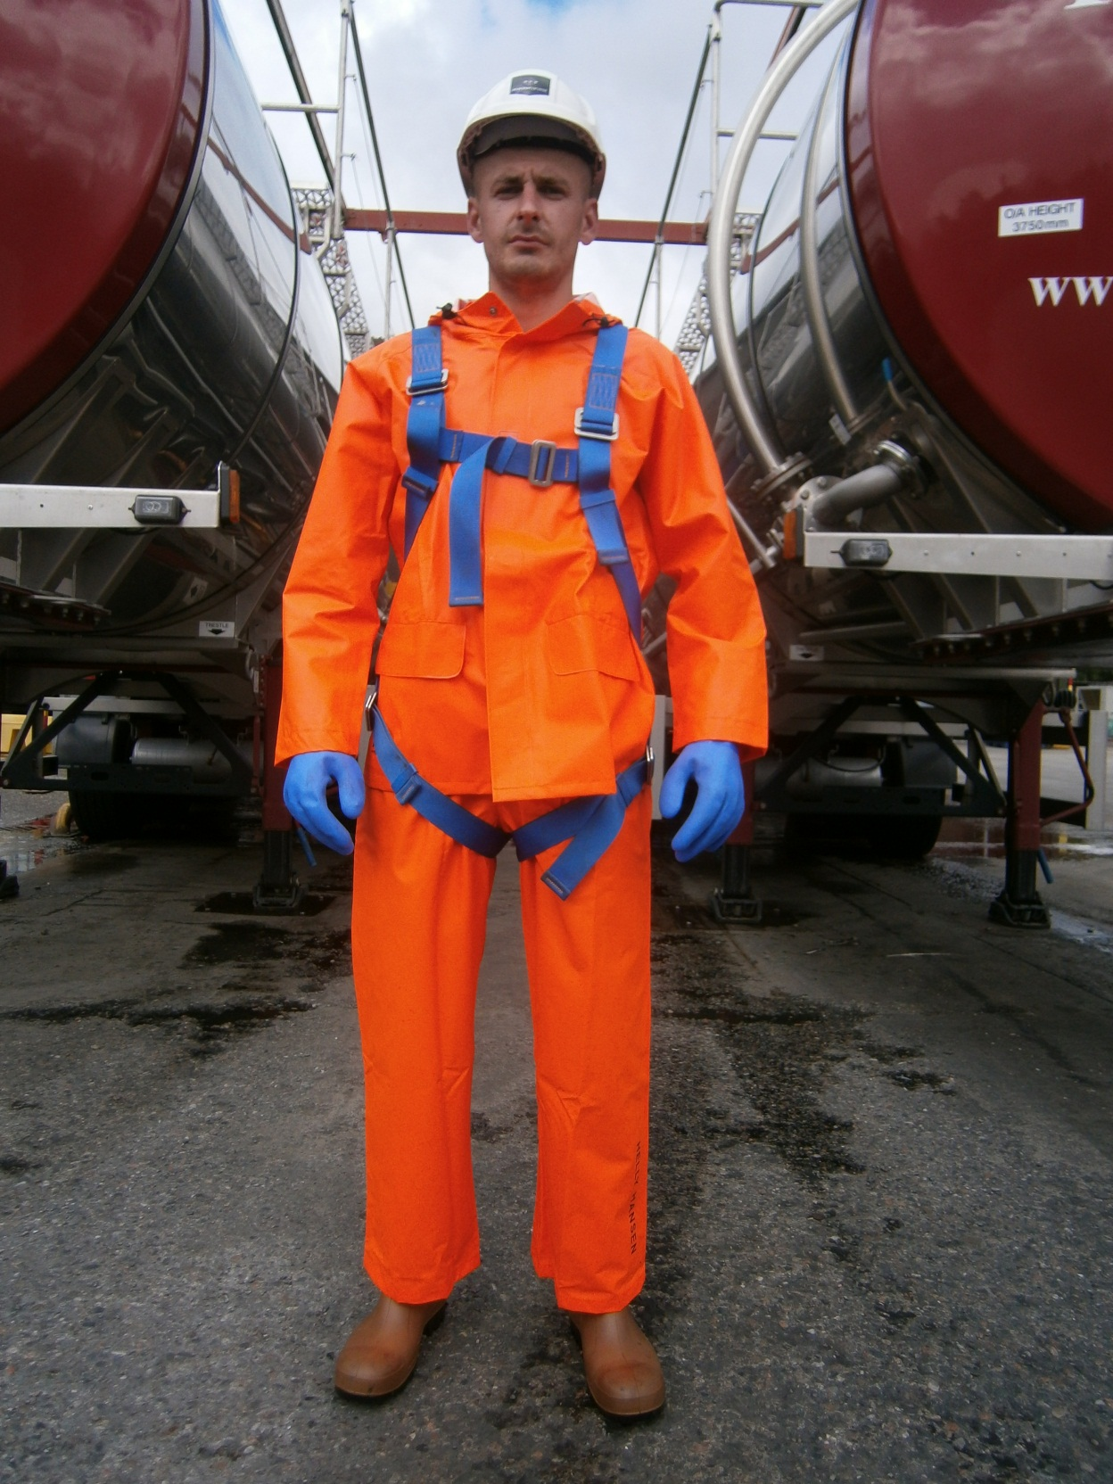
GLOVES


SAFETY HARNESS
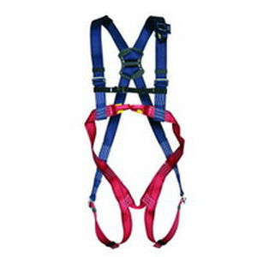

WATERPROOF GEAR
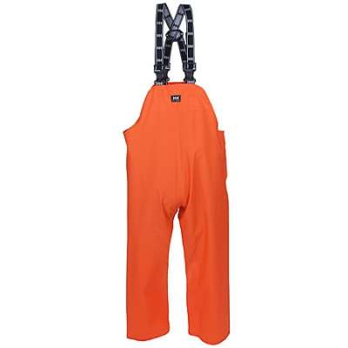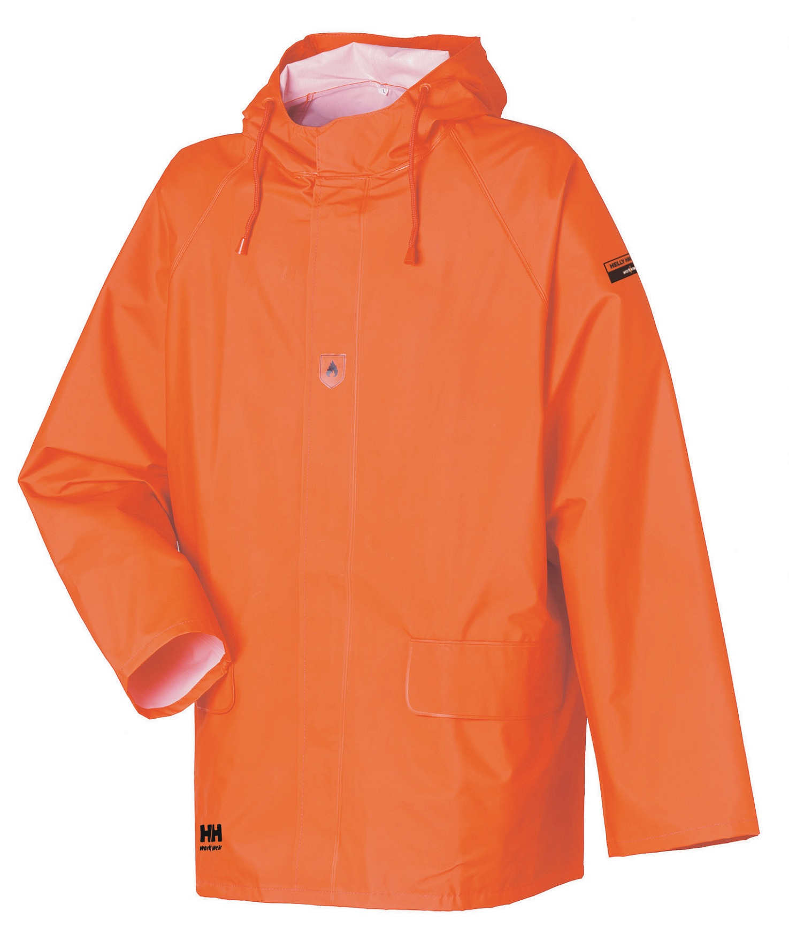

SAFETY BOOTS


If a tanker has been started but will not been finished before the end of a production day the following steps will be taken. Jezeli zaczeto wypompowywac cysterne z ryba lecz niezostala ona oprozniona do konca dnia nalezy wykonac nastepujace czynnosci.

- Shut top hatch. Zamknij gorna pokrywe cysterny.

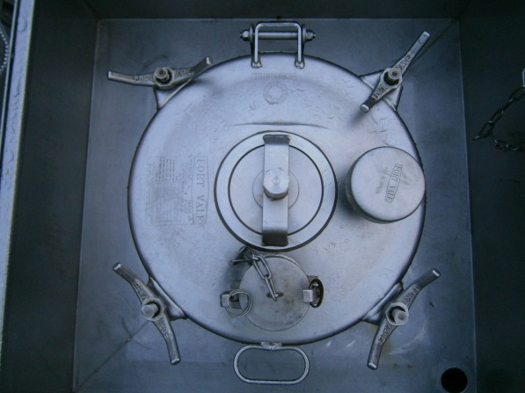

- Shut the 10” tanker guillotine valve. Zamknij gilotynowy zawor cysterny.

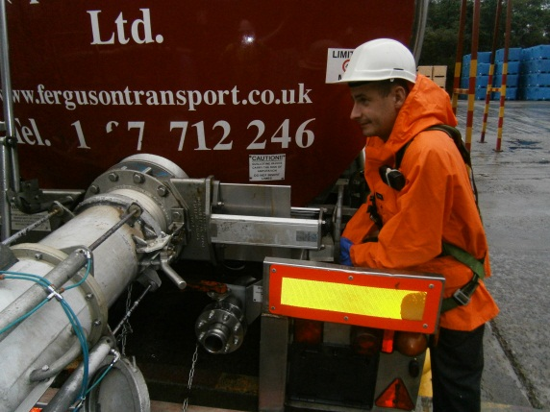

- Using the pneumatic air guillotine valves to shut both lines . Przy pomocy pneumatycznych zaworow zamknij obydwie line.

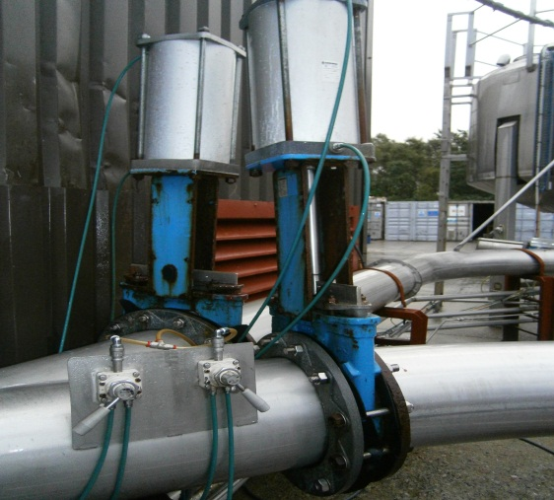

- Using pneumatic air sleeve system disconnect 10” shark hose pipe from the tanker. Przy uzyciu pneumatycznego systemu odlacz rure od cysterny.
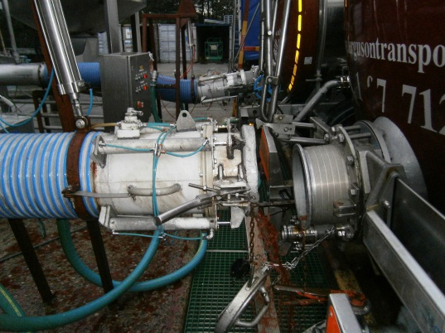
- Move tanker from the tankers bay. Odstaw cysterne z zatoczki.
- Put all remaining fish from the 10” shark hose pipe to the harvest bin prepared as described in “SSW harvest bins preparation” Mark the bin and inform Quality Monitor on duty. Wszystjie ryby ktore zostaly w rurze wrzuc do pojemnika przygotowanego zgodnie z instrukcja SSW
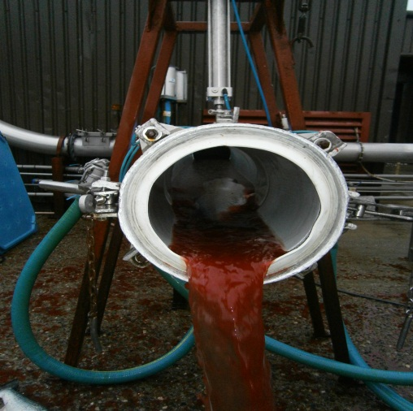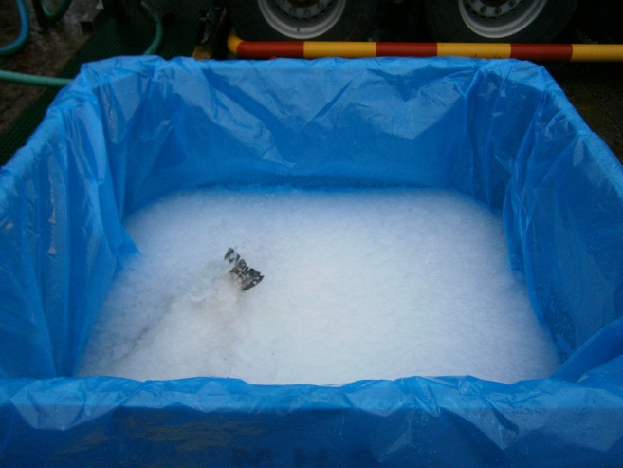

- Fill up flash tank with clean water as described in SOP “Fish pump Hygiene” Napelnij zbiornik do plukania systemu czysta woda tak jak opisano w instrukcj “Fish Pump Hygiene”

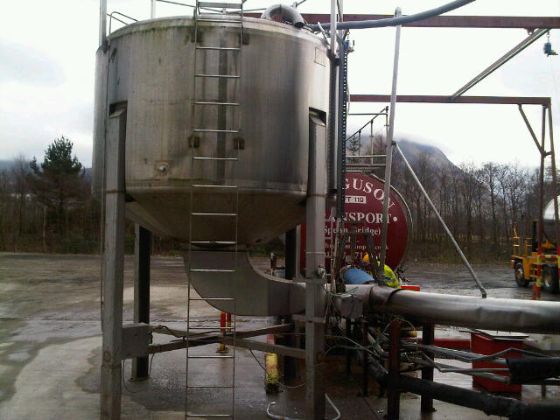

- Flush Fish pump system as described in SOP “Fish pump Hygiene” Przepłukać system tak jak opisano w instrukcji pracy SOP “Fish Pump hygiene”

RISK ASSESMENT
YARD

FISH EVACUATION FROM THE FISH PUMP SYSTEM
RISK |  | PERSON AT RISK | SIGNIFICANT HAZARDS | RISK |  |  |  | RISK CONTROL MEASURES | RESIDUAL RISK
 |  | PERSON AT RISK | SIGNIFICANT HAZARDS | L | S |  | DR | RISK CONTROL MEASURES | L | S | DR
CHEMICALS |  | YARD OPERATIVE | N/A | 3 | 2 |  | 6 | PPE  Chemical handling training | 1 | 2 | 2
REPETIVE STRAIN INJURY(R.S.I.) |  | N/A | N/A |  |  |  |  | N/A
UPPER LIMB DISORDER (U.L.D) |  | N/A | N/A |  |  |  |  | N/A
MANUAL HANDLING |  | YARD OPERATIVE | Risk of strains from handling Tanker connections | 3 | 4 |  | 12 | Manual handling training | 2 | 4 | 8
KNIVES |  | N/A | N/A |  |  |  |  | N/A
AEROSOLS |  | N/A | N/A
SLIPS TRIPS & FALLS |  | YARD OPERATIVE | Wet slippery surfaces could cause slips , trips or falls which can be exasperated by severe winter conditions. | 3 | 3 |  | 9 | Compulsory slips, trips & falls awareness training gritting, gritting, squeegees | 2 | 3 | 6
MACHINERY |  | YARD OPERATIVE | Risk of injury from Tanker connections, valves. | 3 | 4 |  | 12 | N/A | 2 | 4 | 8
COLD CONDITONS |  | YARD OPERATIVE | Extremely cold outside temperature | 4 | 3 |  | 12 | Compulsory use of Yard PPE  Thermal underwear & gloves available  Increased breaks | 2 | 3 | 6
CONGESTED AREAS |  | YARD OPERATIVE | Fork truck and lorry movements. | 3 | 5 |  | 15 | PPE, Signage, procedures | 1 | 5 | 5
PRESSURISED SYSTEMS |  | YARD OPERATIVE | Risk of injury from airlines. | 2 | 4 |  | 8 | P.P.E, staff training and procedures. | 1 | 4 | 4
CONFINED SPACES |  | N/A | N/A |  |  |  |  | N/A
WORKING AT HEIGHT |  | YARD OPERATIVE | Risk of falling from while climbing up to or on top of Tankers | 5 | 5 |  | 25 | Compulsory use of Harness & Fall Arrester | 1 | 5 | 5
FORKTRUCKS |  | YARD OPERATIVE | Risk of collision with persons or Vehicles | 3 | 5 |  | 15 | Compulsory Forklift training  Compulsory Yard personnel , contractor & visitor PPE which includes at minimum Hard Hat & Fluorescent vest  Fork truck audible reverse alarm  Before use check sheet | 2 | 4 | 8
Low 1 to 9 Medium 10 to 16 (Action) High 17 to 25 (STOP)
Risk is the significant hazards identified
Residual risk is the level of risk that remains after suitable and sufficient control measures are introduced

