BLAR mHOR OPERATIONS  STANDARD OPERATING PROCEDURE(SOP) |  |  | 
Title |  |  |  | Version Number
OPERATIONS-SOP-HARVESTING-REMOVAL OF DISPATCHED/TRAPPED FISH FROM RB6-RB7 MACHINES |  |  |  | 6
Revised or amended date | 01/08/2022 | Next revision date |  | 01/08/2023
The instruction within this document is a guide only and should be an accompaniment to practical training
This document shall only be amended by designated persons on the authorisation of the Processing Departmental Manager

Purpose: This operating procedure covers the safe removal of dispatched / trapped fish from the RB6-RB7 Stunning, bleeding machines
Responsibility: All personnel
Health and Safety: Protective clothing, Protective footwear, Protective gloves (where required), Safety goggles (where required)
References: RA

Task steps: | Precautions / considerations:
- Eye Check  & inform | - Always complete an Eye-Check Risk Assessment!  - Ensure all personnel are aware the process taking place
- Hazard Identification | Pneumatically controlled Stunner / bleeding machines Models RB6 – RB7 pose a  significant risk to the operator if the correct isolation procedures are not followed  prior to manually extracting dispatched, trapped fish from the blade – hammer  mechanisms
- Warning signage  & Safety measures | Bleeding blade  Warning signage  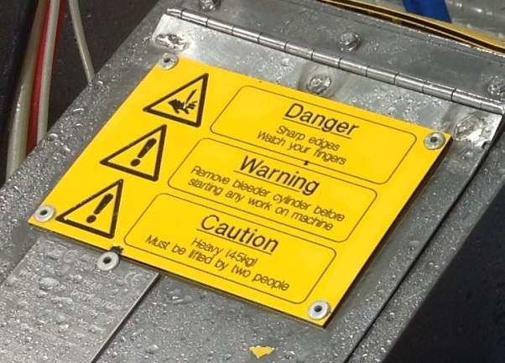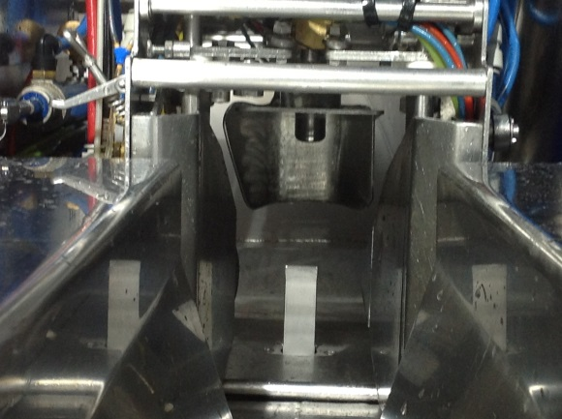  - Danger – Sharp edges watch your fingers  - Warning – Remove bleeder cylinder before starting any work on machine  - Caution – Heavy (45kg) Must be lifted by two people  Note:  Only trained experienced machine minders will operate this machinery.  Only trained experienced service engineers will service, adjust and maintain this machinery  Both the RB6 – RB7 machines models must have their HAMMER & KNIFE mechanisms isolated before a manual extraction of trapped fish is attempted.  Under no circumstances must the manual extraction of trapped fish take place without the isolation of pneumatic air supply to the Hammer & Knife mechanisms, failure to follow this procedure could lead to serious injury.
- RB6-RB7 Machine models | RB6 Model operates with airflow controls & valves  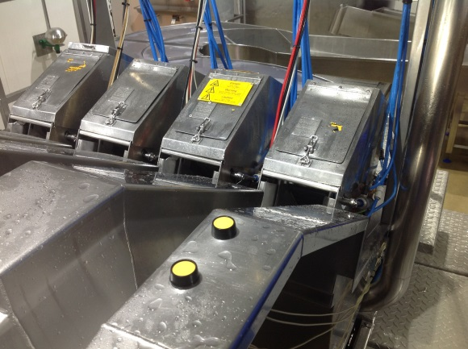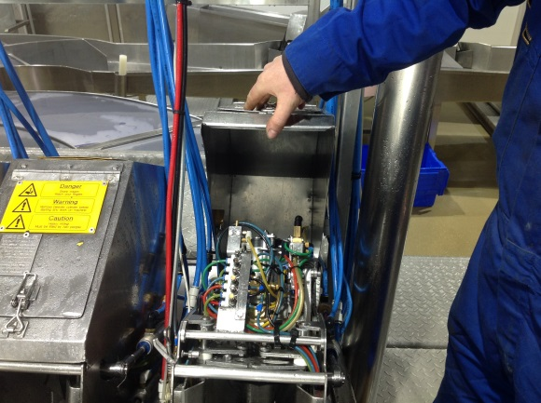  RB7 Model (later revised model) operates utilizing solenoids and PLC control  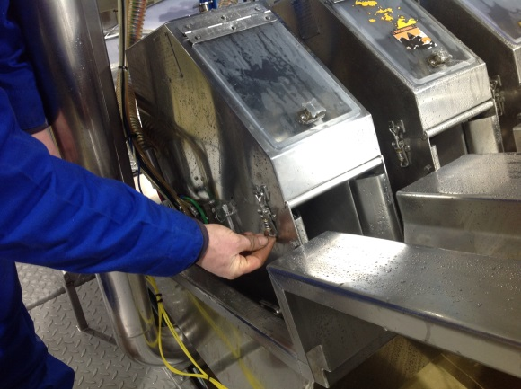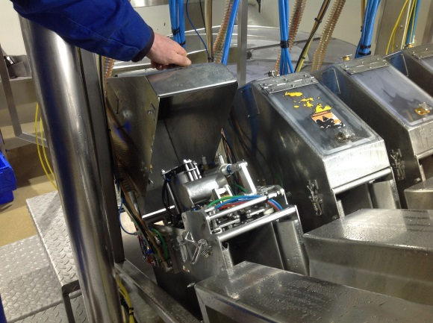
- Resetting the machine via the auto reset buttons | Under normal circumstances pressing the automatic reset button of either the RB6-RB7  machines will retract the hammer and the blade mechanisms, opens the FAD fish  alignment device and opens the trigger plate, releasing trapped fish  Should a fish become trapped in the machine mechanism for any reason your first course of  action will be to:  - Press the Automatic Reset Button on both the RB6 / RB7 Models  - Machines will reset retracting blade and hammer mechanisms allowing trapped fish to pass through the machine  - The RB6 machine also has a reset button accessible under the machine hood via the access cover, press this to reset the machine  Reset Button RB6 / RB7 Models Reset button (RB6 only) Hood access  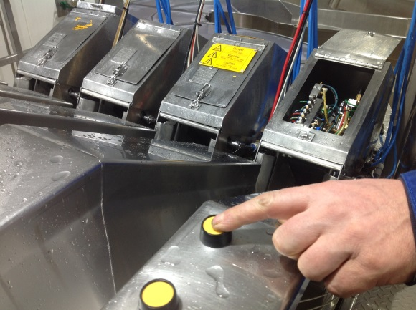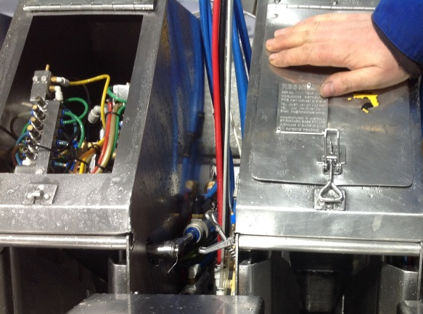  - At this stage it is not necessary to isolate the pneumatic air supply  - Only if the auto reset procedure fails to release trapped fish should you undertake a manual extraction  At no time put your hand / hands into the knife / hammer mechanism area unless the machines pneumatics have been isolated and system has been given time to exhaust
- Pneumatic isolation in order to manually extract trapped fish | If the automatic reset procedure for the RB6 / RB7 machines fails to release trapped fish a manual extraction must be performed.  Until the Pneumatics have been fully isolated and the machine given time to fully exhaust the machine can be presumed live and therefore a serious risk of injury from the knife and hammer remains  Isolating the pneumatics for RB6 / RB7 machines  The air supply to the machine must be isolated in order as described below  - Isolate Knife - RED Airline  - Isolate Hammer - Black airline  - Isolate Air Control - Grey airline  - Allow the airline to fully exhaust before proceeding  ( you may be able to hear the air exhausting, this will take few seconds)  Note: Blue lines are extraction lines for removing ozone’s only  - When turning the machine back on repeat the same procedure in reverse order  Red = Knife feed Black = Hammer feed Grey = Control feed  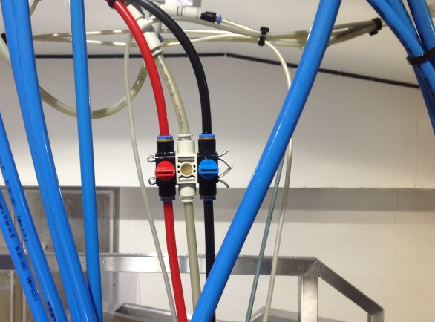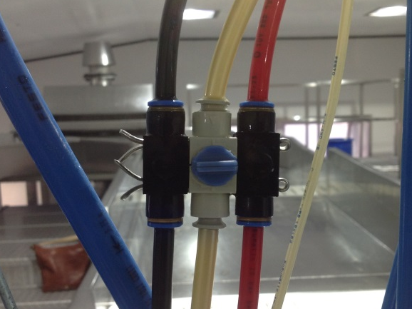
- Opening the machine to access hammer cylinder | Opening the machine hood will fully exhaust the airlines and expose the hammer  cylinder  - Release and lift RB6 / RB7 machine hood cover  - Once opened any residual air will be exhausted (this may take a few seconds)  - The hammer cylinder is now ready to be lifted  Note: you should not put your hand / hands into the trigger, knife or hammer zone at any point  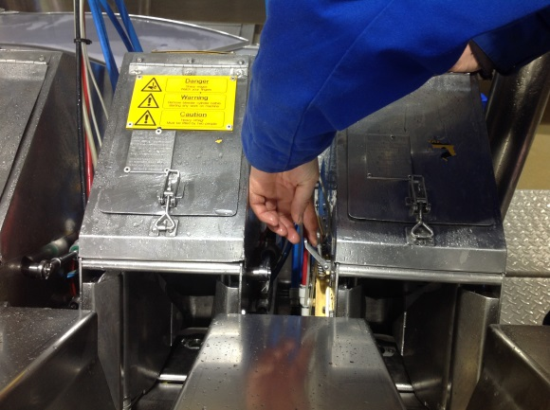  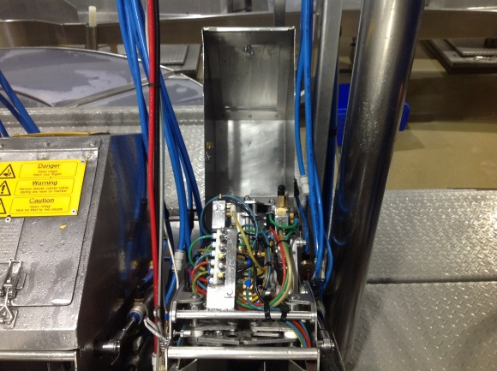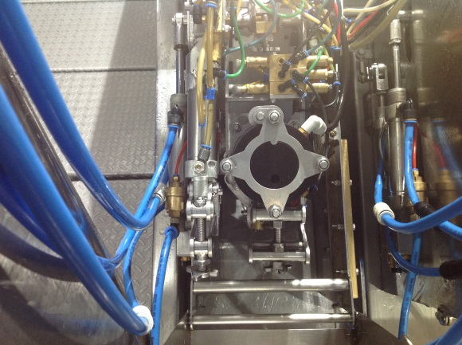
- Lifting the hammer cylinder | Once exposed you can now access and lift the hammer cylinder allowing the safe manual  removal of trapped fish  - Place hand on top of the cylinder and lift, if there is resistance, wait a few seconds there may still be air that requires exhausting from the system  - Once all air has been exhausted, the cylinder will lift freely and trapped fish can be safely removed  Note: take care to keep hand / hands clear of knife area at all times  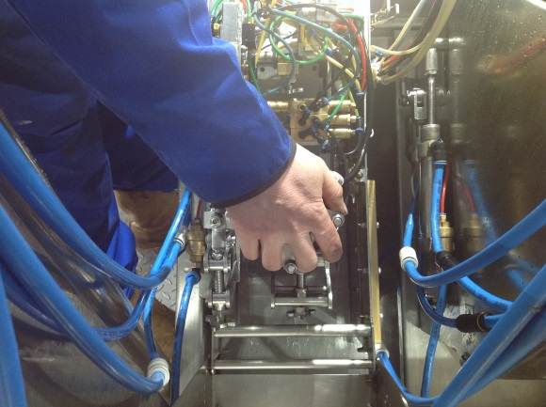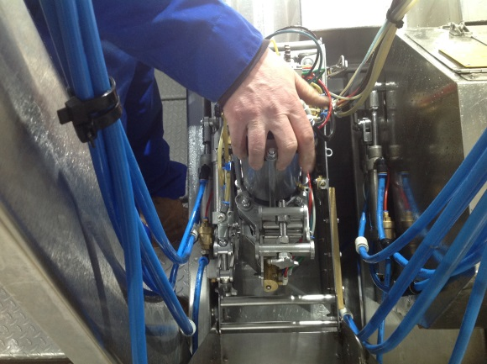  Once the trapped fish has been safely removed the machine can be reinstated  - Drop the hammer cylinder back into position  - Close the machine cover and latch in place  - Turn on Air control = Grey  - Turn on Hamer = Black  - Turn on Knife = Red  - Press reset button  - Remember failure to follow the safe operations procedure puts the operator at serious risk of injury  - Never put hand / hands into the Blade mechanism – hammer mechanism area of this machine  - Ensure the machine has been isolated and all air fully exhausted before opening the machine and performing a manual extraction of a trapped fish

Ergonomic Risk Factors | Explanation and mitigation techniques
Musculoskeletal  strains, sprain type injuries | - Musculoskeletal injuries due to incorrect manual handling techniques  - Tissue bone damage from exposure to sharp knife blade  - Use correct manual handling techniques when lifting heavy objects  - Correct safe operating procedure to be used at all times  - Appropriate PPE must be worn

Note: If you come across any hazards not covered in this document, contact the Mowi Scotland Health and Safety Department to assist with developing safety measures and controls

Site Notes: ________________________________________________________________________________________________________________________________________________________________________________________________________________________________________________________________________________________________________________________________________________________________________________________________________________________________
________________________________________________________________________________________________________________________________________________________________________________________________________________________________________________________________________________________________________________________________________________________________________________________________________________________________

ACTIVITY | PERSON AT RISK | SIGNIFICANT HAZARDS | RISK * |  |  | RISK CONTROL MEASURES | RESIDUAL RISK **
ACTIVITY | PERSON AT RISK | SIGNIFICANT HAZARDS | L | S | DR | RISK CONTROL MEASURES | L | S | DR
Removal of trapped fish from Pneumatic stunner mechanism | Machine minders & engineers | Risk of serious injury from RB6 – RB7 Machines  Pneumatic Hammer  Pneumatic Knife  Failure to isolate Air supply to:  Knife mechanism  Hammer mechanism  Air control | 4 | 5 | 20 | - Never insert your Hand / hands into the machine to retrieve / extract trapped fish  - Ensure correct warning signage / labelling is present and clear on all machinery  - All involved to read and sign Safe operating procedure  - Safe operating procedure must be followed when extracting trapped fish from mechanism  - Only Machine minders / engineers to perform task  - Isolate air supply to knife  - Isolate air supply to hammer  - Isolate air control  - Ensure all air has been exhausted before opening machine cover  - Wait a few seconds once machine cover is opened to ensure all air is fully exhausted | 2 | 5 | 10
Removal of trapped fish from Pneumatic stunner mechanism | Machine minders & engineers | Risk of serious injury from RB6 – RB7 Machines  Failure to isolate air supply to the knife mechanism, hammer mechanism and air control in the correct order can leave blade in an exposed position | 3 | 5 | 15 | - Never insert your Hand / hands into the machine to retrieve / extract trapped fish  - Isolation of air supply to cylinders must be carried out in correct order  - Isolate air supply to knife  - Isolate air supply to hammer  - Isolate air control  - Reverse air isolation order when reinstating machine | 2 | 5 | 10

