BLAR mHOR OPERATIONS  STANDARD OPERATING PROCEDURE(SOP) |  |  | 
Title |  |  |  | Version Number
OPERATIONS-SOP-HARVESTING-STUNNERS RB6 CLEANING |  |  |  | 6
Revised or amended date | 01/08/2022 | Next revision date |  | 01/08/2023
The instruction within this document is a guide only and should be an accompaniment to practical training
This document shall only be amended by designated persons on the authorisation of the Processing Departmental Manager

Purpose: To maintain harvesting RB6 Stunners in a clean and sanitized condition. Utrzymanie ogluszczy RB6 w nalezytej czystosci.
Responsibility: Hygiene operators Osoby wyznaczone do sprzatania
Health and Safety: Risk Assessment Ocena Ryzyka
When working with chemicals eye protection and face mask must be worn. Podczs pracy z chemikaliami uzywaj gogle,przylbice oraz sprzet ochronny gornych drog oddechowych (maski) .
References: On Site Harvest Station Hygiene check list LOG Kontrolna lista prac LOG

Approved Chemicals Used & Dilution Zatwierdzone substancje chemiczne |  |  |  | Equipment Wyposazenie | Comments Komentarz
Product Produkt | Use % Stosowac% | Symbol Symbol | Hazard Ryzyko | Equipment Wyposazenie | Comments Komentarz
SUPERKLENZ | 5 % | ALKALINE |  | Sprayer Spryskiwacz | Used in spray all harvest floor equipment. Urzywac do spryskiwania stacji polowow.
STERIKLENZ 5 | 2 % |  |  | Sprayer Spryskiwacz | Used in spray all harvest floor equipment. Urzywac do spryskiwania stacji polowow.

PPE Required:
RESPIRATOR MASK OR PROTECTIVE EYEWEAR (WORN WHEN REQUIRED)
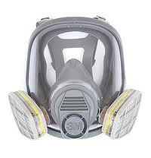

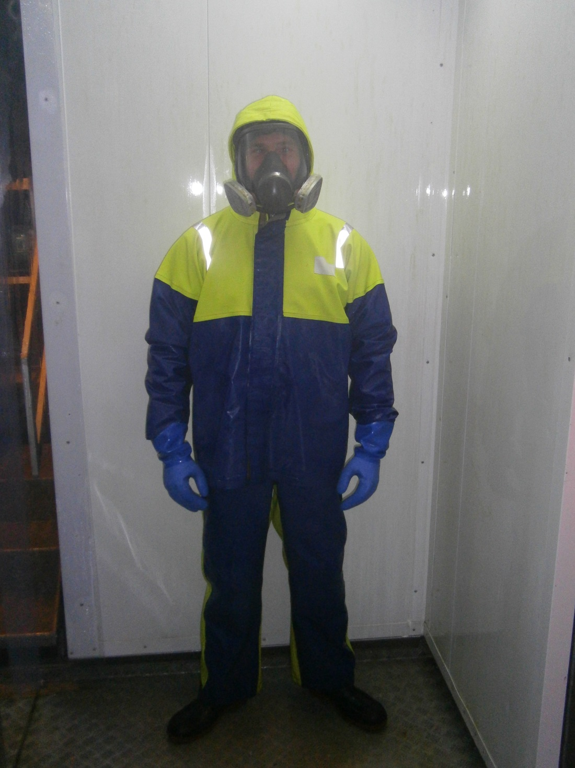
WATERPROOF BOOTS
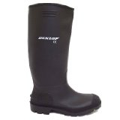

OIL SKIN / WATERPROOF GEAR
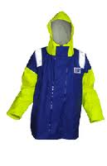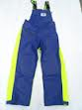

GLOVES
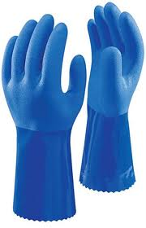

Switch off the air supply and release all remaining air from the air lines. Ensure that all air valves are closed before cleaning has been begun. Wylacz zasilanie powietrza oraz wypusc pozostale powietrze z przewodow. Przed rozpoczeciem pracy upewnij sie ze wszystkie zawory od powietrza sa zamkniete.

Wash Down. Mycie.
For ease of cleaning remove the Stunner from the ‘Stunning Slope Table’ and place it on the ‘bleeding table’. W celu ulatwienia czynnosci zwiazanych z czyszczeniem ogluszacza przenies maszyne ze stolu skosnego na stol plaski (bleeding table)
- Release clamps and swing cover back. Zwolnij zaciski i odchyl pokrywe ogluszacza do tylu.
- Using a freshwater hose, clean thoroughly all external and internal surfaces of the Stunner cover. Za pomoca czystej wody splukaj dokladnie wszystkie zewnetrzne i wewnetrzne powierzchnie pokrywy ogluszacza.
- Remove the Stunner sleeves and place them in the designated container. Usun plastkowe nakladki i umiesc je w wyznaczonym do tego pojemniku.
- Release the ‘Hammer Cylinder Lock’, disconnect the air supply hoses. Take the ‘Hammer Cylinder’ away for cleaning. Zwolnij zacziski mlotka, odlacz przewody powietrza, nastepnie wyciagnij mlotek w celu dokladnego umycia.
- Working from the top to the bottom, thoroughly wash all external and internal surfaces of the Stunner. Umyj dokladnie z gory do dolu wszystkie zewnetrzne i wewnetrzne powierzchnie ogluszacza.

Spraying of chemicals.
Natrysk chemikalii.

Preparation of chemicals (5% solution): Przygotowanie chemikalii (roztwor 5%):

- Pour 5 l clean water into the bucket(blue). Do niebieskiego wiaderka wlej 5 litrow czystej wody.
- Measure 200 ml of approved chemicals and carefully pour into the bucket with clean water. Odmierz 200 ml zatwierdzonych chemikalii i ostroznie wlej do niebieskiego wiaderka z czysta woda.
- Stir well. Dobrze wymieszaj.
- Ready solution put into the sprayer. Gotowy roztwor wlej do spryskiwacza.
- 5.Screw the top on. Tighten so that the pressure will not escape from the tank. Dobrze zamknij gorna pokrywe spryskiwacza mocna ja dokrecajac.
- 6.Rinse the bucket and measuring jug with clean water. Wiadro i dzban do odmierzania chemikalii dokladnie oplukaj czysta woda.
- 7.Pump the handle to increase pressure inside the tank. Pompojac za pomoca raczki znajdujacej sie na gorze spryskiwacza zwiekszysz cisnienie wewnatrz pojemnika.

Thoroughly spray all external and internal surfaces of the machine and leave in contact with the chemicals for 10 minutes before ‘green pad’ cleaning can begin. Spryskaj dokladnie wszystkie zewnetrzne i wewnetrzne powierznie ogluszacza a nastepnie pozostaw na okres 10 minut.

Cleaning with Green Pads and Brushes. Czyszcenie za pomoca zielonych scierek i szczotek.
Using a green pad clean all external and internal surfaces and parts of the machine. For cleaning narrow hard accessible surfaces use bottle type brushes.
Za pomoca zieloch scierek dokladnie wyczysc wszystkie zewnetrzne oraz wewnetrzne powierzchnie ogluszacza. Do czyszcenia trudno dostepnych miejsc uzyj szczotki.

Rinse
Working from the top to the bottom rinse all external and internal surfaces of the machine.

Disinfection:
Dezynfekcja:

Preparation of Sanitizer 2% solution: Przygotowanie dezynfektantu(roztwor 2%):

- Pour 5l. clean water into the bucket(red) . Do czerwonego wiaderka wlej 5 litrow czystej wody.
- Measure 100 ml. of approved Sanitizer and pour into the bucket with clean water. Odmierz 100 ml Sanitaizera i ostroznie wlej do czerwonego wiaderka z czysta woda.
- Stir well. Dobrze wymieszaj.
- Ready solution pour into the sprayer. Gotowy roztwor przelej do spryskiwacza.
- Screw the top on. Tighten so that the pressure will not escape from the tank. Dobrze zamknij gorna pokrywe spryskiwacza mocna ja dokrecajac.
- Rinse the bucket and measuring jug with clean water. Wiadro i dzban do odmierzania sanitaizera dokladnie oplukaj czysta woda.
- Pump the handle to increase pressure inside the tank. Pompojac za pomoca raczki znajdujacej sie na gorze spryskiwacza zwiekszysz cisnienie wewnatrz pojemnika.

Thoroughly spray all external and internal surfaces of the machine.
Note- Disinfectant left on the Stunner must be rinsed with fresh water prior harvest. Uwaga-dezenfektant po natrysku jest pozostawiony do nastepnego polowu na powierzchniach ogluszacza. Przed rozpoczeciem nastepnego polowu konieczne jest splukanie dezynfektantu za pomoca czystej wody.

Sleeves
Plastikowe Nakladki
- Using fresh water and green pads thoroughly wash the sleeves. Za pomoca czystej wody i zielonych scierek umyj dokladnie plastikowe nakladki.
- Soak sleeves in designated container with 2% Sanitizer solution. Zamocz nakladki w pojemniku z 2% roztworem Dezynfektantu.

RISK ASSESMENT
ON SITE-HARVEST
Stunners RB6- Cleaning
RISK | PERSON AT RISK | SIGNIFICANT HAZARDS | RISK |  |  | RISK CONTROL MEASURES |  | RESIDUAL RISK
RISK | PERSON AT RISK | SIGNIFICANT HAZARDS | L | S | DR |  |  |  | L | S | DR
CHEMICALS AND HAZARDOUS SUBSTANCES HANDLING | ALL STAFF | Risk due to contact with cleaning compounds  Risk of injury due to incorrect handling / usage of diesel fuel | 3 | 4 | 12 |  | MH Chemical Handling training  All chemicals stored in suitable, identifiable and designated containers  PPE (and PPE pre use check)  First Aid personnel part of harvest team |  | 2 | 3 | 6
NIGHT TIME WORKING/ WORKING IN LOW LEVEL LIGHT | ALL STAFF | Risks due to working at night or in low level lights conditions :  Slips trips falls.  Working over water  Working with machinery | 4 | 5 | 20 |  | Start-up check sheet  Adequate lighting to be maintained at all times in all areas of operations  High visibility clothing issued as PPE  Safety helmets fitted with head torches  High standard of housekeeping to be maintained |  | 2 | 3 | 6
HOUSEKEEPING |  | Slips, trips & falls  Contact with equipment & machinery | 4 | 5 | 20 |  | High standard of housekeeping to be maintained at all times.  Staff training and awareness |  | 2 | 3 | 6
MANUAL HANDLING | ALL STAFF | Risk due to incorrect lifting techniques, repetitive lifting, lifting excessive loads | 4 | 4 | 16 |  | MH training programme  Staff awareness  Lifting aids (Winches, Lift trucks etc.)  PPE (and PPE pre use check)  First Aid personnel part of harvest team |  | 2 | 4 | 8
KNIVES | ALL STAFF | Risk of injury while cleaning knives | 2 | 3 | 6 |  | PPE. Staff training |  | 1 | 3 | 3
SLIPS TRIPS & FALLS | ALL STAFF | Wet slippery surfaces could cause slip, trips or falls. | 3 | 3 | 9 |  | Compulsory Slips trips & falls awareness training. Squeegees. Fall back rails. |  | 2 | 3 | 6
COLD CONDITONS | HYGIENE OPERATOR | Extremely cold outside temperature | 4 | 3 | 12 |  | PPE  Thermal underwear & gloves available  Increased breaks |  | 2 | 3 | 6
PRESSURISED SYSTEMS | HYGIENE OPERATOR | Risk of injury from airlines. | 2 | 4 | 8 |  | P.P.E, staff training and procedures. |  | 1 | 4 | 4
Low 1 to 9 Medium 10 to 16 (Action) High 17 to 25 (STOP)
Risk is the significant hazards identified
Residual risk is the level of risk that remains after suitable and sufficient control measures are introduced

