BLAR mHOR OPERATIONS  STANDARD OPERATING PROCEDURE(SOP) |  |  | 
Title |  |  |  | Version Number
OPERATIONS-TANKER BAY-TANKER BAY OPERATIONS |  |  |  | 9
Revised or amended date | 01/08/2022 | Next revision date |  | 01/08/2023
The instruction within this document is a guide only and should be an accompaniment to practical training
This document shall only be amended by designated persons on the authorisation of the Processing Departmental Manager

Purpose: To ensure tankers are operated and maintained to company procedures
Responsibility: Yard Operatives Pracownik Yardu
Health and Safety: Risk Assessment Ocena Ryzyka
Compulsory use of Harness and Lifeline / Fall Arrester Wymagane jest obowiazkowe uzywanie szelek bezpieczenstwa oraz lin zabezpieczajacych przed upadkiem
References: LOGTanker Cleaning Logsheet
PRO-Blar Mhor Yard Temperature Hold Procedure
..\LOG SHEETS\blar mhor tanker slush checks .xls
..\LOG SHEETS\Harness Log.xls

PPE Required:
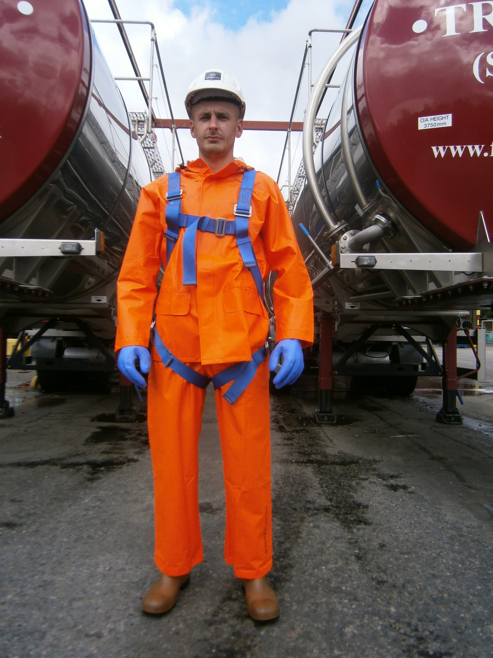
GLOVES


SAFETY BOOTS


HELMET
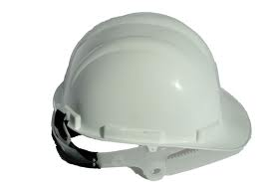

OIL SKIN / WATERPROOF GEAR
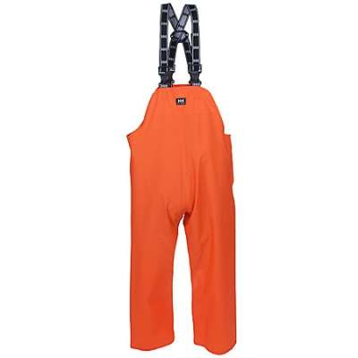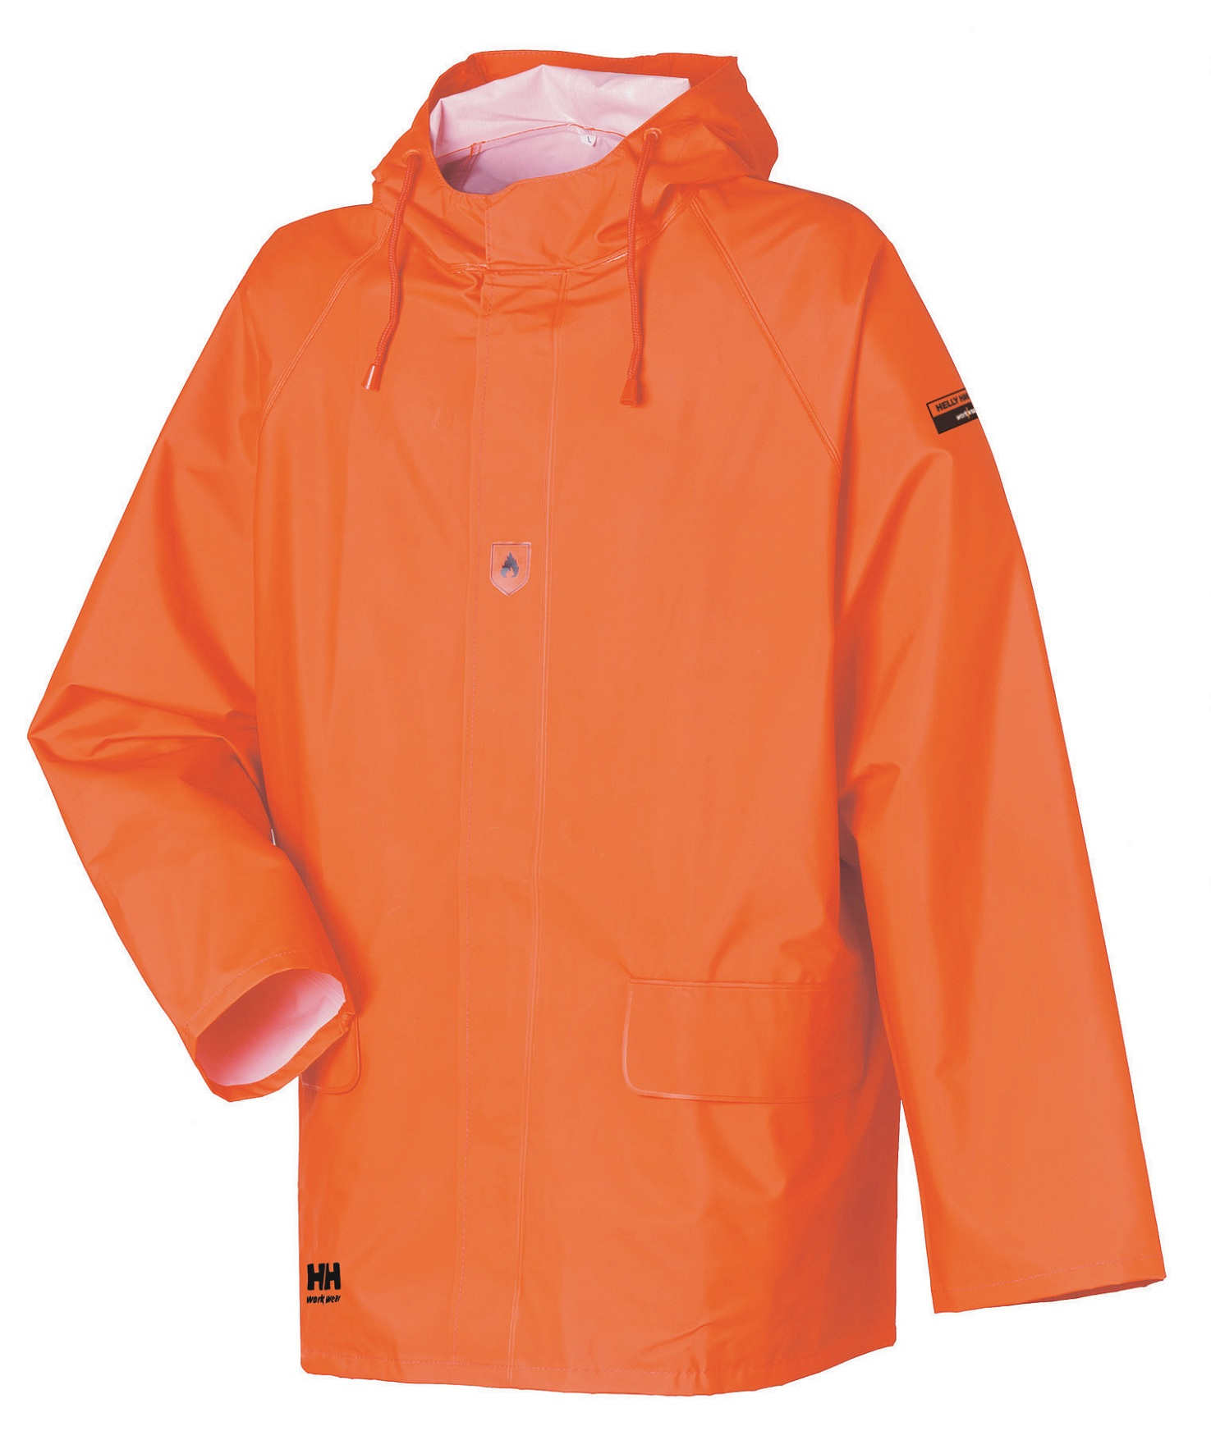

SAFETY HARNESS
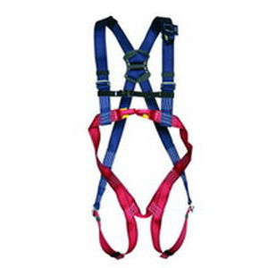

Pre-Processing checks
Intake Area : –
- The blood return main pipe valve must be in the closed position , this located to the right of the intake area on framework below the Bin tipper , photo shows the Closed position Zawor glownej rury od powrotnej wody musi znajdowac sie w pozycji zamknietej. Zawor ten umiejscowiony jest po prawej stronie pomieszenia na ramie ponizej urzadzenia sluzacego do oprozniania binow. Na zdjeciu zaor w pozycji zamknietej.

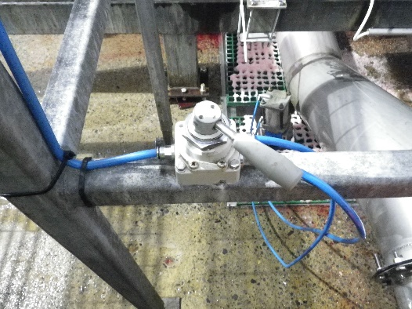

- The Safety hood on the exit of the fish discharge pipe MUST be down and secured while the fish pump is in operation Okap zabezpieczajacy znajdujacy sie na koncu rury sluzacej do rozladunku ryby z cystern MUSI byc opuszczony oraz odpowiednio zabezpieczony podczas uzywania pompy (fish pump)
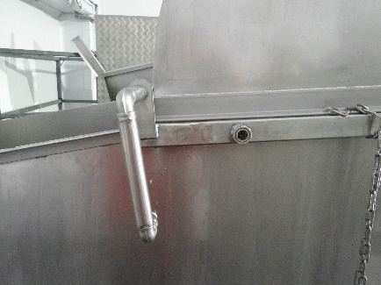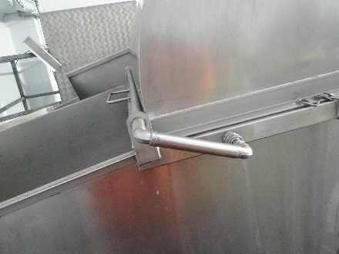
Closed
Open

- The drain valve for the blood return tank is located on the left hand side of the intake area at the top of the stair and should be closed, as per photo below , when the fish pump is in operation. Zawor spustowy od zbiornika z woda powrotna znajduje sie po lewej stronie pomieszczenia na gorze schodow. Zawor powinien znajdowac sie w pozycji zamknietej.
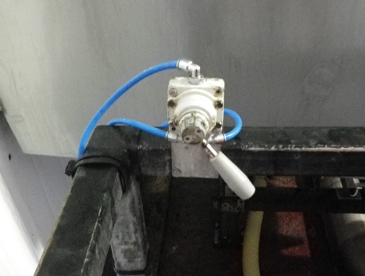
Pump Room : –
- The fish pump water valve must be in the open position as below Zawor wody od pompy musi byc w pozycji otwartej. Zdjecie ponizej
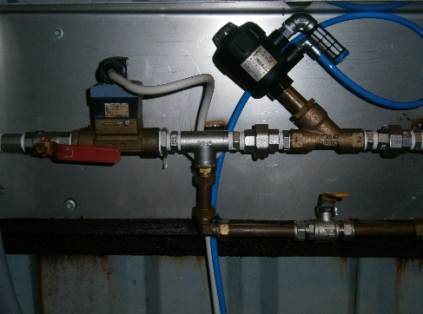

- From the main control panel turn the red switch to the ON position Ustaw czerwony przelacznik znajdujacy sie na glownym panelu w pozycji ON
- press the white ‘alarm water’ button, next press green ‘start button’ Nacisnij bialy przycisk ‘alarm water’ nastepnie nacisnij zielony przycisk ‘start’
- Tanker bay operator must inform the Intake Operator via radio that the tanker is ready to discharge Operator cystern za pmoca radia musi poinformowac pracownika odpowiedzialnego za pobor ryby na hale patroszenia ze cysterna jest gotowa do wypompowania.

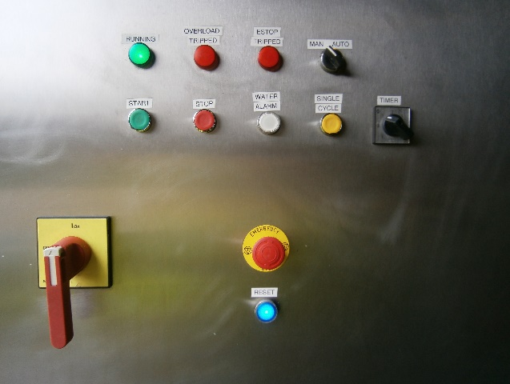

During Processing
Tanker selection Wybor kolejnosci cystern
- A list of the tanker Processing running order is issued by the Quality Monitor before processing begins , Tanker Cleaning Logsheet , it is critical that this order is maintained unless otherwise instructed by the Quality Monitor or Team Leader Formularz kontroli czyszczenia z numerami cystern oraz kolejnoscia wypompowywania ich wydawany przez pracownikow kontroli jakosci ‘Quality Monitor’ przed rozpoczeciem produkcji. Kolejnosc cistern MUSI byc przestrzegana zgodnie z formularzem. Informacje o ewentualnej zmianie kolejnosci moze podac pracownik kontroli jakosci badz kierownik zespolu.
Tanker Positioning Ustawienie Cysterny
- Make sure bays are clear and clean ready for tankers Upewnij sie ze zatoczki sa puste i gotowe na wjazd cystern.
- The Tanker Bay Operator must maintain communication with the shunter driver whilst the tanker is parking onto the discharge bay. Operator Cystern musi utrzymywac komunikacje z manewrowym oraz pomoc bezpiecznie wprowadzic cysterne do zatoczki.
- Once the tanker has been parked correctly support legs will be lowered, the drive unit removed and safety cones put in place in front of the tanker. Only after the driving unit is away should the Tanker Bay Operator proceed with the operation Gdy cysterna zostanie odpowiednio zaparkowana wsporniki zostana opuszczone w celu zabezpieczenia cysterny. Po odstawieniu pojazdu manewrowego nalezy ustawic slupki bezpieczenstwa z przodu cystern.Operator moze rozpaczac prace przy cysternie tylko po odstawieniu pojazdu manewrowego.
- Access ladders are then lowered, this locks all the trailer wheels.The safety barrier is then raised so that access can be gained to the top hatch Po opuszczeniu drabinki zalacza sie hamulce bezpieczenstwa oraz podnisa sie barierki bezpieczenstwa umozliwiajac bezpieczny dostep do gornego wlazu cysterny.
- The top hatch must be raised slightly and rested on the ring nuts this is to allow some circulation of air. This is a critical part of the operation as the fish pump MUST never be switched on when the hatch is closed Gorny wlaz musi byc lekko uniesiony i oparty na nakretkach w celu zapewnienia cyrkulacji powietrza. Nalezy zwracac szczegolna uwage aby pompa nie zostala uruchomiona przy zamknietym gornym wlazie.

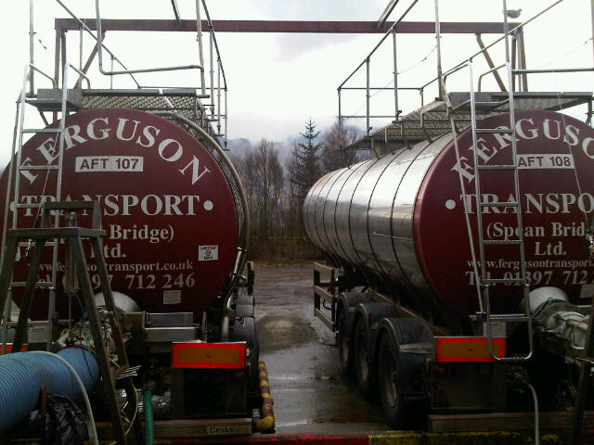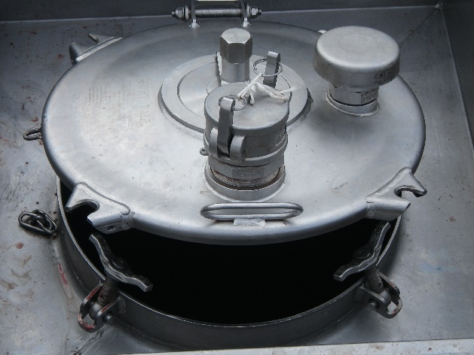
Top hatch

Tanker Connection Podlaczeniue cysterny
- To the tanker outlet we connect a 10” Shark hose by a pneumatic air sleeve and clamp system. Za pomoca sterowanej powietrzem pneumatycznej tuleji oraz klamry do wylotu tankera podlaczamy 10 calowa rure.

Discharging the fish into the Factory
- Open the blood return valve on the tanker Valve 2 (The blood water must circulate continuously until the tanker has been completely emptied of fish). Otworz zawor wody powrotnej znajujacy sie na tyle cysterny Zawor 2 (Woda powrotna musi byc wnieustannie w obiegu az do momentu oproznienia cysterny z ryb).
- Make sure that the bloodwater pump is running and circulating the liquids Upewnij sie ze pompa wody powrotnej jest wlaczona i woda wraca do cysterny.

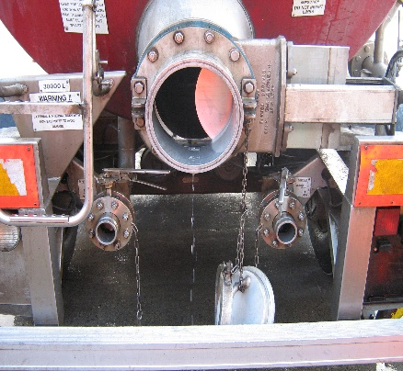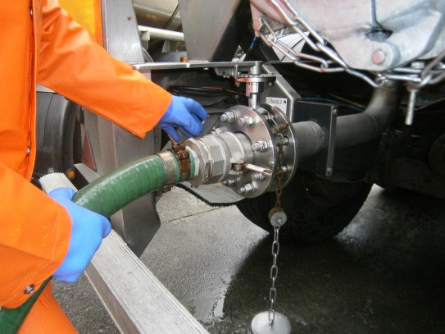
Valve 3
10’’ Tanker Guillotine valve
(Valve 1)
Valve 2
Blood water hose connected to Valve 2

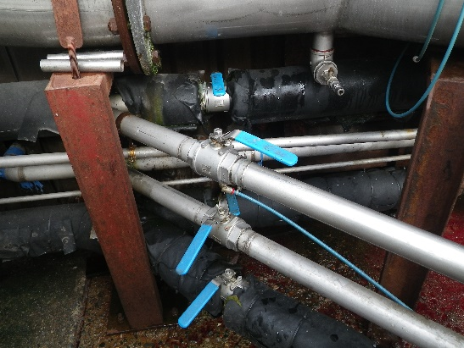
Opened blood water line

- Use the pneumatic air guillotine valve to open the correct line and ensure the other guillotine valve not in use is shut Za pomoca sterowanego powietrzem zaworu gilotynowego otworz odpowiedni rurociag. Upewnij sie ze drugi rurociag jest zamkniety.

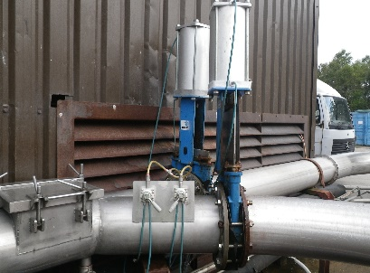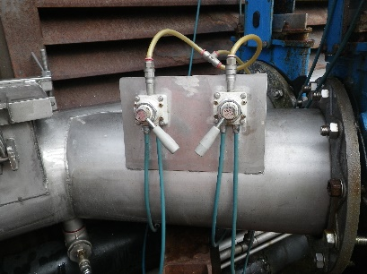
Open

- Open the rear guillotine valve on the tanker Otworz gilotynowy zawor znajdujacy sie na tyle cysterny
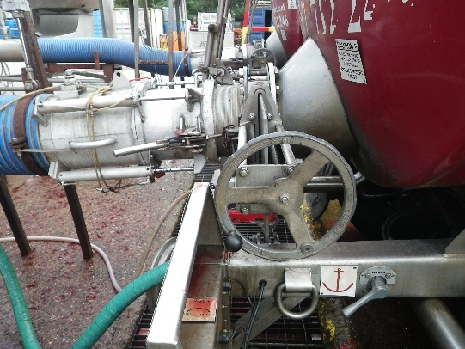

- Inform the Intake Operator via radio that the tanker is ready to discharge Za pomoca radia poinformuj operatora poboru ryby ze cysterna jest gotowa do wypompowania

Pumping should not begin until all lines are connected & all requied valves are open

Tanker Empty
- When the tanker is empty use the pneumatic guillotine valve to close the correct line. Gdy ryba zostanie calkowicie wypompowana z cysterny za pomaca sterowanego powietrzem zaworu gilotynowego nalezy zamknac odpowiedni rurociag
- The 10” shark hose can then be released from the Tanker and a visual inspection must be made through the open valve to make sure no fish remain in the tanker. Nastepnie za pomoca sterowanej powietrzem pneumatycznej tuleji mozna odlaczyc 10 calowa rure od cysterny.
- The Blood line valve 3 should be closed & the line disconnected Zamknac rurociag od powrotnej wody oraz odlaczyc gumowy waz od cysterny.
- Make sure that all connections are uncoupled & valves closed than inform the Shunter driver that the tanker is ready for removal from the bay.
- 10” a pneumatic air sleeve used for the transfer of fish from the tankers to the processing area must be secured with coupling plate when is not in use. Za pomoca sterowanej powietrzem pneumatycznej tuleji oraz klamry do wylotu tankera podlaczamy 10 calowa rure sterowana powietrzem służąca do rozładunku cystern musi być zabezpieczona zaślepką gdy nie jest w użyciu..
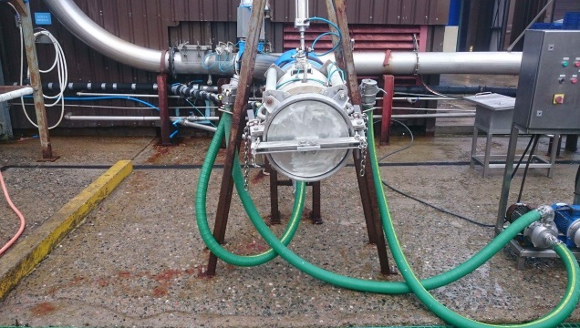

RISK ASSESMENT
YARD
TANKER BAY OPERATIONS
RISK | PERSON AT RISK | SIGNIFICANT HAAY OPERZARDS | RISK |  |  | RISK CONTROL MEASURES | RESIDUAL RISK
RISK | PERSON AT RISK | SIGNIFICANT HAAY OPERZARDS | L | S | DR | RISK CONTROL MEASURES | L | S | DR
CHEMICALS | TBO | N/A
NOISE | TBO | Risk from noise in pump room | 3 | 3 | 9 | PPE (hear protection) | 3 | 1 | 3
REPETIVE STRAIN INJURY(R.S.I.) | N/A | N/A |  |  |  | N/A
UPPER LIMB DISORDER (U.L.D) | N/A | N/A |  |  |  | N/A
MANUAL HANDLING | TBO | Risk of strains from handling Tanker connections , waste materials , fish | 3 | 3 | 9 | Manual handling training | 3 | 1 | 3
KNIVES | N/A | N/A |  |  |  | N/A
AEROSOLS | N/A | N/A
SLIPS TRIPS & FALLS | TBO | Wet slippery surfaces could cause slips , trips or falls which can be exasperated by severe winter conditions. | 3 | 3 | 9 | Compulsory slips, trips & falls awareness training gritting, gritting, squeegees | 2 | 3 | 6
MACHINERY | TBO | Risk of injury from Tanker connections, valves. | 3 | 4 | 12 | N/A | 2 | 4 | 8
COLD CONDITONS | TBO | Extremely cold outside temperature | 4 | 3 | 12 | Compulsory use of Yard PPE  Thermal underwear & gloves available  Increased breaks | 2 | 3 | 6
CONGESTED AREAS | N/A | Fork truck and lorry movements. | 3 | 5 | 15 | PPE, Signage, procedures | 1 | 5 | 5
PRESSURISED SYSTEMS | N/A | Risk of injury from airlines, pressure washers | 2 | 4 | 8 | P.P.E, staff training and procedures. | 1 | 4 | 4
HOT WEATHER | TBO | Extremely hot outside temperatures | 3 | 3 | 9 | Compulsory wear PPE. Sunglasses, use sunscreen. | 2 | 2 | 4
WORKING AT HEIGHT | TBO | Risk of falling from while climbing up to or on top of Tankers | 5 | 5 | 25 | Compulsory use of Harness & Fall Arrester | 1 | 5 | 5
FORKTRUCKS | Yard Operative | Risk of collision with persons or Vehicles | 3 | 5 | 15 | Compulsory Forklift training  Compulsory Yard personnel , contractor & visitor PPE which includes at minimum Hard Hat & Fluorescent vest  Fork truck audible reverse alarm  Before use check sheet | 2 | 4 | 8
Low 1 to 9 Medium 10 to 16 (Action) High 17 to 25 (STOP)
Risk is the significant hazards identified
Residual risk is the level of risk that remains after suitable and sufficient control measures are introduced

