BLAR mHOR OPERATIONS  STANDARD OPERATING PROCEDURE(SOP) |  |  | 
Title |  |  |  | Version Number
OPERATIONS-SOP-TANKER BAY- TANKERS RECIRCULATION |  |  |  | 9
Revised or amended date | 01/08/2022 | Next revision date |  | 01/08/2023
The instruction within this document is a guide only and should be an accompaniment to practical training
This document shall only be amended by designated persons on the authorisation of the Processing Departmental Manager

Purpose: To maintain a suitable temperature of slurry. Zapewnienie odpowiedniej temperatury sleszu.
Responsibility: Yard Operatives Pracownik YardU
Health and Safety: Risk Assessment RA Ocena Ryzyka RA
References: Spread sheet ..\..\MALLAIG\Slurry check.xlsx
SOP-Iced Slurry Exchange/Adding

Approved Chemicals Used & Dilution |  |  |  | Equipment | Comments
Product | Use/Dosage % | Symbol | Hazard | Equipment | Comments
Steriklenz 5 | 2% |  |  | Soak bin | To soak coupling caps

PPE Required
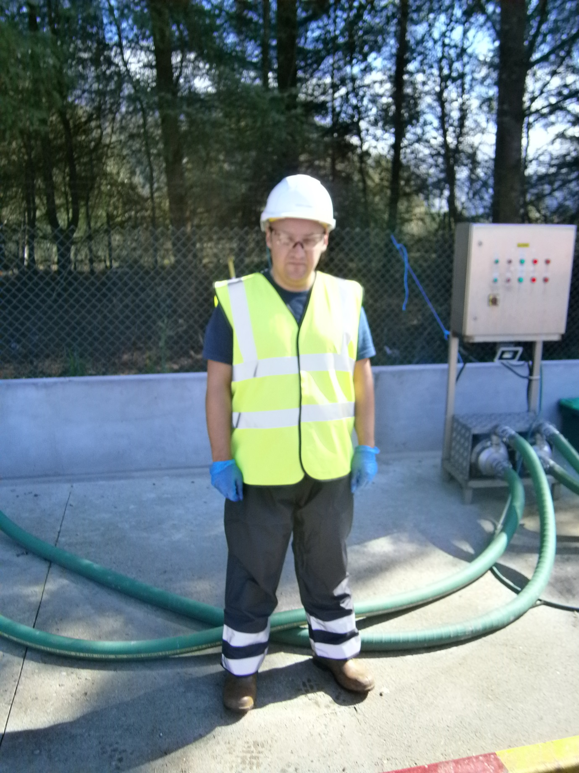
SAFETY HELMET


DISPOSABLE GLOVES


SAFETY GLASSES, VISOR


HIGH VISIBILITY CLOTHING
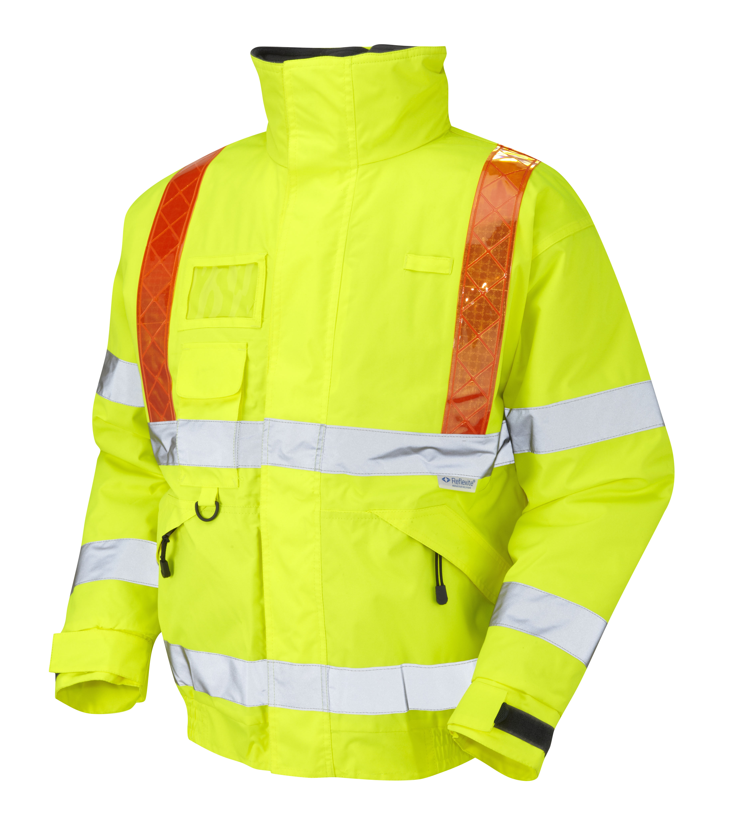

SAFETY BOOTS
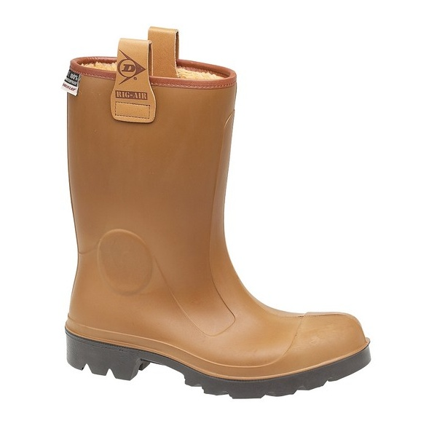

Every tanker must be recirculated before fish will be pumped into processing. In the circumstances such as late arrival of tankers, breakdowns etc tanker can’t be recirculated , Yard Operator using a calibrated thermometer must check ice slurry temperature on arrival than record results on Slurry Check spread sheet ..\..\MALLAIG\Slurry check.xlsx and Efbr (Inbound Transports). Adequate comment must be added in comment section. Kazda cysterna msi byc przerecyrkulowana zanim ryba zostanie wypompowana na linie produkcyjna. Jezeli z powodu opoznionego przyjazdu cystern badz awarii itp. niemozna zrobic recyrkulacji operator yardu przy uzyciu skalibrowanego termometra musi sprawdzic temperature sleszu na przjezdzie. . Odczyt zapisz na ..\..\MALLAIG\Slurry check.xlsx i na Efbr (inbound Transport). Odpowiedni komenarz musi byc dodany.

Once the tanker has been parked correctly support legs will be lowered, the drive unit removed and safety cones put in place in front of the tanker. Only after the driving unit is away should the Yard Operator proceed with the operation. Access ladders are then lowered, this locks all the trailer wheels. The safety barrier is then raised so that access can be gained to the top hatch. Gdy cysterna zostanie odpowiednio zaparkowana wsporniki zostana opuszczone w celu zabezpieczenia cysterny. Po odstawieniu pojazdu manewrowego nalezy ustawic slupki bezpieczenstwa z przodu cystern.Operator moze rozpaczac prace przy cysternie tylko po odstawieniu pojazdu manewrowego. Po opuszczeniu drabinki zalacza sie hamulce bezpieczenstwa oraz podnisa sie barierki bezpieczenstwa umozliwiajac bezpieczny dostep do gornego wlazu cysterny.

Procedure:

- Open the top hatch and check visually if any of ice remained in the tanker. This is essential to determine time of recirculation. Tankers with remained ice have to be recirculated for 30 min, tankers without ice can be recirculate for maximum 20 minutes. Otworz gorna pokrywe tankera i sprawdz wizualnie ilosc pozostalego lodu w cysternie. Jest to istotne w celu okreslenia czas recyrkulacji. Cysterne w ktorej jest widoczny lod nalezy recyrkulowac przez 30 minut. Czas recyrkulacji cysterny bez lodu niemoze byc dluzszy niz 20 minut.

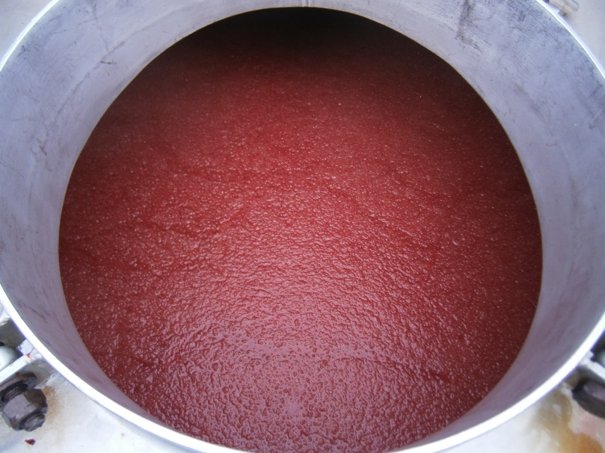

- Wear clean disposable gloves. Open rear tanker valve 3 ,next using a calibrated thermometer check the ice slurry temperature (before recirculation). Record results on Slurry Check spread sheet ..\..\MALLAIG\Slurry check.xlsx and Efbr (Inbound Transports). Zaloz czyste jednorazowe rekawice. Otworz tylni zawor cysterny 3 . Nastepnie przy uzyciu skalibrowanego termometra sprawdz temperature slaszu. Odczyt zapisz na ..\..\MALLAIG\Slurry check.xlsx i na Efbr (inbound Transport).

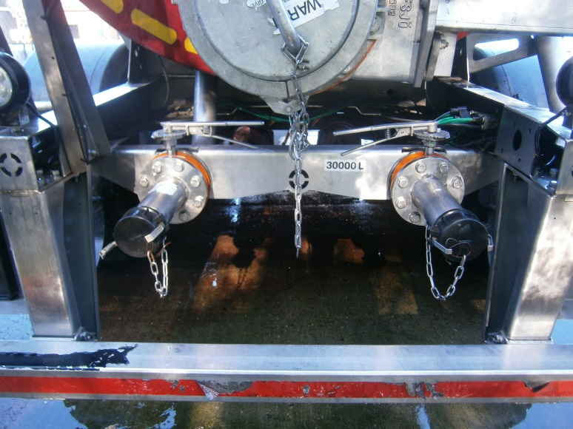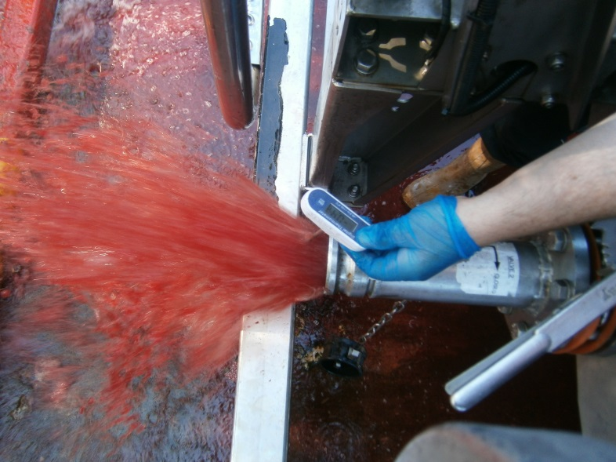
Valve 3
Pump 2
- Choose pump which will be in use. Wybierz pompe ktora uzyjesz do recyrkulacji.
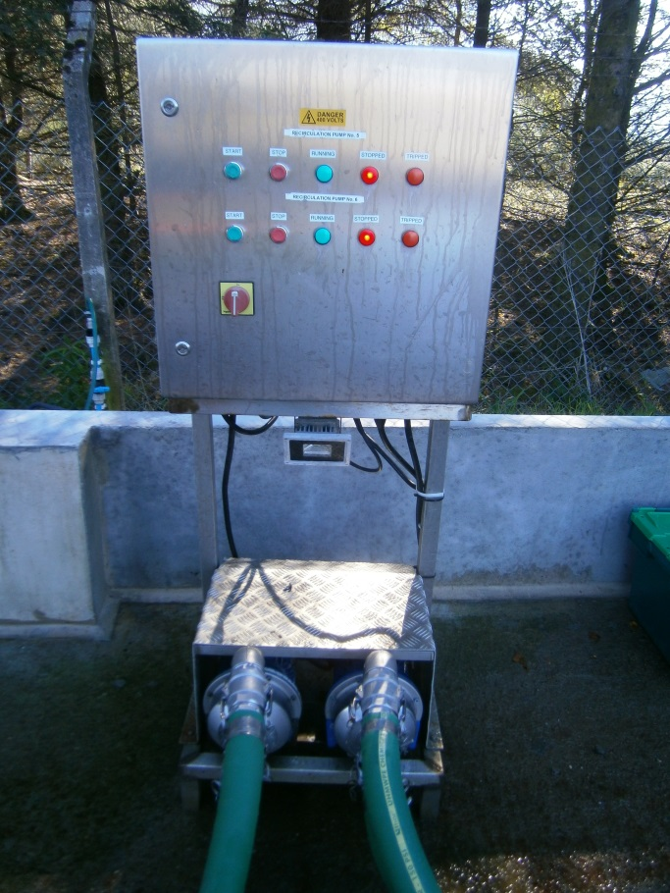
Pump 1
Pump2

- Remove couplings caps and soak them in designated bin with approved Disinfectant (2% Solution) Wyciagnij zatyczki z lacznika i zamocz je w binie z Dezynfektantem (Roztwor 2%)

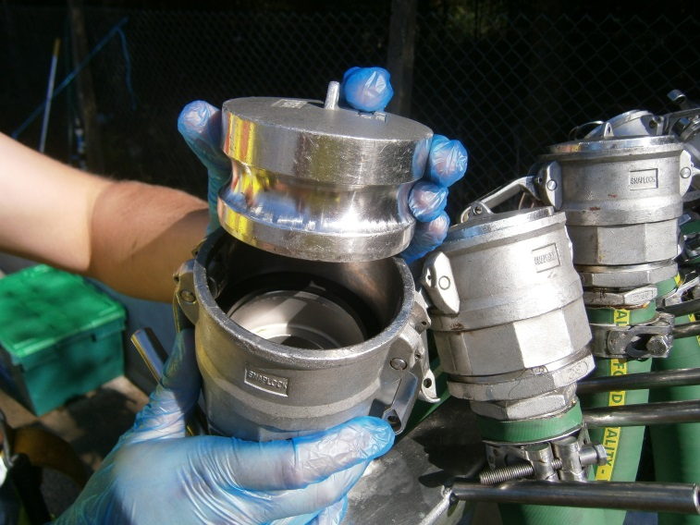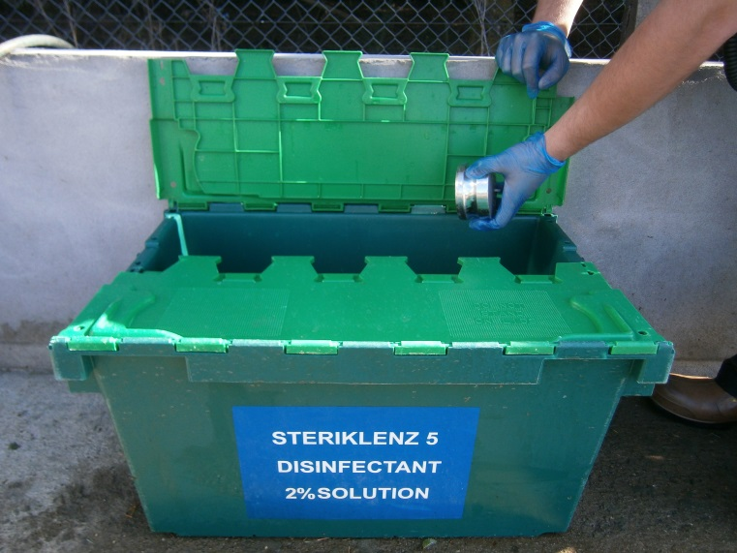

- Attach hose A (outlet) to the rear tanker valve 3 Podlacz gumowy waz A (wlotowy) do zaworu nr 2 umieszczonego na tyle cysterny.

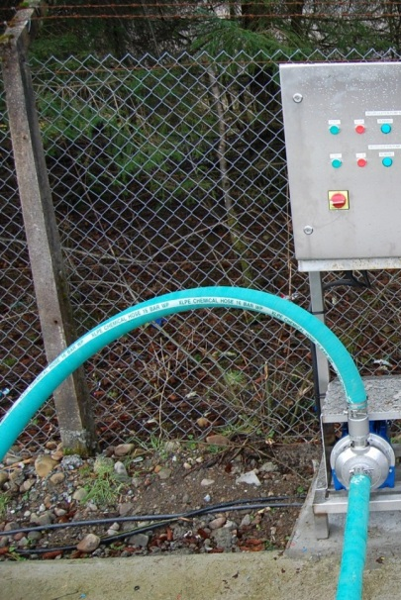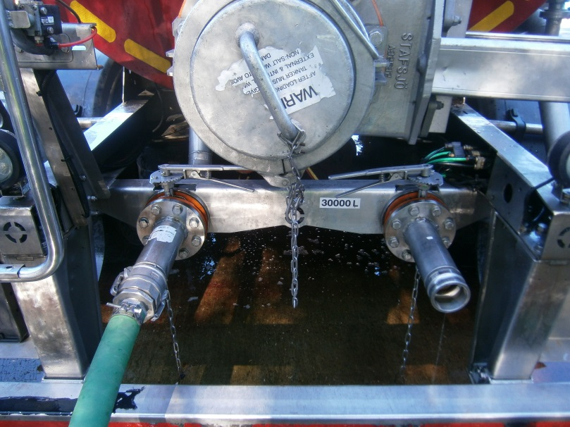
Hose A
Valve 3

- Attach hose B (inlet) to the rear tanker valve 2 Podlacz gumowy waz B (wylotowy) do zaworu nr 3 umieszczonego na tyle cysterny.

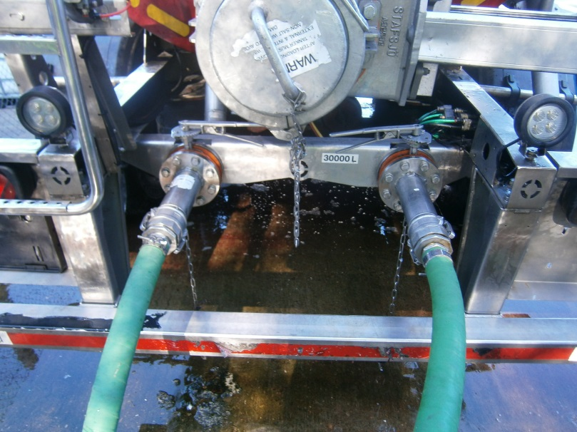
Hose B
Valve 2

- Open rear tanker valves 2 and 3. Otworz zawory nr 2 i 3.

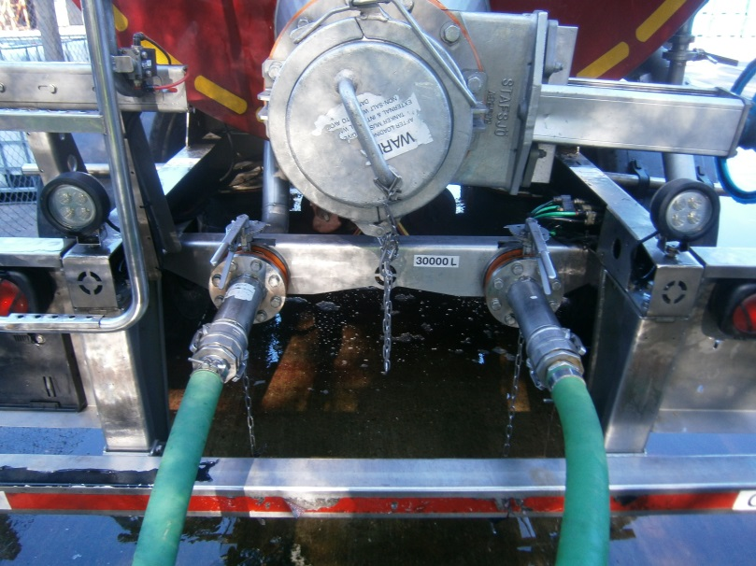
Valves 2,3

- Position valves 4 and 5 horizontally. Ustaw zawory nr 4 i 5 w pozycji poziomej.
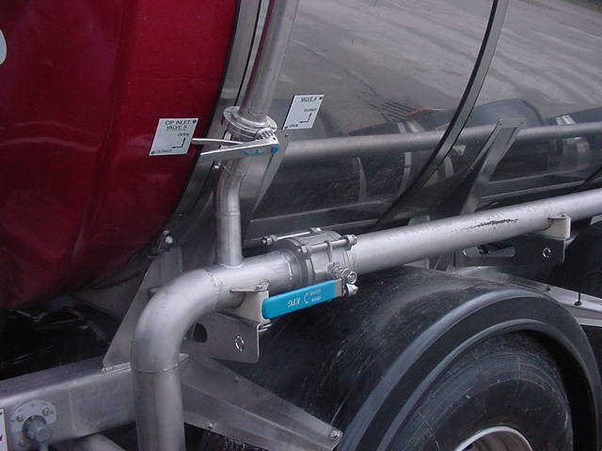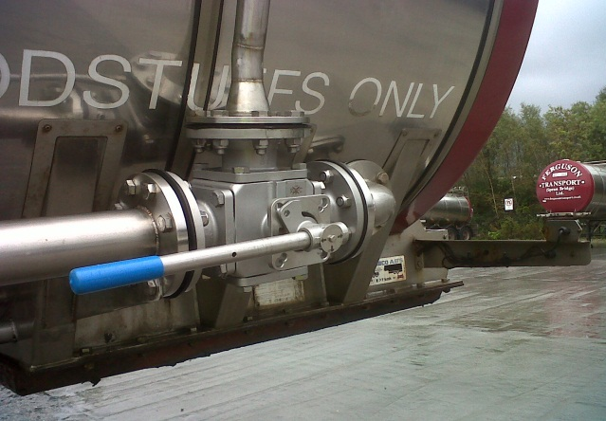
Valve 5
Valve 4

- Press the start button from the main control panel. Green light on main control panel indicates that the recirculation has been begun. Dispose used gloves to the bin. Wcisnij zielony przycisk start znajdujacy sie na panelu kontrolnym. Zielona lampka oznacza rozpoczecie recyrkulacji.
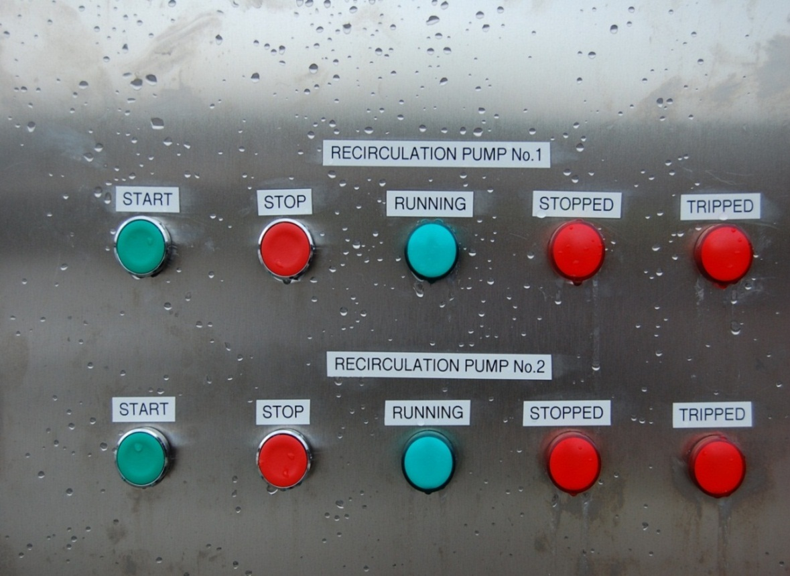
Pump 1
Start button
Pump 2
Start button

- ONCE recirculation has been finished press the stop button from the main control panel .Next shut rear tanker valves 2,3 Po ukonczeniu recyrkulacji wcisnij przycisk stop a nastepnie zamknij tylnie zawory ysterny 2,3
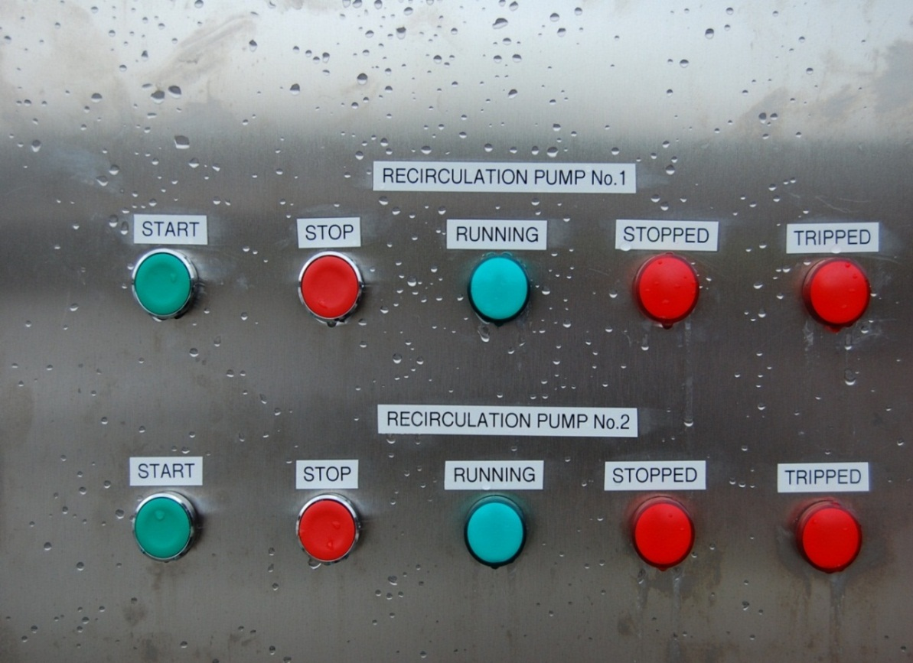
Pump 2
Stop button
Pump 1
Stop button

- Detach hoses from rear tanker valves and hang them on the racks, than refit the caps. Odlacz gumowe weze od tylnich zaworow cysterny i umiesc je na przeznaczonych do tego celu stojakach. Zabezpiecz weze zatyczkami.
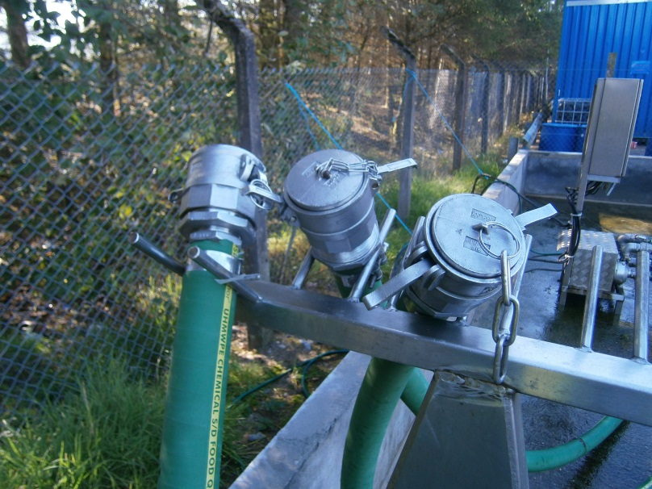

- Always wear clean disposable gloves. Open the rear tanker valve 3 next, using a calibrated thermometer check the ice slurry temperature (after recirculation). Once the reading has been taken dispose of gloves to the bin. Record results on Slurry Check spread sheet ..\..\MALLAIG\Slurry check.xlsx and Efbr (Inbound Transports). If ice slurry temperature after recirculation in tanker is above 2 ºC (internal target) Yard Operator must exchange ice slurry in accordance with Work Instruction SOP-Ice Slurry Exchange Zaloz czyste jednorazowe rekawice. Otworz tylni zawor cysterny 3. Nastepnie przy uzyciu skalibrowanego termometra sprawdz temperature slaszu. Odczyt zapisz na ..\..\MALLAIG\Slurry check.xlsx i na Efbr (inbound Transport). Jezeli temperatura slaszu przekracza 2 ºC (wewnetrzny cel) operator yardu musi wymienic slesz z godnie z procedura SSW1033 (Wymiana/dolewanie sleszu).
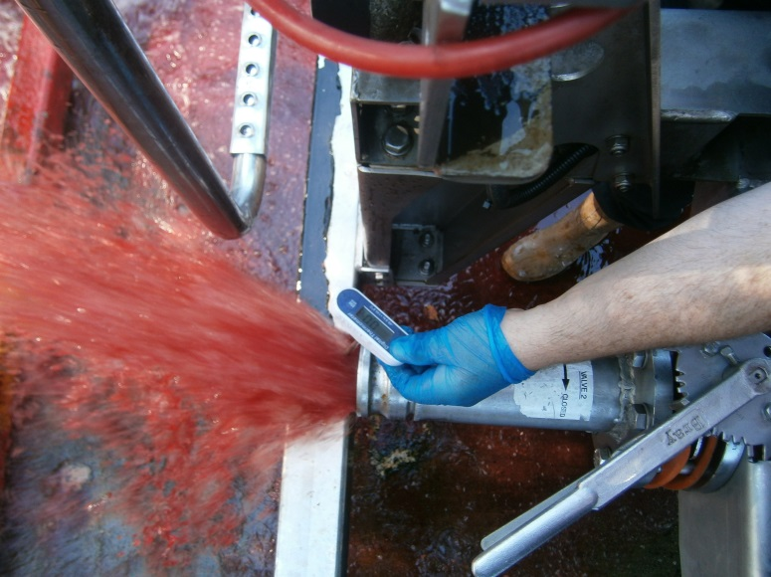
Valves 2,3

Valve 3
- Close the rear tanker valves 2,3 and refit the caps before tanker is moved. Zamknj tylnie zawory cysterny 2,3 oraz zabezpiecz je zatyczkami zanim cysterna zostanie przetransportowana.

RISK ASSESMENT
YARD

TANKERS RECIRCULATION RA
RISK | PERSON AT RISK | SIGNIFICANT HAZARDS | RISK |  |  | RISK CONTROL MEASURES | RESIDUAL RISK
RISK | PERSON AT RISK | SIGNIFICANT HAZARDS | L | S | DR | RISK CONTROL MEASURES | L | S | DR
CHEMICALS | TBO | Risk from sanitizer using for soak caps | 3 | 2 | 6 | PPE  Chemical handling training | 1 | 2 | 2
REPETIVE STRAIN INJURY(R.S.I.) | N/A | N/A |  |  |  | N/A
UPPER LIMB DISORDER (U.L.D) | N/A | N/A |  |  |  | N/A
MANUAL HANDLING | TBO | Risk of strains from handling Tanker connections | 3 | 4 | 12 | Manual handling training | 2 | 4 | 8
KNIVES | N/A | N/A |  |  |  | N/A
AEROSOLS | N/A | N/A
SLIPS TRIPS & FALLS | TBO | Wet slippery surfaces could cause slips , trips or falls which can be exasperated by severe winter conditions. | 3 | 3 | 9 | Compulsory slips, trips & falls awareness training gritting, gritting, squeegees | 2 | 3 | 6
MACHINERY | TBO | Risk of injury from Tanker connections, valves. | 3 | 4 | 12 | N/A | 2 | 4 | 8
COLD CONDITONS | TBO | Extremely cold outside temperature | 4 | 3 | 12 | Compulsory use of Yard PPE  Thermal underwear & gloves available  Increased breaks | 2 | 3 | 6
CONGESTED AREAS | N/A | Fork truck and lorry movements. | 3 | 5 | 15 | PPE, Signage, procedures | 1 | 5 | 5
PRESSURISED SYSTEMS | N/A | Risk of injury from airlines. | 2 | 4 | 8 | P.P.E, staff training and procedures. | 1 | 4 | 4
CONFINED SPACES | N/A | N/A |  |  |  | N/A
WORKING AT HEIGHT | TBO | N/A |  |  |  | N/A
FORKTRUCKS | Yard Operative | Risk of collision with persons or Vehicles | 3 | 5 | 15 | Compulsory Forklift training  Compulsory Yard personnel , contractor & visitor PPE which includes at minimum Hard Hat & Fluorescent vest  Fork truck audible reverse alarm  Before use check sheet | 2 | 4 | 8
Low 1 to 9 Medium 10 to 16 (Action) High 17 to 25 (STOP)
Risk is the significant hazards identified
Residual risk is the level of risk that remains after suitable and sufficient control measures are introduced

