BLAR mHOR OPERATIONS  STANDARD OPERATING PROCEDURE(SOP) |  |  | 
Title |  |  |  | Version Number
OPERATIONS-SOP-EFFLUENT PLANT-VISCERA TRANSFER |  |  |  | 6
Revised or amended date | 01/08/2022 | Next revision date |  | 01/08/2023
The instruction within this document is a guide only and should be an accompaniment to practical training
This document shall only be amended by designated persons on the authorisation of the Processing Departmental Manager

Purpose:
Responsibility: Effluent Plant Operator
Health and Safety: PPE
Risk assessment
References: N/A

PPE Required :
SAFETY HELMET


SAFETY BOOTS


SAFETY BOOTS

SAFETY BOOTS

SAFETY BOOTS

SAFETY BOOTS

PROTECTIVE EYEWEAR (WORN WHEN REQUIRED)


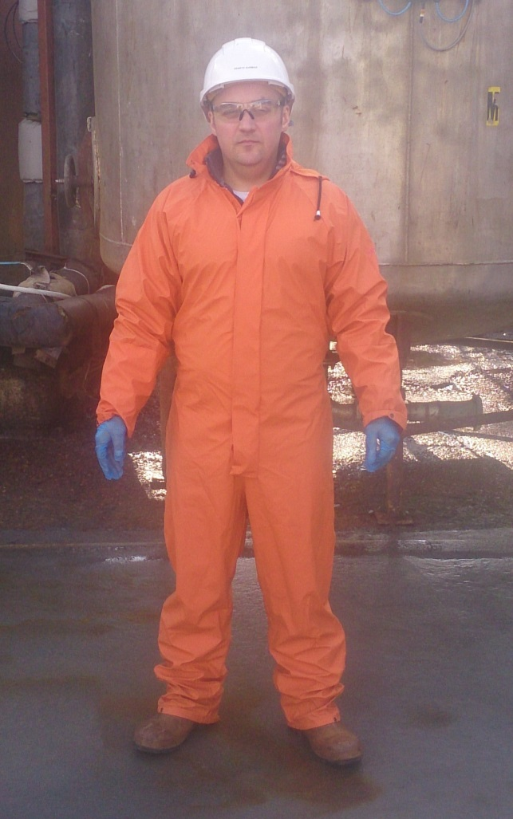
DISPOSABLE GLOVES


SAFETY BOOTS
WATERPROOF
SUIT, OIL SKIN


Before starting machinery ensure the following valve procedures are carried out, do not start machines with all valves closed, there must always be a route for the material to travel to tank.
Never run a pump against a closed system.
Always open valves in the line before closing the other valves this will prevent the possibility of pumping against a dead head.

Transferring material from factory outlet to Macerator tanks.
To transfer to macerator 1 open valve 7 and close valve 5.
To transfer to macerator 2 open valve 5 and close valve 7.

Macerator- acid dosing to the viscera
- On the each start shift, check must be made that sufficient chemical is available in the IBC.
- When 80% viscera level in macerator tank is reached than appropriate amount of acid will be added to the macerator tank.
- After dosing compleated operator must take a sample from the sample point and check PH, result must be recorded in the’ Daily Check Spreadsheet’

Transferring material from macerator tank 1 to the Storage tank
- Ensure the switch on the air valve panel is pointing to tank 1.
- Valve 4 should remain closed.
- Valve 3 should be in open position.
- Open transfer valve on the Landia pump on the top of macerator 1.
Ensure macerator tank 2 Landia pump is in the recirc position.

From Macerator 2 to storage tank (macerator pump running).
1. Ensure the switch on the air valve panel is pointing to tank 2.
2. Valve 4 should remain closed.
3. Valve 3 should be in open position.
4. Open transfer valve on the Landia pump on top of macerator 1.
Ensure macerator tank 1 Landia pump is in the recirc position.

Recirculating material in the storage tank.
Recirculation should not be attempted until the tank is 10% full, less than this will result in the pump running dry which will cause damage.
Once the level is at 10%:
- For pump 1, close valves 9&10, and open valves 8&11.
- Open valves 6&12 and close valve 13.
- Then start pump No 1.

- For pump 2, close valves 8&11 and open valves 9&10.
- Open valves 6&12 and close valve 13.
- Then start pump No 2.
Transferring material from storage tank to road tanker.
Whichever pump is being used the appropriate valves will be operated.
Pump 1 valves 8&11 will be operational.
Pump 2 valves 9&10 will be operational.
- Open valve 13 and close valve 12 (recirc valve)
- Valve 6 should be in the open position.
When filling is complete providing the level is above 10% open valve 12 and then close valve 13 this will return to the recirc mode in the storage tank, should the level be below 10% then the pump will have to switched off, until the level is attained.
In the event of a total pump failure, the material can be pumped from the macerator direct to the road tanker, bypassing the storage tank.
Switch the air switch to whichever tank is to be used, this will open either valve 1 or 2, open valves 4&13, and close valves 3,12&6.
There is a valve and flange on the suction line this is to allow for the pumping out of the macerators should the situation occur.
It is important from a cost factor that the road tanker leaves the site with a full load

RISK ASSESMENT
EFFLUENT PLANT
VISCERIA TRANSFER-RA
RISK | PERSON AT RISK | SIGNIFICANT HAZARDS | RISK |  |  | RISK CONTROL MEASURES | RESIDUAL RISK
RISK | PERSON AT RISK | SIGNIFICANT HAZARDS | L | S | DR | RISK CONTROL MEASURES | L | S | DR
CHEMICALS | EFFLUENT PLANT OPERATOR | Risks from chemicals when taking sample | 3 | 4 | 12 | P.P.E  Chemical Handling Training | 2 | 4 | 8
NOISE | N/A | N/A |  |  |  | N/A
REPETIVE STRAIN INJURY(R.S.I.) | N/A | N/A |  |  |  | N/A
UPPER LIMB DISORDER (U.L.D) | N/A | N/A |  |  |  | N/A
MANUAL HANDLING | EFFLUENT PLANT OPERATOR | Risk of strains from stretching or lifting equipment | 3 | 3 | 9 | Manual handling training | 2 | 2 | 4
KNIVES | N/A | N/A |  |  |  | N/A
SLIPS TRIPS & FALLS | EFFLUENT PLANT OPERATOR | Wet slippery surfaces could cause slips , trips or falls which can be exasperated by severe winter conditions | 3 | 3 | 9 | Compulsory slips, trips & falls awareness training gritting | 2 | 3 | 6
MACHINERY | N/A | N/A |  |  |  | N/A
COLD CONDITONS | EFFLUENT PLANT OPERATOR | Extremely cold outside temperature | 4 | 3 | 12 | Compulsory use of Yard PPE  Thermal underwear & gloves available  Increased breaks | 2 | 3 | 6
CONGESTED AREAS | N/A | N/A |  |  |  | N/A
PRESSURISED SYSTEMS | N/A | N/A |  |  |  | N/A
CONFINED SPACES | N/A | N/A |  |  |  | N/A
WORKING AT HEIGHT | EFFLUENT PLANT OPERATOR | Risk of falling ,while climbing up to .or on top of the road tankers. | 5 | 5 | 25 | Road tanker handrails must be in use when climbing on the road tankers, | 3 | 3 | 9
FORKTRUCKS | EFFLUENT PLANT OPERATOR | Risk of collision with persons or Vehicles | 3 | 5 | 15 | Forklift training  Compulsory Yard personnel , contractor & visitor PPE which includes at minimum Hard Hat & Fluorescent vest  Fork truck audible reverse alarm | 1 | 5 | 5
Low 1 to 9 Medium 10 to 16 (Action) High 17 to 25 (STOP)
Risk is the significant hazards identified
Residual risk is the level of risk that remains after suitable and sufficient control measures are introduced

