Environment, Climate Change and Land Reform Committee
Environmental impacts of salmon farming
Written submission from Don Staniford, Director of the Global Alliance Against Industrial Aquaculture (GAAIA) (30 January)
Preface: GAAIA is concerned that the "call for written views" was poorly publicised (i.e. there was no press release and only a Tweet by the ECCLR Committee and re-Tweet by REC Committee on 25 January with scant media coverage in The Scotsman). Hence any 'call' was muted making the so-called public consultation unrepresentative and undemocratic. Moreover, a deadline of 8 February 2018 (two weeks) for members of the public to respond to a 198 page scientific report written by a consortium of 14 people over a period of several months is unrealistic and unreasonable. Restricting commentary to only 4 pages - that's half a page for each of the 8 sections of the report - smacks of censorship, undermines the integrity of the inquiry and promotes the use of a ridiculously small font size.

Information Bias & Secrecy: The report purports to represent a "Review of the Environmental Impacts of Salmon Farming in Scotland" yet fails to consider news reports detailing environmental impacts sourced from FOI data obtained from various Government agencies. Limiting sources of evidence solely to "scientific papers published after peer review" and "reports that are in the public domain and that the authors have assessed as reliable" is unnecessarily restrictive and Kafkaesque in logic. Excluding damning data which the salmon farming industry, the Scottish Government and SEPA has fought for decades to keep secret waters down the evidence and weakens the review.

For example, the SAMS review excludes damning research from SAMS itself on "large-scale underwater noise pollution" from ADDs used by salmon farms (Read more via Sunday Herald: "Health of whales, dolphins and porpoises put at risk by underwater alarms" ; "Cetaceans Sound Alarm On Salmon Farms - new research sparks EC complaint & call to ban Acoustic Deterrent Devices" and "Large-scale underwater noise pollution from Acoustic Deterrent Devices (ADDs) on the west coast of Scotland").

For example, data on infectious diseases and mortality numbers (shamefully not reported via the Scotland's Aquaculture database) has been excluded (e.g. "Gill Diseases: Scottish Salmon's Dirty Big Secret"). Yet anyone willing to delve deeper can download 'Case Information from Marine Scotland's Fish Health Inspectorate' and can access damning data on diseases and mortalities during 2017 at Marine Harvest, Scottish Sea Farms and the Scottish Salmon Company via FOI (Download via: Marine Harvest mort events in 2017; Scottish Salmon Company mort events in 2017 and Scottish Sea Farms mort events in 2017).

Read more on how the salmon farming sector has excluded damning information for decades via "FOI Number Five – getting you the information they don’t want you to see!"; "Scottish salmon farming’s ‘liciest’ farms named and shamed"; "Scotland’s worst sea lice offenders: Full Farm List"; "Revealed: Scandal of 45 Scottish lochs trashed by pollution"; "Pesticide report suppressed after freedom of information warning"; "How the Scottish Government ‘nuanced’ away fish farm pesticide ban"; The Ferret: "Revealed: secret role of US drug company in fish farm pesticide row"; "Slicegate: Anatomy & Chronology of an Environmental Lobotomy"; "Damning Report on Toxic Salmon Farms Buried - SEPA finally acts on lobster-killing chemical"; "Campaigners welcome ruling on seal shooting disclosure"; "Victory: Disclosure of Seal-Killing Salmon Farm Data Ordered by 21 August"; "FishyLeaks: Scottish Salmon Infested With Parasites - Sea Lice Data Reveals 1001 Reasons to Boycott Farmed Salmon"; "FishyLeaks: Scottish Salmon's Toxic Toilets Named & Shamed"; Scottish Information Commissioner Decision 182/2006 Mr Bruce Sandison and the Fisheries Research Services - Request for information relating to the escape of salmon from an Orkney fish farm; "Gaining Transparency: using the FOIA process to track down data on the impacts of fish farming"; "Scottish watchdog labelled ‘lapdog’ after agreeing to keep fish farm deaths secret"; "Public denied info on full scale of salmon deaths"; "Environment watchdog ‘gave in to industry’ over dead salmon"; "Farmed salmon killed by disease leaps to 8.5 million"; "Fish farmers 'blocked' vital safety study"; "Salmon firms 'hiding damning reports'" and "Keeping salmon farming problems secret").

Context - Scottish salmon ranked the worst in the world: Re. the 'Report Cards' for Sections 2-7 please note that Scottish farmed salmon was ranked as the world's worst (below even Chile, Norway and Canada) according to assessments published by Seafood Watch in September 2017. The red ranking for Scottish farmed salmon which scored a woeful 2.65 out of 10 was attributed to poor performance in terms of chemicals, disease and escapes (hence the "avoid" recommendation to consumers).
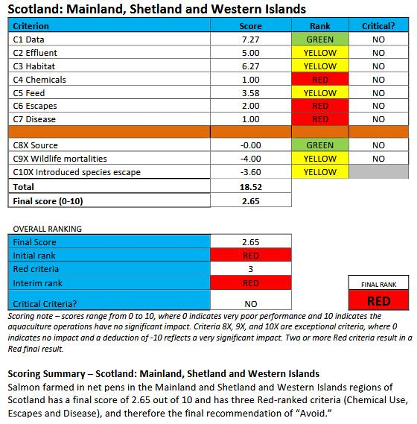
Read more via Press Release: "Red Light for Scottish salmon: Scotland is ranked worst in the world" and "Atlantic Salmon: Scotland - Marine Net Pens".
Comments on Section 2 - Sea Lice & Disease:

How can the review fully answer the question "how successful is disease control" when the reviewers have not even accessed the latest data on diseases and mortalities on Scottish salmon farms?

Data published in January 2018 by GAAIA (following a FOI request to the Scottish Government) reveals the following reasons for mortality on Scottish salmon farms in 2017: gill pathology, complex gill issues, Vibrio anguillarum, Proliferative Gill Disease, Pancreas Disease, fungus, cardiomyopathy syndrome, Haemorrhagic smolt syndrome, Enteric redmouth disease, anaemia and deaths due to the Hydrolicer, Thermolicer and hydrogen peroxide treatment. Download data via: Marine Harvest mort events in 2017; Scottish Salmon Company mort events in 2017 and Scottish Sea Farms mort events in 2017 (data for other companies can be accessed easily via filing FOIs with the Scottish Government). 'Case Information from Marine Scotland's Fish Health Inspectorate' is also publicly available but, shamefully, the Scottish Government have still not made available any data beyond June 2017. A report - "Fish Farmageddon: The Infectious Salmon Aquacalypse" - published by GAAIA in 2011 included:

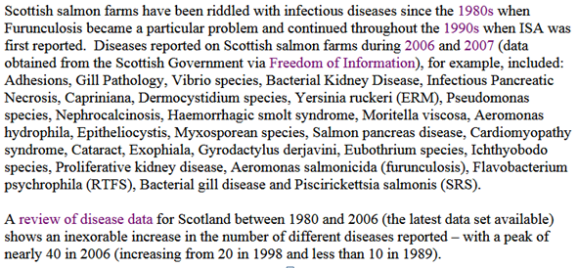

Re. "For Scotland, there are no published accounts of systematic counts of sea lice levels on wild salmon and its association with salmon farming". Then why doesn't the Scottish Parliament force salmon farming companies such as Marine Harvest to disclose decades of unpublished data and fund research to collect systematic counts of sea lice levels?

Thanks to Salmon & Trout Conservation the public can now read damning data on the "liciest" salmon farms (download via "Scottish salmon farming’s ‘liciest’ farms named and shamed"; "Scotland’s worst sea lice offenders: Full Farm List" and "Scottish salmon sold by a range of supermarkets in the UK has sea lice up to 20 times acceptable limit").

Re. "The consequences of increased sea lice levels for wild salmonid populations are unclear". Are the reviewers being serious? Isn't it obvious that the extinction of wild salmonids - already the case in over a dozen Highland rivers - is inevitable?

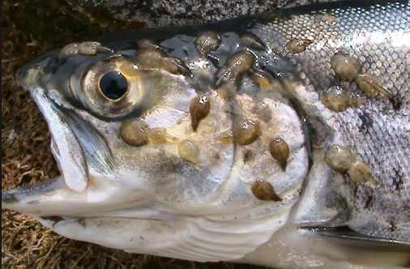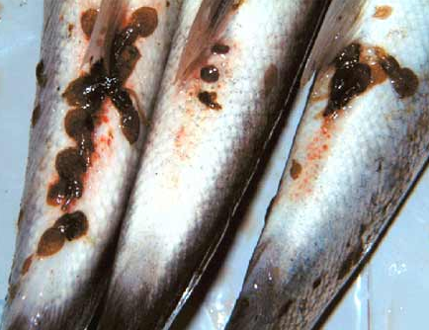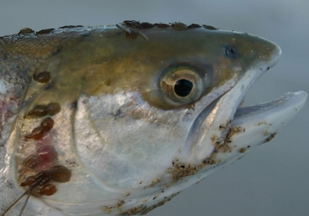

Re. "Sea lice populations also appear to be developing resistance to many existing treatment medicines and therapeutants". No, there is no doubt that resistance has already developed and the efficacy of Emamectin benzoate is reducing (read: "The Efficacy of Emamectin Benzoate against Infestations of Lepeophtheirus salmonis on Farmed Atlantic Salmon (Salmo salar L) in Scotland, 2002–2006"). Hence the staggering increases in the use of toxic chemicals over the last decade (read more via The Sunday Times: "Salmon industry toxins soar by 1000 per cent"; "Scottish Salmon's Lethal Legacy - Ten-fold Increase in Toxic Chemical Use in Ten Years"; Press & Journal: "Scottish salmon farming ‘fighting a losing battle’ against sea lice"; "Scottish fish farmers use record amounts of parasite pesticides"; "Sharp rise reported in Scots fish lice chemical"; "Scottish salmon's 'Silent Spring of the Sea'" and "Silent Spring of the Sea").

Re. "Research gaps and gaps in publically available data in Scotland make it difficult to assess the efficacy of present management and regulatory regimes and have generated some public distrust in the industry and regulator". You can say that again. You can say that again. For a case study sourced from emails obtained from SEPA and the Scottish Government via FOI please read "Slicegate: Anatomy & Chronology of an Environmental Lobotomy" (read more via "Damning Report on Toxic Salmon Farms Buried - SEPA finally acts on lobster-killing chemical"; "Pesticide report suppressed after freedom of information warning"; "How the Scottish Government ‘nuanced’ away fish farm pesticide ban" and The Ferret: "Revealed: secret role of US drug company in fish farm pesticide row").

Re: "the presence of sea lice on farmed salmon is a fish welfare concern and requires treatment for this reason". Sorry, but if salmon farmers were seriously concerned about welfare they would not cram so many farmed salmon into cages creating the perfect breeding ground for infectious diseases and mass mortalities (at least the authorities in Norway occasionally clamp down: "Lerøy fined NOK1.4 million after lice savage salmon"). And if salmon farmers really cared about fish welfare then why do they employ lethal measures such as the Thermolicer? (read more via "Vet warns of head injury risk to fish during delousing"; 'Thermolicer' Back-Fires Killing 95,400 Farmed Salmon"; Fish farm firm kills 175,000 salmon by accident; "Oops: fish farm firm kills 175,000 of its salmon by accident"; "Thousands of fish poached alive in lice treatment bungle"; and "Scottish intensive salmon farming plumbs new depths").

Re. fish vaccination please note scientific research published in December 2017: "Coinfection takes its toll: Sea lice override the protective effects of vaccination against a bacterial pathogen in Atlantic salmon" (read more via "Vaccines not protecting farmed fish from disease").

Re. "the use of cleaner-fish (e.g. wrasse and lumpsuckers)" please note the risks of disease transfer and impacts on wild fish populations (read more via "Salmon farmers ‘put wild fish at risk’ in fight to kill off sea lice"; "Cleaner fish that keep farmed salmon healthy at risk of wipe-out" and Sunday Times: "‘Clean fish’ bring danger of disease to salmon farms").

Comments on Section 3 - Wastes:

Re. "Scottish agencies regularly monitor seabed conditions near farms; however, there is no recent synthesis of the data, or recent research into acceptable sediment loadings for different sediment types, fallowing periods, or long-term changes in the benthos of lochs with anthropogenic organic inputs". The Scottish Parliament should therefore recommend that synthesis of data and research is carried out, especially when FOI data from SEPA reveals that benthic pollution by salmon farms is causing significant environmental impacts (read more via: "Revealed: Scandal of 45 Scottish lochs trashed by pollution"; "Failing Fish Farms - 18% rated "poor" by SEPA in 2015"; "Fish company investigated after salmon farm pollutes Scottish loch"; "Revealed: the dirty dozen salmon farms that contaminate lochs with pesticides"; "Revealed: the toxic pesticides that pollute our lochs").

Comments on Section 4 - Chemicals:

Re. "There are no publically available data on use of hydrogen peroxide, other disinfectants, antibiotics or antifouling paints in salmon farming in Scotland, and no synthesis of annual usage could be found, either per farm or for the country as a whole". The reviewers should have taken the time to read The Sunday Times or the Press & Journal which has published articles sourced from data on the use of hydrogen peroxide and antibiotics obtained from SEPA via FOI (read via The Sunday Times: "Record chemical use ‘of concern’ to salmon giant"; "Sky-Rocketing Chemical Use on Scottish Salmon Farms"; "Antibiotic-ridden Scottish Salmon: FOI reveals of Oxytetracycline, Florfenicol, Amoxycillin and Fenbendazole" and "Press & Journal: Fish 'hooked on chemicals").

The use of antibiotics in salmon farming is also increasing the risk of antibiotic resistance (read "Aquaculture as yet another environmental gateway to the development and globalisation of antimicrobial resistance"; "The Rising Tide of Antimicrobial Resistance in Aquaculture: Sources, Sinks and Solutions"; "Antibiotic resistance could spread through feed at fish farms"; "Salmon Aquaculture and Antimicrobial Resistance in the Marine Environment"; "Heavy use of prophylactic antibiotics in aquaculture: a growing problem for human and animal health and for the environment"; "How do third party certifications control the use of antibiotics in global salmon aquaculture?" and Antibiotic use in aquaculture: development of antibiotic resistance–potential for consumer health risks).

Re. "There is to date no evidence that the chemicals currently used in fish farming in Scotland persist and accumulate in the food chain". Have the reviewers not read the data on Emamectin benzoate contamination of Scottish farmed salmon (sourced from the data published by the Veterinary Medicines Directorate and the Scottish Government) that details at least eight cases (including Scottish Salmon Company in 2016 and 2012, Lakeland Marine in 2010, Skelda Salmon in 2009, Scottish Sea Farms in 2006 and Marine Harvest in 2005)? (read via "Scottish Salmon Overdoses on Toxic Chemical"; Daily Mail: "The toxic chemicals in farmed salmon straight from the loch" and "Emamectin residues in farmed salmon").

Re. "Newly developed chemicals". This is an issue certainly worth tracking (read "Patent sought for neonicotinoid-based sea louse treatment"; "New sea louse treatment nears commercial launch"; "A new generation of biocides for control of crustacea in fish farms" and "New lice bath ‘100% effective’ and pollution-free").

A scientific paper published in the February 2018 issue of the journal Aquaculture is worth reading: Potential effect of pesticides currently used in salmon farming on photo and chemoautotrophic carbon uptake in central – southern Chile

Comments on Section 5 - Escapes:

Re. "Most evidence about the effects of escapes comes from Norway, where flow of genes into wild populations has been documented. There is little information on the extent to which such genetic mixing occurs in Scottish salmon." What about a report published by RAFTS in 2013 which found that one in four salmon sampled on the west coast of Scotland contain DNA from Norwegian fish? (Read more via "Fish farms are 'wiping out Scotland's wild salmon'" and "Report on Genetic Tool Development for Distinguishing Farmed vs Wild Fish in Scotland").

Re. "Is two million a big number?" Of course, yes: "this number of escapes equates very roughly to about half the total numbers of adult salmon in Scottish rivers". Mass escapes from salmon farms are precipitating an 'extinction vortex' in wild salmon (read more via "Scottish Salmon's Great Escape"; "Fitness reduction and potential extinction of wild populations of Atlantic salmon, Salmo salar, as a result of interactions with escaped farm salmon" and "Wild salmon put at risk as a million farmed fish escape").

Re. "The official register does not fully reflect the totality of the farmed escapes in Scotland, as the evidence demonstrates that unreported escape events are occurring". Hence the Scottish Parliament should recommend tagging including DNA/genetic marking which has been used in Norway (read via "On the origin of escaped farmed salmon"; "Forensic identification of fish farm escapees: the Norwegian experience"). Fines for escapes should be introduced as is the case in Norway (read "Marine Harvest accepts fine for salmon escapes").

Re. "It is likely that in Scotland both drip leakage of fish, and large scale one off escapes, will continue at an uncertain level, unless there are major changes in technology such as fully contained land-based farming systems". Hence the Scottish Parliament should recommend that all sea cage salmon farms experiencing escapes should be closed down immediately.

Re. "All other things remaining the same, any increase in salmon production is likely to lead to an increase in escapes, and increase in farm size may result in more fish escaping in a single incident. Given probable underestimation of numbers, and the lack of knowledge of effects of escapees on wild populations in Scotland, this may be a concern". The Scottish Parliament should therefore recommend a reduction in salmon farming production and a reduction in farm size rather than a doubling by 2030 (read more via: "Outrage over secret plans to base world's biggest salmon farm in Scotland" and "Super-sized Scottish Salmon - 8,000 tonnes of trouble on the horizon!").

Comments on Section 6 - Feed:

Re. "Krill products are also used in small amounts in some feeds". So the ecological footprint of Scottish salmon farms extends thousands of miles away to Antarctica and impacts on penguins, whales and other species dependent upon krill? (read via "Krill fishing threatens the Antarctic";"Danger of going in for the krill"; "Taras Grescoe on factory salmon farming" and "Farmed salmon threat to Antarctic krill").

Re. "The situation in Scotland is very similar. Rapeseed oil is the VO used almost exclusively in combination with FO both in Norway and Scotland, although small amounts of palm oil and, perhaps, linseed oil, may be included". So the ecological footprint of Scottish salmon farming even extends to the Tropics and impacts on forest-dwelling species such as orangutans? (read via "Laksegigant skal kutte palmeolje"; "Do farmed salmon eat palm oil?"; "The use of palm oil in aquaculture feeds for salmonid species" and "Farmed fish could bring us cheaper food, but is it ethical?").

Re. "At least 50% of the FM and FO used in Norwegian salmon feed in 2012 was from Peru and Chile (Ytrestøyl et al., 2014) and the Scottish sourcing profile is likely very similar". So Scottish salmon farming is stealing precious marine resources - fish such as anchovies - which could be consumed directly by hungry people in Latin America? (read more via "Fighting for fish meals not fishmeal"; "Farming Salmon is Stealing Food from Poor People & Our Oceans"; "Letter to Kofi Annan"; "The Greed of Feed – the hidden cost of your cheap farmed salmon"; "Greed of Feed: what's feeding our cheap farmed salmon?" and "Hugh Fearnley-Whittingstall tackles farmed salmon feed controversy").

Re. "Although some sources of FM and FO are poorly managed with debatable, if any, enforcement, the South American and European reduction fisheries are regarded as generally sustainable". If space permitted, I would take particular issue with this statement (read via "Global reduction fisheries and their products in the context of sustainable limits" and "Sustainability Issues Still Remain in Fish Oil, Fish Meal Fisheries"). Suffice to say that stealing away precious wild fish to fuel the expansion of salmon farming is inherently unsustainable and unethical as well as morally and ecologically bankrupt (read "Aquacalypse Now"; "Fish as Food" "Feed Matters: Satisfying the Feed Demand of Aquaculture"; "Fishing for Aquaculture: Non-Food Use of Small Pelagic Forage Fish—A Global Perspective" and "Responsible Aquaculture and Trophic Level Implications to Global Fish Supply").

Re. the increasing use of VO there are significant environmental impacts. "Aquaculture's environmental footprint may now include nutrient and pesticide runoff from industrial crop production," stated a scientific paper published in 2016 (read "Environmental health impacts of feeding crops to farmed fish"; "The hidden drawbacks of moving farmed fish towards a vegan diet" and "Study warns against fish farmers switching to plant-based feeds"). Moreover, there does not appear to be any mention of the impact of increasing VO content of feeds on waste pollution. Yet scientific research dating back to 1994 flags up fish diets and eutrophication as an issue (read "Fish diets and the control of eutrophication resulting from aquaculture"). Not to mention the impacts on fish health ( read via "Fishmeal replacement ‘damaging health and quality’"; "Fisheries challenged by rising cost of fish oil in feed"; "Scottish Salmon to get sustainable wheat feed" and "Impact of sustainable feeds on omega-3 long-chain fatty acid levels in farmed Atlantic salmon, 2006–2015").

Re. "Transgenic oilseed crops". It is alarming to discover that trials using GM feed have already taken place via the University of Stirling (read "Genetically modified crop successfully fed to salmon, say scientists" and "Fish oils from GM crop fed to Atlantic salmon") with a switch to GM feed ingredients seen as most likely happening by 2020 ("SARF: Production of high quality healthy farmed salmon from a changing raw material base with special reference to a sustainable Scottish industry"). Surely Scotland will stand firm against GM?

Using chicken blood and guts in farmed salmon may be palatable to some people with an appalling lack of taste (Morrisons is working with the University of Stirling to encourage the use of chicken parts in Scottish salmon farming - read Mail On Sunday: "Coming soon to a fish counter near you, the salmon that's truly fowl...."; "Will it Fly: Avian proteins could help reduce costs and help the industry grow but only if the market is ready"; "Supermarkets chickening out of feather meal for fish" and "Backlash against chicken and pork in farmed fish"). However, there does not appear to have been an environmental assessment of the impact of chicken meal on water quality and pollution (read "Impacts of Waste from Concentrated Animal Feeding Operations on Water Quality"). Using insects such as cockroaches and maggots in salmon feed is enough to make your flesh creep and your stomach churn (read via "The feasibility of using insects in salmon feed in Scotland"; "Insect meal in salmon feeds"; "Start-up receives funds for salmon insect feed"; "Aquafeed fly farmer creates a buzz in business" and "Attitudes towards the use of insect-derived materials in Scottish salmon feeds").

Comments on Section 7 - Emerging Environmental Impacts - marine mammals & cleaner fish:

It is strange to see the impact of marine mammals dealt with as an "emerging issue" when the salmon farming issue has been killing seals for decades (with over 800 seals killed since 2011 from when official statistics were available) and continues to kill ca. 100 seals per year with RSPCA-certified Marine Harvest leading the way ("Carry on killing says RSPCA"; "RSPCA in firing line over Marine Harvest's seal-killing spree in Scotland - 118 seals killed by Marine Harvest's RSPCA Assured farms since 2011"; "Marine Harvest: Scotland's #1 Seal Killer"; "The Killing Farms"; "RSPCA Assured Seals Killers!"; "Scottish Fish Farmers Slaughter Seals"; "Marine Harvest's Slaughter of Seals in Loch Alsh, Scotland"; "Seal killing concern at fish farm").

Perhaps it is more to do with the threat of a ban on US imports sourced from seal-killing farms by 2022? (read more via Sunday Herald: "Scotland's 'trigger-happy' salmon farmers risk losing £200m US export market"; "US warning over continued killing of seals by Scots fish farms"; "The $2 Billion Dollar Salmon Ban"; "Salmon chiefs seek clarity on possible US ban"; "Import ban on Scottish fisheries set to cost £200m a year"; "Seal of Approval for U.S. Ban on Salmon"; "Five-Year stay of execution for Scottish salmon's serial killers - US outlaws killing of marine mammals by 2022"; "US ban on lethal Scottish salmon - £200 million in exports killed off by seal slaughter").

In terms of omissions, why did the report fail to address the obvious issue of the import of ova? According to data published by the Scottish Government via the annual fish farm surveys, 90% of 'Scottish' salmon is actually imported as eggs with Norway accounting for 86% of egg imports (read via "Viking Invasion Taints 'Scottish' Salmon" and "Invasion of the Viking Salmon Hits Scotland!"). By banning the import of ova and allowing only Scottish strains of farmed salmon the risks of genetic pollution would be drastically reduced.

Re. "Marine litter". The threat posed by microplastics must be investigated, especially in terms of the spread of infectious diseases such as Furunculosis (read "Feed pipe wear ‘putting tonnes of plastic into sea’"; "Microplastics as a vector for the transport of the bacterial fish pathogen species Aeromonas salmonicida"; "Are You Eating Microplastics With Your Salmon Filet?"; "Microplastics in seafood"; "Fish for dinner? Your seafood might come with a side of plastic").

