Scottish Salmon Watch, 8 May 2018

Supersized McSalmon - I'm Lovin' It Sings Fergus!

"I'm lovin' it!" will be the take-away message tomorrow (9 May) when Fergus Ewing (Cabinet Secretary for Rural Economy & Connectivity) is gently grilled by the Scottish Parliament's inquiry into salmon farming.

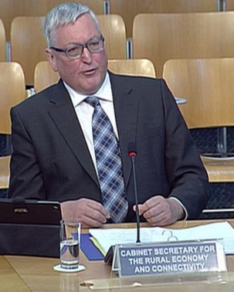
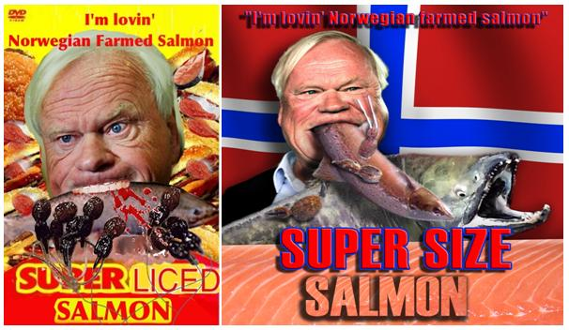

When it comes to his love for Scottish salmon farming - a misnomer since over 70% is controlled by Norway with over 90% of the eggs used for 'Scottish' salmon imported from Norway - Fergus warbles like a Norwegian blue parrot from Monty Python.

"Salmon has been a great success story for Scotland and its aquaculture sector," crowed the Cabinet Secretary for Rural Economy & Connectivity to Holyrood magazine in February 2017 (despite the fact that lice-infested dead salmon are piling up higher than Galdhøpiggen - Norway's tallest mountain - with 15-20 million dead salmon in 2017 and 61 salmon farms in Scotland breaching lice limits).
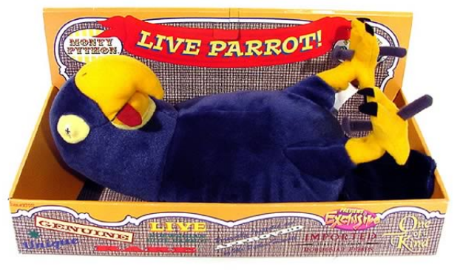

"We fully support the plans for sustainable growth that the Industry Leadership Group have said to double production by 2030," parroted the Cabinet Secretary last month in Brussels whilst peddling disease-ridden Scottish salmon.

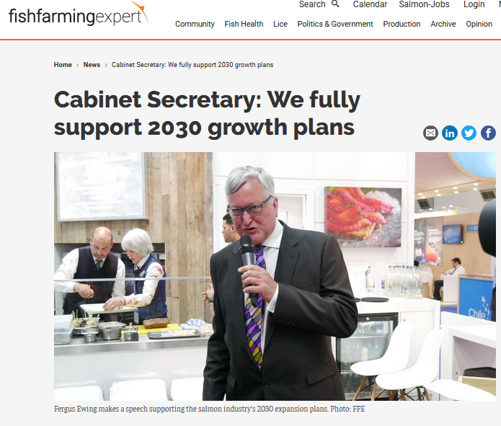
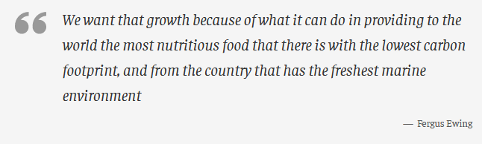
Fish Update reported (25 April 2018):

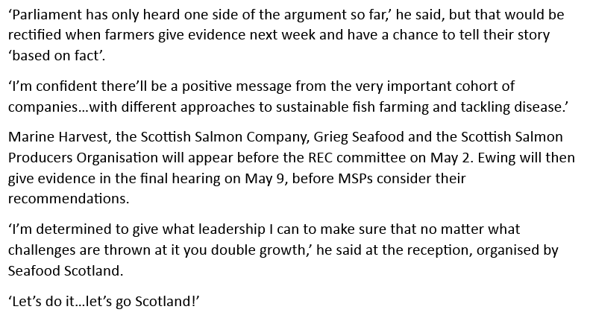

As Ben Hadfield, Managing Director of Marine Harvest Scotland, testified to the Scottish Parliament's Rural Economy & Connectivity Committee on 2 May 2018:

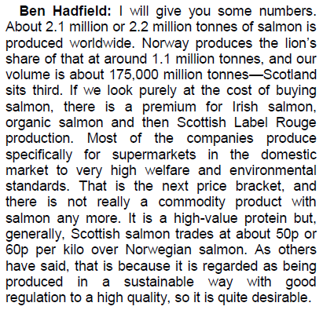

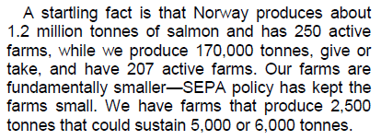

Insider reported in November 2017:

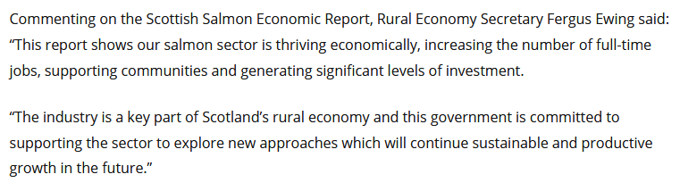

Lest Fergus forgets that mass mortalities on Scottish salmon farms are also 'thriving' with infectious diseases driving up mortality rates to over a quarter (26.7% to be exact according to Fergus Ewing's Parliamentary Reply in January 2018).

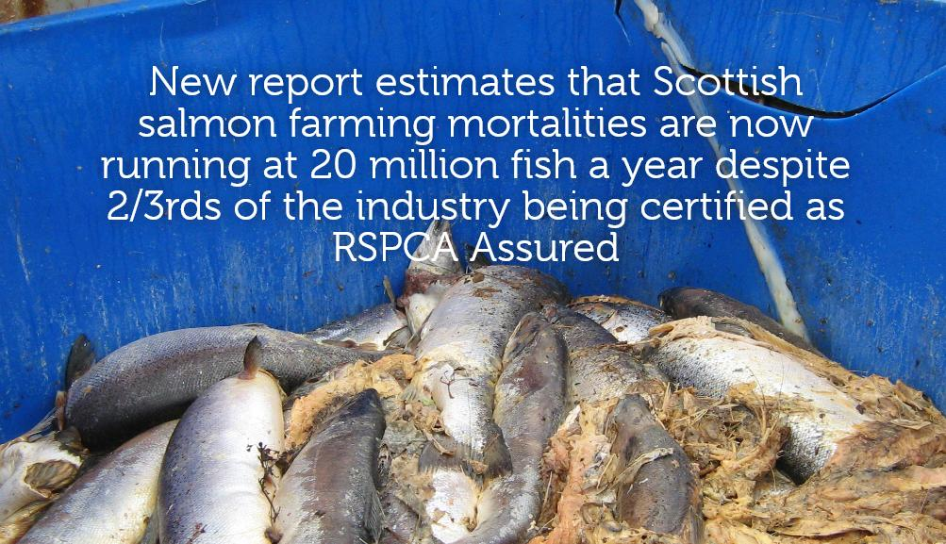

Tweet Tweet as Fergus sang for his salmon supper at Seafood Expo Global in April 2018 showing his appetite for a doubling of salmon farming production by 2030.

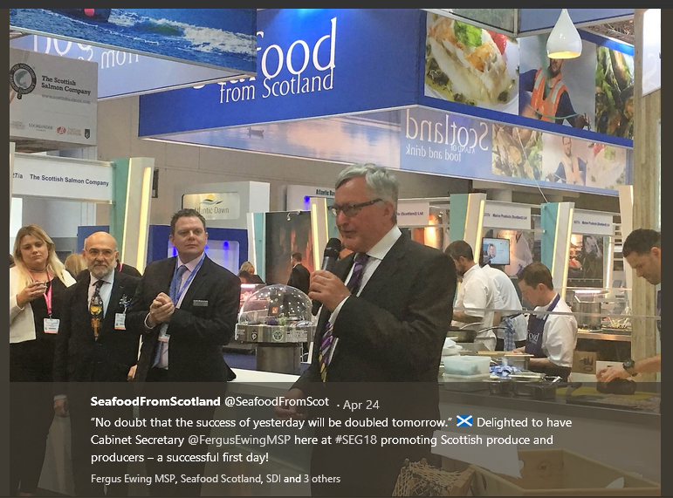

Read more on the salmon farming industry's 2030 expansion plans via "Value of Scottish Aquaculture 2017" (June 2017) - including:

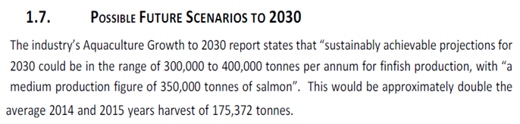

Read more via:
"New strategy launched to 'double' size of aquaculture" (BBC News, October 2016)
"Aquaculture Growth to 2030" (Scotland Food & Drink, October 2016)
"New innovation roadmap outlines pathway for Scottish aquaculture growth" (SAIC, February 2017)

How far does Fergus want to go in terms of pushing salmon farming into bigger and bigger offshore sites?

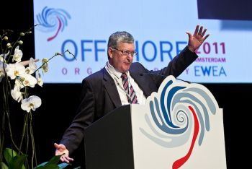

Is the sky the limit to salmon farming production under Fergus's bird-brained vision of progress?

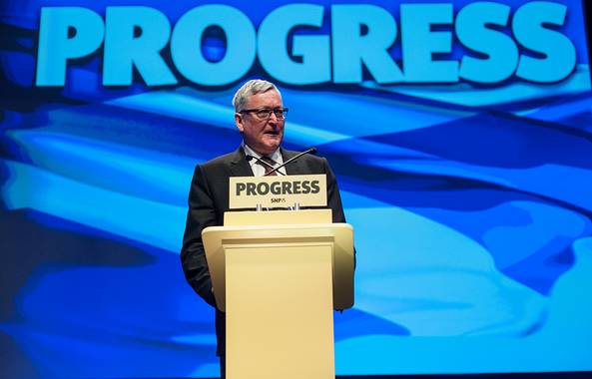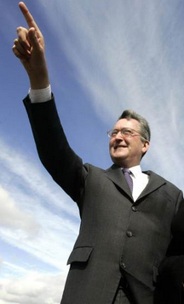

The Cabinet Secretary's 'progress' in expanding salmon farming exports comes at a heavy price.

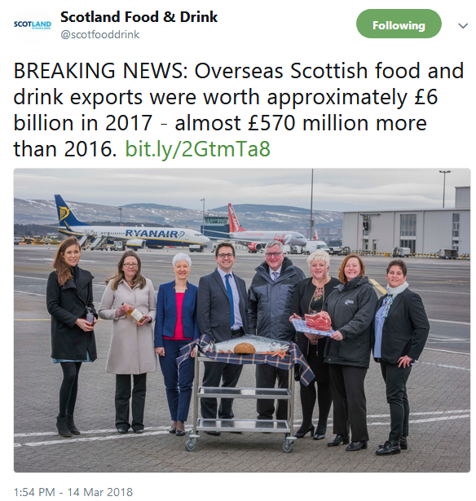

Both to wild fish which are being eaten alive by sea lice from salmon farms.

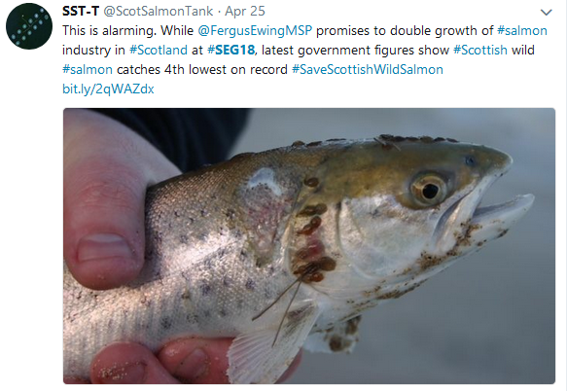
And to Scotland's seal population which is being slaughtered by trigger-happy salmon farmers threatening a ban on exports to the United States.


Supersizing Scottish salmon farming is certainly not green as the Scottish Government Tweeted via Greener Scotland in April 2018.

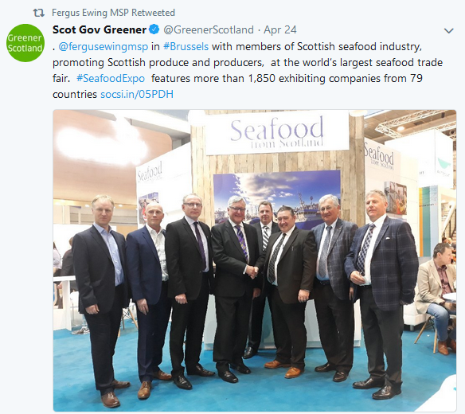
When pressed by the real Scottish Greens in the Scottish Parliament on 24 April 2018, the Cabinet Secretary for Environment, Climate Change & Land Reform conceded that "there is a point beyond which it becomes difficult to sustain growth":

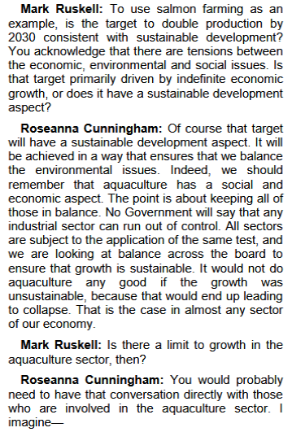

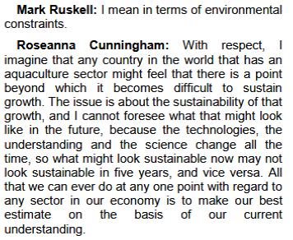
A coalition of wild fish and environmental NGOs certainly think a critical point has already been reached. The Fish Site reported (26 April 2018):

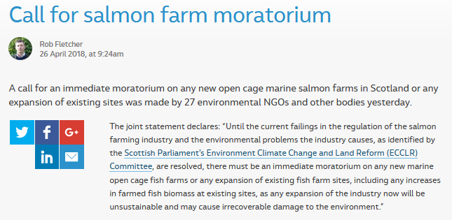

The Oban Times reported (4 May 2018):

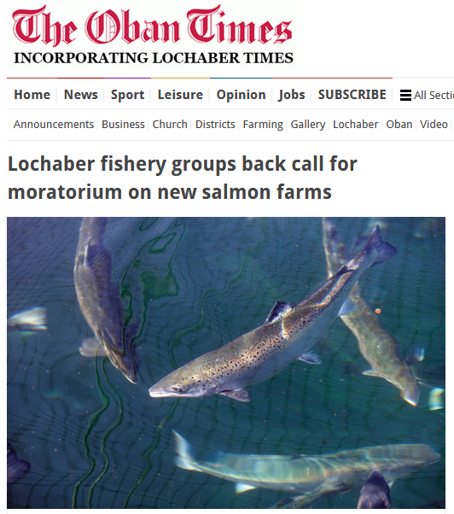
Salmon & Trout Conservation Scotland reported (26 April 2018):

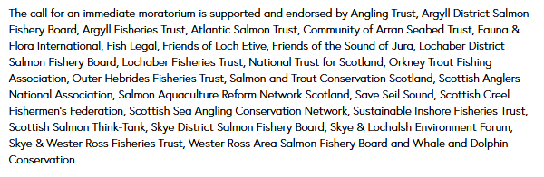
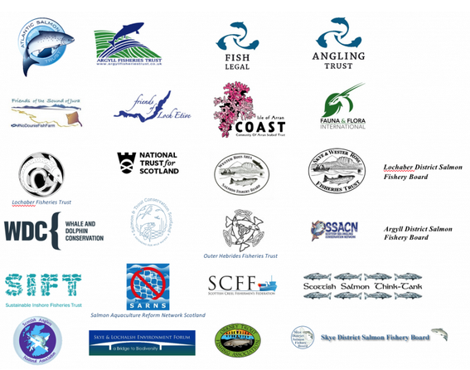

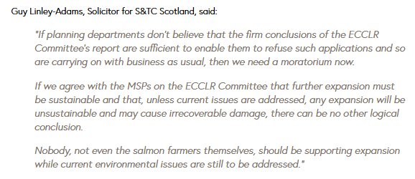
If the Scottish Government has a single jot of ecological foresight, they must heed the Scottish Parliament's damning report into the environmental impacts of salmon farming published in March 2018.

"The planned expansion of salmon farming over the next 10 to 15 years, which aims to grow the industry by 300,000 - 400,000 tonnes, is unsustainable and may, without changes in approach, cause 'irrecoverable damage'," warned a press release (5 March 2018).

Environment, Climate Change and Land Reform Committee Convener, Graeme Dey said:

"The sector has ambitious expansion targets but the Committee is concerned as to how these can be achieved in an environmentally-sustainable way. The sector continues to grow and expand with little meaningful thought given to the impact this will have on the environment. In the Committee’s view, if the current environmental impact issues are not addressed, the expansion will be unsustainable and may cause irrecoverable damage."

Fergus Ewing should read and heed the report in full online here

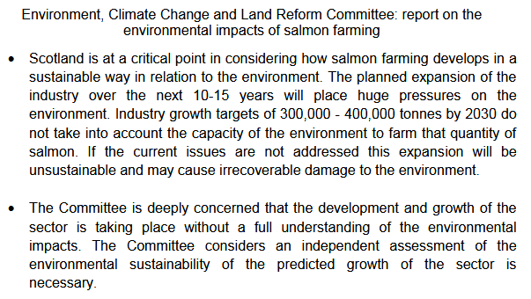

As the Shetland News reported (5 March 2018):

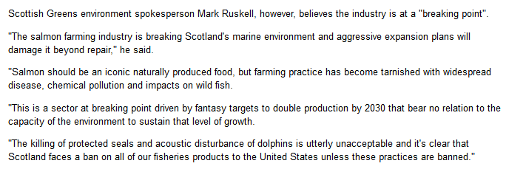
The Sunday Times reported (6 May 2018):
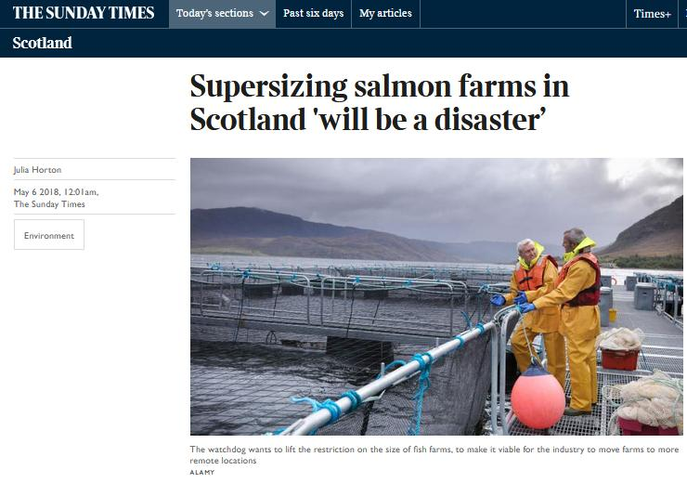
Even retailers are questioning the supersizing of Scottish salmon with The Fish Site reporting (7 May 2018):
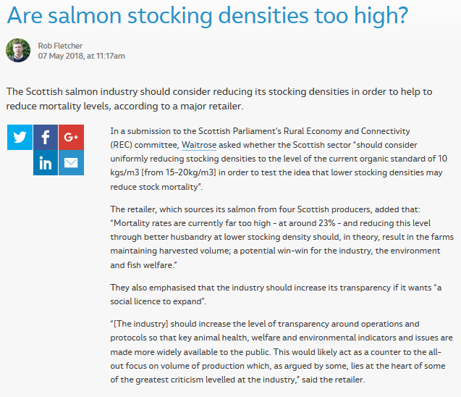
Yet the Scottish Government appears hell-bent on expanding salmon farming in Scotland at all costs. In February 2018, the Scottish Government Tweeted:

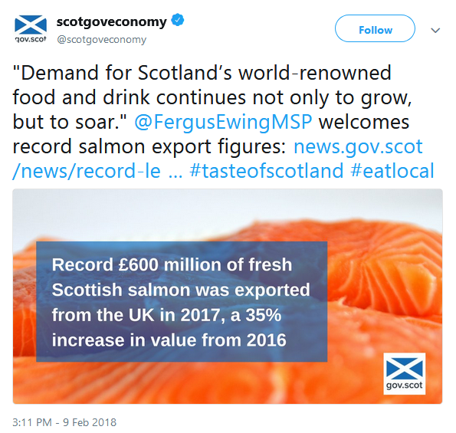

Fish Farming Expert reported in December 2017:

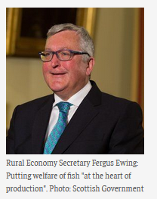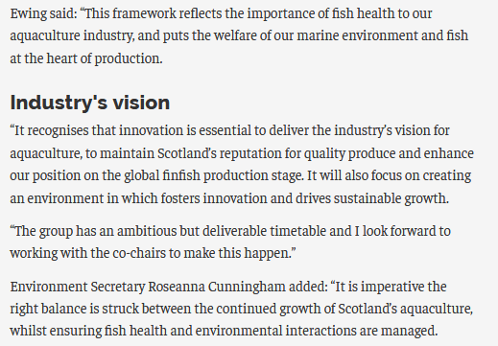

Nearly twenty years ago in 1999 the Scottish Government announced a moratorium on salmon farms on the North and East coasts of Scotland.

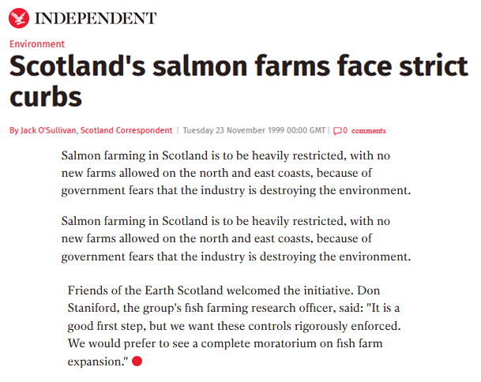

Friends of the Earth Scotland and other members of Scottish Environment LINK have been calling for a moratorium on salmon farming for 20 years - back when salmon farming production was less than 100,000 let alone the proposed 400,000 tonnes.

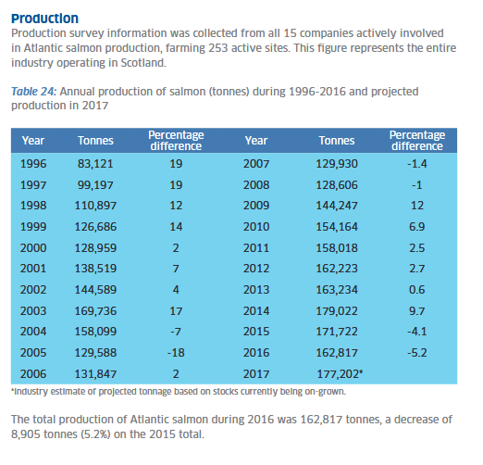

WWF Scotland called for a moratorium back in 2001. 'Bitter Harvest - A Call for Reform in Scottish Aquaculture' stated:

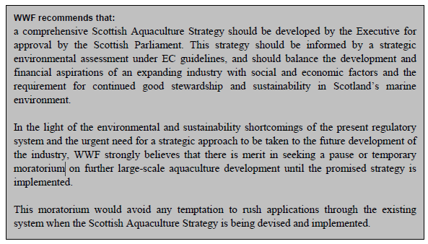

Anglers and environmentalists proposed a moratorium back in 2014 when a letter was delivered to the then First Minister of Scotland, Alex Salmond.

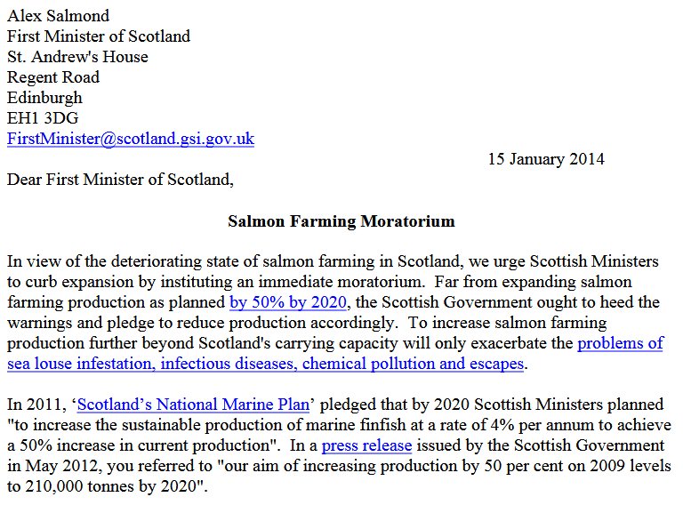
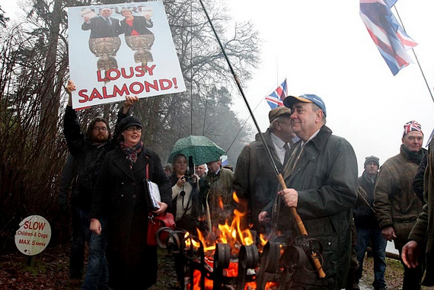

A moratorium on salmon farming in Scotland has become a burning issue with the Scottish Greens questioning the First Minister of Scotland (Nicola Sturgeon) in the Scottish Parliament in December 2017.

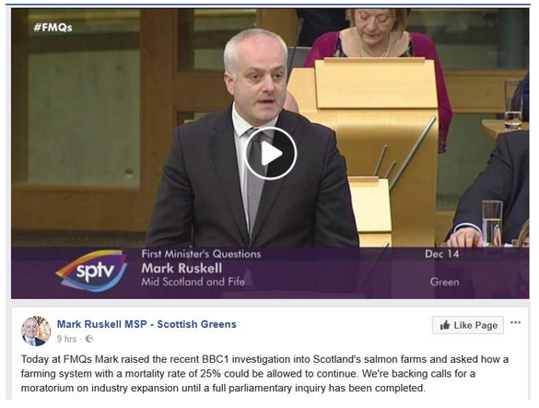

The Herald reported in October 2017:

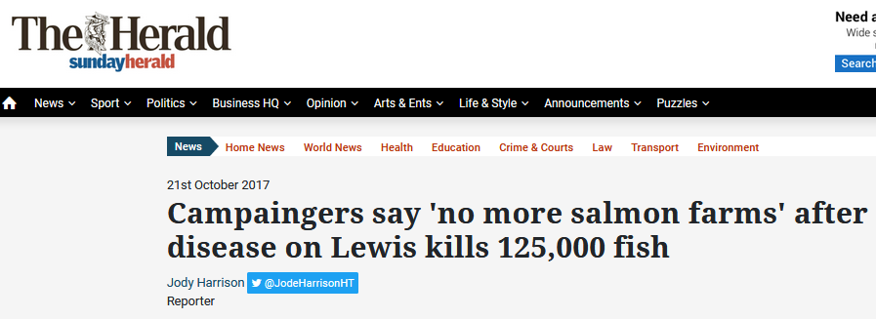
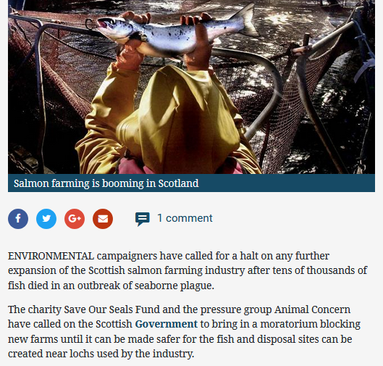

Writing in The Scotsman in February 2017, Ilona Amos said:

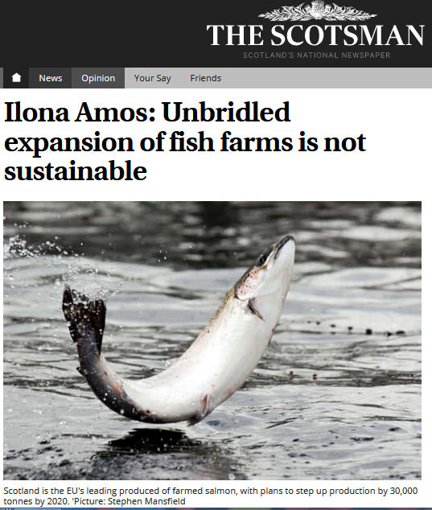
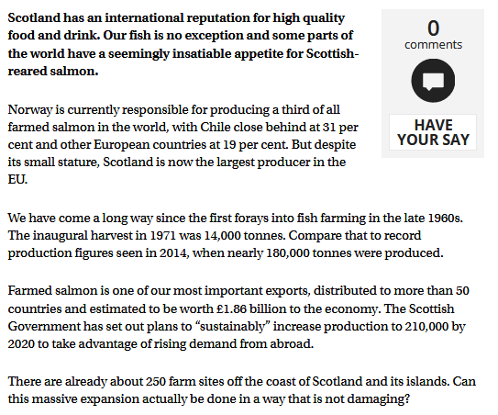

Scottish Environment LINK's written submission to the Rural Economy & Connectivity Committee in April 2018 included:

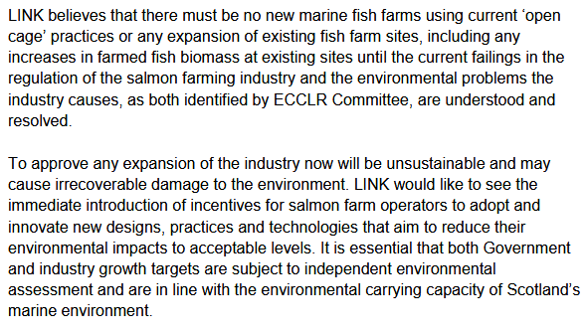

Scottish Wildlife Trust wrote in their submission to the Rural Economy & Connectivity Committee in April 2018:

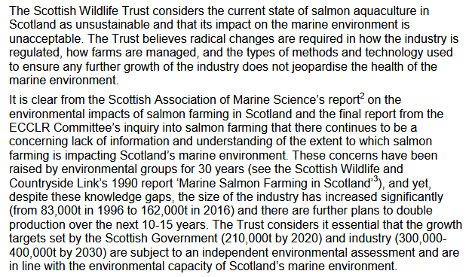
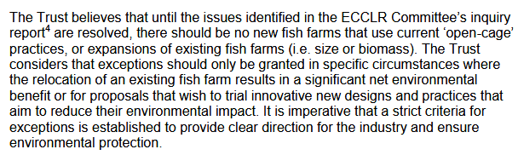

Scottish Wildlife Trusts wrote in April 2018:

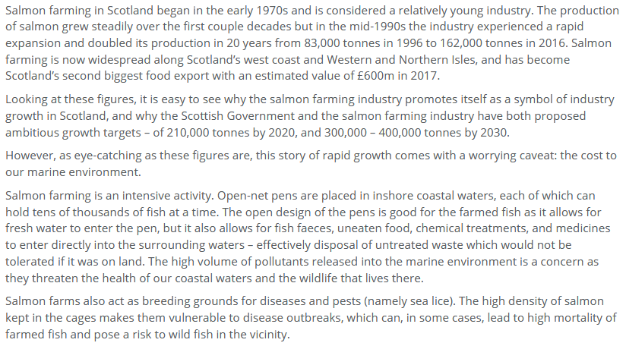

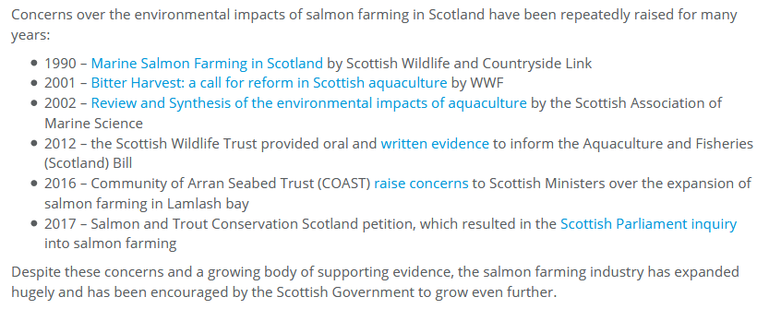

Read more via "Time for Change in Scottish Salmon Farming"
Scottish Salmon Watch wrote in their submission to the Rural Economy & Connectivity Committee in March 2018:

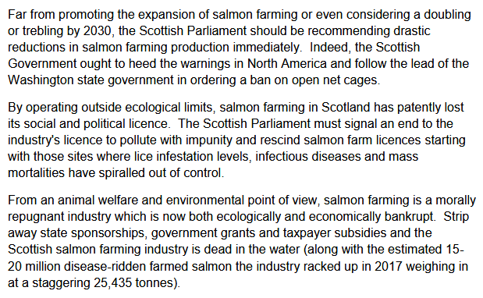

Salmon & Trout Conservation Scotland wrote in their submission to the Rural Economy & Connectivity Committee in April 2018:

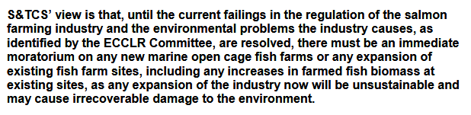

It's a no-brainer for sure.

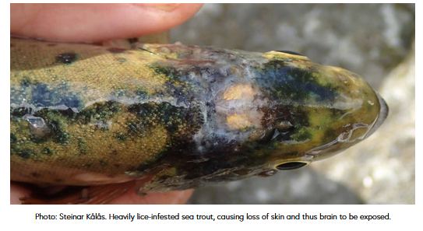
Bigger and bigger salmon farms will mean even more sea lice problems.

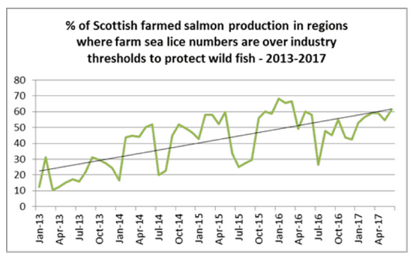
Read more via "Scottish salmon farming's 'liciest' farms named and shamed" and "Scottish salmon sold by a range of supermarkets in the UK has sea lice up to 20 times acceptable limit"

38 Degrees reported in May 2018:

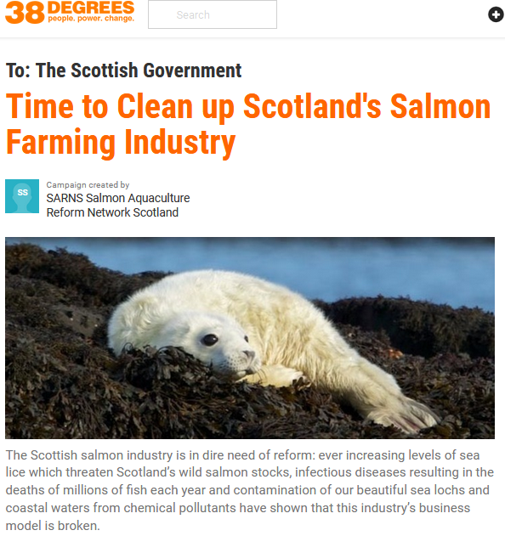

The question is whether the Scottish Government is prepared to listen to environmental warnings and truly balance the costs and benefits of salmon farming - or just go 'Kerching' as the dirty cash rolls in?

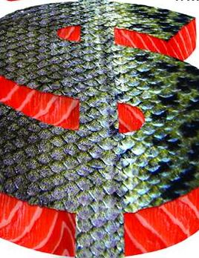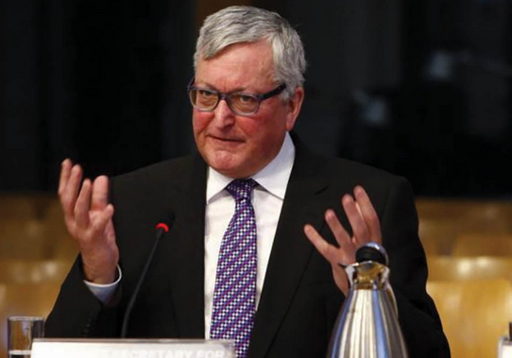

Tomorrow's oral evidence to the Rural Economy & Connectivity Committee will feature not only the Cabinet Secretary but other cheerleaders of the salmon farming industry including Alastair Mitchell who was caught up in the 'Slicegate' scandal.
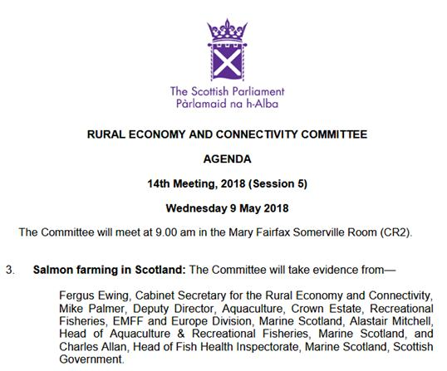

Expect a 'Wham Bam Salmon' play straight out of the Scotch Lamb promotional handbook.

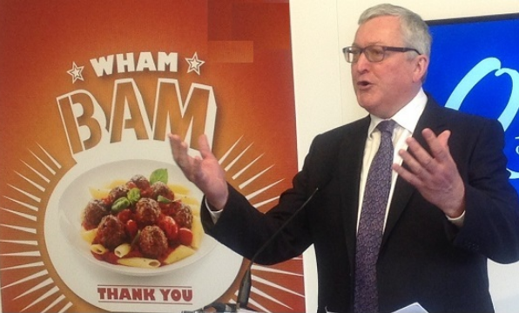

Writing in today's Scotsman (8 May 2018), Ilona Amos warns:

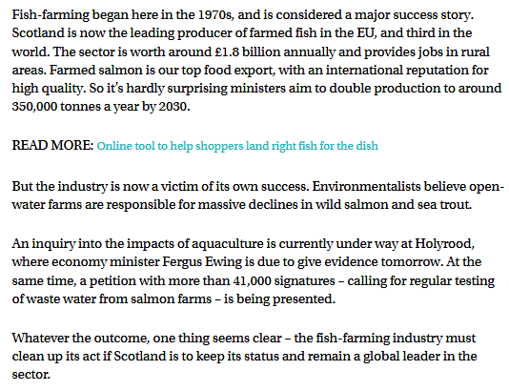

Fergus would be loathe to admit it but the prized image of Scottish salmon is being used and abused by Norwegian companies like a drive-through McDonald's take-away.

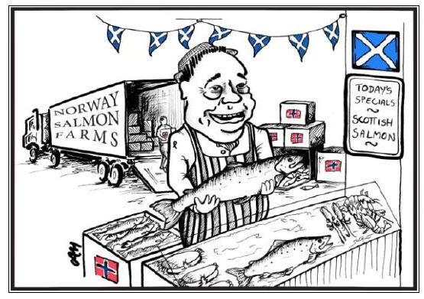

Fast food farmed fish leaves a bad taste in the mouth. Big McSalmon - I'm not lovin' it!

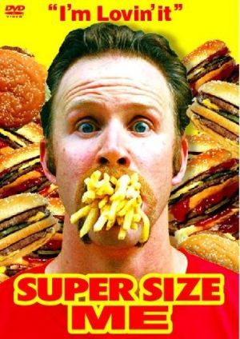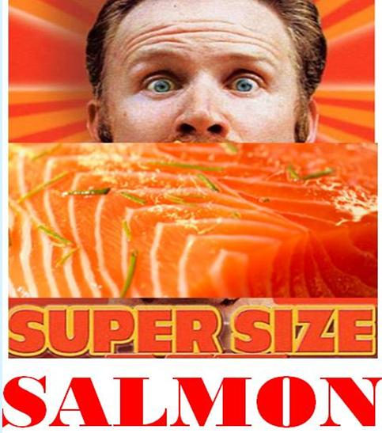

Supersized Scottish salmon is stomach-churning stuff.

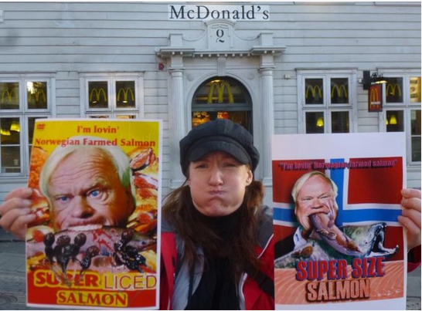

Read more on supersized salmon farming via:

Big McSalmon, Large Lice & Toxic Chemicals - Supersized Salmon Goes Global!
Sunday Times: "Supersizing salmon farms in Scotland 'will be a disaster’"
SEPA proposes lifting biomass cap for Scottish salmon farms
Industry: no imminent plans for super-sized salmon farm
Outrage over secret plans to base world's biggest salmon farm in Scotland
Super-sized Scottish Salmon - 8,000 tonnes of trouble on the horizon!
Opposition mounts to super-sized fish farm in Galway Bay

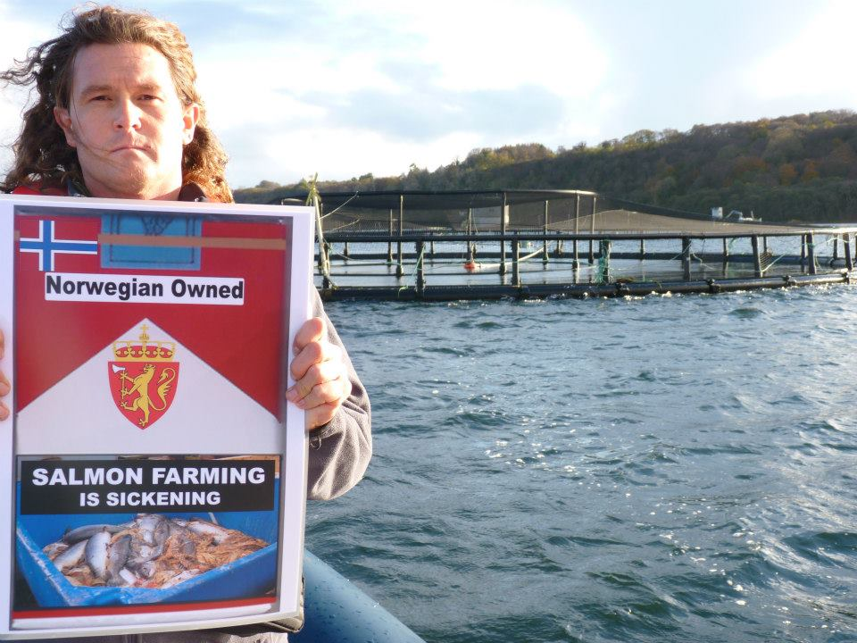

Don Staniford, Director of Scottish Salmon Watch

