The Scottish Salmon Polluters Organisation (SSPO)

As the Scottish Salmon Producers Organisation (SSPO) prepares to "set the record straight" at the Scottish Parliament's inquiry into the environmental impacts of salmon farming, GAAIA takes a closer look at the SSPO's claims towards 'sustainability' and 'responsibility'.

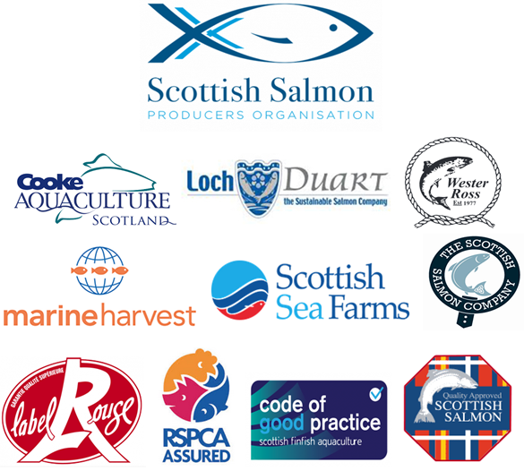

The Scottish Salmon Producers Organisation (SSPO) - whose member producers include Cooke Aquaculture (Scotland), Loch Duart, Marine Harvest (Scotland), The Scottish Salmon Company, Scottish Seafarms and Wester Ross Salmon - is a rogues' gallery in terms of lice infestation, toxic chemicals, waste pollution, infectious diseases, killing of seals and mass escapes.

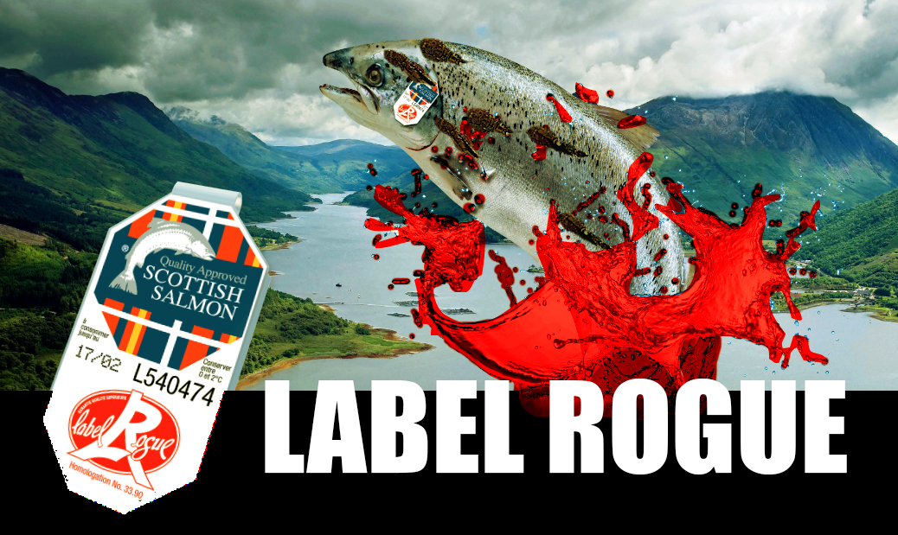
If only SSPO member producers were honest when marketing Scottish salmon.......

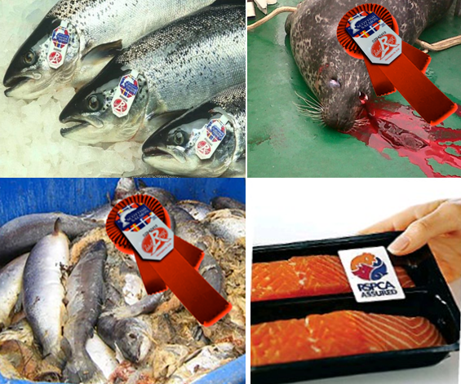

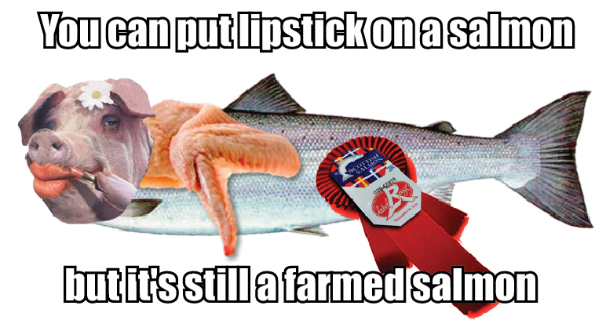

......they would rebrand themselves the Scottish Salmon Polluters Organisation.
"Sustainable" and "responsible" do not even belong in the same sentence as Scottish salmon:

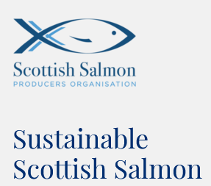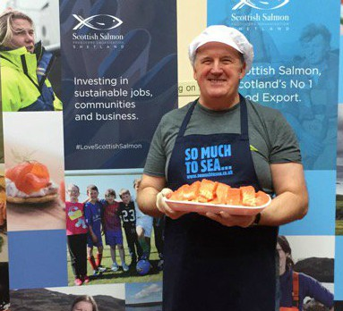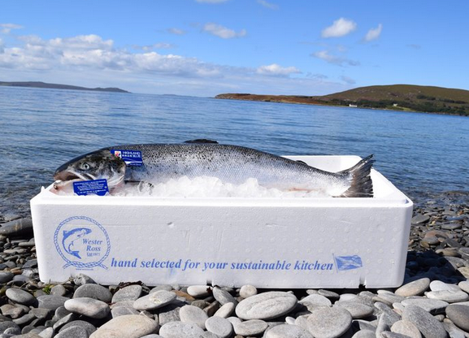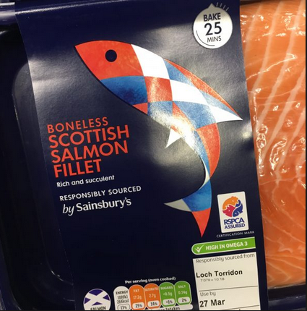
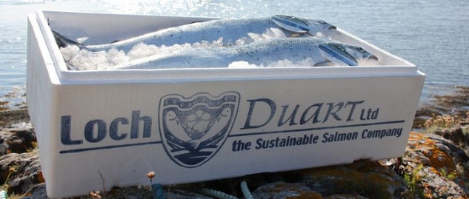

Read more via "Sustainable Scottish Salmon"; "Scottish Salmon Farming: A Sustainable Industry"; "Scottish Salmon's Sustainability Scam"; "Unbridled expansion of fish farms is not sustainable" and "25 Reasons to Boycott Scottish Salmon"

Lice infestation is a common denominator at all SSPO member producers - in fact 51 of the 62 salmon farms breaching sea lice limits between November 2016 and August 2017 were SSPO member producers (19 sites operated by The Scottish Salmon Company, 11 by Marine Harvest, 10 by Scottish Sea Farms, 7 by Cooke Aquaculture and 4 by Loch Duart).

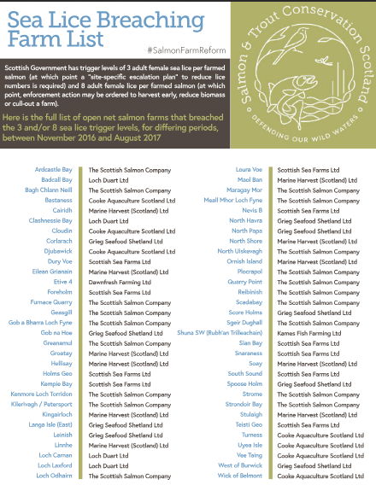

Read more via "Scottish salmon farming's 'liciest' farms named and shamed" and "Scotland's worst sea lice offenders - Full farm list"

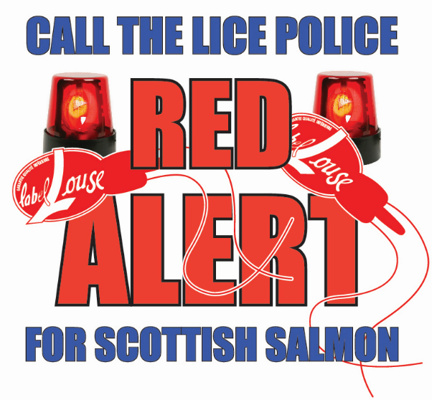

In March 2017, the Chief Executive of the SSPO (Scott Landsburgh) admitted that Label Rouge "is not a standard designed to assess environmental or animal welfare criteria":

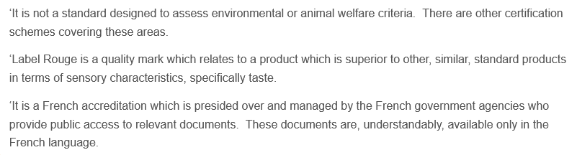
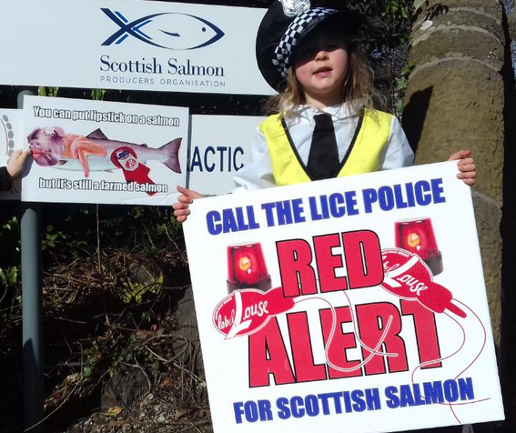
The SSPO's public admission may come as a surprise to many people who have been duped into believing that the Label Rouge is the industry's gold standard.
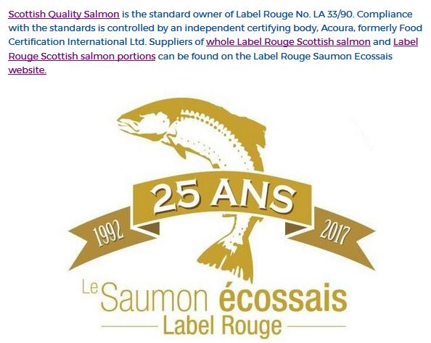
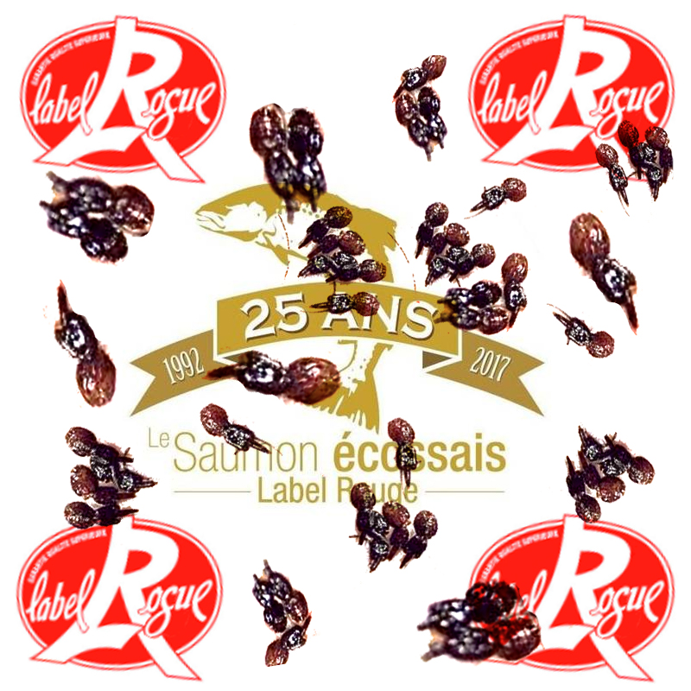

Read more via: "SSPO admit Label Rouge "is not a standard designed to assess environmental or animal welfare criteria"; "Concerns Over Label Rouge Salmon Certification"; Letter to French Government: "Label Rouge Saumon Ecossais - Quelle Horreur!" and "Red Alert for Label Rouge - Lousy Label Goes Rogue"
The use of toxic chemicals on Scottish salmon leapt 1000% over the last decade - with SSPO member producers winning gold medals for the use of Emamectin benzoate (shown to be lethal to lobsters), Teflubenzuron (now banned following evidence it can kill crabs, shrimp and lobsters), Azamethiphos (shown to cause neuromuscular dysfunction, hypoxia, metabolic disturbances and mortality in lobsters), Cypermethrin ("particularly toxic to crustacea") and Deltamethrin (fast-tracked for use by SEPA):
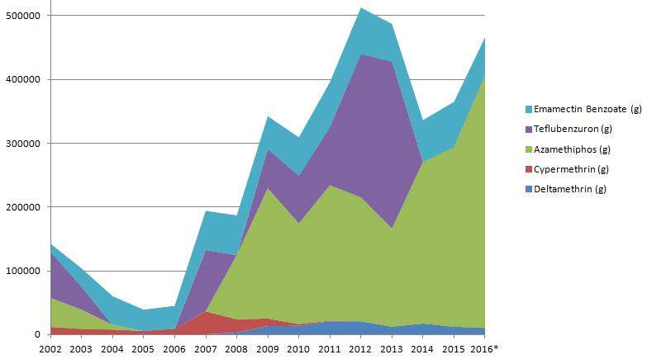

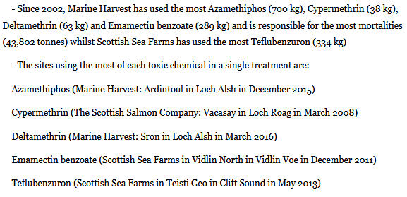

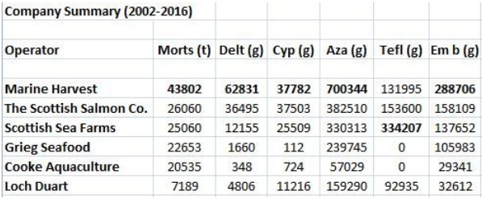

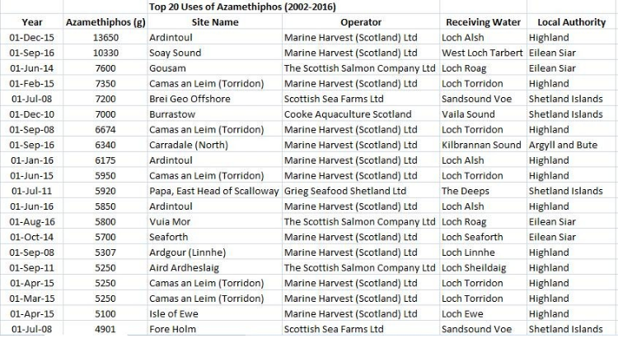

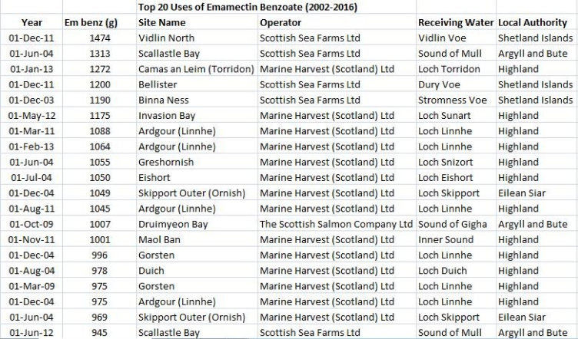

SSPO member producers have also been caught breaching SEPA's biomass limits (i.e. producing more salmon than permitted):

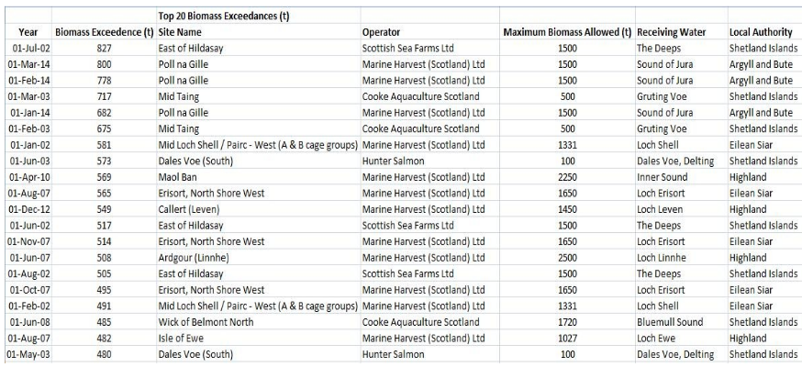

Read more via The Sunday Times: "Salmon industry toxins soar by 1000 per cent"; "Scottish Salmon's Lethal Legacy - Ten-fold Increase in Toxic Chemical Use in Ten Years"; Press & Journal: "Scottish salmon farming ‘fighting a losing battle’ against sea lice"; "Scottish fish farmers use record amounts of parasite pesticides" and "Sharp rise reported in Scots fish lice chemical".

Search 'Scotland's Aquaculture' database company by company online here:

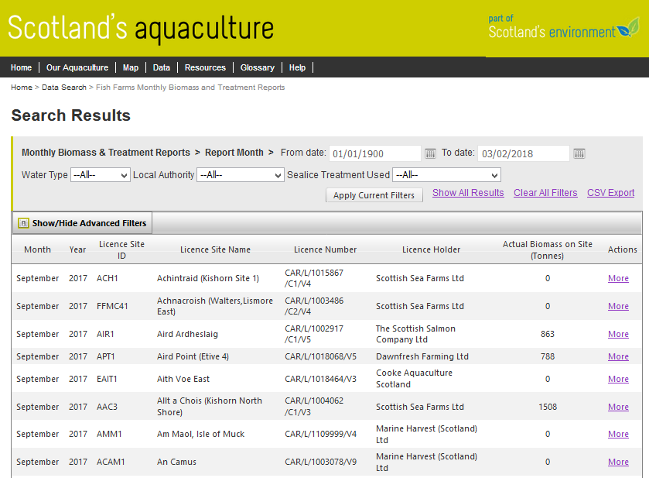

The use of Hydrogen peroxide on Scottish salmon farms has also sky-rocketed:

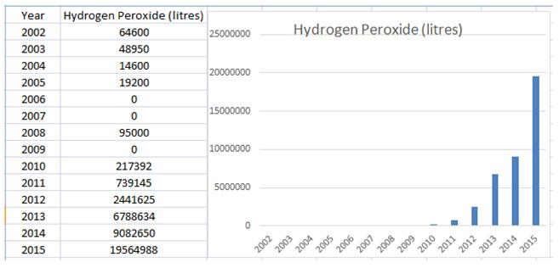

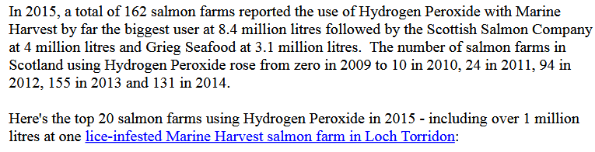
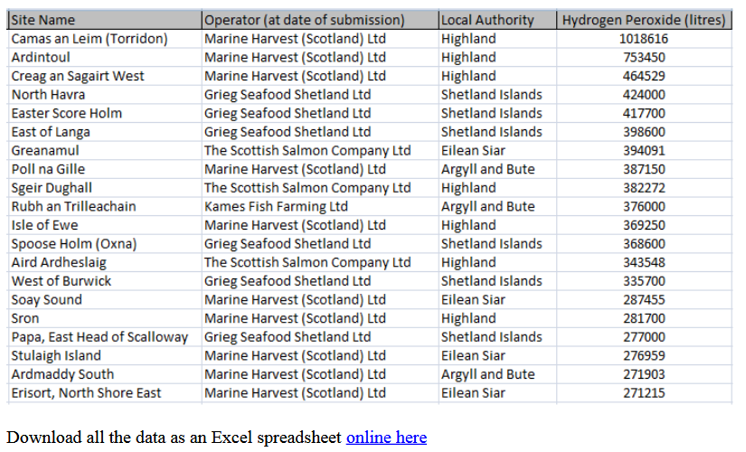

Read more via The Sunday Times: "Record chemical use ‘of concern’ to salmon giant" and "Sky-Rocketing Chemical Use on Scottish Salmon Farms"
Data on antibiotic use reveals that SSPO member producers are the biggest drug users:

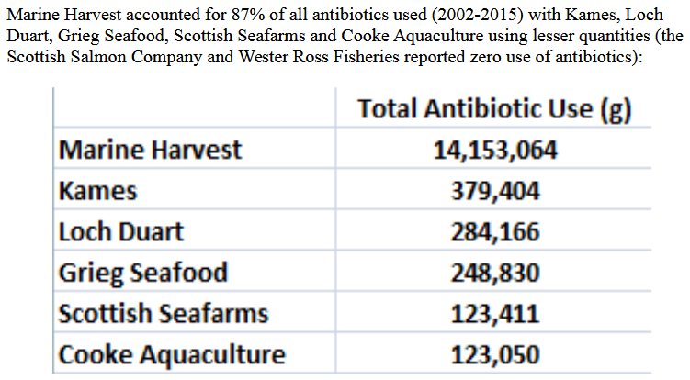

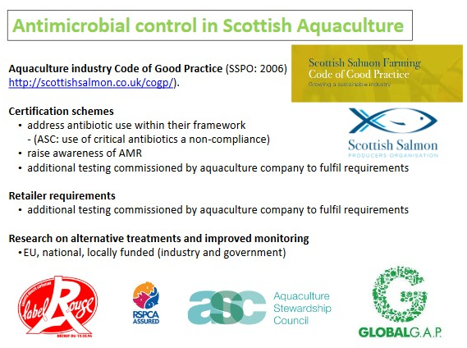

Read more via "Antibiotic-ridden Scottish Salmon: FOI reveals of Oxytetracycline, Florfenicol, Amoxycillin and Fenbendazole" and "Fish 'hooked on chemicals"

Given the industry's reliance on drugs and chemicals it is not surprising that SSPO member producers have been caught by the Veterinary Medicines Directorate with chemical contamination of farmed salmon. Emamectin contamination of Scottish farmed salmon has now occurred at least eight times (including The Scottish Salmon Company in 2016 and 2012, Scottish Sea Farms in 2006 and Marine Harvest in 2005):
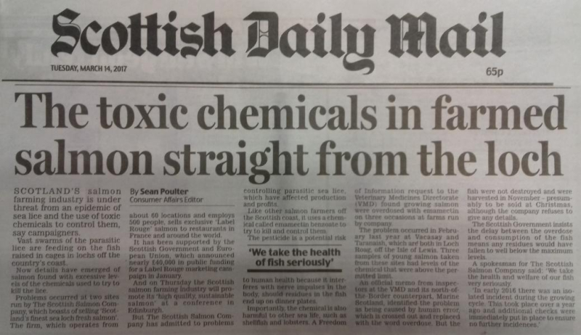
Read more via "Scottish Salmon Overdoses on Toxic Chemical"; Daily Mail: "The toxic chemicals in farmed salmon straight from the loch" and "Emamectin residues in farmed salmon"
Data from SEPA ranked fish farms as 2nd worst out of "Scotland's polluting industries" - with SSPO member producers guilty of the vast majority of fish farm pollution breaches:

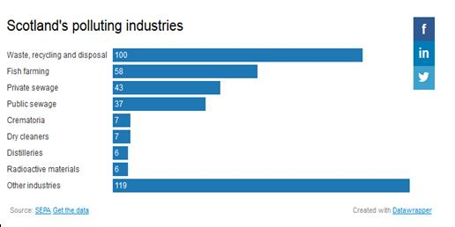
Read more via "Exposed: the 383 plants that pollute Scotland" and "Mapped: the hundreds of firms condemned for ‘poor’ pollution performance"
Almost a fifth (18%) of Scottish fish farms were classified by SEPA as failing and responsible for "at least one significant breach" in 2015. SSPO member Marine Harvest, Scotland's largest salmon farming company, was the worst operator with 13 "failing" salmon farms in 2015 (that's 27% of the 49 marine salmon farms operated by Marine Harvest).

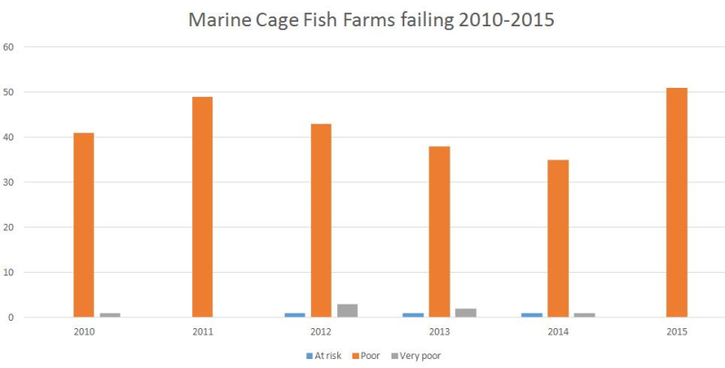

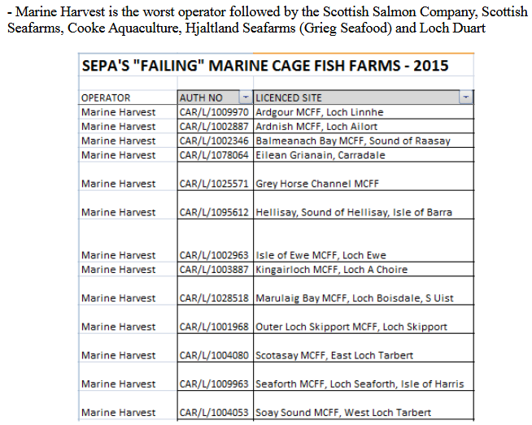
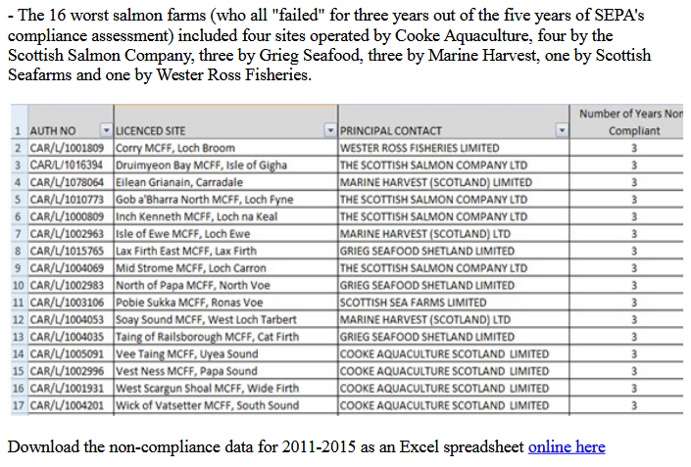

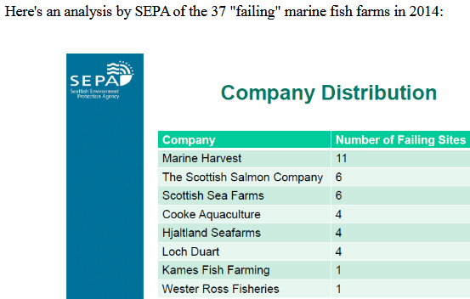

Read more via "Failing Fish Farms - 18% rated "poor" by SEPA in 2015"
In 2006, The Sunday Herald reported on "Scotland's 'dirty dozen'" ecologically risky companies - with Marine Harvest's processing plant in Fort William topping the list (i.e. the worst of the worst.

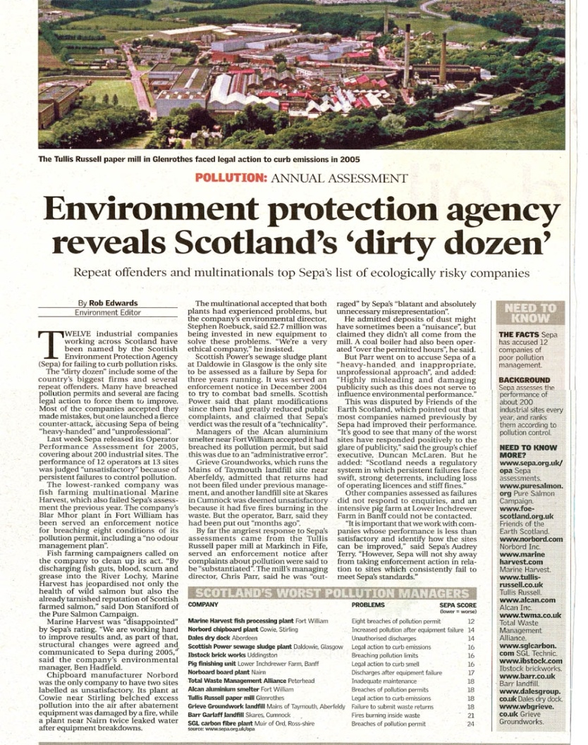

The SSPO's marketing materials gloss over such negatives.

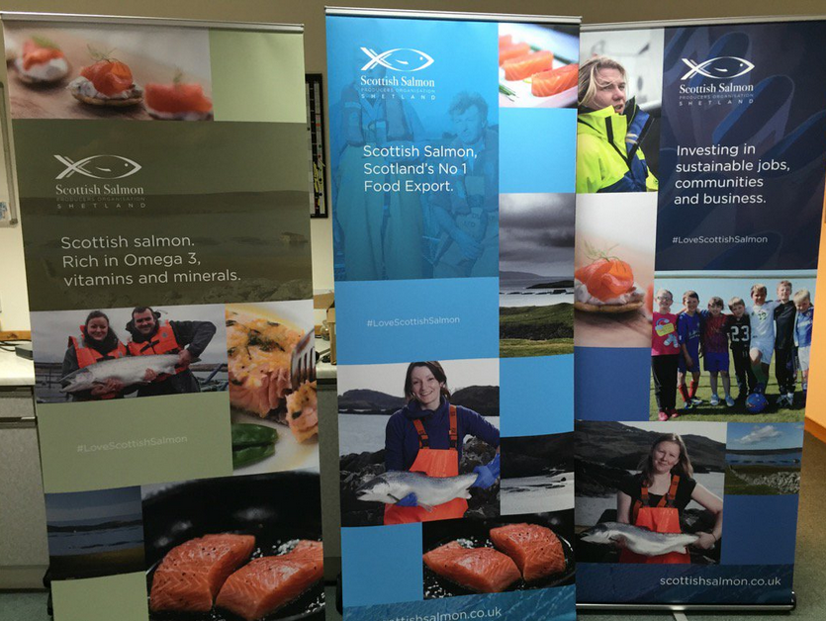

Cooke Aquaculture (Scotland):

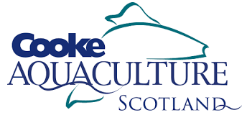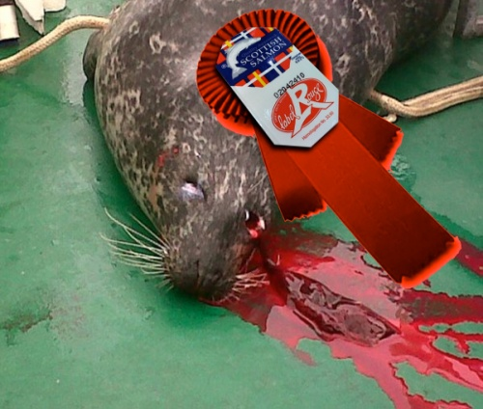

Canadian-owned Cooke Aquaculture only entered the Scottish market in 2014 when it bought Meridian followed by Thompson Bros Salmon in 2015 but has wasted little time in polluting the waters around Shetland, breaching sea lice limits and killing seals.

The BBC reported in January 2018:

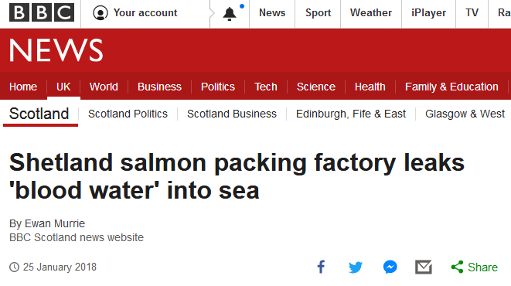
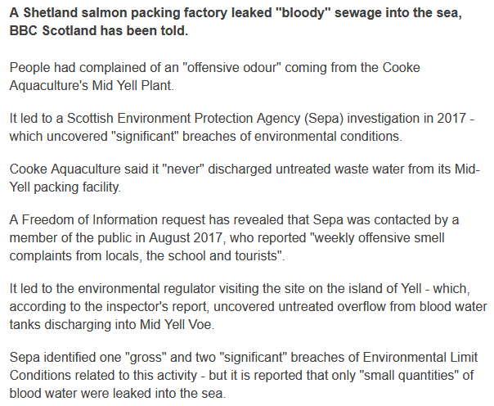
SEPA's assessment of Cooke's Mid Yell processing factory in August 2017 was rated "Poor" due to one "Gross" and two "Significant" breaches reported as "Untreated overflow from blood water tanks discharging down bank & into Mid Yell Voe". SEPA reported that there was an "Environmental Event notification of odour from plant" and "Operation of blood water treatment plant not operating properly - improvement required".
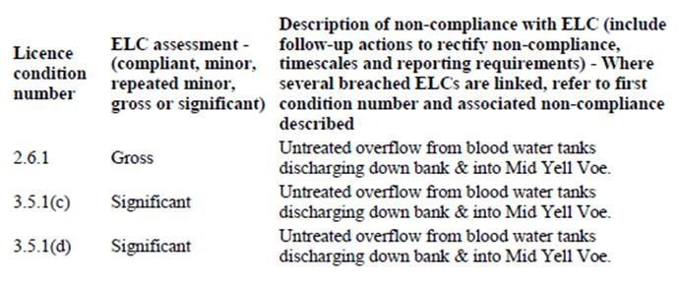
SEPA's 'Action Points' to Cooke Aquaculture in August 2017 included: "It was also evident that small amounts of effluent from the blood water storage tanks was discharging directly to Mid Yell Voe, without treatment, via what were assumed overflow pipes. You were aware of this problem and are to put in place remedial actions to prevent the overflow discharging untreated effluent directly to Mid Yell Voe"
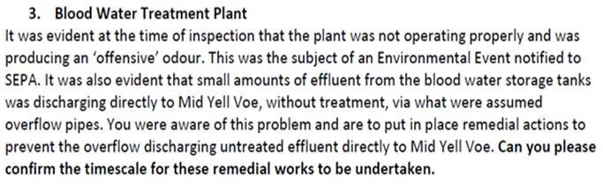
An 'Environmental Event Notification' in January 2017 complained that "Over the last 6 months hundreds of litres of Hyphochlorous Acid - labelled 'Harmful to Marine Environment has been added to the blood water silos at the Mid Yell packing station. As can be seen from the accompanying photograph this is overflowing into the sea. The majority of the raw effluent has been flowing directly into the sea as the water treatment works have no chance of coping with the quantity involved due to the design flaw."

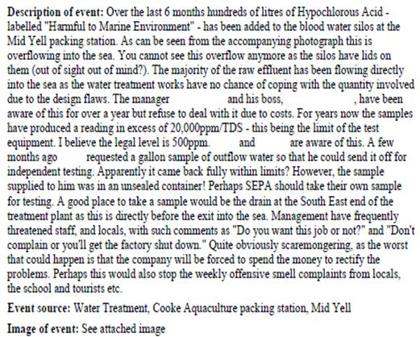
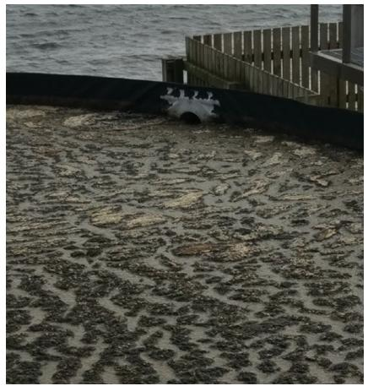
Read more via:
International Business Times: "Scottish waters flooded with salmon blood after food plant leaks"
Shetland News: "Salmon firm allowed discharge of effluent"
Undercurrent News: "Cooke Scotland plant found to have leaked blood water"
Shetland Times: "Salmon company reacts over 'blood water' issue"
Press Release: "Cooke's Untreated Blood Water is 'Gross' says SEPA"
BBC Radio Shetland on Cooke's "untreated blood water" in Scotland
BBC News: "Shetland salmon packing factory leaks 'blood water' into sea"

The Herald reported in April 2017:

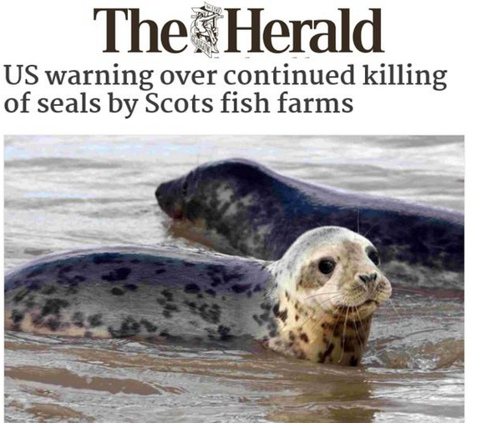

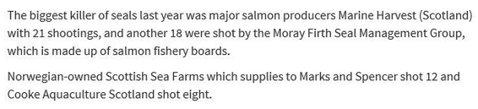

The Scottish Government's data on seal killings on Scottish salmon farms reveals that in 2016 Cooke Aquaculture killed eight seals with five killed at Ouseness and one each killed at Djubawick, Stead of Aithness and Winna Ness.

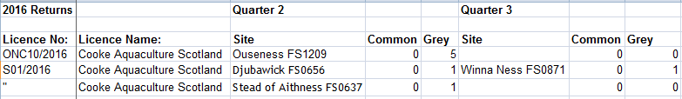

In 2015, Cooke Aquaculture killed three seals:

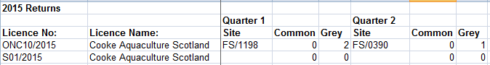

According to the Scotland's Aquaculture database, Cooke Aquaculture has suffered mass mortalities and has used toxic chemicals such as Azamethiphos:

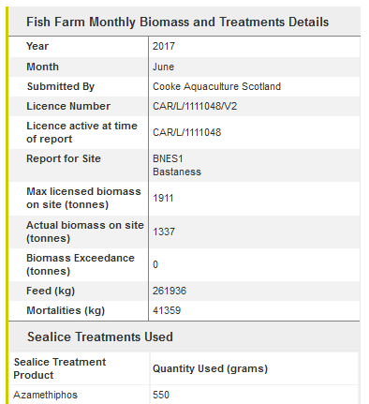

Salmon & Trout Conservation reported in November 2017 that six salmon farms operated by Cooke Aquaculture breached lice limits.

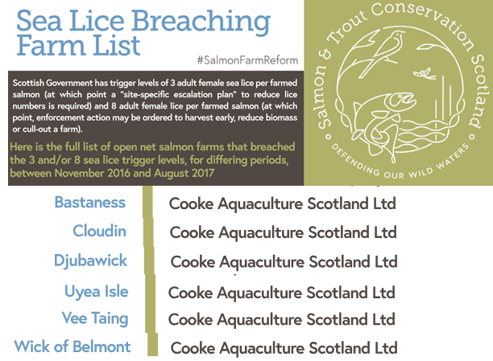

In 2016, around 10,000 salmon escaped from Cooke Aquaculture's farm at Swarta Skerry in Shetland:

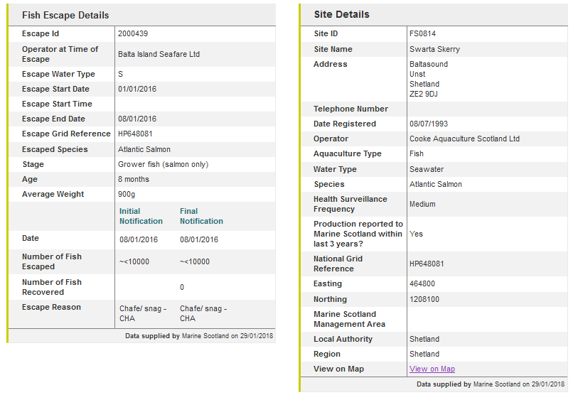
Marine Harvest (Scotland):

Marine Harvest is guilty of widespread environmental pollution - in Scotland as well as in Norway and around the globe.

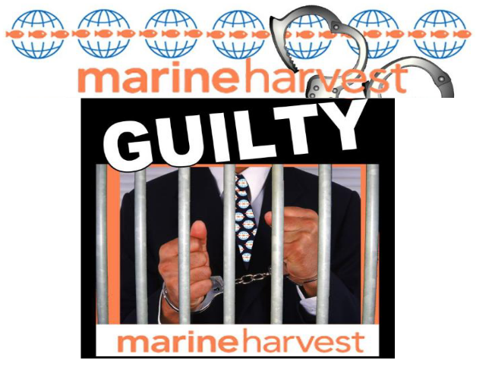

Marine Harvest's slaughter of seals in Loch Alsh - a Special Area of Conservation - attracted widespread condemnation:

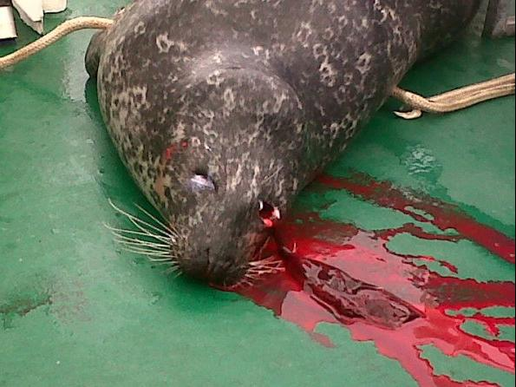

GAAIA reported in November 2017:

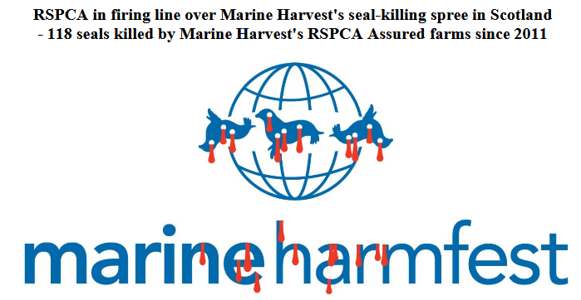

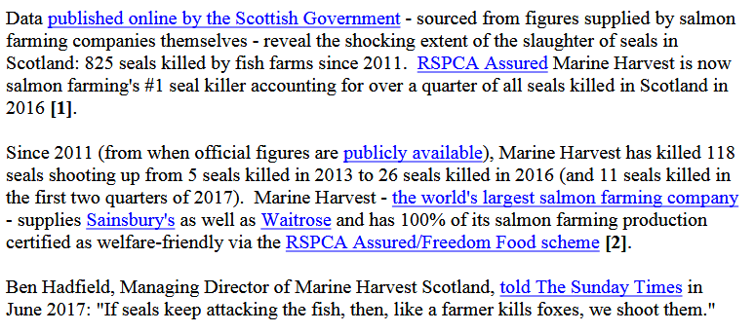

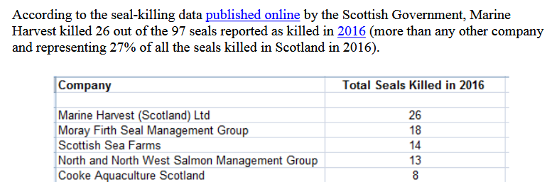

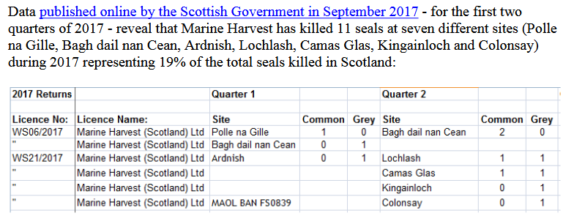

More details via "Scottish Fish Farmers Slaughter Seals"; "Marine Harvest's Slaughter of Seals in Loch Alsh, Scotland"; "Seal killing concern at fish farm"; "Marine Harvest: Scotland's #1 Seal Killer" and "RSPCA in firing line over Marine Harvest's seal-killing spree in Scotland"

Marine Harvest polluted Loch Shell with the toxic pesticide Teflubenzuron (subsequently banned by SEPA) up to 450 times higher than recommended levels:

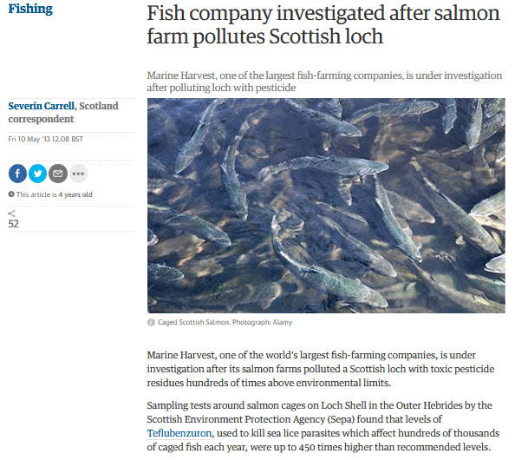
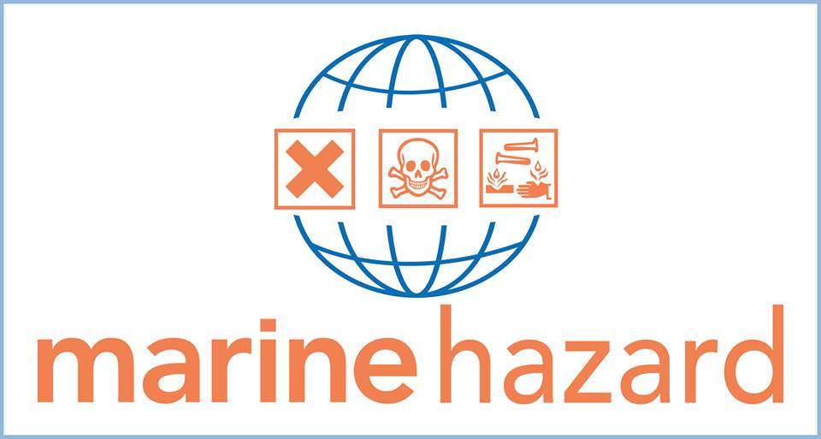

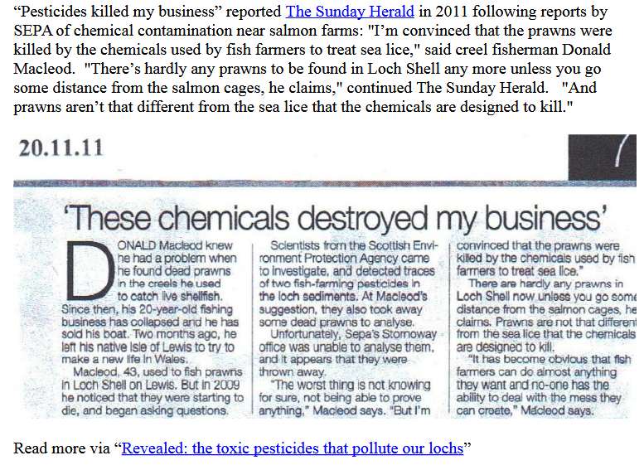

Read more via "Fish company investigated after salmon farm pollutes Scottish loch"; "Revealed: the dirty dozen salmon farms that contaminate lochs with pesticides" and "Revealed: the toxic pesticides that pollute our lochs" and "The drug that's meant to save Salmon but is killing the creatures on the Ocean floor"

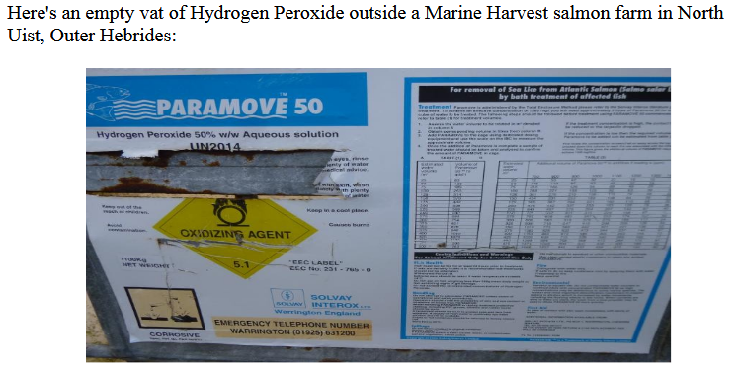

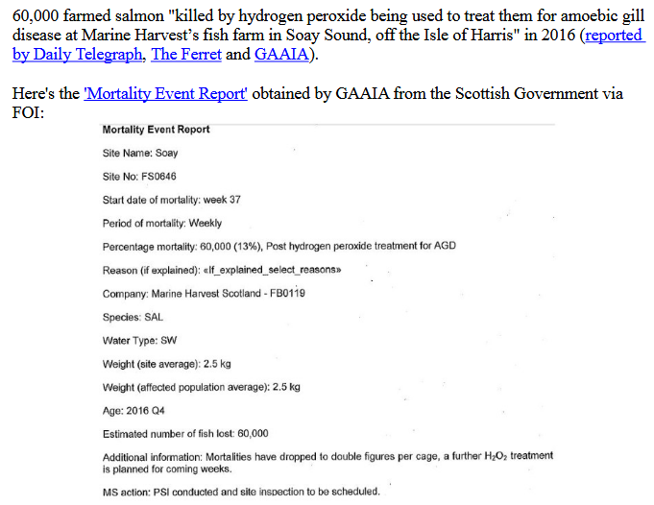

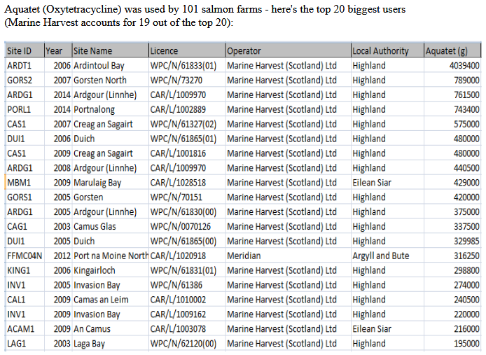
Read more via "Antibiotic-ridden Scottish Salmon: FOI reveals of Oxytetracycline, Florfenicol, Amoxycillin and Fenbendazole" and "Fish 'hooked on chemicals"

In 2005, Marine Harvest was fined £4,000 for polluting the River Lochy with fish viscera, blood and congealed fats deposits, scum and grease:

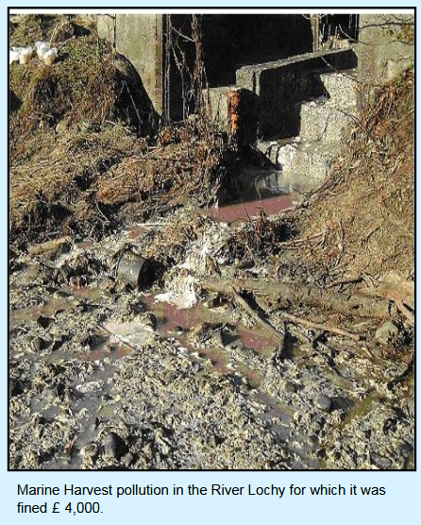

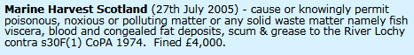

Read more via "Scottish Farmed Salmon Exposed"

Nearly 100,000 farmed salmon were 'Thermoliced' to death by Marine Harvest during 2016:
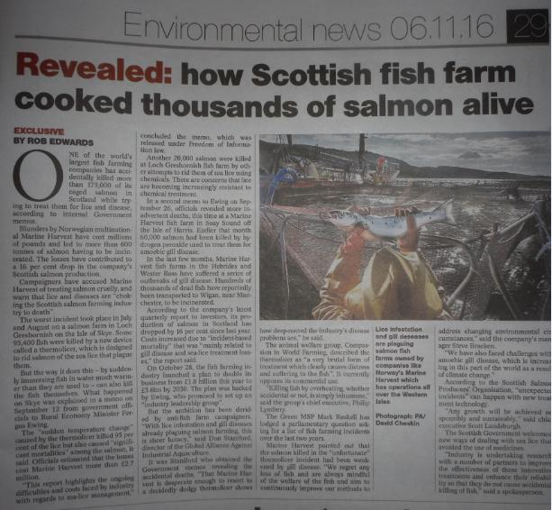
Read more via "'Thermolicer' Back-Fires Killing 95,400 Farmed Salmon"; Fish farm firm kills 175,000 salmon by accident; "Oops: fish farm firm kills 175,000 of its salmon by accident" and "Thousands of fish poached alive in lice treatment bungle"

Mortality events reported by Marine Harvest in 2017 include three cases involving over 20,000 dead salmon due to using a Thermolicer:
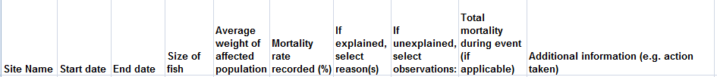

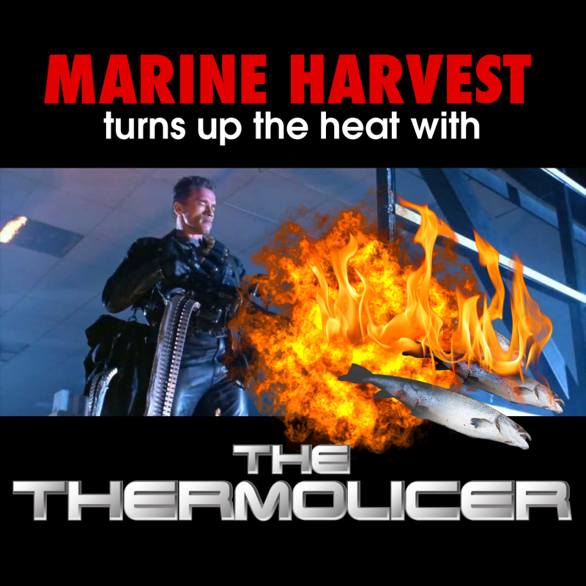

In January 2018, a fish vet from Norway "highlighted major head injuries she has seen to fish treated with warm water delousing machinery". "No matter what non-drug method you use for delousing, it kills," said Kristin Ottesen in a report by Fish Farming Expert. "Same if it’s Skamik, FLS, Thermolicer and Optilice" (read more via "Vet warns of head injury risk to fish during delousing").

The Sunday Times reported (12 February 2017):

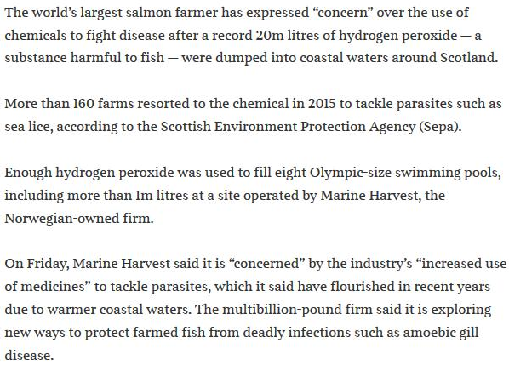

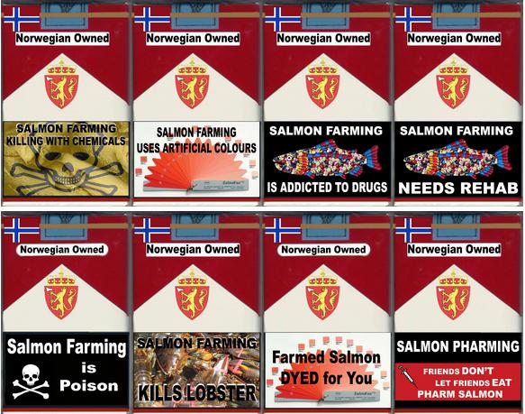
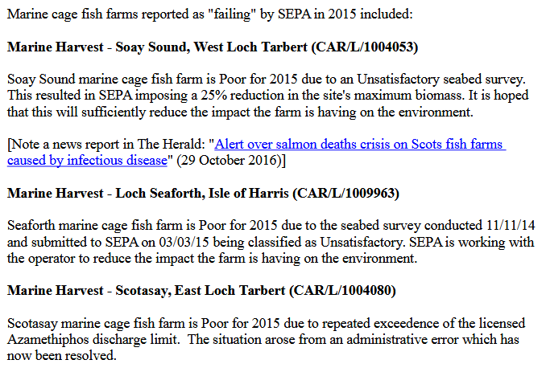
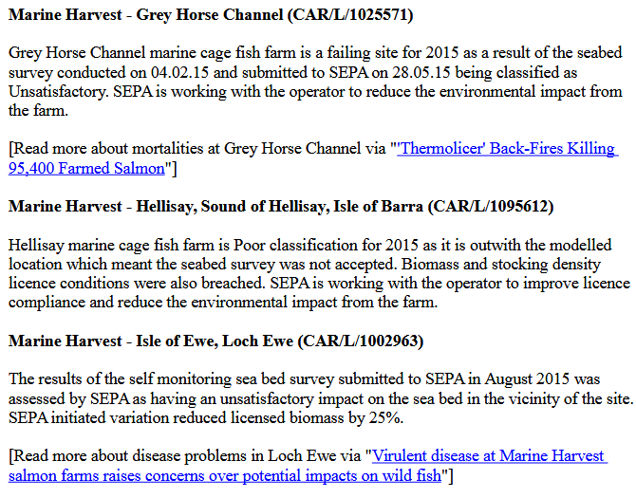

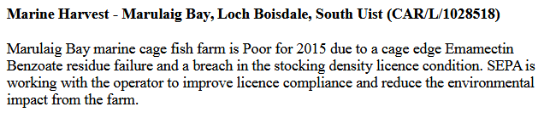

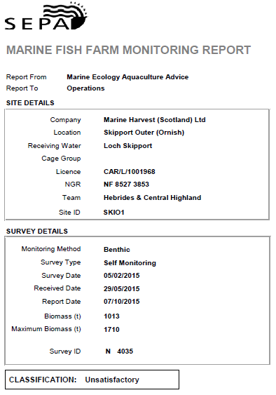

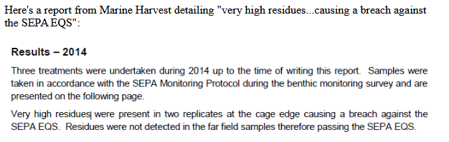
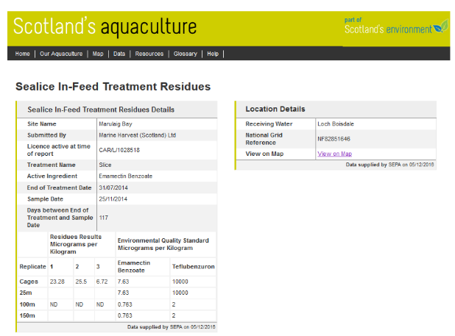

Read more via "Failing Fish Farms - 18% rated "poor" by SEPA in 2015"

Marine Harvest is certainly no stranger to breaching pollution limits:

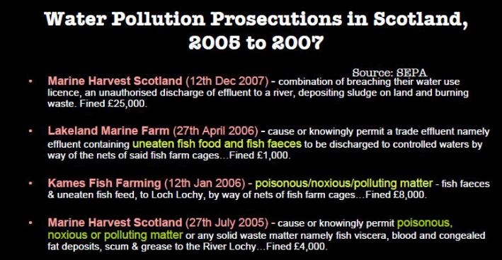

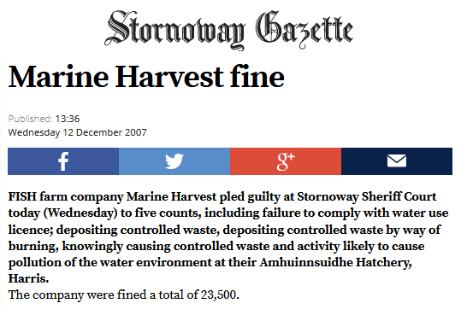

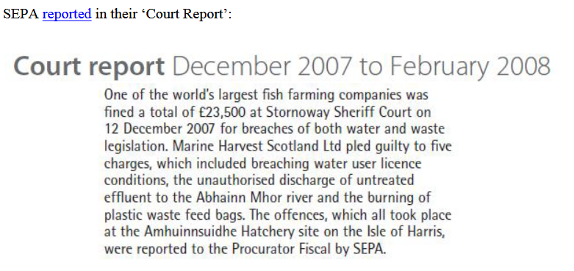

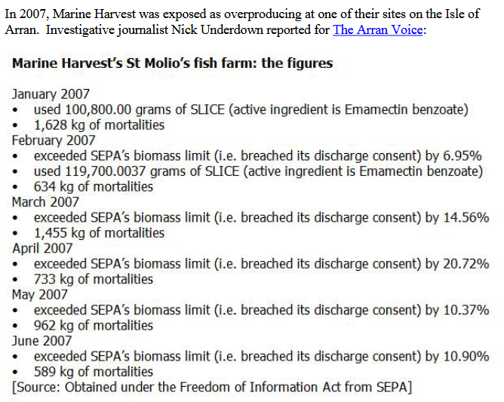

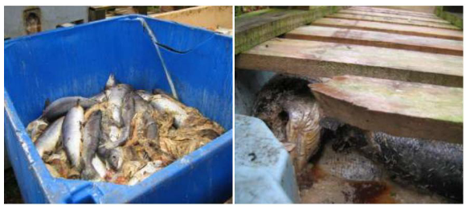

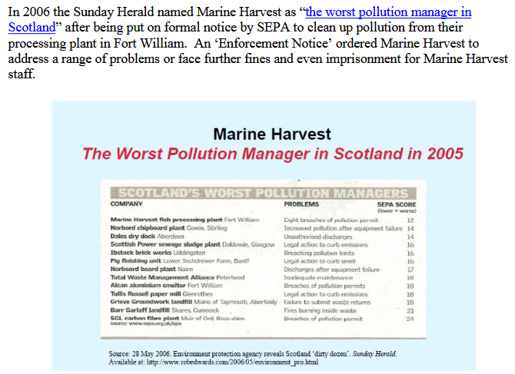

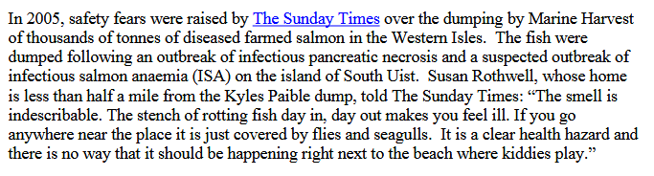

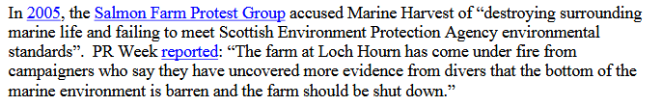

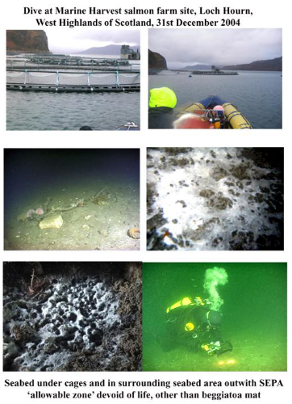

In addition to killing marine life, Marine Harvest has also been criticised for the death of a Royal Marine who dived on a farm in Loch Ewe.

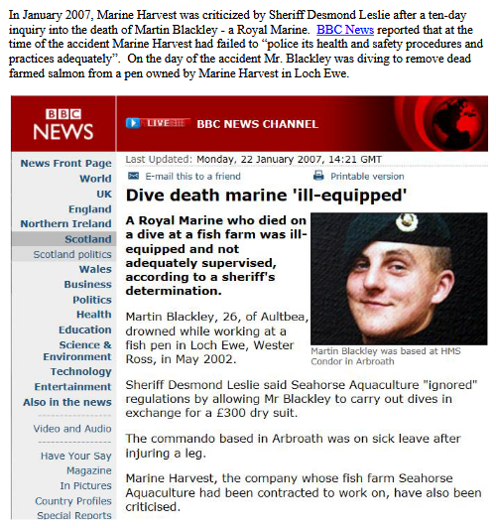

Headless seal corpses have also washed up near Marine Harvest's salmon farm in Loch Alsh (within the Loch Alsh 'Special Area of Conservation'):

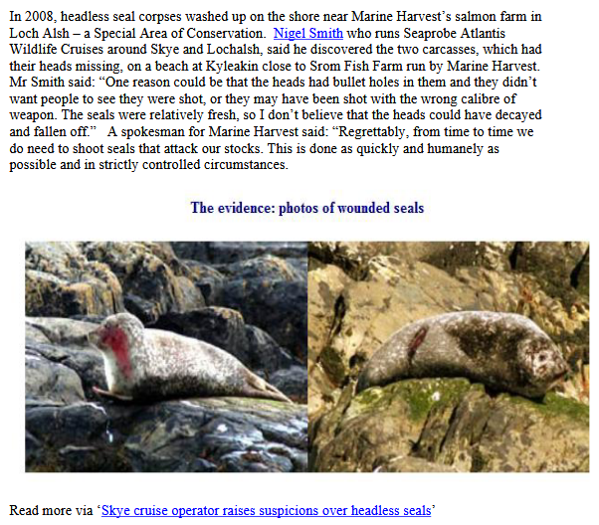

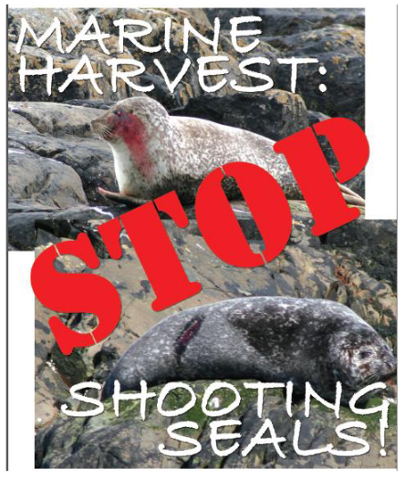

Watch "Marine Harvest: Stop Shooting Seals!"
The Scottish Salmon Company:

In 2016, 300,000 salmon escaped from The Scottish Salmon Company's farm at Scadabay on the Isle of Harris.

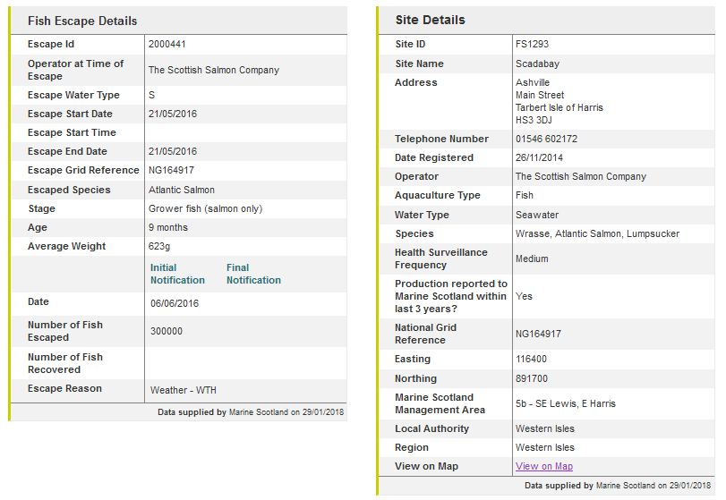

In 2017, 11,040 salmon escaped from The Scottish Salmon Company's farm at Geasgill on the Isle of Mull:

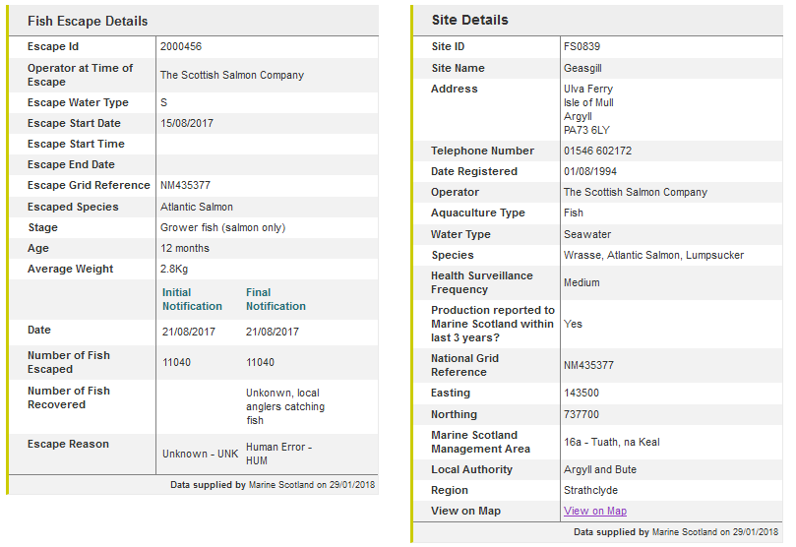

STV News reported in September 2017:

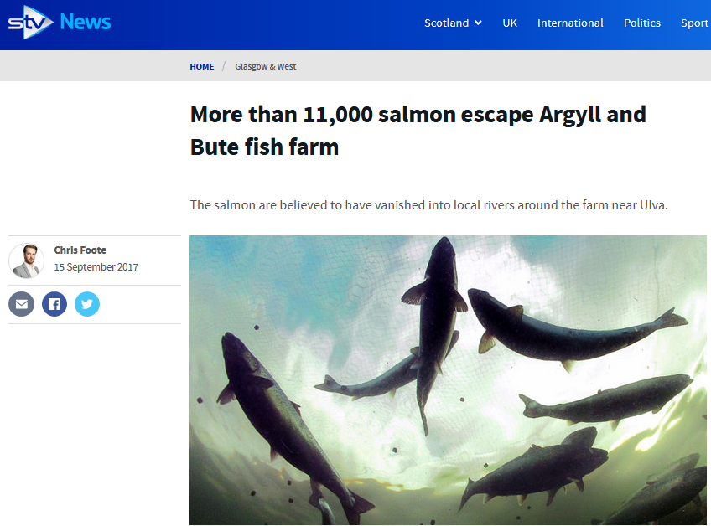

iNews reported in September 2017:

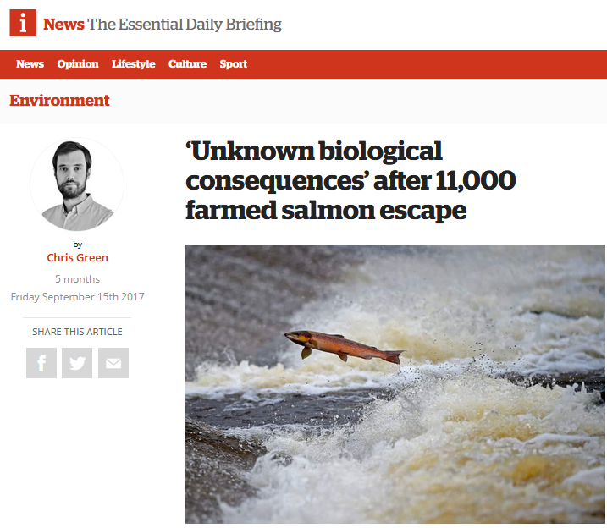

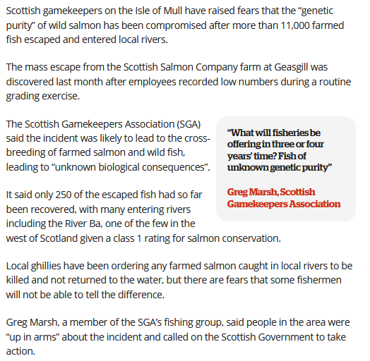

The Scottish Salmon Company was caught out calling a local community a "vipers nest" in leaked documents:

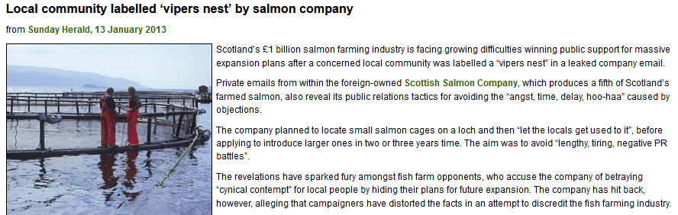

Read more via "Local community labelled ‘vipers nest’ by salmon company"

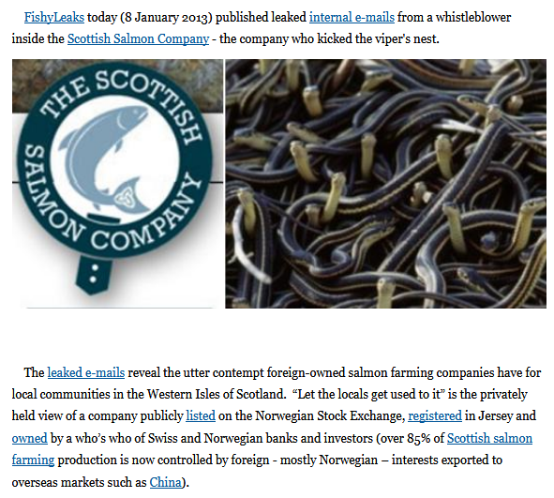

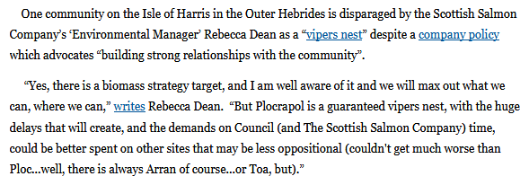

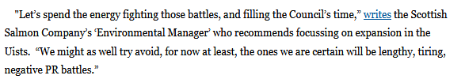

The Scottish Salmon Company markets itself as 'Shaped in Scotland' but it is registered in Jersey and controlled by a Swiss-based financial institution and shareholders from Norway.

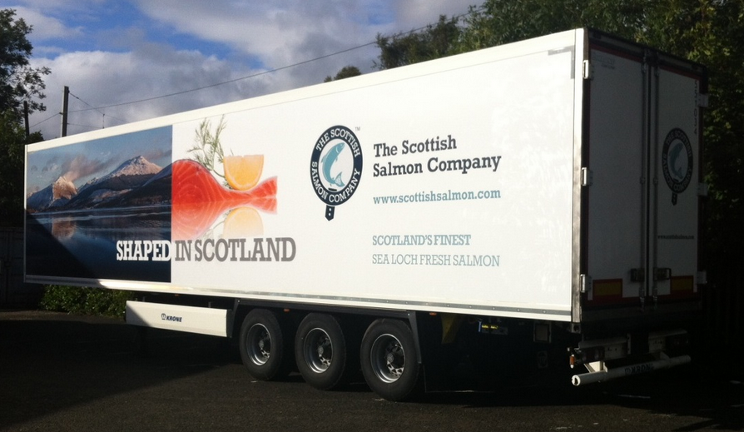

The Scottish Salmon Company has been shaped by infectious diseases such as Amoebic Gill Disease and the use of toxic chemicals.

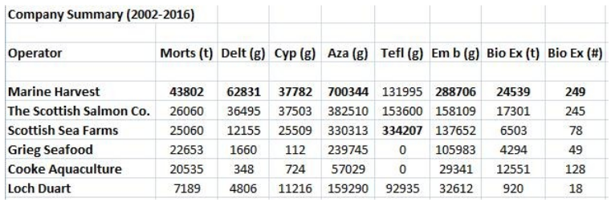

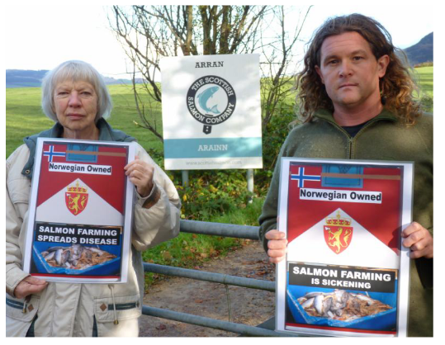
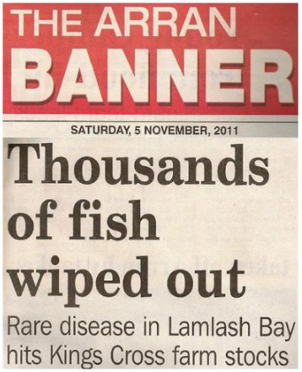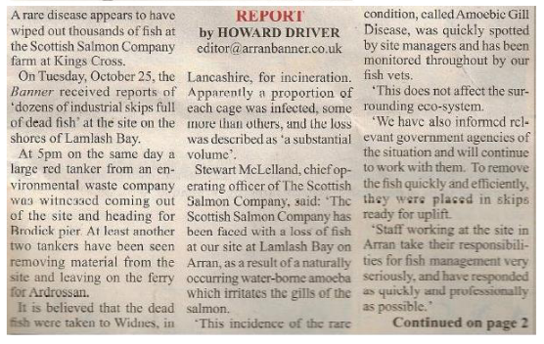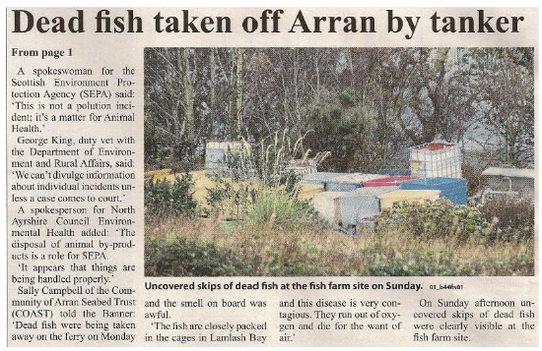
Scottish Salmon Company mort events in 2017 - 1,512,077 mortalities in 131 separate reports/incidents during 2017 including:

85 reported as Gill Diseases (Gill Pathology, AGD, PGD, gill issues and complex gill issues)
41 reported as Treatment
14 reported as CMS
11 reported as PD (Pancreas Disease)

The top ten mortality events reported by the Scottish Salmon Company in 2017 (up to November) were:

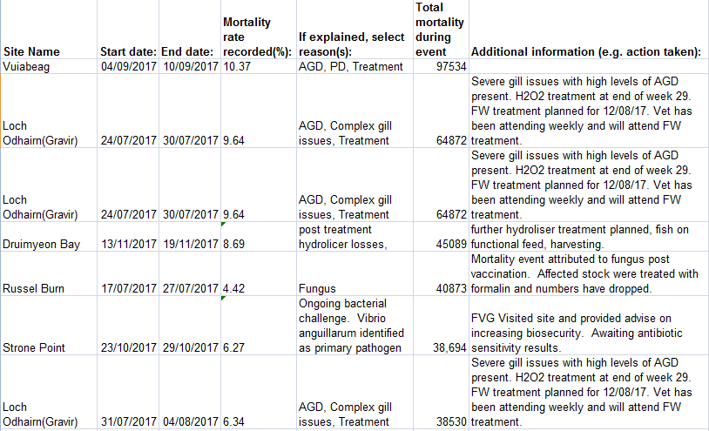
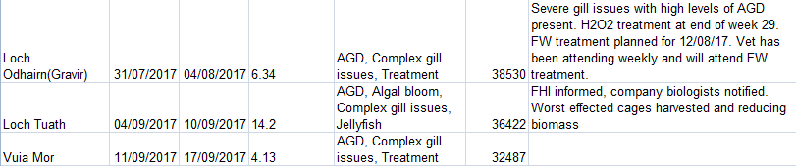

The Scottish Salmon Company has also killed dozens of seals since data was made available by the Scottish Government from 2011. GAAIA reported in 2015:

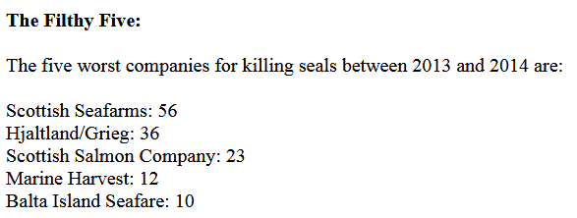

Watch video report via "The Scottish Seal Killers (aka The Scottish Salmon Company"

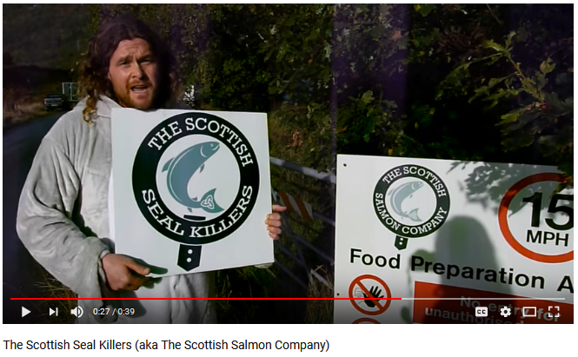

Scottish Sea Farms:

Norwegian-owned Scottish Sea Farms has been riddled by infectious diseases, lice infestations, mass mortalities and the killing of seals.

Scottish Sea Farms mort events in 2017 - 356,082 mortalities in 46 separate reports/incidents during 2017 - including:

27 reported as Gill Diseases (Gill Pathology, AGD, PGD, gill issues and complex gill issues)
18 reported as Anaemia
14 reported as Treatment
7 reported as CMS

The top ten mortality events reported by Scottish Sea Farms in 2017 (up to November) were:

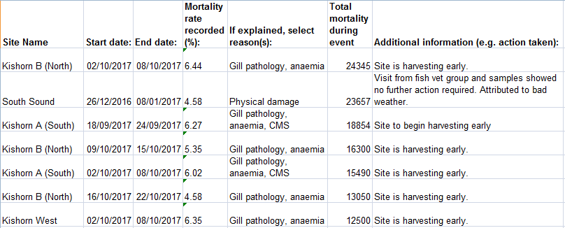
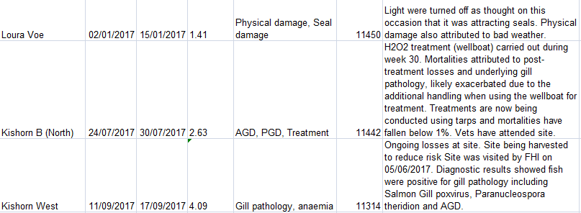

In 2017, GAAIA revealed that Scottish Sea Farms topped the league table in terms of use of the toxic chemical Emamectin benzoate:

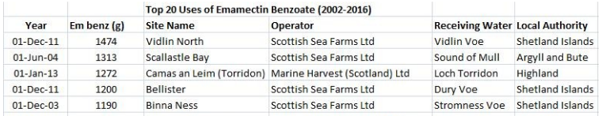

GAAIA revealed in 2015 that Scottish Sea Farms was responsible for five out of the top ten seal-killing salmon farm sites:

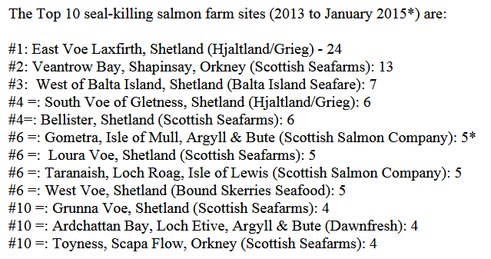

The Ferret reported in 2016:

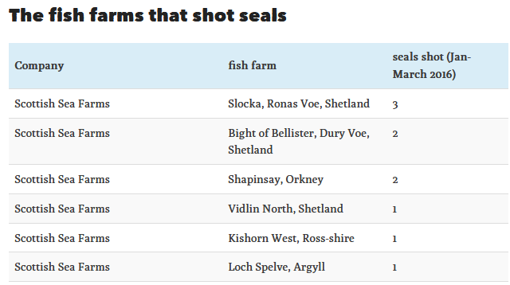

In 2016, Scottish Sea Farms killed 14 seals according to official figures published by the Scottish Government:

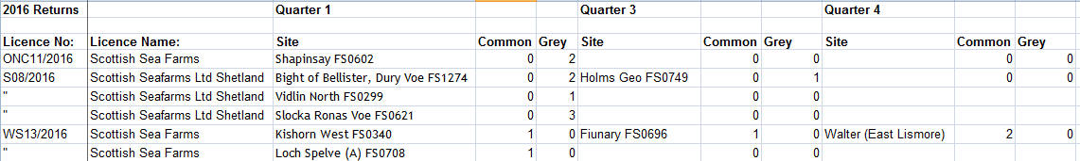

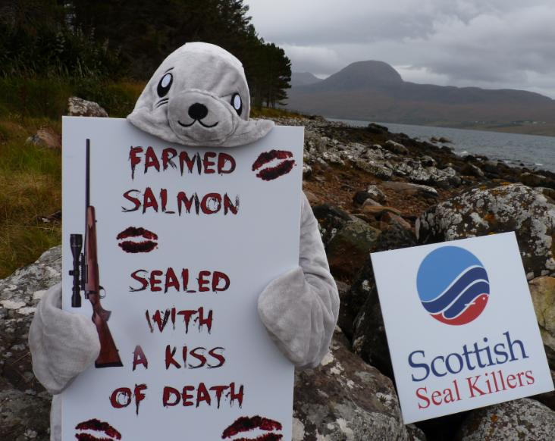
A humpback whale died in a salmon farm operated by Scottish Sea Farms in the Sound of Mull:

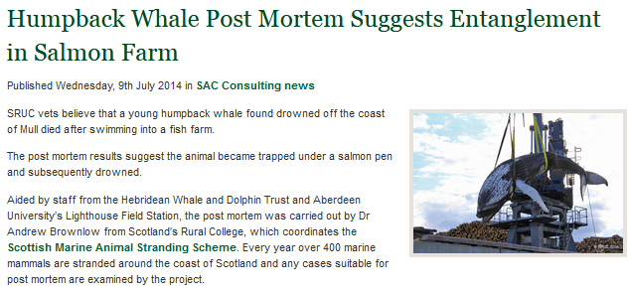
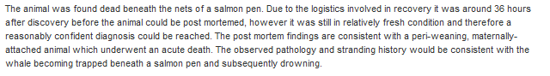

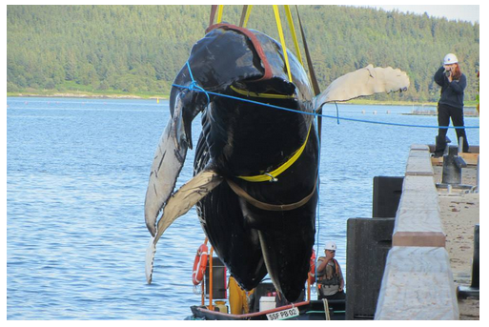

Read more via "Salmon Farming Kills Whales!"; "Humpback Whale Post Mortem Suggests Entanglement in Salmon Farm"; "Humpback Whale died after swimming into fish farm" and "Whale drowned after being trapped under salmon pen"
BBC News reported in 2012 that Scottish Sea Farms had been fined £333,335 following the deaths of two workers - that's around £166,700 each for the lives of Scottish Sea Farms worker Campbell Files and engineer Arthur Raikes.
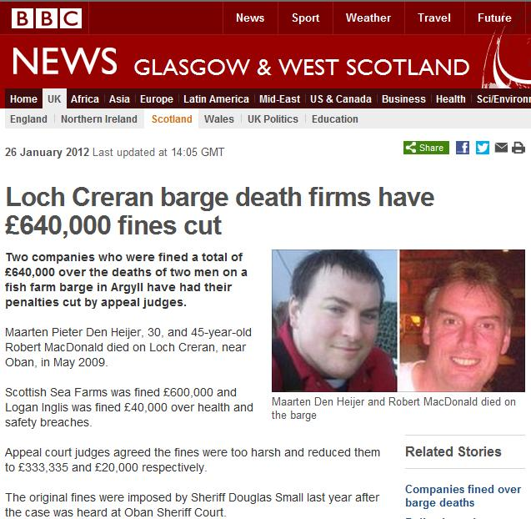

"Following the incident on 11 May 2009, inspectors from the Health and Safety Executive (HSE) discovered Scottish Sea Farms had failed to suitably prepare staff for working in the small, sealed chambers on the Loch Creran barge," reported the BBC.

Speaking after the conclusion of the case, HSE principal inspector Barry Baker said: "These two men were trying to help save their colleague's life when they tragically lost their own. Aquaculture is an important industry in Scotland and one that we can be very proud of, however, we must not forget that the marine environment is dangerous and unforgiving. The deaths in this case should have been avoided - the risks should have been identified and a clear and safe system of work prepared."

Read more via "Firms fined £640,000 over Loch Creran barge deaths"; "Loch Creran barge death firms have £640,000 fines cut" and "Barge pair ‘died in two minutes’"

Scottish Sea Farms has been found guilty of "serious violations" of food safety rules on pesticides in salmon:

"Your firm's aquaculture farmed salmon appear to be adulterated," the US Food & Drug Administration said, "in that the products have been prepared, packed, or held under conditions whereby they may have been rendered injurious to health."
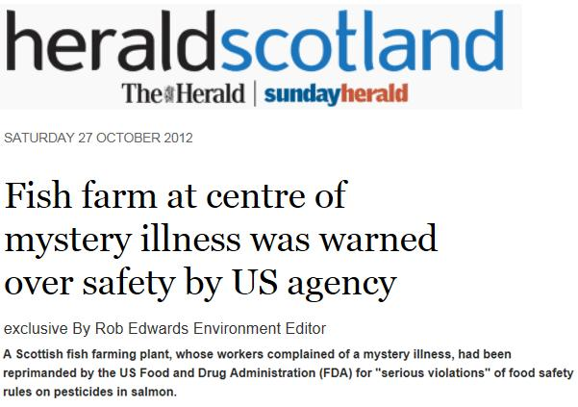
Read more via FDA Health Warning for Scottish Farmed Salmon and Salmon Farming is Sickening: FDA warning for "adulterated" Scottish farmed salmon "injurious to health"

Scottish Sea Farms has also been deemed "unsatisfactory" by SEPA over benthic pollution in Shetland:
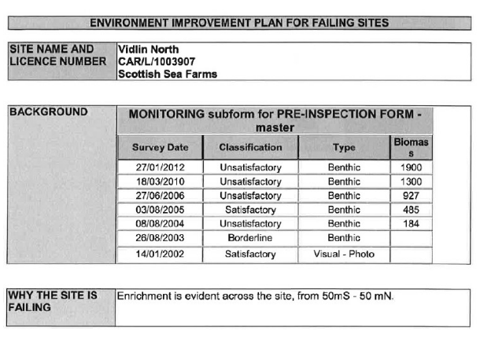
Read more via "Failing Fish Farms - 18% rated "poor" by SEPA in 2015"
Scottish Sea Farms hit the news in December 2017 when footage of a haulage truck removing dead and diseased salmon from their farms in Loch Kishorn was broadcast by the BBC' The One Show'.

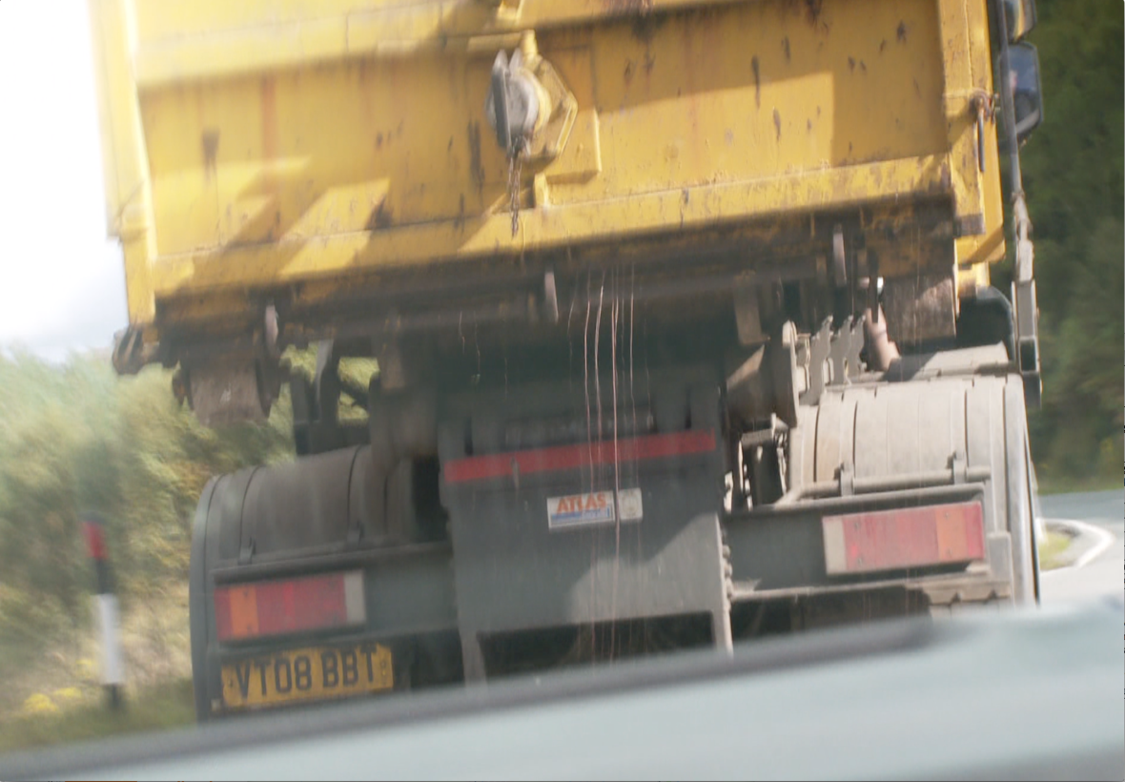
Photo: Fluids leaking from a Billy Bowie haulage truck transporting diseased farmed salmon from Loch Kishorn - broadcast by the BBC's 'The One Show' on 11 December 2017

According to a statement from the Scottish Government: "Mortality information provided to the FHI from farms in Loch Kishorn assign mortalities due to gill pathology, cardiomyopathy syndrome (CMS) and anaemia"

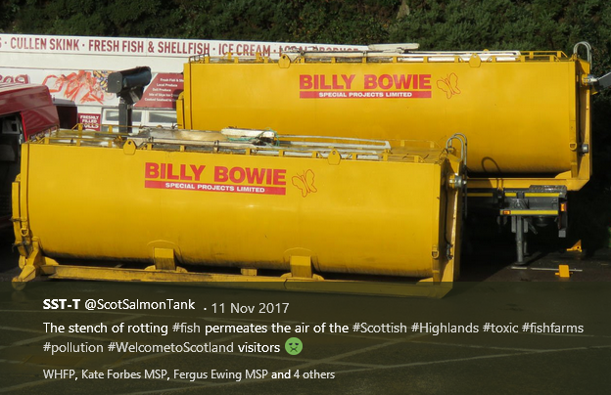

Wester Ross Salmon:

Wester Ross Salmon was dropped by ASDA due to concerns over its environmental impact - including benthic pollution and sea lice infestation:

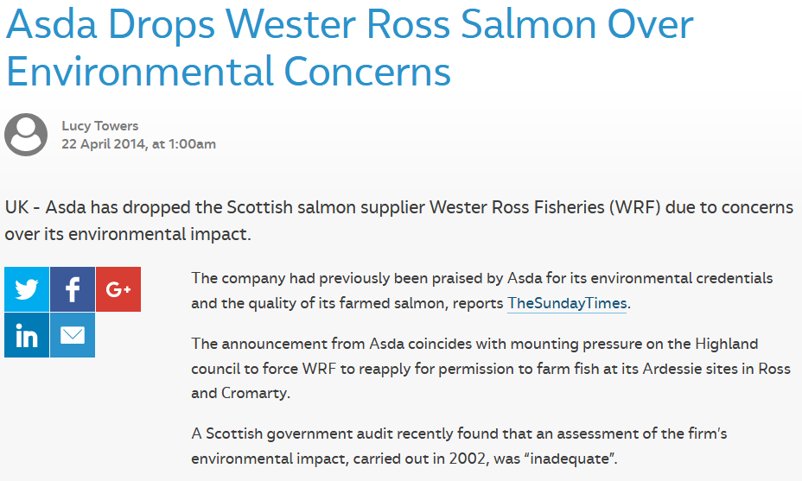

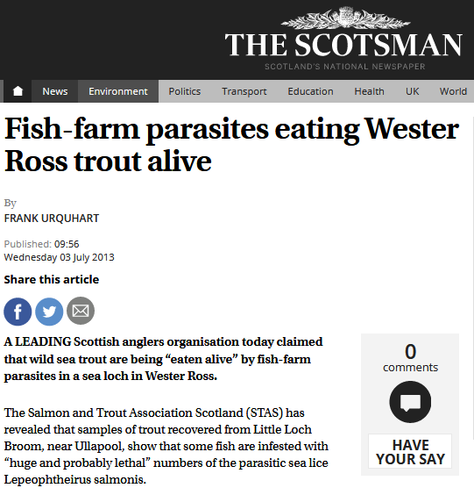

Read more via "Asda axes salmon from ‘problem’ WRF"; "'Unsatisfactory' Wester Ross Salmon: Over a decade of non-compliance"; "Prizes for polluting fish farm under fire"; "Wester Ross fish farms under fire over sea lice outbreaks" and "Fish-farm parasites eating Wester Ross trout alive"

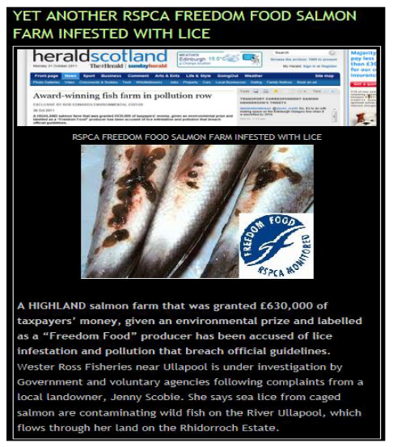

Read more via "Award-winning fish farm in pollution row"

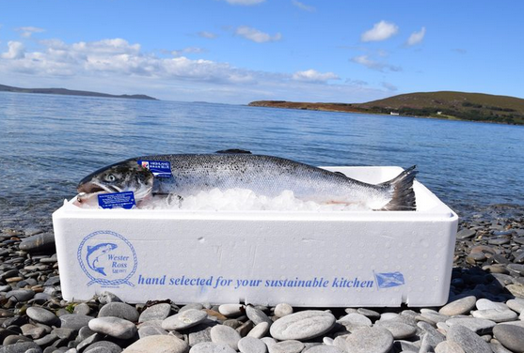
Protect Wild Scotland reported in 2014:

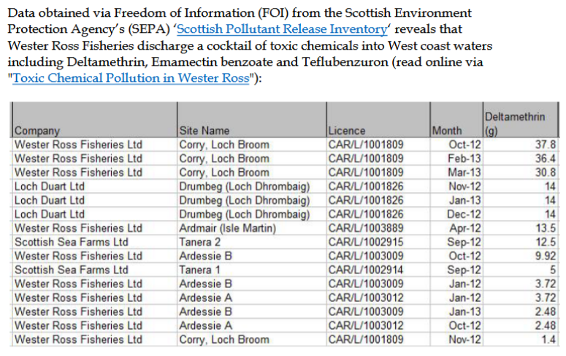

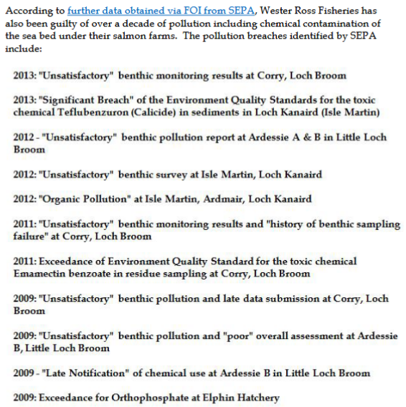

Read more via "Campaign FOI reveals true state of Wester Ross Salmon Pollution" and ""Unsatisfactory" Wester Ross Salmon - FOI from SEPA reveals over a decade of pollution"

Protect Wild Scotland reported in 2014:

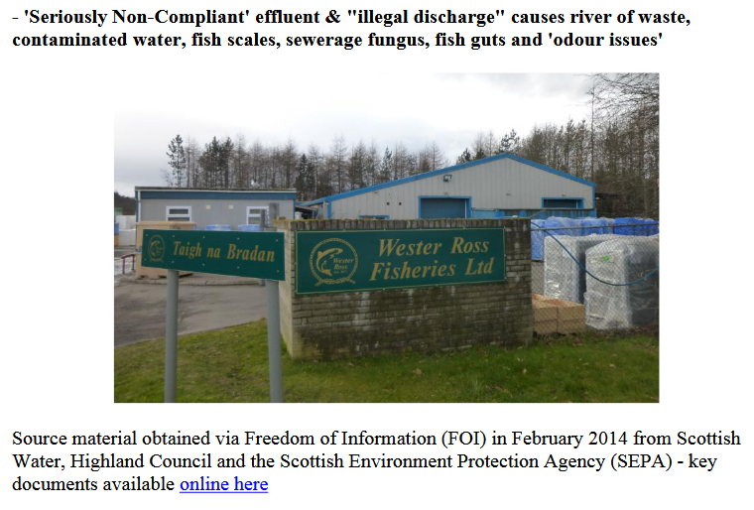

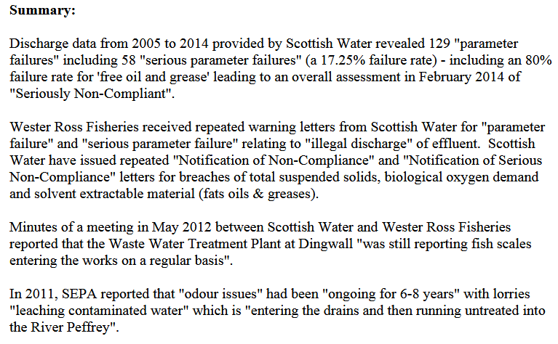
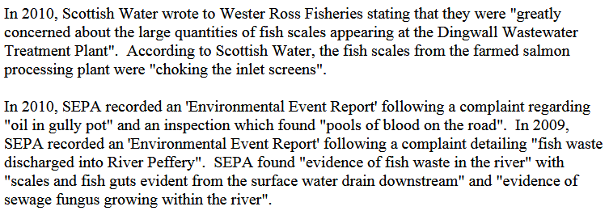

Read more via "FOI Dossier on Wester Ross Fisheries Processing Plant in Dingwall"

Protect Wild Scotland reported in 2014:

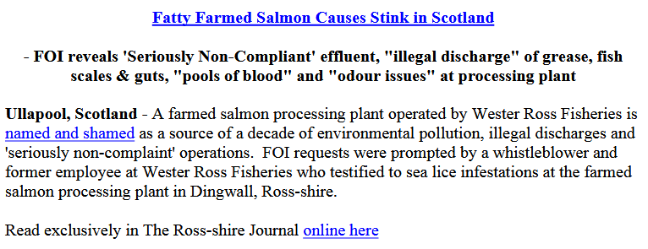

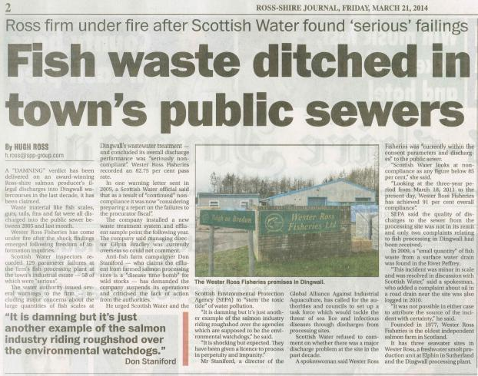

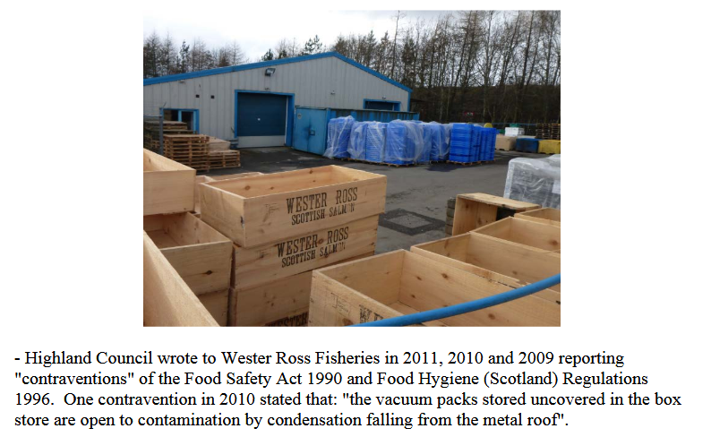
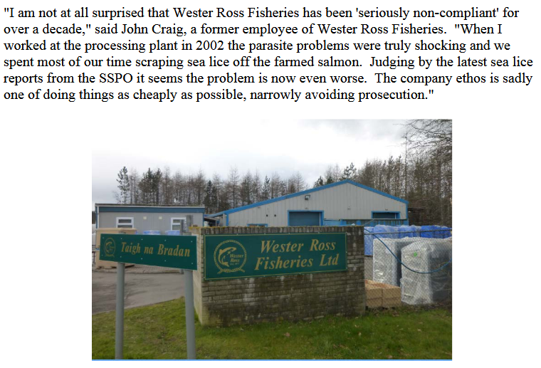
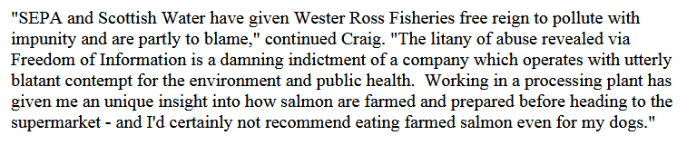

Read more via "Fatty Farmed Salmon Causes Stink in Scotland"
Loch Duart:

Read a dossier via "Loch Duart - The (Really Not Very) Sustainable Salmon Company"

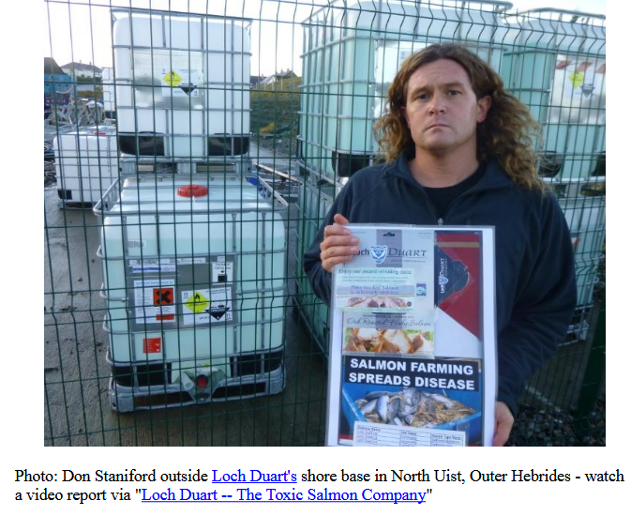

The SSPO would have more member producers but two companies were kicked out due to breaking quarantine and chemical rules. Hjaltland Sea Farms (owned by the Norwegian multinational Grieg Seafood) was kicked out of the Scottish Salmon Producers Organisation for importing smolts without quarantine:

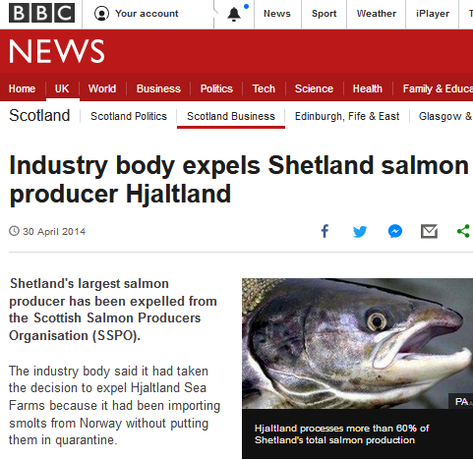

Read more via "Industry body expels Shetland salmon producer Hjaltland" and "Salmon firm defiant after SSPO expulsion"

Ardessie Salmon were kicked out of Scottish Quality Salmon for illegal chemical use:

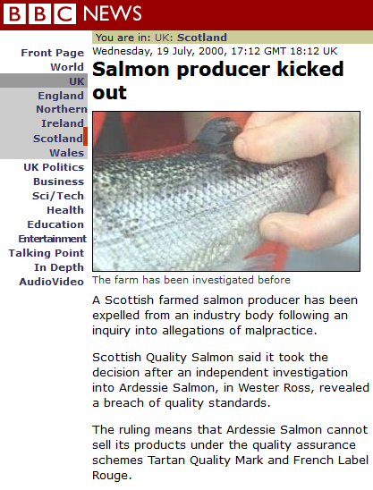

Read more via "'Illegal poison' used on salmon"; "Illegal chemical 'used on salmon'" and "Salmon producer kicked out"

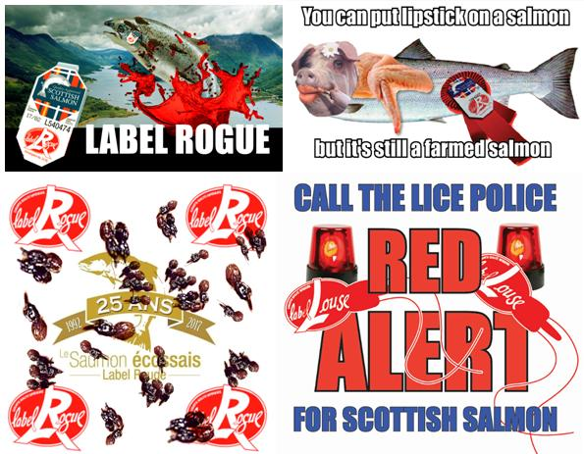

Read more via:
SSPO "sets the record straight"
"Scottish Salmon Farming 101"
"25 Years of Scottish Salmon Shame"
SSPO admit Label Rouge "is not a standard designed to assess environmental or animal welfare criteria"
"Concerns Over Label Rouge Salmon Certification"
"Red Alert for Label Rouge - Lousy Label Goes Rogue"
"Who's Calling Who a Convicted Criminal?"

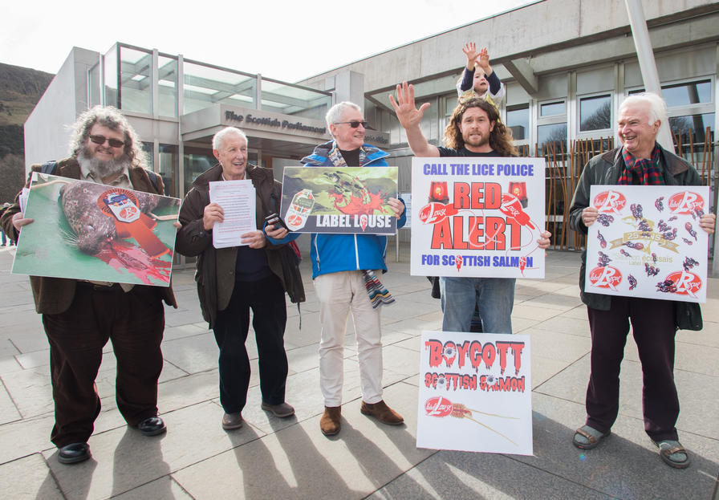

Don Staniford, 5 February 2018

